High-Quality Three-Dimensionally Cultured Cells Using Interfaces of Diblock Copolymers Containing Different Ratios of Zwitterionic N-oxides

Naoto Ogiwara ^{1,2)}, Takenobu Nakano ¹⁾,Koki Baba ¹⁾, Hidenori Noguchi ³⁾, Tsukuru Masuda²⁾, and Madoka Takai²⁾*
¹⁾ Biotech business unit, Incubation center, artience Co., Ltd., 5-6-7 Chiyoda, Sakado-city, Saitama 350-0214, Japan
²⁾ Department of Bioengineering, School of Engineering, The University of Tokyo, 7-3-1 Hongo, Bunkyo-ku, Tokyo 113-8656, Japan
³⁾ Center for Green Research on Energy and Environmental Materials and Global Research Center for Environment and Energy based on Nanomaterials Science (GREEN), National Institute for Materials Science (NIMS), 1-1 Namiki, Tsukuba, Ibaraki 305-0044, Japan
*E-mail: takai@bis.t.u-tokyo.ac.jp

KEYWORDS: cell spheroid, N-oxide, diblock copolymer, protein adsorption, atomic force microscope, sum frequency generation
ABSTRACT:

To control three-dimensional (3D) cell spheroid formation, it is well known the surface physicochemical and mechanical properties of cell culture materials are important; however, the formation and function of 3D cells are still unclear.
This study demonstrated the precise control of the formation of 3D cells and 3D cell functions using diblock copolymers containing different ratios of a zwitterionic trimethylamine N-oxide (N-oxide) group. The diblock copolymers were composed of poly(n-butyl methacrylate)(PBMA) as the hydrophobic unit for surface coating on a cell culture dish and stabilization in water, and poly(2-(dimethylamino)ethyl methacrylate)(PDMAEMA) as the precursor of N-oxide. The zwitterionic N-oxide converted from 0 to 100% using PDMAEMA. The wettability and surface zeta potential varied with different ratios of N-oxide diblock copolymer-coated surfaces, and the amount of protein adsorbed in the cell culture medium decreased monotonically with increasing N-oxide ratio. 3D cell spheroid formations were observed by seeding human umbilical cord mesenchymal stem cells (hUC-MSCs) in diblock copolymer-coated flat-bottom well plates, and the N-oxide ratio was over 40%. The cells proliferated in two-dimensions (2D) and did not form spheroids when the N-oxide ratio was less than 20%. Interestingly, the expression of undifferentiated markers of hUC-MSCs was higher on surfaces that adsorbed proteins to some extent and formed 50–150 μm spheroids in the range of 40–70% of N-oxide ratio.
We revealed that a moderately protein-adsorbed surface allows precise control of spheroid formation and undifferentiated 3D cells and has potential applications for high-quality spheroids in regenerative medicine and drug screening.

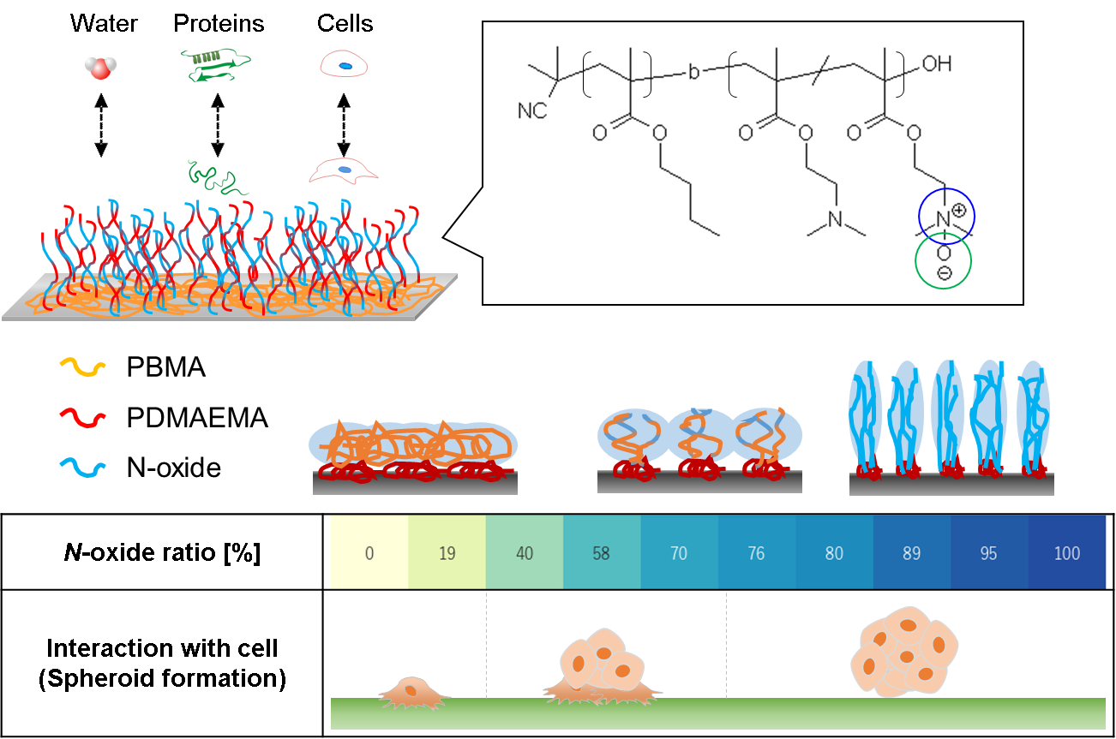
- Introduction

Zwitterionic molecules, which have both positively and negatively charged groups with an overall net charge of zero, are classified into three major classes: phosphobetaines [1-4], sulfobetaines [5,6], and carboxybetaines [7,8]. They have been studied for various applications owing to their antibiofouling properties. Studies on the interaction of zwitterionic interfaces with proteins have been extensively reported, and the effects of the alkyl spacer length between negative and positive charges [9], modification time of tertiary amino groups [10], and the thickness and density of zwitterionic polymers [11] on protein adsorption have been investigated in detail. The strong hydration effect is thought to be the primary factor determining the resistance to protein adsorption. [12]
Trimethylamine N-oxides (N-oxides) are zwitterionic molecules consisting of a direct bond between a positively charged N⁺ and a negatively charged O⁻. N-oxide polymers have been investigated as unique zwitterionic polymers for drug delivery that do not adsorb proteins [13], stabilize proteins [14], or bind reversibly to cell membranes. [15-17] Furthermore, molecular dynamics simulations and sum frequency generation (SFG) spectroscopy have been used to investigate the hydration mechanism of N-oxide polymers. [18] Recently, it was reported that N-oxide polymers, unlike other betaine polymers, exhibit both antibacterial and antibiofouling properties. [19] These unique behaviors make N-oxides a promising fourth zwitterionic material for a wide range of applications.
Cell spheroids produced by three-dimensional (3D) cell culture, which differs from conventional two-dimensional (2D) cell culture, have attracted significant attention in the field of regenerative medicine to fully demonstrate the original functions of cells. [20-22] For example, mesenchymal stem cell (MSC) spheroids are expected to have better therapeutic efficacy when transplanted because they produce more cytokines and growth factors. [23-25] It is important to control the size of spheroids in terms of the distribution of oxygen and nutrients in the interior [26,27] and promote endogenous extracellular matrix expression. [28,29] Moreover, several studies have reported that spheroid formation influences the functional enhancement of spheroids. [30-35] This type of spheroid is designated as a spontaneous spheroid, in which spheroid formation occurs spontaneously with cellular selectivity. [30] From these perspectives, the systematic design of biomaterial interfaces characterized by physicochemical surface properties, including structure, swelling ratio, wettability, surface charge, mechanical properties, and topographical properties, can contribute to the development of novel cell culture substrates for 3D cell spheroid formation. [36] Therefore, these factors are expected to significantly influence the adhesion and stemness of MSCs. In fact, when the cells are seeded on a chemical vapor-deposited polymer, the polymer acts as an extracellular matrix and thus has a substantial impact on cells, continuously contacting the polymer surface, which presumably provides a favorable environment for the deposition of ECM proteins and substantially enriches the self-renewal abilities, pro-angiogenic efficacy, and differentiation capabilities. [34]
In this study, electrically cationic and hydrophilic zwitterionic surfaces were used to systematically investigate cell adhesion and its effects on the function of spheroids formed on biomaterial surfaces. Positively charged surfaces have been reported to have strong interactions with fibronectin, resulting in strong binding to cells and inhibition of intracellular signaling necessary for cell proliferation. [37] It has also been reported that when surfaces have both cationic and zwitterionic groups, protein adsorption and cell adhesion are inhibited, regardless of whether the surfaces are positively charged. [38] Therefore, we aimed to achieve moderate cell adhesion and formation of 3D cell spheroids by adjusting the zwitterionic ion conversion ratio of the cationic tertiary amino substituents. In addition, the use of block polymers for surface treatment is an effective method for facilitating the formation of stable surfaces in water. [39,40] Hence, we designed a novel diblock copolymer containing N-oxide by oxidizing tertiary amino groups at arbitrary ratios and fabricating surfaces with different N-oxide ratios. The physicochemical, topographic, and mechanical factors of the surfaces affecting their interactions with water, proteins, and cells were systematically evaluated by varying the N-oxide ratio. Based on these results, suitable interfacial states for controlling cell adhesion on N-oxidized surfaces were identified, and novel biomaterials were developed to obtain highly functionalized 3D cell spheroids.

2. EXPERIMENTAL SECTION
2-1. Materials
n-Butyl methacrylate (BMA) was purchased from Mitsubishi Chemical Co. (Tokyo, Japan). 2-(Dimethylamino)ethyl methacrylate (DMAEMA) was purchased from Sanyo Chemical Industries Ltd. (Kyoto, Japan). Both BMA and DMAEMA were purified by treatment with basic alumina to remove inhibitors before use. Furthermore, 2,2’-Azobis-isobutyronitrile (AIBN), 2-cyano-2-[(dodecylsulfanylthiocarbonyl)sulfanyl]propane (CDTP), hydrogen peroxide (H₂O₂), N,N-dimethylformamide (DMF), and lithium chloride (LiCl) were purchased from Fujifilm Wako Pure Chemical Co., Ltd. (Tokyo, Japan). Methyl ethyl ketone (MEK), acetone, and methanol were purchased from Kishida Chemical Co., Inc. (Tokyo, Japan). These solvents, initiators, and chemical reagents were of extra pure grade and were used without further purification. Methanol-d₄ and deuterium oxide (D₂O) were purchased from Sigma–Aldrich (St. Louis, MO, USA).
Hemisphere prisms with outer diameters of 25 mm (FQIR25-25HC) were purchased from Pier Optics Co., Ltd. (Gunma, Japan). A gold-quartz crystal microbalance with dissipation monitoring (QCM-D sensors (QSX-301) was purchased from ALTECH Co., Ltd. (Tokyo, Japan). Tissue culture polystyrene (TCPS) dishes with a diameter of 35 mm (#3000-035) were purchased from AGC Techno Glass (Chiba, Japan) as a planar substrate. A polystyrene U-shaped 96-well plate (196-96US; Fukaekasei Co., Ltd., Kobe, Japan) was used for cell culture.
Bovine serum albumin (Alb) and fibrinogen (Fng) from human plasma and lysozyme (Lyz) from chicken egg whites were purchased from Merck (Darmstadt, Germany).
Phosphate-buffered saline (PBS) tablets were purchased from Takara Bio Inc. (T9181, Shiga, Japan). Dulbecco’s modified Eagle’s medium (DMEM) was purchased from Merck (Darmstadt, Germany). USDA fetal bovine serum (FBS) was purchased from Cytiva (MA, USA). Penicillin-streptomycin was purchased from Gibco (Grand Island, NY). Mouse embryo fibroblasts, NIH3T3-3-4 (RCB1862), and human liver carcinoma cell line, HepG2; RCB1886) were purchased from the Riken Bio Resource Center (Ibaraki, Japan). Human mesenchymal stem cells (hUC-MSCs) from Wharton’s jelly umbilical cord matrix (C-12971) were purchased from Promo Cell GmbH (Heidelberg, Germany). The MSC growth medium 2 (C-28009) was purchased from PromoCell GmbH (Heidelberg, Germany).

2-2. Synthesis and characterization of N-oxide containing diblock copolymers
Figure 1 shows the synthetic process for the N-oxide-containing diblock copolymers. The diblock copolymers were designed to contain poly(n-butyl methacrylate) (PBMA) as the hydrophobic segment, which improved substrate adhesion after coating and reduced elution during immersion in water. [41] Poly(2-(dimethylamino)ethyl methacrylate) (PDMAEMA) was used as the hydrophilic segment of the diblock copolymers, which allowed robust bioadhesion by electrostatic interactions. The tertiary amino groups of the DMAEMA moiety were quantitatively N-oxidized using an aqueous solution of hydrogen peroxide and polymers with different N-oxide ratios were synthesized.
Molecular-weight-controlled diblock copolymers of PBMA-b-PDMAEMA were prepared as precursors of N-oxide-containing diblock copolymers and characterized by reversible addition fragmentation chain transfer (RAFT) polymerization. For the initial PBMA synthesis, BMA (49.8 g, 3.50 mol/L), CDTP (1.21 g, 35.0 mmol/L) as a chain transfer agent and AIBN (115 mg, 7.00 mmol/L) as an initiator were dissolved in MEK (100 mL), followed by N₂ bubbling over 60 min. The flask was placed in an 80 °C oil bath, and the polymerization proceeded with stirring for 6 h. Polymerization was terminated by cooling the flask to 5 °C and exposing the solution to open air. The mixture was then precipitated in excess methanol as a poor solvent and purified by repeated precipitation, followed by drying in vacuo to obtain PBMA. For the subsequent polymerization, PBMA (5 g, 8.18 mmol/L) as a macro-RAFT reagent, DMAEMA (11.57 g, 1.63 mol/L) and AIBN (12.09 mg, 1.64 mmol/L) were dissolved in MEK (135 mL), followed by N₂ bubbling over 60 min. Polymerization was then performed at 80 °C for 8 h. After polymerization, the mixture was precipitated twice in excess hexane and dried in vacuo. The obtained PBMA-b-PDMAEMA was dissolved in methanol at a concentration of 15 wt%. Under nitrogen protection, an aqueous hydrogen peroxide solution was added and the reaction was carried out at 50 °C for 24 h with stirring. The amount of aqueous hydrogen peroxide solution was adjusted according to the target denaturation ratio of the tertiary amino groups of PDMAEMA. After confirming the disappearance of hydrogen peroxide by titration with a sodium thiosulfate solution, the product was freeze-dried overnight.
The monomer conversion was calculated by comparing the ¹H-NMR peak integrals obtained using a JEOL JNM-LA400 spectrometer at 400 MHz in CDCl₃ or methanol-d₄. For the molecular weight measurements, gel permeation chromatography (GPC) was performed using a TOSOH EcoSec HLC/GPC 8320 system. Three sequentially connected columns (TSKgel Super AW2500, TSKgel Super AW3000, and TSKgel Super AW4000) at 40 °C using DMF containing 10 mM LiCl as an eluent at a flow rate of 0.6 ml/min. Polymer molecular weights and their distributions were calculated from calibration curves prepared using poly(methyl methacrylate) standards (Shodex, Tokyo, Japan).

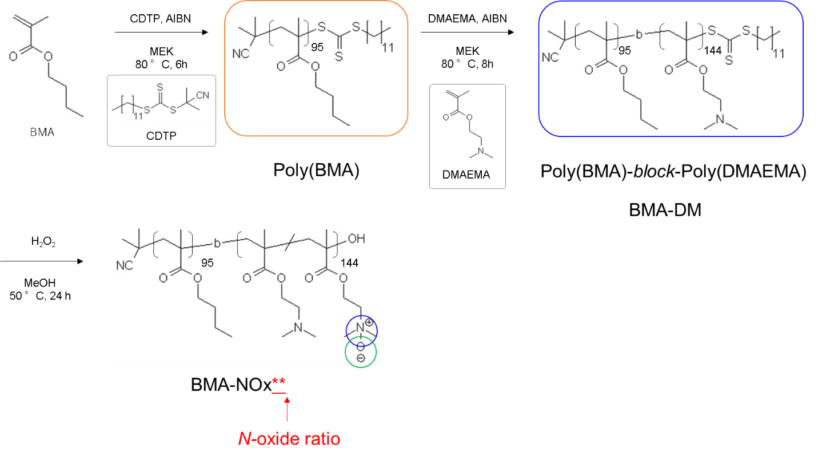
Figure 1. Synthetic pathway of the N-oxide-containing diblock copolymer
Abbreviations: BMA, n-butyl methacrylate; DMAEMA, 2-(dimethylamino)ethyl methacrylate; AIBN, 2,2'-azobis(isobutyronitrile); MEK, methyl ethyl ketone; CDTP, 2-cyano-2-[(dodecylsulfanylthiocarbonyl)sulfanyl]propane; H₂O₂, hydrogen peroxide; “BMA-DM” indicate Poly(BMA)-block-Poly(DMAEMA); “BMA-NOx**” indicate N-oxide containing diblock copolymer, where ** indicates a N-oxide ratio.

2-3. Fabrication of diblock copolymer-coated surface
The diblock copolymer-coated surfaces were prepared via a spin-coating method because it is simple and facile to form uniform layers even on substrates with complex shapes, such as U-shaped bottom plates. The N-oxide containing diblock copolymers were dissolved in methanol to obtain a 3 mg/mL solution. Next, 400 µL of the solution was spin-coated on a TCPS dish with a 35 mm diameter at 3000 rpm for 30 sec, and then the dishes were dried in vacuo at 25 °C for 1 h. The coated dishes were filled with water, incubated at 25 °C for 1 h to wash off the excess polymer, and then dried in vacuo again at 25 °C for 1 h. The dishes were cut using an ultrasonic cutter, if necessary.
Polymer-coated U-shaped bottom 96-well plates were used to determine the spheroid formation rates. The copolymer (3 mg/mL) in methanol was poured into U-shaped 96-well plates and removed. After the coated plates were dried at 24 °C under vacuum for 2 h, they were washed once with PBS before use.

2-4. Evaluation of surface properties (thickness, effective medium approximation, contact angle, surface zeta potential, chemical composition, surface morphology)

The thickness and effective medium approximation (EMA) of the copolymers on the TCPS dishes were measured using spectroscopic ellipsometry (alpha-SE, J. A. Woolam, Nebraska, USA) in air. A He-Ne laser (632.8 nm) was used and the incident angle was 70°. The obtained data were fitted to the Cauchy layer model, and the refractive index was assumed to be 1.517. [42] The data were fitted and evaluated using CompleteEASE software package. The Cauchy model was applied to the polymer film layer (A = 1.517, B = 0.01, and C = 0.00) on the Si/SiO₂ sublayer.
Contact angle measurements were conducted with a contact angle meter (Drop Master DMs-401, Kyowa Interface Science Co., Tokyo, Japan) at 24 °C. Two methods were used to characterize wetting. For the sessile drop technique, a water droplet of 2-3 μL was deposited on a substrate and contact angle was measured after 10 seconds. For the captive bubble method, substrates were immersed in water beforehand and an air bubble with a volume of 3-4 μL was supplied with a micro syringe at the interface with an inverted needle.
The surface zeta potentials of the polymer coated TCPS dishes were measured by an electrophoretic light-scattering spectrophotometer (ELSZ2000Z, Otsuka Electron, Osaka, Japan) at 25 °C. The zeta potentials were estimated using the Smoluchowski approximation. Polymer-coated TCPS dishes (cut to 10 mm × 35 mm) were used for the measurements. Surface zeta potential measurements were performed in a 10 mM NaCl aqueous solution.
Chemical composition was analysed by ATR/FT-IR spectroscopic analyser (Nicolet iS5 spectrometer, Thermo Nicolet, USA) and X-ray photoelectron spectroscopy (XPS; K-Alpha, Thermofisher Scientific, E. Grinstead, UK). Surface elemental composition of polymer coated TCPS dishes was evaluated by XPS at 1.1 × 10^{‒6} Pa using a monochromatic Al-Kα X-ray source at 72 W. The takeoff angle was 90°. Survey scans were collected at a pass energy of 200 eV and dwell time of 10 ms over 10 scans. Narrow scans were collected at a pass energy of 50 eV and a dwell time of 50 ms over 10 scans. The peak corresponding to graphitic C was calibrated at 284 eV.
Surface morphology observations were conducted using atomic force microscopy (AFM; MFP-3D, Oxford Instruments PLC). In this study, the different morphological parameters of air and water were obtained using AFM analysis. For the tapping scan mode in air, AC240TS (spring constant k = 2.0 N/m, resonance frequency f = 70 kHz, and tip radius of 7 nm; Olympus Co., Ltd., Tokyo, Japan) was used as a cantilever. Images were acquired; the scan areas were within a range of 25 μm² with a resolution of 256 × 256 pixels and a resolution of 19.5 nm, with a drive frequency of 67 kHz, target amplitude of 2 V, set point of 1.4 V, and scan rate of 1 Hz. For the tapping scan mode in water, BL-AC40TS (spring constant k = 0.1 N/m, resonance frequency f = 110 kHz (in air), 25 kHz (in water), and tip radius of 8 nm; Olympus Co.) was used as a cantilever. Images were acquired; scan areas were within a range of 4 μm² with a resolution of 256 × 256 pixels and a resolution of 7.8 nm, with a drive frequency of 33 kHz, target amplitude of 1 V, set point of 0.7 V, and scan rate of 0.75 Hz. Roughness is discussed using Ra, which refers to the arithmetic mean roughness. Ra is the average of ten profiles randomly extracted from one image. The roughness of the copolymer films was measured in distilled water and the samples were maintained under these conditions for > 60 min before observation.
To measure the viscoelastic properties using AFM, force-distance curves were recorded. Force-distance curves were collected at a cantilever velocity of 150 nm/s and a trigger point of 2.00 nN. Cantilevers (Biosphere B500-CONT, NanoAndMore GmbH, Wetzlar, Germany) with a spring constant k = 0.264 N/m, deflection InvOLS = 73.3 nm/V, resonance frequency f = 13 kHz (in air), and a high-density spherical carbon tip with a tip radius of 500 nm were used.

2-5. Protein adsorption test
Each diblock copolymer (3 mg/mL) in methanol was spin-coated onto the Au sensor of QCM-D (E4, Q-sense, Gothenburg, Sweden) using a spin coater at 2000 rpm for 30 s with a slope of 10 s, and then dried at 24 °C under vacuum for 2 h. The protein adsorption test was conducted by QCM-D at 35 MHz, the seventh overtone of a 5 MHz sensor and 37 ± 0.1 °C using a window chamber. After exposure to PBS for 7 min at a flow rate of 0.25 mL/min, the flow was stopped. After confirming the baseline stability, Alb solution, Fng solution, Lyz solution, and 10% FBS containing DMEM medium was injected into the sensors at 0.25 mL/min of 7 min. The concentration of Alb, Fng, and Lyz in PBS were adjusted to 3000, 300, and 3000 μg/mL, respectively. Alb and Fng were used as anionic proteins, and Lyz was used as a cationic protein. After 30 min, the resonance frequency change (Δf) was measured, and the adsorbed protein was calculated using the Sauerbrey equation for instance. [43] The seventh overtone values of obtained Δf and ΔD were used in the analysis.
2-6. Cell adhesion test and gene expression test
Copolymer spin-coated TCPS dishes and dip-coated U-shaped 96-well plates were used in this experiment. The substrates were sterilized under UV light for 1 h before the cell assay. Suspensions of NIH3T3-3-4, HepG2, and hUC-MSCs in DMEM supplemented with 10% FBS and 1% penicillin-streptomycin were seeded. The cultures were maintained at 37 °C in a 5% CO₂ atmosphere. Cells were observed under an optical microscope (BioStudio-T; Nikon Engineering, Kanagawa, Japan) (CELENA S Digital Imaging System; Logos Biosystems, Inc., South Korea).
Quantitative reverse transcription-polymerase chain reaction (qRT-PCR) was performed to determine the expression levels of stem cell markers in cell spheroids. Briefly, total RNA was extracted using a PureLinkTM RNA Mini Kit (Thermo Fisher Scientific, Waltham, MA, USA). After quantification of total RNA with a spectrophotometer (NanoDrop® ND-2000, Thermo Fisher Scientific, Waltham, MA, USA), RNA samples were reverse transcribed into complementary DNA (cDNA) using SuperScriptTM IV VILOTM Master Mix (Thermo Fisher Scientific, Waltham, MA, USA) according to the manufacturer’s instructions. qRT-PCR was performed in a thermal cycler (TaKaRa PCR Thermal Cycler Dice®, Takara Bio, Kusatsu, Japan) using the TaqMan™ Fast Advanced Master Mix for qPCR (Thermo Fisher Scientific, Waltham, MA, USA) according to the manufacturer’s protocol. The TaqMan Gene Expression Assays (Thermo Fisher Scientific, Waltham, MA, USA) used for the PCR experiments are listed in Table S1 in the Supporting Information. Each qRT-PCR was performed in triplicate, and the relative expression levels of the genes were normalized against glyceraldehyde 3-phosphate dehydrogenase (GAPDH).

2-7. Interfacial water analysis by SFG spectroscopy
The SFG measurement system was constructed as described previously. [44] An (OPG (optical parametric Generation)/OPA (Optical parametric Amplification)/DFG (Difference frequency generation)) system (EKSPLA, PG501VIS/DFG) was pumped using a picosecond Nd:YAG laser (EKSPLA, PL2143B) to generate tunable infrared radiation. The visible and infrared beams were made to overlap the flat face of the cylindrical hemiprism from the cylindrical face. A Teflon flow cell was used. The polarization combinations were s, s, and p for the SFG, visible light, and infrared light, respectively. The SFG spectrum in the OH stretching region (3000–3800 cm^{–1}) was acquired at the interface between the diblock copolymer-coated surfaces and water media. The SFG spectrum of the OH stretching region is influenced by the intermolecular and/or intramolecular coupling of H₂O. Isotopically diluted water (HOD) simplified the SFG spectrum by eliminating this effect. [45,46] Therefore, we used isotopically diluted water (H₂O/D₂O = 1/4, H₂O/HOD/D₂O = 1/8/16).

2-8. Statistical analysis
All data are presented as mean ± standard deviation (SD). Statistical analysis of the contact angle and the amount of adsorbed protein was performed using the unpaired t-test, with *p < 0.05, and **p < 0.01 set as levels of statistical significance.

3. RESULTS AND DISCUSSION
3-1. Structural analysis of N-oxide containing diblock copolymers
First, a molecular-weight-controlled diblock copolymer, PBMA-b-PDMAEMA, was prepared as a precursor for the N-oxide diblock copolymer by RAFT polymerization. The unimodal GPC chart with a peak shift toward a lower retention time indicated successful synthesis of the diblock copolymer (Figure S1). The number-averaged molecular weight (M_{n}) and polydispersity index (PDI) of the first segment of poly(BMA) were 13,600 and 1.12, respectively. For the diblock copolymer, PBMA-b-PDMAEMA, M_{n} and PDI were 28,100 and 1.19, respectively. The PDI remained relatively narrow (<1.20), indicating well-controlled RAFT polymerization.
The chemical composition of the diblock copolymer was determined by ¹H-NMR (Figure 2). The degrees of polymerization of DMAMEA:BMA were calculated to be 144:95 by comparing the integrated methylene chain-derived protons from the BMA residues at 1.4–1.6 ppm to the two methylene-chain-derived protons assigned to the DMAMEA residues at 2.6–2.8 ppm. Furthermore, ¹H-NMR analysis provided information on the zwitterionic ratio or the conversion ratio to N-oxide after reaction with a hydrogen peroxide aqueous solution (Figure S2). The methylene chain-derived proton peaks at 2.6–2.7 and 4.1–4.2 ppm observed in the DMAEMA residues of PBMA-b-PDMAEMA were shifted to lower fields at 3.6–3.7 and 4.5–4.6 ppm, respectively, with increasing N-oxide ratio. The N-oxide ratio was calculated from the integrated methylene chain-derived protons at 2.6–2.7 ppm from the DMAMEA sequence (d: orange lower-case letter) and 3.6–3.7 ppm from the N-oxide sequence (d: blue lower-case letter). Herein, PBMA-b-PDMAEMA diblock copolymer is abbreviated as BMA-DM and PBMA-b-P(DMAEMA-r-NO) diblock copolymer with a zwitterionic ratio of 70% is abbreviated as BMA-NOx70 for example.
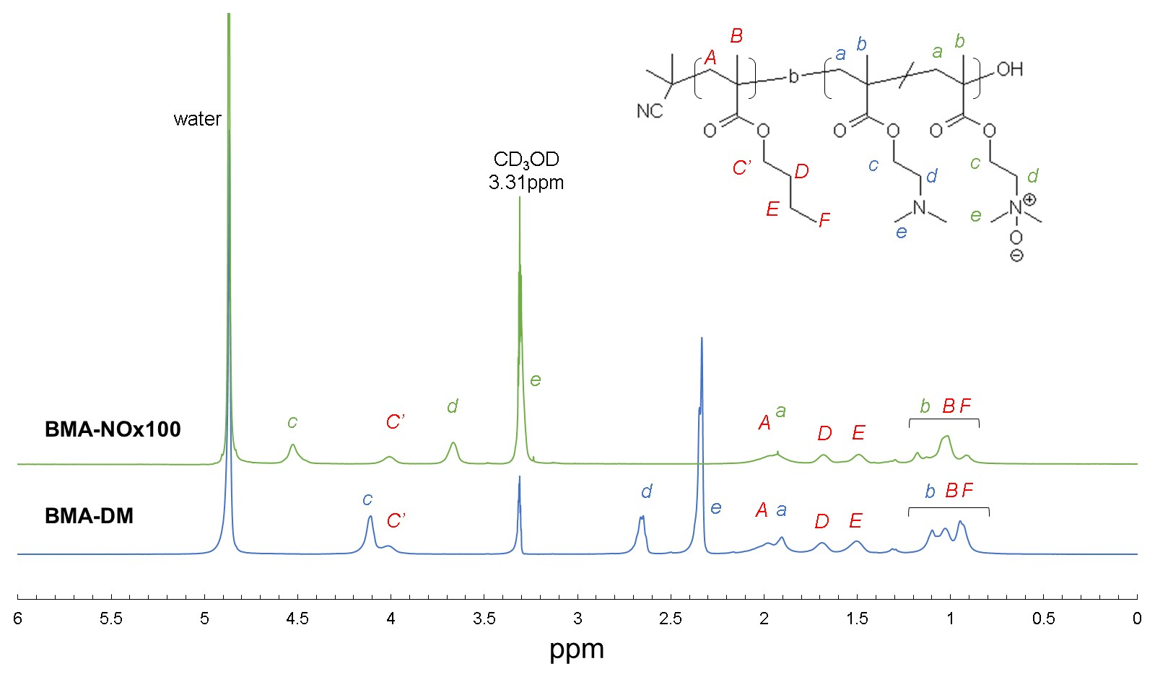
The homopolymer of N-oxide is a water-soluble polymer but has properties different from those of other betaine polymers; it is soluble in ethanol, 2-propanol, and binary mixtures of water and ethanol. (Figure S3) This solubility property results from the unique hydration of the N-oxide structure, which directly binds positive and negative charges. This good solubility allowed for subsequent coating procedures.

Figure 2. ¹H-NMR spectra of BMA-DM and BMA-NOx100 in methanol-d₄.
¹H NMR (400 MHz, CD₃OD) of BMA-DM δ = 0.8–2.2 (br, polymer backbone and −CH₂–CH₂–CH₂–CH₃), 2.3 (s, 6H, −N(-CH₃)₂), 2.6 (s, 2H, −CH₂–CH₂–N(–CH₃)₂), 4.0 (br, 2H, −CH₂–CH₂–CH₂–CH₃), and 4.1 (br, −CH₂–CH₂–N(–CH₃)₂).
¹H NMR (400 MHz, CD₃OD) of BMA-NOx100 δ = 0.8–2.2 (br, polymer backbone and −CH₂–CH₂–CH₂–CH₃), 3.3 (s, 6H, −N(-CH₃)₂), 3.65 (s, 2H, −CH₂–CH₂–N(–CH₃)₂), 4.0 (br, 2H, −CH₂–CH₂–CH₂–CH₃), and 4.5 (br, −CH₂–CH₂–N(–CH₃)₂).

3-2. Physicochemical properties of the diblock copolymer-coated surfaces
N-oxide containing diblock copolymer-coated surfaces were prepared using the spin-coating method. Material properties that affect protein adsorption and subsequent cell adhesion are categorized into (1) physicochemical factors, (2) mechanical factors such as viscoelasticity, and (3) topographical factors such as surface roughness and microphase separation. Thus, the properties of the obtained surfaces were analyzed considering these categories. The physicochemical properties of the diblock polymer-coated surfaces were evaluated (Table 1).

Table 1. Results of characterized diblock copolymers-coated surfaces
Sample name | TCPS  (substrate) | BMA-  DM | BMA-  NOx 19 | BMA-  NOx 40 | BMA-  NOx 58 | BMA-  NOx 70 | BMA-  NOx 76 | BMA-  NOx 80 | BMA-  NOx 89 | BMA-  NOx 95 | BMA-  NOx 100
Thickness  in air [nm] ª | - | 23.3±2.2 | 19.5±0.3 | 19.5±0.7 | 18.0±0.4 | 19.4±0.2 | 19.9±0.6 | 19.9±1.3 | 20.1±0.3 | 19.7±0.3 | 21.2±0.6
Thickness  in water [nm] ª | - | 38.4±0.4 | 37.0±0.4 | 61.8±0.6 | 53.7±0.5 | 70.7±0.6 | 39.4±0.8 | 70.2±0.9 | 42.6±0.9 | 61.4±1.0 | 57.9±1.3
EMA [%] ª | - | 50.4±6.7 | 53.6±3.1 | 68.7±4.8 | 73.9±0.8 | 85.1±1.0 | 84.4±0.4 | 86.1±1.1 | 86.7±0.2 | 90.0±0.6 | 91.1±0.1
Contact angle  in air [゜] ^{b} | 66.7±4.3 | 58.7±2.9 | 64.8±4.0 | 71.3±10.5 | 72.7±1.3 | 74.1±2.1 | 76.4±0.3 | 72.9±5.2 | 73.4±14.2 | 43.5±6.2 | 48±12.3
Contact angle  in water [゜] ^{b} | 180±0.0 | 137.8±4.3 | 133.9±2.1 | 133.7±0.5 | 136.2±2.0 | 145.1±1.1 | 153.1±4.2 | 155.1±2.0 | 180±0.0 | 180±0.0 | 180±0.0
Surface zeta  potential (mV) ^{c} | -65.7±1.2 | 30.9±0.5 | 23.2±1.7 | 18.7±0.4 | 17.1±2.1 | 8.3±0.4 | 10.7±0.1 | 11.2±1.5 | 6.4±1.0 | 7.6±1.3 | 4.8±1.4
1730cm⁻¹ /1600cm⁻¹ ^{d} | 0.13 | 0.25 | 0.23 | 0.20 | 0.21 | 0.22 | 0.22 | 0.21 | 0.27 | 0.23 | 0.24
N-oxide ratio in DMAEMA unit ^{e} | - | 0 | 32.3 | 50.0 | 63.9 | 61.1 | 75.0 | 68.8 | 72.7 | 78.1 | 76.5
ª Determined by spectroscopic ellipsometry. Abbreviations: EMA, effective medium approximation
^{b} Determined using contact angle measurements. Water-in-air (sessile drop) and air bubbles in water (captive bubbles).
^{c} Determined using a zeta potential analyzer.
^{d} Calculated by ATR-FTIR.
^{e} Estimated by XPS.

The thicknesses of the diblock copolymer-coated surfaces in air and water were measured using spectroscopic ellipsometry. All samples had a layer thickness of >10 nm in air. The chemical structure of the diblock copolymer-coated surface was characterized using ATR/FT-IR spectroscopy (Figure S4). ATR/FT-IR spectroscopy is a useful tool for the preliminary qualitative evaluation of polymers. As the base substrate was TCPS, an absorption arising from mono-substituted aromatic rings was observed at 1600 cm⁻¹. Absorption of ester carbonyl units derived from copolymer side groups appeared in the region of 1730 cm⁻¹. To confirm whether the polymer layer was still present on the TCPS after immersion in water, the peak intensities of I₁₇₃₀ /I₁₆₀₀ were examined. As shown in Figure S3 and Table 1, a peak at 1730 cm⁻¹ derived from polymer-derived carbonyls was observed in all substrates, regardless of the N-oxide ratio, even after immersion in water for 1 h at 24 °C. Moreover, XPS measurements were conducted to verify the presence of each diblock copolymer (Figures S5 and S6, and Table S2). Thus, these results indicate that the hydrophobic PBMA segment strongly enhanced physical polymer adsorption on the TCPS substrates and stabilized the diblock copolymer-coated surface without eluting the polymer, irrespective of the increased hydrophilic N-oxide ratio.
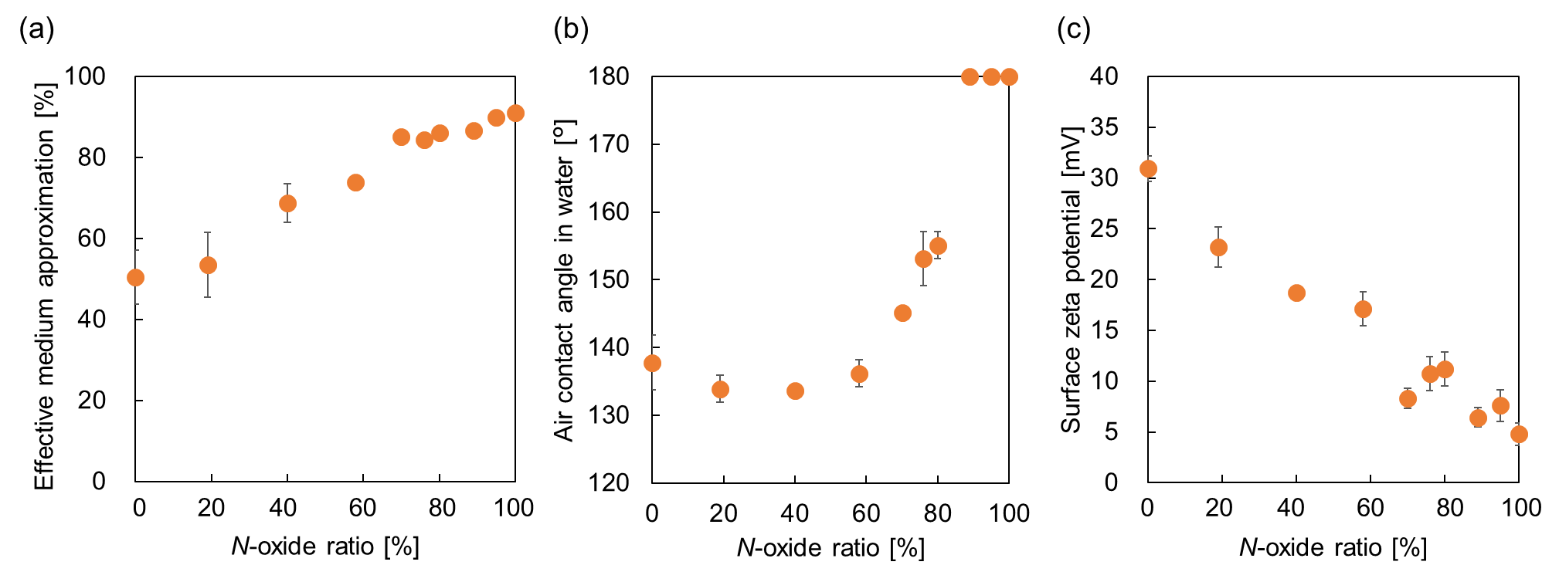
Figure 3 shows N-oxide ratio dependence of EMA, the air contact angle in water, and the surface zeta potential. EMA was estimated from the optical properties obtained using spectroscopic ellipsometry. This approximation was useful for estimating the swelling ratio. [47] The EMA value increased with increasing hydrophilicity, owing to the zwitterionic N-oxide ratio (Figure 3(a)). The hydrophilicity of the copolymer-coated TCPS dishes was evaluated by measuring the static contact angles of sessile air bubbles in water. The hydrophilicity increased with N-oxide ratio above 58% dramatically, and At N-oxide ratio above 89%, no bubbles adhered to the surface and the air contact angle was 180° (Figure 3(b)). Thus, the surface enrichment with N-oxide units resulted in a superhydrophilic surface. The zeta potential of BMA-DM was 30.9 ± 1.2 mV, indicating that the diblock copolymer-coated surface is positively charged because of the DMAEMA moiety. The zeta potential varied almost linearly with the N-oxide ratio and was shown to be almost neutral at 4.8 mV when the N-oxide ratio was 100% (Figure 3(c)).

Figure 3. N-oxide ratio dependence on the effective medium approximation (a), air contact angle in water (b), and surface zeta potential (c) of diblock copolymer-coated surfaces which are depicted from Table 1.

3-3. Topographic and mechanical properties
AFM images were obtained to evaluate the topographic and mechanical properties of the diblock copolymer-coated surfaces in water. As shown in Figure 4, the number of protrusions increased as the N-oxide ratio increased. It is well known that block copolymers in thin films minimize the free energy by exposing the block with the lowest interfacial energy to the surface. [48] With sufficient mobility for each component of the polymer block, surface reorganization occurs when the environment changes from air to water. Because the polymers in this study consisted of BMA with a low T_{g}, it is considered that surface reorganization occurred because of the sufficient mobility of the polymers. Roughness is discussed using Ra, which refers to the arithmetic mean roughness. Ra is the average of all the protrusions in the profile. The roughness of the diblock copolymer-coated surfaces was measured in distilled water and the samples were maintained under these conditions for > 60 min before observation. The Ra values of BMA-DM, BMA-NOx19, BMA-NOx40, and BMA-NOx58 in water were1.68, 2.20, 3.88, and 4.69 nm, respectively. The Ra of BMA-DM was the lowest and increased with increasing N-oxide ratio; the Ra reached plateau at an N-oxide ratio of 58% or higher. This behavior was similar to the change in EMA, as shown in Figure 3(a), suggesting that when the denaturation ratio was above 58%, the hydrophilic segments were fully oriented to the surface because of the high water content.
To verify the mechanical properties of N-oxide containing surfaces, the force-displacement curves of BMA-DM, BMA-NOx19, BMA-NOx40, BMA-NOx58, BMA-NOx70, BMA-NOx76, and BMA-NOx100 in water were measured. As shown in Figure 5, the force-displacement curves show how the polymer chains were compressed and stretched as the colloidal probe approached and retracted from the surface. In the BMA-DM, adhesive interactions appeared during approach and retraction. This was due to the fact that the material of the probe is negatively charged diamond-like carbon, which causes electrostatic interaction with the DM segment, which is strongly positively charged, resulting in high adhesive force. And then, adhesion force (F) was estimated and the free energy of adhesion (W) was calculated by Johnson–Kendal–Roberts theory, where W = 2F/3πR for soft deformable surfaces. [49] As shown in Table S3 in the Supporting Information, adhesion force decreased significantly from DM to BMA-NOx19, and remarkably there was no adhesion at all on polymer surfaces with N-oxide ratios of 40% or higher. The results indicated that the N-oxide containing surface had stronger repulsion and lower adhesion to the probe, resulting in a smaller hysteresis loop. Considering that surfaces with zwitterionic structures exhibit antifouling properties [44], we estimated that as the N-oxide ratio increased, the adhesive interactions decreased to zero. From the results of AFM measurements in water, it was revealed that topographical and viscoelastic properties changed significantly for N-oxide ratios of 40% or lower, whereas the changes were limited for N-oxide ratios of 40% or higher.

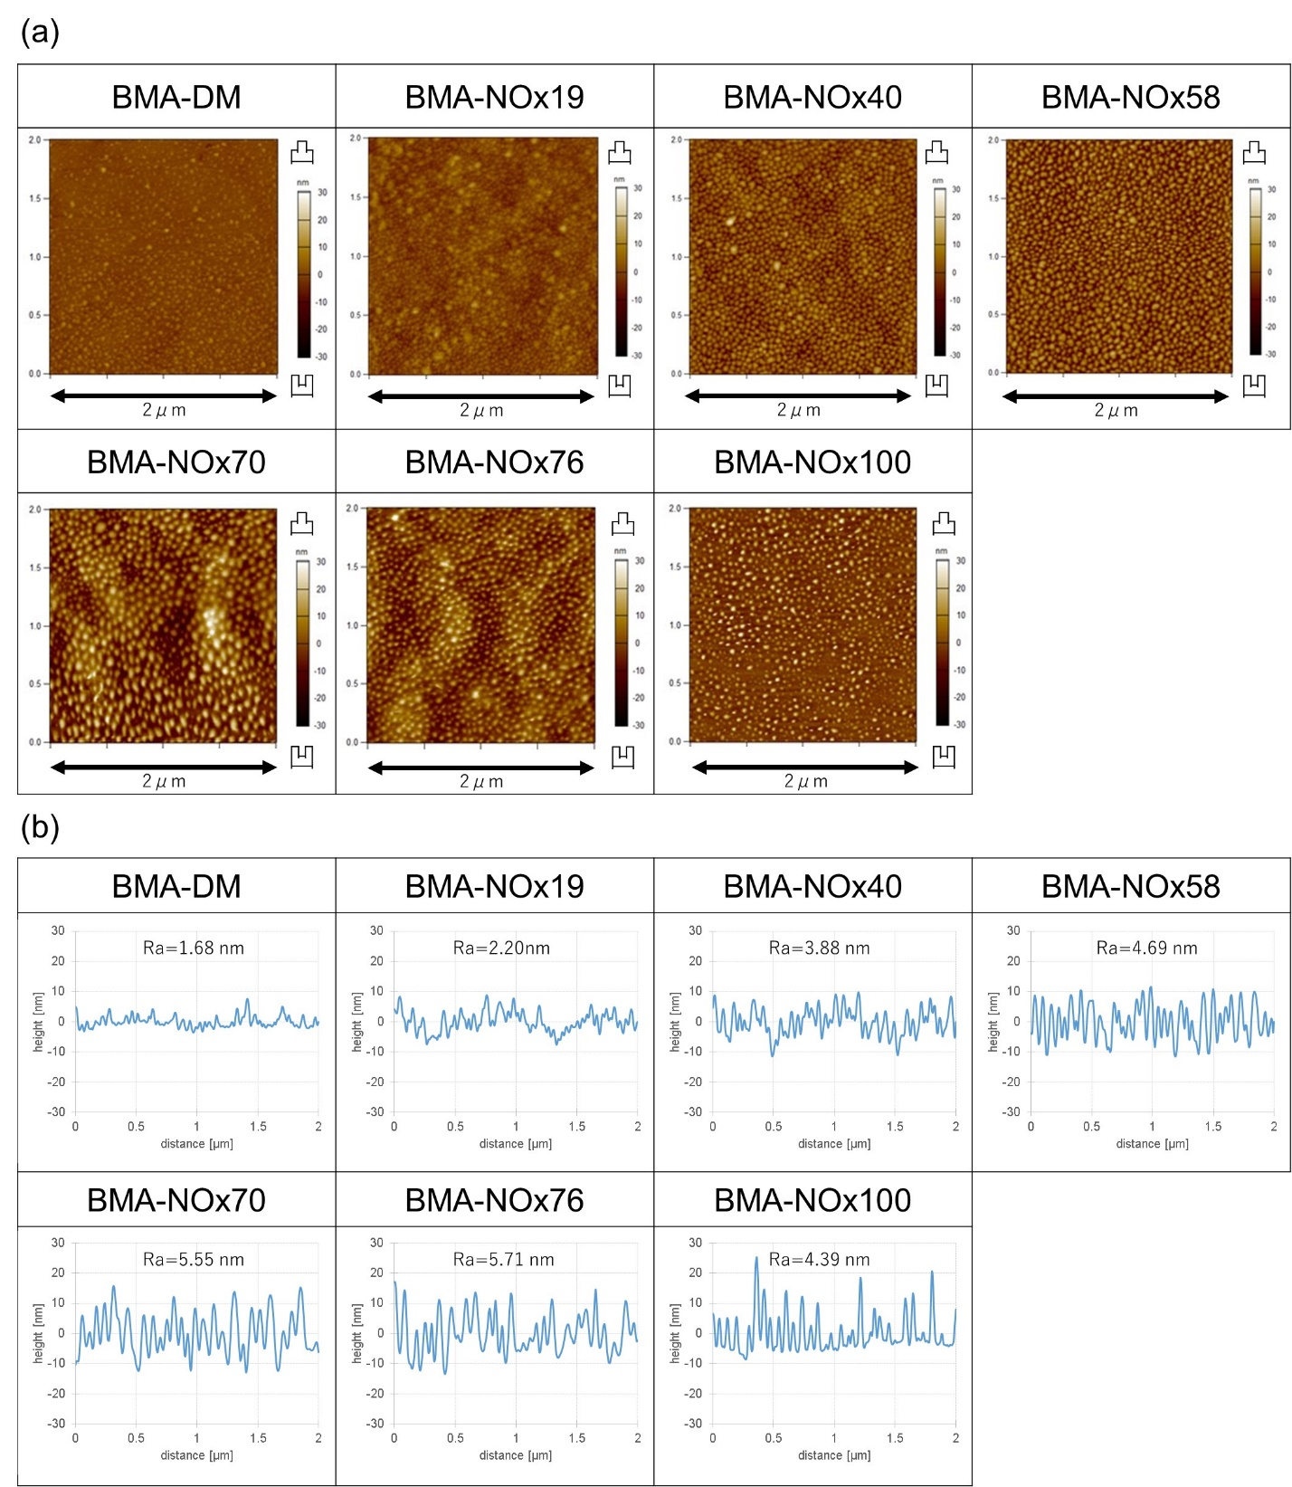
Figure 4. AFM topographic images (a) and the corresponding cross-sectional profile (b) of diblcok copolymer-coated surfaces in water obtained using a colloidal probe cantilever with a tip radius of 8 nm. Ra is the mean roughness and represents the average of all protrusions in the profile.
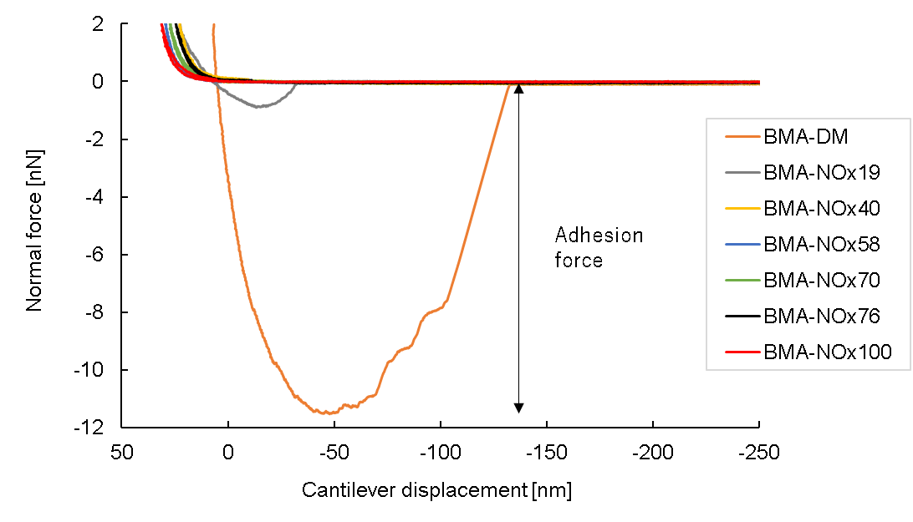
Figure 5. Force-displacement curves recorded with a high-density spherical carbon tip on diblock copolymer-coated surfaces in water using a colloidal probe cantilever with a tip radius of 500 nm. The force-distance curves were recorded at cantilever velocity, 150 nm/s; and trigger point, 2.00 nN.

3-4. Structural analysis of interfacial water by SFG spectroscopy
SFG measurements were also performed to focus on the structure of the interfacial hydration water as it has been demonstrated that strong surface hydration plays an important role in determining the excellent antifouling properties of zwitterionic polymers. [18, 44] This strong surface hydration is caused by the strong interaction between surface charges and water molecules at the zwitterionic polymer surface, resulting in an ordered and strongly hydrogen-bonded water layer on the polymer surface. This hydration creates an elevated physical and energy barrier that prevents pollutants from adhering to the surface.
Figure 6 shows the SFG spectra in the OH stretching region (2800–3800 cm^{–1}) at the interface between each diblock copolymer-coated surface and isotopically diluted water (HOD). In these spectra, only one broad peak was observed, because intermolecular and/or intramolecular coupling was eliminated using isotopically diluted water, which allowed for a more precise investigation of interfacial water than pure water. [50] In this study, we focused on the interface between the diblock copolymer-coated surface and the water molecules. Therefore, we interpreted the peak center position of the OH stretching vibration as an interaction between the interfacial water molecules and the diblock copolymer-coated surface. The peak center positions at low wavenumbers indicate strong interactions between the interfacial water molecules and diblock copolymers. The different peak positions indicate the strength of the interaction between the interfacial water molecules and diblock copolymers. It has been previously shown that zwitterionic polymer brushes have low peak center positions and strongly interact with water molecules. [44] The interaction between prism and water has already been investigated by SFG in a previous study [51], and a peak at 3200–3300 cm⁻¹ was observed as well. Next, a peak was observed at approximately 3480 cm⁻¹ in BMA-DM. This peak was also observed on surfaces with N-oxide ratios at 19–80% and also agreed with the peak position of poly(DMAEMA-r-BMA). [52] The peak center wavenumber changed drastically at N-oxide ratios of 80–89% (Figure 6(b)). This suggests that the hydration structure of the interfacial water changed significantly between BMA-NOx80 and BMA-NOx89. As described in contact angle measurements in water, the diblock copolymer-coated surfaces with N-oxide ratios of ≥89% were super hydrophilic (no bubbles adhered to them in contact angle measurements under water). Figure 6(c) shows the 3230/3480 cm⁻¹ SFG intensity ratio plotted against the N-oxide ratio. Here, 3230 and 3480 cm⁻¹ were selected because a peak of strongly hydrogen-bonded water derived from zwitterions was observed near 3230 cm⁻¹ in Ref 44 and a peak of weakly hydrogen-bonded water derived from DMAEMA was observed near 3480 cm⁻¹ in Ref 52. The peak at 3230 cm⁻¹/3480 cm⁻¹ gradually increased with respect to the N-oxide ratio, indicating that N-oxide residues gradually appeared on the surface, and the relative amount of strongly hydrogen-bonded water molecules increased. The SFG results suggest that this was because the interfacial water is constructed with strong hydrogen bonding water.

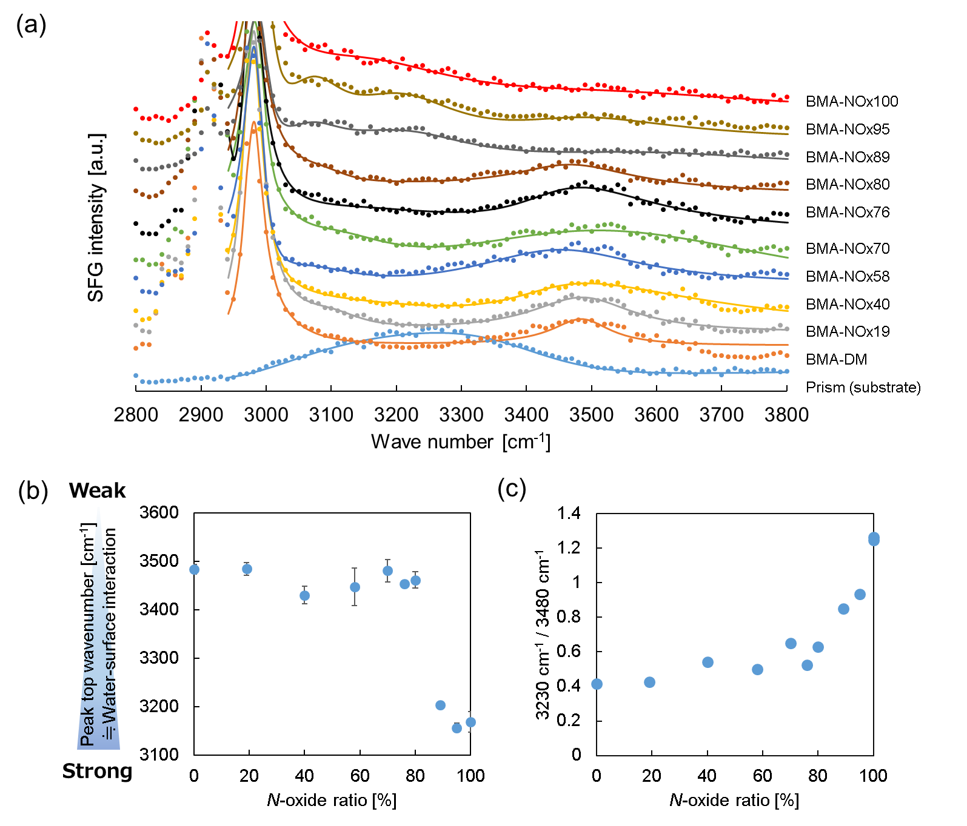
Figure 6. SFG spectra in the OH stretching region at the interface between each diblock copolymer-coated surface and isotopically diluted water (H₂O/D₂O = 1/4 (v/v)). Dot, experimental data; line, fitting results. (a) N-oxide ratio dependence of the peak center wavenumber of the fitting results. (b) N-oxide ratio dependence of the intensity ratio of the SFG signal at 3230 to the intensity at 3480 cm⁻¹. (c)
3-5. Protein adsorption behavior
To analyze the amount of protein adsorbed on each N-oxide containing diblock copolymer, QCM-D was performed. the Δf and ΔD values were monitored during the adsorption process. Three representative proteins–Alb, Fng, and Lyz–were used in this study. In PBS, Alb ( pI: 4.7) [53] and Fng (pI: 5.5) [54] are negatively charged, whereas Lyz (pI: 11.4) [55] is positively charged. Moreover, 10% FBS containing DMEM medium was used to estimate the amount of protein adsorbed during the cell culture because cell adhesion is influenced by the proteins adsorbed from the medium. [56] The time-course profiles of the QCM-D measurements are shown in Figure S7. The amount of protein adsorbed, calculated using the Sauerbrey equation, is summarized in Figure 7. The adsorption of Lyz onto the BMA-DM surface was suppressed; however, large amounts of Alb and Fng were adsorbed. This indicates that protein adsorption is promoted by electrostatic interactions when the polymer surface and the protein are oppositely charged. The adsorption of Alb, Fng, and 10% FBS-containing media decreased with N-oxide ratios, with protein adsorption below 100 ng/cm² at N-oxide ratios of 76% or higher.
As the thickness of the obtained polymer coatings was similarly controlled to the same degree as approximately 20 nm, thus the changes in protein adsorption were not expected to be due to the thickness of the polymer coating. In addition, because there were no significant differences in the surface mechanical and topographic properties, this effect was attributed to the increased ratio of hydrophilic and electrically neutral N-oxide structures. In the case of the zwitterionization of polymer brushes with tertiary amino groups, the reaction proceeds preferentially from the top surface. [57,58] In this study, polymers with randomly N-oxidized tertiary amino groups were synthesized beforehand before coating, allowing a precise discussion of the N-oxide dependence of protein adsorption, and which was found that protein adsorption could be significantly suppressed at an N-oxide ratio of 76%.
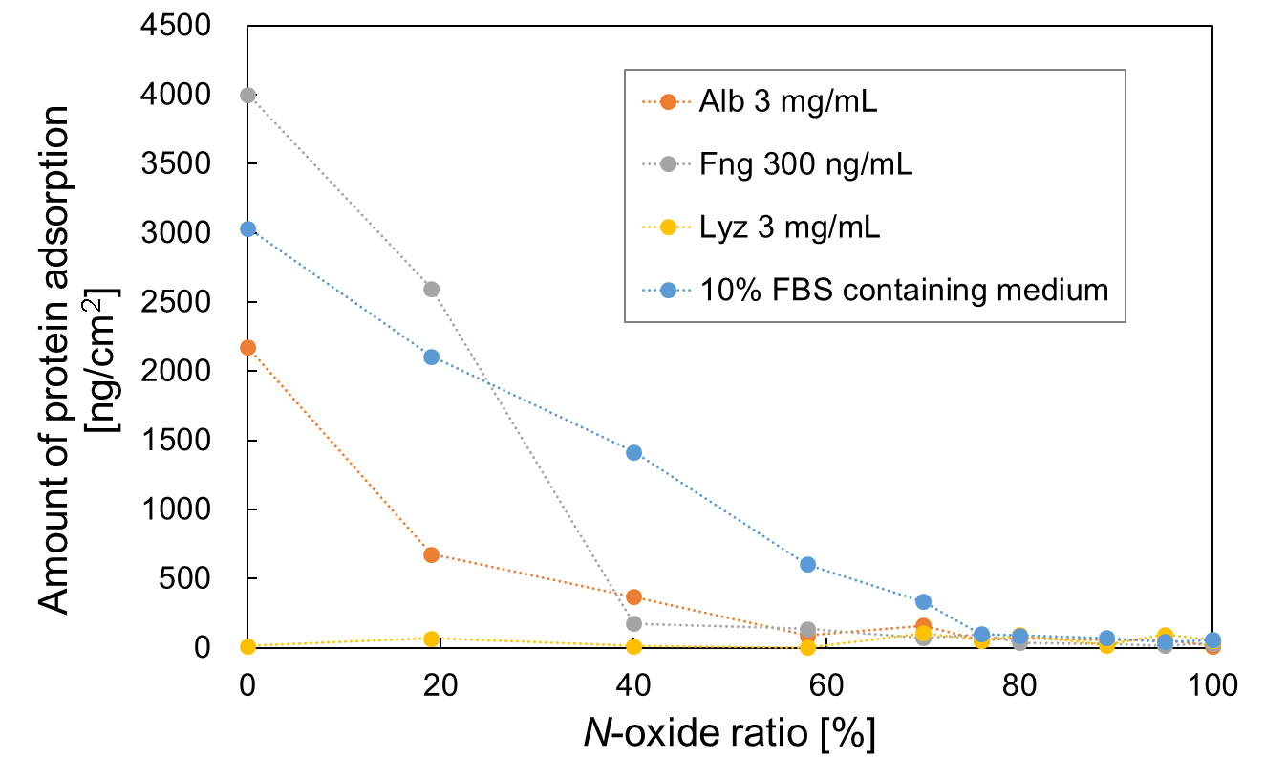
Figure 7. Adsorbed amount of Alb, Lyz, Fng, and 10% FBS-containing medium on each diblock copolymer-coated surface

3-6. Cell adhesion properties and gene expression behavior
To examine the interaction between the cells and diblock copolymer-coated surfaces in detail, hUC-MSCs were cultured in polymer-coated U-shaped bottom 96-well plates (Figure 8). Here, hUC-MSCs were selected for potential applications in regenerative medicine because universalized UC-MSCs are considered convenient in various respects, including ready-to-use availability, no requirement for cell banks, reduced production costs, and increased value as carriers. By using U-shaped bottom wells, when cells do not interact with the polymer, cells aggregate at the bottom of the U-shaped bottom wells due to gravity and form spheroids, whereas when cells interact with the polymer, cells adhere and proliferate in situ.[59] Phase-contrast images of hUC-MSCs cultured at 2,000 cells/well on 96-well U-bottom plates coated with each diblock copolymer 1 d after seeding are shown in Figure 8, and time-lapse microscopy videos for 4 d are shown in Videos S1–S10. For BMA-DM and BMA-NOx19, 2D proliferation of cells was observed; for BMA-NOx40 and 58, cells were kept in situ and appeared to be divided; for BMA-NOx70, cells were observed to aggregate to the bottom due to gravity, and numerous spheroids with a diameter of 50–100 μm were observed after 1 d. For BMA-NOx 76, 80, 89, 95, and 100, single spheroids were formed within 8 h of cell seeding because of the cell non-adhesiveness. It has been reported that there is a correlation between the amount of protein adsorbed onto 10% FBS medium and cell adhesion [59], and the results of this study support this hypothesis. NIH3T3-3-4 and HepG2 cells showed similar cell adhesion (Figures S8 and S9). These results strongly suggest that N-oxide ratio affects cell adhesion and controls the rate of spheroid formation by altering the amount of protein adsorbed.

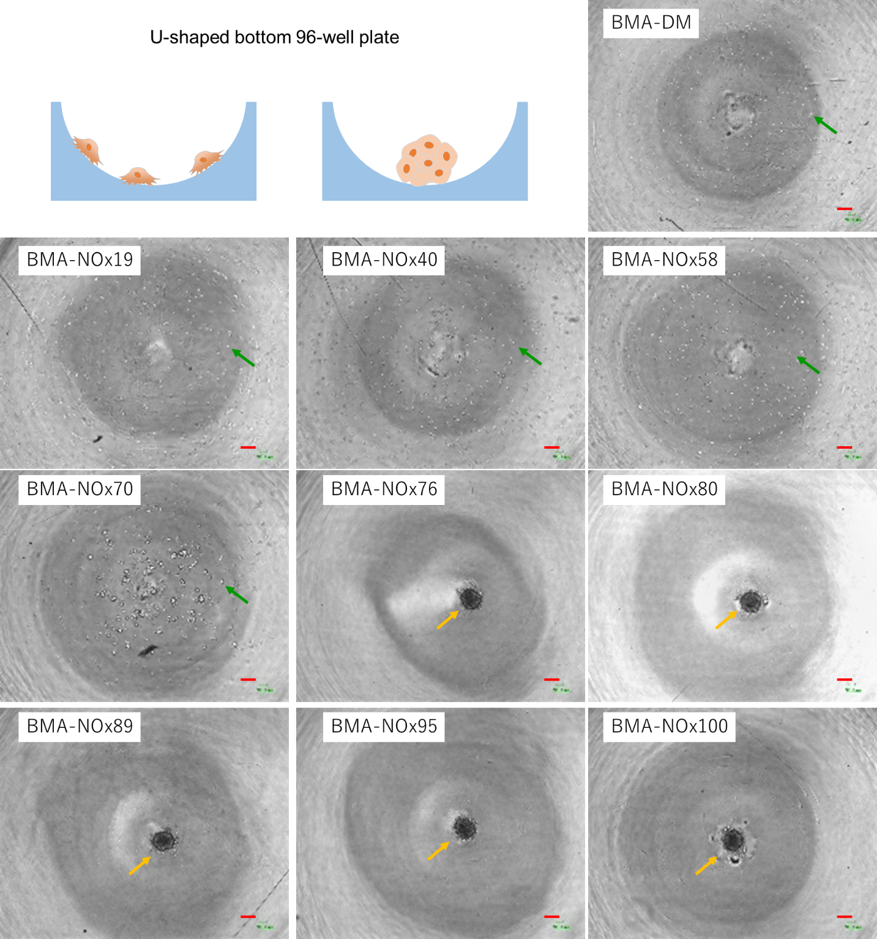
Figure 8. Phase-contrast images of hUC-MSCs cultured at 2,000 cells/well in a 96-well U-bottom plate coated with each diblock copolymer. Images were captured 1 d after cell seeding. Scale bar, 200 μm. The green arrow indicates single cell, the yellow arrow indicates cell spheroid. Time-lapse microscopy videos for 4 d are shown in Videos S1–S10.

We used a spin-coated TCPS dish with N-oxide containing diblock copolymers to investigate the interaction between the polymer and hUC-MSCs. (Figure 9) Because the effect of gravity was ignored in this experiment, the process of spheroid formation could be discussed in more depth. Therefore, it is possible to discuss how cells initially encounter the polymer surface, migrate over it, and aggregate to form spheroids. Histograms of spheroid size on day 4 of hUC-MSC culture are shown in Figure 10. The “Analyze Particles” tool in the analysis toolbar of ImageJ was used to count and calculate the area occupancy of selected spheroids of various sizes in the thresholding image. Figure 10 shows that when the N-oxide ratio was >76%, cells could no longer adhere to the diblock copolymer-coated surface and the cells gathered to form large aggregates. When the N-oxide ratio was ranged 40–70%, the cells could not fully adhere to the surface, and a moderate-sized spheroid was considered to be formed. And then, the WST assay was performed to determine the relative number of viable cells. As shown in Figure S10 in the Supporting Information, when the N-oxide ratio was 40-70%, cells were proliferative slightly. Considering the cell aggregate in Figure 10, over 70% of the N-oxide ratio surface induced large-sized cell-spheroid because of non-cell adhesiveness, and small-sized spheroids were formed on the surfaces at an N-oxide ratio of 40-70%. Fibroblast spheroid formation is mediated by a balance between two competing forces: cell-substrate and cell-cell interactions. [60] When cell–substrate interactions are sufficiently strong compared to cell–cell interactions, the cells would stably attach and spread on the substrate. In contrast, when cell–cell interactions exceed cell–substrate interactions, the cells would aggregate into spheroids. [61,62] Considering these facts, it was strongly suggested that in the case of N-oxide containing diblock copolymers, the cell adhesion changes dramatically between 70% and 76% N-oxide ratios.
Next, qRT-PCR was performed to determine the expression levels of stem cell markers in monolayer-cultured cells on TCPS, spheroid-forming cells on diblock copolymer-coated surfaces, and ultra-low-attachment (ULA) surface (Figure 11), because it has been reported that 3D spheroid culture may improve the properties of MSCs. [63] As the ULA surface, a multi-block copolymer, which is composed of poly(2-methoxyethyl acrylate) and polyethylene glycol (PEG) with a PEG feed amount of 10 wt%, named PEG-M10, was used. [59] The reason to use the multi-block copolymer, PEG-M10, is available for spheroid formation, and that was almost the same behavior on the Ultra Low Attachment (ULA) surface of PrimeSurface®️ (Sumitomo Bakelite Co., Ltd.) (Figure S11). The qRT-PCR results showed that the relative expression of Oct4, Sox2, and Nanog in spheroids on diblock copolymer-coated surfaces was significantly higher than that in monolayer-cultured cells on TCPS and BMA-DM. It has been reported that mesenchymal stem cells induce differentiation into osteoblasts when the cell density increases and the cells become nearly confluent, [64] thus, it is assumed that the formation of spheroids and the process leading to spheroid formation may contribute to the maintenance or enhancement of undifferentiated markers.
Interestingly, the expression of stem cell markers is enhanced when the cells form spheroids while interacting with their substrates, as in the case of BMA-NOx40, 58, and 70 compared to spheroids obtained on BMA-NOx100 and ULA surfaces. This was predicted to be due to prominent integrin-laminin interactions inside the spheroid, as reported in a previous study [33]. It has also been indicated that the function of spheroids is potentially enhanced by surfaces coated with polymers with modified amine oxide levels instead of the adhesion mechanism originally present in living organisms. However, the results of in vitro studies may not always match those of in vivo experiments, and further studies should be conducted using spheroids with undifferentiated markers to induce adipocyte and osteoblast differentiation.
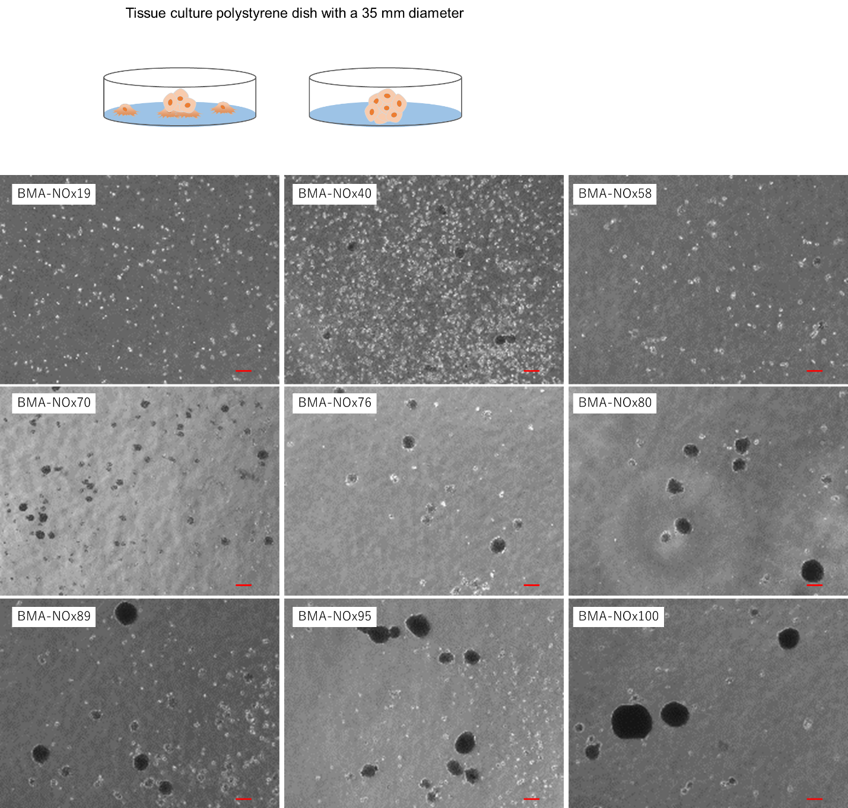
Figure 9. Phase-contrast images of hUC-MSCs cultured at 150,000 cells/well in a 35 mm dish spin-coated with each diblock copolymer. Images were captured 4 d after cell seeding.
Scale bar, 200 μm.
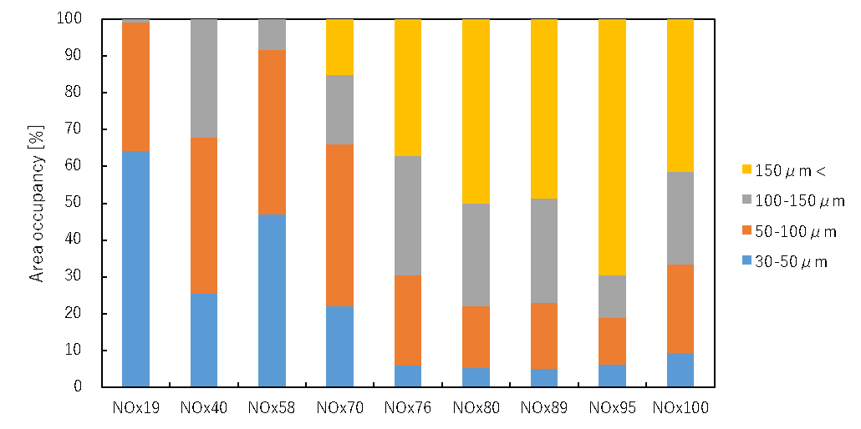

Figure 10. Area occupancy of cell spheroids formed after cultivating for 4 d.
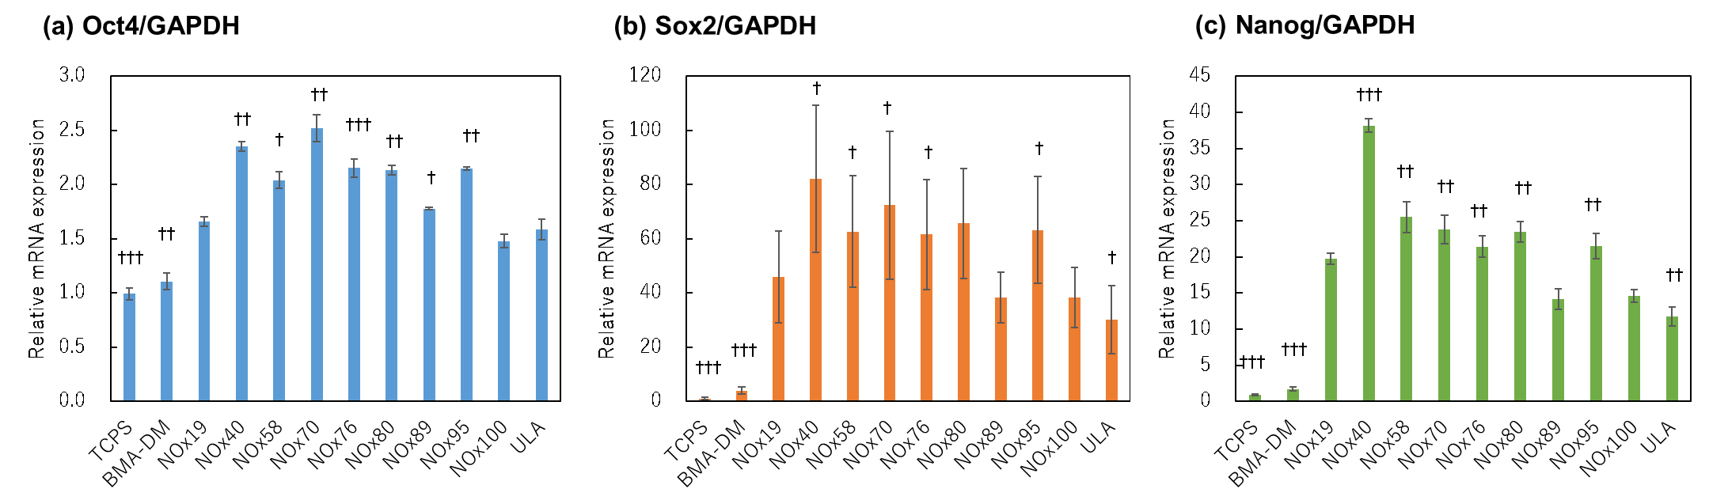
Figure 11. Relative mRNA expression of stem cell markers with respect to Oct4/GAPDH (a), Sox2/GAPDH (b), and Nanog/GAPDH (c) in monolayer-cultured cells on TCPS, spheroid-forming cells on the diblock copolymer-coated surface, and ULA surface.
(†p < 0.05, ††p < 0.01, and †††p < 0.001 vs. BMA-NOx100, analyzed via unpaired t-test, n = 3).

The surface properties and interactions with water, proteins, and cells are summarized as functions of N-oxide ratio in Figure 12. By systematically varying the N-oxide ratio, EMA and surface zeta potential of the polymer surface correlated with the amount of protein adsorbed in the 10% FBS containing cell culture medium and contributed to the spheroid formation rate. Although the correlation between the N-oxide ratio and the peak central wavenumber from the SFG measurements was low, it was correlated with 3230/3480cm⁻¹ calculated as an index of the strength of hydrogen bonds in hydration water, suggesting that it may affect cell adhesion along with changes in physicochemical factors, such as wettability and zeta potential. Cell adhesion is controlled by N-oxide ratio, with cell adhesion predominating at low N-oxide ratios and nonadhesion at high N-oxide ratios. Interestingly, to some extent, the N-oxide ratio (40–70%), cells formed cell spheroids while interacting with their substrates, and the expression of stem cell markers was enhanced. The results mentioned that surfaces were adsorbed some proteins from the medium, and then small sized cell spheroids were formed on it moderately. Thus it was seen that higher cellular undifferentiation is the surfaces having protein adsorption moderately rather than not adsorb proteins. Consequently, spheroids formed on the surface where proteins and cells adhere weakly are of higher quality.

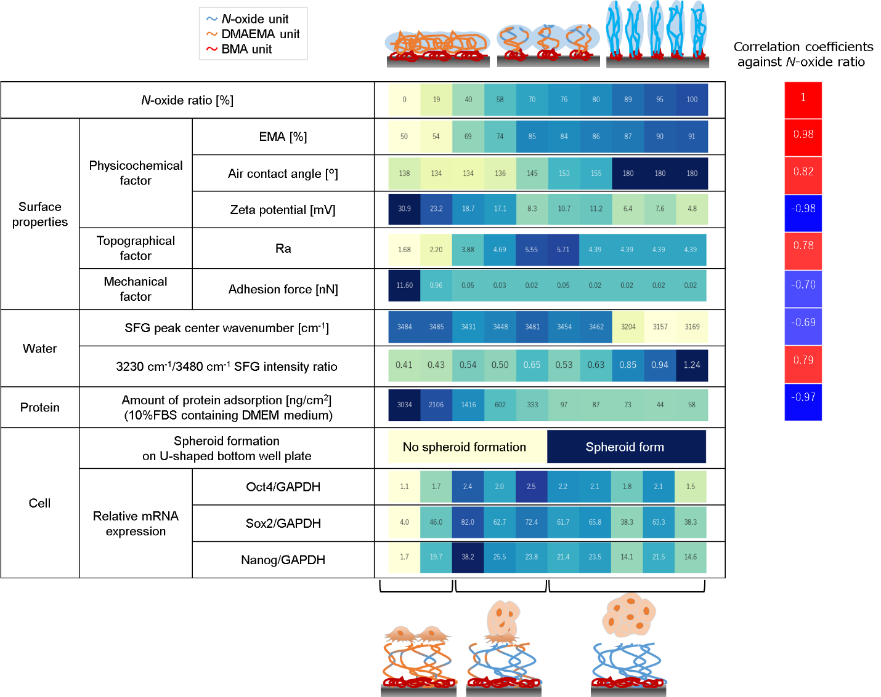
Figure 12. Schematic illustration of the diblock copolymer-coated surface and interaction between surface properties and water, proteins, and cells.

4. CONCLUSIONS
Inspired by the unique behavior of N-oxide as a zwitterionic polymer, molecular weight-controlled diblock copolymers with tertiary side-chain amino groups were designed using the RAFT method, and the N-oxide ratio was varied using hydrogen peroxide. The zwitterionic N-oxide polymers developed in this study are soluble in alcoholic solvents but insoluble in water; thus, a simple coating method for depositing the polymers on the substrate surface could be used to obtain surfaces with different N-oxide ratios. Physicochemical factors, such as wettability, zeta potential, and the strength of hydrogen bonds in hydration water varied with the N-oxide ratio, and surface enrichment by N-oxide units resulted in a super-hydrophilic and electrically neutral surface. Among the series of diblock copolymers, the expression of stem cell markers was enhanced when cells formed spheroids while interacting with their substrates, as in the case of N-oxide ratios ranging 40–70%. Although not all functions of spheroids obtained from diblock copolymer-coated surfaces have been fully elucidated, unique and simple surface coatings with N-oxide-containing diblock copolymers will be a steppingstone for designing new biomaterials for regenerative medicine, tissue engineering, and medical devices.

ASSOCIATED CONTENT
Supporting Information
The Supporting Information is available free of charge at https://xxxxxxx.
Experimental details, including qRT-PCR primer set list, structural analysis of N-oxide containing diblock copolymers, solubility test of zwitterionic polymer, the ATR spectra of each diblock copolymer-coated surface, the XPS spectra of each diblock copolymer-coated surface, adhesion force and free energy of adhesion, protein adsorption test using QCM-D, and cell adhesion behavior on copolymer films at low cell seeding numbers. (PDF)
Time-lapse microscopy video of hUC-MSCs seeded in a 96-well U-bottom plate coated with each diblock copolymer.

Author Contributions
The manuscript was written with contributions from all authors. All authors approved the final version of the manuscript. Experiments were designed and data were analyzed and interpreted by N. Ogiwara, T. Masuda, and M. Takai. Atomic force microscopy was performed by T. Nakano. qRT-PCR was performed by N. Ogiwara and K. Baba. Sum frequency generation spectroscopy measurements were performed by H. Noguchi. The manuscript was prepared by N.Ogiwara, T. Masuda, and M. Takai.

Author Information
Corresponding Author
Madoka Takai − Department of Bioengineering, School of Engineering, The University of Tokyo, Tokyo 113-8656, Japan; orcid.org/0000-0002-6238-6717; Email: takai@bis.t.u-tokyo.ac.jp
Authors
Naoto Ogiwara − Biotech Business Unit, Incubation Center, artience Co., Ltd., Saitama 350-0214, Japan
Takenobu Nakano – Analysis Technology Laboratory, R&D, artience Co., Ltd., Saitama 350-0214, Japan
Koki Baba − Biotech Business Unit, Incubation Center, artience Co., Ltd., Saitama 350-0214, Japan
Hidenori Noguchi − Center for Green Research on Energy and Environmental Materials and Global Research Center for Environment and Energy based on Nanomaterials Science (GREEN), National Institute for Materials Science (NIMS), Ibaraki 305-0044, Japan; orcid.org/0000-0001-9643-1689
Tsukuru Masuda − Department of Bioengineering, School of Engineering, The University of Tokyo, Tokyo 113-8656, Japan; orcid.org/0000-0001-6452-811X

ACKNOWLEDGEMENTS
We thank the Japan Society for the Promotion of Science (JSPS) for providing support through a Grant-in-Aid for Scientific Research (B) (No. 20H02795 to T.M.), and Transformative Research Areas (A) (No. 21H05231 to M.T.). We would like to thank Editage (www.editage.com) for the English language editing.

ABBREVIATIONS
AIBN, 2,2'-azobis(isobutyronitrile); THF, tetrahydrofuran; Alb, bovine serum albumin; Fng, fibrinogen; Lyz, lysozyme; FN, fibronectin; FBS, fatal bovine serum; DMEM, Dulbecco’s modified Eagle medium; PBS, phosphate-buffered saline; QCM, quartz crystal microbalance; QCM-D, quartz crystal microbalance with dissipation monitoring; AFM, atomic force microscopy; SFG, sum frequency generation.

References

[1] Ishikhara, K.; Ziats, N. P.; Tierney, B. P.; Nakabayashi, N.; Anderson. J. M. Protein adsorption from human plasma is reduced on phospholipid polymers. J. Biomed. Mater. Res. 1991, 25, 1397-1407. DOI: 10.1002/jbm.820251107.
[2] Ishihara, K.; Goto, Y.; Takai, M.; Matsuno, R.; Inoue, Y.; Konno, T. Novel polymer biomaterials and interfaces inspired from cell membrane functions. Biochimica et Biophysica Acta (BBA) - General Subjects, 2011, 1810, 268-275. DOI: 10.1016/j.bbagen.2010.04.008.
[3] Mallik, S.; Prasad, R.; Bhattacharya, A.; Sen, P. Synthesis of Phosphatidylserine and Its Stereoisomers: Their Role in Activation of Blood Coagulation. ACS Med. Chem. Lett.. 2018, 9, 434– 439, DOI: 10.1021/acsmedchemlett.8b00008.
[4] Wang, R.; Xiao, R.; Zeng, Z.; Xu, L.; Wang, J. Application of poly(ethylene glycol)–distearoylphosphatidylethanolamine (PEG-DSPE) block copolymers and their derivatives as nanomaterials in drug delivery. International Journal of Nanomedicine, 2012, 7, 4185–4198. DOI: 10.2147/IJN.S34489.
[5] Lowe, A. B.; Vamvakaki, M.; Wassall, M. A.; Wong, L.; Billingham, N. C.; Armes, S. P.; Lloyd, A. W. Well-defined sulfobetaine-based statistical copolymers as potential antibioadherent coatings. J Biomed. Mater Res. 2000, 52, 88-94. DOI: 10.1002/1097-4636(200010)52:1<88::AID-JBM11>3.0.CO;2-%23.
[6] Villa-Diaz, L., Nandivada, H., Ding, J. et al. Synthetic polymer coatings for long-term growth of human embryonic stem cells. Nat Biotechnol. 2010, 28, 581–583. DOI: 10.1038/nbt.1631.
[7] Zhang, Z.; Chao, T.; Chen, S.; Jiang, S. Superlow Fouling Sulfobetaine and Carboxybetaine Polymers on Glass Slides. Langmuir 2006 22 (24), 10072-10077. DOI: 10.1021/la062175d.
[8] Cao, B.; Tang, Q.; Cheng, G. Recent advances of zwitterionic carboxybetaine materials and their derivatives. Journal of Biomaterials Science, Polymer Edition, 2014, 25:14-15, 1502-1513. DOI: 10.1080/09205063.2014.927300.
[9] Zhang, Z.; Vaisocherová, H.; Cheng, G.; Yang, W.; Xue, H.; Jiang, S. Nonfouling Behavior of Polycarboxybetaine-Grafted Surfaces: Structural and Environmental Effects. Biomacromolecules 2008, 9 (10), 2686-2692. DOI: 10.1021/bm800407r.
[10] Wang, Y.; Shen, J.; Yuan, J. Design of hemocompatible and antifouling PET sheets with synergistic zwitterionic surfaces. Journal of Colloid and Interface Science 2016,
480, 205-217. DOI: 10.1016/j.jcis.2016.07.022.
[11] Feng, W.; Brash, J. L.; Zhu, S. Non-biofouling materials prepared by atom transfer radical polymerization grafting of 2-methacryloloxyethyl phosphorylcholine: Separate effects of graft density and chain length on protein repulsion. Biomaterials, 2006, 27 (6), 847-855. DOI: 10.1016/j.biomaterials.2005.07.006.
[12] Chen, Z.; Surface Hydration and Antifouling Activity of Zwitterionic Polymers. Langmuir 2022, 38 (15), 4483-4489. DOI: 10.1021/acs.langmuir.2c00512.
[13] Li, B.; Jain, P.; Ma, J.; Smith, J. K.; Yuan, Z.; Hung, H.-C.; He, Y.; Lin, X.; Wu, K.; Pfaendtner, J.; Jiang, S. Trimethylamine N-oxide–derived zwitterionic polymers: A new class of ultralow fouling bioinspired materials. Sci. Adv. 2019, 5, eaaw9562. DOI: 10.1126/sciadv.aaw9562.
[14] Anjum, R.; Nishimura, S.; Kobayashi, S.; Nishida, K.; Anada, T.; Tanaka, M. Protein Stabilization Effect of Zwitterionic Osmolyte-bearing Polymer. Chemistry Letters, 2021, 50, 1699–1702, DOI: 10.1246/cl.210335.
[15] Chen, S.; Zhong, Y.; Fan, W.; Xiang, J.; Wang, G.; Zhou, Q.; Wang, J.; Geng, Y.; Sun, R.; Zhang; Z.; Piao, Y.; Wang, J.; Zhuo, J.; Cong, H.; Jiang, H.; Ling, J.; Li, Z.; Yang, D.; Yao, X.; Xu, X.; Zhou, Z.; Tang, J.; Shen, Y. Enhanced tumour penetration and prolonged circulation in blood of polyzwitterion–drug conjugates with cell-membrane affinity. Nat Biomed Eng. 2021, 5, 1019–1037. DOI: 10.1038/s41551-021-00701-4.
[16] Gao, Z.; Li, Y.; Zhang, Y.; An, P.; Chen, F.; Chen, J.; You, C.; Wang, Z.; Sun, B. A CD44-targeted Cu(II) delivery 2D nanoplatform for sensitized disulfiram chemotherapy to triple-negative breast cancer. Nanoscale 2020, 12, 8139-8146. DOI: 10.1039/D0NR00434K.
[17] Zhang, L.; Sun, J.; Huang, W.; Zhang, S.; Deng, X.; Gao, W. Hypoxia-Triggered Bioreduction of Poly(N-oxide)–Drug Conjugates Enhances Tumor Penetration and Antitumor Efficacy. Journal of the American Chemical Society 2023, 145 (3), 1707-1713. DOI: 10.1021/jacs.2c10188.
[18] Huang, H.; Zhang, C.; Crisci, R.; Lu, T.; Hung, H-C.; Sajib, M. S. J.; Sarker, P.; Ma, J.; Wei, T.; Jiang, S.; Chen, Z. Strong Surface Hydration and Salt Resistant Mechanism of a New Nonfouling Zwitterionic Polymer Based on Protein Stabilizer TMAO. Journal of the American Chemical Society 2021, 143 (40), 16786-16795. DOI: 10.1021/jacs.1c08280.
[19] Burmeister, N.; Zorn, E.; Farooq, A.; Preuss, L.; Vollstedt, C.; Friedrich, T.; Mantel, T.; Scharnagl, N.; Rohnke, M.; Ernst, M.; Wicha, S. G.; Streit, W. R.; Maison, W. Surface Grafted N-Oxides have Low-Fouling and Antibacterial Properties. Adv. Mater. Interfaces 2023, 2300505. DOI: 10.1002/admi.202300505.
[20] Foglietta, F.; Canaparo, R.; Muccioli, G.; Terreno, E.; Serpe, L.; Methodological aspects and pharmacological applications of three-dimensional cancer cell cultures and organoids. Life Sciences, 2020, 254, 117784. DOI: 10.1016/j.lfs.2020.117784.
[21] S. Gunti, A. T. K. Hoke, K. P. Vu, and N. R. London, Jr., Cancers 2021, 13, 874.
Gunti, S.; Hoke, A.T.K.; Vu, K.P.; London, N.R., Jr. Organoid and Spheroid Tumor Models: Techniques and Applications. Cancers 2021, 13, 874. DOI: 10.3390/cancers13040874.
[22] Patel, M.; Vernon, B.; Jeong, B. Low-Molecular-Weight PEGs for Cryopreservation of Stem Cell Spheroids. Biomater Res. 2024, 6 (28), 0037. DOI: 10.34133/bmr.0037.
[23] Bhang, S. H.; Lee, S.; Shin, J-Y.; Lee, T-J.; Kim, B-S. Transplantation of Cord Blood Mesenchymal Stem Cells as Spheroids Enhances Vascularization. Tissue Engineering Part A 2012, 18, 2138-2147. DOI: 10.1089/ten.tea.2011.0640.
[24] Bhang, S. H.; Cho, S-W.; La, W-G.; Lee, T-J.; Yang, H. S.; Sun, A-Y.; Baek, S-H.; Rhie, J-W.; Kim, B-S. Angiogenesis in ischemic tissue produced by spheroid grafting of human adipose-derived stromal cells, Biomaterials 2011, 32, 2734-2747. DOI: 10.1016/j.biomaterials.2010.12.035.
[25] Kim, M.; Yun, H-W.; Park, D. Y.; Choi, B. H.; Min, B-H. Three-Dimensional Spheroid Culture Increases Exosome Secretion from Mesenchymal Stem Cells. Tissue Eng Regen Med 2018, 15, 427–436. DOI: 10.1007/s13770-018-0139-5.
[26] Franko, A. J.; Sutherl, R. M. Radiation Survival of Cells from Spheroids Grown in Different Oxygen Concentrations. Radiat. Res. 1979, 79,439 –467. DOI: 10.2307/3575174.
[27] Jiang, B. H.; Semenza, G. L.; Bauer, C.; Marti, H. H. Hypoxia-inducible factor 1 levels vary exponentially over a physiologically relevant range of O₂ tension. American Journal of Physiology-Cell Physiology 1996, 271:4, C1172-C1180. DOI: 10.1152/ajpcell.1996.271.4.C1172.
[28] Cho, Y.; Yu, S. J.; Kim, J.; Ko, U. H.; Park, E. Y.; Choung, J. S.; Choi, G.; Kim, D.; Lee, E.; Im, S. G.; Shin, J. H. Remodeling of Adhesion Network within Cancer Spheroids via Cell–Polymer Interaction. ACS Biomaterials Science & Engineering 2020, 6 (10), 5632-5644. DOI: 10.1021/acsbiomaterials.0c009.
[29] Yu, S. J.; Choi, G.; Cho, Y.; Lee, M.; Cho, Y.; Shin, J. H.; Lee, E.; Im. S. G. Three-Dimensional Spheroid Culture on Polymer-Coated Surface Potentiate Stem Cell Functions via Enhanced Cell–Extracellular Matrix Interactions. ACS Biomaterials Science & Engineering 2020, 6 (4), 2240-2250. DOI: 10.1021/acsbiomaterials.9b01738.
[30] Li, X.; Li, N.; Chen, K.; Nagasawa, S.; Yoshizawa, M.; Kagami, H. Around 90° Contact Angle of Dish Surface Is a Key Factor in Achieving Spontaneous Spheroid Formation. Tissue Engineering Part C: Methods 2018, 24:10, 578-584. DOI: 10.1089/ten.tec.2018.0188
[31] Li, N.; Dai, X.; Yang, F.; Sun, Y.; Wu, X.; Zhou, Q.; Chen, K.; Sun, J.; Bi, W.; Shi, L.; Yu, Y. Spontaneous spheroids from alveolar bone-derived mesenchymal stromal cells maintain pluripotency of stem cells by regulating hypoxia-inducible factors. Biol Res 2023, 56, 17. DOI: 10.1186/s40659-023-00421-w.
[32] Lin, W-H.; Lin, C-Y.; Tsai, C-C.; Yu, J.; Tsai, W-B. Spheroid Formation of Human Adipose-Derived Stem Cells on Environmentally Friendly BMA/SBMA/HEMA Copolymer-Coated Anti-Adhesive Surface. Bulletin of the Chemical Society of Japan, 2018, 91, 9, 1457-1464. DOI: 10.1246/bcsj.20180100.
[33] Cho, Y.; Yu, S. J.; Kim, J.; Ko, U. H.; Park, E. Y.; Choung, J. S.; Choi, G.; Kim, D.; Lee, E.; Im, S. G.; Shin, J. H. Remodeling of Adhesion Network within Cancer Spheroids via Cell–Polymer Interaction. ACS Biomaterials Science & Engineering 2020, 6(10), 5632-5644. DOI: 10.1021/acsbiomaterials.0c00977.
[34] Yu, S. J.; Choi, G.; Cho, Y.; Lee, M.; Cho, Y.; Shin, J. H.; Lee, E.; Im, S. G. Three-Dimensional Spheroid Culture on Polymer-Coated Surface Potentiate Stem Cell Functions via Enhanced Cell–Extracellular Matrix Interactions. ACS Biomaterials Science & Engineering 2020, 6 (4), 2240-2250. DOI: 10.1021/acsbiomaterials.9b01738.
[35] Luo, L.; Zhang, W.; Wang, J.; Zhao, M.; Shen, K.; Jia, Y.; Li, Y.; Zhang, J.; Cai, W.; Xiao, D.; Bai, X.; Liu, K.; Wang, K.; Zhang, Y.; Zhu, H.; Zhou, Q.; Hu, D. A Novel 3D Culture Model of Human ASCs Reduces Cell Death in Spheroid Cores and Maintains Inner Cell Proliferation Compared With a Nonadherent 3D Culture. Front. Cell Dev. Biol. 2021, 9, 737275. DOI: 10.3389/fcell.2021.737275.
[36] Kim, S.; Kim, E. M.; Yamamoto, M.; Park, H.; Shin, H. Engineering Multi-Cellular Spheroids for Tissue Engineering and Regenerative Medicine. Adv. Healthcare Mater. 2020, 9, 2000608. DOI: 10.1002/adhm.202000608.
[37] Ishihara, K.; Mitera, K.; Inoue, Y.; Fukazawa, K. Effects of molecular interactions at various polymer brush surfaces on fibronectin adsorption induced cell adhesion. Colloids and Surfaces B: Biointerfaces, 2020, 194, 111205, DOI: 10.1016/j.colsurfb.2020.111205.
[38] Xu, Y.; Takai, M.; Kazuhiko Ishihara, K. Protein adsorption and cell adhesion on cationic, neutral, and anionic 2-methacryloyloxyethyl phosphorylcholine copolymer surfaces, Biomaterials 2009, 30, 4930-4938. DOI: 10.1016/j.biomaterials.2009.06.005.
[39] Nakayama, M.; Yamada, N.; Kumashiro, Y.; Kanazawa, H.; Yamato, M.; Okano, T. Thermoresponsive Poly(N-isopropylacrylamide)-Based Block Copolymer Coating for Optimizing Cell Sheet Fabrication. Macromol. Biosci., 2012, 12, 751-760. DOI: 10.1002/mabi.201200018.
[40] Amiji, M.; Kinam Park, K. Prevention of protein adsorption and platelet adhesion on surfaces by PEO/PPO/PEO triblock copolymers. Biomaterials 1992, 13(10), 682-692. DOI: 10.1016/0142-9612(92)90128-B.
[41] Sawada, S.; Sakaki, S.; Iwasaki, Y.; Nakabayashi, N.; Ishihara, K. Suppression of the inflammatory response from adherent cells on phospholipid polymers. J. Biomed. Mater. Res., 2003, 64A: 411-416. DOI: 10.1002/jbm.a.10433.
[42] Chen, J-K.; Bai, B-J. pH-Switchable Optical Properties of the One-Dimensional Periodic Grating of Tethered Poly(2-dimethylaminoethyl methacrylate) Brushes on a Silicon Surface. The Journal of Physical Chemistry C 2011, 115(43), 21341-21350. DOI: 10.1021/jp207728f.
[43] Rodahl, M.; Fredrik Höök, F.; Fredriksson, C.; Keller, C. A.; Krozer, A.; Brzezinski, P.; Voinova, M.; Kasemo, B. Simultaneous frequency and dissipation factor QCM measurements of biomolecular adsorption and cell adhesion. Faraday Discuss. 1997, 107, 229-246. DOI: 10.1039/A703137H.
[44] Nagasawa, D.; Azuma, T.; Noguchi, H.; Uosaki, K.; Takai, M. Role of Interfacial Water in Protein Adsorption onto Polymer Brushes as Studied by SFG Spectroscopy and QCM. The Journal of Physical Chemistry C 2015, 119 (30), 17193-17201. DOI: 10.1021/acs.jpcc.5b04186.
[45] Sovago, M.; Campen, R. K.; Wurpel, G. W. H.; Muller, M. H.; Bakker, J.; Bonn, M. Vibrational Response of Hydrogen-Bonded Interfacial Water is Dominated by Intramolecular Coupling. Phys. Rev. Lett. 2008, 100, 173901. DOI: 10.1103/PhysRevLett.100.173901.
[46] Bonn, M.; Bakker, H. J.; Tong, Y.; Backus, E. H. G. No Ice-Like Water at Aqueous Biological Interfaces. Biointerphases 2012, 7 (20) 1– 5. DOI: 10.1007/s13758-012-0020-3.
[47] Ogieglo, W.; Wormeester, H.; Eichhorn, K-J.; Wessling, M.; Benes, N. E. In situ ellipsometry studies on swelling of thin polymer films: A review. Progress in Polymer Science 2015, 42, 42-78. DOI: 10.1016/j.progpolymsci.2014.09.004.
[48] Z. Li, Z.; Zhao, W.; Liu, Y.; Rafailovich, M. H.; Sokolov, J.; Khougaz, K.; Eisenberg, A.; Lennox, R. B.; Krausch, G. Self-Ordering of Diblock Copolymers from Solution. Journal of the American Chemical Society 1996, 118(44), 10892-10893. DOI: 10.1021/ja961713d.
[49] Johnson, K.L.; Kendall, K.; Roberts, A. D. Surface energy and the contact of elastic solids. Proc. R. Soc. Lond. 1971, A324, 301–313. DOI: 10.1098/rspa.1971.0141.
[50] Kondo, T.; Gemmei-Ide, M.; Kitano, H.; Ohno, K.; Noguchi, H.; Uosaki, K. Sum frequency generation study on the structure of water in the vicinity of an amphoteric polymer brush. Colloids and Surfaces B: Biointerfaces, 2012, 91, 215-218. DOI: 10.1016/j.colsurfb.2011.11.012.
[51] Liu, W-T.; Shen, Y. R. Surface Vibrational Modes of α-Quartz(0001) Probed by Sum-Frequency Spectroscopy. Phys. Rev. Lett. 2008, 101, 016101. DOI: 10.1103/PhysRevLett.101.016101.
[52] Kondo, T.; Nomura, K.; Gemmei-Ide, M.; Kitano, H.; Noguchi, H.; Uosaki, K.; Saruwatari, Y. Structure of water at zwitterionic copolymer film–liquid water interfaces as examined by the sum frequency generation method. Colloids and Surfaces B: Biointerfaces, 2014, 113, 361-367. DOI: 10.1016/j.colsurfb.2013.08.051.
[53] D. C. Carter, J. X. Ho. In Advances in Protein Chemistry; Academic Press: San Diego, California, United States, 1994, 153.
[54] Zhu, Y.; Liu, R.; Wu, D.; Yu, Q.; Shea, K. J., Zhu, Q. Engineered polymer nanoparticles incorporating l-amino acid groups as affinity reagents for fibrinogen. Journal of Pharmaceutical Analysis, 2021, 11(5), 596-602. DOI: 10.1016/j.jpha.2020.10.004.
[55] Bharti, B.; Meissner, J.; Findenegg, G. H. Aggregation of Silica Nanoparticles Directed by Adsorption of Lysozyme. Langmuir 2011, 27(16), 9823-9833. DOI: 10.1021/la201898v.
[56] Cai, S.; Wu, C.; Yang, W.; Liang, W.; Yu, H.; Liu, L. Recent advance in surface modification for regulating cell adhesion and behaviors. Nanotechnology Reviews, 2020, 9(1), 971-989. DOI: 10.1515/ntrev-2020-0076.
[57] Burmeister, N.; Zorn, E.; Preuss, L.; Timm, D.; Scharnagl, N.; Rohnke, M.; Wicha, S. G., Streit, W. R.; Maison, W. Low-Fouling and Antibacterial Polymer Brushes via Surface-Initiated Polymerization of a Mixed Zwitterionic and Cationic Monomer. Langmuir 2023, 39(49), 17959-17971. DOI: 10.1021/acs.langmuir.3c02657.
[58] Y. Wang, J. Shen, and J. Yuan. Journal of Colloid and Interface Science, 2016, 480, 205. Wang, Y.; Shen, J.; Yuan, J. Design of hemocompatible and antifouling PET sheets with synergistic zwitterionic surfaces. Journal of Colloid and Interface Science, 2016, 480, 205-217. DOI: 10.1016/j.jcis.2016.07.022.
[59] Ogiwara, N.; Nakano, T.; Masuda, T.; Kushiro, K.; Takai, M. Cell Spheroid Formation on the Surface of Multi-Block Copolymers Composed of Poly(2-methoxyethyl acrylate) and Polyethylene Glycol. Macromol. Biosci. 2023, 23, 2200486. DOI: 10.1002/mabi.202200486.
[60] Lin, S-J.; Jee, S-H.; Hsaio, W-C.; Lee, S-J.; Young, T-H. Formation of melanocyte spheroids on the chitosan-coated surface. Biomaterials 2005, 26(12), 1413-1422. DOI: 10.1016/j.biomaterials.2004.05.002.
[61] Lin, S-J.; Hsiao W-C.; Jee, S-H.; Yu, H-S.; Tsai, T-F.; Lai, J-Y.; Young, T-H. Study on the effects of nylon–chitosan-blended membranes on the spheroid-forming activity of human melanocytes. Biomaterials, 2006, 27(29), 5079-5088. DOI: 10.1016/j.biomaterials.2006.05.035.
[62] Otsuka, H.; Hirano, A.; Nagasaki, Y.; Okano, T.; Horiike, Y.; Kataoka, K. Two-Dimensional Multiarray Formation of Hepatocyte Spheroids on a Microfabricated PEG-Brush Surface. ChemBioChem, 2004, 5, 850-855. DOI: 10.1002/cbic.200300822.
[63] Bartosh, T. J.; Ylöstalo, J. H.; Mohammadipoor, A.; Bazhanov, N.; Coble, K.; Claypool, K.; Lee, R. H.; Choi, H.; Prockop, D. J. Aggregation of human mesenchymal stromal cells (MSCs) into 3D spheroids enhances their antiinflammatory properties. Proc Natl Acad Sci USA 2010, 107(31), 13724-13729. DOI: 10.1073/pnas.1008117107.
[64] Linsley, C.; Wu, B.; Tawil, Bill. The Effect of Fibrinogen, Collagen Type I, and Fibronectin on Mesenchymal Stem Cell Growth and Differentiation into Osteoblasts. Tissue Engineering Part A 2013, 19, 1416-1423. DOI: 10.1089/ten.tea.2012.0523.

