Effect of surface vacancy defects on the phonon thermal transport across GaN/diamond interface
Kongping Wu,†, Renxiang Cheng¹, Leng Zhang¹, Wenxiu Wang¹, Fangzhen Li¹, Meiyong Liao,‡
¹School of Electronics and Information Engineering, Jinling Institute of Technology, Nanjing, Jiangsu, 211169, China
²Research Center for Electronic and Optical Materials, National Institute for Materials Science (NIMS), Tsukuba, Ibaraki 305-0044, Japan
Abstract: To enhance interfacial thermal transport at the GaN/diamond interface is of significant interest due to its potential applications in high-power electronic devices. In this work, we investigate the interfacial thermal conductance of GaN/diamond interfaces using non-equilibrium molecular dynamics, with a particular focus on examining the effects of vacancy defects on phonon thermal transport. The interfacial thermal conductance of GaN/diamond interfaces was calculated to be 14.31 MWm⁻²K⁻¹ for C-Ga bonding and 4.79 MWm⁻²K⁻¹ for C-N bonding, respectively. These computational results are in excellent agreement with experimental data reported in the literatures. Additionally, it is revealed that Ga and N vacancies at the interface did not enhance the interfacial thermal conductance. However, carbon vacancy defects at the interface substantially improve the interfacial thermal conductance from 14.31 to 20.89 MWm⁻²K⁻¹ for the C-Ga interface and from 4.79 to 22.55 MWm⁻²K⁻¹ for the C-N interface. Through comprehensive analysis of the phonon density of states, phonon participation rate and spectral heat current, we observed that besides harmonic phonon scattering, anharmonic phonon scattering made an important contribution to the interfacial thermal conductance. These research conclusions provide valuable theoretical insights in thermal management and design of GaN-based power electronic devices in experiments.
Keywords: GaN/diamond interfaces; interfacial thermal conductance; thermal conductivity; non-equilibrium molecular dynamics; phonon scattering
I. INTRODUCTION
Wurtzite GaN (GaN) is a typical wide-bandgap semiconductor and widely used in high-power, and high-frequency electronic devices represented by high electron mobility transistors (HEMTs), [1,2] where if the heat cannot be dissipated in time, the performance of the electronic device will be degraded at high powers. The thermal conductivity (155~270 W•m⁻¹K⁻¹) [3] of GaN itself is relatively low, and the interfaces formed with other semiconductors often exhibit large lattice and thermal mismatch, which is the main obstacle for heat dissipation. Therefore, interface engineering for thermal management has become the bottleneck as the power and integration density increase in GaN-based electronic and photonic devices, such as power amplifiers, high-frequency transistors, and light-emitting diodes (LEDs). [4,5,6] In exploring heat dissipation techniques, [7,8] heat sinks with high thermal conductivity and thermal interface materials are often used to enhance the thermal transport and improve the performance of the GaN-based electronic device.
Due to its exceptionally high thermal conductivity of 2200 W•m⁻¹K⁻¹, [9] diamond (C) is often considered an ideal heat dissipation substrate, effectively enhancing thermal management in power electronic devices such as β-Ga₂O₃-based and GaN-based systems. [10,11] However, the interfacial thermal conductance (ITC) at the GaN/diamond (GaN/C) interface is only about 5 MW m⁻² K⁻¹ reported recently by Waller, where microwave plasma enhanced chemical vapor deposition method was used to grow diamond on GaN directly. [12] Then the average value of ITC is no more than 10 MW m⁻² K⁻¹ reported also by Kuball, where the microwave plasma chemical vapor deposition method was used to grow diamond on GaN directly. [13] And the same fabrication method for the GaN/C device, the measured ITC value of 11.8~15.4 MW m⁻² K⁻¹ was reported by Yates. [14] Despite a value of ITC reaching 100 MW m⁻²K⁻¹ at the GaN/C interface was reported early by Kuzmik, [15] where molecular beam epitaxy method was used to grow GaN on diamond. Recent experimental data suggests that the ITC of the GaN/C interface is generally low. Therefore, two transition layers, AlN [13,14] and SiN [16,17], often appear between GaN and diamond to improve the ITC value. In these experimental results, the ITC value of the GaN/C interface did show a significant improvement. However, the introduction of a transition layer implies the presence of an extra interface, which could also adversely affect the ITC of the GaN/C interface and also make the mechanism of interfacial heat transport more complex.
Developing effective interface engineering strategies to enhance thermal conduction between GaN and diamond is still at an early stage. Tailoring interfacial properties through surface functionalization, [18] interface details control, [19,20] and interlayer design [21] holds promise for optimizing thermal transport across the GaN/C interface. Especially, in molecular dynamics simulation (MD) calculations, interface intrinsic point vacancies could greatly increase the ITC due to the increased vibration modes of interface anharmonic phonons within a certain frequency range or the widened scattering channels of interface anharmonic phonons. [20,22,23] For the GaN/C interface, a work about nonequilibrium molecular dynamics simulations (NEMD) carried out using the LAMMPS package was first performed by Tao, [24] where the calculated ITC value is 12.45 MW m⁻² K⁻¹ and the value can be boosted by three times through the introduction of graphene to enhance the generation of intermediate frequency phonons. But in the other work about the ITC of GaN/C interface based on the NEMD method, the calculated ITC value is as high as 300 MW m⁻² K⁻¹ or more, [25] which far exceeds the experimental values (about 4.5~15 MW m⁻² K⁻¹) [12,13,14] ​​and the highest predicted value (about 200 MW m⁻² K⁻¹) experimentally. [26] Besides, it was believed that intrinsic point vacancy defects (Ga and N vacancies, Vga and Vn) in GaN would lead to a reduced ITC due to anharmonic phonon scattering. But the effect of carbon vacancy (Vc) in diamond on the ITC of the GaN/C interface was not considered in their work. [25]
Although various theoretical models exist to describe thermal conduction at the semiconductor interfaces, [27] the specific mechanisms governing heat transfer across the semiconductor interface remain not fully understood. Further research is still needed to systematically explore and optimize these strategies for practical applications. Detailed theoretical investigations, supported by experimental validation, are necessary to elucidate the dominant phonon scattering mechanisms, interface details effects, and the role of interfacial bonding in dictating thermal conduction across the interface.
In this work, the impact of intrinsic point vacancy defects (Vga, Vn, and Vc) on the thermal conductivity of GaN and diamond were examined, respectively. Especially, it was revealed that these vacancy defects played important roles in the ITC of the GaN/C interface. It is helpful for us to gain insight into the behavior of these vacancy defects in the thermal conduction of GaN, diamond, and their interface, facilitating more accurate predictions for the ITC at the GaN/C interface. The NEMD method was first used to calculate the ITC at the abrupt GaN/C interface, where the N-terminated surface and the Ga-terminated surface were used for the part of GaN. Subsequently, the effects of Vc on the phonon properties and thermal conductivity of diamond were systematically studied through first-principles calculations and iterative solutions to the Boltzmann transport equation. Based on the phonon properties of diamond and GaN, transmission coefficients can be obtained by the traditional mismatch model [28,29] and used to analyze the thermal conduction of the GaN/C interface, in comparison to the results calculated by NEMD methods. Finally, we focus on studying the anharmonic phonon scattering characteristics caused by Vc at the surface of the diamond, to reveal the physical mechanism of the enhanced ITC caused by Vc at the GaN/C interface.
II. METHODOLOGY
In this study, we optimized the total energy and structures of GaN and diamond interfaces using first-principles calculations based on density functional theory (DFT) under the generalized gradient approximation (GGA). The crystal structure of GaN, cleaved GaN (001) surface, and diamond without and with the Vc are shown in Figs. 1(a)-1(d), respectively. Key parameters such as the 2nd- and 3rd-order force constants were determined to compute lattice thermal conductivity, while specific interfacial configurations of GaN and diamond were constructed using the supercell approach as shown in Figs. 1(e)-1(f). For MD simulations, the GaN/C interface was represented using the Lennard-Jones (LJ) potential to model atomic interactions. The ITC across the GaN/C interface was then calculated using the large-scale atomic/molecular massively parallel simulator (LAMMPS) under a temperature gradient, with initial system stabilization steps conducted under various thermostats and relaxation conditions to ensure convergence. The computational details are available in the Supplementary Material.

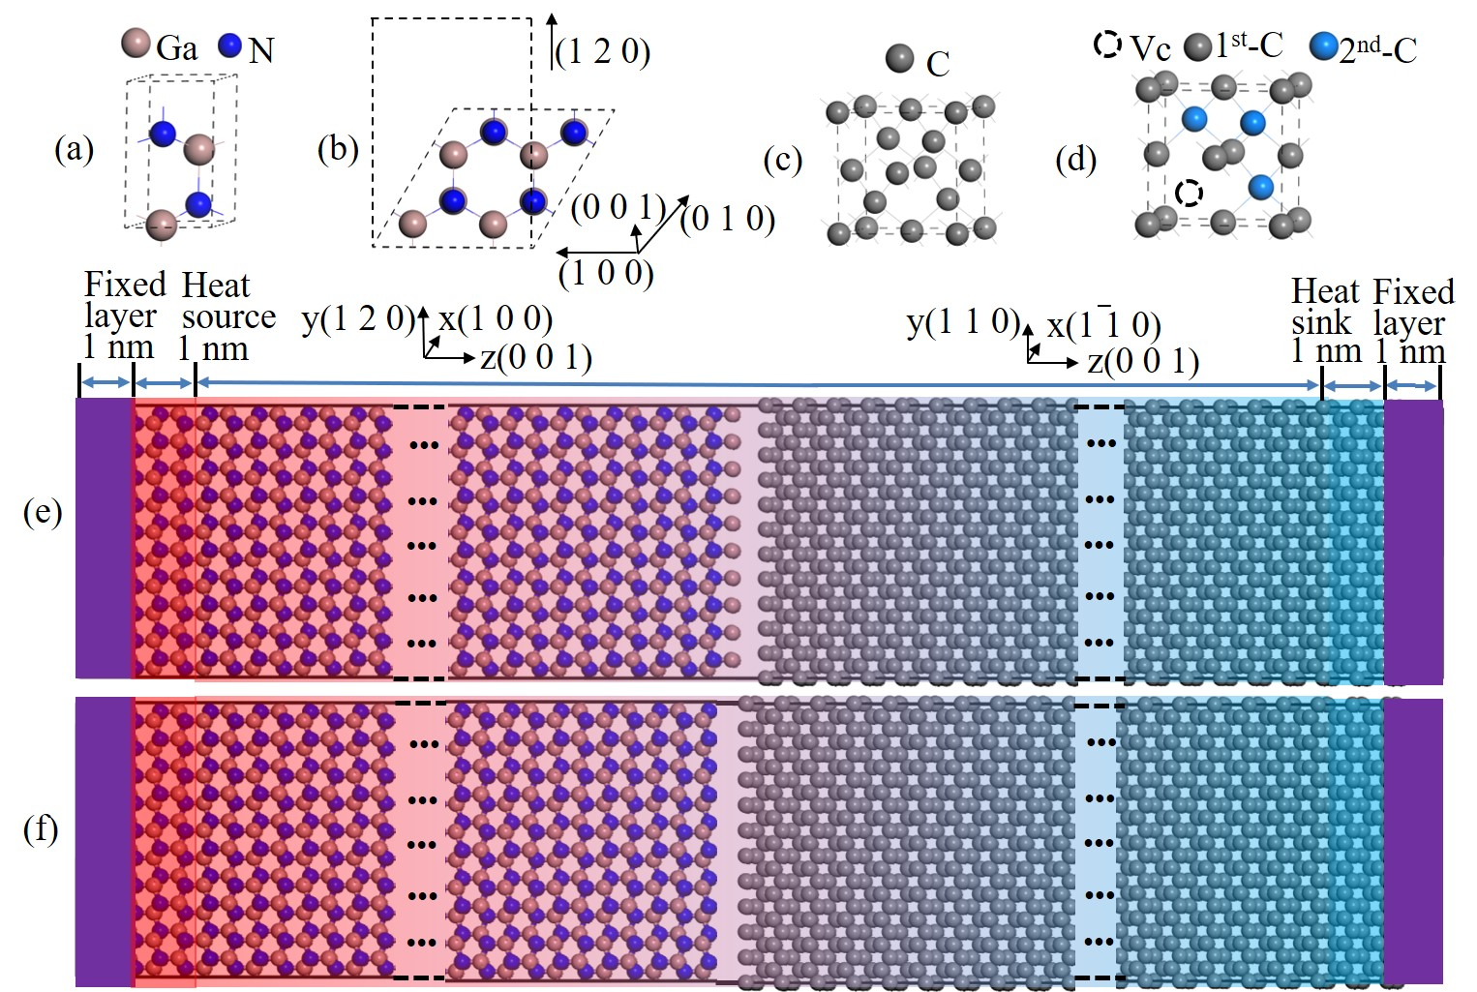
Fig. 1 (a) Side and (b) cross-sectional view of GaN crystal structure. (c) Diamond crystal structure and (d) diamond with one carbon vacancy. Schematic of the (e) Ga-GaN/C and (f) N-GaN/C interface models for NEMD simulation.
III. RESULTS AND DISCUSSION
A. Effect of vacancy defects on the phonon thermal conductivity
In bulk GaN and bulk diamond, intrinsic vacancy defects can significantly affect thermal conductivity. Thermal conductivities in bulk GaN and bulk diamond are primarily governed by the movement of phonons. Vacancy defects act as scattering centers for phonons, disrupting their movement. In our first-principles calculations, [23] 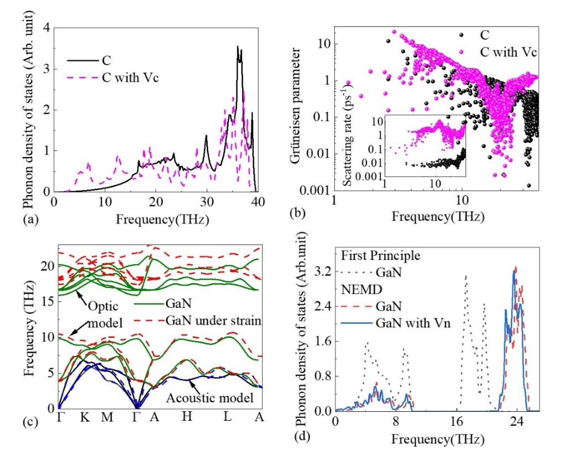
Fig. 2 (a) Phonon density of states and (b) the Grüneisen parameters of diamond with and without carbon vacancy. (c) Phonon dispersion curves of GaN and GaN under strain (-0.96% for a and +0.35% for b). (d) the calculated phonon density of states of GaN and GaN with 3.125% Vn using NEMD.

the defect Vc in diamond causes its thermal conductivity to drop dramatically. Where a phonon collides with the Vc, its direction changes, leading to a decrease in its mean free path (the average distance a phonon travels before scattering). As a result, phonons in the diamond with the Vc encounter more obstacles, leading to a decrease in the overall thermal conductivity. Besides, the Vc in the diamond can also create additional phonon modes, including low-frequency modes, which contribute to an increase in the number of low-frequency phonons as shown in Fig. 2(a). These low-frequency modes are associated with localized vibrations of atoms around the defect sites, further enhancing phonon localization. These are mainly due to the enhancement of the anharmonicity and the scattering rates resulted from the Vc as shown in Fig. 2(b). For GaN, the effect of intrinsic vacancy defect (take the Vn as an example) on its thermal conductivity is calculated by the NEMD method. This is mainly because a small GaN unit cell can only be calculated by first principles, while a small GaN unit cell with a high Vn concentration is an unstable system, in whose phonon dispersion the imaginary frequencies appear. The phonon dispersion curves of GaN and GaN under strain (-0.96% for a and +0.35% for b) are calculated by density-functional-perturbation theory (DFPT) [30] and shown in Fig. 2(c). It can be observed that the acoustic branch of the phonon dispersion exhibits almost no significant change under strain and has a maximum frequency of about 8 THz, while the maximum frequency of the optical branch shows a noticeable increase from 20.85 to 23.05 THz. Besides, the phonon density of states (PDOS) of GaN with 3.125% Vn is shown in Fig. 2(d). And the PDOS of GaN was also included in the Fig. 2(d). In NEMD, the PDOS can be calculated using the Fourier transform of the velocity autocorrelation function (VACF(t)): [31,32,33]
(1)
(2)
In Eq. (2), N is the number of atoms, the and are the initial velocity and velocity at time t of the i-th atom, respectively. < > is taking the average of the system. Besides, it is important to highlight that both the PDOS and phonon participation ratio (PPR) calculations were conducted specifically along the out-of-plane direction (z-direction). [34,35]
In Fig. 2(d), the PDOS calculated by first-principles are in good agreement with experimental data, [36] and the PDOS obtained from NEMD are consistent with the experimental data at the lower-frequency acoustic modes, while there is a notable deviation between the results calculated by NEMD and the results of first-principles calculations and experimental data above 16THz. This is mainly because the SW potential incorporating electrostatic interactions may also encounter challenges in accurately describing both acoustic and optical phonons simultaneously. [37]
Although the SW potential is inaccurate in describing the high-frequency optical phonon modes of GaN, it will not significantly affect our calculation of thermal conduction. It is mainly because the thermal transport capability of optical phonons is far lower than that of the acoustic phonons, which means that thermal conduction is mainly determined by acoustic phonon modes and low-frequency optical phonon modes, and the contribution of high-frequency optical phonon modes can almost be neglected. [38,39] The thermal conductivities of GaN in-plane and out-of-plane at room temperature are iterative solutions of the linearized Boltzmann transport equation. [40,41] The calculated in-plane and out-of-plane values ​​are 204.52 and 186.31 W/(m·K), respectively. It indicates that the thermal conductivity of GaN is anisotropic. The average value of thermal conductivity is about 198.21 W/(m·K), which is very close to most reported experimental data, [42,43] but smaller than the results of theoretical calculation, [44] where a smaller cutoff radius was used to calculate third-order force constants. In addition, the in-plane thermal conductivity is slightly larger than the cross-plane thermal conductivity, which differs from the results reported by Ju et al. [45] This may be due to a slight difference in the lattice parameters used. The observed difference between the in-plane and cross-plane thermal conductivities can be attributed to variations in phonon group velocity and scattering mechanisms in these directions. In the cross-plane direction, phonon modes often encounter more scatterings due to the layered atomic structure, which impedes phonon transport and reduces thermal conductivity relative to the in-plane direction. In-plane thermal conductivity benefits from stronger atomic bonding and less anharmonic scattering, further enhancing phonon transport efficiency.
Besides, it can be confirmed from the cumulative thermal conductivity of the GaN. The cumulative thermal conductivity of the GaN was calculated using the ShengBTE code [40,41] and shown in Fig. 3(a). Whether it is the in-plane lattice thermal conductivity (along the GaN (1 0 0) direction) or the out-of-plane lattice thermal conductivity (along the GaN (0 0 1) direction), the change curves of the cumulative thermal conductivity with frequency are very similar. In addition, the contribution of acoustic phonon modes to thermal conductivity is about 90% as shown in the dotted box in the Fig. 3(a). Besides, considering the low-frequency optical phonon, the contribution of phonon modes below the frequency of 10 THz to thermal conductivity reaches 95%, and the contribution of the optical phonon modes with frequencies above 16THz to thermal conductivity only accounts for 5%. This indicates that for the thermal transport of GaN in the NEMD, we only need to examine the frequency below 16THz.
In the NEMD simulation, the thermal conductivities of GaN with and without Vn were calculated using Fourier’s law [46]
, (3)
, (4)
where is the thermal conductivity at a specific length , represents the heat flux, S is the cross-sectional area, and ▽T is the temperature gradient along the z direction. The Langevin thermostat method was used to control temperature, [47] and the temperature of the heat source and sink were 315 K and 285 K, respectively. After the system is at a stable temperature, the temperatures at each location in the system were shown in the Fig. 3(b). The changes in energy over time in the heat source and sink regions were also shown in the inset of the Fig. 3(b).
The energy in the Eq. (4) represents the work done by the Langevin forces on each atom, which is computed by integrating the product of the Langevin force and atomic velocity over time. In the LAMMPS implementation, it is calculated on each timestep as: , whereis the total Langevin force on the ith atom, is the velocity of the ith atom and Δt is the simulation timestep. The detailed process for calculating energy exchange in Langevin thermostats was reported by Shen et al. [48] In addition, we set friction coefficient γ to a value of 20 ps⁻¹. This relatively high friction coefficient ensures efficient energy exchange between the modeled system and the thermostat, allowing for rapid thermalization while maintaining accurate representation of phonon transport properties in the system.

The energy change curves can be linearly fitted, and the energy transfer rate is the average of the slope of the fitted lines. Based on these processes, the thermal conductivities of the 4×5√3×16, 4×5√3×30, 4×5√3×40 and 4×5√3×50 supercells for the GaN and GaN with 3.125% Vn were calculated and shown in Fig. 3(c). For each calculated model, five independent calculations were performed at different random initial velocities to obtain the error range of the data. The linear fitting and extrapolation method [49] was used to obtain the thermal conductivity
, (5)
where represents the value of . We ensured that the system length was sufficiently large to minimize the truncation effects of long mean free path phonons in the NEMD simulations. [50] The extrapolation approach allows the thermal conductivity values to more closely reflect the intrinsic values of an infinitely large system.
.
The calculated thermal conductivities and deviation range have been shown in the Fig. 3(c). The calculated thermal conductivities ​​are 205.33 and 42.02 W/(m·K) for the GaN and GaN with 3.125% Vn, respectively. It indicates that the thermal conductivity of GaN decreases sharply due to the enhanced Vn-phonon scattering. And the localized Vn defects act as the Vn-phonon scattering centers. The localized characteristic of the Vn can also be verified by the PPR. In NEMD, the PPR is an effective method to understand phonon activity and describe phonon localization. It can be directly computed from the trajectory and velocity of atoms and defined as [31,51,52]
. (6)
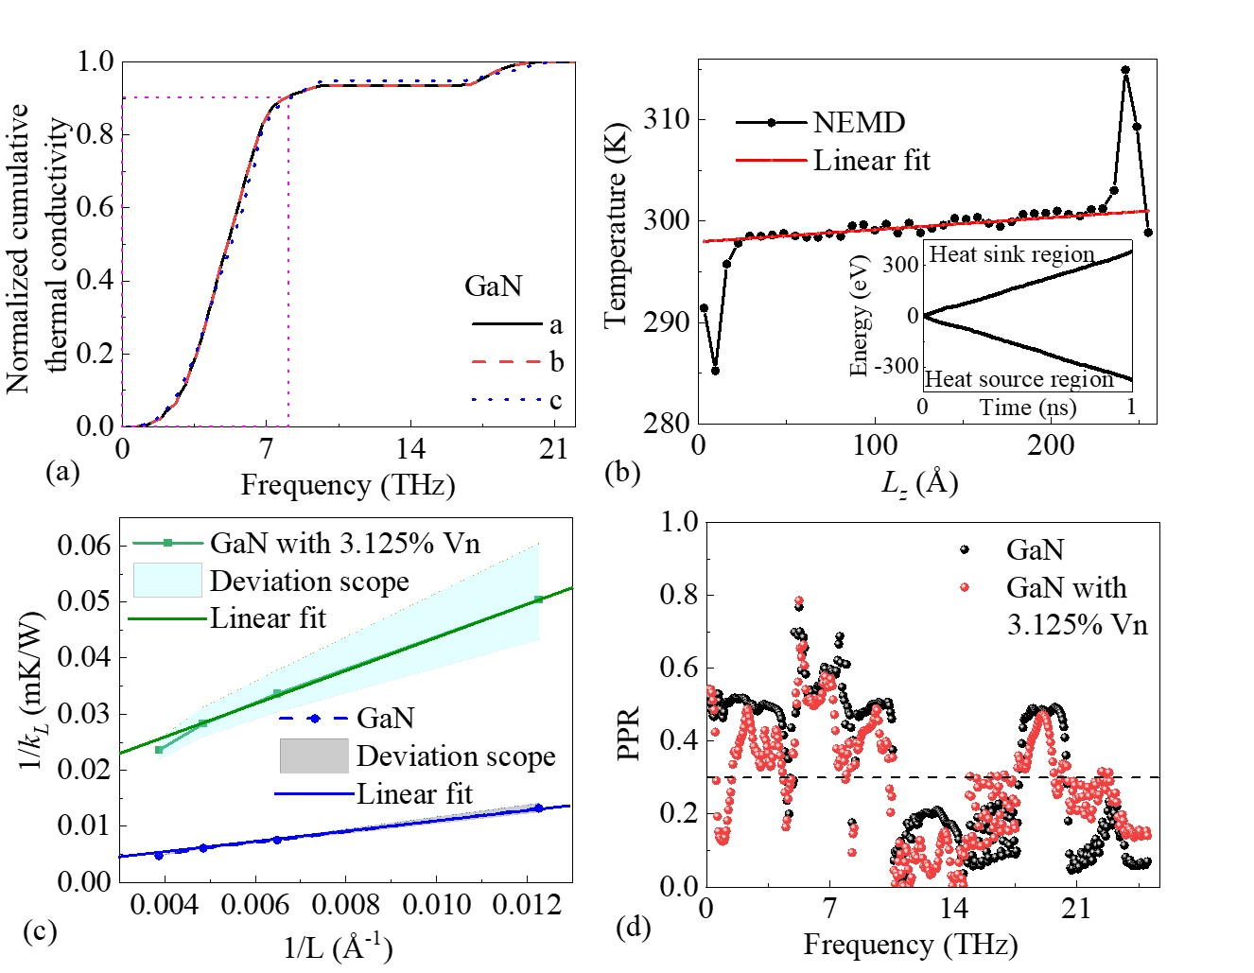
Fig. 3 (a) the cumulative thermal conductivity as a function of frequency for GaN. (b) Temperature distribution in the z direction of GaN. The relationship between the energy of the heat source and heat sink region over time in the inset. (c) The reciprocal of thermal conductivity as a function of the reciprocal of the length (1/Lz) for GaN and GaN with the 3.125% Vn. (d) The PPR of GaN and GaN with 3.125% Vn.

In Eq. (6), PDOS(ω)_{n} is the PDOS of the n-th atom and ω is its frequency, N is the number of atoms. The PPRs of GaN and GaN with 3.125% Vn are shown in Fig. 3(d), where the PPR less than 0.3 means that phonons are localized. In the Fig. 3(d), Using a supercell for PPR calculations introduces folded phonon modes that extend beyond the maximum frequency (21.5 THz) of phonon dispersion as shown in the Fig. 2(c), reaching up to 63 THz. Especially, within the phonon band gap region (12~16 THz), there are indeed no localized modes, and the PPR in this range is notably higher than in other frequency ranges. [53,54] Besides, it is obvious that whether in GaN or GaN with 3.125% Vn, low-frequency phonons ( ˂ 22 THz ) play a major role in thermal conductivity, and the PPR of high-frequency ( ˃ 22 THz ) phonons is very low. Especially, the PPR in GaN with 3.125% Vn is significantly lower than that in GaN below 12 THz. Therefore, the Vn leads to a decrease in the PPR, which further leads to a decrease in thermal conductivity.

B. The ITC of GaN/C with and without vacancy
The ITC of the GaN/C interfaces was calculated using NEMD methods. For GaN, there are two surface configurations Ga-terminated and N-terminated, so the GaN/C interfaces include both Ga-GaN/C and N-GaN/C interfaces accordingly. To determine
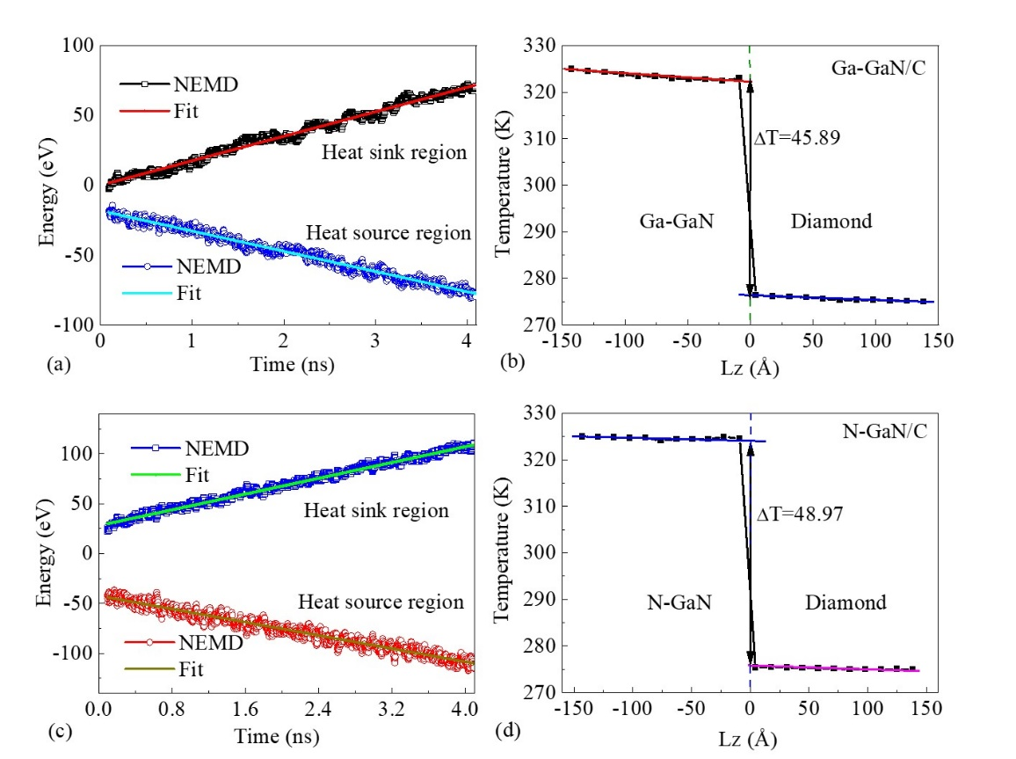
Fig. 4 (a) Energy of the heat source and sink region as a function of time in steady state and (b) temperature distribution in the z-direction for the Ga-GaN/C interface. (c) Energy of the heat source and sink region as a function of time in steady state and (d) temperature distribution in the z-direction for the N-GaN/C interface.
the computational error range, five independent calculations of the ITC of the GaN/C interface without vacancy defects were performed at different random initial velocities, while five independent calculations of the ITC of the GaN/C interface with vacancy defects were performed for five different positions of vacancy defects. In addition, vacancy defects were only generated on the surfaces of GaN and diamond in these GaN/C interfaces. The concentration of vacancy defect was directly represented by the amount of vacancy. Because the effect of vacancy on phonon properties exhibits strong localized characteristics, the effect of vacancies generated at the surface on ITC is also the most direct and significant.
The ITC at the GaN/C interface was calculated using the NEMD method. It can be written as: [23,30,55]
. (7)
In Eq. (7), the represents the heat flux along the z direction and can be calculated by the average of the slopes of the fitted lines as shown in Fig. 4(a) for the Ga-GaN/C interface. The ΔT represents the temperature drop as shown in Fig. 4(b) for the Ga-GaN/C interface. And the Figs. 4(c) and 4(d) are the heat flux and the temperature drop for the N-GaN/C interface, respectively.
According to Eq. (7), the ITC of the Ga-GaN/C and N-GaN/C interfaces are about 14.31 and 4.79 MW·m⁻²K⁻¹ as shown in Figs. 5(a) and 5(b), respectively. The former is in good agreement with the experimental data ( 11.8~15.4 MW·m⁻²K⁻¹ ) reported by Yate [14] and is slightly smaller than the calculated value ( 12.45~18.98 MW·m⁻²K⁻¹ ) reported by Tao, [24] where the terrsoff potential was used. The latter is comparable to Waller's experimental data ( about 5 MW·m⁻²K⁻¹ ). [12] Our calculated values of ITC are listed in Table 1, along with the theoretical results and experimental data in the literature. The significant variability in the ITC of GaN/diamond heterointerfaces in Table 1 can be attributed to both theoretical and experimental factors. Theoretically, the substantial thermal mismatch between GaN and diamond, especially in phonon spectra and vibrational frequencies, affects phonon transmission efficiency. Experimentally, the high lattice mismatch and weak interfacial bonding between GaN and diamond contribute to this variability. The lattice mismatch induces defects and strain, while weak bonding reduces phonon coupling, leading to ITC values that vary widely under different interfacial conditions. Comparing our numerical simulation results with the experimental results indicates an acceptable agreement between the calculated value of ITC and the experiment data. Thus, we will be confident about the simulation results and obtain more detailed information about ITC at the GaN/C interfaces under different vacancy defect conditions using numerical simulation studies.
Subsequently, the Vga and Vc defects were generated at the Ga-GaN/C interface, and Vn and Vc defects were generated at the N-GaN/C interface. The calculation results show that the generation of Vga and Vn defects at these interfaces does not increase the ITC of the GaN/C interfaces, but instead causes a decrease in thermal transport as shown in Figs. 5(a) and 5(b). The conclusion that intrinsic vacancy defects in GaN will lead to reduced ITC, which is in good agreement with the calculation results recently reported by Yang. [25] However, the Vc generated at the Ga-GaN/C and N-GaN/C interfaces can increase the ITC. Especially at the N-GaN/C interface, the Vc can increase the ITC by about 4 times as shown in Fig. 5(b). Although the Vc can increase the ITC of the GaN/C interfaces, the maximum value of the ITC is only about 22.55 MW·m⁻²K⁻¹. Therefore, we will focus on investigating the effect of the Vc defects on the interfacial phonon thermal transport properties at the GaN/diamond interface.
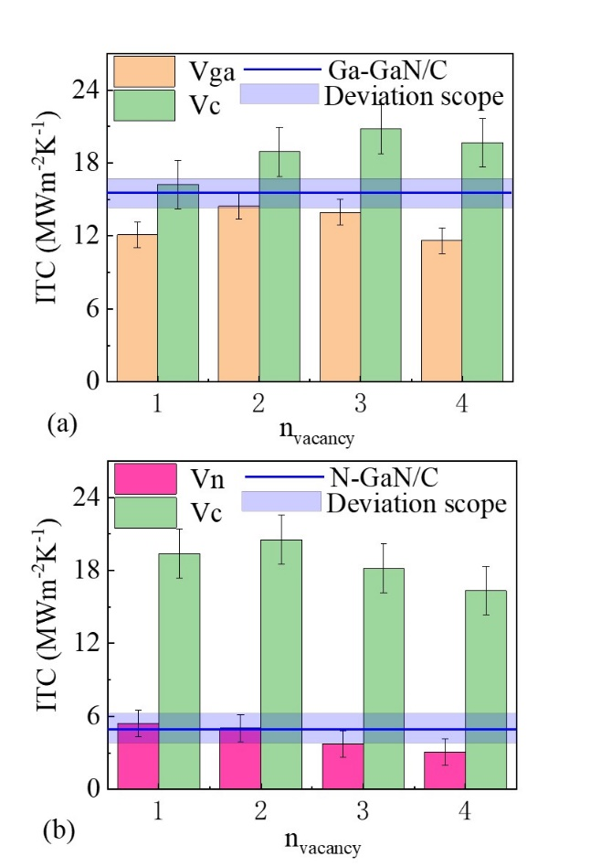
Fig. 5. (a) The ITC under different Ga and C vacancy concentrations at Ga-GaN/C interface and (b) the ITC under different N and C vacancy concentrations at N-GaN/C interface.
In addition, according to our calculations, the ITC obtained from NEMD simulations is much smaller than the results ( >300 MW·m⁻²K⁻¹ ) calculated using the diffuse mismatch model. [56] The simplified assumptions have been made in the diffusion mismatch mode. [29] These assumptions often oversimplify the interface behavior, neglecting factors such as atomic-level details and vibrational modes, leading to an overestimation of the ITC at the interface. For example, the ITC at the Ga-GaN/C interface is much larger than that of the N-GaN/C interface. To account for atomic interactions and energy transfer mechanisms more accurately at the GaN/C interface, PDOS and PPR near the GaN/C interface were calculated and analyzed to further clarify the physical mechanism behind it.

Table 1. The values of ITC ​​obtained by different methods at GaN/diamond
Measurement method |  | ITC (MWm⁻²K⁻¹)
This work  (NEMD) | Hybrid potential function | 14.31 for Ga-GaN/C
This work  (NEMD) | Hybrid potential function | 4.79 for N-GaN/C
Theoretical predictions | Tersoff potential function (NEMD) | 12.45~18.98 | Ref. [24]
Theoretical predictions | Tersoff potential function (NEMD) | >300 | Ref. [25]
Theoretical predictions | Diffuse mismatch model | ~333.33 | Ref. [56]
Experimental measurements | Transient thermoreflectance | ~5 | Ref. [12]
Experimental measurements | Contactless  thermoreflectance | 12~15 | Ref. [14]
Experimental measurements | Time-domain thermoreflectance | ~21.2 | Ref. [13]
Experimental measurements | Optical transient interferometric mapping technique | ~100 | Ref. [15]

C. PDOS and PPR analysis
According to the Eqs. (1) and (2), the VACF and PDOS near the GaN/C interface were calculated and shown in Figs. 6(a)-6(b) for the Ga-GaN/C interface and Figs. 6(c)-6(d) for the N-GaN/C interface. As shown in Figs. 6(b) and 6(d), the PDOS of GaN at the GaN/C interface exhibits additional phonon modes above 10 THz compared to bulk GaN. These new phonon modes arise due to the interaction between the GaN and C atoms at the interface, which introduces scattering mechanisms that are absent in the bulk material. For the Ga-GaN/C interface, significant variations occur near 11 THz, while for the N-GaN/C interface, pronounced changes are observed around 15 THz. These frequency ranges indicate where interface scattering most affects the phonon modes, likely due to differences in bonding characteristics and atomic mass between Ga, N, and C atoms at the interface.
In the case of elastic scattering occurring at the interface, the PDOS overlap factor (S) between GaN and diamond helps determine phonon transmission at the GaN/C interfaces and is defined as [22]
. (8)
In Eq. (8), the PDOS_{C}(ω) and PDOS_{GaN}(ω) are the PDOSs of C and GaN in the GaN/C interface region, respectively.
The PDOS overlap factor S reflects the degree of matching between the phonon density of states of the C and GaN across the frequency spectrum. A higher PDOS overlap factor indicates greater similarity in the PDOS between C and GaN at certain frequencies, thereby enhancing phonon transmission efficiency at the interface. A similar PDOS distribution also reduces phonon scattering at the GaN/C interface, allowing more phonons to transmit elastically from one material to the other, which increases the ITC. Besides, the Kullback-Leibler (K-L) divergence value () serves as a quantitative measure of the similarity in the PDOSs between GaN and diamond. The K-L divergence value can be calculated as following: [57]
(9)
This K-L divergence value helps determine the contributions of elastic and inelastic scatterings to the ITC. The lower K-L values indicate a predominant contribution of elastic scattering to the ITC, while the higher values suggest an increased role of inelastic scattering.
The overlap of PDOS at the GaN/C interface was also displayed in Figs. 6(b) and 6(d). For the ideal abrupt GaN/C interface, when the phonons from GaN can efficiently propagate into diamond without significant scattering or reflection at the interface, a larger overlap of PDOS will result in a higher ITC. According to our calculation, the S values of PDOS are 0.016 for the Ga-GaN/C interface and 0.011 for the N-GaN/C interface. Especially, in the frequency range of less than 8 THz, the S values of the Ga-GaN/C and N-GaN/C interfaces are equivalent. For the Ga-GaN/C interface, the broadening of the PDOS towards the high-frequency region (more than 10 THz) predicts the creation of new phonon vibrational modes in the region, leading to the S larger. This primarily occurs because, upon the establishment of the interface between GaN and diamond, their spatial inversion symmetry is disrupted. In addition, according to Eq. (9), we calculated the values of for the Ga-GaN/C and N-GaN/C interfaces within the frequency range below 16 THz, yielding values of 0.21 and 0.15 as shown in Figs. S2(a)-S2(b) in the Supplementary Material, respectively. It indicates that the C-Ga interaction at the Ga-GaN/C interface is stronger than the C-N interaction at the N-GaN/C interface, likely leading to more pronounced anharmonic interactions at the Ga-GaN/C interface. When considering higher frequency ranges, these values significantly increase to 0.58, suggesting that phonon modes influenced by anharmonic atomic interactions play a crucial role in interfacial thermal conduction at higher frequencies.
Besides, according to Eq. (6), the PPRs of the Ga-GaN/C and the N-GaN/C interfaces were calculated and shown in Figs. 6(e) and 6(f), respectively. The PPR value of 0.3 is set as a reference standard. The PPR value lower than the value is considered to correspond to localized phonons. Otherwise, they are regarded as delocalized phonons. By comparing the PPR of the Ga-GaN/C and the N-GaN/C interfaces, we find that the PPR of the Ga-GaN/C interface is slightly larger than that of the N-GaN/C interface, which is especially evident around the frequency of 10 THz. It suggests that the generated new phonon transport channel or anharmonic phonon scattering channel promotes phonon transport and contributes to the improvement of the ITC of the Ga-GaN/C interface.
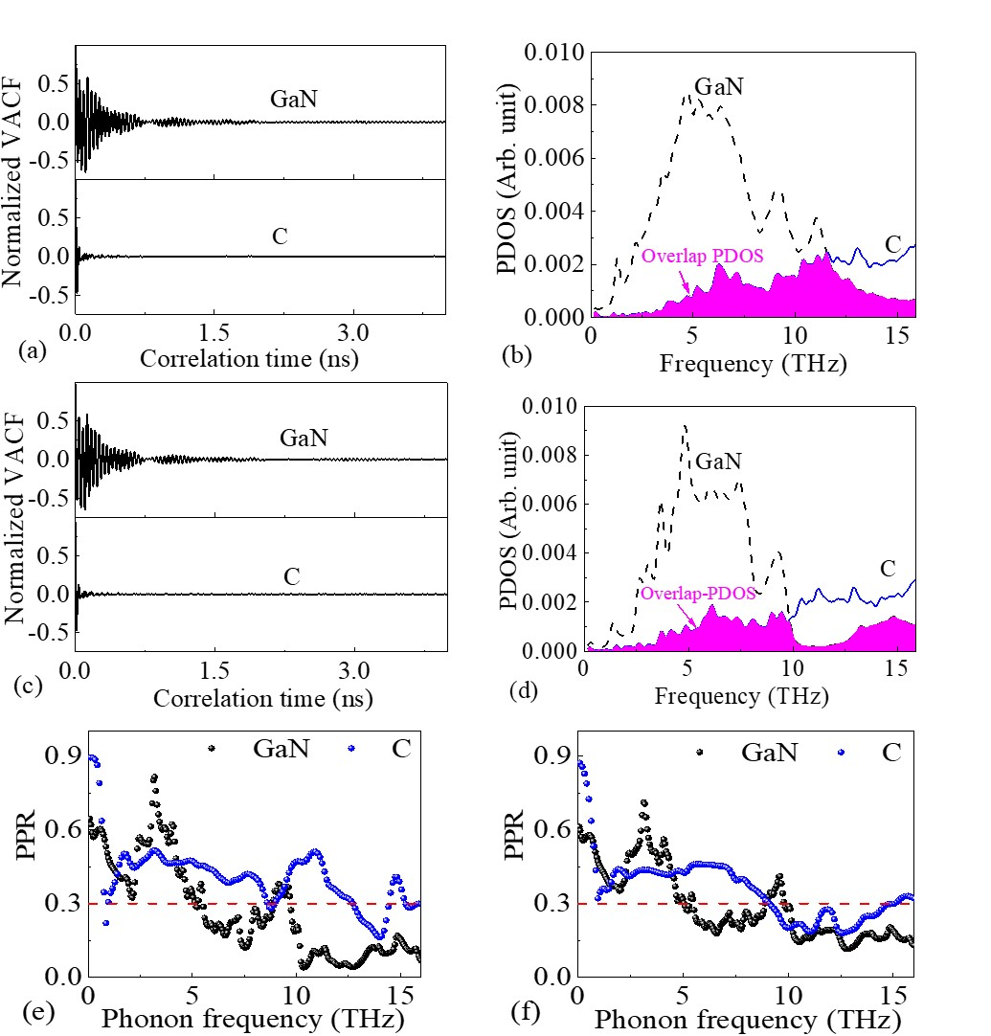
Fig. 6 (a) Normalized VACF and (b) PDOS for GaN and C in the Ga-GaN/C interface. (c) Normalized VACF and (d) PDOS for GaN and C in the N-GaN/C interface. And calculated PPRs for (e) the Ga-GaN/C interface and (f) the N-GaN/C interface.

We investigate the impact of the Vc defects on the S of the GaN/diamond interface. The calculated PDOSs of GaN and C in the Ga-GaN/C interface with one Vc defect and three Vc defects are shown in Figs. 7(a) and 7(b), respectively. For the N-GaN/C interface, the calculated PDOSs of GaN and C in the interface with one Vc defect and three Vc defects were shown in Figs. 7(c) and 7(d), respectively. The S values are 0.0173 and 0.0175 for the Ga-GaN/C interface with one Vc defect and three Vc defects, 0.0170 and 0.0196 for the N-GaN/C interface with one Vc defect and three Vc defects. Comparing values of S of the Ga-GaN/C interfaces with one and three Vc defects, the concentration of the Vc defects has almost no effect on the values of the S, while for the N-GaN/C interfaces, the Vc defects can induce an increase from 0.011 to 0.0196, which is favorable for the increase of ITC across the N-GaN/C interface.
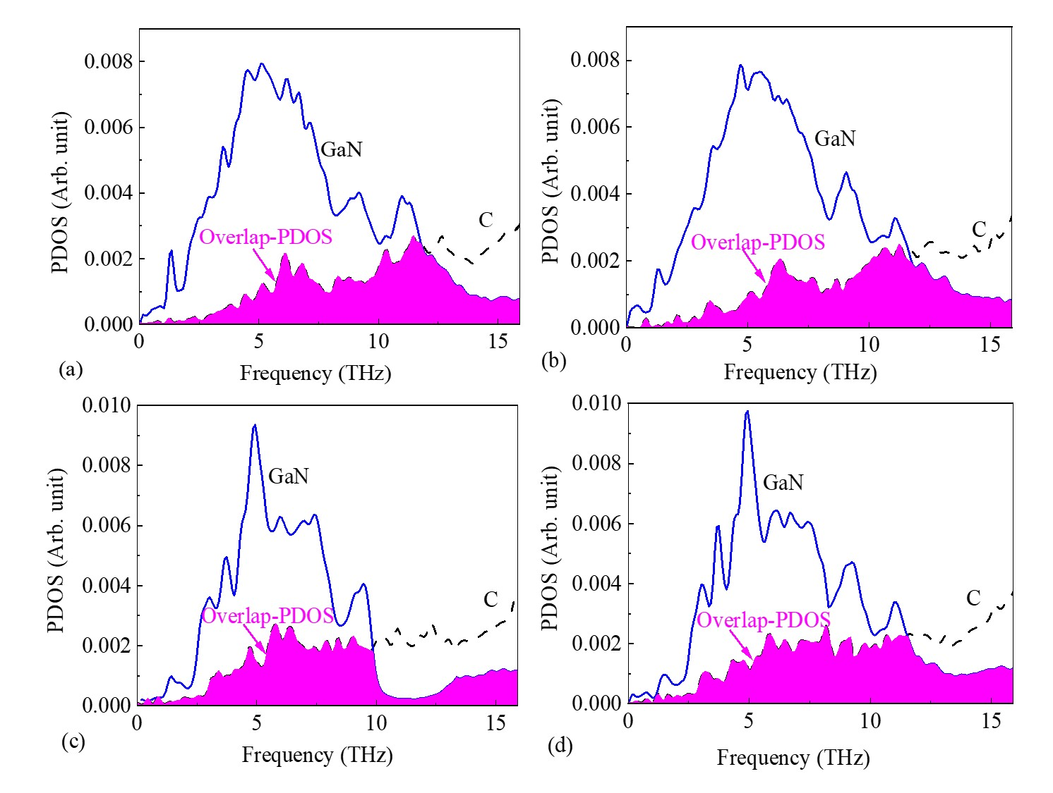
Fig. 7 PDOSs of GaN and C at the Ga-GaN/C interface with (a) one Vc defect and (b) three Vc defects. PDOSs of GaN and C at the N-GaN/C interface with (c) one Vc defect and (d) three Vc defects.
However, compared with the ITC of the N-GaN/C interface without the Vc defects, the Vc defects in the N-GaN/C interface can cause the value of ITC to increase more than four times. This inconsistency shows that the ITC includes not only the contribution of harmonic phonon scattering, but also a larger contribution of anharmonic phonon scattering, such as the scattering of optical phonons above the cutoff frequency of GaN acoustic phonon. The findings on enhancing the ITC through interfacial engineering have been reported in the literatures, [27,58] where introducing nanoscale mass-graded layers and atomic-level interface roughness were shown to increase ITC. Similarly, our study demonstrates that the Vc at the GaN/C interface can also enhance ITC. Firstly, the vacancy defects on the GaN surface increase interface roughness, Additionally, the presence of vacancies alters the average atomic mass within the GaN/C interfacial layer, producing effects comparable to the mass-graded layers described in the literature. This change in atomic mass contributes to enhanced thermal conductance across the interface. Moreover, vacancy-induced vibrational modes at 10 THz expand the anharmonic phonon transport pathways, facilitating phonon transmission through the GaN/C interface.

For the N-GaN/C interface, the Vc in diamond surface led to nearly a fivefold increase in the ITC, rising from 4.79 to 22.55 MWm⁻²K⁻¹. The spectral heat current (SHC) of the N-GaN/C interface was calculated and analyzed to examine the contributions of different phonon modes. The SHC allows for the decomposition of the total heat flow into contributions from different phonon frequencies, which can be written as [59,60,61]
. (10)
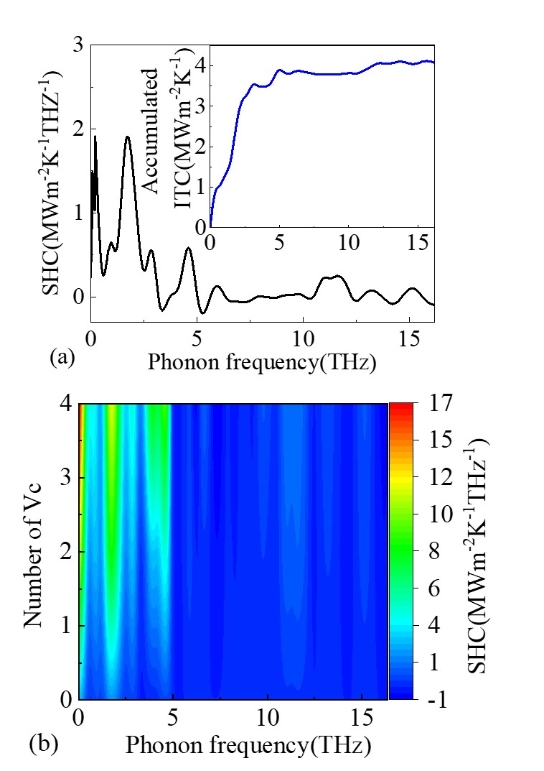
Fig. 8 Calculated SHC for (a) the N-GaN/C interface without vacancy defects and (b) the N-GaN/C interfaces with different number of the Vc defects in diamond surface. The integration of SHC with frequency is shown in the inset.
In Eq. (10), represents the harmonic force exerted by the ith atom on the left side of the interface on the jth atom on the right side of the interface. The harmonic force can be defined as the partial derivative of the interatomic potential with respect to the position of the jth atom at time τ (). And is the velocity of the ith atom. The interatomic forces as well as the atomic velocity are updated every 15 fs.
The computed SHC as a function of frequency is shown in Fig. 8(a), and the cumulative ITC as a function of frequency is presented in the inset. The accumulated ITC is approximately 4.03 MWm⁻²K⁻¹, which is slightly lower than the 4.79 MWm⁻²K⁻¹ calculated using the Fourier's law. Additionally, from the SHC, we observe that the ITC of the N-GaN/C interface is predominantly contributed by low-frequency phonon modes (below 5 THz), accounting for about 95% of the total ITC. The SHC of the N-GaN/C interfaces with different number of Vc defects are calculated and shown in Fig. 8(b). It can be seen that low-frequency phonon modes (below 5 THz) are the primary contributors to the ITC. Besides, according to Eq. (9), we calculated the values of for the Ga-GaN/C and N-GaN/C interfaces with 1 Vc and 3Vc within the frequency range below 16 THz. The respective values are 0.23, 0.25, 0.17 and 0.21 as shown in Fig. S3 in the Supplementary Material, respectively. The results indicate that the Vc induce stronger anharmonic interactions at the Ga-GaN/C interface compared to the N-GaN/C interface. Within this low-frequency range, the values are relatively small, suggesting that the ITC is predominantly governed by elastic scattering. Notably, for the N-GaN/C interface, the introduction of the Vc leads to an increase in the value, indicating that the Vc enhances inelastic scattering, further increasing the contribution of inelastic scattering to the ITC. [62,63] The Vc defects induce anharmonic phonon modes in diamond at low frequencies, significantly reducing the thermal conductivity of diamond but expanding the phonon transmission channels at the interface, thereby effectively enhancing the ITC.

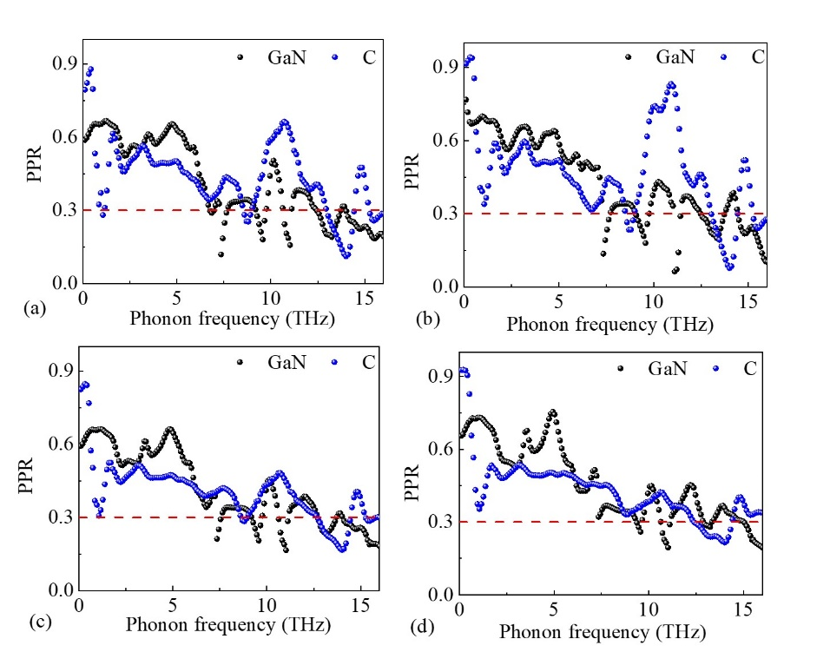
Fig. 9 Calculated PPRs of GaN and C at the Ga-GaN/C interface with (a) one Vc defect and (b) three Vc defects. Calculated PPRs of GaN and C at the N-GaN/C interface with (c) one Vc defect and (d) three Vc defects.

In our NEMD simulations, the PPR can provide valuable evidence for explaining the localization characteristics of phonon and the contribution of anharmonic phonon scattering to the ITC. [31,50] According to Eq. (6), the PPRs of the interfacial C and GaN at the Ga-GaN/C interfaces with the one and three Vc defects are shown in Figs. 9(a)-9(b), respectively. Compared to the PPR of the Ga-GaN/C interface with one Vc, the PPR of the Ga-GaN/C interface with three Vc is slightly larger in the lower frequency region (less than 8 THz) and significantly larger in the higher frequency region (more than 8 THz). It suggests that inelastic phonon scattering between the Vc defects and harmonic phonons can enable the anharmonic phonons across the Ga-GaN/C interface, which enhances the ITC of the Ga-GaN/C interface. Besides, the PPRs of the interfacial C and GaN at the N-GaN/C interfaces with the one and three Vc defects are shown in Figs. 9(c)-9(d), respectively. Through comparing their PPRs, we found that in the low-frequency region (less than 8 THz), the PPR values are comparable, whereas in the high-frequency region (more than 8 THz), the former exhibits a slightly larger PPR. This indicates that for the N-GaN/C interface, the inelastic scattering induced by more Vc defects in the N-GaN/C interface does not lead to higher transmission of anharmonic phonons across the N-GaN/C interface.
Therefore, by calculating the ITC at the GaN/C interface, it can be observed that the phonon matching between GaN and diamond within the acoustic phonon frequency range is crucial for the ITC. The greater the S between GaN and diamond is, the more significant the contribution of harmonic phonons crossing the GaN/C interface through elastic phonon scattering to the ITC is. However, in the interfacial region, inelastic phonon scattering induced by anharmonic phonons also play an important role in the increased ITC. [61,64]
In recent years, many similar reports have been made in studies of other interfacial thermal transport. [65,66] During the process of interface thermal transport, phonons encounter various scattering due to various factors, including GaN/C interface, vacancy defects, and anharmonic interactions. Contrary to intuition, these interactions can sometimes expand new phonon vibration modes or enhance anharmonic phonon scattering to increase phonon interface transmission. Our findings suggest that the introduction of carbon vacancies on the diamond surface promotes thermal transport across the GaN/diamond interface. This provides valuable insights for experimental studies, particularly in cases where a third interface material is introduced to serve as a phonon bridge, potentially increasing additional interface thermal resistance.

IV. SUMMARY
In conclusion, the first-principles calculation and NEMD simulation were employed to investigate the ITC of the GaN/C interfaces, with a specific focus on the influence of interface vacancy defects on phonon thermal transport. The results indicated that the ITC of the Ga-GaN/C interface was more than three times greater than that of the N-GaN/C interfaces. Interestingly, after introducing vacancy defects at the GaN/C interface, the Vga and Vn defects did not significantly affect the ITC of the GaN/C interfaces, while the Vc defect increased the ITC of the N-GaN/C interface by about five times. Comprehensive analysis of the interface PDOS, PPR and SHC indicates that the introduction of the Vc defects not only improves phonon matching but also enhances the transmission of anharmonic phonons through inelastic scattering. Compared to the phonon transition layer introduced at the GaN/C interfaces, controlling interface details offers a more versatile and potentially effective means of improving interfacial thermal transport properties. This finding provides valuable insights for experimental studies aiming to improve heat dissipation in GaN-based devices.

ACKNOWLEDGMENTS
This work is financially supported by the Science Foundation of Jinling Institute of Technology (jit-rcyj-202001) and the scholarship from China Scholarship Council (CSC) under the Grant No.202308320197. We thank the technology support from the National Supercomputer Center (TianHe-2) in Lvliang and Dawning Intelligent Computing AC Platform (KunShan) for providing computer resources.

REFERENCES
[1] R. Xu, P. Chen, X. C. Liu, J. G. Zhao, T. G. Zhu, D. J. Chen, Z. L. Xie, J. D. Ye, X. Q. Xiu, F. Y.Wan, J. H. Chang, R. Zhang, Y. D. Zheng, A lateral AlGaN/GaN Schottky barrier diode with 0.36-V turn-on voltage and 10-kV breakdown voltage by using double-barrier anode structure, Chip 3 (2024) 100079.
[2] J. S. Raj Kumar, H. Victor Du John, I. V. Binola K Jebalin, J. Ajayan, A. Angelin Delighta, D. Nirmal, A comprehensive review of AlGaN/GaN High electron mobility transistors: Architectures and field plate techniques for high power/high frequency applications, Microelectron. J. 140 (2023) 105951.
[3] D. Q. Tran, R. D. Carrascon, M. Iwaya, B. Monemar, V. Darakchieva, P. P. Paskov, Thermal conductivity of Al_{𝑥}Ga_{1−𝑥}N (0≤𝑥≤1) epitaxial layers, Phys. Rev. Mater. 6 (2022) 104602.
[4] P. Neininger, M. Mikulla, P. Döring, M. Dammann, F. Thome, S. Krause, D. Schwantuschke, P. Brückner, C. Friesicke, R. Quay, Advances in GaN Devices and Circuits at Higher mm-Wave Frequencies, Adv. Electr. Electron. 4 (2023) 100177.
[5] X. Y. Zhou, M. Malakoutian, R. Soman, Z. L. Bian, R. P. Martinez, S. Chowdhury, Impact of Diamond Passivation on fT and fmax of mm-wave N-Polar GaN HEMTs, IEEE T. Electron Dev. 69 (2022) 6650-6655.
[6] Y. Lee, Z. Yang, P. Chen, Y. Hsieh, Y. Yao, M. Liao, M. Lee, M. Wang, J. Hwang, Monolithic integration of GaN-based light-emitting diodes and metal-oxide-semiconductor field-effect transistors, Opt. Express 22 (2014) A1589-A1595.
[7] K. Liu, J. Zhao, H. Sun, H. Guo, B. Dai, J. Zhu, Thermal characterization of GaN heteroepitaxies using ultraviolet transient thermoreflectance, Chin. Phy. B 28 (2019) 060701.
[8] F. Mu, Z. Cheng, J. Shi, S. Shin, B. Xu, J. Shiomi, S. Graham, T. Suga, High thermal boundary conductance across bonded heterogeneous GaN–SiC interfaces, ACS Appl. Mater. Interfaces 11 (2019) 33428-33434.
[9] D. J. Twitchen, C. S. J. Pickles, S. E. Coe, R. S. Sussmann, C. E. Hall, Thermal conductivity measurements on CVD diamond, Diam. Relat. Mater. 10 (2001) 731-735.
[10] G. Wang, Y. G. Zhou, Thermal Management Modeling for β-Ga₂O₃-Highly Thermal Conductive Substrates Heterostructures, IEEE Trans. Compon. Packag. Manuf. Technol. 12 (2022) 638-646.
[11] Z. Cheng, F. W. Mu, L. Yates, T. Suga, S. Graham, Interfacial Thermal Conductance across Room-Temperature-Bonded GaN/Diamond Interfaces for GaN-on-Diamond Devices, ACS Appl. Mat. Int. 12 (2020) 8376-8384.
[12] W. M. Waller, J. W. Pomeroy, D. Field, E. J. W. Smith, P. W. May, M. Kuball, Thermal boundary resistance of direct van der Waals bonded GaN-on-diamond, Semicond. Sci. Technol. 35 (2020) 095021.
[13] Y. Zhou, J. Anaya, J. Pomeroy, H. Sun, X. Gu, A. Xie, E. Beam, M. Becker, T. A. Grotjohn, C. Lee, M. Kuball, Barrier-Layer Optimization for Enhanced GaN-on-Diamond Device Cooling, ACS Appl. Mater. Interfaces 9 (2017) 34416-34422.
[14] L.Yates, J. Anderson, X. Gu, C. Lee, T. Bai, M. Mecklenburg, T. Aoki, M. S. Goorsky, M. Kuball, E. L. Piner, S. Graham, Low Thermal Boundary Resistance Interfaces for GaN-on-Diamond Devices, ACS Appl. Mater. Interfaces 10 (2018) 24302-24309.
[15] J. Kuzmik, S. Bychikhin, D. Pogany, E. Pichonat, O. Lancry, C. Gaquiere, G. Tsiakatouras, G. Deligeorgis, A. Georgakilas, Thermal characterization of MBE-grown GaN/AlGaN/GaN device on single crystalline diamond, J. Appl. Phys. 109 (2011) 086106.
[16] H. Sun, R. B. Simon, J. W. Pomeroy, D. Francis, F. Faili, D. J. Twitchen, M. Kuball, Reducing GaN-on-diamond interfacial thermal resistance for high power transistor applications, Appl. Phys. Lett. 106 (2015) 111906.
[17] J. Cho, D. Francis, D. H. Altman, M. Asheghi, K. E. Goodson, Phonon conduction in GaN-diamond composite substrates, J. Appl. Phys. 121 (2017) 055105.
[18] D. Z. Huang, R. M. Ma, T. Zhang, T. F. Luo, Origin of Hydrophilic Surface Functionalization-Induced Thermal Conductance Enhancement across Solid–Water Interfaces, ACS Appl. Mater. Interfaces 10 (2018) 28159-28165.
[19] J. W. Zhao, R. Zhao, Y. K. Huo, W. L. Cheng, Effects of surface roughness, temperature and pressure on interface thermal resistance of thermal interface materials, Int. J. Heat Mass Transf. 140 (2019) 705-716.
[20] K. P. Wu, G. Q. Chang, J. D. Ye, G. Zhang, Significantly Enhanced Interfacial Thermal Conductance across GaN/Diamond Interfaces Utilizing Al_{x}Ga_{1–x}N as a Phonon Bridge, ACS Appl. Mater. Interfaces 16 (2024) 58880-58890.
[21] F. W. Mu, B. Xu, X. H. Wang, R. H. Gao, S. Huang, K. Wei, K. Takeuchi, X. J. Chen, H. B. Yin, D. H. Wang, J. H. Yu, T. Suga, J. Shiomi, X. Y. Liu, A novel strategy for GaN-on-diamond device with a high thermal boundary conductance, J. Alloy. Compd. 905 (2022) 164076.
[22] X. J. Liu, G. Zhang, Y. W. Zhang, Topological Defects at the Graphene/h-BN interface Abnormally Enhance Its Thermal Conductance, Nano Lett. 16 (2016) 4954-4959.
[23] K. P. Wu, L. Zhang, F. Z. Li, L. W. Sang, M. Y. Liao, K. Tang, J. D. Ye, S. L. Gu,
Enhancement of interfacial thermal conductance by introducing carbon vacancy at the Cu/diamond interface, Carbon 223 (2024) 119021.
[24] L. Tao, S. T. Sreenivasan, R. Shahsavari, Interlaced, Nanostructured Interface with Graphene Buffer Layer Reduces Thermal Boundary Resistance in Nano/Microelectronic Systems, ACS Appl. Mater. Interfaces 9 (2017) 989-998.
[25] C. Yang, J. Wang, D. Z. Ma, Z. Q. Li, Z. Y. He, L. H. Liu, Z. W. Fu, J. Y. Yang, Phonon transport across GaN-diamond interface: The nontrivial role of pre-interface vacancy-phonon scattering, Int. J. Heat Mass Transf. 214 (2023) 124433.
[26] T. L. Feng, H. Zhou, Z. Cheng, L. S. Larkin, M. R. Neupane, A Critical Review of Thermal Boundary Conductance across Wide and Ultrawide Bandgap Semiconductor Interfaces, ACS Appl. Mater. Interfaces 15 (2023) 29655-29673.
[27] Z. T. Tian, K. Esfarjani, G. Chen, Enhancing phonon transmission across a Si/Ge interface by atomic roughness: First-principles study with the Green's function method, Phys. Rev. B 86 (2012) 235304.
[28] J. Chen, X.F. Xu, J. Zhou, B.W. Li, Interfacial thermal resistance: Past, present, and future, Rev. Mod. Phys. 94 (2022) 025002.
[29] E.T. Swartz, R.O. Pohl, Thermal boundary resistance, Rev. Mod. Phys. 61 (1989) 605-668.
[30] K. P. Wu, L. Zhang, D. B. Wang, F. Z. Li, P. Z. Zhang, L. W. Sang, M. Y. Liao, K. Tang, J. D. Ye, S. L. Gu, A comparative study of interfacial thermal conductance between metal and semiconductor, Sci. Rep. 12 (2022) 19907.
[31] T. Liang, M. Zhou, P. Zhang, P. Yuan, D. G. Yang, Multilayer in-plane graphene/hexagonal boron nitride heterostructures: Insights into the interfacial thermal transport properties, Int. J. Heat Mass Transfer 151 (2020) 119395.
[32] H. Y. Yang, S. Gao, Y. C. Pan, P. Yang, Manipulating heat transfer at graphene/silicon interface with nitrogen doping, Int. Commun. Heat Mass Transf. 155 (2024) 107521.
[33] H. Y. Yang, Y. J. Shen, L. Li, Y. C. Pan, P. Yang, Surface modification to induce efficient heat transfer at graphene/silicon heterointerface, Appl. Therm. Eng. 238 (2023) 121913.
[34] D. B. Li, H. Y. Yang, L. Li, P. Yang, Numerical investigation of thermal conductivity of Cu/graphene/Cu interface, Appl. Phys. Lett. 123 (2023) 041602.
[35] H. Y. Yang, Y. Q. Tang, P. Yang, Factors influencing thermal transport across graphene/metal interfaces with van der Waals interactions, Nanoscale 11 (2019) 14155.
[36] J. C. Nipko, C. K. Loong, C. M. Balkas, R. F. Davis, Phonon density of states of bulk gallium nitride, Appl. Phys. Lett. 73 (1998) 34-36.
[37] Z. Liang, A. Jain, A. J. H. McGaughey, P. Keblinski, Molecular simulations and lattice dynamics determination of Stillinger-Weber GaN thermal conductivity, J. Appl. Phys. 118 (2015) 125104.
[38] W. Kim, J. Zide, A. Gossard, D. Klenov, S. Stemmer, A. Shakouri, A. Majumdar, Thermal Conductivity Reduction and Thermoelectric Figure of Merit Increase by Embedding Nanoparticles in Crystalline Semiconductors, Phys. Rev. Lett. 96 (2006) 045901.
[39] Z. Li, D. D. Shi, J. Yang, W. J. Luo, C. L. Wan, W. Pan, Contribution of optical phonons to lattice thermal conductivity in complex structural thermal insulation materials, J. Eur. Ceram. Soc. 41 (2021) 7981-7987.
[40] W. Li, J. Carrete, N. A. Katcho, and N. Mingo, ShengBTE: A solver of the Boltzmann transport equation for phonons, Comput. Phys. Commun. 185 (2014) 1747-1758.
[41] Z. R. Han, X. L. Yang, W. Li, T. L. Feng, X. L. Ruan, FourPhonon: An extension module to ShengBTE for computing four-phonon scattering rates and thermal conductivity, Comput. Phys. Commun. 270 (2021) 108179.
[42] D. I. Florescu, V. M. Asnin, F. H. Pollak, A. M. Jones, J. C. Ramer, M. J. Schurman, I. Ferguson, Thermal conductivity of fully and partially coalesced lateral epitaxial overgrown GaN/sapphire (0001) by scanning thermal microscopy, Appl. Phys. Lett. 77 (2000) 1464-1466.
[43] A. Jeżowski, B. A. Danilchenko, M. Boćkowski, I. Grzegory, S. Krukowski, T. Suski, T. Paszkiewicz, Thermal conductivity of GaN crystals in 4.2–300 K range, Solid State Commun. 128 (2003) 69-73.
[44] L. Lindsay, D. A. Broido, T. L. Reinecke, Thermal conductivity and large isotope effect in GaN from first principles, Phys. Rev. Lett. 109 (2012) 095901.
[45] W. J. Ju, Z. Y. Zhou, Z. Y. Wei, Anisotropic thermal transport property of defect-free GaN, AIP Adv. 6 (2016) 065328.
[46] A. Dhar, Heat transport in low-dimensional systems, Adv. Phys. 57 (2008) 457-537.
[47] P. Jund, R. Jullien, Molecular-dynamics calculation of the thermal conductivity of vitreous silica, Phys. Rev. B 59 (1999) 13707-13711.
[48] Y. J. Shen, D. B. Li, Z. Cheng, Y. Q. Tang, P. Yang, Coupling field optimization to improve the thermal transport of Gr/h-BN heterostructure, Diam. Relat. Mater. 147 (2024) 111226.
[49] P. K. Schelling, S. R. Phillpot, P. Keblinski, Comparison of atomic-level simulation methods for computing thermal conductivity, Phys. Rev. B 65 (2002) 144306.
[50] Y. G. Zhou, X. L. Zhang, M. Hu, Quantitatively analyzing phonon spectral contribution of thermal conductivity based on nonequilibrium molecular dynamics simulations. I. From space Fourier transform, Phys. Rev. B 92 (2015) 195204.
[51] H. Bao, J. Chen, X. K. Gu, B. Y. Cao, A review of simulation methods in micro/nanoscale heat conduction, ES Energy Environ. 1 (2018) 16-55.
[52] G. C. Loh, E. H. T. Teo, B. K. Tay, Phonon localization around vacancies in graphene nanoribbons, Diam. Relat. Mater. 23 (2012) 88-92.
[53] A. Bodapati, P. K. Schelling, S. R. Phillpot, P. Keblinski, V ibrations and thermal transport in nanocrystalline silicon, Phys. Rev. B 74 (2006) 245207.
[54] X. S. Zhang, Y. Wang, D. Q. Lei, Z. F. Wang, Atomistic wave packet investigation of phonon scattering at rough surfaces, J. Appl. Phys. 136 (2024) 045102.
[55] Z. J. Qi, W. Shen, R. Li, X. Sun, L. J. Li, Q. J. Wang, G. Wu, K. Liang, AlN/diamond interface nanoengineering for reducing thermal boundary resistance by molecular dynamics simulations, Appl. Surf. Sci. 615 (2023) 156419.
[56] Y. Won, J. Cho, D. Agonafer, M. Asheghi, K.E. Goodson, Fundamental cooling limits for high power density gallium nitride electronics, IEEE Transact. Compon. Packag. Manufact. Technol. 5 (2015) 737-744.
[57] Y. X. Xu, Y. G. Zhou, Metric for quantifying elastic and inelastic thermal transport at interfaces, Phys. Rev. B 110 (2024) 115305.
[58] Y. G. Zhou, X. L. Zhang, M. Hu, An excellent candidate for largely reducing interfacial thermal resistance: a nano-confined mass graded interface, Nanoscale 8 (2016) 1994-2002.
[59] K. Xu, S. C. Deng, T. Liang, X. Z. Cao, M. Han, X. L. Zeng, Z. S. Zhang, N. Yang and J. Y. Wu, Efficient mechanical modulation of the phonon thermal conductivity of Mo₆S₆ nanowires, Nanoscale 14 (2022) 3078-3086.
[60] K. Sääskilahti, J. Oksanen, S. Volz, J. Tulkki, Phys. Rev. B 91 (2015) 115426.
[61] Y. X. Xu, H. Z. Fan, Z. G. Li, Y. G. Zhou, Signatures of anharmonic phonon transport in ultrahigh thermal conductance across atomically sharp metal/semiconductor interface, Int. J. Heat Mass Transfer 201 (2023) 123628.
[62] Y. G. Zhou, M. Hu, Full quantification of frequency-dependent interfacial thermal conductance contributed by two- and three-phonon scattering processes from nonequilibrium molecular dynamics simulations, Phys. Rev. B 95 (2017) 115313.
[63] Q. Q. He, Y. X. Xu, H. D. Wang, Z. G. Li, Y. G. Zhou, Role of elastic phonon couplings in dictating the thermal transport across atomically sharp SiC/Si interfaces, Int. J. Therm. Sci. 204 (2024) 109182.
[64] Y. X. Xu, L. N. Yang, Y. G. Zhou, The interfacial thermal conductance spectrum in nonequilibrium molecular dynamics simulations considering anharmonicity, asymmetry and quantum effects, Phys. Chem. Chem. Phys. 24 (2022) 24503-24513.
[65] Y. J. Zhang, Z. Y. Wang, N. Li, F. Y. Sun, J. P. Hao, H. J. Wu, H. L. Zhang, Amorphous carbon interlayer modulated interfacial thermal conductance between Cu and diamond, Appl. Surf. Sci. 638 (2023) 158001.
[66] L. N. Yang, B. S. Yang, B. W. Li, Enhancing interfacial thermal conductance of an amorphous interface by optimizing the interfacial mass distribution, Phys. Rev. B 108 (2023) 165303.

† Corresponding author. Tel: +86(025) 8618-8572. E-mail address: kpwu@jit.edu.cn (K. P. Wu).
‡ Corresponding author. Tel: +81(29) 860-4508. E-mail: Meiyong.Liao@nims.go.jp (M. Y. Liao).

