Experimental determination of nanoscale thermal transport properties in heat-assisted magnetic recording media using step-by-step time-domain thermoreflectance method

Kota Hasegawa^{1,2a)}, Takamasa Hirai^{2b)}, Takayuki Fukushima^{3c)}, Fuyuki Ando², Naoki Takahara¹, and Ken-ichi Uchida^{2,4}

AFFILIATIONS
¹ Resonac Corporation, Tsukuba 300-4247, Japan
² National Institute for Materials Science, Tsukuba 305-0047, Japan
³ Resonac Hard Disk Corporation, Ishihara 290-0067, Japan
⁴ Department of Advanced Materials Science, The University of Tokyo, Kashiwa 277-8561 Japan
^{a)}E-mail: kota.hasegawa.xhbqd@resonac.com
^{b)}E-mail: HIRAI.Takamasa@nims.go.jp
^{c)}E-mail: takayuki.fukushima.xhdzh@resonac.com

ABSTRACT
Heat-assisted magnetic recording (HAMR) enables ultra-high areal density by locally heating magnetic recording media with high magnetic anisotropy, but the writing performance critically depends on the behavior of heat flow in its complex multilayer structure. In this work, we establish an experiment-informed approach that combines time-domain thermoreflectance (TDTR) with a step-by-step fitting strategy to extract the thermal conductivities and interfacial thermal resistances in HAMR media. These experimentally determined properties are directly implemented in finite-element method simulations, which show good agreement with reported spin-stand measurements. The TDTR-based experiment-informed modeling established in this study reliably describes a device-level HAMR behavior and provides a quantitative guidance for recording media design.

With the rapid expansion of cloud computing, artificial intelligence, and edge computing devices, the volume of data generated and stored worldwide continues to increase, projected to reach several zettabytes annually.^{1,2} Under these circumstances, demand is increasing for storage technologies that offer high capacity, high reliability, and low cost per bit. Hard disk drives remain the dominant solution for large-scale storage. However, conventional perpendicular magnetic recording (PMR) technology is approaching its physical limits as further miniaturization of bit size is required.^{3,4} As the bit dimensions shrink, the thermal stability of magnetic grains decreases. To achieve higher areal density, it is necessary not only to reduce grain sizes but also to increase magnetic anisotropy. In contrast, magnetic recording media with high magnetic anisotropy require stronger writing fields than existing write heads can provide, causing a trade-off between thermal stability and writability. This “magnetic recording trilemma”—the task of balancing thermal stability, writability, and signal-to-noise ratio—highlights the need for advanced recording technologies that can temporarily reduce the coercivity of the media during the writing process.
Heat-assisted magnetic recording (HAMR) has been proposed as a promising solution to this trilemma.^{5–9} In HAMR, a nanoscale near-field transducer concentrates a laser spot to locally heat the recording media during writing process, temporarily reducing the coercivity of the magnetic recording layer so that magnetization reversal can be achieved with the magnetic fields from write heads. The heating process is completed instantaneously, allowing the recording layer to recover its high anisotropy and thermal stability after the writing process. This enables long-term retention of extremely fine bits, which achieves the areal density exceeding that of conventional PMR.
For practical HAMR media, thermal management is a critical design factor.^{10–12} In particular, the heat-sink layer plays a pivotal role in extracting heat from the recording layer, cooling rate, and thermal gradient during writing process. Tungsten (W) is adopted as a heat-sink layer in practical HAMR stacks,¹³ however, its effective out-of-plane thermal conductivity and the interfacial thermal resistances in realistic nanoscale multilayer configurations have not been quantified. Because HAMR introduces highly localized and intense heating into a complex multilayer structure, recording performance metrics, such as magnetic writing width (MWW) and thermal gradient, depend strongly on the thermal conductivity of each layer and interfacial thermal resistance at each interface. Currently, the behavior of heat flow in HAMR media has been mainly investigated through spin-stand measurements and accompanying finite-element method (FEM) simulations.^{10–12,14,15} In most FEM simulations for HAMR media, thermal transport properties have been approximated using bulk values or single-layer properties taken from the literature. However, nanoscale thermal transport properties often differ from bulk behaviors, and it has also been reported that multilayer stacking can change the effective thermal conductivity.^{16,17} Therefore, to accurately predict the temperature distribution during HAMR operation, it is important to quantify the thermal transport properties of each layer within the realistic and complex multilayer structure of HAMR media and perform the simulation using experiment-informed parameters.
In this study, we develop an experiment-informed approach for measuring thermal transport properties in HAMR media by means of time-domain thermoreflectance (TDTR). TDTR has emerged as a powerful ultrafast pump-probe technique for measuring thermal transport properties in thin films and multilayer structures.^{18–21} Regarding HAMR-relevant materials, several studies have been conducted on the thermal conductivity of single-layer films such as an FePt recording layer and heat-sink layers.^{22–24} However, the full-stack characterization of realistic HAMR media has not been investigated so far, because TDTR analysis of such complex multilayers suffers from strong parameter correlations and non-unique solutions, making it challenging to uniquely determine thermal transport properties of each layer.^{25,26} To address this challenge, this study applies a step-by-step fitting strategy to TDTR measurements for layer-stop samples to determine the thermal transport properties of each layer and interface in a realistic HAMR media structure.
Figure 1(a) shows the concept of this study. Following the aforementioned strategy, we first experimentally estimate the out-of-plane thermal conductivities of each layer and interfacial thermal resistances in the HAMR medium through TDTR measurements. Each layer includes not only the FePt recording layer but also internal layers (Ta alloy, Cr alloy, Nitride and MgO layers), heat-sink layer (W), and soft magnetic underlayer (SUL) in a realistic stacked configuration [Fig. 1(b)]. These obtained properties are then directly used as input parameters for FEM simulations of laser heating in the HAMR stack. Consequently, compared with conventional FEM simulations relying on literature values for bulk materials, this experiment-informed approach substantially improves the reliability and accuracy of the calculated temperature distributions. As a result, it is expected to enhance the accuracy of thermal modeling, and accelerate further optimization of HAMR media design.
Figure 2 shows the structure of the HAMR media and the analysis workflow used for the TDTR measurements. We fabricated a series of layer-stop samples using a dc magnetron sputtering to isolate the thermal transport properties of individual layers and interfaces. The detailed TDTR setup, measurement conditions, and fitting model, used in this work have been described in our previous study.^{19,27} It was conducted using the front-heating and front-detection configuration with a repetition rate of 20 MHz, pulse width of 0.5 ps, pump/probe wavelength of 1550/775 nm, and pump modulation frequency of 200 kHz. The phase signals, corresponding to the ratio of the in-phase and out-of-phase components of the probed voltage signal, were acquired via lock-in detection at the pump modulation frequency. The workflow begins with the measurement using a single Al layer with a thickness of 70 nm on a glass substrate. Note that the Al layer is often used as a detection layer for TDTR.²⁸ Here, the thicknesses of each layer were independently measured by X-ray fluorescence. TDTR measurements in this simplest configuration can determine the thermal effusivity of the glass substrate. Next, the 50-nm-thick SUL layer was deposited on the glass substrate, followed by the Al layer, and TDTR measurements were repeated. In this second step, the thermal effusivity of the glass substrate, obtained at the previous step, can be allowed to vary within its 95% confidence interval (CI95%) during the fitting. Accordingly, and the fitting parameters were limited to the thermal transport properties of the SUL layer, the interfacial thermal resistance between the SUL layer and glass substrate, and that between the Al layer and the SUL layer, while the substrate property was constrained within the uncertainty range determined in the previous step. This procedure was repeated for each layer in the HAMR stack. For the n-th layer, the thermal transport properties of all underlying layers (up to the n–1-th layer) were allowed to vary within their respective CI95% ranges obtained from the preceding fitting steps, and only the thermal transport property of the n-th layer and the interfacial thermal resistance with upper and lower layers were treated as fitting parameters. This procedure was applied step by step up to the nitride layer. However, the subsequent MgO layer was not treated as an independent layer in the TDTR analysis because its thickness is too thin (2.5 nm). Instead, the MgO layer was treated as an interfacial thermal resistance so that its thermal contribution could still be incorporated into the fitting without introducing excessive fitting uncertainty. In addition, the Cr alloy layer and Ta alloy layer were not treated as separate layers because of the difficulty in independently extracting their parameters with sufficient reliability. Instead, these two layers were combined and treated as a single internal layer, and their contribution was evaluated as an effective thermal resistance. Based on this framework, we finally fabricated a sample with a realistic HAMR structure including the nitride/MgO/FePt stack (corresponding to the rightmost structure in Fig. 2). In the TDTR analysis of this final sample, the sensitivity of the MgO-related interfacial thermal resistance was examined in comparison with that of the FePt layer. By reducing the number of unknown parameters at each step while constraining previously determined parameters within their CI95% ranges, this step-by-step fitting approach significantly decreases parameter uncertainty, enabling more reliable extraction of thermal transport properties in the multilayer HAMR media.
Figure 3 shows the TDTR phase signals and corresponding fitting results for the realistic HAMR structure including a nitride/MgO/FePt stack. The fitting was performed using a one-dimensional heat-conduction model.¹⁶ The TDTR fitting curves for the other layer-stop samples used in the step-by-step analysis are shown in Supplementary Fig. S1. For each layer-stop configuration, the phase signals are plotted together with the multilayer-model fits obtained from the step-by-step fitting procedure. The good agreement across all layer-stop samples indicates that our strategy appropriately captures the thermal transport properties of each layer and its adjacent interfaces. Since the thermal transport properties of the underlying layers were fixed based on previously extracted values, the fitting converges stably even for upper layers in the HAMR stack. These results confirm the effectiveness of the step-by-step approach in accurately estimating thermal transport properties in complicated multilayers of the HAMR media.
Table 1 summarizes the thermal transport properties obtained from the TDTR analyses and thicknesses for all layers in the HAMR media. The detailed uncertainty analysis and upper-bound evaluation for weakly sensitive parameters are provided in the Supplementary Material. Several importing findings were obtained from these results. First, the out-of-plane thermal conductivity of the W heat-sink layer was significantly lower than its bulk value.²⁹ This is a critical information that substantially alters the results of conventional thermal simulations, which assume bulk thermal transport properties for HAMR stacks. Second, the thermal conductivity obtained for the FePt recording layer showed the almost equivalent value to those estimated from the TDTR measurement in a single FePt layer,^{22,24} indicating that the FePt recording layer exhibits similar thermal transport properties in both single-layer structure and the practical device-like stack. Finally, the interfacial thermal resistances varied across the different interfaces, suggesting substantial room for performance improvement through interface engineering in the HAMR media.
Finally, we performed FEM simulations with TDTR-based experiment-informed modeling. Specifically, we calculated the temperature distribution under laser heating conditions on the HAMR stack using obtained thermal transport properties (Table 1) on COMSOL Multiphysics. In the FEM analysis, all layers, including the W heat-sink layer, were treated as isotropic materials. We mainly focus on the W heat-sink layer as it plays a crucial role for heat dissipation in HAMR. Considering the fact that the thermal conductivity of the sputtered W heat-sink layer deviates from the bulk value, we investigated the impact of the W layer thickness on the actual temperature distribution in the HAMR media. In these simulations, the thermal transport properties of the W layer were fixed to the values experimentally obtained by TDTR (Table 1). Here, the two-dimensional transient heat transfer model was applied since the multilayer structure for HAMR is laterally uniform and the dominant temperature gradients induced by laser heating can be represented within a single cross-sectional plane. The computational domain was set to a width of 5 μm and a substrate thickness of 2 μm, and the initial temperature was fixed at 300 K. Adiabatic boundary conditions were imposed on the bottom and lateral boundaries of the computational domain. To model the transient temperature field in the HAMR stack under localized laser heating, we applied a surface heat flux with a Gaussian spatial profile and a finite pulse width in time to simulate near-field laser heating.^{30,31} The surface heat flux was expressed as
$$\begin{aligned}q\left(x,t\right)=\frac{2P}{\sqrt{π}w}exp\left[-\frac{{2x}^{2}}{w^{2}}\right]f_{pulse}\left(t\right)\#\left(1\right)\end{aligned}$$
where x, t, P, and w denote the in-plane position along the film surface, time, line power with 5000 W/m, and 1/e² radius of the Gaussian heat spot with 10 nm, respectively, and x = 0 corresponds to the heating center. The temporal profile of the pulsed heating was implemented using a smooth step function in COMSOL (flc2h), which provides a numerically stable approximation of the Heaviside step response and avoids convergence issues associated with abrupt discontinuities.³² The pulse waveform was defined as
$$\begin{aligned}f_{pulse}\left(t\right)=flc2h\left(t-t_{ON},t_{r}\right)-flc2h\left(t-\left(t_{ON}+τ\right),t_{r}\right)\#\left(2\right)\end{aligned}$$
with t_{ON} = 5 ns, pulse duration $τ$ = 10 ns, and rise time t_{r} = 0.2 ns. The pulse was applied to the top surface of the multilayer stack, and the transient temperature distribution was calculated under these conditions.
Figure 4(a) shows the simulated result of the two-dimensional temperature distribution in the HAMR multilayer stack with the 50-nm-thick W heat-sink layer. The temperature rise is highly localized near the top surface, and the lateral spreading of heat within the stack is clearly observed. To quantify the recording characteristics, we defined MWW as the lateral extent of the region in the FePt recording layer where the temperature exceeds 700 K at the peak of the heating pulse. The thermal gradient was evaluated as the spatial temperature gradient $∂T/∂x$ at the FePt layer along the 700 K isotherm, at the center of the track. Both MWW and the thermal gradient were evaluated at t = 8 ns, which corresponds to the center of the heating pulse. Figures 4(b) and 4(c) show the dependence of MWW and the thermal gradient on the W heat-sink layer thickness. As the W thickness increased, the thermal gradient gradually increased, while MWW decreased. It was suggested the improvement in temperature localization and sharper thermal gradient in the recording layer. For comparison, we also performed FEM simulations using bulk thermal transport properties for the W heat-sink layer. The bulk-based simulation showed even stronger temperature localization, with a smaller MWW and a larger thermal gradient than those obtained using the experimentally determined thin-film values. This result indicates that the use of bulk values tends to overestimate thermal confinement in realistic HAMR stacks. These trends in both MWW and thermal gradient agree well with previously reported spin-stand measurements of HAMR media.¹⁴ This agreement suggested that replacement of bulk-based inputs with experimentally determined values enables a more realistic and accurate FEM prediction. Thus, the experiment-informed FEM not only bridges the gap between thin-film thermal metrology and full-stack HAMR performance, but also provides a quantitative framework for investigating heat-sink layers and related materials as a design guidance for further improvement of HAMR performance. As a future direction, we plan to extend the present TDTR methodology to evaluate not only the out-of-plane thermal transport properties but also the in-plane thermal conductivity, which is expected to further improve the accuracy of thermal simulations for realistic HAMR stacks. ³³
In conclusion, we developed the experiment-informed thermal characterization and simulation framework for realistic multilayer HAMR media. By combining layer-stop TDTR measurements with a step-by-step fitting method and FEM simulations that directly use the extracted thermal parameters, we demonstrated that film-dimension and interfacial effects play an important role in determining the HAMR performance such as magnetic writing width and thermal gradient. This experiment-based simulation approach is expected to further improve the accuracy of thermal modeling and accelerate the optimization of HAMR media and device performance.
This study was partially supported by ERATO “Magnetic Thermal Management Materials” (Grant no. JPMJER2201) from the Japan Science and Technology Agency, Japan and Grant-in-Aid for Early-Career Scientists (No. 25K17940) from Japan Society for the Promotion of Science, Japan.

REFERENCES
- M. Butaboev, B. Qodirov, and X. Askarov, BIO Web Conf. 186, 02009 (2025).
- D. Reinsel, J. Gantz, and J. Rydning, The Digitization of the World: From Edge to Core, IDC (2018).
- J. Chu, N. Chérrière, G. Brennan, M. Yang, and G. O’Shea, J. Gladrow, D. J. Kelly, G. Maltese, A. Sanders, D. Narayanan, B. Thomsen, and A. Rowstron, Commun. Eng. 3, 79 (2024).
- M. H. Kryder, and C. S. Kim, IEEE Trans. Magn. 45, 3406 (2009).
- M. T. Kief and R. H. Victora, MRS Bull. 43, 87 (2018).
- H. Gavrilă, J. Eng. Sci. Innov. 2, 2 (2017).
- W. A. Challener, C. Peng, A. V. Itagi, and M. A. Roth, A. V. Smith, G. Ju, and M. H. Kryder, Nat. Photonics 3, 220 (2009).
- P. O. Jubert, E. Yitamben, W. Kuang, T. Matsumoto, B. Stipe, and R. Brockie, IEEE Trans. Magn. [in press] (2025).
- Y. Ogata, Y. Imai, and S. Nakagawa, J. Magn. Soc. Jpn. 34, 209 (2010).
- G. Zhang, H. Li, S. Shen, J. Lei, H. Zheng, and S. Wu, Microsyst. Technol. 22, 2877 (2016).
- J. A. Bain, J. A. Malen, M. Jeong, and T. Ganapathy, MRS Bull. 43, 112 (2018).
- B. Xu, Z. Cen, J. H. Goh, S. Xiong, J. Shi, M. H. Kryder, and R. H. Victora, IEEE Trans. Magn. 49, 2559 (2013).
- H. Yuan, S. A. Pirzada, H. C. Ho, P. C. Dorsey, and B. R. Acharya, U.S. Patent 9,824,710 B1 (2017).
- S. Kaitwanidvilai, N. Chaiduangsri, and D. Tongsomporn, IEEE Magn. Lett. 9 (2018).
- Y. Hu, H. Wu, Y. Meng, and D. B. Bogy, J. Appl. Phys. 122, 134303 (2017).
- M. Maldovan, Nature 503, 209 (2013).
- T. Hirai, T. Morita, S. Biswas, J. Uzuhashi, T. Yagi, Y. Yamashita, V. K. Kushwaha, F. Makino, R. Modak, Y. Sakuraba, T. Ohkubo, R. Guo, B. Xu, J. Shiomi, D. Chiba, and K. Uchida, Adv. Funct. Mater. 35, 2506554 (2025).
- H. Arima, Y. Yamashita, and T. Yagi, Sci. Technol. Adv. Mater. 26, 2523240 (2025).
- F. Makino, T. Hirai, T. Shiga, H. Suto, H. Fujihisa, K. Oyanagi, S. Kobayashi, T. Sasaki, T. Yagi, K. Uchida, and Y. Sakuraba, Phys. Rev. B 112, 054407 (2025).
- H. Nakayama, B. Xu, S. Iwamoto, A. Miura, K. Uchida, and Y. Sakuraba, Appl. Phys. Lett. 118, 042403 (2021).
- A. Giri, S. H. Wee, S. Jain, O. Hellwig, and P. E. Hopkins, Sci. Rep. 6, 32077 (2016).
- P. O. Jubert, T. Santos, T. Le, B. Ozdol, and C. Papusoi, IEEE Trans. Magn. 57, 2 (2021).
- A. Chernyshov, D. Treves, T. Le, F. Zong, A. Ajan, and R. Acharya, J. Appl. Phys. 115, 17B728 (2014).
- T. Chen and P. Jiang, Phys. Rev. Appl. 23, 044004 (2025).
- P. Jiang, X. Qian, and R. Yang, J. Appl. Phys. 124, 161103 (2018).
- T. Yamazaki, T. Hirai, T. Yagi, Y. Yamashita, K. Uchida, T. Seki, and K. Takanashi, Phys. Rev. Appl. 21, 024039 (2024).
- D. G. Cahill, P. V. Braun, G. Chen, D. R. Clarke, S. Fan, K. E. Goodson, P. Keblinski, W. P. King, G. D. Mahan, A. Majumdar, H. J. Maris, S. R. Phillpot, E. Pop, and L. Shi, Appl. Phys. Rev. 1, 011305 (2014).
- R. P. Tye, J. Less-Common Met. 3, 1 (1961).
- J. P. Feser and D. G. Cahill, Rev. Sci. Instrum. 83, 104901 (2012).
- Y. Chen, and R. H. Victora, Sci. Rep. 13, 11479 (2023).
- P. O. Jubert, S. Burgos, V. Mehta, and M. Grobis, IEEE Trans. Magn. 52(7), 3201704 (2016).
- COMSOL Multiphysics® Reference Manual: Specifying Discontinuous Functions (definition of flc2hs, smoothed Heaviside with continuous second derivative).
- P. Jiang, X. Qian, and R. Yang, Rev. Sci. Instrum. 88, 074901 (2017).

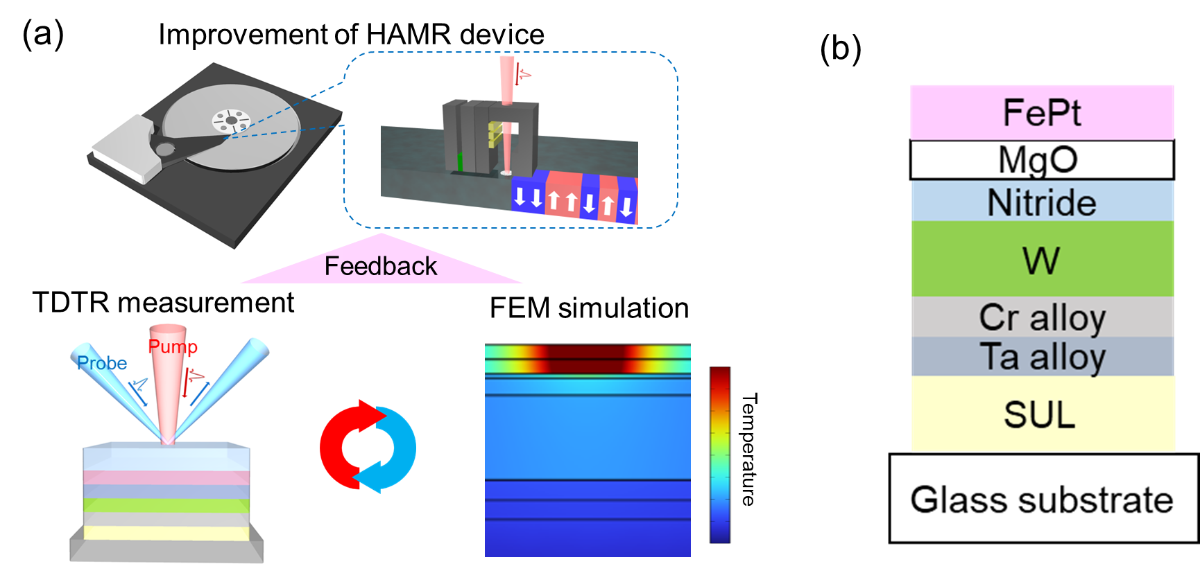

FIG. 1. (a) Concept of the experiment-informed thermal characterization and modeling framework for heat-assisted magnetic recording (HAMR) media. Thermal transport properties including interfacial thermal resistances in a realistic HAMR medium are first determined by time-domain thermoreflectance (TDTR) method. The experimentally obtained thermal transport properties are then directly implemented in finite-element method (FEM) simulations to calculate the HAMR performance such as temperature distribution, magnetic writing width, and thermal gradient in the recording layer. This approach accelerates the improvement of HAMR performance. (b) Schematic illustration of a representative HAMR media stack structure, consisting of a magnetic recording layer (FePt), internal layers (Ta alloy, Cr alloy, Nitride and MgO layers ), heat-sink layer (W), and soft magnetic underlayer (SUL).
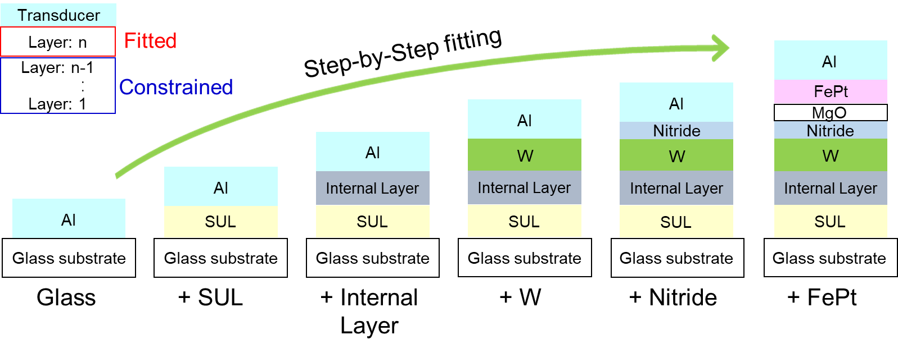

FIG. 2. Structure of the HAMR media and TDTR analysis workflow using layer-stop samples. Here shows schematic cross-section of the seven-layer HAMR stack, consisting of an Al layer, FePt recording layer, MgO interlayer, nitride interlayer, W heat-sink layer, Cr alloy and Ta alloy combined layer (internal layer), soft magnetic underlayer (SUL), and glass substrate. The step-by-step fitting analysis starts from the Al thin film on a glass substrate. As additional layers are added, TDTR measurements are repeated while constraining the thermal properties of all underlying layers within their uncertainty ranges and fitting only the thermal conductivity and interfacial thermal resistances of the added layer.

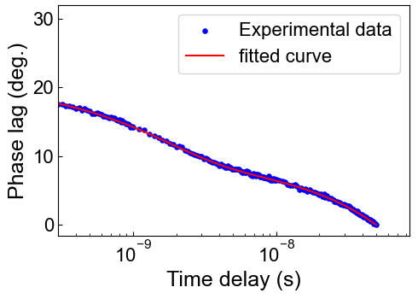

FIG. 3. TDTR phase signal (blue plots) and step-by-step fitting result (red line) for the final layer-stop sample corresponding to the realistic HAMR stack including the nitride/MgO/FePt layers. The TDTR fitting curves for all layer-stop samples is shown in Supplementary Fig. S1, the corresponding sensitivity curves are shown in Supplementary Fig. S2, and detailed procedures for the uncertainty and upper-bound analyses are described in the Supplementary Material.

Layer | Thickness (nm) | κ (W/m/K) | R (K·m²/MW)  with underlying layer | Effective thermal resistance (K·m²/MW)
FePt | 17.3 | 18 ± 2 | 5.9 ± 0.1 | -
Nitride | 10.1 | 29 ± 6 | 1.5 ± 0.1 | -
W | 48.5 | 47 ± 7 | 2.0 ± 0.3 | -
Internal Layer | 23.4 | - | < 1.22 | 12.8 ± 0.7
SUL | 50.0 | 1.8 ± 0.1 | < 13.7 | -
Thermal effusivity of Glass substrate: 1407 ±9 (W·s^{0.5}/m²/K)

Table. 1. Thermal transport properties and thicknesses of the HAMR media obtained from the step-by-step TDTR analysis. For each layer, the out-of-plane thermal conductivity (κ), thickness, interfacial thermal resistances to the underlying layers (R), effective thermal resistance, and the thermal effusivity of the glass substrate. The Ta alloy layer and Cr alloy layer were combined and treated as an Internal layer and their contribution was evaluated as an effective thermal resistance. In addition, the MgO layer was not treated as an independent layer because of its very small thickness, but was instead represented as an interfacial thermal resistance.

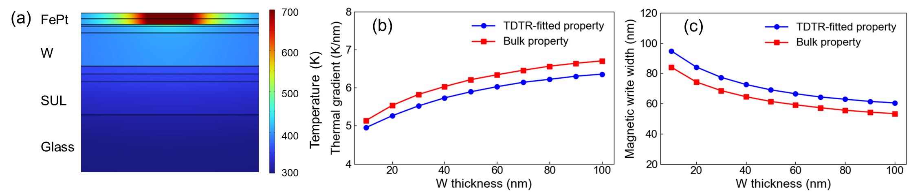

FIG. 4. Two-dimensional FEM-simulated thermal response of the HAMR media using TDTR-informed thermal parameters. (a) Temperature distribution at t = 8 ns under laser heating for W heat-sink layer thickness of 50 nm. (b) Thermal gradient in the HAMR multilayer structure under pulsed laser heating. (c) Magnetic writing width (MWW) at the FePt recording layer as a function of W heat-sink layer thickness. Thermal gradient is defined as the in-plane temperature gradient, $∂T/∂x$, evaluated at T = 700 K isotherm in the FePt layer and MWW is defined as the lateral width of the region in the FePt layer where the temperature exceeds 700 K. The red square symbols indicate the FEM results obtained using the bulk thermal conductivity of the W heat-sink layer for comparison.

