Water vapor adsorption performance of hydrophobic zeolite bulks with mesopores and interconnected macropores

Masako Uematsu^{a,b*}, Kento Ishii^{c}, Sadaki Samitsu^{d}, Teiichi Kimuraª, Tetsuo Uchikoshi^{b,e}

ª Materials Research and Development Laboratory, Japan Fine Ceramics Center,
Nagoya, Aichi 456-8587, Japan.
^{b} Graduate School of Chemical Sciences and Engineering, Hokkaido University,
Sapporo, Hokkaido 060-8628, Japan.
^{c}Advanced Ceramics Research Center, Nagoya Institute of Technology,
Tajimi, Aichi 507-0033, Japan.
^{d} Microstructural Characterization Platform, National Institute for Materials Science,
Tsukuba, Ibaraki 305-0047, Japan.
^{e} Research Center for Electronic and Optical Materials, National Institute for Materials Science,
Tsukuba, Ibaraki 305-0047, Japan.

Corresponding author: Masako Uematsu
E-mail: masako_uematsu@jfcc.or.jp; Phone: +81-52-66-1666, Fax: +81-52-871-3599
Postal address: 2-4-1 Mutsuno, Atsuta-ku, Nagoya, Aichi, 456-8587, Japan.

Abstract
Humidity-control materials that maintain a comfortable indoor environment are required to have both of high water-vapor absorption properties under high humidity and appropriate moisture release properties around 40-70% relative humidity. Such properties are often observed in mesoporous materials but are generally absent in zeolites, which are microporous materials. Bulk zeolite bodies with mesopores and interconnected macropores we previously reported were characterized by mercury porosity and water vapor adsorption/desorption measurement. The bulk material had bottleneck-shaped pores and possessed a humidity-controlling function not exhibited in conventional zeolite materials. Bulk zeolites demonstrated potential as an excellent humidity-control material with VOCs removal functions owing micropores.
Keywords: ZSM-5, mesoporous material, zeolite bulk, three-dimensional structure, H2O gas adsorption

- Introduction
In modern airtight buildings, humidity-controlled materials that adsorb and release water vapors in response to temperature and humidity changes are in demand to maintain a comfortable environment. The comfort relative humidity range for humans is 40 %–70 % [1]; extremely humid or dry environments can adversely affect human health. To exert a humidity-control function, a material should possess high water–vapor-adsorption property at high humidity and a water-–vapor-releasing property at an appropriate humidity. Humidity- controlled porous ceramics made from natural clay minerals, such as allophane, have been developed and are commercially available as construction materials that exhibit such properties [2].
Zeolite has been examined as a highly functional construction material with the ability to adsorb water and remove harmful volatile organic compounds (VOCs) owing to its microporous structure. In particular, the water–vapor-adsorption properties of zeolites have been previously investigated as potential materials for humidity-control tiles [3]. Moreover, natural zeolites, such as mordenite, have been proposed as construction materials with the ability to adsorb moisture and VOCs [4]. Although common zeolites exhibit excellent water–vapor-adsorption properties, their water–vapor-releasing properties are limited, making them unsuitable for humidity-control applications.
The humidity-control function of clay minerals is attributed to the capillary condensation of water owing to the mesopores [5]. Our research group previously reported the fabrication of a high-strength porous bulk material with mesopores using ZSM-5, a high-silica zeolite that is widely used in the industry [6]. Zeolite bulk materials with mesopores have the potential to be used as building materials because of their ability to facilitate capillary condensation of water within their mesopores, exerting a humidity control function. Therefore, the porous structure on the surface of bulk zeolites and their water-–vapor-adsorption properties were investigated.

- Material and methods
Previously reported bulk ZSM-5 zeolites were characterized [6]. The raw materials used were commercially available ZSM-5 powder (HSZ- 840HOA, Tosoh Corp.), colloidal silica (Snowtex ST-S, Nissan Chemical Corp.), and rice starch (Sigma-Aldrich Co., LLC), and these were used as pore-forming agents. In previous studies, a process using starch was used to fabricate connected macropore structures. Three types of bulk bodies with different pore structures were fabricated by different starch treatment processes. The presence of micropores and mesopores in all the bulk bodies was confirmed by X-ray diffraction measurements (Mini f lex600, Rigaku) and nitrogen gas adsorption/desorption isotherms. The macropore structure significantly changed based on differences in the starch formation processes, as evidenced by the three-dimensional observation of the internal structure via confocal laser fluorescence microscopy (CLFM; TCS-SP5, Leica Microsystem). CLFM observations were performed by allowing 1-methyl-2-francalboxyrate, which served as an immersion liquid, to permeate the pores and suppress the strong light scattering caused by the macroporous structure.
The pore structures of the bulk bodies were characterized by mercury intrusion and extrusion curves obtained using a mercury porosimeter (AutoPore IV 9520, Micromeritics Instrument Corp.). The Washburn method was used for analysis. The adsorption/desorption isotherms of water vapor at 313.15 K were measured using a surface area and pore size distribution analyzer (BELSORP-II, MicrotracBEL Corp.), to compare the adsorption/desorption characteristics of water on the sur face of the bulk zeolites.

- Results and Discussion
Fig. 1 depicts the macropore structures of the three bulk bodies observed using CLFM. In Fig. 1, the pores are shown in white. Sample (1) (Fig. 1(a)) is a bulk prepared without starch, and it does not contain macropores larger than 1 μ m. Sample (2) (Fig. 1(b)), prepared with granular starch, exhibits spherical macropores with a size of ~ 5–10 m. Sample (3) (Fig. 1(c)), exhibits a continuous macropore structure derived from the heat treatment of starch during preparation.
Notably, only macropores larger than approximately 1 μm are visible in Fig. 1. A black portion, which seems to lack pores, contains mesopores and micropores that are not discernible at the resolution of observation. The Archimedes method demonstrated that Sample (1) contained 34 % pores that were not visible in Fig. 1(a). Similarly, Samples (2) and (3) contained pores with a size of less than 1 μ m.
Fig. 2 shows the results of mercury porosimetry. Fig. 2(a) shows the intrusion and extrusion curves of the three samples. The extrusion curves were not obtained in the low-pressure region because there were points at which the pressurization method of the equipment was switched to hydraulic pressure. The total pore volumes determined from the intrusion curves were similar for Samples (2) and (3), at 0.42 mL/g. However, Sample (1) exhibited a smaller value of 0.25 mL/g. This discrepancy can be attributed to the macropores, formed by the pore- forming agents. As shown in Fig. 2(a), the intrusion and extrusion curves of the samples do not overlap. The hysteresis shape, in which the extrusion curve is above the intrusion curve, indicates that mercury is retained in the pores during depressurization. This indicates the presence of bottleneck-shaped pores, where the entrance size is smaller than the internal diameter [6]. The images of the pore shapes shown in Fig. 1 corroborate this result.
The pore size distributions calculated from the intrusion and extrusion curves are shown in Fig. 2(b) and (c), respectively, and Fig. 2 (d) shows an enlarged view of the range of pore diameters around 10 m in Fig. 2(b). In Fig. 2(c), the peak corresponding to the maximum peak in Fig. 2(b) was eliminated because of the bottleneck shape of the pores. The position of the maximum peak of each curve in Fig. 2(b) indicates the typical entrance diameters of the samples. Furthermore, all samples exhibited a peak in the mesopore region of 0.007 μm, as shown in Fig. 2 (b). In Fig. 2(c), the peaks were present at 0.01–0.02 μm. The peak positions corresponding to mesopores varied between Fig. 2(b) and (c). Therefore, the mesopores can also be assumed to have a bottleneck shape with a wide interior and narrow entrance.
The images of the pore structures shown in Fig. 1(b) and (c) suggest that the two samples have entrance size peaks in the range of several microns. Furthermore, the presence of peaks at 7–9 μ m were confirmed for Samples (2) and (3) in Fig. 2(d), where the entrance diameter distribution was expanded. To interpret a hierarchical or non-cylindrical pore structure, the results of mercury porosimetry should be combined with the three-dimensional observation of the structure.
Fig. 3 shows the water adsorption/desorption isotherms of bulk and raw zeolite powders. The raw material powder exhibited the characteristics of a typical microporous material with no hysteresis curves. Materials with a small difference in the amount of water adsorbed in low- and high-humidity environments are not suitable for humidity control because of the saturation of the water adsorbed in low-humidity environments. In contrast, all the bulk bodies exhibited hysteresis curves with large differences in moisture uptake at low and high humidity levels, which are not exhibited in common zeolite powders. A similar water adsorption/desorption isotherm with a hysteresis curve was previously reported for commercially available humidity-control tiles made from natural clay [3]. The large difference in the amount of adsorbed water depends on the humidity level, indicating the good response of the material to humidity changes. The hysteresis indicates the higher tendency of the material to retain water because the humidity required to release water is lower than that required to adsorb water.
The amount of water adsorbed on each sample corresponded to the magnitude of the mesopore peak observed in Fig. 2(b). The amount of adsorption varied depending on the sample preparation process. The hysteresis curves observed in the desorption isotherms were attributed to capillary condensation of the adsorbate within the mesopores. Therefore, the number of mesopores contributes more to water adsorption than the total pore volume or number of macropores. The bottleneck shape of the mesopores, as confirmed by mercury porosimetry, is theoretically advantageous for water retention within the pores.
ZSM-5 is a synthetic zeolite with a hydrophobic surface The VOC adsorption performance of natural hydrophilic zeolites decreases in the presence of water vapor because of the competitive adsorption of water and VOCs [7]. In contrast, hydrophobic zeolites maintain their good performance even in the presence of water vapors [8]. Therefore, the fabrication of mesoporous materials from synthetic zeolites can be used in developing materials with customizable properties, such as moisture control and adsorption of harmful substances.

Conclusions
The novel bulk zeolite body material exhibited bottleneck-shaped macropores with submicron-level inlets on its surface. The shift in the typical inlet diameter distribution confirmed the bottleneck shape of the mesopores. Furthermore, the material exhibited a humidity control function, as evidenced by the hysteresis curve of the water adsorption–desorption isotherm. For materials with hierarchical pore structures, the structures can be characterized by combining the observations of the three-dimensional structure with those surface characterization techniques, such as mercury porosimetry. The potential of the bulk zeolite, prepared from a hydrophobic zeolite with VOC adsorption properties, as a humidity-control material was demonstrated.

Acknowledgements
Funding: This study was supported in part by the Kazuchika Okura Memorial Foundation of Japan.

References
[1] J. Castellano, V. Sanz, E. Cañas, E. Sánchez, J. Eur. Ceram. Soc.42 (2) (2022) 716-723.
[2] S.Terao, K. Gotou, P3041348, Japan Patent Office, 15 May. 2000.
[3] H. Fukumizu, S. Yokoyama, K. Kitamura, Resources processing (Kankyo-shigen-kougaku) 52 (2005) 128-135.
[4] Y. Shibazaki, K. Oda, S. Sano, M. Maeda, Y. Muraguchi, H. Fukumizu, M. Kosaka, P4332605, Japan Patent Office, 16 Sept. 2009.
[5] H. Maeda, E. H. Ishida, Ceram. Inter.35 (3) (2009) 987-990
[6] M. Uematsu, K. Ishii, S. Samitsu, E. B. Ismail, I. Ichinose, N. Ohashi, D. Berthebaud, J. Halet, T. Ishigaki, T. Uchikoshi, Adv. Powder Technol. 33(6) (2022) 103626
[7] M. Kraus, U. Trommler, F. Holzer, F. D. Kopinke, U. Roland, Chem. Eng. J. 351 (2018) 356–363.
[8] T. Yin, X. Meng, S. Wang, X. Yao, N. Liu, L. Shi, Sep. Purif. Technol.280 (2022) 119634

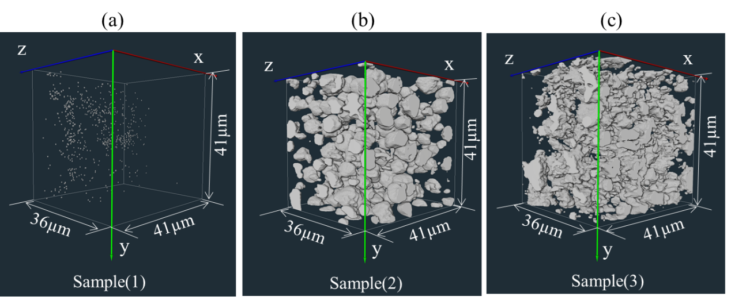
Fig. 1 Three-dimensional images of macropores obtained using from CLFM images: (a) Sample (1) (pore-forming agent free sample), (b) Sample (2) (with starch grains as pore-forming agent), and (c) Sample (3) (with starch networks as pore-forming agent).

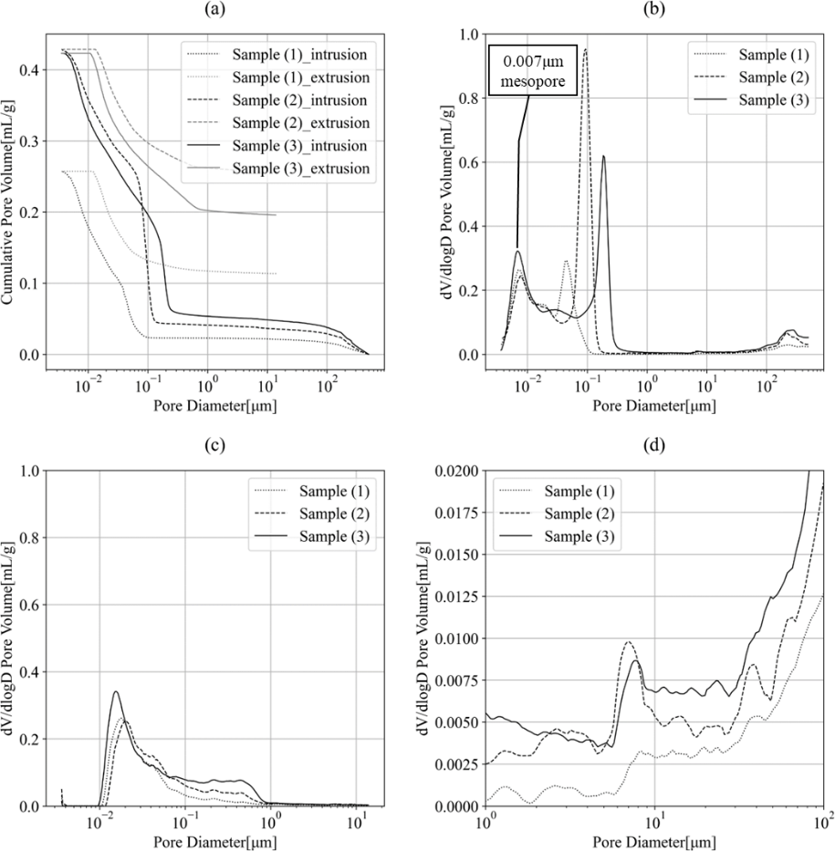
Fig. 2 Mercury porosimetry results: (a) mercury intrusion and extrusion curves, (b) pore size distribution estimated from the intrusion curves, (c) pore size distribution estimated from the extrusion curves, and (d) enlarged view of the range of pore diameters around 10 μm in Fig. 2(b).

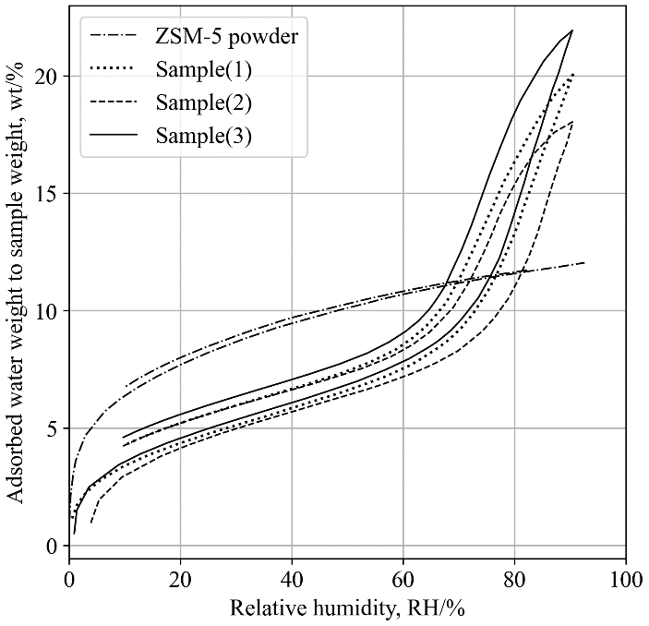
Fig. 3 Water vapor adsorption/ desorption isotherm of the zeolite bulks and raw material at 298.15 K

