Promoting effects of alternating current and input power on grain growth behavior of cubic ZrO₂ polycrystals

Kohta Nambu^{1,2}, Akio Ishii³, Kohei Soga³, Koji Morita^{1,2,3}

¹Department of Materials Science and Engineering, Kyushu University, 744 Moto-oka, Nishi-ku, Fukuoka, 891-0395, Japan
²National Institute for Material Science, 1-2-1 Sengen, Tsukuba, Ibaraki, 305-0047, Japan
³Department of Materials Science and Technology, Tokyo University of Science, 6-3-1 Niijuku, Katsushika-ku, Tokyo, 125-8585, Japan

*Author to whom correspondence should be addressed.
e-mail: nambu.kohta.188@s.kyushu-u.ac.jp

Keywords: Flash event, Electric current, Zirconia, Grain growth, AC field

ABSTRACT
The grain growth behavior during an AC flash event was examined in 8 mol% yttria-stabilized cubic zirconia (8Y-CSZ) polycrystals. The effects of current/power densities on the grain growth behavior were investigated in 8Y-CSZ samples with different specific surface areas at a constant sample temperature and applied field strength. The grain growth rate of flash-treated 8Y-CSZ was 300 times faster than that of heat-treated 8Y-CSZ at the same sample temperature in the absence of an electric current/field, suggesting that the promoted grain growth cannot be ascribed only to a thermal effect but also to an athermal effect occurring during the AC flash event. Moreover, the grain growth during the flash treatment strongly depends on the applied current/power densities and grain size; in particular, the grain growth showed enhancements with increasing applied current/power densities and for relatively small grain sizes. This result suggests that the grain boundary diffusivity of cations, which are regarded as the rate-controlling species for grain growth, could be accelerated by tuning the current/power densities during the flash event. The grain growth mechanism was characterized using a grain growth exponent (n) value of 4.8 for the flash treatment at high current/power densities and using a conventional value of n = 3 under normal heat treatment conditions. The dependence of the grain growth behavior on the AC current/power density suggests that because the cation diffusivity is accelerated due to the formation of numerous point defects during the AC flash event, the grain growth mechanism might depend on the current/power densities and differ from that of conventional grain growth.

- INTRODUCTION
The flash event is a peculiar behavior occurring when an electric field larger than a critical value is applied to a ceramic green compact, which results in an instantaneous complete sintering even at relatively low temperatures.^{1–4} Despite the intense efforts that have been devoted to the elucidation of the flash event mechanism, this is still under discussion. The primary mechanism of the flash event has been ascribed to an accelerated diffusivity caused by a thermal effect due to thermal runaway,⁵ which is an avalanche effect due to Joule heating that results in an increase in the sample temperature and consequently in the electrical conductivity. In contrast, athermal effects that cannot be explained by temperature increment due to the Joule heating have also been suggested to promote atomic diffusivity in materials.⁶ For example, high-temperature processes such as enhanced plastic deformation^{7–14}, diffusion joining,^{15–17} and crack healing^{18–21} of fully densified yttria-stabilized zirconia (YSZ) materials have already been achieved at lower temperatures and in shorter times. Therefore, during the flash event, cation diffusion, which is regarded as the rate-controlling process in high-temperature processes, is expected to be promoted athermally by applying an electric field and current. Previous studies have revealed that the DC flash event introduces excess oxygen vacancies into the sample due to a strong reduction, resulting in an enhanced diffusion event.^{22–31} Our recent studies have also suggested that even during a AC flash event, the formation of polarity-independent and positively charged excess oxygen vacancies and changes in the chemical bonding states are associated with promoted diffusivity.³²
To clarify the athermal effects on the diffusion phenomena during a flash event, the effects of the electric field and current on the microstructures have been investigated in the flash sintering of zirconia systems.^{27, 29–31, 33–45} However, conflicting results have been described even for the same zirconia system. For example, Ren et al. reported that the grain growth in flash-sintered YSZ samples was accelerated upon increasing the current density in the range of 100–500 mA/mm².³⁷ The current density dependence of the grain growth rate was attributed to the generation of oxygen vacancies due to electrical reduction during the flash event. Dong et al. also reported that increasing current density in the range of 10-600 mA/mm² promoted the grain growth near the cathode in fully densified YSZ bodies.^{28, 30, 31} They concluded that the polarity-dependent gradient of the oxygen potential of the DC electric field increased with increasing current, and that the decrease in oxygen potential, especially near the cathode, increased the diffusivity of cations. In addition, Liu et al. reported that the grain size of flash-sintered YSZ samples increased with increasing applied field strength in the range of 70–300 V/cm.⁴¹ The acceleration of the grain growth under an electric field was explained in terms of the segregation of $Y_{Zr}^{´}$ along the grain boundaries and the generation of space-charge layers due to oxygen vacancies. Other studies have indicated that the grain growth is enhanced during the flash event as a result of the generation of defects such as oxygen vacancies.^{28–31, 34, 36, 38, 39, 45} In contrast, opposite results stating that the electric field and current suppress the grain growth have also been reported.^{33, 35, 40, 43, 44} For example, Ji et al. showed that the grain growth of flash-sintered YSZ samples at a current density of 42 mA/mm² was suppressed compared with that of a rapid heating treatment without an electric field.³³ This result was attributed to the interaction between the electric field and the space charge formed along the grain boundaries. In addition, Conrad and Wang argued that the suppressed grain growth under an electric field is mainly related to the Frenkel defects generated by the electric field; the Frenkel defects can reduce the grain boundary energy, and hence, lower the rate of the grain growth.^{43, 44}
As mentioned above, the grain growth behavior during the flash event has already been reported in several studies. However, the specific effects of electric field and current on the promotion or inhibition of the grain growth during the flash event remain unclear. In the previous studies, several factors prevented revealing the effects of electric field and current on the grain growth. First, since the grain growth was examined during the flash sintering, the pure intrinsic grain growth behavior was not evaluated; the intrinsic grain growth component might be masked by the grain coarsening occurring during densification in the sintering process.^{33–41, 45} Second, the thermal and electric field/current effects on the grain growth during the flash event were not evaluated separately from the experimental results; the effect of the electric field strength and current density on the grain growth was investigated at different temperatures.^{33, 35, 37, 41} With regard to the current effect on the grain growth promotion during the flash sintering, although the promotion effect was examined by comparing the sintered microstructures, the sample temperatures during the flash sintering differed by 1000°C depending on the current density.³⁷ Meanwhile, the promotion effect of the electric field on the grain growth was determined at temperatures that differed by 830°C.⁴¹ To investigate the suppression of the grain growth induced by an electric field, the microstructures were compared in samples flash-sintered at temperatures differing by 70°C.³³ Therefore, in such studies, the effects of electric field and current on the microstructure were investigated under different temperature conditions due to Joule heating caused at different electric field/current, which prevents evaluating precisely the athermal effect on the grain growth during the flash event.
To investigate the athermal effects on the grain growth behavior, the grain growth behavior during the flash event should be examined at the same sample temperatures. The relationship between the sample temperature and the power density during the flash event have often been characterized by the following blackbody radiation relationship:^{5, 6}

$T_{s}= {\left[T_{f}^{4}+ \frac{W}{Aεσ}\right]}^{1/4}$, (1)

where T_{s} is the sample temperature, T_{f} is the furnace temperature, W is the power dissipation, A is the surface area of the sample gauge section, σ is the Stefan–Boltzmann constant, and ε is the emissivity. Since the electric field and current during the flash event cannot be separated from each other and individual control of each parameter is difficult, the sample temperature has generally been related to the power density. In addition, the sample temperature depends strongly on the surface area owing to thermal losses from the surfaces. Hence, the term of W/A on the right side of Eq. (1) can be expressed by the power density (P) as follows:
$\frac{W}{A} = \frac{W･V}{A･V} = \frac{P}{S} ,$ (2)
Accordingly, Eq. (1) can be rewritten as
$T_{s}= {\left[T_{f}^{4}+ \frac{P}{Sεσ}\right]}^{1/4}$, (3)
where P is the power loss per unit volume at the steady state and S is the specific surface area of the sample gauge section.
Using Eq. (3), under a constant furnace temperature condition, the sample temperature can be determined according to the relationship between the power loss and the specific surface area. Hence, if the specific surface area is varied by controlling the sample width, the dependence of the current/power densities on the grain growth behavior can be evaluated by maintaining a constant sample temperature and electric field strength.
On the basis of these considerations, this study investigated the athermal effects of the current/power densities on the grain growth behavior at the same temperature in 8 mol% yttria-stabilized cubic zirconia (8Y-CSZ) samples with different specific surface areas.

- EXPERIMENTALPROCEDURES
The material used in this study was a fully densified 8Y-CSZ body fabricated via conventional pressureless sintering using commercially available 8Y-CSZ powder (TZ-8Y; Tosoh Co., Japan). Green compacts of the raw powder were prepared using cold isostatic pressing at 350 MPa and densified via conventional sintering in ambient air at 1250°C for 40 h. The density of the samples was measured using the Archimedes method (the theoretical density of 8Y-CSZ is 5.90 g/cm³).⁴⁶ A fully dense sample with a relative density of >98% was used for the grain growth experiments. The average grain size of the as-sintered 8Y-CSZ body was 0.8 μm. The densified body was ground into rectangular specimens with dimensions of 1.5 × 1.6 × 26 and 3.3 × 1.6 × 26 mm³ and specific surface areas of 2.6 and 1.9 mm⁻¹, respectively. The corresponding flash-treated (FT) samples were denoted as FT-2.6 and FT-1.9, respectively.
The grain growth experiments under AC flash conditions were performed in a box-type electric furnace, as described in a previous report.¹⁸ For the flash treatment, both ends of the rectangular specimen were coated with Pt paste to make electrodes and fasted by Pt wires. The distance of the electrode was approximately 20 mm. The rectangular specimen was suspended from two Pt wires in the electric furnace. The furnace was heated to 600°C, 800°C, and 1000°C. After the furnace temperature reached the set value in air, an AC square wave with a maximum strength of 50 V/cm was applied to the samples using a high voltage power supply (PKT330-13.5 (800 W), Matsusada Precision, Japan) via the two Pt wires. The flash experiments under the AC field were conducted at a constant frequency of 500 Hz. The maximum current limit was controlled at a current density of 200-300 mA/mm² to reach the sample temperatures of 1280°C, 1340°C and 1400°C. During the flash event, the surface temperatures of the specimens were measured at the center of the samples using an optical pyrometer (IR-CAS; Chino, Japan), which was pre-calibrated in a blank test at a furnace temperature of 1000°C–1400°C through an observation window made in the furnace door. The electric power supply and furnace were turned off after certain time periods.
Microstructural observations were performed on the surface of the samples after the flash experiment. The grain growth experiment and microstructure observation were repeated for the same sample for a total holding time of 30 min. To examine the effect of the AC flash treatment on the grain growth, a thermal treatment without applying an electric field was also performed at a furnace temperature of 1400°C and a duration range of 30–120 min. The dimensions of the sample used for heat treatment were 3.3 × 1.6 × 26 mm³. The heat-treated samples in the absence of an electric field were denoted as HT.
The power density (P; mW/mm³) is defined as the electric power dissipated per unit volume of the samples between the Pt wires during the grain growth experiments and is given by $P ={EJ}/{10}$, where E (V/cm) is the electric field and J (mA/mm²) is the electric current density.
After the flash treatment, the microstructures were examined via field-emission scanning electron microscopy (FE-SEM; S-4800, Hitachi High-Tech. Co., Ltd., Hitachi, Japan). The SEM images were taken from the center area of the rectangular specimen. Prior to the grain growth experiment during the flash treatment, the surfaces of rectangular 8Y-CSZ rods were mirror-polished with 0.5 μm diamond slurry. Using the SEM micrographs, the grain size was determined by counting the number of grains. Assuming the grains to be spherical, the average grain size (d) was determined to be 1.225 times the apparent grain size, which was calculated from the average cross-sectional area per grain.⁴⁷ The d value was evaluated as an average value of more than 500 grains using the SEM images taken at 4–5 different areas.

- RESULTS & DISCUSSION
FIGURE 1 presents the applied electric field strength, current density, power density, and sample temperature as functions of time during the flash treatment on the samples with different specific surface areas. The flash experiment was performed under constant furnace and constant sample temperatures of 1000°C and 1400°C, respectively, by adjusting the power density values, which were pre-calibrated in a blank test under an AC field. When the AC field was applied to the samples, the current density steeply increased to each preset limit (FIGURE 1(b)) and the field strength was automatically reduced to maintain the preset limit of the current density (FIGURE 1(a)). After the voltage drop, the field strength remained stable at approximately 30 V/cm for FT-2.6 and FT-1.9. The power density values exhibited surges during the occurrence of the flash events (FIGURE 1(c)). The maximum power density instantaneously reached 3000 mW/mm³ only at the onset of the flash event for FT-2.6, which has a larger specific surface area than FT-1.9, but rapidly dropped to a stable value of 1000 mW/mm³ within 1 s. A rapid increase in the power density also occurred during the onset of the flash event for FT-1.9, but it rapidly decreased to a stable value of 550 mW/mm³. As shown in FIGURE 1(d), the sample temperature smoothly increased to ~1400°C within 5 s due to the rapid application of electric power to the sample; however, overheating due to the power surge did not occur. The sample temperature of FT-2.6 became unstable during the third and fourth cycles of flash treatment. However, the deviation of the sample temperature of 1400°C was negligible (±10°C), as summarized in TABLE 1. Consequently, changing the specific surface area of the sample allows evaluating the grain growth behavior under different current/power densities by maintaining the sample temperature and electric field strength almost constant.

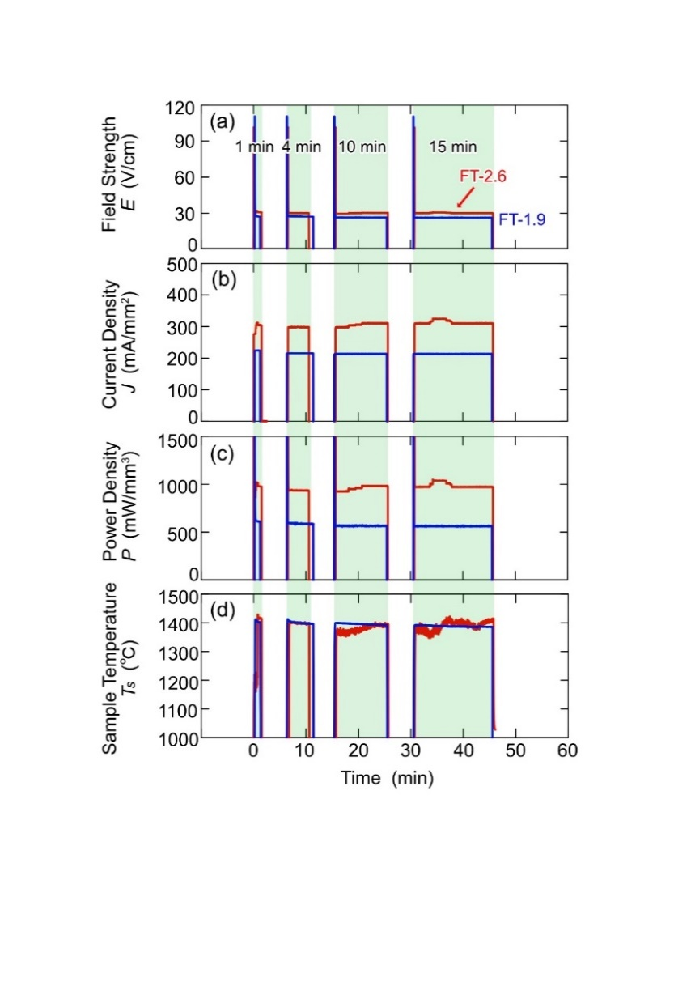
FIGURE 1 (a) Applied field strength (E; V/cm), (b) current density (J; mA/mm²), (c) power density (P; mW/mm³), and (d) sample temperature (T_{s}; °C) as functions of time during AC flash experiments on samples with different specific surface areas (FT-1.9 and FT-2.6). The grain growth experiment and microstructure observation were repeated for the same sample for a total experimental holding time of 30 min.

TABLE 1 Sample geometry, applied maximum field strength (E), current density (J), power density (P), holding time (t_{H}), sample temperature (T_{s}), and average grain size (d_{t}) in an AC flash treatment at a furnace temperature of 1000°C.

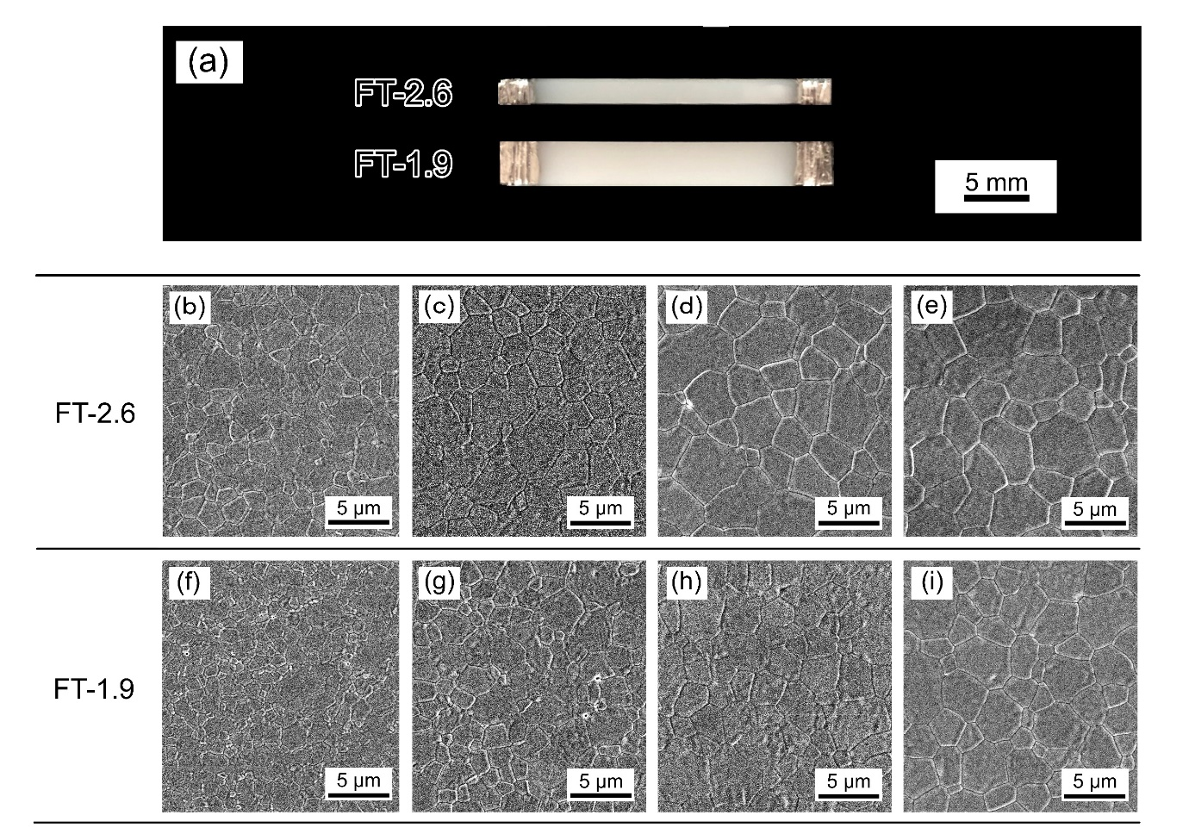
The sample appearance after the flash treatment at furnace and sample temperatures of 1000°C and 1400°C, respectively, for 30 min is shown in FIGURE 2(a). Although blackening has often been reported on DC flash experiments, it was not observed in the present AC flash samples.^{32, 48–50} FIGURES 2(b)–(i) show the SEM micrographs taken from the center of the gauge section of each sample. The microstructure of the FT samples showed uniform and equiaxed grains irrespective of the holding time and specific surface area. However, the FT samples exhibited different growth behavior depending on the specific surface area, as summarized in TABLE 1. The grain size of FT-2.6 increased from 0.8 to 2.3 μm within 1 min. After holding the flash condition for 30 min, the average grain size reached 4.5 μm. In contrast, the average grain size of FT-1.9 was 3.8 μm even after the flash treatment at the same sample temperature of 1400°C for 30 min.
FIGURE 2 (a) Sample appearance after flash treatment at a furnace temperature of 1000°C and a sample temperature of 1400°C for 30 min. SEM images of (b)–(e) FT-2.6 and (f)–(i) FT-1.9 taken at the center of the gauge sections of the flash-treated samples for holding times of 1, 5, 15, and 30 min.
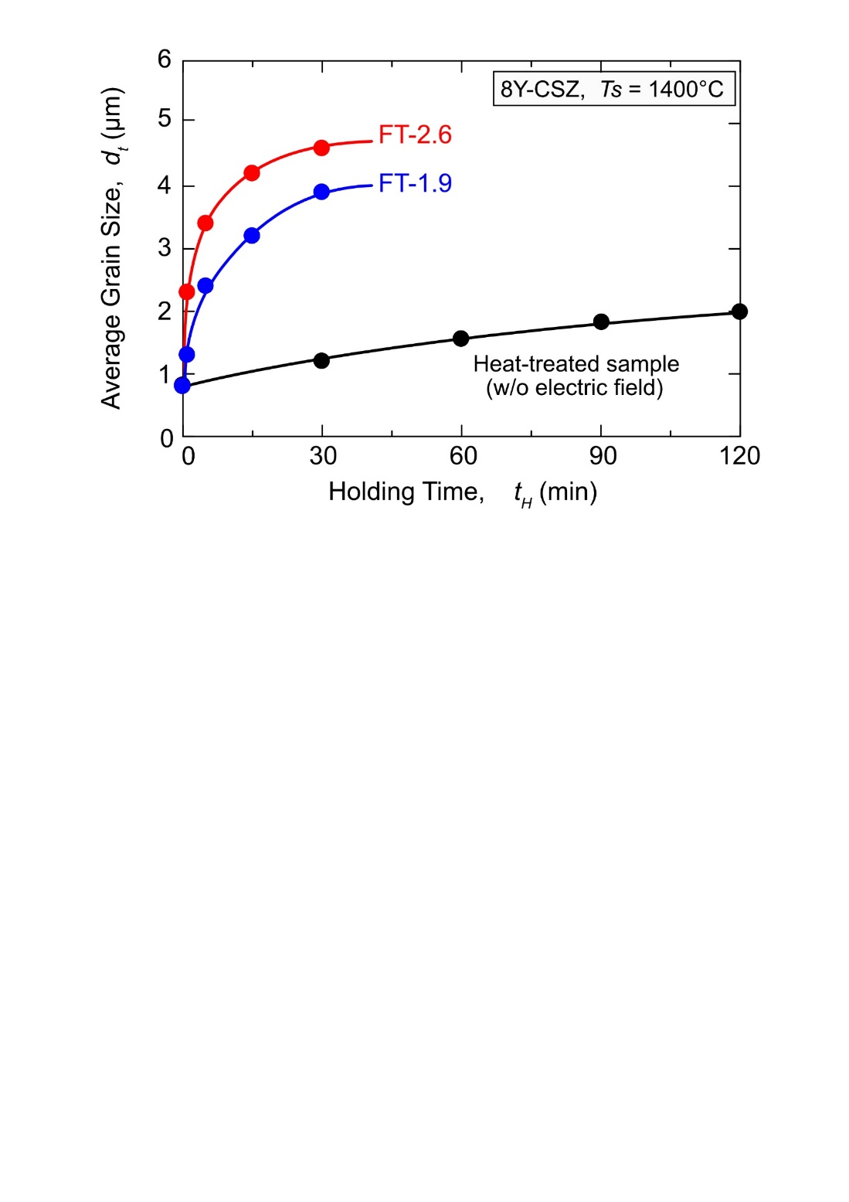
The grain growth behavior during the AC flash treatment is compared in FIGURE 3 with that during heat treatment without an electric field at the same sample temperature of 1400°C. The grain growth curves of the FT and HT samples are parabolic, with the increasing grain growth rate moderating with time. For the HT sample, the average grain size annealed for 2 h increased up to 2.0 μm, which is consistent with previous literature values.^{51–54} Despite having the same sample temperature, the grain growth of 8Y-CSZ was relatively slower in the HT sample than in FT-1.9 and FT-2.6. This indicates that the acceleration of the grain growth under the AC field cannot be explained only in terms of the thermal effect caused by Joule heating; instead, an athermal effect caused by the flash event should be also considered.
FIGURE 3 Grain growth behavior of the AC flash-treated samples FT-1.9 (blue symbols) and FT-2.6 (red symbols) at a sample temperature (T_{s}) of 1400°C. For comparison, the grain growth behavior of a heat-treated sample (black symbols) without an electric field at the same temperature is also shown.

In addition, the average grain size was apparently larger in FT-2.6 with higher current/power densities than in FT-1.9. In particular, the grain growth behavior during the flash event also seemed to depend on the grain size; the rate of the grain growth in FT-2.6 was substantial for relatively fine grain sizes but drastically became sluggish with the grain growth. A similar grain-size-dependent flash effect was confirmed in other high-temperature processes. In our recent study, the crack healing behavior of 8Y-CSZ during the flash event was strongly dependent on the initial grain size; the crack healing effect was considerably enhanced for a fine grain size of 0.8 μm compared with that for a coarse grain size of 2.4 μm.¹⁹ The grain-size-dependent healing behavior indicated that the grain boundaries play an important role in the flash event and the crack healing would be accelerated via field/current-enhanced diffusional processes. These results suggest that the athermal effects due to the flash event may activate the grain boundary diffusivity of cations and that the effect of the promoting grain boundary diffusivity might also depend on the current/power densities.
The grain growth kinetics of Ostwald ripening obey a power-law relationship given by the following equation:⁵⁵
$d_{t}^{n}-d_{0}^{n} = Kt_{H}$, (4)
where d_{t} is the average grain size at the holding time t_{H}, d₀ is the initial grain size at t_{H} = 0, K is the grain growth rate constant, and n is the grain growth exponent. To clarify the two unknown parameters K and n in Eq. (4), the slope of log–log plots of ($d_{t}^{n}-d_{0}^{n}$) and t_{H} is shown in FIGURE 4. For the appropriate n value, the slope of the double logarithmic ($d_{t}^{n}-d_{0}^{n}$) vs. t_{H} relationship should be 1, as indicated by the broken lines in FIGURE 4.
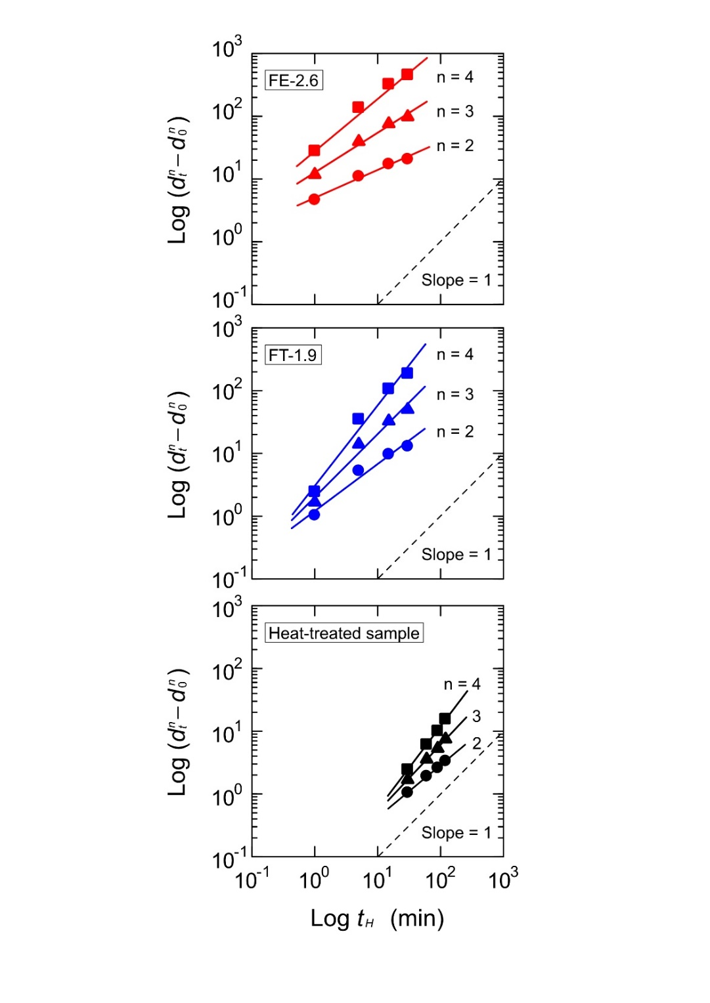
Considering the ideal slope of 1, the best-fitted n values and the resultant K value determined using FIGURE 4 according to Eq. (4) are summarized in TABLE 2. The grain growth behavior of 8Y-CSZ is generally characterized by n values of 2 or 3.^{30, 31, 51–54} Interestingly, n deviated from the conventional values only for FT-2.6, which was flash-treated at higher current/power densities. In contrast, for HT and FT-1.9, the grain growth behavior was characterized by an n value close to 3, as observed in previous studies,^{51–54} although the grain growth was faster in FT-1.9 than in HT. Meanwhile, the grain growth rate of FT-2.6 was much faster than that of FT-1.9 and was characterized by a larger n value of 4.8. A large n value of 5 is limited not only in 8Y-CSZ but also in other materials, suggesting that the grain growth mechanism during the flash event might differ from those of conventional grain growth.
FIGURE 4 Double logarithmic plots of ($d_{t}^{n}-d_{0}^{n}$) and holding time (t_{H}), where d_{t} is the average grain size at t_{H} and d₀ is the initial grain size (t_{H} = 0). The slope of the log–log plots of ($d_{t}^{n}-d_{0}^{n}$) versus t_{H} should be 1 for the appropriate grain growth exponent n (dashed line).
TABLE 2 Initial average grain size (d₀), grain growth exponent (n), grain growth rate constant (K), and slope of the log–log plots of ($d_{t}^{n}-d_{0}^{n}$) and holding time (t_{H}).

The grain growth behavior promoted by the AC flash treatment could be ascribed to the accelerated cation diffusivity because cation diffusivity is generally the predominant rate-controlling process. For example, a previous study revealed that the grain growth during the flash event was much faster than that under conventional heat treatment due to vacancy diffusion occurring at the grain boundaries.⁵⁶ Qin et al. argued that supersaturated oxygen vacancies along the grain boundaries might activate new mass transfer mechanisms, thus promoting the grain growth.³⁹ These studies suggest that point defects induced by the flash event are strongly related to diffusion phenomena at the grain boundaries. At the moment, the relevance of these results to the present study is not clear. Nevertheless, the promoted grain growth behavior can be explained in terms of the grain growth mechanism correlating to the point-defect-related diffusivity during the AC flash treatment, more remarkably at larger current/power densities.
TABLE 2 summarizes the K values for FT-2.6, FT-1.9, and HT, which were calculated assuming an n value of 3. The K value of FT-2.6 is not directly comparable to that of FT-1.9 and HT because its n value is different. Nevertheless, the K value at the conventional n value of 3 was used as a guide value for comparative purposes. The grain growth rate was largely accelerated during the flash treatment, especially in FT-2.6. The grain growth rates of FT-1.9 and FT-2.6 were approximately 50 and 300 times faster, respectively, than that of HT. Since the grain growth behavior of 8Y-CSZ would be rate-controlled by the diffusivity of cations,^{53, 57, 58} the enhancement of the grain growth by the flash event might be attributed to the increased cation diffusivity. According to these results, the cation diffusivity athermally promoted by the flash event most likely depend on the current/power densities.
The conventional grain growth behavior of 8Y-CSZ without an electric field can be expressed using the following grain growth equation:^{40, 42, 44}

$d_{t}^{3}-d_{0}^{3} = Kt_{H}$ , (5)
with
$K = \frac{48D_{0}Ωγ_{gb}}{RT}exp\left(-\frac{Q_{gg}}{RT}\right)$ , (6)

where D₀ is the pre-exponential diffusion constant, $Ω$ is the atomic volume, $γ_{gb}$ is the grain boundary energy, Q_{gg} is the activation energy of grain growth, R is the ideal gas constant, and T is the absolute temperature. Assuming that the grain growth during flash treatment also follows Eq. (6), the grain growth behavior promoted by the flash treatment can be ascribed to the following two factors: the grain boundary energy γ_{gb} must be increased, and/or the activation energy for grain growth Q_{gg} must be decreased due to the increase in the grain growth rate constant. The precise grain boundary energy under the flash-treated sample has not been reported yet. Regarding the activation energy Q_{gg} of the grain growth, on the other hand, it would be possible to evaluate experimentally based on Equation (6) by investigating the grain growth behavior at different sample temperatures.
FIGURE 5 plots the average grain size vs. holding time for FT-2.6 at different furnace temperatures of 600°C and 800°C with constant power input during the flash event. The grain growth behavior at a furnace temperature of 1000°C (Ts = 1400°C) is also shown for comparison. Irrespective of the furnace temperatures, the input power density was kept at approximately 920 mW/mm³, which is almost the same power to the furnace temperature of 1000°C. For the furnace temperatures of 600°C and 800°C, the FT-2.6 sample temperatures reached 1280°C and 1340°C, respectively (as shown in FIGURE S1). Under the constant power density conditions, the grain growth behavior of 8Y-CSZ showed the conventional trend that the rate of the grain growth increased with the sample temperature. Nevertheless, even under the different sample temperature conditions, the grain growth of the flash-treated samples shows similar trend; the rate of the grain growth tended to be faster in the relatively fine-grained region and drastically became sluggish with the grain growth.
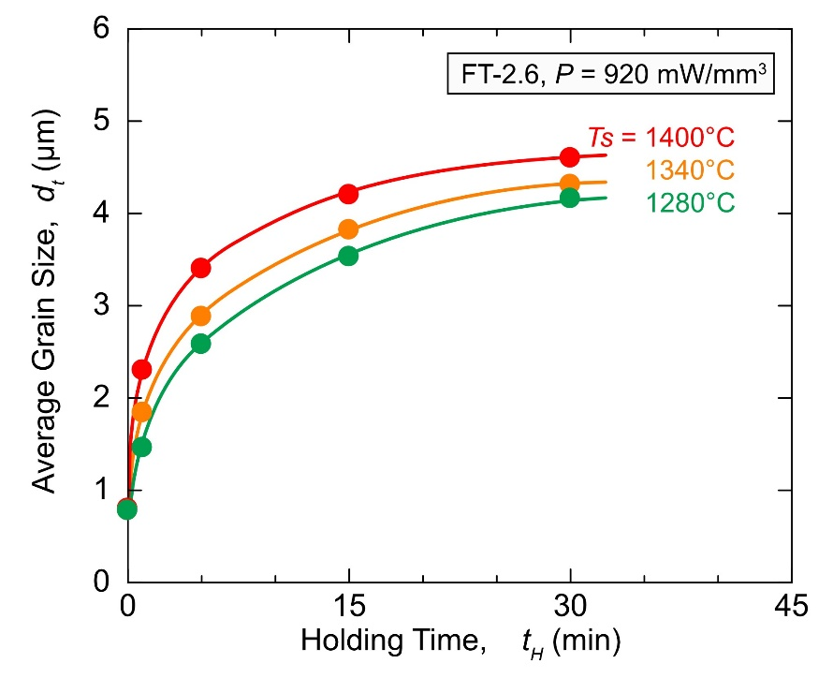
TABLE 3 summarizes the grain growth behavior of FT-2.6 at different sample temperatures; the n- and K-values were determined by double logarithmic plots. The best-fit n values changed with the sample temperatures, even though the power density and sample size were the same, as shown in FIGURE S2. The results summarized in TABLE 3 indicate that the grain growth behavior under the flash conditions is affected by complex factors such as power density, grain size and sample temperature, and hence, this would make it difficult to determine n and the grain growth mechanism.
FIGURE 5 Grain growth behavior of the AC flash-treated samples FT-2.6 at a sample temperature (T_{s}) of 1280°C (green symbols), 1340°C (orange symbols) and 1400°C (red symbols).
TABLE 3 Sample geometry, applied maximum field strength (E), current density (J), power density (P), furnace temperature (T_{f}), sample temperature (T_{s}), initial average grain size (d₀), average grain size (d_{t}) grain growth exponent (n), grain growth rate constant (K), and slope of the log–log plots of ($d_{t}^{n}-d_{0}^{n}$) and holding time (t_{H}) in an AC flash treatment at a furnace temperature of 600°C, 800°C and 1000°C.
To compare the Q_{gg} value of 8Y-CSZ with and without the electric field, the Q_{gg} value under the flash event was estimated for n = 3. This is because, first, the grain growth has often been characterized by n = 3 without the electric field,^{51–53} and second, it shows relatively reasonable slope of ~1 at n = 3 under the flash condition examined in this study (FIGURE S2). The Q_{gg} value of the conventional grain growth without the field has been reported to show about 340-400 kJ/mol.^{51–53} Under the flash event, it takes about 260 kJ/mol, which is lower than that of the conventional grain growth without the field. This trend also agrees well with the previous studies, in which it has also reported a decrease in the apparent activation energy for sintering and plastic deformation during flash events.^{12, 59} It should be noted, however, that although the Q_{gg} value under the flash event is estimated under the assumption of n = 3, additional examinations seem to be necessary to discuss the validity of the activation energy in the future. This is because the grain growth promotion during the flash event changes with the grain size; the rate of the grain growth is significant for the fine grain sizes but became sluggish with the grain growth. This suggests that the grain growth behavior under the flash conditions may be characterized separately for fine- and coarse-grain size ranges.
Regarding the decrease in the activation energy caused by the promotion of the grain growth under the flash conditions, first-principles calculations suggested that the presence of oxygen vacancies in YSZ might reduce the migration barrier for Zr cation vacancies, resulting in a lower apparent activation energy.^{60, 61} In addition, a detailed study on the photoluminescence of oxygen vacancies in flash-sintered YSZ revealed that the oxygen vacancy concentration increased with increasing current density.^{26, 62} Therefore, the apparent activation energy can be expected to decrease as the oxygen vacancy concentration increases with increasing current density during the flash event. Accordingly, it can be concluded that the activation energy of the apparent grain growth decreases upon increasing the current and power densities, thereby promoting the grain growth at high current/power densities.
- CONCLUSION
In this study, the athermal effects on the grain growth behavior of 8Y-CSZ were investigated by focusing on the effect of the current/power densities using samples with different specific surface areas. The results can be summarized as follows:
- By changing the specific surface area of the sample, the effect of the current/power densities on the grain growth behavior of 8Y-CSZ could be evaluated at constant sample temperature and electric field strength.
- Despite having the same sample temperature and a much shorter holding time, the rate of the grain growth of FT 8Y-CSZ was approximately 300 times faster than that of a heat-treated sample without an electric field/current. Therefore, the enhancement of the grain growth under the AC electric field cannot be explained only by thermal effects such as Joule heating but should be also ascribed to athermal effects induced by the large current/power densities.
- The grain growth became more pronounced in the FT samples with increasing current/power densities, and a remarkably rapid grain growth was observed for grain sizes below 2.0 μm. This result suggests that the athermal effect of athermal effects of the current/power densities might activate the grain boundary diffusivity of cations.
- For the sample FT at relatively low current/power densities, the grain growth behavior showed a conventional n value of 3 similar to that described in previous studies. In contrast, for the sample FT at higher current/power densities, the n value was estimated to be 4.8, suggesting the occurrence of a grain growth mechanism depending on the current/power densities during the flash treatment different from that of conventional grain growth.

ACNOWLEDGEMENTS
The author appreciates to the financial support by Core Research for Evolutionary Science and Technology (CREST) (JPMJCR1996) from Japan Science and Technology Agency (JST) and by Japan Society for the Promotion of Science (JSPS) KAKENHI (20H02444 and 22J11973) Japan. The authors would like to thank Enago (www.enago.jp) for the English language review.

REFERENCES
1. Cologna M, Rashkova B, Raj R. Flash Sintering of Nanograin Zirconia in <5 s at 850°C: Rapid Communications of the American Ceramic Society. J Am Ceram Soc. 2010;93(11):3556–3559. https://doi.org/10.1111/j.1551-2916.2010.04089.x
2. Dancer CEJ. Flash sintering of ceramic materials. Mater Res Express. 2016;3(10):102001. https://doi.org/10.1088/2053-1591/3/10/102001
3. Yu M, Grasso S, Mckinnon R, Saunders T, Reece MJ. Review of flash sintering: materials, mechanisms and modelling. Adv Appl Ceram. 2017;116(1):24–60. https://doi.org/10.1080/17436753.2016.1251051
4. Biesuz M, Sglavo VM. Flash sintering of ceramics. J Eur Ceram Soc. 2019;39(2–3):115–143. https://doi.org/10.1016/j.jeurceramsoc.2018.08.048
5. Todd RI, Zapata-Solvas E, Bonilla RS, Sneddon T, Wilshaw PR. Electrical characteristics of flash sintering: thermal runaway of Joule heating. J Eur Ceram Soc. 2015;35(6):1865–1877. https://doi.org/10.1016/j.jeurceramsoc.2014.12.022
6. Raj R. Joule heating during flash-sintering. J Eur Ceram Soc. 2012;32(10):2293–2301. https://doi.org/10.1016/j.jeurceramsoc.2012.02.030
7. Yoshida H, Sasaki Y. Low temperature and high strain rate superplastic flow in structural ceramics induced by strong electric-field. Scr Mater. 2018;146:173–177. https://doi.org/10.1016/j.scriptamat.2017.11.042
8. Wang K, Chen G, Wang Q, Fu X, Zhou W. Unusual electrode-dependent deformation of 3Y-TZP induced by weak electric current in oxygen-lean atmosphere. Scr Mater. 2021;205:114220. https://doi.org/10.1016/j.scriptamat.2021.114220
9. Sasaki Y, Morita K, Yamamoto T, Soga K, Masuda H, Yoshida H. Electric current dependence of plastic flow behavior with large tensile elongation in tetragonal zirconia polycrystal under a DC field. Scr Mater. 2021;194:113659. https://doi.org/10.1016/j.scriptamat.2020.113659
10. Morita K, Kim B-N. Effect of electric current on high temperature flow behavior of 8Y-CSZ ceramics. J Eur Ceram Soc. 2022;42(5):2341–2348. https://doi.org/10.1016/j.jeurceramsoc.2022.01.018
11. Liu D, Wang K, Zhao K, Liu J, An L. Creep behavior of zirconia ceramics under a strong DC field. Scr Mater. 2022;214:114654. https://doi.org/10.1016/j.scriptamat.2022.114654
12. Motomura H, Tamao D, Nambu K, Masuda H, Yoshida H. Athermal effect of flash event on high-temperature plastic deformation in Y2O3-stabilized tetragonal ZrO2 polycrystal. J Eur Ceram Soc. 2022;42(12):5045–5052. https://doi.org/10.1016/j.jeurceramsoc.2022.04.055
13. Morikawa D, Nambu K, Morita K, Yoshida H, Soga K. Effect of direct and alternating current (DC and AC) fields on creep behavior of 8 mol% Y2O3 stabilized cubic ZrO2 polycrystal. J Eur Ceram Soc. 2023;43(8):3498–3506. https://doi.org/10.1016/j.jeurceramsoc.2023.02.051
14. Tasaka M, Maeda K, Nambu K, Motomura H, Yoshida H. Sintering and deformation properties of forsterite + diopside aggregates in an electrical field. Phys Earth Planet Inter. 2023;341:107051. https://doi.org/10.1016/j.pepi.2023.107051
15. Xia J, Ren K, Liu W, Wang Y. Ultrafast joining of zirconia ceramics using electric field at low temperatures. J Eur Ceram Soc. 2019;39(10):3173–3179. https://doi.org/10.1016/j.jeurceramsoc.2019.04.023
16. Xia J, Ren K, Wang Y. One-second flash joining of zirconia ceramic by an electric field at low temperatures. Scr Mater. 2019;165:34–38. https://doi.org/10.1016/j.scriptamat.2019.02.004
17. Nambu K, Kitaoka T, Morita K, et al. Flash self‐joining of Y‐TZP ceramics assisted with an AC electric field. J Am Ceram Soc. 2023;106(3):2073–2082. https://doi.org/10.1111/jace.18889
18. Morita K, Naito F, Terada D. Microcrack healing in zirconia ceramics under a DC electric field/current. J Eur Ceram Soc. 2021;41(16):282–289. https://doi.org/10.1016/j.jeurceramsoc.2021.09.044
19. Takahashi S, Morita K, Nambu K, et al. Effect of Initial Grain Size on Crack Healing Behavior under DC Electric Field of Zirconia (8Y‐CSZ) Ceramic. Adv Eng Mater. 2023;2201807. https://doi.org/10.1002/adem.202201807
20. Kawabata S, Takahashi S, Nambu K, Morita K. Effect of DC and AC electric fields on crack healing behavior in 8 mol% yttria stabilized cubic zirconia polycrystal. J Am Ceram Soc. 2023;jace.19269. https://doi.org/10.1111/jace.19269
21. Naito F, Morita K, Terada D. Micro-Crack Healing in Cubic Zirconia (8Y-CSZ) Using Flash Event. J Jpn Inst Met Mater. 2022;86(2):23–29. https://doi.org/10.2320/jinstmet.J2021044
22. Yoshida H, Morita K, Kim B-N, Sakka Y, Yamamoto T. Reduction in sintering temperature for flash-sintering of yttria by nickel cation-doping. Acta Mater. 2016;106:344–352. https://doi.org/10.1016/j.actamat.2016.01.037
23. Nakagawa Y, Yoshida H, Uehashi A, Tokunaga T, Sasaki K, Yamamoto T. Electric current‐controlled synthesis of BaTiO ₃. J Am Ceram Soc. 2017;100(9):3843–3850. https://doi.org/10.1111/jace.14938
24. Nambu K, Hayasaka H, Yamamoto T, Yoshida H. Photoluminescence properties of undoped and Si ⁴⁺ -doped polycrystalline Y ₂ O ₃ phosphors prepared by flash-sintering. Appl Phys Express. 2019;12(7):075504. https://doi.org/10.7567/1882-0786/ab2b6e
25. Charalambous H, Jha SK, Okasinski JS, Tsakalakos T. Generation of electric-field stabilized zirconium monoxide secondary phase within cubic zirconia. Scr Mater. 2021;190:22–26. https://doi.org/10.1016/j.scriptamat.2020.08.026
26. Itoh A, Tokunaga T, Kodaira A, Yoshida H, Yamamoto T. Variation of photoluminescence intensity depending on the timing of electric field application during isothermal flash sintering for 3mol%Y2O3–ZrO2 polycrystal. Ceram Int. 2022;48(19):28712–28717. https://doi.org/10.1016/j.ceramint.2022.06.185
27. Wang S, Mishra TP, Deng Y, Kaletsch A, Bram M, Broeckmann C. Experimental and Numerical Studies of Densification and Grain Growth of 8YSZ during Flash Sintering. Adv Eng Mater. 2023;2201744. https://doi.org/10.1002/adem.202201744
28. Kim S-W, Kim SG, Jung J-I, Kang S-JL, Chen I-W. Enhanced Grain Boundary Mobility in Yttria-Stabilized Cubic Zirconia under an Electric Current. J Am Ceram Soc. 2011;94(12):4231–4238. https://doi.org/10.1111/j.1551-2916.2011.04800.x
29. Morisaki N, Yoshida H, Tokunaga T, Sasaki K, Yamamoto T. Consolidation of undoped, monoclinic zirconia polycrystals by flash sintering. J Am Ceram Soc. 2017;100(9):3851–3857. https://doi.org/10.1111/jace.14954
30. Dong Y, Wang H, Chen I-W. Electrical and hydrogen reduction enhances kinetics in doped zirconia and ceria: I. grain growth study. J Am Ceram Soc. 2017;100(3):876–886. https://doi.org/10.1111/jace.14615
31. Dong Y, Chen I. Electrical and hydrogen reduction enhances kinetics in doped zirconia and ceria: II . Mapping electrode polarization and vacancy condensation in YSZ. J Am Ceram Soc. 2018;101(3):1058–1073. https://doi.org/10.1111/jace.15274
32. Nakamoto A, Nambu K, Masuda H, Yoshida H. Chemical bonding and crystal structure in flash sintered Y2O3 under DC or AC field. J Eur Ceram Soc. 2023;43(8):3516–3523. https://doi.org/10.1016/j.jeurceramsoc.2023.01.062
33. Ji W, Zhang J, Wang W, Fu Z, Todd RI. The microstructural origin of rapid densification in 3YSZ during ultra-fast firing with or without an electric field. J Eur Ceram Soc. 2020;40(15):5829–5836. https://doi.org/10.1016/j.jeurceramsoc.2020.07.027
34. Grimley CA, Prette ALG, Dickey EC. Effect of boundary conditions on reduction during early stage flash sintering of YSZ. Acta Mater. 2019;174:271–278. https://doi.org/10.1016/j.actamat.2019.05.001
35. Dong J, Biesuz M, Sglavo VM, et al. Athermal electric field effects in flash sintered zirconia. Adv Appl Ceram. 2021;120(4):193–201. https://doi.org/10.1080/17436753.2021.1919361
36. Prajzler V, Maca K, Šťastný P, Todd RI. Abnormal grain growth in DC flash sintered 3‐mol% yttria‐stabilized zirconia ceramics. J Am Ceram Soc. 2022;105(9):5562–5568. https://doi.org/10.1111/jace.18542
37. Ren K, Xia J, Wang Y. Grain growth kinetics of 3 mol. % yttria-stabilized zirconia during flash sintering. J Eur Ceram Soc. 2019;39(4):1366–1373. https://doi.org/10.1016/j.jeurceramsoc.2018.11.032
38. Qin W, Yun J, Thron AM, Van Benthem K. Temperature gradient and microstructure evolution in AC flash sintering of 3 mol% yttria-stabilized zirconia. Mater Manuf Process. 2017;32(5):549–556. https://doi.org/10.1080/10426914.2016.1232814
39. Qin W, Majidi H, Yun J, Benthem K. Electrode Effects on Microstructure Formation During FLASH Sintering of Yttrium‐Stabilized Zirconia. J Am Ceram Soc. 2016;99(7):2253–2259. https://doi.org/10.1111/jace.14234
40. Narayan J. Grain growth model for electric field-assisted processing and flash sintering of materials. Scr Mater. 2013;68(10):785–788. https://doi.org/10.1016/j.scriptamat.2013.01.008
41. Liu D, Liu J, Gao Y, et al. Effect of the applied electric field on the microstructure and electrical properties of flash-sintered 3YSZ ceramics. Ceram Int. 2016;42(16):19066–19070. https://doi.org/10.1016/j.ceramint.2016.09.065
42. Conrad H, Yang D. Effect of the strength of an AC electric field compared to DC on the sintering rate and related grain size of zirconia (3Y-TZP). Mater Sci Eng A. 2013;559:591–594. https://doi.org/10.1016/j.msea.2012.08.146
43. Conrad H, Wang J. Equivalence of AC and DC electric field on retarding grain growth in yttria-stabilized zirconia. Scr Mater. 2014;72–73:33–34. https://doi.org/10.1016/j.scriptamat.2013.10.010
44. Wang J, Yang D, Conrad H. Transient-regime grain growth in nanocrystalline yttria-stabilized zirconia annealed without and with a DC electric field. Scr Mater. 2013;69(5):351–353. https://doi.org/10.1016/j.scriptamat.2013.05.001
45. Yao S, Liu Y, Liu D, Zhao K, Liu J. Flash sintering of Al2O3–ZrO2 ceramics under alternating current electric field. Ceram Int. 2022;48(24):36764–36772. https://doi.org/10.1016/j.ceramint.2022.08.239
46. Ingel RP, Iii DL. Lattice Parameters and Density for Y2O3-Stabilized ZrO2. J Am Ceram Soc. 1986;69(4):325–332. https://doi.org/10.1111/j.1151-2916.1986.tb04741.x
47. Apetz R, Bruggen MPB. Transparent Alumina: A Light-Scattering Model. J Am Ceram Soc. 2003;86(3):480–486. https://doi.org/10.1111/j.1151-2916.2003.tb03325.x
48. Muccillo R, Kleitz M, Muccillo ENS. Flash grain welding in yttria stabilized zirconia. J Eur Ceram Soc. 2011;31(8):1517–1521. https://doi.org/10.1016/j.jeurceramsoc.2011.02.030
49. Morisaki N, Yoshida H, Matsui K, Tokunaga T, Sasaki K, Yamamoto T. Synthesis of zirconium oxynitride in air under DC electric fields. Appl Phys Lett. 2016;109(8):083104. https://doi.org/10.1063/1.4961624
50. Yoshida H, Biswas P, Johnson R, Mohan MK. Flash-sintering of magnesium aluminate spinel (MgAl ₂ O ₄ ) ceramics. J Am Ceram Soc. 2017;100(2):554–562. https://doi.org/10.1111/jace.14616
51. Sharif AA, Imamura PH, Mitchell TE, Mecartney ML. Control of grain growth using intergranular silicate phases in cubic yttria stabilized zirconia. Acta Mater. 1998;46(11):3863–3872. https://doi.org/10.1016/S1359-6454(98)00080-9
52. Aktas B, Tekeli S, Kucuktuvek M. Grain growth and sinterability in Er ₂ O ₃ -doped cubic zirconia (c-ZrO ₂ ). Int J Mater Res. 2014;105(2):208–214. https://doi.org/10.3139/146.110999
53. Chokshi AH. Diffusion, diffusion creep and grain growth characteristics of nanocrystalline and fine-grained monoclinic, tetragonal and cubic zirconia. Scr Mater. 2003;48(6):791–796. https://doi.org/10.1016/S1359-6462(02)00519-5
54. Alexander KB, Becher PF, Waters SB, Bleier A. Grain Growth Kinetics in Alumina-Zirconia (CeZTA) Composites. J Am Ceram Soc. 1994;77(4):939–946. https://doi.org/10.1111/j.1151-2916.1994.tb07250.x
55. Nichols FA. Theory of Grain Growth in Porous Compacts. J Appl Phys. 1966;37(13):4599–4602. https://doi.org/10.1063/1.1708102
56. Chaim R, Chevallier G, Weibel A, Estournès C. Grain growth during spark plasma and flash sintering of ceramic nanoparticles: a review. J Mater Sci. 2018;53(5):3087–3105. https://doi.org/10.1007/s10853-017-1761-7
57. Chaim R. Activation energy and grain growth in nanocrystalline Y-TZP ceramics. Mater Sci Eng A. 2008;486(1–2):439–446. https://doi.org/10.1016/j.msea.2007.09.022
58. Swaroop S, Kilo M, Argirusis C, Borchardt G, Chokshi AH. Lattice and grain boundary diffusion of cations in 3YTZ analyzed using SIMS. Acta Mater. 2005;53(19):4975–4985. https://doi.org/10.1016/j.actamat.2005.05.031
59. Jalali SIA, Raj R. Reactive flash sintering in a bilayer of zirconia and lanthana: Measurement of the diffusion coefficient in real time. J Am Ceram Soc. 2023;106(2):867–877. https://doi.org/10.1111/jace.18804
60. Dong Y, Qi L, Li J, Chen I-W. Electron Localization Enhances Cation Diffusion in Reduced ZrO2, CeO2 and BaTiO3. 2018. https://doi.org/10.48550/ARXIV.1808.05198
61. Dong Y. Redox enhanced slow ion kinetics in oxide ceramics. J Am Ceram Soc. 2023;jace.19441. https://doi.org/10.1111/jace.19441
62. Morisaki N, Tokunaga T, Kobayashi K, Kodaira A, Yamamoto T. Excess oxygen-vacancy formed by FAST regime of direct-current electric field during flash sintering for 3 mol%–10 mol% Y2O3-doped ZrO2. Ceram Int. 2022;48(9):12091–12097. https://doi.org/10.1016/j.ceramint.2022.01.069

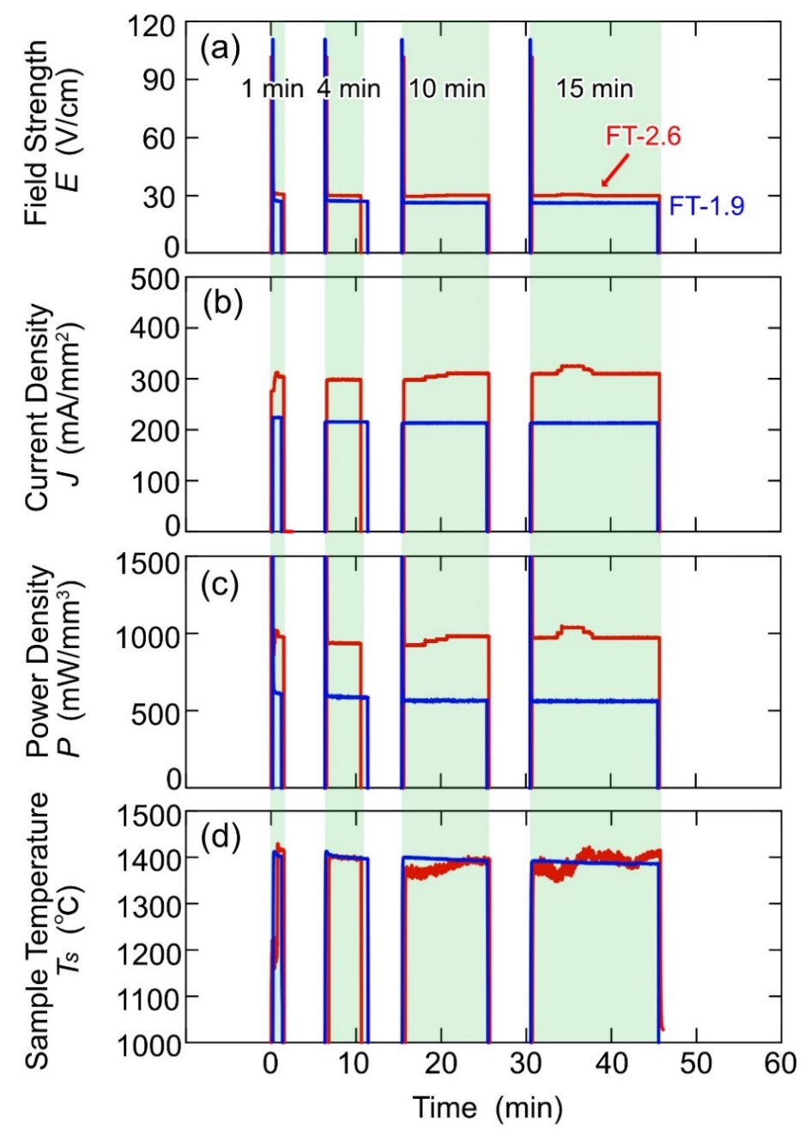
FIGURES

FIGURE 1 (a) Applied field strength (E; V/cm), (b) current density (J; mA/mm²), (c) power density (P; mW/mm³), and (d) sample temperature (T_{s}; °C) as functions of time during AC flash experiments on samples with different specific surface areas (FT-1.9 and FT-2.6). The grain growth experiment and microstructure observation were repeated for the same sample for a total experimental holding time of 30 min.

FIGURE 2 (a) Sample appearance after flash treatment at a furnace temperature of 1000°C and a sample temperature of 1400°C for 30 min. SEM images of (b)–(e) FT-2.6 and (f)–(i) FT-1.9 taken at the center of the gauge sections of the flash-treated samples for holding times of 1, 5, 15, and 30 min.

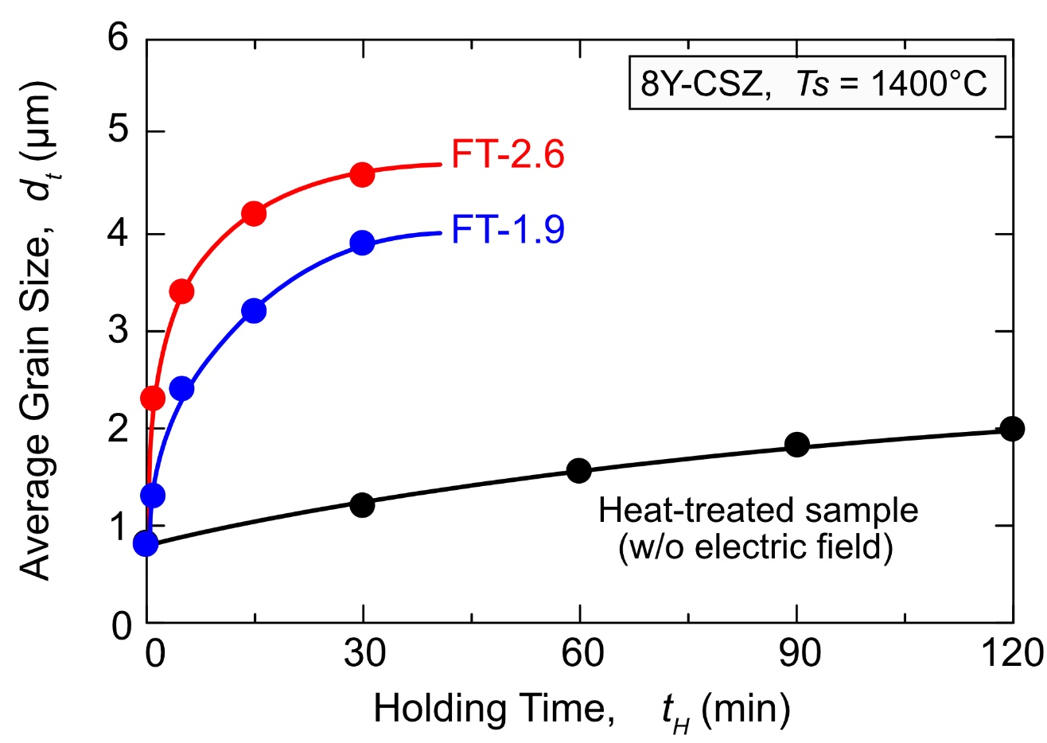

FIGURE 3 Grain growth behavior of the AC flash-treated samples FT-1.9 (blue symbols) and FT-2.6 (red symbols) at a sample temperature (T_{s}) of 1400°C. For comparison, the grain growth behavior of a heat-treated sample (black symbols) without an electric field at the same temperature is also shown.

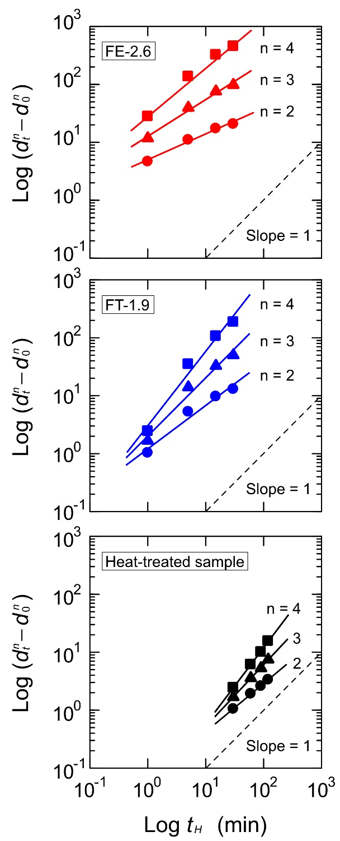

FIGURE 4 Double logarithmic plots of ($d_{t}^{n}-d_{0}^{n}$) and holding time (t_{H}), where d_{t} is the average grain size at t_{H} and d₀ is the initial grain size (t_{H} = 0). The slope of the log–log plots of ($d_{t}^{n}-d_{0}^{n}$) versus t_{H} should be 1 for the appropriate grain growth exponent n (dashed line).
FIGURE 5 Grain growth behavior of the AC flash-treated samples FT-2.6 at a sample temperature (T_{s}) of 1280°C (green symbols), 1340°C (orange symbols) and 1400°C (red symbols).

TABLE 1 Sample geometry, applied maximum field strength (E), current density (J), power density (P), holding time (t_{H}), sample temperature (T_{s}), and average grain size (d_{t}) in an AC flash treatment at a furnace temperature of 1000°C.

TABLE 2 Initial average grain size (d₀), grain growth exponent (n), grain growth rate constant (K), and slope of the log–log plots of ($d_{t}^{n}-d_{0}^{n}$) and holding time (t_{H}).

TABLE 3 Sample geometry, applied maximum field strength (E), current density (J), power density (P), furnace temperature (T_{f}), sample temperature (T_{s}), initial average grain size (d₀), average grain size (d_{t}) grain growth exponent (n), grain growth rate constant (K), and slope of the log–log plots of ($d_{t}^{n}-d_{0}^{n}$) and holding time (t_{H})in an AC flash treatment at a furnace temperature of 600°C, 800°C and 1000°C.

SUPPLIMENTARY FIGURES
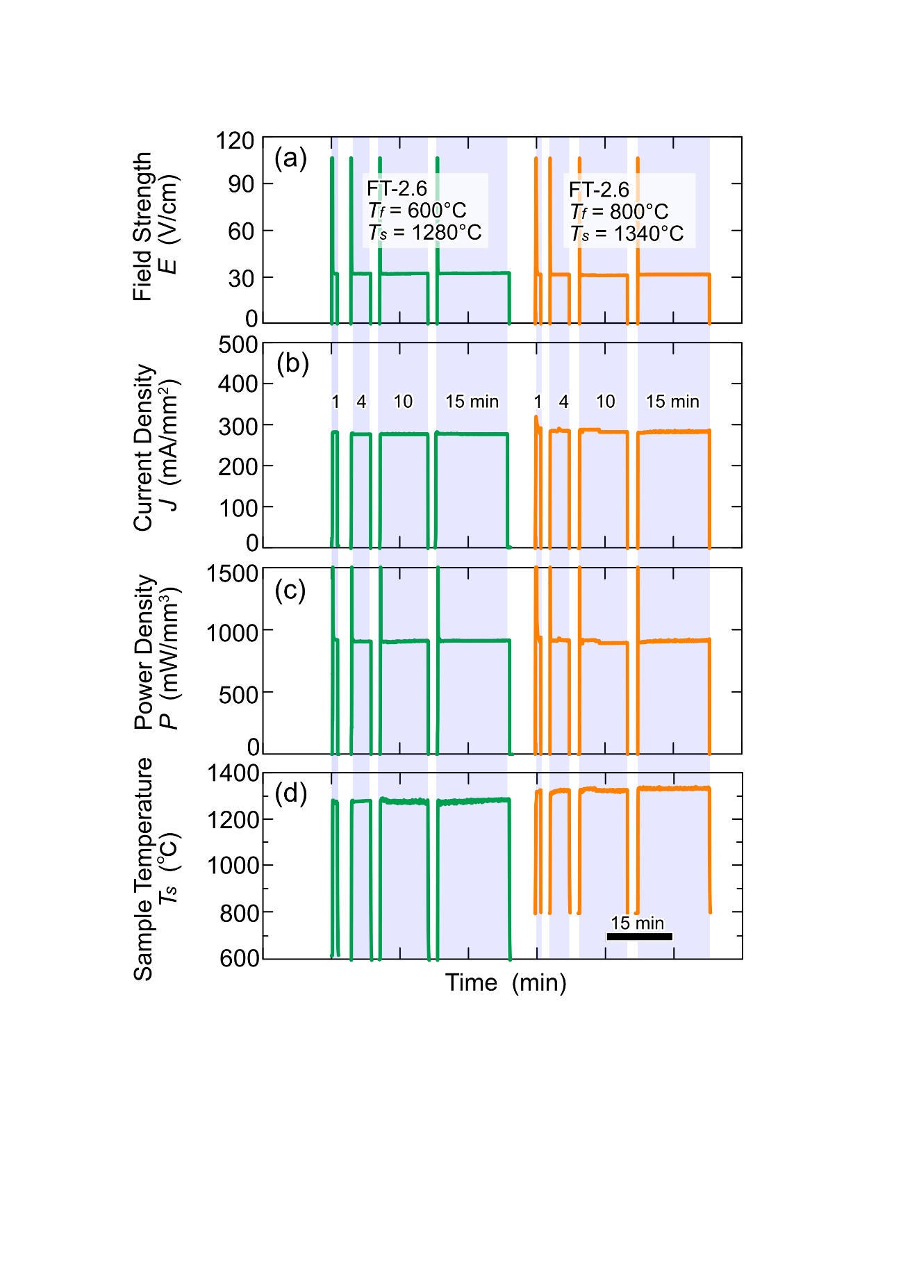
FIGURE S1 (a) Applied field strength (E; V/cm), (b) current density (J; mA/mm²), (c) power density (P; mW/mm³), and (d) sample temperature (T_{s}; °C) as functions of time during AC flash experiments on FT-2.6 samples with different furnace temperature (T_{f}; °C). The grain growth experiment and microstructure observation were repeated for the same sample for a total experimental holding time of 30 min.

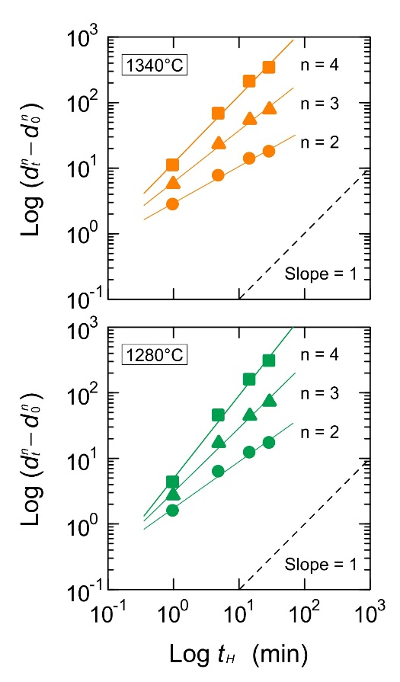
FIGURE S2 Double logarithmic plots of ($d_{t}^{n}-d_{0}^{n}$) and holding time (t_{H}), where d_{t} is the average grain size at t_{H} and d₀ is the initial grain size (t_{H} = 0). The slope of the log–log plots of ($d_{t}^{n}-d_{0}^{n}$) versus t_{H} should be 1 for the appropriate grain growth exponent n (dashed line).

