Crosslinker Additive Integration: A Strategy to Boost Performance and Stability in FASnI₃ Perovskite Solar Cells
Md. Abdul Karim ^{a‡}, Vishnuvardhan Reddy Chappidi ^{a,b‡},Md. Emrul Kayesh ^{a,c}, Sai Santosh Kumar Raavi ^{b,d}, Ashraful Islam ^{*a,}
ªPhotovoltaic Materials Group, Center for Green Research on Energy and Environmental Materials, National Institute for Materials Science (NIMS), Tsukuba 305-0047 Ibaraki, Japan
^{b}Department of Physics, Indian Institute of Technology Hyderabad, Kandi, Sangareddy, TS, INDIA-50 22 85
^{c}Department of Materials Science and Engineering, University of Rajshahi, Rajshahi-6205, Bangladesh
^{d}Department of Climate Change, Indian Institute of Technology Hyderabad, Kandi, Sangareddy, TS, INDIA-50 22 85
‡Equally contributed

ABSTRACT
Tin perovskite solar cells (Sn-PSCs) offer considerable potential for lead (Pb)-free photovoltaic applications. Unfortunately, the poor crystallinity and facial tendency of oxidation from Sn²⁺ to Sn⁴⁺ are still challenging for the performance of Sn-PSCs. Herein, we introduced butylphosphonic acid 4-ammonium chloride (4ABPACl) bifunctional additive as a crosslinker in the Sn-perovskite precursor solution. The morphological and structural analysis confirmed that the terminal group –NH₃⁺ and –PO(OH)₂ of 4ABPACl cross-linked with the iodide ions (I⁻) of the perovskite framework through hydrogen bonding and suppressed the Sn²⁺ oxidation. As a result, a pinhole-free uniform perovskite film with an extended lifetime of charge carriers as confirmed by scanning electron microscope and time-resolved photoluminescence respectively. These improvements in Sn-perovskite enhanced the power conversion efficiency of Sn-PSCs from 6.65 to 9.20 %. Moreover, crosslinker-modified PSCs showed an improvement in stability both under continuous light for encapsulated PSCs and in the N₂ glove box for unencapsulated PSCs.
KEYWORDS: Sn perovskite solar cells, 4ABPACl, hydrogen bonding, crosslinker additive, stability
- Introduction
Regarding the advancement of photovoltaic technology in the next iteration, organic-inorganic halide perovskites are being considered as a growing alternative. They possess numerous advantageous properties, including high carrier mobility, strong broad-band absorption, extensive carrier diffusion length, minimal rate of electron-hole recombination, characteristics of ambipolar transport, as well as a cost-effective and simple solution procedure (Xing et al., 2013; Stranks et al., 2013; Liang et al., 2020; Yu et al., 2017; Dong et al., 2015). The rapid enhancement in power conversion efficiency (PCE), soaring from 3.8% to certified 26.1%, has propelled the widespread acceptance of lead-based perovskite solar cells (Pb-based PSCs) (Kojima et al., 2009; NREL et al., 2024). Moreover, the application and commercialization of PSCs are severely hampered by the hazardous properties of Pb (Wang et al., 2019; Ke et al., 2019; Gillis et al., 2012). Addressing this issue, Sn-based PSCs or bismuth-based (Bi-based) PSCs have been thought as a favourable alternative to Pb-based PSCs (Ke et al., 2019; Joker et al., 2018; Jiang et al., 2021; Karim et al., 2022; Ahmmed et al., 2021). Moreover, Sn-containing perovskites have superior optoelectronic characteristics relative to Pb-based perovskites, featuring a smaller ionic radius, a lower exciton binding energy, high charge carrier mobility, and a narrower band gap than Pb²⁺ (Fang et al., 2018; Diau et al., 2019; Kahmann et al., 2019). Unfortunately, owing to several limitations, the PCE of Sn-PSCs are still far from Pb-PSCs (Jiang et al., 2021). One major challenge with Sn-PSC is their inadequate stability, resulting from the Sn²⁺ to Sn⁴⁺ oxidation and origination of Sn vacancies during the fabrication process (Cao et al., 2020; Karim et al., 2022; Karim et al., 2023). Additionally, rapid crystallization results in the generation of numerous pinholes and non-uniformities in Sn perovskite films, which contribute to nonradiative recombination (Hao et al., 2015).
Researchers have examined plenty of techniques to boost the performance of Sn-PSCs using different strategies. One strategy involves using tin double halides (SnX₂; X=Cl, F, I, Br) as antioxidants to reduce Sn-cation vacancies in FASnX₃ perovskites (Marshall et al., 2016; Kumar et al., 2014; Liu et al., 2020). Diethyl ether was introduced as an anti-solvent and SnF₂ was employed as an additive to attain pinhole-free and uniform Sn perovskite films (Liao et al., 2016). The champion device, containing 10 mol% of SnF₂, achieved a PCE of 6.22%. Hydrazinium chloride (N₂H₅Cl) additive was included to FASnI₃ perovskite precursor solution (Kayesh et al., 2018). The 2.5 mol% inclusion of N₂H₅Cl reduced the Sn⁴⁺ content in FASnI₃ films and promoted the formation of homogeneous, pinhole-free films. However, an excessive SnX₂ salts or unfunctional molecules have a narrow range of passivation ability and restricted control over the perovskite films crystallization process, thereby preventing the PCE from reaching theoretical limit. To address those limitations, it is important to introduce an effective approach to both passivate and control the crystallization process of perovskite films. Yan et al. incorporated antioxidant additive hydroxybenzene sulfonic acid to perovskite precursor solutions containing SnCl₂, effectively preventing phase segregation (Tai et al., 2019). These additives containing sulfonate (-SO₃⁻) and hydroxybenzene (-OH) groups serve to protect against air exposure and coordinate with Sn²⁺ to eliminate SnCl₂ phase separation. The resulting device, based on 1.5% KHQSA-FASnI₃, retained over 80% of their initial PCE for more than 500 hours. Recently, 𝜶-Tocopherol was introduced in PSCs as a surface passivator and forms hydrogen bond and van der Waals interactions at the perovskite terminals (Ma et al., 2023). Wang et al. introduced multifunctional additive in Sn-PSCs to inhibits the formation of I₃⁻ and related defect density and achieved PCE of 13.40% (Wang et al., 2023). To inhibit the oxidation to Sn⁴⁺ from Sn²⁺, the 2-(2-aminoethyl)–2-thiopseudourea dihydrobromide (AET) was incorporated into the Sn-based perovskites and slowed down the crystallization process. The incorporation of AET into Sn-based perovskite results in achieved a high fill factor of 80.26% with PCE of 13.55% (Li et al., 2023). Yu et al. introduced a novel amphoteric semiconductor to manage interface defects and carrier dynamics in Sn-PSCs and maintained 91.6% of its initial PCE after 1000 h of continuous illumination (Yu et al., 2023).
Incorporation of butylphosphonic acid 4-ammonium chloride (4ABPACl) containing the ammonium group (-NH³⁺) and phosphonic acid group (-PO(OH)₂) in Pb-based perovskite to promote the perovskite crystals formation and boost defect-passivation on grain boundaries and surfaces (Li et al., 2015). This was achieved by cross-linking via hydrogen bond formation between phosphate groups and perovskite halide anions. Rapid crystallization in Sn-perovskite film plugs in the Sn²⁺ oxidation, forms vacancies, and hinders the overall PSCs performance. Interestingly, hydrogen bonding slows down the crystallization during the fabrication process and promotes the generation of a uniform film with suppressed the Sn²⁺ oxidation and enhanced the PSCs performance (Ma et al., 2023). We assume the crosslinker 4ABPACl additive control the regulation of crystallization process and suppresses the Sn²⁺ oxidation of Sn-perovskite by hydrogen bonding.
In this study, we have introduced a bifunctional crosslinker additive 4ABPACl in the FASnI₃ perovskite precursor solution and used a very simple one-step fabrication process. The 4ABPACl additive chemically modified the perovskite grain surface via hydrogen bonding. ¹H nuclear magnetic resonance (¹H NMR) studies confirmed that the ammonium group (-NH³⁺) and phosphonic acid group (-PO(OH)₂) of 4ABPACl engaged in hydrogen bonding interactions with the iodide (I⁻) ions present in the perovskite structure. We demonstrated that adding 4ABPACl into perovskite effectively reduced the electrical defect, increased carrier lifetimes, and enhanced V_{OC} of PSC. Therefore, the modified PSCs exhibited a PCE of 9.20 % whereas pristine PSCs displayed a PCE of 6.65%. Additionally, the modified PSCs show higher stability both in the inside glovebox for unencapsulated PSC and in atmospheric environments under continuous light conditions for encapsulated PSCs than pristine PSCs.
- Results and discussion
We use bifunctional additive 4ABPACl as shown in Fig. 1a to perform a chemical modification on the surface of perovskites grains by crosslinking approach. The crosslinker hydrogen bond formation was investigated using liquid-state ¹H NMR spectroscopy. In Fig. 1b illustrate the ¹H NMR spectra of 4ABPACl, 4ABPACl+FAI, 4ABPACl+SnI₂, FAI+SnI₂, and 4ABPACl+FAI+SnI₂ in a solution of deuterated N,N-dimethylformamide-d₆ (DMSO-d₆). The proton resonance peaks of ammonium group (-NH₃⁺) and phosphonic acid group (-PO(OH)₂) of 4ABPACl was appeared at 8.03 and 9.98 ppm, respectively (Li et al., 2015). The resonance signal of –PO(OH)₂ at 9.98 ppm was described the characteristic peak of O-H…..Cl⁻ between -PO(OH)₂ group and chloride-anion (Cl⁻). Due to the formation of hydrogen bond between SnI₂ and -NH₃⁺, the resonance peak of -NH₃⁺ in 4ABPACl+SnI₂ was shifted to upfield (to a lower ppm value) from 8.03 ppm to 7.63 ppm. Proton resonance peaks have been identified in the ¹H NMR spectra of FAI+SnI₂ at 7.88, 8.70, and 9.01 ppm. These peaks might be ascribed to the −CH−, −NH₂, and =NH₂ groups in FA, respectively (Ke et al., 2017). After introducing 4ABPACl to the FAI+SnI₂ solution, a separate peak emerged at 7.63 ppm and this peak position was identical with 4ABPACl+SnI₂ peak position. Moreover, the resonance peaks of −CH, −NH₂, and =NH₂ were not changed when 4ABPACl was added, suggesting that a limited interaction between FA⁺ and 4ABPACl. Moreover, the resonance peak -PO(OH)₂ at 9.98 ppm in 4ABPACl upfield shifted to 9.82 ppm in 4ABPACl+FAI+SnI₂ due to crosslink formation of -PO(OH)₂ group with the SnI₆⁴⁻ octahedral of perovskite. Based on this observation, we anticipated that 4ABPACl engages in crosslinking called hydrogen bond interactions with the iodide ions (I⁻) from the SnI₆⁴⁻ octahedral via -NH₃⁺ and the -PO(OH)₂ group of 4ABPACl due to deshielding of the hydrogen atoms involved in bonding (Li et al., 2015; Wang et al., 2024).
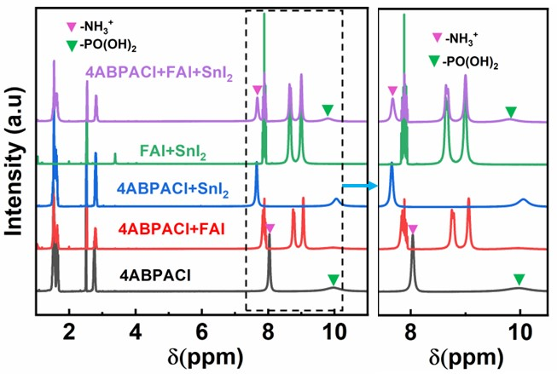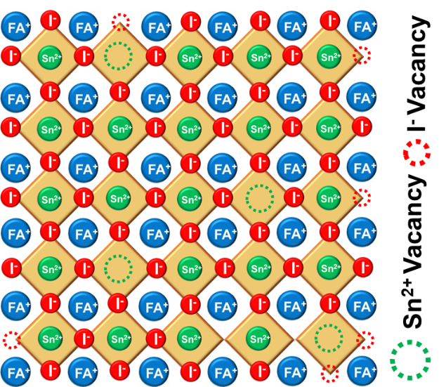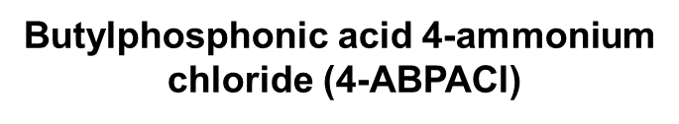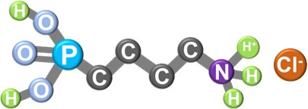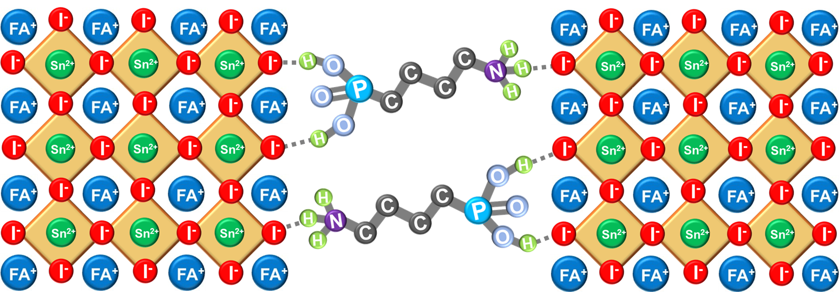
(c)
(d)
(a)
(e)
(b)
Fig. 1. (a) Molecular structure of 4ABPACl. (b) ¹HNMR spectra of 4ABPACl, 4ABPACl+FAI, 4ABPACl +SnI₂, FAI+SnI₂, and 4ABPACl+FAI+SnI₂ in solution of DMSO-d₆. (c) XRD patterns for the FASnI₃ and FASnI₃-4ABPACl perovskite films. (d, e) Schematic illustration of perovskite framework without and with additive, respectively. The terminal group of –NH₃⁺ and –PO(OH)₂ of bifunctional 4ABPACl is crosslinked through hydrogen-bonding (–N-H…I and -O-H…I) interaction with iodide (I⁻) ions in the grain boundary of perovskite framework.

We performed structural characterization using X-ray diffraction (XRD) to determine if the 4ABPA cations are evenly distributed on the surface of perovskite or whether they infiltrate to perovskite lattice and generate a new mixed-cation perovskite. In Fig. 1c, the XRD patterns of thin films obtained from pristine FASnI₃ and modified FASnI₃-4ABPACl fabricated on an indium tin oxide (ITO)/PEDOT:PSS, are contrasted for comparison. The dominant diffraction peaks, attributed to the (100), (102), (200), and (122) planes at 14.1°, 24.4°, 28.2°, and 31.6°, respectively, were found to be in the same positions for both the pristine and FASnI₃-4ABPACl films. This indicates that both precursor solutions produce perovskites with an orthorhombic lattice (Amm2 space group) crystal structure, thereby ruling out the possibility of 4ABPACl integration to the crystal structure of FASnI₃ perovskite. The inclusion of a small quantity of 4ABPACl into the FASnI₃ precursor solution substantially strengthened the diffraction peaks linked to the [100] and [200] planes, signifying a considerable enhancement in the film's crystallinity compared to pristine films. This improvement can be attributed to a controlled crystallization process facilitated by 4ABPACl. Table S1 presents the values of the full width at half maximum (FWHM) for both FASnI₃ and FASnI₃-4ABPACl perovskite films. Notably, the FASnI₃-4ABPACl perovskite films exhibited narrower FWHM values for the (100) and (200) peaks. This result suggests that the addition of a small quantity of 4ABPACl additive resulted in improved crystallinity in comparison to the pristine FASnI₃ perovskite. The crystallization process of perovskite without and with 4ABPACl additive is shown in Fig. 1d, e.
Sn-based perovskites exhibit a significantly higher Lewis acidity compared to Pb-based perovskites. This elevated Lewis acidity of Sn perovskite leads to faster crystallization kinetics, presenting a challenge in achieving homogeneous and pin holes free perovskite films during the fabrication process (Zhu et al., 2018). We utilized a scanning electron microscope (SEM) to conduct a comparative analysis of the surface morphologies for pristine and FASnI₃-4ABPACl films, with the aim of verifying the impact of 4ABPACl. In Fig. 2a and Fig. S1, 2, the SEM images of pristine FASnI₃ films showed the existence of a significant quantity of pinholes, together with an average particle size of 763nm. However, the inclusion of 4ABPACl to the FASnI₃ precursor solution enabled the maintenance of a uniform, homogeneous film without any pinholes, as shown in Fig. 2b and Fig. S1, 2.
This improvement may be due to the retardation of perovskite crystallization by crosslinking the terminal group -NH³⁺ and the end group −PO(OH)₂ of the 4ABPACl with the iodide ions (I⁻) within the SnI₆⁴⁻ octahedral structure of perovskite matrix. This assumption is proved by the solid evidence of ¹H NMR. This crosslinking involves N-H···I− and P–OH···I− bonding, which is called hydrogen bonding. Consequently, the grains get complete coverage across the whole surface of the film. The concentration of 4ABPACl (0.5, 1, and 3 mol%) inversely correlates with the grain size, which measures 473nm, 428nm, and 198nm, respectively, as shown in Fig. S2. This phenomenon is likely due to an increase in the quantity of heterogeneous nucleation sites as the concentration of 4ABPACl increased. As a result, the 4ABPACl molecules functioned as crosslinking agents, binding adjacent perovskite grains together. The presence of the 4ABPACl resulted in the formation of a uniform and consistent perovskite layer, as opposed to pristine perovskite layers.
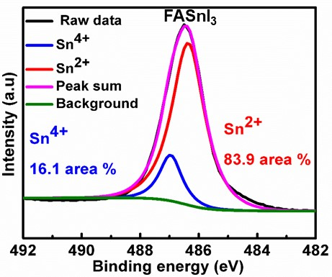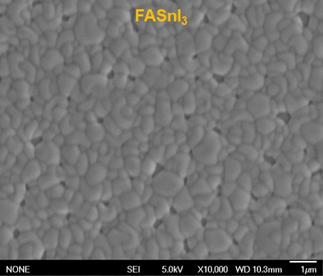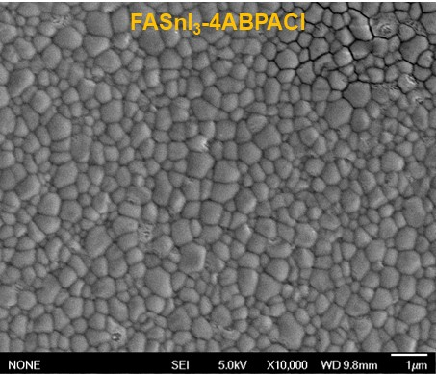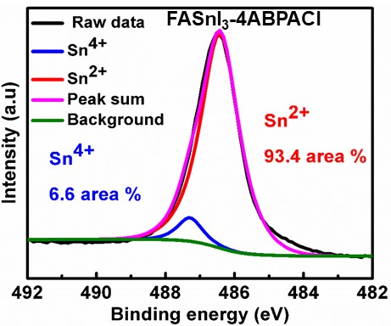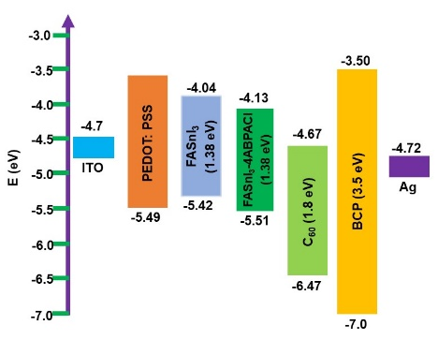
(a)
(b)
(c)
(d)
(e)
(f)
(i)
(g)
(h)
Fig. 2. SEM of (a) FASnI₃, and (b) FASnI₃-4ABPACl (0.5 mol%) perovskite films. High-resolution XPS spectra of Sn 3d_{5/2} for (c) FASnI₃, and (d) FASnI₃-4ABPACl (0.5 mol%) perovskite films. (e) PL spectra, and (f) TRPL of perovskite films fabricated on glass substrates. AC-3E spectra for (g) FASnI₃, (h) FASnI₃- 4ABPACl (0.5 mol%) films. (i) Schematic presentation of energy levels in the inverted PSCs of FASnI₃ without and with 4ABPACl additive.
The strong coordination between FASnI₃ perovskite and 4ABPACl additive, resulting a stable perovskite framework compared to without additive and reduced the oxidation of the deposited perovskite films. To understand the impact of 4ABPACl on the inhibition of Sn²⁺ oxidation, we carried out XPS measurements of the fabricated film. In Fig. 2c, d, the Sn 3 d_{5/2} region are showed two separate peaks having the binding energies of 486.42 eV and 487.29 eV, respectively. The Sn²⁺ ions within the structure of perovskite and oxidized Sn⁴⁺ ions on the film surface are responsible for these peaks (Xue et al., 2023). After analysing the films, it was observed that the FASnI₃-4ABPACl perovskite films displayed a reduced percentage of Sn⁴⁺ comparison to the pristine film. Specifically, the Sn⁴⁺ concentration decreased significantly from 16.1 % in the pristine film to 6.6 % in the FASnI₃-4ABPACl perovskite film.

UV-visible-IR absorption spectra have been used to analyze the optical characteristics of the films, as shown in Fig. S3. Upon the addition of 4ABPACl to the FASnI₃ perovskite, the band edge of the absorption spectrum was not affected, as confirmed by PL spectra displayed in Fig. 2e. The addition of 4ABPACl to perovskite film resulted in a more stronger PL intensity, indicating the formation of a higher quality film and effective suppression of non-radiative charge carrier recombination. The improvement of films quality is confirmed by XRD, SEM and XPS analysis. Fig. 2f utilizes time-resolved photoluminescence (TRPL) spectroscopy to investigate the PL lifetime. Additionally, the carrier lifetime of the pristine film was measured to be 3.70 ns, whereas the film with 4ABPACl exhibited a longer carrier lifetime of 7.50 ns. The longer duration of carrier lifetime can be ascribed to the enhanced crystallinity with uniform and consistent crystal, and the suppression of Sn²⁺ defects in the perovskite films. With increased exciton lifetime in modified perovskite films, we anticipate that the associate solar cells will have a reduced chance of charge recombination, resulting in an increase in open-circuit voltages (V_{OC}).

The band gap of the fabricated films was calculated from UV-visible-IR absorption spectra, as depicted in Fig. S3. An AC-3E photoelectron spectrometer as shown in Fig. 2g, h and Fig. S4, was used to calculate valence band maximum (VBM) values for both pristine FASnI₃ and modified FASnI₃-4ABPACl perovskite film. The determination of conduction band minimum (CBM) values of pristine and modified FASnI₃-4ABPACl perovskite films involved utilizing the optical band gap and valence band maximum (VBM) values. This information was subsequently employed to construct the diagram of energy band of FASnI₃ and modified FASnI₃-4ABPACl PSCs, as illustrated in Fig. 2i. In the energy band diagram of inverted structure PSCs, notable improvements were observed in the alignment at the interfaces between hole transport layer (HTL) and perovskite layer, as well as at the boundaries between the perovskite layer and the electron transport layer (ETL). The improved perovskite layer has shallower VBM and CBM due to defect suppression. The improved perovskite layer's band energy alignment enhances charge transmission in PSCs and improves their PCE.
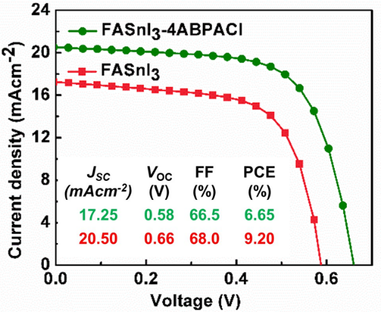
(a)
(b)
Fig. 3. (a) J-V curves and (b) PCE statistical distribution for pristine FASnI₃ and FASnI₃−4ABPACl (0.5%)-based PSCs.
The investigation of impact of the 4ABPACl additive on photovoltaic performance in an inverted structure perovskite solar cell (PSC), we fabricated PSC with configuration of ITO/PEDOT:PSS/FASnI₃/C₆₀/BCP/Ag and performance summarised in Table S2. In this configuration, the perovskite layer is positioned between the electron transport layer (ETL) of C₆₀ and the hole transport layer (HTL) of PEDOT:PSS, as depicted in the schematic diagram in Fig. S5a. Fig. 3a depicts the current density-voltage (J-V) curves, with pristine PSCs exhibiting a PCE of 6.65%, a current density (J_{SC}) of 17.25 mA cm⁻², a voltage (V_{OC}) of 0.58 V, and a fill factor (FF) of 66.5%. The introduction of 4ABPACl resulted in a substantial improvement in device performance. FASnI₃ PSCs with 4ABPACl demonstrated a J_{SC} of 20.50 mA cm⁻², a V_{OC} of 0.66 V, an FF of 68.0%, and a PCE of 9.20%. Compared to pristine FASnI₃, the device with 4ABPACl exhibited a notable 38% increase in PCE. The improved films quality and well-matched energy alignment helps to facilitate charge extraction and transmission in PSCs and improved PCE. The monochromatic incident photocurrent conversion efficiency (IPCE) of both pristine FASnI₃ and FASnI₃-4ABPACl modified PSCs is illustrated in Fig. S5b. The integrated values of short-circuit current density (J_{SC}) closely correlate with the outcomes obtained from the corresponding J−V curves.
In order to gain a more profound insight into the impact of 4ABPACl on charge carrier transit and recombination in perovskite solar cells (PSCs), we conducted an assessment of transient photovoltage (TPV), depicted in Fig. 4a. Photovoltage decay constant of the modified PSC (0.5 % 4ABPACl) was 4.98 μs longer than that of pristine FASnI₃ PSC (3.98 μs). This expanded decay time suggested that improved electron transport and recombination were delayed, resulting in greater V_{OC}.
To gain insight into charge carrier recombination in PSCs, an electrochemical impedance spectroscopy test was conducted in the dark. The Nyquist plots for FASnI₃ and FASnI₃-4ABPACl PSCs are shown in Fig. 4b. FASnI₃-4ABPACl-based PSCs had a larger semicircle than FASnI₃-based PSCs. The larger size of the semicircle implies that recombination resistance (R_{rec}) is improving. The inclusion of the additive resulted in a high R_{rec} for the FASnI₃-4ABPACl PSC, indicating that reduced charge carrier recombination, and charge transport is quicker. Fig. 4c presents the measurement of dark current density, conducted to deepen our insight into the charge transport behaviours exhibited by the device. The large leakage current in pristine FASnI₃ solar cells was induced by the high p-type doping (Cao et al., 2019). The leakage current of the 4ABPACl-modified FASnI₃ solar cells was approximately two orders of magnitude lesser than that of the pristine FASnI₃ PSCs, suggesting a much-reduced background carrier density. Fig. 4d shows admittance spectra used to estimate trap density in PSCs. Specifically, the FASnI₃-4ABPACl PSC demonstrated notably lower capacitance (C) at lower frequencies than pristine PSCs, suggesting a decline in defects attributed to additive-assisted defect passivation.
(a)
(b)
(c)
(d)
(e)
(f)
Fig. 4. (a) Transient photovoltage decay for pristine and 4ABPACl-modified PSCs. (b) Nyquist plot characterized under dark conditions, (c) J−V curve of dark current, (d) admittance spectra for the FASnI₃ and FASnI₃−4ABPACl (0.5%)-based PSCs. (e) Shelf-life stability of unencapsulated PSCs. (f) Normalized PCE of encapsulated PSCs under continuous light illumination.
The fabricated PSC's stability was assessed by storing the unencapsulated PSCs in an N₂-filled glovebox and monitoring its degradation over a period in ambient air. The pristine PSC possessed a drop of approximately 53% in its initial PCE over a period of 60 days. Fig. 4e illustrates that, the PSC modified by 4ABPACl maintained approximately 90% of its initial PCE over 90 days. This outcome demonstrated that 4ABPACl is an additive that may slow down PSC degradation. Additionally, we conducted observations of encapsulated PSC under continuous light condition in an atmospheric environment. The pristine PSC retained only 75% of its initial performance. The PSCs that were modified with 0.5% 4ABPACl showed exceptional operational stability for a duration of 300 hours, as shown in Fig. 4f. Furthermore, they were able to retain 95% of their original PCE for a period of 180 hours while operating under continuous light measurement system. This outstanding stability is attributed to the superior film quality and enhanced resistance to moisture, providing effective protection against film degradation.

- Conclusion
In this study, we have revealed the addition of 4-ABPACl into Sn-perovskite precursor solution, form a hydrogen bond between the terminal groups (–NH₃⁺ and –PO(OH)₂) of 4ABPACl and iodide ions (I⁻) in the FASnI₃ perovskite framework. This hydrogen bond formation helped to form uniform and pinhole-free FASnI₃ films with reduced Sn⁴⁺ content. As a results, the PCE of modified FASnI3 PSCs increased to 9.2 % when compared to 6.2% of pristine PSCs. Moreover, crosslinker modification of perovskite films showed stability under continuous light for encapsulation and retained 95% of their original PCE for a period of 180 hours. We anticipate that these findings will provide a new dimension to improve the performance of lead-free Sn-PSCs.
AUTHOR INFORMATION
Corresponding Authors
Ashraful Islam - Photovoltaic Materials Group, Center for Green Research on Energy and Environmental Materials, National Institute for Materials Science (NIMS), Tsukuba 305-0047 Ibaraki, Japan; Email: Islam.Ashraful@nims.go.jp
Author Contributions
Md. Abdul Karim and Vishnuvardhan Reddy Chappidi have contributed equally to complete this work. The manuscript has been reviewed and approved by all authors.
ACKNOWLEDGMENTS
A.I. expresses gratitude for the assistance provided by JSPS KAKENHI grant no. 22H02190 and JST-ALCA-Next grant no. JPMJAN23B2 in Japan. VVR and RSSK are grateful for the support received by IITH-NIMS research exchange scheme.
References
Xing, G., Mathews, N., Sun, S., Lim, S.S., Lam, Y.M., Gratzel, M., Mhaisalkar, S., Sum, T.C., 2013. Long-range balanced electron-and hole-transport lengths in organic-inorganic CH3NH3PbI3. Science 342(6156), 344-347.
Stranks, S.D., Eperon, G.E., Grancini, G., Menelaou, C., Alcocer, M.J., Leijtens, T., Herz, L.M., Petrozza, A., Snaith, H.J., 2013. Electron-hole diffusion lengths exceeding 1 micrometer in an organometal trihalide perovskite absorber. Science 342(6156), 341-344.
Liang, Y., Li, F., Zheng, R., 2020. Low‐dimensional hybrid perovskites for field‐effect transistors with improved stability: progress and challenges. Advanced Electronic Materials 6(9), 2000137.
Yu, Z.-G., 2017. Excitons in orthorhombic and tetragonal hybrid organic–inorganic perovskites. The Journal of Physical Chemistry C 121(5), 3156-3160.
Dong, Q., Fang, Y., Shao, Y., Mulligan, P., Qiu, J., Cao, L., Huang, J., 2015. Electron-hole diffusion lengths> 175 μm in solution-grown CH3NH3PbI3 single crystals. Science 347(6225), 967-970.
Kojima, A., Teshima, K., Shirai, Y., Miyasaka, T., 2009. Organometal halide perovskites as visible-light sensitizers for photovoltaic cells. Journal of the american chemical society 131(17), 6050-6051.
National Renewable Energy Laboratory. Best research-cell efficiency chart. (2024). https://www.nrel.gov/pv/cell-efficiency.html.
Wang, R., Wang, J., Tan, S., Duan, Y., Wang, Z.-K., Yang, Y., 2019. Opportunities and challenges of lead-free perovskite optoelectronic devices. Trends in Chemistry 1(4), 368-379.
Ke, W., Stoumpos, C.C., Kanatzidis, M.G., 2019. “Unleaded” perovskites: status quo and future prospects of tin‐based perovskite solar cells. Advanced Materials 31(47), 1803230.
Gillis, B.S., Arbieva, Z., Gavin, I.M., 2012. Analysis of lead toxicity in human cells. BMC genomics 13(1), 1-12.
Jokar, E., Chien, C.-H., Fathi, A., Rameez, M., Chang, Y.-H., Diau, E.W.-G., 2018. Slow surface passivation and crystal relaxation with additives to improve device performance and durability for tin-based perovskite solar cells. Energy & Environmental Science 11(9), 2353-2362.
Jiang, X., Zang, Z., Zhou, Y., Li, H., Wei, Q., Ning, Z., 2021. Tin halide perovskite solar cells: an emerging thin-film photovoltaic technology. Accounts of Materials Research 2(4), 210-219.
Karim, M.A., Matsuishi, K., Chowdhury, T.H., Chowdhury, W.I., Abdel-shakour, M., Islam, A., 2022. Bathocuproine interfacial layer leads to solid improvement of reproducibility and stability of Pb-free CsBi₃I₁₀ based perovskite solar cells. Journal of Materials Science: Materials in Electronics 33(10), 8114-8126.
Ahmmed, S., Karim, M.A., Rahman, M.H., Aktar, A., Islam, M.R., Islam, A., Ismail, A.B.M., 2021. Performance analysis of lead-free CsBi3I10-based perovskite solar cell through the numerical calculation. Solar Energy 226, 54-63.
Fang, H.-H., Adjokatse, S., Shao, S., Even, J., Loi, M.A., 2018. Long-lived hot-carrier light emission and large blue shift in formamidinium tin triiodide perovskites. Nature communications 9(1), 243.
Diau, E.W.-G., Jokar, E., Rameez, M., 2019. Strategies to improve performance and stability for tin-based perovskite solar cells. ACS Energy Letters 4(8), 1930-1937.
Kahmann, S., Shao, S., Loi, M.A., 2019. Cooling, scattering, and recombination—the role of the material quality for the physics of tin halide perovskites. Advanced Functional Materials 29(35), 1902963.
Jiang, X., Li, H., Zhou, Q., Wei, Q., Wei, M., Jiang, L., Wang, Z., Peng, Z., Wang, F., Zang, Z., 2021. One-step synthesis of SnI2·(DMSO) x adducts for high-performance tin perovskite solar cells. Journal of the American Chemical Society 143(29), 10970-10976.
Cao, K., Cheng, Y., Chen, J., Huang, Y., Ge, M., Qian, J., Liu, L., Feng, J., Chen, S., Huang, W., 2020. Regulated Crystallization of FASnI3 Films through Seeded Growth Process for Efficient Tin Perovskite Solar Cells. ACS Applied Materials & Interfaces 12(37), 41454-41463.
Karim, M.A., Matsuishi, K., Chowdhury, T.H., Abdel-Shakour, M., He, Y., Islam, A., 2022. Additive-Assisted Electronic Defect Passivation in Lead-Free Tin Perovskite Solar Cells: Suppression of Sn2+ Oxidation and I–Losses. ACS Applied Energy Materials 5(12), 15038-15047.
Karim, M.A., Matsuishi, K., Kayesh, M.E., He, Y., Islam, A., 2023. Inhibition of Sn2+ Oxidation in FASnI3 Perovskite Precursor Solution and Enhanced Stability of Perovskite Solar Cells by Reductive Additive. ACS Applied Materials & Interfaces 15(39), 45823-45833.
Hao, F., Stoumpos, C.C., Guo, P., Zhou, N., Marks, T.J., Chang, R.P., Kanatzidis, M.G., 2015. Solvent-mediated crystallization of CH3NH3SnI3 films for heterojunction depleted perovskite solar cells. Journal of the American Chemical Society 137(35), 11445-11452.
Marshall, K.P., Walker, M., Walton, R.I., Hatton, R.A., 2016. Enhanced stability and efficiency in hole-transport-layer-free CsSnI3 perovskite photovoltaics. Nature Energy 1(12), 1-9.
Kumar, M.H., Dharani, S., Leong, W.L., Boix, P.P., Prabhakar, R.R., Baikie, T., Shi, C., Ding, H., Ramesh, R., Asta, M., 2014. Lead‐free halide perovskite solar cells with high photocurrents realized through vacancy modulation. Advanced Materials 26(41), 7122-7127.
Liao, W., Zhao, D., Yu, Y., Grice, C.R., Wang, C., Cimaroli, A.J., Schulz, P., Meng, W., Zhu, K., Xiong, R.-G., 2016. Lead-free inverted planar formamidinium tin triiodide perovskite solar cells achieving power conversion efficiencies up to 6.22%. Advanced Materials 28(NREL/JA-5K00-67095).
Liu, X., Wang, Y., Wu, T., He, X., Meng, X., Barbaud, J., Chen, H., Segawa, H., Yang, X., Han, L., 2020. Efficient and stable tin perovskite solar cells enabled by amorphous-polycrystalline structure. Nature communications 11(1), 2678.
Kayesh, M.E., Chowdhury, T.H., Matsuishi, K., Kaneko, R., Kazaoui, S., Lee, J.-J., Noda, T., Islam, A., 2018. Enhanced photovoltaic performance of FASnI3-based perovskite solar cells with hydrazinium chloride coadditive. ACS Energy Letters 3(7), 1584-1589.
Tai, Q., Guo, X., Tang, G., You, P., Ng, T.W., Shen, D., Cao, J., Liu, C.K., Wang, N., Zhu, Y., 2019. Antioxidant grain passivation for air‐stable tin‐based perovskite solar cells. Angewandte Chemie International Edition 58(3), 806-810.
Ma, X., Zhang, Y., Zhou, J., Liu, L., Ju, M., Wang, N., 2023. Mitigating surface defects in tin-based perovskite films with α-tocopherol for enhanced photovoltaic performance. Small, 20(15), 2307373.
Wang, S., Wu, C., Yao, H., Xie, L., Xiao, Y., Ding, L., Hao, F., 2023. Defect compensation and lattice stabilization enables high voltage output in tin halide perovskite solar cells. Small, 20(13), 2308877.
Li, T., Zhang, Z., He, F., Deng, L., Yang, Y., Mo, X., Zhan, Y., Liang, J., 2023. Alleviating the crystallization dynamics and suppressing the oxidation process for tin‐based perovskite solar cells with fill factors exceeding 80 percent. Advanced Functional Materials, 33(51), 2308457.
Yu, B., Sun, Y., Zhang, J., Wang, K., Yu, H., 2023. Synergetic regulation of interface defects and carriers dynamics for high‐performance lead‐free perovskite solar cells. Small, 20(12), 2307025.
Li, X., Ibrahim Dar, M., Yi, C., Luo, J., Tschumi, M., Zakeeruddin, S.M., Nazeeruddin, M.K., Han, H., Grätzel, M., 2015. Improved performance and stability of perovskite solar cells by crystal crosslinking with alkylphosphonic acid ω-ammonium chlorides. Nature chemistry 7(9), 703-711.
Ke, W., Stoumpos, C.C., Zhu, M., Mao, L., Spanopoulos, I., Liu, J., Kontsevoi, O.Y., Chen, M., Sarma, D., Zhang, Y., 2017. Enhanced photovoltaic performance and stability with a new type of hollow 3D perovskite {en} FASnI3. Science advances 3(8), e1701293.
Zhu, Z., Chueh, C.C., Li, N., Mao, C., Jen, A.K.Y., 2018. Realizing efficient lead‐free formamidinium tin triiodide perovskite solar cells via a sequential deposition route. Advanced materials 30(6), 1703800.
Wang, J., Huang, J., Abdel‐Shakour, M., Liu, T., Wang, X., Pan, Y., Wang, L., Cui, Enhao., Hu, J-S., Yang, S., Meng, X., 2024. Colloidal Zeta Potential Modulation as a Handle to Control the Crystallization Kinetics of Tin Halide Perovskites for Photovoltaic Applications. Angewandte Chemie International Edition, 63(17), e202317794.
Ma, X., Zhang, Y., Zhou, J., Liu, L., Ju, M., Wang, N., 2023. Mitigating Surface Defects in Tin‐Based Perovskite Films with α‐Tocopherol for Enhanced Photovoltaic Performance. Small, 2307373.
Cao, J., Tai, Q., You, P., Tang, G., Wang, T., Wang, N., Yan, F., 2019. Enhanced performance of tin-based perovskite solar cells induced by an ammonium hypophosphite additive. Journal of Materials Chemistry A 7(46), 26580-26585.

