Supplementary Materials
Observation of Odd-Even Effect in 1-Alcohols Through Pentapeptide-Coated Gas Sensors with Molecular Docking Study

Thuc Anh Ngo^{1,2}, Kosuke Minami¹, Tanju Yildirim¹, Kota Shiba¹, Genki Yoshikawa^{1,2}

Keywords: odd-even effect, gas sensor, volatile organic compounds.

¹Research Center for Macromolecules and Biomaterials, National Institute for Materials Science (NIMS), 1-1 Namiki, Tsukuba, 305-0044, Ibaraki, Japan
²Materials Science and Engineering, Graduate School of Pure and Applied Science, University of Tsukuba, 1-1-1 Tennodai, Tsukuba, Ibaraki 305-8577, Japan.

- Method
Materials: Synthetic pentapeptides, EHIPW and KVYYY, were purchased from Cosmo Bio Co., Ltd. with 80% purity. 1-Heptanol, 1-nonanol, 1-decanol, 1-undecanol, and 1-dodecanol were purchased from Tokyo Chemical Industry Co., Ltd. 1-Octanol was purchased from Fujifilm Wako Pure Chemical Corporation. 1-Dodecanol was purchased from Sigma-Aldrich. MilliQ water (Millipore) was used for preparing peptide stock solution.
QCM system: An AT-cut quartz crystal resonator (QA-A9M-AU(M), SEIKO EG&G Co., Ltd.) with a size of 7.9 mm × 7.9 mm was used as the sensing element. The electrode is made of gold, sputtered onto a 100 nm titanium film, with the gold layer having a thickness of 300 nm and a diameter of 5 mm. Data was recorded using a crystal oscillator measurement system (QCM922A, SEIKO EG&G Co., Ltd.) in the form of frequency shift, Δf.

- Gas measurement at different concentrations
FIG. S1. Gas response of pentapeptide-coated QCM sensors at different relative concentrations from 10% to 15% for (a) EHIPW and (b) KVYYY.
- The sensing performance of pentapeptide-coated gas sensors.
Limit of detection (LOD) calculation methods: In determining the LOD for each gas towards pentapeptide-based sensors, the responses of the sensors at relative concentrations of 2–12% were measured. The relative concentration of 100% corresponds to the saturated vapor pressure at 25 ℃, which is calculated based on Antoine coefficients and methods in Ref. [1]. Next, we considered the absolute volume concentration in ppm at a fixed relative concentration by multiplying the value of saturated vapor pressure by relative concentration. LOD was calculated using the following equations:²
$$LOD = \frac{3σ}{a}$$
where σ is the standard deviation of response frequency during background exposure and defined as the background noise, a is the slope of linear fitting between either absolute volume concentration or relative concentration and the absolute frequency shift |Δf|.
FIG. S2. LOD analysis of 1-alcohols from C7 to C12 using pentapeptide-coated gas sensors. Dynamic response curve to different relative concentrations ranging from 2% to 12% for (a) EHIPW and (c) KVYYY, and calculated linear fit based on absolute volume concentration for (b) EHIPW and (d) KVYYY. The average of the values from replicates (n = 3) is represented as a dot, and the corresponding standard deviation from three replicates is represented as a vertical line. The result of a linear fit is presented in each graph.

Table S1. Limit of detection (LOD) for EHIPW- and KVYYY-coated pentapeptides calculated based on absolute volume concentrations and relative concentrations.
Gas molecules | Absolute volume concentration (ppm)  at a fixed relative concentration |  |  |  |  | LOD in terms of absolute volume concentration (ppm) |  | LOD in terms of relative concentration (%)
 | 100%ª | 12% | 10% | 5% | 2% | EHIPW | KVYYY | EHIPW | KVYYY
1-Heptanol | 402 | 48.3 | 40.2 | 20.1 | 8.05 | 3.30 | 3.68 | 0.786 | 0.865
1-Octanol | 138 | 16.6 | 13.8 | 6.9 | 2.8 | 1.80 | 3.48 | 1.32 | 2.49
1-Nonanol | 36.0 | 4.32 | 3.69 | 1.79 | 0.719 | 0.341 | 0.151 | 0.957 | 0.416
1-Decanol | 14.8 | 1.77 | 1.48 | 0.74 | 0.295 | 0.0645 | 0.0372 | 0.436 | 0.251
1-Undecanol | 2.74 | 0.328 | 0.274 | 0.137 | 0.0550 | 0.0311 | 0.00556 | 1.15 | 0.202
1-Dodecanol | 1.19 | 0.143 | 0.119 | 0.0594 | 0.0238 | 0.00667 | 0.00474 | 0.560 | 0.397
- A relative concentration of 100% corresponds to the saturated vapor pressure, which is calculated with Antoine coefficients at 25 ℃.¹ The absolute volume concentration at a relative concentration is calculated by multiplying the value of the relative concentration.

Response time calculation methods: In determining the response time for each gas towards pentapeptide-based sensors, the responses of the sensors at gas concentrations of 10−15% were calculated using the following equations³:
$$t_{90}= \min\left\{t ∣ ∆f\left(t\right)=0.9∆f\left(t_{1}\right),t∈\left[t_{0},t_{1}\right]\right\}$$
where t₀ and t₁ are the times when the absorption and desorption phases start, respectively, as denoted in Fig. 2.
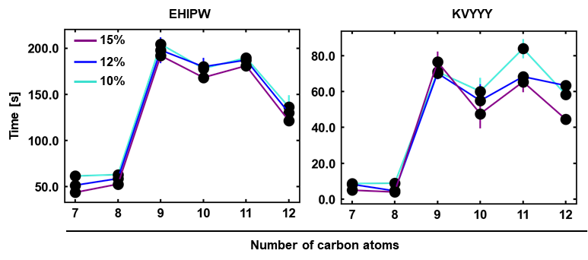
FIG. S3. The response time (t₉₀) calculated for EHIPW and KVYYY. The average of the values from replicates (n = 3) is represented as a dot, and the corresponding standard deviation from three replicates is represented as a line.
- The separation of odd- and even-numbered carbon compounds in the case of KVYYY

FIG. S4. Plot of three extracted features from sensing signals of KVYYY to 1-alcohols ranging from 1-heptanol to 1-dodecanol. Within a gas group, the average of the values from replicates (n = 3) at a certain relative concentration is represented as a dot.

REFERENCES
¹ C. L. Yaws, M. A. Satyro, In The Yaws Handbook of Vapor Pressure, Elsevier, 2015, pp. 1–314.
² L. Wang, J. Li, Y. Wang, K. Yu, X. Tang, Y. Zhang, S. Wang, and C. Wei, “Construction of 1D SnO₂-coated ZnO nanowire heterojunction for their improved n-butylamine sensing performances,” Sci. Rep. 6, 35079 (2016).
³ X. Zhang, J. Sun, K. Tang, H. Wang, T. Chen, K. Jiang, T. Zhou, H. Quan, and R. Guo, “Ultralow detection limit and ultrafast response/recovery of the H2 gas sensor based on Pd-doped rGO/ZnO-SnO₂ from hydrothermal synthesis,” Microsyst. Nanoeng. 8(1), 67 (2022).

