Effect of Plasma-Cracked Sulfur on the Growth of Tin-sulfide Thin Films by Molecular Beam Deposition
Ryo Matsumura¹*†, and Naoki Fukata ^{1,2}
¹Research Center for Materials Nanoarchitectonics (MANA), National Institute for Materials Science (NIMS), Tsukuba, Ibaraki 305-0044, Japan
² Graduate School of Pure and Applied Sciences, University of Tsukuba, Tsukuba, Ibaraki 305-8573, Japan;
*E-mail: MATSUMURA.Ryo@nims.go.jp

In this study, we have investigated the growth behavior of SnSₓ thin films by molecular beam deposition using a plasma-cracked sulfur source to explore the influence of sulfur chemical activity on phase formation and stability. Plasma activation of elemental sulfur enabled the successful formation of stoichiometric and crystalline SnS at moderate substrate temperatures, while uncracked S₈ resulted in sulfur-deficient films. Furthermore, under higher sulfur flux and lower thermal budget, crystalline SnS₂ formation was observed. The phase selectivity was systematically evaluated through Raman spectroscopy, X-ray diffraction, and AES, and the desorption behavior of SnS correlated well with reported vapor pressure data. These findings demonstrate that plasma cracking enhances sulfur reactivity and enables access to distinct tin sulfide phases depending on growth conditions. These results and discussions provide a basis for understanding SnS_{x} thin-film growth and points toward future development of phase-selective IV-VI chalcogenide thin-film growth technique.

1. Introduction
Tin sulfides (SnSₓ), including tin monosulfide (SnS) and tin disulfide (SnS₂), have attracted increasing attention as promising semiconductors for next-generation energy and electronic applications due to their earth-abundant composition, low toxicity, and layered crystal structures^{1)–3)}. These materials are part of the IV–VI chalcogenide family and offer a range of desirable properties, including high absorption coefficients, moderate carrier mobilities, and environmental stability, making them suitable for use in photovoltaic devices^{4),5)}, thermoelectric modules⁶⁾, photodetectors⁷⁾, thin-film electronics⁸⁾, and next-generation field effect transistors^{9),10)}. SnS and SnS₂ show distinct electronic and structural characteristics. SnS is a p-type semiconductor with an orthorhombic layered structure and a direct bandgap of approximately 1.1–1.4 eV^{11),12)}. It has been explored as an absorber layer for thin-film solar cells, thermoelectric devices, channel material in thin-film electronics, and so on. In contrast, SnS₂ is typically an n-type semiconductor with a wider bandgap of ~2.2 eV and a hexagonal CdI₂-type layered structure^{3),13)}. While both compounds exhibit layered structures, their bonding configurations are fundamentally different: SnS consists of puckered layers held together by relatively weak van der Waals forces along the stacking direction, whereas SnS₂ consists of electrically neutral layers composed of a tin atomic plane sandwiched between two sulfur atomic planes¹⁴⁾. Its two-dimensional nature and high electron mobility make it attractive for applications in photodetectors, thin-film electronics, and so on. Beyond individual material applications, the combination of SnS and SnS₂ in vertically or laterally stacked heterostructures presents an exciting opportunity for constructing all-tin-sulfide-based junctions^{15)–17)}. Such structures can potentially enable complementary device behavior (e.g., p–n diodes or tunnel junctions), while maintaining chemical compatibility and minimizing interface issues associated with lattice mismatch. However, conventional bottom-up fabrication techniques of IV-VI materials—such as chemical vapor deposition (CVD)^{18),19)}, thermal evaporation^{20)–22)}, and sputtering^{23),24)}—often suffer from limited control over film composition, crystallinity, and uniformity, which restricts both fundamental studies and practical applications. Moreover, in some case, hydrogen sulfide (H₂S) has been employed to enhance sulfur incorporation and improve stoichiometry of grown chalcogenide films^{18),25)}. However, H₂S is toxic and flammable, posing substantial safety concerns for both laboratory and industrial settings, which has also been a problem to be solved.
Recently, the use of plasma-cracked sulfur vapor has been reported as an effective means to overcome one of the major limitations in IV-VI film growth: the low chemical reactivity of elemental sulfur, which predominantly exists as stable S₈ rings²⁶⁾. Suzuki et al. demonstrated that by cracking S₈ molecules using a plasma source and combining them with sputtered Sn, SnS films could be successfully synthesized under reactive conditions²⁷⁾. This approach underscores the importance of enhancing sulfur activity for reliable film formation.
Building on this insight, we explore whether plasma-activated sulfur can be effectively incorporated into molecular beam deposition (MBD), which offers a cleaner and more precisely controlled environment than sputtering. The ultra-high vacuum conditions of MBD minimize contamination and allow precise control of deposition fluxes, making it well suited for investigating fundamental growth mechanisms, phase stability, and stoichiometry in chalcogenide systems.
In line with this, in this work, we demonstrate that MBD, when combined with plasma-cracked sulfur, enables the controlled growth of SnS thin films with tunable crystalline quality and phase composition. By systematically examining the effects of growth temperature and sulfur activity, we observed clear trends in the formation and stability of SnS versus SnS₂ phases. Notably, in contrast to previous sputtering-based approaches using plasma-cracked sulfur²⁷⁾, our study revealed the emergence of crystalline SnS₂ phases under high sulfur flux conditions. This distinction likely arises from the use of a Knudsen cell (K-cell) for Sn evaporation and the ultra-high vacuum environment of MBD, which enable finer control of flux during growth. These results provide insight into the phase behavior of tin sulfides under clean vacuum conditions and suggest that MBD, when combined with plasma-cracked sulfur, offers a promising approach for investigating phase-selective thin-film growth.

2. Experimental methods
SnSₓ thin films were grown on Si(100) substrates covered with a 100-nm-thick thermally oxidized SiO₂ layer. Prior to deposition, the substrates were sequentially cleaned using acetone and a 1.5% hydrofluoric acid (HF) aqueous solution, and then immediately introduced into a MBD chamber with a base pressure of approximately 5 × 10⁻⁶ Pa.
During growth, tin (Sn) was supplied from a solid-source K-cell, and sulfur was introduced through a plasma-assisted cracking cell. The external view and configuration of the sulfur cracking source are shown in Fig. 1(a) and Fig. 1(b), respectively. This dual-chamber cell features a lower compartment in which solid source sulfur is sublimated by a resistively heated K-cell-like structure. The upper compartment contains an RF plasma zone supplied with argon gas, where the S₈ molecules are dissociated into reactive sulfur species. The cell is designed such that all sublimated sulfur vapor must pass through this cracking zone before entering the main chamber, thereby enhancing sulfur reactivity at the substrate surface.
In the present study, the Sn K-cell temperature was fixed at 950 °C. The substrate temperature (T_{sub}) was varied from room temperature (RT) to 500 °C, and the sulfur source temperature was adjusted in the range of 100–130 °C. For plasma-on conditions, the Ar flow rate and RF plasma power for sulfur cracking were set to 3 sccm and 100 W, respectively. The presence or absence of sulfur cracking was controlled by switching the plasma on or off, and the deposition time for all samples was fixed at 30 minutes.
After the deposition, film thickness was determined using a surface profiler (BRUKER Dektak 6M), and elemental composition was analyzed by Auger electron spectroscopy (AES; ULVAC PHI680). Crystallographic information was obtained using X-ray diffraction (XRD; PANalytical X’Pert Pro), while Raman spectroscopy (excitation wavelength: 532 nm) was employed to investigate vibrational modes and assess phase composition.

3. Results and discussion
Figure 2(a) shows the optical appearance of the samples after deposition at various T_{sub}, with the sulfur cell temperature fixed at 100 °C. The samples were prepared under two different conditions: without and with plasma cracking, which is indicated as “w/o plasma” and “w/ plasma”, respectively. Under the w/o plasma condition, uniform contrast was observed for all samples across the investigated substrate temperature range, indicating consistent film formation for all T_{sub}. In contrast, under w/ plasma conditions, while the appearance of samples below 400 °C remains similar with w/o plasma samples, those grown at 400 °C and above show complete disappearance of films.
To quantify these observations, the film thickness was measured using a surface profiler, and the results are shown in Fig. 2(b). In the absence of plasma, the film thickness remained relatively constant at approximately 25 ± 5 nm, independent of T_{sub}. For samples grown with plasma-cracked sulfur, similar thicknesses were maintained at T_{sub} ≤ 300 °C. Surface SEM observation of a representative sample grown at T_{sub} = 200 °C confirmed that, although the surface did not appear atomically flat, the film exhibited continuous coverage under these conditions. However, at 350 °C, the thickness decreased abruptly, and at 400 °C and above, the film thickness fell below the detection limit of the measurement system.
The sulfur concentration in the films was evaluated using AES to examine the effect of plasma cracking on chemical incorporation, which are shown in Fig. 2(c). Interestingly, although the sulfur cell temperature was kept constant in all experiments, films grown without plasma showed minimal sulfur content, while for samples grown under w/ plasma conditions, sulfur concentrations of approximately 50 at.% were observed in films which is consistent with the stoichiometry of SnS.
To interpret the observed differences in film formation and composition between the w/ and w/o plasma conditions, the thermodynamic behavior of the involved materials was examined in terms of their vapor pressures. Figure 3 compares reported vapor pressure curves for sulfur^{28),29)}, SnS²⁸⁾, and Sn³⁰⁾. Among these, sulfur exhibits the highest vapor pressure across the investigated temperature range. In the absence of plasma cracking, sulfur is supplied in its molecular form, predominantly as S₈, which is known to adopt a stable closed-ring structure and exhibits low chemical reactivity. When co-deposited with Sn, the S₈ molecules tend not to react efficiently on the substrate surface. As a result, Sn and S₈ are likely deposited independently without forming a compound, and the unreacted sulfur re-evaporates due to its high vapor pressure. As a result, the sulfur content in the films remains low, and tin-rich films remain on the substrate even at elevated temperatures. This interpretation is consistent with previous observations in systems such as in-situ Sb doping of Ge, where the high vapor pressure of Sb leads to its loss from the growing film during deposition³¹⁾.
In contrast, under w/ plasma conditions, the chemical reactivity of sulfur is enhanced through the dissociation of S₈ molecules into more reactive species. This increase in reactivity is expected to facilitate the formation of Sn–S compounds on the substrate surface during deposition. Based on the sulfur concentration of approximately 50 at.% observed in Fig. 2(c), the dominant phase formed under these conditions is inferred to be stoichiometric SnS. Compared with pure sulfur, SnS has lower vapor pressure and is therefore more likely to remain on the surface during growth. However, SnS still has a higher vapor pressure than pure Sn. As a result, at substrate temperatures approaching 350 °C, SnS starts re-evaporating from the surface, resulting in a sharp decrease in film thickness as observed in Fig. 2(b).
It should be noted that the vapor pressure of pure sulfur at room temperature is already higher than that of SnS at approximately 350 °C, which corresponds to the temperature at which film thinning was first observed for w/ plasma samples. This vapor pressure relationship is also consistent with the mechanism, that is, unreacted sulfur readily re-evaporates at RT, while SnS remains on the surface at lower temperatures but re-evaporates at elevated temperatures. These trends support the overall thermodynamics of the growth and re-evaporation behaviors discussed above.
The crystallinity of the deposited films was evaluated using Raman spectroscopy and XRD. Figure 4(a) shows the Raman spectra of samples grown under w/ plasma conditions with a fixed sulfur cell temperature of 100 °C, measured after deposition at various substrate temperatures. Characteristic peaks associated with SnS begin to appear at substrate temperatures around 200 °C, indicating the onset of crystalline phase formation. Orthorhombic SnS typically exhibits three prominent peaks at approximately 164 cm⁻¹, 192 cm⁻¹, and 218 cm⁻¹, corresponding to the B₃g, Ag, and Ag vibrational modes, respectively³²⁾. In the present measurements, only the peaks near 192 cm⁻¹ and 218 cm⁻¹ are observed, as the system used in this study is not capable of detecting Raman shifts below ~180 cm⁻¹. The presence of these peaks confirms the formation of crystalline SnS in this temperature range. On the other hand, at substrate temperatures of 350 °C and above, the SnS-related Raman peaks disappear, consistent with the disappearance of the film observed in the optical and thickness measurements. This suggests that no detectable amount of crystalline SnS remains on the surface under these conditions.
XRD measurements were also performed to further assess the structural characteristics of the films, as shown in Fig. 4(b). For samples that exhibited Raman peaks, a distinct diffraction peak appears near 32°, corresponding to the (400) reflection of orthorhombic SnS^{33),34)}. No other SnS-related diffraction peaks were observed, indicating a high degree of preferred orientation and high crystallinity. As with the Raman results, the XRD peak intensity decreased with increasing substrate temperature and was no longer detectable at 400 °C and above.
The effect of sulfur source temperature on phase formation was investigated by varying the S-cell temperature while fixing the substrate temperature. Figure 5(a) shows the Raman spectra of samples grown at T_{sub} = 200 °C under different S-cell temperatures. As the sulfur source temperature increased, a new peak emerged around 310 cm⁻¹. This peak is attributed to the A₁g vibrational mode of SnS₂³⁵⁾, indicating the formation of crystalline SnS₂ under high sulfur flux conditions. These results suggest that the relative sulfur activity during deposition plays a critical role in determining the dominant phase of the resulting film.
Further insight was obtained by increasing the substrate temperature to 300 °C, as shown in Fig. 5(b). In this case, Raman peaks corresponding to both SnS and SnS₂ were observed in the films grown at elevated S-cell temperatures. This coexistence indicates that SnS₂ formation is favored at lower substrate temperatures, while SnS begins to crystallize as the substrate temperature increases. Given their structural and thermodynamic differences, SnS₂ tends to form under conditions of high sulfur concentration and low substrate temperature, while SnS is more likely to appear at higher substrate temperatures and lower sulfur activity.
A possible explanation for the observed coexistence of SnS and SnS₂ phases at intermediate conditions is a difference in their crystallization temperatures. It is considered that both phases may coexist in the film at lower substrate temperatures (e.g., 200 °C), but only SnS₂ crystallizes sufficiently to be detected by Raman spectroscopy, while SnS remains amorphous or poorly ordered. As the temperature increases to 300 °C, SnS also begins to crystallize, leading to the detection of both phases. This interpretation is supported by previous studies on the vapor-phase growth of SnSₓ materials, which have reported that SnS₂ tends to crystallize at lower temperatures than SnS³⁶⁾.
To further support these observations, the sulfur content in the films was analyzed using AES. At a S-cell temperature of 100 °C, the sulfur atomic ratio approached 1:1 with increasing T_{sub}, consistent with stoichiometric SnS. In contrast, at an S-cell temperature of 120 °C, the sulfur content increased with substrate temperature and approached a Sn:S ratio of 1:2, consistent with SnS₂. These results indicate that both sulfur flux and thermal energy play important roles in determining not only the film crystallinity but also the resulting phase composition.
These findings suggest that by appropriately tuning the sulfur source temperature and substrate temperature, it may be possible to influence the preferential formation of SnS or SnS₂ during growth. While further optimization and control are needed, the high flux controllability afforded by MBD offers a promising pathway toward phase-selective synthesis in the SnSₓ system.

4. Conclusions
In this study, we investigated the growth behavior of SnS_{x} thin films using molecular beam deposition with plasma-assisted sulfur cracking. By systematically varying the substrate temperature and sulfur source conditions, we clarified the role of sulfur chemical activity in determining the film thickness, composition, and phase formation.
Film formation was found to be highly dependent on sulfur activation. Under w/o plasma conditions, uniform but sulfur-deficient films were formed across a wide temperature range, likely due to the low reactivity and high volatility of molecular S₈. In contrast, plasma cracking enhanced sulfur reactivity and enabled the formation of stoichiometric SnS at moderate substrate temperatures. However, at elevated temperatures, re-evaporation of the film was confirmed both by thickness measurements and spectroscopic analysis. These results were consistent with the relative vapor pressure relationships among sulfur, Sn, and SnS.
Raman and XRD analyses showed that crystalline SnS formed above 200 °C under w/ plasma conditions, with preferential orientation along the (400) plane. At higher sulfur flux and lower substrate temperatures, SnS₂ formation was also detected, and AES confirmed that the film composition shifted toward stoichiometric SnS₂. These findings demonstrate that phase formation in the SnS_{x} system is sensitive to both sulfur flux and thermal energy.
While further optimization is required, the present work outlines a thermodynamically consistent framework for phase selection in SnS_{x} thin films and suggests possible routes for future development of phase-controlled growth processes using plasma-assisted molecular beam techniques.

Acknowledgments
This work was supported by JSPS Kakenhi (Grant Nos. JP20K14796, JP21H04642, JP23K13370), and the World Premier International Research Center Initiative (WPI Initiative), MEXT, Japan. Part of this work was also supported by the Advanced Research Infra-structure for Materials and Nanotechnology (ARIM) in Japan (proposal numbers 24NM5064 and 24UT1037).

References
- S. Chandrasekaran, L. Yao, L. Deng, C. Bowen, Y. Zhang, S. Chen, Z. Lin, F. Peng and P. Zhang, Chem. Soc. Rev. 48, 4178 (2019).
- N. Koteeswara Reddy, M. Devika and E. S. R. Gopal, Crit. Rev. in Solid State Mater. Sci. 40, 359 (2015).
- X. Guo, F. Zhang, Y. Zhang and J. Hu, J. Mater. Chem. A Mater. 11, 7331 (2023).
- H. Noguchi, A. Setiyadi, H. Tanamura, T. Nagatomo and O. Omoto, Sol. Energy Mater. Sol. Cells 35, 325 (1994).
- R. W. Miles, O. E. Ogah, G. Zoppi and I. Forbes, Thin Solid Films 517, 4702 (2009).
- B. Zhou, S. Li, W. Li, J. Li, X. Zhang, S. Lin, Z. Chen and Y. Pei, ACS Appl. Mater. Interfaces 9, 34033 (2017).
- Y. Wang, L. Huang, Z. Wei, Y. Wang, L. Huang and Z. Wei, J. Semicond. 38, 034001 (2017).
- H. Choi, J. Lee, S. Shin, J. Lee, S. Lee, H. Park, S. Kwon, N. Lee, M. Bang, S. B. Lee and H. Jeon, Nanotechnology 29, 215201 (2018).
- D. Mudusu, K. R. Nandanapalli, S. R. Dugasani, R. Karuppannan, G. Kothakota Ramakrishna Reddy, R. G. Erode Subramanian and S. H. Park, RSC Adv. 7, 11111 (2017).
- J. Liang, H. Li, F. Liu and J. Lu, Adv. Theory. Simul. 4, 2000290 (2021).
- W. Albers, C. Haas and F. van der Maesen, J. Phys. Chem. Solids 15, 306 (1960).
- J. Henry, K. Mohanraj, S. Kannan, S. Barathan and G. Sivakumar, J. Exp. Nanosci. 10, 78 (2015).
- A. Voznyi, V. Kosyak, A. Opanasyuk, N. Tirkusova, L. Grase, A. Medvids and G. Mezinskis, Mater. Chem. Phys. 173, 52 (2016).
- J. M. Skelton, L. A. Burton, A. J. Jackson, F. Oba, S. C. Parker and A. Walsh, Phys. Chem. Chem. Phys. 19, 12452 (2017).
- J. Wang, Z. Zhang and H. Zhao, Nanoscale 13, 20481 (2021).
- S. Li, Y. Wang, P. Cheng, B. Feng, L. Chen, K. Wu, S. Li, Y. Wang, P. Cheng, B. Feng, L. Chen and K. Wu, Small 17, 2101154 (2021).
- J. Felton, E. Blundo, Z. Kudrynskyi, S. Ling, J. Bradford, G. Pettinari, T. Cooper, M. Wadge, Z. Kovalyuk, A. Polimeni, P. Beton, D. Grant, G. Walker and A. Patanè, Small 18, 2202661 (2022).
- F. Y. Ran, Z. Xiao, H. Hiramatsu, H. Hosono and T. Kamiya, Appl. Phys. Lett. 104, 072106 (2014).
- Q. Zhang, R. Matsumura and N. Fukata, ACS Appl. Nano. Mater. 6, 6920 (2023).
- A. Yago, T. Kibishi, Y. Akaki, S. Nakamura, H. Oomae, H. Katagiri and H. Araki, Jpn. J. Appl. Phys. 57, 02CE08 (2018).
- S. Cheng and G. Conibeer, Thin Solid Films 520, 837 (2011).
- Y. Kawano, J. Chantana and T. Minemoto, Curr. Appl. Phys. 15, 897 (2015).
- K. Hartman, J. L. Johnson, M. I. Bertoni, D. Recht, M. J. Aziz, M. A. Scarpulla and T. Buonassisi, Thin Solid Films 519, 7421 (2011).
- R. E. Banai, H. Lee, M. A. Motyka, R. Chandrasekharan, N. J. Podraza, J. R. S. Brownson and M. W. Horn, IEEE J. Photovolt. 3, 1084 (2013).
- H. Zhang, Y. Balaji, A. Nalin Mehta, M. Heyns, M. Caymax, I. Radu, W. Vandervorst and A. Delabie, J. Mater. Chem. C Mater. 6, 6172 (2018).
- L. Pauling, Proc. Natl. Acad. Sci. U.S.A. 35, 495 (1949).
- T. Nogami, I. Suzuki, D. Motai, H. Tanimura, T. Ichitsubo and T. Omata, APL Mater. 13, 031115 (2025).
- A. Fairbrother, ‘Development of Cu(2)ZnSn(S,Se)(4) based solar cells’, Doctoral Thesis, University of Barcelona (2014).
- J. R. Lyons, J. Sulfur Chem. 29, 269 (2008).
- Vapor Pressure Data - Selection-Guides -, https://www.mbe-komponenten.de/selection-guide/vapor-pressure/, (accessed 19 May 2025).
- R. H. Saputro, R. Matsumura and N. Fukata, Cryst. Growth. Des. 21, 6523 (2021).
- H. R. Chandrasekhar, R. G. Humphreys, U. Zwick and M. Cardona, Phys. Rev. B 15, 2177 (1977).
- P. K. Nair, M. T. S. Nair, R. A. Zingaro and E. A. Meyers, Thin Solid Films 239, 85 (1994).
- P. C. Huang, Y. M. Shen, S. Brahma, M. O. Shaikh, J. L. Huang and S. C. Wang, Catalysts 7, 252 (2017).
- D. G. Mead and J. C. Irwin, Solid State Commun. 20, 885 (1976).
- Z. Mutlu, W. Ryan J., D. Wickramaratne, S. Shahrezaei, C. Liu, S. Temiz, A. Patalano, M. Ozkan, R. K. Lake, K. A. Mkhoyan and C. S. Ozkan, Small 12, 2998 (2016).

Figures
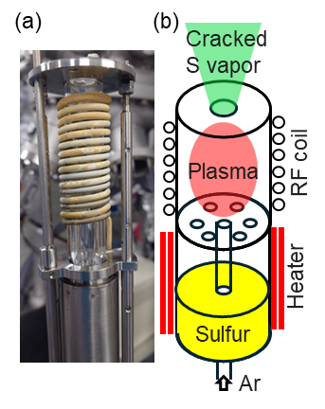

Fig. 1. (a) Actual photograph and (b) schematic illustration of the plasma cracking sulfur cell used in this study.

Fig. 2. (a) Optical appearance, (b) film thickness, and (c) sulfur concentration of the samples after the film growth at various T_{sub}, without and with plasma cracking of sulfur with sulfur cell temperature of 100ºC. Surface SEM images of a sample grown at T_{sub}:200ºC are also shown as insets in (b).

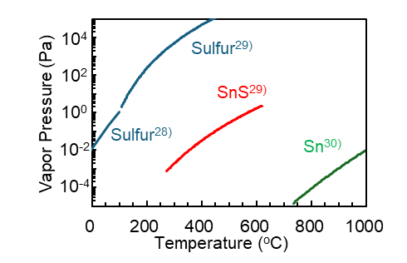
Fig. 3. Reported vapor pressure curves of sulfur, SnS, and Sn as a function of temperature.

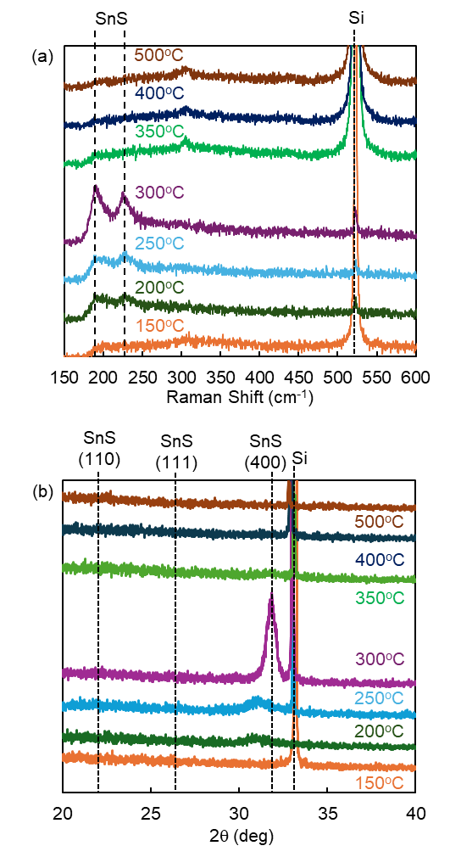
Fig. 4. (a) Raman spectra and (b) XRD results of samples grown with plasma-cracked sulfur at various T_{sub}. S cell temperature is fixed to be 100ºC for all samples.

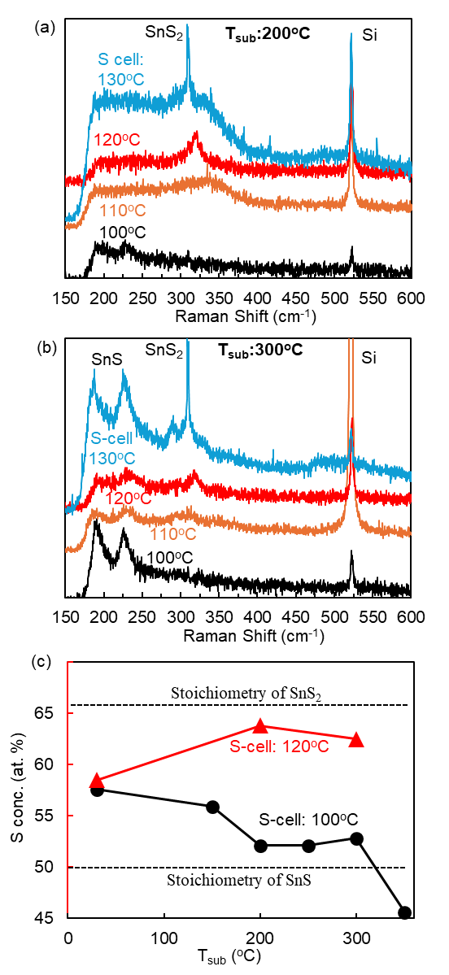
Fig. 5. Raman spectra of samples grown at (a) T_{sub}: 200ºC, and (b) T_{sub}: 300ºC, with various S-cell temperatures. (c) Sulfur composition in the films as a function of substrate temperature for two different S-cell temperatures.

