Thermal stability of internal stress in drawn pearlitic steel

Takumi Akada^{1,2,3}, Rintaro Ueji^{2,3}*, Tsubasa Tokuzumi³, Masatoshi Mitsuhara⁴, Shigeto Yamasaki⁵, Masaki Tanaka⁵

¹ Sumitomo Electric Industries, Ltd. Itami, Hyogo 664-0016, Japan
² Graduate School of Engineering, Kyushu University, Fukuoka 819-0395, Japan
³ National Institute for Materials Science, Tsukuba, Ibaraki 305-0047, Japan
⁴ Department of Advanced Materials Science and Engineering, Kyushu University, Kasuga-shi, Fukuoka 816-8580, Japan
⁵ Department of Materials, Kyushu University, Fukuoka 819-0395, Japan

*Corresponding author.
e-mail address: ueji.rintaro@nims.go.jp

ABSTRACT
Anisotropy found at the difference in yield stress between uniaxial tensile and compressive tests of the drawn pearlitic steel was studied at the perspective of thermal stability of internal stress. The 0.84 wt.% C steel was drawn to a drawing strain of 1.26, followed by the heat treatment at various temperature ranging from 200 °C to 500 °C. These samples were examined by both the tensile and compression tests in the direction parallel to the drawing direction. The as-drawn specimen shows that the tensile yield stress is higher than that in the compression, indicating the back stress parallel to the drawing direction exists to bring the anisotropy. The difference in the yield stress decreased with increasing the post heat treatment temperature, while the compressive yield stress showed significant increase. These indicates the less thermal stability of compressive internal stress. The microstructure observation showed that the elongated morphology of the pearlite and the texture of ferrite showed no significant change in the heat treatment at the temperature less than 500 ℃. This thermal instability of internal stress was confirmed by the X-ray diffraction which shows the elastic extent of the {110} spacing of ferrite without the recovery of dislocations indicated by the half width of diffraction peak. These results suggests that the internal stress is governed by constraint effect by interphase boundaries between ferrite and cementite.

Key words: steel, pearlite, yield stress, polarity, drawing, internal stress, Bauschinger effect

1. Introduction
Anisotropy of the deformation behaviors in structural metals has significant effects on the plastic deformation in the fabrication of industrial products. The physical mechanisms of the anisotropy can be found in several properties such as elastic anisotropy related to crystallographic orientation, crystallographic texture, microstructure, and other factors. For example, rolled materials have the anisotropy in strength, toughness and ductility, and there are many previous studies on these in various materials such as copper [1,2], aluminium [3,4], and steels [5,6]. It has been found generally in these studies that, in the rolled sheets, higher tensile strength in the rolling direction brings lower bendability when the rolling direction is perpendicular to bend axis. This means the understanding of anisotropy is necessary to optimize the fabrication process without failure in product.

Other typical example for plastic anisotropy [7-9] is the drawn pearlitic steels with high tensile strength [10-15]. Stobbs & Paetke [7], and Toribio et al. [8] studied on the Bauschinger effect of the drawn wires mainly in a perspective of macroscopic mechanics. Their experiments revealed that the internal stresses is induced by plastic deformation, while the detailed relation between that and microstructure evolved by drawing was not clarified. The authors of this paper [9] previously focused on the internal stress in the as-drawn wires and clarified the plastic anisotropy in the uniaxial deformation at different loading axes and polarity. Although the cause of the anisotropy has not been clarified adequately, but this can be related to layered microstructure in pearlite consisting of soft ferrite and hard cementite [16]. In other words, the dominant mechanism for the internal stress appeared in the heterogeneous deformation in microstructural scale rather than macroscopically non-uniform deformation by wire drawing [9].

On the other hand, the post heat treatment in drawn steels have been studied in long years. Most of these studies have been mainly focused on mechanical properties, including strain aging [17-20] and hydrogen embrittlement [21,22]. The cementite morphology has been investigated by some studies [18,22-25] as well. However, none of studies about the anisotropy can be found. The changes in mechanical properties by post heat treatment should be brought by various transitions in microstructure, such as the dislocation structure [25-28] and the cementite [24,29,30]. These different microstructural changes in different manners according to the condition of post heat treatment. If the plastic anisotropy changes by post heat treatment, it should be possible to investigate the cause of anisotropy with the microstructural changes. Therefore, this study aims to clarify the change in the anisotropy by post heat treatment of drawn pearlitic steel with the focus on both internal stress and microstructural change.

2. Experimental method
The steel wire rod, SWRH82A, coded by the Japanese Industrial Standards, JIS (G 3506), was used. The chemical composition is shown in Table 1. This wire rod has a full pearlitic structure due to the heat treatment (patenting). The initial diameter of this wire rod was 15 mm and drawn to 8 mm at room temperature by multi passes. The reduction in diameter at each pass was approximately 20%. This total drawing strain, 2ln (d₀/d_{n}), was 1.26. d₀ (=15 mm) and d_{n} (=8 mm) are initial and final diameter, respectively. The drawn samples were heat treated at various temperatures ranging 200 ℃ to 500 ℃ for 3.6ks in an air atmosphere, followed by air cooling.
Table 1 Chemical composition (mass %).
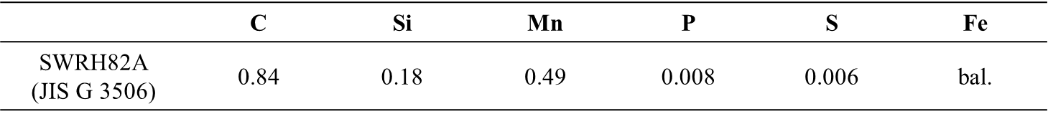

The as-drawn and heat-treated specimens were examined by both tensile and compressive tests in the direction parallel to the longitudinal direction of the wire with an initial strain rate of 1.0 × 10⁻¹/s. For the tensile test, the samples were cut in the shape of conventional dog-bone specimen. Cylindrical specimens of 8 mm × a height of 12 mm were used in the compressive test. In the compression test, a 0.2 mm thick mica plate coated with BN powder was placed between the compression specimen and anvils for lubrication.
Microstructural observations by a scanning electron microscope (SEM, JEOL JSM-7000F) and crystal orientation measurement by electron back scattering diffraction (EBSD, TSL-OIM data collection) were conducted. The observed surface was prepared by mechanical polishing and then electropolishing with a solution 10 vol% perchloric acid +90 vol% acetic acid. The EBSD measurements were conducted at an acceleration voltage of 15 kV and a step size of 0.1μm. Only bcc phase is adopted for possible phase in EBSD analysis.

X-ray diffraction (Rigaku Smart Lab) was conducted to measure the residual stress in the as-drawn wire and the heat-treated samples. The X-ray diffraction measurements were conducted at a voltage of 45 kV and a current of 200 mA with a Cu Kβ radiation source. The diffraction vector was set to be the parallel to the longitudinal direction of the wire, and thus the shift of diffraction peaks is regarded to imply lattice strain component parallel to the drawing direction. There are several methods for measuring residual stresses in pearlitic steel wire rods. For example, a slit method [31] for confirming the width change when a notch is inserted in the center of the wire, Hyne₋Bauer method [32] for confirming the length change when removing the surface of the wire are generally known. However, these methods measure the macroscopic residual stress in the whole wire rod. In this study, the residual stress was evaluated by the change in spacing crystallographic plane in ferrite, because the yield stress should be controlled by the soft ferrite phase.

3. Results
3.1 Microstructure and plastic anisotropy before and after drawing
The microstructures of the initial (as-patented) and as-drawn specimens are shown in Fig.1. The orientation color maps (IPF map) of EBSD measurement results (b,d) are shown from the drawing direction. The initial specimen has a full pearlitic structure and the lamellar spacing is 95 nm. The crystal orientations of the IPF map are randomly distributed. On the other hand, the lamellar of as-drawn specimen are oriented parallel to the drawing direction, and the lamellar spacing is decreased by drawing. Fig. 1(d) indicates that the commonly known <110> fiber texture [33,34] has been formed. To evaluate the development of dislocation substructure, KAM (Kernel Average Misorinetation) angle were calculated with the orientation difference between each EBSD measurement point and its second neighboring points. The KAM angle of as-drawn specimen increased compared with that of as-patented specimen. It suggested that the dislocation density in ferrite increased by drawing.
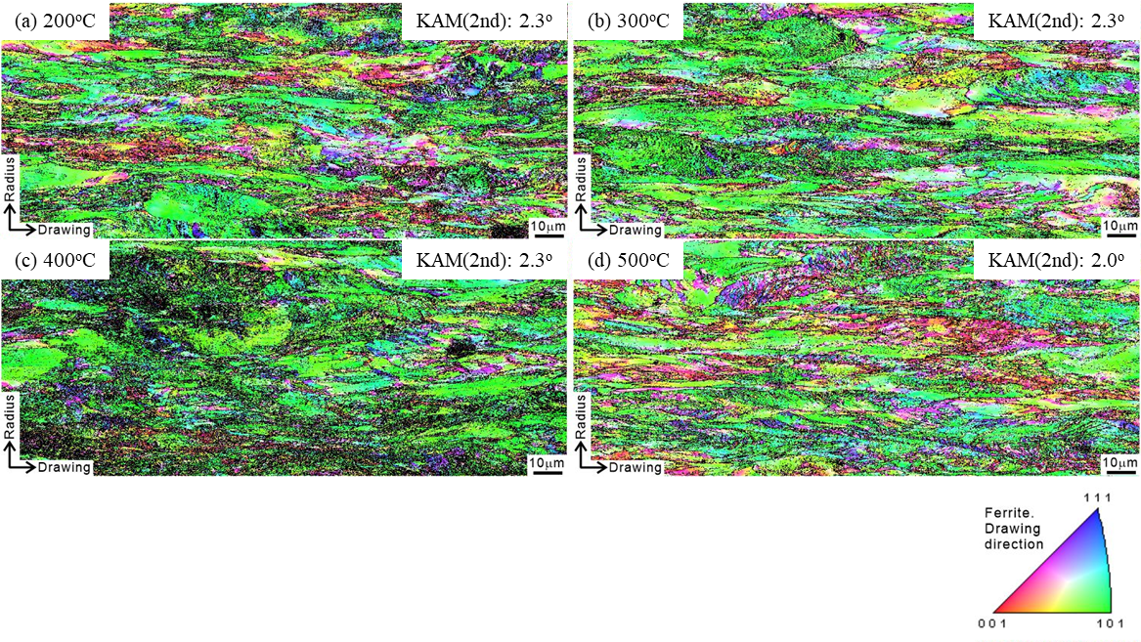
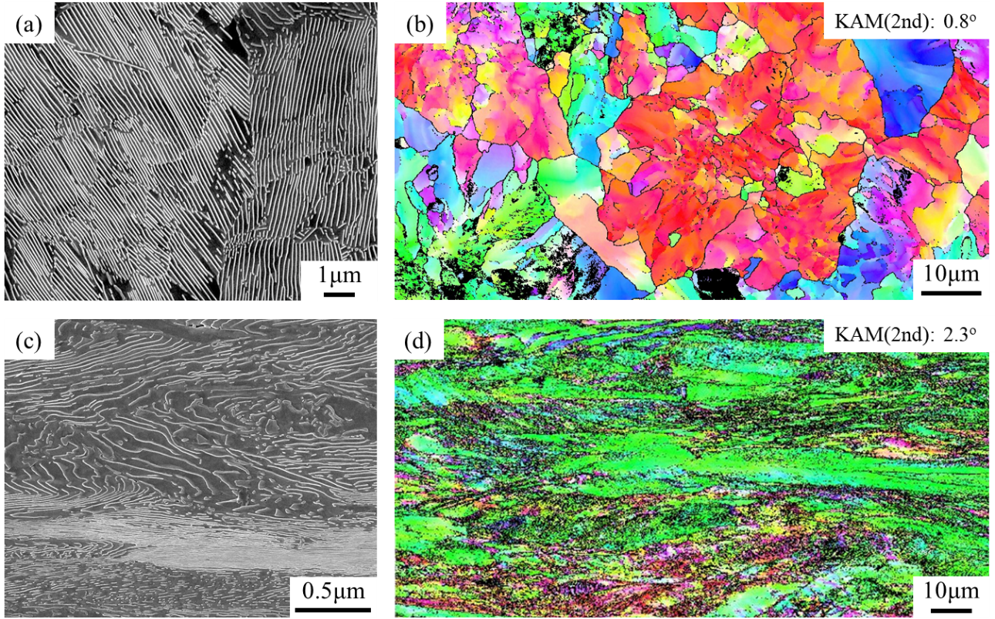
Fig.1 SEM images (a,c) and EBSD measurement results (b,d) of the as-patented (a,b) and as-drawn (c,d) steels. EBSD measurement results were obtained from the center area in the radial directions. The black line on the color maps indicates the high angle boundary and the color represents the crystallographic orientation of ferrite parallel to the drawing directions with the color-key triangle at the bottom-right on this figure.

Figure 2 shows the relationship between drawing strain and anisotropy of yield stresses. A part of this result is previously reported by the authors [9], and newly added the result of drawing strain of 1.26. No differences in radial microstructures and hardness were observed in the previous report [9]. In addition, the drawing strain of 1.26 shows the anisotropy of yield stress similar to that at the strain lower than 1.26, indicated by the similar difference of that between the tension and the compression. This means that the microstructural factors that cause the anisotropy have not undergone significant changes.

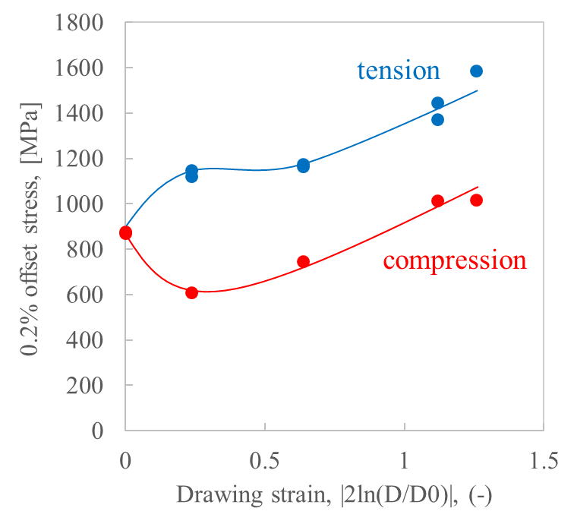
Fig.2 0.2% offset stress obtained by tensile and compressive tests in the drawing direction as a function of a drawing strain. Data except for those at a drawing strain of 1.26 have been already reported by the authors previously [9].

3.2 Microstructural analysis of heat-treated materials
Figure 3 shows the microstructures of the heat-treated specimens at various temperatures. No change in the morphology of cementite such as lamellar spacing is observed at 200℃ and 300℃. On the other hand, the spheroidizations of some cementite are confirmed at 400℃, and most of cementite are spheroidized at 500℃. These results indicate that spheroidization began at lower temperatures and in shorter time than in previous studies on cementite spheroidization in pearlitic steels [35,36]. Based on the study of accelerated spheroidization in drawn perlite [18,20,37-39], it is considered that the increased driving force due to large drawing strain, the effect on diffusion due to finer lamellar spacing, and the stability of the interface between ferrite and cementite may have influenced spheroidization at low temperatures and in a short time even in the heat-treated specimens in this study.

The EBSD measurement results of the heat-treated specimens are shown in Fig.4, where the IPF maps and KAM angles are presented by the same manners as in Fig. 1. The ferrite in all the post heat-treated specimens keeps <110> fiber texture as found in the as-drawn specimen. No appearance of newly evolved components of texture was identified even at the highest temperature. In other words, the texture transition that is occasionally found with recrystallization was not found. Additionally, the KAM angles remain unchanged below 400℃ and slightly decrease at 500℃. This indicates little change in the density of geometrically necessary dislocation.

Fig.4 IPF maps showing the drawing orientation of the samples heat-treated at (a)200℃, (b)300℃, (c)400℃ or (d)500℃. Corresponding KAM angles are added on these maps.
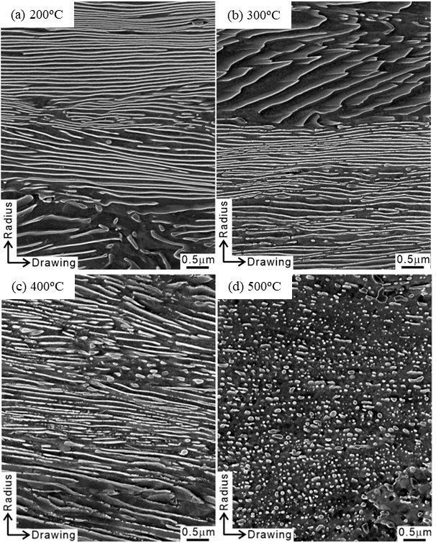
Fig.3 SEM images of the samples heat-treated at (a)200℃, (b)300℃, (c)400℃ or (d)500℃.
The {110} diffraction peaks of the ferrite are shown in Fig.5. Both diffraction pattern and FWHM (Full Width at Half Maximum) appears the same for the 200°C and as-drawn, indicating that the decrease in dislocation density due to recovery does not occur at 200°C. This result is consistent with the previous report by Tarui et al [25]. The FWHM at 300℃ or higher gradually decreases, corresponding to the decreasing of dislocation density by recovery. Fig.5 (b) is obtained by calculating the changes in {110} plane spacing of the ferrite estimated with the diffraction peaks. The {110} plane spacing tends to increase as the heat treatment temperature increases, and the {110} plane spacing increased at 200℃.
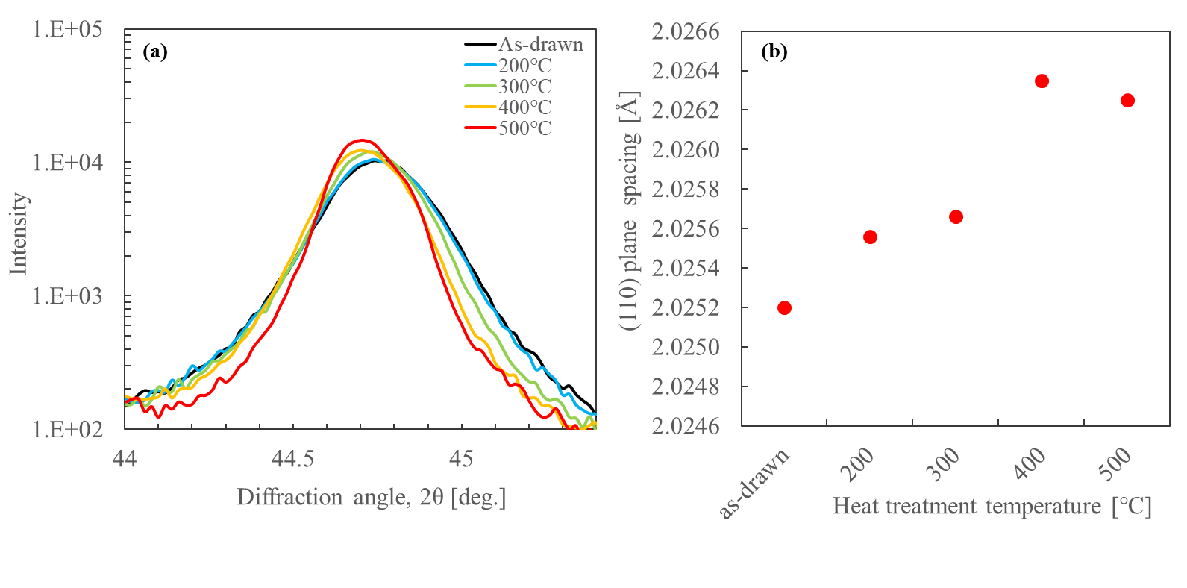
Fig.5 (a) XRD intensity profiles around the {110} ferrite diffraction peaks and (b) (110) plane spacing of the samples heat treated at various temperatures.

3.3 Mechanical properties of heat-treated specimens
Figure 6 shows the tensile and compressive tests of as-drawn and heat-treated specimens. Regarding tensile tests (Fig.6 (a)), the shapes of the stress-strain curves change at each heat treatment temperature. All curves show the continuous yielding without any yielding phenomenon followed by work hardening. The difference between the yield stress and the tensile strength gradually increases up to 400℃ and decreases at 500℃. The work hardening ability of as heat-treated pearlitic steels has been discussed linking with some factors; (i) internal stresses caused by constraining effect between ferrite and cementite [40,41] and (ii) the morphology of the cementite [42,43] and so on. In this work, since no significant change in lamellar morphology was observed after the heat treatment at 400℃ or lower, the work hardening ability is improved by the change in internal stress and/or the conventional recovery of dislocations. At 500℃, the spheroidization of the cementite reduced the partitioning of stress to the ferrite, which may have resulted in less work hardening. On the other hand, the compressive stress-strain curves in Fig. 6(b) show that the yield stresses are higher than that of the as-drawn specimen in heat treatment at 400℃ or lower. The difference to the tensile curves can be found in the work hardening behaviors as well. All of the specimens show relatively higher work hardening rate immediately after the yielding, and these rate keeps similar behavior even after the annealing at higher temperature. This difference in work hardening behaviors should be related to the internal stress which also brings to the anisotropy in yield stress as discussed later. It is also notable that the curve obtained by the compression test of the specimen annealed at 200℃ showed sudden drop in stress at a strain around 2%. This drop has been observed sometimes with the compression of the pearlitic steels as shown in authors previous work [9]. While the mechanism is difficult to be considered due to the randomness of appearance, this is probably due to kinking of the lamellar structure.
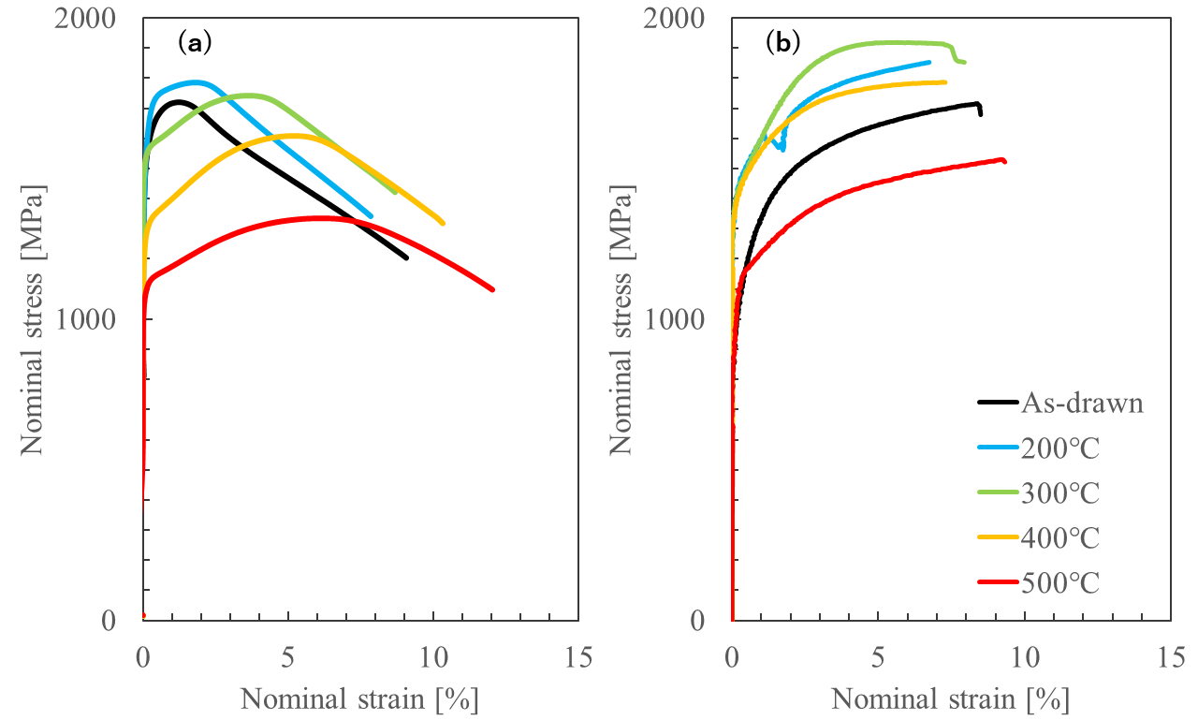
Fig.6 Stress-strain curves of as-drawn and heat‐treated samples obtained by (a) tension and (b) compression tests.

Figure 7 summarizes the 0.2% offset stress as a function of heat treatment temperature. The anisotropy found in the as-drawn specimen gradually disappeared by increasing of the temperature, and the yield stresses in tension and compression are equal at 400℃ or higher. Heat treatment at 200℃ slightly increased the yield stress by several tens of MPa in tension, while the compression brought more significant increase the yield stresses by around 400 MPa. The previous works [19] considered that the strengthening by post heat treatment is caused by strain aging, and the mechanism of strengthening is generally explained in terms of the microscopic interaction between dislocations and solute atoms. This mechanism is unlikely to depend so strongly on the polarity of the macroscopic loading axis. And thus, the different properties for the change in the polarity in strength should exist. The most possible one should be the internal stress which brings the polarity in strength of the as-drawn specimen. If the back stress is relieved by post heat treatment, the change in anisotropy of the strength can be explained by the combination of the isotropic strengthening due to strain aging and the relaxation of internal stress. Heat treatment at 300℃ or higher temperature reduces the yield strength in both tension and compression, and the anisotropy of the yield stress disappeared completely at temperature higher than 400℃. These reductions can be explained by the softening due to the recovery of dislocations and the relaxation of internal stress. Therefore, the internal stress is a key property.
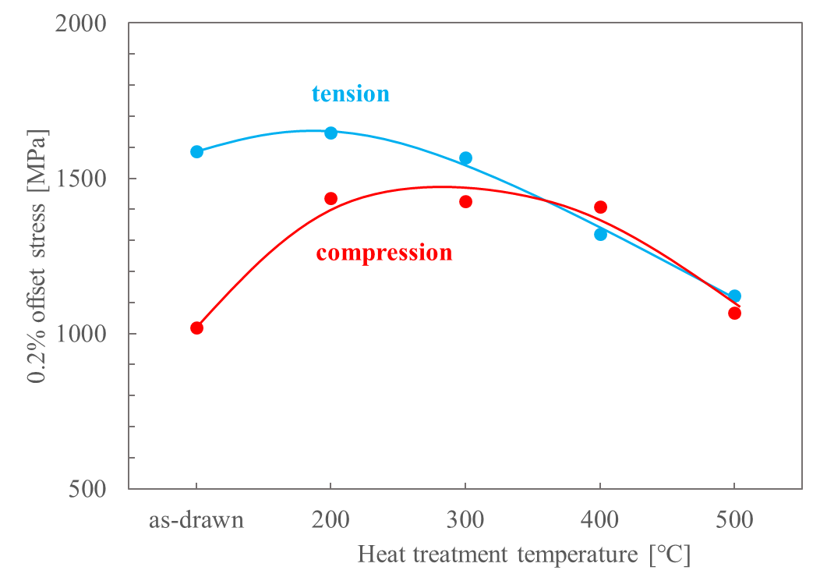
Fig.7 Relationship between heat treatment temperature and yield stress on loading polarity.

4. Discussion
The experimental results in this work clarifies the significant change in internal stress by post heat treatment. The possible mechanism for this change should be the most important question to be discussed, while it is necessary to summarize the evolution mechanism of internal stress by drawing before the discussion in the previous work [9]. When a composite material consisting of hard and soft microstructures such as pearlite undergoes plastic deformation by drawing, the longitudinally oriented lamellar structure of the wire is further stretched, as shown in Fig. 1. Because of the difference in yield stress, the plastic strain at the soft ferrite is larger than the plastic strain at the hard cementite, resulting in compressive residual stress in ferrite. This distribution of residual stresses has been confirmed in in situ neutron diffraction [44], and may be related to the previous results [7-9] on plastic anisotropy of drawn pearlitic steel. In other words, the anisotropy of yield stress can be explained by the existence of compressive residual stress in ferrite, assuming that the yielding in pearlite is dependent strongly on the internal stress in ferrite.

Since the nature of internal stress is closely related to the elastic strain in ferrite, the relationship between the {110} plane spacing (Fig. 5) and the back stress should be examined to show the change in the lattice shape of ferrite as shown in Fig. 8. The back stress was evaluated as half value of the difference between the tensile and compressive yield stresses in Fig. 7. It is interesting that the liner relation is found clearly between the back stress and the plane spacing, implying this relation is governed by liner elasticity. Although The effect of solid solute carbon may be considered, Koga et al. reported that the effect of solid solute carbon on the change in lattice parameter is significant small with the specimen is unprocessed [45]. For the quantitative evaluation of this relation, the apparent Young's modulus due to the internal stress was evaluated by the following procedure: the intersection of the regression line at horizontal axis (back stress = 0, 2.0262Å) in Fig. 8 was measured as the standard condition of {110} spacing without any internal stress, and the lattice strain along with the {110} normal was calculated with this standard spacing. The slope of the liner regression between the back stress and the lattice strain was evaluated as the apparent Young's modulus, that was 470 GPa. While the actual Young's modulus of ferrite single crystal has strongly dependent with crystallographic orientation in loading direction, the average modulus is approximately 200 GPa [46-48]. This value indicates the similar order to the modulus evaluated in this work, however, still significant difference exists between these values. Although the clear reason for this difference has not been clarified yet, it is notable that there are several possible mechanisms, one of which should be due to the multicomponent stress condition in the internal stress as found in the authors previous work [9]. The as-drawn wire has the internal stress not only parallel to the drawing direction but also perpendicular to the drawing direction. Both stress component can provide the change in the back stress via elastic constants such as Poisson rate. And thus, the change in the lattice spacing appears underestimated in the relation shown in Fig.8. Anyway, the change in plastic anisotropy and compressive internal stress of ferrite due to heat treatment may also be influenced by elastic deformation of ferrite.
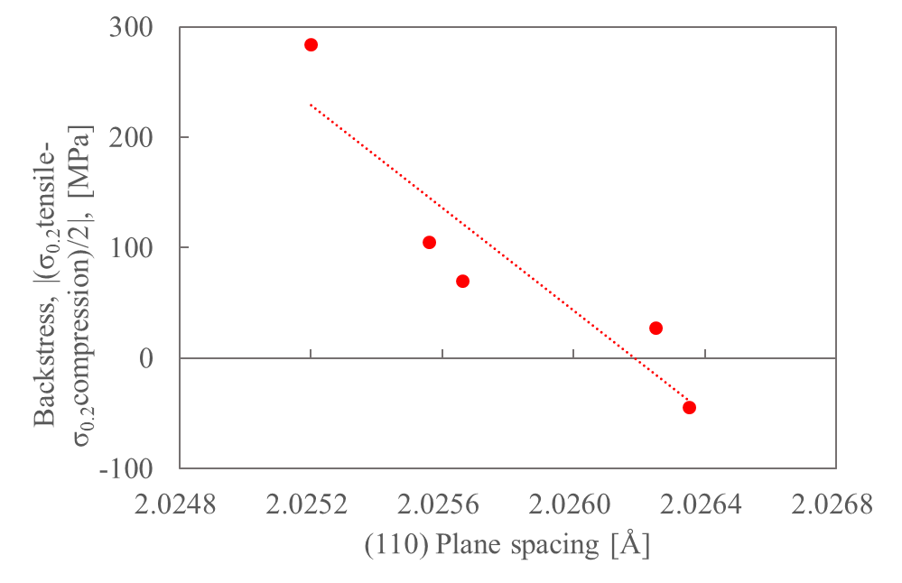
Fig.8 Relationship between {110} plane spacing and back stress.

Based on the above discussion, the changes in compressive internal stress and microstructure in ferrite at each heat treatment temperature are organized. The decrease in compressive internal stress due to heat treatment was particularly large at 200℃, decreased further at 300℃, and the compressive internal stress disappeared at 400℃ or higher. These suggest that the heat treatment reduces the compressive internal stresses in the ferrite. Firstly, at 200℃, where the largest decrease in internal stress was observed, the X-ray diffraction results in Fig. 5 show that the {110} plane spacing widens without a decrease in dislocation density, and thus recovery of dislocation is not dominant mechanism of the change in the internal stress. Tarui et al. [25] reported that heat treatment at about 200℃ causes decomposition of cementite and diffusion of carbon. This indicates that the diffusion of carbon is assumed to provide the mechanism to accommodate the lattice strain. Secondly, at 300℃, where the compressive internal stress decreased further, Hirakami et al. [22] observed that heat treatment at 300℃ causes not only strain aging but also local recovery of dislocation or recrystallization of cementite. Fig. 5 also shows a decrease in dislocation density, which may have influenced the decrease in compressive internal stress. Finally, when the compressive internal stress disappears at 400℃, in addition to a decrease in dislocation density (Fig.5), spheroidization of cementite occurs as shown in Fig. 3. Sudo et al. [20] and Kawabe et al. [18] observed cementite spheroidization in drawn pearlitic steel at 400℃ heat treatment. From these findings, the cause of the change in plastic anisotropy of drawn pearlitic steel due to heat treatment is thought to be due to changes in the microscopic structure around the ferrite-cementite interface, which all have different scales, although the causes vary with heat treatment temperature. In particular, the large change in anisotropy at 200℃ suggests that the effect of the release of the elastic ferrite-cementite interface constraint is significant. The reason for the release of the restraints at the ferrite-cementite interface is currently unclear, but analysis focusing on the microscopic structure around the interface associated with carbon diffusion and cementite decomposition, as described above, is considered necessary.

5. Conclusion
The change in the plastic anisotropy (difference in yield stress between at tension and at compression) of drawn pearlitic steel by the post heat treatment was investigated. The post heat treatment significantly increased the compressive yield stress more than that found at tension and the anisotropy disappeared. The main results are as follows.

1. The morphology of the lamellae did not change significantly below 400°C, and cementite spheroidization partially occurred at 500℃.
2. X-ray diffraction indicated that the recovery of dislocation occurred at above 300℃. On the other hand, the {110} plane spacing showed a broadening from 200℃.
3. The compressive yield stress relative to tensile increased significantly after heat treatment at 200℃. This suggests that the compressive residual stress at ferrite is reduced by the heat treatment. The one possible reason for this result is the release of the restraints at the interface between ferrite and cementite.

Acknowledgements
This study is based on the work partially supported by a Grant-in-Aid for Scientific Research (ID: 23H01732) through the Japan Society for the Promotion of Science (JSPS) and by JST CREST (JPMJCR24S4).

References
[1] J. Li, H. Ding and L. Wang, Microstructure and bending properties of Cu-Cr-Zr alloy subjected to heat treatment and rolling, J. Mater. Eng. Perform., 30 (2021), 5825-5833.
https://doi.org/10.1007/s11665-021-05833-x
[2] T. Yamane, M. Yasunaga, K. Hirao, S. Yamasaki, K. Kazama, S. Yamasaki, K. Azama, K. Yoshida, R. Takeda, M. Hiratani, Repetition bend properties of Cu-Cr and Cu-Cr-Sn alloys, J. Mater. Sci., 23 (1988), 305-310.
https://doi.org/10.1007/BF01174070
[3] H. Inoue, T. Takasugi, Texture control for improving deep drawability in rolled and annealed aluminium alloy sheets, Mater. Trans. 48 (2007), 2014-2022.
https://doi.org/10.2320/matertrans.L-MRA2007871
[4] H. Tanaka and S. Ikawa, Effect of texture on 0°/180° earing in deep drawing of aluminum alloy sheets, 53 (2012), 1852-1857.
https://doi.org/10.2320/matertrans.L-M2012825
[5] T. Tanno, Y. Yano, H. Oka, S. Ohtsuka, T. Uwaba, T. Kaito, Strength anisotropy of rolled 11Cr-ODS steel, Nucl. Mater. Energy 9 (2016), 353-359.
https://doi.org/10.1016/j.nme.2016.02.009
[6] W.B. Hutchinson, K. Ushioda, G. Runnsjö, Anisotropy of tensile behaviour in a duplex stainless steel sheet. Mater. Sci. Technol., 1(9) (2013), 728-736.
http://dx.doi.org/10.1179/026708385790124224
[7] W.M. Stobbs and S. Paetke, The Bauschinger effect in cold drawn patented wire, Acta Metall. 33 (1985), 777-783.
https://doi.org/10.1016/0001-6160(85)90101-4
[8] J. Toribio, V. Kharin, F.-J. Ayaso, M. Lorenzo, B. González, J.-C. Matos and L. Aguado, Analysis of the Bauschinger effect in cold drawn pearlitic steels, Metals, 10 (2020), 114.
https://doi.org/10.3390/met10010114
[9] T. Akada, R. Ueji, M. Mitsuhara, S. Yamasaki, M. Tanaka, Plastic anisotropy in yield stress of drawn pearlitic steels, Mater Sci Eng, A, 898 (2024), 146380.
https://doi.org/10.1016/j.msea.2024.146380
[10] H.K.D.H. Bhadeshia and A.R. Chintha, Critical assessment 41: the strength of undeformed pearlite, Mater. Sci. Technol., 38 (2022), 1291-1299.
https://doi.org/10.1080/02670836.2022.2079295
[11] N. Nakada, N. Koga, Y. Tanaka, T. Tsuchiyama, S. Takaki and M. Ueda, Strengthening of Pearlitic Steel by Ferrite/Cementite Elastic Misfit Strain, ISIJ Int., 55 (2015), 2036-2038.
http://dx.doi.org/10.2355/isijinternational.ISIJINT-2015-102
[12] J.D. Embury and R.M. Fisher, The structure and properties of drawn pearlite, Acta Metall., 14 (1966), 147-159.
https://doi.org/10.1016/0001-6160(66)90296-3
[13] G. Langford and M. Cohen, Microstructural analysis by high-voltage electron diffraction of severely drawn iron wires, Metall. Trans. 6A (1975) 901-910.
https://doi.org/10.1007/BF02672314
[14] G. Langford, Deformation of Pearlite, Metall. Trans. A, 8A (1977), 861-875.
https://doi.org/10.1007/BF02661567
[15] Y. Li, D. Raabe, M, Herbig, P. P. Choi. S. Goto, A. Kostka, H. Yarita, C. Borchers and R. Kirchheim, Segregation Stabilizes Nanocrystalline Bulk Steel with Near Theoretical Strength, Phys. Rev. Lett., 113 (2014), 106104.
https://doi.org/10.1103/PhysRevLett.113.106104
[16] M. Umemoto, Z.G Liu, K. Masuyama, K. Tsuchiyama, Influence of alloy additions on production and properties of bulk cementite, Scripta Mater. 31 (2001) 391-397.
https://doi.org/10.1016/S1359-6462(01)01016-8
[17] V. T. L. Buono, M. S. Andrade and B. M. Gonzalez, Kinetics of strain aging in drawn pearlitic steels, Metall. Mater. Trans. A, 29A (1998), 1415.
https://doi.org/10.1007/s11661-998-0356-y
[18] N. Kawabe, T. Murai and K. Yamaguchi, Mechanisms of increase in mechanical strength and heat resistance of Si-enriched hard drawn steel wire, Transactions of Japan Society of Spring Engineers. 44 (1999), 1-6 (in Japanese).
https://doi.org/10.5346/trbane.1999.1
[19] V. T. L. Buono, M. S. Andrade and B. M. Gonzalez, Kinetics of strain aging in drawn pearlitic steels, Metall. Mater. Trans. A, 29 (1998), 1415-1423.
https://doi.org/10.1007/s11661-998-0356-y
[20] H. Suto and T. Kudo, Annealing structure of heavily drawn pearlite, J. Jpn. Inst. Met., 36 (1972), 693-701 (in Japanese).
https://doi.org/10.2320/jinstmet1952.36.7_693
[21] K.Takai and R.Watanuki, Hydrogen in Trapping States Innocuous to Environmental Degradation of High-strength Steels, ISIJ Int., 43 (2003), 520-526.
https://doi.org/10.2355/isijinternational.43.520
[22] D. Hirakami, T. Manabe, K. Ushioda, et al. Effect of aging treatment on hydrogen embrittlement of drawn pearlitic steel wire. ISIJ Int., 56 (2016), 893–898.
https://doi.org/10.2355/isijinternational.ISIJINT-2015-735
[23] X. Zhang, A. Godfrey, N. Hansen, X. Huang. W. Liu. Q. Liu, Evolution of cementite morphology in pearlitic steel wire during wet wire drawing, Mater. Charact., 61 (2010), 65-72.
https://doi.org/10.1016/j.matchar.2009.10.007
[24] J. Languillaume, G. Kapelski and B. Baudelet, Cementite dissolution in heavily cold drawn pearlitic steel wires, Acta Mater., 45 (1997), 1201-1212.
https://doi.org/10.1016/S1359-6454(96)00216-9
[25] T. Tarui and N. Maruyama, Cementite decomposition in high carbon steel wires, Tetsu-to-Hagané, 91 (2005), 265-271 (in Japanese).
https://doi.org/10.2355/tetsutohagane1955.91.2_265
[26] X. Zhang, A. Godfrey, X. Huang, N. Hansen, Q. Li, Microstructure and strengthening mechanisms in cold-drawn pearlitic steel wire, Acta Mater. 59 (2011), 3422–3430.
https://doi.org/10.1016/j.actamat.2011.02.017
[27] X. Zhang, N. Hansen, A. Godfrey, X. Huang, Dislocation-based plasticity and strengthening mechanisms in sub-20 nm lamellar structures in pearlitic steel wire, Acta Mater. 114 (2016), 176–183.
https://doi.org/10.1016/j.actamat.2016.04.040
[28] Y. Daitoh and T. Hamada, Microstructure of heavily-deformed high carbon steel wires, Testu-to-Hagane 86 (2000), 105-110 (in Japanese).
https://doi.org/10.2355/tetsutohagane1955.86.2_105
[29] Y. J. Li, P. Choi, C. Borchers, S. Westerkamp, S. Goto, D. Raabe and R. Kirchheim, Atomic-scale mechanisms of deformation-induced cementite decomposition in pearlite, Acta Mater., 59 (2011), 3965-3977.
https://doi.org/10.1016/j.actamat.2011.03.022
[30] J. Takahashi, M. Kosaka, K. Kawakami and T. Tarui, Change in carbon state by low-temperature aging in heavily drawn pearlitic steel wires, Acta Mater., 60 (2012), 387-395.
https://doi.org/10.1016/j.actamat.2011.09.014
[31] S. Kajino, T. Hatakeyama, Y. Tamura, Y. Ohsawa, S. Shishido, W. Sasaki, T. Hamamoto, S. Misaki and M. Asakawa, Effect of die geometry on residual stress at surface of drawn bar, J. Jpn. Soc. Technol. Plast., 54 (2013), No.634, 998-1002 (in Japanese).
https://doi.org/10.9773/sosei.54.998
[32] E. Heyn and O. Bauer: Mitt. K. Mater. Priif. Amt. Berl-Dahlem, 28 (1910), 62.
[33] S. Gondo, R. Tanemura, R. Mitsui, S. Kajino, M. Asakawa, K. Takemoto, K. Tashima and S. Suzuki, Relationship between mesoscale structure and ductility of drawn high carbon steel wire, Mater. Sci. Eng. A, 800 (2021), 140283.
https://doi.org/10.1016/j.msea.2020.140283
[34] M. Ettisc, M. Polanyi and K. Weissenberg, Über Faserstruktur bei Metallen, Z. Phys. 7 (1921), 181-184.
[35] K. Ishida, M. Ohkubo, M. Y. Wey and T. Nishizawa, Rate equation for spheroidization of lamellar pearlite, J. Jpn. Inst. Met., 52 (1988), 388-394 (in Japanese).
https://doi.org/10.2320/jinstmet1952.52.4_388
[36] M. Honjo, T. Kimura, K. Hase, Effect of Cr on lamellar spacing and high-temperature stability in eutectoid steels, ISIJ Int. 56 (2016), 161–167.
https://doi.org/10.2355/isijinternational.ISIJINT-2015-395
[37] H.Takenaka, S.Toyoshima and Y.Tuchida: Netsu Shori, 43(2003), 425 (in Japanese).
[38] T.Saito and S.Murakami, Effects of working on the spheroidization of cementite in carbon steel, J. Jpn. Inst. Met., 29 (1965), 995-1001 (in Japanese).
https://doi.org/10.2320/jinstmet1952.29.10_995
[39] M. Okonogi, D. Hirakami, T. Hara, and H. Miura, Effect of Prior Microstructure on Mechanical Properties of Medium Carbon Pearlitic Steels After Spheroidizing Annealing, Tetsu-to-Hagané, 102 (2016), 96–104 (in Japanese).
https://doi.org/10.2355/tetsutohagane.TETSU-2015-070
[40] Y. Tomota, P. Lukas, D. Neov, S. Harjo and Y.R.Abe, In situ neutron diffraction during tensile deformation of a ferrite-cementite steel, Acta Mater., 51 (2003), 805-817.
https://doi.org/10.1016/S1359-6454(02)00472-X
[41] Y. Tomota, T. Suzuki, A. Kanie, Y. Shiota, M. Uno, A. Moriai, N. Minakawa and Y. Morii, In situ neutron diffraction of heavily drawn steel wires with ultra-high strength under tensile loading, Acta Mater., 53 (2005) 463-467.
https://doi.org/10.1016/j.actamat.2004.10.003
[42] Y. Yajima, N. Koga and C. Watanabe, Influential factors on the deformability of colonies in pearlitic steel, Mater. Charact., 177 (2021), 111197.
https://doi.org/10.1016/j.matchar.2021.111197
[43] N. Koga, Y. Yajima and C. Watanabe, Deformation and fracture behaviors of spheroidized pearlitic steel under tensile loading, ISIJ Int., 62 (2022), 2025-2035.
https://doi.org/10.2355/isijinternational.ISIJINT-2022-154
[44] Y. Wang, Y. Tomota, S. Hajyo, W. Gong and T. Ohmura, In-situ neutron diffraction during tension-compression cyclic deformation of a pearlitic steel, Mater. Sci. Eng. A, 676 (2016), 522-530.
https://doi.org/10.1016/j.msea.2016.08.122
[45] N. Koga, O. Umezawa, M. Yamamoto, T. Yamamoto, T. Yamashita, S. Morooka, T. Kawasaki, S. Harjo, Effect of solute carbon on the characteristic hardening of steel at high temperature, Metall. Mater. Trans. A, 52 (2021), 897-901.
https://doi.org/10.1007/s11661-020-06113-4
[46] M.T. Hutchings, P.J. Withers, T.M. Holden and T. Lorentzen: Introduction to the Characterization of Residual Stress by Neutron Diffraction, CRC Press, Taylor & Francis, Oxford, (2005), 229.
https://doi.org/10.1201/9780203402818
[47] A.Muramatsu: The Modulus of Elasticity of Metals and Alloys, JSME, Tokyo, (1980), 40 (in Japanese).
[48] H.Kitagawa, Anisotropy of young’s modulus and texture in cold rolled mild steel, J. Soc. Mater. Sci., Jpn., 29 (1980), 691 (in Japanese).
https://doi.org/10.2472/jsms.29.691

