Synergistic effect of integrating N‑functionalized graphene
and PEDOT:PSS as hole transporter bilayer for high‑performance
perovskite solar cells
A. G. Al‑Gamal^{1,2} · Ahmed Mourtada Elseman³ · M. Abdel‑Shakour^{2,4} · T. H. Chowdhury² · K. I. Kabel¹ · A. A. Farag¹ ·A. M. Rabie¹ · N. E. A. Abd El‑Sattar⁵ · Naoki Fukata^{6,7} · Ashraful Islam^{2,7}
1 Photovoltaic Materials Group, Center for Green Research on Energy and Environmental Materials, National Institute for Materials Science (NIMS), 1-2-1 Sengen, Tsukuba, Ibaraki 305-0047, Japan.
2 Egyptian Petroleum Research Institute (EPRI), Nasr City, 11727, Cairo, Egypt.
3 Electronic & Magnetic Materials Department, Advanced Materials Institute, Central Metallurgical Research and Development Institute (CMRDI), Helwan, P.O. Box 87, Cairo 11421, Egypt.
4Chemistry Department, Faculty of Science, Assiut University, Assiut 71516, Egypt
5 Chemistry Department, Faculty of Science, Ain Shams University, Abbassia, 11566 Cairo, Egypt.
6 International Center for Materials Nanoarchitectonics, National Institute for Materials Science, Tsukuba, Ibaraki 305-0044, Japan
7 Faculty of Pure and Applied Sciences, University of Tsukuba, Tsukuba, Ibaraki 305-8573, Japan.
Corresponding author: A. M. Elseman Email: amourtada@cmrdi.sci.eg; AhmedMourtada5555@yahoo.com
Corresponding author: Ashraful Islam Email: ISLAM.Ashraful@nims.go.jp
ABSTRACT
One of the most critical factors that impact perovskite solar cells'(PSCs) efficiency is the hole transport layers (HTLs). Poly (3,4-ethylenedioxythiophene):poly(styrenesulfonate) (PEDOT:PSS) has been considered the most conducting polymer to use as an organic HTL for the inverted structure of PSCs. Because of the high acidic value and low open-circuit voltage (V_{OC}) influences the whole PSCs device performance. To overcome that dilemma, here HTLs were fabricated using bilayer structure engineering to synergy the stability and conductivity using ethylenediamine functionalized graphene (EDA-FG). The new bilayer successfully matches the energy valence band at HTLs/perovskite layer interface. The photoluminescence (PL) confirms that the deposited EDA-FG/PEDOT:PSS quenched the perovskite layer more than PEDOT:PSS. The champion PSCs device based on bilayer HTL structure gave a power conversion efficiency (PCE) of 17.39% compared with 12.85 % for PEDOT: PSS-based PSCs.
Keywords: Functionalized graphene, Graphene oxide, Graphene ethylenediamine, Perovskite solar cell, Stability.
- Introduction
Compared with mesoporous organic-inorganic perovskite solar cells (PSCs) that recorded a power conversion eﬃciency (PCE) exceeding 25%, the inverted structure of PSCs granted more beneficial properties, including their low hysteresis, low-temperature processed and, long-term stability of PSCs ^{[1]}. In a typical inverted (p-i-n) PSCs, the light absorber layer, perovskite film, is actually placed between two chargers’ carriers; hole and electron-transporting layers (HTLs and ETLs). In order to magnify the holes collection several conductive-polymers (i.e., poly (3,4 ethylenedioxy thiophene):poly(styrene sulfonate) (PEDOT:PSS) ^{[2]}, poly (triarylamine) (PTAA)) ^{[3]}, in addition to metal oxides (i.e., NiO_{x} ^{[4]}, V₂O₅ ^{[5]}, and CoO_{x} ^{[6]}, Cu₂ZnSnS₄ ^{[7]} and CuSCN ^{[8]} has been utilized as HTLs to better PSCs device performance. Particularly PEDOT: PSS was adopted as the most efficient conductive-polymers HTLs in the inverted PSCs; however, its acidic property degrades the perovskite layer and shares the whole solar device instability via corrosion of ITO transparent electrode ^{[9]}.
Graphene and its allotropes were successfully applied as an alternative candidate as HTLs for PEDOT:PSS due to its unique characteristics such as good stability, optoelectronic property, and long-term stability ^{[10]}. Unfortunately, the Graphene’s work function (WF) is around 4.9 eV, and this value has severe mismatch with the absorber layer. Graphene based HTLs result in poor surface morphology and result in non-homogenous film with low surface coverage ^{[10a, 11]}. To overcome the defects in both types of HTLs, some reports synergized benefits by combining them as HTLs using two different techniques; intercalation of the Graphene into PEDOT:PSS while another is forming a bilayer HTL which consist of PEDOT:PSS and one of the Graphene allotropes ^{[12]}. Obispo et al. showed an easy low-temperature spin coating technique for preparing homogenous PEDOT:PSS thin-film doped with Graphene oxide (GO). The obtained results approved that the PSCs device based on PEDOT:PSS-doped GO enhanced the electrical conductivity crystallinity of the perovskite layer without declining the optical transmittance ^{[12b]}. Shanglei Feng et al.; followed bilayer HTLs techniques by precipitating GO and modiﬁed with NH₃ layer on the tope of PEDOT:PSS to form a PSCs with configuration (PEDOT:PSS)-GO: NH₃/CH₃NH₃PbI_{3−x}Cl_{x}/PCBM/Bphen/Ag. The obtained results depicted that PSCs device based on bilayer HTLs structure enhanced signiﬁcantly the performance and stability of perovskite layer outcomes compared with all the reference devices without the GO:NH₃ layer where the champion device gave PCE up to 16.11% ^{[13]}.
Recently, many articles declared that doping the Graphene with amine compounds like ethylene diamine (EDA), diethylenetriamine (DETA), and triethylenetetramine (TETA) using different methods, including spin-coating, dipping, vapor phase depositions led to improve its electronics properties. In addition to hole mobility, films resistance, carrier concentrations, and electrical conductivity, the work function (WF) was regularly enhanced without affecting the Graphene layer transmittance compared to pristine Graphene, which promotes using N-DG as an HTLs in the PSCs ^{[14]}.
Herein, we stress the benefits of the HTLs using the bilayer technique. Firstly, ethylenediamine functionalized graphene (EDA-FG) was synthesized via a simple solvothermal method. Thus EDA-FG film was spin-coated over ITO with different concentrations of 0.25, 0.5, and 1 mg/ml, followed by PEDOT:PSS. The fabricated bi-layer HTLs of EDA-FG/ PEDOT:PSS were characterized by scanning electron microscopy (SEM), X-ray diffraction (XRD), and Ultraviolet-Visible spectroscopy (UV-Vis). The electrical resistances of various deposited HTLs, including EDA-FG, PEDOT:PSS, and bi-layer HTLs structures, were measured by electrochemical impedance spectroscopy (EIS). The performances of different fabricated devices based on EDA-FG, PEDOT:PSS, and bi-layer HTLs are investigated. The evaluated HTLs with 0.5 mg.mL⁻¹ EDA-FG/PEDOT: PSS-based PSCs showed PCE of 17.39% stability up to 500 h, compared to lower efficiency of the controls devices fabricated with PEDOT:PSS or pristine EDA-FG.
- Experimental
  - Materials
The following chemicals were obtained from commercial suppliers: PbI₂ (99%) and CH₃NH₃I (>98%) were purchased from Tokyo Chemical Industry Co., Japan, PCBM (99.5%), Lumtec Co., Taiwan), bathocuproine (BCP) (Wako chemicals), graphite powder, and ethylenediamine (Sigma-Aldrich). Dimethyl sulfoxide (DMSO), dimethylformamide (DMF), toluene, chlorobenzene, and methanol were purchased from Wako Chemicals, Japan. All the chemicals were used without any further purification.
  - Preparation of Graphene-Ethylenediamine (EDA-FG)
Using hummer's method techniques, the GO was obtained from graphite powder ^{[15]}. The EDA-FG was prepared by direct solvothermal reaction between the obtained GO and ethylenediamine (EDA) solution in the presence of Li metal and ammonium hydroxide (NH₄OH) as catalysts and nitrogen dopant agents, respectively. The dried GO powder was mixed with EDA solutions in the autoclaves to form a physical adsorbed EDA over the GO surface. Then the autoclaves were placed in a furnace for 4 hr at 200 ℃. The reaction finished when the suspension color changed from yellowish-brown to black color due to the reduction effect of the amine solution over the GO surface (see Figure S1). The black solid resediments of EDA-FG was washed with 0.1 M HCl solution to remove the excess amine and unreacted Li, followed by repeatedly rinsing with ethanol and water to eliminate any impurities. The obtained product EDA-FG was dried at 60 ℃ overnight under a vacuum to remove the physically adsorbed amines, then well-kept-up for further analysis.
  - Device fabrication
Firstly, an aqueous solution of PEDOT:PSS was deposited over the ITO substrate by spin-coating at 1500 and 4000 rpm for 15 and 20 s, respectively, and then it was annealed at 150 ° C for 15 min. The formation of an interfacial film based on EDA-FG was initialized via 120 µL (0.25, 0.5, and 1 mg mL⁻¹ suspendered in diethyl ether were deposited under of PEDOT:PSS by spin-coating at a speed of 2000 rpm for 25 s followed by of 4000 rpm for 15 s, and the film was dried at 50 ° C for 10 mins. Scheme 1a describes the made-up HTL with a bilayer structure with an optical image for every step. Then, MAPbI₃ precursor perovskite solution (100 µL) containing PbI₂ (998 mg) and CH₃NH₃I (343 mg) well dissolved in 1.8 mL of 5:1 (v/v) DMF/DMSO was dropped onto the resultant bilayer HTLs by spinning at 1000 rpm for 12 s and then at 5000 rpm for 30 s. Chlorobenzene (anti-solvent) (100 µL) was dropped onto the perovskite layer after 5 s of the spinning increased to 5000 rpm, and the film was annealed for 15 min at 120 °C. Next, the ETL layer was formed by 20 mg of PCBM in chlorobenzene (1 mL), then spin-coated over perovskite film at 1000 rpm for 30 s. For inhibiting the corrosion of perovskite by Ag anode, 140 µL of a saturated solution of BCP in methanol was deposited on top of the PCBM film within rotation at 6000 rpm for 30 s. Device fabrication was completed with an active area of 0.09 cm² by thermal evaporation of 70 nm Ag. The steps of PSCs devices fabrications with bilayer structure are illustrated in Scheme 1b.
  - Characterization
Fourier transform infrared spectra (FTIR) was observed by Thermo Fisher Scientific; Nicoletti S10 FTIR spectrometer, the USA, with ranges from 400-4000 cm⁻¹ and 4 cm⁻¹ resolutions. The ultraviolet-visible (UV-Vis) and transmittance spectra were detected UV-VIS-NIR spectrophotometer (Jasco-V-570 spectrophotometer, Japan). Scanning electron microscope (SEM) images were observed using (JEOL- JSM- 5300 Japan) field-emission scanning electron microscope under an acceleration voltage of 5 kV. The X-Ray Diffraction (XRD) was measured using an X-ray diffractometer PANalytical device (model: X’Pert Pro) with 2θ from (5-80º) with conditions at 40 mA, 40 kV, and wavelength of Cupper Kα 1.5418 Å. Electrochemical impedance spectroscopy (EIS) technique was carried out using Origalys – signal channel (OrigaFlex 01A) system at a frequency ranging from 100 kHz to 0.01Hz with the amplitude of 20 mV to measure the resistances of bi-layer HTLs and recorded Nyquist plot of the impedance data fitted by Zsimwin Version 3.0.1 software. Steady-state photoluminescence (PL) was measured by a Hamamatsu C12132 fluorescence lifetime spectrometer using a 1.5 ns pulsed laser (frequency 15 kHz) at an excitation wavelength of 407 nm. The current density-voltage (J-V) characteristics were measured using a solar simulator with standard AM1.5 G sunlight (Wacom Denso Co., Japan WXS-155S-10) under ambient conditions with a humidity of ˃70 %. The J-V curves were measured by forward (-0.2V to 1.2V) or reverse (1.2V to -0.2V) scans. All devices were masked with an aperture area of 0.09 cm^{2,} and the voltage was fixed at 10mV and with a delay time of 50 ms. Monochromatic incident photon-to-current conversion efficiency (IPCE) spectra were measured with monochromatic incident light of 1 ×10¹⁶ photon cm² in direct current mode (PVE 300, Bentham). The light soaking stability was tested on a solar cell light resistance test system (Model BIR-50, Bunkoukeiki Co., LTD). Keithley was used for automatically recording J–V curves.
- Result and discussions
FT-IR spectra of PEDOT:PSS, various deposited bilayers of different concentrations of EDA-FG (0.5 and 1.0 mg. mL⁻¹) over PEDOT:PSS, pure EDA-FG and GO (0.5 mg. mL⁻¹) on the top of ITO as baseline are shown in Figure 1a. PEDOT:PSS shows its characteristics peaks at 678, 823, 950, 1085, 1184, 1327, 1381, 1621, 1737, 2908, and 3414 cm⁻¹ ^{[16]}. The FTIR spectra of PEDOT:PSS are elucidated as follows; the three first peaks are related to C-S stretching, and then the adsorption peaks at 1085 and 1184 cm⁻¹ are attributed to O−C−C−O stretching of a di-oxy group, and S-O stretching. The next two peaks correspond to C=C and C-C stretching vibrations in the thiophene ring. The sharp peak at 1621 cm⁻¹ refers to the conjugation system (C=C—C) stretching in the benzene ring, and a weak band around 2908 cm⁻¹ is explained by the stretching vibration of -CH₂ in the thiophene heterocycle ring. The last peak at 3414 cm⁻¹ is due to the stretching vibration of OH groups ^{[16-17]}. EDA-FG spectra confirmed the complete conversion of GO to EDA-FG, where new peaks were observed at 942, 1436, 1641, 1737 cm⁻¹ compared with FTIR spectra of GO. The newly adsorbed peaks are attributed to –NH out plane ﬂexural vibration, C–N stretching vibrations, –NH in plan vibration, and C=O carbonyl vibration in the amide bond of the EDA-FG structure ^{[18]}. At 0.5 mg mL⁻¹ of EDA-FG/PEDOT:PSS, the FITR is similar, corresponding to both PEDOT:PSS where all peaks related to both components are observed. However, the peaks attributed to PEDOT:PSS are detected, but a shift toward a higher wavenumber can be noticed. These blue peaks shift about 5~8 cm⁻¹ compared to pure PEDOT:PSS. This shift indicated a certain physical attraction between the molecular chains of PEDOT:PSS and EDA-FG. This intra-attraction between two layers stabilises the 0.5 mg mL⁻¹ EDA-FG/PEDOT:PSS dual-layer structure ^{[16]}. The peak around 1370 cm⁻¹ is significantly increased due to overlapping the peak related to C-C stretching vibrations in the thiophene ring and S=O stretching of sulfonamide groups ^{[19]}. The reaction of amino groups of the EDA-FG and a sulphonic group of PEDOT:PSS produces sulfonamide bonds, which may consume the energy of bond formation from PEDOT:PSS drying heat. The FTIR was demonstrated at the highest concentration of EDA-FG 1.0 mg mL-1 despite the adsorption peaks of both –C=C– and hydroxyl groups of PEDOT:PSS. EDA-FG dominated the spectra due to the weakness of the intensities of PEDOT:PSS peaks compared with peaks related to EDA-FG. This disappearing of PEDOT:PSS peaks would negatively affect double structure hole transporting layer (HTLs) affinity to quenching the hole from the absorber perovskite layer. A schematic of a possible sulfonamide bond via a PSCs device is shown in Figure 1b. It can be seen that the linkage led to rearrangement between PEDOT:PSS intermolecular and thus enhanced its film crystallinity, which pushes in the direction of depositing better PSK crystals. The possible crosslinking between EDA-FG and PEDOT:PSS is shown in Figure 1b. Crosslinking occurs by every plate terminated -NH₂ of EDA-FG that can bond to free sulphonic groups of polystyrene sulphonic acid (PSS). Taking into account the truth that PEDOT:PSS consists of Poly(3,4-ethylene dioxythiophene) blended with polystyrene sulfonate and poly (styrene sulfonic acid) ^{[20]}.
Figure 1c shows the XRD spectra of GO and EDA-FG dominated the spectra due to the weakness of PEDOT:PSS peaks compared with peaks related to EDA-FG and PEDOT:PSS. As informed, the graphite revealed a peek at 2θ = 26.1° with diffraction plane (002), which is related to an interlayer spacing (d) = 3.33 Å ^{[21]}. After oxidation of graphite, the GO is obtained, and this peak completely went down to lower reflection at 10.78º. Remarkably, the solvothermal treatment of GO with EDA solution led to the complete conversion of GO to EDA-FG, which is proven by the disappearance of the GO peak and manifesting the broad peak at ~25.1° as well as a peak at 43.3° with diffraction plan (100). This tremendous change can be attributed to the correlation of the GO hexagonal plane and restoring the conjugation structure by the amination process that affects the GO surface via removing the oxygenated functional and grafting the amine molecules over the GO basal structure ^{[18b]}.
Regarding the conductive polymer, PEDOT:PSS, the low diffraction angel displays the distance between lamellar stacking of two substitutes components of a conductive film (PEDOT and PSS) ^{[22]}. In comparison, the high diffraction angle at 2θ= 17.3° and 25.6° demonstrates the amorphous halo of PSS and the distance (d₀₁₀) between 𝜋–𝜋 stacking of thiophene ring at interchain planar of PEDOT ^{[23]}. To realize EDA-FG's role with different concentrations in the PSK layer enhancement, XRD of various deposited PSK over a single layer and bilayer’s HTLs with other structures were observed. The attributed XRD patterns are shown in Figure 1d. The sharped peaks at 14.11°, 28.05°, 31.61°, 34.89° are related to the (110), (220), (310), and (312) diffraction planes of the PSK layers. In the case of single-layer HTLs EDA-FG/PSK, these peaks are roughly shifted to higher diffraction angles by 0.2 than PEDOT:PSS, which explains that the G in its reduced form can form a giant PSK crystal than PEDOT:PSS ^{[24]}. The perovskite layer deposited on the pristine PEDOT:PSS was reasonably rough due to random grains growth and superposition with each other ^{[12a]}. Fortunately, inserting the EDA-FG layer in the bottom of PEDOT:PSS works to decline the roughness and wettability of PEDOT:PSS surface while the PEDOT:PSS surface improvement reaches its maximum at 0.5 EDA-FG mg mL⁻¹ concentration. The morphological surface enhancement of PEDOT:PSS, in turn, is reflected in the crystallinity of PSK films, where the peaks intensities ratios of I ₍₁₁₀₎/ I ₍₂₂₀₎ impressively increased from 1.59 to 1.97 for pristine PEDOT:PSS and 0.5 EDA-FG/PEDOT:PSS, respectively. The EDA-FG may enhance the PEDOT:PSS surface through crosslinking effect by formation the sulfonamide bond that confirmed previously by FTIR analysis. This crosslinking is occurred through the terminated -NH₂ which bonded to free sulphonic groups ^{[20]}. This linkage leaded to rearrangement between PEDOT:PSS intermolecular and thus enhanced its film crystallinity which push in the direction of deposit better PSK crystals. The possible crosslinking of between EDA-FG and PEDOT: PSS is shown in Figure 1b. At the highest concentration of the EDA-FG the crystallinity of PSK film is gone down due to inappropriate high concentration leading to agglomeration, of EDA-FG particles which hindered from a sulfonamide bond with PEDOT:PSS, confirmed by FTIR analysis. To approve the obtained results, the lattice size of MAPbI₃ over the various HTLs was calculated employing the Scherrer equation, l = Kλ/β cos θ, where l: crystallite size, K: Scherrer constant, λ: wavelength of the X-rays, β: FWHM of the diffraction peak, and θ: diffraction angle. The obtained result has been summarized in Table S1.
Because the absorbed light through the HTLs on ITO is a significantly important factor in determining the outcome photocurrent, the optical characteristics (transmittance and absorption) of the EDA-FG, PEDOT: PSS, and dual-layer of various EDA-FG concentrations (0.25, 0.5, and 1.0 mg. mL⁻¹) on the top of PEDOT:PSS/ITO, have been measured by of UV-VIS spectroscopy and shown in Figure 2a. The observed spectra showed that the spin-coated EDA-FG over ITO/glass is more light-absorber than GO and pristine PEDOT:PSS. The increasing absorbance is due to the reduction of GO through the amination process, which led to the conversion of GO (yellow color) to EDA-FG (blackish brown color), see Figure S1a. The photographs of GO and EDA-FG solution taken under 365 nm UV light are shown in Figure S1b. By inspection of light consumption, it is clear that PEDOT:PSS absorbed the lowest light compared to pure EDA-FG and bilayer various structures. By investigating the adsorption spectra of the bilayers’ HTLs structures of EDA-FG/PEDOT:PSS, it is noticed that increasing the concentration of the deposited underlayer of EDA-FG from 0.25 to 1.0 mg. mL⁻¹, the absorption slightly amplified and reached a maximum with the highest EDA-FG concentration. Improving incident light consumption raises these structures' affinity to make the light-soaking stable PSCs devices ^{[25]}. All bilayers’ HTLs forms except EDA-FG with a concentration of 1.0 mg mL⁻¹, PEDOT:PSS, and EDA-FG observed high transmittance in the visible wavelength range over 85%, which transfers maximum incident light to the next PSK absorber layer ^{[25-26]}. The UV-optical absorption spectra of MAPbI₃ thin ﬁlms deposited over the different HTLs layers on the top of the glass exist in Figure 2b. However, the pristine behavior of PSK deposited over EDA-FG is not similar to the attitude of PEDOT:PSS and other bilayer structures. The Figure arising light-captivation between 400 nm to 750 nm, with one topical minimum is detected at 761 nm. Thus, it suggested that the inserting bilayer structure under the PSK film didn’t impact its regional absorption area. It can be noticed that the light consumption is reaching its maximum in the case of 0.5 mg mL⁻¹ EDA-FG/PEDOT:PSS/PSK structure which is explained by the smooth transition of the photons ^{[27]}. The facile photons transition occurred through the conjugated EDA-FG/sulfonamide bond/PEDOT:PSS/hydrogen bonds that formed bonds between sulfonamide groups and iodide ions (I⁻) of perovskite. Figure S2 shows the possible hydrogen bond formation between the HTL bilayer structure and the perovskite layer. The comfortable crossing of photons minimizes the optical power loss through EDA-FG/PEDOT:PSS/PSK interfaces, which refers to energy level matching as discussed later in the WF section. The perovskite layer fabricated on the top of 0.5 mg. mL⁻¹ EDA-FG/PEDOT:PSS exhibits the best absorbance performance compared with other EDA-FG ratios due to the crystal lattice enhancement which is proved by XRD analysis.
From UV absorbance, we calculated direct and indirect bandgap according to Tauc’s equation as follows ^{[28]}:
$$αhν=A{(hν-E_{g})}^{n}$$
where α is the absorption coefﬁcient; ν is the frequency; h is the Planck's constant; A is a constant; E_{g} is the energy bandgap, and varied from n=1/2 for the direct transition to 2 for the indirect transition and α is calculated according to the following equation ^{[29]}:
$$α={-Ln (T)}/d$$
where T is transmission and d is the optical path length, and Energy ($E=hν$) is calculated according to the equation $E={1240 (eV.nm)}/{λ(nm)}$ where λ is the wavelength of the incident light. The extrapolation of the linear segment of the plot of ${(αhν)}^{2 }$ and ${(αhν)}^{1/2 }$ versus $hν$ has been plotted, and corresponding curves can be shown in Figure 2c and Figure S3. The curves show that the direct bandgap Eg values equal 2.47, 2.41, and 2.30 eV for GO, pristine PEDOT:PSS, and EDA-FG. By inspection of the behavior of bilayer structures, it was evident that the bandgap shifted toward the EDA-FG direction with increasing in the deposited underlayer from 0.25 to 1.0 mg/mL⁻¹. An enhancement in the bandgap is attributed to the restoration of GO layer conjugation system structure through amination operation, which is reliable with the literature ^{[30]}. Hence, inserting EDA-FG under PEDOT:PSS with the increased ratio makes the band gap smaller. Thus, easing electronic transitions between the high occupied molecular orbital – low occupied molecular orbital (HOMO–LUMO) energy levels makes the bilayer HTL structure more electro-conductive.
In order to investigate energy matches between the perovskite absorber layer and HTLs bilayer structures, the band alignment of various deposited HTLs is assessed using ultraviolet photoelectron emission spectra (AC3-E). Figure 2d reveals the measured spectra of the valence bands (VB) of different deposited HTLs. The outcome data were confirmed the shifting of the valance band toward the upper value from - 4.95 eV for GO to - 4.83 eV for EDA-FG due to the reduced influence of EDA over the GO surface during the amination process ^{[10b]}. Intriguingly, the perception of the EDA-FG with various concentrations in the bottom of PEDOT: PSS work to upshift its valance band value from 5.1 to 4.92, 4.89, and 4.85 eV for EDA-FG with concentrations of 0.25, 0.5, and 1.0/ PEDOT: PSS, respectively. The obtained results are consistent with the survey where the WF of EDA-FG is less than GO but higher than non-doped Graphen, where the doping Graphene layer with nitrogen atoms pushes down the WF less than GO due to the ability of amines to reduce the GO surface ^{[10b, 31]}. In an inverted PSCs device with the n-i-p configuration shown in Figure 1b, a perovskite device with the matching of VB of EDA-FG, PEDOT:PSS, and absorber layer conductance band (CB) supposes to improve holes extraction and efficient transport at HTL/PSK interface, Figure S2, which can enhance the photovoltaic outcome of fabricated PSCs devices ^{[25]}.
The morphological properties of the PEDOT:PSS and 0.5 EDA-FG mg mL⁻¹/PEDOT:PSS ﬁlms were examined by SEM. Signiﬁcant differences in the morphology are detected, as shown in Figure S4. The pristine ﬁlm is smooth, whereas the under film of bilayer structure observed that the EDA-FG fragments are scattered at the bottom of the surface of the PEDOT:PSS layer. The EDA-FG does not produce a continuous ﬁlm while its crystal size ranges from numerous hundred nanometers (nm) to tens of micrometers (µm). The EDA-FG formed only a few layers of nitrogen-doped graphitic substant over ITO with a typical thickness of about 2 nm, as determined from the TEM image, Figure 3. The PSS material of the PEDOT:PSS polymer has hygroscopic properties as emphasized by the chemical structure of the PEDOT:PSS ^{[32]} as revealed in Figure S5. PEDOT can be dispersed in water using PSS amphipathic property; however, surrounding the PEDOT phase with a thin PSS-rich film minimizes its conductivity ^{[33]}. Overlaying the G derivatives like EDA-FG with PEDOT:PSS surface is expected to enhance the conductivity and decrease wettability of the PEDOT:PSS layer ^{[34]}, in addition to VB values as previously discussed in the WF section.
The SEM of PSK layers deposited over the PEDOT:PSS and 0.5 mg. mL⁻¹ EDA-FG/PEDOT:PSS, can be shown in Figures 4a and b. The crystal size of PSK over EDA-FG (0.5 mg. mL⁻¹) /PEDOT:PSS bilayer HTLs remarkably increased became more regular compared to other HTLs layers. The PSK film upward on the pristine PEDOT:PSS grew with varying crystal sizes and darknets Figure 4a. This fluctuation is related to PEDOT:PSS roughness and the low wettability, which pay the perovskite crystal to deposit in non-equal densities and distributions ^{[34b, 35]}. After adding the EDA-FG under PEDOT:PSS, it worked to better arrange PSK grains via hydrogen bonds between sulfonamide groups and iodide ions (I⁻) of the perovskite crystals Figure 4b. The 0.5 mg. mL⁻¹ EDA-FG/PEDOT:PSS promotes growing the PSK more excellent crystals with a minor number of boundaries, which minimizes the besieged electrons and facilitates charges transport. In turn, it may reinforce the corresponding PSC performance via increasing short-circuit current density (J_{SC}) and the open-circuit voltage (V_{OC}) ^{[36]}.
To investigate the holes’ quenching and transportation abilities of the prepared pristine PEDOT:PSS and varied HTLs bilayer structure, the steady-state photoluminescence (PL) technique was utilized, and the results have been illustrated in Figure 4c. The CH₃NH₃PbI₃ on the tope of various fabricated HTLs, including PEDOT:PSS, EDA-FG, and (0.25, 0.5, and 1.0 mg. mL⁻¹) EDA-FG/PEDOT:PSS on glass displayed light-emission at 778 nm. Compared to the PL emission of the MAPbI₃ based on PEDOT:PSS, the PL intensity of 0.5 EDA-FG/G-PEDOT:PSS layer decreases by about 78%. These results imply that holes were extracted from perovskite to bilayer efficiently compared to the pristine PEDOT:PSS or EDA-FG-based devices. The mollification in the light quenching in bilayer HTL structures will result in a valance band with better matching and reduction in trap density by restraining the holes recombination at ITO/EDA-FG/PEDOT:PSS/PSK interface, which enhances the V_{OC} value ^{[10b]}. Another factor is more hole ability capturing due to donating more electronic density to the photoexcited PSK layer holes by creating new sulfonamide groups. Transporting of positive charges via the non-destructive C=C conjugation system of EDA-FG occurs quickly through ITO/EDA-FG/PEDOT:PSS/PSK than ITO/pristine EDA-FG or PEDOT:PSS/PSK interfaces and resulting in boosts holes collection and increasing J_{SC}. The alignment of the energy levels for EDA-FG, PEDOT:PSS, and perovskite can be seen in Figure 4d. The PL intensities of the fabricated films has been arranged as follows: ITO/PEDOT: PSS/ PSK > ITO/EDA-FG/PSK > ITO/0.25 EDA-FG/G-PEDOT: PSS /PSK > ITO/1.0 EDA-FG/G-PEDOT: PSS/PSK > ITO/0.5 EDA-FG/G-PEDOT: PSS /PSK. The highest concentration of EDA-FG/PEDOT: PSS suppressed the light compared with 0.5 EDA-FG/PEDOT:PSS, which may be affected by fewer sulfonamide groups formation, confirmed by FTIR characterization. The decrease in the number of sulfonamide groups in the case of 1.0 EDA-FG/PEDOT: PSS may be attributed to the aggregation of G plates at the EDA-FG highest ratio, which may strict the amine groups of EDA-FG from attaching to the sulphonic groups of PEDOT:PSS.
The current-voltage (J-V) characteristics and incident photon to current conversion efficiency (IPCE) spectra of the fabricated PSCs with these HTLs has been shown in Figure 5a and b, respectively. All PSCs based on HTL bilayer showed higher PCE yield in reverse bias (0.25 EDA-FG/PEDOT:PSS 15.28%, 0.5 EDA-FG/PEDOT:PSS 17.76%, and 1.0 EDA-FG/PEDOT:PSS 15.69%) compared with devices based on separate PEDOT:PSS 13.76 % or EDA-FG 12.91%. The J_{SC} dramatically increased from 20.32 mA.cm⁻² for the device built on PEDOT:PSS to 22.22 mA.cm⁻² based on 0.5 EDA-FG/G-PEDOT:PSS bilayer structure. The J_{SC} value then declined to 21.30 mA.cm⁻² for 1.0 EDA-FG/PEDOT:PSS based device. The V_{OC} has a slight change from 1.052 V to 1.057 V with increasing the ratio of deposited EDA-FG layers from 0.5 to 1.0 mg. mL⁻¹. The photovoltaic parameters of the champion PSCs devices are based on several HTLs, including PEDOT:PSS, EDA-FG, and (0.25, 0.5, and 1.0 mg. mL⁻¹) EDA-FG/PEDOT:PSS are listed in Table 1. From IPCE measurements shown in Figure 5b, a broad spectral swap ranging from 350 to 850 nm, the integrated values of J_{SC} from IPCE spectra correspond to J_{SC} values obtained from J-V recordings. All IPCE spectra performances of devices depending on HTLs bilayer structures are similar to a device fabricated with PEDOT:PSS, but their values in the entire wavelength range were going higher than PEDOT:PSS device. The integrated J_{SC} for the PEDOT:PSS, EDA-FG, 0.25 EDA-FG/PEDOT:PSS 0.5 EDA-FG/PEDOT:PSS, 1.0 EDA-FG/PEDOT:PSS and EDA-FG based PSCs devices were 19.74 mA.cm⁻², 18.01 mA.cm⁻², 20.09 mA.cm⁻², 21.97 mA.cm⁻² and 20.63 mA.cm⁻², respectively.
To further examine the diverse processes caused by inserting EDA-FG with different concentrations under PEDOT:PSS as bilayer HTLs in p-i-n type PSCs spectroscopy (EIS). EIS has been utilized as a helpful technique to inspect the process that occurs inside photovoltaic (PV) devices ^{[37]}. The R_{s} linked to the ITO and top electrode and R_{sc} (contact resistance) and R_{rec} (recombination resistance) may be derived by fitting a matching circuit inserted in Figure S6a. A zoom for R_{sc} circles of perovskite solar cells fabricated with PEDOT:PSS, EDA-FG, and (0.25, 0.5 and 1.0 mg. mL⁻¹) EDA-FG/PEDOT:PSS are shown in Figure 5c. The equivalent circuit is drawn in Figure S6b, with more detailed figures for the fitted impedance spectra for all devices have been presented in Figure S7. The EEC described the experimental data well, and the fitting electrochemical parameters are listed in Table 2. The R_{sc} is due to selective connections or interfacial contacts with the perovskite film, whereas the R_{rec} is due to charge recombination in the perovskite layer and at interfaces. The R_{rec} of the device increases after adding the EDA-FG under layer, indicating that the improved shape and more giant crystals are responsible for the reduced charge recombination and more effective carrier migration to the electrode. Smaller R_{s}, R_{sc}, and bigger R_{rec} are advantageous for the device because they make it easier to separate photogenerated carriers and send them to the appropriate HTL or ETL. Refer to the supplementary file (SI) for more details and an explanation of the EIS interpretation-based equation; refer to the supplemental file (SI). The electrical conductivity of different HTLs can be arranged as follows ITO/EDA-FG > 1.0 EDA-FG/G-PEDOT:PSS > ITO/0.5 EDA-FG/G-PEDOT:PSS> ITO/0.25 EDA-FG/G-PEDOT:PSS ITO/PEDOT:PSS. However, the EDA-FG is the most conductive HTL, but its PCE value was the least compared with other deposited HTLs. This refers to the Graphene derivatives deposition by spin coating technique cannot form a continuous film, which affects the J_{SC} and FF values ^{[10a, 25, 34b, 38]}. In contrast, PEDOT:PSS that can be deposited in a continuous layer despite the V_{OC} value is the least. The low value of V_{OC} of the device fabricated with PEDOT:PSS as HTL is attributed to slightly compatible matching between ITO and PEDOT:PSS and low conductivity value, which reduced holes collections at the transparent conductive electrode ^{[39]}. All devices based on the bilayer HTLs structures show s synergistic effect by combining two advantages of both HTLs bilayer components where the PCE values were higher than PEDOT:PSS or EDA-FG alone.
The device with a configuration ITO/0.5 EDA-FG/G-PEDOT:PSS/PSK/PCPM/PCB/Ag appeared to have a supreme performance might be the influence of two factors: a) collecting holes effectively through sulfonamide bands and compatibility between the various VB at the ITO/0.5 EDA-FG/PEDOT:PSS/MAPbI₃ interface, confirmed by WF measuring Figure 2d, and b) equivalent distribution of EDA-FG on the top of ITO without pinholes as the case of 0.25 EDA-FG or sheets agglomeration as the case of 1.0 EDA-FG, has been proved from SEM property Figure S4b. The hysteresis behavior, both forward bias and reverse bias, was measured under AM 1.5 G at simulated illumination (100 mW.cm⁻²) with a delay time of 50 ms for the respective PSCs device, had been shown in Figure S8. All PSCs showed negligible hysteresis might be due to the role that the deposited HTLs are ultrathin ^{[24]}. The characteristic cross-sectional SEM of the champion device fabricated with 0.5 mg. mL-1 EDA-FG/PEDOT: PSS bilayer structure is demonstrated in Figure 5d.
A significant feature of PSCs' commercialization is their enduring stability. The stability performances as a function of the storage period for four PSCs without encapsulation were carried out for 500 h at 25 °C and relative humidity of 25% and shown in Figure 6a. For the device fabricated with PEDOT:PSS, less than 30% of the initial PCE value was preserved after 500 hours of air exposure due to PEDOT: PSS's hygroscopic value ^{[9b]}. The EDA-FG-based device was maintained 89% from the initial measurement. The device was fabricated with a bilayer structure at a high concentration of EDA-FG (0.5 and 1.0 GEDA)/PEDOT:PSS resisting loss PCE and kept around 88%. In contrast, the low concentration saved only 68% from the initial PSCs peromance evaluation. In addition, the normalized PCE% of various devices can be shown Figure 6b. The PSCs devices based on EDA-FG increase the stability of the corresponding device due to Graphene derivatives . When Graphene layers act as a substrate for PEDOT:PSS, it could mitigate the severity of the hygroscopic and wettability properties of PEDOT:PSS and the prohibition of ITO from direct contact with its PEDOT:PSS ^{[34]}. The results authorized the long-term constancy of EDA-FG/PEDOT:PSS perovskite-based device compared to PEDOT:PSS, which encourages a more stable and effective PSCs based on other N-FG and PEDOT:PSS as bilayer structure HTLs.
- Conclusion
Overall, the concentration of the EDA-FG under PEDOT:PSS was optimized from 0.25 to 1.0 mg/mL⁻¹ as bilayer HTL to achieve high-performance PSCs. Then, the EDA-FG/PEDOT:PSS with different constructions were optimized by FTIR, XRD, UV, and work function (WF). Based on FTIR and XRD data, the results confer that the new linkage between EDA-FG and PEDOT:PSS leaded to rearrangement between PEDOT:PSS intermolecular, thus enhancing its film crystallinity for better PSK crystals. The PL manifested that the 0.5 mg/mL EDA-FG/PEDOT as HTLs quenched PL intensity of the CH₃NH₃PbI₃ layer by 78%, which is beneficial for extracting holes efficiently from perovskite compared to the pristine PEDOT:PSS based devices. All PSCs based on HTL bilayer showed high yielding PCE harvesting in reverse bias as follows; 0.25 G-EDA/PEDOT: PSS 15.28 %, 0.5 G-EDA/PEDOT: PSS 17.76 %, and 1.0 G-EDA/PEDOT: PSS 15.69% compared with devices based on only PEDOT: PSS 13.76 %. The photovoltaics behavior estimation studies confirmed that all PSCs devices fabricated with G-EDA/PEDOT: PSS bi-layers HTL without encapsulation exhibited high stability under atmosphere conditions with light consumption for 500 h, the PCE losses were less than 10%.
Acknowledgments
Ashraful Islam thanks JSPS KAKENHI Grant No.18H02079 for the financial support for this work.
References
[1] aN. J. Jeon, H. Na, E. H. Jung, T.-Y. Yang, Y. G. Lee, G. Kim, H.-W. Shin, S. Il Seok, J. Lee, J. Seo, Nature Energy 2018, 3, 682-689; bJ. Jeong, M. Kim, J. Seo, H. Lu, P. Ahlawat, A. Mishra, Y. Yang, M. A. Hope, F. T. Eickemeyer, M. Kim, Nature 2021, 592, 381-385; cA. M. Elseman, W. Sharmoukh, S. Sajid, P. Cui, J. Ji, S. Dou, D. Wei, H. Huang, W. Xi, L. Chu, Advanced Science 2018, 5, 1800568.
[2] aO. Malinkiewicz, A. Yella, Y. H. Lee, G. M. Espallargas, M. Graetzel, M. K. Nazeeruddin, H. J. Bolink, Nature Photonics 2014, 8, 128-132; bW. Hu, C. Y. Xu, L. B. Niu, A. M. Elseman, G. Wang, D. B. Liu, Y. Q. Yao, L. P. Liao, G. D. Zhou, Q. L. Song, ACS applied materials & interfaces 2019, 11, 22021-22027.
[3] aY. Ko, Y. Kim, C. Lee, Y. Kim, Y. Jun, ACS applied materials & interfaces 2018, 10, 11633-11641; bY. Liu, Z. Liu, E.-C. Lee, ACS Applied Energy Materials 2019, 2, 1932-1942; cC. Y. Xu, W. Hu, G. Wang, L. Niu, A. M. Elseman, L. Liao, Y. Yao, G. Xu, L. Luo, D. Liu, ACS nano 2019, 14, 196-203.
[4] aS. Sajid, A. M. Elseman, D. Wei, J. Ji, S. Dou, H. Huang, P. Cui, M. Li, Nano Energy 2019, 55, 470-476; bS. Sajid, A. M. Elseman, H. Huang, J. Ji, S. Dou, H. Jiang, X. Liu, D. Wei, P. Cui, M. Li, Nano Energy 2018, 51, 408-424; cA. M. Hasan, I. Raifuku, N. Amin, Y. Ishikawa, D. Sarkar, K. Sobayel, M. R. Karim, A. Ul-Hamid, H. Abdullah, M. Shahiduzzaman, Optical Materials Express 2020, 10, 1801-1816; dA. M. Elseman, L. Luo, Q. L. Song, Dalton Transactions 2020, 49, 14243-14250.
[5] aX. Wang, J. Wu, Y. Yang, X. Liu, Q. Guo, Z. Song, G. Li, Z. Lan, M. Huang, Journal of Materials Chemistry A 2019, 7, 13256-13264; bY.-H. Lou, Z.-K. Wang, Nanoscale 2017, 9, 13506-13514.
[6] aC.-H. Chiang, C.-C. Chen, M. K. Nazeeruddin, C.-G. Wu, Journal of Materials Chemistry A 2018, 6, 13751-13760; bR. Kaneko, T. H. Chowdhury, G. Wu, M. E. Kayesh, S. Kazaoui, K. Sugawa, J.-J. Lee, T. Noda, A. Islam, J. Otsuki, Solar Energy 2019, 181, 243-250.
[7] A. M. Elseman, M. Rashad, Optical Materials 2022, 124, 111998.
[8] aV. E. Madhavan, I. Zimmermann, A. A. Baloch, A. Manekkathodi, A. Belaidi, N. Tabet, M. K. Nazeeruddin, ACS Applied Energy Materials 2019, 3, 114-121; bB. R. Krishna, G. Veerappan, P. Bhyrappa, C. Sudakar, E. Ramasamy, Materials Advances 2022.
[9] aK. Girish, K. Vishnumurthy, T. Roopa, Materials Today Sustainability 2022, 17, 100090; bT. A. Berhe, W.-N. Su, C.-H. Chen, C.-J. Pan, J.-H. Cheng, H.-M. Chen, M.-C. Tsai, L.-Y. Chen, A. A. Dubale, B.-J. Hwang, Energy & Environmental Science 2016, 9, 323-356.
[10] aE. Jokar, Z. Y. Huang, S. Narra, C. Y. Wang, V. Kattoor, C. C. Chung, E. W. G. Diau, Advanced Energy Materials 2018, 8, 1701640; bX. Yin, Y. Zhou, J. Han, H. Nan, M. Tai, Y. Gu, J. Li, H. Lin, Journal of Materials Chemistry A 2018, 6, 20702-20711.
[11] J. Liu, Y. Xue, Y. Gao, D. Yu, M. Durstock, L. Dai, Advanced Materials 2012, 24, 2228-2233.
[12] aS. Feng, Y. Yang, M. Li, J. Wang, Z. Cheng, J. Li, G. Ji, G. Yin, F. Song, Z. Wang, J. Li, X. Gao, ACS Applied Materials & Interfaces 2016, 8, 14503-14512; bC. Redondo-Obispo, T. S. Ripolles, S. Cortijo-Campos, A. L. Alvarez, E. Climent-Pascual, A. de Andrés, C. Coya, Materials & Design 2020, 191, 108587.
[13] Y. Wu, X. Yang, W. Chen, Y. Yue, M. Cai, F. Xie, E. Bi, A. Islam, L. Han, Nature Energy 2016, 1, 1-7.
[14] aJ. M. Kim, S. Kim, S.-H. Choi, ACS Sustainable Chemistry & Engineering 2018, 7, 734-739; bY. Kim, J. Ryu, M. Park, E. S. Kim, J. M. Yoo, J. Park, J. H. Kang, B. H. Hong, ACS Nano 2014, 8, 868-874.
[15] W. S. Hummers Jr, R. E. Offeman, Journal of the american chemical society 1958, 80, 1339-1339.
[16] Y. Xie, S.-H. Zhang, H.-Y. Jiang, H. Zeng, R.-M. Wu, H. Chen, Y.-F. Gao, Y.-Y. Huang, H.-L. Bai, e-Polymers 2019, 19, 61-69.
[17] Y. Wang, Y. Hu, D. Han, Q. Yuan, T. Cao, N. Chen, D. Zhou, H. Cong, L. Feng, Organic Electronics 2019, 70, 63-70.
[18] aN. H. Kim, T. Kuila, J. H. Lee, Journal of Materials Chemistry A 2013, 1, 1349-1358; bA. G. Al-Gamal, T. H. Chowdhury, K. I. Kabel, A. A. Farag, N. E. A. Abd El-Sattar, A. M. Rabie, A. Islam, Solar Energy 2021, 228, 670-677.
[19] aN. S. Chundawat, G. S. Shanbhag, N. P. S. Chauhan, Journal of the Iranian Chemical Society 2021, 18, 903-920; bS. I. Jeon, I. J. Chung, C.-H. Ahn, Macromolecular Research 2020, 28, 172-178; cS. Rostamizadeh, Z. Daneshfar, H. Moghimi, European Journal of Medicinal Chemistry 2019, 171, 364-371.
[20] T. P. van der Pol, S. T. Keene, B. W. Saes, S. C. Meskers, A. Salleo, Y. van de Burgt, R. A. Janssen, The Journal of Physical Chemistry C 2019, 123, 24328-24337.
[21] K. I. Kabel, A. A. Farag, E. Elnaggar, A. Al-Gamal, Journal of Superhard Materials 2015, 37, 327-334.
[22] H. Lee, Y. Kim, H. Cho, J.-g. Lee, J. H. Kim, RSC Advances 2019, 9, 17318-17324.
[23] J. Kim, C. Park, S. Im, H. Lee, J. H. Kim, RSC advances 2019, 9, 4028-4034.
[24] E. Jokar, Z. Y. Huang, S. Narra, C.-Y. Wang, V. Kattoor, C.-C. Chung, E. W.-G. Diau, Advanced Energy Materials 2018, 8, 1701640.
[25] Z. Zhou, X. Li, M. Cai, F. Xie, Y. Wu, Z. Lan, X. Yang, Y. Qiang, A. Islam, L. Han, Advanced Energy Materials 2017, 7, 1700763.
[26] J. C. Yu, J. A. Hong, E. D. Jung, D. B. Kim, S.-M. Baek, S. Lee, S. Cho, S. S. Park, K. J. Choi, M. H. Song, Scientific reports 2018, 8, 1-9.
[27] K. Wang, R. Yin, W. Sun, X. Huo, J. Liu, Y. Gao, T. You, P. Yin, Solar RRL 2022, 6, 2100647.
[28] aV. Singh, T. Kumar, Journal of Science: Advanced Materials and Devices 2019, 4; bM. Rashad, A. Hassan, A. Nassar, N. Ibrahim, A. Mourtada, Applied Physics A 2014, 117, 877-890.
[29] S. S. Parui, N. Kumar, P. Tiwari, N. Tiwari, R. N. Chauhan, Materials Today: Proceedings 2021, 41, 233-236.
[30] aC. Bronner, S. Stremlau, M. Gille, F. Brauße, A. Haase, S. Hecht, P. Tegeder, Angewandte Chemie 2013, 125, 4518-4521; bF. M. Hassan, V. Chabot, J. Li, B. K. Kim, L. Ricardez-Sandoval, A. Yu, Journal of Materials Chemistry A 2013, 1, 2904-2912; cS. Naghdi, G. Sanchez-Arriaga, K. Y. Rhee, Journal of Alloys and Compounds 2019, 805, 1117-1134; dG. Witjaksono, M. Junaid, M. H. Khir, Z. Ullah, N. Tansu, M. S. B. M. Saheed, M. A. Siddiqui, S. S. Ba-Hashwan, A. S. Algamili, S. A. Magsi, Molecules 2021, 26, 6424.
[31] aH.-J. Shin, W. M. Choi, D. Choi, G. H. Han, S.-M. Yoon, H.-K. Park, S.-W. Kim, Y. W. Jin, S. Y. Lee, J. M. Kim, Journal of the American Chemical Society 2010, 132, 15603-15609; bA. Dey, P. Ghosh, J. Bowen, N. S. J. Braithwaite, S. Krishnamurthy, Physical Chemistry Chemical Physics 2020, 22, 7685-7698.
[32] K. Sun, S. Zhang, P. Li, Y. Xia, X. Zhang, D. Du, F. H. Isikgor, J. Ouyang, Journal of Materials Science: Materials in Electronics 2015, 26, 4438-4462.
[33] D. A. Mengistie, M. A. Ibrahem, P.-C. Wang, C.-W. Chu, ACS applied materials & interfaces 2014, 6, 2292-2299.
[34] aD.-Y. Lee, S.-I. Na, S.-S. Kim, Nanoscale 2016, 8, 1513-1522; bH. Luo, X. Lin, X. Hou, L. Pan, S. Huang, X. Chen, Nano-Micro Letters 2017, 9, 1-11.
[35] T. Salim, S. Sun, Y. Abe, A. Krishna, A. C. Grimsdale, Y. M. Lam, Journal of Materials Chemistry A 2015, 3, 8943-8969.
[36] D. Zhao, M. Sexton, H. Y. Park, G. Baure, J. C. Nino, F. So, Advanced Energy Materials 2015, 5, 1401855.
[37] aA. Guerrero, G. Garcia-Belmonte, I. Mora-Sero, J. Bisquert, Y. S. Kang, T. J. Jacobsson, J.-P. Correa-Baena, A. Hagfeldt, The Journal of Physical Chemistry C 2016, 120, 8023-8032; bB. Romero, G. del Pozo, B. Arredondo, D. Martín-Martín, E. Hernández-Balaguera, M. d. C. L. González, in Women in Renewable Energy (WiRE), Vol. 11095, International Society for Optics and Photonics, 2019, p. 110950N.
[38] T. H. Chowdhury, M. Akhtaruzzaman, M. E. Kayesh, R. Kaneko, T. Noda, J.-J. Lee, A. Islam, Solar Energy 2018, 171, 652-657.
[39] C. Zuo, L. Ding, Advanced Energy Materials 2017, 7, 1601193.

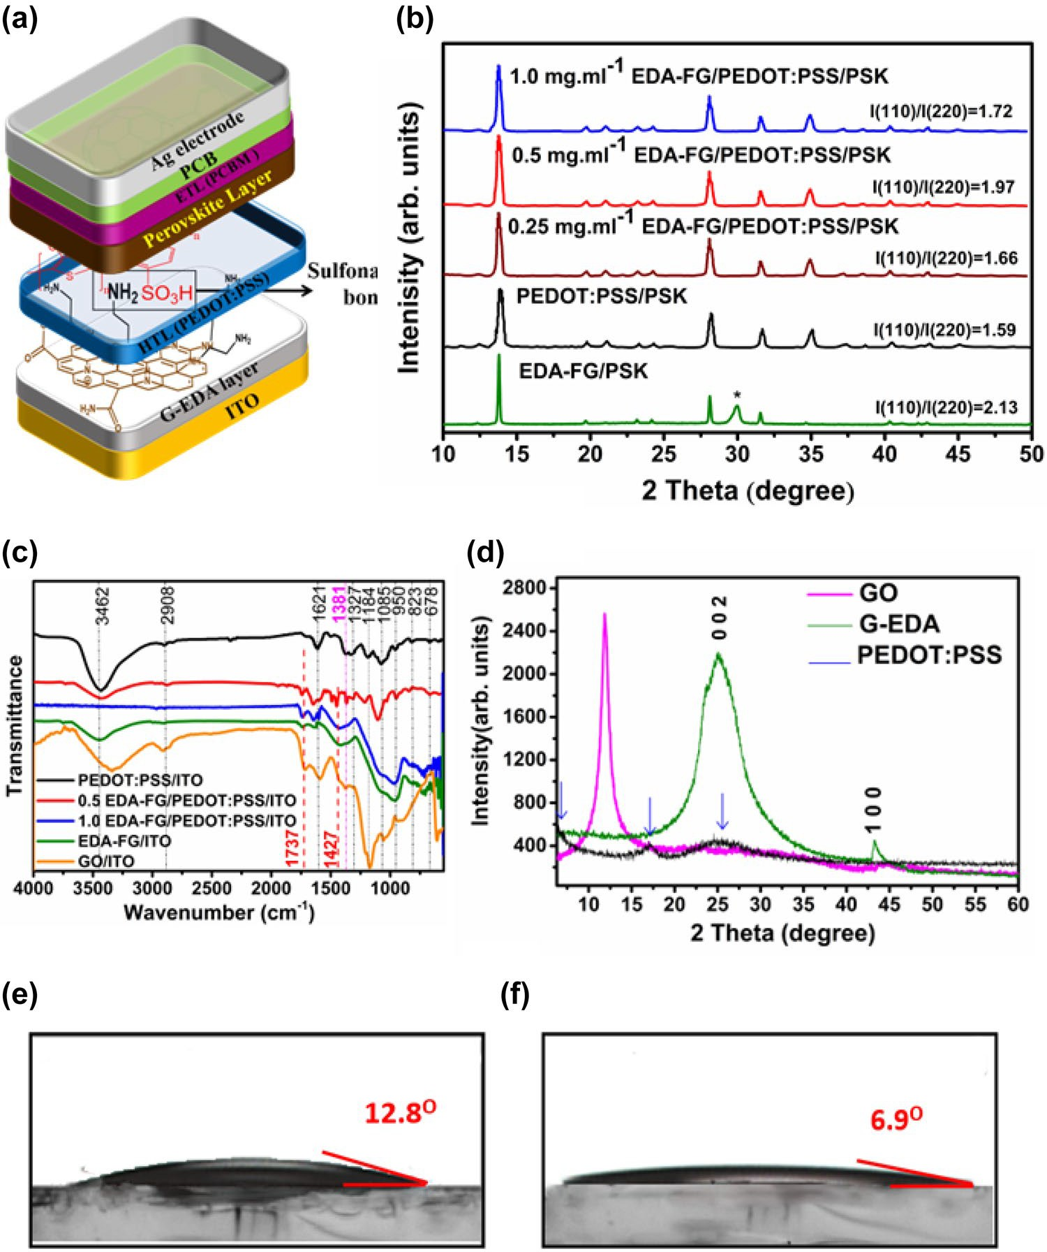

Fig. 1 a Schematic of pos- sible sulfonamide bonds at bilayer EDA-FG/PEDOT:PSS interface with the PSCs inverted structure. b XRD spectra of MAPbI3 deposited on various used HTLs. c FTIR of various deposited HTLs d XRD of GO, EDA-FG, and PEDOT:PSS. Contact angel of e PEDOT: PSS and f 0.5 GEDA mg. mL−1/ PEDOT:PSS

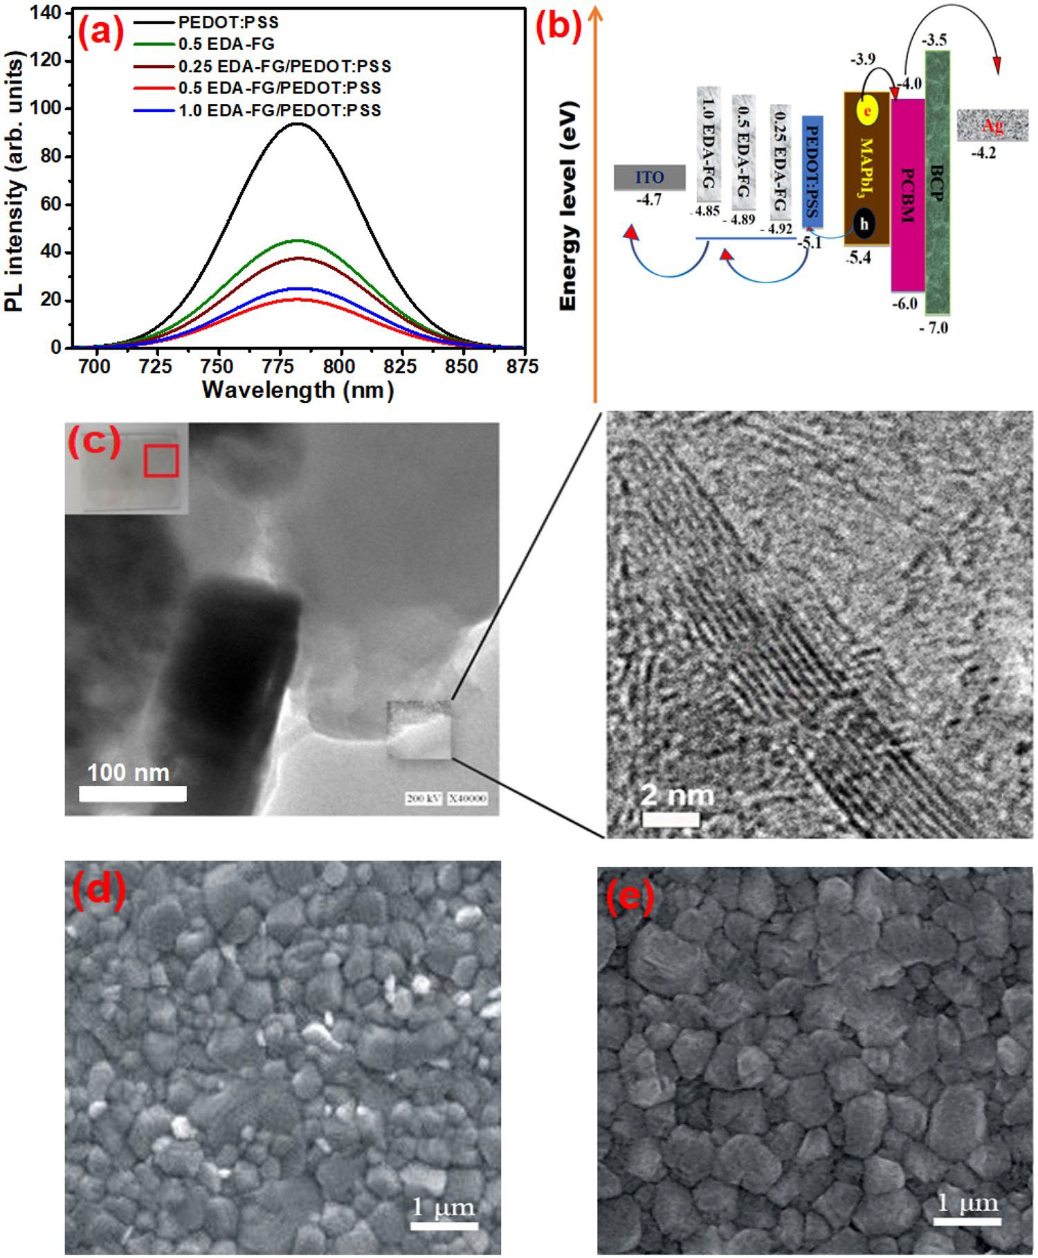

Fig. 2 a PL of PSK fabricated on the top of various deposited HTLs and b Schematic energy level diagram of different HTLs in perovskite solar cell. c TEM image of EDA-FG with measuring edge thickness. SEM of PSK layers on the top of d PEDOT:PSS, e 0.5 mg. mL⁻¹ EDA-FG/PEDOT:PSS

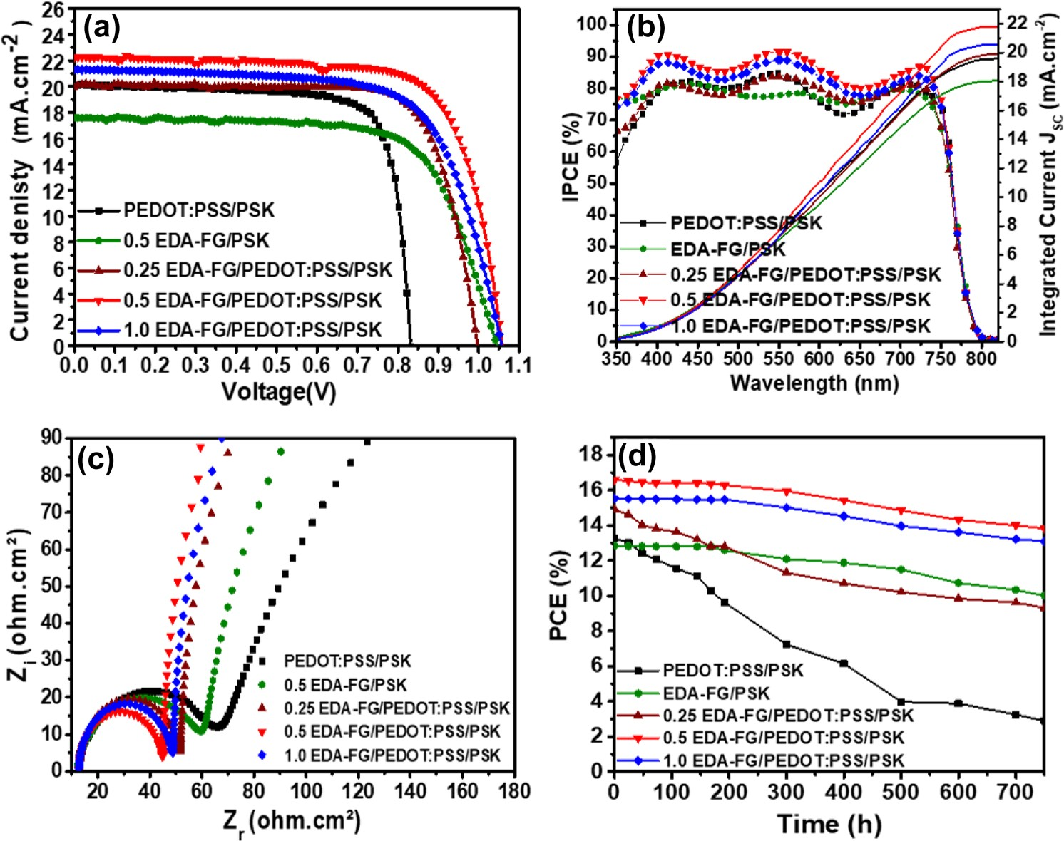

Fig. 3 a J–Vcurves, b IPCE spectra of PSCs fabricated with different HTLs. c EDA-FG/ PEDOT:PSS in a dark condi- tion. c A zoom for Rsc circle of perovskite solar cells fabricated with PEDOT: PSS, EDA-FG, and (0.25, 0.5, and 1.0 mg. mL−1) EDA-FG/PEDOT:PSS. D Light soaking stability of PSCs fabricated

Table 1 Photovoltaic performance of the fabricated inverted planar PSCs with various HTLs under simulated AM 1.5 illumination (forward direction, power density 100 mW cm⁻²)

