Nonequilibrium layered PbS stabilized by Sn doping: bipolar semiconductors with low thermal conductivity
Mari Hiramatsu^{1,§}, Zhongxu Hu^{1,§}, Sakura Yoshikawa¹, Zan Yang¹, Xinyi He¹, Takayoshi Katase^{1,*}, Jun-ichi Yamaura^{2,3}, Hajime Sagayama³, Terumasa Tadano⁴, Shigenori Ueda⁵, Hidenori Hiramatsu^{1,6}, Hideo Hosono¹, and Toshio Kamiya^{1,*}
¹ MDX Research Center for Element Strategy, Institute of Integrated Research, Institute of Science Tokyo, 4259 Nagatsuta, Midori, Yokohama 226-8501, Japan
² Institute for Solid State Physics, University of Tokyo, Kashiwa, Chiba 227-8581, Japan
³ Institute of Materials Structure Science, High Energy Accelerator Research Organization, Tsukuba, Ibaraki 305-0801, Japan
⁴ Research Center for Magnetic and Spintronic Materials, National Institute for Materials Science, 1-2-1 Sengen, Tsukuba, Ibaraki 305-0047, Japan
⁵ Research Center for Electronic and Optical Materials, National Institute for Materials Science, 1-1 Namiki, Tsukuba, Ibaraki, 305-0044, Japan
⁶ Materials and Structures Laboratory, Institute of Integrated Research, Institute of Science Tokyo, 4259 Nagatsuta, Midori, Yokohama 226-8501, Japan

* Correspondence to: katase.t.aa@m.titech.ac.jp, kamiya.t.aa@m.titech.ac.jp
KEYWORDS. chalcogenide, nonequilibrium synthesis, carrier doping, carrier transport property, thermoelectric property

ABSTRACT: Layered Sn- and Ge-based monochalcogenides have been known as promising semiconductor materials with appropriately narrow band gaps, close to those of Si and GaAs. On the other hand, Pb-based ones possess much narrower band gaps and adopt the cubic rock-salt (RS) type structure under ambient conditions, and their layered structures are considered to be thermodynamically unstable. We recently succeeded in stabilization of GeS-type layered structure in lightly Sn-doped PbS by combination of high-temperature solid-state reaction with thermal quenching. In this paper, we have comprehensively investigated the relationship between the crystal structures, electronic structures, and also electronic and thermal transport properties of (Pb_{1–x}Sn_{x})S (x = 0 – 1). It is experimentally confirmed that an equilibrium phase of the layered GeS-type Sn-rich (Pb_{1−x}Sn_{x})S is a p-type semiconductor at x ≥ 0.7 whereas n-type conduction is observed at x = 0.5 and 0.6. In contrast, the stabilized nonequilibrium layered phase with 0.2 ≤ x ≤ 0.4 is a n-type semiconductor with the band gaps of 1.18–1.22 eV, and the electron density increases up to 6.4×10¹⁷ cm⁻³ in the (Pb_{0.8}Sn_{0.2})S. Furthermore, the layered nonequilibrium phase exhibits an ultra-low room-temperature thermal conductivity of 0.40–0.65 W/(mK), much lower than those of both end members; i.e., the GeS-type SnS (x = 1) and the RS-type PbS (x = 0). Based on the first-principles electron and phonon transport calculations, the layered n-type (Pb_{0.75}Sn_{0.25})S potentially shows a high thermoelectric figure-of-merit of 0.34 even at 300 K under an optimized electron concentration. The controllability of bipolar carrier polarity in the layered (Pb_{1−x}Sn_{x})S alongside the low thermal conductivity is an advantageous characteristic for applications based on p-n homojunctions such as photovoltaics and thermoelectrics.

1. INTRODUCTION
Layered Sn- and Ge-based monochalcogenides, MCh (M = Sn, Ge and Ch = S, Se), have received great attention as promising semiconductors for various applications to optoelectronics, photovoltaics, and thermoelectrics.¹⁻⁴ The material system adopts a unique layered crystal structure (called the GeS-type, space group: Pnma, No. 62) built from alternate stacking of 2-dimentional (2D) M−Ch layers as a thermodynamically stable phase under ambient conditions.⁵ The layered structure of MCh is characterized by the stereochemically active lone pair states of Ge²⁺ 4s² and Sn²⁺ 5s², which do not form a covalent bond with Ch ions in the adjacent M−Ch layers along the stacking direction. The layered structure is analogous to a 2D material of black-phosphorus,⁶ and thus the great interest has been paid to their monolayers and few-layers as a new 2D material system, leading to the recent increasing reports on theoretical prediction and experimental validation of the exceptionally exciting properties, such as large piezoelectricity,⁷ high carrier mobility,^{8,9} and tunable bandgap.¹⁰
On the other hand, Pb-based monochalcogenides adopt the rock-salt (RS) type crystal structure (space group: Fm3̅m, No. 225) at ambient condition¹¹, and its layered structure is considered to be thermodynamically unstable.¹² Pb²⁺ 6s² state stabilizes a 2D layered structure in oxides as seen in α-PbO,¹³ while it stabilizes the RS-type structure in PbCh (Ch = S, Se, and Te) with the high-symmetric cubic structure formed by a 3D network of edge-shared Pb-Ch₆ octahedra. It is known that the layered PbS contains as small grains in a mineral, molybdenite,¹⁴ suggesting that the layered structure could be stabilized at high-temperature and high-pressure conditions. However, the nonequilibrium layered PbS have not been artificially obtained as a single bulk form, and therefore the electronic structures and physical/chemical properties have not been investigated until now. Stabilization of layered PbCh would lead to further exploration of new opto-electronic and thermal functionalities.
Here, we focus on Sn²⁺ substitution at the Pb²⁺ site in RS-type PbS to stabilize the GeS-type layered structure. It is theoretically explained that the lone pair in layered SnS is produced by Sn 5s−S 3p antibonding, while the RS-type PbS does not produce such lone pair effect as the 6s orbital of Pb is deepened by the relativistic effect.¹⁵ Therefore, the solid solution between PbS and SnS would manipulate the lone pair activity to switch the RS-type structure to the layered GeS-type one. However, the solid solution range (maximum x) in the RS-type (Pb_{1–x}Sn_{x})S is limited only in x = 0.03–0.10 under a thermally equilibrium condition, as seen in the PbS – SnS binary phase diagram.¹⁶⁻¹⁸ Meanwhile, the maximum x enhances to x = 0.5–0.6 in Sn-rich layered (Pb_{1–x}Sn_{x})S,¹⁹⁻²⁶ but the phase separation to the mixed phases of the GeS-type and the RS-type structures thermodynamically occurs in the Pb-rich region at 0.1 < x < 0.5. On the other hand, we recently demonstrated the expansion of the GeS-type’s single-phase solid-solution range to Pb-rich region (x = 0.2−0.4) by high-temperature solid-state reaction and subsequent rapid thermal quenching.²⁷ The nonequilibrium synthesis is a powerful approach to expand the solubility limit between the layered GeS-type and the cubic RS-type binary MCh systems, such as (Pb_{1–x}Sn_{x})Se²⁸⁻³⁰ and Sn(Se_{1–x}Te_{x}).³¹ Additionally, nonequilibrium vapor phase thin-film deposition stabilized the RS-type (Sn_{1–x}Ca_{x})Se with x = 0.4–0.8, which cannot be obtained through equilibrium synthesis.³²
In this paper, we have investigated the relationship between the crystal structures, electronic structures, and also electronic and thermal transport properties of the stabilized nonequilibrium layered Pb-rich (Pb_{1–x}Sn_{x})S phases with x = 0.2−0.4, and their properties are discussed with those of the equilibrium layered Sn-rich (Pb_{1–x}Sn_{x})S phases with x = 0.5−1.0. Especially, we clarify that the stabilized nonequilibrium layered GeS-type (Pb_{1–x}Sn_{x})S bulk with x = 0.2−0.4 exhibits n-type conductivity and the electronic conductivity largely increases with increase of Pb concentration, although the conventional layered SnCh and GeCh are p-type semiconductors. That is, bipolar carrier polarity is realized in the same layered GeS-type structure, indicating that the stabilized GeS-type (Pb_{1–x}Sn_{x})S possesses an advantageous characteristic for applications based on p-n homojunctions such as photovoltaics and thermoelectrics. Furthermore, the layered nonequilibrium phase exhibits an ultra-low room-temperature (RT) thermal conductivity. We finally simulate the thermoelectric properties to demonstrate one of the potential applications of n-type layered (Pb_{1−x}Sn_{x})S for thermoelectrics by theoretical calculations.

2. EXPERIMENTAL SECTION
2.1. Bulk synthesis. First, the binary precursor powders of PbS and SnS were synthesized by solid-state reactions between each element. The PbS and SnS powders were mixed at the molar ratios of PbS : SnS = 1−x : x. The mixture was pressed into pellets at 500 ºC under 40 MPa in vacuum by Spark Plasma Sintering (SPS). After that, the sintered pellet was sealed in an Ar-filled silica-glass ampule. The sealed ampule was annealed at 700 ºC, and then it was subjected to rapid quenching from 700 °C to RT in iced water in order to stabilize the high-temperature layered GeS-type (Pb_{1−x}Sn_{x})S solid solution phase. See ref. 27 for the details of synthesis procedures. The obtained bulk density was ~95%. For comparison, PbS and SnS bulk polycrystals were synthesized under similar heating condition without the quenching process. The reagents and products were handled in a glove box filled with a dry Ar gas (the dew point <−80 °C, the oxygen concentration < 1 ppm).
2.2. Crystal structure analysis. Synchrotron X-ray diffraction (XRD) measurements were performed at RT with powder samples on the BL-8B beamline at the Photon Factory of the High Energy Accelerator Research Organization (KEK). 2D diffraction images were collected on a curved imaging plate (RIGAKU RAPID) at a wavelength of λ = 0.683799 Å and converted to 1D data (RIGAKU DISPLAY). The crystal structure was determined from Rietveld analysis (RIETAN-FP).³³ The chemical compositions (i.e., the atomic ratio of Sn, Pb, and S) of the bulk samples were measured with X-ray fluorescence spectroscopy.
2.3. Electronic and thermal property characterization. The electronic conductivity (σ) was measured by the four-probe method, and Hall coefficient (R_{H}) was measured with the van der Pauw configuration at RT. The low-temperature electronic properties were measured using a 6-terminal Hall bar structure under applied magnetic field up to ± 5 T with a physical property measurement system (PPMS, Quantum Design). The carrier concentration was calculated by n = 1/(e|R_{H}|), and Hall mobility was calculated by μ = σ/(en), where e is the elementary charge. The Seebeck coefficient (S) was measured at RT by giving a temperature difference (ΔT). The thermoelectromotive force (ΔV) and ΔT were simultaneously measured, and S was obtained from the slope of the ΔV–ΔT plots.
The thermal conductivity (κ) was obtained from κ = D·C·ρ, where the thermal diffusivity (D) was measured in an Ar atmosphere by a laser flash diffusivity method (LFA 457, NETZSCH) and the heat capacity (C) was measured by differential scanning calorimetry (DSCvesta, Rigaku Corp.), and the sample density (ρ) was determined by the dimensions and mass of the samples. The electronic thermal conductivity (κ_{ele}) was calculated by Wiedemann-Franz law as κ_{ele} = LTσ, where L is Lorenz number. The κ_{ele} was obtained using L_{ξe} calculated by $L_{ξ_{e}}={\left(\frac{k_{B}}{e}\right)}^{2}\frac{\left(r+1\right)\left(r+3\right)F_{r}\left(ξ_{e}\right)F_{r+2}\left(ξ_{e}\right)-{\left(r+2\right)}^{2}F_{r+1}{\left(ξ_{e}\right)}^{2}}{\left(r+1\right)F_{r}{\left(ξ_{e}\right)}^{2}}$, where k_{B} is Boltzmann constant, $F_{r}\left(ξ_{e}\right)=\int_{0}^{∞}{\frac{x^{r}}{e^{x-ξ_{e}}+1}}dx$ is the Fermi integral, and $ξ_{e}=\frac{E_{F}}{k_{B}T}$ is the reduced Fermi level. $ξ_{e}$ was estimated from the measured S by $S=\frac{k_{B}}{e}\left(\frac{(r+2)F_{r+1}(ξ_{e})}{(r+1)F_{r}(ξ_{e})}-ξ_{e}\right)$. Here, r = 0 was used for acoustic phonon scattering. The lattice thermal conductivity (κ_{lat}) was obtained by subtracting κ_{ele} from κ, i.e. κ_{lat} = κ – κ_{ele}. The phonon velocity (v_{ph}) was obtained by $v_{ph}={\left(\frac{1}{3}\left[\frac{2}{v_{t}^{3}}+\frac{1}{v_{l}^{3}}\right]\right)}^{-1/3}$, where v_{t} and v_{l} are the transverse and longitudinal phonon velocities measured by ultrasonic pulse-echo method (1077DATA, KARL DEUTSCH) at RT.
2.4. Electronic structure analysis. Diffuse reflectance (R) spectra were measured at RT with a spectrophotometer in the λ range of 200−2400 nm. The obtained R spectra were converted using the Kubelka−Munk function (1 − R)² / (2R) = α / S_{f} to obtain the quasi-optical absorption spectra. The direct and the in-direct optical band gaps (E_{g}) were estimated from plots of (αhν /S_{f})² vs. hν and (αhν /S_{f})^{1/2} vs. hν, respectively. α, S_{f}, h, and ν denote the optical absorption coefficient, the scattering factor, the Planck constant, and the frequency. The electronic structures around the valence band maximum (VBM) and the valence states of Sn, Pb, S were evaluated by hard X-ray photoemission spectroscopy (HAXPES) at the undulator beamline BL09XU³⁴ (the excitation X-ray energy: hv = 5.95 keV) of SPring-8 at RT. A high-resolution hemispherical electron analyzer (Scienta Omicron R4000) was used to analyze and detect photoelectrons. The binding energy was calibrated with the Fermi level (E_{F}) of an evaporated reference Au thin film, where the energy resolution of 216 meV for a Gaussian type apparatus function was obtained. To extract intrinsic VB spectra of the samples by cancelling the apparatus function, HAXPES VB spectra were deconvoluted by the Gaussian type apparatus function with the half-width at half-maximum of 108 meV using the Gauss-Seidel method.^{35,36}
2.5. First-principles calculation. First-principles calculations were performed for the layered GeS-type structures of SnS and (Pb_{0.75}Sn_{0.25})S models using the projector-augmented wave (PAW) method as implemented in the Vienna Ab initio Simulation Package (VASP).^{37,38} Sn [4d5s5p], Pb [5d6s6p], and S [3s3p] orbitals were treated as valence states. Variable-cell structure optimizations were conducted using the Perdew–Burke–Ernzerhof functional adapted for solids (PBEsol) functional.³⁹ The plane wave cutoff energy was set to 600 eV with the convergence criteria of 10^{–6} eV for the energy and 0.01 eV/Å for the force. A Γ-centered k-mesh with the k-spacing of 0.2 Å^{–1} was applied. Electronic band structures and density of states (DOSs) were obtained by the Heyd–Scuseria–Ernzerhof (HSE) hybrid functional⁴⁰ with spin–orbit interaction.
The electronic transport properties, including σ, S, and κ_{ele}, were calculated by ab initio scattering and transport (AMSET) package,⁴¹ using the layered SnS and (Pb_{0.75}Sn_{0.25})S models. The calculation with AMSET can simulate thermoelectric properties of layered SnS and SnSe with considerable accuracy^{42,43} and it is recently widely used to simulate the properties of several thermoelectric materials.⁴³⁻⁴⁶ The scattering from acoustic deformation potential (ADP), ionized impurity (IMP), and polar-optical phonon (POP) were considered. Density functional perturbation theory (DFPT)⁴⁷ with the Perdew–Burke–Ernzerhof (PBE) functional was used to calculate the polar-optical phonon frequency, elastic constant, and ionic dielectric constant.
Calculations of phonon dispersions and κ_{lat} were performed by VASP and ALAMODE codes^{48,49} using SnS and (Pb_{0.75}Sn_{0.25})S models. A 2 × 4 × 4 supercell with 256 atoms was used for calculating the harmonic interatomic force constants (IFCs), and a 1 × 3 × 3 supercell with 72 atoms was used for calculating the anharmonic IFCs.²⁷ The harmonic IFCs were fixed to the values determined by the finite-displacement approach,^{50,51} and the anharmonic IFCs up to the sixth order were estimated by the compressive sensing lattice dynamics. We included all allowed interactions for the harmonic IFCs, the third-order IFCs within a 12-bohr cutoff radii, and the fourth- to sixth-order IFCs within an 8-bohr cutoff radii. Density functional theory (DFT) calculations to obtain the energies and the forces were performed using the PBEsol functional with a plane-wave energy cutoff of 400 eV and an energy convergence criterion of 10^{–8} eV. We included the nonanalytic correction to the dynamical matrix using the Ewald method⁵² with the Born effective charges of constituent elements and dielectric constant calculated through DFPT. Phonon dispersions at T = 300 K were calculated by using the self-consistent phonon (SCPH) theory.⁴⁸ κ_{lat} was obtained by solving the Peierls-Boltzmann transport equation under the single-mode relaxation time approximation. The crystal structure models of layered (Pb_{0.75}Sn_{0.25})S were built using an ordered Pb/Sn arrangement. Since Pb and Sn are randomly distributed in the actual samples, the effect of the disorder on the κ_{lat} was estimated using a simplified model based on Tamura’s model.⁵³

3. RESULTS & DISCUSSION
3.1. Crystal structures
We previously reported the phase change in the (Pb_{1−x}Sn_{x})S bulks with x = 0−1.0 synthesized by non-equilibrium process.²⁷ Here, we performed detailed crystal structure analyses by synchrotron XRD measurements for the (Pb_{1−x}Sn_{x})S powders with x = 0.2, 0.6, and 1.0 (Fig. 1). XRD patterns for All diffraction peaks were assigned to the layered GeS-type structure with space group of Pnma, and the diffraction peaks assigned to RS-type phase were not observed, supporting the successful stabilization of layered structure in nonequilibrium (Pb_{0.8}Sn_{0.2})S by the thermal quenching process. Note that the uniformity of chemical composition of Sn, Pb, and S was confirmed in the whole region of the (Pb_{0.8}Sn_{0.2})S bulk.²⁹ With increasing Pb concentration, the diffraction peak of 400 largely shifted to lower angle, and the diffraction peaks of 201 and 210 shifted to higher and lower angles, respectively, and the peak positions of 201 and 210 became closer to each other. Figures 2a,b schematically illustrate the crystal structures of SnS and (Pb_{0.8}Sn_{0.2})S, obtained from the Rietveld analyses of the XRD patterns. The results of Rietveld analyses for (Pb_{1−x}Sn_{x})S with x = 0.2, 0.6, and 1.0 are shown in Fig. S1, and their crystallographic data are summarized in Table S1 of Supporting Information. Figures 2c,d summarize the a-, b-, c-axis lattice parameters (a, b, c) and the unit-cell lattice volume (V) of (Pb_{1−x}Sn_{x})S as a function of x. Compared to pure SnS (x = 1), the a expanded from 11.19 Å to 11.55 Å and the b also expanded from 3.98 Å to 4.17 Å, while the c shrunk from 4.33 Å to 4.22 Å with increasing Pb concentration, i.e., decreasing x from 1.0 to 0.2 (Fig. 2c), as mentioned in peak shifts observed in Fig. 1. The lattice parameter of a √2 × √2 supercell unit, i.e.$\sqrt{b^{2}+c^{2} }$ , increased from 5.88 Å to 5.93 Å with decreasing x, leading to V expansion from 192.73 Å³ to 203.20 Å³ (Fig. 2d). Note that Δa (a_{(Pb0.8Sn0.2)S} − a_{SnS}) = 0.37 Å was much larger than Δ$\sqrt{b^{2}+c^{2} }$ = 0.05 Å, indicating the significantly anisotropic expansion along the a-axis (the direction perpendicular to the layer) than in-plane b,c-axes. The SnS has strong distortion in the Sn−S layer, i.e., largely different length between the short Sn−S bond (d_{M−S}, M = Sn) and long Sn−S’ (d_{M−S’}) one, as shown in Fig. 2a. With increasing Pb concentration (decreasing x), the d_{M−S} (M = Pb, Sn) increased, while the d_{M−S’} decreased (Fig. 2e), indicating that the Pb²⁺ ion substitution at the Sn²⁺ site relaxed the in-plane structural strain in the Sn−S layer presumably due to the weakened electrostatic repulsion between Sn²⁺/Pb²⁺ and S²⁻ ions (Fig. 2b). In addition, the inter-layer M−M distance (d_{M−M}) became longer with decreasing x (Fig. 2f). Figure 2g compares the intra-layer distance of M−S layer (d_{intra.}) and inter-layer distance between the M−S layers (d_{inter.}) as a function of x. The d_{intra.} showed negligible change with respect to x, but the d_{inter.} increased largely with decreasing x, indicating the inter-layer space became larger with increasing Pb concentration. The x dependences of Δa/2 ((a_{(Pb1−xSnx)S} − a_{SnS})/2), Δd_{intra.} (d _{intra.,(Pb1−xSnx)S} − d _{intra.,SnS}), and Δd_{inter.} (d _{inter.,(Pb1−xSnx)S} − d _{inter.,SnS}) are compared in Fig. 2h. In the entire range of x, the Δd_{intra.} was less than 0.02 Å, but the Δd_{inter.} became larger up to 0.2 Å, which correlated with Δa/2. Therefore, the large increase of a originates from the increase in d_{inter.} with increasing the large size Pb²⁺ concentration in the layered (Pb_{1−x}Sn_{x})S.

3.2. Electronic properties and electronic structures
Next, we investigated electronic properties of the GeS-type layered (Pb_{1−x}Sn_{x})S bulks. Figures 3a-e summarize σ, S, R_{H}, n, and μ as a function of x at RT. Those of the RS-type PbS bulk (x = 0) are also shown for comparison. Compared to pure SnS (x = 1), the σ decreased from 1.6×10⁻² S/cm to 1.4×10⁻⁵ S/cm with decreasing x to 0.6, then it conversely increased up to 3.4 S/cm at x = 0.2 (Fig. 3a). Pure SnS (x = 1) showed positive S, indicating p-type conduction and the absolute values of S decreased with decreasing x (Fig. 3b). On the other hand, the S became negative when x ≤ 0.6, indicating the carrier polarity changed to n-type. The absolute values of S slightly increased from x = 0.6 to 0.4, and then decreased with decreasing x to 0.2. The carrier polarity change was also confirmed by Hall effect measurements. Pure SnS showed positive R_{H} with hole n = 1.9×10¹⁶ cm⁻³ (Figs. 3c,d). The p-type conduction in SnS originates from the naturally formed acceptor-type Sn vacancy (V_{Sn}²⁻) defects.²⁴ With decreasing x to 0.7, R_{H} largely increased and hole n decreased to 5.8×10¹³ cm⁻³. With a further decrease of x, R_{H} could not be measured at x = 0.5−0.6, but R_{H} became negative for x = 0.2−0.4. In the n-type region, the absolute value of |R_{H}| decreased with decreasing x and electron n increased up to 6.4×10¹⁷ cm⁻³ at x = 0.2. We previously reported n-type conduction in a (Pb_{1−x}Sn_{x})S thin film with x = 0.5 but the electron n was limited at ~10¹⁵ cm⁻³.²⁴ The nonequilibrium layered (Pb_{1−x}Sn_{x})S bulk with smaller x = 0.2 realized the heavier n-type doping and the wide-range controllability of n. The μ decreased from 5.2 cm²/(Vs) of SnS to ~0.1 cm²/(Vs) with decreasing x to 0.7, then it conversely increased up to 2.8 cm²/(Vs) at x = 0.2 (Fig. 3e). The RS-type PbS bulk (x = 0) showed much higher σ = 36.6 S/cm and μ = 50.9 cm²/(Vs) than those of the GeS-type layered (Pb_{1−x}Sn_{x})S bulks because the high symmetric RS-type structure with a higher coordination number of Pb-S₆ polyhedra than that of the layered GeS-type forms a larger band dispersion (i.e., smaller carrier effective mass) with narrow bandgap, resulting in the higher σ and μ.
We then compared the temperature (T) dependence of electronic properties for p-type SnS and n-type (Pb_{0.8}Sn_{0.2})S bulks. Both samples showed the semiconducting behavior, i.e., the σ decreased with decreasing T (Fig. 4a). Figure 4b shows the Arrhenius plots of n, i.e., $Ln\left(n\right)=\left(-\frac{E_{a}}{k_{B}}\right)\left(\frac{1}{T}\right)+Ln(n_{0})$, where E_{a} is the activation energy and n₀ is the intrinsic carrier concentration. Both samples showed the linear relationship between the Ln(n) and T⁻¹. The estimated E_{a} are 68 meV for SnS and 203 meV for (Pb_{0.8}Sn_{0.2})S. The n₀ are estimated to be 2.5×10¹⁷ cm⁻³ for SnS and 1.2×10²¹ cm⁻³ for (Pb_{0.8}Sn_{0.2})S. T dependence of μ is compared in Fig. 4c. The μ of SnS monotonically decreased from 5.4 cm²/(Vs) at 300 K to 0.8 cm²/(Vs) at 175 K. On the other hand, the μ of (Pb_{0.8}Sn_{0.2})S increased from 2.8 cm²/(Vs) at 300 K to 11.9 cm²/(Vs) at 200 K. For pure SnS, the Ln(μT^{1/2}) vs. T⁻¹ plot exhibits a good straight line in the whole T range (Fig. 4d), indicating that the electron transport in SnS is limited by grain boundary (GB) scattering, following the form of Ln(μT^{1/2}) = −E_{b}/kT + A (A is constant).⁵⁴ The GB potential barrier height (E_{b}) is estimated to be 80 meV. On the other hand, the μ of (Pb_{0.8}Sn_{0.2})S showed the T^{−3/2} dependence (Fig. 4e), indicating that the acoustic phonon scattering dominates the carrier transport in a non-degenerate regime,⁵⁵ where the GB contribution is negligible presumably due to its high n for (Pb_{0.8}Sn_{0.2})S, i.e., the high-density carriers screen the GB background charges and reduce the GB barrier height.
Next, we investigated the electronic structure change of (Pb_{1−x}Sn_{x})S bulks as a function of x. The direct and indirect E_{g} estimated from diffuse reflectance spectra are summarized in Fig. 5a. The raw spectra of diffuse reflectance are shown in Fig. S2 of Supporting Information. The direct E_{g} was almost constant at 1.22−1.23 eV, while the indirect E_{g} gradually increased from 1.10 to 1.22 eV with a decrease of x. The indirect E_{g} = 1.22 eV of the GeS-type layered (Pb_{0.8}Sn_{0.2})S is much larger than the E_{g} = 0.3 eV of the RS-type PbS (x = 0).⁵⁶ Calculated optical absorption spectra of SnS and (Pb_{0.75}Sn_{0.25})S are compared in Fig. S3 of Supporting Information. Large optical absorption coefficient ~10⁶ cm⁻¹ at 4 eV and steep slope in the vicinity of the absorption edge are observed both for (Pb_{0.75}Sn_{0.25})S and SnS. Both p-type SnS and n-type Pb-rich (Pb_{1−x}Sn_{x})S have appropriate bandgaps for solar cell. Therefore, the Pb-rich (Pb_{1−x}Sn_{x})S would be promising for solar cell applications as n-type layer, which would lead to develop p-n homojunction solar cells.
Figure 5b shows the HAXPES spectra near E_{F} after the deconvolution process. The comparison of HAXPES spectra before and after deconvolution is shown in Fig. S4 of Supporting Information. The VBM energies (E_{VBM}), determined by extrapolating the leading edge shown by the black dotted lines, located at 0.39 eV from E_{F} for SnS, 0.61 eV for (Pb_{0.4}Sn_{0.6})S, and 0.90 eV for (Pb_{0.8}Sn_{0.2})S, indicating the E_{VBM} shifts to deeper energy by increasing Pb concentration. By using the measured optical E_{g} and E_{VBM}, the band alignment diagram was built as drawn in Fig. 5c. E_{F} locates near the VBM for SnS (x = 1), while the E_{F} position moves away from the VBM with decreasing x to 0.6 and locates almost at the midgap level. With further decreasing x to 0.2, its position becomes nearby the conduction band minimum (CBM). The change of carrier polarity observed in Fig. 3 is consistent with this result; i.e., the upper shift of E_{F} originates from electron doping by increasing Pb concentration. The electronic structure changes were examined by DFT calculations. The electronic band structures and DOSs of the layered SnS and (Pb_{0.75}Sn_{0.25})S models are compared in Fig. 6. In the calculated electronic structure (top panels of Figs. 6a,b), the direct gap of 1.14 eV between A and C points is similar for SnS and (Pb_{0.75}Sn_{0.25})S, while the in-direct gap between B and C points becomes larger from 0.91 eV of SnS to 1.13 eV of (Pb_{0.75}Sn_{0.25})S, because the VBM at B point shifts to deeper energy by Pb substitution. The difference between indirect and direct E_{g} is 0.23 eV for SnS, while it becomes only 0.01 eV for (Pb_{0.8}Sn_{0.2})S. Note that the D point in the conduction band also shifts to deeper energy, and the gap from B to D points becomes smaller from 1.43 eV of SnS to 1.25 eV of (Pb_{0.75}Sn_{0.25})S. For SnS, the Sn 5s, Sn 5p, and S 4p mainly contribute to the VBM, while the Sn 5p predominate the CBM (bottom panel of Fig. 6a). For (Pb_{0.75}Sn_{0.25})S, the Pb 6s and 6p additionally contribute to the VBM, and Pb 6p differentially dominate the CBM (Fig. 6b). The A point is predominantly composed of S 3p_{y} and Sn 5s (Pb 6s) orbitals, and the C point primarily arises from Sn 5p_{y} (Pb 6p_{y}) and S 3s orbitals, while the B point is mainly characterized by contributions from S 3p_{z} and Sn 5s (Pb 6s) orbitals, and the D point consists almost of Sn 5p_{z} (Pb 6p_{z}) and S 3s orbitals (Fig. S7 of Supporting information). Crystal structure analysis reveals that while the a and b expand, the c contracts with an increase of Pb concentration, suggesting stronger bonding along the c-axis. This enhanced bonding conditions lower the energy at the D and B points, which modulate the band structures and result in the almost direct-gap semiconductor for (Pb_{0.75}Sn_{0.25})S.
Usually, isovalent ion substitution does not generate carriers, while with increase of Pb²⁺ concentration (decreasing x), p-type to n-type transition occurs and the n increases in the layered (Pb_{1−x}Sn_{x})S bulks (Fig. 3d). The HAXPES spectra for the Sn 3d, Pb 4f, and S 2p core levels are summarized in Fig. S5 of Supporting Information, which indicate that Sn, Pb, and S exist as single valence states with Sn²⁺, Pb²⁺, and Se²⁻, respectively, i.e., n-type doping mechanism would not be related to the valence state changes of Sn and Pb. Note that S vacancy (V_{S}²⁺) contributes to the n-type conduction in RS-type PbS.⁵⁷ However, point-defect calculations predict that free electrons generated from V_{S}²⁺ is compensated by larger amounts of holes generated from V_{Sn}²⁻ in GeS-type layered SnS.²⁴ On the other hand, we proposed a possible origin by defect calculations, where the Pb²⁺ or Sn²⁺ ion is intercalated in the interlayer space of the GeS-type layered (Pb_{1−x}Sn_{x})S, and it works as electron donor.²⁴ Actually, the inter-layer space (d_{inter.} > 2.65 Å) obtained from the Rietveld analyses (Fig. 2g) is much larger than the Sn²⁺ ion diameter 1.62 Å (twice of the ion radius d_{Sn2+} = 0.81 Å) and Pb²⁺ ion diameter 1.92 Å (twice of ion radius d_{Pn2+} = 0.96 Å). We then tried maximum entropy method (MEM) analysis based on the XRD data for (Pb_{0.8}Sn_{0.2})S in Fig. 1 to check the existence of the interstitial atoms in the inter-layer space, where we considered the interstitial Sn (Sn_{i}) at the center between S atoms of adjacent layers (see Fig. S6 of Supporting Information). However, we could not observe Sn_{i} atoms in the electron density map, and the estimated occupancy at Sn_{i} site is only 0.006(12), i.e. the estimated Sn_{i} occupancy is less than standard deviation (1.2%) of the measurement. (Similar results were obtained also for interstitial Pb ion). If we assume that the carrier activation rate from interstitial Sn²⁺ or Pb²⁺ donating 2 electrons to (Pb_{1−x}Sn_{x})S is 100%, the concentration of interstitial ions for (Pb_{0.8}Sn_{0.2})S would be ~3.2×10¹⁷ cm⁻³, which is much smaller than the detection limit (2.4×10²⁰ cm⁻³) of XRD. Further analysis is necessary to clarify the electron doping mechanism, but the present analyses based on XRD and electronic properties support that the systematic increase of n with increase of Pb concentration (decreasing x) would originate from the increase of inter-layer space and possibly associated interstitial Sn²⁺ or Pb²⁺ concentrations, realizing the stable and high-density n-type doping in nonequilibrium layered Pb-rich (Pb_{1−x}Sn_{x})S bulks.

3.3. Thermal transport properties
Next, we investigated thermal transport properties of layered (Pb_{1−x}Sn_{x})S bulks at RT as a function of x. Pure SnS (x = 1) bulk showed κ = 1.23 W/(mK), which largely decreased to 0.40 W/(mK) with decreasing x to 0.5 (red circles in Fig. 7a). On the other hand, by further decreasing x to 0.2, the κ gradually increased to 0.66 W/(mK). Therefore, the x dependence of κ showed different behavior between in the Sn-rich (x ≤ 0.5) region and in the Pb-rich (x ≥ 0.5) one. All the samples of the GeS-type layered (Pb_{1−x}Sn_{x})S showed quite low κ_{ele} less than 1×10⁻³ W/(mK) (blue diamonds in Fig. 7a), indicating that the κ is dominated by phonon transport (κ_{lat}) and the electronic contribution is almost negligible. Note that the κ_{lat} = 0.40 W/(mK) for the x = 0.5 sample is comparable with previously-reported values; e.g., with 0.5 W/(mK) reported for polycrystalline PbSnS₂ bulk that exhibits glassy thermal conductivity in the entire temperature range²⁶ and with 0.65 W/(mK) reported for PbSnS₂ single crystal along out-of-plane direction (perpendicular to the layer), while much lower than 1.16 W/(mK) along in-plane direction (parallel to the layer).²⁵ Therefore, the layered structure acts as a strong phonon scattering along the out-of-plane direction. Acharyya et al. discussed the origin of ultralow κ_{lat} in relation to the stereochemical activity of Pb²⁺ and Sn²⁺ lone pairs of PbSnS₂.²⁶ We then analyzed the phonon transport properties by a phonon gas model of $κ_{lat}=\frac{1}{3}C∙v_{ph}∙l_{ph}=\frac{1}{3}C∙v_{ph}^{2}∙τ_{ph}$, where C is the specific heat per volume, v_{ph} is the phonon velocity, l_{ph} is the phonon mean free path, and τ_{ph} is the phonon lifetime. The C roughly exhibited a monotonic decrease with decreasing x (i.e., increase of heavy Pb concentration) (Fig. 7b). On the other hand, the v_{ph}, including both v_{t} and v_{l}, decreased with decreasing x on the Sn-rich side (x ≥ 0.5), while those increased gradually on the Pb-rich side (x ≤ 0.5) (Fig. 7c). The x dependence of v_{ph} is related with the change of bulk modulus (K) obtained as $K= ρ\left(v_{l}^{2}-\frac{4v_{t}^{2}}{3}\right)$. The K decreased in the Sn-rich region (x ≥ 0.5), presumably because the larger size Pb²⁺ ion substitution at the Sn²⁺ site increases the Sn/Pb−S bond distance and is expected to reduce the hardness of SnS crystal (Fig. 7d). On the other hand, the K increased on the Pb-rich side (x ≤ 0.5), where the strong Pb−S bonds become dominant to enhance the hardness of the (Pb_{1−x}Sn_{x})S crystal. In addition, the τ_{ph} also decreased with decreasing x in the Sn-rich region (x ≥ 0.5) and conversely increased on the Pb-rich side (x ≤ 0.5) (Fig. 7e). The randomness of Pb and Sn ions should become maximum at x = 0.5, and thus the large mass difference between them enhances the phonon scattering to reduce τ_{ph}. The RS-type PbS bulk (x = 0) showed much higher κ of 2.30 W/(mK) at RT, where κ_{ele} was 0.02 W/(mK) associated with higher σ as shown in Fig. 3a. The high symmetric RS-type structure and high coordination number Pb-S₆ polyhedra provide high v_{ph} and long τ_{ph}, which results in higher κ_{lat} in RS-type PbS, while the highly anisotropic layered structure gives lower v_{ph} and shorter τ_{ph}, leading to the much lower κ_{lat} in the GeS-type layered (Pb_{1−x}Sn_{x})S.
We then performed the anharmonic phonon calculations using the GeS-type layered SnS and (Pb_{0.75}Sn_{0.25})S models. Figures 8a,b show the phonon band structures (left panels) and phonon DOSs projected on each element (right panels), respectively. The phonon dispersion of SnS is characterized by highly dispersed acoustic and optical phonon branches along the Γ–Y (b-axis) and the Γ–Z (c-axis) (left panel of Fig. 8a), indicating large v_{ph} in the in-plane Sn–S layer. On the other hand, flat branches were observed along Γ–X (a-axis), i.e., along the direction perpendicular to the layer. The atom-projected phonon DOSs are separated into two major regions (right panel of Fig. 8a). The lower and the higher frequency parts are mainly contributed by the vibrations of heavier Sn and lighter S atoms, respectively. In contrast, for (Pb_{0.75}Sn_{0.25})S model, the heavy Pb contributes to lower frequency part of phonon DOS and shifts the phonon bands to lower frequency side (Fig. 8b). Therefore, the dispersion of acoustic phonons along Γ–X, Γ–Y, Γ–Z gradually becomes small. The ν_{ph} and τ_{ph} in terms of the phonon frequency are compared between (Pb_{0.75}Sn_{0.25})S and SnS (Figs. 8c,d). (Pb_{0.75}Sn_{0.25})S has lower ν_{ph} than SnS at low frequency range because of the heavy Pb contribution. Especially, the τ_{ph} is strongly reduced in (Pb_{0.75}Sn_{0.25})S in wide frequency range, when compared with SnS. The large mass difference between Pb and Sn, which enhances phonon scattering, as discussed in Fig. 7e.
Figures 8e,f compare the T dependence of calculated κ_{lat} for SnS and (Pb_{0.75}Sn_{0.25})S models along different directions. The experimentally measured κ_{lat} for SnS and (Pb_{0.8}Sn_{0.2})S bulks are also shown for comparison. Note that (Pb_{0.8}Sn_{0.2})S bulk is thermally stable even when heated at T up to 623−680 K; i.e., phase separation to RS-type PbS and GeS-type SnS does not occur in this T range.²⁷ On the other hand, (Pb_{0.8}Sn_{0.2})S bulk shows the structure transition from the GeS-type layered structure to the RS-type structure when T is increased over ~500 K.²⁷ High anisotropy of κ_{lat} was found in the calculations due to their layered structures. The calculated κ_{lat} along the out-of-plane a-axis is much lower than those along the in-plane b,c-axes. Note that SnS exhibits large in-plane anisotropy in the κ_{lat} between the b- and c-directions, because of the distorted Sn−S layer (Fig. 2a). On the other hand, (Pb_{0.75}Sn_{0.25})S exhibits almost the similar κ_{lat} along the in-plane b- and c-directions, because the Pb substitution relaxed the in-plane structural strain, as discussed in Fig. 2. Consequently, the κ_{lat} along in-layer b-axis (c-axis) decreases from 3.12 (1.97) W/(mK) of SnS to 1.15 (1.14) W/(mK) of (Pb_{0.75}Sn_{0.25})S, and the κ_{lat} along a-axis more largely decreases from 1.30 W/(mK) of SnS to 0.32 W/(mK) of (Pb_{0.75}Sn_{0.25})S at T = 300 K. The extremely low κ_{lat} along a-axis leads to the lower average κ_{lat} = 0.87 W/(mK) of (Pb_{0.75}Sn_{0.25})S than 2.13 W/(mK) of SnS at T = 300 K. The experimentally measured κ_{lat} for SnS bulk decreased from 1.23 to 0.71 W/(mK) with increasing T from RT to 673 K. The measured κ_{lat} of SnS is much lower than calculated average κ_{lat} in entire T range, while it is almost comparable to the calculated κ_{lat} along a-axis. For (Pb_{0.8}Sn_{0.2})S bulk, the measured κ_{lat} decreased from 0.66 to 0.59 W/(mK) with increasing T from RT to 510 K. The RT κ_{lat} of (Pb_{0.8}Sn_{0.2})S bulk is lower than the calculated average κ_{lat} for the (Pb_{0.75}Sn_{0.25})S model, where the κ_{lat} would be reduced by scattering from the (Sn,Pb)−S layers along the a-axis. On the other hand, the measured κ_{lat} becomes comparable to the calculated average κ_{lat} at higher temperature. These analyses suggest that the κ_{lat} along a-axis is strongly reduced mainly by the expansion of inter-layer space between the (Sn,Pb)−S layers, which dominates the phonon transport in Pb-rich (Pb_{1−x}Sn_{x})S with anisotropic layered crystal structure.

3.4. Potential thermoelectric properties
Finally, we investigated the potential thermoelectric properties of the n-type GeS-type layered (Pb_{1−x}Sn_{x})S with the ultra-low κ_{lat} under optimizing n. Note that DFT studies predicted higher ZT for n-type SnS than that of p-type one,^{58,59} and there have been several works on n-type doping to SnS.⁶⁰⁻⁶² In addition, it was recently reported that a Cl-doped layered (Pb_{0.5}Sn_{0.5})S single-crystal achieved a maximum ZT of ~0.3 at 300 K and ~1.2 at 773 K.²⁵ Figure 9 summarizes the calculated thermoelectric properties, averaged along all the crystal axes of the (Pb_{0.75}Sn_{0.25})S model, as a function of n at T = 300 K (blue circles), compared with those of the SnS model (red squares). The σ, S, power factor (PF = S²σ), and κ_{ele} were calculated by AMSET codes, and the calculated carrier scattering rates are summarized in Figs. S8,9 of Supporting Information. Dimension-less figure of merit, ZT (= $\frac{S^{2}σ}{\left(κ_{ele}+κ_{lat}\right)T}$) was obtained by using the calculated average κ_{lat} values (Figs. 8e,f). The σ increases while the absolute value of S (|S|) decreases with increasing n for both cases (Figs. 9a,b). The σ of (Pb_{0.75}Sn_{0.25})S is slightly lower than that of SnS. The σ = 13 S/cm for Cl-doped SnS single crystal with n = 3.2×10¹⁷ cm⁻³ ⁶¹ is consistent with the calculated σ = 16 S/cm for the electron-doped SnS model with the same n. The σ = 3.4 S/cm observed for (Pb_{0.8}Sn_{0.2})S bulk with n = 6.3×10¹⁷ cm⁻³ is 5-times lower than the calculated σ = 16 S/cm for the (Pb_{0.75}Sn_{0.25})S model, but it may originate from the scattering from randomly distributed Pb and Sn ions and/or grain boundary scattering. The |S| of (Pb_{0.75}Sn_{0.25})S is comparable at low n ≤ ~10¹⁹ cm⁻³, but it becomes higher than that of SnS in the higher n region. The contribution of the highly localized band D in the conduction band enlarges the DOS and |S| in the high n region for (Pb_{0.75}Sn_{0.25})S (Fig. 6b). The SnS shows a maximum PF = 22.5 μW/(cmK²) at n = 1.0×10²⁰ cm⁻³ and the maximum ZT = 0.23 at an optimal n = 4.6×10¹⁹ cm⁻³. On the other hand, (Pb_{0.75}Sn_{0.25})S exhibits a maximum PF = 28.7 μW/(cmK²) at a higher n = 2.2×10²⁰ cm⁻³ due to the contribution of larger |S| in the high n region than SnS. The maximum ZT = 0.34 is obtained at an optimal n = 1.0×10²⁰ cm⁻³, where the much lower κ_{lat} = 0.87 W/(mK) for (Pb_{0.75}Sn_{0.25})S results in the higher ZT than SnS.

4. CONCLUSIONS
In summary, we investigated the relationship between the crystal structures, electronic structures, and also electronic and thermal transport properties of nonequilibrium GeS-type layered (Pb_{1−x}Sn_{x})S bulk polycrystals with x = 0.2−0.4 stabilized by combination of high-temperature solid-state reaction with thermal quenching. The equilibrium layered Sn-rich (Pb_{1−x}Sn_{x})S is a p-type semiconductor at x ≥ 0.7 whereas n-type conduction is observed at x = 0.5 and 0.6. In contrast, the stabilized nonequilibrium layered Pb-rich (Pb_{1−x}Sn_{x})S with 0.2 ≤ x ≤ 0.4 are n-type semiconductor and the electron density increases up to 6.4×10¹⁷ cm⁻³ in the (Pb_{0.8}Sn_{0.2})S with maximum Pb concentration. Usually, isovalent ion substitution does not generate carriers, but the large size Pb²⁺ substitution at Sn²⁺ site enlarges the inter-layer space, and it is considered that the intercalated Sn²⁺ or Pb²⁺ increases the electron density with increasing Pb concentration. It was found that the (Pb_{0.8}Sn_{0.2})S became n-type direct-gap semiconductor with E_{g} = 1.2 eV, while pure SnS, a promising solar cell material, is p-type in-direct gap semiconductor with E_{g} = 1.1 eV. Both (Pb_{0.8}Sn_{0.2})S and SnS have appropriate bandgaps for solar cell, and possess large optical absorption coefficient and steep slope in the vicinity of the absorption edge. Therefore, the Pb-rich (Pb_{1−x}Sn_{x})S would be promising for solar cell applications as n-type layer. Furthermore, the layered nonequilibrium (Pb_{1−x}Sn_{x})S exhibits an ultra-low κ of 0.40–0.65 W/(mK) at RT, much lower than those of both end members; i.e., the GeS-type SnS (x = 1) and the RS-type PbS (x = 0). Based on the first-principles electron and phonon transport calculations, the layered n-type (Pb_{0.75}Sn_{0.25})S potentially shows a high ZT ~0.34 under optimized electron concentration even at 300 K.
The controllability of carrier type and carrier concentration in semiconductor materials is an important requirement for several semiconductor device applications, such as p-n junction solar cells and π-type thermoelectric devices. However, the most studies have focused on carrier transport and device applications of p-type SnS,⁶³⁻⁶⁸ while there has been a limited study on n-type SnS,^{60,61,69} because of the difficulty in wide-range control of n-type conductivity. On the other hand, present study demonstrated the p-type to n-type control with wide-range carrier concentration, which would lead to develop p-n homojunction devices based on (Pb_{1−x}Sn_{x})S bipolar semiconductors.

ASSOCIATE CONTENT
Supporting Information
Supporting Information is available free of charge.
Rietveld analyses of XRD patterns and crystallographic data for SnS, (Pb_{0.4}Sn_{0.6})S, and (Pb_{0.8}Sn_{0.2})S powders. MEM analysis for (Pb_{0.8}Sn_{0.2})S. Diffuse reflectance spectra and HAXPES spectra for (Pb_{1−x}Sn_{x})S bulks. Band structure analyses and carrier transport calculations as well as calculated optical absorption spectra of SnS and (Pb_{0.75}Sn_{0.25})S models.

AUTHOR INFORMATION
Corresponding Authors
Takayoshi Katase; katase.t.aa@m.titech.ac.jp
Toshio Kamiya; kamiya.t.aa@m.titech.ac.jp

Author contributions
§M.H. and Z.H. contributed equally to this work.
M.H., Z.H., S.Y., Ta.K., J.Y., H.S., S.U., H. Hi. contributed to the synthesis and characterization of (Pb_{1−x}Sn_{x})S bulks, and Z.Y., X.H., T.T., To.K. contributed to the DFT calculations. All authors discussed the results and commented on the study. Ta.K. and To.K. co-wrote the manuscript. Ta.K. and To.K. proposed the idea and supervised the entire project.
Note
The authors declare no conflict of interest.

ACKNOWLEDGMENT
This work was supported by MEXT Program: Data Creation and Utilization Type Material Research and Development Project (Grant No. JPMXP1122683430), and also by Design and Engineering by Joint Inverse Innovation for Materials Architecture, MEXT. Ta.K. was supported by Japan Society for the Promotion of Science (JSPS) through Grants-in-Aid for Scientific Research (B) (Grant No. JP22H01766), Scientific Research (S) (Grant No. JP22H04964), and Challenging Research (Exploratory) (Grant No. JP24K21671). H.Hi. was supported by JSPS through Grants-in-Aid for Scientific Research (A) (Grant Nos. JP20H00302, JP21H04612, and 24H00376). The XRD study was performed with the approval of the Photon Factory Program Advisory Committee (Proposal No.2022PF-Q005). The HAXPES experiments at SPring-8 were performed with the approval of Japan Synchrotron Radiation Research Institute (Proposal Nos. 2022B0537, 2022B1969, and 2023A1816). The crystal structures in Figs. 2a,b and Fig. S4 were drawn using the VESTA code.⁷⁰

REFERENCES
(1) Deng, Z.; Cao, D.; He, J.; Lin, S.; Lindsay, S. M.; Liu, Y. Solution synthesis of ultrathin single-crystalline SnS nanoribbons for photodetectors via phase transition and surface processing. ACS Nano 2012, 6, 6197–6207.
(2) Mukherjee, B.; Cai, Y.; Tan, H. R.; Feng, Y. P.; Tok, E. S.; Sow, C. H. NIR Schottky photodetectors based on individual single-crystalline GeSe nanosheet. ACS Appl. Mater. Interfaces 2013, 5, 9594–9604.
(3) Zhao, L.-D.; Lo, S.-H.; Zhang, Y.; Sun, H.; Tan, G.; Uher, C.; Wolverton, C.; Dravid, V. P.; Kanatzidis, M. G. Ultralow thermal conductivity and high thermoelectric figure of merit in SnSe crystals. Nature 2014, 508, 373–377.
(4) Banai, R.E.; Horn, M.W.; Brownson, J.R.S. A review of tin (II) monosulfide and its potential as a photovoltaic absorber. Sol. Energy Mater. Sol. Cells 2016, 150, 112–129.
(5) Wiedemeier, H.; von Schnering, H. G. Refinement of the structures of GeS, GeSe, SnS, and SnSe. Z. Kristallogr. Cryst. Mater. 1978, 148, 295–304.
(6) Hu, Z.; Niu, T.; Guo, R.; Zhang, J.; Lai, M.; He, J.; Wang, L.; Chen, W. Two-dimensional black phosphorus: its fabrication, functionalization and applications. Nanoscale 2018, 10, 21575.
(7) Fei, R.; Li, W.; Li, J.; Yang, L. Giant piezoelectricity of monolayer group IV monochalcogenides: SnSe, SnS, GeSe, and GeS. Appl. Phys. Lett. 2015, 107, 173104.
(8) Li, F.; Liu, X.; Wanga, Y.; Li, Y. Germanium monosulfide monolayer: a novel two-dimensional semiconductor with a high carrier mobility. J. Mater. Chem. C 2016, 4, 2155−2159.
(9) Xin, C.; Zheng, J.; Su, Y.; Li, S.; Zhang, B.; Feng, Y.; Pan, F. Few-Layer Tin Sulfide: A New Black-Phosphorus-Analogue 2D Material with a Sizeable Band Gap, Odd–Even Quantum Confinement Effect, and High Carrier Mobility. J. Phys. Chem. C 2016, 120, 22663–22669.
(10) Huang, Y.; Li, L.; Lin, Y.-H.; Nan, C.-W. Liquid Exfoliation Few-Layer SnSe Nanosheets with Tunable Band Gap. J. Phys. Chem. C 2017, 121, 17530–17537.
(11) Ramsdell, L. S. The crystal structure of some metallic sulfides. Am. Mineral. 1925, 10, 281–304.
(12) Bencherif, Y.; Boukra, A.; Zaoui, A.; Ferhat, M. High-pressure phases of lead chalcogenides. Mater. Chem. Phys. 2011, 126, 707−710.
(13) Walsh, A.; Watson, G. W. The origin of the stereochemically active Pb(II) lone pair: DFT calculations on PbO and PbS. J. Solid State Chem. 2005, 178, 1422–1428.
(14) Yang, Y.; He, H.; Tan, W.; Tao, Q.; Yao, J.; Xian, H.; Li, S.; Xi, J.; Zhu, J.; Xu, H. Incorporation of incompatible trace elements into molybdenite: Layered PbS precipitates within molybdenite. Am. Mineral. 2022, 107, 54–64.
(15) Walsh, A.; Payne, D. J.; Egdell, R. G.; Watson, G. W. Stereochemistry of post-transition metal oxides: revision of the classical lone pair model. Chem. Soc. Rev. 2011, 40, 4455.
(16) Chalapathi, U.; Park, S.-H.; Choi, W. J. Chemically Deposited Sn-Doped PbS Thin Films for Infrared Photodetector Applications. Appl. Phys. A: Mater. Sci. Process. 2021, 127, 645.
(17) Hayashi, K.; Kitakaze, A.; Sugaki, A. A re-examination of herzenbergite−teallite solid solution at temperatures between 300 and 700°C. Mineral. Mag. 2001, 65, 645−651.
(18) Lebedev, A. I.; Sluchinskaya, I. A.; Munro, I. H. An EXAFS Study of the Local Structure of the Pb_{x}Sn_{1-x}S Solid Solution. Phys. Solid State 2002, 44, 1643–1647.
(19) Prior, G. T. On Teallite, a new sulphostannite of lead from Bolivia; and its relations to Franckeite and Cylindrite. Mineral. Mag. J. Mineral. Soc. 1904, 14, 21−27.
(20) Leute, V.; Behr, A.; Hünting, C.; Schmidtke, H. M. Phase diagram and diffusion properties of the quasibinary system (Sn, Pb)S. Solid State Ion. 1994, 68, 287−294.
(21) Volykhov, A. A.; Shtanov, V. I.; Yashina, L. V. Phase Relations Between Germanium, Tin, and Lead Chalcogenides in Pseudobinary Systems Containing Orthorhombic Phases. Inorg. Mater. 2008, 44, 345– 356.
(22) He, J.; Girard, S. N.; Zheng, J.-C.; Zhao, L.-D.; Kanatzidis, M. G.; Dravid, V. P. Strong phonon scattering by layer structured PbSnS₂ in PbTe based thermoelectric materials. Adv. Mater. 2012, 24, 4440–4444.
(23) Soriano, R. B.; Malliakas, C. D.; Wu, J.; Kanatzidis, M. G. Cubic Form of Pb_{2-x}Sn_{x}S₂ Stabilized through Size Reduction to the Nanoscale. J. Am. Chem. Soc. 2012, 134, 3228–3233.
(24) Ran, F. Y.; Xiao, Z.; Toda, Y.; Hiramatsu, H.; Hosono, H.; Kamiya, T. n-type Conversion of SnS by Isovalent Ion Substitution: Geometrical Doping as a New Doping Route. Sci. Rep. 2015, 5, 10428.
(25) Zhan, S.; Hong, T.; Qin, B.; Zhu, Y.; Feng, X.; Su, L.; Shi, H.; Liang, H.; Zhang, Q.; Gao, X.; Ge, Z.-H.; Zheng, L.; Wang, D.; Zhao, L.-D. Realizing high-ranged thermoelectric performance in PbSnS₂ crystals. Nat. Commun. 2022, 13, 5937.
(26) Acharyya, P.; Pal, K.; Zhang, B.; Barbier, T.; Prestipino, C.; Boullay, P.; Raveau, B.; Lemoine, P.; Malaman, B.; Shen, X.; Vaillant, M.; Renaud, A.; Uberuaga, B. P.; Candolfi, C.; Zhou, X.; Guilmeau, E. Structure Low Dimensionality and Lone-Pair Stereochemical Activity: the Key to Low Thermal Conductivity in the Pb−Sn−S System. J. Am. Chem. Soc. 2024, 146, 13477−13487.
(27) Hu, Z.; Hiramatsu, M.; He, X.; Katase, T.; Tadano, T.; Ide, K.; Hiramatsu, H.; Hosono, H.; Kamiya, T. Reversible Thermal Conductivity Modulation of Non-equilibrium (Sn_{1-x}Pb_{x})S by 2D-3D Structural Phase Transition above Room Temperature. ACS Appl. Energy Mater. 2023, 6, 3504−3513.
(28) Inoue, T.; Hiramatsu, H.; Hosono, H.; Kamiya, T. Nonequilibrium Rock-Salt-Type Pb-Doped SnSe with High Carrier Mobilities ≈ 300 cm²/(Vs). Chem. Mater. 2016, 28, 2278−2286.
(29) Katase, T.; Takahashi, Y.; He, X.; Tadano, T.; Ide, K.; Yoshida, H.; Kawachi, S.; Yamaura, J.; Sasase, M.; Hiramatsu, H.; Hosono, H.; Kamiya, T. Reversible 3D-2D structural phase transition and giant electronic modulation in nonequilibrium alloy semiconductor, lead-tin-selenide. Science Adv. 2021, 7, eabf2725.
(30) Nishimura, Y.; He, X.; Katase, T.; Tadano, T.; Ide, K.; Kitani, S.; Hanzawa, K.; Ueda, S.; Hiramatsu, H.; Kawaji, H.; Hosono, H.; Kamiya, T. Electronic and Lattice Thermal Conductivity Switching by 3D−2D Crystal Structure Transition in Nonequilibrium (Pb_{1−x}Sn_{x})Se. Adv. Electron. Mater. 2022, 8, 2200024.
(31) He, X.; Zhang, H.; Nose, T.; Katase, T.; Tadano, T.; Ide, K.; Ueda, S.; Hiramatsu, H.; Hosono, H.; Kamiya, T. Degenerated Hole Doping and Ultra-Low Lattice Thermal Conductivity in Polycrystalline SnSe by Nonequilibrium Isovalent Te Substitution. Adv. Sci. 2022, 9, 2105958.
(32) He, X.; Chen, J.; Katase, T.; Minohara, M.; Ide, K.; Hiramatsu, H.; Kumigashira, H.; Hosono, H.; Kamiya, T. High-Mobility Metastable Rock-Salt Type (Sn,Ca)Se Thin Film Stabilized by Direct Epitaxial Growth on a YSZ (111) Single-Crystal Substrate. ACS Appl. Mater. Interfaces 2022, 14, 18682−18689.
(33) Izumi, F.; Momma, K. Three-Dimensional Visualization in Powder Diffraction. Solid State Phenom. 2007, 130, 15−20.
(34) Yasui, A.; Takagi, Y.; Osaka, T.; Senba, Y.; Yamazaki, H.; Koyama, T.; Yumoto, H.; Ohashi, H.; Motomura, K.; Nakajima, K.; Sugahara, M.; Kawamura, N.; Tamasaku, K.; Tamenori, Y.; Yabashi, M. BL09XU: an advanced hard X-ray photoelectron spectroscopy beamline of SPring-8, J. Synchrotron Rad. 2023, 30, 1013−1022.
(35) Wiener, N. Extrapolation, Interpolation, and Smoothing of Stationary Time Series. Cambridge, Mass: MIT Press. 1964, ISBN 0-262-73005-7.
(36) Yamamoto, C.; He, X.; Katase, T.; Ide, K.; Goto, Y.; Mizuguchi, Y.; Samizo, A.; Minohara, M.; Ueda, S.; Hiramatsu, H.; Hosono, H.; Kamiya, T. Double Charge Polarity Switching in Sb-Doped SnSe with Switchable Substitution Sites. Adv. Funct. Mater. 2021, 31, 2008092.
(37) Kresse, G.; Joubert, D. From ultrasoft pseudopotentials to the projector augmented-wave method. Phys. Rev. B 1999, 59, 1758−1775.
(38) Kresse, G.; Furthmüller, J. Efficient iterative schemes for ab initio total-energy calculations using a plane-wave basis set. Phys. Rev. B 1996, 54, 11169−11186.
(39) Perdew, J. P.; Ruzsinszky, A.; Csonka, G. I.; Vydrov, O. A.; Scuseria, G. E.; Constantin, L. A.; Zhou, X.; Burke, K. Restoring the Density-Gradient Expansion for Exchange in Solids and Surfaces. Phys. Rev. Lett. 2008, 100, 136406.
(40) Heyd, J.; Scuseria, G.E.; Ernzerhof, M. Hybrid functionals based on a screened Coulomb potential. J. Chem. Phys. 2003, 118, 8207−8215.
(41) Ganose, A. M.; Park, J.; Faghaninia, A.; Woods-Robinson, R.; Persson, K. A.; Jain, A. Efficient calculation of carrier scattering rates from first principles. Nat. Commun. 2021, 12, 2222.
(42) Li, Z.; Su, X.; Tang, X. Doping Achieves High Thermoelectric Performance in SnS: A First-Principles Study. ACS Appl. Mater. Interfaces 2022, 14, 6916−6925.
(43) Pöhls, J.-H.; Chanakian, S.; Park, J.; Ganose, A. M.; Dunn, A.; Friesen, N.; Bhattacharya, A.; Hogan, B.; Bux, S.; Jain, A.; Mar, A.; Zevalkink, A. Experimental validation of high thermoelectric performance in RECuZnP₂ predicted by high-throughput DFT calculations. Mater. Horiz. 2021, 8, 209−215.
(44) Rodriguez, L. H.; Spooner, K. B.; Einhorn, M.; Scanlon, D. O. Sr₂Sb₂O₇: a novel earth abundant oxide thermoelectric. J. Mater. Chem. C 2023, 11, 9124−9134.
(45) Al-Fahdi, M.; Yuan, K.; Yao, Y.; Rurali, R.; Hu, M. High-throughput thermoelectric materials screening by deep convolutional neural network with fused orbital field matrix and composition descriptors. Appl. Phys. Rev. 2024, 11, 021402.
(46) Dou, W.; Spooner, K. B.; Kavanagh, S. R.; Zhou, M.; Scanlon, D. O. Band Degeneracy and Anisotropy Enhances Thermoelectric Performance from Sb₂Si₂Te₆ to Sc₂Si₂Te₆. J. Am. Chem. Soc. 2024, 146, 17679−17690.
(47) Baroni, S.; De Gironcoli, S.; Dal Corso, A.; Giannozzi, P. Phonons and Related Crystal Properties from Density-Functional Perturbation Theory. Rev. Mod. Phys. 2001, 73, 515−562.
(48) Tadano, T.; Tsuneyuki, S. Self-Consistent Phonon Calculations of Lattice Dynamical Properties in Cubic SrTiO₃ with First-Principles Anharmonic Force Constants. Phys. Rev. B 2015, 92, 054301.
(49) Tadano, T.; Gohda, Y.; Tsuneyuki, S. Anharmonic Force Constants Extracted from First-Principles Molecular Dynamics: Applications to Heat Transfer Simulations. J. Phys.: Condens. Matter 2014, 26, 225402.
(50) Kresse, G.; Furthmüller, J.; Hafner, J. Ab initio Force Constant Approach to Phonon Dispersion Relations of Diamond and Graphite. Europhys. Lett. 1995, 32, 729−734.
(51) Parlinski, K.; Li, Z.; Kawazoe, Y. First-Principles Determination of the Soft Mode in Cubic ZrO₂. Phys. Rev. Lett. 1997, 78, 4063−4066.
(52) Gonze, X.; Lee, C. Dynamical Matrices, Born Effective Charges, Dielectric Permittivity Tensors, and Interatomic Force Constants from Density-Functional Perturbation Theory. Phys. Rev. B 1997, 55, 10355.
(53) Tamura, S. I. Isotope Scattering of Dispersive Phonons in Ge. Phys. Rev. B 1983, 27, 858−866.
(54) Seto, J. Y. W. The electrical properties of polycrystalline silicon films. J. Appl. Phys. 1975, 46, 5247−5254.
(55) Vining, C. B. A model for the high‐temperature transport properties of heavily doped n-type silicon-germanium alloys. J. Appl. Phys. 1991, 69, 331−341.
(56) Xu Y.; Schoonen M. A. A. The absolute energy positions of conduction and valence bands of selected semiconducting minerals. Am. Mineral. 2000, 85, 543–556.
(57) Abrikosov, N. K.; Bankina, V. F.; Poretskaya, L. V.; Shelimova, L. E.; Skudnova, E. V. Semiconducting II–VI, IV–VI, and V–VI Compounds; Plenum Press, 1969.
(58) Guo, R.; Wang, X.; Kuang, Y.; Huang, B. First-principles study of anisotropic thermoelectric transport properties of IV-VI semiconductor compounds SnSe and SnS. Phys. Rev. B 2015, 92, 115202.
(59) Cui, J.; Chen, C.; He, W.; Avila, J.; Zhao, L.-D.; Asensio, M. C.; He, J.; Chen, Y. Large enhancement of electrical transport properties of SnS in the out-of-plane direction by n-type doping: a combined ARPES and DFT study. J. Mater. Chem. A 2018, 6, 24588.
(60) Yanagi, H.; Iguchi, Y.; Sugiyama, T.; Kamiya, T.; Hosono, H. n-type conduction in SnS by anion substitution with Cl. Appl. Phys. Express 2016, 9, 051201.
(61) Iguchi, Y.; Inoue, K.; Sugiyama, T.; Yanagi, Y. Single-Crystal Growth of Cl-Doped n-Type SnS Using SnCl₂ Self-Flux. Inorg. Chem. 2018, 57, 6769−6772.
(62) Hu, X.; He, W.; Wang, D.; Yuan, B.; Huang, Z.; Zhao, L.-D. Thermoelectric transport properties of n-type tin sulfide. Script. Mater. 2019, 170, 99−105.
(63) He, W.; Wang, D.; Wu, H.; Xiao, Y.; Zhang, Y.; He, D.; Feng, Y.; Hao, Y.-J.; Dong, J.-F.; Chetty, R.; Hao, L.; Chen, D.; Qin, J.; Yang, Q.; Li, X.; Song, J.-M.; Zhu, Y.; Xu, W.; Niu, C.; Li, X.; Wang, G.; Liu, C.; Ohta, M.; Pennycook, S. J.; He, J.; Li, J.-F.; Zhao, L.-D. High thermoelectric performance in low-cost SnS_{0.91}Se_{0.09} crystals. Science 2019, 365, 1418–1424.
(64) C. Haas and M. M. G. Corbey, J. Phys. Chem. Solids 20, 197-203 (1961).
(65) Zhou, B.; Li, S.; Li, W.; Li, J.; Zhang, X.; Lin, S.; Chen, Z.; Pei, Y. Thermoelectric Properties of SnS with Na-Doping. ACS Appl. Mater. Interfaces 2017, 9, 34033–34041.
(66) Niu, Y.; Chen, Y.; Jiang, J.; Pan, Y.; Yang, C.; Wang, C. Enhanced thermoelectric performance in Li doped SnS via carrier concentration optimization. IOP Conf. Ser: Mater. Sci. Eng. 2020, 738, 012016.
(67) Tan, Q.; Zhao, L.-D.; Li, J.-F.; Wu, C.-F.; Wei, T.-R.; Xing Z.-B.; Kanatzidis, M. G. Thermoelectrics with earth abundant elements: low thermal conductivity and high thermopower in doped SnS. J. Mater. Chem. A 2014, 2, 17302–17306.
(68) Čermák, P.; Hejtmánek, J.; Plecháček, T.; Navrátil, J.; Kašparová, J.; Holý, V.; Zmrhalová, Z.; Jarošová, M.; Beneš, L.; Drašar, Č. Thermoelectric properties and stability of Tl-doped SnS. J. Alloy Compd. 2019, 811, 151902.
(69) Hu, X.; He, W.; Wang, D.; Yuan, B.; Huang, Z.; Zhao, L.-D. Thermoelectric transport properties of n-type tin sulfide. Script. Mater. 2019, 170, 99−105.
(70) Momma, K.; Izumi, F. VESTA 3 for three-dimensional visualization of crystal, volumetric and morphology data. J. Appl. Crystallogr. 2011, 44, 1272−1276.

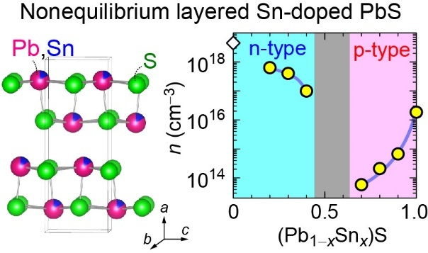
For Table of Contents Only

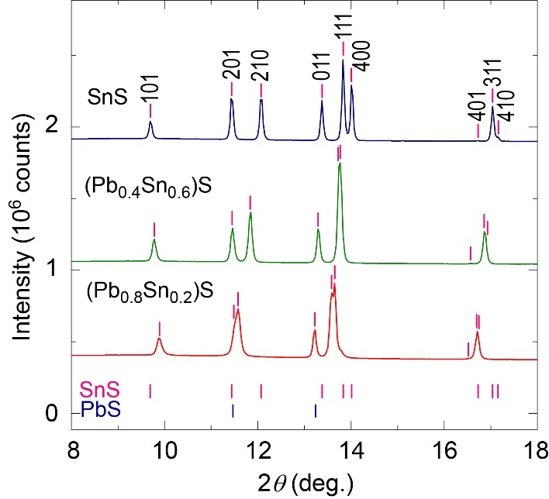
Figure 1. Synchrotron XRD patterns for (Pb_{1−x}Sn_{x})S polycrystalline powders with x = 0.2, 0.6, and 1.0. The pink vertical bars denote the diffraction angle positions of the layered GeS-type phase (othorhombic Pnma). The peak positions of RS-type PbS (cubic Fm3̅m) are also shown by dark blue vertical bars for comparison.

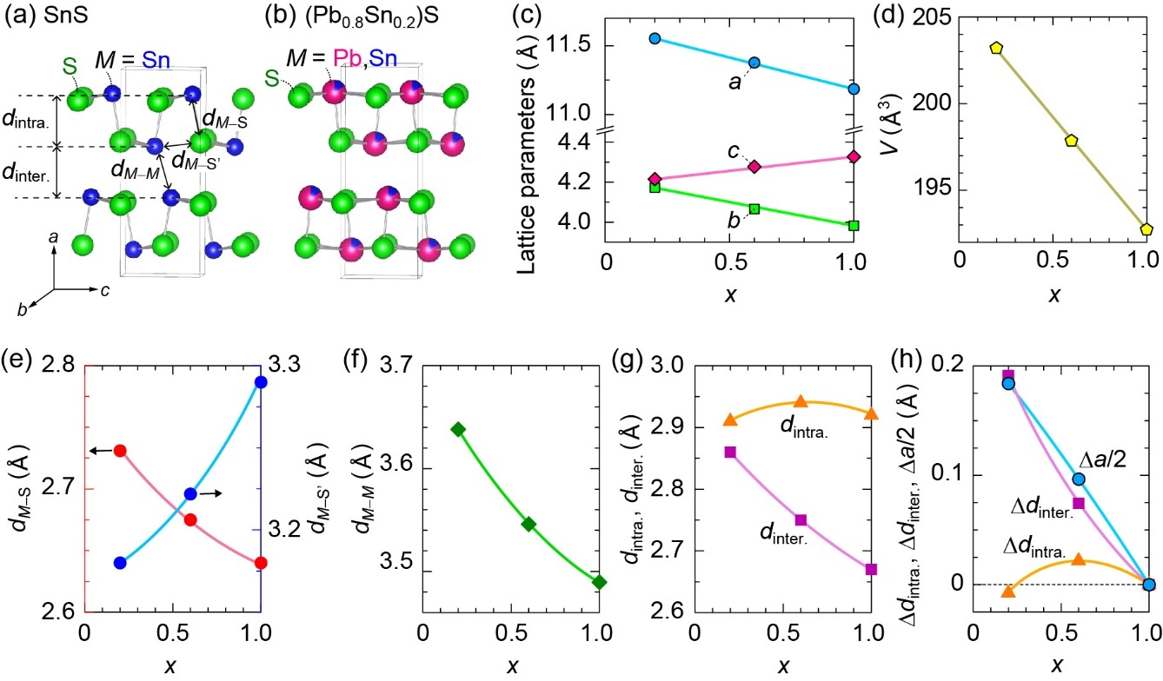
Figure 2. Crystal structure analyses of layered (Pb_{1−x}Sn_{x})S with x = 0.2–1.0. (a,b) Schematic illustration of crystal structures for (a) SnS and (b) (Pb_{0.8}Sn_{0.2})S, obtained from the Rietveld analyses. x dependences of (c) the a-axis, b-axis, and c-axis lattice parameters, (d) the unit cell volume (V), (e) the bond lengths of short M−S (d_{M−S}) and long M−S’ (d_{M−S’}) in M−S (M = Pb and Sn) layer, (f) the inter-layer M−M distance (d_{M−M}), (g) the intra-layer distance of M−S layer (d_{intra.}) and inter-layer distance between M−S layers (d_{inter.}). (h) Comparison of Δa/2 ((a_{(Pb1−xSnx)S} − a_{SnS})/2), Δd_{intra.} (d _{intra.,(Pb1−xSnx)S} − d _{intra.,SnS}), and Δd_{inter.} (d _{inter.,(Pb1−xSnx)S} − d _{inter.,SnS}) as a function of x.

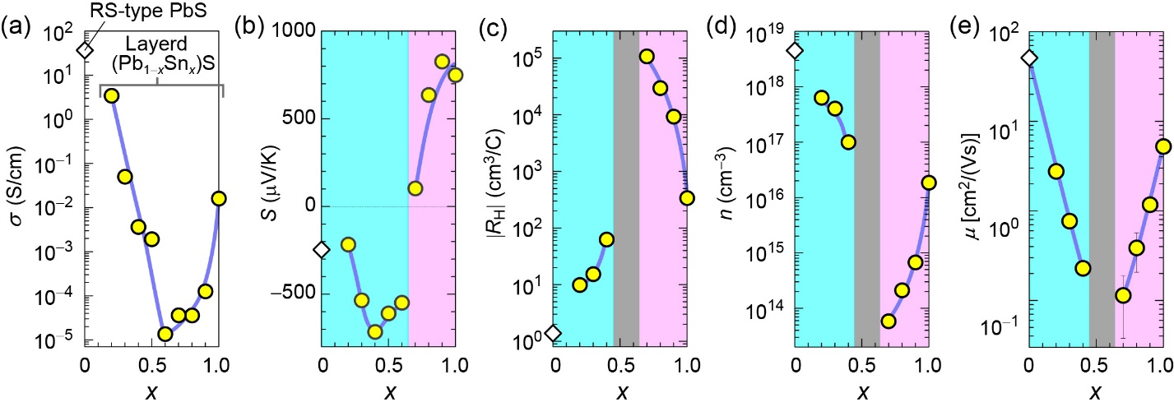
Figure 3. Electronic properties of layered (Pb_{1−x}Sn_{x})S polycrystalline bulks with x = 0.2−1.0 at room temperature. Those of RS-type PbS (x = 0) are also shown by open diamonds for comparison. x dependences of (a) electronic conductivity (σ), (b) Seebeck coefficient (S), (c) absolute value of Hall coefficient (|R_{H}|), (d) carrier concentration (n), and (e) carrier mobility (μ). The pink and blue areas indicate p-type and n-type conduction regions, respectively. The gray areas in (c) – (e) show that the reliable Hall signal was not obtained for x = 0.5−0.6.

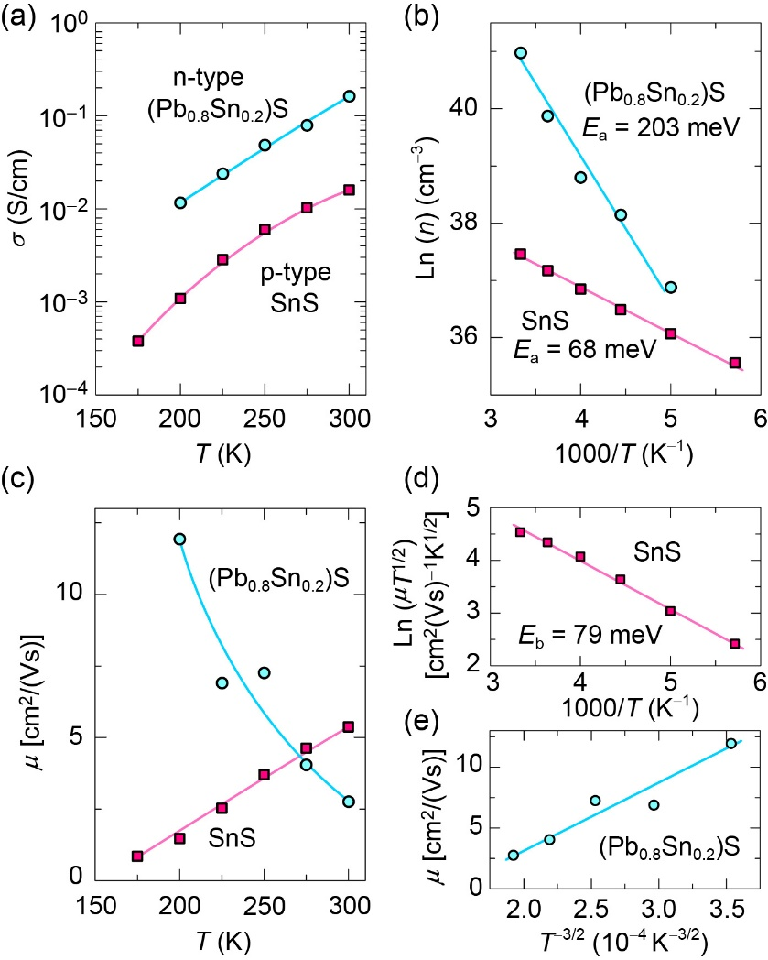
Figure 4. T dependence of electronic properties for p-type SnS and n-type (Pb_{0.8}Sn_{0.2})S polycrystalline bulks. (a) σ vs. T plots, (b) Arrhenius plots of Ln(n) vs. 1000/T, and (c) μ vs. T plots. (d) Ln(μT^{1/2}) vs. 1000/T plot for SnS. (e) μ vs. T^{−3/2} plot for (Pb_{0.8}Sn_{0.2})S. The bule and red lines are guide for the eye. The activation energy (E_{a}) of n is described in (b), and the grain boundary potential barrier height (E_{b}) is described in (d). (e) indicates that the electron transport in (Pb_{0.8}Sn_{0.2})S is dominated by phonon scattering.

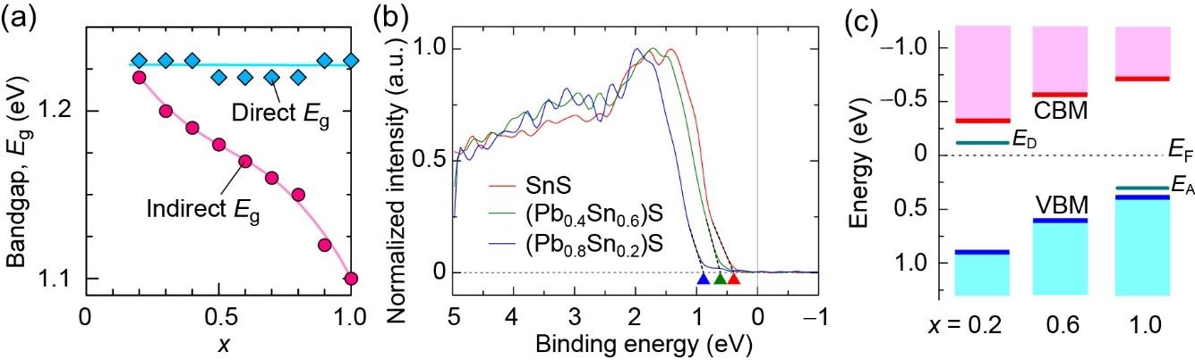
Figure 5. Electronic structure analysis of (Pb_{1−x}Sn_{x})S bulks at RT. (a) Direct- and indirect E_{g} as a function of x, estimated from diffuse reflectance measurements. (b) HAXPES spectra near E_{F} for (Pb_{1−x}Sn_{x})S bulks with x = 0.2, 0.6, and 1.0 after the deconvolution process. The energy of VBM is estimated by the leading-edge analysis as indicated by dotted black lines. (c) Schematic electronic structure of (Pb_{1−x}Sn_{x})S. The CBM and VBM are indicated by red and blue lines, respectively. The donor level (E_{D}) for x = 0.2 and acceptor level (E_{A}) for x = 1.0, estimated from the Arrhenius plots of carrier concentrations (Fig. 4b), are also drawn by green lines.

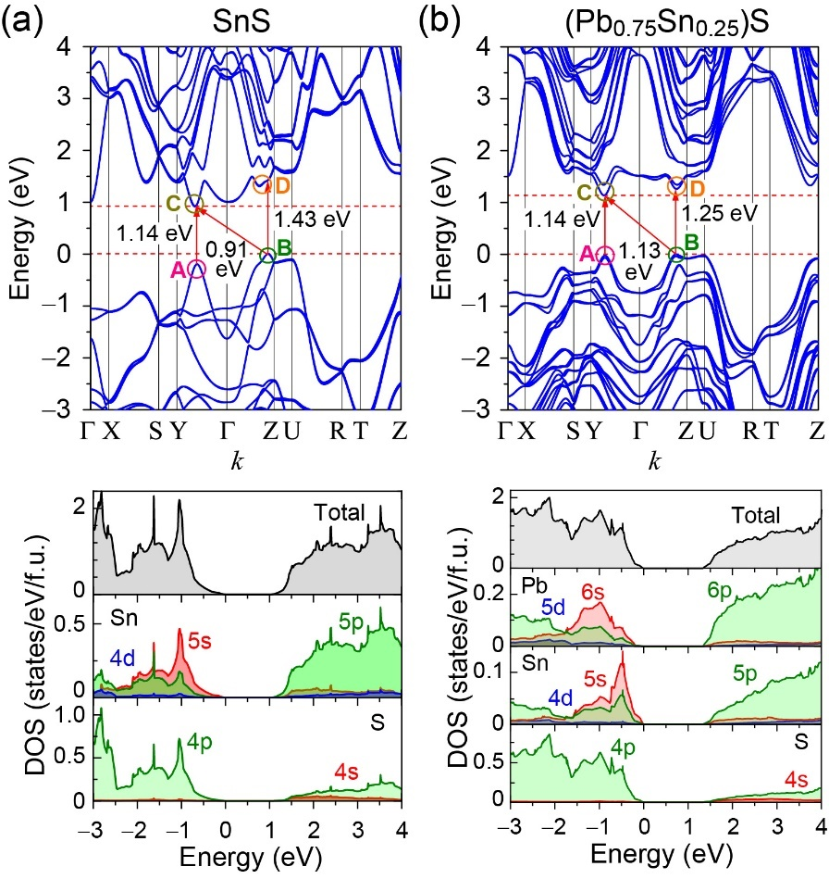
Figure 6. Calculated electronic band structures and density of states (DOSs) for the GeS-type layered (a) SnS and (b) (Pb_{0.75}Sn_{0.25})S models.

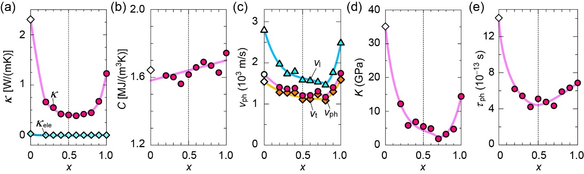
Figure 7. Thermal transport properties of layered (Pb_{1−x}Sn_{x})S bulks with x = 0.2−1.0 at RT. Those of RS-type PbS (x = 0) are also shown by open diamonds for comparison. (a) Thermal conductivity (κ) and electronic thermal conductivity (κ_{ele}), (b) specific heat per volume (C), (c) phonon velocity (v_{ph}) including the transverse and longitudinal phonon velocities (v_{t} and v_{l}), (d) bulk modulus (K), and (e) phonon lifetime (τ_{ph}).

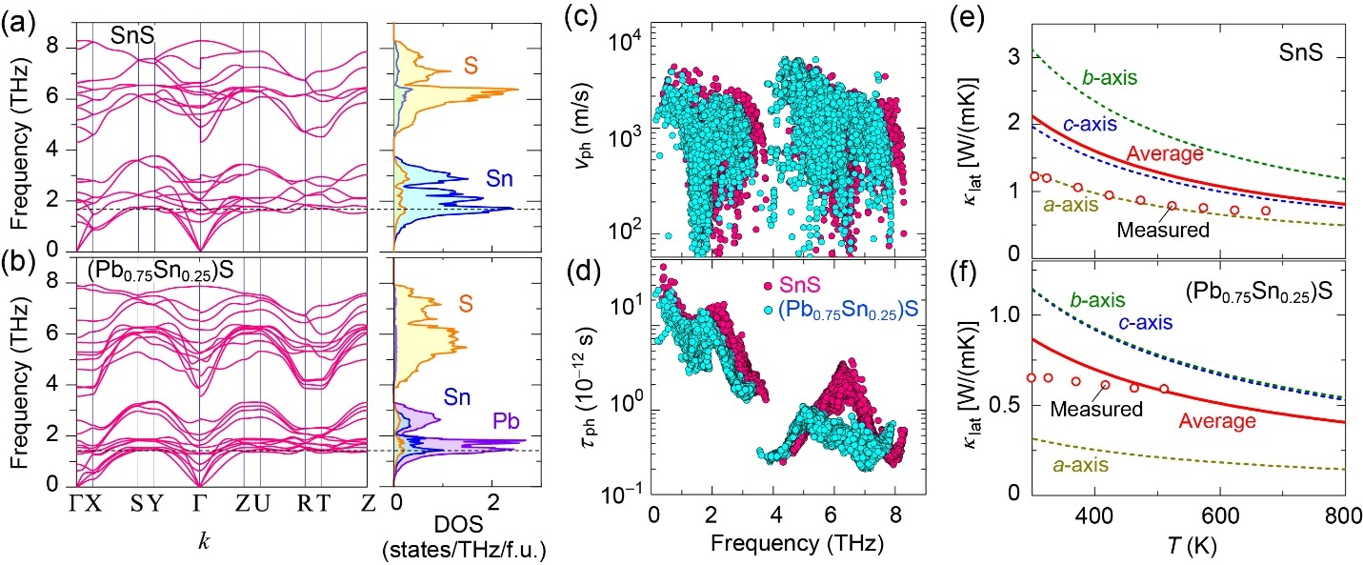
Figure 8. Calculated phonon transport properties for the GeS-type layered (Pb_{1−x}Sn_{x})S models with x = 0.25 and 1. (a,b) Phonon band structures and density of states. (c) Phonon group velocity (v_{ph}) and (d) phonon lifetime (τ_{ph}) as a function of frequency at 300 K. (e,f) T dependence of lattice thermal conductivity (κ_{lat}). The experimentally measured κ_{lat} of SnS and (Pb_{0.8}Sn_{0.2})S bulks are also shown by open circles in (e,f) for comparison.

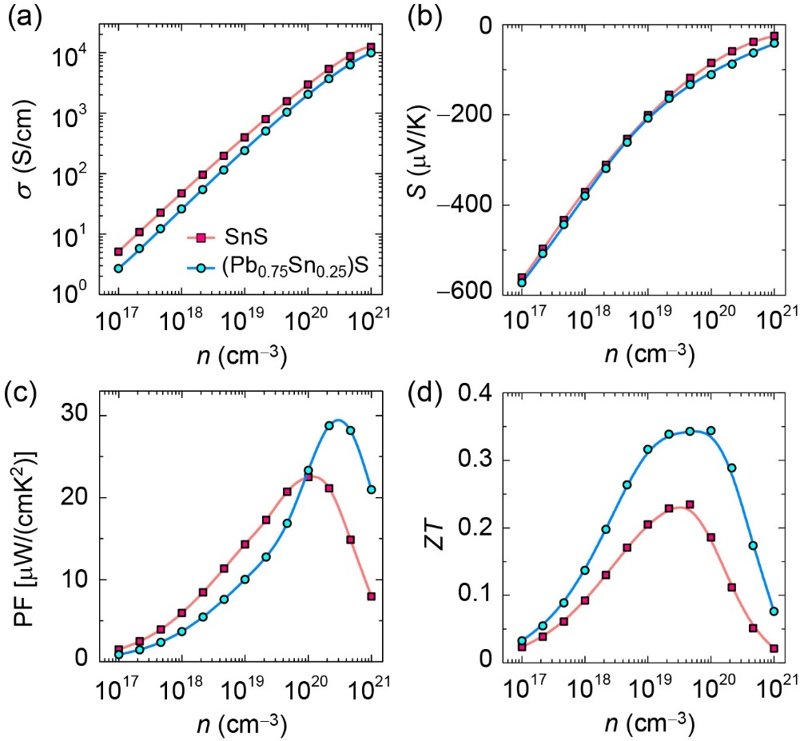
Figure 9. Calculated thermoelectric properties (closed circles), averaged along all crystal axes, for n-type layered (Pb_{0.75}Sn_{0.25})S model as a function of electron concentration (n) at T = 300 K. Those of layered SnS are also shown by squares for comparison. (a) electronic conductivity (σ), (b) Seebeck coefficient (S), (c) power factor (PF), and (d) dimension-less figure of merit (ZT).

