Supplemental
Fabrication of g-C₃N₄ films with enhanced mechanical and charge transfer properties by electrophoretic deposition and subsequent citric acid modification

Preyaphat Wongchaiya ^{a,b}, Thi Kim Ngan Nguyen ^{c,*}, Pornapa Sujaridworakun ^{a,d,e,*}, Siriporn Larpkiattaworn ^{f}, Tohru S. Suzuki ^{b}, Tetsuo Uchikoshi ^{b,*}
ª Department of Materials Science, Faculty of Science, Chulalongkorn University, 254 Phayathai Road, Pathumwan, Bangkok 10330, Thailand
^{b} Research Center for Electronic and Optical Materials, National Institute for Materials Science, 1-2-1 Sengen, Tsukuba, Ibaraki 305-0047, Japan
^{c} International Center for Young Scientists, National Institute for Materials Science, 1-2-1 Sengen, Tsukuba, Ibaraki 305-0047, Japan
^{d} Photocatalysts for Clean Environment and Energy Research Unit, Faculty of Science, Chulalongkorn University, 254 Phayathai Road, Pathumwan, Bangkok 10330, Thailand
^{e} Center of Excellence on Petrochemical and Materials Technology, Chulalongkorn University, 254 Soi Chula 12, Phayathai Road, Wang Mai, Pathumwan, Bangkok 10330, Thailand
^{f} Expert Centre of Innovative Materials, Thailand Institute of Scientific and Technological Research, 35 Mu 3 Technopolis, Tambon Khlong Ha, Amphoe Khlong Luang, Pathum Thani 12120, Thailand

* Corresponding Authors:
Email address: uchikoshi.tetsuo@nims.go.jp (T. Uchikoshi)
Email address: NGUYEN.Thikimngan@nims.go.jp (T.K.N. Nguyen)
Email address: pornapa.s@chula.ac.th (P. Sujaridworakun)

b)
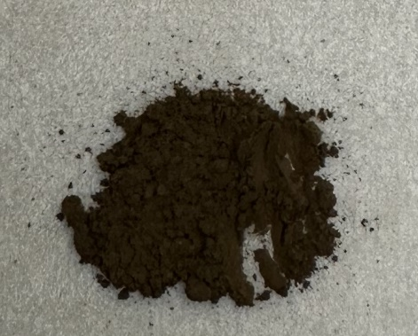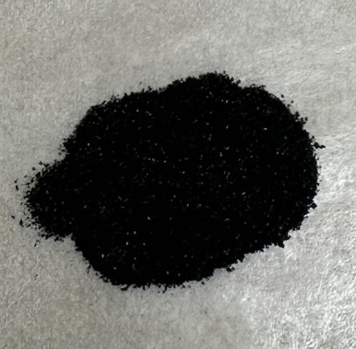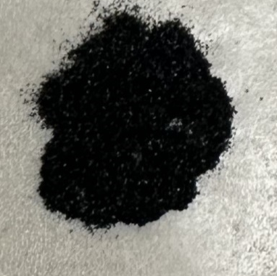
CA-200°C CA-250°C CA-300°C CA-350°

Fig. S1. a) X-ray diffraction (XRD) patterns of the Citric acid (CA) obtained at different calcination temperatures b) Photo of citric acid (CA) heated at different temperature.

Fig. S2. FTIR of pure Citric acid after heated at 300 °C.
Fig. S3. XPS spectra of C1s of g-C₃N₄ and g-C₃N₄-CA-300 °C

Fig. S4. UV-vis spectra of a) g-C₃N₄-CA on ITO glass obtained at various citric acid (CA) concentrations after heating at 300 °C
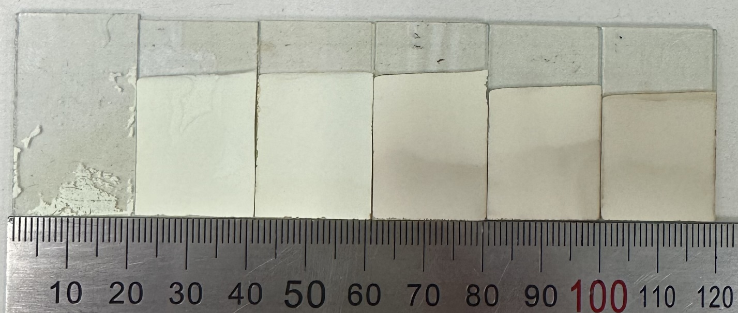
g-C₃N₄ g-C₃N₄-CA g-C₃N₄-CA g-C₃N₄-CA g-C₃N₄-CA g-C₃N₄-CA
200 °C 250 °C 300 °C 350 °C

Fig. S5. Photographs of the EPD films were taken to investigate their physical properties through manual removal using fingers, obtained at different calcination temperatures, with a constant CA concentration of 75 g/l
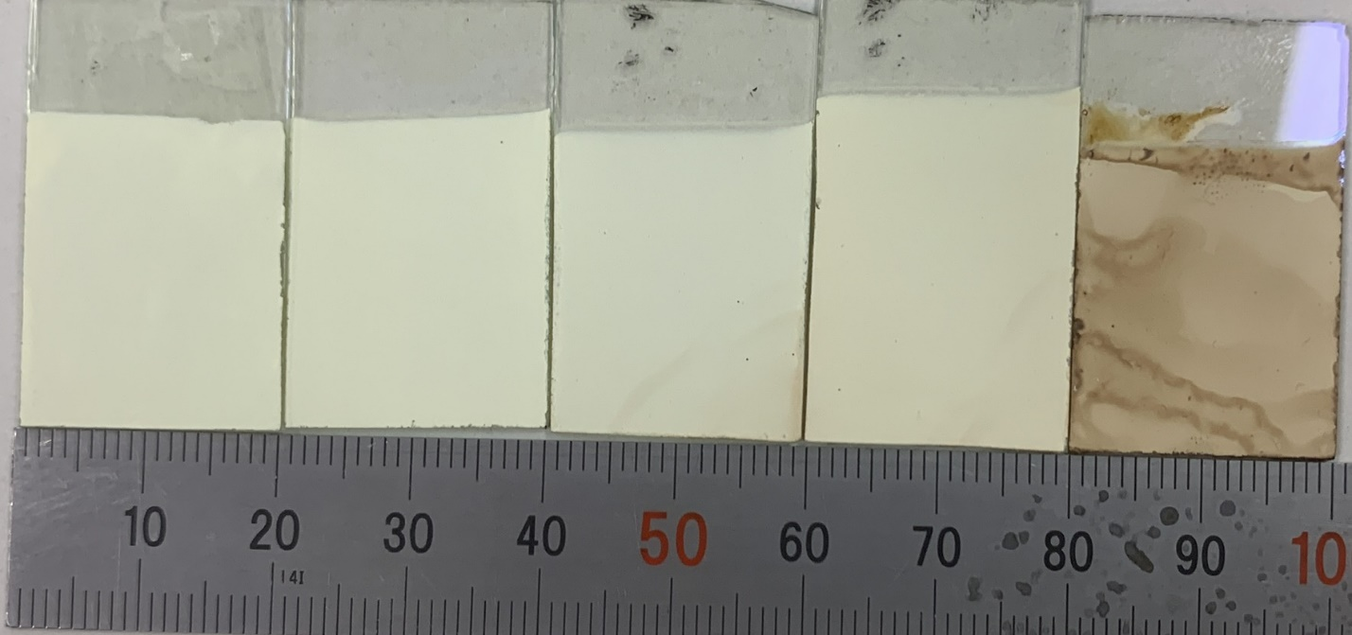
a)
g-C₃N₄ g-C₃N₄-CA g-C₃N₄-CA g-C₃N₄-CA g-C₃N₄-CA
10 g/l 50 g/l 75 g/l 100 g/l
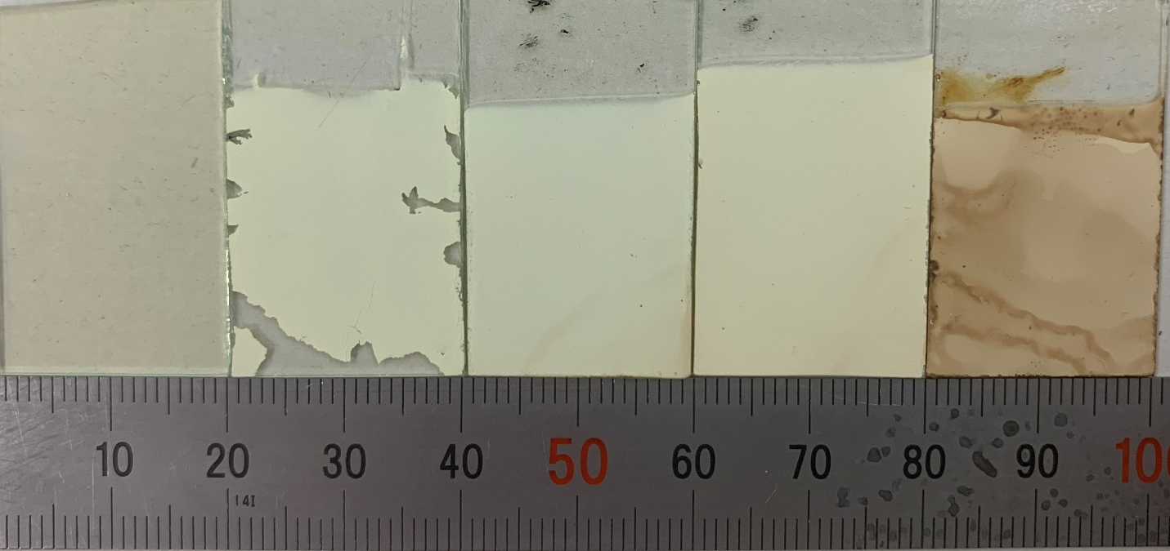
b)
g-C₃N₄ g-C₃N₄-CA g-C₃N₄-CA g-C₃N₄-CA g-C₃N₄-CA
10 g/l 50 g/l 75 g/l 100 g/l
Fig. S6. Photographs of the EPD films with vary CA concentrations and heated at 300 °C, 2h a) before and b) after electrochemical measurement
b)
a)
Fig. S7. a) Photocurrent response b) linear sweep voltammetry (LSV) plots of the films at different citric acid concentration after heat-treated at 300°C

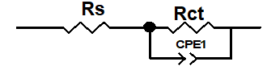
Sample Name | Charge transfer (Rs) | Rct
g-C₃N₄-CA-200°C | 106.2 | 310,840
g-C₃N₄-CA-250°C | 112.2 | 393,550
g-C₃N₄-CA-300°C | 77.16 | 38,171
g-C₃N₄-CA-350°C | 93.32 | 38,712
Fig. S8. Equivalent circuit of EIS consisted of solution resistance (Rs)

