Optimum asymmetry for nanofabricated refractometric sensors at quasi-bound states in the continuum

Keisuke Watanabe¹* and Masanobu Iwanaga²
1.* International Center for Young Scientists (ICYS), National Institute for Materials Science (NIMS), 1-1 Namiki, Tsukuba, Ibaraki 305-0044, Japan, E-mail: watanabe.keisuke@nims.go.jp. https://orcid.org/0000-0002-4285-2135
2. Research Center for Electronic and Optical Materials, National Institute for Materials Science (NIMS), 1-1 Namiki, Tsukuba, Ibaraki 305-0044, Japan. https://orcid.org/0000-0002-8930-6940

ABSTRACT
A symmetry-protected bound state in the continuum (BIC) is one of the bases for high-resolution photonic refractometric sensors that rely on spectral shifts. However, a trade-off exists between the quality (Q) factors and the resonance amplitudes when the asymmetries of the unit cell are changed, making it difficult to intuitively determine the optimal nanostructural geometry. In this study, we present a theoretical and experimental approach for identifying the asymmetry parameters of dielectric metasurfaces that yield the lowest limit of detection (LOD). Silicon-based metasurfaces with asymmetric pair-rod arrays are fabricated experimentally, and the minimum LOD is obtained under a critical coupling condition with equal radiative and nonradiative Q factors. The results agree well with the theoretical model derived from the temporal coupled-mode theory. We reveal that the LOD and the optimum asymmetry are significantly influenced by nonradiative losses in the nanostructure, emphasizing the importance of loss reduction in dielectric metasurfaces at quasi-BICs for high-performance refractometric sensors.

All-dielectric photonic nanostructures with high-quality (Q) factors enabled by bound states in the continuum (BICs) have provided a new sensing method with the potential to replace conventional plasmon nanostructures.¹ Over the past two decades, photonic crystals (PCs) without broken symmetry in active surface-emitting devices have demonstrated the sensing of environmental refractive index,^{2–4} pH,⁵ proteins, ⁶ and biological cells,⁷ for which the mechanisms are based on band-edge resonances at the Γ point of the Brillouin zone. More recently, a new method has been proposed to introduce asymmetry to the unit cells of PCs or metasurfaces.^{8,9} The BIC condition protected by the in-plane symmetry of the structure is transformed into a quasi-BIC (qBIC) by breaking the symmetry of the unit structure of the dielectric array, enabling coupling to far-field radiation under normal incident excitation. Owing to the design flexibility of metasurfaces using qBIC modes, they exhibit potential as sensing configurations leveraging strong interactions with the surrounding medium,^{10–14} particularly in protein detection applications.^{15,16}
For refractometric sensing that measures spectral shifts, a sharp spectrum (i.e., a high Q factor) favors high-resolution sensing. Thus, the conventional figure-of-merit (FOM) is given by the refractive index sensitivity S divided by the full width at half maximum (FWHM) of the resonance spectrum.¹⁷ On the other hand, Conteduca et al. have recently emphasized the importance of resonance amplitude, which is influenced by nonradiative losses in photonic refractometric sensors.¹⁸ Their findings suggest that the minimum limit of detection (LOD) for the environmental refractive index is obtained under the critical coupling condition, where radiative and nonradiative losses are equal, achieving a balance between Q factors and resonance amplitudes. Yet, for photonic sensors relying on qBIC modes, there is a trade-off between the Q factors and amplitudes when changing the asymmetries of the unit cell.^{19–21} This makes it challenging to intuitively determine the optimal degree of asymmetry added to nanostructures for enabling high-resolution sensing.
In this letter, we theoretically explore the structural conditions that yield the lowest LOD of the environmental refractive index for dielectric metasurfaces at qBICs and experimentally compare these conditions. We first derive the theoretical LOD using temporal coupled-mode theory. Subsequently, we fabricate silicon metasurfaces with asymmetric pair-rod arrays and characterize their refractive index sensitivities and wavelength fluctuations in the structures with different degrees of asymmetry. Our experimental values align with theoretical models, highlighting that the minimum LOD is obtained under the critical coupling condition, influenced significantly by nonradiative losses of the metasurfaces, primarily due to fabrication imperfections. This condition strikes a balance between the Q factors and resonance amplitudes amid the trade-off resulting from changes in unit cell asymmetries, emphasizing the importance of loss-engineering in refractometric sensing applications of metasurfaces at qBICs. Note that our study aims to clarify the conditions that optimize the LOD rather than the FOM. This approach leads to the conclusion that maximizing the conventional FOM does not necessarily optimize the LOD due to nonzero nonradiative losses.
To explore the optimal structural conditions for refractometric sensing, we examine how system losses impact the LOD for the refractometric sensors, as given by:²²
(1)
where δλ represents the wavelength fluctuation of the resonance mode, often expressed as three times the standard deviation (3σ) of the noise. Although the experimental LOD can be determined using Eq. (1), we derive the theoretical LOD as follows. Initially, we establish the relationship between the wavelength fluctuation δλ and amplitude fluctuation δA of the resonance mode. Here, we begin with the reflection amplitude A(λ₀, λ) of the resonance mode derived from the temporal coupled-mode theory (TCMT),²³ as expressed by:
(2)
where λ₀ is the resonance peak wavelength, and Q_{R} and Q_{NR} are the radiative and nonradiative Q factors, respectively. The interference between broad background spectra and sharp qBIC modes explains Fano lineshapes, which are expressed by incorporating the reflection and transmission coefficients r and t, respectively, of the background spectra without resonances. Note that Eq. (2) is only applicable to structures with symmetric cladding layers. However, we use this equation for simplicity, assuming a sufficiently small index difference between the upper cladding (water) and lower cladding (quartz). When λ = λ₀, the amplitude fluctuation caused by the wavelength fluctuation δλ is given by δA(λ₀, λ₀)|_{δλ} = A(λ₀, λ₀) − A(λ₀ + δλ, λ₀),²⁴ which provides the following relative amplitude noise (see Supplementary Material S1 for derivation) using Eq. (2):
(3)
where Δλ is the FWHM of the resonance mode. For simplicity, A(λ₀, λ₀) is written as A below. Solving Eq. (3) for δλ and substituting it into Eq. (1), the theoretical LOD can be obtained as:
(4)
Here, an approximation of δA|_{δλ}/A << 1 is used. Note that the actual amplitude fluctuation includes other extrinsic noise sources, and is the sum of the contributions from the relative intensity noise, shot noise, and Johnson noise.²⁵ However, as we focus on the amplitude fluctuation triggered by wavelength fluctuation δA|_{δλ}, we separate the noise sources into two factors:²⁴ δA|_{δλ} and all other sources of noise δA|_{O}. This separation can be expressed as (δA/A)² = (δA|_{δλ}/A)² + (δA|_{O}/A)². Because Eq. (3) is derived from the relationship between the wavelength and amplitude fluctuations, δA|_{δλ} can be determined by substituting the experimental δλ into this equation. In the ideal condition of r = 0, the LOD is expressed by substituting A obtained from Eq. (2) into Eq. (4):
(5)
The optimal structural parameter at which the minimum LOD is obtained can be determined by taking the derivative of Eq. (5) with respect to Q_{R} and equating it to zero, yielding the critical coupling condition^{26,27} Q_{R} = Q_{NR}. Here, we implicitly assume that δA|_{δλ} is constant, which is not always the case, as will be shown later. However, the critical coupling condition can be used to roughly predict optimal structural conditions.
Our next goal is to compare the experimental LOD obtained from Eq. (1) with the theoretical LOD obtained from Eq. (4). To this end, we fabricated and characterized a metasurface consisting of asymmetric pair-rod arrays using a silicon-on-quartz (SOQ) wafer with a top silicon layer thickness of 200 nm, as illustrated in Fig. 1(a). The period of the unit structure P was 790 nm, the primitive rod length L was 595 nm, the width of the upper and lower rods was 230 nm, and the separation between the centers of the pair of rods was 380 nm. The asymmetry parameter is defined as α = 2ΔL/L, where ΔL represents the difference in lengths between the upper and lower rods. A distinctive feature of this metasurface design is that the resonance wavelength λ₀ and refractive index sensitivity S remain almost unchanged even with changes in the asymmetry parameter α. This design choice simplifies the discussion of the α-dependence of the LOD expressed in Eq. (4). These characteristics are shown in Fig. 1(b), whose spectra were simulated using a commercial finite-difference time-domain (FDTD) solver (Ansys Lumerical) with Bloch boundary conditions in the x and y directions and perfectly matched layers in the z direction. An x-polarized plane wave was normally incident to the metasurfaces in the simulation. Fabrication was then performed using electron-beam lithography (EBL) and dry-etching.²¹ Figure 1(c) shows a field-emission scanning electron microscopy (SEM) image of the fabricated metasurface, along with the simulated near-field intensity |E|². The electric fields are enhanced by the resonance enhancement of the qBIC mode and are strongly localized outside the silicon rods. This localization makes them highly sensitive to the surrounding medium, including small changes in the surrounding refractive indices.

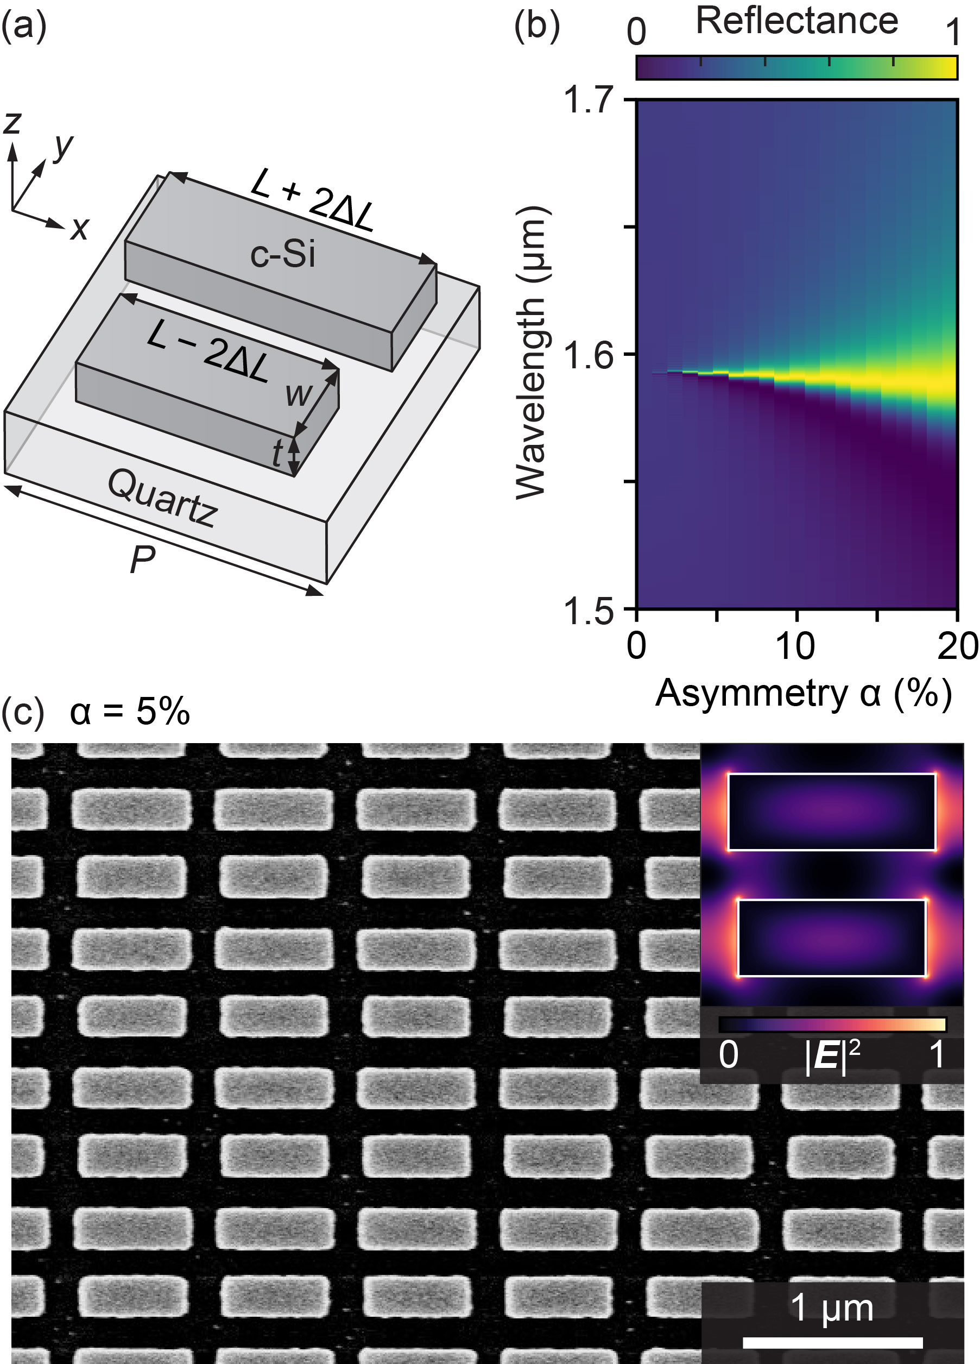
FIG. 1. Silicon metasurface with asymmetric pair-rod arrays. (a) Schematic of the unit cell. (b) Simulated reflectance map for different α. (c) Top-view SEM image of the fabricated silicon metasurface with α = 5%. Inset shows the simulated electric field intensity |E|² of the corresponding structure at the resonance peak wavelength in the xy plane at half height of the silicon nanostructures. Incidence is set to the x-polarization.

To characterize the fabricated samples, we used a custom-made transmittance setup employing a cross-polarized configuration. A tunable laser source was focused onto a metasurface sample with a focal spot size of 30 μm through a 10× objective, and the transmittance was measured using a photodetector through a 5× objective. The cross-polarized configuration was used to cancel out the unwanted excitation light while preserving the resonance mode, which displays a resonance peak different from the dip.^{28,29} Figures 2(a) and (b) show the real-time tracking results of the resonance peak wavelengths and the representative spectra when the metasurface was immersed in a mixture of water and isopropyl alcohol (IPA). In our measurements, the spectra were acquired every ~1.9 seconds, corresponding to the sampling rate of approximately 0.52 Hz. The peak wavelengths were determined from the curves fitted using the Fano resonance. For α = 5%, the refractive index sensitivity was calculated to be 229 nm/RIU from the average resonance wavelengths for different values of the index solution. The number of wavelength fluctuations observed over a minute in water was δλ = 6.4 pm, which was calculated as thrice the standard deviation of the 31 points of the peak wavelengths and averaged four different measurements. This corresponds to 1/1000 the linewidth of the resonance mode, indicating that the noise from the thermal fluctuations and mechanical vibrations was sufficiently small.²⁴ Figure 2(c) shows the experimental λ₀ and S as functions of α. Although λ₀ was slightly blueshifted, particularly when α was large, both λ₀ and S remained almost constant over a wide range of α values, as expected. A possible cause of this slight blueshift is the dense patterning of the upper rods for a larger α, resulting in the overexposure of neighboring rods during EBL.

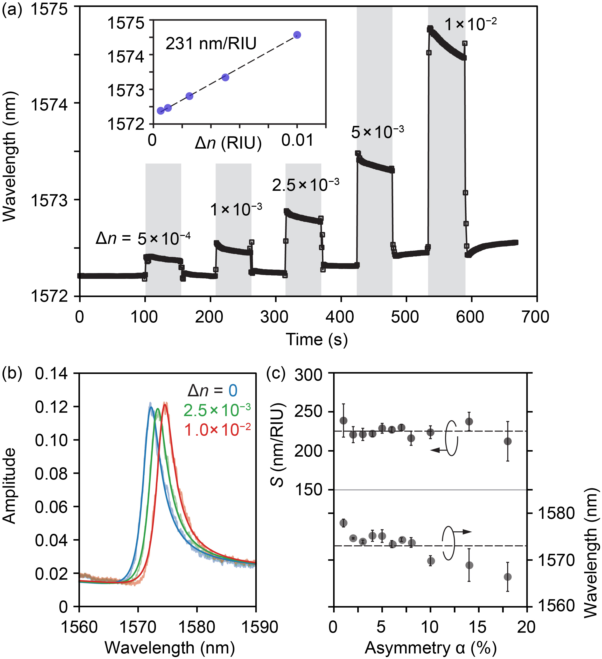
FIG. 2. Experimental demonstration of bulk refractive index sensing using silicon metasurfaces. (a) Real-time measurement of the resonance peaks when α = 5%. Gray-shaded regions indicate the injection of different concentrations of index solutions, while the other white regions indicate the injection of water. Inset: Average resonance wavelengths as a function of the index change Δn, whose linear fitting (dashed line) gives the refractive index sensitivity S. (b) Spectra in different Δn. Solid lines represent the curves fitted by using the Fano function. (c) Plot of S (left axis) and resonance wavelength λ₀ (right axis) for different α, where dashed lines represent the respective average values.

Next, the experimentally obtained qBIC spectra were characterized using Eq. (2). To determine the Q_{R} and Q_{NR} in this equation, a Q factor analysis was performed. First, Q_{R} was numerically determined by applying Q_{R} = ω₀U(t)/P(t),³⁰ where ω₀ is the angular frequency of the mode, U(t) is the modal electromagnetic energy, and P(t) is the radiation power absorbed in the calculation boundary. Figure 3(a) shows the calculated and experimental Q factors as a function of α. Here, the well-known relation Q_{R} = Q₀α⁻² for qBIC modes was used⁹ and the constant value Q₀ = 2.3 was determined by linear fitting of the Q_{R}. The difference between the Q_{R} and experimental Q factors, especially at a small α, can be explained by the contribution of the nonradiative Q factor Q_{NR}. Based on the relation Q⁻¹ = Q_{R}⁻¹ + Q_{NR}⁻¹, the Q_{NR}, which is attributed to the sum of the material absorption and scattering losses owing to fabrication imperfections, was then fitted and determined. Note that the array size N x N of our fabricated metasurface was sufficiently large (200 μm × 200 μm, N~ 250); thus, we ignored the finite-size effects^{31,32} below. This assumption is valid because the in-plane Q factor Q_{in} can be considered infinitely large. By applying Eq. (2), the resonance spectra of the fabricated metasurfaces were characterized using Q₀ and Q_{NR} obtained. Parameters r and t were determined by curve fitting the experimentally obtained background spectra of the metasurface with α = 0%. As shown in Fig. 3(b), the experimental amplitudes and FWHM were consistent with those of the numerically calculated models, validating the theoretical models.
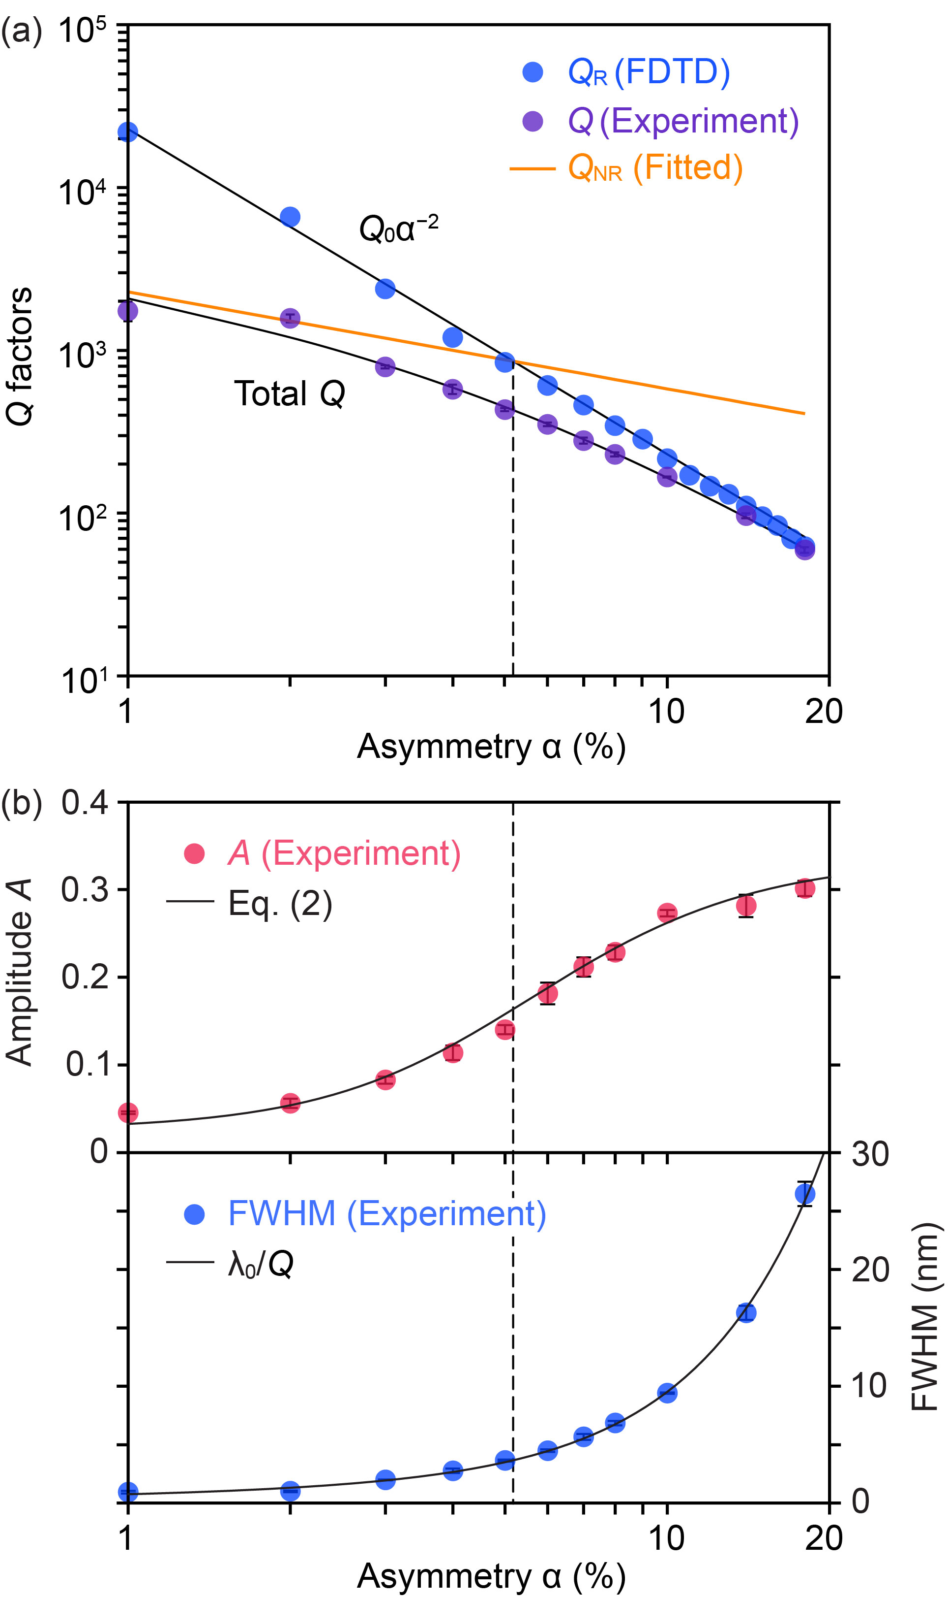
FIG. 3. Characterization of experimentally obtained qBIC spectra. (a) Experimental and calculated Q factors under periodic boundary conditions in the xy plane (infinite array size). (b) Upper (left axis): Experimental amplitude (red dots) and theoretical curve (Eq. (2)). Lower (right axis): Experimental FWHM (blue dots) and numerically determined FWHM (= λ₀/Q). Error bars indicate the standard errors of four different measurements. Vertical dashed line represents α, where the Q_{R} and Q_{NR} lines intersect in (a).

The α-dependent LOD for various Q_{NR} was then calculated by substituting the relation Q_{R} = Q₀α⁻² for qBIC modes and experimentally determined parameters into Eq. (4). Here, we also used the α-dependence of δA|_{δλ} = 1.56 × 10⁻⁷α^{−0.94} (see Supplementary Material S3) to obtain a smooth LOD curve, which was obtained by substituting the experimentally obtained δλ into Eq. (3). The calculated theoretical LOD is shown in Fig. 4(a). Overall, a larger Q_{NR} (i.e., smaller loss) and smaller α yielded a smaller LOD. However, the LOD increased when α approached zero, implying that there exists an α at which the LOD is minimized at a specific Q_{NR} (as indicated by the white line). Figure 4(b) compares the experimental LOD with the theoretical curves for different Q_{NR}. When Q_{NR} = 1200, these two values were almost in agreement, with the LOD being minimal at α = 5%. Importantly, this condition satisfies the critical coupling condition Q_{R} = Q_{NR}, as indicated in Fig. 3(a), where the Q_{R} and Q_{NR} lines intersect around α = 5%. For both smaller and larger α, the error bars of the LOD were likely larger, indicating less stability in measurements at these α. By contrast, the measurements around α = 5% were more stable, resulting in a minimum LOD of 2.8 × 10⁻⁵ RIU. Here, α_{min} shifts to smaller values when the Q_{NR} is large because the condition that satisfies the critical coupling shifts accordingly, and simultaneously, the LOD decreases. Therefore, to obtain the minimum LOD, it is important to accurately predict the Q_{NR} of the fabricated sample to determine the α_{min} and reduce nonradiative losses. If the Q_{NR} is increased (by decreasing the nonradiative losses) to 8000, the LOD can be improved several times.
We attribute the slight inconsistency between the theory and experiment to the uncertainty in the experimental plots and the implicit assumption that the Q_{NR} is independent of α. Resonance peak wavelengths measured in real time are highly sensitive to changes in the external environmental conditions, causing inaccurate evaluations of wavelength fluctuations δλ with even slight drifts. Although we obtained δλ by averaging the results of four individual measurements, conducting more measurements would allow for more accurate LOD evaluation.
Note that the α_{min} shifts to larger values when the array size is small because the in-plane losses Q_{in}⁻¹ are added to the nonradiative losses (Q_{NR} decreases).³³ If the array size N × N of the fabricated metasurface is sufficiently large, the nonradiative losses in nanofabricated silicon-based metasurfaces are predominantly determined by the scattering losses due to fabrication imperfections because material absorption losses are small for SOQ wafers in the telecom wavelength range. Therefore, it is crucial to decrease nonradiative losses or employ a strategy robust to fabrication errors to reduce LOD.
It should also be noted that the conventional FOM = S/FWHM for refractometric sensors is only applicable when Q_{NR} is infinite, as shown by the black line in Fig. 4(b), where the LOD monotonically decreases with decreasing α. By contrast, for a finite Q_{NR}, maximizing the FOM does not optimize the LOD and fails to account for the increase in the LOD when α is small. Rather, a finite Q_{NR} significantly impacts the practical value of the LOD. Although this study used asymmetric pair-rod arrays to simplify the discussion, where λ₀ and S are invariant with respect to α, the LOD optimization strategy is generally applicable to any BIC-based photonic sensors with different asymmetry parameters, including metasurfaces and photonic crystals. In any case, varying the degree of asymmetry changes Q_{R} and, hence, Q₀ in the relation Q_{R} = Q₀α⁻², depending on the asymmetry parameters added to the structure. Therefore, our conclusion that the optimal LOD is obtained at the critical coupling condition satisfying Q_{R} = Q_{NR} is always true, and no generalizability is lost.
Although the experimental LOD was comparable to typical nanostructures using surface plasmon resonances (10⁻⁵ − 10⁻⁶ RIU)^{34,35} and was slightly larger than that of photonic sensors using guided mode resonances with lower scattering losses (10⁻⁶ RIU),^{36,37} it is difficult to directly compare our LOD with other BIC metasurfaces^{15,38–40} because no other reports have evaluated the LOD at the moment. Considering our conclusion that the highest FOM does not give the lowest LOD owing to the nonzero Q_{NR}, BIC metasurfaces still have potential, as they possess both high Q factors and large resonance strengths once the fabrication errors are reduced. Increasing S directly decreases the LOD, as indicated in Eq. (5), and further optimization of the LOD can also be achieved by enhancing the interactions between the resonantly enhanced near-field and the surrounding medium.^{21,41} Leveraging its high-resolution refractometric sensing capability, our silicon metasurfaces can potentially be applied to biosensors for environmental monitoring, food safety, and medical diagnostics by incorporating appropriate surface functionalizations, including antibodies,⁴² aptamers,⁴³ peptides,⁴⁴ and receptors.⁴⁵
In summary, this study has theoretically and experimentally explored the conditions under which the LOD is minimized in a refractometric sensor utilizing a silicon metasurface at a qBIC. Asymmetric pair-rod arrays in the near-infrared region have demonstrated a minimum LOD of 2.8 × 10⁻⁵ RIU under the condition of Q_{R} = Q_{NR} when α = 5%. The theoretical analysis indicates that the optimal α shifts to smaller values with decreasing nonradiative losses. These findings provide a generally applicable strategy for setting asymmetry parameters in experiments and highlight the significance of nonradiative losses in the LOD as a key factor for high-resolution refractometric sensors at qBICs.

SUPPLEMENTARY MATERIAL
See the supplementary material for detailed information on the derivation of the theoretical model, real-time measurement of the resonance amplitude at a fixed wavelength, and the α-dependence of the amplitude fluctuation.
This work was financially supported by JSPS KAKENHI Grant Number JP22K20496, and by a research granted from The Murata Science Foundation. The authors thank Shin-Etsu Chemical, Co., Ltd., Japan, for kindly providing the SOQ wafers. Nanofabrication processes were conducted at the Nanofabrication Platform and Namiki Foundry at NIMS.

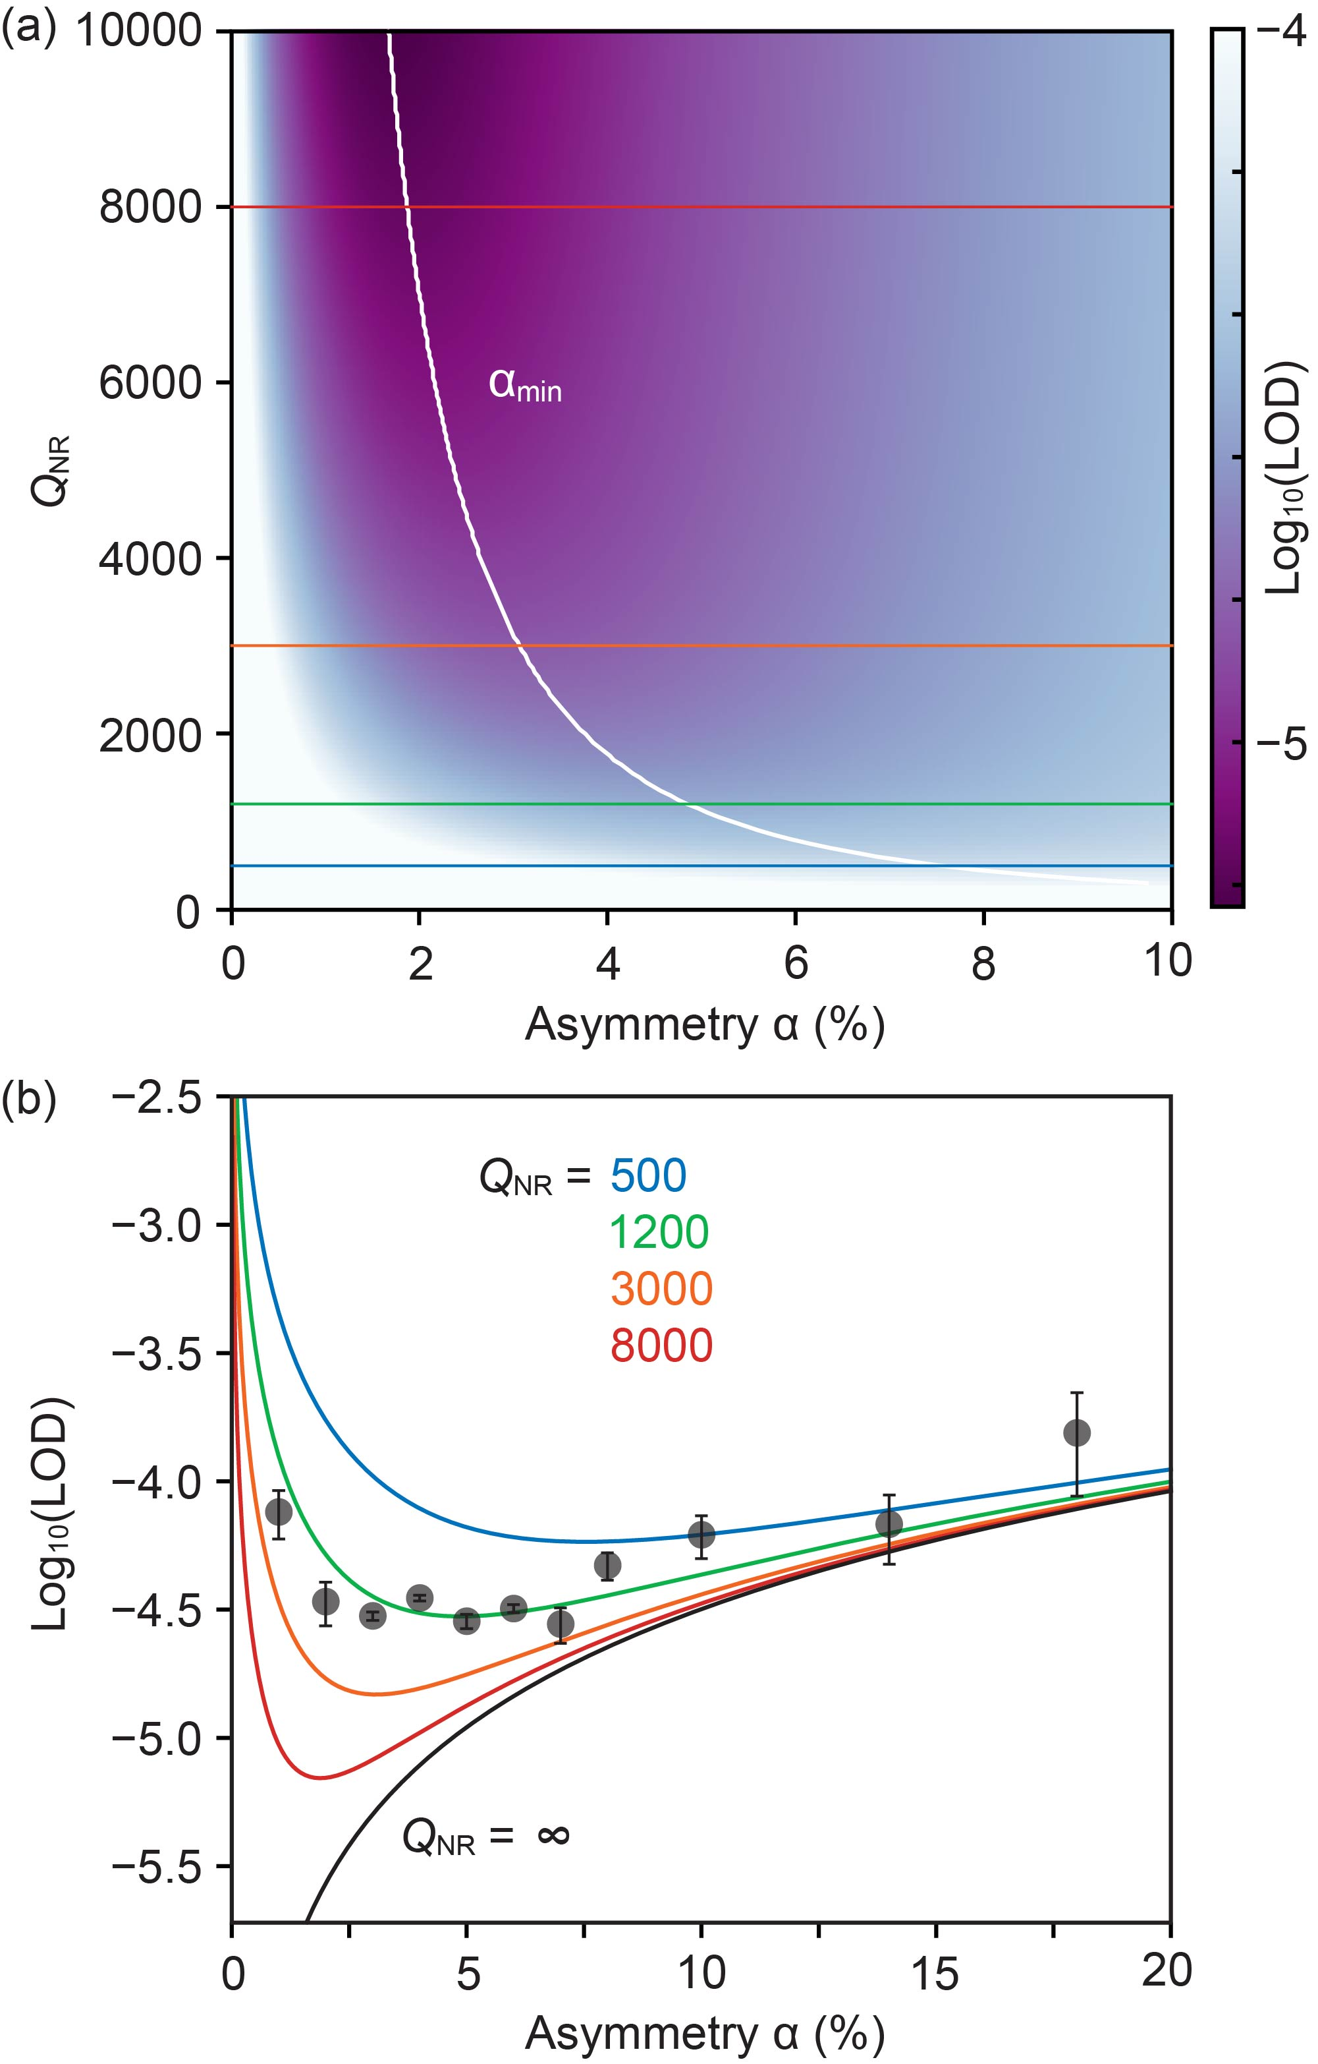
FIG. 4. Limit of detection (LOD) of silicon metasurfaces at qBICs with different α. (a) Calculated LOD of metasurfaces with different Q_{NR}. White solid curve (α_{min}) shows the α value at which the minimum LOD is obtained. (b) Superposition of the experimental (black dots) and theoretical (solid lines) LODs. Colors of the theoretical curves correspond to those in (a) except the black line (Q_{NR} = ∞).

AUTHOR DECLARATIONS
The authors have no conflicts to disclose.

DATA AVAILABILITY
The data that support the findings of this study are available from the corresponding author upon reasonable request.

REFERENCES
¹ J. Wang, S.A. Maier, A. Tittl, J. Wang, S.A. Maier, and A. Tittl, “Trends in nanophotonics-enabled optofluidic biosensors,” Adv Opt Mater 10(7), 2102366 (2022).
² F. Bernal Arango, M.B. Christiansen, M. Gersborg-Hansen, and A. Kristensen, “Optofluidic tuning of photonic crystal band edge lasers,” Appl Phys Lett 91(22), 223503 (2007).
³ S. Kim, J. Lee, H. Jeon, and H.J. Kim, “Fiber-coupled surface-emitting photonic crystal band edge laser for biochemical sensor applications,” Appl Phys Lett 94(13), 133503 (2009).
⁴ P.T. Lee, T.W. Lu, and K.U. Sio, “Multi-functional light emitter based on band-edge modes near Γ-Point in honeycomb photonic crystal,” Journal of Lightwave Technology 29(12), 1797–1801 (2011).
⁵ K. Watanabe, A. Sakata, Y. Saijo, and T. Baba, “pH-sensitive GaInAsP photonic crystal fractal band-edge laser,” Opt Lett 45(22), 6202 (2020).
⁶ H. Cha, J. Lee, L.R. Jordan, S.H. Lee, S.-H. Oh, H.J. Kim, J. Park, S. Hong, and H. Jeon, “Surface passivation of a photonic crystal band-edge laser by atomic layer deposition of SiO₂ and its application for biosensing,” Nanoscale 7(8), 3565–3571 (2015).
⁷ M.B. Christiansen, J.M. Lopacinska, M.H. Jakobsen, N. Asger Mortensen, G. Blagoi, M. Dufva, and A. Kristensen, “Polymer photonic crystal dye lasers as Optofluidic Cell Sensors,” Opt Express 17(4), 2722–2730 (2009).
⁸ O. Kilic, M. Digonnet, G. Kino, and O. Solgaard, “Controlling uncoupled resonances in photonic crystals through breaking the mirror symmetry,” Opt Express 16(17), 13090 (2008).
⁹ K. Koshelev, S. Lepeshov, M. Liu, A. Bogdanov, and Y. Kivshar, “Asymmetric metasurfaces with high- Q resonances governed by bound states in the continuum,” Phys Rev Lett 121(19), 193903 (2018).
¹⁰ X. Long, M. Zhang, Z. Xie, M. Tang, and L. Li, “Sharp Fano resonance induced by all-dielectric asymmetric metasurface,” Opt Commun 459, 124942 (2020).
¹¹ L. Kühner, L. Sortino, R. Berté, J. Wang, H. Ren, S.A. Maier, Y. Kivshar, and A. Tittl, “Radial bound states in the continuum for polarization-invariant nanophotonics,” Nat Commun 13, 4992 (2022).
¹² Z. Liu, T. Guo, Q. Tan, Z. Hu, Y. Sun, H. Fan, Z. Zhang, Y. Jin, and S. He, “Phase interrogation sensor based on all-dielectric BIC metasurface,” Nano Lett 23(22), 10441–10448 (2023).
¹³ H. Chen, X. Fan, W. Fang, B. Zhang, S. Cao, Q. Sun, D. Wang, H. Niu, C. Li, X. Wei, C. Bai, and S. Kumar, “High-Q Fano resonances in all-dielectric metastructures for enhanced optical biosensing applications,” Biomed Opt Express 15(1), 294–305 (2024).
¹⁴ T. Wang, S. Liu, J. Zhang, L. Xu, M. Yang, D. Ma, S. Jiang, Q. Jiao, and X. Tan, “Dual high-Q Fano resonances metasurfaces excited by asymmetric dielectric rods for refractive index sensing,” Nanophotonics 13(4), 463–475 (2024).
¹⁵ F. Yesilkoy, E.R. Arvelo, Y. Jahani, M. Liu, A. Tittl, V. Cevher, Y. Kivshar, and H. Altug, “Ultrasensitive hyperspectral imaging and biodetection enabled by dielectric metasurfaces,” Nat Photonics 13(6), 390–396 (2019).
¹⁶ J. Wang, J. Kühne, T. Karamanos, C. Rockstuhl, S.A. Maier, and A. Tittl, “All-dielectric crescent metasurface sensor driven by bound states in the continuum,” Adv Funct Mater 31(46), 2104652 (2021).
¹⁷ J.N. Anker, W.P. Hall, O. Lyandres, N.C. Shah, J. Zhao, and R.P. Van Duyne, “Biosensing with plasmonic nanosensors,” Nat Mater 7(6), 442–453 (2008).
¹⁸ D. Conteduca, G.S. Arruda, I. Barth, Y. Wang, T.F. Krauss, and E.R. Martins, “Beyond Q: The importance of the resonance amplitude for photonic sensors,” ACS Photonics 9, 1757–1763 (2022).
¹⁹ L. Cong, M. Manjappa, N. Xu, I. Al-Naib, W. Zhang, and R. Singh, “Fano resonances in terahertz metasurfaces: a figure of merit optimization,” Adv Opt Mater 3(11), 1537–1543 (2015).
²⁰ W.X. Lim, and R. Singh, “Universal behaviour of high-Q Fano resonances in metamaterials: terahertz to near-infrared regime,” Nano Converg 5(1), 1–7 (2018).
²¹ K. Watanabe, and M. Iwanaga, “Nanogap enhancement of the refractometric sensitivity at quasi-bound states in the continuum in all-dielectric metasurfaces,” Nanophotonics 12(1), 99–109 (2023).
²² I.M. White, and X. Fan, “On the performance quantification of resonant refractive index sensors,” Opt Express 16(2), 1020 (2008).
²³ W. Suh, J.D. Joannopoulos, and S. Fan, “Temporal coupled-mode theory for the Fano resonance in optical resonators,” Journal of the Optical Society of America A 20(3), 569–572 (2003).
²⁴ K. Saurav, and N. Le Thomas, “Probing the fundamental detection limit of photonic crystal cavities,” Optica 4(7), 757 (2017).
²⁵ L. Zhang, W. Pang, and X. Zhou, “Performance and noise analysis of optical microresonator-based biochemical sensors using intensity detection,” Opt Express 24(16), 18197–18208 (2016).
²⁶ T.J. Seok, A. Jamshidi, M. Kim, S. Dhuey, A. Lakhani, H. Choo, P.J. Schuck, S. Cabrini, A.M. Schwartzberg, J. Bokor, E. Yablonovitch, and M.C. Wu, “Radiation engineering of optical antennas for maximum field enhancement,” Nano Lett 11(7), 2606–2610 (2011).
²⁷ K. Koshelev, Y. Tang, K. Li, D.Y. Choi, G. Li, and Y. Kivshar, “Nonlinear metasurfaces governed by bound states in the continuum,” ACS Photonics 6(7), 1639–1644 (2019).
²⁸ Y. Nazirizadeh, U. Lemmer, and M. Gerken, “Experimental quality factor determination of guided-mode resonances in photonic crystal slabs,” Appl Phys Lett 93(26), 261110 (2008).
²⁹ J. Reverey, U. Lemmer, T. Becker, Y. Nazirizadeh, C. Selhuber-Unkel, M. Gerken, and D.H. Rapoport, “Photonic crystal slabs for surface contrast enhancement in microscopy of transparent objects,” Opt Express 20(13), 14451–14459 (2012).
³⁰ O. Painter, J. Vuckovic, and A. Scherer, “Defect modes of a two-dimensional photonic crystal in an optically thin dielectric slab,” J Opt Soc Am B 16(2), 275–285 (1999).
³¹ D.N. Maksimov, and E.N. Bulgakov, “Light enhancement by quasi-bound states in the continuum in dielectric arrays,” Opt Express 25(13), 14134–14147 (2017).
³² S. Droulias, T. Koschny, and C.M. Soukoulis, “Finite-size effects in metasurface lasers based on resonant dark states,” ACS Photonics 5(9), 3788–3793 (2018).
³³ X. Yin, J. Jin, M. Soljačić, C. Peng, and B. Zhen, “Observation of topologically enabled unidirectional guided resonances,” Nature 580(7804), 467–471 (2020).
³⁴ B.E. Feller, X. Wang, R.D. Miller, A. Knoesen, M. Jefferson, P.C.D. Hobbs, and W.P. Risk, “Shot-noise limited detection for surface plasmon sensing,” Opt Express 19(1), 107–117 (2011).
³⁵ K. Li, C. Reardon, T.F. Krauss, M. Simmons, and A. Drayton, “Performance limitations of resonant refractive index sensors with low-cost components,” Opt Express 28(22), 32239–32248 (2020).
³⁶ S. Wang, Y. Liu, D. Zhao, H. Yang, W. Zhou, and Y. Sun, “Optofluidic Fano resonance photonic crystal refractometric sensors,” Appl Phys Lett 110(9), 091105 (2017).
³⁷ D. Conteduca, I. Barth, G. Pitruzzello, C.P. Reardon, E.R. Martins, and T.F. Krauss, “Dielectric nanohole array metasurface for high-resolution near-field sensing and imaging,” Nat Commun 12, 3293 (2021).
³⁸ A. Ndao, L. Hsu, W. Cai, J. Ha, J. Park, R. Contractor, Y. Lo, and B. Kanté, “Differentiating and quantifying exosome secretion from a single cell using quasi-bound states in the continuum,” Nanophotonics 9(5), 1081–1086 (2020).
³⁹ Y. Jahani, E.R. Arvelo, F. Yesilkoy, K. Koshelev, C. Cianciaruso, M. De Palma, Y. Kivshar, and H. Altug, “Imaging-based spectrometer-less optofluidic biosensors based on dielectric metasurfaces for detecting extracellular vesicles,” Nat Commun 12(1), 3246 (2021).
⁴⁰ H.H. Hsiao, Y.C. Hsu, A.Y. Liu, J.C. Hsieh, and Y.H. Lin, “Ultrasensitive refractive index sensing based on the quasi-bound states in the continuum of all-dielectric metasurfaces,” Adv Opt Mater 10(19), 2200812 (2022).
⁴¹ C. Fang, Q. Yang, Q. Yuan, L. Gu, X. Gan, Y. Shao, Y. Liu, G. Han, and Y. Hao, “Efficient second-harmonic generation from silicon slotted nanocubes with bound states in the continuum,” Laser Photon Rev 16(5), 2100498 (2022).
⁴² J. Kang, S. Kim, and Y. Kwon, “Antibody-based biosensors for environmental monitoring,” Toxicol Environ Health Sci 1(3), 145–150 (2009).
⁴³ R. Wang, Q. Zhang, Y. Zhang, H. Shi, K.T. Nguyen, and X. Zhou, “Unconventional split aptamers cleaved at functionally essential sites preserve biorecognition capability,” Anal Chem, (2019).
⁴⁴ Q. Zhu, and X. Zhou, “A colorimetric sandwich-type bioassay for SARS-CoV-2 using a hACE2-based affinity peptide pair,” J Hazard Mater 425, 127923 (2022).
⁴⁵ J. Tan, L. Liu, F. Li, Z. Chen, G.Y. Chen, F. Fang, J. Guo, M. He, and X. Zhou, “Screening of endocrine disrupting potential of surface waters via an affinity-based biosensor in a rural community in the Yellow River Basin, China,” Environ Sci Technol 56(20), 14350–14360 (2022).

