Received 00th January 20xx,
Accepted 00th January 20xx
DOI: 10.1039/x0xx00000x

Structural Insights and Electronic State Analysis of PtNi Nanowire Catalysts by operando High-Energy Resolution Fluorescence Detection X-ray Absorption Spectroscopy
Weijie Cao,ª Neha Thakur,^{*a} Mukesh Kumar,ª Tomoki Uchiyama,ª Yunfei Gao,ª Satoshi Tominaka,^{b} Akihiko Machida,^{c} Toshiki Watanabe,ª Ryota Sato,^{d} Toshiharu Teranishi,^{d} Masashi Matsumoto,^{e} Hideto Imai,^{e} Yoshiharu Sakurai,^{f} Yoshiharu Uchimotoª
Low-platinum alloy nanowire (NW) catalysts improve the performance of polymer electrolyte membrane fuel cells, but ultrafine PtNi-NW catalysts, particularly those with high Ni content, often experience significant Ni leaching during electrochemical processes. In this study, a Pt-rich surface layer was successfully formed on PtNi NWs through a simple post-annealing process. Pair distribution function (PDF) analysis revealed a Pt surface layer with a face-centered cubic (fcc) structure, along with internal body-centered cubic (bct) PtNi and fcc Ni phases. Operando X-ray absorption spectroscopy (XAS), including conventional and high-energy resolution fluorescence detection (HERFD) XAS, was used to investigate the catalysts' electronic states and structural changes under oxygen reduction reaction (ORR) conditions. The results showed that the Pt-rich surface layer of PtNi-NW/C catalysts, with its short Pt-Pt bond lengths, effectively suppresses Pt oxidation at high polarization potentials and restricts Ni leaching, leading to a significant increase in ORR-specific activity of 2.07 mA cm_{Pt}⁻², which is a 2.5- and 7-fold activity enhancement compare to Pt-NW/C and commercial Pt/C catalysts.
Introduction
Polymer electrolyte fuel cells (PEFCs) efficiently convert chemical energy into electrical energy, offering high efficiency, low noise, and clean operation.¹⁻³ Due to their potential as a reliable energy source, they have gained significant attention for applications in vehicles and portable electronics, addressing the energy crisis.⁴ Carbon-supported Pt nanoparticles (Pt/C) have been widely used as oxygen reduction reaction (ORR) electrocatalysts due to their excellent properties.⁵ However, the high cost and limited utilization of commercial Pt/C catalysts, where approximately 60% of Pt remains inaccessible, pose substantial challenges.^{6, 7} As a result, developing low-platinum catalysts with enhanced activity has become a key area of research to improve PEFC efficiency while reducing costs.
ª Graduate School of Human and Environmental Studies, Kyoto University, Yoshida Nihonmatsu-cho, Sakyo, Kyoto 606-8501, Japan.
^{b} International Centre for Materials Nanoarchitectonics (MANA), National Institute for Materials Science (NIMS), 1-1 Namiki, Tsukuba, Ibaraki 305-0044, Japan
^{c} Synchrotron Radiation Research Center, National Institutes for Quantum and Radiological Science and Technology, 1-1-1, Kouto, Sayo-cho, Sayo-gun, Hyogo 679-5148, Japan
^{d.} Institute for Chemical Research, Kyoto University, Uji, Kyoto 611-0011, Japan
^{e} Fuel Cell Cutting-Edge Research Center Technology Research Association, Aomi, Koto, Tokyo, 135-0064 Japan
^{f} Japan Synchrotron Radiation Research Institute (JASRI), Koto, Sayo, Hyogo, 679-5198, Japan
† Electronic Supplementary Information (ESI) available. See DOI: 10.1039/x0xx00000x
Recent efforts have focused on developing cost-effective electrocatalysts by alloying Pt with transition metals like Fe, Co, and Ni,^{8, 9} which reduces Pt content while enhancing the intrinsic activity of the electrocatalysts. ¹⁰ Among these alternatives, PtNi alloys have attracted considerable attention due to the beneficial effects of Ni atoms on the Pt structure, leading to superior catalytic performance.¹¹ Additionally, strategies such as size control,^{12, 13} metal doping,¹⁴ structural modifications, ¹⁵ and the creation of specific morphologies such as nanowires (NWs) have been employed to further refine the properties of these alloy catalysts.¹⁶
One-dimensional NWs with active crystalline surfaces, anisotropic structures, minimal aggregation, and efficient conduction have emerged as promising ORR catalysts.¹⁷ For instance, jagged Pt-NWs demonstrate outstanding ORR activity with specific surface structural feature.¹⁸ However, the stability and durability of bimetallic catalysts remain a challenge due to the dealloying of transition metals during fuel cell operation.¹⁵ Intentional dealloying has been explored to exploit defects as a catalytic advantage,¹⁹ but this often leads to the loss of beneficial alloy properties and issues like membrane and ionomer contamination.²⁰ Takahashi et al. observed that the Co content in Pt₁Co₂ nanoparticle catalysts dropped to 20% after undergoing 300 cyclic voltammetry (CV) cycles,²¹ and Ahluwalia et al. reveal a Ni loss from the Pt₁Ni₃ catalyst ranging between 55% to 90% during potential cycling.²² This dealloying effect was even more pronounced in ultrafine NWs. Kato et al. found that, after 100 cycles of electrochemical cleaning, the atomic ratio of platinum to nickel in PtNi-NW catalysts decreased from 52:48 to 94:6.²³ Additionally, Pt oxides formed on Pt and Pt alloy NWs with 1D anisotropy exhibit structural and electronic properties that differ from conventional nanoparticle catalysts.²⁴ Retaining high Ni content in catalysts, especially in ultrafine NWs, and thoroughly examining their structural and electronic changes under operando conditions remain critical challenges.
Operando X-ray absorption spectroscopy (XAS), including high-energy resolution fluorescence detection (HERFD) XAS, has been essential for investigating the structure and electronic states of Pt catalysts under reaction conditions.^{15, 25} HERFD-XAS enhances the resolution of spectral features compared to conventional XAS,²⁶ making it particularly effective for identifying changes in the near-edge absorption maximum, or "white line".²⁷ This improved resolution allows for clearer differentiation between Pt metal and Pt oxides, providing valuable insights into the electronic states of PtNi alloy catalysts under operando conditions. Additionally, X-ray powder diffraction (PXRD) combined with pair distribution function (PDF) analysis is useful for the structural analysis of nanomaterials with low crystallinity and multiple phases.²⁸
In this study, Pt₂₅Ni₇₅ nanowires (PtNi-NW/C) with high Ni content were synthesized through an H₂/N₂ post-annealing treatment, resulting in a Pt-rich surface and PtNi alloy core, demonstrating enhanced ORR activity compared to commercial Pt/C and Pt-NW/C catalysts. PDF analysis revealed a structure comprising pure Ni face-centered cubic (fcc) and PtNi body-centered tetragonal (bct) phases in the bulk, with a Pt fcc phase on the surface characterized by compressed lattice parameters compared to standard Pt crystals. Operando conventional and HERFD-XAS analyses confirmed that the PtNi-NW/C catalyst exhibits lower oxygen bonding energy and a shorter Pt-Pt bond length, further enhancing ORR activity and stability. These findings underscore the key structural features of the PtNi alloy NWs and provide valuable insights for future catalyst design.
Experimental
Materials
Pt (II) acetylacetonate (Pt(acac)₂, 98%), Ni (II) acetylacetonate (Ni(acac)₂, 95%), tungsten hexacarbonyl (W(CO)₆, 99%) were purchased from Sigma-Aldrich. Ethanol (99.5%), 2-Propanol (99.7%), oleylamine (OAm, 85%), cyclohexane (99.5%) glucose, and hexadecyltrimethylammonium chloride (CTAC, 99%) were purchased from Fujifilm. The electrolyte was prepared from ultra-pure water (Milli-Q, 18.2 MΩ) and perchloric acid (ultra-pure, Kanto Chemical Co. Inc.). The Vulcan XC-72 was purchased from Cabot Corporation. O₂ (99.995%), N₂ (99.999%), H₂ (5%, 95% N₂ balance) gases were purchased from Kyoto Teisan Co., Ltd.
The Pt/C catalyst (29.1 wt%; TEC10V30E) was purchased from Tanaka Kikinzoku Kogyo Co. Ltd., Japan.
Synthesis of the Pt nanowire catalyst
Synthesis of the Pt-NW catalyst involved dissolving 10 mg Pt(acac)₂, 6.4 mg Ni(acac)₂, 5 mg W(CO)₆, and 40 mg CTAC in 5 mL of OAm. The mixture was sealed in a 30 mL glass vial and sonicated at room temperature for 1 hour to form a homogeneous suspension. It was then heated at 160 °C for 2 hours to produce NW-structured catalysts. Residual organic impurities were removed by washing with a cyclohexane/ethanol mixture, followed by drying at room temperature to obtain a black powder. Subsequently, the product was dispersed in 15 mL of cyclohexane/ethanol, and 30 mg of carbon black (Vulcan XC-72) was added. The mixture was sonicated in an ice-water bath for 2 hours and centrifuged to obtain Pt-NW/C (12.3 wt% Pt). The catalyst was then dispersed in 0.1 M HClO₄ solution and heated to 80 °C for 2 hours to remove excess Ni. After etching, the sample was filtered, washed with water, and dried in an oven at 60 °C.
Synthesis of the PtNi nanowire catalyst
The Pt₂₅Ni₇₅ NW catalyst (PtNi-NW/C) (11.9 wt% Pt) was synthesized using a process similar to that of Pt NWs, without acid leaching. In this method, 70 mg of glucose and 20 mg of Ni(acac)₂ were added to the reactants. For the synthesis of the Pt₄₀Ni₆₀ NW catalyst, the amount of Ni(acac)₂ was reduced to 10 mg. The resulting NW samples were calcined at temperatures between 250 and 450 °C for 1 hour under a 5% H₂ and 95% N₂ atmosphere to achieve the Pt-rich surface layer structure.
Characterization
Synchrotron XRD patterns were collected in BL02B2 at SPring-8, Japan, and the background was subtracted using Match! 3 software. The wavelength was calibrated with CeO₂ (SPring-8) as 0.61950 Å. X-ray photoelectron spectroscopy (XPS) data were collected at the BL7U Aichi Synchrotron Radiation Center. The incident X-rays source was Monochromated Al-Kα (1486.6 eV) and photoelectron extraction angle was 45°. The carbon 1s peak was set at 284.60 eV for charge correction. The background was subtracted using the Shirley method. The morphologies of the NW samples were observed using a JEM-2200FS transmission electron microscope (JEOL, Ltd.) at an acceleration voltage of 200 kV. For High-resolution transmission electron microscopy (HR-TEM) imaging and energy-dispersive X-ray spectroscopy (EDS) mapping, the JEOL-JEM-ARM200F was used.
X-Ray Total scattering measurements
X-ray total scattering data for pair distribution function (PDF) analysis were collected using synchrotron radiation at the BL22XU beamline of SPring-8, Japan. A Varex Imaging XRD1621 flat panel detector captured the data, with a 2-second exposure and a 150-second integration time. Calibration of the beam center coordinates, detector tilt, and sample-to-detector distance (225.7759 mm) was performed using the PIXIA program, based on image data from CeO₂ (NIST, 674B; lattice constant, a = 5.41165 Å). ²⁹ The wavelength (λ = 0.180420 Å) was calibrated through PDF fitting of the CeO₂ data using PDFfit2. ³⁰
The data were normalized with the form factor using the Faber-Ziman formalism and the MaterialsPDF program. ²⁹ The structure function, S(Q), was converted into reduced PDFs, G(r), through Fourier transformation within the Q range of 1.3–29.0 Å^{–1}. Simultaneous joint curve fitting and simulation of the PDF data and XRD patterns were performed using the TOPAS program with a common structural model, ³¹ assuming individual lattice constants for PDF and XRD analyses.
Electrochemical measurement
All electrochemical experiments were performed in a three-electrode cell at room temperature. A reversible hydrogen electrode (RHE) with 5% H₂ was used as the reference electrode, Pt mesh as the counter electrode, and a glassy carbon rotating disk electrode (RDE) (Φ=5 mm) with a drop-coated catalyst served as the working electrode (WE). Prior to measurements, the glassy carbon RDE was polished with alumina micropolish and rinsed three times with water to remove any residual particles.
The catalyst ink was prepared by dispersing 2 mg of catalyst in a 2 ml mixture of ultrapure water and 2-propanol (0.3:1.7), along with 40 µL of 5 wt% Nafion® solution as a binder. The mixture was sonicated for 30 minutes and then deposited onto the glassy carbon RDE with a Pt loading of 6.5 µg cm⁻². Before testing the oxygen reduction reaction (ORR), 50 cycles of cyclic voltammetry (CV) were carried out in N₂-saturated 0.1 M HClO₄, scanning between 0.02 and 1.2 V (vs. RHE) at 100 mV s⁻¹ to remove residual surfactants. After activation, a stable CV was recorded at a scan rate of 50 mV s⁻¹.
ORR linear sweep voltammograms (LSVs) were recorded in O₂-saturated 0.1 M HClO₄, scanning from 0.2 to 1.2 V vs. RHE at 10 mV s⁻¹. LSVs under different mass transport conditions were measured using a rotating disk electrode (RDE) system with rotational speeds ranging from 100 to 2500 rpm. The ORR data were corrected using an N₂ background and analyzed with the Koutechy-Levich (K-L) equation at 0.9 V vs. RHE. The electrochemical active surface area (ECSA) was determined by integrating the hydrogen adsorption charge over the CV curve, assuming a hydrogen monolayer adsorption value of 210 µC/cm².
The accelerated degradation test (ADT) was conducted by applying constant potential polarization at 0.60 V and 1.00 V, each held for 3 s, and repeated for 10,000 cycles. After the ADT cycles, LSV was performed to evaluate the stability of the catalysts.
Oxygen coverage was determined by calculating the ratio of charges associated with reducing surface oxides ($Q_{O}$) to those from hydrogen underpotential deposition ($Q_{H}$). The $Q_{O}$ values were measured by stepping the electrode potential from 0.4 V vs. RHE to specific potentials ranging from 0.5 to 1.1 V vs. RHE in N₂-saturated 0.1 M HClO₄, holding for 5 minutes, and then scanning back to 0.4 V at 50 mV s⁻¹.
$$Oxygen coverage=\frac{Q_{O}}{Q_{H}} (1)$$
CO stripping voltammograms were obtained by immersing the working electrode in CO-saturated 0.1 M HClO₄ at 0.12 V vs. RHE for 20 minutes, allowing full CO adsorption on the catalyst. The electrolyte was then purged with N₂ gas for 40 minutes to remove any remaining CO. The adsorbed CO was stripped from the catalyst surface by scanning from 0.02 to 1.0 V vs. RHE at a rate of 10 mV s⁻¹.
operando Conventional XAS measurement
XAS measurements were carried out at the BL37XU beamline in SPring-8, Japan. Monochromatic X-rays were generated using a Si (111) monochromator and a total reflection Ru mirror (4 mrad). The operando cell setup, as described in previous studies, ³² were made from polyether ether ketone (PEEK). An Ag/AgCl electrode (Saturated KCl, RE-8, EC Frontier CO., LTD., Japan) and a platinum mesh served as the reference and counter electrodes, while the working electrode was a glass-carbon RDE coated with the catalyst. Gas was introduced into the electrolyte through a PTFE tube at the bottom of the cell, with a check valve (MFTD-6V, AS ONE Corporation, Japan) at the top to maintain stable pressure during gas bubbling. X-ray measurements were conducted through a 25 µm Kapton® film window. Data analysis was performed using ATHENA and ARTEMIS from the IFEFFIT software suite.³³
operando High-Energy Resolution Fluorescence Detection-XAS
Operando HERFD-XAS spectra of the Pt L₃-edge were acquired at the BL39XU beamline at SPring-8, Japan, in a 0.1 M HClO₄ electrolyte under O₂-saturated conditions, with the potential referenced to the reversible hydrogen electrode (RHE). X-ray emission spectroscopy (XES) was employed to monochromatize the fluorescent X-rays before collecting the XAS signals. During the test, collimated and monochromatic X-rays were generated using Si (220) monochromators and a total-reflection Rh mirror (4.5 mrad). The HERFD-XAS spectra were fitted using an arrangement equation for the background and two pseudo-Voigt (Gaussian-Lorentzian) equations for the peaks.
$$\frac{A_{bg}}{π}\left[\tan^{-1}\left(\frac{E-E_{bg}}{∆E_{bg}}\right)+\frac{π}{2}\right] (2)$$
$$\frac{A_{n}}{1+4m_{n}\frac{{(E-E_{n})}^{2}}{∆E_{n}^{2}}}\exp\left[-4∙ln2∙\left(1-m_{n}\right)∙\frac{{\left(E-E_{n}\right)}^{2}}{∆E_{n}^{2}}\right] (3)$$
Here, A_{bg} denotes the height for the arctan, which was adjusted to match the μ_{E} within the range of 11568-11570 eV. E_{bg} and E_{n} were determined as previous research. ³⁴ m_{n} was set as 0.5.
Results and discussion
Identification of the Pt nanowire structure
In the typical synthesis of Pt-NWs, OAm functions as both the solvent and surfactant, CTAC acts as a capping agent, and Ni(acac)₂ is introduced to facilitate NW formation, as outlined in the experimental section. The presence of a small amount of Ni²⁺ is crucial for the anisotropic growth of Pt NWs (Fig. S1†), as previous studies have shown that transition metal cations can slow Pt²⁺ reduction and promote the formation of one-dimensional structures.³⁵ Due to the limited reducing capability of OAm, the Ni(acac)₂ in the system was not fully reduced, preventing the formation of a PtNi-NW catalyst.³⁶ After acid treatment, ICP analysis revealed that only 3 at% of Ni remained in the alloy (Pt₉₇Ni₃-NW/C), with no significant Ni signal observed in STEM-EDS mapping (Fig. S2†). Considering the further dissolution of Ni during electrochemical testing (e.g., cleaning CV process) and for comparison with PtNi-NW, this catalyst was named Pt-NW/C, as the remaining Ni content does not significantly affect its Pt-rich properties.
The morphological characteristics of the synthesized Pt-NWs were analyzed using TEM, HR-TEM, and HAADF-STEM. As shown in Fig. 1a and Fig. S3†, the NWs are uniformly dispersed on the carbon support without noticeable agglomeration, with an average length of 11.3 ± 6.6 nm and a diameter of 2.5 ± 1.2 nm. The selected area electron diffraction (SAED) image (inset in Fig. 1a) shows distinct polycrystalline diffraction rings, where the first ring corresponds to carbon and rings 2 through 5 align with the (111), (200), (220), and (311) facets of Pt with Fm-3m symmetry, confirming the high crystallinity of the NWs.
Fig. 1c shows that most of the NWs have a lattice spacing of 0.227 nm, corresponding to the (111) facets of a typical fcc Pt nanocrystal. Atomic-level observations revealed a polycrystalline nature, suggesting a stepped structure. Surface defects within the NWs, including grain boundaries (GBs), kinks, and steps, disrupt the interfacial water network and destabilize ORR intermediates, significantly enhancing catalytic activity. ^{24, 37}
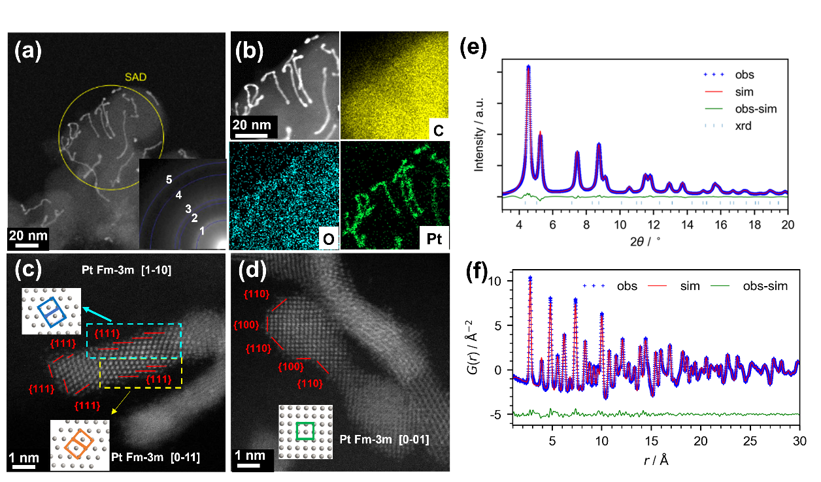
PXRD patterns, recorded with a wavelength (λ) of 0.61950 Å, were used to analyze the Pt-NW crystal structure (Fig. 1e). By simulation with fcc Pt models, the total scattering patterns indicated a lattice constant of 3.918 Å (Table S1). However, the weak and broad Bragg reflections made precise determination of crystal symmetry challenging, highlighting the need for alternative methods to enhance precision. The PDF technique, which provides the weighted probability of detecting any pair of atoms at a distance 𝑟, establishes the distribution of interatomic distances in real space and is a powerful tool for resolving material structures. PDF results indicated a slightly larger lattice constant of 3.921 Å compared to the PXRD measurement, while the synthesized NWs exhibited a more compact lattice structure than standard Pt crystals (3.925 Å).³⁸
Identification of the PtNi alloy nanowire structure
To address the issue of weak reduction by OAm in the synthesis of PtNi-NW/C, glucose was used as a stronger reducing agent, ensuring the complete reduction of Ni during the formation of PtNi NWs.³⁶ The TEM and STEM-EDS spectra of the PtNi-NW/C before H₂/N₂ annealing (Fig. S4†) revealed that the NWs had diameters ranging from 2 to 3 nm, and the distribution of Ni in the structure was non-uniform. Given the more positive reduction potential of Pt²⁺/Pt compared to Ni²⁺/Ni, the structural features of the Pt core and Pt-Ni shell formation can be deduced, which is further confirmed by the HR-TEM images (Fig. S5†).^{18, 39} Due to the sensitivity of metallic nanostructures with highly segregated compositions to exposure atmospheres,^{40, 41} efforts were focused on engineering Pt-rich layer PtNi-NWs through thermal annealing under an H₂/N₂ atmosphere.
To prevent agglomeration, PtNi-NW/C was annealed at various temperatures (Fig. S6†), resulting in different morphological changes. The experimental results show that annealing at 400 °C produces NWs with an average length of 8.5 ± 8.1 nm and a diameter of 2.6 ± 1.5 nm (Fig. S7†). At temperatures above 400 °C, large particles were observed, indicating the disruption of the NW structure and the onset of agglomeration.
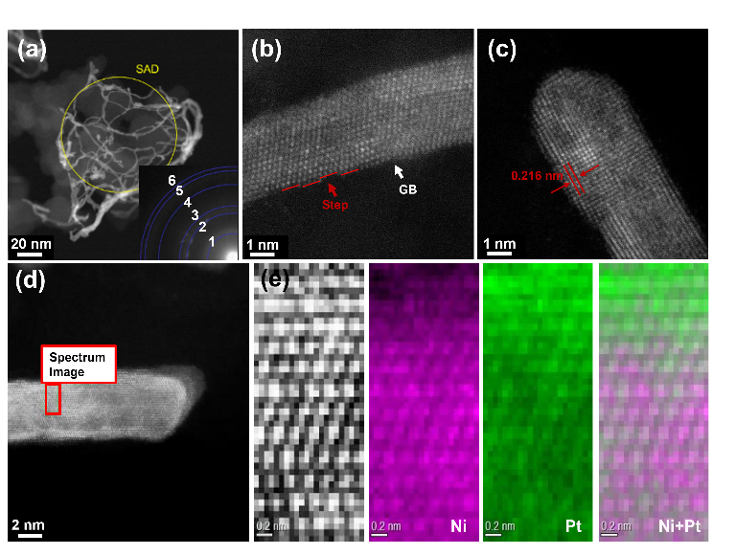
To further demonstrate the effect of annealing temperature on the formation of a Pt-rich surface, STEM-Electron Energy Loss Spectroscopy (EELS) characterization was performed on PtNi-NW/C annealed at 300 °C. As shown in Fig. S8†, the distribution of Pt and Ni within the NW structure was uniform, with no significant element segregation. This is attributed to the slow atomic diffusion and surface relaxation at lower temperatures (~300 °C).⁴² In contrast, the sample annealed at 400 °C showed a decreased Ni concentration from the core to the surface, revealing a PtNi alloy core and a Pt shell structure, highlighting the formation of a Pt-rich surface layer (Fig. 2e). Further STEM-EDS mapping and HR-TEM analysis (Fig. S9 and S10†) confirmed the development of the core-shell structure. Studies indicate that annealing at around 400 °C accelerates bulk atom diffusion and element segregation, leading to a concentration gradient that forms a Pt-rich surface.⁴³ This arrangement contributes to the specific catalytic properties of PtNi NW/C catalysts by balancing the strain effects of Ni in the core with a stable, highly active Pt-rich shell. Therefore, 400 °C was selected as the optimal annealing temperature. Subsequent PXRD results (Fig. S11†) indicate improved crystallinity of PtNi-NW/C after annealing.
Fig. 1 (a, c, d) HAADF-STEM image, (b) STEM-EDS element mapping spectrum, (e) Powder XRD patterns, and (f) PDF patterns of Pt-NW/C (obs: observed data, sim: fitted data, obs-sim: residual value). The inset in (a) is SAED image from the yellow area.

Fig. 2a presents HAADF-STEM and SAED images of the PtNi-NW/C catalysts, providing further insight into the synthesized structure. Diffraction rings 2, 3, and 4 correspond to the (111), (200), and (220) facets of Pt₇₅Ni₂₅ with Fm-3m symmetry, along with the (101), (110), and (002) facets of PtNi with P4/mmm symmetry, indicating the presence of the bct alloy phase in the NWs. Figs. 2b and 2c highlight the steps and grain boundaries in PtNi-NW/C.²⁴
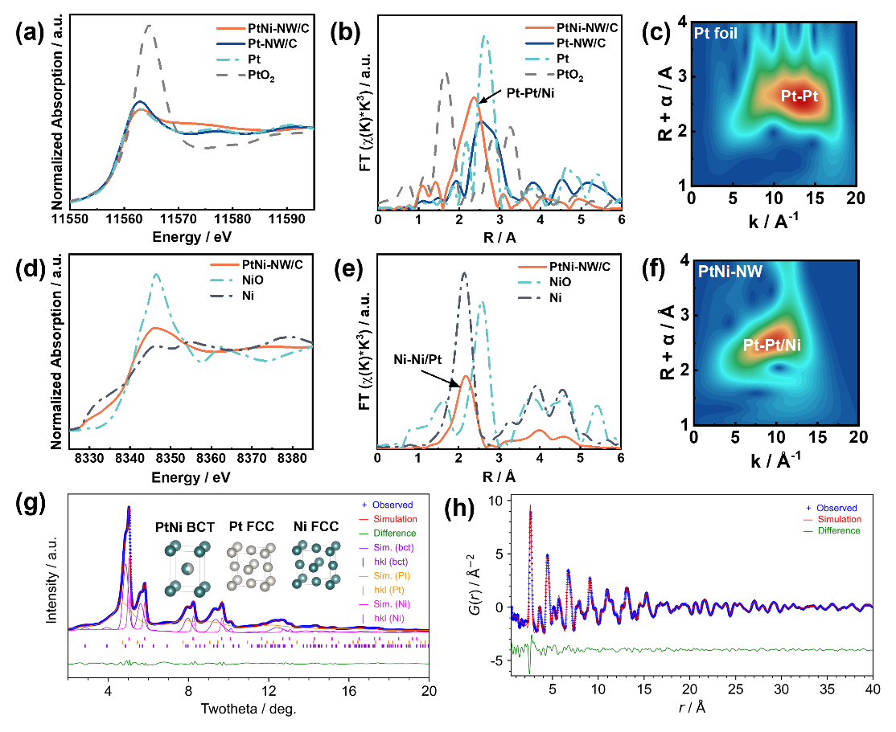
XPS was used to analyze the elemental composition and valence states in catalysts(Fig. S12† and Table S2). The Pt 4f binding energy in PtNi-NW/C (71.46 eV) showed a slight negative shift compared to Pt-NW/C (71.53 eV), attributed to the interaction between Pt and Ni, where Pt exhibits an electron-withdrawing effect.^{44, 45} This electron transfer also leads to a partial oxidation state of Ni, with Ni²⁺ accounting for approximately 69%. The Pt/Ni atomic ratio in PtNi-NW/C, determined from the XPS survey spectra (Fig. S13†), was 1/3, consistent with the ICP-MS results (26.9/73.1).
Fig. 2 (a, b, c, d) HAADF-STEM image and (e) STEM-EELS mappings for PtNi-NW/C.
Ex-situ XAS analysis was conducted to further evaluate the valence states and coordination environments of Pt and Ni. The X-ray absorption near edge structure (XANES) spectra for the Pt L₃-edge (Fig. 3a) indicate a metallic state in both Pt-NW/C and PtNi-NW/C.⁴⁶ Additionally, the reduced white line intensity for Pt in PtNi-NW/C compared to Pt-NW/C suggests electron transfer from Ni to Pt in the PtNi alloy, consistent with XPS results. Ni K-edge XANES spectra (Fig. 3d) show that the white line intensity of PtNi-NW/C falls between that of Ni foil and NiO, indicating a Ni valence state between 0 and +2. Fourier-transformed Extended X-ray absorption fine structure (FT-EXAFS) analyses for the Pt L₃-edge and Ni K-edge (Figs. 3b and e) provide insights into the local atomic structure, with PtNi-NW/C exhibiting a positive shift in the Ni-Ni signal and a negative shift in the Pt-Pt signal compare to Ni/Pt foil, causing lattice contraction.⁴⁷ Further analysis by wavelet transform (WT) reveals a shift in the maximum intensity of Pt-Pt to a lower k region, from approximately 12 Å⁻¹ to 10 Å⁻¹ (Figs. 3c and f). The strong interaction between Pt and Ni in PtNi-NW/C enhances oxidation resistance and changes the Pt coordination environment, which is considered to be favorable for ORR activity.⁴⁸
Fig. 3 (a) Pt L₃-edge XANES spectra and (b) FT-EXAFS spectra of PtNi-NW/C, Pt-NW/C, and Pt/C, (d) Ni K-edge and (e) FT-EXAFS spectra of PtNi-NW/C. Wavelet transform of the k³ weighted Pt L₃-edge EXAFS spectra of (c) Pt foil and (f) PtNi-NW/C. (g) Powder XRD patterns, and (h) PDF patterns of PtNi-NW/C.

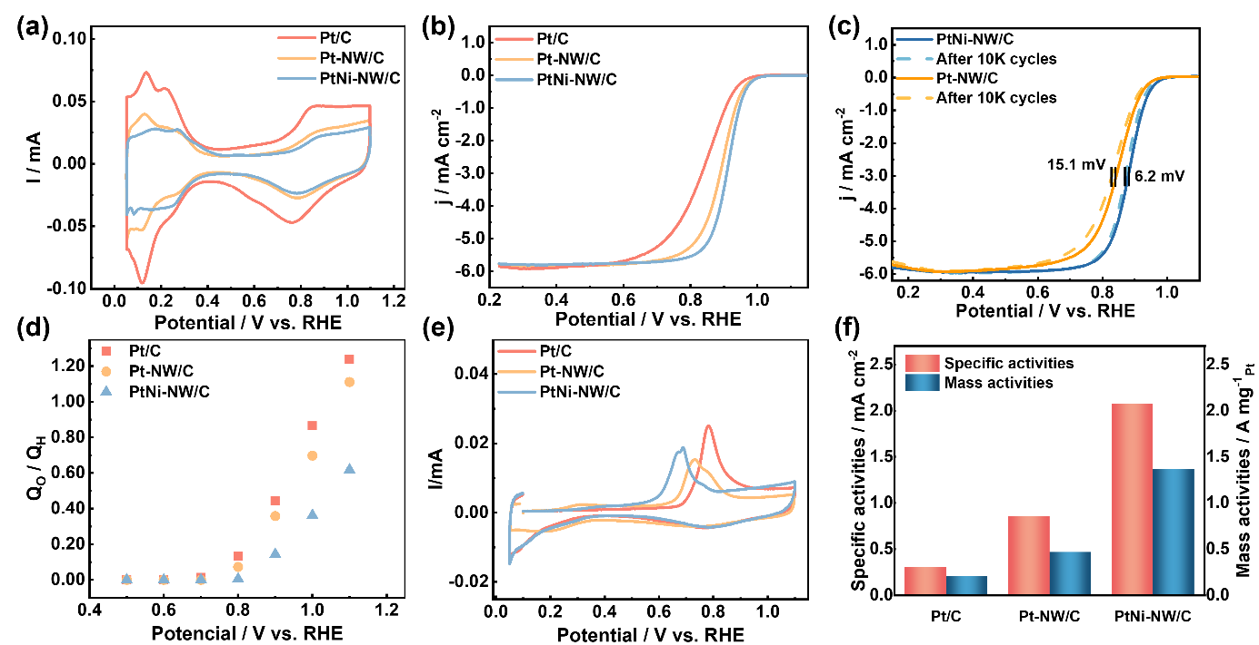
Figs. 3g and 3h present the PXRD and PDF analysis for the PtNi-NW/C catalyst, revealing the presence of a tetragonal phase attributed to the L1₀ structure in the PtNi alloy core.⁴⁹ Further analysis identifies a phase near pure Pt, characterized by a compressed fcc structure with a lattice constant of 3.79 Å and a shorter Pt-Pt distance of 2.67 Å compared to bulk Pt (Table S3), consistent with the Pt-rich layer observed in TEM images. Interestingly, PXRD did not show clear peaks for the tetragonal phase; instead, displayed broad intensities in regions where these peaks were expected, along with sharp Bragg peaks associated with pseudo-cubic phases. This pattern, combined with PDF data, suggests the formation of large pseudo-cubic crystals composed of randomly oriented c-axes of tetragonal phases. Additionally, the analysis indicated the presence of a pure fcc Ni phase within PtNi-NW/C, attributed to excess Ni content. Both the bct PtNi alloy and pure fcc Ni phases synergistically influence the core, positively impacting the structure and properties of the Pt-rich surface layer.
Electrochemical measurement
The RDE method was used to assess the electrocatalytic ORR activity of the catalysts in a 0.1 M HClO₄ electrolyte. The cleaning CV was performed in an N₂ environment for 50 cycles. Fig. S14† shows the cleaning CVs of the different NWs catalysts during the first and fiftieth cycles. In the initial cycle, the underpotential deposition of hydrogen (H_{UPD}) and Pt redox peaks were discrete, likely due to residual surfactants and organic matter on the Pt surface. After 50 cycles, a standard CV curve was obtained, with a significantly reduced peak around 1.1~1.2 V vs. RHE, indicating the removal of organic matter from the Pt surface. Additionally, the PtNi-NW/C catalysts before and after annealing exhibited different CV shapes (Fig. S14b† and c†), with the unannealed PtNi-NW/C showing electrochemical behavior similar to that of Pt-NW/C after cleaning.²³ This indicates that the Pt-rich surface layer formed after annealing effectively protects the internal Ni from dissolution.
Fig. 4 (a) CV and (b) ORR polarization curves (1600 rpm) for Pt /C, Pt-NW/C, and PtNi-NW/C catalysts, respectively in O₂-saturated 0.1M HClO₄. (c) ORR polarization curves before and after the ADT. (d) Oxygen coverage and (e) The CO-stripping curves of the Pt-NW/C and PtNi-NW/C. (f) Comparison of specific and mass activity.

Fig. 4a presents the CV curves of the Pt-NW/C, PtNi-NW/C, and Pt/C catalysts after 50 cleaning cycles. The redox peak associated with oxide formation/reduction in the NW catalysts shifted to higher potentials compared to the Pt/C catalyst. In oxygen-saturated 0.1 M HClO₄, LSV was conducted at 1600 rpm (Fig. 4b and Fig. S15†), with mass-transfer correction applied for kinetic current calculation. A four-electron pathway for ORR was identified,⁵² as shown in the Koutecky-Levich plot. Further comparison of PtNi-NW/C catalysts, accounting for variations in Ni content and annealing temperature (Fig. S16† and Table S4†), showed that catalysts with higher Ni content and annealed at 400°C displayed enhanced ORR activity. This aligns with previous studies, where increasing Ni content in Pt_{x}Ni_{y} alloys induces lattice contraction, shortening Pt-Pt bond lengths in the Pt-rich surface layer due to strain effects, thereby enhancing catalytic activity (Fig. S17†).⁵⁰ Notably, the NW-structured catalysts exhibited a positive shift in the half-wave potential relative to Pt/C, supported by the Tafel plots (Fig. S18†), confirming the significant boost in ORR activity from one-dimensional NW catalysts. Under the combined influence of strain and ligand effects, PtNi-NW/C achieved an impressive specific activity of 2.07 mA cm⁻² at 0.9 V vs. RHE, nearly 7-fold that of Pt/C and 2.5-fold that of Pt-NW/C. Additionally, it exhibited the highest mass activity of 1.37 A mg_{Pt}⁻¹, surpassing Pt/C (0.21 A mg_{Pt}⁻¹) and Pt-NW/C (0.47 A mg_{Pt}⁻¹) (Fig. 4f).
The durability of the catalysts was evaluated by ADT between 0.60 V and 1.0 V vs. RHE. Fig. 4c shows a significant negative shift in half-wave potentials for Pt-NW/C compared to PtNi-NW/C after 10k ADT cycles. TEM and STEM-EDS spectra revealed structural disruption, but the PtNi-NW/C catalyst retained a high Ni content of 60.3 at%, while the unannealed PtNi-NW/C showed approximately 95 at% Ni dissolution, confirming that the Pt-rich surface layer effectively shielded the inner Ni atoms (Fig. S19-21†). Oxygen coverage was also analyzed at various potentials (Fig. 4d and S22†), showing the relationship between oxygen species binding and the Pt surface. At 0.8 V vs. RHE, oxygen coverage increased, with the Q_{O}/Q_{H} value exceeding 0.0, marking the formation of Pt-OH on the catalyst surface, consistent with previous research.⁵¹ A notable change occurred at 1.1 V vs. RHE, where the Q_{O}/Q_{H} values for Pt/C and Pt-NW/C exceeded 1.0, indicating the transformation of Pt-OH to Pt-O, which requires two electron transfers per Pt site. This transformation reduced ORR activity by occupying surface-active sites.³² Interestingly, PtNi-NW/C exhibited lower oxygen coverage than Pt/C and Pt-NW/C, suggesting that the Pt-rich layer in PtNi-NW/C lowers oxygen adsorption energy at higher potentials, which could improve ORR performance. This finding is further supported by CO stripping results (Fig. 4e), where CO_{ads} electrooxidation shifted to a negative potential in PtNi-NW/C due to the synergistic effects of surface steps, grain boundaries, and core-shell structures.⁵² These structural factors, as noted in previous studies, disrupt the interfacial water network, reduce the activation barrier for O-species conversion, and weaken oxygenated species adsorption, promoting CO_{ads} electrooxidation and enhancing ORR activity.⁵³
Chemisorption observation from operando HERFD-XANES
To investigate the electronic state of Pt in the Pt/C, Pt-NW/C, and PtNi-NW/C catalysts under ORR condition, operando HERFD-XANES analysis was conducted. This technique provides enhanced resolution compared to conventional XAS,⁵⁴ and allows for the distinct identification of changes in the white line, enabling differentiation between chemisorbed oxygen species, Pt oxides, and Pt metal.^{55, 56} For measurements, the catalysts were mounted on RDE and evaluated in an operando cell. The primary intensity of the Pt L₃-edge white line increased and shifted positively with incerasing polarization potential, particularly for the Pt/C catalyst (Fig. 5 and S23†). This broadening and shifting in the spectrum is attributed to Pt adsorption and subsequent oxidation.⁵⁷ Between 0.5 and 0.8 V vs. RHE, signs of hydroxyl (OH) adsorption on Pt caused a slight shift in peak position and an increase in white line intensity,⁵⁸ with Pt oxidation becoming more pronounced above 1.0 V vs. RHE.^{51, 59} The initial steps involve the dehydration of chemisorbed OH, leaving oxygen atoms on the Pt surface, which eventually form Pt-O bonds.²⁵
The subsequent oxidation of the Pt surface leads to the formation of PtO, which not only remains on the surface but also penetrates deeper, forming higher-order oxides such as α-PtO₂, β-PtO₂, and Pt₃O₄ at high polarization potentials.^{51, 60} Computational results from FEFF calculations suggest that as PtO fully converts to α-PtO₂, there is a significant shift of approximately 2 eV towards the higher-energy side, along with a noticeable increase in intensity.⁵⁹ However, in the case of PtNi-NW/C, this shift is smaller, indicating the catalyst does not undergo further oxidation to PtO₂, which is attributed to the Pt-rich surface layer and strain effects.⁴⁶
Fig. 5 operando HERFD- Pt L₃-edge XANES analysis for (a) Pt/C, (b) Pt-NW/C, and (c) PtNi-NW/C catalyst varying different polarization potential. (d) operando HERFD- Ni K-edge XANES analysis for PtNi-NW/C.

Catalysts with high transition metal content often tend to adsorb OH species at reaction potentials. The strong affinity of Ni or Co atoms for oxygen (oxyphilicity) accelerates the oxidation of Pt at high polarization potentials. This effect extends to internal Ni atoms, which are prone to oxidation due to interfacial place exchange with surface Pt atoms and adsorbed oxygen.^{61, 62} The operando Ni K-edge spectra (Fig. 5d) show that the PtNi-N/C catalyst with a stable Pt-rich surface layer, minimizing Ni oxidation and resulting in no significant spectral intensity changes. This demonstrates the effectiveness of post-annealing treatment in forming Pt-rich layer, which prevents Ni dissolution during the ORR process and suppresses the "positional exchange" effect.
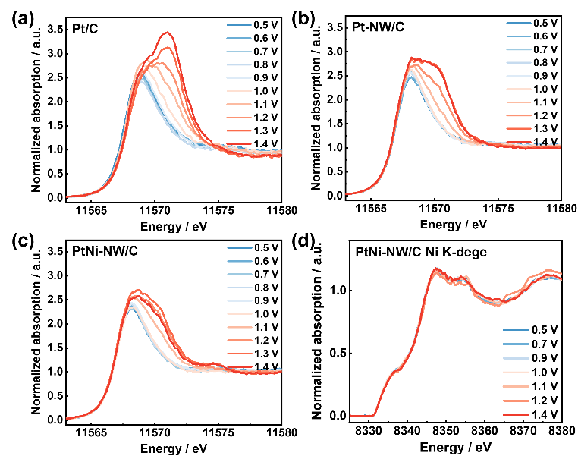
To examine changes in the electronic state of Pt at varying potentials, the spectra were analyzed using an arctangent function combined with two pseudo-Voigt peaks (Fig. 6a–c). The peaks at 11568.1 eV and 11570.3 eV correspond to the metallic and oxidized states of Pt, respectively. Fig. 6d–f illustrates the variations in the metallic, oxide, and combined peaks as a function of potential. The PtO_{x} component increased with rising polarization potential, though this oxidation was mitigated by the NW-structured catalyst, due to its specific surface structure. ²⁴ While Pt-NW/C limits PtO_{x} formation, Pt still tends to convert into PtO_{x} in highly polarized regions, which can lead to Pt dissolution and catalyst degradation.⁶³ In contrast, a significant reduction in the oxidized composition was observed for PtNi-NW/C compared to Pt-NW/C, indicating that the Pt-rich surface layer and strain effect of the PtNi alloy hinders PtO_{x} formation. With lower oxygen adsorption energies and reduced conversion to Pt oxide, PtNi-NW/C catalysts exhibit enhanced activity and stability.

Conventional operando XAS measurements
The electronic states of Pt in these catalysts were also analyzed using conventional XAS, as shown in Fig. S24† and S25†, which display the spectra of the Pt L₂ and L₃-edge at varying potentials. An increase in white line intensity was observed as the potential increased, indicating electron depletion in the Pt d-orbitals due to oxidation. To further investigate changes in Pt valence, Δμ (defined as Δμ = μ_{E} - μ_{edge}) was calculated and depicted in Fig. S26† and Fig. 7d. The consistent increase in Δμ reflects the presence of chemisorbed oxygen.³⁴ Notably, the minimal increase in white line intensity observed in the PtNi-NW/C catalyst aligns with the results from HERFD-XANES analysis, confirming its resistance to oxidation.
Fig. 6 Least-square fits by two peaks (metal peak and oxides peak) of all HERFD-XANES spectra from Fig. 5 for (a) Pt/C, (b) Pt-NW/C, (c) PtNi-NW/C. Integrated peak areas of metal peak, oxides peak, and sum peak for (d) Pt/C, (e) Pt-NW/C, (f) PtNi-NW/C.

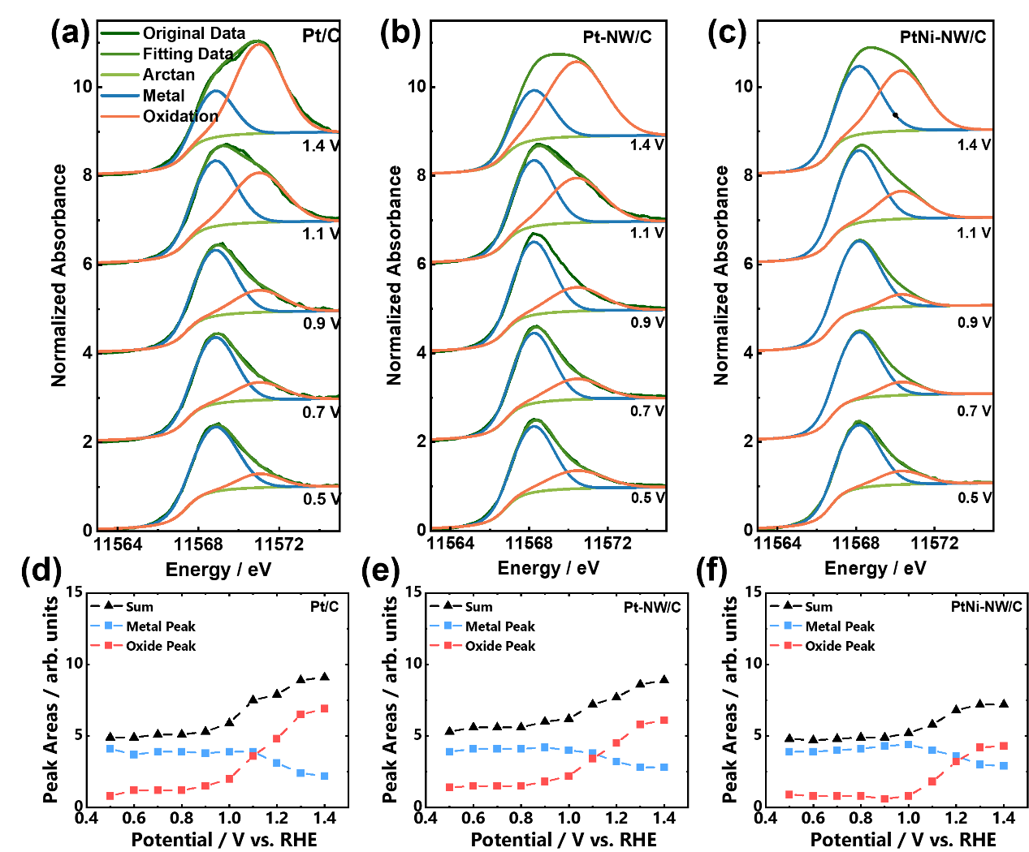
Fig. 7 a-c and S27† present the FT-EXAFS analysis, showing an increase in the Pt-O signal (1.6 Å) and a decrease in the Pt-Pt signal (2.5 Å) as the potential increases. The wavelet-transform EXAFS spectra further confirm the formation of Pt-O bonds at high polarization potentials (Fig. S28†). Compared to Pt/C catalysts, Pt-NW/C and PtNi-NW/C catalysts exhibit less fluctuation in these signals, indicating weaker oxygen binding energies and reduced Pt-O formation on the surface. Pt-Pt bond lengths, calculated by Artemis' IFEFFIT (Table S5-7 and Fig. 7e), play a crucial role in influencing the d-band center state, which directly impacts ORR activity.⁶⁴ For Pt/C and Pt-NW/C catalysts, a simple fcc Pt model was applied, showing bond lengths of 2.751 Å and 2.746 Å at 0.5 V vs. RHE, respectively. As the potential increased, the bond lengths expanded to 2.825 Å and 2.779 Å at 1.1 V vs. RHE, due to the combined effect of reduced Pt-Pt coordination number and Pt oxidation.
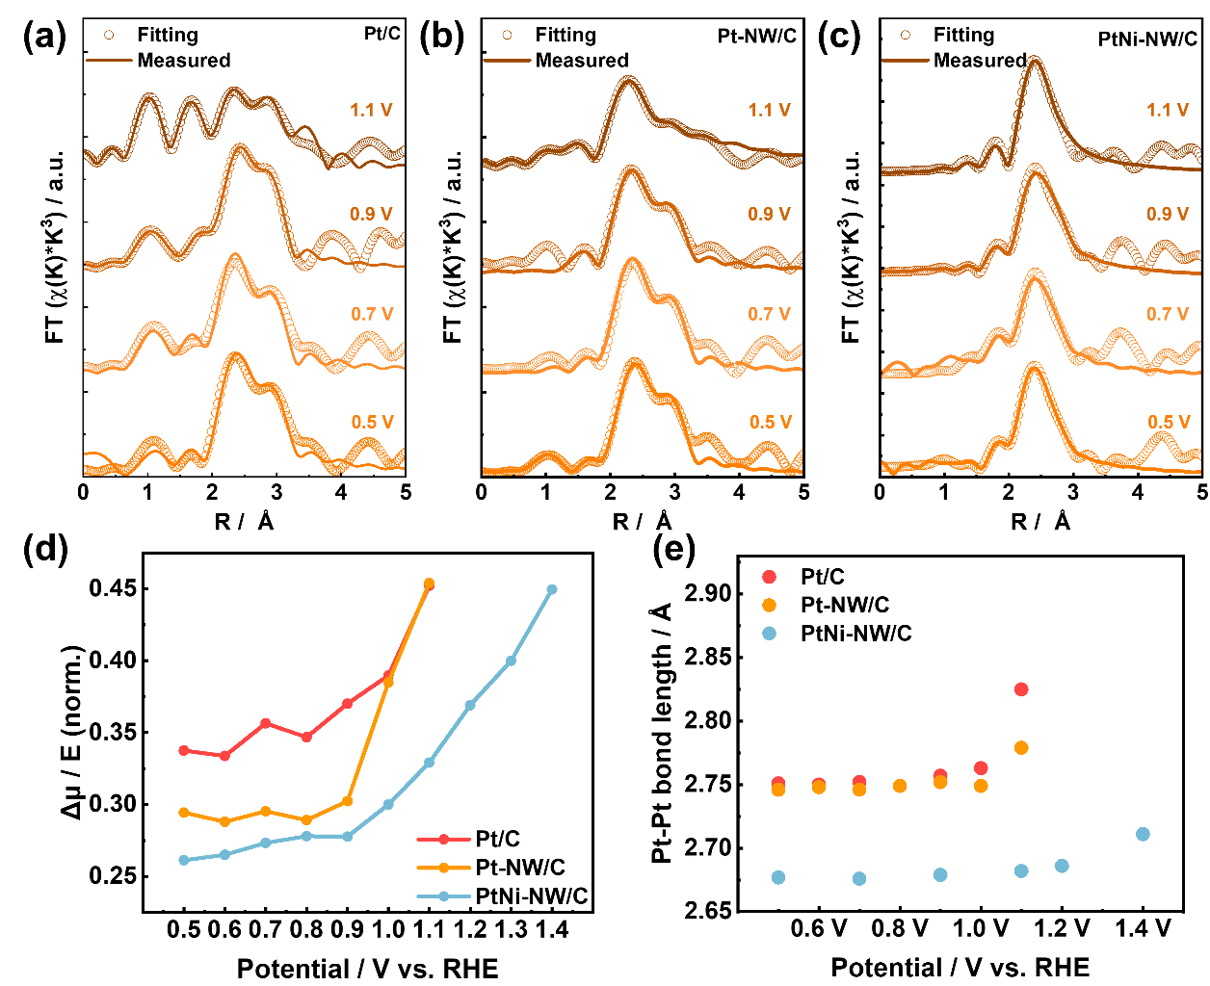
For the PtNi-NW/C catalysts with a Pt-rich layer structure, fitting was performed using both fcc Pt and bct PtNi models. At a potential of 0.5 V vs. RHE, the Pt-Pt and Pt-Ni bond lengths were determined to be 2.677 Å and 2.639 Å, respectively, consistent with the PDF results. Although these bond lengths increase with rising potential, the expansion is significantly smaller than that observed in the Pt-NW/C catalyst. The Pt-Pt bond length increases by approximately 0.01 Å at 1.1 V vs. RHE, and even at a high polarization potential of 1.4 V vs. RHE, it remains at 2.711 Å. DFT computational studies support the idea that Pt skins in Pt-Ni catalysts suppress the d-band center, effectively reducing ΔE_{O}.^{46, 65} This theory, aligned with operando XAS results, confirms that the Pt-rich layer and high Ni content in PtNi-NW/C catalysts contribute to enhanced catalytic activity.
Fig. 7 Pt L₃-edge FT-EXAFS spectra and corresponding fits for (a) Pt/C, (b) Pt-NW/C, and (c) PtNi-NW/C varying different polarization potential. (d) Δμ of the white line peak heights and (e) Pt-Pt bond length from the corresponding fitting results for Pt/C, Pt-NW/C, and PtNi-NW/C catalysts.
Conclusions
In summary, high-Ni-content PtNi-NW/C catalysts were synthesized and characterized using techniques such as TEM, XRD, PDF, and XAS, revealing an intriguing fcc Pt-rich surface layer and bct PtNi alloy core structure. Advanced operando HERFD-XANES analysis was used to examine the changes in Pt bonding to oxygenated species under reaction conditions, emphasizing the contribution of the Pt-rich layer and PtNi alloy core in suppressing Pt oxidation and preventing Ni dissolution. EXAFS fitting analysis showed minimal changes in Pt-Pt bond lengths in PtNi-NW/C catalysts as applied potential increased, indicating structural stability. This study provides valuable insights into the relationship between catalyst structure, activity, and stability, offering guidance for future catalyst design and optimization.
Author Contributions
W. Cao collected data, performed analysis, and wrote the manuscript. T. Uchiyama validated data, supervised the project, and revised the draft. M. Kumar and N. Thakur revised the manuscript. S. Tominaka and A. Machida conducted crystal structure analysis. T. Watanabe and Y. Gao performed XAS analysis. R. Sato and T. Teranishi supported TEM and ICP measurement. M. Matsumoto and H. Imai conducted High-resolution TEM measurements. Y. Sakurai supported HERFD-XANES measurement. Y. Uchimoto validated data, supervised the project, provided resources, and revised the manuscript.
Conflicts of interest
There are no conflicts to declare
Acknowledgements
This work was supported by PEFC project (20001199-0) and NEDO FC-Platform project (20001310-0) commissioned by the New Energy and Industrial Technology Development Organization (NEDO). The synchrotron radiation experiments were performed at several beamlines of SPring-8 (Proposal 2021A1014, 2021B1016, 2020A1799, 2021B1048, 2020A1800, 2021A1665, 2021B1047, 2021B1010, 2022A1020, 2022B1012, 2023A1013). The XAFS measurements were carried out at BL36XU, SPring-8. High-resolution TEM measurements and operando HERFD-XANES and were performed under the NEDO FC-Platform.
References
1. C. Y. Ahn, J. E. Park, S. Kim, O. H. Kim, W. Hwang, M. Her, S. Y. Kang, S. Park, O. J. Kwon, H. S. Park, Y. H. Cho and Y. E. Sung, Chem. Rev., 2021, 121, 15075-15140.
2. D. Banham and S. Y. Ye, ACS Energy Lett., 2017, 2, 629-638.
3. Y. J. Wang, W. Y. Long, L. L. Wang, R. S. Yuan, A. Ignaszak, B. Z. Fang and D. P. Wilkinson, Energy Environ. Sci., 2018, 11, 258-275.
4. I. E. Stephens, J. Rossmeisl and I. Chorkendorff, Science, 2016, 354, 1378-1379.
5. F. Xiao, Q. Wang, G. L. Xu, X. P. Qin, I. H. Hwang, C. J. Sun, M. Liu, W. Hua, H. W. Wu, S. Q. Zhu, J. C. Li, J. G. Wang, Y. M. Zhu, D. J. Wu, Z. D. Wei, M. Gu, K. Amine and M. H. Shao, Nat. Catal., 2022, 5, 503-512.
6. A. Kulkarni, S. Siahrostami, A. Patel and J. K. Norskov, Chem. Rev., 2018, 118, 2302-2312.
7. L. Bu, S. Guo, X. Zhang, X. Shen, D. Su, G. Lu, X. Zhu, J. Yao, J. Guo and X. Huang, Nat. Commun., 2016, 7, 11850.
8. Z. Kong, Y. Maswadeh, J. A. Vargas, S. Shan, Z. P. Wu, H. Kareem, A. C. Leff, D. T. Tran, F. Chang, S. Yan, S. Nam, X. Zhao, J. M. Lee, J. Luo, S. Shastri, G. Yu, V. Petkov and C. J. Zhong, J. Am. Chem. Soc., 2020, 142, 1287-1299.
9. A. Gunnarson, J. De Bellis, T. Imhof, N. Pfänder, M. Ledendecker and F. Schüth, Chem. Mater., 2023, 35, 2006-2015.
10. M. C. Luo and S. J. Guo, Nat. Rev. Mater., 2017, 2, 17059.
11. V. R. Stamenkovic, B. Fowler, B. S. Mun, G. Wang, P. N. Ross, C. A. Lucas and N. M. Markovic, Science, 2007, 315, 493-497.
12. X. Chen, J. Guo, J. Liu, Z. Luo, X. Zhang, D. Qian, D. Sun-Waterhouse and G. I. N. Waterhouse, J. Phys. Chem. Lett., 2023, 14, 1740-1747.
13. Z. Yao, Y. Yuan, T. Cheng, L. Gao, T. Sun, Y. Lu, Y. G. Zhou, P. L. Galindo, Z. Yang, L. Xu, H. Yang and H. Huang, Nano Lett., 2021, 21, 9354-9360.
14. H. Wang, J. Gao, C. Chen, W. Zhao, Z. Zhang, D. Li, Y. Chen, C. Wang, C. Zhu, X. Ke, J. Pei, J. Dong, Q. Chen, H. Jin, M. Chai and Y. Li, Nanomicro Lett., 2023, 15, 143.
15. Y. F. Gao, T. Uchiyama, K. Yamamoto, T. Watanabe, S. Tominaka, N. Thakur, R. Sato, T. Teranishi, H. Imai, Y. Sakurai and Y. Uchimoto, ACS Catal., 2023, 13, 10988-11000.
16. Q. Shao, K. Y. Lu and X. Q. Huang, Small Methods, 2019, 3, 1800545.
17. S. Li, H. Jin and Y. Wang, Nanoscale, 2023, 15, 2488-2515.
18. M. Li, Z. Zhao, T. Cheng, A. Fortunelli, C. Y. Chen, R. Yu, Q. Zhang, L. Gu, B. V. Merinov, Z. Lin, E. Zhu, T. Yu, Q. Jia, J. Guo, L. Zhang, W. A. Goddard, 3rd, Y. Huang and X. Duan, Science, 2016, 354, 1414-1419.
19. H. Jin, Z. Xu, Z. Y. Hu, Z. Yin, Z. Wang, Z. Deng, P. Wei, S. Feng, S. Dong, J. Liu, S. Luo, Z. Qiu, L. Zhou, L. Mai, B. L. Su, D. Zhao and Y. Liu, Nat. Commun., 2023, 14, 1518.
20. S. F. Zaccarine, S. M. Alia, W. W. McNeary, R. Chattot, M. J. Dzara, I. Martens, S. A. Mauger, A. W. Weimer, J. Drnec, B. S. Pivovar and S. Pylypenko, ACS Appl. Energy Mater., 2022, 5, 4587-4602.
21. S. Takahashi, N. Takahashi, N. Todoroki and T. Wadayama, ACS Omega, 2016, 1, 1247-1252.
22. R. K. Ahluwalia, X. Wang, J. K. Peng, N. N. Kariuki, D. J. Myers, S. Rasouli, P. J. Ferreira, Z. Yang, A. Martinez-Bonastre, D. Fongalland and J. Sharman, J. Electrochem. Soc., 2018, 165, F3316-F3327.
23. M. Kato, Y. Iguchi, T. Li, Y. Kato, Y. Zhuang, K. Higashi, T. Uruga, T. Saida, K. Miyabayashi and I. Yagi, ACS Catal., 2021, 12, 259-264.
24. X. Zhao, S. Takao, Y. Yoshida, T. Kaneko, T. Gunji, K. Higashi, T. Uruga and Y. Iwasawa, Appl. Catal. B: Environ., 2023, 324, 122268.
25. N. Yamamoto, D. Matsumura, Y. Hagihara, K. Tanaka, Y. Hasegawa, K. Ishii and H. Tanaka, J. Power Sources, 2023, 557.
26. D. Friebel, D. J. Miller, C. P. O'Grady, T. Anniyev, J. Bargar, U. Bergmann, H. Ogasawara, K. T. Wikfeldt, L. G. Pettersson and A. Nilsson, Phys. Chem. Chem. Phys., 2011, 13, 262-266.
27. T. J. P. Hersbach, A. C. Garcia, T. Kroll, D. Sokaras, M. T. M. Koper and A. T. Garcia-Esparza, ACS Catal., 2021, 11, 9904-9915.
28. A. D. Bertelsen, M. Kløve, N. L. N. Broge, M. Bondesgaard, R. B. Stubkjær, A.-C. Dippel, Q. Li, R. Tilley, M. R. Vogel Jørgensen and B. B. Iversen, J. Am. Chem. Soc., 2024, 146, 23729-23740.
29. S. Tominaka, H. Yamada, S. Hiroi, S. I. Kawaguchi and K. Ohara, ACS Omega, 2018, 3, 8874-8881.
30. C. L. Farrow, P. Juhas, J. W. Liu, D. Bryndin, E. S. Božin, J. Bloch, T. Proffen and S. J. L. Billinge, J.Phys.: Condens. Matter, 2007, 19, 335219.
31. A. A. Coelho, J. Appl. Crystallogr., 2018, 51, 210-218.
32. C. Liu, T. Uchiyama, N. Nagata, M. Arao, K. Yamamoto, T. Watanabe, X. Gao, H. Imai, S. Katayama, S. Sugawara, K. Shinohara, K. Oshima, S. Sakurai and Y. Uchimoto, ACS Appl. Energy Mater., 2021, 4, 1143-1149.
33. J. J. Rehr and R. C. Albers, Rev. Mod. Phys., 2000, 72, 621-654.
34. L. R. Merte, F. Behafarid, D. J. Miller, D. Friebel, S. Cho, F. Mbuga, D. Sokaras, R. Alonso-Mori, T. C. Weng, D. Nordlund, A. Nilsson and B. Roldan Cuenya, ACS Catal., 2012, 2, 2371-2376.
35. J. Chen, T. Herricks, M. Geissler and Y. Xia, J. Am. Chem. Soc., 2004, 126, 10854-10855.
36. K. Jiang, D. Zhao, S. Guo, X. Zhang, X. Zhu, J. Guo, G. Lu and X. Huang, Sci. Adv., 2017, 3, e1601705.
37. L. Bu, J. Liang, F. Ning, J. Huang, B. Huang, M. Sun, C. Zhan, Y. Ma, X. Zhou and Q. Li, Adv. Mater., 2023, 35, 2208672.
38. O. Seo, J. Kim, S. Hiroi, C. Song, L. S. R. Kumara, A. Tayal, Y. N. Chen, H. Kobayashi, H. Kitagawa and O. Sakata, Appl. Phys. Lett., 2018, 113.
39. H. Jin, Z. Xu, Z.-Y. Hu, Z. Yin, Z. Wang, Z. Deng, P. Wei, S. Feng, S. Dong, J. Liu, S. Luo, Z. Qiu, L. Zhou, L. Mai, B.-L. Su, D. Zhao and Y. Liu, Nat. Commun., 2023, 14, 1518.
40. P. Wang, K. Jiang, G. Wang, J. Yao and X. Huang, Angew. Chem. Int. Ed., 2016, 55, 12859-12863.
41. M. Ahmadi, F. Behafarid, C. Cui, P. Strasser and B. R. Cuenya, ACS Nano, 2013, 7, 9195-9204.
42. C. Wang, G. Wang, D. van der Vliet, K.-C. Chang, N. M. Markovic and V. R. Stamenkovic, Phys. Chem. Chem. Phys., 2010, 12, 6933-6939.
43. M. Ahmadi, F. Behafarid, C. Cui, P. Strasser and B. R. Cuenya, ACS Nano, 2013, 7, 9195-9204.
44. H. J. Zhang, Y. C. Zeng, L. S. Cao, L. M. Yang, D. H. Fang, B. L. Yi and Z. G. Shao, Front. Energy, 2017, 11, 260-267.
45. T.-W. Chen, J.-X. Kang, D.-F. Zhang and L. Guo, RSC Adv., 2016, 6, 71501-71506.
46. H. B. Tang, Y. Q. Su, B. Chi, J. W. Zhao, D. Dang, X. L. Tian, S. J. Liao and G. R. Li, Chem. Eng. J., 2021, 418, 129322.
47. V. R. Stamenkovic, B. S. Mun, K. J. Mayrhofer, P. N. Ross and N. M. Markovic, J. Am. Chem. Soc., 2006, 128, 8813-8819.
48. Y. Liu, H. Chen, C. Tian, D. Geng, D. Wang and S. Bai, Electrocatalysis, 2019, 10, 613-620.
49. X. R. Zhao, C. Xi, R. Zhang, L. Song, C. Y. Wang, J. S. Spendelow, A. I. Frenkel, J. Yang, H. L. Xin and K. Sasaki, ACS Catal., 2020, 10, 10637-10645.
50. Y. Gao, N. Thakur, T. Uchiyama, W. Cao, K. Yamamoto, T. Watanabe, M. Kumar, R. Sato, T. Teranishi, H. Imai, Y. Sakurai and Y. Uchimoto, ACS Appl. Mater. Interfaces, 2023, 15, 52473-52484.
51. H. Imai, K. Izumi, M. Matsumoto, Y. Kubo, K. Kato and Y. Imai, J. Am. Chem. Soc., 2009, 131, 6293-6300.
52. X. Zhao, T. Gunji, T. Kaneko, Y. Yoshida, S. Takao, K. Higashi, T. Uruga, W. He, J. Liu and Z. Zou, J. Am. Chem. Soc., 2019, 141, 8516-8526.
53. Z. Zhao, L. Castanheira, L. Dubau, G. Berthome, A. Crisci and F. Maillard, J. Power Sources, 2013, 230, 236-243.
54. D. Friebel, F. Mbuga, S. Rajasekaran, D. J. Miller, H. Ogasawara, R. Alonso-Mori, D. Sokaras, D. Nordlund, T. C. Weng and A. Nilsson, J. Phys. Chem. C, 2014, 118, 7954-7961.
55. J. Szlachetko, D. Ferri, V. Marchionni, A. Kambolis, O. V. Safonova, C. J. Milne, O. Krocher, M. Nachtegaal and J. Sa, J. Am. Chem. Soc., 2013, 135, 19071-19074.
56. A. I. Frenkel, M. W. Small, J. G. Smith, R. G. Nuzzo, K. O. Kvashnina and M. Tromp, J. Phys. Chem. C, 2013, 117, 23286-23294.
57. S. Kusano, D. Matsumura, K. Ishii, H. Tanaka and J. Mizuki, Nanomaterials, 2019, 9, 642.
58. S. Kukunuri and H. Noguchi, J. Phys. Chem. C, 2020, 124, 7267-7273.
59. D. Friebel, V. Viswanathan, D. J. Miller, T. Anniyev, H. Ogasawara, A. H. Larsen, C. P. O'Grady, J. K. Norskov and A. Nilsson, J. Am. Chem. Soc., 2012, 134, 9664-9671.
60. D. J. Miller, H. Oberg, S. Kaya, H. Sanchez Casalongue, D. Friebel, T. Anniyev, H. Ogasawara, H. Bluhm, L. G. Pettersson and A. Nilsson, Phys. Rev. Lett., 2011, 107, 195502.
61. K. Sasaki, N. Marinkovic, H. S. Isaacs and R. R. Adzic, ACS Catal., 2015, 6, 69-76.
62. T. M. Arruda, B. Shyam, J. M. Ziegelbauer, S. Mukerjee and D. E. Ramaker, J. Phys. Chem. C, 2008, 112, 18087-18097.
63. T. Dukic, L. J. Moriau, L. Pavko, M. Kostelec, M. Prokop, F. Ruiz-Zepeda, M. Sala, G. Drazic, M. Gatalo and N. Hodnik, ACS Catal., 2022, 12, 101-115.
64. X. Wang, Y. Orikasa, Y. Takesue, H. Inoue, M. Nakamura, T. Minato, N. Hoshi and Y. Uchimoto, J. Am. Chem. Soc., 2013, 135, 5938-5941.
65. S. M. Alia, C. Ngo, S. Shulda, M. A. Ha, A. A. Dameron, J. N. Weker, K. C. Neyerlin, S. S. Kocha, S. Pylypenko and B. S. Pivovar, ACS Omega, 2017, 2, 1408-1418.

