Simultaneous removal of ammonium, phosphate, and phenol via self-assembled biochar composites CBCZrOFe₃O₄ and its utilization as soil acidity amelioration
Endar Hidayat^{1,2,3*}, Nur Maisarah Mohamad Sarbani^{1,2}, Sadaki Samitsu³, Yaressa Vaskah Situngkir^{2,4}, Sudip Kumar Lahiri^{5,6}, Seiichiro Yonemura^{1,2}, Yoshiharu Mitoma⁷, Hiroyuki Harada^{1,2}
¹Graduate School of Comprehensive Scientific Research, Program in Biological System Sciences, Prefectural University of Hiroshima, Shobara 727-0023, Japan
²Department of Life System Science, Faculty of Bioresources Science, Prefectural University of Hiroshima, Shobara 727-0023, Japan
³Data-driven Polymer Design Group, Research Center for Macromolecules and Biomaterials, National Institute for Materials Science, 1−2−1 Sengen, Tsukuba 305-0047, Japan
⁴Department of Agricultural Engineering, Politeknik Negeri Jember 68121, Jember, Indonesia
⁵Department of Mechanical & Industrial Engineering, University of Toronto, Toronto, Ontario M5S 3G8, Canada
⁶Faculty of Allied Health Sciences, Chettinad Hospital and Research Institute, Chettinad Academy of Research and Education, Kelambakkam-603103, Tamil Nadu, India
⁷Department of Integrated Science and Engineering for Sustainable Societies, Faculty of Science and Engineering, Chuo University, Tokyo 112-8551, Japan.

Correspondence : Endar Hidayat (hidayatendar1@gmail.com)

Abstract: High concentrations of ammonium, phosphate, and phenol are recognized as water pollutants that contribute to the degradation of soil acidity. In contrast, small quantities of these nutrients are essential for soil nutrient cycling and plant growth. Here, we reported composite materials comprising biochar, chitosan, ZrO, and Fe₃O₄, which were employed to mitigate ammonium, phosphate, and phenol contamination in water and to lessen soil acidity. Batch adsorption experiments were conducted to assess the efficacy of the adsorbents. Initially, comparative studies on the simultaneous removal of NH₄, PO₄, and phenol using CB (biochar), CBC (biochar + chitosan), CBCZrO (biochar + chitosan + ZrO), and CBCZrOFe₃O₄ (biochar + chitosan + ZrO + Fe₃O₄) were conducted. The results discovered that CBCZrOFe₃O₄ exhibited the highest removal percentage among the adsorbents (P<0.05). Adsorption data for CBCZrOFe₃O₄ were well fitted to the second-order kinetic and Freundlich isotherm models, with maximum adsorption capacities of 112.65 mg/g for NH₄, 94.68 mg/g for PO₄ and 112.63 mg/g for phenol. Subsequently, the effect of CBCZrOFe₃O₄-loaded NH₄, PO₄, and phenol (CBCZrOFe₃O₄-APP) on soil acidity was studied over a 60-day incubation period. The findings showed no significant changes (P<0.05) in soil exchangeable acidity, H⁺, Mg, K, and Na. However, there was a substantial increase in the soil pH, EC, available P, CEC, N-NH₄, and N-NO₃. A significant reduction was also observed in the available soil exchangeable Al and Fe (P<0.05). This technique demonstrated multi-functionality in remediating water pollutants and enhancing soil acidity.
Keywords: recycle waste, adsorption, soil acidity amelioration, removal of water pollutants, biochar composite

- Background
Ammonium (NH₄) and phosphate (PO₄) represent key macronutrients essential for plant growth and development. These elements are commonly used as agricultural fertilizers to sustain the world's growing population (Jing et al., 2019). The commercial manufacturing of chemical fertilizers heavily relies on energy sources that are not renewable, such as natural gas and finite mineral reserves (i.e., phosphate rock). If the demand for fertilizers continues to rise annually at a rate of 3%, the remaining accessible phosphate mineral sources will be diminished within 50 years (Nancharaiah et al., 2016). There is a need to recover resources that can be used as fertilizer. On the other hand, the recent escalating demand for food production has resulted in the excessive use of fertilizers, leading to potential water contamination, eutrophication, and an increase in harmful algal blooms. These algal blooms adversely impact aquatic ecosystems, reduce oxygen levels (Chen et al., 2018), and negatively affect the taste and odor of drinking water (Pawar et al., 2016). Moreover, NH₄ could give rise to carcinogenic nitrates through the activity of nitrifying bacteria, posing a potential hazard to the general population (Nguyen et al., 2019). Potential water pollutants other than NH₄ and PO₄ are phenolic compounds in effluent from industries such as chemicals, petrochemicals, coke factories, and refineries (Kim et al., 2008). Phenolic substances considered to be hazardous and mutagenic at elevated levels, and the human body can absorb them through the skin (Abdelwahab and Amin, 2013; Al Bsoul et al., 2021). On the other hand, small amounts of phenolic compounds play a beneficial role as a vital nutrient cycling process for soil and plant life (Kraus et al., 2003). Therefore, if excess NH₄, PO₄, and phenol can be recovered from wastewater and supplied to the soil in optimal amounts as fertilizer, this can improve water quality and also conserve valuable NH₄, PO₄, and phenol resources, resulting in significant environmental and socioeconomic advantages (Shakoor et al., 2021).
Various effective techniques have been identified for removing water contaminants from liquid solutions, such as encompassing biological methods (Cai et al., 2013), precipitation (Chen et al., 2021; González-Morales et al., 2021; Zhou and Chen, 2019), electrochemical methods (Wang et al., 2019; Wang and He, 2022), ion exchange (Tarpeh et al., 2018), and adsorption (Harada et al., 2021; Wang et al., 2016; Xie et al., 2020). Each of these approaches possesses distinct advantages and limitations. Biological methods offer greater cost efficiency; nevertheless, the drawback lies in the residual dead bacteria post-treatment (Matei and Racoviteanu, 2021). While the precipitation process proves simple and effective in chemical treatment, it falters in managing sewage sludge, waste disposal, and organic compounds (Huang et al., 2017). Despite being costly, electrochemical techniques exhibit lower efficacy in ion removal (Rodrigues and da Silva, 2009). Ion exchange presents an alternative for removing anions by substituting sulfates (SO₄) with PO₄ ions (Blaney et al., 2007). However, this approach worsens solution corrosiveness and necessitates expensive clean-up procedures. Adsorption, considered an efficient and widely employed method for water contaminant removal, is characterized by ecological sustainability, a straightforward and swift procedure, and high technological effectiveness. In particular, environmentally compatible adsorbents such as biochar and chitosan are promising because of their potential to convert adsorbed compounds into fertilizer.
Biochar has garnered great attention as a prospective adsorbent due to its cost-effectiveness, environmental friendliness, abundance, and high carbon content (Srivatsav et al., 2020). Produced through pyrolysis in the temperature range of 350-800°C under a restricted oxygen supply (Chatterjee et al., 2020), biochar's suitability for adsorption applications is attributed to its high porosity and extensive surface area (Lita et al., 2023; Suliman et al., 2017). Numerous experiments have been conducted to remove N-NH₄, PO₄, and phenol. For instance, Hu et al. (2020) utilized biochar derived from pineapple, orange peel, and dragon fruit, reporting maximum adsorption capacities for N-NH₄ of 5.60 mg/g, 4.71 mg/g, and 2.65 mg/g, respectively. In another study, Begum et al. (2021) observed an N-NH₄ adsorption capacity of 0.96 mg/g. Emenike et al. (2022) reported that Delonix regia biochar has a limited phenol adsorption capacity, reaching a maximum of 2.59 mg/g. In one study, Lawal et al. (2021) showed a phenol adsorption capability of 62.89 mg/g using oil palm frond in the biochar. The use of coffee husks as a biochar source is currently in high demand and increasingly recognized as a viable alternative (Silveira Junior et al., 2023). Global coffee production in the 2021/2022 recorded 0.3 billion metric tons, based on 6% coffee husks obtained from 48% of coffee trees (Hidayat et al., 2020). However, the substantial quantities may pose serious issues if not properly managed. There is little studies on the simultaneous removal of NH₄, PO₄, and phenol from water. Still, this combination is being actively studied for use as a soil amendment, and the integration of adsorbents and agricultural applications could be promising.
Enhancing the adsorption capacity via modifying biochar increases its surface characteristics and structure (Wu et al., 2020). Chitosan is becoming a promising polymer to be used as an efficient adsorbent for water pollutants due to its abundant hydroxyl (–OH) and amino (–NH₂) functional groups, facilitating easy interactions with other substances, along with its environmentally friendly characteristics (Li et al., 2021). However, due to its low tensile strength and susceptibility to dissolution in acidic environments (Aranaz et al., 2021), it is not desirable to directly employ chitosan in wastewater treatment. Therefore, it is crucial to enhance chitosan`s chemical stability and adsorption capability through modification. Chitosan-metal oxide composites have been synthesized as an interesting approach due to their advantageous properties, including chemical stability, a substantial surface area, and effective adsorptive capabilities (Nga et al., 2020; Spoială et al., 2022). In particular, magnetic materials have attracted much focus in recent years for their efficient and rapid separation of adsorbents from wastewater (Cordova Estrada et al., 2021; Wang et al., 2020). With the chemical formula Fe₃O₄, magnetites are highly magnetic particles widely utilized for their compact dimensions and extensive surface area (Fu et al., 2015). However, simple Fe₃O₄ magnetic particles generally form aggregates, reducing stability and limiting available functional groups (Zhao et al., 2023).Therefore, zirconium oxide (ZrO) was additionally incorporated to increase the porosity of chitosan (Zhang et al., 2022) and to increase the potential to adsorb PO₄ ions, which is difficult with biochar alone. To improve the stability and physicochemical quality of the composite, cross-linking, a chemical procedure that creates strong covalent bonds between two or more molecules and results in their linkage was performed, which would improve the physicochemical qualities of chitosan (Jawad et al., 2023). Employing a crosslinking process to combine biochar, chitosan, ZrO, and Fe₃O₄ proves to be a successful method for increasing the surface-active sites and assisting easy separation. Thus, the integrating coffee husk biochar-loaded chitosan, ZrO, and magnetite (CBCZrOFe₃O₄) composite materials hold promise with diverse components.
When the composites are used as soil modifiers, the NH₄, PO₄, and phenol supplied to the soil exist in three forms: dissolved molecules freely moving within the soil solution, sorbed molecules capable of reversible binding to soil particles or proteins, and polymerized molecules forming part of humic substances (Min et al., 2015). The compounds would be useful in mitigating soil acidification. Soil acidification significantly influences the soil environment, leading to deterioration of soil quality (Geng et al., 2022). This issue negatively impacts agricultural output and food safety. Soil acidification occurs naturally and relatively slowly for hundreds to millions of years. However in recent decades, this process has accelerated dramatically due to acid deposition (Driscoll et al., 2016) and overuse of N-based fertilizers (Tian and Niu, 2015). When nitrogen (N) is applied to farmland soils, it undergoes a process called hydrolysis, which involves ammonification (R–NH₂ + H⁺ + H₂O → R–OH + NH₄⁺ + OH⁻) and followed by nitrification (NH₄⁺ + 2O₂ → 2H⁺ + H₂O + NO₃⁻). Ammonification increases the soil pH, whereas nitrification decreases it. Several scientists have used biochar to regulate soil acidification (Fidel et al., 2017) via decarboxylation and chitosan, which releases -OH groups to elevate soil pH. Phosphorus (P) is a macronutrient essential to soil health and plant development. It affects soil acidity by releasing hydrogen (H⁺) ions through PO₄³⁻ molecules. Besides macronutrients, a micronutrient such as iron is needed by plants for regulation of plant growth and development and is involved in the metabolism processes of photosynthesis and dark respiration. A study performed by Kreslavski et al. (2023) has stated that treating plants with Fe₃O₄ nanoparticles could enhance plant growth and photosynthesis by minimizing the negative impact of soil salinity. In addition, Liu et al. (2023) have used a polymer- Fe₃O₄ interaction to increase soil’s pH effectively. Contrastingly, the presence of phenol in soil may be observed to lower the rate of organic matter’s decomposition by reducing soil pH. However, other studies (Hättenschwiler and Vitousek, 2000; Misra et al., 2023) have highlighted the addition of phenol able to improve nutrient cycling, help with chemical stabilization of soil N, and enhance the mobilization of nutrients such as P in soil. Since few works are reported regarding these compounds` effect on soil acidity, further research is needed to investigate the possible interactions. We hypothesize that a combination of biochar, chitosan, magnetite, and ZrO (CBCZrOFe₃O₄) could be useful to alleviate soil acidity with loaded NH₄, PO_{4,} and phenol via adsorption.
This research aimed to develop a novel adsorbent (CBCZrOFe₃O₄) to remove NH₄, PO₄, and phenol from water simultaneously in a single-step process. Subsequently, the adsorbent, enriched with NH₄, PO₄, and phenol, was employed as an alternative fertilizer to enhance soil acidity properties. The impact of various process factors, including pH, initial concentration, and contact time, on achieving the maximum adsorption capacity was investigated. Additionally, adsorption isotherms and kinetic models were computed to elucidate the adsorption process.
- Materials and methods
- Materials
Chitosan (CH), with a molecular weight ranging from 100,000 to 300,000, was procured from Acros Organics in Belgium. Coffee husk was sourced from the Solok Radjo Cooperative in Solok, Indonesia. Sodium hydroxide (NaOH), acetic acid (CH₃COOH), disodium hydrogen phosphate (Na₂HPO₄), phenol (C₆H₅OH), ferric chloride (FeCl₃), ferrous sulfate (Fe₂SO₄), hexammonium molybdate [(NH₄)₆Mo₇O₂₄.4H₂O)], antimony potassium tartrate (K₂Sb₂(C₄H₂O₆)₂), ascorbic acid (C₆H₈O₆), hydrochloric acid (HCl), and sulfuric acid (H₂SO₄) were all obtained from Kanto Chemical Co. Inc. in Japan. Zirconium oxychloride (ZrClO) was purchased from Fujifilm Wako Chemical in Tokyo, Japan.
- Fabrication of adsorbent
Coffee husk biochar (CB) was generated by heating a muffle furnace at 600 °C for 3 h. The preparation of CB + chitosan (CBC) involved mixing 0.5 g of CB with 25 mL of chitosan solution (1 g of chitosan dissolved in 100 mL of 1% acetic acid for 24 h), followed by stirring the mixture for 1 h at 60°C. The resulting solution was filtered and washed with deionized water (DW) and ethanol. In addition, CBCZrO was produced by incorporating ZrClO (0.5 M) into the CBC solution. Finally, CBCZrOFe₃O₄ was prepared by adding the magnetic materials to the mixture. The production process for the samples was similar to that for the CBCZrO. Chitosan solution (25 mL) was mixed with CB (0.5 g), 1 M FeCl₃, 0.5 M Fe₂SO₄, and ZrClO (20 mL). The mixture was subsequently heated until 60°C while agitated for 1 h. The pH of the mixture was raised to 10 by adding 3 M NaOH and stirred magnetically at room temperature for 24 h. The solution was subsequently passed through filter and washed with distilled water and ethanol for multiple times to remove residual NaOH. All of the adsorbent samples were then dried in an oven for three days at 60°C for further experiments.
- Batch adsorption and desorption experiments
In a sequence of experiments, the simultaneous removal of NH₄, PO_{4,} and phenol was examined, considering various experimental factors such as initial pH (ranging from 6 to 10), concentrations of NH₄, PO_{4,} and phenol solutions (ranging from 10 to 250 mg/L), and adsorption duration (ranging from 30 to 90 min). Batch adsorption tests were carried out by immersing the adsorbent in 50 mL. The mathematical calculations for calculating the percentage of removal and adsorption equilibrium amount are outlined in Eq. (1) and (2), respectively.
$\text{R}\text{emoval, }\text{\% =}\frac{{\text{C}}_{\text{o}}\text{ -}{\text{C}}_{\text{e}}}{{\text{C}}_{\text{o}}}\text{×100}$ (1)
${\text{q}}_{\text{e}}\text{ =}\frac{{\text{C}}_{\text{o}}\text{ -}{\text{C}}_{\text{e}}}{\text{W}}\text{×}\text{V}$ (2)
where Removal, % is the removal efficiency, and C_{o} and C_{e} are the initial and equilibrium NH₄, PO_{4,} and phenol concentrations (mg/L), respectively, q_{e} is the equilibrium adsorption capacity of the adsorbent (mg/g), W is the amount of adsorbent (g), and V is the volume of ion solution (L).
In desorption studies, we used adsorption conditions such as contact time: 90 min and ions concentration: 250 mg/L. Then, we soaked in 1 M (HCl and H₂SO₄) solution for 24 h at 30 °C. The desorption equation is calculated using in Eq. (3)
$\text{Desorption, \% =}\frac{{\text{q}}_{\text{e}}\text{des}}{{\text{q}}_{\text{e}}}\text{×100}$ (3)
where, Desorption, %, represented by Desorption, is calculated as the ratio of the equilibrium ions concentration after desorption (q_{e}des, mg/g) to the initial ions concentration after adsorption (q_{e}, mg/g), multiplied by 100.
- Analytical measurements
The physical characteristics of CBCZrOFe₃O₄ were determined using the BET (Brunauer-Emmett-Teller) technique (MicroActive AutoPore V 9600 2.03.00, Shimadzu Techno-Research Incorporation, Japan). The crystalline configuration of CBCZrOFe₃O₄ was examine using powder X-ray diffraction (XRD) with Cu/Kα radiation (Rigaku, SmartLab 9kW, Japan). The Fourier transform infrared spectroscopy (FTIR) analysis was accessed using a Thermo Scientific Nicolet iS10 instrument (Thermo Fisher Scientific Inc., Waltham, MA, USA). The surface morphology of the adsorbent was observed by scanning electron microscopy (SEM) (Miniscope TM3000, Hitachi-hitech, Tokyo, Japan). The pH_{zpc} value, representing the neutral surface charge, was calculated using the equation pH_{zpc} = pH-final − pH-initial.
- Soil incubation experimental design
One kilogram of air-dried soil samples was mixed with 1 litter of deionized water in a plastic container, and the pH was adjusted with 10 mM H₂SO₄ until the pH reached 2.5 and 4.0. Subsequently, the soil was incubated for 24 h, filtered, and dried in an oven at 60°C for 3 days for subsequent experiments. The soil acidity experiment spanned 30 days with the following experimental design: control (soil only at pH 2.5 and 4.0), CBCZrOFe₃O₄ loaded with NH₄, PO₄, and phenol (CBCZrOFe₃O₄-APP) (1 wt% of soil at pH 2.5 and 4.0), all conducted under a constant temperature of 25°C. All experiments were conducted in plastic cups, with 40% of the soil's field water-holding capacity. Soil subsamples were collected after 3, 7, 15, 30, and 60 days. Following each day of incubation, 30 g of soil samples were taken out and dried in an oven at 60°C for 3 days for further analysis.
- Determination of soil properties
After each day of the incubation period, the soil's exchangeable acidity, H⁺, and aluminium (Al) were extricated using 1.0 mol/L KCl solution, followed by titration with NaOH solution. Then, 1.0 mol/L CH₃COONH₄ solution was utilized to extract exchangeable cations of the soil (Na, K, Ca, and Mg), and the cation exchange capacity (CEC) was subsequently measured after the addition of 10 wt% NaCl. Subsequently, the soil's pH and electrical conductivity (EC) were assessed using pH and EC meters, correspondingly. This process involved preparation of soil-water mixture at a ratio of 1:5, followed by shaking for 30 minutes. The Olsen technique which utilizing 0.5 M NaHCO₃ solution, was employed to assess the available phosphorus (P). The soil's cation exchange capacity (soil CEC) was determined through a 1 N ammonium acetate (CH₃COONH₄) extraction method (Hidayat et al., 2024).
- Results and discussion
- Characterization
The four types of porous composite adsorbents were first prepared using coffee husk biochar alone, and then subsequently combined with chitosan, magnetite, and ZrO, respectively. The photograph and morphological structures of all the adsorbents in as-synthesized state and after adsorption test are depicted in Fig. 1. It is evident that the CHB sample (Fig. 1b) exhibited porous structures, with an increase in porosity observed after the incorporation of chitosan (Fig. 1c) and chitosan-ZrO (Fig. 1d). Furthermore, the structure underwent a significant transformation with CBCZrOFe₃O₄ (Fig. 1e), displaying a heterogeneous, uneven, and rough groove structure, attributed to the possible iron oxide layer covering the surface. However, following the adsorption process, the surface underwent noticeable changes, with a reduced number of rough grooves that appeared relatively flatter and smoother (Fig. 1f). This alteration was likely due to the presence and deposition of adsorbed NH₄, PO₄, and phenol on the surface.
All the four types of composite adsorbents prepared were tested for their adsorption performance on NH₄, PO₄, and phenol. The adsorption of NH₄, PO₄, and phenol onto various adsorbents was conducted at pH 6 and a contact time of 30 min at room temperature (Fig. 2a). Statistical analysis revealed that CBCZrOFe₃O₄ demonstrated the highest removal efficiency for NH₄, PO₄, and phenol (P<0.05), whereas CB exhibited the lowest removal efficiency (P<0.05). This indicates that the combination of chitosan and metal oxides are effective for concurrently removing ions from water. Consequently, this adsorbent was selected for subsequent experiments.
The chemical functional groups of the CBCZrOFe₃O₄ (Fig. 2b) and post-adsorption CBCZrOFe₃O₄ (Fig. 2c) samples were analyzed using FTIR. The decrease in peak intensity observed from 3188 cm⁻¹ to 3177 cm⁻¹ is likely due to the adsorption process involving functional groups engaged in intermolecular bonding interactions, such as van der Waals forces and -OH bonding, along with the C-H peak of phenol (Allahkarami et al., 2023; Modrzejewska, 2013; Zheng et al., 2020). Additionally, a shift in the peak from 1557 cm⁻¹ to 1633 cm⁻¹ corresponds to the asymmetric stretching of COO- and C=O, respectively (Qurrat-Ul-Ain et al., 2019; Ravikumar et al., 2013). These changes were attributed to the electrostatic interactions that occur between NH₄ (positive charge) and carboxylate (negative charge). Another distinct shift was observed between 1346 cm⁻¹ and 1434 cm⁻¹, indicating the symmetric bending vibrations of N-H, which confirmed the existence of chitosan. Furthermore, the shift of the bands from 893 cm⁻¹ to 1000 cm⁻¹ after adsorption, typical of the aromatic C-H bending region, suggests the adsorption of phenol onto the adsorbent. The presence of peaks in the range of 560 cm⁻¹ to 595 cm⁻¹ indicated the existence of Fe-O and Zr-O bonds (Azizi, 2020), serving as distinctive markers for identifying phosphate adsorption from a solution by the adsorbent. The appearance of new peaks after adsorption at 549 cm⁻¹, 536 cm⁻¹, and 529 cm⁻¹ confirms the success of the adsorption process.
Fig. 2d presents the XRD spectrum aimed at validating the crystalline structure of CBCZrOFe₃O₄. The broad diffraction peak observed within the angle range of 2θ = 10° to 20° is likely attributed to chitosan. Peaks identified at 30.05°, 35.45°, and 36.63° correspond to mineral quartz and hematite. Peaks indicating the presence of iron (Fe) are observed at 43.08°, 53.41°, 56.98°, 62.58°, and 73.99° (Liu et al., 2023; Zhang et al., 2020). According to mercury intrusion analysis, the CBCZrOFe₃O₄ adsorbent exhibits a specific surface area (SSA-BET) of 73.6 m²/g, a pore volume of 1.041 mL/g, an average pore diameter of 56.58 nm, and a porosity of 72% (see Table 1). The high porosity of the adsorbents facilitates the transfer of NH₄, PO₄, and phenol molecules within the adsorbent matrix.
- Initial pH effect and surface charge of adsorbent (pH_{zpc})
The influence of pH on the adsorption capacity of adsorbents has been demonstrated to be significant, as indicated by (Abdellaoui et al., 2021; Li et al., 2017). As depicted in Fig. 3, the concurrent adsorption of NH₄, PO₄, and phenol is subjected to variations in solution’s pH conditions. Notably, the findings reveal a pH of 8.0, representing the optimal condition for NH₄ and PO₄ adsorption, with removal percentages of 37.50% and 77.40%, respectively. The highest removal percentage of phenol was examined to be 83.50% at pH condition of 6. Similar findings have been reported by Liu et al. (2021), who employed Rhizoma Typhonium Gigantei and Radix Glycyrrhizae Preparata to remove NH₄ and PO₄ at pH 8.
At pH levels below 8, the increased release of H⁺ ions leading to competitive interaction between NH₄ ions and H⁺ for exchange site, impeding NH₄ adsorption. Conversely, at pH levels above 8, NH₄ predominantly exists in the NH₃ form, resulting in a reduction in the proportion of NH₄ removal due to the volatilization of NH₄ as NH₃. The formation of NH₄ above pH 8 can be described by the following equation (4):
NH₄⁺ + OH⁻ ↔ NH₃ + H₂O (4)
Under acidic conditions, hydroxyl (-OH) and carboxyl (-COOH) groups present on the adsorbent's surface undergo protonation. This protonation process facilitates PO₄ adsorption through ligand exchange with -OH groups. Furthermore, at a pH of 8.0, amino groups (-NH) exist in a free amine state, creating a favourable environment for PO₄ adsorption in the form of H₂PO₄⁻. However, as pH levels increase, the concentration of H₂PO₄⁻ decreases, resulting in the prevalence of HPO₄²⁻ in the solution and consequently reducing PO₄ uptake. As for phenol, raising the initial pH level led to a decline in the percentage removal of phenol (Fig. 3a). This observation aligns with those reported by Gundogdu et al. (2012), who utilized activated carbon derived from waste generated in the tea industry to adsorb phenol. This decrease is attributed to phenol's nature as a weak acid, which reacts with NaOH to form sodium phenoxide, as depicted in Eq. (5). At higher pH levels, repulsion occurs between the adsorbent surface and phenolate anions due to the negative charge on the surface of adsorbent (Fig. 3b), resulting in decreased removal efficiency.
C₆H₆O + NaOH → C₆H₅NaO + H₂O (5)
- Kinetic of the adsorption process
The kinetic information provide valuable insights into the adsorption process. The graphs in Fig. 5 and 6 visualize the fluctuation trends in the adsorption capacity (q_{e}) of NH₄, PO₄, and phenol over time (min). Certain study has shown an inconsistent trend of adsorption of PO₄ as described by Tomin and Yazdani (2022) due to undesired desorption of the ions. Generally, at the beginning of adsorption process, adsorbate rapidly diffuses into the adsorbent since there are plenty of adsorption sites that are accessible to ions. Eventually after some time, there are fewer active sites left throughout the adsorption process, causing the uptake of ions slows down and fluctuates.
To further the analysis on kinetic studies, data derived from the adsorption of NH₄, PO₄, and phenol onto the adsorbent surface were evaluated using two distinct kinetic models: the pseudo-first-order model linear and non-linear in Eq. (6-7), respectively and the pseudo-second-order models linear and non-linear in Eq. (8-9), respectively.
$\text{ln}{\text{(}{\text{q}}_{\text{e}}\text{- }{\text{q}}_{\text{t}}\text{)}}\text{=}\text{ln}{{\text{q}}_{\text{e}}}\text{-}{\text{k}}_{\text{1}}\text{t}$ (6)
${\text{q}}_{\text{t}}\text{=}{\text{q}}_{\text{e}}\text{(1}\text{-}{\text{e}}^{\text{-}{\text{k}}_{\text{1}}\text{t}}\text{)}$ (7)
$\text{t}\text{/}{\text{q}}_{\text{t}}\text{=1/(}{\text{k}}_{\text{2}}{{\text{q}}_{\text{e}}}^{\text{2}}\text{)}\text{+}\text{t}\text{/}{\text{q}}_{\text{e}}$ (8)
${\text{q}}_{\text{t}}\text{=}\frac{{\text{k}}_{\text{2}}{\text{q}}_{\text{e}}^{\text{2}}\text{t}}{\text{1+}{\text{k}}_{\text{2}}{\text{q}}_{\text{e}}\text{t}}$ (9)
where k₁ (min⁻¹) represents the rate constant of the pseudo-first-order model, t (min) denotes the time. Linear plots of ln(q_{e}-q_{t}) against ln t and t/q_{t} against t were created and used to determine k₁ and k₂ from the slopes of the linear plots corresponding to the pseudo-first-order and pseudo-second-order models, respectively.
Fig. 5-6 and Table 2-3 show the linear and non-linear correlation coefficients and kinetic factors associated with NH₄, PO₄, and phenol adsorption, respectively. The results observed that the correlation coefficient R² of the second-order models in linear equation was higher than others in all analyses, and were mostly greater than 0.99. These high correlation coefficient values of pseudo-second-order reaction demonstrating that chemisorption was the main adsorption process involved in this experiment. This finding is comparable with those of the previous studies conducted by Mohamad Sarbani et al. (2023) utilized carboxyl methyl cellulose-chitosan magnetite for Cr (VI) and Pb (II) adsorption, respectively. The reaction constant (k₂) was determined by identifying the point of intersection on the t/q_{e} plot against t. According to the Table 2, the rate constant values indicated that the adsorbents accelerate the absorption kinetics for NH₄, PO₄, and phenol at initial concentrations of 250, 50, and 50 mg/L, respectively after 90 minutes of adsorption experiments.
  - Adsorption isotherm analysis
This experiment focused on the impact of varying the initial concentrations of NH₄, PO₄, and phenol on the adsorption capacity of the adsorbent, ranging from 10 to 250 mg/L, as depicted in Fig. 7-8. The adsorption capacity exhibited a clear correlation with the initial ion concentration. The increase in ion adsorption is directly associated with the higher concentration of the initial ions, resulting in an augmented driving force for mass transfer. Consequently, a steeper concentration gradient is established between the ions in the solution and those in the adsorbent (Al Bsoul et al., 2021; Yeliz Ozudogru and Ecem Tekne, 2023).
From the adsorption data, the adsorption isotherms of adsorbent were analyzed using Langmuir, Freundlich, Temkin, and Redlich-Peterson models. The Langmuir model implies single-layer adsorption on a homogenous surface, wherein adsorption taking place at specified places on the adsorbent surface. This model suggests that no further adsorption can happen once an adsorbate molecule occupies a spot on a surface. By contrast, the Freundlich model is an empirical equation that explains multilayer adsorption on heterogeneous surfaces. This model signify that the adsorption process take place at a surface with uneven energy distribution, resulting in a heterogeneous surface. Temkin model posits that the heat of adsorption for all molecules within the layer diminishes proportionally with coverage because of interactions between the adsorbent and the adsorbate (NH₄, PO₄ and phenol). While, the Redlich-Peterson isotherm extends beyond the Langmuir model, which presupposes monolayer adsorption on a uniform surface. The linear mathematical representations of the Langmuir, Freundlich, Temkin, and Redlich-Peterson models are provided in Eq. (10), (11), (12), and (13), respectively.
$\frac{{\text{C}}_{\text{e}}}{{\text{q}}_{\text{e}}}\text{=}\frac{{\text{C}}_{\text{e}}}{{\text{q}}_{\text{max}}}\text{+}\frac{\text{1}}{{\text{K}}_{\text{L}}{\text{q}}_{\text{max}}}$ (10)
$\text{log }{\text{q}}_{\text{e}}\text{= log}{\text{K}}_{\text{F}}\text{ +}\frac{\text{1}}{\text{n}}\text{ log}{\text{C}}_{\text{e}}$ (11)
${\text{q}}_{\text{e}}\text{= }\text{RT}\text{ln}{\text{K}}_{\text{T}}\text{ + }\text{RT}\text{ln}{\text{C}}_{\text{e}}$ (12)
$\text{ln(}\frac{{\text{C}}_{\text{e}}}{{\text{q}}_{\text{e}}}\text{)= β}\text{ln}{\text{C}}_{\text{e}} \text{-} \text{lnA}$ (13)
where q_{e} (mg/g) is the amount of solute adsorbed per unit mass of adsorbent at equilibrium (adsorption capacity), C_{e} (mg/L) is the equilibrium concentration of the solute in solution, q_{max} (mg/g) is the maximum adsorption capacity (related to the number of adsorption sites on the surface), C_{o} (mg/L) is the initial concentration. K_{f} (mg/g) is the Freundlich equilibrium constant (related to the adsorption capacity of the adsorbent) and 1/n is the Freundlich constant. R is the gas constants of the model (differential surface capacity for the ions sorption per unit binding energy), K_{T} is the equilibrium binding constant corresponding to maximum binding energy were obtained from the slope and intercept of the graph of the q_{e} versus lnC_{e}, respectively. β is an empirical constant.
Table 4 presents the linear regression coefficient (R₂) values extracted from Fig. 7 and 8, alongside additional parameters pertaining to the adsorption isotherm. The Freundlich model demonstrated superior accuracy in fitting the NH₄, PO₄, and phenol adsorption data compared to the Langmuir, Temkin, and Redlich-Peterson models, as indicated by higher R₂ values across all initial concentrations. This study suggests that NH₄, PO₄, and phenol molecules adhere to the heterogeneous surface through multilayer adsorption.
  - Desorption studies
The desorption percentages of NH₄, PO₄, and phenol using different desorbing agent solutions are depicted in Fig. 9. The findings indicate that HCl exhibits the highest efficacy for NH₄ and phenol, with values of 85.31% and 92.12%, respectively, while H₂SO₄ shows the highest desorption percentage for PO₄, at 79.87%. This suggests that each desorbing agent may influence the simultaneous release of ions from the adsorbent.
  - Soil response to the effect of adsorbent loaded adsorbate (NH₄, PO₄, and phenol)
Fig. 10 and Fig. 11 show the results of applying CBCZrOFe₃O₄-APP on soil acidity characteristics at pH levels of 2.5 and 4.0. The results revealed that the application of CBCZrOFe₃O₄-APP did not significantly (P<0.05) altered the exchangeable acidity (Fig. 10a) and H⁺ (Fig. 10b). However, a notable decrease (P-value <0.05) was evident in soil exchangeable Al (Fig. 10c). This reduction may be ascribed to the reduced solubility of Al ions in soil water at pH levels above 5.20, thus leading to a decrease in the Al value. In addition, Al may compete with other cations for binding sites on soil particles, further contributing to the reduction in soil exchangeable Al. Furthermore, there was a significant (P-value < 0.05) improvement in the soil pH (Fig. 10d) and EC (Fig. 10e) after treated with CBCZrOFe₃O₄-APP under both initial soil pH conditions. Findings from a study by Geng et al. (2022) showed similar outcome of improved soil pH after biochar addition. This increase is attributed to various metals and polymers especially coffee husk biochar in CBCZrOFe₃O₄-APP, which interact with soil and water to influence soil pH and EC.
P is one of the major plant nutrients in the soil (Bechtaoui et al., 2021). The findings indicated that there was a substantial increase in available P content in the soil containing adsorbent (P-value <0.05) compared to intact soil (pH 2.5 and 4.0) (Fig. 10f). After three days of incubation, the control sample (soil only) resulted in the lowest concentration of available P for both pH conditions. However, the soil treated with CBCZrOFe₃O₄-APP showed the most significant increase in available P content after 60 days of incubation. This is because soil P becomes more soluble at pH levels above 5.20 (after treatment) (Fig. 10d), making more P available to the soil which simultaneously explained the decrease in the Al content (Fig. 10c).
The soil CEC is shown in Fig. 10g. The results demonstrated a significant increase (P<0.05) in soil CEC following treatment with BCZrO@Fe₃O₄-APP compared with the control soil with the pH levels of 2.5 and 4.0. Interestingly, CEC exhibited a large increase after 15 days of incubation, followed by a significant decrease up to 60 days. This fluctuation may be attributed to the increased microbial activity during the initial incubation period, fuelled by the availability of fresh organic matter (Domingues et al., 2020). However, as decomposition progresses and organic matter content diminishes, microbial activity may decline, leading to a gradual decrease in CEC over time. Additionally, CBCZrOFe₃O₄-APP comprises carboxyl, hydroxyl, and phenolic groups on its surface, capable of attracting and retaining positively charged cations, thereby effectively enhancing the CEC of the soil.
Fig. 11a-d depict the exchangeable values of Mg, K, Na, and Ca across all treatments. The data highlight no significant difference (P<0.05) in soil’s Mg, K, and Na values after 60 days of incubation. Conversely, Ca values increased significantly (P<0.05) following the treatment with CBCZrOFe₃O₄-APP. This suggests that CBCZrOFe₃O₄-APP may have a high binding preference for Ca compared to Mg, K and Na, potentially resulting in an increase in soil Ca levels. Additionally, the introduction of CBCZrOFe₃O₄-APP significantly increased available N-NH₄ levels in the soil (P< 0.05) (Fig. 11e). Specifically, CBCZrOFe₃O₄-APP + soil at an initial pH of 4.0 displayed the maximum concentration of N-NH₄ after a 60-day incubation period, reaching up to 93.17% of the control soil content, followed by CBCZrOFe₃O₄-APP + soil at an initial pH of 2.5 (91.78%). Moreover, the application of CBCZrOFe₃O₄-APP resulted in a substantial reduction of the N-NO₃ content in the soils, with a decrease of up to 65.91% after 60 days of incubation (Fig. 11f). This reduction implies that the application of CBCZrOFe₃O₄-APP, particularly at pH levels above 5.20, created conditions for Fe oxide to partially inhibited nitrification, thereby allowing more N-NH₄, to persist in the soil. Numerous studies have supported the role of iron oxide in forming organo-Fe precipitates (flocs) in soil which can delay the process of nitrification in soil (Jiang et al., 2015; Slimani et al., 2024).
As previously mentioned, iron oxides are likely to coprecipitate and form flocs, therefore we anticipated a decrease in the soil Fe value after treatment with CBCZrOFe₃O₄-APP. The results show a reduction in available soil Fe (P<0.05) (Fig. 11g). The available soil Fe content decreased by 64.32% after a 60-day incubation period with CBCZrOFe₃O₄-APP. This phenomenon could also be attributed to carboxyl and amine groups, which may acquire negative charges at pH levels of 5.2 or higher. In contrast, phenolic and hydroxyl groups from CBCZrOFe₃O₄-APP may remain neutral or negatively charged. These disparities in surface charge can influence the electrostatic interactions between the soil particles and Fe ions, consequently affecting their sorption and immobilization.
  - Analysis cost of adsorbent
The present study aimed to examine the cost of adsorbents, specifically CBCZrOFe₃O₄. Table 5 illustrates the expenses linked to individual activities concerning the physical and chemical activation processes, along with the total production cost. The estimated cost for producing 1 kg of adsorbent was ¥ 79388. The cost analysis was particularly centred on eliminating 1 g of NH₄, PO₄, and phenol from industrial wastewater, detailed in Table 5. The study revealed that the unit cost for removing each gram of NH₄, PO₄, and phenol amounted to ¥704.73, ¥838.49, and ¥704.85 per kg, respectively. From a cost standpoint, the expenses associated with adsorbent preparation are deemed reasonable. Consequently, the study's findings suggest that CBCZrOFe₃O₄ has the potential to serve as a cost-effective adsorbent for removing NH₄, PO₄, and phenol from water.
4. Conclusion
In this study, biochar composite materials were prepared and utilized to remove water pollutants, such as NH₄, PO₄, and phenol, followed by their application to improve soil acidity. Initially, comparative studies on the simultaneous removal of NH₄, PO₄, and phenol using CB (biochar), CBC (biochar + chitosan), CBCZrO (biochar + chitosan + ZrO), and CBCZrOFe₃O₄ (biochar + chitosan + ZrO + Fe₃O₄) were conducted. The results discovered that CBCZrOFe₃O₄ exhibited the highest removal percentage among the adsorbents (P<0.05). The adsorption kinetics followed a second-order model, whereas the isotherms adapted to the Freundlich model.
Desorption studies revealed that HCl is more effective at desorbing NH₄ and phenol, whereas H₂SO₄ is more efficient for PO₄. In our hypothesis suggests that the treated adsorbent, containing ammonium, phosphate, and phenol, can be reused for soil acidity treatment, enhancing soil characteristics and reducing nitrification. The CBCZrOFe₃O₄ sample was chosen for soil experiments due to its highest removal percentage. Results from soil acidity incubation experiments demonstrated a significant increase in soil pH, electrical conductivity (EC), available phosphorus (P), cation exchange capacity (CEC), ammonium nitrogen (N-NH₄), and nitrate nitrogen (N-NO₃). However, no significant changes (P<0.05) were observed in soil exchangeable acidity, hydrogen ions (H⁺), magnesium (Mg), potassium (K), or sodium (Na). Additionally, a notable decrease was observed in available soil exchangeable aluminum (Al) and iron (Fe) (P<0.05). Overall, this innovative adsorbent exhibits promising potential for soil applications. Despite that, further studies and improvement are necessary to maximize the efficiency of this material, particularly in addressing exchangeable acidity and nitrogen fixation processes to improve overall soil’s properties.
Acknowledgment: Endar Hidayat (E.H.) wishes to thank the MEXT Scholarship for providing sponsorship during studies at the Prefectural University of Hiroshima. E. H. would like to express gratitude to the National Institute for Materials Science (NIMS), Japan, for accepting the research internship.
Data available statement
The data that support the findings of this study are available from the corresponding author, Hidayat E., upon reasonable request.
Reference
Abdellaoui, Y., Abou Oualid, H., Hsini, A., El Ibrahimi, B., Laabd, M., El Ouardi, M., Giácoman-Vallejos, G., Gamero-Melo, P., 2021. Synthesis of zirconium-modified Merlinoite from fly ash for enhanced removal of phosphate in aqueous medium: Experimental studies supported by Monte Carlo/SA simulations. Chemical Engineering Journal 404, 126600. https://doi.org/10.1016/j.cej.2020.126600
Abdelwahab, O., Amin, N.K., 2013. Adsorption of phenol from aqueous solutions by Luffa cylindrica fibers: Kinetics, isotherm and thermodynamic studies. Egypt J Aquat Res 39, 215–223. https://doi.org/10.1016/j.ejar.2013.12.011
Al Bsoul, A., Hailat, M., Abdelhay, A., Tawalbeh, M., Al-Othman, A., Al-kharabsheh, I.N., Al-Taani, A.A., 2021. Efficient removal of phenol compounds from water environment using Ziziphus leaves adsorbent. Science of the Total Environment 761. https://doi.org/10.1016/j.scitotenv.2020.143229
Allahkarami, E., Dehghan Monfared, A., Silva, L.F.O., Dotto, G.L., 2023. Toward a mechanistic understanding of adsorption behavior of phenol onto a novel activated carbon composite. Sci Rep 13. https://doi.org/10.1038/s41598-023-27507-5
Aranaz, I., Alcántara, A.R., Civera, M.C., Arias, C., Elorza, B., Heras Caballero, A., Acosta, N., 2021. Chitosan: An Overview of Its Properties and Applications. Polymers (Basel) 13, 3256. https://doi.org/10.3390/polym13193256
Azizi, A., 2020. Green Synthesis of Fe3O4 Nanoparticles and Its Application in Preparation of Fe3O4/Cellulose Magnetic Nanocomposite: A Suitable Proposal for Drug Delivery Systems. J Inorg Organomet Polym Mater 30, 3552–3561. https://doi.org/10.1007/s10904-020-01500-1
Bechtaoui, N., Rabiu, M.K., Raklami, A., Oufdou, K., Hafidi, M., Jemo, M., 2021. Phosphate-Dependent Regulation of Growth and Stresses Management in Plants. Front Plant Sci 12. https://doi.org/10.3389/fpls.2021.679916
Begum, S.A., Golam Hyder, A.H.M., Hicklen, Q., Crocker, T., Oni, B., 2021. Adsorption characteristics of ammonium onto biochar from an aqueous solution. Journal of Water Supply: Research and Technology-Aqua 70, 113–122. https://doi.org/10.2166/aqua.2020.062
Blaney, L., Cinar, S., Sengupta, A., 2007. Hybrid anion exchanger for trace phosphate removal from water and wastewater. Water Res 41, 1603–1613. https://doi.org/10.1016/j.watres.2007.01.008
Cai, T., Park, S.Y., Li, Y., 2013. Nutrient recovery from wastewater streams by microalgae: Status and prospects. Renewable and Sustainable Energy Reviews 19, 360–369. https://doi.org/10.1016/j.rser.2012.11.030
Chatterjee, R., Sajjadi, B., Chen, W.Y., Mattern, D.L., Hammer, N., Raman, V., Dorris, A., 2020. Effect of Pyrolysis Temperature on PhysicoChemical Properties and Acoustic-Based Amination of Biochar for Efficient CO2 Adsorption. Front Energy Res 8. https://doi.org/10.3389/fenrg.2020.00085
Chen, M., Ding, S., Chen, X., Sun, Q., Fan, X., Lin, J., Ren, M., Yang, L., Zhang, C., 2018. Mechanisms driving phosphorus release during algal blooms based on hourly changes in iron and phosphorus concentrations in sediments. Water Res 133, 153–164. https://doi.org/10.1016/j.watres.2018.01.040
Chen, Y., Gao, Y., Ng, C.W.W., Guo, H., 2021. Bio-improved hydraulic properties of sand treated by soybean urease induced carbonate precipitation and its application Part 1: Water retention ability. Transportation Geotechnics 27, 100489. https://doi.org/10.1016/j.trgeo.2020.100489
Cordova Estrada, A.K., Cordova Lozano, F., Lara Díaz, R.A., 2021. Thermodynamics and Kinetic Studies for the Adsorption Process of Methyl Orange by Magnetic Activated Carbons. Air, Soil and Water Research 14. https://doi.org/10.1177/11786221211013336
Domingues, R.R., Sánchez-Monedero, M.A., Spokas, K.A., Melo, L.C.A., Trugilho, P.F., Valenciano, M.N., Silva, C.A., 2020. Enhancing Cation Exchange Capacity of Weathered Soils Using Biochar: Feedstock, Pyrolysis Conditions and Addition Rate. Agronomy 10, 824. https://doi.org/10.3390/agronomy10060824
Driscoll, C.T., Driscoll, K.M., Fakhraei, H., Civerolo, K., 2016. Long-term temporal trends and spatial patterns in the acid-base chemistry of lakes in the Adirondack region of New York in response to decreases in acidic deposition. Atmos Environ 146, 5–14. https://doi.org/10.1016/j.atmosenv.2016.08.034
Emenike, E.C., Ogunniyi, S., Ighalo, J.O., Iwuozor, K.O., Okoro, H.K., Adeniyi, A.G., 2022. Delonix regia biochar potential in removing phenol from industrial wastewater. Bioresour Technol Rep 19, 101195. https://doi.org/10.1016/j.biteb.2022.101195
Fidel, R.B., Laird, D.A., Thompson, M.L., Lawrinenko, M., 2017. Characterization and quantification of biochar alkalinity. Chemosphere 167, 367–373. https://doi.org/10.1016/j.chemosphere.2016.09.151
Fu, Z., Li, H., Yang, L., Yuan, H., Jiao, Z., Chen, L., Huang, J., Liu, Y.-N., 2015. Magnetic polar post-cross-linked resin and its adsorption towards salicylic acid from aqueous solution. Chemical Engineering Journal 273, 240–246. https://doi.org/10.1016/j.cej.2015.03.005
Geng, N., Kang, X., Yan, X., Yin, N., Wang, H., Pan, H., Yang, Q., Lou, Y., Zhuge, Y., 2022. Biochar mitigation of soil acidification and carbon sequestration is influenced by materials and temperature. Ecotoxicol Environ Saf 232, 113241. https://doi.org/10.1016/j.ecoenv.2022.113241
González-Morales, C., Fernández, B., Molina, F.J., Naranjo-Fernández, D., Matamoros-Veloza, A., Camargo-Valero, M.A., 2021. Influence of pH and Temperature on Struvite Purity and Recovery from Anaerobic Digestate. Sustainability 13, 10730. https://doi.org/10.3390/su131910730
Gundogdu, A., Duran, C., Senturk, H.B., Soylak, M., Ozdes, D., Serencam, H., Imamoglu, M., 2012. Adsorption of phenol from aqueous solution on a low-cost activated carbon produced from tea industry waste: Equilibrium, kinetic, and thermodynamic study. J Chem Eng Data 57, 2733–2743. https://doi.org/10.1021/je300597u
Harada, H., Hidayat, E., Uemoto, S., Fujita, K., 2021. Extraction of phosphorous from thermally treated sludge and separation of aluminum by adsorption. J Mater Cycles Waste Manag 23, 2112–2119. https://doi.org/10.1007/s10163-021-01273-w
Hättenschwiler, S., Vitousek, P.M., 2000. The role of polyphenols in terrestrial ecosystem nutrient cycling. Trends Ecol Evol 15, 238–243. https://doi.org/10.1016/S0169-5347(00)01861-9
Hidayat, E., Afriliana, A., Gusmini, G., Taizo, M., Harada, H., 2020. Evaluate of Coffee Husk Compost. International Journal on Food, Agriculture and Natural Resources 1, 37–43. https://doi.org/10.46676/ij-fanres.v1i1.8
Hidayat, E., Sarbani, N.M.M., Lahiri, S.K., Samitsu, S., Yonemura, S., Mitoma, Y., Harada, H., 2024. Effects of sodium alginate-poly(acrylic acid) cross-linked hydrogel beads on soil conditioner in the absence and presence of phosphate and carbonate ions. Case Studies in Chemical and Environmental Engineering 9, 100642. https://doi.org/10.1016/j.cscee.2024.100642
Hu, X., Zhang, X., Ngo, H.H., Guo, W., Wen, H., Li, C., Zhang, Y., Ma, C., 2020. Comparison study on the ammonium adsorption of the biochars derived from different kinds of fruit peel. Science of The Total Environment 707, 135544. https://doi.org/10.1016/j.scitotenv.2019.135544
Huang, W., Zhang, Y., Li, D., 2017. Adsorptive removal of phosphate from water using mesoporous materials: A review. J Environ Manage 193, 470–482. https://doi.org/10.1016/j.jenvman.2017.02.030
Jawad, A.H., Hameed, B.H., Abdulhameed, A.S., 2023. Synthesis of biohybrid magnetic chitosan-polyvinyl alcohol/MgO nanocomposite blend for remazol brilliant blue R dye adsorption: solo and collective parametric optimization. Polymer Bulletin 80, 4927–4947. https://doi.org/10.1007/s00289-022-04294-z
Jiang, X., Xin, X., Li, S., Zhou, J., Zhu, T., Müller, C., Cai, Z., Wright, A.L., 2015. Effects of Fe oxide on N transformations in subtropical acid soils. Sci Rep 5, 8615. https://doi.org/10.1038/srep08615
Jing, H.P., Li, Y., Wang, X., Zhao, J., Xia, S., 2019. Simultaneous recovery of phosphate, ammonium and humic acid from wastewater using a biochar supported Mg(OH)2/bentonite composite. Environ Sci (Camb) 5, 931–943. https://doi.org/10.1039/c8ew00952j
Kim, Y.M., Park, D., Lee, D.S., Park, J.M., 2008. Inhibitory effects of toxic compounds on nitrification process for cokes wastewater treatment. J Hazard Mater 152, 915–921. https://doi.org/10.1016/j.jhazmat.2007.07.065
Kraus, T.E.C., Dahlgren, R.A., Zasoski, R.J., 2003. Tannins in nutrient dynamics of forest ecosystems - a review. Plant Soil 256, 41–66. https://doi.org/10.1023/A:1026206511084
Kreslavski, V.D., Shmarev, A.N., Ivanov, A.A., Zharmukhamedov, S.K., Strokina, V., Kosobryukhov, A., Yu, M., Allakhverdiev, S.I., Shabala, S., 2023. Effects of iron oxide nanoparticles (Fe3O4) and salinity on growth, photosynthesis, antioxidant activity and distribution of mineral elements in wheat (Triticum aestivum). Functional Plant Biology 50, 932–940. https://doi.org/10.1071/FP23085
Lawal, A.A., Hassan, M.A., Ahmad Farid, M.A., Tengku Yasim-Anuar, T.A., Samsudin, M.H., Mohd Yusoff, M.Z., Zakaria, M.R., Mokhtar, M.N., Shirai, Y., 2021. Adsorption mechanism and effectiveness of phenol and tannic acid removal by biochar produced from oil palm frond using steam pyrolysis. Environmental Pollution 269, 116197. https://doi.org/10.1016/j.envpol.2020.116197
Li, R., Wang, J.J., Zhou, B., Zhang, Z., Liu, S., Lei, S., Xiao, R., 2017. Simultaneous capture removal of phosphate, ammonium and organic substances by MgO impregnated biochar and its potential use in swine wastewater treatment. J Clean Prod 147, 96–107. https://doi.org/10.1016/j.jclepro.2017.01.069
Li, W., Zhang, L., Hu, D., Yang, R., Zhang, J., Guan, Y., Lv, F., Gao, H., 2021. A mesoporous nanocellulose/sodium alginate/carboxymethyl-chitosan gel beads for efficient adsorption of Cu2+ and Pb2+. Int J Biol Macromol 187, 922–930. https://doi.org/10.1016/j.ijbiomac.2021.07.181
Lita, A.L., Hidayat, E., Mohamad Sarbani, N.M., Harada, H., Yonemura, S., Mitoma, Y., Herviyanti, Gusmini, 2023. Glyphosate Removal from Water Using Biochar Based Coffee Husk Loaded Fe3O4. Water (Basel) 15, 2945. https://doi.org/10.3390/w15162945
Liu, L., Sun, P., Chen, Y., Li, X., Zheng, X., 2023. Distinct chromium removal mechanisms by iron-modified biochar under varying pH: Role of iron and chromium speciation. Chemosphere 331, 138796. https://doi.org/10.1016/j.chemosphere.2023.138796
Liu, R., Yang, Z., Wang, G., Xian, J., Li, T., Pu, Y., Jia, Y., Zhou, W., Cheng, Z., Zhang, S., Xiang, G., Xu, X., 2021. Simultaneous removal of ammonium and phosphate in aqueous solution using Chinese herbal medicine residues: Mechanism and practical performance. J Clean Prod 313. https://doi.org/10.1016/j.jclepro.2021.127945
Matei, A., Racoviteanu, G., 2021. Review of the technologies for nitrates removal from water intended for human consumption. IOP Conf Ser Earth Environ Sci 664, 012024. https://doi.org/10.1088/1755-1315/664/1/012024
Min, K., Freeman, C., Kang, H., Choi, S.-U., 2015. The Regulation by Phenolic Compounds of Soil Organic Matter Dynamics under a Changing Environment. Biomed Res Int 2015, 1–11. https://doi.org/10.1155/2015/825098
Misra, D., Dutta, W., Jha, G., Ray, P., 2023. Interactions and Regulatory Functions of Phenolics in Soil-Plant-Climate Nexus. Agronomy 13, 280. https://doi.org/10.3390/agronomy13020280
Modrzejewska, Z., 2013. Sorption mechanism of copper in chitosan hydrogel. React Funct Polym 73, 719–729. https://doi.org/10.1016/j.reactfunctpolym.2013.02.014
Mohamad Sarbani, N.M., Hidayat, E., Naito, K., Mitoma, Y., Harada, H., 2023. Cr (VI) and Pb (II) Removal Using Crosslinking Magnetite-Carboxymethyl Cellulose-Chitosan Hydrogel Beads. Gels 9, 612. https://doi.org/10.3390/gels9080612
Nancharaiah, Y.V., Venkata Mohan, S., Lens, P.N.L., 2016. Recent advances in nutrient removal and recovery in biological and bioelectrochemical systems. Bioresour Technol 215, 173–185. https://doi.org/10.1016/j.biortech.2016.03.129
Nga, N.K., Thuy Chau, N.T., Viet, P.H., 2020. Preparation and characterization of a chitosan/MgO composite for the effective removal of reactive blue 19 dye from aqueous solution. Journal of Science: Advanced Materials and Devices 5, 65–72. https://doi.org/10.1016/j.jsamd.2020.01.009
Nguyen, T.T.N., Némery, J., Gratiot, N., Strady, E., Tran, V.Q., Nguyen, A.T., Aimé, J., Peyne, A., 2019. Nutrient dynamics and eutrophication assessment in the tropical river system of Saigon – Dongnai (southern Vietnam). Science of The Total Environment 653, 370–383. https://doi.org/10.1016/j.scitotenv.2018.10.319
Pawar, R.R., Gupta, P., Lalhmunsiama, Bajaj, H.C., Lee, S.-M., 2016. Al-intercalated acid activated bentonite beads for the removal of aqueous phosphate. Science of The Total Environment 572, 1222–1230. https://doi.org/10.1016/j.scitotenv.2016.08.040
Qurrat-Ul-Ain, Khatoon, J., Shah, M.R., Malik, M.I., Khan, I.A.T., Khurshid, S., Naz, R., 2019. Convenient pH-responsive removal of Acid Black 1 by green l-histidine/iron oxide magnetic nanoadsorbent from water: Performance and mechanistic studies. RSC Adv 9, 2978–2996. https://doi.org/10.1039/c8ra09279f
Ravikumar, N., Gaddamanugu, G., Anand Solomon, K., 2013. Structural, spectroscopic (FT-IR, FT-Raman) and theoretical studies of the 1:1 cocrystal of isoniazid with p-coumaric acid. J Mol Struct 1033, 272–279. https://doi.org/10.1016/j.molstruc.2012.10.029
Rodrigues, L.A., da Silva, M.L.C.P., 2009. An investigation of phosphate adsorption from aqueous solution onto hydrous niobium oxide prepared by co-precipitation method. Colloids Surf A Physicochem Eng Asp 334, 191–196. https://doi.org/10.1016/j.colsurfa.2008.10.023
Shakoor, M.B., Ye, Z.-L., Chen, S., 2021. Engineered biochars for recovering phosphate and ammonium from wastewater: A review. Science of The Total Environment 779, 146240. https://doi.org/10.1016/j.scitotenv.2021.146240
Silveira Junior, E.G., Perez, V.H., de Paula, S.C.S.E., Silveira, T. da C., Olivares, F.L., Justo, O.R., 2023. Coffee Husks Valorization for Levoglucosan Production and Other Pyrolytic Products through Thermochemical Conversion by Fast Pyrolysis. Energies (Basel) 16. https://doi.org/10.3390/en16062835
Slimani, I., Doane, T., Zhu-Barker, X., Lazicki, P., Lybrand, R.A., Zaharescu, D.G., Horwath, W., 2024. Iron-organic carbon coprecipitates reduce nitrification by restricting molybdenum in agricultural soils. Front Mater 11. https://doi.org/10.3389/fmats.2024.1346112
Spoială, A., Ilie, C.I., Dolete, G., Croitoru, A.M., Surdu, V.A., Trușcă, R.D., Motelica, L., Oprea, O.C., Ficai, D., Ficai, A., Andronescu, E., Dițu, L.M., 2022. Preparation and Characterization of Chitosan/TiO2 Composite Membranes as Adsorbent Materials for Water Purification. Membranes (Basel) 12. https://doi.org/10.3390/membranes12080804
Srivatsav, P., Bhargav, B.S., Shanmugasundaram, V., Arun, J., Gopinath, K.P., Bhatnagar, A., 2020. Biochar as an eco-friendly and economical adsorbent for the removal of colorants (Dyes) from aqueous environment: A review. Water (Switzerland). https://doi.org/10.3390/w12123561
Suliman, W., Harsh, J.B., Abu-Lail, N.I., Fortuna, A.M., Dallmeyer, I., Garcia-Pérez, M., 2017. The role of biochar porosity and surface functionality in augmenting hydrologic properties of a sandy soil. Science of the Total Environment 574, 139–147. https://doi.org/10.1016/j.scitotenv.2016.09.025
Tarpeh, W.A., Wald, I., Wiprächtiger, M., Nelson, K.L., 2018. Effects of operating and design parameters on ion exchange columns for nutrient recovery from urine. Environ Sci (Camb) 4, 828–838. https://doi.org/10.1039/C7EW00478H
Tian, D., Niu, S., 2015. A global analysis of soil acidification caused by nitrogen addition. Environmental Research Letters 10. https://doi.org/10.1088/1748-9326/10/2/024019
Tomin, O., Yazdani, M.R., 2022. Production and characterization of porous magnetic biochar: before and after phosphate adsorption insights. Journal of Porous Materials 29, 849–859. https://doi.org/10.1007/s10934-022-01217-1
Wang, F., Wei, J., Zou, X., Fu, R., Li, J., Wu, D., Lv, H., Zhu, G., Wu, X., Chen, H., 2019. Enhanced electrochemical phosphate recovery from livestock wastewater by adjusting pH with plant ash. J Environ Manage 250. https://doi.org/10.1016/j.jenvman.2019.109473
Wang, P., Shen, T., Li, X., Tang, Y., Li, Y., 2020. Magnetic Mesoporous Calcium Carbonate-Based Nanocomposites for the Removal of Toxic Pb(II) and Cd(II) Ions from Water. ACS Appl Nano Mater 3, 1272–1281. https://doi.org/10.1021/acsanm.9b02036
Wang, Y., Chen, H., Liu, Y.X., Ren, R.P., Lv, Y.K., 2016. An adsorption-release-biodegradation system for simultaneous biodegradation of phenol and ammonium in phenol-rich wastewater. Bioresour Technol 211, 711–719. https://doi.org/10.1016/j.biortech.2016.03.149
Wang, Z., He, Z., 2022. Electrochemical phosphorus leaching from digested anaerobic sludge and subsequent nutrient recovery. Water Res 223, 118996. https://doi.org/10.1016/j.watres.2022.118996
Wu, P., Wang, Z., Wang, H., Bolan, N.S., Wang, Y., Chen, W., 2020. Visualizing the emerging trends of biochar research and applications in 2019: a scientometric analysis and review. Biochar 2, 135–150. https://doi.org/10.1007/s42773-020-00055-1
Xie, B., Qin, J., Wang, S., Li, X., Sun, H., Chen, W., 2020. Adsorption of Phenol on Commercial Activated Carbons: Modelling and Interpretation. Int J Environ Res Public Health 17. https://doi.org/10.3390/ijerph17030789
Yeliz Ozudogru, Ecem Tekne, 2023. Adsorption of Methylene Blue from Aqueous Solution Using Spent Coffee/Chitosan Composite. Journal of Water Chemistry and Technology 45, 234–245. https://doi.org/10.3103/s1063455x23030086
Zhang, L., Lou, S., Hao, X., Zhang, H., Zhang, W., Liu, X., Huang, J., 2022. Highly-porous and excellent-capacity zirconium-chitosan composite with superior Sb(III)/Sb(V) removal performance. Sep Purif Technol 303, 122253. https://doi.org/10.1016/j.seppur.2022.122253
Zhang, M., Zhang, Z., Peng, Y., Feng, L., Li, X., Zhao, C., Sarfaraz, K., 2020. Novel cationic polymer modified magnetic chitosan beads for efficient adsorption of heavy metals and dyes over a wide pH range. Int J Biol Macromol 156, 289–301. https://doi.org/10.1016/j.ijbiomac.2020.04.020
Zhao, Y., Shi, H., Du, Z., Zhou, J., Yang, F., 2023. Removal of As(V) from aqueous solution using modified Fe3O4 nanoparticles. R Soc Open Sci 10. https://doi.org/10.1098/rsos.220988
Zheng, Q., Yang, L., Song, D., Zhang, S., Wu, H., Li, S., Wang, X., 2020. High adsorption capacity of Mg–Al-modified biochar for phosphate and its potential for phosphate interception in soil. Chemosphere 259, 127469. https://doi.org/10.1016/j.chemosphere.2020.127469
Zhou, X., Chen, Y., 2019. An integrated process for struvite electrochemical precipitation and ammonia oxidation of sludge alkaline hydrolysis supernatant. Environmental Science and Pollution Research 26, 2435–2444. https://doi.org/10.1007/s11356-018-3667-6

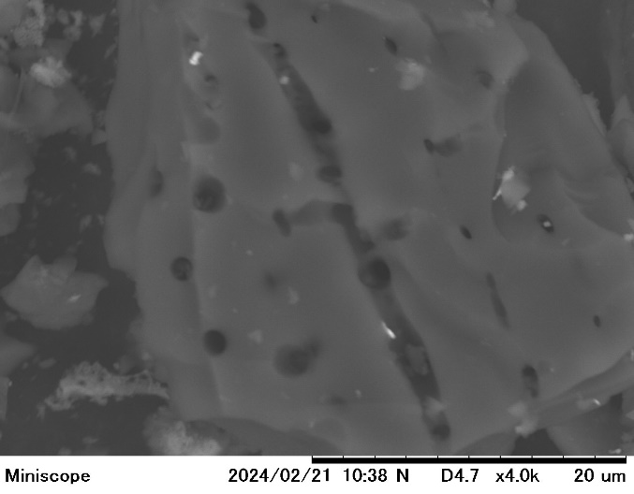
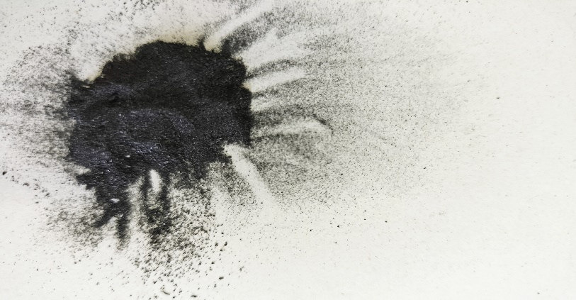
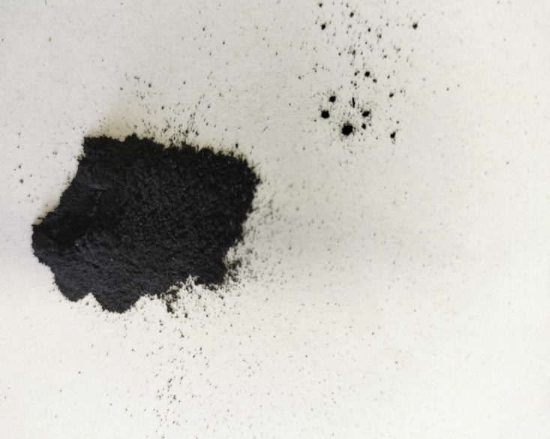
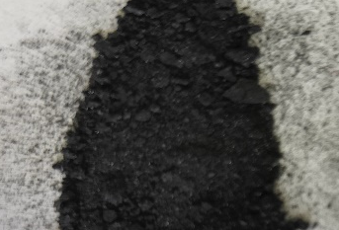
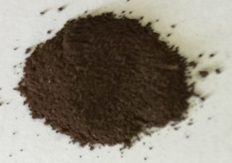
(b)
(a)
CB
CBC
CBCZrO
CBCZrOFe₃O₄

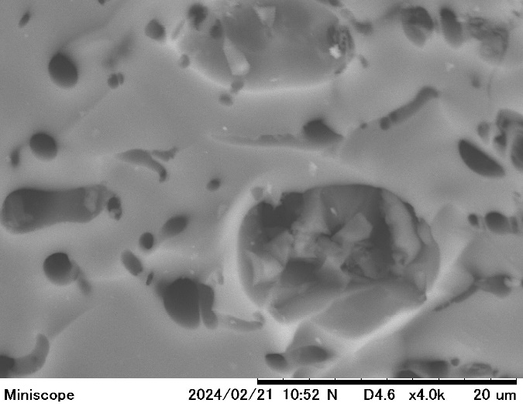
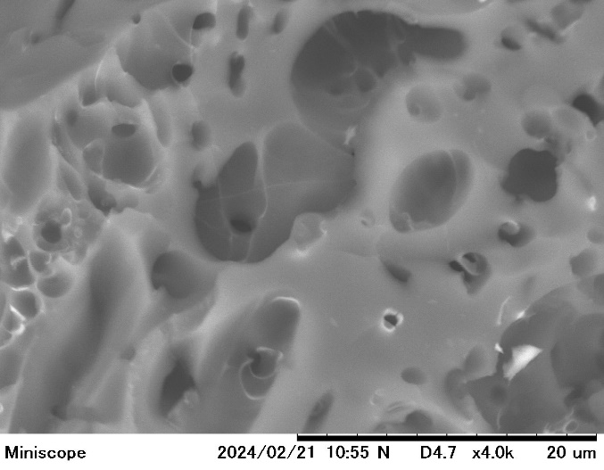
(d)
(c)

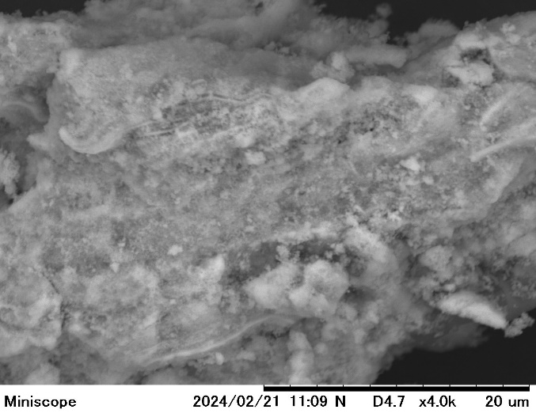
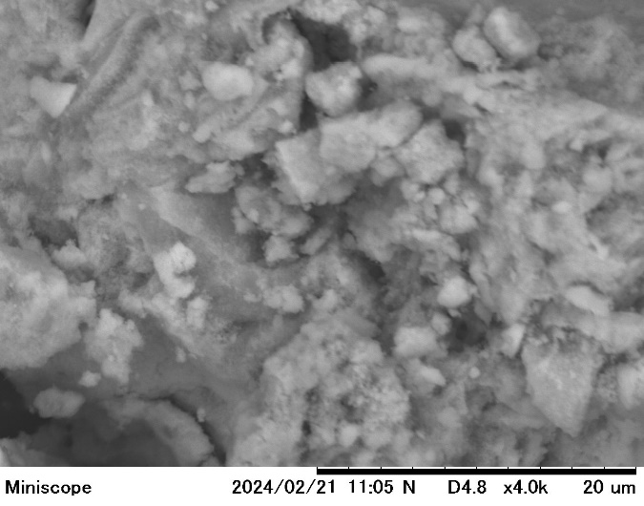
(f)
(e)

Fig. 1. (a) Photograph of adsorbent. SEM photograph of the adsorbent (b) CB (c) CBC (d) CBCZrO (e) CBCZrOFe₃O₄ (before adsorption) (f) CBCZrOFe₃O₄-APP (after adsorption).

(a)
(b)

3188
1557
1346
893
792

595
560

(d)
(c)
35.46
1633
1434
73.99
62.58
56.98
53.41
43.09
18.37
30.05
21.15
36.63
3177
1000
792
595
560
549
536
529

Fig. 2. (a) Comparison of various adsorbents for simultaneous removal percentage of NH₄, PO₄, and phenol. FTIR spectra of adsorbent (b) CBCZrOFe₃O₄ (before adsorption) (c) CBCZrOFe₃O₄ (after adsorption) (d) XRD of CBCZrOFe₃O₄. Statistical analytical by Tukey test (P<0.05).

(a)
(b)

Fig. 3. (a) Initial pH effect versus percentage removal (b) Surface charge (pH_{zpc}) of the CBCZrOFe₃O₄.

(b)
(a)
(c)

Fig. 4. Effect of various initial ion concentrations and contact time (min) versus adsorption capacity (q_{e}) (a) NH₄ (b) PO₄ (c) phenol.

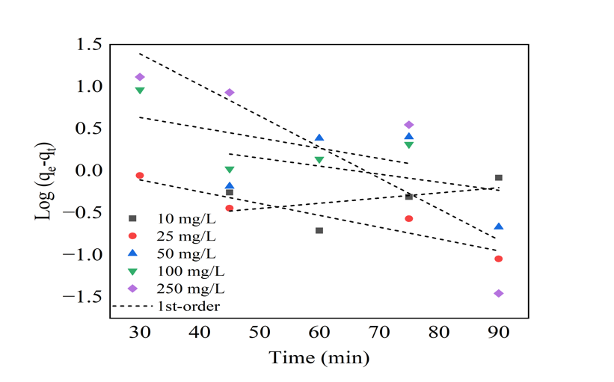
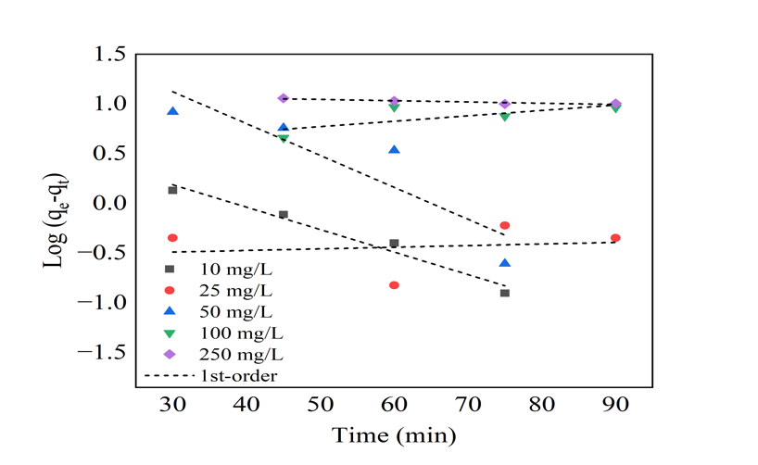
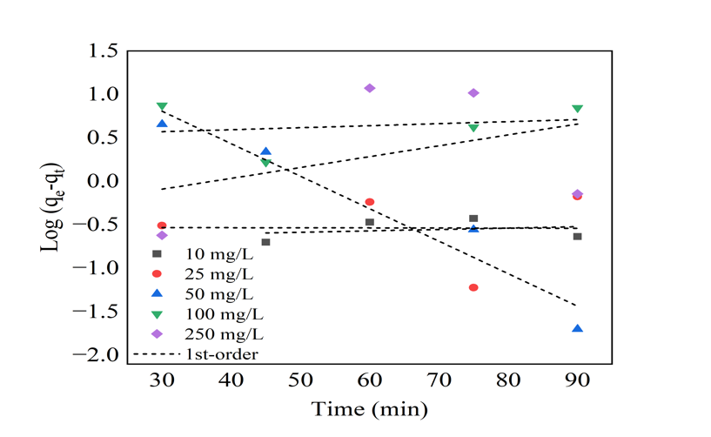
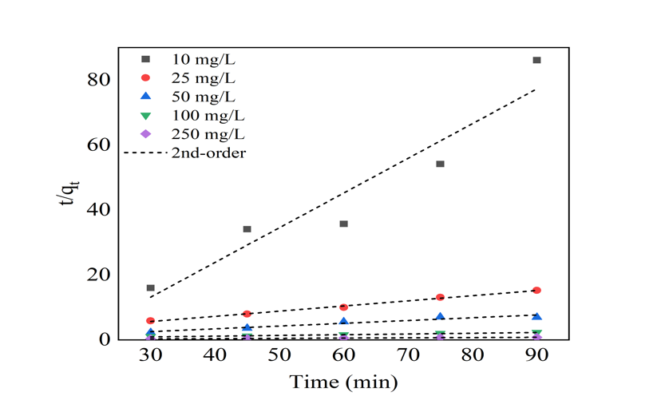
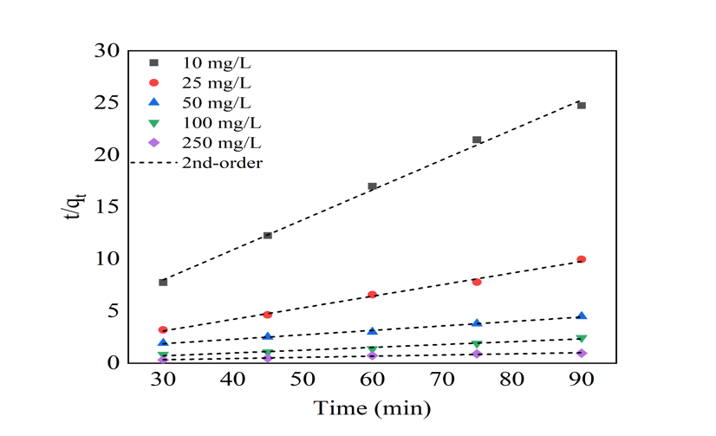
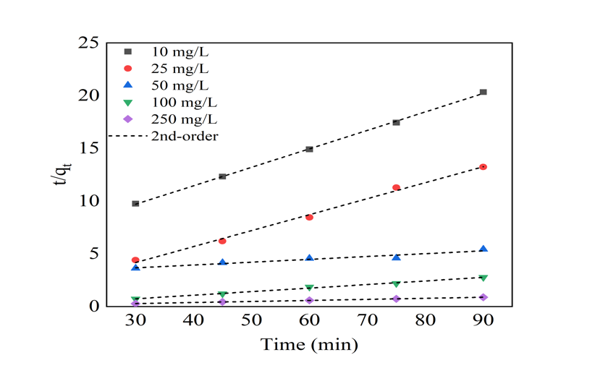
1st Order
2nd Order
(a)
(b)
(c)

Fig. 5. Linear curve of adsorption kinetic models (a) NH₄ (b) PO₄ (c) phenol.

(a)
1st Order
2nd Order
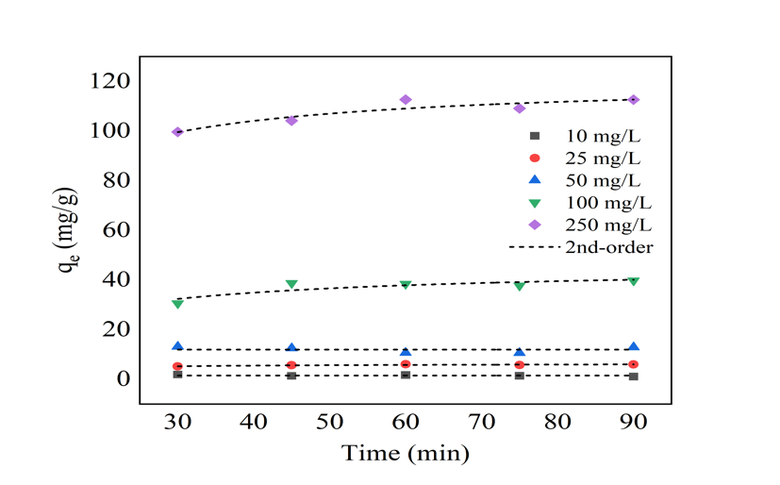
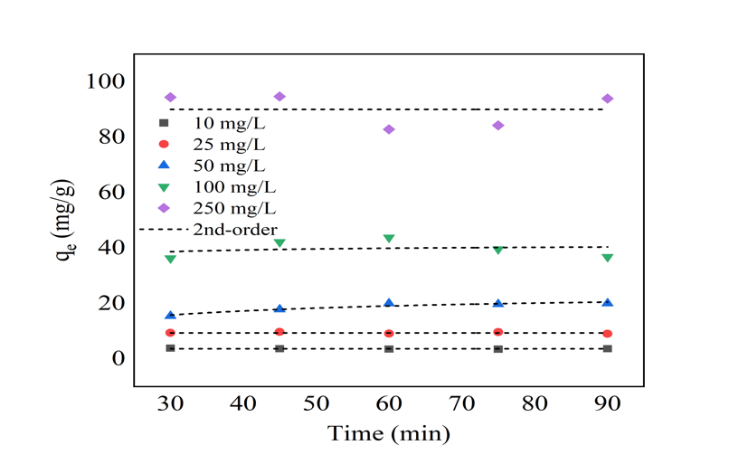
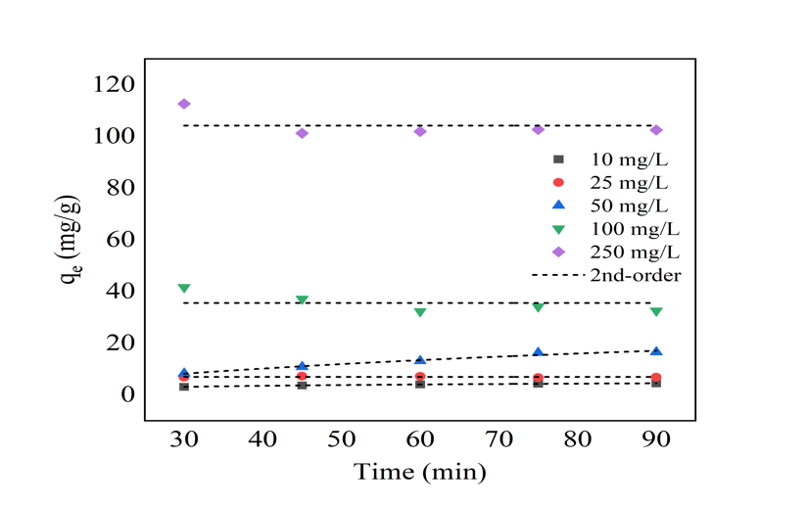
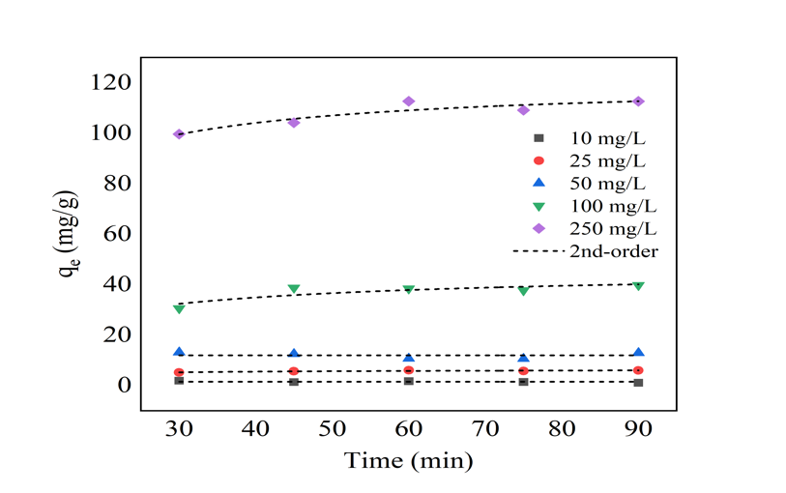
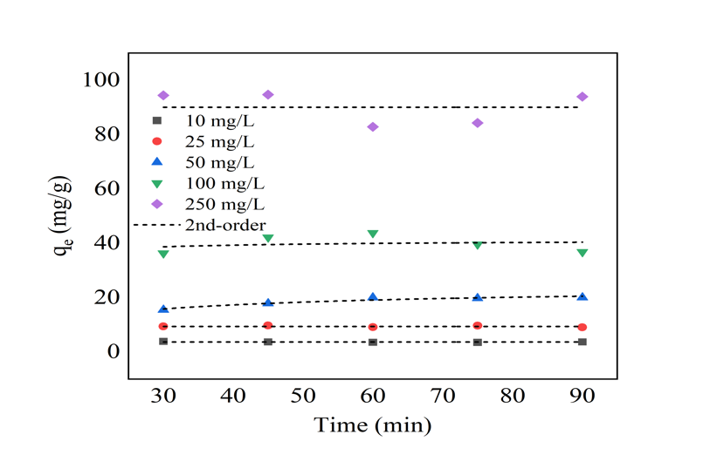
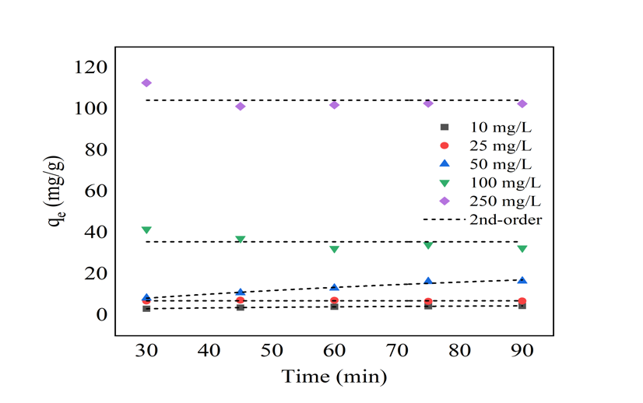

(b)

(c)

Fig. 6. Non-linear curve of adsorption kinetic models (a) NH₄ (b) PO₄ (c) phenol.

Langmuir
Freundlich

(a)

(b)

(c)

Fig. 7. Linear curve of adsorption isotherm models (a) NH₄ (b) PO₄ (c) phenol.

Temkin
Redlich-Peterson
(a)

(b)

(c)

Fig. 8. Linear curve of adsorption isotherm models (a) NH₄ (b) PO₄ (c) phenol.

Fig. 9. Desorption studies with different agent solutions.

(b)
(a)

(c)
(d)

(e)
(f)

15 Days
3 Days
60 Days
Soil (initial pH 2.5)
Soil (initial pH 2.5) + CBCZrO@Fe₃O₄-APP
Soil (initial pH 4.0)
Soil (initial pH 4.0) + CBCZrO@Fe₃O₄-APP
(g)

Fig. 10. Effect of CBCZrOFe₃O₄-APP on soil exchangeable acidity, exchangeable H⁺, exchangeable Al, pH, EC, available P, and CEC. Statistical analytical by Tukey test (P<0.05).

(a)
(b)

(c)
(d)

(e)
(f)

(g)
15 Days
3 Days
60 Days
Soil (initial pH 2.5)
Soil (initial pH 2.5) + CBCZrO@Fe₃O₄-APP
Soil (initial pH 4.0)
Soil (initial pH 4.0) + CBCZrO@Fe₃O₄-APP

Fig. 11. Effect of CBCZrOFe₃O₄-APP on soil exchangeable Mg, K, Na and Ca, available N-NH₄, N-NO₃ and Fe. Statistical analytical by Tukey test (P<0.05).

Table 1. Physical characteristics of CBCZrOFe₃O₄.
Adsorbent | SSA_{BET} [m²/g] | Pore Volume [mL/g] | Average pore diameter [nm] | Porosity (%)
CBCZrOFe₃O₄ | 73.6 | 1.041 | 56.58 | 72

Table 2. Linear kinetic model parameters for adsorption NH₄, PO₄, and phenol.
Isotherm models | Parameters | Initial concentration (mg/L) | Value
Isotherm models | Parameters | Initial concentration (mg/L) | NH₄ | PO₄ | Phenol
1st-order | R² | 10 | 0.2016 | 0.2426 | 0.9681
1st-order | R² | 25 | 0.8864 | 0.0030 | 0.0244
1st-order | R² | 50 | 0.1299 | 0.9068 | 0.8074
1st-order | R² | 100 | 0.3159 | 0.0071 | 0.5267
1st-order | R² | 250 | 0.7264 | 0.2376 | 0.8257
2nd-order | R² | 10 | 0.9110 | 0.9961 | 0.9994
2nd-order | R² | 25 | 0.9947 | 0.9933 | 0.9948
2nd-order | R² | 50 | 0.9251 | 0.9920 | 0.9231
2nd-order | R² | 100 | 0.9854 | 0.9691 | 0.9938
2nd-order | R² | 250 | 0.9968 | 0.9700 | 0.9980
2nd-order | q_{e} (mg/g) | 10 | 4.6795 | 17.3611 | 28.5714
2nd-order | q_{e} (mg/g) | 25 | 31.4465 | 45.0450 | 33.0033
2nd-order | q_{e} (mg/g) | 50 | 58.4795 | 117.6471 | 185.1852
2nd-order | q_{e} (mg/g) | 100 | 222.2222 | 185.1852 | 147.0588
2nd-order | q_{e} (mg/g) | 250 | 588.2353 | 434.7826 | 500
2nd-order | k₂ (g/mg min⁻¹) | 10 | 0.0121 | 0.0263 | 0.0013
2nd-order | k₂ (g/mg min⁻¹) | 25 | 0.0056 | 0.0102 | 0.0123
2nd-order | k₂ (g/mg min⁻¹) | 50 | 0.0573 | 0.0006 | 0.00005
2nd-order | k₂ (g/mg min⁻¹) | 100 | 0.0004 | 0.0013 | 0.0008
2nd-order | k₂ (g/mg min⁻¹) | 250 | 0.0003 | 0.0053 | 0.0009

Table 3. Non-linear kinetic model parameters for adsorption NH₄, PO₄, and phenol.
Isotherm models | Parameters | Initial concentration (mg/L) | Value
Isotherm models | Parameters | Initial concentration (mg/L) | NH₄ | PO₄ | Phenol
1st-order | R² | 10 | <0.0001 | <0.0001 | 0.9960
1st-order | R² | 25 | 0.8794 | <0.0001 | <0.0001
1st-order | R² | 50 | <0.0001 | 0.95879 | 0.9769
1st-order | R² | 100 | 0.8206 | 0.19912 | <0.0001
1st-order | R² | 250 | 0.8298 | <0.0001 | <0.0001
2nd-order | R² | 10 | <0.0001 | <0.0001 | 0.9980
2nd-order | R² | 25 | 0.7911 | <0.0001 | <0.0001
2nd-order | R² | 50 | <0.0001 | 0.91905 | 0.9757
2nd-order | R² | 100 | 0.73963 | 0.0475 | <0.0001
2nd-order | R² | 250 | 0.8482 | <0.0001 | <0.0001

Table 4. Linear isotherm model parameters for adsorption NH₄, PO₄, and phenol.
Isotherm models | Parameters | Time  (min) | Value
Isotherm models | Parameters | Time  (min) | NH₄ | PO₄ | Phenol
Langmuir | R² | 30 | 0.9520 | 0.0559 | 0.1905
Langmuir | R² | 45 | 0.6592 | <0.0001 | 0.0082
Langmuir | R² | 60 | 0.3859 | 0.9389 | 0.0240
Langmuir | R² | 75 | 0.6275 | 0.0442 | 0.0426
Langmuir | R² | 90 | 0.7223 | 0.1428 | 0.0090
Freundlich | R² | 30 | 0.9680 | 0.9585 | 0.6644
Freundlich | R² | 45 | 0.9137 | 0.9607 | 0.7380
Freundlich | R² | 60 | 0.6468 | 0.8473 | 0.7628
Freundlich | R² | 75 | 0.7853 | 0.9399 | 0.7496
Freundlich | R² | 90 | 0.8106 | 0.9854 | 0.7317
Temkin | R² | 30 | 0.5826 | 0.9085 | 0.6874
Temkin | R² | 45 | 0.6484 | 0.9378 | 0.4723
Temkin | R² | 60 | 0.2550 | 0.9139 | 0.4272
Temkin | R² | 75 | 0.4010 | 0.9674 | 0.4524
Temkin | R² | 90 | 0.3837 | 0.8409 | 0.4246
Redlich-Peterson | R² | 30 | 0.7994 | 0.8512 | 0.0349
Redlich-Peterson | R² | 45 | 0.7883 | 0.0531 | 0.0005
Redlich-Peterson | R² | 60 | 0.3474 | 0.0304 | 0.0602
Redlich-Peterson | R² | 75 | 0.5550 | 0.0628 | 0.1384
Redlich-Peterson | R² | 90 | 0.6765 | 0.0554 | 0.2584
Freundlich | K_{f}  (g/mg min⁻¹)^{n} | 30 | 1.9534 | 1.0905 | 5.5187
Freundlich | K_{f}  (g/mg min⁻¹)^{n} | 45 | 0.8257 | 3.050 | 0.9585
Freundlich | K_{f}  (g/mg min⁻¹)^{n} | 60 | 1.005 | 4.2598 | 2.6342
Freundlich | K_{f}  (g/mg min⁻¹)^{n} | 75 | 0.3350 | 3.7447 | 5.8339
Freundlich | K_{f}  (g/mg min⁻¹)^{n} | 90 | 0.00000017 | 2.0504 | 9.6511
Freundlich | 1/n | 30 | 0.0848 | 1.9910 | 1.1564
Freundlich | 1/n | 45 | 0.1199 | 1.0503 | 1.0129
Freundlich | 1/n | 60 | 0.1356 | 0.9301 | 0.8763
Freundlich | 1/n | 75 | 0.1429 | 0.9385 | 0.8119
Freundlich | 1/n | 90 | 3.3209 | 1.0304 | 0.7367

Table 5. Comprehensive cost analysis of adsorbents CBCZrOFe₃O₄
Preparation of adsorbent | Unit cost | Used | Cost (¥) | q_{e} (mg/g) | Adsorbent cost (¥/Kg)
Coffee husk | 0 | 1 Kg | 0 | NH₄: 112.65 | 704.73
Chitosan | ¥ 6790/50 g | 500 g | 67900 | PO₄: 94.68 | 838.49
NaOH | ¥ 8280/500 g | 50 g | 82.8 | Phenol: 112.63 | 704.85
ZrClO | ¥ 873/100 g | 3560 g | 3107
Fe₂SO₄ | ¥ 467/1000 g | 3020 g | 1410
FeCl₃ | ¥ 537/500 g | 6400 g | 6873
Heating cost (¥) | ¥ 7.78/24 h | 24 h | 7.78
Drying cost (¥) | ¥ 7.78/24 h | 24 h | 7.78
Total Cost (¥) |  |  | 79388

