High bending strength at 1800 °C exceeding 1GPa in TiB₂-B₄C composite

A. Kuncserª, O. Vasylkiv^{b*}, H. Borodianska^{b}, D. Demirskyi^{c,d*}, P. Badica^{a*}

ªNational Institute of Materials Physics, street Atomistilor 405 A, 077125 Magurele, Romania
^{b}National Institute for Materials Science, 1-2-1 Sengen, Tsukuba, Ibaraki 305-0047, Japan
^{c}WPI-Advanced Institute for Materials Research (WPI-AIMR), Tohoku University, 2-1-1 Katahira, Aoba-ku, Sendai, 980-8577 Japan
^{d}Department of Materials Science and Engineering, Tohoku University, 6-6-02 Aramaki Aza Aoba, Sendai, 980-8579, Japan

Supplementary information

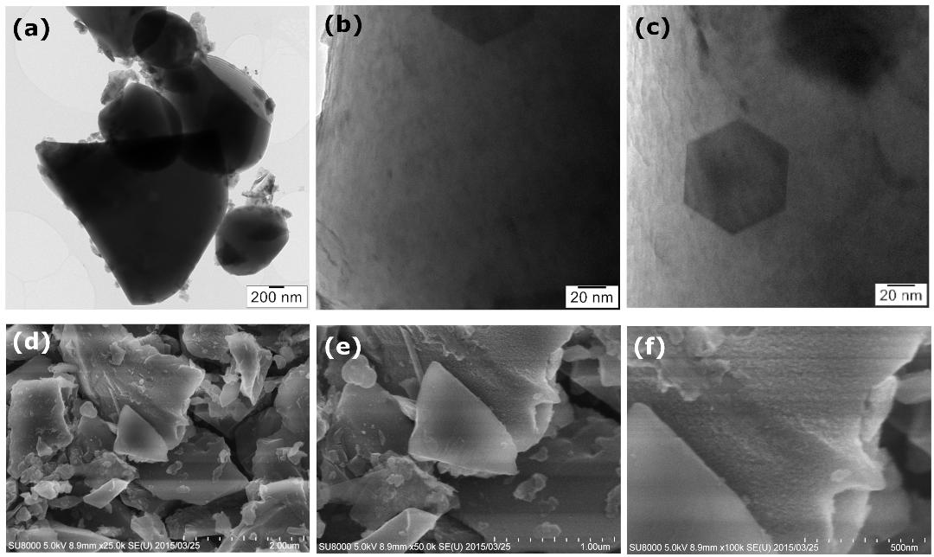

Figure 1, Supplementary. TEM and SEM images taken on raw (a)-(c) TiB₂ (purity 99 wt. %) and (d)-(f) BC (purity 99 wt. %) powders. The average particle size of TiB2 is 1.8 µm (impurities are 0.8 wt. % oxygen, 0.08 wt. % carbon and 0.12 wt. % nitrogen), while for BC it is 1.5 µm (impurities are 0.8 wt. % oxygen, and?? what is difference to 1%??; Andrei, maybe we detected some impurities in EDS??)????

