Fabrication of coherent γ-Al₂O₃/Ga₂O₃ superlattices on MgAl₂O₄ substrates
Yuji Kato¹, Masataka Imura², Yoshiko Nakayama³, Masaki Takeguchi³, Takayoshi Oshima^{1,}*

¹Department of Electrical and Electronic Engineering, Saga University, 1 Honjo, Saga, Saga 840-8502, Japan
²National Institute for Materials Science (NIMS), 1-1 Namiki, Tsukuba, Ibaraki 305-0044, Japan
³NIMS, 1-2-1 Sengen, Tsukuba, Ibaraki 305-0047, Japan

E-mail: oshima@cc.saga-u.ac.jp

Abstract
We succeeded in fabricating 10-period coherent γ-Al₂O₃/Ga₂O₃ superlattices (SLs) on MgAl₂O₄ substrates by molecular beam epitaxy. By varying the each layer thickness, we tuned the average Al composition (x_{ave}) of the coherent SLs from 0.20 to 0.85, and obtained nearly-lattice-matched SLs to the substrate at x_{ave} ~ 0.5. The lattice-matched SLs maintained coherent interfaces up to a period length of 7.2 nm in spite of a large lattice mismatch between the end members. Our results suggest lots of flexibility in designing γ-(Al_{x}Ga_{1−x})₂O₃-based heterostructures for future functional heterojunction devices.

Behind the rapid progress of research and development of ultra-wide-band-gap semiconductor of Ga₂O₃, (Al_{x}Ga_{1−x})₂O₃ alloy and heterostructures have also gained lots of attentions recently.^{1,2)} Among the existed polymorphs of Ga₂O₃,^{3–6)} α, β, γ, ε-phases are verified that their (Al_{x}Ga_{1−x})₂O₃ heteroepitaxial films can be obtained on the proper substrates under the controlled growth conditions,^{7–14)} whose facts pave the way to further studies regarding their respective heterostructures. In particular, development of β-(Al_{x}Ga_{1−x})₂O₃/Ga₂O₃ heterojunctions have preceded those of other phases owing to the thermodynamic stability⁴⁾ and the use of high quality β-Ga₂O₃ single crystal substrates¹⁵⁾. Such β- (Al_{x}Ga_{1−x})₂O₃/Ga₂O₃ heterojunctions^{10,11,16,17)} including superlattices (SLs)¹⁸⁾ were fabricated to understand the band-alignments,¹¹⁾ which are in good agreement with those extracted from theoretical calculation,¹⁹⁾ and to confine two dimensional electron gas,^{16,17)} which brought the realization of modulation-doped transistors^{20,21)}. In contrast to the β-phase, α-(Al_{x}Ga_{1−x})₂O₃/Ga₂O₃ heterojunctions^{22,23)} and superlattices^{24,25)} were prepared on isostructural sapphire substrates to clarify band-alignments^{22,23,25)} and are ready for device applications. In contrast, γ- and ε-(Al_{x}Ga_{1−x})₂O₃-based heterostructures have rarely been studied.
In the case of γ-(Al_{x}Ga_{1−x})₂O₃ alloy and heterojunctions, the last author (TO) and coworkers have performed some preliminary studies using epitaxial growth. The end members of the alloy, or γ-Ga₂O₃ and γ-Al₂O₃, exist in metastable form having a defective-spinel-type structure with a-lattice constants of a_{Ga} = 8.23760⁵⁾ and a_{Al} = 7.911 Å²⁶⁾, respectively. To obtain such metastable films, we performed epitaxial stabilization using spinel-type-structured (001) MgAl₂O₄ substrate (a_{S} = 8.0806 Å²⁷⁾) for γ-Ga₂O₃²⁸⁾ and γ-(Al_{x}Ga_{1−x})₂O₃ alloy¹²⁾ films. By analyzing the epitaxial films, we found that the band gap of γ-(Al_{x}Ga_{1−x})₂O₃ can be controlled in a wide range (4.96–6.97 and 4.80–6.86 eV for direct and indirect transitions, respectively).¹²⁾ In addition, we recently have prepared very thin coherent γ-Ga₂O₃ and γ-Al₂O₃ single layer films on MgAl₂O₄ substrates to reveal Poisson’s ratios of 0.31 and 0.28 and to estimate critical thicknesses (h_{C}) of 5.3 and 4.0 nm, respectively.²⁹⁾ We also confirmed that the coherent γ-Ga₂O₃/Al₂O₃ heterojunction interface has a type-I band alignment with conduction- and valence-band-offsets of 1.6 and 0.2 eV, respectively.²⁹⁾ Moreover, we verified that heavy doping on γ-Ga₂O₃ is effective to a carrier concentration level as high as ~10¹⁹ cm⁻³.³⁰⁾ These fundamental investigation results make us expect future realization of coherent γ-(Al_{x}Ga_{1−x})₂O₃/Ga₂O₃ heterojunction devices.
In this study, we further attempted to fabricate γ-(Al_{x}Ga_{1−x})₂O₃-based heterostructures as a successive study. Among possible heterostructures, we demonstrated the fabrication of γ-Al₂O₃/Ga₂O₃ SLs to attract attentions, because the γ-Al₂O₃/Ga₂O₃ structure is considered to be the most difficult to maintain high crystallinity due to the largest lattice mismatches to the substrate (1.9 and −2.1 % for γ-Ga₂O₃ and γ-Al₂O₃, respectively).
10-period γ-Al₂O₃/Ga₂O₃ multilayers were prepared on (001) MgAl₂O₄ substrates by plasma-assisted molecular beam epitaxy (MBE). Before the growth, the substrate was degreased through ultrasonic cleaning in acetone and methanol. Epitaxial growth was carried out by supplying evaporated Ga and Al and oxygen radicals to the heated rotating substrate from conventional effusion cells and an inductively coupled plasma gun, respectively. The Ga and Al beam equivalent pressures were set at 1.75±0.05×10⁻⁷ and 3.08±0.10×10⁻⁷ Pa, respectively. While the plasma gun was operated under an input RF power of 200 W and an O₂ flow rate of 0.50 sccm. The temperature of a SiC thermal diffusion plate, on which the substrate was mounted, was maintained at 575±5°C, which was monitored through a pyrometer. Under these growth conditions, growth rates of γ-Ga₂O₃ and γ-Al₂O₃ layers were 0.56±0.05 and 0.21±0.03 nm/min, respectively. By controlling the growth times for the comprised γ-Ga₂O₃ and γ-Al₂O₃ layers, whose layer thicknesses are labeled as d_{Ga} and d_{Al}, respectively, various multilayers (samples A–G) having different average Al compositions (x_{ave}) and period lengths (L = d_{Ga} + d_{Al}) were prepared.
To evaluate epitaxial and layered structures of the samples, X-ray diffraction (XRD) measurement was conducted using monochromatic Cu K_{α1} radiation. We found that all the samples except for samples F and G exhibited satellite peaks in the θ-2θ scan patterns, indicating SL structures. For these SL structures, the measured θ-2θ scan patterns were analyzed based on theoretical calculation using models with the parameters (a period number, d_{Ga}, and d_{Al}), which were optimized by simulation and curve fitting [See blue curves in Figs. 1 and 3]. In the simulation model, SLs were assumed to be coherent to the substrate and have deformed lattices, which can be defined using bulk lattice constants (a_{Ga}, a_{Al}, a_{S}), and the ratios of elastic stiffness tensors of γ-Ga₂O₃ and γ-Al₂O₃ (C₁₁/C₁₂ = 0.44 and 0.39, respectively)²⁹⁾. The sample labels and corresponding optimized structural parameters by the curve fitting were summarized in Table I. In this table, values for samples F and G were estimated from the growth rates and times because they were not SL. Note that x_{ave} is also extracted using d_{Ga} and d_{Al} values using the following equations:
$$x_{ave} =\frac{{d_{Al}}/{a_{Al}}}{{d_{Ga}}/{a_{Ga}}+{d_{Al}}/{a_{Al}}},$$
where, a_{⊥Ga} and a_{⊥Al} represent the strained lattice constants of γ-Ga₂O₃ (8.376 Å) or γ-Al₂O₃ (7.778 Å) films along the growth direction²⁹⁾.
We first varied x_{ave} by controlling the fraction of d_{Al} with maintaining L. Figure 1 shows XRD θ-2θ scan patterns near 004 reflections for the SL samples A, B, C with different x_{ave}. [See Table I for the corresponding d_{Ga}, d_{Al}, and L]. According to x_{ave}, 2θ angle of the 0th satellite peaks shift around the substrate one. We note that a nearly lattice-matched SL to the substrate can be realized at x_{ave} = 0.48 (sample B), whose composition is very close to x = 0.47 of our previously reported nearly-lattice matched γ-(Al_{x}Ga_{1−x})₂O₃ alloy film.¹²⁾ As for the crystallinity of these SLs, even 8 small peaks between the satellite ones are clearly observed, indicating relatively high-crystalline 10-perid SLs. The full widths at half maximums (FWHMs) of 004 XRD rocking curve of the samples A, B, and C were 304, 256, and 266 (0th) arcsec, respectively, as shown in Fig. 2 (a).
We then controlled L under the nearly-lattice matched conditions. Figure 3 shows XRD θ-2θ scan patterns for the samples D, B, E, F, and G having different L. We can see satellite reflections for the samples with L = 3.4–7.2 nm (samples D, B, and E), where intervals between the neighboring ones become narrower accordingly as L increases. The crystallinity of these SLs are relatively high as well taking observable small sub-peaks between the satellite ones into consideration. FWHMs of 004 rocking curve for the samples D, B, and E were 478, 256, and 220 arcsec, respectively, as shown in Fig. 2(b). Note that the larger FWHM value for sample D is considered to be attributed to small intensity of peak signal owing to the small sample volume. Whereas, at L ≥ 10.7 nm (samples F and G), weak and broad reflections appear instead of satellite ones. In particular, at L = 17.4 (sample G), two weak peaks are observed at the 2θ angles corresponding to γ-Ga₂O₃ and γ-Al₂O₃ single epitaxial films¹²⁾ [Compare peak positions of XRD patterns of sample G with those of γ-Ga₂O₃ and γ-Al₂O₃ films], indicating that long-range lattice order no longer exists in the layered structure by lattice relaxation due to increased strain energy induced by thicker d_{Ga}, and d_{Al}.
All the SLs were verified to be coherent to the substrate. Figure 4 shows XRD reciprocal space maps taken near asymmetric 115 spots for the SL samples A, B, C, and E. For these SL samples, satellite spots of the SLs and the substrate one are aligned vertically at the same Q_{X}, indicating coherent SLs to the substrate. As for the sample D, we could not get a map with significant 115 spots from the SL because XRD intensity was too weak to detect owing to the small total thickness of the SL. However, it is highly likely that the SL also has structural coherence to the substrate because a cumulative strain in the SL (L = 3.4 nm) is considered as smaller than that of sample B (L = 5.8 nm). These results indicate that we succeeded in controlling the γ-Al₂O₃/Ga₂O₃ SL structure in wide x_{ave} and d_{Ga} ranges of at least 0.20 ≤ x_{ave} ≤ 0.85 and d_{Ga} ≤ 4.0 nm and d_{Al} ≤ 3.2 nm (L = 7.2 nm) with maintaining coherent interfaces to the substrate, which well agrees with our previously estimated h_{C} (5.3 and 4.0 nm for γ-Ga₂O₃ and γ-Al₂O₃ films, respectively)²⁹⁾.
Finally, the crystal lattices of the one of the coherently grown SL (sample B) was observed by cross-sectional scanning transmission electron microscopy (STEM). For this purpose, a TEM specimen was prepared by conventional focused ion beam lift out by the following procedure. A 40 kV beam was employed to roughly dig the both sides of the target position near the center of the sample, followed by two step thinning process with a 30 and a 10 kV beams to obtain 70-nm thick lamella specimen, which was finally polished gently with a 5 kV beam for 60 s for each side to eliminate the damaged layer. The measurement was carried out under an acceleration voltage and a viewing direction of 200 kV and [100], respectively.
Figure 5(a) shows low-magnification bright-field (BF) STEM image of the sample B. 10-period γ-Al₂O₃ (lighter contrast) and γ-Ga₂O₃ (darker contrast) strips are seen without any observable dislocations, indicating a relatively high crystalline quality of the SL. To view more detailed lattice images, magnified BF- and HAADF-STEM images for the same area near the SL/substrate interface are shown in Figs 5(b) and (c). The crystal lattices of the SL in both figures are well ordered but are curved at the γ-Al₂O₃/Ga₂O₃ interfaces, reflecting strain attributed to the large lattice mismatch. In particular, in the HAADF image, we can clearly see that cross-stripes, which correspond to the network of heavier metal atoms of the spinel framework [Compare the cross-strips in Fig. 5(c) and Ga atom positions in (d)], maintain the coherency from MgAl₂O₄ to the upper SLs with some distortion at the interfaces. This result indicates that these heterojunctions (γ-Ga₂O₃/MgAl₂O₄ and γ-Al₂O₃/Ga₂O₃) had coherent interfaces without misfit dislocation.
In summary, γ-Al₂O₃/Ga₂O₃ SLs were successfully fabricated on MgAl₂O₄ substrates by MBE despite the metastability and the large lattice mismatch. The average lattice constant as well as x_{ave} of the SL were able to be controlled with tuning d_{Al} and d_{Ga}, and the nearly lattice-matched SL was obtained at x_{ave} ~ 0.5. XRD reciprocal space map and STEM characterization revealed coherent interfaces without misfit dislocation. Considering that γ-Al₂O₃ and γ-Ga₂O₃ are end members of γ-(Al_{x}Ga_{1−x})₂O₃ alloy, our results also suggest that high quality γ-(Al_{x}Ga_{1−x})₂O₃/Ga₂O₃ heterojunctions including SLs with entire x can be fabricated as well. Such outlook regarding the wide controllability of high quality γ-(Al_{x}Ga_{1−x})₂O₃-based heterostructures will trigger the successive studies on characterization and device application in the future.

Acknowledgments
We would like to thank NIMS Microstructural Characterization Platform as a program of the “Nanotechnology Platform” of the Ministry of Education, Culture, Sports, Science and Technology (MEXT), Japan for STEM observation. This study was partially supported by the Murata Science Foundation.

References
1) M. Higashiwaki and G.H. Jessen, Appl. Phys. Lett. 112, 060401 (2018).
2) S.J. Pearton, J. Yang, P.H. Cary, F. Ren, J. Kim, M.J. Tadjer, and M.A. Mastro, Appl. Phys. Rev. 5, 011301 (2018).
3) M.A. Mastro, A. Kuramata, J. Calkins, J. Kim, F. Ren, and S.J. Pearton, ECS J. Solid State Sci. Technol. 6, P356 (2017).
4) R. Roy, V.G. Hill, and E.F. Osborn, J. Amer. Chem. Soc. 74, 719 (1952).
5) H.Y. Playford, A.C. Hannon, E.R. Barney, and R.I. Walton, Chem. - A Eur. J. 19, 2803 (2013).
6) H. von Wenckstern, Adv. Electron. Mater. 3, 1600350 (2017).
7) R. Kumaran, T. Tiedje, S.E. Webster, S. Penson, and W. Li, Opt. Lett. 35, 3793 (2010).
8) H. Ito, K. Kaneko, and S. Fujita, Jpn. J. Appl. Phys. 51, 100207 (2012).
9) G.T. Dang, T. Yasuoka, Y. Tagashira, T. Tadokoro, W. Theiss, and T. Kawaharamura, Appl. Phys. Lett. 113, 062102 (2018).
10) T. Oshima, T. Okuno, N. Arai, Y. Kobayashi, and S. Fujita, Jpn. J. Appl. Phys. 48, 070202 (2009).
11) R. Wakabayashi, M. Hattori, K. Yoshimatsu, K. Horiba, H. Kumigashira, and A. Ohtomo, Appl. Phys. Lett. 112, 232103 (2018).
12) T. Oshima, Y. Kato, M. Oda, T. Hitora, and M. Kasu, Appl. Phys. Express 10, 051104 (2017).
13) H. Nishinaka, D. Tahara, and M. Yoshimoto, Jpn. J. Appl. Phys. 55, 1202BC (2016).
14) V. Gottschalch, S. Merker, S. Blaurock, M. Kneiß, U. Teschner, M. Grundmann, and H. Krautscheid, J. Cryst. Growth 510, 76 (2019).
15) A. Kuramata, K. Koshi, S. Watanabe, Y. Yamaoka, T. Masui, and S. Yamakoshi, Jpn. J. Appl. Phys. 55, 1202A2 (2016).
16) T. Oshima, Y. Kato, N. Kawano, A. Kuramata, S. Yamakoshi, S. Fujita, T. Oishi, and M. Kasu, Appl. Phys. Express 10, 035701 (2017).
17) Y. Zhang, A. Neal, Z. Xia, C. Joishi, J.M. Johnson, Y. Zheng, S. Bajaj, M. Brenner, D. Dorsey, K. Chabak, G. Jessen, J. Hwang, S. Mou, J.P. Heremans, and S. Rajan, Appl. Phys. Lett. 112, 173502 (2018).
18) S.W. Kaun, F. Wu, and J.S. Speck, J. Vac. Sci. Technol. A Vacuum, Surfaces, Film. 33, 041508 (2015).
19) H. Peelaers, J.B. Varley, J.S. Speck, and C.G. Van de Walle, Appl. Phys. Lett. 112, 242101 (2018).
20) S. Krishnamoorthy, Z. Xia, C. Joishi, Y. Zhang, J. McGlone, J. Johnson, M. Brenner, A.R. Arehart, J. Hwang, S. Lodha, and S. Rajan, Appl. Phys. Lett. 111, 023502 (2017).
21) E. Ahmadi, O.S. Koksaldi, X. Zheng, T. Mates, Y. Oshima, U.K. Mishra, and J.S. Speck, Appl. Phys. Express 10, 071101 (2017).
22) K. Kaneko, K. Suzuki, Y. Ito, and S. Fujita, J. Cryst. Growth 436, 150 (2016).
23) T. Uchida, R. Jinno, S. Takemoto, K. Kaneko, and S. Fujita, Jpn. J. Appl. Phys. 57, 040314 (2018).
24) T. Oshima, Y. Kato, M. Imura, Y. Nakayama, and M. Takeguchi, Appl. Phys. Express 11, 065501 (2018).
25) T. Oshima, Y. Kato, E. Kobayashi, and K. Takahashi, Jpn. J. Appl. Phys. 57, 080308 (2018).
26) R. ‐S Zhou and R.L. Snyder, Acta Crystallogr. Sect. B Struct. Sci. 47, 617 (1991).
27) T. Yamanaka, Y. Takéuchi, and M. Tokonami, Acta Crystallogr. Sect. B Struct. Sci. 40, 96 (1984).
28) T. Oshima, T. Nakazono, A. Mukai, and A. Ohtomo, J. Cryst. Growth 359, 60 (2012).
29) T. Oshima, Y. Kato, E. Magome, E. Kobayashi, and K. Takahashi, Submitted (2019).
30) T. Oshima, K. Matsuyama, K. Yoshimatsu, and A. Ohtomo, J. Cryst. Growth 421, 23 (2015).

Figures
Figure 1. XRD θ-2θ scan patterns (red) of samples A, B, and C with various x_{ave}. Simulated XRD patterns (blue) are also plotted, which are calculated under the assumption that grown films are coherent to the substrates.

Figure 2. XRD ω-rocking curves of 004 reflection for the samples showing (a) x_{ave} dependence (samples A, B, and C) and (b) L dependence (samples D, B, and E). The curves correspond to 0th (sample A and C) and –1th (samples B, D, and E) reflections.

Figure 3. Experimental (red) and simulated (blue) XRD θ-2θ scan patterns of samples D, B, E, F, and G with nearly matched lattices to the substrate and various L. The patterns of γ-Ga₂O₃ and γ-Al₂O₃ epitaxial single layers (green) are also plotted as references.¹²⁾

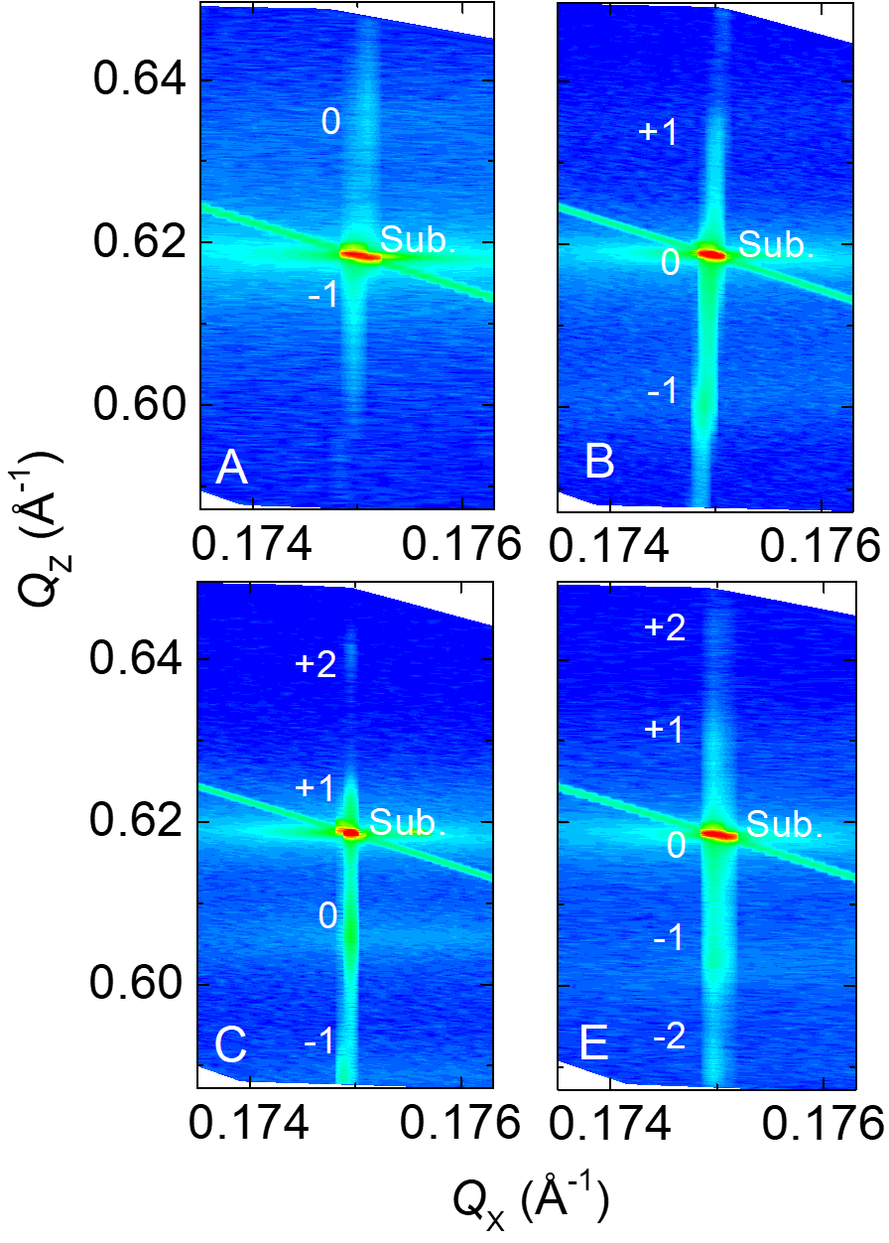
Figure 4. XRD reciprocal space maps in vicinity of 115 spots of samples A, B, C, and E. Directions of Q_{Z} and Q_{X} are along [001] and [110], respectively.

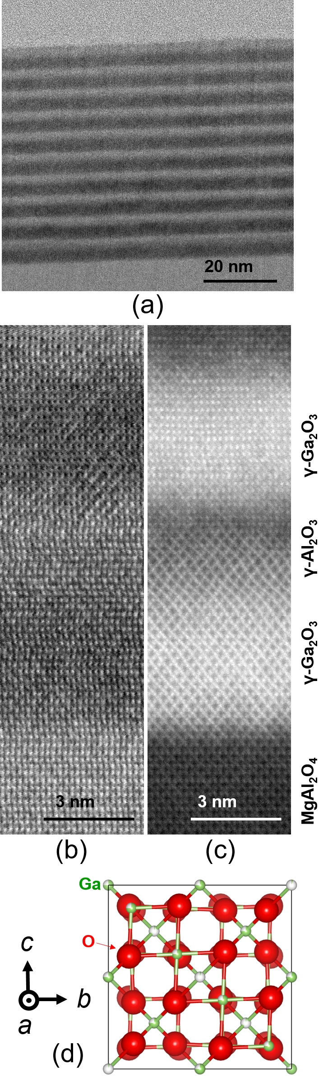
Figure 5. (a) and (b) BF- and (c) HAADF-STEM images of the SL sample B with incident electron beam direction along [100]. (b) and (c) are magnified images taken from the same area near the substrate. (d) Unit cell of γ-Ga₂O₃ viewing from the same direction as the STEM.

Table I. Summary of each layer thickness and x_{ave} for the samples.
Sample | d_{Ga}  (nm) | d_{Al}  (nm) | L  (nm) | x_{ave}
A | 0.8 | 4.2 | 5.0 | 0.85
B | 3.1 | 2.7 | 5.8 | 0.48
C | 4.7 | 1.1 | 5.8 | 0.20
D | 2.0 | 1.4 | 3.4 | 0.44
E | 4.0 | 3.2 | 7.2 | 0.48
F | 6.2 (est.) | 4.5 (est.) | 10.7 (est.) | 0.44 (est.)
G | 9.3 (est.) | 8.1 (est.) | 17.4 (est.) | 0.48 (est.)

