Critical Current Measurements of Prototype REBCO Round Cables at 77 K

Xudong Wang, Kiyosumi Tsuchiya, Akio Terashima, Suguru Tanabe, Nobuyuki Negishi, and Akihiro Kikuchi

Abstract—High temperature superconducting (HTS) cables are necessary for next-generation high-field accelerator magnets, and various types of HTS cables have been developed worldwide. We have started the development of HTS cables in which rare-earth barium copper oxide (REBCO) coated conductors are spirally wound around a flexible multi-wire core. In this study, we constructed five sample cables with a 2-mm-wide coated conductor and a 1.8-mm-diameter multi-wire core. The transport critical current (I_{c}) of the coated conductors used for the sample cables was measured at 77 K and 4.2 K. At 4.2 K, the I_{c} was measured in a perpendicular magnetic field from 1 T to 18 T. The transport I_{c} and bending properties of the sample cables were characterized at 77 K. The cable I_{c} degraded 10-16% due to the cable construction and 10% after bending the cable with a radius of 20 mm. The cable current density (J_{e}) at 20 T and 4.2 K was estimated as a function of the cable diameter.

Index Terms—REBCO, cable, critical current, current density, high magnetic field.

I. Introduction
W
ITH the advances in manufacturing technology of rare-earth barium copper oxide (REBCO) coated conductors, the development of high-field accelerator magnets has become more active in recent years. Since REBCO coated conductors are in tape form rather than round wires like NbTi conductors, new high current cables with coated conductors have been developing worldwide, such as Roebel cables [1, 2], twisted stacked-tape cables [3, 4], CORC® wires [5-11], and STAR® wires [12-15]. In particular, the CORC® and STAR® wires, which are small diameter round cables with a structure similar to superconducting power transmission cables in which coated conductors are spirally wound around a metal core, are expected to be applied to the future accelerator magnets. This round cable configuration provides the bending flexibility required for coil manufacturing and makes it easy to increase the current capacity through multi-layering. Considering these advantages, we started the development of the REBCO round cable using our previous research experience with the coated conductors [16-18] and a REBCO sextupole magnet [19-23].
In this study, five prototype REBCO round cables were fabricated and measured to characterize the transport critical current (I_{c}) and the cable current density (J_{e}) at 20 T and 4.2 K. The bending properties of the sample cables were also measured to confirm its flexibility.

II. Experiments

A. REBCO Coated Conductor Properties
A 2-mm-wide coated conductor, manufactured by SuperPower Inc., was used to construct the sample cable. The specifications of the coated conductor are summarized in Table 1. As a first attempt at cable construction, this relatively thick coated conductor was chosen for ease of handling. The voltage versus current (V-I) properties of the coated conductor were measured by the standard four-probe method at 77 K and 4.2 K with a U-shape holder developed in our previous studies [16-18]. A pair of voltage taps with a conductor length of 29 mm were soldered to the center of a 120-mm-long sample. The transport I_{c} of the sample was determined using an electric field criterion of 1.0 µV/cm calculated by dividing the measured voltage by 29 mm. An 18 T solenoid with a 52-mm-bore was used to measure the I_{c} in a perpendicular magnetic field from 1 T to 18 T at 4.2 K.

B. REBCO Cable Properties
Five 300-mm-long sample cables #1 to #5, shown in Fig. 1 and summarized in Table 2, were constructed using the 2-mm-wide coated conductor and the 1.8-mm-diameter multi-wire core. The core was stranded with 37 0.26-mm-diameter wires. The coated conductors were spirally wound around the core with the superconducting layer facing to the core so that the superconducting layer was under compressive strain. The winding direction of the next layer was opposite to that of the previous layer for the multi-layer sample cables #3 to #5. There was no insulating layer between the core and the conductor layer, and between the conductor layers. The coated conductors and core were soldered together with a round terminal at the end of the cable. The round terminal was bolted to a copper block to transport the current. A pair of voltage taps with cable lengths between 110 mm to 240 mm were soldered to the center of the outermost layer of each sample cable. The cable I_{c} was determined using an electric field criterion of 1.0 µV/cm calculated by dividing the measured voltage by the cable length between the voltage taps.
TABLE I
Specifications of REBCO Coated Conductor

Parameters | Values
Conductor width | 2 mm
Conductor thickness | 0.12 mm
Substrate thickness | 30 µm
REBCO thickness | 1.6 µm
Copper thickness | 40 µm per side
I_{c} (self-field, 77 K) | 54 A (>50 A) ª
ª The minimum I_{c} was provided by SuperPower Inc.

C. Cable Bending Tests
Three sample cables #2 to #4 were sequentially bent to radii of 40 mm, 30 mm, and 20 mm at room temperature using glass fiber reinforced plastic (GFRP) disk holders. Fig. 2 shows the GFRP disk holders and the sample cable #2 bent to a radius of 40 mm. The transport I_{c} was measured first without bending, then after bending at each radius, and finally again without bending at 77 K. The voltage taps were the same as the cable I_{c} measurements.
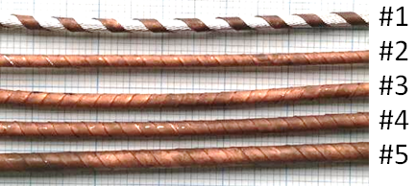
Fig. 1. Five REBCO sample cables #1 to #5 constructed by spirally winding a 2-mm-wide coated conductor around a 1.8-mm-diameter multi-wire core without insulation.

TABLE II
Specifications of Five REBCO Sample Cables

Cable  no. | # of  layers | # of  conductors | Diameter  (mm) | Cable length between  voltage taps (cm)
#1 | 1 | 1 | 2.05 | 13 (19) ª
#2 | 1 | 2 | 2.05 | 12 (19) ª
#3 | 2 | 4 | 2.25 | 11 (19) ª
#4 | 3 | 6 | 2.50 | 13 (26) ª
#5 | 5 | 11 | 3.00 | 24 (38) ª
ª The values in parentheses are the conductor length measured from the outermost layer of the cable between the voltage taps.

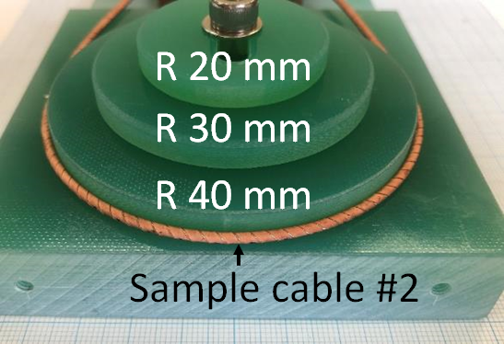
Fig. 2. GFRP disk holders used for the bending test with radii of 40 mm, 30 mm, and 20 mm. The sample cable #2 was bent to a radius of 40 mm in this photo.

III. Results and Discussion

A. Transport I_{c} of Coated Conductor
Fig. 3 shows the electric field versus current plots of the coated conductor at 77 K and 4.2 K. Fig. 4 shows the perpendicular magnetic field dependence of the transport I_{c}. The conductor I_{c} was 54 A in self-field at 77 K and 86 A at 18 T and 4.2 K. To extrapolate the perpendicular field dependence up to 20 T at 4.2 K, a well-known power law equation of I_{c}=kB^{-α} [24, 25] was adopted using the measured I_{c} from 10 T to 18 T. Where, k and α are the fitting parameters. The dashed lines in the insets of Fig. 4 represent the fitting results of the conductor I_{c}. The lift factor defined as I_{c} (B, 4.2 K)/I_{c} (self-field, 77 K) was used to estimate the cable I_{c} at 20 T and 4.2 K.

B. Cable I_{c} and J_{e}
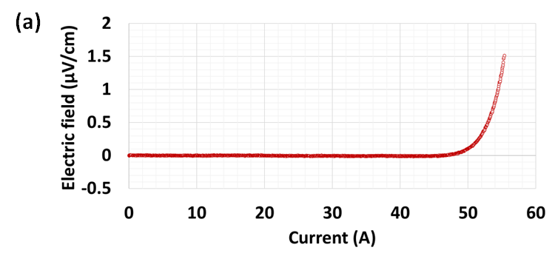
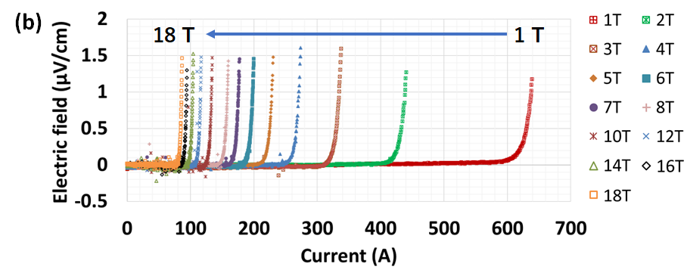
Fig. 3. Electric field versus current plots of the coated conductor at (a) 77 K and (b) 4.2 K. The magnetic field dependence of the I_{c} perpendicular to the coated conductor was measured from 1 T to 18 T at 4.2 K.

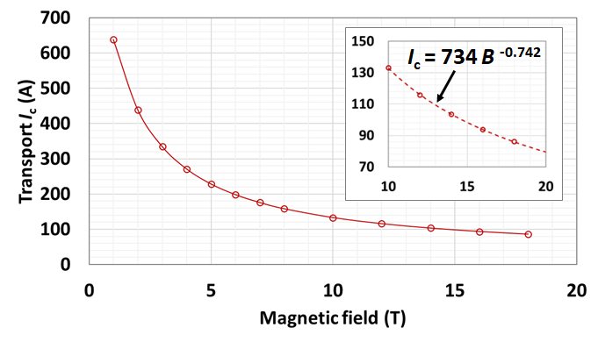
Fig. 4. Magnetic field dependence of the conductor I_{c} measured at 4.2 K. The dashed lines in the insets show the fitting curve using the power law equation.
Fig. 5 shows the V-I plots of the sample cables #1 to #5 measured in self-field at 77 K. The cable I_{c} measured at 77 K is summarized in Table 3. Because the coated conductor is spirally wound around the core, the length of the coated conductor is longer than that of the cable between the voltage taps. As a result, the cable I_{c} calculated using the cable length is smaller than that calculated using the conductor length as the tap length. In Table 3, the cable I_{c} at 77 K shown in parentheses were calculated using the conductor length listed in parentheses of Table 2. Comparing these I_{c} values, the cable I_{c} calculated using the cable length was less than that calculated using the conductor length by several percent. Excluding this I_{c} difference, there was no I_{c} degradation for the single-layer cables #1 and #2 compared to the expected I_{c} as a multiple of the conductor I_{c}. On the other hand, the multi-layer cables #3 to #5 showed 10% to 16% I_{c} degradation compared to the cable #1. Considering that the compressive strain induced in the superconducting layer decreases as the cable diameter increases, this I_{c} degradation may be due to the self-field effect and interference at intersections between the conductor layers in the multi-layer cables, rather than due to the compressive strain during conductor winding. The maximum self-field perpendicular to the coated conductor (B//c) of the cable #5 was analyzed to be less than 0.015 T by an Opera-3D model as shown in Fig. 6. The self-field profile shows peaks around the edges of the coated conductor. This self-field effect reduces the cable I_{c} by up to 5% at 77 K according to our previous study [18]. As shown in Fig. 7, the non-uniform copper plating thickness on the conductor edge may cause interference between the conductor layers and induce additional strain in the superconducting layer. Therefore, dimensional uniformity of the coated conductor thickness might be important for the cable construction.
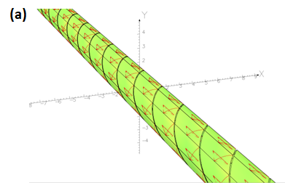
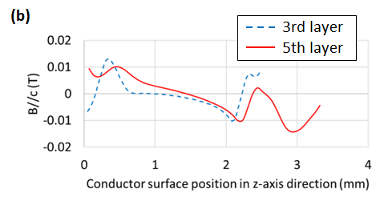
Fig. 6. The self-field perpendicular to the coated conductor (B//c) of the cable #5, (a) an Opera-3D model and (b) field profile in the z-axis direction on the conductor surface of the 3rd layer and the 5th layer. The length of the 5th layer conductor in the z-axis direction is longer than that of the 3rd layer conductor because its winding pitch is longer.

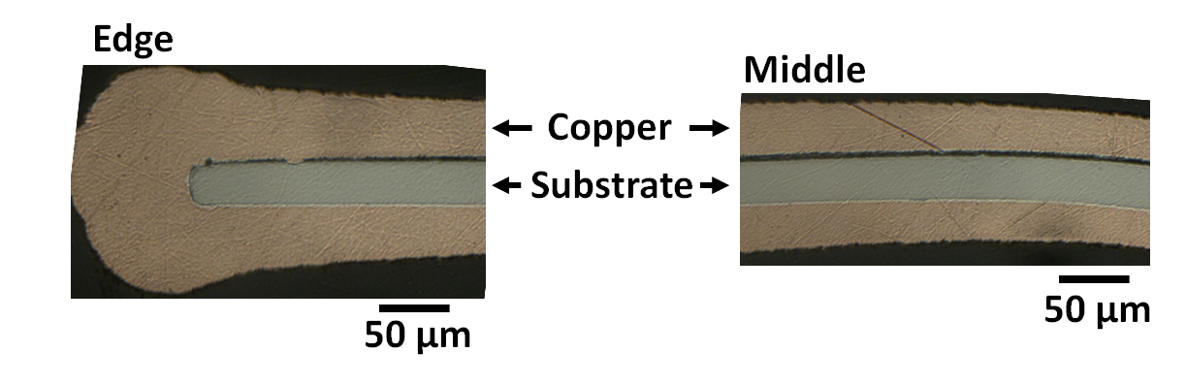
Fig. 7. Micrographs of the coated conductor with a nominal copper thickness of 40 µm per side. The photos on the left and right are the edge and middle of the coated conductor in the width direction.

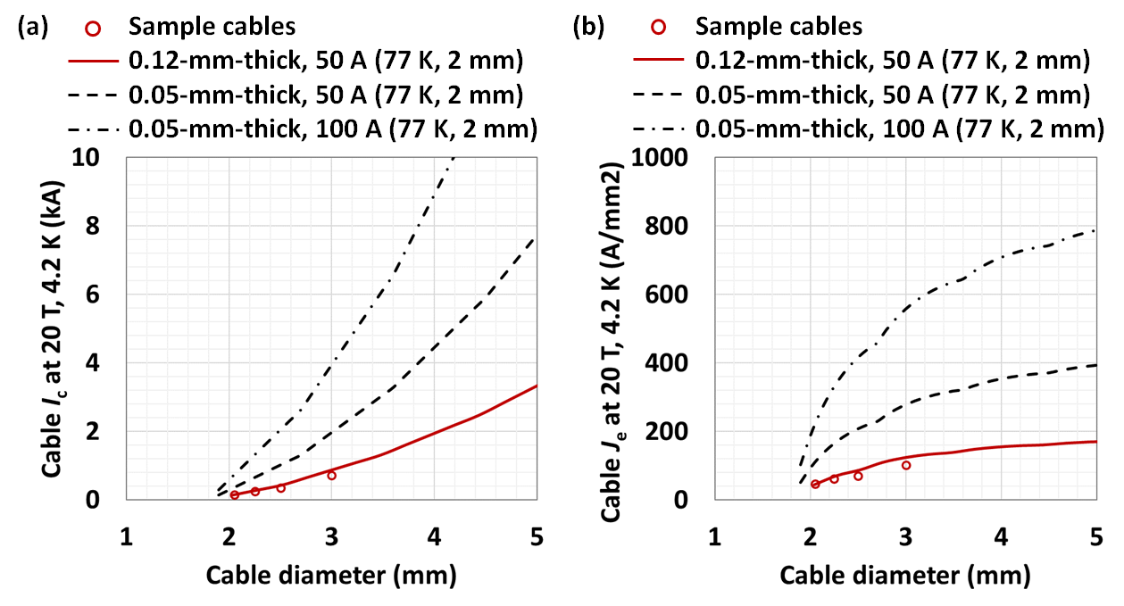
Fig. 8. Estimated cable (a) I_{c} and (b) J_{e} at 20 T and 4.2 K as a function of the cable diameter. The plots are the estimated values of the sample cables #2 to #5. The lines are calculated assuming a 2-mm-wide coated conductor with a thickness of 0.12 mm or 0.05 mm. The 0.12-mm-thick coated conductor has the same configuration as listed in Table 1. The 0.05-mm-thick coated conductor has the same configuration as the 0.12-mm-thick coated conductor, except that the copper plating layer is thinner. Estimations were made taking into consideration a gap of around 0.2 mm between coated conductors in the same layer.
The cable I_{c} and J_{e} estimated at 4.2 K are also summarized in Table 3. The lift factors of 1.72 and 1.46 obtained from Fig. 4 are used to estimate the cable I_{c} at 16 T and 20 T, respectively. The cable J_{e} was calculated by dividing the cable I_{c} by the cable cross-sectional area obtained from the measured cable diameter listed in Table 2. The sample cable #5, consisting of 11 2-mm-wide coated conductors, was estimated to have an I_{c} of 853 A at 16 T and 4.2 K, and 724 A at 20 T and 4.2 K. Fig. 8 shows the estimated cable I_{c} and J_{e} at 20 T and 4.2 K as a function of the cable diameter. These estimations were made not only for the 0.12-mm-thick coated conductor tested in this study, but also for the commercially available 0.05-mm-thick coated conductor with a thinner copper plating layer. The conductor I_{c} of the 0.05-mm-thick and 2-mm-wide coated conductor was set to 50 A or 100 A at 77 K. The cable I_{c} and J_{e} of the sample cables constructed using the 0.12-mm-thick coated conductor are less than 4 kA and 200 A/mm² at 20 T and 4.2 K for cable diameters less than 5 mm (plots and solid line in Fig. 7). The cable I_{c} and J_{e} close to 8 kA and 400 A/mm² at 20 T and 4.2 K are expected to be achieved using a 0.05-mm-thick coated conductor with the conductor I_{c} of 50 A at 77 K (dotted line in Fig. 7), and further improvement is expected by increasing the conductor I_{c} of the 0.05-mm-thick coated conductor (dash-dot line in Fig. 7). Reducing the core size is also essential to improve cable current density. However, the bending strain of the superconducting layer increases as the core size decreases, resulting in I_{c} degradation in the current conductor configuration. Therefore, to reduce the core size, the superconducting layer should be placed close to the neutral axis of the coated conductor to minimize strain induced I_{c} degradation.
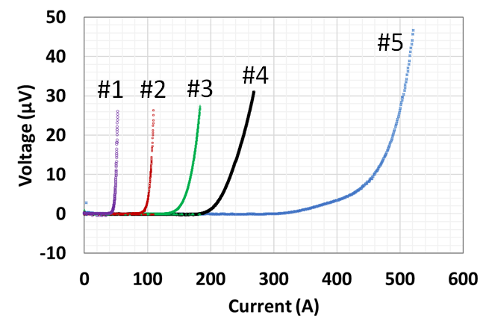
Fig. 5. V-I plots of the sample cables #1 to #5 measured in self-field at 77 K.

TABLE III
Cable I_{c} and J_{e} Measured at 77 K and Estimated at 4.2 K
Cable  no. | Cable I_{c} (A)  77K | Cable I_{c} (A)  16 T, 4.2 K | Cable I_{c} (A)  20 T, 4.2 K | Cable J_{e} (A/mm²)  20 T, 4.2 K
#1 | 51 (52) ª | 88 | 74 | 22
#2 | 106 (109) ª | 182 | 155 | 47
#3 | 170 (178) ª | 292 | 248 | 62
#4 | 238 (262) ª | 410 | 348 | 71
#5 | 496 (514) ª | 853 | 724 | 102
ª The I_{c} values in parentheses are calculated with the coated conductor length measured from the outermost layer of the cable between the voltage taps.

C. Cable Bending results
Fig. 9 shows the electric field versus current plots of the sample cables #2 to #4 measured in the bending test at 77 K. Fig. 10 summaries the cable I_{c} normalized to the initial value as a function of the bending radius. The I_{c} degradation was not observed for these cables when bending radii were 40 mm and 30 mm. Interestingly, the cable I_{c} of the sample cable #4 recovered by 4% under the 40-mm-radius bend. The measured and expected I_{c} of the sample cable #4 were 262 A and 312 A before bending. The coated conductor was subjected to compressive strain by winding it around the core during cable manufacturing, and it inside of the cable bend was subjected to tensile strain when the cable was bent. Therefore, bending the cable after manufacturing could partially release the strain and slightly recover the cable I_{c}. This I_{c} recovery indicates that the I_{c} degradation after cable construction could be a reversible degradation. In the bending test at a radius of 20 mm, the sample cable #4 shows the largest I_{c} degradation of approximately 10%, and the sample cable #2 shows the least I_{c} degradation. This tendency of the I_{c} degradation is not only caused by the increase in compressive strain in the outermost conductor layer as the cable diameter increases, but also may be due to further interference at intersections between the conductor layers. Furthermore, insufficient clearance between coated conductors can also cause the I_{c} degradation, although the gap was carefully controlled during cable construction. Overall, the sample cables have approximately 90% of the cable I_{c} before bending even after the 20-mm-radius bending. The flexible multi-wire core might have contributed to mitigating this I_{c} degradation.
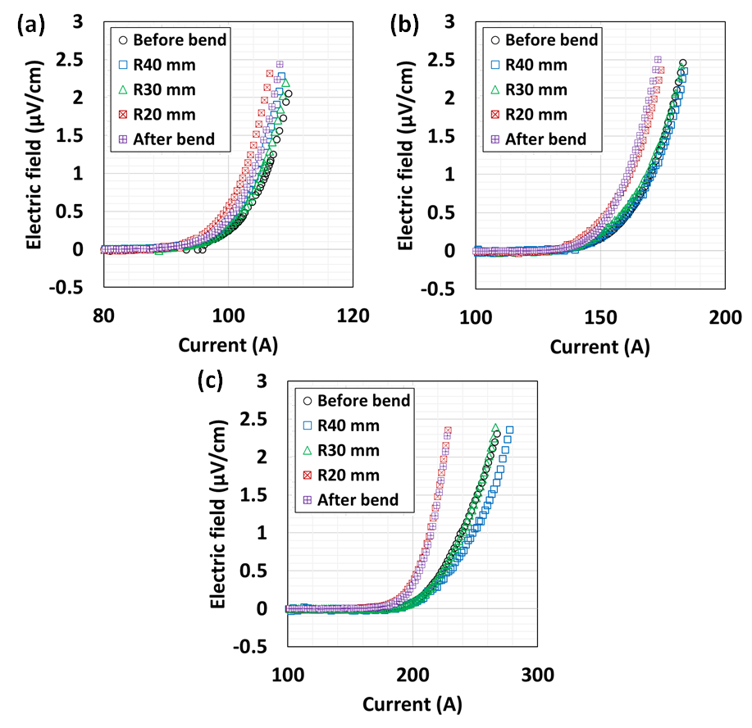
Fig. 9. Electric field versus current plots of the sample cables (a) #2, (b) #3, and (c) #4 measured from the bending test at 77K.

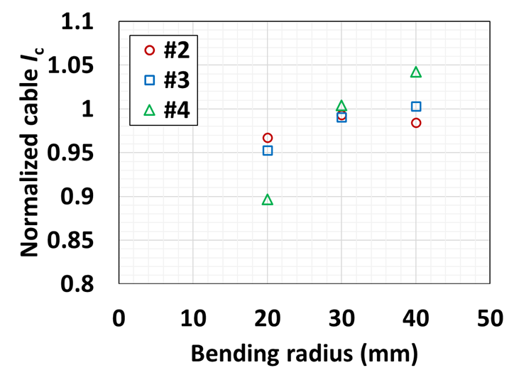
Fig. 10. Cable I_{c} normalized to the initial value as a function of the bending radius for the sample cables #2 to #4.

IV. Conclusion
The transport I_{c} of a 2-mm-wide and 0.12-mm-thick commercial REBCO coated conductor was measured at 77 K and 4.2 K. The magnetic field dependence of the conductor I_{c} was also determined to estimate the I_{c} at 20 T and 4.2 K. As a result, a lift factor of 1.46 was obtained from the fitting curve for the 77 K self-field. Five sample cables were constructed using this coated conductor and a 1.8-mm-diameter multi-wire core to investigate the cable I_{c} and J_{e} at 20 T and 4.2 K. The bending properties of these sample cables were also measured at radii of 40 mm, 30 mm, and 20 mm. In cable construction, the single-layer cables #1 and #2 showed the expected I_{c}, while the multi-layer cables #3 to #5 showed a 10% to 16% I_{c} degradation. Although the interlayer interference may be reduced by installing the insulation layer, the dimensional uniformity of the coated conductor thickness is also important for this cable construction. The cable I_{c} and J_{e} were estimated at 20 T and 4.2 K for the 0.12-mm-thick and 0.05-mm-thick coated conductors. These values of the sample cables made with the 0.12-mm-thick coated conductor were estimated to be less than 4 kA and 200 A/mm² for cable diameters less than 5 mm. These values are expected to be improved by using thinner coated conductors with higher I_{c}. In the bending test, the I_{c} degradation was observed only after bending with a radius of 20 mm, and approximately 90% was retained compared to the cable I_{c} before bending.

Acknowledgment
The authors thank the staff of the KEK mechanical engineering center for fabricating the sample holders and the staff of the Tsukuba Magnet Laboratory at NIMS for their technical support on conducting the measurements.

References
- W. Goldacker, A. Frank, R. Heller, S. I. Schlachter, B. Ringsdorf, K.-P. Weiss, C. Schmidt, and S. Schuller, “ROEBEL Assembled Coated Conductors (RACC): Preparation, Properties and Progress,” IEEE Trans. Appl. Supercond., vol. 17, pp. 3398-3401, 2007, doi: 10.1109/TASC.2007.899417.
- W. Goldacker, F. Grilli, E. Pardo, A. Kario, S. I. Schlachter, and M. Vojenčiak, “Roebel cables from REBCO coated conductors: a one-century-old concept for the superconductivity of the future,” Supercond. Sci. Technol., vol. 27, 2014, Art. no. 093001, doi: 10.1088/0953-2048/27/9/093001.
- M. Takayasu, L. Chiesa, L. Bromberg, J. V. Minervini, “Cabling Method for High Current Conductors Made of HTS Tapes,” IEEE Trans. Appl. Supercond., vol. 21, pp. 2340-2344, 2011, doi: 10.1109/TASC.2010.2094176.
- M. Takayasu, L. Chiesa, L. Bromberg, and J. V. Minervini, “HTS twisted stacked-tape cable conductor,” Supercond. Sci. Technol., vol. 25, 2012, Art. no. 014011, doi: 10.1088/0953-2048/25/1/014011.
- D. C. van der Laan, “YBa₂Cu₃O_{7−δ} coated conductor cabling for low ac-loss and high-field magnet applications,” Supercond. Sci. Technol., vol. 22, 2009, Art. no. 065013, doi: 10.1088/0953-2048/22/6/065013.
- D. C. van der Laan, X. F. Lu, and L. F. Goodrich, “Compact GdBa₂Cu₃O_{7–δ} coated conductor cables for electric power transmission and magnet applications,” Supercond. Sci. Technol., vol. 24, 2011, Art. no. 042001, doi: 10.1088/0953-2048/24/4/042001.
- D. C. van der Laan, P. D. Noyes, G. E. Miller, H. W. Weijers, and G. P. Willering, “Characterization of a high-temperature superconducting conductor on round core cables in magnetic fields up to 20 T,” Supercond. Sci. Technol., vol. 26, 2013, Art. no. 045005, doi: 10.1088/0953-2048/26/4/045005.
- D. C. van der Laan, J. D. Weiss, P. Noyes, U. P. Trociewitz, A. Godeke, D. Abraimov, and D. C. Larbalestier, “Record current density of 344 A mm⁻² at 4.2 K and 17 T in CORC® accelerator magnet cables,” Supercond. Sci. Technol., vol. 29, 2016, Art. no. 055009, doi: 10.1088/0953-2048/29/5/055009.
- J. D. Weiss, T. Mulder, H. J. ten Kate, and D. C. van er Laan, “Introduction of CORC® wires: highly flexible, round high-temperature superconducting wires for magnet and power transmission applications,” Supercond. Sci. Technol., vol. 30, 2017, Art. no. 014002, doi: 10.1088/0953-2048/30/1/014002.
- J. D. Weiss, D. C. van der Laan, D. Hazelton, A. Knoll, G. Carota, D. Abraimov, A. Francis, M. A. Small, G. Bradford, and J. Jaroszynski, “Introduction of the next generation of CORC® wires with engineering current density exceeding 650 A mm⁻² at 12 T based on SuperPower's ReBCO tapes containing substrates of 25 μm thickness,” Supercond. Sci. Technol., vol. 33, 2020, Art. no. 044001, doi: 10.1088/1361-6668/ab72c6.
- D. C. van der Laan, K. Radcliff, V. A. Anvar, K. Wang, A. Nijhuis, and J. D. Weiss, “High-temperature superconducting CORC® wires with record-breaking axial tensile strain tolerance present a breakthrough for high-field magnets,” Supercond. Sci. Technol., vol. 34, 2021, Art. no. 10LT01, doi: 10.1088/1361-6668/ac1aae.
- S. Kar, W. Luo, V. Selvamanickam, “Ultra-Small Diameter Round REBCO Wire With Robust Mechanical Properties,” IEEE Trans. Appl. Supercond., vol. 27, 2017, Art. no. 6603204, doi: 10.1109/TASC.2017.2669727.
- S. Kar, W. Luo, A. B. Yahia, X. Li, G. Majkic, and V. Selvamanickam, “Symmetric tape round REBCO wire with J_{e} (4.2 K, 15 T) beyond 450 A mm⁻² at 15 mm bend radius: a viable candidate for future compact accelerator magnet applications,” Supercond. Sci. Technol., vol. 31, 2018, Art. no. 059601, doi: 10.1088/1361-6668/aaba69.
- S. Kar, J. S. Sandra, W. Luo, M. Kochat, J. Jaroszynski, D. Abraimov, G. Majkic, and V. Selvamanickam, “Next-generation highly flexible round REBCO STAR wires with over 580 A mm⁻² at 4.2 K, 20 T for future compact magnets,” Supercond. Sci. Technol., vol. 32, 2019, Art. no. 10LT01, doi: 10.1088/1361-6668/ab3904.
- E. Galstyan, J. Kadiyala, M. Paidpilli, C. Goel, J. S. Sandra, V. Yerraguravagari, G. Majkic, R. Jain, S. Chen, and Y. Li, “High critical current STAR® wires with REBCO tapes by advanced MOCVD,” Supercond. Sci. Technol., vol. 36, 2023, Art. no. 055007, doi: 10.1088/1361-6668/acc4ed.
- K. Tsuchiya, A. Kikuchi, A. Terashima, K. Suzuki, K. Norimoto, M. Tawada, M. Masuzawa, N. Ohuchi, X. Wang, Y. Iijima, T. Takao, S. Fujita, M. Daibo, and Y. Iijima, “Critical Current Characterization of Commercial REBCO Coated Conductors at 4.2 and 77 K,” IEEE Trans. Appl. Supercond., vol. 27, 2017, Art. no. 6600205, doi: 10.1109/TASC.2016.2625762.
- K. Tsuchiya, A. Kikuchi, A. Terashima, K. Norimoto, M. Uchida, M. Tawada, M. Masuzawa, N. Ohuchi, X. Wang, T. Takao, and S. Fujita, “Critical current measurement of commercial REBCO conductors at 4.2 K,” Cryogenics, vol. 85, pp. 1-7, 2017, doi: 10.1016/j.cryogenics.2017.05.002.
- K. Tsuchiya, X. Wang, S. Fujita, A. Ichinose, K. Yamada, A. Terashima, and A. Kikuchi, “Superconducting properties of commercial REBCO-coated conductors with artificial pinning centers”, Supercond. Sci. Technol., vol. 34, 2021, Art. no. 105005, doi: 10.1088/1361-6668/ac1e65.
- K. Tsuchiya, M. Tawada, M. Masuzawa, A. Terashima, N. Ohuchi, M. Sugano, X. Wang, A. Kikuchi, Y. Arimoto, Z. Zong, S. Fujita, M. Daibo, and Y. Iijima, “Development of HTS Sextupole Magnet for SuperKEKB Interaction Region,” IEEE Trans. Appl. Supercond., vol. 26, 2016, Art. no. 4100904, doi: 10.1109/TASC.2016.2526069.
- X. Wang, K. Tsuchiya, S. Fujita, S. Muto, and Y. Iijima, “Experiment and Numerical Simulation on Quench Characteristics of ReBCO-Impregnated Coil,” IEEE Trans. Appl. Supercond., vol. 27, 2017, Art. no. 4700105, doi: 10.1109/TASC.2016.2625766.
- K. Tsuchiya, S. Fujita, A. Terashima, X. Wang, Y. Arimoto, M. Masuzawa, N. Ohuchi, M. Tawada, A. Kikuchi, M. Daibo, and Y. Iijima, “Prototype HTS Sextupole Magnet for SuperKEKB Interaction Region”, IEEE Trans. Appl. Supercond., vol. 29, Aug. 2019, Art. no. 4002604, doi: 10.1109/TASC.2019.2898329.
- X. Wang, M. Uchida, K. Tsuchiya, A. Terashima, T. Takao, and A. Kikuchi., “Splice Resistance Measurements of REBCO Tapes for a REBCO Sextupole Magnet”, IEEE Trans. Appl. Supercond., vol. 29, 2019, Art. no. 8800905, doi: 10.1109/TASC.2019.2908603.
- X. Wang, K. Tsuchiya, Y. Arimoto, A. Terashima, S. Fujita, M. Tawada, R. Ueki, Z. Zong, M. Kawai, M. Masuzawa, N. Ohuchi, and A. Kikuchi, “Excitation and Magnetic Field Performances of a Prototype REBCO Sextupole Coil at 4.2 K”, IEEE Trans. Appl. Supercond., vol. 30, 2020, Art. no. 4600304, doi: 10.1109/TASC.2020.2969396.
- C. Senatore, C. Barth, M. Bonura, M. Kulich, and G. Mondonico, “Field and temperature scaling of the critical current density in commercial REBCO coated conductors,” Supercond. Sci. Technol., vol. 29, 2016, Art. no. 014002, doi: 10.1088/0953-2048/29/1/014002.
- A. Francis, D. Abraimov, Y. Viouchkov, Y. Su, F. Kametani, and D. C. Larbalestier, “Development of general expressions for the temperature and magnetic field dependence of the critical current density in coated conductors with variable properties,” Supercond. Sci. Technol., vol. 33, 2020, Art. no. 044011, doi: 10.1088/1361-6668/ab73ee.

Submitted for review September 19, 2023 This work was supported by “MEXT Development of key element technologies to improve the performance of future accelerators Program” Japan Grant Number JPJ123456 and JSPS KAKENHI Grant Numbers 19H01911. Xudong Wang, Kiyosumi Tsuchiya, and Akio Terashima are with the High Energy Accelerator Research Organization (KEK), Tsukuba, Ibaraki 305-0801, Japan (e-mail: wanxdon@post.kek.jp). Suguru Tanabe is with the Junkosha Inc., Kasama, Ibaraki 309-1603 Japan. Nobuyuki Negishi is with the Junkosha Inc., Chiyoda, Tokyo 101-0062 Japan. Akihiro Kikuchi is with the National Institute for Materials Science (NIMS), Tsukuba, Ibaraki 305-0028, Japan. Color versions of one or more of the figures in this article are available online at http://ieeexplore.ieee.org

