Asymmetric porous catalyst structures for low temperature photocatalytic dry reforming of methane
William Moore^{1†}, Shusaku Shoji^{1,2,3†*}, Lieihn Tsaur¹, Fei Yu^{1,4}, R. Paxton Thedford^{1,5}, William R. Tait^{1,5}, M. Sadegh Riasi⁷, Aniruddha Saha⁸, Kayhun Hur⁹, Austin Reese⁵, Ali Y. Kozbek¹, Sarah Hesse^{1,4,10}, Sol M. Gruner⁶, Lilit Yeghiazarian⁷, Sadaf Sobhani⁸, Jin Suntivich^{1,2}, Ulrich B. Wiesner^{1,2,11*}
¹ Department of Materials Science and Engineering, Cornell University, Ithaca, New York 14853, United States
² Kavli Institute at Cornell for Nanoscale Science, Cornell University, Ithaca, New York 14853, United States
³ National Institute for Materials Science, 1-1 Namiki, Tsukuba, Ibaraki 305-0044, Japan
⁴ Department of Chemistry and Chemical Biology, Cornell University, Ithaca, New York, 14853, United States
⁵ Robert Frederick Smith School of Chemical and Biomolecular Engineering, Ithaca, New York, 14853, United States
⁶ Department of Physics, Cornell University, Ithaca, New York 14853, United States
⁷ Department of Chemical and Environmental Engineering, University of Cincinnati, Cincinnati, Ohio 45521, United States
⁸ Sibley School of Mechanical and Aerospace Engineering, Cornell University, Ithaca, New York 14853, United States
⁹Korea Institute of Science and Technology 5, Hwarang-ro 14-gil Seongbuk-gu Seoul, 02792 Republic of Korea
¹⁰Present address: Stanford Synchrotron Radiation Lightsource, SLAC National Accelerator Laboratory; Menlo Park, California 94025, United States
¹¹ Department of Design Tech, Cornell University; Ithaca, New York 14853, United States

†Authors contributed equally to this work

Abstract
Recent advances in the photocatalytic activation of dry reforming of methane (DRM: CO₂ + CH₄ → 2CO + 2H₂) at low temperature and ambient pressure have generated considerable interest as a promising route to convert greenhouse gases into valuable synthetic gas (syngas). While detailed studies have revealed the mechanisms involved in photocatalytic DRM at metal-semiconductor interfaces, less attention has been devoted to how high surface area semiconductor supports may enhance such conversions. Here we structure triblock terpolymer self-assembly directed sol-gel derived transition metal oxide (Ta₂O₅ or TiO₂) supports of Rh-decorated photocatalysts into various equilibrium and non-equilibrium derived porous morphologies and show how they modulate single-pass conversion, total production rate, and material efficiency. Supported by in-depth materials characterization, flow and optics simulations rationalizing observed trends, results reveal record catalyst performance. Our work suggests that asymmetric pore structures simultaneously optimizing mass transport and surface area may be well-suited to maximize photocatalyst performance.

Introduction
The drastic increase in atmospheric greenhouse gases such as carbon dioxide (CO₂) and methane (CH₄) is a primary driver of climate change. Dry reforming of methane (DRM: CO₂ + CH₄ → 2CO + 2H₂) has been attracting attention as one of the most promising ways to convert CO₂ and CH₄ into a valuable synthesis gas (syngas) consisting of carbon monoxide (CO) and hydrogen (H₂)^{1,2}. This technology can potentially reduce environmental harms associated with emissions from the extraction and utilization of natural gas, shale gas, biogas, methane hydrates, and other natural resources, while providing a pathway to creating feedstocks for organic chemistry precursors³⁻⁶. DRM is a highly endothermic reaction (ΔH = +247 kJ/mol) that traditionally requires temperatures of 800°C or higher to proceed efficiently⁷. Due to these high reaction temperatures, DRM catalysts suffer from deactivation by thermal aggregation of co-catalysts and carbon deposition, limiting their practical use.
Recent advances have been made toward photocatalytic, rather than thermally activated, DRM. These systems use metals supported by oxide semiconductors such as Ga₂O₃, SrTiO₃, TiO₂, or CeO₂, or metal localized surface plasmon resonances in reactant activation⁸⁻¹⁴. Very recently, it has been reported that rhodium nanoparticle-loaded strontium titanate (Rh/SrTiO₃) and rhodium intertwined with cerium oxide (termed Rh#CeO₂) considerably exceeded the theoretical thermal catalyst thermodynamic limit by utilizing light rather than heat^{15,16}. Several studies have further investigated the degree to which DRM photocatalysis is separate from thermal catalysis due to surface heating. In the Rh/SrTiO₃ study, the illumination-induced heating of the catalyst surface reached only 300 °C, yet the observed catalytic activity exceeded the thermal catalyst thermodynamic limit at that temperature by an order of magnitude. Similarly, in a DRM study of β-Ga₂O₅ at a surface temperature of 200 °C, CO and H₂ were only generated under illumination. No CO or H₂ products were generated without illumination up to a surface temperature of 400°C¹⁷. Given the low activity of thermal catalysts at these surface temperatures, the photocatalytic mechanism should be dominant in similar systems without external heating. On the higher end of the temperature range, photothermal work on Pt/CeO₂ measured a surface temperature of 480°C under 30 suns irradiation with moderate CO and H₂ production, while no activity was measured at the same temperature without irradiation. At higher temperatures where thermal catalysis became more active, irradiation still doubled catalyst activity on Pt/CeO₂ up to 700°C¹⁸. In all these systems, thermal catalysis in response to surface heating under illumination cannot be primarily responsible for the measured photo-DRM activity.
Mechanistic investigations on the Rh/SrTiO₃ system via electron spin resonance (ESR) spectroscopy demonstrated the generation of photocarriers and diffusion of photogenerated electrons to surface Rh particles (Supplementary Figure 1). Upon the introduction of CH₄, the measured hole signal decreased, suggesting CH₄ oxidation on the semiconductor support. Isotope studies of the photocatalytic DRM system identified that lattice oxygen in the oxide mediates CH₄ oxidation with oxygen isotopes doped into the oxide appearing in generated CO, while charge density in the supported metal mediates the reduction of CO₂, suggesting that the metal-semiconductor interface is key to the photocatalytic reaction. Activity was strongly dependent on sub-bandgap wavelengths of incident light and scaled with light intensity, supporting a photocatalytic DRM mechanism based on photocarrier generation in the semiconductor^{15,16}. In particular, the Rh#CeO₂ photocatalyst with many exposed nanoscopic metal-semiconductor interfaces exhibited a methane conversion rate exceeding 60% due to the efficient charge separation of photoexcited electron-hole pairs and diffusion of lattice oxygen. The photocatalysts described above were used in the form of non-porous solids, however, thus limiting the accessible surface area per unit volume. Furthermore, despite relatively high reactant conversions, these studies were performed at very low flow rates of dilute reactants, achieving impractically low production rates of CO and H₂.
Here photocatalysts for DRM were developed from porous semiconducting oxides decorated with Rh metal nanoparticles. To that end, block copolymer self-assembly (BCP SA) directed periodically ordered mesoporous TiO₂ and Ta₂O₅ supports with hexagonally-packed cylinders (Hex), co-continuous double gyroid (G^{D}), or alternating gyroid (G^{A}) morphologies and homogeneous 15-30 nm diameter pores were synthesized from evaporation-induced SA (EISA), a (close to) equilibrium process. For comparison, TiO₂ film supports combining asymmetric, hierarchical pore structures across the film normal with well-defined mesoporosity throughout the material were derived from a non-equilibrium BCP SA approach referred to as SNIPS (self-assembly plus non-solvent induced phase separation). Metal nanoparticles of Rh were generated on supports by reduction of rhodium chloride hydrate to rhodium metal. While the effects of various BCP directed porous supports with equilibrium-type network morphologies on other photocatalytic reactions have been studied, none of them were on DRM¹⁹⁻²¹. Most importantly, to the best of our knowledge no photocatalytic studies to date compared such equilibrium-type porous catalysts supports with photocatalysts exhibiting non-equilibrium derived asymmetric pore structures. Photocatalytic DRM conversions were studied under light irradiation without external heating, achieving up to 75% (Rh/Ta₂O₅-G^{D}), 78% (Rh/TiO₂-Film) and 82% (Rh/Ta₂O₅-G^{A}) CO₂ and CH₄ conversion at low flow rates. In concentrated gas at high flow rates, CO/H₂ production rates up to 28,500 mmol / (hr·g) at 9.7% CO₂/CH₄ conversion were achieved (Rh/TiO₂-Film). This mass-normalized production rate is more than 400 times higher than that of previous state-of-the-art ambient-temperature photocatalysts. All mesoporous catalysts outperformed commercial non-mesoporous Ta₂O₅ and TiO₂ powder-based catalysts. Furthermore, only moderate performance degradation was observed over a 72-hour long test run for Ta₂O₅-G^{A} supports, yielding a turnover frequency of 38,300/hr. Especially at high flow rates, G^{A} and asymmetric film supports demonstrated enhanced single-pass conversions as well as production rates on the bases of mass and surface area over hexagonal and G^{D} supports. With respect to the latter two performance metrics, the asymmetric thin film catalyst substantially outperformed all other samples across all flow rates tested. Results rationalized by further flow and optics simulations demonstrate the importance of asymmetric hierarchical pore structures that optimize both mass transport and surface area, thereby allowing substantial improvements in DRM photocatalytic reactivity.

Results and Discussion
Synthesis and characterization of porous supports and metal decorated photocatalysts
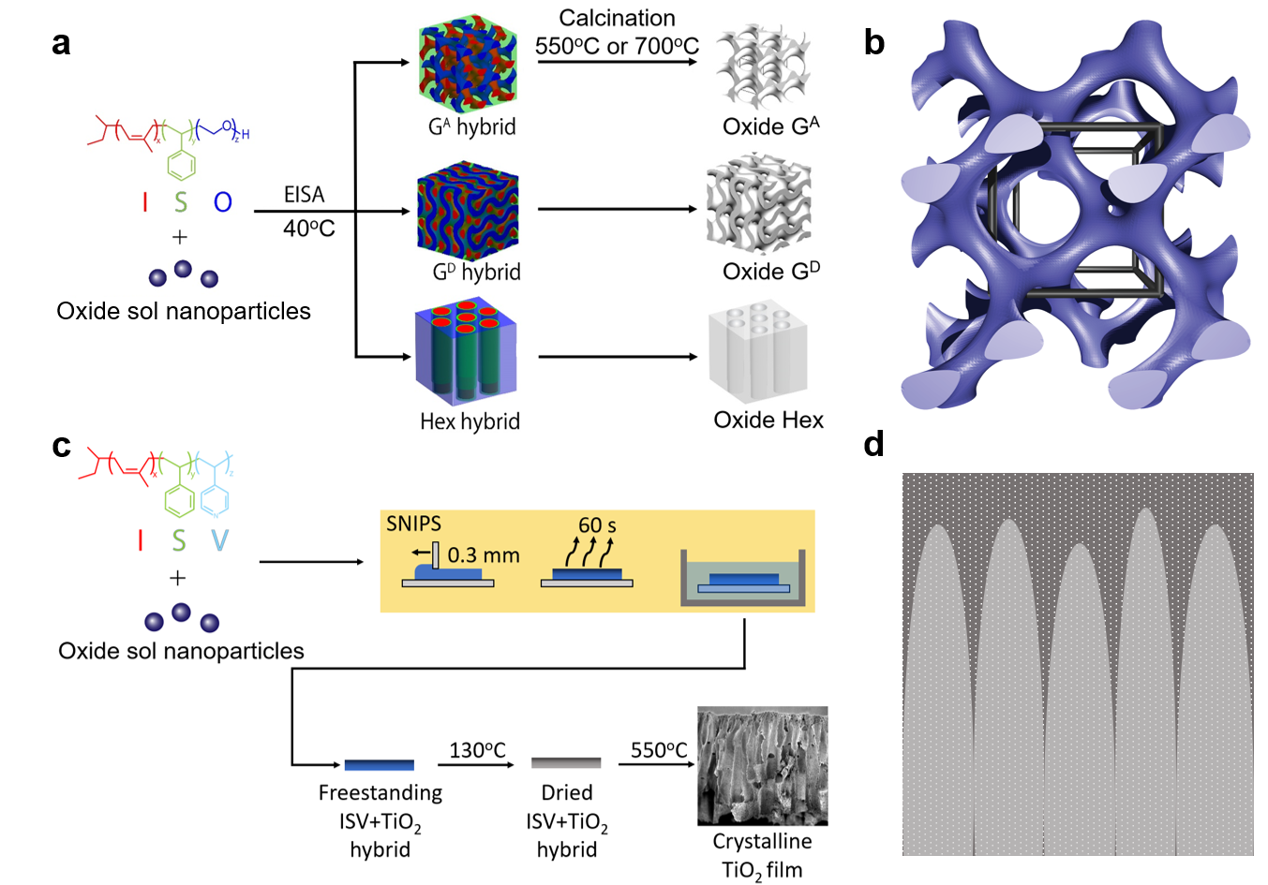
Figure 1: Schematic of the synthesis steps for the different types of porous metal oxide supports. (a) For gyroidal and hexagonal materials, a mixture of ISO triblock terpolymer and Ta₂O₅ or TiO₂ sol nanoparticles undergoes evaporation-induced self-assembly (EISA) at 40°C to yield hybrids with alternating gyroid (G^{A}), double gyroid (G^{D}) or hexagonally packed cylinders (Hex) equilibrium structures. The hybrids are calcined at 550°C (TiO₂) or 700°C (Ta₂O₅) for 3hr in air to remove the polymer template and obtain mesoporous oxide supports. (c) For asymmetric TiO₂ films, solutions of ISV triblock terpolymer and TiO₂ sol are combined, cast onto glass, allowed to partially evaporate, then plunged into water; yielding freestanding polymer-inorganic-hybrid thin films with hierarchical asymmetric pore structure. Subsequent heat treatment at 550°C yields crystalline TiO₂ thin film supports. Polyisoprene, polystyrene, polyethylene oxide and poly(4-vinyl-pyridine) blocks are shown in red, green, dark blue and light blue, respectively. (b, d) Illustrations of the G^{A} and asymmetric support structures, with the former emphasizing the open and continuous pore space, and the latter exhibiting a finger-like substructure with large macropores extending from the bottom toward the surface of the universally mesoporous films.
Seven porous catalyst supports were synthesized for this study from two materials and with four morphologies: mesoporous TiO₂ and Ta₂O₅ supports with alternating gyroid (G^{A}), double-gyroid (G^{D}), and hexagonal-cylindrical (Hex) structures, as well as a porous TiO₂ thin film combining asymmetric, hierarchical pore structures across the film normal with well-defined mesoporosity throughout the material (Figure 1, Materials and Methods)²². Gyroidal and hexagonal supports were fabricated via BCP SA with one of two poly(isoprene-block-styrene-block-ethylene oxide) (PI-b-PS-b-PEO or ISO) terpolymers (ISO-1 and ISO-2, Supplementary Table 1), depending on the desired mesostructure: G^{A} from ISO-1; G^{D} and Hex from ISO-2. Structure formation for gyroidal and hexagonal structures occurred overnight via evaporation-induced self-assembly (EISA) at 40°C. The TiO₂ thin film was fabricated via SNIPS using a poly(isoprene-block-styrene-block-4-vinyl-pyridine) (PI-b-PS-b-P4VP or ISV) terpolymer (ISV-1, Supplementary Table 1). Hybrid polymer/oxide materials were subsequently heat treated at 130°C for 5 hours in vacuum, followed by calcination in air to remove the ISO or ISV terpolymer and crystallize the oxide phase. TiO₂ and Ta₂O₅ materials were calcined at 550°C and 700°C, respectively. After calcination, porous supports were characterized via a combination of small-angle X-ray scattering (SAXS), scanning electron microscopy (SEM), and nitrogen sorption to establish sample structure and porosity (Materials and Methods).
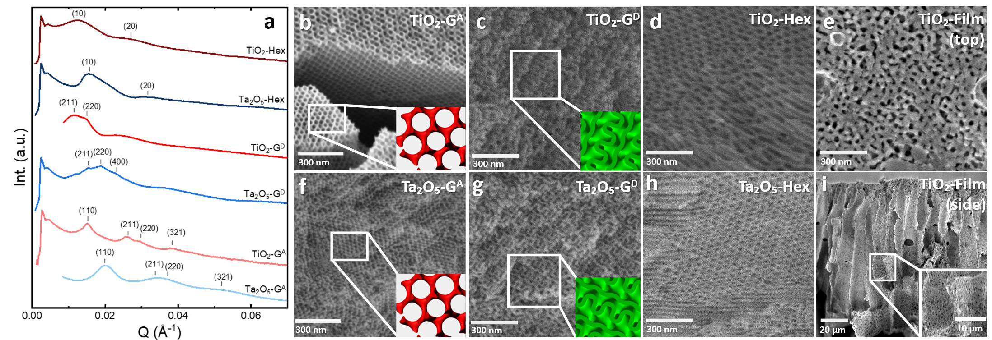
Figure 2: Characterization of porous catalyst supports. (a) SAXS results for the gyroidal or hexagonal oxide support materials studied as indicated. For each sample, visible peaks are indexed according to expected peak positions for G^{A}, G^{D}, or Hex lattices (as indicated). (b-i) SEM micrographs of the catalyst supports studied. Micrographs b, f and c, g are consistent with network morphologies for G^{A} and G^{D} samples, respectively. Micrographs d, h establish hexagonally packed cylinder morphologies for TiO₂-Hex and Ta₂O₅-Hex samples, respectively. Insets in panels b, f and c, g show simulated [111] projections of a G^{A} structure and [211] projections of a G^{D} structure, respectively, consistent with distinctive observed features in the associated SEMs. Micrographs e, i show top surface layer and film cross section, respectively, of the asymmetric TiO₂ film support. The micrograph of the top-surface of the TiO₂ film, e, shows disordered pores in the 20-30 nm range, while the cross-section, i, shows the 10-20 µm sized macroporous fingers extending almost to the top surface and lined with mesoporous walls (see inset). Additional larger SEM micrographs are shown in Supplementary Figure 2.

The corresponding scattering patterns for the six periodically ordered materials are shown in Figure 2a. The asymmetric SNIPS derived TiO₂-Film sample lacking mesoscale periodic order was not included in the SAXS analysis. The low signal intensity for all support materials due to the strongly absorbing nature of these crystalline oxides, together with the relatively broad observed peaks, makes assignments to underlying lattices challenging. Tentative indexing of the observed peaks is shown in the figure. The four peaks assigned to samples TiO₂-G^{A} and Ta₂O₅-G^{A} are consistent with an alternating gyroid (G^{A}) lattice with cubic unit cell lattice parameters of 52.3 nm and 44.8 nm, respectively. For sample TiO₂-G^{D}, the first two indexed peaks of the pattern have been tentatively assigned to a double gyroid lattice with cubic lattice parameter of a = 135.8 nm. For sample Ta₂O₅-G^{D}, three of the observed peaks have been tentatively assigned to a double gyroid lattice with cubic lattice parameter a = 94.0 nm. SAXS results for samples TiO₂-Hex and Ta₂O₅-Hex both show a very broad first order peak and one additional higher order reflection tentatively assigned to hexagonal lattices. Associated (10) lattice dimensions, d₁₀, were 47.6 nm and 39.8 nm, respectively. Interestingly, although TiO₂ and Ta₂O₅ samples were synthesized from the same terpolymers, all TiO₂ structures showed patterns shifted to smaller values of q, i.e., larger mesostructure unit cell sizes than Ta₂O₅ counterparts. This shift is likely due to the higher density of Ta₂O₅, resulting in higher degrees of shrinkage during calcination.
To corroborate lattice interpretations from SAXS (Table 1), sample mesostructure was further investigated via SEM (Figure 2b-i, Supplementary Figure 2). Supports were imaged after calcination (to increase contrast), but prior to rhodium deposition. SEM images for G^{A} and G^{D} samples clearly show continuous network morphologies, while those of TiO₂-Hex and Ta₂O₅-Hex both show cylinders, consistent with gyroidal and hexagonally-packed cylinder lattice assignments from SAXS, respectively. In the G^{A} morphology, the d₁₀₀ distance can be measured as the distance between the wall of a pore, and the center of the neighboring pore. From the visible [111] projection of the G^{A} samples in Figure 2b, f lattice parameters of d₁₀₀ = 51 ± 2 nm for TiO₂-G^{A} and d₁₀₀ = 45 ± 3 nm for Ta₂O₅-G^{A} were obtained. These are similar to the respective d₁₀₀ values obtained from SAXS (52.3 nm and 44.8 nm). Along the G^{D} structure [211] projection, the width of each row of coils is approximately 80% of the d₁₀₀ length, which was determined as d₁₀₀ = 132 ±5 nm for TiO₂ and d₁₀₀ = 88 ± 6 nm for Ta₂O₅ from suitably orientated grains in Figure 2c, g²³. This is again similar to the values for TiO₂ (d₁₀₀ = 135.8 nm) and Ta₂O₅ (d₁₀₀ = 94.0 nm) derived from SAXS. SEM images of the respective gyroid structures in Figure 2b, c, f, g have visible features in agreement with simulated projections of these structures (see insets) corroborating the lattice assignments. SEM analysis of the (10) spacing for the hexagonal structures (Figure 2d, h), the distance between rows of pores, yields 48 ± 2 nm and 42 ± 3 nm for the TiO₂-Hex and Ta₂O₅-Hex structures, respectively, consistent with values of 47.6 nm and 39.8 nm from SAXS results. SEM images of the asymmetric TiO₂ film (Figure 2e, i) show a finger-like asymmetric cross-section with mesoporous walls and a mesoporous top surface. In the context of photocatalysis applications, these images collectively suggest that pore accessibility should increase in the following order: hexagonally packed cylinder < networked gyroidal < asymmetric structures. Finally, all seven supports were characterized by quantitative sorption/desorption analyses (Supplementary Discussion, Supplementary Figure 3). Results summarized in Table 1 show systematic decreases in surface area for both TiO₂- and Ta₂O₅-supports across morphologies (G^{A} > G^{D} > Hex) and higher values for TiO₂ as compared to Ta₂O₅.

Table 1: Summary of structural characterization results for oxide catalyst supports and rhodium particles. BJH pore statistics do not include pores larger than 300 nm, thus the TiO₂ film values marked with asterisks (BET surface area, average pore width, pore volume, and overall porosity) are likely slight underestimations.
Catalyst | SAXS d₁₀₀ size (nm) | BET surface area (m²/g) | BJH avg. pore width (nm) | BJH pore vol. (cm³/g) | Porosity (%) | XRD oxide crystallite size (nm) | XRD Rh crystallite size (nm)
TiO₂-G^{A} | 52.3 | 123.8 | 29.9 | 1.275 | 84.2 | 13.8 | 12.4
Ta₂O₅-G^{A} | 44.8 | 39.1 | 35.7 | 0.349 | 74.1 | 17.6 | 17.1
TiO₂--G^{D} | 135.8 | 61.1 | 23.5 | 0.364 | 60.6 | 8.6 | 9.1
Ta₂O₅-G^{D} | 94.0 | 25.7 | 22.9 | 0.147 | 54.6 | 27.5 | 12.5
TiO₂-Hex | 47.6 | 43.7 | 18.7 | 0.204 | 46.1 | 9.0 | 9.8
Ta₂O₅-Hex | 39.8 | 11.7 | 29.0 | 0.087 | 42.1 | 18.3 | 18.3
TiO₂--Film | -- | 29.6* | 50.7* | 0.375* | 61.3* | 12.1 | 6.1

The seven catalyst supports were decorated with Rh metal nanoparticles via hydrothermal infiltration of Rh and subsequent photoreduction under illumination during catalytic evaluation (Materials and Methods). Resulting metal photocatalysts were characterized by X-ray diffraction (XRD), X-ray photoemission spectroscopy (XPS), or inductively coupled plasma mass spectroscopy (ICP-MS) (Supplementary Figure 4), with quantitative XPS (and ICP-MS) results summarized in Supplementary Table 2. All materials measured were phase-pure and fully crystalline, indicated by the lack of broad amorphous background scattering, with metallic Rh detected on all samples. Ta₂O₅ supports could be matched to the orthorhombic tantalum oxide lattice structure. TiO₂ supports exclusively showed an anatase titania lattice structure. XPS results confirmed no chemical discrepancies between different structures of each material (Supplementary Figure 4b, d). Corroboratory UV-vis measurements (Supplementary Figure 5) confirmed all oxides have approximately 3 eV band gaps. Samples were not intentionally doped but may have lower than expected band gaps due to either unintentional impurities or the higher surface-to-bulk ratio resulting from the 10-30 nm diameter pores. Rhodium particles were fully reduced to the metallic phase, without remnant rhodium chloride precursor detected in XRD, although some remnant Cl was detected in XPS as a low-intensity peak around 200 eV. Raman spectra were collected on representative catalyst materials and commercial non-porous references (Supplementary Figure 6). Porous samples showed a small Raman peak shift to higher wavenumbers, and less intense peaks associated with metal-oxygen bending modes relative to non-porous references. From previous studies, this behavior is associated with changes in oxygen vacancy concentration^{24, 25}. Results suggest a higher oxygen vacancy content in our porous samples as compared to non-porous materials, not unexpected from materials with substantially increased surface area relative to the bulk. Importantly, however, this apparent increase in oxygen vacancy concentration was not associated with systematic trends in XRD peak positions (Supplemental Figure 4) or the UV-Vis derived band gaps (Supplemental Figure 5) among our tested catalysts. This suggests that within our tested porous materials there are no systematic variations in oxygen vacancy concentrations.
Oxide crystallite sizes and rhodium particle sizes were calculated via Scherrer analysis from XRD patterns (Supplementary Figure 4a, c). XRD-based structural information for oxide supports and rhodium particles is summarized in Table 1. Oxide crystallite sizes can be compared to oxide domain dimensions as reflected by SEM results (Figure 2b-i). From SEM, the TiO₂-G^{A} and Ta₂O₅-G^{A} structures have ~12 nm thick struts, slightly smaller than the XRD derived crystallite sizes of 14 nm and 18 nm. TiO₂-G^{D} and Ta₂O₅-G^{D} oxide strut dimensions were ~25 nm, larger than the TiO₂-G^{D} 9 nm crystallite size and close to the ~27-28 nm Ta₂O₅ XRD crystallite size. SEM derived oxide domain dimensions for both hexagonal supports were also ~25 nm, larger than the XRD based crystallite sizes of ~9 nm and ~18 nm for TiO₂-Hex and Ta₂O₅-Hex, respectively. Oxide crystallite sizes for most samples were therefore either close to (for G^{D} structures) or smaller (for hexagonal structures) than the associated oxide domain dimensions. Slightly larger domain sizes in G^{A} structures without loss of mesostructure may suggest elongation of crystallites along the sample strut direction. Results are consistent with periodic mesoscale structure retention after high temperature processing, as substantial crystalline overgrowth beyond the confinement of BCP SA directed nanoscale domains is typically associated with loss of mesoscale structure.
TEM micrographs were collected for the three most active catalyst supports (TiO₂-Film and G^{A} catalysts, vide infra) to confirm the presence of metallic rhodium (Figure 3, Supplementary Figure 7). Figure 3a-c show open pore networks for all structures, including the TiO₂-Film (Figure 3c) which is likely a fragment from the more-ordered top surface layer. The micrograph of the TiO₂-G^{A} structure (Figure 3b) suggests slightly improved periodic order relative to the Ta₂O₅-G^{A} material (Figure 3a), consistent with the slightly improved peak definition observed in its SAXS pattern (Figure 2a). Figure 3d-f depicts high-magnification images of the same structures revealing lattice spacings (see insets) that can be indexed to Rh metal (200) and various oxide lattice planes. Results agree with earlier XRD and XPS datasets suggesting the presence of metallic Rh in catalyst samples. In is instructive to point out that in Table 1 we conservatively chose to report XRD derived Rh particle sizes as this technique averages over macroscopic sample volumes. When averaging over local TEM images (for an example see the case of TiO₂-G^{A} shown in Supplemental Figure 7d) smaller average particle sizes were determined (e.g., 2.3 nm vs. 12.4 nm for Rh on TiO₂-G^{A}). The values provided in Table 1 should therefore be regarded as closer to the upper Rh particle size limit in our catalysts.
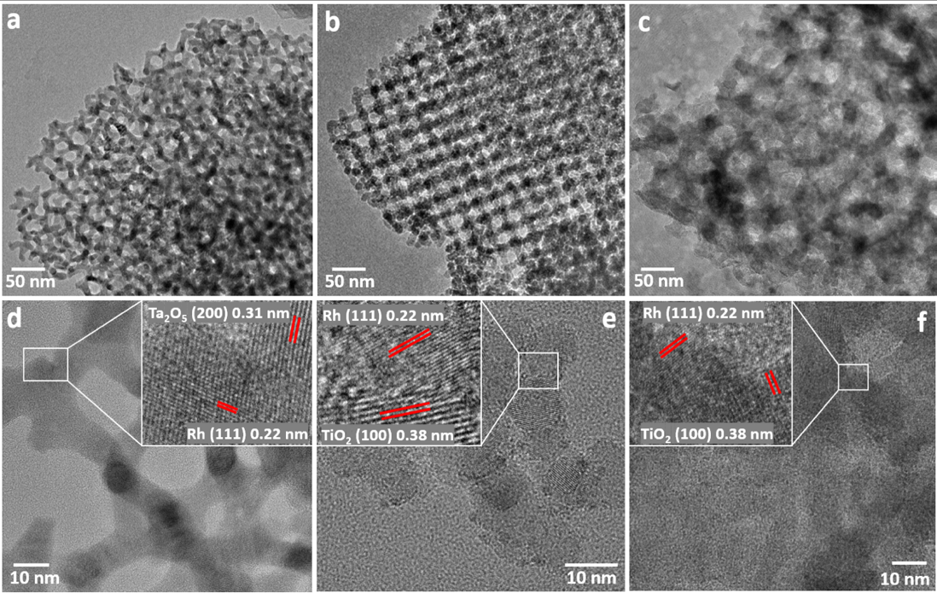

Figure 3: TEM microscopy characterization of the three most active catalyst supports. TEM micrographs of (a, d) Ta₂O₅-G^{A}, (b, e) TiO₂-G^{A}, and (c, f) the TiO₂-Film materials after catalytic evaluation. (a-c) Lower resolution images of all three structures. The region of the TiO₂ film shown likely stems from the more periodically ordered top-surface layer of the film. (d-f) High-magnification images with indexed lattice spacings for Rh and each oxide. Observed Rh metal particles varied between 2-10 nm in size, highlighting contributions from particles smaller than the average values obtained from XRD peak fitting based Scherrer analysis (Supplementary Figure 4, Table 1). Additional larger TEM micrographs are shown in Supplementary Figure 6.

Photocatalytic DRM
Photocatalysts were evaluated in a flow-through setup (Materials and Methods). Feed gas streams of either 1%/1%/98% or 10%/10%/80% CH₄/CO₂/Ar were delivered to the photocatalysts at flow rates of 0.2-2.1 mmol / hr for the 1% feed gas and 2.5-25 mmol / hr for the 10% feed gas. A large range of flow rates was used to enable a more comprehensive investigation of catalyst behavior relative to singe flow rate studies. The gyroidal and hexagonal catalyst materials were held in a quartz glass reactor (Supplementary Figure 8a), while the TiO₂ film was held in a top-loading brass reactor designed to accept samples in a film geometry (Supplementary Figure 8b and 9). Both reactors were illuminated by a 300W Xe lamp (Supplementary Figure 10) and oriented to make the reactant gas incident to the top illuminated surface. For a performance comparison of both reactors, please see Materials and Methods section. Products were measured with a gas chromatograph (Supplementary Figure 11). Volumetric flow rates ranged from 10-100 mL / min for each gas concentration. Conversion (%) is defined as the amount of products generated relative to the complete conversion of all reactants to products.
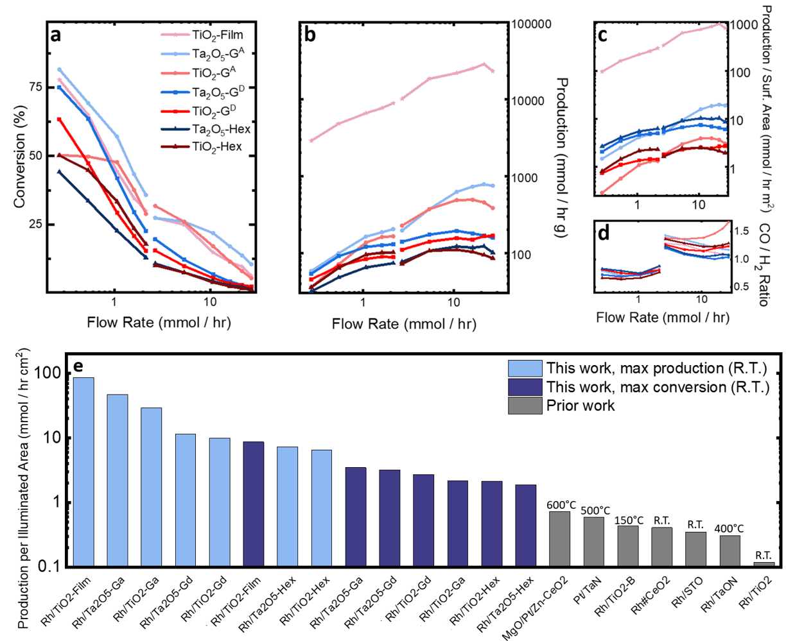
Figure 4: Photocatalytic DRM activity of the photocatalysts studied (as indicated) under 5.9 mW / cm² irradiance. (a) Conversion of CH₄ and CO₂ to CO and H₂, (b) averaged production of CO and H₂ per gram of catalyst, (c) averaged production per catalyst surface area, (d) and product ratio of CO/H₂ produced. Data representations are interrupted between 1%/1% CH₄/CO₂ (0.25-2.1 mmol / hr) and 10%/10% CH₄/CO₂ (2.5-25 mmol / hr) feed gas streams to help visually distinguish the two data sets. Individual data points in (a-d) are connected via straight lines. (e) Comparison of this work (light blue: highest production rate; violet: highest conversion of reactants to products) to other published photocatalytic or photothermal DRM results, normalized by illuminated photocatalyst area, and averaged between CO and H₂. External heating temperature is noted for prior photo-thermal work. Detailed values and references are available in Supplementary Table 3.
Figure 4a-c shows the photocatalytic DRM performance of all seven materials. At the lowest 0.25 mmol / hr feed rate, maximum conversions for the highest performers Ta₂O₅-G^{A}, TiO₂-Film, and Ta₂O₅-G^{D} were 81.6%, 77.8% and 75.1%, respectively. These conversion values all exceeded the 50-64% conversion by the most active DRM room-temperature photocatalysts to date, i.e., Rh/SrTiO₃ and Rh#CeO₂ nanocomposites^{15,16}. The G^{A} and thin film catalysts exhibit a similar flow-rate dependence above 1 mmol / hr, with both types of catalyst supports showing conversions that outpace the performance of all other samples. Both the G^{A} and asymmetric film catalysts are templated by terpolymers with only ~7-12 vol% hydrophilic blocks (as compared to ~46% for all other structures, Supplementary Table 1), consistent with more accessible surface area of openly porous materials compared to the other catalysts. Since the asymmetric thin film catalyst has ~50x less mass (Supplementary Figure 9) for the same illuminated area than other materials tested, its mass-normalized performance shows a record photocatalytic mass activity (Figure 4b), substantially outperforming all other samples across all flow rates tested in this performance metric. The two catalysts with G^{A} morphology outperform all other equilibrium derived and periodically ordered photocatalysts in this metric (especially above a flow rate of ~1 mmol / hr) due to their high-porosity-derived reduced density. Typical plateaus in production occur at 10 mmol / hr for Hex / G^{D} catalysts, 10-20 mmol / hr for G^{A} catalysts, and 20 mmol / hr for the asymmetric TiO₂ film (Figure 4b).
For both studied oxides, surface area was significantly higher for the gyroidal supports as compared to their hexagonal counterparts (Table 1). But using the performance metric of production per surface area, the asymmetric film also comes out on top by a large margin across all flow rates tested (Figure 4c). Due to the inability of the BJH method to characterize pores larger than 300 nm, the measured surface area of the asymmetric TiO₂ film is likely slightly underestimated. But since the surface area of the limited number of >300 nm macropores is minute compared to that of the many < 50 nm mesopores, this overestimation cannot account for the large margin by which the TiO₂ film outperforms the remaining structures on a surface-area-normalized basis. Within the family of equilibrium derived periodically ordered catalysts, when normalized to the internal (BET) surface area, the production rates of tantalum oxide-based catalysts are higher than those of their titania counterparts across all flow rates measured. In part, this performance difference results from TiO₂’s higher surface area, around a factor of 3 across all morphologies (Table 1). Other contributing effects (e.g., side reactions) are discussed in the Supplementary Information. Within the set of samples for each oxide, at slow feed rates (< 2 mmol / hr), surface-area-normalized performance of the gyroidal and hexagonally structured samples are comparable (Figure 4c). In contrast, at high flow rates (> 2 mmol / hr), the surface-area-normalized production rates of catalysts with G^{A} morphology increasingly outperform those of catalysts with either hexagonal or G^{D} morphology (by 2-3x at 20 mmol / hr).
A durability test was conducted over 72 hours with photocatalyst Ta₂O₅-G^{A} at its maximum mass-normalized reaction condition, i.e., at a high flow rate of 18.5 mmol / hr (Supplementary Figure 12). Photocatalyst performance only moderately declined to ~75% of its initial activity over the 72hr time period, reaching a turnover frequency, defined as mole of CO and H₂ (averaged) produced per mole of Rh over time, of 38,320 / hr or 10.6 / s. Additional comparisons to the porous catalysts were performed with commercial non-porous Ta₂O₅ and TiO₂ particle powder catalysts (Supplementary Figure 13, Supplementary Table 3). These reference results verify that the used reactors adequately reproduce the performance of reference catalysts relative to the literature. As expected, all porous catalysts outperform the non-porous catalysts in percentage of reactants converted, mass-normalized production, and surface-area-normalized production (Supplementary Figure 13a-c).
The product ratio between CO and H₂ as a function of flow rate is shown in Figure 4d. Notably, the CO/H₂ ratio substantially changed with feed gas concentration, with ratios below and above 1 for feed gas concentrations of 1% and 10% CH₄/CO₂, respectively. Overall, there seems to be qualitatively different behavior for tantalum oxide and titania based photocatalysts, with product ratios at high flow rates (>2 mmol / hr) converging towards 1 for tantalum oxide-based catalysts, while those of titania diverge towards a higher CO to H₂ ratio in the product stream. The asymmetric TiO₂ film catalyst is the exception to this rule as its behavior converges towards 1, similar to the tantalum oxide-based materials. For further in-depth analysis and discussion of this behavior, we refer to the supplementary information (Supplementary Discussion; Supplementary Table 4).
Figure 4e and Supplementary Table 3 provide an overall comparison of the (meso-) porous catalysts studied in this work to published works in photocatalytic and photo-thermal DRM in the form of a bar chart of production per illuminated area (spot size). This measure of performance is relevant for photocatalyst deployment since reactor design is primarily limited by the illuminated area of the catalyst, rather than its mass. Notably, Rh/TiO₂-G^{A} can be directly compared to a non-structured powder Rh/TiO₂ catalyst¹⁶, where Rh/TiO₂-G^{A} demonstrates both a higher maximum reactant conversion (50.3% vs 20.7%) and a 240x improvement in the maximum measured production per illuminated area. Mesostructure variations alone account for this substantial uplift in both single-pass conversion and maximum production for Rh/TiO₂. The highest activity catalyst studied, the asymmetric TiO₂ film, demonstrated a 719x improvement over the previously studied room-temperature Rh/TiO₂ catalyst in terms of production per illuminated area. This performance metric is not affected by the very low mass of the thin film, rather, the highly porous material and hierarchical pore network drove improvements in both conversion and production over all other TiO₂ structures studied. When normalized by mass, the asymmetric TiO₂ film achieved between 150-1500x improvements in production rate (depending on flow rate) compared to previously studied Rh/TiO₂.
Simulations
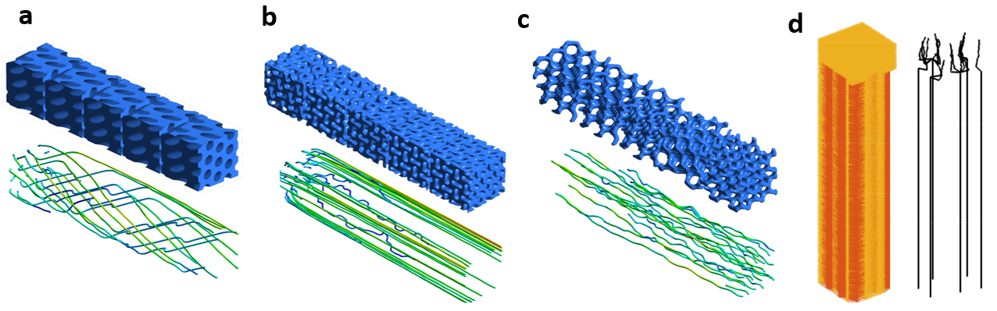
Figure 5: Gas flow simulations through the different porous media studied. (a) Hex, (b) G^{D}, and (c) G^{A} periodic mesostructures and (d) asymmetric film structures exhibiting 45%, 55%, 85%, and 95% porosity, respectively. Simulated flow pathways of gas are shown below (or next to) each structure, with gas flowing left-to-right (a-c), or top-down (d). Tortuosity was estimated for each structure based on the ratio of the path length of each flow line to the length of the simulated structures. For clarity, fewer flow lines are shown than were produced from the simulations (note: in a-c straight lines result from gas flowing past rather than through the porous structures). Based on these simulations, estimated tortuosity values for the Hex, G^{D}, G^{A}, and asymmetric film (with 100 μm thickness) structures are 3.3, 2.0, 1.2, and 1.1, respectively.
Flow simulations were performed to estimate the tortuosity for each of the catalyst structures used (Figure 5, Materials and Methods). Tortuosity in this study is defined as the path length of a simulated gas flow line versus the length of the structure studied. Each of the simulations provided qualitative insights into gas transport through these porous photocatalysts. As expected, of all the equilibrium-based periodically ordered structures tested, the highly porous G^{A} structure with approximately 85% porosity had the lowest simulated tortuosity of T = 1.2 (Figure 5c). The path of gas through this structure would be 1.2x longer than a direct path. Tortuosity is inversely related to diffusivity through catalyst structures, so it follows that the G^{A} structure with the lowest tortuosity has the most advantageous gas flow characteristics for catalysis, and thus the highest activity. The G^{D} structure had an estimated tortuosity of T = 2.0, while the hexagonal structure resulted in an estimate of T = 3.3 (Figure 5a, b). Conceptually, 1-dimensional pores should have about 3x higher tortuosity compared to a 3-D pore network (G^{A}), which agrees with these estimates.
Determining tortuosity in the porous asymmetric thin film structure required a separate approach derived from a previously described method (Materials and Methods)²⁶. From associated simulations, tortuosity varied as a function of membrane thickness (Supplementary Figure 14). The top 8 µm mesoporous layer of the film, dominated by BCP SA, has a tortuosity slightly above T = 1.3. However, when averaged over the entire ~100 μm thick asymmetric film (Figure 2i, Supplementary Figure 14), including the essentially open macroporous substructure, tortuosity of the membrane decreases to below T = 1.1, the lowest tortuosity of all catalyst structures studied. This is consistent with the high conversion efficiency of this structure measured in the catalysis experiments (Figure 4).
Analysis of light absorption, transmittance, and reflectance for the asymmetric TiO₂ film versus a uniform film were performed via finite difference time domain (FTFD) simulations (Supplementary Figure 15, Materials and Methods). The asymmetric films have pore structures on two distinct length-scales: macropores associated with the finger-like substructure and mesopores throughout the walls of the macropores (e.g., see Figure 2e,i, and Supplementary Figure 2g,h). Because the size of the mesopores is much smaller than the wavelength of incident light, the model consists of a uniform material with finger-like macropores (Supplementary Figure 15a). The resulting absorbance of the asymmetric film is slightly larger than that of a planar film, as shown in Supplementary Figure 15b. Because absorbed photonic energy leads to the formation of excitons, greater absorbance implies higher photocatalytic efficiency. Supplementary Figure 15c shows that reflectance is also more pronounced in the asymmetric film. Due to the curved interface of the finger-like macropores, propagating photons refract at the interface, and photon energy reflects back into the film. In this process, photons experience more opportunities to be absorbed in the photocatalytic materials. However, the overall impact of such optical effects are expected to be limited, with less than a 20% increase in absorbance below 400 nm (Supplementary Figure 15b). The structure-light interaction differences across asymmetric and uniform pore structures are therefore too minimal to properly account for the substantial (order of magnitude and larger) catalytic activity improvements of the asymmetric films over photocatalysts with periodic pore structures. This is consistent with the conclusion that activity improvements across the probed catalytic structures should be primarily rationalized through distribution of catalyst material and mass transport (vide supra).

Conclusions
Rh metal nanoparticles on semiconducting titanium and tantalum oxide supports with porous periodic alternating gyroid, double gyroid, hexagonally-packed cylinder, and asymmetric thin-film structures were studied to evaluate the impact of pore geometry, connectivity, and asymmetry on photocatalytic DRM at ambient pressure in the absence of external heating. Porous supports were prepared by BCP SA directed sol-gel synthesis from either ISO triblock terpolymers (periodic structures) or an ISV triblock terpolymer (asymmetric films) followed by thermal processing, and Rh metal decoration. A combination of SAXS, WAXS, SEM, TEM, and nitrogen sorption/ desorption characterization demonstrated that the oxide supports had either periodically ordered mesopores or asymmetric hierarchical pore structures exhibiting meso- to macro-porosity derived from equilibrium or non-equilibrium formation processes, respectively. In all cases, oxide crystallization occurred without mesostructure collapse, while Rh metal nanoparticle sizes were significantly smaller than the pore diameters of the oxide supports, preventing pore clogging. Photocatalytic DRM showed conversion rates of over 81% for Ta₂O₅-G^{A} and 77% for the asymmetric TiO₂-Film at low flow rates. At higher flow rates, activity increased, reaching a maximum production rate of over 28,560 mmol / (hr·g) for the TiO₂-Film, and 780 mmol / (hr·g) for the Ta₂O₅-G^{A} structure. To the best of our knowledge, these photocatalysts showed the highest reported activities to date for photocatalytic DRM without external heating. Furthermore, comparing periodic titanium- to tantalum-based oxide mesostructure supports, the latter showed better performance and more optimal DRM product ratios, especially at high flow rates. Comparing samples with different periodic mesopore structures derived from the same material (e.g., Ta₂O₅-G^{A} vs Ta₂O₅-Hex) demonstrated that details of the pore geometry and connectivity are critical to optimizing photocatalysis. Widely open alternating gyroids with three-dimensionally co-continuous network pore structures enhanced activity, whereas one-dimensional hexagonal pore structures met early performance plateaus. Photocatalytic results align with insights from flow and optics simulations, suggesting that interconnected pores improve gas diffusion dynamics, thereby significantly enhancing performance of photocatalysts for DRM. Additionally, to the best of our knowledge, this first-time study of an asymmetric, hierarchically porous DRM photocatalyst film suggests that such membrane-type structures, combining fast mass transport through (finger-like) macropores and high surface area from mesopores distributed throughout the material, may be well-suited for not only photocatalytic DRM, but also other photocatalytic reactions. Such low-density thin membrane-type catalysts effectively achieve high reactant conversion while minimizing the required mass of expensive metal promoters. While this study focused on improvements in catalytic materials using simple reactor designs, further performance gains should be possible through improved process designs to recycle unreacted gas, advanced reactor designs to minimize unilluminated catalyst, and optimized low-power LED illuminations. We hope that our results of enhancing photocatalytic performance of a given class of catalysts (here: of semiconductor-metal photocatalysts) via fine control over pore geometry, connectivity, and asymmetry in mesoporous supports will stimulate further efforts to not only control atomic level structure but also meso- to macro-structural aspects to develop next generation high-performance reaction systems.
Experimental
Materials: Unless otherwise stated, materials were used in the form they were received. Gyroidal and hexagonal supports were structure directed using one of two poly(isoprene-block-styrene-block-ethylene oxide) (PI-b-PS-b-PEO or ISO in short) triblock terpolymers synthesized using approaches detailed elsewhere²⁷: ISO-1 (113 kg/mol; 30.3/63.1/6.6 (I/S/O vol%); PDI: 1.06) for synthesizing alternating gyroid supports, or ISO-2 (105 kg/mol; 17.2/36.9/45.9 (I/S/O vol%); PDI: 1.14) for preparing hexagonal cylindrical and double gyroid supports. A poly(isoprene-block-styrene-block-4-vinyl-pyridine) (PI-b-PS-b-P4VP or ISV in short) triblock terpolymer (ISV-1) (113 kg/mol; 29.0/59.0/12.0 (I/S/V vol%); PDI: 1.3) was used for asymmetric SNIPS-based TiO₂ membrane supports, as described elsewhere²⁸. Detailed polymer characterization information is listed in Supplementary Table 1. Tetrahydrofuran (THF, Sigma-Aldrich, anhydrous, ≥99.9%, inhibitor-free) and (for ISV-solutions only) dioxane (DOX, Sigma-Aldrich, anhydrous, ≥99.9%, inhibitor-free) were used as described below to prepare various polymer solutions. The TiO₂ and Ta₂O₅ sols were synthesized using hydrochloric acid (HCl, VWR, BDH, ACS Grade, 36.5-38%), THF, and either titanium isopropoxide (TTIP, Sigma-Aldrich, 99.999% trace metals basis or Alfa Aesar, 99.995% trace metals basis) or tantalum ethoxide (Sigma-Aldrich 99.98% trace metals basis). Rhodium co-catalysts were hydrothermally deposited on the supports as rhodium chloride hydrate (Sigma-Aldrich 99.98% trace metals basis), before in-situ reduction to rhodium metal during catalytic evaluation. For comparison to SA based nanostructured materials, tantalum oxide (Beantown Chemical, ≥99% trace metals basis) and anatase titanium oxide (Sigma-Aldrich ≥99.8 trace metals basis) powders were used as supports. These non-structured powders were employed as received and underwent identical addition of the rhodium co-catalyst (see below).
Preparation of photocatalytic oxide sols: The TiO₂ sol was prepared in a vial via a hydrolytic sol-gel route adapted from a previously reported process²⁰. 1.0 mL titanium isopropoxide (TTIP) was added to 0.3 mL 37% HCl in a septum vial and stirred vigorously for 5 min. After that time, 2 mL of THF was added. Then the mixture was again stirred for 5 min before being added to the casting solution of ISO dissolved in THF, or an ISV solution in THF and DOX, see details below. The Ta₂O₅ sol was synthesized similarly, derived from a protocol described earlier²⁹. To that end, 0.33 mL of 37% HCl and 0.79 mL of THF were combined in a septum-capped vial. 0.79 mL of tantalum ethoxide was added and stirred vigorously for 5 min. Then, 1 mL THF was rapidly injected into the sol solution, which was then allowed to stir for another 5 min before being added to ISO casting solutions dissolved in THF, see details below.
Gyroidal and Hexagonal Support preparation: Sol solutions were added to solutions of ISO-1 or ISO-2 dissolved in THF (5 wt% polymer) in varying fractions to synthesize different mesostructured materials. Volume fractions refer to fractions of isoprene, styrene, and ethylene oxide with TiO₂ or Ta₂O₅ clusters, excluding solvent. O block + oxide (the combined volume of poly(ethylene oxide) and TiO₂ or Ta₂O₅ additive) fractions were calculated using the following densities, d_{TiO₂} = 4.23 g/mL and d_{Ta₂O₅} = 8.2 g/mL, and assuming complete conversion of oxide precursors to oxides in the sol. Oxide sol was added to ISO-1 to achieve 13-15 vol% O block + oxide for alternating gyroid morphologies. Sol was added to ISO-2 to achieve 50-53 vol% O + oxide for double gyroids, or 53-55 vol% O + oxide for hexagonal cylinder morphologies. For example, to synthesize a Ta₂O₅ alternating gyroid, 0.165 mL of Ta₂O₅ sol was added to 50mg of ISO-1 dissolved in 2mL of THF to achieve 13.25 vol% O block + oxide. The ISO/oxide casting solutions were stirred vigorously for 12 hours before casting.
The solutions were cast in poly(tetrafluoroethylene) (PTFE) dishes. The dishes were placed under a glass dome and heated to 40°C overnight to evaporate the solvent (THF) for EISA. Solidified ISO/oxide hybrid materials were subsequently heat processed at 130°C for 5 hours in a vacuum oven to remove remaining THF. Then the hybrid materials were calcined in a tube furnace open to air to create free-standing porous nanostructured oxides. To that end, films were heated at a rate of 1°C/min to 550°C for TiO₂, or 700°C for Ta₂O₅, and held for 3 hours, and then allowed to passively cool to ambient temperature.
SNIPS TiO₂ membrane preparation: The SNIPS technique to create asymmetrically porous TiO₂ membranes has been described elsewhere^{22,28} For this work, 100mg of ISV-1 polymer was dissolved in 0.39 mL dioxane (DOX) and 0.19 mL tetrahydrofuran (THF) under stirring. 0.583 mL of TiO₂ sol (described earlier) was added and stirred for 24hr. Solution viscosity would initially increase, before returning to a thick honey-like consistency after 24hr. After 24hr, the solution was pipetted onto a glass slide, and leveled with a doctor blade to 0.3-0.38 mm. The solution was allowed to evaporate for 60s in air, before being plunged into a deionized water bath to halt self-assembly and induce phase inversion. The film de-adhered from the glass slide in water and was transferred to an alumina furnace boat. Each film was dried at 100°C for 2hr before calcination at 550°C for 3hr in a tube furnace open to air with a 1°C/min heating rate.
Addition of rhodium co-catalyst: Gyroid, hexagonal, and non-structured powder catalyst supports were added to a PTFE-lined pressure vessel with 15 mL of deionized water and 15 wt% Rh (wt% refers to Rh metal mass, after reduction from RhCl₃∙H₂O) relative to the oxide support mass. The pressure vessel was sealed and heated to 180°C for 12 hours. After heating, catalyst material was collected from the solution, dried, and ground in a mortar and pestle. Catalyst material was passed through a <50 µm metal mesh to establish maximum pellet size, chosen to maintain a Thiele modulus less than 2 (Supplementary Figure 16).
SNIPS film supports were infiltrated with rhodium via immersion in a rhodium chloride solution. 15 wt% Rh relative to the film mass (as RhCl₃∙H₂O) was dissolved in 10 mL methanol, and the intact film was loaded into a glass vial with the rhodium chloride solution. The methanol was evaporated at 80°C over a hot plate, and the infiltrated film was removed.
Prior to catalytic testing, catalyst material was loaded into the reactor and illuminated under a 300W Newport Xe lamp (see Supplementary Figure 10 for spectrum) under a 20mL/min 1%/1%/98% CH₄/CO₂/Ar flow to reduce rhodium chloride hydrate to rhodium metal; this was accompanied by a quick color change of the material from orange to black. Initial reduction occurred rapidly under any flow rate tested, typically within 1-2 minutes under 20 mL/min. After reduction, catalytic performance was measured.
Catalytic Testing: Catalytic performance was measured on an Agilent 990 Micro-GC gas chromatograph, and products were measured in a CP-Molsieve 5Å 10m, 0.25mm diameter column (Supplementary Figure 11). Either 1%/1%/98% or 10%/10%/80% CH₄/CO₂/Ar was fed into a flow-through quartz glass reactor (mesoporous powders, Supplementary Figure 8a) or top-loading flow-through brass reactor (thin films, Supplementary Figure 8b) over a range of flow rates (10-100 mL/min), comprising a total measurement range of 0.25-25 mmol / hr CH₄/CO₂. An additional test was conducted using a Ta₂O₅-Hex catalyst in the thin-film top-loading reactor to quantify any differences in the two reactors for the same catalyst (Supplementary Figure 8c-e). The quartz glass reactor exhibited higher performance for the same material, likely due to a larger cross-sectional area (0.125 cm² vs 0.07 cm²).0.25-2.15 mmol / hr (10-80 mL/min) flow rates correspond to 1%/1%/98% gas, and 2.5-25 mmol / hr (10-100 mL/min) flow rates correspond to 10%/10%/80% gas. Gas flowed through a 7.5 mg, 4 mm wide and 4 mm deep cylindrical stack of catalyst powder granules (sieved to <50 μm particle size, chosen based on Thiele modulus calculation (Supplementary Figure 16)), or a single 2.5 mm x 2.5 mm piece of TiO₂ film, illuminated by a 300 W Newport Xe lamp creating a 0.125 cm² illuminated spot on the powder reactor, or a 0.07 cm² spot on the film reactor at 59 W/m² irradiance (at 0.5 m), from λ = 250-2400 nm (see Supplementary Figure 10 for full spectrum). All testing used either 7.5mg of gyroid or hexagonal catalyst powder, or the actual mass of a 0.05 cm² monolithic TiO₂ film (0.145 mg). Flow rates for each catalytic evaluation increased sequentially from 0.25 mmol/hr to 25 mmol/hr. At each measured flow rate, the reaction was allowed to proceed for five minutes before recording GC data. After testing, catalyst powders were retained for subsequent characterization. Percentages of components in the effluent gas measured by the GC were converted to mmol / (hr∙g_{catalyst}) using the measured reactant gas flow rate, where g_{catalyst} refers to the combined mass of Rh and oxide support. GC calibration curves were generated using MESA VGM-1, VGM-3, and VGM-7 calibration gas, a 1%/2%/97% CO/H₂/Ar cylinder from Airgas, as well as the two CH₄/CO₂/Ar reactant gas mixtures from Airgas. GC calibration curves and example raw data are provided in Supplementary Figure 11. Production rates (mmol / hr g) are expressed as the average of CO and H₂ production, normalized by catalyst mass, with the CO/H₂ product ratio reported separately. No external heating was applied to the reactor for any catalytic testing.

Supplementary Information
Additional details of materials characterization are available in the supplementary information.

Author Information
Corresponding Authors
*E-mail: ubw1@cornell.edu (U.W.) and shoji.shusaku@nims.go.jp (S.S.)
Conflict of Interest
The authors declare no conflict of interest.
Data Availability Statement
Data supporting this work has been made available via the Materials Data Facility at doi.org/10.18126/xr9e-js38

Acknowledgement
W. M. and S. S. contributed equally to this work.
This work was supported by the National Science Foundation (NSF) Single Investigator Award (DMR-2307013). S.S. thanks the Kavli Institute at Cornell (KIC) for nanoscale science as well as the Japan Society for the Promotion of the Science (JSPS) for fellowship funding. J.S. acknowledge support from NSF (CBET-1805400). This work made further use of the Cornell Center for Materials Research Shared Facilities which are supported through the NSF MRSEC program (DMR-1719875).
We acknowledge Karl Termini and the Cornell CAS Professional Glass Shop for their contributions to designing and fabricating equipment used in the study.
This research used beamline 11-BM (CMS) of the National Synchrotron Light Source II, a U.S. Department of Energy (DOE) Office of Science User Facility operated for the DOE Office of Science by Brookhaven National Laboratory under Contract No. DE-SC0012704. The authors thank Peter Beaucage for the collection of this data.
This work is based on research conducted at the Center for High-Energy X-ray Sciences (CHEXS), which is supported by the National Science Foundation (BIO, ENG and MPS Directorates) under award DMR-1829070.
We thank Rajesh Bhaskaran and ANSYS Inc. for the ANSYS License Key.
Proton nuclear magnetic resonance (¹H NMR) spectroscopy was performed at the Cornell University NMR facility, which is supported in part by the NSF through an MRI award (CHE1531632).
References
1. A. Ashcroft, A. Cheetham, and M. Green. Partial oxidation of methane to synthesis gas using carbon dioxide. Nature 1991, 352, 225–226, DOI: 10.1038/352225a0
2. D. Pakhare, and J. Spivey, A review of dry (CO2) reforming of methane over noble metal catalysts. Chem. Soc. Rev. 2014, 43, 7813–7837, DOI: 10.1039/C3CS60395D.
3. S. M. Kim, P. M. Abdala, T. Margossian, D. Hosseini, L. Foppa, A. Armutlulu, W. van Beek, A. Comas-Vives, C. Coperet, and C. Muller, Cooperativity and Dynamics Increase the Performance of NiFe Dry Reforming Catalysts. Journal of the American Chemical Society, 2017, 139, 1937-1949, DOI: 10.1021/jacs.6b11487.
4. J. C. Abanades, E. S. Rubin, M. Mazzotti, and H. J. Herzog, On the climate change mitigation potential of CO2 conversion to fuels. Energy & Environmental Science 2017, 10, 2491-2499, DOI: 10.1039/C7EE02819A.
5. S. V. V. Hanssen, Z. J. N. Daioglou, J. C. Steinmann, D. P. Van Vuuren Doelman, and M. A. J. Huijbregts. The climate change mitigation potential of bioenergy with carbon capture and storage. Nature Climate Change 2020, 10, 1023-1029, DOI: 10.1038/s41558-020-0885-y.
6. L. C. Buelens, V. V. Galvita, H. Poelman, C. Detavernier, and G. B. Marin, Super-dry reforming of methane intensifies CO₂ utilization via Le Chatelier’s principle. Science 2016, 354, 449-452, DOI: 10.1126/science.aah7161
7. Y. Lei, J. Ye, J. Garcia-Anton, H. Liu, Recent advances in the built-in electric-field-assisted photocatalytic dry reforming of methane. Chinese Journal of Catalysis, 2023, 53, 72-101. DOI: 10.1016/S1872-2067(23)64520-6
8. D. Takami, Y. Ito, S. Kawaharasaki, A. Yamamoto, and H. Yoshida, Low temperature dry reforming of methane over plasmonic Ni photocatalysts under visible light irradiation. Sustainable Energy & Fuels 2019, 3, 2968-2971, DOI: 10.1039/C9SE00206E
9. B. Han, W. Wei, L. Chang, P. Cheng, and Y. H. Hu, Efficient visible light photocatalytic CO₂ reforming of CH₄. ACS Catalysis 2016, 6, 494-497, DOI: 10.1021/acscatal.5b02653.
10. M. Kushida, A. Yamaguchi, and M. Miyauchi, Photocatalytic dry reforming of methane by rhodium supported monoclinic TiO₂-B nanobelts. Journal of Energy Chemistry 2022, 71, 562-571, DOI: 10.1016/j.jechem.2022.04.022
11. H. Liu, T. D. Dao, L. Liu, X. Meng, T. Nagao, and J. Ye, Light assisted CO2 reduction with methane over group VIII metals: Universality of metal localized surface plasmon resonance in reactant activation. Applied Catalysis B: Environmental 2017, 209, 183-189, DOI: 10.1016/j.apcatb.2017.02.080
12. H. Song, X. Meng, Z. Wang, H. Liu, and J. Ye, Solar-Energy-Mediated Methane Conversion. Joule 2019, 3, 1606-1636, DOI: 10.1016/j.joule.2019.06.023
13. Y. Cho, S. Shoji, A. Yamaguchi, T. Hoshina, T. Fugita, H. Abe, and M. Miyauchi, Visible-light-driven dry reforming of methane using a semiconductor-supported catalyst. Chemical Communications 2020, 56, 4611-4614, DOI: 10.1039/D0CC00729C
14. D. Takami, A. Yamamoto, and H. Yoshida, Dry reforming of methane over alumina-supported rhodium catalysts at low temperatures under visible and near-infrared light. Catalysis Science & Technology 2020, 10, 5811-5814, DOI: 10.1039/D0CY00858C
15. S. Shoji, X. Peng, Yamaguchi, R. Watanabe, C. Fukuhara, Y. Cho, T. Yamamoto, S. Matsumura, M-W. Yu, S. Ishii, T. Fujita, H. Abe and M. Miyauchi, Photocatalytic uphill conversion of natural gas beyond the limitation of thermal reaction systems. Nature Catalysis 2020, 3, 148-153, DOI: 10.1038/s41929-019-0419-z
16. S. Shoji, A. S. B. M. Najib, M-W. Yu, T. Yamamoto, S. Yasuhara, A. Yamaguchi, X. Peng, S. Matsumura, S. Ishii, Y. Cho, T. Fujita, S. Udea, K-P. Chen, H. Abe and M. Miyauchi, Charge partitioning by intertwined metal-oxide nano-architectural networks for the photocatalytic dry reforming of methane. Chem Catalysis 2022, 2, 321-329, DOI: 10.1016/j.checat.2021.11.015
17. L. Yuliati, H. Itoh, H. Yoshida, Photocatalytic conversion of methane and carbon dioxide over gallium oxide. Chemical Physics Letters, 2008, 452, 178-182, DOI: 10.1016/j.cplett.2007.12.051
18. Z. Du, F. Pan, E. Sarnello, X. Feng, Y. Gang, T. Li, Y. Li. Probing the Origin of Photocatalytic Effects in Photothermalchemical Dry Reforming of Methane on a Pt/CeO₂ catalyst. Journal of Physical Chemistry C, 2021, 125, 18684-18692, DOI: 10.1021/acs.jpcc.1c04152
19. Q. Li, C. Chen, C. Li, R. Liu, S. Bi, P. Zhang, Y. Zhou, and Y. Mai, Ordered Bicontinuous Mesoporous Polymeric Semiconductor Photocatalyst. ACS Nano 2020, 14, 13652-13662, DOI: 10.1021/acsnano.0c05797
20. T. S. Dorr, L. Deilmann, G. Haselmann, A. Cherevan, P. Zhang, P. Blaha, P. W. de Oliveria, T. Kraus, and D. Eder, Ordered Mesoporous TiO₂ Gyroids: Effects of Pore Architecture and Nb-Doping on Photocatalytic Hydrogen Evolution under UV and Visible Irradiation. Advanced Energy Materials 2018, 8, 1082566, DOI: 10.1002/aenm.201802566
21. T. Weller, J. Timm, L. Deilmann, T.S. Doerr, C. Greve, A. Cherevan, P. A. Beaucage, U. Wiesner, E. Herzig, D. Eder, and R. Marschall, Effects of Periodic Pore Ordering on Photocatalytic Hydrogen Generation with Mesoporous Semiconductor Oxides. Small Structures 2022, 4, 220184, DOI: 10.1002/sstr.202200184
22. S. A. Hesse, K. E. Fritz, P. A. Beaucage, R. P. Thedford, F. Yu, F. J. DiSalvo, J. Suntivich, and U. Wiesner, Materials Combining Asymmetric Pore Structures with Well-Defined Mesoporosity for Energy Storage and Conversion. ACS Nano 2020, 14, 16897-16906, DOI:10.1021/acsnano.0c05903
23. T. Hashimoto, Y. Nishikawa, and K. Tsutsumi, Identification of the “Voided Double-Gyroid-Channel” A New Morphology in Block Copolymers. Macromolecules. 2007, 40, 1066-1072, DOI: 10.1021/ma061739h
24. X. Bi, G. Du, A. Kalam, D. Sun, Y. Yu, Q. Su, B. Xu, A. G. Al-Sehemi, Tuning oxygen vacancy content in TiO₂ nanoparticles to enhance the photocatalytic performance. Chemical Engineering Science, 2021, 234, 116440. DOI: 10.1016/j.ces.2021.116440
25. K. N. Manukumar, R. Viswanatha, G. Nagaraju, Ionic liquid-assisted hydrothermal synthesis of Ta₂O₅ nanoparticles for lithium-ion battery applications. Ionics, 2020, 26, 1197-1202. DOI: 10.1007/s11581-019-03264-2
26. M. S. Riasi, L. Tsaur, Y. M. Li, Q. Zhang, U. Wiesner, and L. Yeghiazarian, Stochastic microstructure delineation and flow simulation in asymmetric block copolymer ultrafiltration membranes. Journal of Membrane Science, 2023, 668, 121163, DOI: 10.1016/j.memsci.2022.121163
27. T. S. Bailey, H. D. Pham, and F. S. Bates, Morphological Behavior Bridging the Symmetric AB and ABC States in the Poly(styrene-b-isoprene-b-ethylene oxide) Triblock Copolymer System. Macromolecules 2001, 34, 6994-7008, DOI:10.1021/ma0103371
28. S. Hesse, K. Fritz, P. Beaucage, E. Susca, J. Suntivich, and U. Wiesner, Oxides and Nitrides with Asymmetric Pore Structure from Block Copolymer Co-Assembly and Non-Solvent Induced Phase Separation. Macromolecular Chemistry and Physics. 2022, 14, 3, DOI: 10.1002/macp.202200304
29. A. S. Cherevan, S. Robbins, D. Dieterle, P. Gebhardt, and U. Wiesner, Ordered gyroidal tantalum oxide photocatalysts: eliminating diffusion limitations and tuning surface barriers. Nanoscale. 2016, 8, 16694-16701, DOI: 10.1039/C6NR04430A.

For Table of Contents Only
