Supplementary

Evaluation of the thermoelectric component for USMR measurements
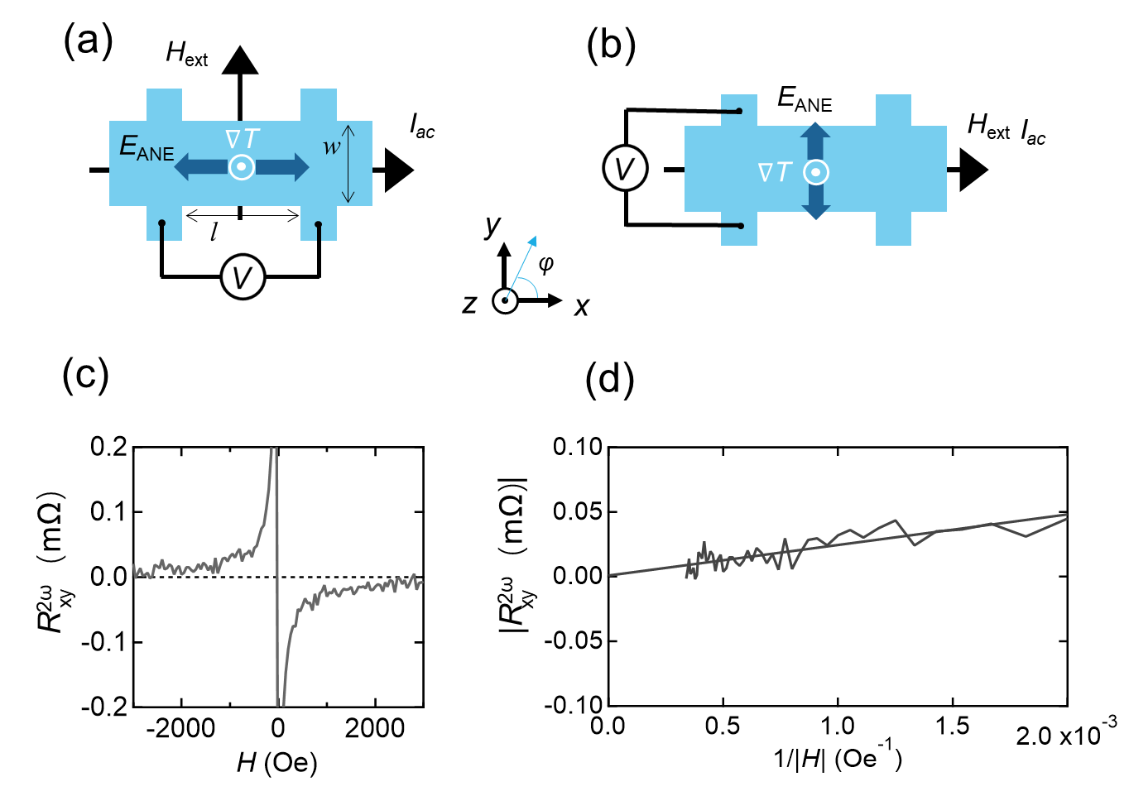
Figure S1. Illustrations of the experimental setup for measuring the second harmonic components of (a) longitudinal resistance $R_{xx}^{2ω}$ and (b) transverse resistance $R_{xy}^{2ω}$. E_{ANE} is the electric motive force generated by the ANE effect, ∇T is the thermal gradient generated by the Joule heating. (c) The second harmonic component of the transverse resistance $R_{xy}^{2ω}$ for Ru (10nm)/Cu (10nm) recorded during a field sweep along the x direction with a current density j = 1.4 × 10⁷ A cm⁻². (d) The absolute value of $R_{xy}^{2ω}$ as a function of the reciprocal of |H| using the data from (c). The y-axis intercept corresponds to the ANE contribution $R_{xy\left(ANE\right)}^{2ω}$.
In the USMR measurements, the longitudinal second harmonic resistance $R_{xx}^{2ω}$ has two components with the same angular dependence, which can be derived by,
$R_{xx}^{2ω}=$ $R_{xx(USMR)}^{2ω}+R_{xx(ANE)}^{2ω}$ (S1)
The signal $R_{xx(ANE)}^{2ω}$ is due to the anomalous Nernst effect (ANE) and we need to separate this effect from the $R_{xx}^{2ω}$ signal to get the USMR results. From the references [1,2] we know that the ANE effect can be evaluated by the transverse Hall voltage ($R_{xy}^{2ω}$) measurement as illustrated in Fig. S1(b). When the magnetic field sweeps along the longitudinal direction (φ = 0), the second harmonic components of the transverse resistance $R_{xy}^{2ω}$ contain two constituents from ANE and spin-orbital torques (SOTs):
$R_{xy}^{2ω}=$ $R_{xy\left(ANE\right)}^{2ω}+R_{xy\left(SOT\right)}^{2ω}$ (S2)
Here the $R_{xy\left(SOT\right)}^{2ω}$ is attributed to the magnetization oscillations and its amplitude decreases with increasing the magnetic field because of the proportional relationship between the SOT component and the magnetic susceptibility. Whereas, the ANE is independent of the magnetic field and maintains constant. The intercept of the y-axis with $R_{xy}^{2ω}$ versus 1/H yields the $R_{xy\left(ANE\right)}^{2ω}$ value, as given by:
$R_{xy}^{2ω}≈$ $R_{xy(ANE)}^{2ω} (\left|H\right|→∞)$ (S3)
The fitting results are plotted in Fig. S1(d) using the results in Fig. S1(c) from Ru (10nm)/Cu (10nm)/NiFe (5nm) sample with a current density j = 1.4 × 10⁷ A cm⁻². From the intercept of the y-axis, the $R_{xy\left(ANE\right)}^{2ω}$ contribution is rather small.
To obtain the ANE signal in the longitudinal direction, we used the aspect ratio of the Hall bar to convert the $R_{xy(ANE)}^{2ω}$ to $R_{xx(ANE)}^{2ω}$ since that the ANE effect is proportional to the voltage between the devices:
$|R_{xx\left(ANE\right)}^{2ω}|=|R_{xy\left(ANE\right)}^{2ω}×\frac{l}{w}|$ (S4)
In this work, we have l = 25 μm and w = 10 μm, and the $R_{xx(USMR)}^{2ω}$ was obtained by substituting the $R_{xx(ANE)}^{2ω}$ as given by:
$R_{xx(USMR)}^{2ω}=$ $R_{xx}^{2ω}-R_{xx(ANE)}^{2ω}$ (S5)
After conversion the range of the $R_{xx(ANE)}^{2ω}$ signal is around 0.003–0.005mΩ. For all results shown in this study, we performed the subtraction of the ANE contribution as mentioned above.

References:
[1] Okano G, Matsuo M, Ohnuma Y, Maekawa S and Nozaki Y 2019 Nonreciprocal Spin Current Generation in Surface-Oxidized Copper Films Phys. Rev. Lett. 122 217701
[2] Avci C O, Garello K, Ghosh A, Gabureac M, Alvarado S F and Gambardella P 2015 Unidirectional spin Hall magnetoresistance in ferromagnet/normal metal bilayers Nat. Phys. 11 570–5

