Supporting information
Gravity-Assisted Infiltration Enables a Spatially Extended and Dynamically Stable Multi-Phase Interface in Air Cathodes for Practical Lithium–Air Batteries
Wenfeng Cui^{1,2,3}, Qifa Gao³, Guangxu Xu^{1,2,3}, Hang Yin^{1,3}, Wipakorn Jevasuwan², Sadaki Samitsu¹, Misa Hazutani¹, Naoki Fukata^{2,3}*, Jie Tang^{1,3}*

¹ National Institute for Materials Science, 1-2-1 Sengen, Tsukuba 305-0047, Ibaraki, Japan;
² National Institute for Materials Science, 1-1-1 Namiki, Tsukuba 305-0044, Ibaraki, Japan;
³ Graduate School of Pure and Applied Sciences, University of Tsukuba, 1-1-1 Tennodai,
Tsukuba 305-0006, Ibaraki, Japan

Email: TANG.Jie@nims.go.jp and FUKATA.Naoki@nims.go.jp

1. Materials and methods
1.1 Materials
The MnO-rGO materials were prepared via our previous work.^{[1]} Lithium sheets (diameter is 16 mm) were obtained from Honjo Metal Co., Ltd. The Whatman glass fibers (GF/A) were purchased from Avantor. Glass diffusion layers (GDL, TGP-H-030, TGP-H-060, TGP-H-090 and TGP-H-120) were purchased from Toray Innovation by Chemical. The LiTFSI (Lithium Bis(trifluoromethanesulfonyl)imide, 99.99%) was purchased from Sigma-Aldrich. LiI (Lithium Idoine, 99.9%) was obtained from Sigma-Aldrich. TEGDME (Tetraethylene glycol dimethyl ether, 99.0%) was provided by Tokyo Chemical Industry Co., Ltd. THF (Tetrahydrofuran, 99.0 %) was obtained from Tokyo Chemical Industry Co., Ltd. None of the chemicals were without any further purification process.
1.2 Preparation of cathodes
The slurry-cast layer (SCL) cathodes were prepared by mixing active materials and PTFE, then coating onto the GDL. The gravity-assisted infiltration (GAI) cathodes were prepared by nature sedimentation of a uniform materials-ethanol solution onto GDL. Each cathode was dried overnight at vacuum before used into battery.
1.3 Characterization
The surface and cross-section morphology of cathodes and discharged/charged cathodes were performed by SEM (SU8000, Bruker). The elemental distributions of the electrode surface were determined by EDS mapping.
X ray-CT images were performed using a nano3DX (Rigaku, Japan) equipped with an L0270 detector to scan cathode coupons (rectangular size ≤0.5 mm × 5 mm in Figure S1). The scan employed a Mo/Cu X-ray source operated at 40-50 kV (24-30 mA), with an isotropic voxel size of 0.65 μm (2× binning) and a field of view of 0.666 mm × 0.666 mm. In total, 600 sequential projections were collected over a 180° rotation with an exposure time of 8-12 s per projection (total acquisition time ~1-2 hours).
The XRD patterns of the discharged and charged cathodes were collected on a Rigaku MiniFlex diffractometer using a Cu Kα source, scanning over 2θ from 10 to 80°.
TOF-SIMS measurement was performed using PHI TRIFT V nanoTOF (ULVAC-PHI) with Bi³⁺ primary beam (** keV with 100 × 100 μm² spot size) and Cs⁺ secondary gun (2 keV with 300 × 300 μm² analysis area).
1.4 Contact angle and gas adsorption test
The contact angle between the liquid (electrolyte) and cathode surface, and Gas adsorption test, both were measured by a pendant drop tensiometer (DSA100, KRUSS) with organic electrolyte.
1.3 The assembly of Li-air batteries (LABs)
The electrolyte for room and high temperature was obtained by dissolving the 1 M LiTFSI dissolve into TEGDME solvent. The electrolyte for low temperature was the same as the above process but using THF as solvent.
The cathode and Li sheet were separated by a GF/A separator immersed in electrolyte and sealed into CR 2032 coin cell with meshed positive cases.
These steps were completed in an argon-filled glovebox. To ensure complete electrolyte immersion in both cathode and anode, the batteries were left to rest in an air environment for about 12 hours.
1.5 Electrochemical Measurements
All the galvanostatic charge-discharge and full cycle (full charge-discharge) performance were tested on LAND and Beidou HJ1010SD8 electrochemical system.
All the galvanostatic charge-discharge were conducted at 40-45 RH%, all the full cycle were conducted at 50-60RH%.
All cycling tests were conducted with the LABs placed in a small bottle. For the cycling tests at high temperatures, to minimize the influence of electrolyte evaporation, the LABs were tested in a small bottle containing a small amount of TEGDME. After LABs degradation, the LABs were immediately disassembled to examine the wetting state of the separator.
1.6 DRT, DCT process EIS data
Electrochemical impedance spectroscopy (EIS) was measured by using Biologic VSP 300 electrochemical workstations with frequency of 100 KHz to 100 mHz.
In LOBs/LABs composite cathodes, mass transport typically manifests at very low frequencies, this slow frequency window less reliably resolved by DRT, whereas DCT provides a more robust way to analyze transport-dominated timescales.^{[1,2]} The characteristic time constant τ, identified at the frequency where the Bode phase angle approaches −45° (equivalently, where $Z^{'}$varies linearly with $ω^{-1/2}$), was used as the boundary separating the DRT and DCT regimes.^{[1,2]} DRT and DCT depend on the Ciucci et al. work and Li et al. work.^{[2,3]}
Notably, for the EIS measurements performed at different electrolyte volumes, GAI cathode with loading of 3.0 mg cm⁻² was used to assemble batteries, and the temperature varied from 15 to 40 °C to minimize the influence of electrolyte evaporation at elevated temperatures.
1.7 Fabrication of flexible pouch cells
The carbon cloth and carbon paper (3.0 * 3.0 cm) were chosen as the GDL of cathode. The loading mass ratio of active materials was consistent with coin cells. The Li@Cu composite belt (3.1 cm * 3.1 cm, with 150 um Li layer), GF/A, and 1M LiTFSI-TEGDME were used as anode, separator, and electrolyte, respectively. The Al (aluminum) and Ni (nickel) tab were mechanically secured to the GDL and Cu sheet, respectively. The low-density polyethylene film was used to encapsulate cells. Pouch cells were assembled by stacking the cathode, separator and anode, followed by insertion of electrolyte, and then sealed by a hot press sealer.
For the energy density of pouch cells, calculating was defined as the ratio of actual energy (Wh) to the core mass of the cell (cathode + separator + electrolyte + anode). The specific calculation method is as follows:
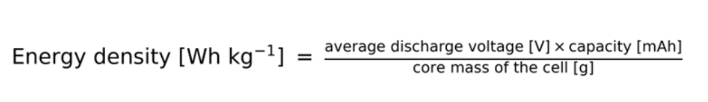
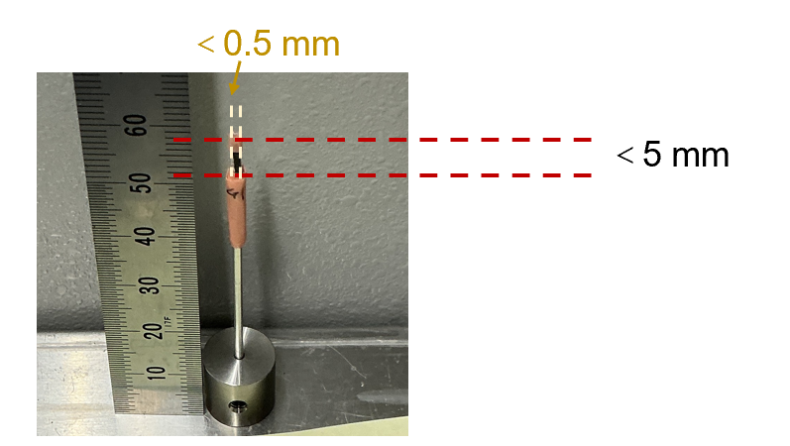
Figure S1. The photo of X-ray computed tomography (X-ray CT) sample.

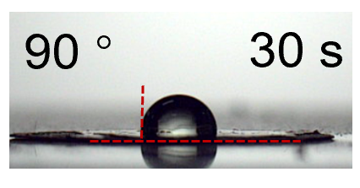
Figure S2. The contact angle between the electrolyte and SCL cathode after 30 s.
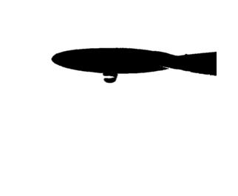
Figure S3. The state of O₂ bubble on the SCL cathode after 10 s.

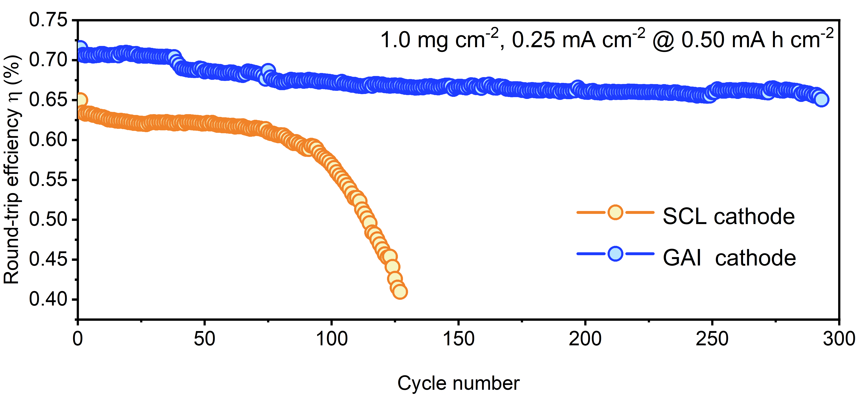
Figure S4. The round-trip efﬁciency of long cycle performance for LABs with 0.25 mA cm⁻² and 0.50 mA h cm⁻².

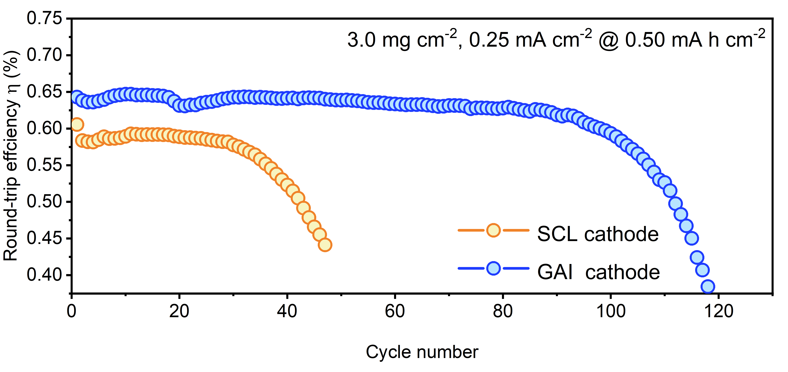
Figure S5. The round-trip efﬁciency of long cycle performance for LABs with loading mass of 3.0 mg cm⁻².

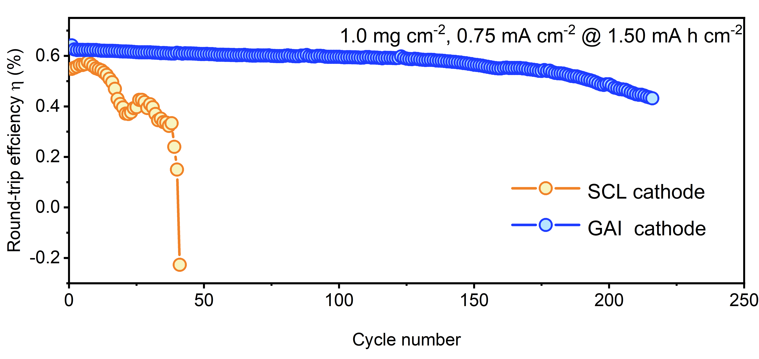
Figure S6. The round-trip efﬁciency of long cycle performance for LABs with 0.75 mA cm⁻² and 1.50 mA h cm⁻².

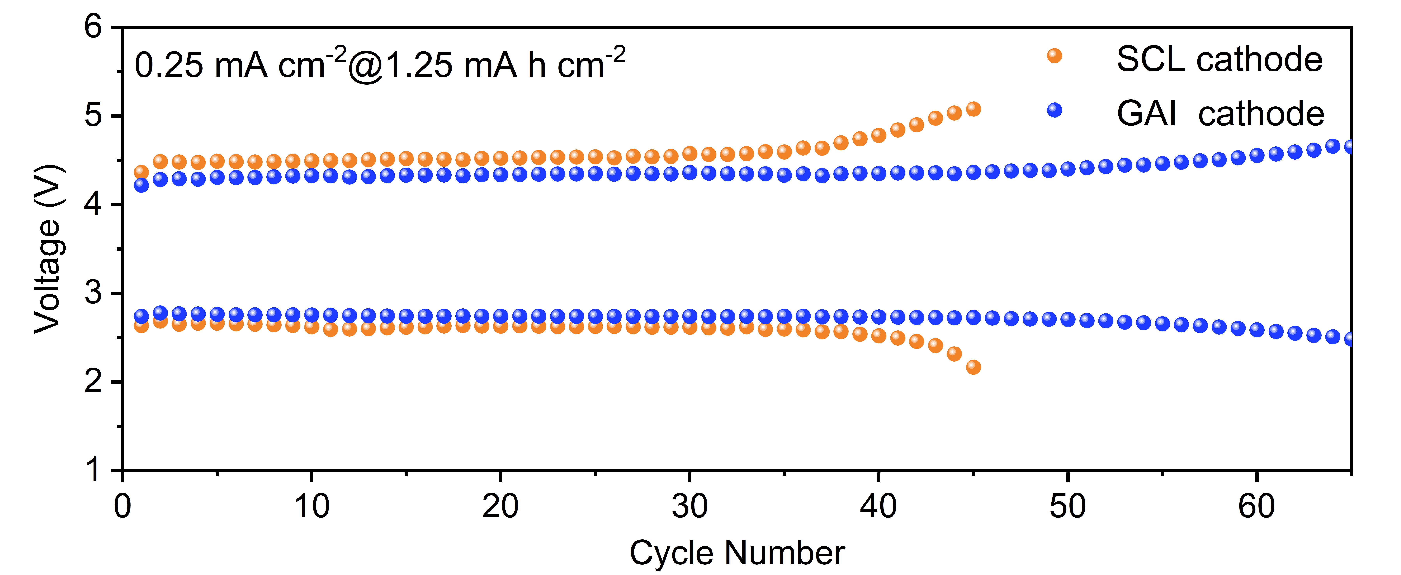
Figure S7. The long cycle performance of LABs at 0.25 mA cm⁻² and 1.25 mA h cm⁻².

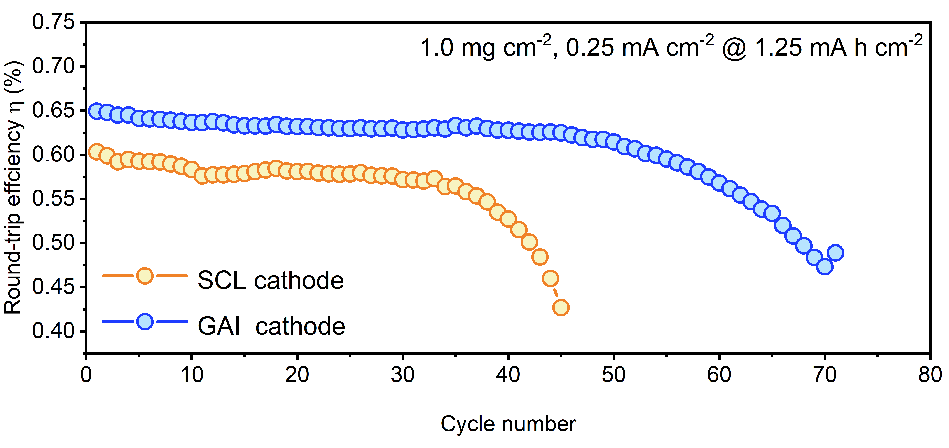
Figure S8. The round-trip efﬁciency of long cycle performance for LABs with 0.25 mA cm⁻² and 1.25 mA h cm⁻².

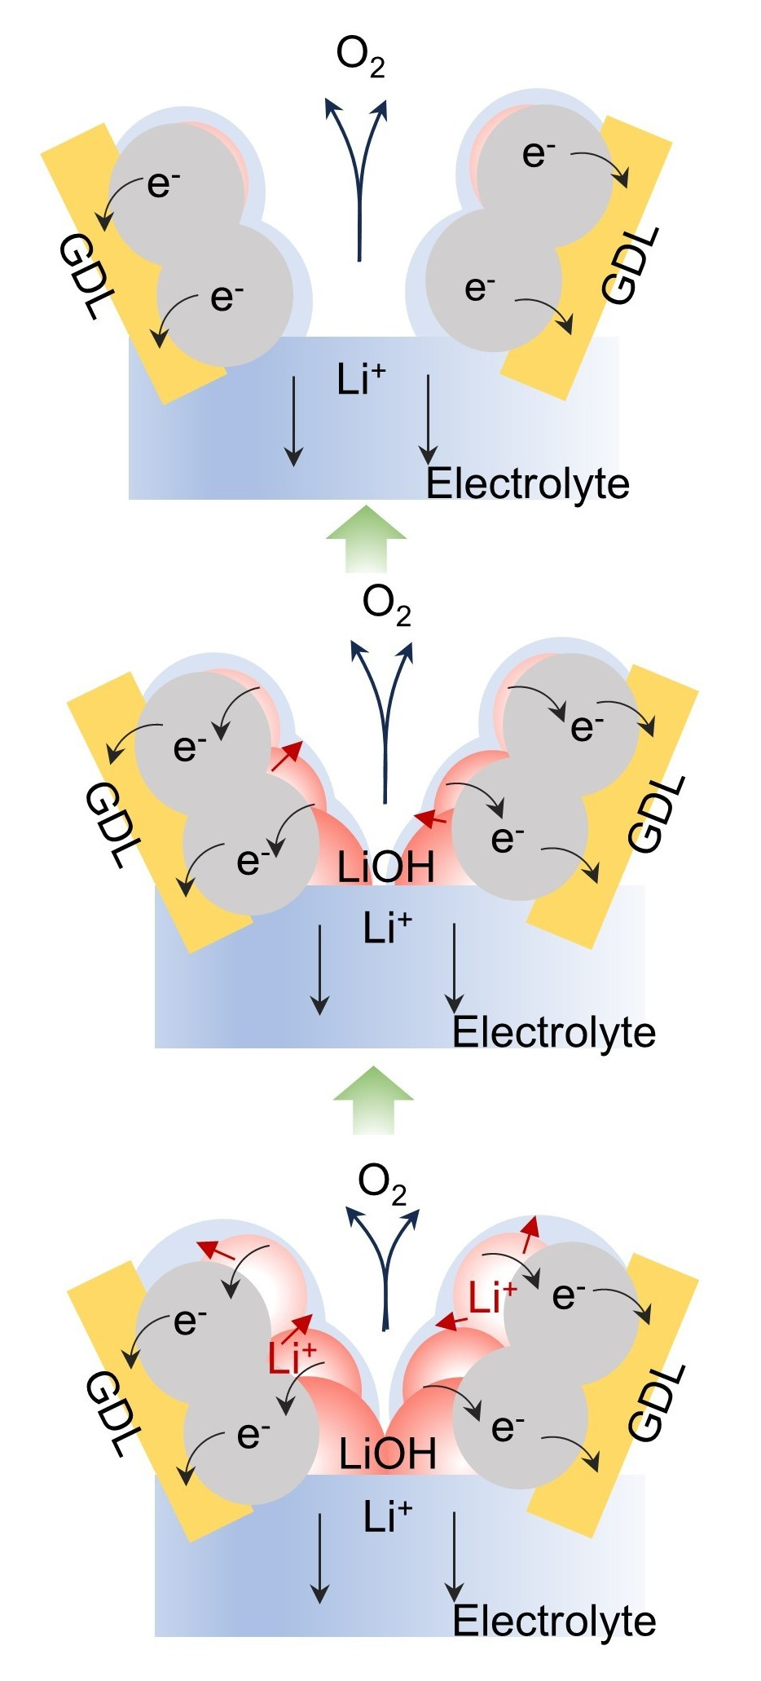
Figure S9. The schematic diagram of decomposing products for GAI cathode during charging process.

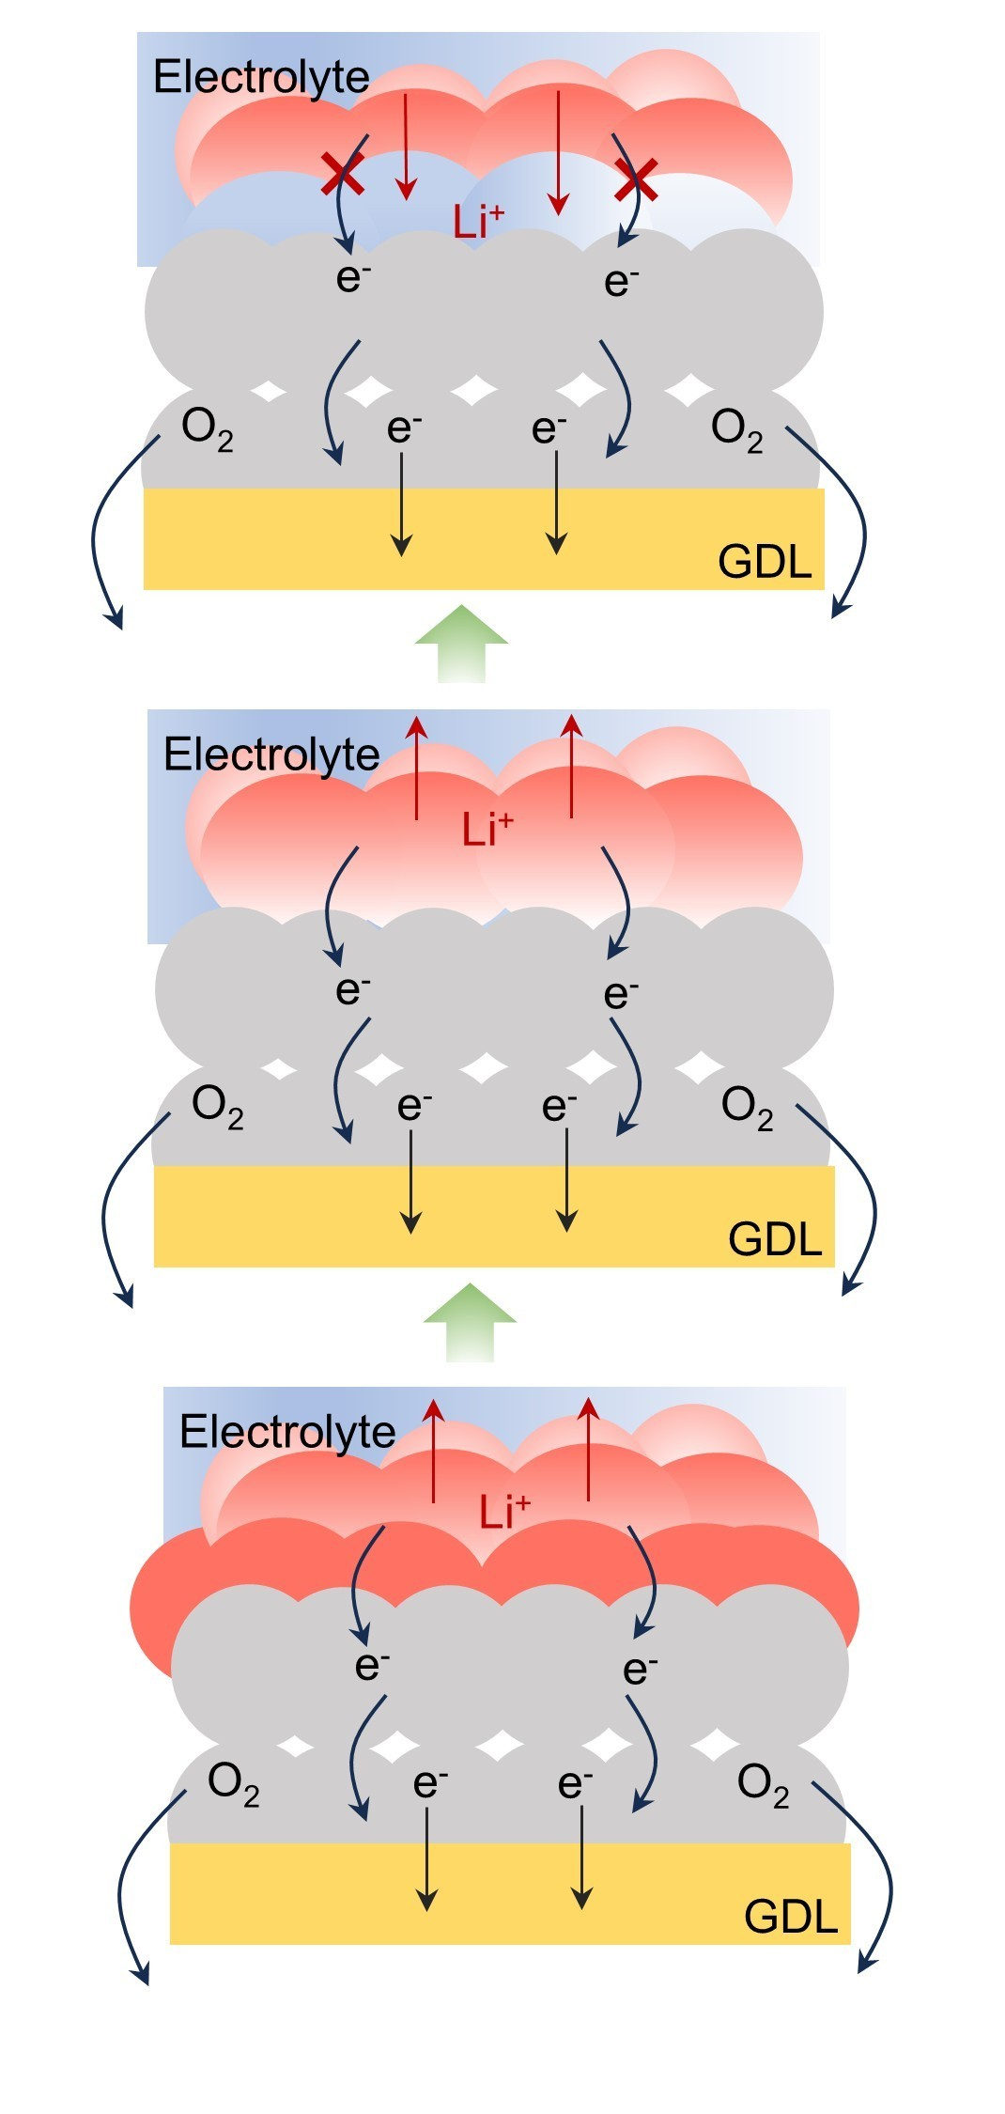
Figure S10. The schematic diagram of decomposing products for SCL cathode during charging process.
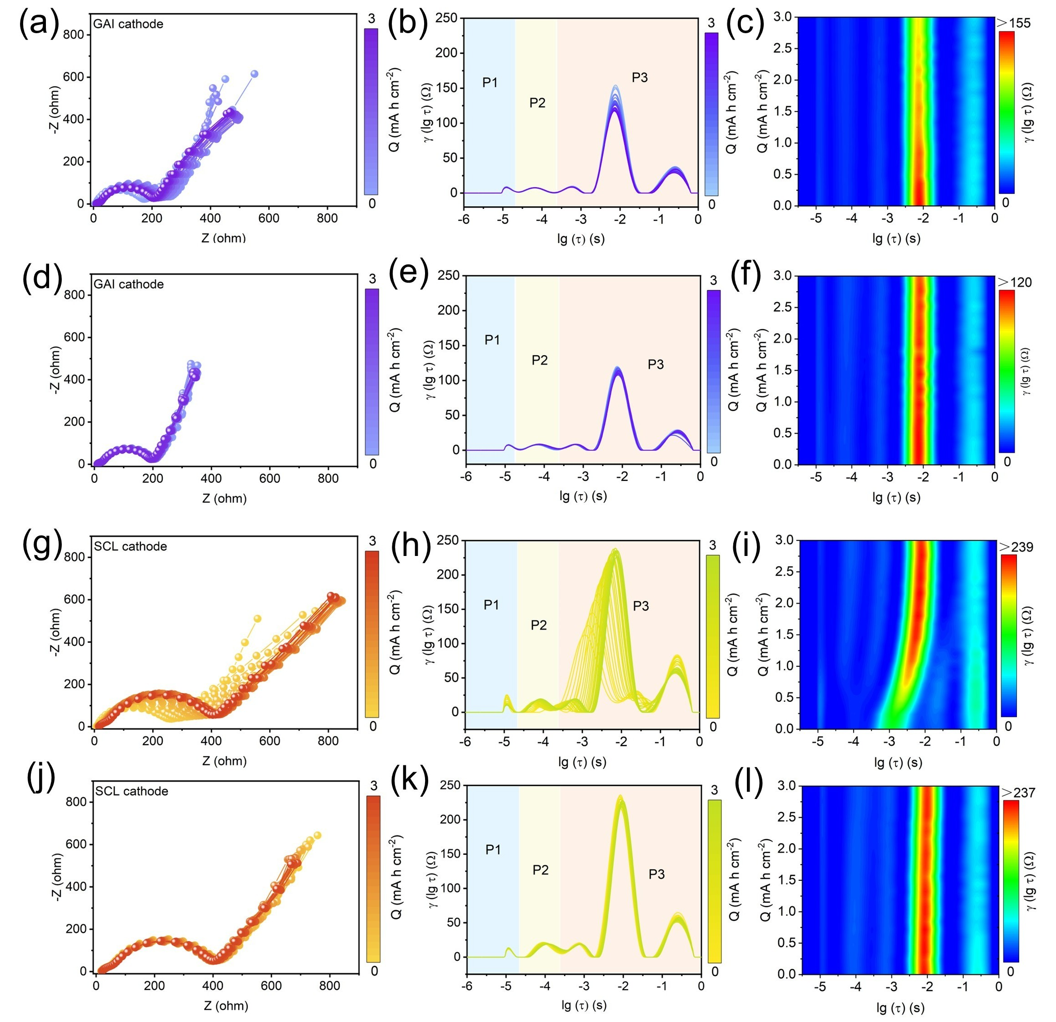
Figure S11. The EIS, DRT and counters plots of LABs with GAI and SCL cathode during discharge/charge process.

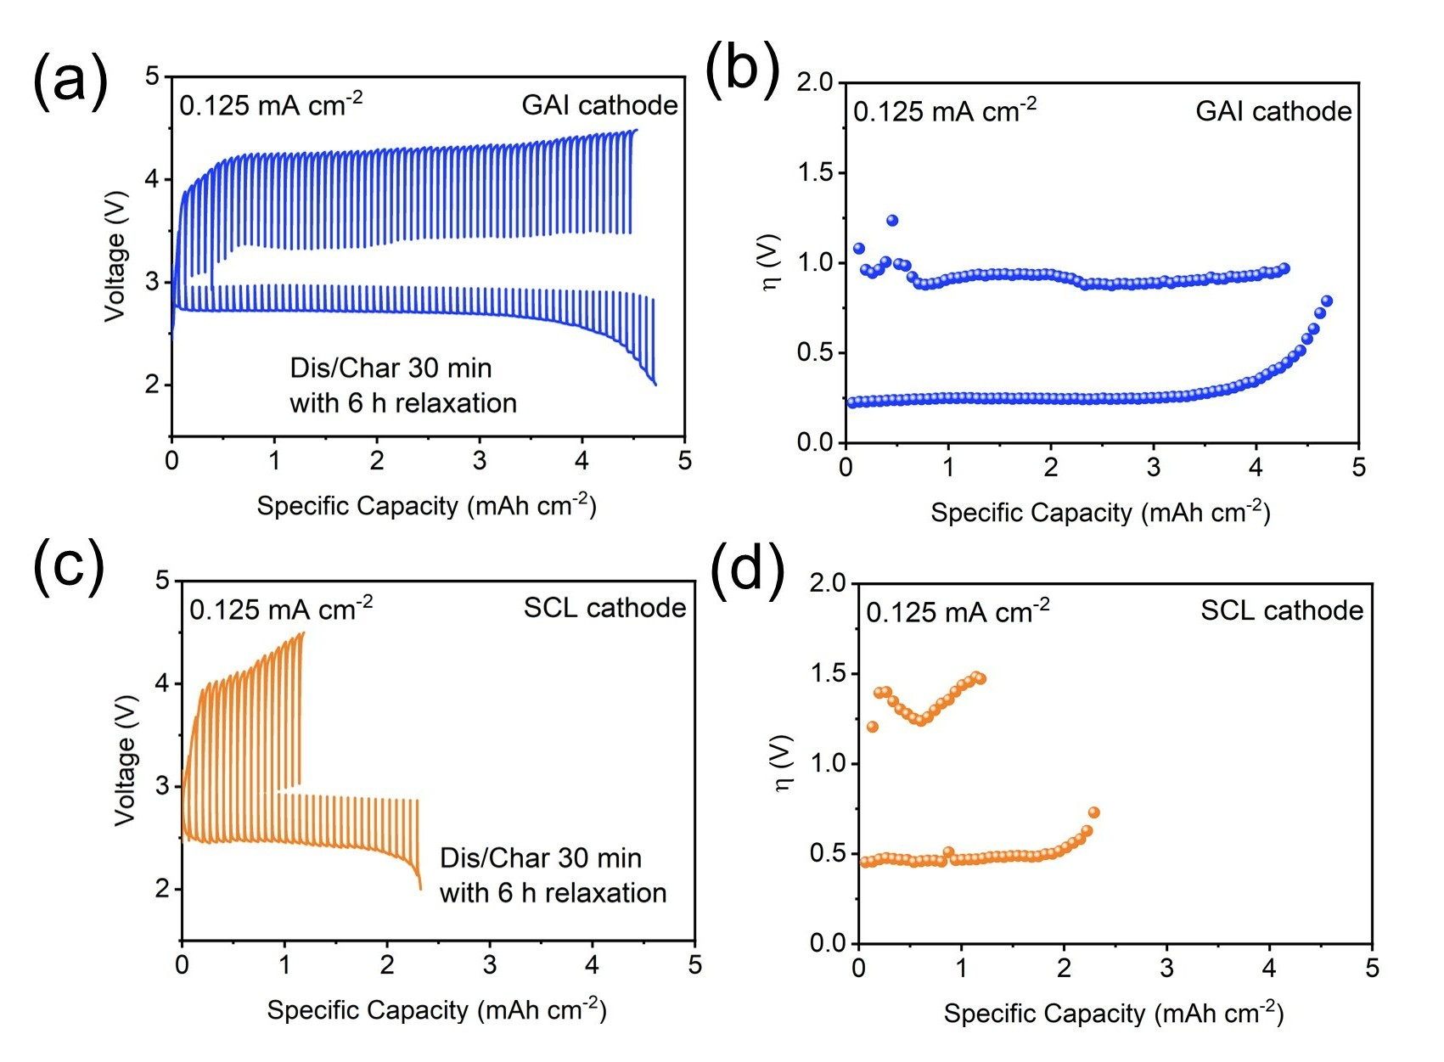
Figure S12. (a) GITT curves and (b) the overpotential values for LABs with GAI cathode. (c) GITT curves and (d) the overpotential values for LABs with SCL cathode. The batteries were measured at the fixed current density of 0.125 mA cm⁻² with the relaxation time of 6 h.

As shown in Figure S12a and 12c, compared with the SCL cathode, the GAI cathode delivers a higher discharge platform (~3.00 V vs ~2.89 V), indicating markedly reduced polarization under identical operating conditions.^{[4,5]} In addition, the GAI cathode exhibits a larger discharge capacity of 4.75 mA h cm⁻² (Figure S12a), together with lower and more stable discharge/charge overpotentials (Figure S12b). By contrast, the SCL cathode shows an early end-of-discharge voltage collapse even at a relatively small capacity (Figure S12c), accompanied by unstable and substantially higher charge overpotentials (Figure S12d).
These trends are fully consistent with the polarization analysis in Figure 3: at the same current density, the GAI cathode displays a smaller discharge polarization, reflecting more efficient transport of e⁻, Li⁺, and O₂. Such transport robustness ensures superior accessibility of the three-phase reaction interfaces during discharge and the four-phase reaction interfaces during charge, thereby substantially delaying interfacial impedance buildup and pore blockage induced by discharge-product deposition.^{[6]} In comparison, the SCL cathode exhibits a pronounced overpotential rise, particularly during charge, implying more severe interfacial passivation and transport limitations arising from reaction region clogging and hindered mass transfer.

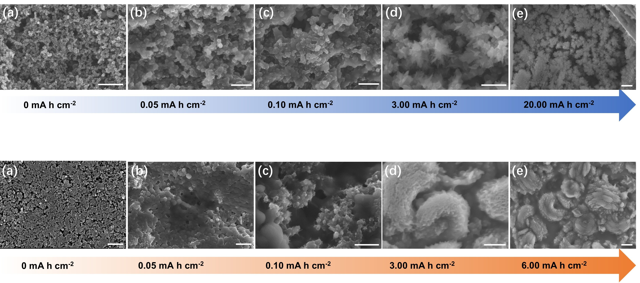
Figure S13. The SEM characterization of discharge products for GAI cathode at (a) 0, (b) 0.05, (c) 1.00, (d) 3.00 and (e) 20.00 mA h cm⁻², scan bar is 500 nm.

Figure S14. The SEM characterization of discharge products for SCL cathode at(a) 0, (b) 0.05, (c) 1.00, (d) 3.00 and (e) 6.00 mA h cm⁻², scan bar is 500 nm.

As shown in Figure S13-14, SEM was conducted to monitor the morphological evolution of the discharge products produced during the gradual discharge for GAI and SCL cathode, respectively. For GAI cathode (Figure S13), when the discharge capacity reached 0.05 mA h cm⁻², the products deposited on GAI cathode existed in the form of a shell conformal to the catalyst surface. When discharge capacity reached 0.10 mA h cm⁻², the products deposited on GAI cathode still showed a conformal shell-like morphology then growth larger. When discharge capacity reached 3.00 mA h cm⁻², the aforementioned conformal products shell further evolved into a film-like morphology. When the full discharge capacity was as high as 20.00 mA h cm⁻², increased film-like conformal products cover the GAI cathode surface. For SCL cathode (Figure S14), when the discharge capacity reached 0.05 mA h cm⁻², plate-like products were found on SCL cathode. When discharge capacity reached 0.10 mA h cm⁻², a large amount of thicker plate-like products was formed on SCL cathode, covering almost the entire catalyst surface. When discharge capacity reached 3.00 mA h cm⁻², the plates self-assembled into a stacked multilayer superstructure and further formed a toroidal-like morphology. When the full discharge capacity was 6.00 mA h cm⁻², the larger toroidal-like products assembled with multilayer structure occurred on the SCL cathode surface.

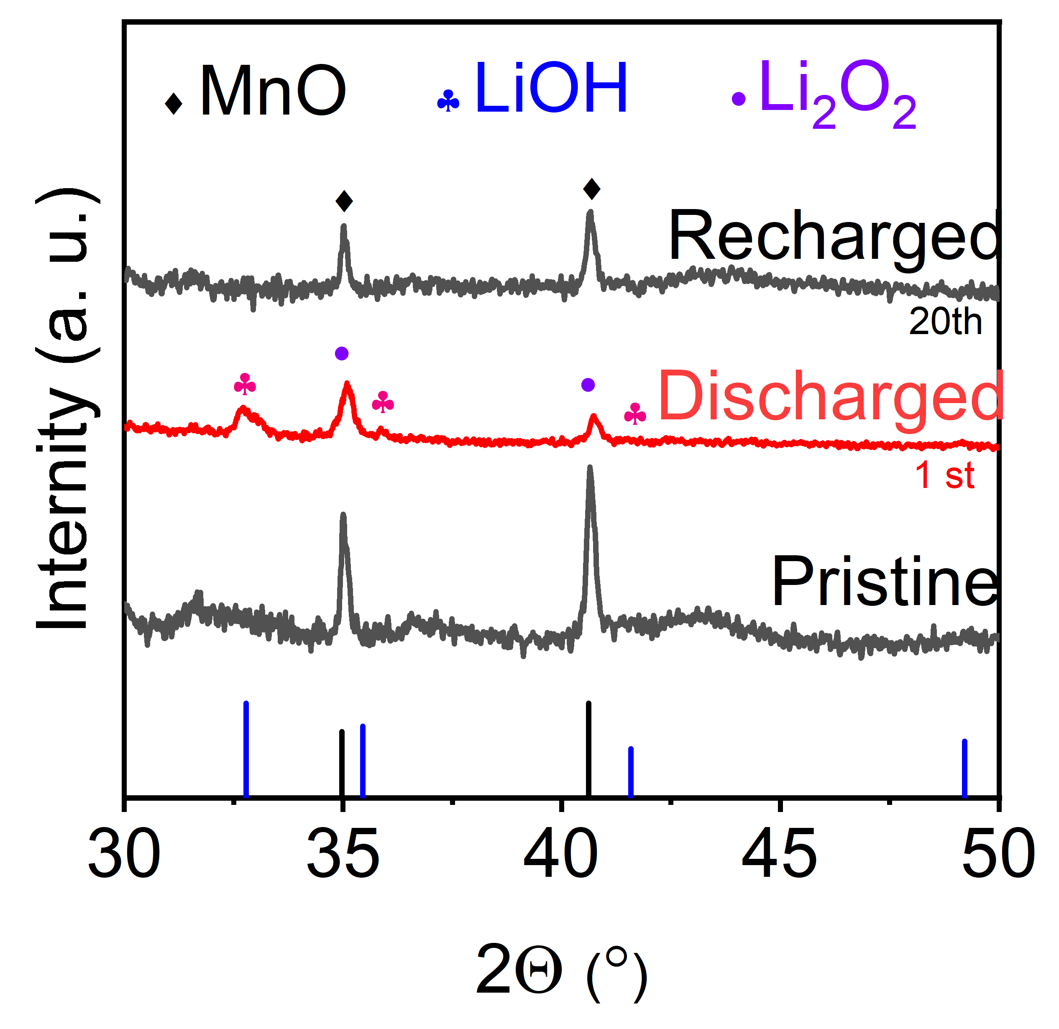
Figure S15. XRD characterization of discharge products for GAI cathode and SCL cathode at 0.5 mA h cm⁻². (PDF information for XRD: PDF#01-077-2929 for MnO, PDF#00-004-0708 for LiOH, PDF#01-074-0115 for Li₂O₂.)

Figure S15 shows the X-ray diffraction (XRD) patterns of cathodes. When discharge to 0.5 mA h cm⁻², the LiOH signals are not distinctly visible for GAI cathode, which means weak crystallite LiOH were produced on the GAI cathode. In contrast, SCL cathode exhibits a slightly higher XRD peaks intensity, demonstrating high crystallinity of LiOH.

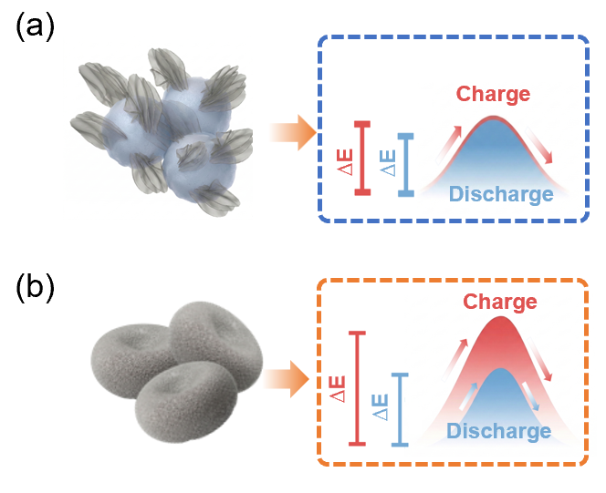
Figure S16. The discharge products formation/decomposition energy-level diagram for (a) GAI cathode and (b) SCL cathode.

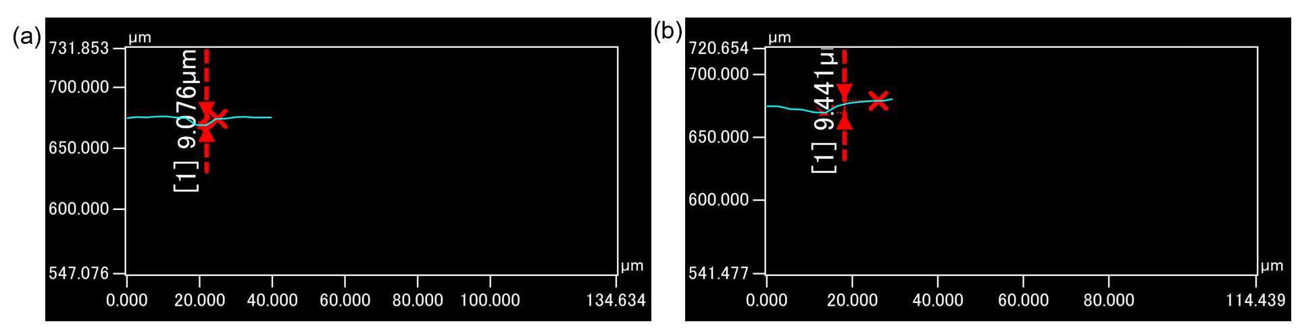
Figure S17. The etching depth data in TOF-SIMS test. (a) SCL cathode, (b) GAI cathode.

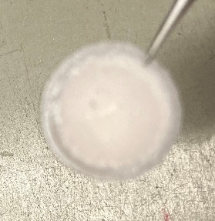
Figure S18. Optical photograph of separator in the disassembled LABs with SCL cathode.

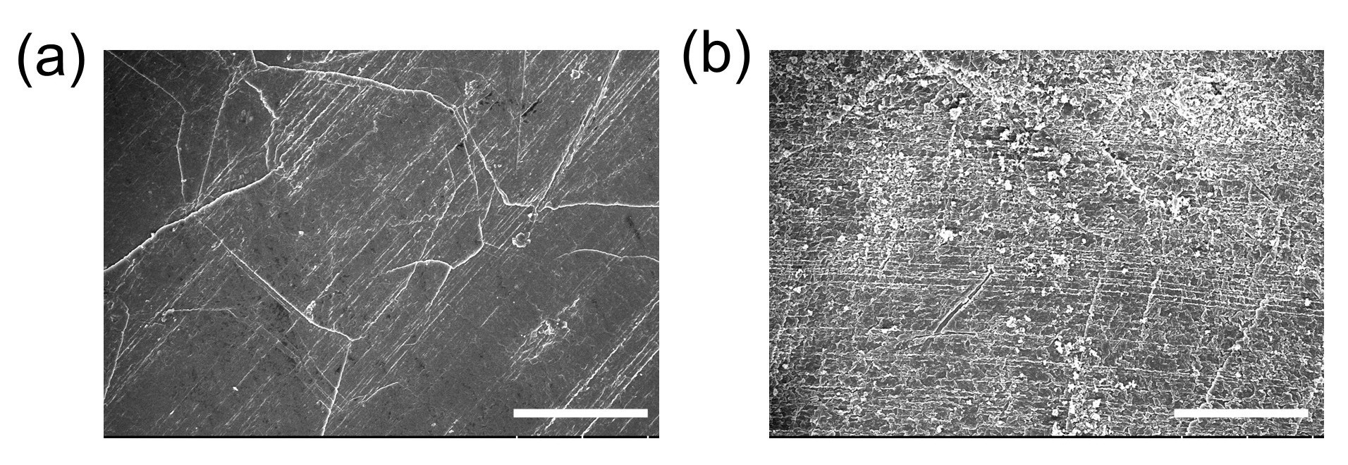
Figure S19. SEM images of the Li surface at the 4th cycle. (a) GAI cathode, (b) SCL cathode.

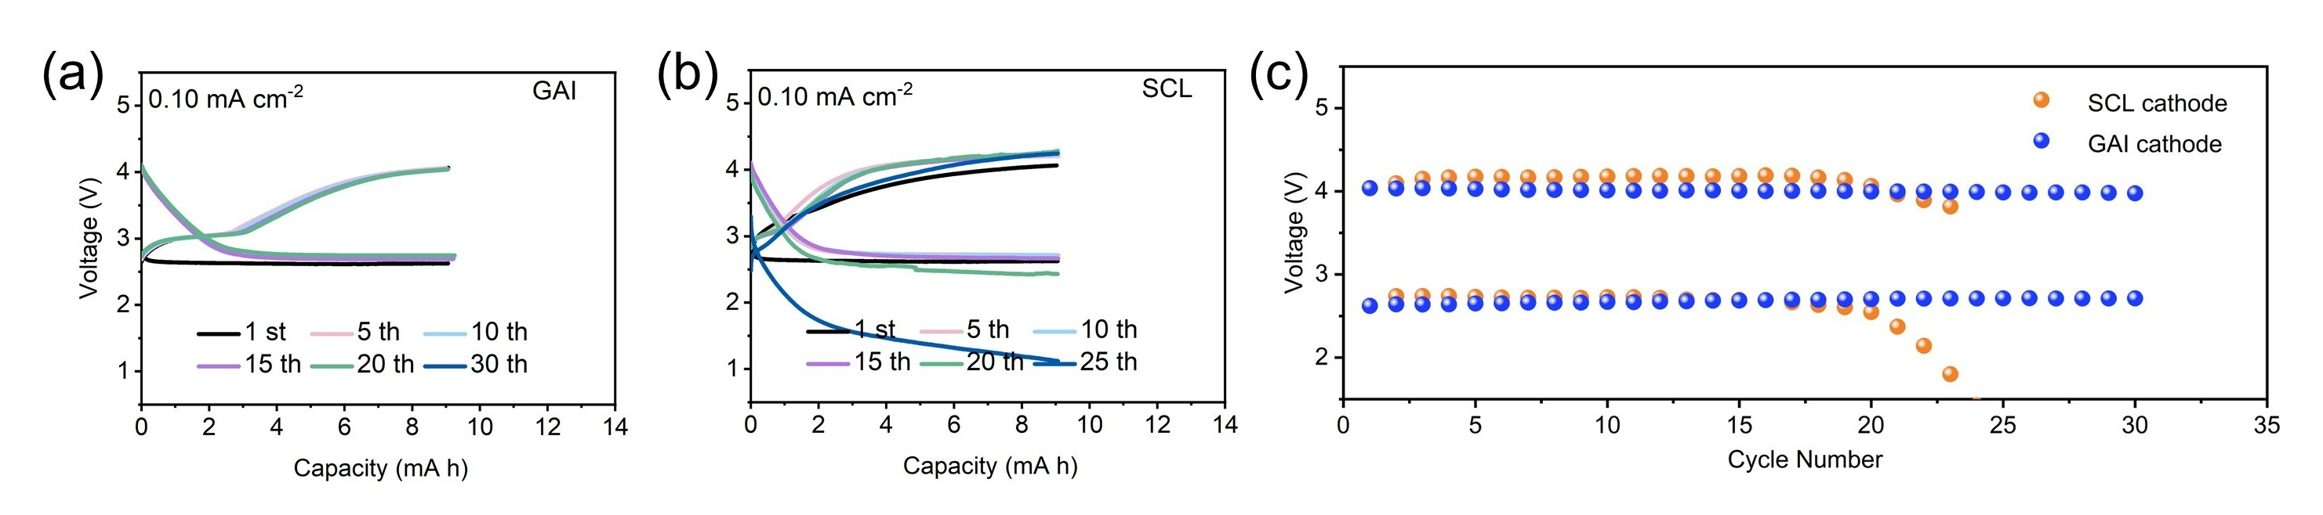
Figure S20. The selected discharge/charge profiles for (a) GAI, (b) SCL based pouch LABs, and (c) the corresponding cycling performance at a high loading mass of 3.0 mg cm⁻² with a limit capacity of 1.0 mA h cm⁻².

Table S1. Parameters of the pouch LABs (double layers) with different cathodes.
Component | GAI-based | SCL-based
Loading  of cathode | 0.018 | 0.023
GDL | 0.037 | 0.037
Electrolyte | 0.336 | 0.673
Separator | 0.099 | 0.099
Li-Cu belt | 0.324 | 0.324
Others (Al and Ni tabs, tapes and the Plastic film and so on) | 0.5 | 0.5
Corn body (g) | 0.850 | 1.192
Total (g) | 1.350 | 1.692

Reference
[1] W. Cui, J. Tang, G. Xu, H. Yin, W. Jevasuwan, N. Fukata, Composites, Part B 2026, 312, 113331.
[2] J. Chen, E. Quattrocchi, F. Ciucci, Y. Chen, Chem 2023, 9, 2267.
[3] Chem. Eng. J. 2020, 400, 125919.
[4] Y. Liu, B. Li, Z. Cheng, C. Li, X. Zhang, S. Guo, P. He, H. Zhou, Journal of Power Sources 2018, 395, 439.
[5] L.-N. Song, L.-J. Zheng, X.-X. Wang, D.-C. Kong, Y.-F. Wang, Y. Wang, J.-Y. Wu, Y. Sun, J.-J. Xu, J. Am. Chem. Soc. 2024, 146, 1305.
[6] W.-H. Ryu, F. S. Gittleson, J. Li, X. Tong, A. D. Taylor, Nano Lett. 2016, 16, 4799.

