Emitted Secondary Electrons: In Vacuo Plasmon Energy Gain Observation using a Three-Point Combined Measurement Method
B. Da^{1,2*}, X. Liu^{1,3}, J. M. Gong^{1,3}, Z.H. Zhang³, Z. J. Ding^{3#}, N. T. Cuong^{4,5}, H. Jin⁶, J. W. Liu⁷, Z. S. Gao⁸, H. X. Guo⁹, H.X. Wang², H. Zhang², Y. Harada², H. Yoshikawa^{1,2†}, and S. Tanuma²
¹Research and Services Division of Materials Data and Integrated Systems, National Institute for Materials Science, 1-1 Namiki, Tsukuba, Ibaraki 305-0044, Japan
²Research Center for Advanced Measurement and Characterization, National Institute for Materials Science, 1-1 Namiki, Tsukuba, Ibaraki 305-0044, Japan
³Department of Physics, University of Science and Technology of China, Hefei, Auhui 230026, China
⁴International Center for Young Scientists (ICYS), National Institute for Materials Science, Tsukuba, Ibaraki 305-0044, Japan
⁵International Center for Materials Nanoarchitectonics (WPI-MANA), National Institute for Materials Science, Tsukuba, Ibaraki 305-0044, Japan
⁶Department of Physics and Institute for Nanoscience and Engineering, University of Arkansas, Fayetteville, Arkansas 72701, United States
⁷Research Center for Functional Materials, National Institute for Materials Science, 1-1 Namiki, Tsukuba, Ibaraki 305-0044, Japan
⁸Institute of Electrical Engineering, Chinese Academy of Sciences, Beijing, 100190, P.R. China.
⁹Key Laboratory of MEMS of Ministry of Education, School of Electronic Science and Engineering, Southeast University, Nanjing, 210096, People’s Republic of China.
*DA.Bo@nims.go.jp
#zjding@ustc.edu.cn
†YOSHIKAWA.Hideki@nims.go.jp

Abstract
A surface plasmon energy gain for emitted secondary electrons (SEs) was recently observed in SE spectroscopy measurements from a tailor-made nanostructured Au specimen as a satellite on the high energy side of the vacuum level. However, thus far, this plasmon energy gain phenomenon has been observed only for Au samples because surface plasmons in Au arise at 2.3 eV, which is relatively far from the strong background cascade peak of SEs. Here, we report a new type of combined measurement technique: a three-point combined measurement method, for enlarging the surface plasmon energy gain structure in SE spectra. Using this scheme, three different SE energy spectra were measured from nanostructured samples of Au and Ag. By combining their spectra, the surface plasmon energy gain structure of Au and Ag can be clearly observed. The observed structures revealed that the plasmon energy gain process for SEs contributing to a potentially observable feature in a spectrum occurs only in vacuum above the sample surface and is naturally related only to surface plasmons. This unusual plasmon energy gain phenomenon observed by the three-point combined measurement method suggests the potential for development of a new physical image directly in space based on surface plasmons in vacuum above the surface of a medium.

Introduction
When an electron moves inside or in the vicinity of a solid, it may transfer part of its energy to conduction electrons in well-defined quanta because of group oscillations of the conduction electrons, leading to the well-known plasmon loss process [1,2]. Because the charge density oscillation occurs in two or three dimensions, the plasmon loss process can be further subdivided into surface plasmon loss [3] and bulk plasmon loss [1,2], respectively. The processes of surface and bulk plasmon loss are two of the most common processes in electron–plasmon interactions and are fundamentally important in the interpretation of spectra obtained by electron-based techniques such as Auger electron spectroscopy (AES) [4-7], X-ray photoelectron spectroscopy (XPS) [4,8,9], electron energy loss spectroscopy (EELS) [10,11,12], and the newly developed method of near-field emission secondary electron (SE) microscopy [13]. Therefore, to further exploit these electron-based techniques, a thorough knowledge of electron–plasmon interactions is needed.
Besides losing energy via plasmon excitation, energetic electrons may also gain energy from a plasmon quantum if they interact with plasmons already present inside or in the vicinity of a solid, leading to the plasmon energy gain process, the reverse reaction of the plasmon loss process. The phenomenon of bulk plasmon energy gain was first observed in 1970 by Jenkins and Chung [14], who suggested that a satellite peak observed on the high energy side of the ~60-eV Cu Auger peak was caused by an outgoing electron in the Auger electron emission that gained the energy of a pre-existing bulk plasmon quantum, i.e., an “extrinsic” plasmon produced by scattering of this outgoing electron.
In the following decade, numerous experiments were conducted to study bulk plasmon energy gain in Al [15], Si [16], Mg [17], Na [17], Mg₂Cu [18], and Mg-Cd alloys [19] using AES or XPS, and the resulting observations clearly indicate that energetic electrons inside a solid can experience characteristic plasmon energy gains analogous to the characteristic plasmon losses.
However, the mechanism of bulk plasmon energy gain associated with an “extrinsic” plasmon is highly controversial. As early as 1971, Matthew and Watts [20] proposed another possible mechanism for bulk plasmon energy gain, in which the annihilated bulk plasmon is an “intrinsic” plasmon produced during dynamical screening of the initial state ion by conduction electrons, rather than a pre-existing “extrinsic” plasmon. Later, this hypothesis was verified by Fuggle et al. [21], who demonstrated that the intensity of the bulk plasmon energy gain satellite in the Auger process for Na and Mg excited by X-ray photoemission increases with increasing X-ray energy.
This result clearly demonstrated that the observed bulk plasmon energy gain satellite primarily arises from an “intrinsic” plasmon because only “intrinsic” plasmon creation depends on the radiation energy used to excite photoemission. In essence, the argument between an “extrinsic” or “intrinsic” plasmon is involved in the bulk plasmon energy gain process lies in the interpretation of the rationality for an energetic electron to appear within the lifetime of the annihilating plasmon to gain energy from a plasmon quantum. To address this controversy, more experiments related to plasmon–electron interactions are needed.
In addition to bulk plasmon energy gain, a surface plasmon energy gain process has also been observed as the reverse reaction of the surface plasmon loss process, as reported by Schilling and Raether [22]. In their work, the energy spectra of electrons reflected on a very smooth surface of liquid In showed a satellite on the higher energy side of the elastic peak at the exact energies corresponding to a gain of one In surface plasmon. The corresponding possibility of surface plasmon energy gain for elastic electrons is, of course, positively related to the intensity of an elastic electron beam when there is a sufficient number of surface plasmons. These findings clearly demonstrate that once an elastic electron appears in the right place, i.e., within the effective range of a pre-existing surface plasmon, at the right time, i.e., within the lifetime of the pre-existing surface plasmon, it has a certain likelihood of gaining the energy of one surface plasmon quantum via an interaction with the surface plasmon.
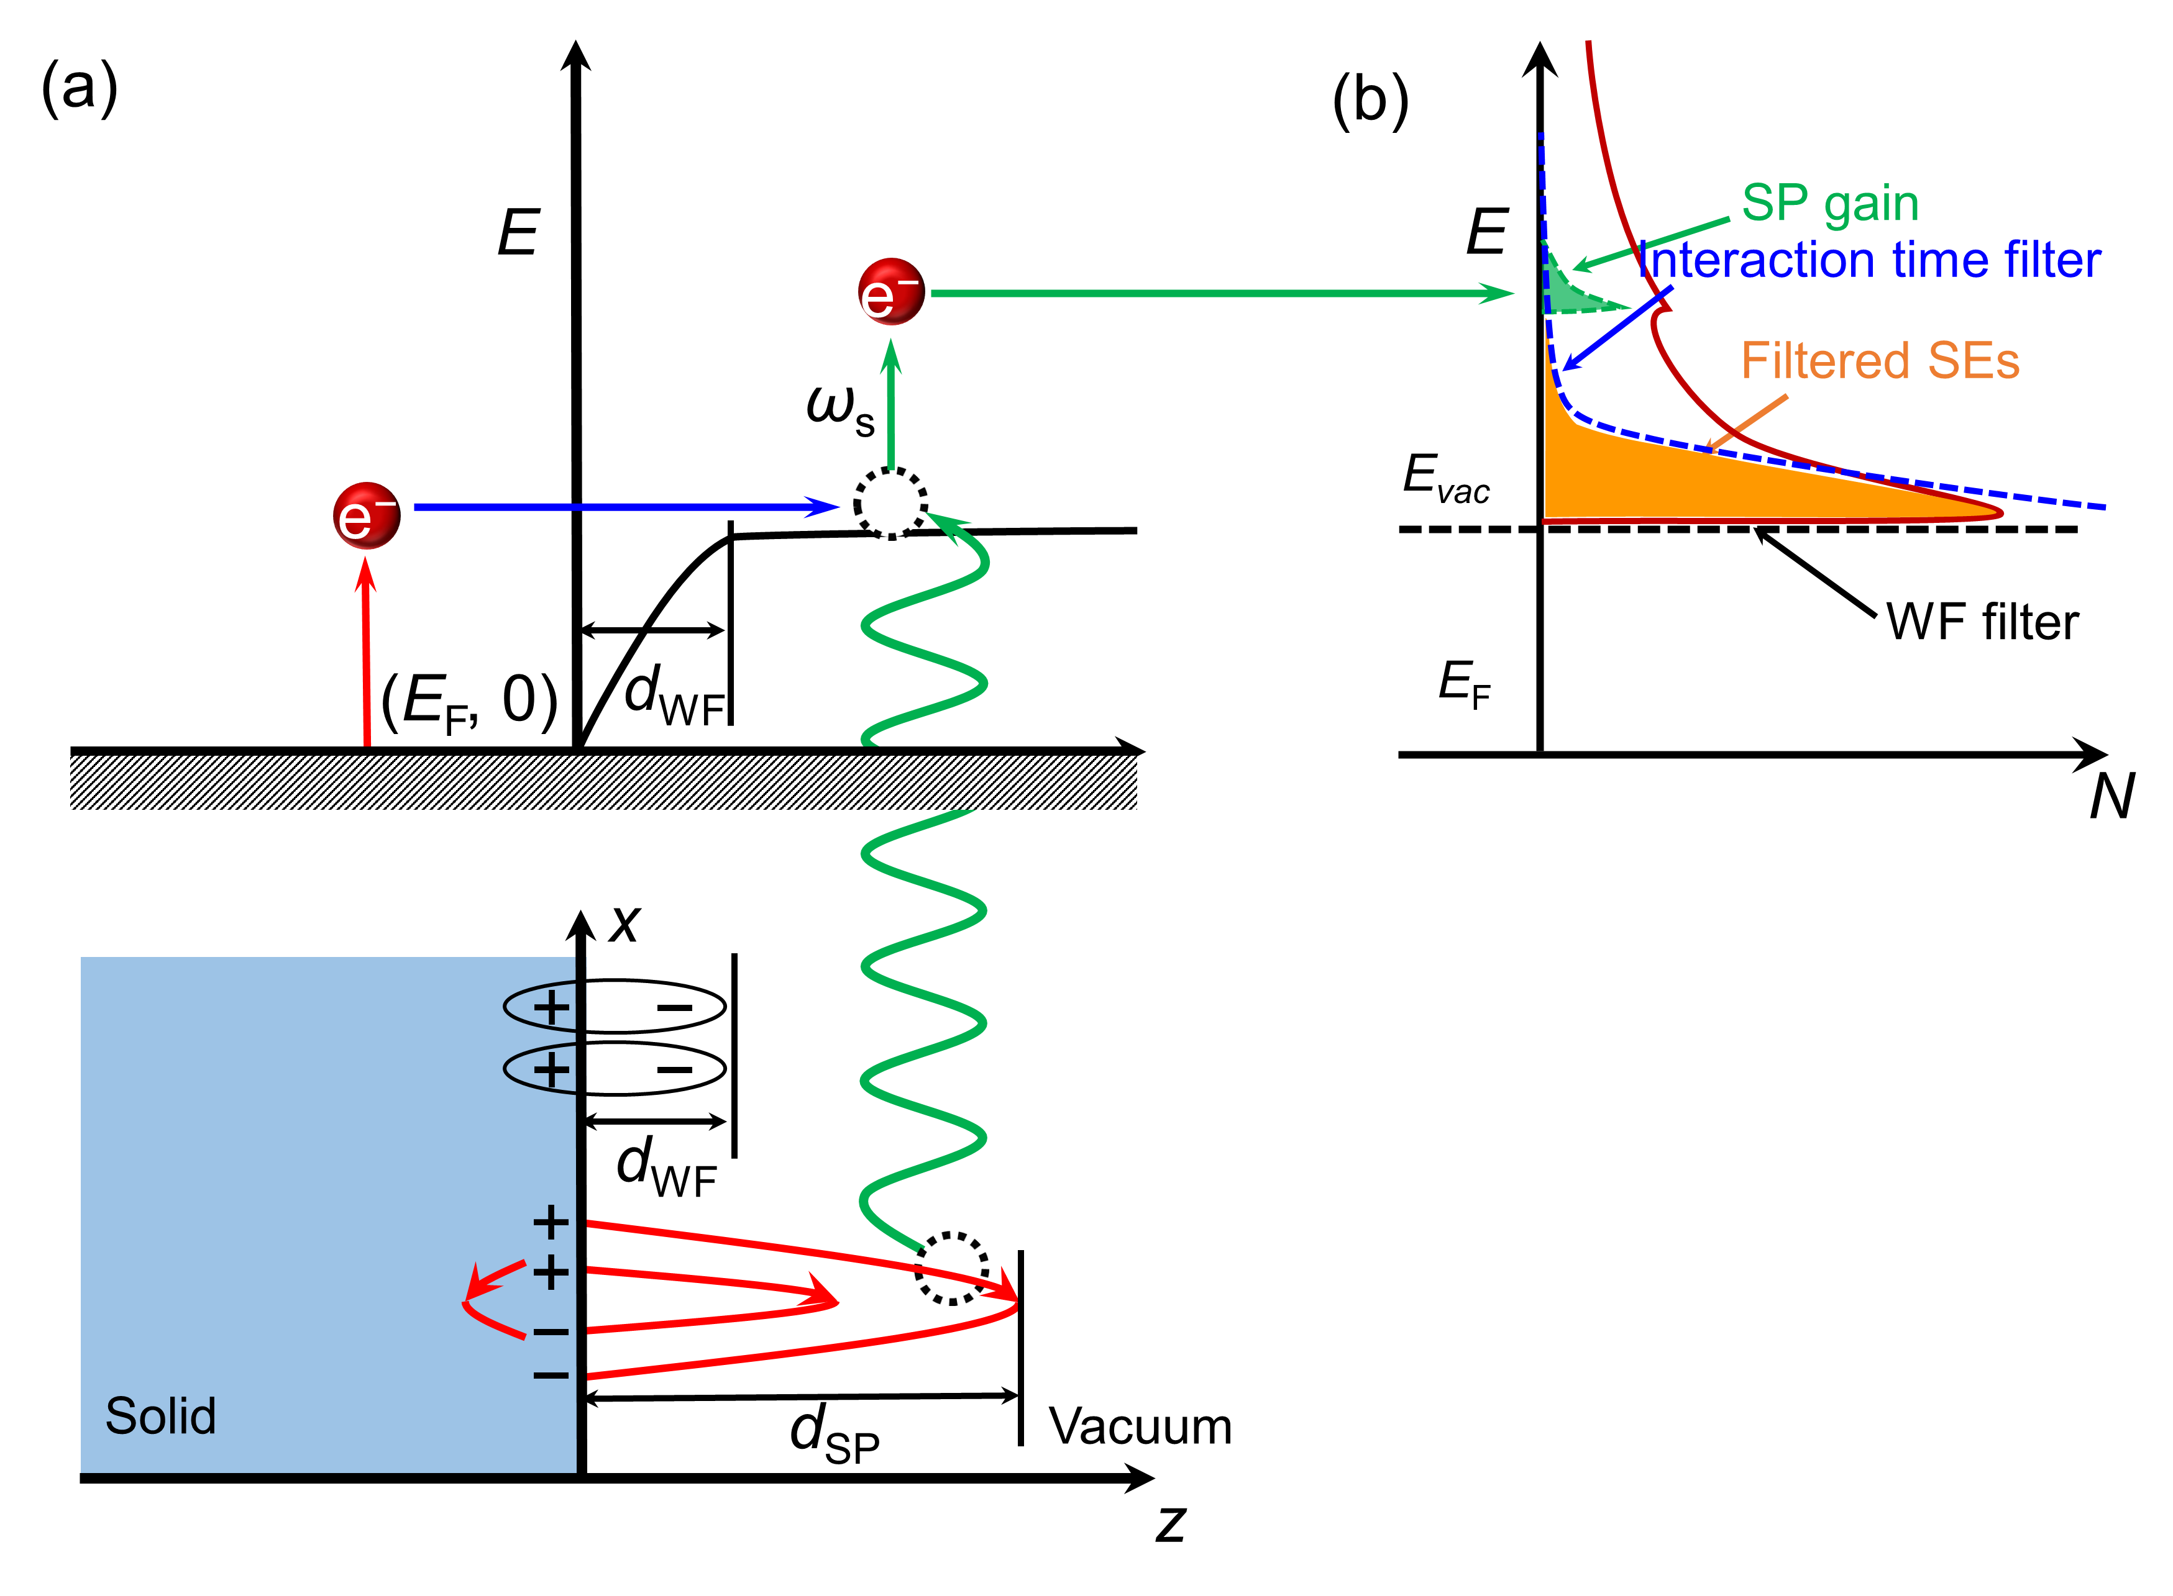
FIG. 1. (a) Schematic diagram of the surface plasmon energy gain process in SE emission. The effective distances of the work function and surface plasmons are d_{WF} and d_{SP}, respectively. (b) Energy distribution and composition of the excited SEs. For the entire process, typical excited SEs primarily arising from the conventional energy loss process are plotted by a red line. SEs with the potential to produce observable plasmon energy gain features are marked by an orange region, which is truncated by the work function and interaction time (see text) on the low and high energy sides, respectively. Finally, emitted SEs that have gained the energy of a surface plasmon quantum are marked as a green region.
Surface plasmons can also transfer energy to emitted SEs. As shown in Fig. 1, when an energetic electron strikes a solid surface, it may transfer part of its energy to solid-state electrons, giving rise to the formation of a cascade of slow electrons. In this case, most of the excited SEs are centralized near E_{F} because of cascade effects. Once the energy of these excited SEs exceeds the work function of the solid, the SEs may escape over the surface barrier after overcoming the work function, and most are centralized near the vacuum level and have the highest possibility of gaining a surface plasmon quantum because of their long interaction time in the effective surface plasmon area. Therefore, only SEs emitted with a level of energy similar to that of the work function screened out by the “work function filter” and “interaction time filter” have the potential to produce a spectral feature above the vacuum level in a spectrum related to surface plasmons.
Details regarding the mechanism of this plasmon energy gain for SEs have been reported in Ref. [23,24]. In these works [23,24], a surface plasmon energy gain peak for emitted SEs was observed in the reflected SE spectra of a nanostructured Au specimen as a satellite located at a surface plasmon energy above the vacuum level. A polycrystalline Au film composed of alternating micro- and nano-scale micron-sized single-phase grains with a flat top was adopted in these measurements to achieve a large number of surface plasmons with a long lifetime, which is necessary for observing surface plasmon energy gain phenomena. This plasmon energy gain for SEs is the reverse reaction of supersurface electron scattering [25] and was thus termed as a “supersurface plasmon energy gain process.”
To highlight the features of surface plasmon energy gain in reflected SE spectra, a combined measurement technique has been employed, in which two SE spectra are measured from two types of grains in a polycrystalline Au sample. These two types of grains possess different crystallographic orientations and different crystal qualities, and thus, the lifetimes of surface plasmons excited on these two grains differ, as reported in Ref. [24]. Furthermore, these two types of SE spectra have different proportions of surface plasmon energy gain contributions while maintaining similar proportions of conventional energy loss contributions. Therefore, the difference between these two SE spectra, the difference spectrum, contains more significant surface plasmon energy gain signals because the larger proportion of conventional energy loss contribution is offset in comparison to the surface plasmon energy gain contribution.
However, the use of a difference spectrum works only for Au samples, because the surface plasmon energy gain peak for Au samples is located at ~2.3 eV (surface plasmon energy of Au) above the vacuum level in a reflected SE spectrum, which is far from the very strong cascade SE background of Au (8–12 eV). As a different substance, nanoparticle and nanostructured Ag substrates also possess strong surface plasmon resonance with well-studied characteristics [26]. It is reasonable to expect that the surface plasmon energy gain phenomenon can also be observed in a polycrystalline Ag sample. However, in contrast to the Au case, the surface plasmon energy gain peak for Ag is expected to occur at ~3.8 eV (surface plasmon energy of Ag), which is close to the cascade SE peak of Ag (5–7 eV), and will thus be buried in the strong SE background, even in difference spectra. In this case, a new technique is needed to further distinguish the surface plasmon energy gain features of reflected SE spectra.
Fortunately, insights into this problem can be obtained from a theoretical study of electron–solid interactions based on the dielectric response theory. The surface plasmon mode is the response of a medium to a perturbation induced by electrons on the surface of a solid and was theoretically predicted in the 1950s by Ritche [3] and later observed experimentally by Powell and Swan [27].
Following these works, interactions between moving electrons and solids through surface plasmon excitation have been well studied both theoretically [28-45] using Monte Carlo methods and experimentally [6,46-57] using the reflected EELS (REELS) technique. To obtain a quantitative understanding of measured electron spectra based on the analysis of reflected or emitted electrons from a solid specimen, there is a need for an accurate description of the inelastic interaction between electrons and solid surfaces through surface excitation. The inelastic interaction is described by the electron inelastic scattering cross section (ISCS) (or the inverse of the inelastic mean free path) [58-62], which is position-dependent when electrons cross the surface of the solid owing to the spatially varying inelastic electron interaction.
Because the electron ISCS indicates the possibility for a moving electron to lose energy when it interacts with a solid surface, this parameter should always be positive. However, negative values will appear for an outgoing trajectory over a certain range of distances on the vacuum side of the sample when the electron–solid interaction is modeled theoretically using the dielectric response theory [34]. A number of theoretical models have been developed over the past decades. Some models consider a simplified dielectric response of the solid within semi-classical electrodynamics [6,40,41,43,63-65], whereas others use many-body quantum theory [44,45,66,67]. However, all available theories present negative ISCSs in such circumstances regardless of semi-classical or quantum mechanical considerations, as reported in Ref. [68].
In this work, we first theoretically model the interaction between emitted electrons and a metal surface using the dielectric response theory. It is found that the surface plasmon energy gain process is strongly influenced by the emission angle of the emitted electrons. In this case, a combined measurement technique, i.e., a three-point combined measurement method, is developed to enlarge the surface plasmon energy gain feature in the reflected SE spectrum. In this method, a nanostructured metal specimen is adopted, and SE spectra are measured at three different locations on the nanostructured surface. Finally, by applying simple mathematical operations to the measured SE spectra, the SE background caused by the conventional energy loss process in the SE spectra is eliminated, thus amplifying the proportion of plasmon energy gain-related features in the SE spectrum. This new combined measurement scheme allows us to observe the plasmon energy gain phenomenon in not only Au samples, but also Ag samples.
Methods

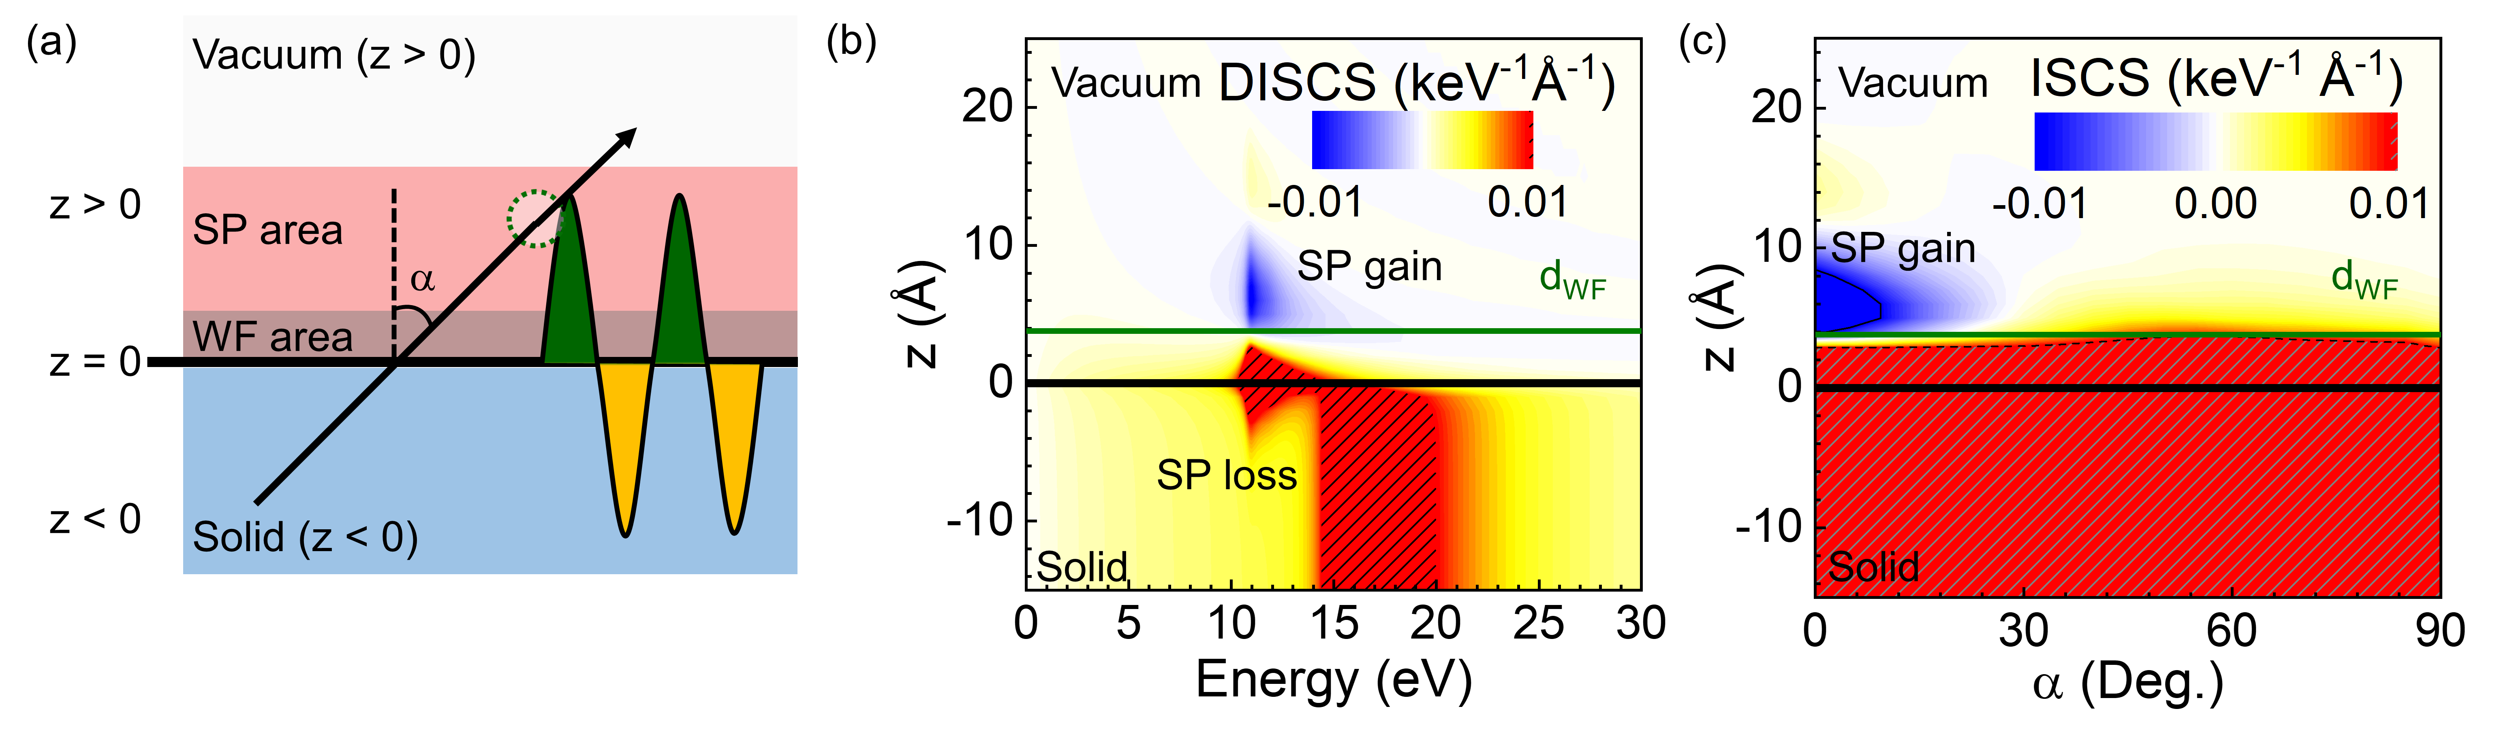
FIG. 2. (a) Schematic of the geometry of a SE emitted from a solid surface (z = 0) for an emission angle α with respect to the surface normal. The vacuum and solid correspond to the regions of z > 0 and z < 0, respectively. The space above the solid surface and below the effective distance of the work function (d_{WF}) and surface plasmon (d_{SP}) are marked as the SP area and WF area, respectively. (b) Calculated differential inelastic scattering cross section (DISCS) of a 50-eV electron for a vacuum Al system as a function of the energy of an electron escaping from the sample surface to the vacuum. The shaded regions indicate where the DISCS values are larger than 0.01 keV⁻¹Å⁻¹. The corresponding d_{wf} for Al is set to 3.8 Å (green line). The negative DISCS is marked as SP gain, and the positive DISCS region at 11 eV is marked as SP loss. (c) Calculated position dependence of the inelastic scattering cross section (ISCS) for a 50-eV electron in the Al surface region from 25 Å to −15 Å for different emission angles. The shaded regions indicate where the ISCS values are larger than 0.01 keV⁻¹Å⁻¹.
Here, a simplified dielectric response of the solid using many-body quantum theory [44,45,66,67] is presented to calculate the position-dependent ISCS of an electron as it escapes from the surface of a medium as shown in Fig. 2(a). The bulk dielectric function ε(q,ω) of the solid is used to derive the inelastic scattering probability based on the dielectric response theory. In the model, the dielectric function ε(q,ω) is expanded in the q-plane with the experimental optical dielectric function ε(ω) from a database in Ref. [69]. We applied the scheme of Ritchie and Howie [70] to extrapolate from the optical limit (q = 0) to other momentum transfers (q). In this scheme, the optical energy loss function Im[-1/ε(ω)] can be extended to the energy loss function Im[-1/ε(q,ω)], and the combination of the N-term Drude–Lindhard model energy loss function is fitted to the bulk energy loss function:
,
which includes the following 3N parameters: a_{i} is the oscillator strength, which can be negative; ω_{pi} is the oscillator energy; and γ_{i} is the width of the ith oscillator. The fitting procedure described above was applied to the experimental optical energy loss function for Al, Au, and Ag [69] to acquire these parameters.
According to the specular surface reflection model, the potential is determined by an external charge based on the dielectric function ε(q,ω). In detail, the boundary conditions [71,72] obtained via a common quantum mechanics framework [25,34,45] were used to fix the mirror image charge and the fictitious surface charges. The potentials in the form of Fourier components in the medium can be obtained by solving Poisson’s equation. Different cases hold for a charge in vacuum (z > 0) or inside the solid (z < 0) and for the induced potential at point z' in the vacuum (z' > 0) or inside the solid (z' < 0) as follows:
,
where matching conditions for incidence and emission at the surface determine the surface charges, while and are for surface charges inside the vacuum and the metal respectively, as
.
The surface dielectric function, , is defined by
.
Thus, after removing the potential of the external charge, the corresponding induced potentials are given as
,
,
, and
.
The random-phase approximation (RPA) self-energy of a system that is inhomogeneous in the z-direction is obtained in the time-ordered formalism:
,
where G_{S} is a surface Green function derived from a bulk free-electron Green function. The corresponding differential self-energy that is inhomogeneous in the z-direction of the moving electrons is obtained by integrating over . For various conditions of position and direction, we derive the following:
,
where is a position-independent bulk term, is an image charge term, is a surface charge term, and is a term corresponding to interference between the image charge and surface charges. For a vacuum-region electron, the classical self-energy for its incidence onto and escape from the surface is , while the contributions from both the image charge and surface charges are included in the additional term . In Eq. (10), is the vertical component of the velocity vector, and the vertical distance z measured from the surface is positive in the vacuum region and negative in the solid region. Now, the imaginary part of the differential self-energy can be applied to the differential inelastic scattering cross-section (DISCS):
,
where E = v²/2 is the electron kinetic energy and α is the angle between the surface normal and the velocity vector.
Once the DISCS is determined, the ISCS, i.e., the inverse inelastic mean free path, corresponding to the electron kinetic energy can be calculated by
where is the Bohr radius and is the Fermi energy.
As a well-known free electron gas metal, Al has a very clear bulk plasmon loss peak at approximately 17 eV and a surface plasmon peak at 11 eV. Based on the optical constants of Al [69], the DISCS was calculated using Eq. (11) for 50-eV electrons emitted from the vacuum/Al interface along the surface normal. Figure 2(b) clearly shows that when z < 5 Å, i.e., when the electron is deep inside the Al, the electron DISCS exhibits a very strong bulk plasmon loss peak feature at 15–20 eV. As the electron gradually approaches the vacuum/Al interface from inside the Al sample at -5 Å < z < 0, the electron DISCS exhibits a surface plasmon loss feature at 11 eV that gradually becomes stronger near the interface. When the electron leaves the Al surface, the bulk plasmon loss feature disappears, leaving only the surface plasmon loss feature at 11 eV, which decreases sharply as the electron moves away from the vacuum/Al interface. However, for an electron emitted from the surface at a distance of d_{WF}, a negative DISCS suddenly appears with an energy of 11 eV, which is consistent with the energy position at which the surface energy loss feature is located.
The intensity of this negative DISCS decays as electrons are emitted from the surface, with a maximum intensity of 4–12 Å. Because a positive cross section indicates the possibility for the electron energy to be transferred to a plasmon, a negative cross section naturally implies the possibility of a plasmon energy gain process, i.e., that a moving electron may gain energy via plasmon decay under specific circumstances. The negative DISCS value at 11 eV shown in Fig. 2(b) most likely indicates that the emitted electron at this position has gained a quantum of surface plasmon energy. According to Eq. (12), we can also calculate the electron ISCS for an emitted electron crossing the vacuum/Al surface at different emission angles.
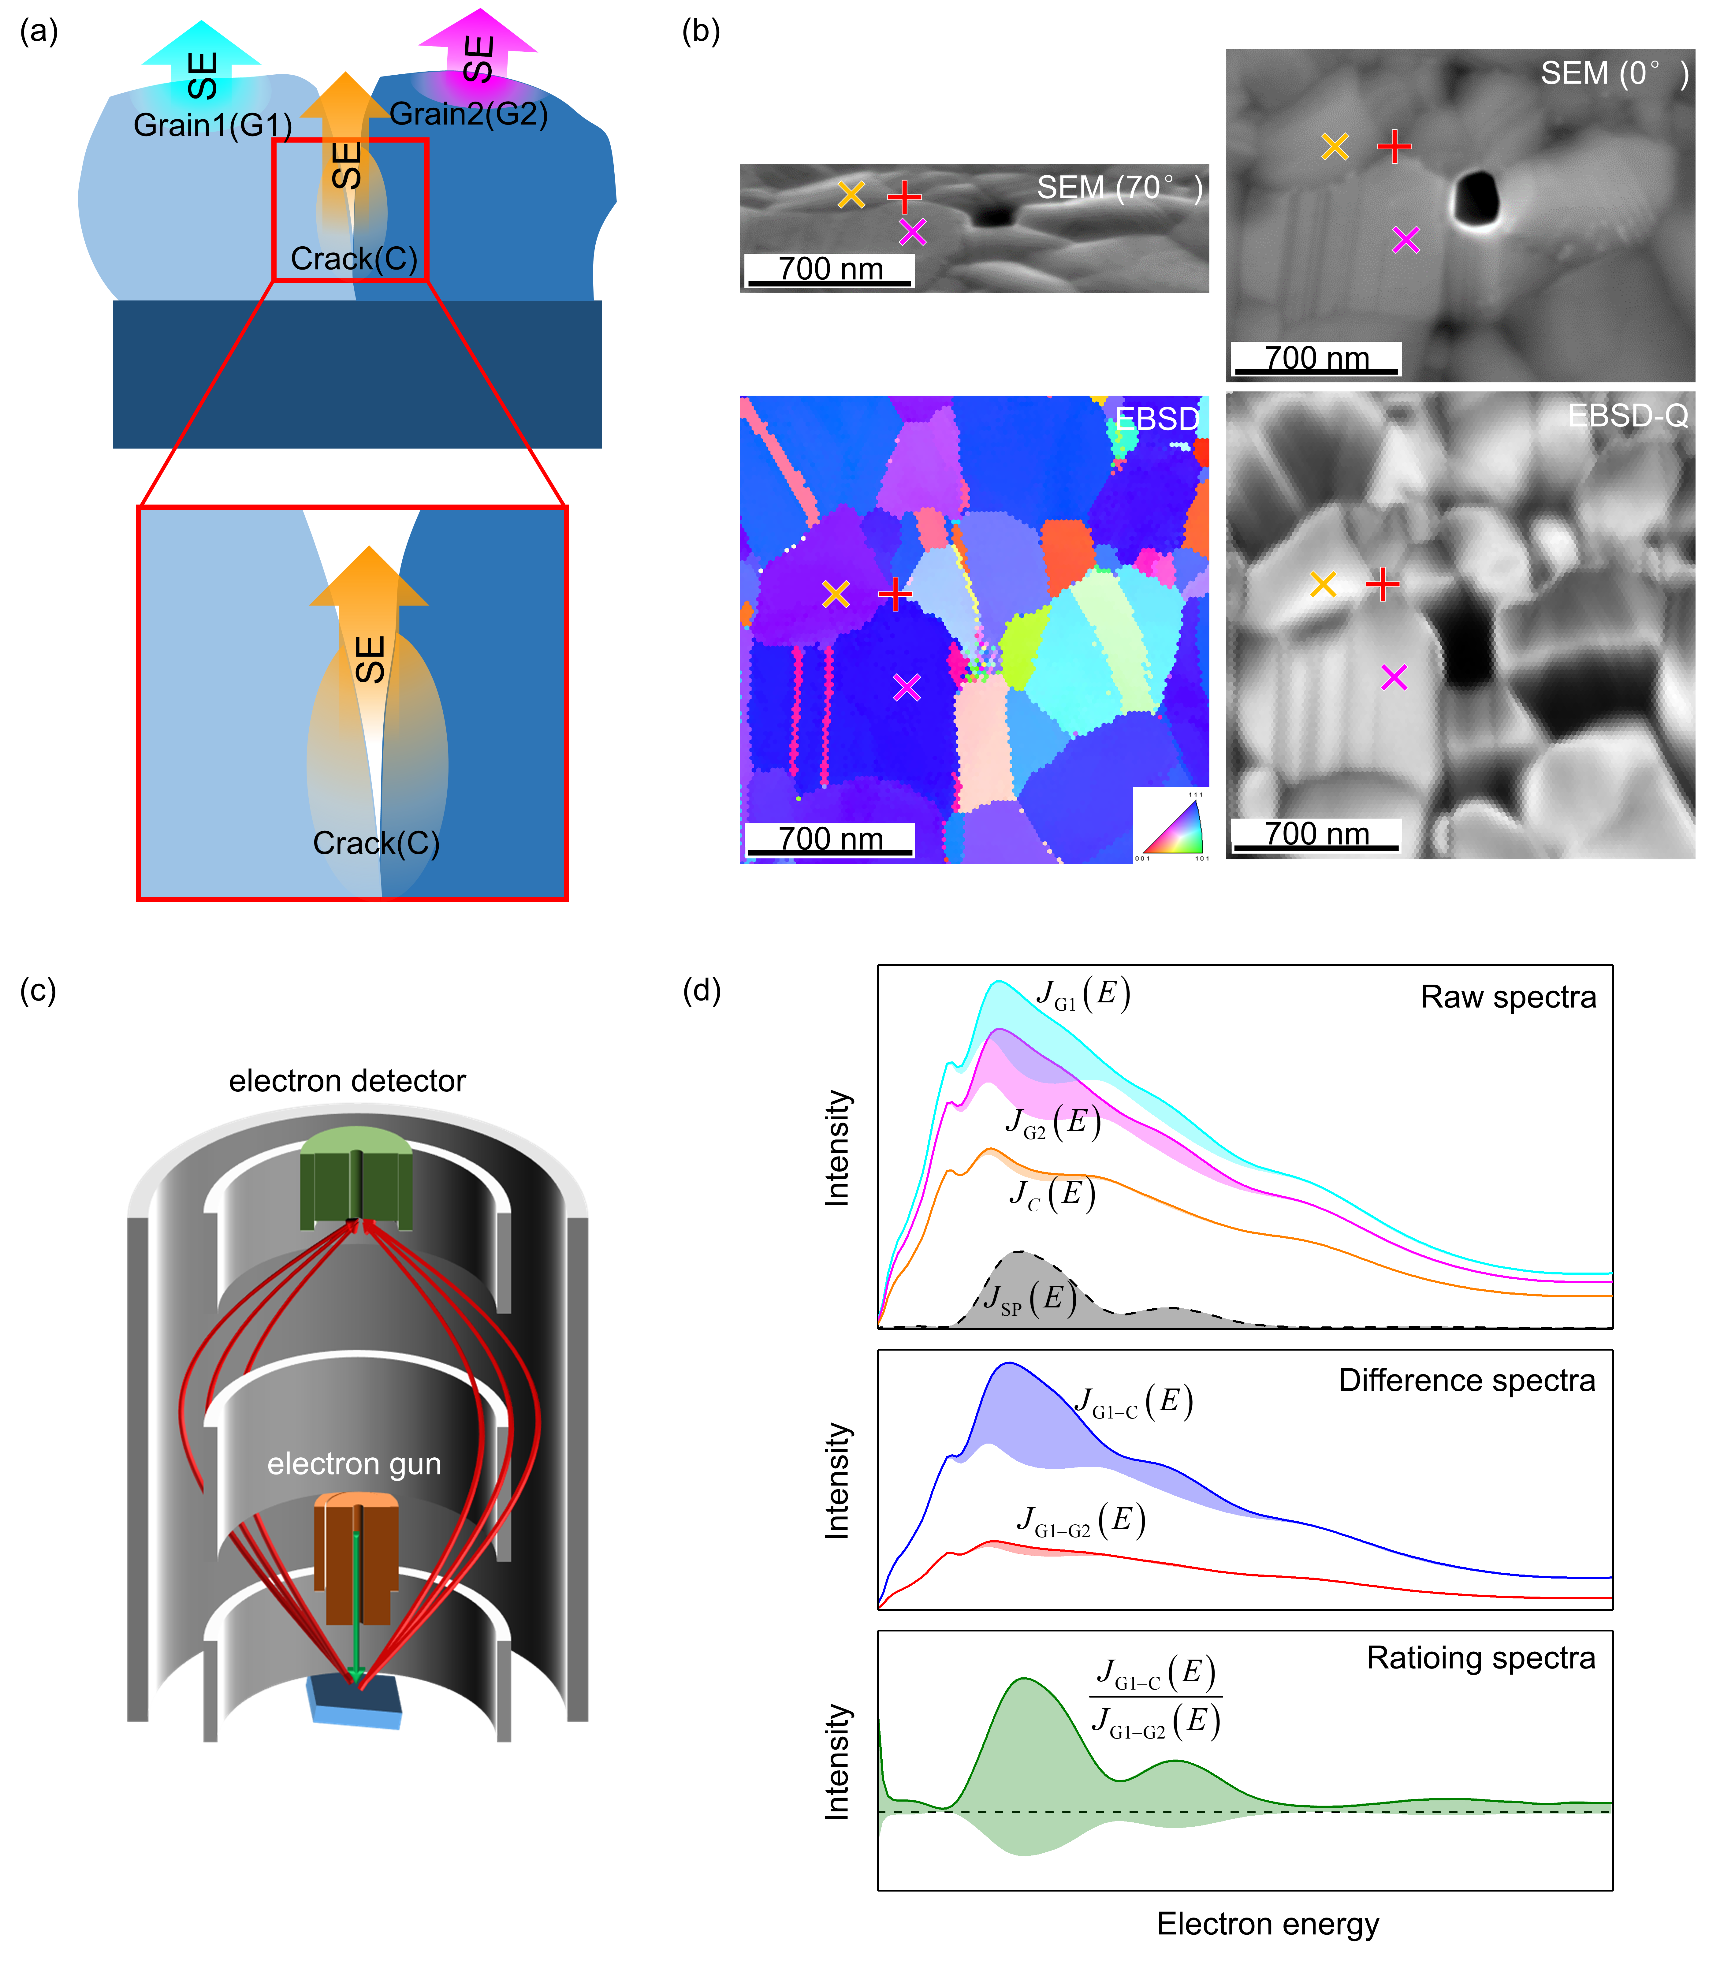
FIG. 3. (a) Schematic of the implementation of the three-point combined measurement method to highlight the hidden surface plasmon energy gain contribution in reflected SE spectra. (b) Scanning electron microscopy (SEM) image for sample stage at 70°, SEM image for sample stage at 0°, electron backscatter diffraction (EBSD) image, and EBSD quality map (EBSD-Q) of the same region of a polycrystalline Ag sample. One group of measurements sites for J_{G1}, J_{G2}, and J_{C} is presented in the images as a yellow diagonal cross, magenta diagonal cross, and red cross, respectively. The black hole in the central region is a pinhole formed by the shrinkage of the Ag film during annealing, and this pinhole is exposed Si substrate, which is confirmed by energy dispersive X-ray spectroscopy. (c) Diagram of scanning Auger electron spectrometer (SAM650, Ulvac-Phi, Kanagawa, Japan) setup with a cylindrical mirror analyzer (CMA). The take-off angle of the instrument was 42.3±6°. The incident electron beam current for these raw spectra was about 0.87nA, as calibrated with a Faraday cup before the measurements. (d) Three different types of prototype SE spectra, J_{G1} (cyan solid line), J_{G2} (magenta solid line), and J_{C} (orange solid line), are plotted in the top panel, with 30%, 25%, and 5% surface plasmon energy gain contributions. The surface plasmon energy gain spectrum, J_{SP}, is also presented as a grey dashed line. Two calculated difference spectra, J_{G1}−J_{C} and J_{G1}−J_{G2}, with corresponding surface plasmon energy gain contributions are plotted in the middle panel. The calculated ratio spectrum, (J_{G1}−J_{C})/(J_{G1}−J_{G2}), with surface plasmon energy gain contributions is plotted in the bottom panel.
Fig. 2(a) shows the ISCS for a 50-eV electron emitted from a solid Al surface as a function of emission angle. For a near-normal emission case (α < 10°), the contributions of these plasmon energy gains are significant, and their percentages rapidly decrease as the emission angle increases, approaching zero for electron emission angles larger than 45°. In agreement with theoretical predictions, the likelihood of a plasmon energy gain process reflected by the absolute value of a negative cross section is strongly dependent on the emission angle. With this characteristic, we can design a combination of measurements to highlight the features of the present plasmon energy gain process, which is commonly buried by the SE emission, in measured spectra by using spectrum subtraction and ratioing techniques.
In these combined measurements, three spectra are acquired independently on different surface regions of deposited metal films (Fig. 3(a)): two spectra are acquired on the flat top surface of two different, but similar, grains (marked as J_{G1} and J_{G2}), and another spectrum is acquired on a shrinkage crack region (marked as J_{C}) on the metal surface. According to theoretical predictions, the J_{G1} and J_{G2} spectra contain slightly different but significant proportions of plasmon energy gain contributions due to the relatively small emission angle of the detected SEs, whereas the J_{C} spectrum contains almost no plasmon energy gain contribution due to the relatively large emission angle. The sample with such morphologies can be prepared by sputter coating a metal layer on the substrate. Fig. 3b show the surface topography of Ag samples, as obtained by scanning electron microscopy (SEM), and electron backscatter diffraction (EBSD). Here, Ag layers (200 nm) were evaporated at a rate of 0.2 nm s⁻¹ on Si(100) substrates with Ti buffer layers (5 nm) pre-evaporated at a rate of 0.05 nm s⁻¹ by electron-beam evaporation (RDEB-1206 K, R-DEC Co. Ltd., Ibaraki, Japan) under a chamber pressure of approximately 1.0 × 10⁻⁵ Pa. After evaporation, the Ag samples underwent rapid thermal annealing (QHC-P410, Ulvac-Riko Inc., Kanagawa, Japan) under an N₂ atmosphere at 400 °C for 60 s. From the SEM images, it is clear that the present Ag polycrystalline films are composed of alternating micron-sized single-phase grains and obvious shrinkage cracks as the boundary of these grains. Furthermore, from the corresponding EBSD images, crystal orientation and crystal quality of these grains are significantly verified as a factor for choosing the location of the spectrum measurement. Based on the SEM and EBSD images of the Ag surface, two spectra can be acquired on the flat top surface of two different, but similar, grains (marked as J_{G1} and J_{G2}), according to the crystal orientation and crystal quality information demonstrated in EBSD map, and the other spectrum can be acquired on the shrinkage crack region (marked as J_{C}) on the Ag surface, as shown in Fig. 3b.
Fig. 3c shows a scanning Auger electron microscopy (SAM) setup with a cylindrical mirror analyzer (CMA). Focused electrons are incident on a sample, and emitted electrons are deflected into a CMA. The raw SE spectra in the three-point combined measurement method are measured by selecting incident positions on different crystallographic orientations in the top surface of grains in the Ag films and the shrinkage crack region as the boundary of these grains at room temperature with a SAM (SAM650, ULVAC-PHI, Kanagawa, Japan). The reliability of these selected incident positions in the shrinkage crack regions are verified by the consistency of the raw spectra measured on the indecent positions. The take-off angle of the instrument was 42.3±6°. The incident electron beam current for these raw spectra was approximately 0.87 nA, as calibrated with a Faraday cup before the measurements. The raw spectra are generally averaged from several different sample regions (~490 nm²) on the top surface of grains in the Ag films and the shrinkage crack region. Short-term repeated measurements for multiple cycles with micrometre distances between different measurement sites are used to minimize the influence of changes in the stability of the instrument over time and shrinkage crack region inhomogeneity.
It is worth mentioning here that the measured SE energy spectra obtained for different morphologies of shrinkage crack region may different, see Supplementary Material. Although it is difficult to describe and evaluate the different morphology of the shrinkage crack region quantitively with specific parameters, as well as other properties of the shrinkage crack region that may have an impact on the reflected SE energy spectrum. However, according to the definition of the three-point combined measurement method, this technique only relies on the reflected SE spectra produced from these shrinkage crack regions. Therefore, instead of estimating the similarity of shrinkage crack region by their various quantifiable parameters, we can directly evaluate the sum of their influences from secondary electron, whether or not the selected shrinkage crack region produce the similar reflected SE spectra under the same experimental conditions is the best judge for the reliability of a shrinkage crack region.
Generally speaking, the morphology of shrinkage crack on the SE energy spectrum strongly affects its absolute intensity, while has less influence on the structure of the characteristic peaks of its energy spectrum, see Supplementary Material. However, some strange spectrums that due to the adsorption of organic contaminants inside its cracks, leading to the change of local conductive properties in this region, thus greatly affecting the shape and intensity of the SE spectrum. Therefore, we can perform SE spectroscopy measurements on extra-large number of shrinkage crack regions form, compare with the SE spectrum, thus eliminate the strange SE spectrum which is largely different from others.
Finally, to intuitively demonstrate how the plasmon energy gain spectral features are highlighted by the combined measurements, we employed three prototype SE spectra, J_{G1}, J_{G2}, and J_{C} (Fig. 3(b)), which provide a linear combination of common SE spectral features and interesting hidden spectral features with different weight factors, to simulate reflected SE spectra measured at appropriate locations on the sample, as described above.
First, a spectrum subtraction technique was adopted between J_{G1} and J_{G2} and between J_{G1} and J_{C} to distinguish the hidden contribution of interest. As shown in the middle panel of Fig. 3(b), only a small amount of the hidden contribution of interest remains in the difference spectrum, J_{G1}−J_{G2}, as calculated by subtracting the spectra J_{G1} and J_{G2}, which have comparably large proportions of the hidden contribution of interest.
By contrast, the difference spectrum J_{G1}−J_{C} calculated by subtracting J_{G1} and J_{C} will have a relatively large hidden contribution of interest, because the hidden contribution of interest in spectrum J_{C} is far less than that in spectrum J_{G1}. The hidden spectral features of interest are indistinctly observable in the difference spectrum J_{G1}−J_{C} and can be further highlighted by the calculating ratio of spectrum J_{G1}−J_{C}, which has a large proportion of the hidden contribution of interest, to spectrum J_{G1}−J_{G2}, which has a small proportion of the hidden contribution of interest. By applying this method, the common SE spectral features become a gently varying background.
As shown in the bottom panel of Fig. 3(b), the hidden spectral features of interest are dominant in the ratio spectrum (J_{G1}−J_{C})/(J_{G1}−J_{G2}) and in line with the original templated hidden spectral features of interest in prototype spectra J_{SP}.
Therefore, we can use this combined measurement technique to amplify the surface plasmon energy gain phenomenon found in the SE spectral measurements of Au and Ag samples to highlight the fine structure of the plasmon energy gain spectral feature.
It should be noted that, beside the emission-angle-dependent plasmon energy gain spectral features, this combination measurement technique will also highlight other emission-angle-dependent spectral features, such as different degrees of shadowing effects at different electron energies and energy-dependent angular dependence among SEs. However, these spectral features generally exhibit a monotonic variation and will not affect the identifiability of plasmon energy gain spectral features.
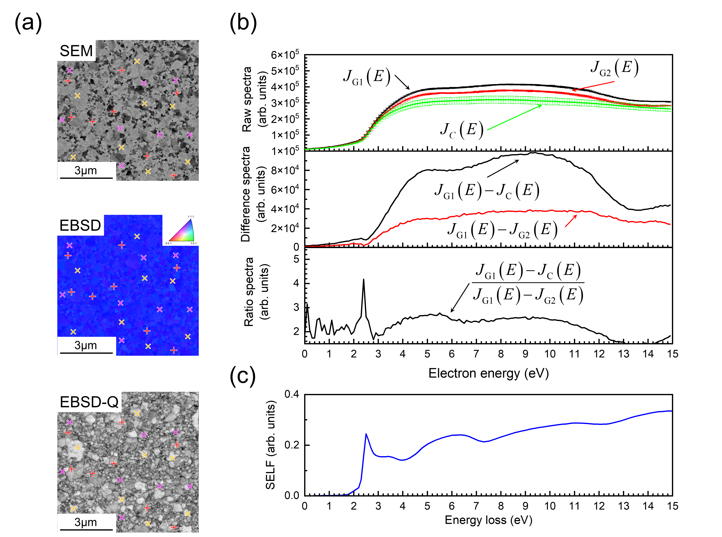
FIG. 4. (a) Scanning electron microscopy (SEM) image, electron backscatter diffraction (EBSD) image, and EBSD quality map (EBSD-Q) of the same region of a polycrystalline Au sample. Eight groups of measurements sites for J_{G1}, J_{G2}, and J_{C} is presented in the images as a yellow diagonal cross, magenta diagonal cross, and red cross, respectively. Selection rules are shown in Fig. 3. (b) Raw, difference, and ratio spectra obtained from eight independent groups of measurements in the energy range of 0–15 eV with an energy step of 0.1 eV for a polycrystalline Au sample with an incident electron energy of 10 keV. The standard deviations for the eight group measurements are presented as error bars at intervals of 0.5 eV in the raw spectra. (c) Surface energy loss function of Au calculated from the dielectric function of bulk Au [69].
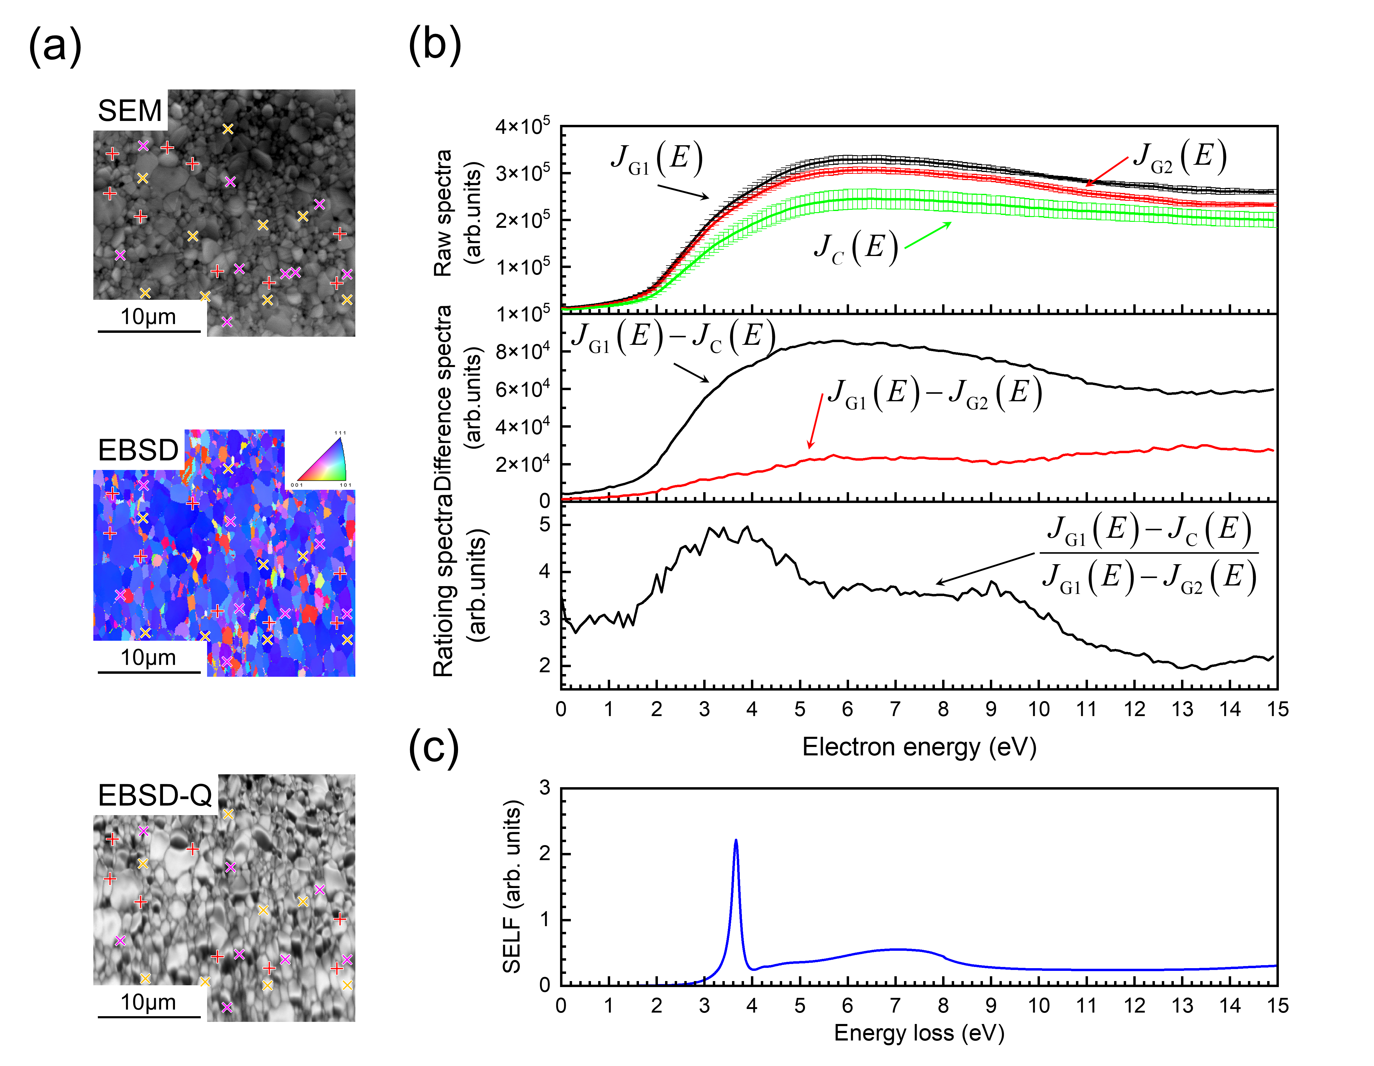
FIG. 5. (a) SEM image, EBSD image, and EBSD-Q map of the same region of a polycrystalline Ag sample. Measurements sites for J_{G1} , J_{G2}, and J_{C} are presented in the images as a yellow diagonal cross, magenta diagonal cross, and red cross, respectively. (b) Raw, difference, and ratio spectra obtained from eight independent groups of measurements in the energy range of 0–15 eV with an energy step of 0.1 eV for a polycrystalline Ag sample with an incident electron energy of 10 keV. The standard deviations for the eight group measurements are presented as error bars at intervals of 0.5 eV in the raw spectra. (c) Surface energy loss function of Ag calculated from the dielectric function of bulk Ag [69].
Results
In this work, the surface plasmon energy gain phenomenon was investigated using Au and Ag samples based on the strong surface plasmon effect that has been well studied from different aspects [73]. Because the surface plasmon energy gain mechanism observed in this work requires a large number of surface plasmons with a long lifetime, polycrystalline Au and Ag films composed of alternating micro- and nano-scale micron-sized single-phase grains with a flat top were prepared to achieve a suitable balance between the number and lifetime of excited surface plasmons. Furthermore, these films underwent rapid thermal annealing to intentionally produce some shrinkage cracks on the surface.
Here, a relatively high temperature (400 °C) was adopted in the thermal annealing procedure to enlarge the grains and to induce more significant shrinkage cracking between grains on the polycrystalline sample surface, as shown in the Supplemental Material. Figs. 4 and 5 show the surface topography of these tailor-made Au and Ag samples, as obtained by scanning electron microscopy (SEM), whereas the crystal orientation and crystal quality were verified by electron backscatter diffraction (EBSD). From the SEM and EBSD images, it is clear that the present Au and Ag polycrystalline films are composed of alternating micron-sized single-phase grains with different crystallographic orientations. For the Au samples, almost all grains are oriented in the (111) direction, and the relative orientation between bright and dark regions on the SEM image is generally approximately 2°–4°. For the Ag sample, the EBSD image shows that the polycrystalline Ag is composed of not only (111) grains but also grains with other orientations such as those oriented in the (001) crystal direction. Therefore, the relative orientation between bright and dark regions on the SEM image of the Ag sample is approximately 10°–20°.
According to theoretical analysis, two spectra measured on the flat top of different Au and Ag grains (J_{G1} and J_{G2}) have almost identical plasmon energy gain contributions; moreover, their proportions are relatively large compared with those measured on the sidewall of Au or Ag grains due to the relatively small emission angle of the detected SEs. Therefore, only a small plasmon energy gain contribution remains in the differential spectrum (J_{G1}−J_{G2}) calculated by subtracting these two spectra. The spectrum measured for the shrinkage crack region (J_{C}) has very little plasmon energy gain contribution because almost all of the detected SEs coming from the sidewall of Au or Ag grains have a small emission angle; therefore, a large plasmon energy gain contribution remains in the calculated differential spectrum (J_{G1}−J_{C}), in which the proportion of the plasmon energy gain contribution is larger because of the counteracting effect of the conventional energy loss contribution. In this case, the plasmon energy gain feature can be identified by taking the ratio of two difference spectra: a spectrum with a large proportion of plasmon energy gain contribution, J_{G1}−J_{C}, and a spectrum with a small proportion of plasmon energy gain contribution, J_{G1}−J_{G2}.
It is worth mentioning that when SE spectra are measured for grains with different qualities, the SE spectra will also exhibit different plasmon energy gain contributions in the energy spectrum because the number and lifetime of surface plasmon excitations for a high-quality grain are larger than those for a low-quality grain, as reported in Ref. [24]. In the EBSD quality map of Au and Ag, J_{G1} and J_{G2} were acquired on the flat top surface of two types of slightly different grains with relatively high quality, while J_{C} was acquired for the shrinkage crack region on the metal surface, which generally has a much lower crystal quality. Therefore, due to the grain quality at the measurement location, the spectra J_{G1} and J_{G2} contain slightly different proportions of surface plasmon energy gain contributions, while the J_{C} spectrum has a lower surface plasmon energy gain contribution. This result is consistent with the plasmon energy gain proportion observed in the SE spectra measured at different emission angles. Therefore, by employing the presented three-point combined measurement method, the ratio of the J_{G1−C} spectrum to the J_{G1−G2} spectrum can also highlight the surface plasmon energy gain features arising from grains with different levels of crystal quality.
To reduce the variation among measuring points, eight measuring points were selected for each type of spectrum, as shown in the Supplementary Material. Following the designed combination scheme, the difference spectra and ratio spectra were calculated from the measured raw spectra, as plotted in Figs. 4(b) and 5(b).
In the raw SE spectrum of Au, we can observe a fuzzy spectral feature located at the Au surface plasmon energy of ~2.3 eV. This fuzzy spectral feature becomes a significant peak in the corresponding difference spectrum. This fuzzy spectral feature can be directly observed in the difference spectrum because it occurs at ~2.3 eV and does not overlap with the cascade SE peaks of Au at ~8 eV. The surface plasmon energy gain peak at 2.3 eV becomes extremely prominent in the ratio spectrum because conventional energy loss spectral features due to the SE cascade, which dominates the majority of the SE energy spectrum, are eliminated during the ratioing operations.
For the Ag samples, the surface plasmon energy gain peak should occur at ~3.8 eV, which is close to the cascade SE peak of Ag; thus, the gain peak may be buried in the strong SE background in both the raw SE spectrum and difference spectrum. However, by calculating the corresponding ratio energy spectrum, the surface plasmon peak at 3.8 eV can be distinguished, and the plateau feature of Ag at 5–9 eV also becomes observable.
Since the energy loss for electron passing through a surface of a semi-infinite medium could be described by a so-called surface energy loss function (SELF), i.e. Im[−1/(ε+1)], which include the effects of surface as well as interference between the bulk and surface process [35,38,74,75]. For comparison, the typical surface plasmon loss of Au and Ag represented by the SELFs [73] is also presented in Figs. 4(c) and 5(c), respectively, where ε is the bulk dielectric function of Au or Ag [69]. It is obvious that the surface plasmon energy gain peak for Au and Ag observed in the ratio SE spectrum occurs at the exact energies corresponding to one quantum of surface plasmon energy observed in the surface energy loss function for Au and Ag. This result provides clear evidence that the observed spectral feature at ~2.3 eV in the ratio SE spectrum of Au and at ~3.8 eV in the ratio SE spectrum of Ag should originate from the surface plasmon energy gain phenomenon that occurs in vacuum.
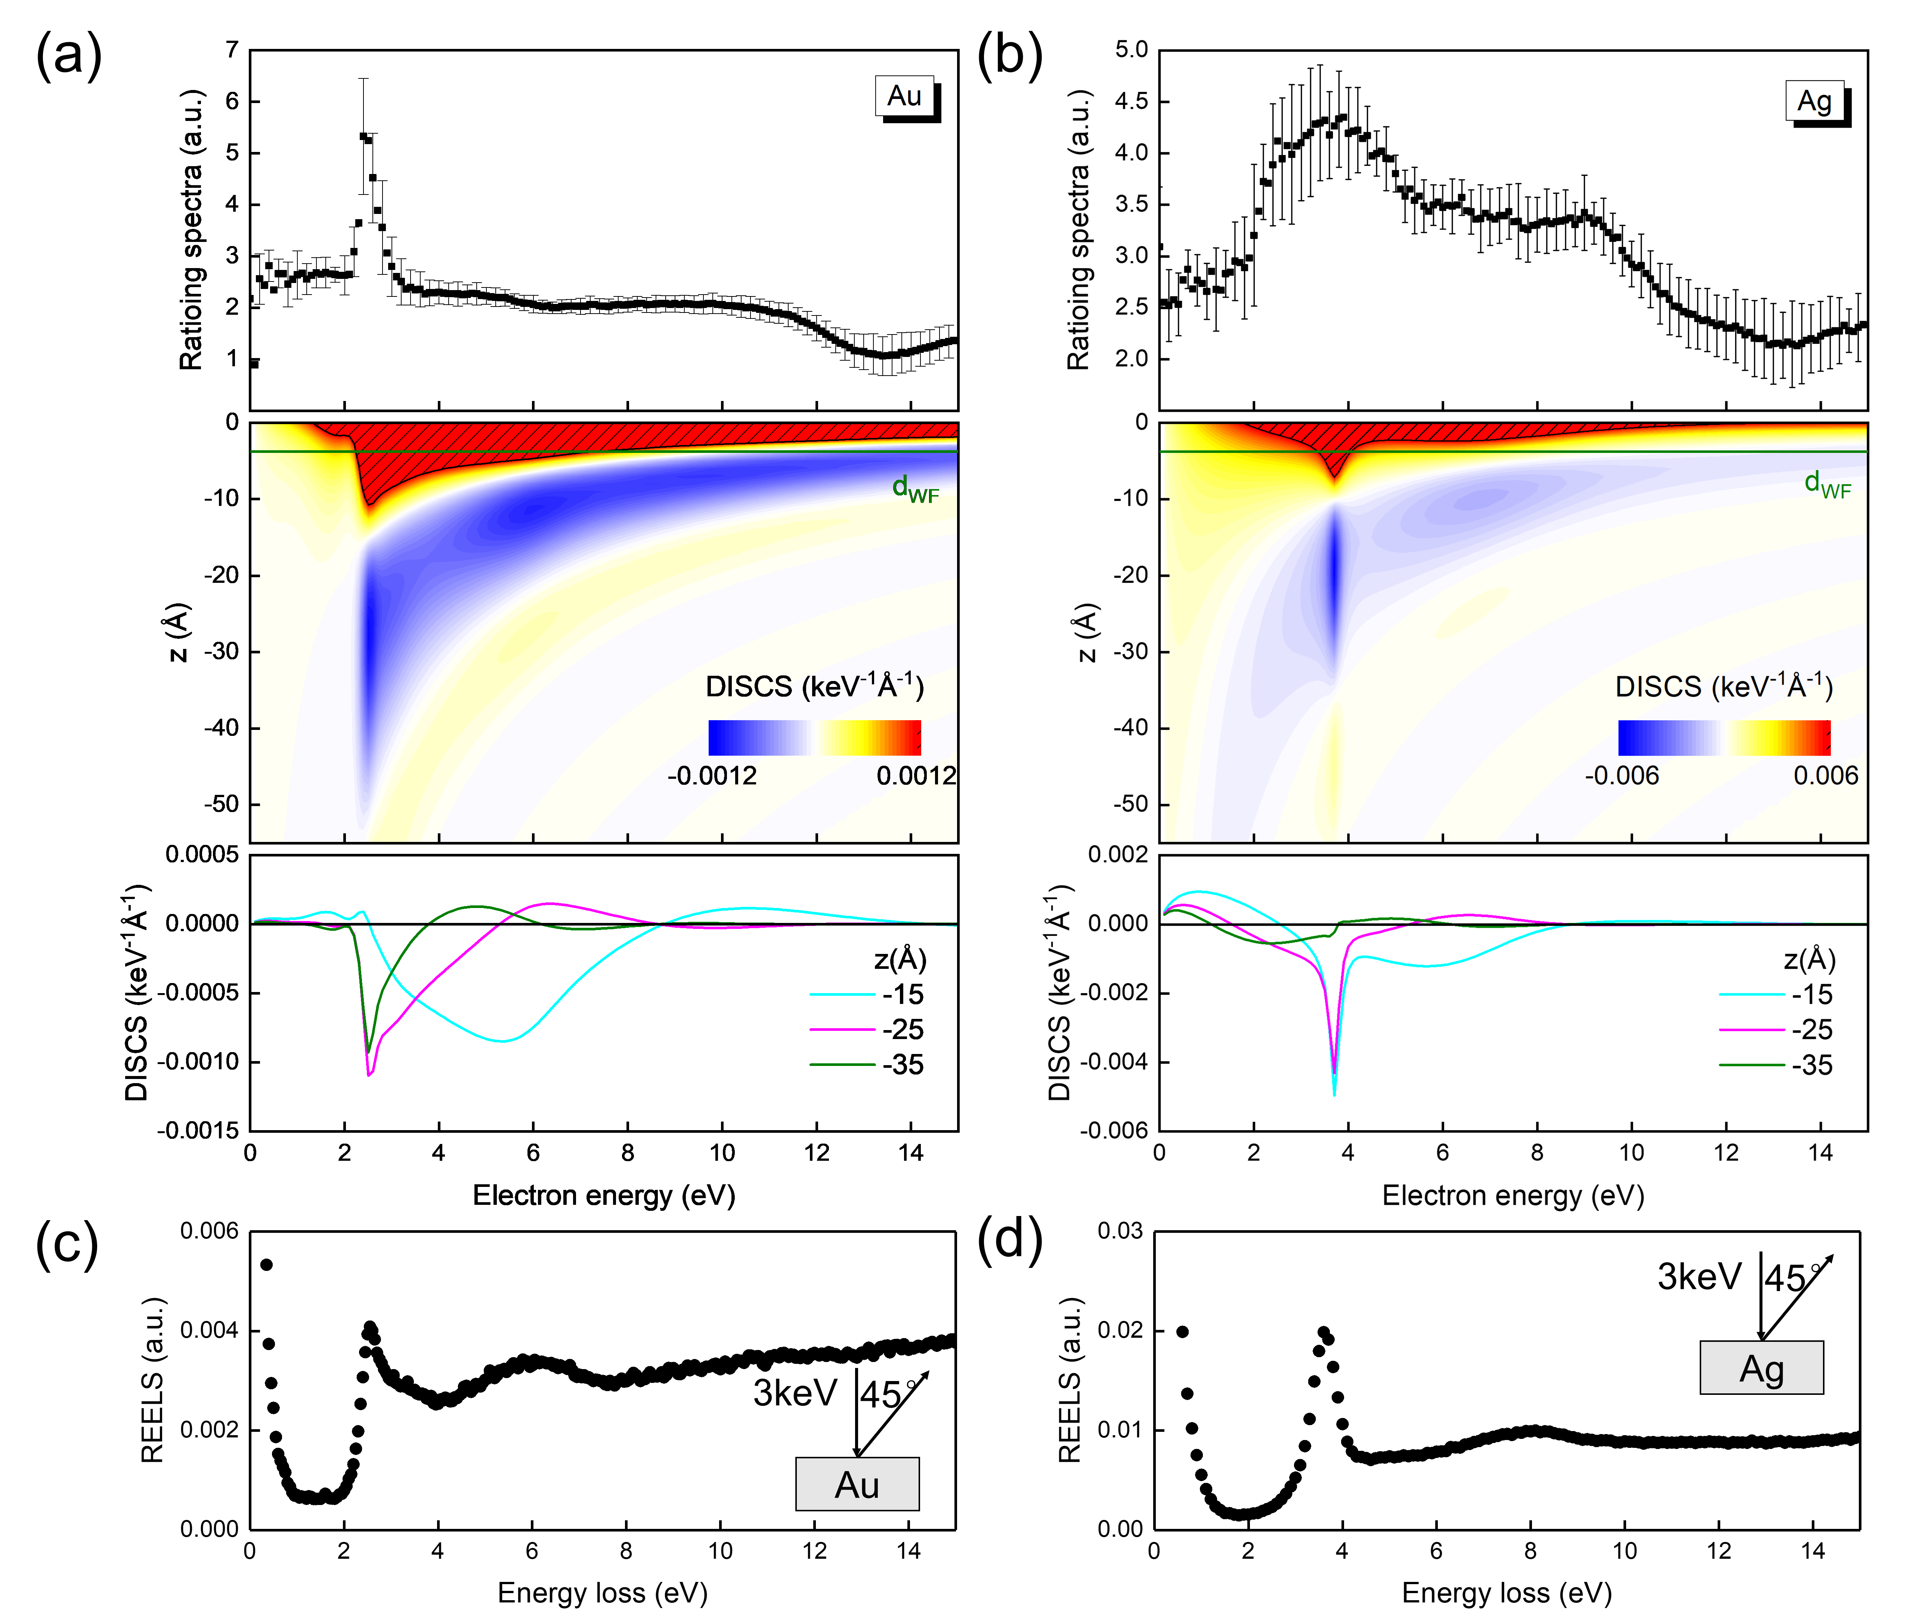
FIG. 6. Top: Normalized ratio spectra (plasmon energy gain spectra) of (a) Au and (b) Ag. Middle: Calculated DISCS for a 50-eV electron in a (a) vacuum/Au system or (b) vacuum/Ag system as a function of electron energy when the electron normally escapes from the sample surface to vacuum. The corresponding d_{wf} for Au and Ag was calculated by first principles as 3.8 Å and 4.1 Å, respectively (green line). The shaded regions indicate where the DISCS values are larger than (a) 0.006 keV⁻¹∙Å⁻¹ or (b) 0.0012 keV⁻¹∙Å⁻¹. Bottom: Calculated DISCS of a 50-eV electron for selected positions between the electron and Au or Ag surface. REELS spectrum measured on the (c) Au and (d) Ag surface, with the experimental geometry shown as an inset.
The averaged ratio spectra obtained via the combined measurements from Au (six groups of measurements) and Ag (three groups of measurements) samples are presented in the top panel of Figs. 6(a) and 6(b), respectively, with error bars representing the standard deviation. The corresponding raw SE spectra are shown in the Supplementary Material. Significant spectral structures can be found in these ratio spectra, including a sharp peak at 2.3 eV for Au and a broad peak at 3.8 eV for Ag. It is reasonable to expect that these observed peaks are caused by the surface plasmon energy gain process because the energies of these observed peaks are consistent with the well-established surface plasmon energies of Au and Ag (2.3 eV and 3.8 eV for Au and Ag, respectively). To further confirm these findings, the DISCS values for the vacuum side (z < 0) for Au and Ag were calculated, as presented in the bottom panel of Figs. 6(a) and 6(b). Positive DISCS values are dominant for short distances from the surface (several angstroms), representing a high likelihood of the surface plasmon loss process, while negative DISCS values, which imply a surface plasmon energy gain process, appear within a certain range of distances, generally ranging from several angstroms to several nanometers, depending on the electron energy. The primary region with negative values for Au and Ag is located near 2.3 eV and 3.8 eV, respectively, which is consistent with the energy positions of the peaks observed in the ratio spectra. Furthermore, although the negative DISCS regions for Au and Ag show similar behaviors as a function of electron energy—expanding and moving away from the metal surface as the electron energy decreases—when the electron energy is lower than the surface plasmon energy (2.3 eV for Au and 3.8 eV for Ag), the intensity of negative DISCS values gradually decreases with decreasing electron energy for Ag, whereas a sharp decline is observed for Au. This finding may explain why an obscure peak and a sharp peak were observed near the surface plasmon energy in the ratio spectra for Au and Ag, respectively. In addition, another negative region in the energy range of 5–9 eV can be found for the calculated DISCS for Ag but not for Au, which leads to a unique plateau feature in the ratio spectra of Ag at 5–9 eV. It is interesting to compare the ratio spectrum, which primarily arises from the surface plasmon energy gain process, and the REELS spectrum, which primarily arises from the surface plasmon loss process. The REELS spectra for Au and Ag are presented in Figs. 6(c) and 6(d), respectively.
For Au, only the surface plasmon peak at 2.3 eV in the REELS spectrum matches the plasmon energy gain spectral structure extremely well, whereas the bulging structure near 5 eV in the loss structure is not found in the plasmon energy gain spectra. This finding suggests that the loss behavior causing the bulging peak is mainly caused by intraband transitions, which is consistent with previous studies on Au [76]. It is worth mentioning that the plasmon energy gain spectra obtained by the present three-point combined measurement method demonstrate a more intense and detailed plasmon energy gain peak at 2.3 eV, compared with the previous study using deviation or differentiation of two SE spectra in Ref. [24].
For Ag samples, the energy loss features in the REELS spectra agree well with those observed in the ratio spectra, for both the sharp surface plasmon peak at 3.8 eV and the plateau feature at 5–9 eV. This result suggests that the shouldered loss structure at 5–9 eV is also associated with surface plasmons, which is consistent with previous findings based on REELS analysis of Ag surfaces via Monte Carlo simulations [56].
The REELS spectra and ratio spectra present similar spectral features. especially at the surface plasmon energy, even though the mechanisms behind these features—surface plasmon loss in the REELS spectra and surface plasmon energy gain in the ratio spectra—are completely reversed. Interestingly, when electrons backscattered from the Au or Ag surface are collected as a spectrum, almost the same spectral features resulting from surface plasmons arise at both the high energy and low energy sides with a mirror symmetry, in the form of surface plasmon loss features exposed in the spectrum and surface plasmon energy gain features buried in the strong SE background.
Discussion
It should be noted that Werner and collaborators [77-79] observed the plasmon decay process from an Al sample using a double-differential SE electron-energy-loss coincidence spectrum, which is another well-established method for studying surface plasmons on metal samples and their interactions with transported electrons. However, the phenomenon reported herein in the present paper is essentially different from the plasmon energy gain process described by Werner. Simply stated, in the plasmon decay process, the excited plasmon transfers its energy to a solid-state electron [80], whereas in the plasmon energy gain process, the excited plasmon transfers its energy to an energetic electron. In the plasmon decay process, plasmons excited by electron energy loss decay via the generation of single electron–hole pairs, acting as a source of SEs. Only those excited SEs whose energy exceeds the work function of the solid can overcome the work function and produce a spectral feature in the low-energy SE spectra at the exact energy corresponding to the plasmon energy minus the work function. In this case, such a surface plasmon decay process can be observed only from a material with a surface plasmon energy larger than the work function of the solid, similar to Al. However, for materials whose surface plasmon energy is smaller than the work function, SEs excited by surface plasmon decay cannot escape over the surface barrier of the solid and thus cannot produce any observable spectral features in the low-energy SE spectra. In the presented plasmon energy gain process, the SEs gain energy from surface plasmons after overcoming the work function of the solid and therefore can produce a spectral feature in the low-energy SE spectra corresponding only to surface plasmons of the solid, regardless of the specific value of the work function of the solid. Thus, the presented plasmon energy gain process is much more suitable for investigating interrelations between surface plasmons and electrons in materials whose surface plasmon energy is smaller than the work function, such as Au or Ag.
Finally, we must emphasize that compared with the previously reported process of plasmon energy gain for elastic electrons and core-level electrons, the plasmon energy gain process for SEs is more suitable for imaging the real spatial distribution of surface plasmons on a nanostructured sample surface, which may provide a new research platform for applying Raman enhancement techniques on the surface of nanostructured samples. Firstly, the signals of plasmon energy gain for SEs outrival those for elastic electrons and core-level electrons in the signal-to-background ratio by orders of magnitude because the absolute intensities of SEs are generally several orders of magnitude higher than those of elastic electrons and core-level electrons. Moreover, the flight speed of emitted SEs is much lower than that of elastic electrons and core-level electrons, implying a longer interaction time with the excited surface plasmon and thus a greater likelihood of transfer for a surface plasmon quantum. Secondly, the previously observed plasmon energy gain for elastic electrons requires an experimental configuration with a grazing incidence setup [22], which limits the application of this phenomenon in imaging techniques. In contrast, the presented plasmon energy gain for SEs can be observed under experimental configurations with normal incidence, which is an important advantage for developing imaging techniques once we could directly observe them in space.
Conclusion
Here, we report a peculiar plasmon gain phenomenon observed in reflected secondary electron spectra. A new mechanism is proposed on plasmon gain for emitted secondary electrons in vacuum but nearby the surface, and is further verified experimentally by using a tailor-made three-point combined measurement method for polycrystalline Au and Ag sample. This measurement method is based on the four-point probe method in materials science for precise determination of the electrical resistance of solids. In this peculiar plasmon gain, the secondary electrons emitted from the metal surface gain energy quanta from surface plasmons after escaping over the surface barrier. They thereby carry the information of the localized surface plasmon within the distance of several angstroms to several nanometers away from the surface. This information was previously only available through Transmission Electron Microscope (TEM) - electron energy loss spectroscopy (EELS). Although EELS is near-perfect tool for understanding the optical and electronic properties for individual plasmonic metal nanoparticles, it is very demanding on the sample preparation process. This limits its convenience. The general reflection configuration electron beam-based instruments such as AES and XPS often require substrates to support the nanosamples when measuring them, making it difficult to obtain local plasmon surface information beyond a few angstroms of the nanoparticle sample. However, the plasmon gain phenomenon reported in this paper provide a possible way to obtain the electronic properties near the nanoparticles of these instruments based on the reflection configuration electron beam even when the nanosamples are placed on the substrate for measurement.
Acknowledgment
We thank Dr. C. J. Powell, Prof. Tarakura, Prof. Tanaka, Prof. M. S. Xu for helpful comments and discussions. This work was supported by the National Institute for Materials Science under the Support system for curiosity-driven research, JSPS KAKENHI Grant Number JP21K14656 and Grant for Basic Science Research Projects from The Sumitomo Foundation. J.H. thanks the support from Chancellor's Innovation and Collaboration Fund at the University of Arkansas. Z.J.D was supported by the National Key Research and Development Project (2019YFF0216404) and Education Ministry through “111 Project 2.0” (BP0719016). All DFT calculations were performed on the Numerical Materials Simulator supercomputer at the National Institute for Materials Science. We also thank Kristi Hatch, PhD, from Edanz (https://jp.edanz.com/ac) for editing a draft of this manuscript.

References
[1] D. Pines and D. Bohm, Phys. Rev. 85, 338 (1952).
[2] D. Bohm and D. Pines, Phys. Rev. 92, 609 (1953).
[3] R. H. Ritchie, Phys. Rev. 106, 874 (1957).
[4] J.D. Bourke and C.T. Chantler, J. Phys. Chem. Lett. 6, 314 (2015).
[5] W.S.M. Werner, W. Smekal, H. Stori, H. Winter, G. Stefani, A. Ruocco, F. Offi, R. Gotter, A. Morgante and F. Tommasini, Phys. Rev. Lett. 94, 038302 (2005).
[6] Z.J. Ding, K. Salma, H.M. Li, Z.M. Zhang, K. Tokesi, D. Varga, J. Toth, K. Goto and R. Shimizu, Surf. Interface Anal. 38, 657 (2006).
[7] N. Cao, B. Da, Y. Ming, S.F. Mao, K. Goto and Z.J. Ding, Surf. Interface Anal. 47, 113 (2015).
[8] C.T. Chantler and J.D. Bourke, J. Phys. Chem. Lett. 1, 2422 (2010).
[9] C.J. Powell and A. Jablonski, Nucl. Instrum. Meth. Phys. Res. A 601, 54 (2009).
[10] T. Eberlein, U. Bangert, R. R. Nair, R. Jones, M. Gass, A. L. Bleloch, K. S. Novoselov, A. Geim, and P. R. Briddon, Phys. Rev. B 77, 233406 (2008).
[11] D.B. Lu, Z.F. Hou, X. Liu, B. Da and Z.J. Ding, J. Phys. Chem. C 123, 25341 (2019).
[12] D.B. Lu, Z.F. Hou, H.M. Li, B. Da and Z.J. Ding, Appl. Surf. Sci. 553, 149558 (2021).
[13] T. L. Kirk, U. Ramsperger and D. Pescia, J. Vac. Sci. Technol. B, 27, 152 (2009).
[14] L. H. Jenkins and M. F. Chung, Surf. Sci. 26, 151 (1971).
[15] M. Suleman and E. B. Pattison, J. Phys. F 1, L21 (1971).
[16] H. D. MeGuire and P. D. Augustus, J. Phys. C 4 L174 (1971).
[17] A. Barrie and F. J. Street, J. Electron Spectrosc. 7, 1 (1975).
[18] J. C. Fuggle, L. M. Watson, D. J. Fabian and S. Affrossman, J. Phys. F: Metal Phys. 5, 375 (1975).
[19] S. A. Abo-Namous, P. T. Andrews and C. E. Johnson, J. Phys. F: Metal Phys. 9, 61 (1979).
[20] J. A. D. Matthew and C. M. K. Watts, Phys. Lett. A 37, 239 (1971).
[21] J. C. Fuggle, R. Lässer, O. Gunnarsson and K. Schönhammer, Phys. Rev. Lett. 44, 1090 (1980).
[22] J. Schilling and H. Raether, J. Phys. C: Solid State Phys. 6, L358 (1973).
[23] B. Da, J.W. Liu, M. Yamamoto, Y. Ueda, K. Watanabe, N.T. Cuong, S.L. Li, K. Tsukagoshi, H. Yoshikawa, H. Iwai, S. Tanuma, H.X. Guo, Z.S. Gao, X. Sun and Z.J. Ding, Nature Commun. 8, 15629 (2017).
[24] B. Da, J. W. Liu, Y. Harada, N. T. Cuong, K. Tsukagoshi, H. Jin, L.H. Yang, Z.J. Ding, H. Yoshikawa and S. Tanuma, J. Phy. Chem. Lett. 10, 5770 (2019).
[25] W. S. M. Werner, M. Novák, F. Salvat–Pujol, J. Zemek, and P. Jiricek, Phys. Rev. Lett. 110, 086110 (2013).
[26] K.J. Zhang, D.B. Lu, B. Da and Z.J. Ding, Sci. Rep. 8, 15993 (2018).
[27] C.J. Powell and J.B. Swan, Phys. Rev. 115, 869 (1959).
[28] B. Da, S.F. Mao and Z.J. Ding, J. Phys.: Condens. Matter. 23, 395003 (2011).
[29] B. Da, S.F. Mao, G.H. Zhang, X.P. Wang and Z.J. Ding, J. Appl. Phys. 112, 034310 (2012).
[30] B. Da, Y. Sun, S.F. Mao, Z.M. Zhang, H. Jin, H. Yoshikawa, S. Tanuma and Z.J. Ding, J. Appl. Phys. 113, 214303 (2013).
[31] B. Da, S. F. Mao, Y. Sun and Z.J. Ding, e-J. Surf. Sci. Nanotech. 10, 441 (2012) .
[32] B. Da, Z.Y. Li, H.C. Chang, S.F. Mao and Z.J. Ding, J. Appl. Phys. 116, 124307 (2014).
[33] B. Da, L.H. Yang, J.W. Liu, Y.G. Li, S.F. Mao and Z.J. Ding, Surf. Interface Anal. 52, 742 (2020).
[34] F. Salvat-Pujol, W. S. M. Werner, Surf. Interface Anal. 45, 873 (2013).
[35] F. Yubero and S. Tougaard, Phys. Rev. B 46, 2486 (1992).
[36] C.J. Tung, Y.F. Chen, C.M. Kwei and T.L. Chou, Phys. Rev. B 49, 16684 (1994).
[37] Y.F. Chen, J. Vac. Sci. Technol. A 13, 2665 (1995).
[38] F. Yubero, J.M. Sanz, B. Ramskov and S. Tougaard, Phys. Rev. B 53, 9719 (1996).
[39] J. I. Juaristi, F.J. Garcia de Abajo and P.M. Echnique, Phys. Rev. B 53, 13839 (1996).
[40] Y.F. Chen and Y.T. Chen, Phys. Rev. B 53, 4980 (1996).
[41] Y.F. Chen and C.M. Kwei, Surf. Sci. 364, 131 (1996).
[42] A.C. Simonsen, F. Yubero and S. S. Tougaard, Phys. Rev. B 56, 1612 (1997).
[43] Y.C. Li, Y.H. Tu, C.M. Kwei and C.J. Tung, Surf. Sci. 589, 67 (2005).
[44] Z.J. Ding, J. Phys.: Conden. Matter 10, 1733 (1998).
[45] Z.J. Ding, J. Phys.: Conden. Matter 10, 1753 (1998).
[46] L.H. Yang, K. Tőkési, J. Tóth, B. Da and Z.J. Ding, Phys. Rev. B 100, 245209 (2019).
[47] L.H. Yang, K. Tőkési, J. Tóth, B. Da and Z.J. Ding, J. Phys.: Conf. Ser. 1412, 202026 (2020).
[48] L.H. Yang, B. Da, K. Tőkési and Z.J. Ding, Sci. Rep. 11, 5954 (2021).
[49] L.H. Yang, A. Hussain, S.F. Mao, B. Da, K. Tőkési and Z.J. Ding, J. Nucl. Mater. 553, 153042 (2021).
[50] D.B. Lu, K. Goto, B. Da, J.W. Liu, H. Yoshikawa, S. Tanuma and Z.J. Ding, J. Electr. Spectrosc. Rela. Phenom. 250, 147086 (2021).
[51] L.H. Yang, J.M. Gong, A. Sulyok, M. Menyhárd, G. Sáfrán, K. Tőkési, B. Da and Z.J. Ding, Phys. Chem. Chem. Phys. 23, 25335 (2021).
[52] H. Xu, B. Da, J. Tóth, K. Tőkési and Z.J. Ding, Phys. Rev. B 95 195417 (2017).
[53] H. Xu, L.H. Yang, J. Tóth, Tőkési, B. Da and Z.J. Ding, J. Appl. Phys. 123 043306 (2018).
[54] L.H. Yang, J. Tóth, K. Tőkési, B. Da and Z.J. Ding, Eur. Phys. J. D 73, 21 (2019).
[55] M. Novak, Surf. Sci. 602, 1458 (2008).
[56] Z. J. Ding, H. M. Li, Q. R. Pu, Z. M. Zhang and R. Shimizu, Phys. Rev. B 66, 085411 (2002).
[57] M. Novak, R. J. Bereczky, Z. M. Zhang, Z. J. Ding, J. Toth, D. Varga and K. Tokesi, Surf. Interface Anal. 40, 522 (2008).
[58] ISO18115 Surface Chemical Analysis—Vocabulary—Part 1: General terms and terms used in spectroscopy, International Organization for Standardization, Geneva, 2010.
[59] B. Da, H. Shinotsuka, H. Yoshikawa, Z.J. Ding and S. Tanuma, Phys. Rev. Lett. 113, 063201 (2014).
[60] B. Da, Y. Sun, Z.F. Hou, J.W. Liu, N.T. Cuong, K. Tsukagoshi, H. Yoshikawa, S. Tanuma, J. Hu, Z.S. Gao and Z.J. Ding, Phys. Rev. Appl. 13, 044055 (2020).
[61] X. Liu, Z. F. Hou, D. B. Lu, B. Da, H. Yoshikawa, S. Tanuma, Y. Sun and Z. J. Ding, Sci. Technol. Adv. Mater. 20, 1090 (2019).
[62] X. Liu, L. H. Yang, Z. F. Hou, D. B. Lu, B. Da, H. Yoshikawa, S. Tanuma, Y. Sun and Z. J. Ding, Phys. Rev. Mater. 5, 033802 (2021).
[63] E.A. Stern, and R.A. Ferrell, Phys. Rev. 120, 130 (1960).
[64] H. Kanazawa, Prog. Theor. Phys. 26, 851 (1961).
[65] N. Takimoto, Phys. Rev. 146, 366 (1966).
[66] J. Harris and R.O. Jones, J. Phys. C: Solid State Phys. 6, 3585 (1973).
[67] J. Harris and R.O. Jones, J. Phys. C: Solid State Phys. 7, 3751 (1974).
[68] B. Da, L.H. Yang, J.W. Liu, D.M. Tang, Y. Harada, H. Yoshikawa, S. Tanuma, J. Hu, Z.J. Ding, Negative Probability, Sampling and Electron Wake Effect, submitted.
[69] E. D. Palik, Handbook of Optical Constants of Solids (Academic, New York, 1998)
[70] R. H. Ritchie and A. Howie, Phil. Mag. A 36, 463 (1977).
[71] F. Garcia-Moliner and F. Flores, Introduction to the Theory of Solid Surfaces (Cambridge University Press, Cambridge, 1979)
[72] F. Flores and F. Garcia-Moliner in Surface Excitations, edited by V. M. Agranovich and R. Loudon (Elsevier, Amsterdam, 1984).
[73] H. Venghaus, Phys. Stat. Sol. (b) 71, 609 (1975).
[74] S. Tougaard and I. Chorkendorff, Phys. Rev. B 35, 6570 (1987).
[75] S. Tougaard and J. Kraaer, Phys. Rev. B 43, 1651 (1991).
[76] Z. J. Ding and R. Shimizu, Phys. Rev. B 61, 14128 (2000).
[77] W. S. M. Werner, A. Ruocco, F. Offi, S. Iacobucci, W. Smekal, H. Winter and G. Stefani, Phys. Rev. B, 78, 233403 (2008).
[78] W. S. M. Werner, F. Salvat‐Pujol, W. Smekal, R. Khalid, F. Aumayr, H. Störi, A. Ruocco, and G. Stefani, Appl. Phys. Lett. 99, 184102 (2011).
[79] W. S. M. Werner, F. Salvat-Pujol, A. Bellissimo, R. Khalid, W. Smekal, M. Novák, A. Ruocco, and G. Stefani, Phys. Rev. B. 88, 201407 (2013).
[80] B.D. Powell and D.P. Woodruff, Surf. Sci., 33, 437 (1972).

Supplementary Material: Emitted Secondary Electrons: In Vacuo Plasmon Energy Gain Observation using a Three-Point Combined Measurement Method
B. Da^{1,2*}, X. Liu^{1,3}, J. M. Gong^{1,3}, Z.H. Zhang³, Z. J. Ding^{3#}, N. T. Cuong^{4,5}, H. Jin⁶, J. W. Liu⁷, Z. S. Gao⁸, H. X. Guo⁹, H.X. Wang², H. Zhang², Y. Harada², H. Yoshikawa^{1,2†}, and S. Tanuma²
¹Research and Services Division of Materials Data and Integrated Systems, National Institute for Materials Science, 1-1 Namiki, Tsukuba, Ibaraki 305-0044, Japan
²Research Center for Advanced Measurement and Characterization, National Institute for Materials Science, 1-1 Namiki, Tsukuba, Ibaraki 305-0044, Japan
³Department of Physics, University of Science and Technology of China, Hefei, Auhui 230026, China
⁴International Center for Young Scientists (ICYS), National Institute for Materials Science, Tsukuba, Ibaraki 305-0044, Japan
⁵International Center for Materials Nanoarchitectonics (WPI-MANA), National Institute for Materials Science, Tsukuba, Ibaraki 305-0044, Japan
⁶Department of Physics and Institute for Nanoscience and Engineering, University of Arkansas, Fayetteville, Arkansas 72701, United States
⁷Research Center for Functional Materials, National Institute for Materials Science, 1-1 Namiki, Tsukuba, Ibaraki 305-0044, Japan
⁸Institute of Electrical Engineering, Chinese Academy of Sciences, Beijing, 100190, P.R. China.
⁹Key Laboratory of MEMS of Ministry of Education, School of Electronic Science and Engineering, Southeast University, Nanjing, 210096, People’s Republic of China.
*DA.Bo@nims.go.jp
#zjding@ustc.edu.cn
†YOSHIKAWA.Hideki@nims.go.jp

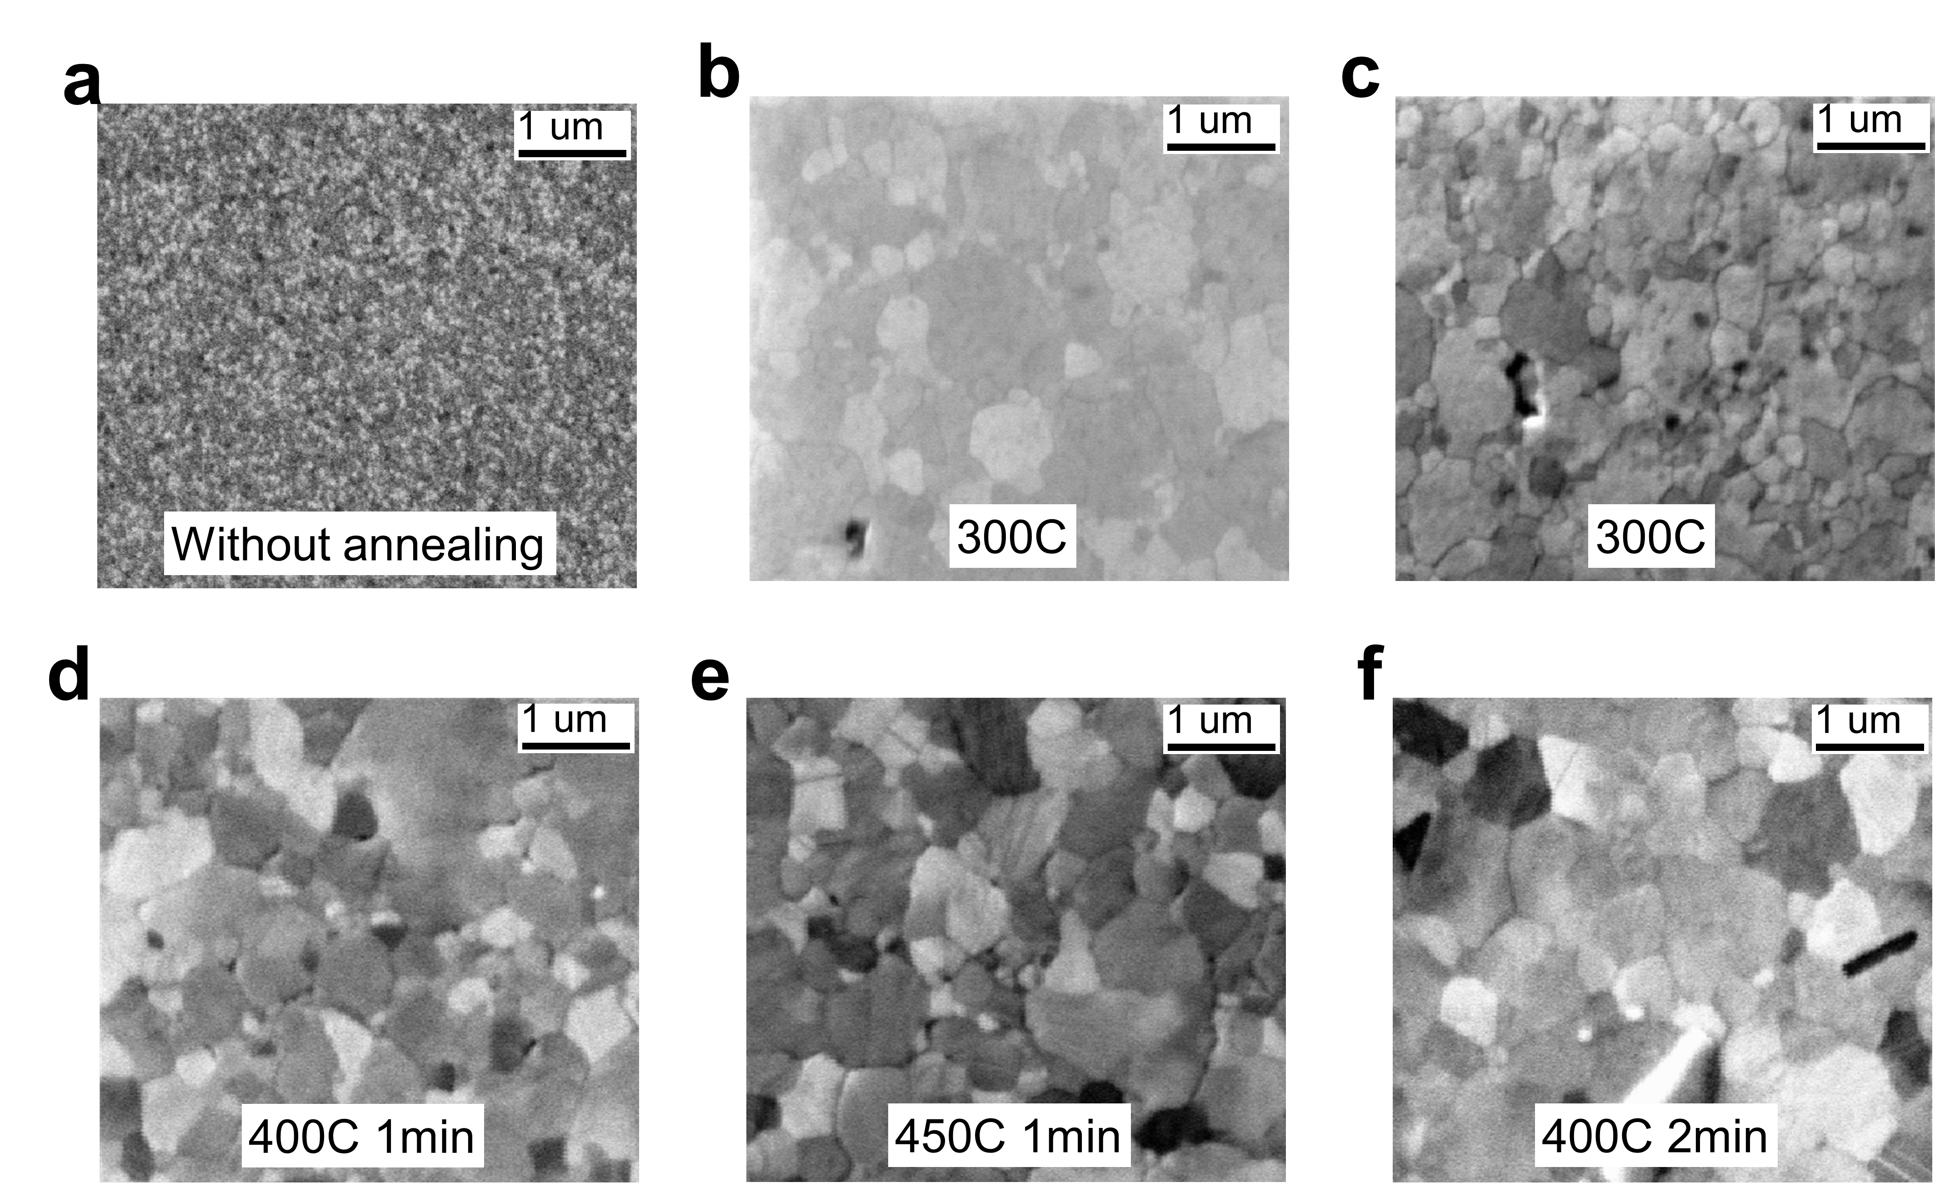
FIG. S1. SEM images of few-layer graphene sheets on a polycrystalline Au film for different annealing temperatures and times. Au and Ag layers (200 nm) were evaporated at a rate of 0.2 nm s⁻¹ on Si(100) substrates with Ti buffer layers (5 nm) pre-evaporated at a rate of 0.05 nm s⁻¹ by electron-beam evaporation (RDEB-1206 K, R-DEC Co. Ltd., Ibaraki, Japan) under a chamber pressure of approximately 1.0 × 10⁻⁵ Pa. After evaporation, the Au and Ag samples underwent rapid thermal annealing (QHC-P410, Ulvac-Riko Inc., Kanagawa, Japan) under an N₂ atmosphere at 400 °C for 30 s or 60 s, respectively.
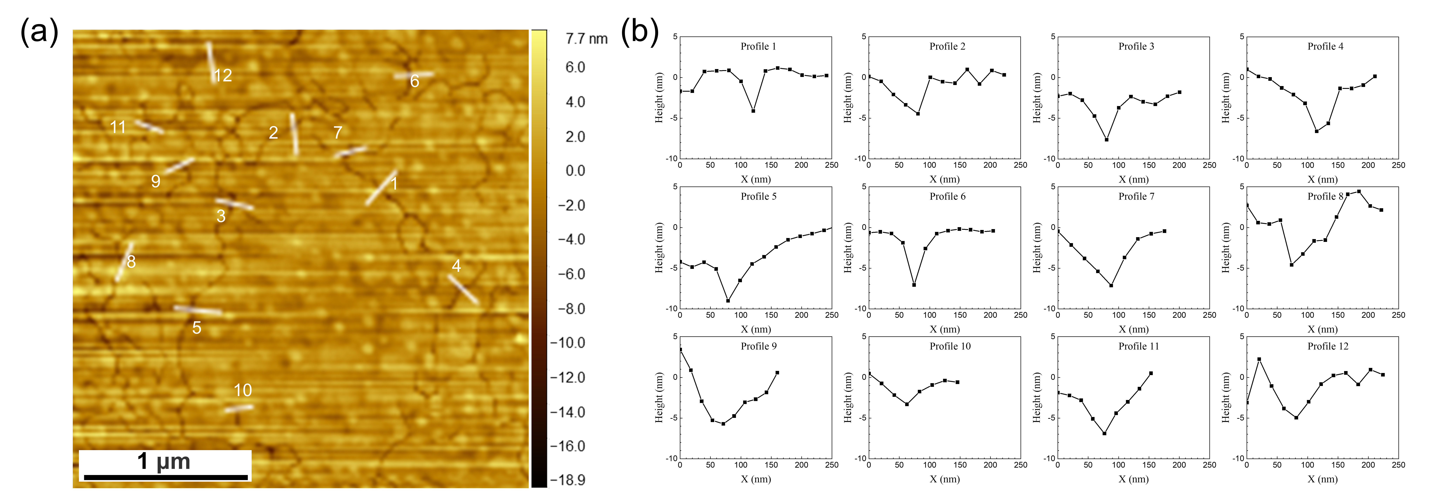
FIG. S2. AFM images for Au film on substrates. 12 kinds of situations are randomly chosen and their cross sections are measured.
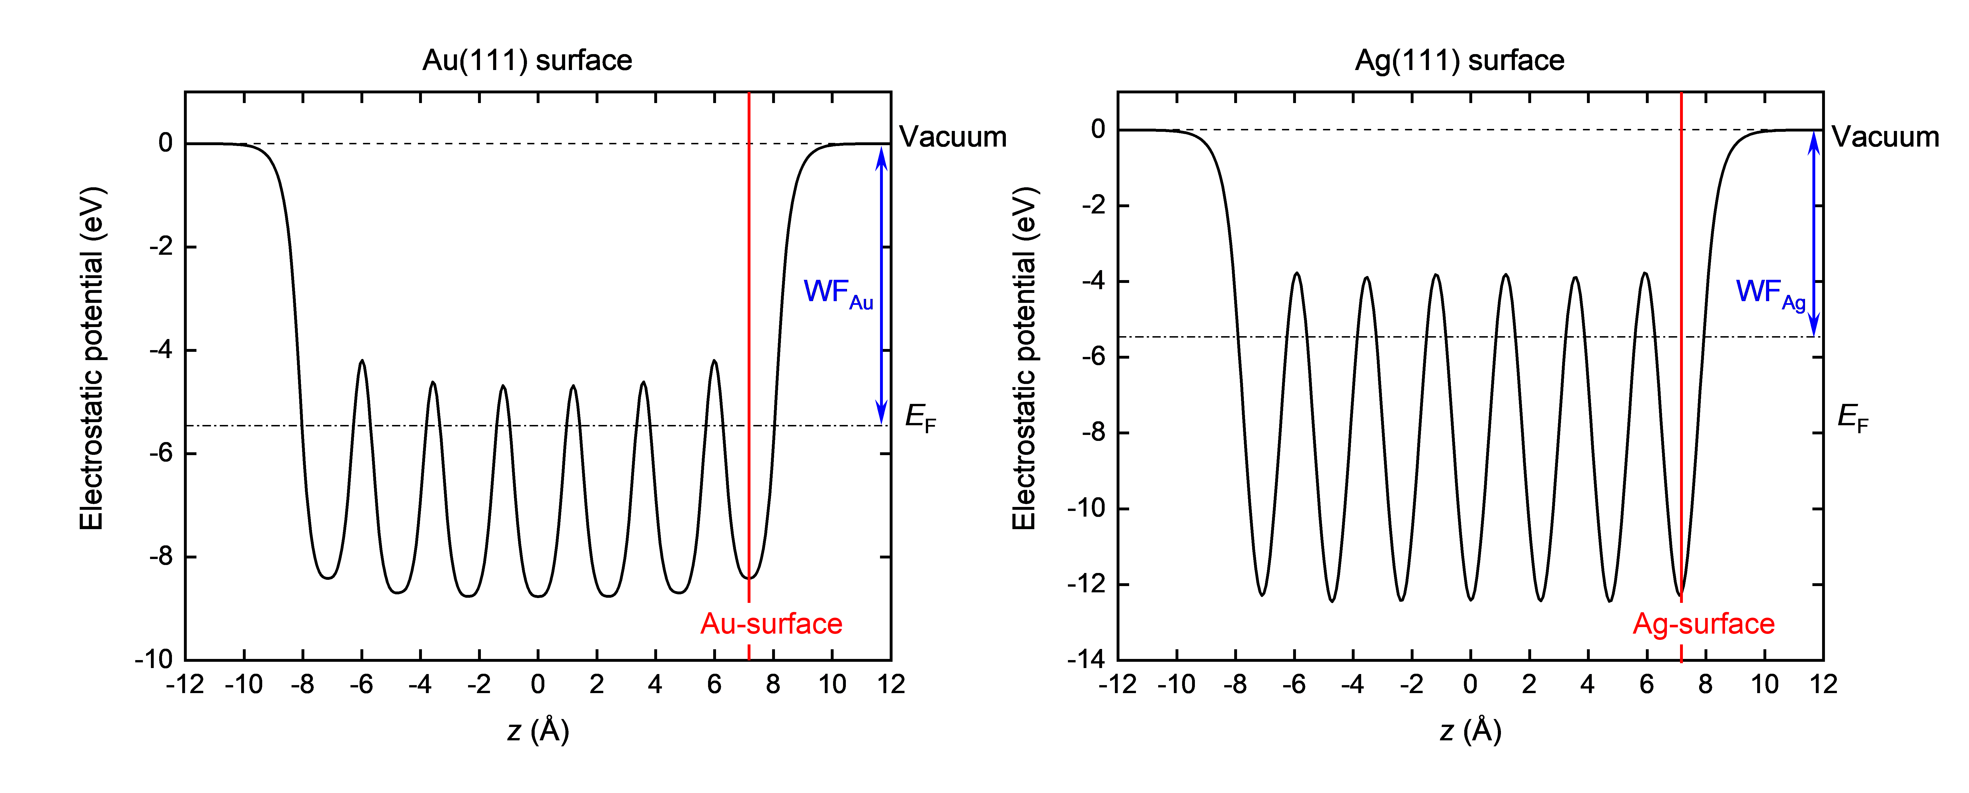
FIG. S3. Respective planar average electrostatic potentials of the Au(111) and Ag(111) surfaces along the perpendicular (z) direction of the surface plane. WF_{Au} and WF_{Ag} denote the work functions of Au(111) and Ag(111), respectively. E_{F} is the Fermi energy level. First-principles calculations of the total energy were performed within the framework of density functional theory [1,2] as implemented in the Quantum Espresso code [3]. Projector-augmented wave pseudopotentials were used to describe the electron–ion interaction [4]. The valence wave functions and augmented charge density were expanded using a plane-wave basis set with cutoff energies of 60 and 540 Ry, respectively. We used a slab model in which the Au or Ag thin film was simulated as a seven-layer Au(111) or seven-layer Ag(111) film. Brillouin-zone integration was sampled by the Monkhorst–Pack scheme [5] with 42×42×1 k-point grids in self-consistent field calculations for optimization structures and energy band structures.

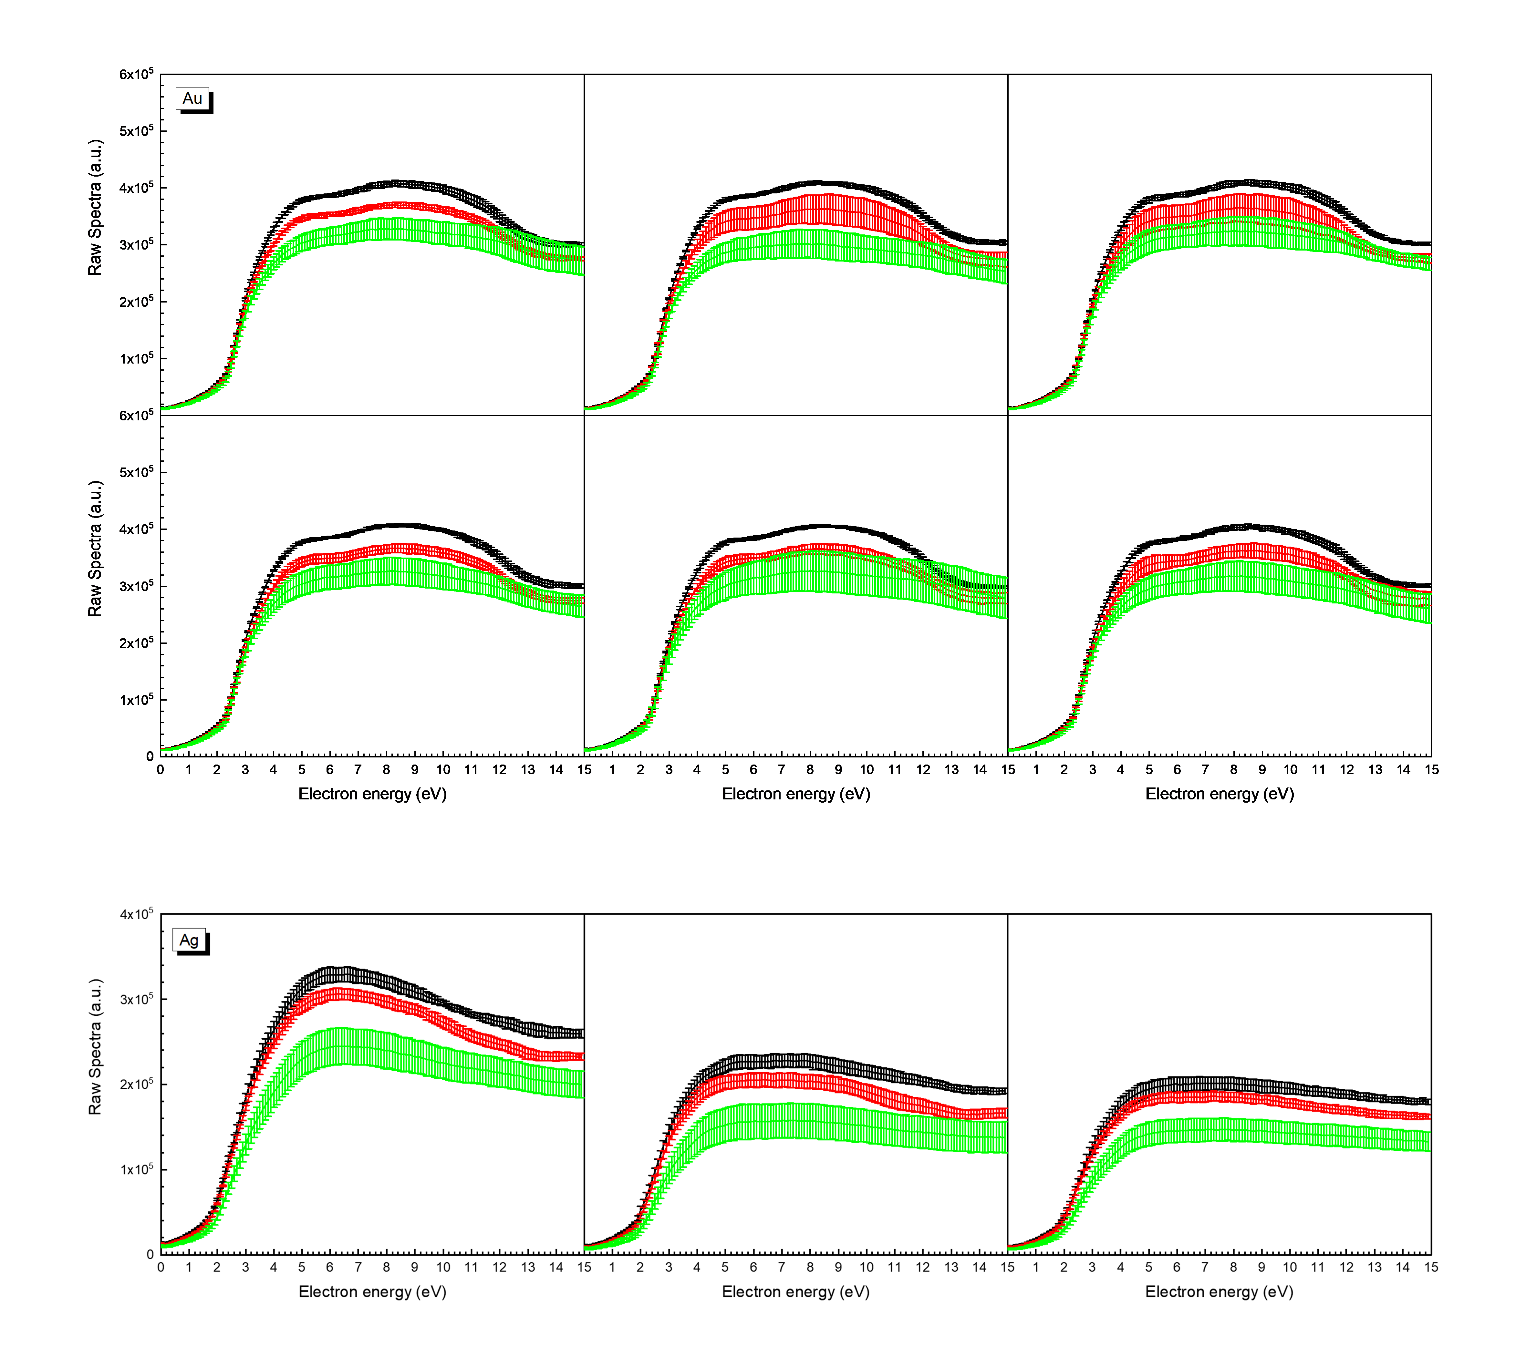
FIG. S4. Three types of SE spectra utilized in the three-point method were measured from Au and Ag films. (Top) Six independent groups of measurements were acquired from an Au surface in the energy range of 0–15 eV with an energy step of 0.1 eV and an incident electron energy of 15 keV. The standard deviations are presented as error bars for each group of measurements. (Bottom) Three independent groups of measurements were acquired from an Ag surface in the energy range of 0–15 eV with an energy step of 0.1 eV and an incident electron energy of 10, 15, and 15 keV, respectively. The standard deviations are presented as error bars for each group of measurements. SE spectra were measured at room temperature using a scanning Auger electron spectrometer (SAM650, Ulvac-Phi, Kanagawa, Japan) with a cylindrical mirror analyzer. The take-off angle of the instrument was 42.3° ± 6°. Each group contained three SE spectra measured in bright and dark regions and in a crack region on the Au or Ag film. Short-term repeated measurements for multiple cycles were used to minimize influences from the stability of the instrument changing over time.

REFERENCES
[1] P. Hohenberg and W. Kohn, Phys. Rev. 136, B864–B871 (1964).
[2] W. Kohn and L. J. Sham, Phys. Rev. 140, A1133–A1138 (1965).
[3] P. Giannozzi et al., J. Phys.: Condens. Matter 21, 395502 (2009).
[4] A. D. Corso, Comput. Mater. Sci. 95, 337–350 (2014).
[5] H. J. Monkhorst and J. D. Pack, Phys. Rev. B 13, 5188–5192 (1976).

