High doping activation (≥10²⁰ cm^{–3}) in
tensile-strained n-Ge alloys achieved by
high-speed continuous wave laser annealing

Rahmat Hadi Saputro^{1, 2}, Tatsuro Maeda³, Kaoru Toko², Ryo Matsumura^{1,*}, Naoki Fukata^{1, 2,*}.

1 Research Center for Materials Nanoarchitectonics (MANA), National Institute for Materials Science, 1-1 Namiki, Tsukuba, Ibaraki 305-0044, Japan
2 Graduate School of Science and Technology, University of Tsukuba, 1-1-1 Tennodai, Tsukuba, Ibaraki 305-8573, Japan
3 National Institute of Advanced Industrial Science and Technology (AIST), 1-1-1 Umezono, Tsukuba, Ibaraki 305-8560, Japan
* Corresponding authors
Emails: MATSUMURA.Ryo@nims.go.jp, FUKATA.Naoki@nims.go.jp

ABSTRACT
Germanium-based materials are essential for the integration of Group IV optoelectronics on silicon devices. In addition to tensile strain, high n-type doping is critical, as it provides abundant carriers for recombination, potentially enabling higher photoemissions from Ge-based materials. We report here record-high 68% doping activation on n-Ge with ≥10²⁰ cm^{–3} carrier density. This study centers on Sb-doped n-type Ge-on-insulator thin films with Si or Sn alloying, grown using high-speed continuous wave laser annealing (CWLA). Crystal mapping revealed the growth of polycrystalline n-GeSn and n-GeSi thin films with grain sizes up to 4 μm in diameter. Micro-PL measurements showed the PL intensity of n-Ge to be enhanced by the alloying of Sn and Si, with peak intensity 1.5 and 3 times higher for n-GeSn and n-GeSi, respectively. Raman peak redshift and broadening are observed in the samples, indicating high tensile strain and n-type doping. The measured carrier density of CWLA-grown films aligns well with the PL intensity trend, suggesting the process to have promise for achieving electrically improved Ge-based thin films.
Keywords: germanium, thin film, polycrystalline growth, laser annealing, impurity doping
- INTRODUCTION
The exploration of Group IV-based photonics aims to create integrated data communication and processing on a single chip, offering energy-efficient solutions for applications such as data centers and telecommunications. The unique properties of Ge make it well suited for these optoelectronic components that employ near-infrared wavelengths.^{1–5} One of the main challenges in Ge-based optoelectronic materials is that of enhancing light emission efficiency. The indirect bandgap nature of Ge historically limits its efficacy as a light emitter. Incorporating tensile strain and n-type doping in Ge holds promise for quasi-direct emission by modulating the bandgap and increasing carriers for radiative recombination.^{6–9} However, the problem is that n-type Ge formation is somewhat more challenging than p-type Ge formation due to its tendency to become p-type with point-defect assisted hole-conduction and limited solubility of Group V elements in Ge.^{10,11} There have been several attempts to grow highly n-doped Ge thin films using ion implantation¹², solid-phase crystallization (SPC)¹³, flash lamp annealing (FLA)¹⁴, and pulse laser annealing (PLA)¹⁵. Several groups have studied the growth of Ge-based thin film on insulators for this purpose, with liquid-phase crystallization (LPC) being a promising strategy for increasing process throughput. LPC by rapid thermal annealing (RTA) in several seconds has been reported, but shows limited incorporation.¹⁶ On the other hand, the nanosecond-order process by PLA limits the crystal grain size to several nanometers.^{15,17} Therefore, microsecond annealing time appears to be effective for improving doping during LPC and achieving a large-grained Ge-on-insulator.
We have recently developed a high-speed continuous-wave laser annealing (CWLA) method for improving the crystallization of GeSn¹⁸, SiGe¹⁹, and Ge²⁰ thin films on insulators. The high-speed CWLA is the process of laser irradiation, melting, then re-crystallization in a microsecond time. The process involves film melting that caused by the rise of temperature induced by laser irradiation. This approach has also successfully enhanced the photoluminescence of polycrystalline Ge on insulators by combining both tensile strain (about 0.5%) and n-type doping.²¹ The results of these studies suggest improved doping activation on tensile-strained Ge to be the key to achieving enhanced photoemission of Ge-based materials. It has been reported that co-doping techniques, such as the use of phosphorus (P) with antimony (Sb)²² or P with nitrogen (N)²³, increase the n-type doping density in Ge. Higher doping is expected to increase the probability of carrier recombination, consequently enhancing optical activity.
Our idea to improve radiative emission is to utilize high-speed CWLA on Sb-doped Ge on an insulating substrate, which has been proven to induce crystallization with tensile strain and n-type doping.²¹ In this study, we describe the effects of alloying with two other Group IV elements (Sn or Si). The addition of Sn or Si is expected to improve the doping activation through the alloying of Ge with different atomic size element. We focus on investigating the effect of alloying on the crystallization process and the improvement of doping activation to enhance the optical activity of Ge-based thin films on insulators.
- EXPERIMENTAL METHODS
Sample preparation
The quartz substrates (thickness 500 μm) were coated with a 50-nm silicon nitride (SiN_{x}) underlayer by sputtering a Si₃N₄ target at room temperature. Sb-doped Ge thin films with thickness of 100 nm were then grown by molecular beam deposition at 450 ˚C. The Sb Knudsen cell was fixed at 350 ˚C for all samples. This deposition method was chosen for its advantageous in precisely controlling growth parameters such as temperature and the composition of elements involved in the growth.²⁷ For the samples with added Si or Sn, the deposition rate was modulated at the ratio of X:Ge = 1:9, where X is Si or Sn, by adjusting the Knudsen cell temperature. After the Ge-based thin film depositions, 50 nm of SiN_{x} top interface layers and a thick SiO₂ capping layer (about 1 μm) were deposited by sputtering at room temperature to suppress the ablation and aggregation of liquid Ge during annealing.²¹ After deposition, the samples were mounted in the CW laser annealing chamber with N₂ ambient (O₂ < 100 ppm). A Nd:YVO₄ solid-state laser with a wavelength of 532 nm was used with this system. The annealing was performed by moving the stage such that the laser scanned the sample at a high v_{scan} speed of 13 - 15 m/s (corresponding to about 1.3 - 1.5 μs annealing time) while also shifting the laser horizontally in 5-μm steps to scan the whole surface, as shown in Figure 1(a) below. The laser beam has a Gaussian profile with diameter of approximately 20 μm. The laser scan overlapped to expect a uniform heat distribution during annealing. CWLA was performed at various laser powers (E_{laser}) to induce crystallization. After the CWLA process, the capping layers were carefully removed in a dilute hydrofluoric acid solution.
Material characterization
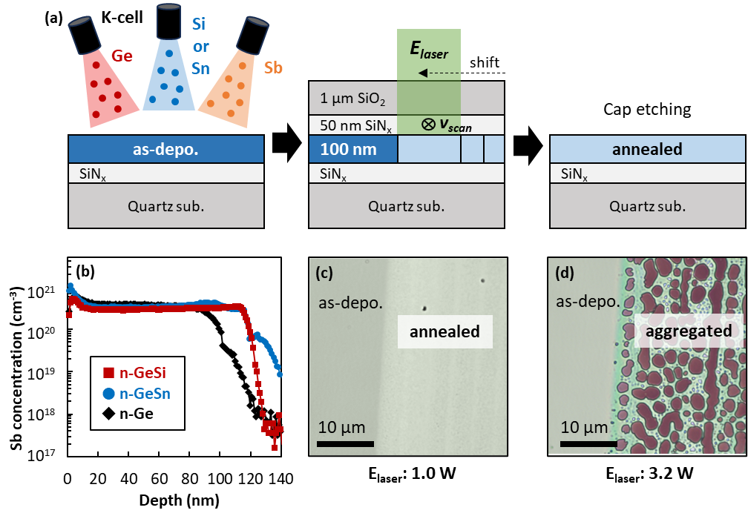
The chemical composition of the thin films was characterized by SIMS (for the Sb dopant) and AES (for Ge, Si, and Sn). A scanning electron microscope equipped with an EBSD attachment was used for crystal characterization (acceleration voltage: 15 kV). The PL spectra were acquired with a micro-PL system equipped with an InGaAs detector. Photoexcitation was induced by a 647-nm laser, focused on the sample surface at a diameter of approximately 1 μm. The PL spectra were carefully verified by varying the excitation power. All the spectra were obtained under the same conditions. Excitation at 20 mW was chosen to prevent local heating. The carrier concentrations were obtained by Hall effect measurements using the 4-probe Van der Pauw method and measured at a magnetic field of 0.5 T. The samples were isolated into a clover-leaf pattern prior to measurement, to suppress current leakage. The data for each sample was averaged over five measurements. Micro-Raman spectroscopy was also performed to investigate the in-plane strain effect using an excitation wavelength of 532 nm. The light was focused via a 100× objective lens, and the absolute Raman shift was calibrated using the optical phonon (300 cm^{–1}) of a single-crystal Ge (100) substrate.
Figure 1. (a) Schematic diagram of sample preparation by molecular beam deposition and continuous-wave laser annealing. (b) Depth profiling of the Sb concentration on as-deposited samples obtained by SIMS measurement. (c) Top-view optical microscope image of the annealed film with low-energy annealing (1.0 W) and (d) ablation effect with high-energy annealing (3.2 W).
- RESULTS AND DISCUSSION
Figure 1(a) illustrates the experimental procedure for CWLA processing of an as-deposited Ge-based thin film. Three samples were prepared for laser annealing: n-Ge with and without Si or Sn alloying. A sandwiched SiN_{x} interface was employed due to its advantages over the SiO₂ interface in enabling large-grained polycrystalline films.^{21,24} For n-type Ge growth, initial dopant atomic concentration is a crucial parameter. It is also known that Sb tends to segregate toward the film surface during molecular beam deposition.^{25,26} We therefore investigated the dopant distribution of all the samples in the depth direction. Figure 1(b) shows the Sb profile in Ge films deposited at 450 ˚C with constant Sb flux from the K-cell maintained at 350 ˚C. Here, the Sb atoms are uniformly distributed throughout the as-deposited Ge-based films, and the dopant concentration was observed to be at a similar level in all samples. The absence of Sb segregation is possibly attributable to the suppression of dopant re-evaporation due to the optimized deposition and K-cell temperatures, similar to epitaxially-grown films in p-Ge(100) substrate.²⁷ On the other hand, the intended ratio of Si (or Sn) over Ge at 1:9 fluctuates throughout the films (Supporting Figure S1). The average chemical compositions, estimated from AES measurements, are summarized in Table 1. The value was extracted up to a depth of 80 nm to avoid inaccuracy at the interface.
Table 1. Chemical composition of the as-deposited films
Sample | x | [Sb] (x10²⁰ cm^{–3})
n-Ge_{1-x}Si_{x} | 0.13 | 3.2
n-Ge_{1-x}Sn_{x} | 0.09 | 3.9
n-Ge | - | 3.8

Subsequently, these samples were CW laser-annealed at various powers to induce crystallization. The effect of laser annealing with E_{laser} of 1 W changed the contrast of the film’s surface, as shown in Figure 1(c), giving evidence of structural changes in the film after annealing. The laser was scanned on these samples from the top to the bottom of the indicated region and shifted horizontally. Increasing laser power may induce better crystallization, but the melted Ge commonly shows strong aggregation during liquid-phase crystallization.^{18–21} Figure 1(d) shows exposed substrate on more than half of the annealed area due to the melted film that breaks up into islands under high laser power (E_{laser}: 3.2 W). All the prepared samples underwent a similar phenomenon, which limits the annealing window for crystallization at high laser power. It is therefore important to investigate the crystallinity of samples annealed within acceptable laser power.
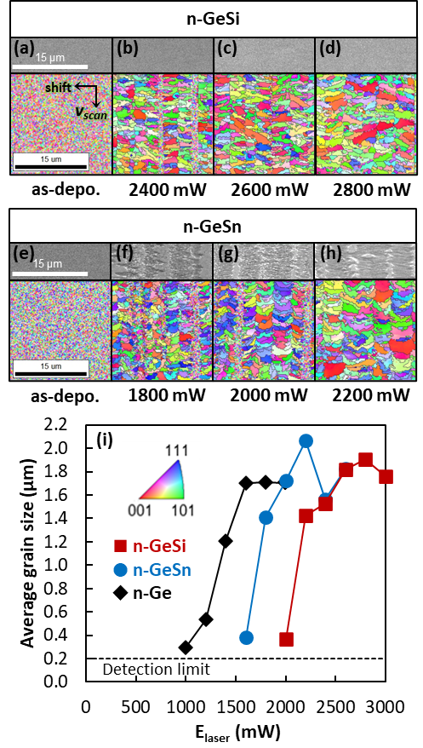
Crystal mapping analysis of the Ge-based thin film was performed to evaluate its crystallinity. The inverse pole figures (IPF) obtained by EBSD analysis, shown in Figures 2(a-d) for n-SiGe samples and Figures 2(e-h) for n-GeSn samples, show the growth of polycrystalline Ge-based thin film alloys using the CWLA process. Here, the as-deposited samples are considered as polycrystalline despite the tiny grain size (< 0.2 µm) because the depositions were performed under high temperature (450°C), which may induce crystallization. The randomly occurring crystal orientation resulted from spontaneous nucleation induced by laser power. This growth behavior is commonly observed in crystal growth on insulating substrates.^{13,21,28–30} In these figures, the crystal grain boundary is shown as black lines. It also found that the grain distribution follows the laser path, as indicated by the presence of amorphous lines between the laser scans at lower powers (Figure 2(b) & 2(f)). The Gaussian distribution of the laser spot caused this non-uniform grain distribution at lower power; however, the overlapping laser spot at higher power successfully suppressed these amorphous lines (Figures 2(d) & 2(h)). More importantly, the crystal grain size of all the samples significantly increased as the laser power was raised, as shown in Figure 2(i). Grain size identification by the TSL OIM analyzer attached to the EBSD equipment involves calculating the area of each segmented grain in the polycrystalline structure and determining an equivalent circular diameter that would have the same area. The average grain size is then determined from these equivalent diameters. It was found that the average grain size saturated at 1.6 - 2 μm before encountering the aggregation problem at higher powers. The addition of Sn or Si into n-Ge gives different effects to its crystal quality. According to the phase diagram, while Si exhibits complete solid solubility in germanium Ge³¹, Sn has a low thermal equilibrium solid solubility of approximately 1% in Ge³². For the n-GeSn samples, the significant decreases in average grain size at E_{laser}> 2200 mW is likely caused by Sn precipitation in higher annealing energy. In this study, large crystal grains with diameters up to 4 μm were obtained on n-GeSn using the CWLA method, demonstrating its advantages over the pulse laser annealing (PLA) method (up to 0.8 μm)^{15,33}. The larger grain size can be attributable to the longer annealing time, in the order of microseconds when using CWLA, in contrast to the much shorter nanosecond times using PLA. Unlike PLA that involves rapid annealing through short bursts of high-energy pulses, CWLA enables longer annealing times due to the continuous delivery of laser energy, which is advantageous for obtaining crystal growth time. Regarding the applications of poly-Ge, it has been reported that the decrease in carrier mobility due to grain boundaries is relatively small, attributed to the lower grain boundary barrier of Ge compared to Si.²⁸ And there are indeed examples of highly mobile device operation reported for poly-Ge MOSFETs.¹⁴ Also, the device size will be scaled down to sub-micrometer size to be utilized in on-chip optical devices.
Figure 2. (a)-(d) Sets of 70°-tilted SEM images and inverse pole figures (IPF) of the n-GeSi films before and after CWLA process at E_{laser}: 2400-2800 mW. Direction of the laser scan and shift are indicated by arrows. (e)-(h) SEM and IPF of n-GeSn films with CWLA at E_{laser}: 1800 - 2200 mW. (i) Average crystal grain size of the CWLA-grown films as a function of E_{laser}. Inset image indicates the crystal orientation of (a)-(h). Dotted line indicates measurement resolution.
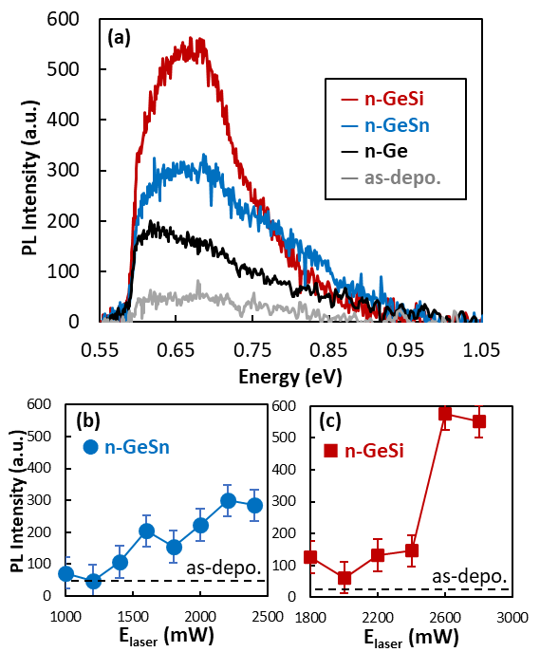
The optical activity of the CWLA-grown Ge-based alloys was investigated by means of micro-PL measurements. Figure 3(a) shows room-temperature PL spectra obtained from the large-grained (1.6 - 2 μm) polycrystalline samples. As expected, broad PL peaks were obtained in all the samples due to their polycrystalline structure. We consider the obtained PL spectrum not as a single peak, but as an overlay of multiple peaks attributed to emissions arising from the coupling of electrons in the Γ-valley and L-valley, and heavy-holes (HH) and light-holes (LH) in the valence band. The sudden drop in PL intensity at about 0.57 eV appears to be the InGaAs detector’s cut-off point. The CWLA-grown n-Ge was found to exhibit higher PL intensity than the as-deposited n-Ge due to improved crystal quality. Moreover, the PL intensity of CWLA-grown n-Ge was enhanced by the alloying of Sn and Si, at about 1.5 times higher for CWLA-grown n-GeSn, followed by n-GeSi at about three times higher, making it the highest among the samples. Without neglecting the possibility of non-radiative recombination by high doping, the results show the dominance of radiative recombination that might indicate the emission through quasi-direct bandgap mechanism. CWLA dependence on PL intensity was also observed in the Ge-based alloys shown in Figure 3(b) for n-GeSn and in Figure 3(c) for n-GeSi. The rising trend of PL intensity with increased E_{laser} is possibly attributed to the increase of carrier concentration that caused by the improved crystal quality, as previously shown in Figure 2. In Figure 3(c), the notable increase at 2400 mW is most likely related to the threshold where quasi-Fermi energy level surpasses the Γ-valley energy level, allowing carrier injection for direct band transition. The PL spectra were measured at the same 20 mW of excitation power. Low excitation power was chosen to prevent structural damage to the thin films, since measurements at an excitation power of 30 mW or higher leave a dark mark on the sample’s surface, caused by sample burn due to local heating. Excitation power dependence of the PL intensity (Supporting Figure S2) was confirmed in all samples at up to 20 mW of excitation power. According to our previous study,²¹ the PL peak analysis of CWLA-grown n-Ge indicating the dominant indirect band transition on the PL intensity and the peak shift toward lower energy is attributable to high tensile strain (about 0.5%). In our experiments, the peak position of the CWLA-grown n-GeSi was obtained at 0.68 eV. Here, we consider that the apparent peak shifts are not attributed to actual shift of peaks, but rather due to changes in the intensity ratios of peak components. Specifically considering the emissions arising from the coupling of electrons in the Γ-valley and L-valley, and heavy- (HH) and light-holes (LH) in the valence band. Meanwhile, the PL peak position on the n-GeSn is highly influenced by Sn incorporation.^{5,34} The peak position, obtained at about 0.66 eV, corresponds to 6 - 7% Sn incorporation, which is reasonable compared to the initial 9% Sn incorporation, shown above in Table 1.
Figure 3. (a) Photoluminescence (PL) spectra of the crystallized n-GeSi, n-GeSn, and n-Ge. PL spectra of as-deposited n-Ge are also shown for comparison. (b) PL intensity of n-GeSn and (c) n-GeSi as a function of E_{laser}. The dotted line indicates the PL intensity of as-deposited film.
Figure 4. Normalized Raman spectra of the crystallized n-GeSi, n-GeSn, and n-Ge films. The numbers indicate the peak position of the corresponding spectrum. The inset shows the wide-range Raman spectra of the n-GeSi samples.
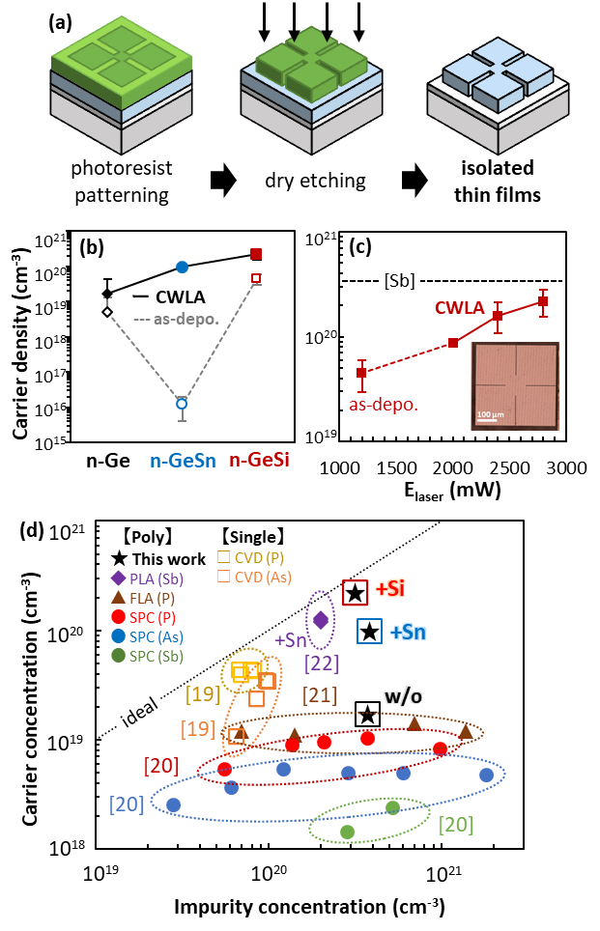
The normalized Raman spectra of CWLA-grown samples are summarized in Figure 4. Here, a single peak around the Ge-Ge phonon mode is observed in the n-Ge and n-GeSn samples, while the n-GeSi also exhibited peaks attributable to the Si-Ge phonon mode, as shown in the inset. The Ge-Ge peak is shifted toward a lower wavenumber in all the samples, indicating Sn or Si incorporation in the grown films. It is known that Raman shifts can significantly change not only due to strain, but also due to doping concentration and alloying. In this study, the tensile strain in the thin films is imposed by the difference in thermal expansion’s coefficient with the substrate, suggesting that alloying by approximately 9-13% would not greatly alter the amount of strain. The Raman shift of n-Ge in this study was observed at a similar position (295.5 cm^{–1}) to our previously reported data²¹. The previous study compares the Raman shift of undoped i-Ge and Sb-doped n-Ge. The i-Ge sample exhibited peak position at 297 cm⁻¹, which corresponds to about 0.56% of high tensile strain, and the excess shift on the n-Ge sample down to 295.5 cm⁻¹ indicating the effect of doping incorporation. Moreover, asymmetric broadening at lower wavenumbers is also prominent in the n-GeSi sample. This asymmetric broadening is a signature of the Fano effect.³⁵ This occurs due to interference between a discrete state (optical phonon) and continuum states (inter-band excitation), indicating the presence of free electrons from the electrically activated Sb atoms. Generally, it is possible to estimate the electrically active doping concentration using the Fano equation with nanostructured Ge^{36,37} or polycrystalline Si³⁸. However, with the incorporation of Si and tensile strain on the films, there are many unknown parameters that will need to be uncovered and taken into account for calculating the doping concentration in these samples. Nevertheless, peak broadening is consistent with the PL result, which may indicate that the enhanced photoluminescence is related to higher carrier concentrations.
Figure 5. (a) Fabrication process of the cloverleaf-shaped thin films for the Hall effect measurement. (b) Carrier density of the crystallized n-GeSi, n-GeSn, and n-Ge before and after the CWLA process. (c) Carrier density of the n-GeSi as a function of E_{laser}. The dotted line indicates the initial Sb dopant level. Inset image is a top-view microscopic image of the cloverleaf-shaped film. (d) Benchmarking of the obtained doping activation rate.
Finally, the electrical properties of the Ge-based alloy films were measured by Hall effect measurements using the Van der Pauw method, in which the current, voltage, and magnetic field were measured to extract Hall coefficient and carrier concentration. The samples are patterned into cloverleaf-shaped structures to isolate the measurement area, as shown in Figure 5(a). This isolation was implemented to ensure the reliability of the measurement results by suppressing current leakage. Figure 5(b) shows the measured highest carrier density of CWLA-grown samples compared to the as-deposited result for each sample. The contrast in carrier density of as-deposited n-GeSn is likely caused by the crystal quality, in which the poor quality of as-deposited state might be resulted from phenomena such as Sn precipitation during deposition. The carrier density of CWLA samples with Sn or Si alloying is consistent with the pattern of PL intensity (Figure 3(a)). The higher electron density increases the likelihood of electron-hole pairs recombining, significantly enhancing photoluminescent emissions. Furthermore, the E_{laser} dependence of carrier density on n-GeSi samples is obtained, as shown in Figure 5(c). This trend might also explain the E_{laser} dependence on PL intensity as previously shown in Figure 3(c). In a general case, in which the film is relaxed and non-highly doped, a GeSi might have lower PL intensity than a GeSn or a Ge films. Here, we reported that in a tensile strained and highly n-doped Ge-based alloys the pronounced PL peak for n-GeSi compared to n-GeSn was also attributable to its higher carrier density.
Figure 5(d) summarizes the activated carrier concentration and the initial impurity concentration of n-type Ge-based thin films grown using various methods. Our work with the high-speed CWLA method exhibited the highest carrier concentration among the polycrystalline n-Ge films (at an impurity level of 10²⁰ cm^{–3}). Although the single crystal epitaxial n-Ge films have higher carrier concentration than our polycrystalline n-Ge, a higher carrier concentration was achieved after incorporating Si or Sn. The highest doping activation at up to 68% was achieved by incorporating Si into n-Ge film. The incorporation of Sn into n-Ge also improved the carrier concentration, with comparable results to PLA-grown n-GeSn¹⁵, which used a similar Sb-doping and liquid-phase growth mechanism. The high carrier concentration combined with high tensile strain achieved by high-speed CWLA is of potential use for optoelectronic applications of Ge-based thin films.
- CONCLUSIONS
We grew Sb-doped n-type Ge thin films with Si and Sn alloying using high-speed CW laser annealing. Crystal mapping analysis showed growth of polycrystalline Ge-based thin films with an average grain size of 1.6 - 2 μm. Large grain sizes of up to 4 μm in diameter were obtained using the high-power CWLA process. The optical activity of the CWLA-grown films was investigated using micro-PL measurements. The PL intensity of n-Ge was enhanced by the alloying of Sn and Si, with a peak intensity about 1.5 times higher for n-GeSn, followed by n-GeSi at about three times higher. The Raman peak redshift and asymmetric broadening at the lower wavenumbers of the Ge-Ge phonon mode suggest higher doping activation. The measured carrier densities of CWLA samples with Sn or Si alloying are consistent with the patterns of PL intensities, indicating that high carrier concentration increases the likelihood of electron-hole pair recombination and enhances photoluminescence. The incorporation of Si in n-Ge exhibited the highest doping activation (about 68%) among the n-type polycrystalline Ge films. These results suggest that the alloying process shows promise for achieving electrically improved n-type Ge-based thin films for optoelectronic device applications.

SUPPORTING INFORMATION
See supporting information for the chemical composition measured by AES (Figure S1) and excitation power dependence of the PL intensity (Figure S2). (PDF)

ACKNOWLEDGMENTS
This work was supported by JSPS Kakenhi (Grants no. JP20K14796 and JP23K13370), the Murata Science Foundation, and the World Premier International Research Center Initiative (WPI-Initiative). A part of this work was also supported by “Advanced Research Infrastructure for Materials and Nanotechnology in Japan (ARIM),” MEXT, Japan, proposal number 23NM5001, 23UT1050, and 23UT0030.

AUTHOR DECLARATIONS
The authors declare no conflicts of interest associated with this manuscript.
REFERENCES
(1) Wirths, S.; Geiger, R.; Von Den Driesch, N.; Mussler, G.; Stoica, T.; Mantl, S.; Ikonic, Z.; Luysberg, M.; Chiussi, S.; Hartmann, J. M.; Sigg, H.; Faist, J.; Buca, D.; Grützmacher, D. Lasing in Direct-Bandgap GeSn Alloy Grown on Si. Nat. Photonics 2015, 9 (2), 88–92. https://doi.org/10.1038/nphoton.2014.321.
(2) Montesinos-Ballester, M.; Vakarin, V.; Ramirez, J. M.; Liu, Q.; Alonso-Ramos, C.; Le Roux, X.; Frigerio, J.; Ballabio, A.; Barzaghi, A.; Deniel, L.; Bouville, D.; Vivien, L.; Isella, G.; Marris-Morini, D. Optical Modulation in Ge-Rich SiGe Waveguides in the Mid-Infrared Wavelength Range up to 11 Μm. Commun. Mater. 2020, 1 (1), 8–13. https://doi.org/10.1038/s43246-019-0003-8.
(3) Palade, C.; Lepadatu, A.; Slav, A.; Teodorescu, V. S.; Stoica, T.; Ciurea, M. L.; Ursutiu, D.; Samoila, C. Nanocrystallized Ge-Rich SiGe-HfO2 Highly Photosensitive in Short-Wave Infrared. Materials (Basel). 2021, 14, 7040.
(4) Xu, S.; Huang, Y.-C.; Lee, K. H.; Wang, W.; Dong, Y.; Lei, D.; Masudy-Panah, S.; Tan, C. S.; Gong, X.; Yeo, Y.-C. GeSn Lateral P-i-n Photodetector on Insulating Substrate. Opt. Express 2018, 26 (13), 17312. https://doi.org/10.1364/oe.26.017312.
(5) Gupta, S.; Magyari-Köpe, B.; Nishi, Y.; Saraswat, K. C. Achieving Direct Band Gap in Germanium through Integration of Sn Alloying and External Strain. J. Appl. Phys. 2013, 113 (7). https://doi.org/10.1063/1.4792649.
(6) Liu, J.; Kimerling, L. C.; Michel, J. Monolithic Ge-on-Si Lasers for Large-Scale Electronic-Photonic Integration. Semicond. Sci. Technol. 2012, 27 (9). https://doi.org/10.1088/0268-1242/27/9/094006.
(7) Barget, M. R.; Virgilio, M.; Capellini, G.; Yamamoto, Y.; Schroeder, T. The Impact of Donors on Recombination Mechanisms in Heavily Doped Ge/Si Layers. J. Appl. Phys. 2017, 121 (24). https://doi.org/10.1063/1.4986236.
(8) Guilloy, K.; Pauc, N.; Gassenq, A.; Niquet, Y. M.; Escalante, J. M.; Duchemin, I.; Tardif, S.; Osvaldo Dias, G.; Rouchon, D.; Widiez, J.; Hartmann, J. M.; Geiger, R.; Zabel, T.; Sigg, H.; Faist, J.; Chelnokov, A.; Reboud, V.; Calvo, V. Germanium under High Tensile Stress: Nonlinear Dependence of Direct Band Gap vs Strain. ACS Photonics 2016, 3 (10), 1907–1911. https://doi.org/10.1021/acsphotonics.6b00429.
(9) El Kurdi, M.; Kociniewski, T.; Ngo, T. P.; Boulmer, J.; D́barre, D.; Boucaud, P.; Damlencourt, J. F.; Kermarrec, O.; Bensahel, D. Enhanced Photoluminescence of Heavily N-Doped Germanium. Appl. Phys. Lett. 2009, 94 (19). https://doi.org/10.1063/1.3138155.
(10) Brotzmann, S.; Bracht, H. Intrinsic and Extrinsic Diffusion of Phosphorus, Arsenic, and Antimony in Germanium. J. Appl. Phys. 2008, 103 (3). https://doi.org/10.1063/1.2837103.
(11) Prucnal, S.; Zuk, J.; Hübner, R.; Duan, J.; Wang, M.; Pyszniak, K.; Drozdziel, A.; Turek, M.; Zhou, S. Electron Concentration Limit in Ge Doped by Ion Implantation and Flash Lamp Annealing. Materials (Basel). 2020, 13 (6), 1–10. https://doi.org/10.3390/ma13061408.
(12) Koffel, S.; Kaiser, R. J.; Bauer, A. J.; Amon, B.; Pichler, P.; Lorenz, J.; Frey, L.; Scheiblin, P.; Mazzocchi, V.; Barnes, J.-P.; Claverie, A. Experiments and Simulation of the Diffusion and Activation of the N-Type Dopants P, As, and Sb Implanted into Germanium. Microelectron. Eng. 2011, 88, 458–461. https://doi.org/10.1016/j.mee.2010.09.023.
(13) Nozawa, K.; Nishida, T.; Ishiyama, T.; Suemasu, T.; Toko, K. N-Type Polycrystalline Germanium Layers Formed by Impurity-Doped Solid-Phase Growth. ACS Appl. Electron. Mater. 2023, 5 (3), 1444–1450. https://doi.org/10.1021/acsaelm.2c01381.
(14) Usuda, K.; Kamata, Y.; Kamimuta, Y.; Mori, T.; Koike, M.; Tezuka, T. High-Performance Tri-Gate Poly-Ge Junction-Less P- and N-MOSFETs Fabricated by Flash Lamp Annealing Process. 2014 IEEE Int. Electron Devices Meet. 2014, 422–425. https://doi.org/10.1109/IEDM.2014.7047066.
(15) Takahashi, K.; Kurosawa, M.; Ikenoue, H.; Sakashita, M.; Nakatsuka, O.; Zaima, S. High N-Type Sb Dopant Activation in Ge-Rich Poly-Ge1-XSnx Layers on SiO2 Using Pulsed Laser Annealing in Flowing Water. Appl. Phys. Lett. 2018, 112 (6). https://doi.org/10.1063/1.4997369.
(16) Matsumura, R.; Tojo, Y.; Kurosawa, M.; Sadoh, T.; Mizushima, I.; Miyao, M. Growth-Rate-Dependent Laterally Graded SiGe Profiles on Insulator by Cooling-Rate Controlled Rapid-Melting-Growth. Appl. Phys. Lett. 2012, 101 (24). https://doi.org/10.1063/1.4769998/124983.
(17) Moto, K.; Matsumura, R.; Sadoh, T.; Ikenoue, H.; Miyao, M. Pulse Number Controlled Laser Annealing for GeSn on Insulator Structure with High Substitutional Sn Concentration. Appl. Phys. Lett. 2016, 108 (26). https://doi.org/10.1063/1.4955059.
(18) Matsumura, R.; Fukata, N. Growth of Tensile Strained Poly Germanium Thin Film on Glass Substrates by High Speed Continuous Wave Laser Annealing, and Its Application to Germanium-Tin. ECS J. Solid State Sci. Technol. 2020, 9 (6), 063002. https://doi.org/10.1149/2162-8777/aba4f1.
(19) Matsumura, R.; Ishii, S.; Fukata, N. Growth of SiGe Thin Films with Uniform and Non-Uniform Si Concentration Profiles on Insulating Substrates by High-Speed Continuous Wave Laser Annealing. Mater. Sci. Semicond. Process. 2021, 134 (February), 106024. https://doi.org/10.1016/j.mssp.2021.106024.
(20) Matsumura, R.; Fukata, N. Self-Organized 〈1 0 0〉 Direction Growth of Germanium Film on Insulator Obtained by High Speed Continuous Wave Laser Annealing. Mater. Lett. 2021, 288, 129328. https://doi.org/10.1016/j.matlet.2021.129328.
(21) Saputro, R. H.; Maeda, T.; Matsumura, R.; Fukata, N. Highly Strained and Heavily Doped Germanium Thin Films by Non-Equilibrium High-Speed CW Laser Annealing for Optoelectronic Applications. Mater. Sci. Semicond. Process. 2023, 162 (November 2022), 107516. https://doi.org/10.1016/j.mssp.2023.107516.
(22) Kim, J.; Bedell, S.; Sadana, D. K. > 10 20 Cm -3 n-Doping in Ge by Sb/P Co-Implants: N + /p Diodes with Improved Rectification . ECS Trans. 2019, 33 (6), 201–204. https://doi.org/10.1149/1.3487549.
(23) Stathopoulos, S.; Tsetseris, L.; Pradhan, N.; Colombeau, B.; Tsoukalas, D. Millisecond Non-Melt Laser Annealing of Phosphorus Implanted Germanium: Influence of Nitrogen Co-Doping. J. Appl. Phys. 2015, 118 (13). https://doi.org/10.1063/1.4932600/140220.
(24) Yoshikawa, I.; Kurosawa, M.; Takeuchi, W.; Sakashita, M.; Nakatsuka, O.; Zaima, S. Low-Temperature Crystallization of Ge-Rich GeSn Layers on Si3N4 Substrate. Mater. Sci. Semicond. Process. 2017, 70, 151–155. https://doi.org/10.1016/J.MSSP.2016.12.038.
(25) Oehme, M.; Werner, J.; Kasper, E. Molecular Beam Epitaxy of Highly Antimony Doped Germanium on Silicon. J. Cryst. Growth 2008, 310 (21), 4531–4534. https://doi.org/10.1016/j.jcrysgro.2008.08.018.
(26) Yurasov, D. V; Antonov, A. V; Drozdov, M. N.; Schmagin, V. B.; Spirin, K. E.; Novikov, A. V. Antimony Segregation in Ge and Formation of N-Type Selectively Doped Ge Films in Molecular Beam Epitaxy. J. Appl. Phys. 2015, 118 (14). https://doi.org/10.1063/1.4932665.
(27) Hadi Saputro, R.; Matsumura, R.; Fukata, N. Dopant Redistribution in High-Temperature-Grown Sb-Doped Ge Epitaxial Films. Cryst. Growth &amp; Des. 2021, 21 (11), 6523–6528. https://doi.org/10.1021/acs.cgd.1c00966.
(28) Saito, M.; Moto, K.; Nishida, T.; Suemasu, T.; Toko, K. High-Electron-Mobility (370 Cm2/Vs) Polycrystalline Ge on an Insulator Formed by As-Doped Solid-Phase Crystallization. Sci. Rep. 2019, 9 (1), 19–24. https://doi.org/10.1038/s41598-019-53084-7.
(29) Oka, H.; Tomita, T.; Hosoi, T.; Shimura, T.; Watanabe, H. Lightly Doped N-Type Tensile-Strained Single-Crystalline GeSn-on-Insulator Structures Formed by Lateral Liquid-Phase Crystallization. Appl. Phys. Express 2018, 11 (1). https://doi.org/10.7567/APEX.11.011304.
(30) Oka, H.; Mizubayashi, W.; Ishikawa, Y.; Uchida, N.; Mori, T.; Endo, K. Non-Equilibrium Solid-Phase Growth of Amorphous GeSn Layer on Ge-on-Insulator Wafer Induced by Flash Lamp Annealing. Appl. Phys. Express 2021, 14 (2). https://doi.org/10.35848/1882-0786/abdac4.
(31) Olesinski, R. W.; Abbaschian, G. J. The Ge−Si (Germanium-Silicon) System. Bull. Alloy Phase Diagrams 1984, 5 (2), 180–183. https://doi.org/10.1007/BF02868957.
(32) Olesinski, R. W.; Abbaschian, G. J. The Ge−Sn (Germanium−Tin) System. Bull. Alloy Phase Diagrams 1984, 5 (3), 265–271. https://doi.org/10.1007/BF02868550.
(33) Moto, K.; Matsumura, R.; Sadoh, T.; Ikenoue, H.; Miyao, M. Pulse Number Controlled Laser Annealing for GeSn on Insulator Structure with High Substitutional Sn Concentration. Appl. Phys. Lett 2016, 108, 262105. https://doi.org/10.1063/1.4955059.
(34) Tanaka, N.; Kuniyoshi, M.; Abe, K.; Hoshihara, M.; Kobayashi, T.; Shimura, T.; Watanabe, H. Impact of Sn Incorporation on Sputter Epitaxy of GeSn. Appl. Phys. Express 2023, 16 (9), 095502. https://doi.org/10.35848/1882-0786/acf4df.
(35) Chandrasekhar, M.; Renucci, J. B.; Cardona, M. Effects of Interband Excitations on Raman Phonons in Heavily Doped N-Si. Phys. Rev. B 1978, 17 (4), 1623–1633. https://doi.org/10.1103/PhysRevB.17.1623.
(36) Fukata, N.; Sato, K.; Mitome, M.; Bando, Y.; Sekiguchi, T.; Kirkham, M.; Hong, J. Il; Wang, Z. L.; Snyder, R. L. Doping and Raman Characterization of Boron and Phosphorus Atoms in Germanium Nanowires. ACS Nano 2010, 4 (7), 3807–3816. https://doi.org/10.1021/nn100734e.
(37) Fukata, N. Doping and Characterization of Impurity Atoms in Si and Ge Nanowires. Phys. Status Solidi Curr. Top. Solid State Phys. 2014, 11 (2), 320–330. https://doi.org/10.1002/pssc.201300106.
(38) Lengsfeld, P.; Brehme, S.; Brendel, K.; Genzel, C.; Nickel, N. H. Raman Spectroscopy of Heavily Doped Polycrystalline and Microcrystalline Silicon. Phys. Status Solidi Basic Res. 2003, 235 (1), 170–178. https://doi.org/10.1002/pssb.200301414.

For table of contents only
TOC Graphic
