Cumulative effect of spectral downshifting, anti-reflection and space charge region formation in enhancing the spectral response of Self-powered Silicon photodetector on sensitisation with CdZnS/ZnS Core-shell Quantum dots
Kumaar Swamy Reddy Bapathi ^{abc}, Mostafa F. Abdelbar ^{cd}, Wipakorn Jevasuwan ^{c},
Pramod H Borse ^{b}, Sushmee Badhulika ª* and Naoki Fukata ^{c}*
ª Department of Electrical Engineering, Indian Institute of Technology Hyderabad, Kandi, Sangareddy, Hyderabad
^{b} Centre for Solar Energy Materials, International Advanced Research Centre for Powder
Metallurgy & New Materials, Balapur, Hyderabad
^{c} Research Centre for Materials Nanoarchitectonics, National Institute for Materials Science, Tsukuba, Japan
^{d} Institute of Nanoscience & Nanotechnology, Kafrelsheikh University, 33516 Kafrelsheikh, Egypt

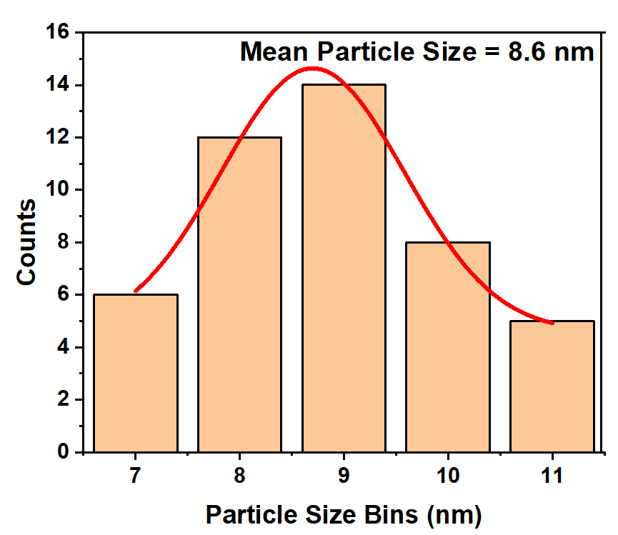
Figure S1. Quantum dots particle size distribution

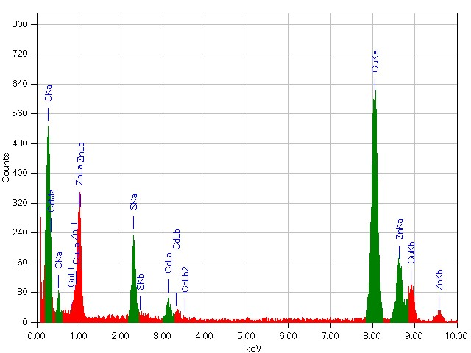

Figure S2. EDS spectrum of CdZnS/ZnS core-shell quantum dots.

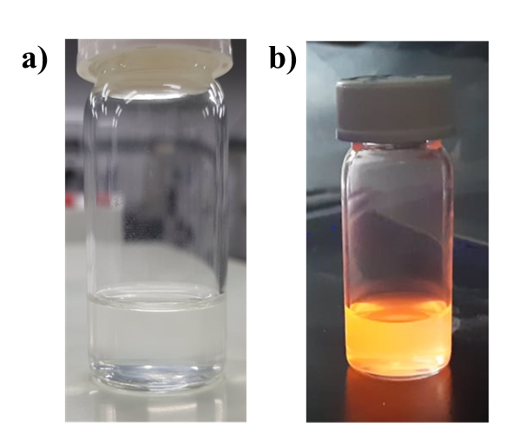
Figure S3. CdZnS/ZnS quantum dots under a) Ambient light and b) UV illumination
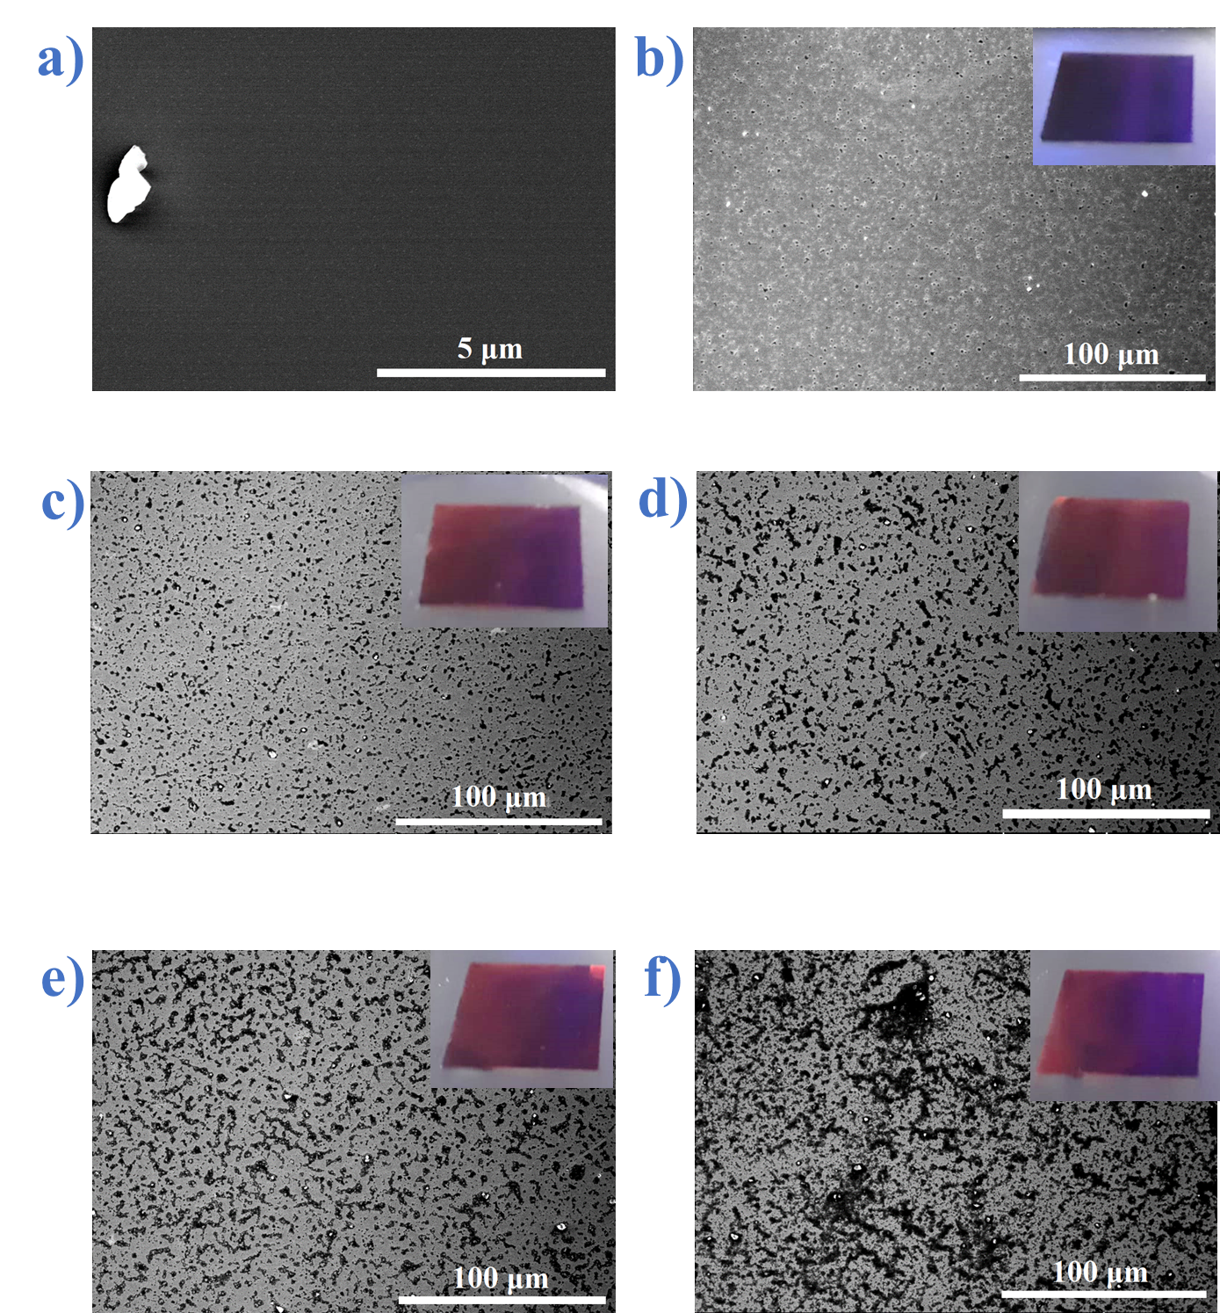

Figure S4. SEM images of Pristine Silicon and CdZnS/ZnS QD films deposited films deposited on Silicon. a) Pristine Silcon b) 1 Layer QDs, c) 2 Layer QDs, d) 3 Layer QDs, e) 4 Layer QDs and f) 5 Layer QDs.
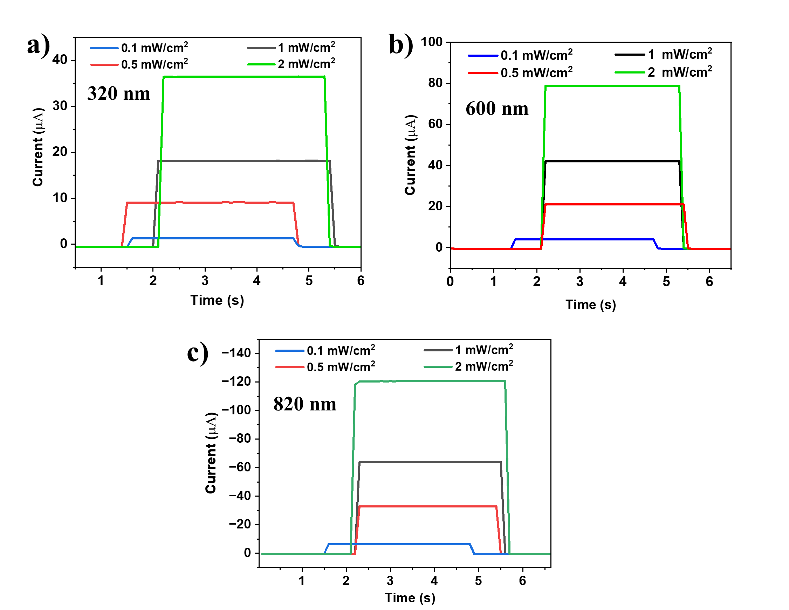
Figure S5. Temporal response of the detector under varied light intensities (0.1 – 2 mW/cm² a) 300 nm, b) 600 nm, and c) 820 nm
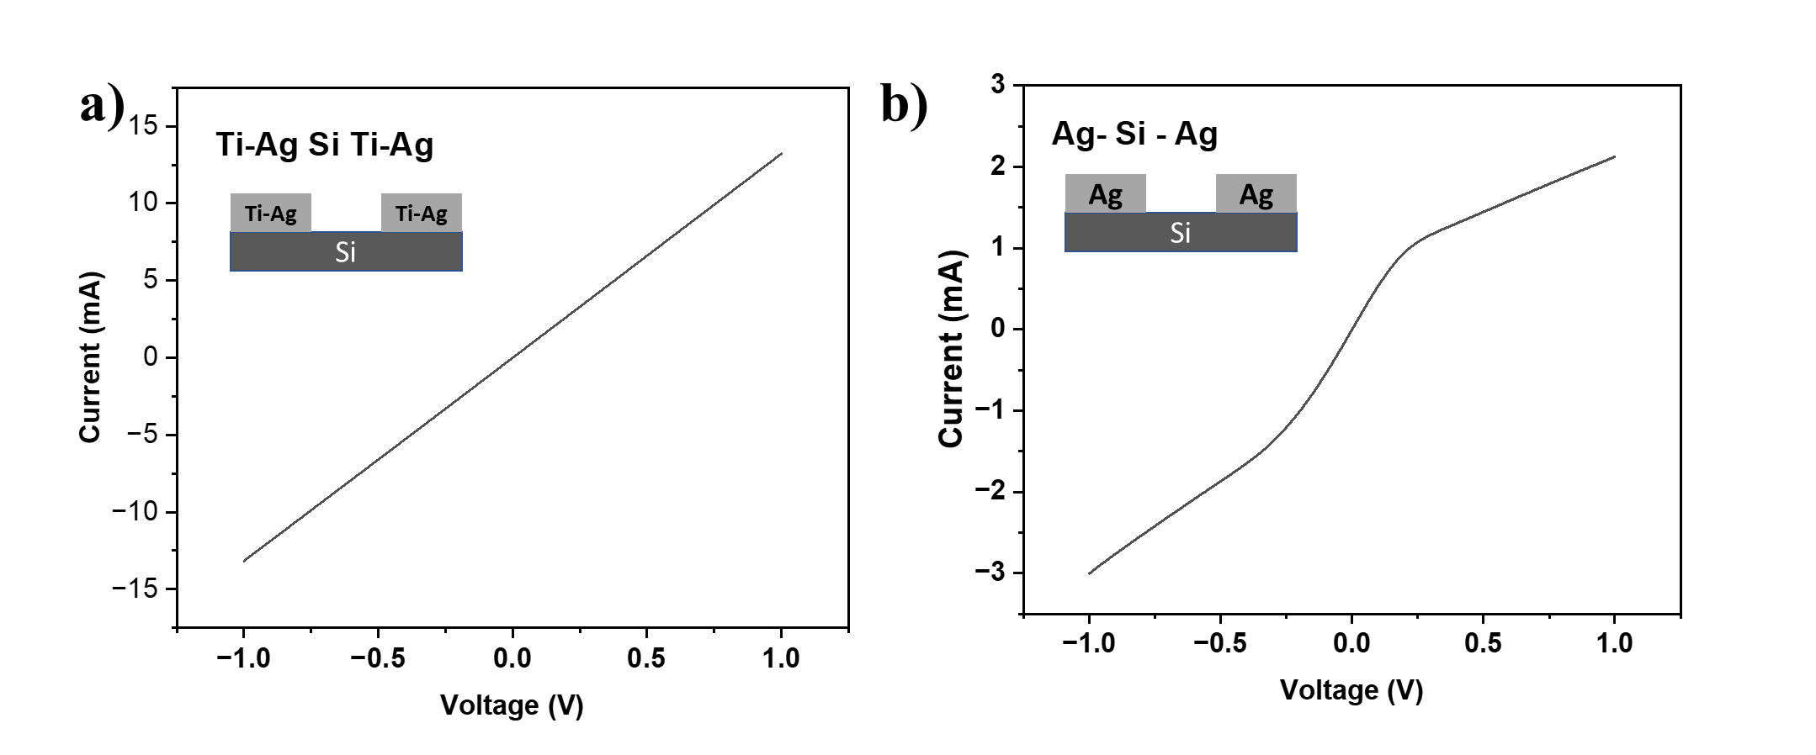
Figure S6. I-V characteristics of Control Si devices with a) Ti-Ag and b) Ag electrodes
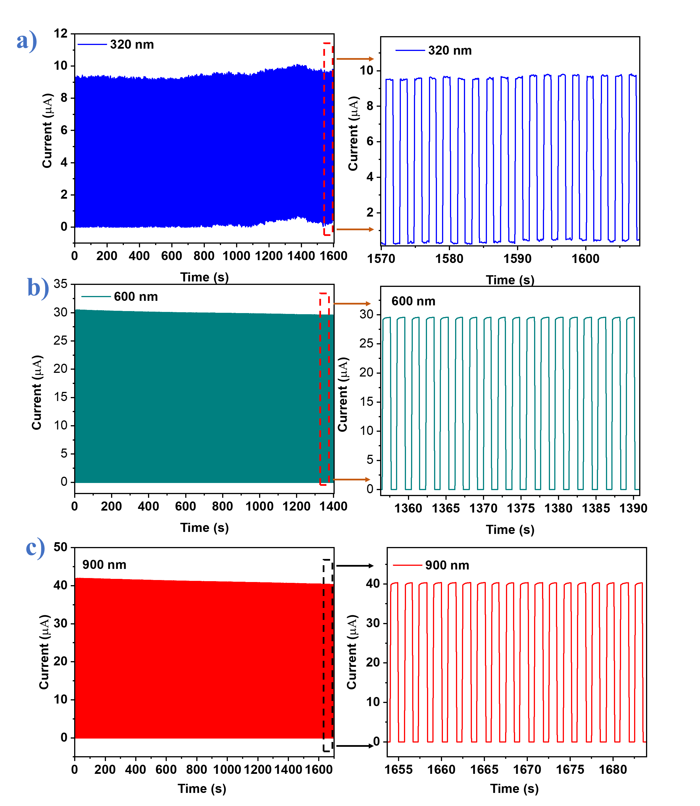
Figure S7. Photocyclic stability of CdZnS/ZnS QD- Si photodetector under a) 320 nm, b) 600 nm and, c) 900 nm

Materials | Synthesis/ Fabrication technique | Architecture | Spectral Response | Bias | Responsivity | Rise Time | Detectivity | Ref
PbSe QDs | Hot Injection and Spin Coating | Au-(Si - ZnO-PbSe QD)-Au | 808 nm | 1V | 100 mA/W | 340 ms | 1.86 × 10¹¹ Jones | ¹
SiNWs-Carbon QDs | Electrochemical Etching and Spin coating | In/Ga – (n-SiNW – Carob QDs) - Au | 300-1100 nm | 0V | 350 mA/W | 20 µs | 3.79 × 10⁹ | ²
Si- Carbon QDs | Hydrothermal and Drop coating | Al/Si/C-QDs/Ag | 352—850 nm | 0V | 9.4 mA/W | 10 µs | 5.9 × 10¹² | ³
MoS₂-CuInS₂ QDs-AuNPs | Hot injection and spin coating | Au- ( MoS₂-CuInS₂-AuNPs) -Au | 405 – 635 nm | 4V | 16.65 mA/W | 5s | 2.2 x 10¹² | ⁴
SWCNT-PbSQDs-MAPbX₃ | Hot injection and dip coating | ITO –( SWCNT-PbSQDs-MAPbX₃)- ITO | 30-1500 nm | 1V | 500 mA/W | 250 µs | 1.4 × 10¹¹ Jones | ⁵
MXene/CsPbBr₃ | Hot injection and spin coating | Au - ( MXene/CsPbBr₃) - Au | 300-550 nm | 1V | 0.1 mA/W | 48.2 ms | 10⁸ | ⁶
AgAuSe QDs | Hot injection and spin coating | Au – AgAuSe-Au | 808 nm | 0V | 0.35 mA/W | 3.1 s | 1.55 × 10¹⁰ Jones | ⁷
CsPbBr₃ (SbBr₃) | Hydrothermal and Drop coating | FTO-CsPbBr₃-Al | 405 nm | 0V | 0.048 mA/W | 98 ms | No data | ⁸
Si-PbS QDs | Hot injection and spin coating | Ti/Pt/Au-P-Si-SiNx-(PbS-TBAI)-ITO | 1064 nm | 0V | 250 mA/W | 20 µs | 7.74 × 10¹⁰ | ⁹
Si - CdZnS/ZnS core-shell QDs | Hydrothermal and Drop coating | Ti/Ag – Si – CdZnS/ZnS - Ag | 300- 1100 nm | 0V | 350 mA/W | 82 ms | 2.89 x 10¹² | This Work

Table S1. Comparison of our fabricated CdZnS/ZnS QD-Si device with other QD based detectors.

(1) Peng, M.; Liu, Y.; Li, F.; Hong, X.; Liu, Y.; Wen, Z.; Liu, Z.; Ma, W.; Sun, X. Room-Temperature Direct Synthesis of PbSe Quantum Dot Inks for High-Detectivity Near-Infrared Photodetectors. ACS Appl. Mater. Interfaces 2021, 13 (43), 51198–51204. https://doi.org/10.1021/acsami.1c13723.
(2) Xie, C.; Nie, B.; Zeng, L.; Liang, F.-X.; Wang, M.-Z.; Luo, L.; Feng, M.; Yu, Y.; Wu, C.-Y.; Wu, Y.; Yu, S.-H. Core–Shell Heterojunction of Silicon Nanowire Arrays and Carbon Quantum Dots for Photovoltaic Devices and Self-Driven Photodetectors. ACS Nano 2014, 8 (4), 4015–4022. https://doi.org/10.1021/nn501001j.
(3) Hsiao, P.-H.; Kuo, K.-Y.; Chen, Y.; Wu, T.-Y.; Chen, C.-Y. Balance of Photon Management and Charge Collection from Carbon-Quantum-Dot Layers as Self-Powered Broadband Photodetectors. Nanoscale Adv. 2023, 5 (4), 1086–1094. https://doi.org/10.1039/D2NA00852A.
(4) Qin, S.; Li, K.; Zhu, J.; Xu, H.; Ali, N.; Rahimi-Iman, A.; Wu, H. A New Strategy to Improve the Performance of MoS2-Based 2D Photodetector by Synergism of Colloidal CuInS2 Quantum Dots and Surface Plasma Resonance of Noble Metal Nanoparticles. J. Alloys Compd. 2021, 856, 158179. https://doi.org/10.1016/j.jallcom.2020.158179.
(5) Ka, I.; Gerlein, L. F.; Asuo, I. M.; Nechache, R.; Cloutier, S. G. An Ultra-Broadband Perovskite-PbS Quantum Dot Sensitized Carbon Nanotube Photodetector. Nanoscale 2018, 10 (19), 9044–9052. https://doi.org/10.1039/C7NR08608C.
(6) Li, H.; Li, Z.; Liu, S.; Li, M.; Wen, X.; Lee, J.; Lin, S.; Li, M.-Y.; Lu, H. High Performance Hybrid MXene Nanosheet/CsPbBr3 Quantum Dot Photodetectors with an Excellent Stability. J. Alloys Compd. 2022, 895, 162570. https://doi.org/10.1016/j.jallcom.2021.162570.
(7) Wang, Z.; Liu, F.; Gu, Y.; Hu, Y.; Wu, W. Solution-Processed Self-Powered near-Infrared Photodetectors of Toxic Heavy Metal-Free AgAuSe Colloidal Quantum Dots. J. Mater. Chem. C 2022, 10 (3), 1097–1104. https://doi.org/10.1039/D1TC03837K.
(8) Subramaniam, M. R.; Pramod, A. K.; Hevia, S. A.; Batabyal, S. K. Enhanced Photoluminescence Quantum Yield, Lifetime, and Photodetector Responsivity of CsPbBr3 Quantum Dots via Antimony Tribromide Post-Treatment. J. Phys. Chem. C 2022, 126 (3), 1462–1470. https://doi.org/10.1021/acs.jpcc.1c07493.
(9) Wang, J.; Chen, J. High-Sensitivity Silicon: PbS Quantum Dot Heterojunction near-Infrared Photodetector. Surf. Interfaces 2022, 30, 101945. https://doi.org/10.1016/j.surfin.2022.101945.

