Ultrasmall α-MnO₂ with Low Aspect Ratio: Applications to Electrochemical Multivalent-Ion Intercalation Hosts and Aerobic Oxidation Catalysts
Reona Iimura,^{[b,c,d]} Shiori Kawasaki,^{[b]} Takashi Yabu,^{[a]} Shinnosuke Tachibana,^{[b]} Kazuya Yamaguchi,^{[e]} Toshihiko Mandai,^{[f]} Kazuaki Kisu,^{[g,h]} Naoto Kitamura,^{[i]} Zhirong Zhao-Karger,^{[c,d]} Shin-ichi Orimo,^{[g,j]} Yasushi Idemoto,^{[i]} Masaki Matsui,^{[a]} Maximilian Fichtner,^{[c,d]} Itaru Honma,^{[b]} Tetsu Ichitsubo,^{[g]} and Hiroaki Kobayashi*^{[a,b]}
[a] T. Yabu, Prof. M. Matsui, Dr. H. Kobayashi
Department of Chemistry, Faculty of Science, Hokkaido University
Sapporo 060-0810, Japan
E-mail: h.kobayashi@sci.hokudai.ac.jp
[b] R. Iimura, S. Kawasaki, S. Tachibana, Prof. I. Honma, Dr. H. Kobayashi
Institute of Multidisciplinary Research for Advanced Materials, Tohoku University
Sendai 980-8577, Japan
[c] R. Iimura, Dr. Z. Zhao-Karger, Prof. M. Fichtner
Institute of Nanotechnology (INT), Karlsruhe Institute of Technology (KIT)
Karlsruhe 76344, Germany
[d] R. Iimura, Dr. Z. Zhao-Karger, Prof. M. Fichtner
Helmholtz Institute Ulm (HIU)
Ulm 89081, Germany
[e] Prof. K. Yamaguchi
Department of Applied Chemistry, School of Engineering, The University of Tokyo
Tokyo 113-8656, Japan
[f] Dr. T. Mandai
Center for Green Research on Energy and Environmental Materials, National Institute for Materials Science (NIMS)
Tsukuba 305-0044, Japan
[g] Dr. K. Kisu, Prof. S. Orimo, Prof. T. Ichitsubo
Institute for Materials Research, Tohoku University
Sendai 980-8577, Japan
[h] Dr. K. Kisu
College of Engineering, Shibaura Institute of Technology
Tokyo 135-8548, Japan
[i] Dr. N. Kitamura, Prof. Y. Idemoto
Faculty of Science & Technology, Tokyo University of Science
Noda 278-8510, Japan
[j] Prof. S. Orimo
Advanced Institute for Materials Research (WPI-AIMR), Tohoku University
Sendai 980-8577, Japan
Supporting information for this article is given via a link at the end of the document.

Abstract: Hollandite-type α-MnO₂ exhibits exceptional promise in current industrial applications and in advancing next-generation green energy technologies, such as multivalent (Mg²⁺, Ca²⁺, and Zn²⁺) ion battery cathodes and aerobic oxidation catalysts. Considering the slow diffusion of multivalent cations within α-MnO₂ tunnels and the catalytic activity at edge surfaces, ultrasmall α-MnO₂ particles with a lower aspect ratio are expected to unlock the full potential. In this study, ultrasmall α-MnO₂ (<10 nm) with a low aspect ratio (c/a ~ 2) is synthesized using a newly developed alcohol solution process. This material demonstrated exceptional performance across various multivalent battery systems, primarily due to the significantly reduced cation diffusion distance. Notably, an ultrasmall α-MnO₂-graphene composite achieved high capacity with low overpotential when paired with an F-free electrolyte in Ca battery. Regarding aerobic oxidation catalysis, the nanosizing of α-MnO₂ had a profound impact on aerobic oxidation catalysis. The increased efficiency of oxidative conversion reactions, such as the oxidation of 1-phenylethanol, was attributed to the greatly expanded active surface area of the catalyst. The versatile functionality of ultrasmall α-MnO₂ underscores its potential to revolutionize energy storage and catalysis, offering broad applicability in next-generation green energy technologies.
Introduction
Owing to its numerous advantages toward industrial use, manganese dioxides (MnO₂) have attracted significant attention as promising functional materials.^{[1]} MnO₂ possesses a diverse range of crystalline structures with multiple valence states (Mn²⁺, Mn³⁺, and Mn⁴⁺),^{[2]} where MnO₆ octahedral units are arranged in various configurations influenced by the presence of other cations and the thermodynamic conditions during crystallization.^{[3]} This diversity results in a wide selection of crystal structures, including α (hollandite),^{[4]} β (pyrolusite),^{[5]} R (ramsdellite),^{[6]} γ (a mixture of β and R),^{[7]} δ (birnessite),^{[8]} and λ (defect spinel),^{[9]} each possessing distinct physical and chemical properties. Among various crystal structures, the hollandite-type (α-type) stands out as a commonly utilized high-performance material with versatile applications, such as cathode for energy storage,^{[10]} aerobic oxidation catalysis,^{[11]} sensing materials,^{[12]} and absorbents.^{[13]}
In the electrode applications, α-MnO₂ has been deeply investigated as a cathode for monovalent cation intercalation host (Li⁺, Na⁺, and K⁺).^{[10a, 14]} However, the host structure tends to be distorted and collapsed after a large amount of cation insertion;^{[15]} its application has been limited to the primary battery.^{[16]} These days, the potential use of α-MnO₂ cathode toward multivalent cation (Mg²⁺, Ca²⁺, and Zn²⁺) battery systems, possessing cost-effectiveness and high-energy density, have been extensively investigated, since the amount of cations required is halved compared with the monovalent battery systems, enabling the reversibility of α-MnO₂ cathode.^{[17]} In addition, the redox cycling of Mn⁴⁺/Mn³⁺ ions occurs at high voltage,^{[18]} which can compensate for the disadvantage of lower reduction potential (Ca; –2.89 V, Mg; –2.36 V, and Zn; –0.763 V) compared to Li.^{[19]} Indeed, previous studies have indicated that α-type materials are relatively suitable for cathode materials capable of reversible magnesium intercalation.^{[3d]} Moreover, many researchers focus on zinc battery systems because of the superior performance in aqueous electrolytes,^{[20]} demonstrating impressive capacity retention and high-rate capabilities.^{[21]}
In the field of catalysis, α-MnO₂ exhibits great potential as an eco-friendly aerobic oxidation catalyst in various oxidative functional group transformations^{[11, 22]} because it can oxidize a variety of substrates by the Mars-van Krevelen mechanism, which directly utilizes its lattice oxygen, or by the one-electron transfer (SET) oxidation mechanism. This approach eliminates the demand for hazardous reagents and the generation of substantial quantities of inorganic by-products, thereby paving the way for environmentally responsible synthesis.
In both electrode and catalyst applications, a key to unlocking the full potential of α-MnO₂ lies in nanoparticulation, but simply reducing particle size is not sufficient. Considering multivalent cations diffuse in the direction of the tunnel much slower than monovalent cations, and catalysts show high activity on the edge of tunnels, achieving a lower aspect ratio (c/a), having low cation diffusion distance and many edge surfaces, holds considerable potential for enhancing material performance significantly. Moreover, α-MnO₂ involves cations like K⁺, NH₄⁺, and Ag⁺ to maintain the tunnel structure;^{[14b, 23]} the type and the amount of introduced cations should affect the host capability. To harness the full potential of α-MnO₂ as an electrode material, a removable guest cation, i.e., NH₄⁺ is the most promising choice. To date, numerous attempts have been made to achieve nanoparticulation of α-MnO₂ through a wide range of metal-doping.^{[11a, 14b, 24]} While their approaches have successfully led to an increase in the specific surface area, the doped metal is likely to enter the guest site of the tunnel structure and distort the structure significantly, which might compromise the host capability as the cathode. Therefore, nanoparticulation techniques without metal doping are required.
Typically, α-MnO₂ is synthesized using a hydrothermal approach, which has a challenge toward nanoparticulation, since the dissolution and recrystallization of the nucleus easily occur during synthesis. Here, we have innovatively combined our extensively reported alcohol reduction method for Mn-based spinel/todorokite/buserite synthesis^{[25]} and the conventional hydrothermal approach,^{[3a, 8a]} enabling the nanoparticulation of α-MnO₂. Our developed alcohol solution process, devoid of any calcination steps, successfully produces ultrasmall α-MnO₂ particles (<10 nm) with a low aspect ratio (c/a ~2). Thus obtained ultrasmall α-MnO₂ shows a superior performance both in multivalent battery cathode and aerobic oxidation catalyst.
Results and Discussion
Synthesis and Characterization of Ultrasmall α-MnO₂
Figure 1 illustrates the alcohol solution process of ultrasmall α-MnO₂ synthesis. In the process, alcohol is just a solvent that suppresses the dissolution and recrystallization of oxides, and α-MnO₂ is synthesized by the redox reaction of Mn⁷⁺ (permanganate MnO₄–) and Mn²⁺ in primary (n-PrOH, EtOH, or MeOH; PrOH: propanol, EtOH: ethanol, MeOH: methanol) or secondary (i-PrOH) alcohol solution. Note that NaMnO₄ was used as a permanganate salt in this work instead of the generally used KMnO₄, since NaMnO₄ has higher solubility in an organic solvent compared to KMnO₄.^{[26]} Additionally, sodium-containing manganese oxides usually form a layered structure;^{[8a]} they serve as precursors for various tunnel-type manganese oxides containing α-MnO₂.^{[3a]} On the other hand, the permanganate should react with alcohol rapidly. Therefore, NaMnO₄ was dissolved in acetonitrile (stable against oxidation) to prepare a precursor solution. In the precursor solution, water and NH₄Cl were added for nucleation of α-MnO₂. This precursor solution was then added dropwise to an alcohol solution containing MnCl₂. A brown precipitate promptly formed, followed by refluxing for an hour to obtain ultrasmall α-MnO₂.
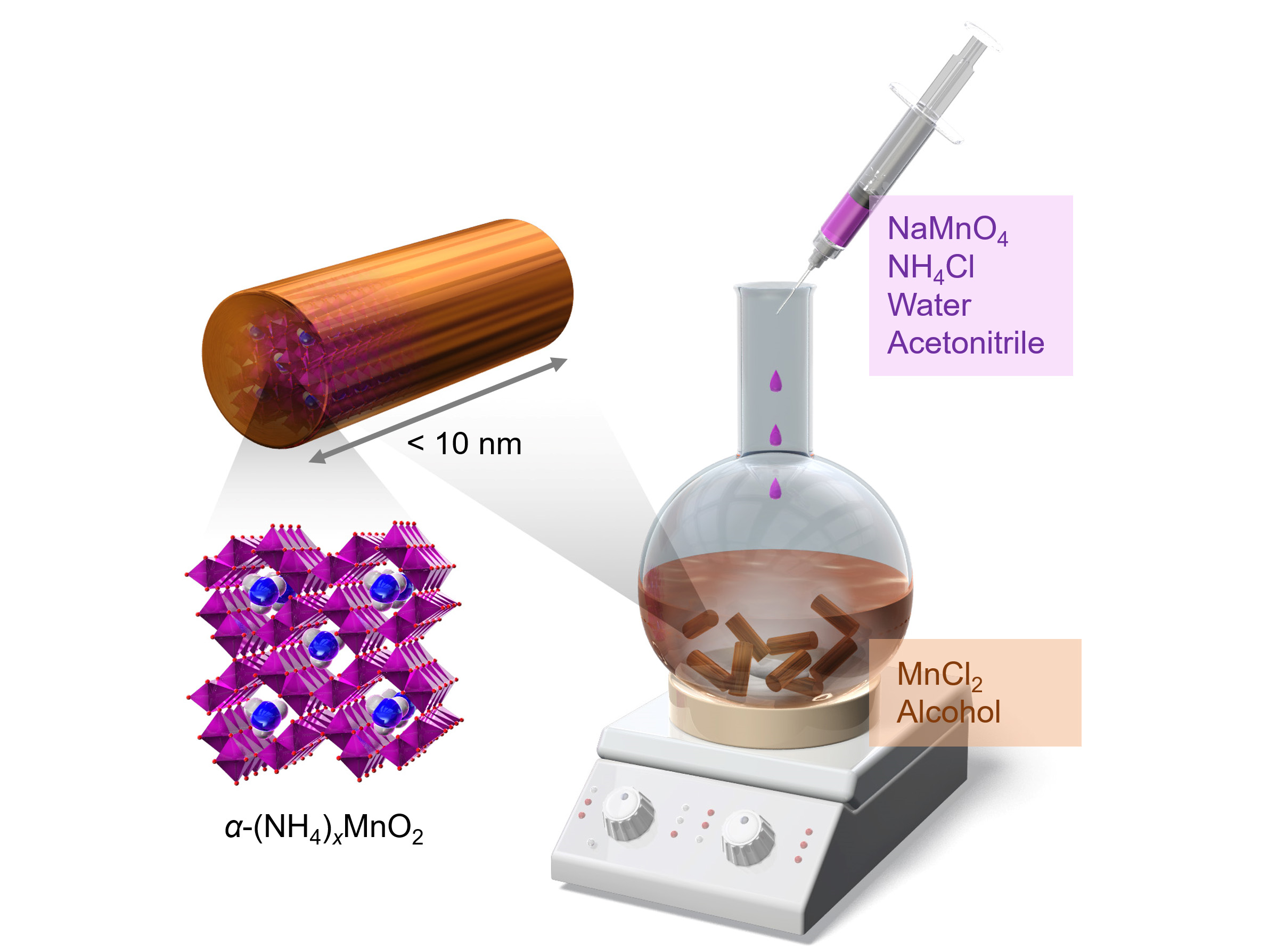
Figure 1. Schematic illustration of ultrasmall α-MnO₂ synthesis.
Figure 2a shows X-ray diffraction (XRD) patterns of α-MnO₂ synthesized via the hydrothermal process (α-MnO₂-hydro) and the alcohol solution process with different alcohol solvents (α-MnO₂-i-PrOH, α-MnO₂-n-PrOH, α-MnO₂-EtOH, and α-MnO₂-MeOH). All the XRD patterns, except α-MnO₂-MeOH, well-matched the single-phase of tetragonal α-MnO₂ with the I4/m space group through Rietveld refinements (Table S1). Compared with XRD patterns of α-MnO₂-hydro, α-MnO₂ synthesized via the alcohol solution process presented markedly broad XRD patterns, suggesting the formation of nanoparticles. The variation in particle size can be attributed to variations in the dielectric constant of the alcohol solvent, as well as disparities in reflux temperatures. For instance, comparing α-MnO₂-i-PrOH to α-MnO₂-EtOH having a similar reflux temperature, EtOH has the higher polarity, strengthening the hydrogen bonds with the permanganate anion. Consequently, this lowers the activation energy required for α-MnO₂ nucleation, favoring nucleation over the growth of larger α-MnO₂ particles. This is in line with a previous report on δ-MnO₂ nanoparticle formation.^{[27]}
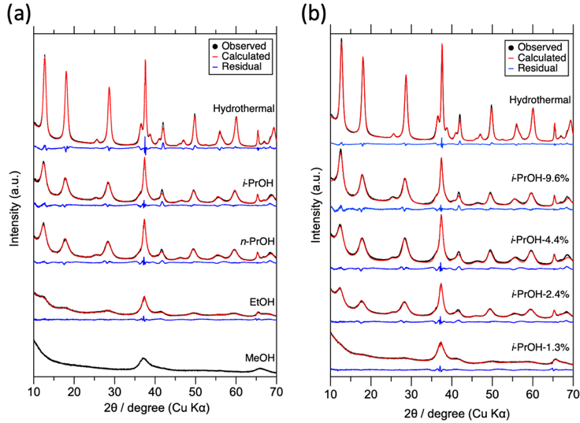
Figure 2. α-MnO₂ XRD patterns with fitting curves by Rietveld refinement with differences of (a) alcohol solvent and (b) differences of water content in i-PrOH reaction solution.
Figure 2b displays the XRD pattern of α-MnO₂, illustrating the influence of varying water contents in the synthesis process. Samples were labeled as α-MnO₂-i-PrOH-x (x is the volume ratio of H₂O/(i-PrOH+H₂O)) to clarify the amount of H₂O in the reaction solvent. As well as Figure 2a, all the XRD patterns well-matched the single-phase of tetragonal α-MnO₂ through Rietveld refinements (Table S1). Moreover, the selected area electron diffraction (SAED) analysis of α-MnO₂-hydro, α-MnO₂-i-PrOH-2.4%, and α-MnO₂-i-PrOH-1.3% shown in Figures S1a-S1c reveals the diffraction rings correlating to the obtained XRD pattern, supporting the formation of α-MnO₂. To further investigate the crystalline phase of the α-MnO₂, a pair distribution function (PDF) analysis using X-ray total scattering data (Figure S2) was conducted. The total correlation function T(r) of the α-MnO₂-i-PrOH-1.3% and α-MnO₂-EtOH clearly shows both edge-shared and corner-shared Mn-Mn peaks. However, α-MnO₂-MeOH exhibits a weak and broad peak of edge-shared Mn-Mn, suggesting the existence of both tunnel and layered phases.
As the water content decreases, the XRD patterns become broader (Figure 2b), indicating the downsizing of nanoparticles, also supported by the Rietveld refinement (Table S1). A large specific surface area (SSA) of more than 150 m² g^{–1} supports the nanoparticulation (Table S2); the SSA of hydrothermally synthesized α-MnO₂ is typically 70~100 m² g^{–1}.^{[23a]} Figure 3 presents high-resolution transmission electron microscopy (HR-TEM) images of α-MnO₂-hydro, α-MnO₂-i-PrOH-2.4%, and α-MnO₂-i-PrOH-1.3%. The low-magnified images are shown in Figure S1c-S1i. In all the samples, clear lattice fringes were observed with evenly spaced intervals, indicating the formation of α-MnO₂ crystals. Additionally, primary particles of α-MnO₂ synthesized through the alcohol solution process underwent significant nanoparticulation, as summarized in Figure 3d. By adjusting the water content in the reaction solution, not only the particle size but also the aspect ratio (c/a) changed significantly. Interestingly, α-MnO₂-EtOH exhibited a needle-like particle morphology with a longer c-axis direction and a larger aspect ratio shown in Figure S3, though it shows a similar XRD pattern shape and lattice constants to α-MnO₂-i-PrOH-1.3%. This discrepancy may derive from the amount of water. During the crystallization process from amorphous manganese oxide to α-MnO₂ and subsequent crystal growth along the c-axis direction, the presence of an adequate amount of water is crucial. Although the high dielectric constant of EtOH contributes to an overall reduction in the particle size, the presence of sufficient water in the reaction solution may have promoted crystal growth along the c-axis direction. From the above discussions, the mechanism of this nanoparticulation can derive from the reduced amount of water in the reaction solution; the crystal growth of α-MnO₂ via the dissolution/recrystallization process is successfully suppressed.
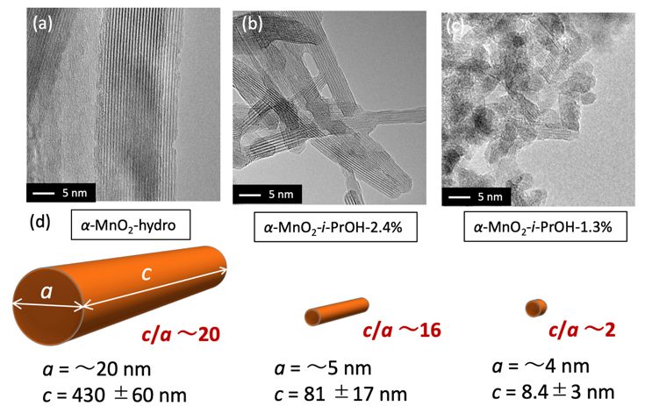
Figure 3. HR-TEM images of (a) α-MnO₂-hydro, (b) α-MnO₂-i-PrOH-2.4%, (c) α-MnO₂-i-PrOH-1.3%. (d) Summary of a and c axis length for each α-MnO₂ particle.
In addition to the crystallite size, the lattice constants also changed as shown in Figure S4 and Table S1. The lattice constants a and c increase as the particles become nanoparticles; the trend in c has a threshold of crystallite size. This is possibly due to the increase in the surface region of the particles, which have O defect regions and lower valence of Mn. The lower valence of Mn forces lattice expansion compared to the bulk, leading to an increase in the bulk lattice parameters. Figure 4a, Figure S5 and S6 display the Mn valence state of α-MnO₂ as determined by X-ray absorption spectroscopy (XAS) and X-ray photoelectron spectroscopy (XPS) analyses, respectively. As the particle size decreases, the Mn valence state decreases as well, evinced by both the Mn K-edge X-ray absorption near edge structure (XANES) and the Mn 2p XPS spectra, as evinced by lower energy shifts. Figure 4b shows the relative amount of NH₄⁺ cation in the tunnel of α-MnO₂, estimated from CHN and inductively coupled plasma atomic emission spectroscopy (ICP-AES) elemental analyses. The NH₄⁺/Mn ratio of 0.108 for α-MnO₂-hydro aligns with previous research findings.^{[10c, 28]} As the particle size decreases, the NH₄⁺/Mn ratio decreases. These results imply that despite the reduced NH₄⁺ content inside the tunnel, the Mn valence state becomes smaller, suggesting the formation of oxygen vacancies. The O 1s XPS spectra (Figure 4c) show larger peaks (around 532 eV) for α-MnO₂-i-PrOH-2.4% and -1.3% compared to α-MnO₂-hydro, supporting the presence of oxygen defects. In addition, EPR spectra of α-MnO₂-i-PrOH-1.3% (Figure S7 ) confirm the presence of oxygen defect since the single width (ΔB) has a positive correlation with the amount of oxygen defect ^{[29]}. These findings are summarized in Figure 4d. Ultrasmall α-MnO₂ exhibits a large surface area, which is associated with oxygen vacancies, lower NH₄⁺ content, and a lower Mn valence state.
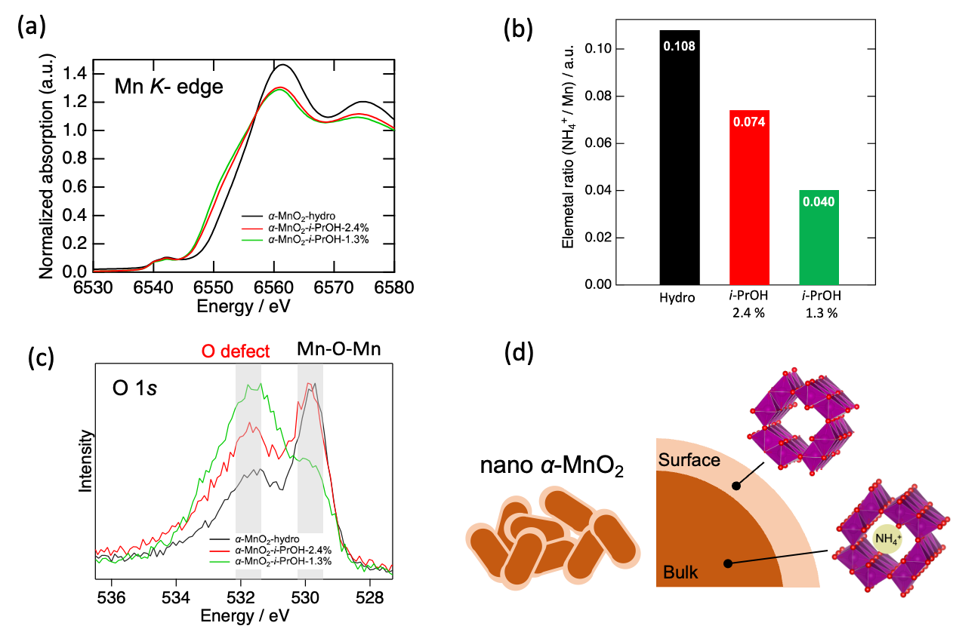
Figure 4. (a) Mn K-edge XANES spectra. (b) NH₄⁺/Mn ratio calculated by CHN and ICP-AES elemental analyses. (c) O 1s XPS spectra. (d) Illustration of Nanosized α-MnO₂ surface and bulk.
Furthermore, highly porous α-MnO₂ nanoparticles are obtained using tetrabutyl ammonium (TBA) permanganate salt instead of NaMnO₄, as shown in Figure S6. Such organic ammonium cations are introduced into a layered MnO₂ precursor to form mesoporous structures.^{[30]} Both α-MnO₂-i-PrOH-2.4% and -1.3% synthesized using TBAMnO₄ exhibited broader XRD patterns and smaller primary particles according to TEM images compared to those synthesized with NaMnO₄. Notably, α-MnO₂-i-PrOH-2.4% synthesized with TBAMnO₄ (Figure S8c) has a smaller aspect ratio particle compared to that synthesized with NaMnO₄ (Figure 3b). The SSAs of α-MnO₂-i-PrOH-1.3% is 263 m² g^{–1}, a larger value synthesized from NaMnO₄.
Electrochemical Multivalent-Ion Intercalation Hosts
Ultrasmall α-MnO₂ (α-MnO₂-i-PrOH-2.4% and -1.3%) exhibits superior cathode performances to hydrothermally synthesized α-MnO₂ (α-MnO₂-hydro) in multivalent (Zn, Mg, and Ca) battery full-cells (Figure 5), indicating that nanoparticulation of the active material reduces multivalent ion diffusion distance, thereby enhancing cathode performance without being hindered by the sluggish diffusion of multivalent ion.
Aqueous Zn-battery, using a 1.0 M ZnSO₄ + 0.05 M MnSO₄ electrolyte, is more easily cyclable compared with nonaqueous batteries. Even at the 50th cycle (Figure 5a), α-MnO₂-i-PrOH-2.4% achieved the discharge capacity of more than one electron reaction (308 mAh g^{–1}) with a clear discharge plateau at around 1.3 V attributable to Zn²⁺ intercalation,^{[20a]} significantly improved compared with α-MnO₂-hydro. Note that the cathode performance of α-MnO₂-i-PrOH-1.3% was lower than α-MnO₂-i-PrOH-2.4%, despite its smaller particle size. It is probably due to a strong particle aggregation, especially occurring in ultrasmall nanoparticles.^{[31]} Such aggregation increases the resistance of multivalent ion migration between particles as the interfacial resistance of α-MnO₂-i-PrOH-1.3% is large as shown in EIS spectra in Figure S9, resulting in inferior cathode properties, which is also a similar trend with nanosized-LiCoO₂ for Li-ion battery case ^{[32]}. Therefore, α-MnO₂ with smaller particle size without severe aggregation is suitable for multivalent ion battery cathodes as illustrated Figure S10. α-MnO₂-i-PrOH-2.4% holds a higher capacity compared with previous works ^{[33]} ^{[34]} and a high-capacity retention rate of around 100 cycles (Figure S11), while α-MnO₂-hydro and α-MnO₂-i-PrOH-1.3% exhibit capacity degradation. Furthermore, as Figure 5b shows, α-MnO₂-i-PrOH-2.4% exhibits superior rate performance; even at 1 A g^{–1}, it exhibits a reversible capacity of around 150 mAh g^{–1}. In addition, the nanosizing effect positively influences the liquid-solid reaction involving dissolved Mn²⁺, as reported in a previous study ^{[35]}. After discharge, Mn²⁺ readily dissolves into the electrolyte and returns to the α-MnO₂ core during charging, accompanied by the formation of ZnMn₂O₄ on the core surface. This indicates that the cathodic performance, driven by H⁺ and Zn²⁺ co-intercalation as well as the liquid-solid reaction involving dissolved Mn²⁺, is strongly dependent on the size of the α-MnO₂ core.
In nonaqueous Mg-battery, nanosized α-MnO₂ also exhibits higher discharge capacity and cyclability (Figures 5c, 5d and Figure S12), indicating that nanoparticulation of the active material reduces Mg²⁺ diffusion distance, thereby enhancing cathode performance without being hindered by the sluggish diffusion rate of Mg²⁺.Moreover, galvanostatic intermittent titration technique (GITT) measurements (Figure S13) exhibit that α-MnO₂-i-PrOH-2.4% has the smallest overvoltage at discharge.
To evaluate the impact of oxygen defects on charge/discharge performance, EPR spectra of α-MnO₂ were measured before and after annealing at 300°C. The annealed sample of α-MnO₂-i-PrOH-1.3% exhibited a greater ΔB in the EPR spectra, indicating an increased amount of oxygen defects (Figure S14a). This observation aligns with the previous report^{[36]}. When comparing the voltage profiles of α-MnO₂-i-PrOH-2.4%, which demonstrated the best cathodic performance, with its annealed counterpart, the cathodic performance significantly deteriorated after annealing. The annealed sample showed a lower operating voltage and reduced discharge capacity, attributed to a higher concentration of oxygen defects. These defects impair the structural stability required for Mg-ion insertion, reducing structural tolerance. We estimate that the increased oxygen defects accelerate the phase transition from the hollandite structure to the halite phase, resulting in diminished capacity and a lower operating voltage. Note that there is no significant change in its specific surface area before and after annealing; annealed α-MnO₂-i-PrOH-2.4% possess 122 m² g⁻¹. Despite optimizing α-MnO₂ particle size, controlling aggregation and changing the amount of oxygen defect, degradation occurred during cycling. According to the recent DFT calculations, the insertion of Mg ions into α-MnO₂ distorts the tunnel structure from square to rhombus.^{[37]} Consistently, ex-situ XRD measurements of α-MnO₂-hydro, exhibiting the most severe cycle degradation, revealed a broadening of the 310-plane peak after discharge, failing to revert to its pristine state (Figure S15). This observation suggests the entrapment of Mg²⁺ ions within the tunnel structure, impeding their deintercalation during charging, consequently leading to capacity degradation. Thus, even with optimized particle conditions as in α-MnO₂-i-PrOH-2.4%, complete deintercalation of Mg ions remains a challenge.
For nonaqueous Ca-battery cell tests as shown in Figure 5e, α-MnO₂-i-PrOH-2.4% and -1.3% demonstrate superior cathodic performance, as well as the Mg-battery cell, primarily due to the reduction in the diffusion distance of Ca²⁺. On the contrary to the Mg and Zn-battery cases, α-MnO₂-i-PrOH-1.3% exhibits a larger charge capacity, suggesting that nanoparticulation may contribute rather to charge performance, specifically in Ca²⁺ deintercalation.
Furthermore, upon comparing the voltage profiles at 10 mA g^{–1} and 100 mA g^{–1}, there appears to be no significant deviation in capacity and polarization between discharge and charge (Figure S16), implying that Ca²⁺ undergo intercalation and de-intercalation more rapidly than Mg²⁺, possibly due to differences in their charge density.
Concerning the cyclability of α-MnO₂-i-PrOH-1.3% in the Ca-battery system, assessing its cathode performance with Ca[B(HFIP)₄]₂ electrolyte presents challenges due to the formation of a CaF₂ passivation layer on Ca metal,^{[38]} resulting in substantial cycle degradation. To address this issue, a Ca full-cell test using Ca[CB₁₁H₁₂]₂ electrolyte was conducted; a fluorine-free electrolyte having high anodic stability (> 4 V vs. Ca²⁺/Ca).^{[39]} As shown in Figure 5f and Figure S17, Ca[CB₁₁H₁₂]₂ electrolyte notably enhances the cyclability of the cathode compared with Ca[B(HFIP)₄]₂ electrolyte, suggesting that most cycle degradation stems from anodic issues and α-MnO₂-i-PrOH-1.3% was found to be superior host material for Ca-battery. Note that the coulombic efficiency of Ca[CB₁₁H₁₂]₂ electrolyte is around 84 % and the passivation layer, which is mainly CaH₂, is gradually formed. This is the main reason for capacity degradation shown Figure 5f. In addition, the coulombic efficiency in the first cycle was far from ideal even with using an F-free electrolyte. Figure S18 presents the XRD patterns of α-MnO₂-i-PrOH-1.3% after discharge and charge. Even though DFT calculation expect no structural distortion for Ca²⁺ insertion, the 310 peak shifted to a lower angle, indicating its structural change and Ca ions were trapped within the structure. Then, this causes low coulombic efficiency in the first cycle and the charge capacity is significantly dependent on the particle size, suggesting that the short migration path facilitate the Ca ion de-insertion.
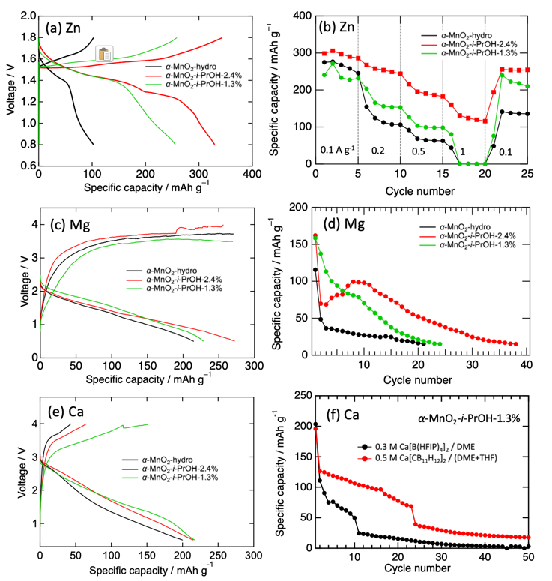
Figure 5. (a) 50th-cycled voltage profile of Zn-battery cell at a current density of 100 mA g^{–1}). (b) Rate capability of Zn-battery cell. (c) 1st voltage profile of Mg-battery cell at a current density of 10 mA g^{–1}. (b) Discharge capacity of Mg-battery cell during cycles at a current density of 100 mA g^{–1}. (e) 1st voltage profile of Ca-battery cell at a current density of 10 mA g^{–1}. (f) Discharge capacity of Ca-battery cell with different electrolytes during cycles at a current density of 100 mA g^{–1}.
In charge-discharge reactions using organic electrolytes such as Ca- and Mg-battery, in addition to cation insertion reactions, side reactions such as electrolyte reductive decomposition reactions^{[40]} and O^{2–} desorption^{[41]} are likely to occur, hence the contribution ratio of cation insertion to capacity is important. Scanning electron microscopy (SEM)-energy dispersive X-ray spectroscopy (EDX) analyses were applied to quantify the cation insertion levels. Figure S19 presents the ratio of Mg²⁺ and Ca²⁺ intercalation reaction per whole discharge reaction. Concerning Mg²⁺ intercalation ability, α-MnO₂-i-PrOH-2.4% exhibits the highest Mg²⁺ contribution of 78% to discharge capacity; more than 20% of side reactions occur. In particular, only 60 % of capacity is contributed by Mg²⁺ insertion in the case of α-MnO₂-i-PrOH-1.3%. In contrast, Ca²⁺ intercalation rather proceeds in all α-MnO₂ cathodes. Particularly noteworthy is α-MnO₂-i-PrOH-1.3%, showing a remarkable 91% cation contribution to capacity. Moreover, α-MnO₂-i-PrOH-1.3% shows excellent selectivity in both Ca²⁺ intercalation and de-intercalation reactions. As displayed in Table S3, almost all charging capacity stems from Ca²⁺ de-intercalation, highlighting the superior performance of nanosized α-MnO₂ as a host material for Ca²⁺ at room temperature compared to Mg²⁺. This host performance owes not only to the low charge density of Ca²⁺ and facile diffusion through its solid phase but also to previous DFT calculations^{[42]} indicating that Ca²⁺ insertions cause minimal distortion to the tunnel structure of α-MnO₂. Additionally, as shown in Figure S20, Mn K-edge XANES analysis, tracing the redox reactions of Mn during the intercalation and deintercalation of Ca ions, indicates semi-reversible redox processes, consistent with the observed voltage profile in the first cycle. Notably, compared with spectra of other samples, α-MnO₂-i-PrOH-1.3% possess the highest Mn re-oxidation ability.
As discussed above, α-MnO₂-i-PrOH-1.3% exhibits excellent properties as a Ca-battery cathode. However, there is still potential for further performance improvement. As shown in the TEM images (Figures 3c and S1f), the primary particles are strongly aggregated. Additionally, electrochemical impedance spectroscopy (EIS) data presented in Figure S21 indicated a large cathodic interfacial resistance for α-MnO₂-i-PrOH-1.3%. This aggregation thereby causing the lack of conductivity likely contributes to the reduced performance. To address this issue, we aimed to suppress particle aggregation by compositing nanoparticles with some porous dispersant materials. Since the alcohol solution process is a wet process, the composite is easily obtained by mixing dispersant into the solution. Here we selected conductive graphene nanosheets. Figure 6a displays HR-TEM images of the α-MnO₂-i-PrOH-1.3%-graphene composite, denoted as α-MnO₂-i-PrOH-1.3%-G. The primary α-MnO₂ nanoparticles were homogeneously dispersed on the graphene sheet, and particle aggregation was scarcely observed. The SAED patterns (Figure 6b) and XRD patterns (Figure S22) show diffraction rings corresponding to the XRD patterns, confirming the crystalline phases of α-MnO₂ and graphene. Regarding its cathodic performance in Ca-battery tests (Figure 6c), α-MnO₂-i-PrOH-1.3%-G exhibited significantly superior charge-discharge performance, especially in the charge curve. The polarization at 150 mAh g^{–1} was reduced from 2.60 V to 1.87 V, achieving the fully reversible charge. When comparing the polarization of nanosized α-MnO₂-graphene composite cathodes with different particle sizes and aspect ratios, the most significant reduction in polarization was observed with the α-MnO₂-i-PrOH-1.3% cathode (Figure 6d). This implies that the graphene composite is a highly effective method for fully utilizing the strongly aggregated nanoparticles as cathodes. As shown in Figure S23, its capacity degradation at first few cycles was significantly suppressed by compositing with graphene.
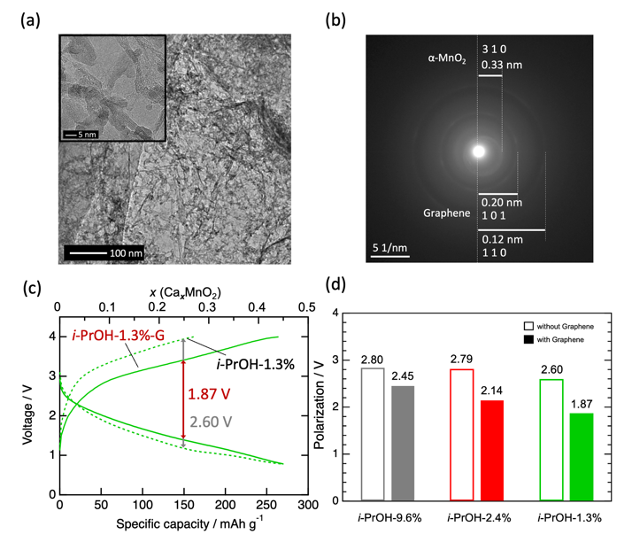
Figure 6. (a) HR-TEM images and (b) SAED patterns of α-MnO₂-i-PrOH-1.3%-G. (c) Voltage profiles of Ca-battery cell at a current density of 100 mA g^{–1} and (d) polarizations at the point of 150 mAh g^{–1}.
Aerobic Oxidation Catalysis
In general, it is known that the catalytic activity increases with decreasing the SSA of manganese oxides, but there is no detailed discussion on how the aspect ratio of α-MnO₂ affects the catalytic performance for the oxidation reactions. Firstly, the catalytic activities of three manganese oxide catalysts prepared in this study, α-MnO₂-hydro, α-MnO₂-i-PrOH-2.4%, and α-MnO₂-i-PrOH-1.3%, were compared for the oxidation of 1-phenylethanol (secondary alcohol) to acetophenone using O₂ as a model reaction. Figure 7a shows the reaction profiles, where the order of the catalytic activities was α-MnO₂-hydro < α-MnO₂-i-PrOH-2.4% < α-MnO₂-i-PrOH-1.3%. In all cases, the reactions proceeded selectively, and no byproducts other than acetophenone were detected. The initial reaction rates determined at less than 10% 1-phenylethanol conversion were 1.25 mM min^{–1}, at 2.21 mM min^{–1}, and 3.05 mM min^{–1} for α-MnO₂-hydro, α-MnO₂-i-PrOH-2.4%, and α-MnO₂-i-PrOH-1.3%, respectively, and the relationship between initial reaction rates and the SSAs was found to be a nearly first order (Table S2). This means that the oxidation of 1-phenylethanol by α-MnO₂ (in other words, the reduction of α-MnO₂) can be considered to depend simply on just their SSA, without regard to the aspect ratios. However, comparing the reaction profiles of α-MnO₂-hydro and α-MnO₂-i-PrOH-1.3%, for example, a clear difference can be observed in the latter half of the reaction that cannot be explained by the difference in their SSAs alone. This result is considered to be due to the fact that more c planes are exposed in the case of α-MnO₂ with a low aspect ratio (c/a), where electron transfer from the reduced manganese species to O₂ proceeds smoothly to complete the catalytic cycle. Based on these results, designing α-MnO₂ with a small SSA and small aspect ratio (c/a) is a very effective strategy for oxidation reactions of this type of substrate.
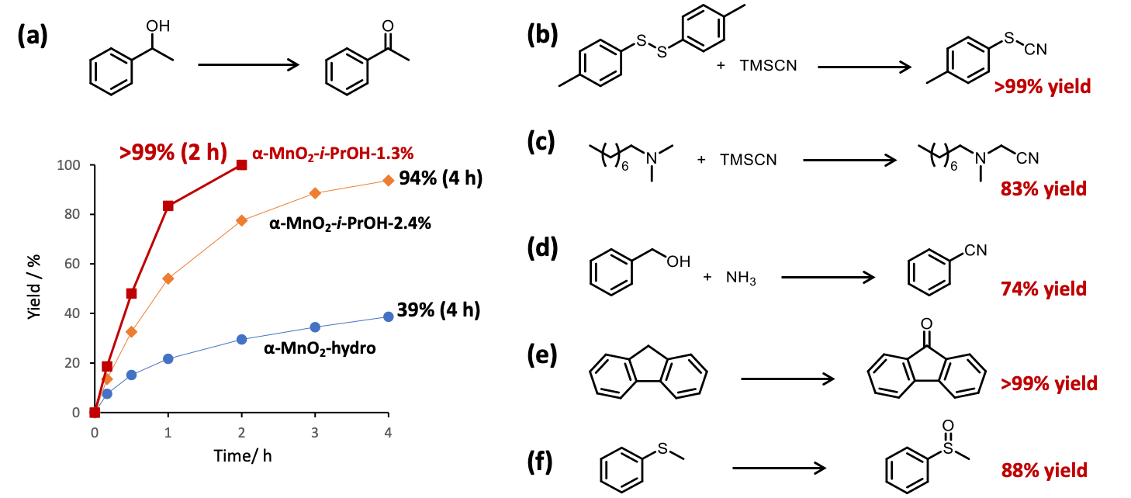
Figure 7. α-MnO₂-catalyzed aerobic oxidations of (a) 1-phenylethanol, (b) benzyl alcohol, (c) di-p-tolyl disulfide, (d) N,N-dimethyl octylamine, (e) fluorene, and (f) thioanisole. Reaction conditions were described in the experimental section. For the reactions (b)-(f), α-MnO₂-i-PrOH-1.3% was used as a catalyst. In reactions (b), (c), and (f), benzamide (25% yield), methylene cyanated product (11% yield), and methyl phenyl sulfone (5% yield) formed as byproducts, respectively.
Finally, the substrate scope of ultrasmall α-MnO₂ catalysts to various oxidation reactions was investigated. With ultrasmall α-MnO₂ catalysts, the selective oxidation of not only secondary alcohols but also primary alcohols to aldehydes proceeded efficiently. The reaction of benzyl alcohol with α-MnO₂-i-PrOH-1.3% as a catalyst in the presence of NH₃ gave benzonitrile in 74% yield for 30 min (Figure 7b); this reaction consists of oxidation of benzyl alcohol to benzaldehyde, the reaction of benzaldehyde with NH₃ to form an aldimine, followed by the oxidation to the corresponding nitrile. In this case, benzamide was also formed in 25% by nitrile hydration.^{[43]} When the reaction of benzyl alcohol with α-MnO₂-i-PrOH-2.4% (otherwise conditions were the same) was carried out for 1 h, the selectivity switch occurred to afford benzamide in 93% yield. α-MnO₂-i-PrOH-1.3% was also extremely effective for reactions originating from SET oxidation (Figures 7c and 7d). In the reaction of a disulfide, a thiol and target thiocyanate were first formed by the nucleophilic addition of CN– to the disulfide substrate, but α-MnO₂-i-PrOH-1.3% showed extremely high catalytic activity for thiol homocoupling via SET oxidation, resulting in selective production of the thiocyanate product (Figure 7c). The α-methyl-selective oxidative cyanation was achieved through the α-MnO₂-i-PrOH-1.3%-mediated SET/deprotonation/SET sequence followed by the nucleophilic addition of CN– (Figure 7d). Moreover, α-MnO₂-i-PrOH-1.3% was effective for the oxygenation reactions of various substrates such as alkylarenes (Figure 7e) and sulfides (Figure 7f).
Conclusion
Ultrasmall α-MnO₂ (<10 nm) with a low aspect ratio (c/a ~2) was, for the first time, successfully synthesized using an alcohol solution process, without any metal doping. Its potential as a host material for multivalent ion (Mg²⁺, Ca²⁺, and Zn²⁺) battery cathodes and as an aerobic oxidation catalyst was fully demonstrated. In the realm of battery application, ultrasmall α-MnO₂ demonstrates superior cathodic performance compared to conventional-sized counterparts in all the battery systems, primarily due to the significant reduction in cation diffusion distance within the solid structure. In particular, ultrasmall α-MnO₂ homogeneously dispersed onto graphene nanosheets was found to be a promising cathode material for Ca-battery. Regarding aerobic oxidation catalysis, the impact of nanosizing is profound, leading to a substantial increase in the efficiency of oxidative conversion reactions of various molecules, such as 1-phenylethanol oxidation, attributable to the vastly expanded active surface area of the catalyst. Thus, the ultrasmall α-MnO₂ has made a significant impact not only in the field of batteries but also in catalysis. It can be anticipated that this material will not only find applications in next-generation green energy technologies but also set new standards for technologies across various industrial sectors.
Main Text Paragraph.
Supporting Information
The authors have cited additional references within the Supporting Information. ^{[44]} ^{[45]} ^{[46]} ^{[47]} ^{[48]} ^{[49]}
CRediT Authorship Contribution
Conceptualization: H.K.; Methodology: H.K.; Formal Analysis: R.I. (lead), H.K.; Investigation: R.I. (synthesis, Mg and Zn battery), S.K. (synthesis, Ca battery), T.Y. (Zn battery), S.T. (Zn battery), K.Y. (catalyst), N.K. (PDF); Resources: T.M. (Mg electrolyte), K.K. (Ca electrolyte); Writing – Original Draft: R.I.; Writing – Review & Editing: H.K. (lead), K.Y., T.M., K.K., N.K., Z.Z.-K., S.O., Y.I., M.M., M.F., I.H., T.I.; Supervision: Z.Z.-K., S.O., Y.I., M.M., M.F., I.H, T.I.; Project Administration: H.K.; Funding Acquisition: H.K.
Acknowledgements
Parts of this work were supported by JSPS KAKENHI (23K1381603), JST ALCA-SPRING (JPMJAL1301), JST GteX (JPMJGX23S1), Cooperative Research Program of NJRC Mater. & Dev. (MEXT), Power Academy, the Light Metal Educational Foundation, and International Joint Graduate Program in Materials Science: GP-MS at Tohoku University, Japan. This work contributes to the research performed at CELEST (Center for Electrochemical Energy Storage Ulm-Karlsruhe) and was partly funded by the German Research Foundation (DFG) under Project ID 390874152 (POLiS Cluster of Excellence).
Keywords: Manganese oxide • nanoparticle • cathode • catalyst
[1] R. Yang, Y. Fan, R. Ye, Y. Tang, X. Cao, Z. Yin, Z. Zeng, Adv. Mater. 2021, 33, 2004862.
[2] I. Kruk, P. Zajdel, W. van Beek, I. Bakaimi, A. Lappas, C. Stock, M. A. Green, J. Am. Chem. Soc. 2011, 133, 13950.
[3] a)Q. Feng, H. Kanoh, K. Ooi, J. Mater. Chem. 1999, 9, 319; b)C. Sun, Y. Zhang, S. Song, D. Xue, J. Appl. Cryst. 2013, 46, 1128; c)D. M. Robinson, Y. B. Go, M. Mui, G. Gardner, Z. Zhang, D. Mastrogiovanni, E. Garfunkel, J. Li, M. Greenblatt, G. C. Dismukes, J. Am. Chem. Soc. 2013, 135, 3494; d)T. Hatakeyama, H. Li, N. L. Okamoto, K. Shimokawa, T. Kawaguchi, H. Tanimura, S. Imashuku, M. Fichtner, T. Ichitsubo, Chem. Mater. 2021, 33, 6983; e)W. Zhao, S. J. B. Rubio, Y. Dang, S. L. Suib, ACS ES&T Eng. 2022, 2, 20.
[4] a)J. Luo, H. T. Zhu, H. M. Fan, J. K. Liang, H. L. Shi, G. H. Rao, J. B. Li, Z. M. Du, Z. X. Shen, J. Phys. Chem. C 2008, 112, 12594; b)Y. Yuan, A. Nie, G. M. Odegard, R. Xu, D. Zhou, S. Santhanagopalan, K. He, H. Asayesh-Ardakani, D. D. Meng, R. F. Klie, C. Johnson, J. Lu, R. Shahbazian-Yassar, Nano Lett. 2015, 15, 2998.
[5] a)D. Zheng, S. Sun, W. Fan, H. Yu, C. Fan, G. Cao, Z. Yin, X. Song, J. Phys. Chem. B 2005, 109, 16439; b)Y. Dong, H. Yang, K. He, S. Song, A. Zhang, Appl. Catal. B 2009, 85, 155.
[6] a)M. M. Thackeray, M. H. Rossouw, R. J. Gummow, D. C. Liles, K. Pearce, A. De Kock, W. I. F. David, S. Hull, Electrochim. Acta 1993, 38, 1259; b)P. K. Gupta, A. Bhandari, J. Bhattacharya, R. G. S. Pala, J. Phys. Chem. C 2018, 122, 11689.
[7] a)Y. Chabre, J. Pannetier, Prog. Solid State Chem. 1995, 23, 1; b)S. Chou, F. Cheng, J. Chen, J. Power Sources 2006, 162, 727.
[8] a)C. A. J. Appelo, D. Postma, Geochim. Cosmochim. Acta 1999, 63, 3039; b)J. Zhou, L. Yu, M. Sun, S. Yang, F. Ye, J. He, Z. Hao, Ind. Eng. Chem. Res. 2013, 52, 9586.
[9] a)J. C. Hunter, J. Solid. State. Chem. 1981, 39, 142; b)J. E. Greedan, N. P. Raju, A. S. Wills, C. Morin, S. M. Shaw, J. N. Reimers, Chem. Mater. 1998, 10, 3058.
[10] a)D. A. Tompsett, M. S. Islam, Chem. Mater. 2013, 25, 2515; b)C. Ling, R. Zhang, F. Mizuno, ACS Appl. Mater. Interfaces 2016, 8, 4508; c)L. M. Housel, L. Wang, A. Abraham, J. Huang, G. D. Renderos, C. D. Quilty, A. B. Brady, A. C. Marschilok, K. J. Takeuchi, E. S. Takeuchi, Acc. Chem. Res. 2018, 51, 575; d)J. Fu, X. Luo, RSC Adv. 2020, 10, 39895; e)X. Gao, H. Wu, W. Li, Y. Tian, Y. Zhang, H. Wu, L. Yang, G. Zou, H. Hou, X. Ji, Small 2020, 16, 1905842.
[11] a)T. Uematsu, Y. Miyamoto, Y. Ogasawara, K. Suzuki, K. Yamaguchi, N. Mizuno, Catal. Sci. Technol. 2016, 6, 222; b)E. Hayashi, Y. Yamaguchi, K. Kamata, N. Tsunoda, Y. Kumagai, F. Oba, M. Hara, J. Am. Chem. Soc. 2019, 141, 890.
[12] a)A. Umar, A. A. Ibrahim, R. Kumar, H. Albargi, W. Zeng, M. A. M. Alhmami, M. A. Alsaiari, S. Baskoutas, Mater. Lett. 2021, 286, 129232; b)C. Revathi, R. T. R. Kumar, Electroanalysis 2017, 29, 1481.
[13] a)H. Li, L. Gui, Z. Gao, F. Ren, H. Zhang, R. Peng, Nanotechnology 2021, 32, 215705; b)M. A. El-Ghobashy, I. A. Salem, W. M. El-Dahrawy, M. A. Salem, J. Mol. Struct. 2023, 1272, 134118.
[14] a)L. I. Hill, R. Portal, A. Verbaere, D. Guyomard, Electrochem. Solid-State Lett. 2001, 4, A180; b)J. Huang, A. S. Poyraz, S.-Y. Lee, L. Wu, Y. Zhu, A. C. Marschilok, K. J. Takeuchi, E. S. Takeuchi, ACS Appl. Mater. Interfaces 2017, 9, 4333; c)X. Wang, F. Zhang, C. Xia, L. Cui, F. Yang, J. Alloys Compd. 2024, 970, 172599.
[15] A. B. Brady, K. R. Tallman, E. S. Takeuchi, A. C. Marschilok, K. J. Takeuchi, P. Liu, J. Phys. Chem. C 2019, 123, 25042.
[16] a)N. Tang, X. Tian, C. Yang, Z. Pi, Q. Han, J. Phys. Chem. Solids 2010, 71, 258; b)Y. Sun, S. Wang, Y. Dai, X. Lei, Functional Materials Letters 2015, 09, 1650005.
[17] a)R. Zhang, X. Yu, K.-W. Nam, C. Ling, T. S. Arthur, W. Song, A. M. Knapp, S. N. Ehrlich, X.-Q. Yang, M. Matsui, Electrochem. Commun. 2012, 23, 110; b)B. Wu, G. Zhang, M. Yan, T. Xiong, P. He, L. He, X. Xu, L. Mai, Small 2018, 14, 1703850; c)C. Zuo, F. Xiong, J. Wang, Y. An, L. Zhang, Q. An, Adv. Funct. Mater. 2022, 32, 2202975; d)Y. Qi, H. Li, K. Shimokawa, X. Ye, T. Kawaguchi, T. Ichitsubo, J. Phys. Chem. C 2023, 127, 21271; e)K. Shimokawa, T. Hatakeyama, H. Li, T. Ichitsubo, Curr. Opin. Electrochem. 2023, 38, 101209.
[18] W. Zhang, H. Li, Z. Zhang, M. Xu, Y. Lai, S.-L. Chou, Small 2020, 16, 2001524.
[19] Y. Tian, G. Zeng, A. Rutt, T. Shi, H. Kim, J. Wang, J. Koettgen, Y. Sun, B. Ouyang, T. Chen, Z. Lun, Z. Rong, K. Persson, G. Ceder, Chem. Rev. 2021, 121, 1623.
[20] a)T. Le, N. Sadique, L. M. Housel, A. S. Poyraz, E. S. Takeuchi, K. J. Takeuchi, A. C. Marschilok, P. Liu, ACS Appl. Mater. Interfaces 2021, 13, 59937; b)Q. Yang, Y. Chen, Y. Yang, T. Xu, Y. Lin, X. Zhang, J. Wang, Y.-N. Liu, Y. Li, Ind. Eng. Chem. Res. 2023, 62, 16757.
[21] K. Ma, Q. Li, C. Hong, G. Yang, C. Wang, ACS Appl. Mater. Interfaces 2021, 13, 55208.
[22] a)M. Koutani, E. Hayashi, K. Kamata, M. Hara, J. Am. Chem. Soc. 2022, 144, 14090; b)K. Kamata, N. Kinoshita, M. Koutani, R. Aono, E. Hayashi, M. Hara, Catal. Sci. Technol. 2022, 12, 6219.
[23] a)J.-H. Moon, H. Munakata, K. Kajihara, K. Kanamura, Electrochemistry 2013, 81, 2; b)G. Zhu, J. Zhu, W. Li, W. Yao, R. Zong, Y. Zhu, Q. Zhang, Environ. Sci. Technol. 2018, 52, 8684.
[24] a)Z. Hu, X. Xiao, C. Chen, T. Li, L. Huang, C. Zhang, J. Su, L. Miao, J. Jiang, Y. Zhang, J. Zhou, Nano Energy 2015, 11, 226; b)S. Chen, S. Zhang, T. Wang, Z. Lei, M. Zhu, X. Dai, F. Liu, J. Li, H. Yin, Mater. Chem. Phys. 2018, 208, 258; c)A. Khan, A. M. Toufiq, F. Tariq, Y. Khan, R. Hussain, N. Akhtar, S. u. Rahman, Mater. Res. Express 2019, 6, 065043; d)M. Lübke, A. Sumboja, L. McCafferty, C. F. Armer, A. D. Handoko, Y. Du, K. McColl, F. Cora, D. Brett, Z. Liu, J. A. Darr, ChemistrySelect 2018, 3, 2613; e)R. Cerc Korošec, P. Umek, A. Gloter, J. Padežnik Gomilšek, P. Bukovec, Beilstein J. Nanotechnol. 2017, 8, 1032; f)S. M. Alharbi, M. A. Alkhalifah, B. Howchen, A. N. A. Rahmah, V. Celorrio, D. J. Fermin, ACS Mater. Au 2024, 4, 74; g)X. Hu, J. Chen, S. Li, Y. Chen, W. Qu, Z. Ma, X. Tang, J. Phys. Chem. C 2020, 124, 701.
[25] a)H. Kobayashi, K. Yamaguchi, I. Honma, RSC Adv. 2019, 9, 36434; b)Y. Sugawara, H. Kobayashi, I. Honma, T. Yamaguchi, ACS Omega 2020, 5, 29388; c)R. Iimura, H. Watanabe, T. Mandai, I. Honma, H. Imai, H. Kobayashi, ACS Applied Energy Materials 2024, 7, 5308.
[26] A. Manthiram, J. Kim, S. Choi, MRS Proc. 1999, 575, 9, 9.
[27] S. Hong, S. Jin, Y. Deng, R. Garcia-Mendez, K.-i. Kim, N. Utomo, L. A. Archer, ACS Energy Lett. 2023, 8, 1744.
[28] C. S. Johnson, D. W. Dees, M. F. Mansuetto, M. M. Thackeray, D. R. Vissers, D. Argyriou, C. K. Loong, L. Christensen, J. Power Sources 1997, 68, 570.
[29] M. Kakazey, N. Ivanova, Y. Boldurev, S. Ivanov, G. Sokolsky, J. G. Gonzalez-Rodriguez, M. Vlasova, J. Power Sources 2003, 114, 170.
[30] J. Luo, S. L. Suib, Chem. Commun. 1997, 1031.
[31] H. Kobayashi, Y. Fukumi, H. Watanabe, R. Iimura, N. Nishimura, T. Mandai, Y. Tominaga, M. Nakayama, T. Ichitsubo, I. Honma, H. Imai, ACS Nano 2023, 17, 3135.
[32] M. Okubo, E. Hosono, J. Kim, M. Enomoto, N. Kojima, T. Kudo, H. Zhou, I. Honma, J. Am. Chem. Soc. 2007, 129, 7444.
[33] Y. Chen, Z. Li, B. Li, Z. Zhang, J. Wei, B. Wang, Y. Huang, ACS Applied Energy Materials 2023, 6, 3329.
[34] L. Wu, Z. Li, Y. Xiang, W. Dong, X. Qi, Z. Ling, Y. Xu, H. Wu, M. D. Levi, N. Shpigel, X. Zhang, Small 2024, 20, 2404583.
[35] S. J. Kim, D. Wu, N. Sadique, C. D. Quilty, L. Wu, A. C. Marschilok, K. J. Takeuchi, E. S. Takeuchi, Y. Zhu, Small 2020, 16, 2005406.
[36] T. Subramaniam, B. S. Krishnaveni, S. Devaraj, Journal of Materials Science: Materials in Electronics 2024, 35, 1184.
[37] C. Ling, R. Zhang, T. S. Arthur, F. Mizuno, Chem. Mater. 2015, 27, 5799.
[38] a)Z. Li, O. Fuhr, M. Fichtner, Z. Zhao-Karger, Energy Environ. Sci. 2019, 12, 3496; b)Z. Li, B. P. Vinayan, T. Diemant, R. J. Behm, M. Fichtner, Z. Zhao-Karger, Small 2020, 16, 2001806.
[39] a)K. Kisu, S. Kim, T. Shinohara, K. Zhao, A. Züttel, S. Orimo, Sci. Rep. 2021, 11, 7563; b)K. Kisu, R. Mohtadi, S. Orimo, Adv. Sci. 2023, 10, 2301178.
[40] a)R. Iimura, H. Kobayashi, I. Honma, Electrochemistry 2022, 90, 067002; b)J. Han, S. Yagi, H. Takeuchi, M. Nakayama, T. Ichitsubo, J. Phys. Chem. C 2022, 126, 19074; c)W. Zhou, C. Xu, B. Gao, M. Nakayama, S. Yagi, Y. Tateyama, ACS Energy Lett. 2023, 8, 4113.
[41] X. Ye, H. Li, T. Hatakeyama, H. Kobayashi, T. Mandai, N. L. Okamoto, T. Ichitsubo, ACS Appl. Mater. Interfaces 2022, 14, 56685.
[42] T. R. Juran, J. Young, M. Smeu, J. Phys. Chem. C 2018, 122, 8788.
[43] a)K. Yamaguchi, H. Kobayashi, T. Oishi, N. Mizuno, Angew. Chem. Int. Ed. 2012, 51, 544; b)K. Yamaguchi, Y. Wang, H. Kobayashi, N. Mizuno, Chem. Lett. 2012, 41, 574; c)K. Yamaguchi, H. Kobayashi, Y. Wang, T. Oishi, Y. Ogasawara, N. Mizuno, Catal. Sci. Technol. 2013, 3, 318.
[44] F. Izumi, K. Momma, Solid State Phenomena 2007, 130, 15.
[45] S. Kohara, M. Itou, K. Suzuya, Y. Inamura, Y. Sakurai, Y. Ohishi, M. Takata, J Phys. Condens. Matter 2007, 19, 506101.
[46] D. A. Keen, J. Appl. Cryst. 2001, 34, 172.
[47] B. Ravel, M. Newville, J. Synchrotron Rad. 2005, 12, 537.
[48] T. Mandai, ACS Appl. Mater. Interfaces 2020, 12, 39135.
[49] A. Shyamsunder, L. E. Blanc, A. Assoud, L. F. Nazar, ACS Energy Lett. 2019, 4, 2271.

Entry for the Table of Contents

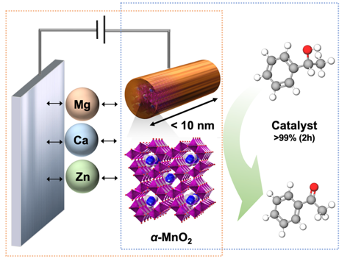
An ultrasmall α-MnO₂ (<10 nm) with a low aspect ratio (c/a~2) is synthesized using an alcohol solution process. It exhibits superior performances in both multivalent-ion battery cathodes and aerobic oxidation catalysts. The versatile functionality of ultrasmall α-MnO₂ underscores its potential to revolutionize energy storage and catalysis, offering broad applicability in next-generation green energy technologies.

