Hard X-ray Photoelectron Spectroscopy (HAXPES) Cr Kα and XPS Al Kα measurements of bulk Lithium metal
Hideyuki Yasufuku, Tsuyoshi Ohnishi, Shigenori Ueda, Yoshiyuki Yamashita, Hiroshi Shinotsuka, Hideki Yoshikawa, Shigeo Tanuma, Satoshi Kawada, and Yoshitaka Matsushita
National Institute for Materials Science, 1-1, Namiki, Tsukuba, Ibaraki 305-0044, Japan.
(Received day Month year; accepted day Month year; published day Month year)
Electronic states of bulk lithium were measured by hard X-ray photoelectron spectroscopy (HAXPES) and XPS. The samples were measured using Cr Kα and Al Kα excitation sources at 5414.8 eV and 1486.6 eV, respectively, including survey, Li 1s, O 1s and F 1s spectra were obtained.
Keywords: Lithium, HAXPES, Cr Kα, Al Kα

Accession#: Enter Accession Number.
Technique: XPS
Specimen: Lithium
Instrument: ULVAC-PHI Quantes
Major Elements in Spectra: Li
Minor Elements in Spectra: O, F, Ar
Published Spectra: 9
Spectral Category: Reference

INTRODUCTION
With the launch of hard X-ray photoelectron spectroscopy (HAXPES) using Cr Kα excitation sources (Ref. 1), XPS measurements using hard X-rays became more accessible. Reference spectra of various elements and compounds are vigorously published. How ever, the spectra using Cr Kα excitation sources of alkali metals and alkaline earth metals and their compounds are still largely unpublished, even they are hot and important materials for the application such as for secondary battery (Ref. 2), caused by their high chemical reactivities.
In this work, we present the results of measurements of bulk lithium metal using a laboratory-based HAXPES (Excitation source: monochromatic Cr Kα, 5414.8 eV) / XPS (monochromatic Al Kα, 1486.6 eV) equipment, as reference data. The results shown here include the survey spectrum as well as high resolution spectra of Li 1s, O 1s and F 1s.
SPECIMEN DESCRIPTION (ACCESSION # Enter Accession Number.)
Specimen: Lithium, Li
CAS Registry #: 7439-93-2
Specimen Characteristics: unknown homogeneity; solid; unknown crystallinity; conductor; metal; -
Chemical Name: Lithium
Source: Honjo Metal Co., Ltd.
Composition: Lithium
Form: Foil, approximately 15 mm x 10 mm x ^{t}0.5 mm
Structure: Li
History & Significance: Metal foil, 99.9% in metal basis
As Received Condition: Lithium stored in an argon atmosphere.
Analyzed Region: Rectangular region (Raster size of the X-rays: 400 µm x 100 µm) approximately in the center of the sputtered area.
Ex Situ Preparation/Mounting: Li samples were cut into a lateral size of 15 mm x 10 mm in a glove box under an Ar atmosphere, adhered to a sample holder with using a jig with a 40˚ inclination angle. The jig was fixed to the sample holder with double-sided carbon tape, and the Li sample was pressure-bonded to the jig. Then the sample was introduced into the HAXPES/XPS equipment using a transfer vessel. The vessel was filled with Ar gas (positive pressure <0.4 Pa), maintaining the same environment as was in the glovebox.
In Situ Preparation: Ar ion sputtering was performed with an ion beam incidence angle of 85˚ (5˚ with respect to the sample surface), with an acceleration voltage of 4 kV. Therefore, the footprint of the sputtered area becomes large. The ion beam was scanned linearly with a width of 3 mm in order to make the sputtered area rectangular. The estimated sputtered area on the sample surface was approximately 3 mm x 2 mm. The geometry and the sputtered area size during sputtering were the same throughout the HAXPES/XPS measurements. To prevent oxidation of the Li surface, the spectra were accumulated by repeating sputtering and short-time measurements at the same sample position. Regarding the O 1s and F 1s spectra using Cr Kα, measurements were conducted sequentially, one sweep at a time, following a 5 minutes Ar sputtering process, and this procedure was repeated. To avoid surface oxidation during the measurement, the survey spectral measurement was split into two energy regions, separated by a binding energy of 1500 eV, and each spectrum was measured by repeating one sweep after 5 minutes of Ar ion sputtering. The spectra were measured at X-ray incident angle of 84˚ for both Cr Kα and Al Kα.
Charge Control: None
Temp. During Analysis: 298K
Pressure During Analysis: 5 x 10⁻⁷ Pa
Pre-analysis Beam Exposure: 330s
INSTRUMENT DESCRIPTION
Manufacturer and Model: ULVAC-PHI Quantes
Analyzer Type: spherical sector
Detector: multichannel resistive plate
Number of Detector Elements: 32
INSTRUMENT PARAMETERS COMMON TO ALL SPECTRA
■Spectrometer
Analyzer Mode: constant pass energy
Throughput (T=E^{N}): Choose an item. a polynomial function (The manufacturer does not disclose information.)
Excitation Source Window: Al
Excitation Source: Cr Ka monochromatic
Source Energy: 5414.8 eV
Source Strength: 50 W
Source Beam Size: 100 μm x 100 μm
Signal Mode: multichannel direct
■Geometry
Incident Angle: 84 ˚ (Cr Kα), 84˚ (Al Kα)
Source-to-Analyzer Angle: 46 ˚ (Cr Kα), 45˚ (Al Kα)
Emission Angle: 38 ˚ (Cr Kα), 39˚ (Al Kα)
Specimen Azimuthal Angle: 148.8 ˚ (Cr Kα), 180˚ (Al Kα)
Acceptance Angle from Analyzer Axis: 0 ˚
Analyzer Angular Acceptance Width: 20 ˚ x 20 ˚
■Ion Gun
Manufacturer and Model: ULVAC-PHI
Energy: 4000 eV
Current: 0.0025 mA
Current Measurement Method: biased stage
Sputtering Species and Charge: Ar⁺
Spot Size (unrastered): approximately 200 μm
Raster Size: 3000 μm x 2000 μm (indicate approximate sputtered area size)
Incident Angle: 85 ˚
Polar Angle: 60 ˚
Azimuthal Angle: 86 ˚ (Cr Kα), 54.7˚ (Al Kα)
Comment: A differentially pumped ion gun was used for surface cleaning and the Ar ion sputtering was done between the cycles of spectrum measurement to prevent re-oxidation during XPS analysis.
DATA ANALYSIS METHOD
Energy Scale Correction: The binding energy of the spectra was referred to the Au 4f_{7/2} peak (84.00 eV).
Recommended Energy Scale Shift: 0 eV for Cr Kα and Al Kα.
Peak Shape and Background Method: Shirley background was used for the determination of the peak area.
Quantitation Method: PHI MULTIPAK software version 9.9.3 was used to perform quantification. Empirically determined relative sensitivity factors (RSFs) were provided by the software. The RSFs were derived according to ISO 18118 equation (A7) (Ref. 4).

ACKNOWLEDGMENTS
This work was supported by "Advanced Research Infrastructure for Materials and Nanotechnology in Japan (ARIM)" of the Ministry of Education, Culture, Sports, Science and Technology (MEXT). Proposal Number JPMXP1225NM2201.

AUTHOR DECLARATIONS

Conflicts of Interest (required)
The authors have no conflicts of interest to declare.

Author Contributions (if applicable)
H. Yausfuku: Methodology (equal); Investigation (lead); Validation (lead); Writing – original draft (lead); Writing – review & editing (equal).
T. Ohnishi: Sample provision (lead); Sample preparation (lead).
S. Ueda: Writing – review & editing (lead).
Y. Yamashita: Writing – review & editing (equal).
H. Shinotsuka: Software (lead).
H. Yoshikawa: Methodology (lead); Validation (equal); Software (equal); Writing – review & editing (equal).
S. Tanuma: Methodology (equal); Validation (equal); Software (equal).
S. Kawada: Funding acquisition (lead); Writing – review & editing (equal).
Y. Matsushita: Sample preparation (equal); Writing – original draft (equal); Conceptualization (lead); Supervision (lead); Writing – review & editing (equal).

DATA AVAILABILITY STATEMENT
The data that support the findings of this study are available within the article and its supplementary material.

REFERENCES
- K. Artyushikova, S. R. Leadley, and A. G. Shard, J. Vac. Sci. Technol. A 42, 052801 (2024); Surf. Sci. Spectra, 31, (2024), and “HAXPES Database” by Furukawa Electric Co., Ltd. and ULVAC-PHI, Inc. (https://www.ulvac-phi.com/ja/club-phi/database/haxpes_notices/).
- "Materials and Working Mechanisms of Secondary Batteries" Ed. C. -z. Yang, Y. Lou, J. Zhang, X. Xie, and B. \Xia, Springer-Nature (2023).
- Y. Takata, Y. Kayanuma, M. Yabashi, K, Tamasaku, Y. Nishino, D. Miwa, Y.Harada, K.Horiba, S. Shin, S. Tanaka, E. Ikenaga, K Kobayashi, Y. Senba, H. Ohashi, and T. Ishikawa, Phys. Rev. B, 75, 233404 (2007)
- ISO 18118:2015, Surface Chemical Analysis—Auger Electron Spectroscopy and X-ray Photoelectron Spectroscopy—Guide to the Use of Experimentally Determined Relative Sensitivity Factors for the Quantitative Analysis of Homogeneous Materials (International Organization for Standardization, Geneva, Switzerland, 2015).
- W. Smekal, W. S. M. Werner1 and C. J. Powell, Surf. Interface Anal., 37, 1059 (2005)

SPECTRAL FEATURES TABLE
Spectrum ID # | Element/ Transition | Peak Energy (eV) | Peak Width FWHM (eV) | Peak Area  (eV x cts/s) | Sensitivity Factor | Concentration (at. %) |  | Peak Assignment
Li1s (Cr Kα) | Li 1s | 55.47 | 1.38 | 41 | 0.009 | 100 | Li
Li1s (Cr Kα) | Li loss | 63.01 | 2.94 | 32 | … | … | Li
O1s (Cr Kα) | O 1s | … | … | … | … | … | No peak
F1s (Cr Kα) | F 1s | … | … | … | … | … | No peak
Li1s (Al Kα) | Li 1s | 55.07 | 0.67 | 5098 | 0.028 | 99.78 | Li
Li1s (Al Kα) | Li loss | 62.53 | 2.04 | 3020 | … | … | Li
O1s (Al Kα) | O 1s | 531.1 | 1.95 | 398 | 0.733 | 0.22 | Surface oxidation
F1s (Al Kα) | F 1s | … | … | … | … | … | No peak

Comment to Spectral Features Table: The peak position of Li 1s measured with the Cr Kα is 0.40 eV higher in the binding energy compared to that measured with the Al Kα. This difference is considered to be the recoil effect in photoelectron emission (Ref. 3). The calculated recoil energy of photoelectrons emitted from the isolated Li atom for the 1s core level using the Cr Kα is 0.42 eV, while that using the Al Kα is 0.11 eV. Therefore, the difference in the calculated peak shift due to the recoil effect is 0.31 eV. This calculated recoil difference (0.31 eV) is the same order as the difference in the experimental Li 1s peak positions of 0.40 eV between the Cr Kα and Al Kα.

ANALYZER CALIBRATION TABLE
Spectrum ID # | Element/ Transition | Peak Energy (eV) | Peak Width FWHM (eV) | Peak Area (eV x cts/s) | Sensitivity Factor | Concentration (at. %) | Peak Assignment
… | Au 4f_{7/2} | 84.00 | 0.84 | 235574 | ... | ... | Au (Al Kα)
… | Ag 3d_{5/2} | 368.29 | 0.75 | 292514 | ... | ... | Ag (Al Kα)
 | Cu 2p_{3/2} | 932.72 | 1.04 | 276369 | ... | ... | Cu (Al Kα)
 | Au 4f_{7/2} | 84.00 | 1.39 | 2698.7 | ... | ... | Au (Cr Kα)
 | Ag 3d_{5/2} | 368.30 | 1.43 | 5012 | ... | ... | Ag (Cr Kα)
… | Cu 2p_{3/2} | 932.77 | 1.63 | 12555 | ... | ... | Cu (Cr Kα)

Comment to Analyzer Calibration Table: In the calibration table, the top three peak energies are obtained with the Al Kα, and the bottom three peak energies are obtained with the Cr Kα. The pass energies were 55 and 112 eV for Al Kα and Cr Kα, respectively.

GUIDE TO FIGURES
Spectrum (Accession) # | Spectral Region | Voltage Shift* | Multiplier | Baseline | Comment #
Survey (Al Kα) | Survey | 0 eV | 1 | 0 | …
Survey (Cr Kα) Lower | Survey | 0 eV | 1 | 0 | …
Survey (Cr Kα) Higher | Survey | 0 eV | 1 | 0 | …
Li1s (Cr Kα) | Li 1s | 0 eV | 1 | 0 | …
O1s (Cr Kα) | O1s | 0 eV | 1 | 0 | …
F1s (Cr Kα) | F1s | 0 eV | 1 | 0 | …
Li1s (Al Kα) | Li 1s | 0 eV | 1 | 0 | …
O1s (Al Kα) | O1s | 0 eV | 1 | 0 | …
F1s (Al Kα) | F1s | 0 eV | 1 | 0 | …

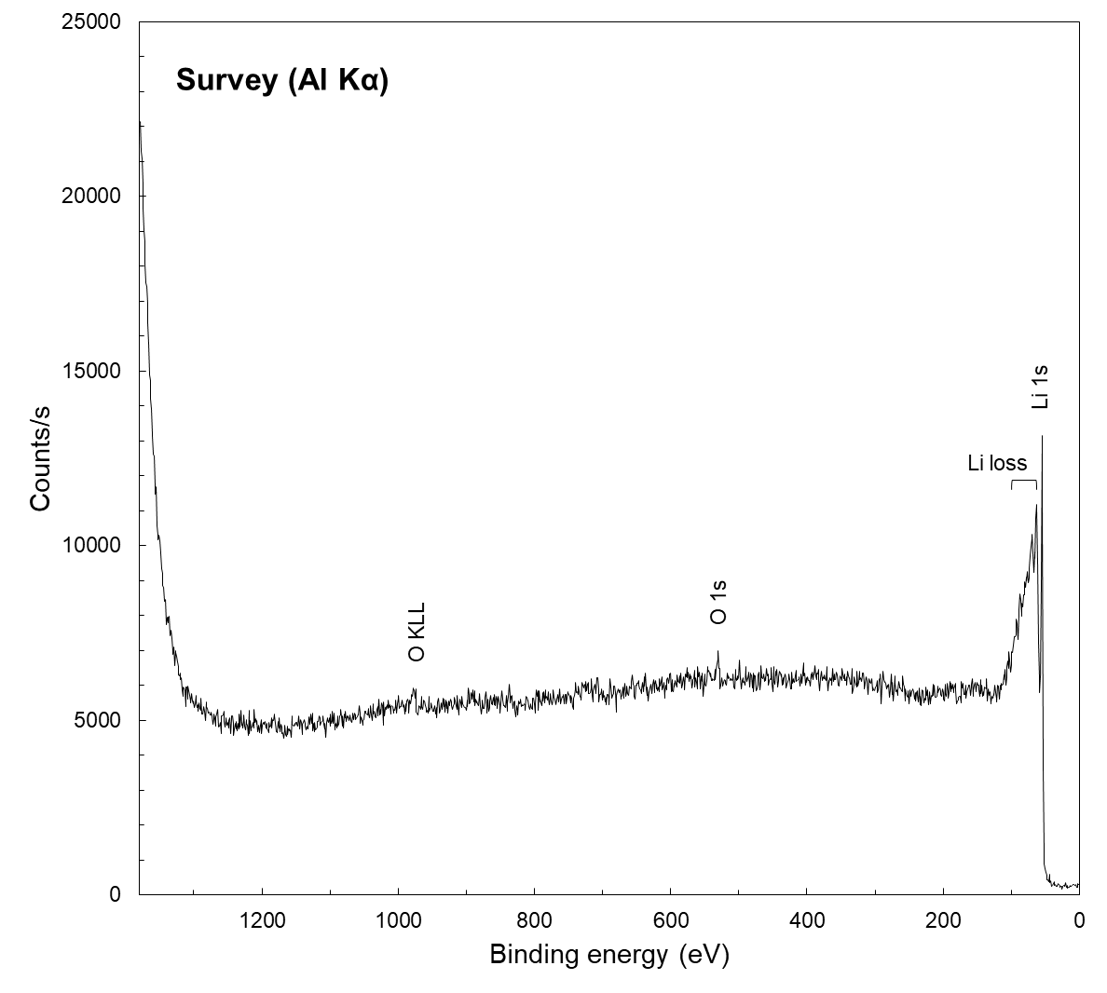
 |  | Publish in Surface Science Spectra: Yes ☒ No ☐
Accession # | Survey (Al Kα)
■ Specimen | Li
■ Technique | XPS
■ Spectral Region | survey
Instrument | ULVAC-PHI Quantes
Excitation Source | Al Ka monochromatic
Source Energy | 1486.6 eV
Source Strength | 25 W
Source Size | 0.1 mm x 0.1 mm
Analyzer Type | spherical sector analyzer
Incident Angle | 84˚
Emission Angle | 39˚
Analyzer Pass Energy | 280 eV
Analyzer Resolution | 1.69 eV
Total Signal Accumulation Time | 456 s
Total Elapsed Time | 504 s
Number of Scans | 8
Effective Detector Width | 32 eV
Comments | The survey spectrum was obtained after a long period of Ar sputter cleaning. In the spectrum, no Ar 2p and 2s peaks were detected.

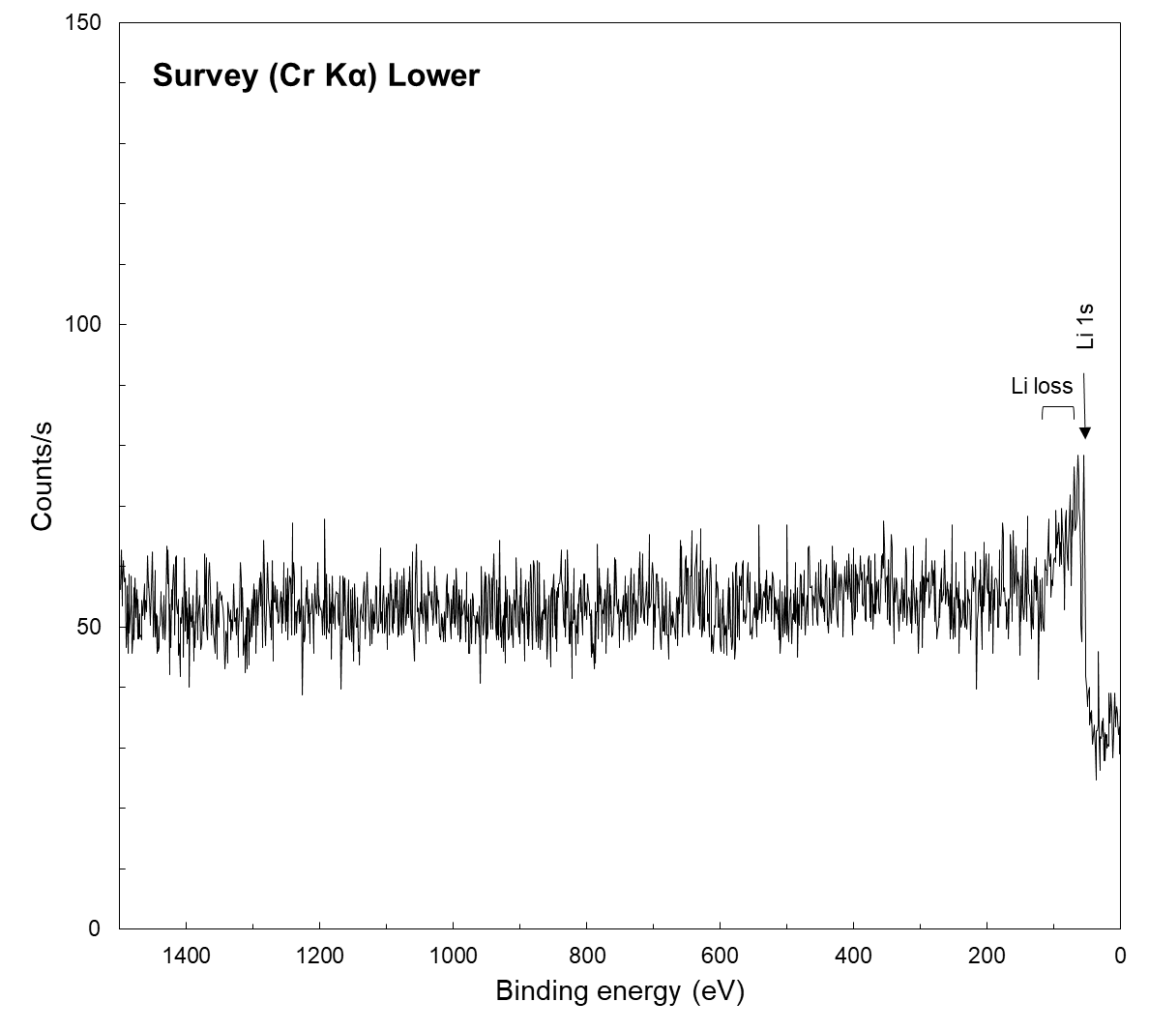
 |  | Publish in Surface Science Spectra: Yes ☒ No ☐
Accession # | Survey (Cr Kα) Lower
■ Specimen | Li
■ Technique | XPS
■ Spectral Region | survey
Instrument | ULVAC-PHI Quantes
Excitation Source | Cr Ka monochromatic
Source Energy | 5414.8 eV
Source Strength | 50 W
Source Size | 0.1 mm x 0.1 mm
Analyzer Type | spherical sector analyzer
Incident Angle | 84˚
Emission Angle | 38˚
Analyzer Pass Energy | 280 eV
Analyzer Resolution | 2.32 eV
Total Signal Accumulation Time | 4932 s
Total Elapsed Time | 5424 s
Number of Scans | 8
Effective Detector Width | 32 eV
Comments | The survey spectrum shown here is the lower part of the spectrum, which was measured separately from the higher part by dividing the spectrum at a binding energy of 1500 eV. This division was made to shorten the measurement time and prevent surface oxidation. This spectrum was obtained by repeating the spectral measurement (11 minutes) and Ar sputtering (5 minutes).

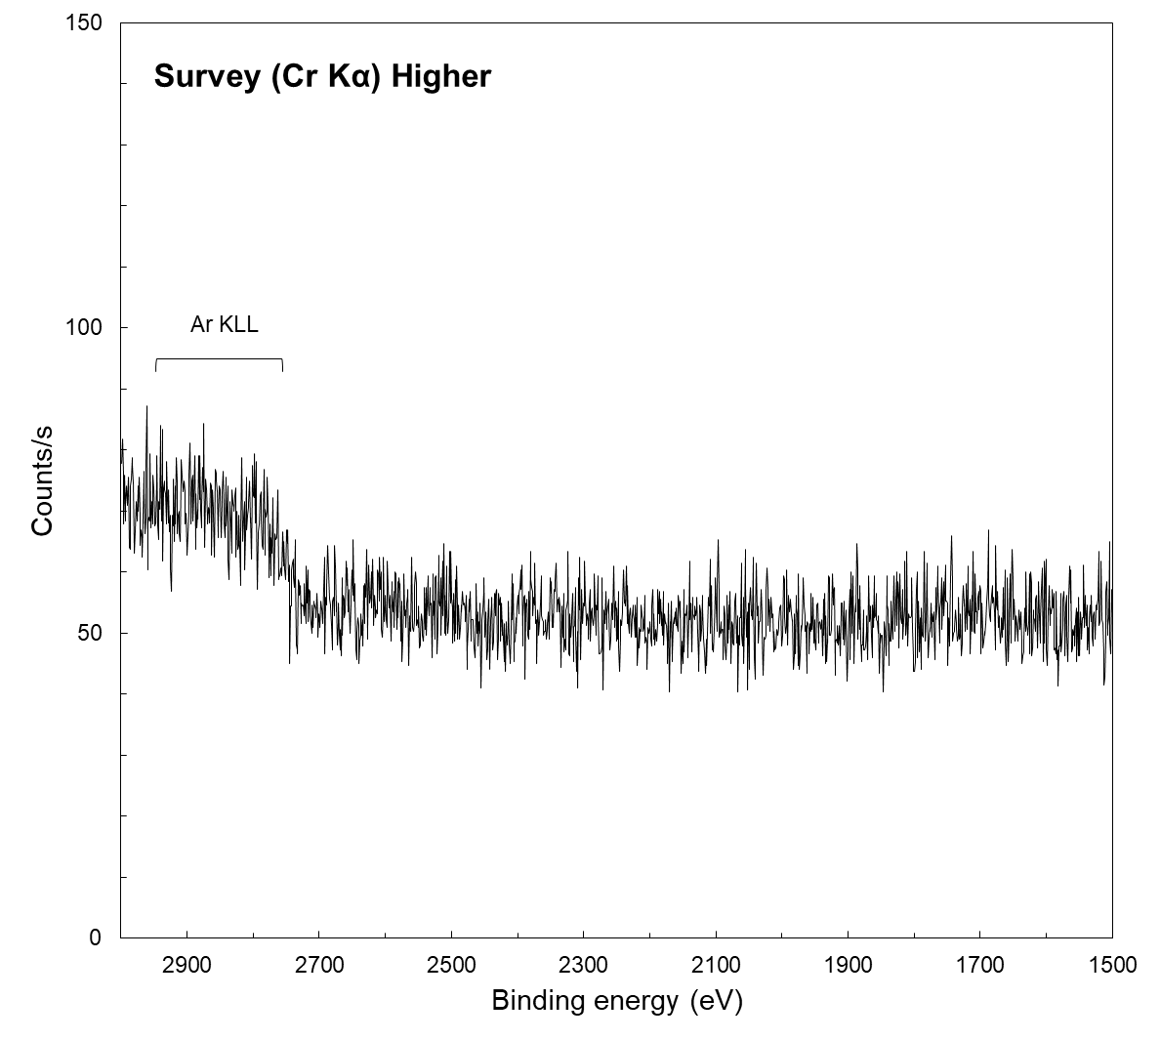
 |  | Publish in Surface Science Spectra: Yes ☒ No ☐
Accession # | Survey (Cr Kα) Higher
■ Specimen | Li
■ Technique | XPS
■ Spectral Region | survey
Instrument | ULVAC-PHI Quantes
Excitation Source | Cr Ka monochromatic
Source Energy | 5414.8 eV
Source Strength | 50 W
Source Size | 0.1 mm x 0.1 mm
Analyzer Type | spherical sector analyzer
Incident Angle | 84˚
Emission Angle | 38˚
Analyzer Pass Energy | 280 eV
Analyzer Resolution | 2.32 eV
Total Signal Accumulation Time | 4902 s
Total Elapsed Time | 5394 s
Number of Scans | 8
Effective Detector Width | 32 eV
Comments | The survey spectrum shown here is the higher part of the spectrum, which was measured separately from the lower part by dividing the spectrum at a binding energy of 1500 eV. The broad peak detected in the binding energy region above 2700 eV was assigned as Ar KLL Auger peaks due to small amount of Ar atoms deeply buried in Li specimen, based on simulations using SESSA package (Ref. 5).

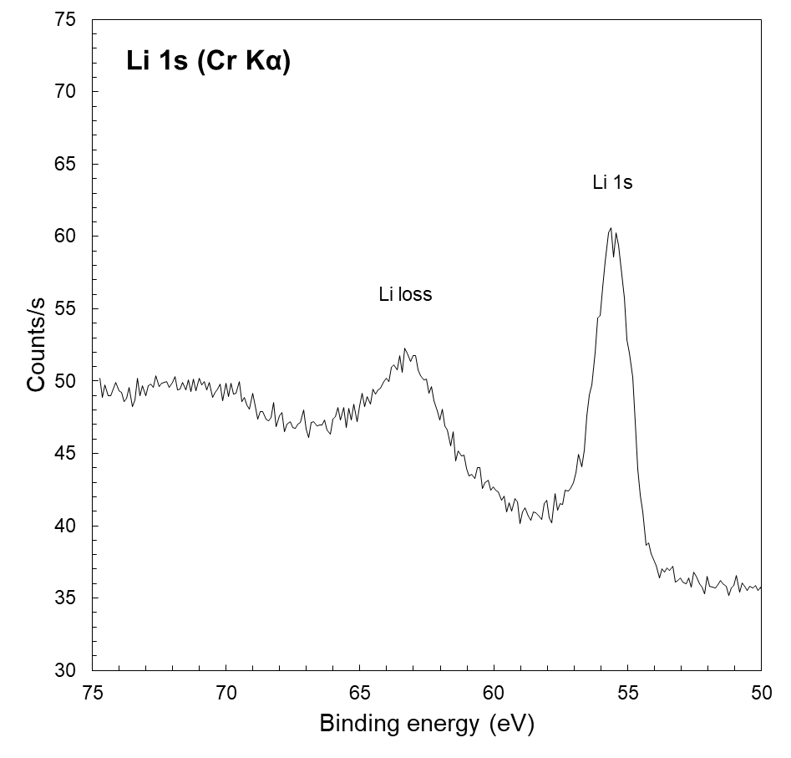 | Publish in SSS: Yes ☒ No ☐
 | ■ Accession #: Li 1s (Cr Kα)
 | ■ Specimen: Li
 | ■ Technique: XPS
 | ■ Spectral Region: Li 1s
 | Instrument: ULVAC-PHI Quantes
 | Excitation Source: Cr Ka monochromatic
 | Source Energy: 5414.8 eV
 | Source Strength: 50 W
 | Source Size: 0.1 mm x 0.1 mm
 | Analyzer Type: spherical sector
 | Incident Angle: 84 ˚
 | Emission Angle: 38 ˚
 | Analyzer Pass Energy 112 eV
 | Analyzer Resolution: 1.42 eV
 | Total Signal Accumulation Time: 95742 s
 | Total Elapsed Time: 105414 s
 | Number of Scans: 320
 | Effective Detector Width: 12.8 eV
 | Comments: The Li 1s spectrum was obtained by repeating the spectral measurement (11 minutes) and Ar sputtering (5 minutes).

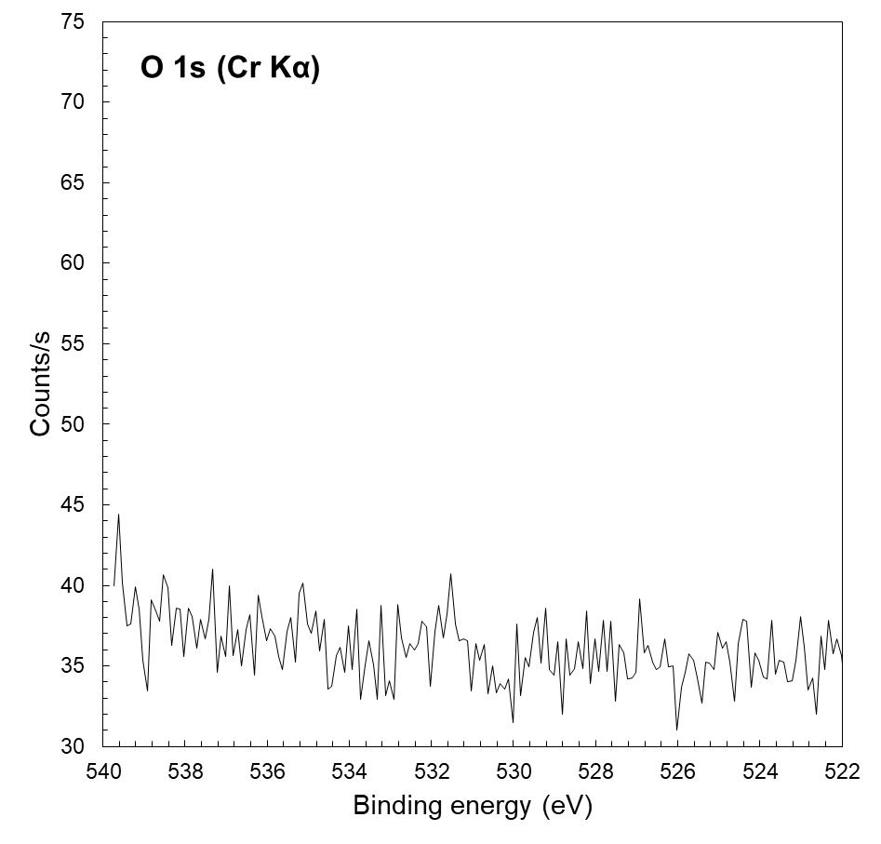 | Publish in SSS: Yes ☒ No ☐
 | ■ Accession #: O 1s (Cr Kα)
 | ■ Specimen: Li
 | ■ Technique: XPS
 | ■ Spectral Region: O 1s
 | Instrument: ULVAC-PHI Quantes
 | Excitation Source: Cr Ka monochromatic
 | Source Energy: 5414.8 eV
 | Source Strength: 50 W
 | Source Size: 0.1 mm x 0.1 mm
 | Analyzer Type: spherical sector
 | Incident Angle: 84 ˚
 | Emission Angle: 38 ˚
 | Analyzer Pass Energy 112 eV
 | Analyzer Resolution: 1.42 eV
 | Total Signal Accumulation Time: 3894 s
 | Total Elapsed Time: 4284 s
 | Number of Scans: 16
 | Effective Detector Width: 12.8 eV
 | Comments: The spectrum was acquired by repeating the spectral measurement (4.5 minutes) and Ar sputtering (5 minutes).

I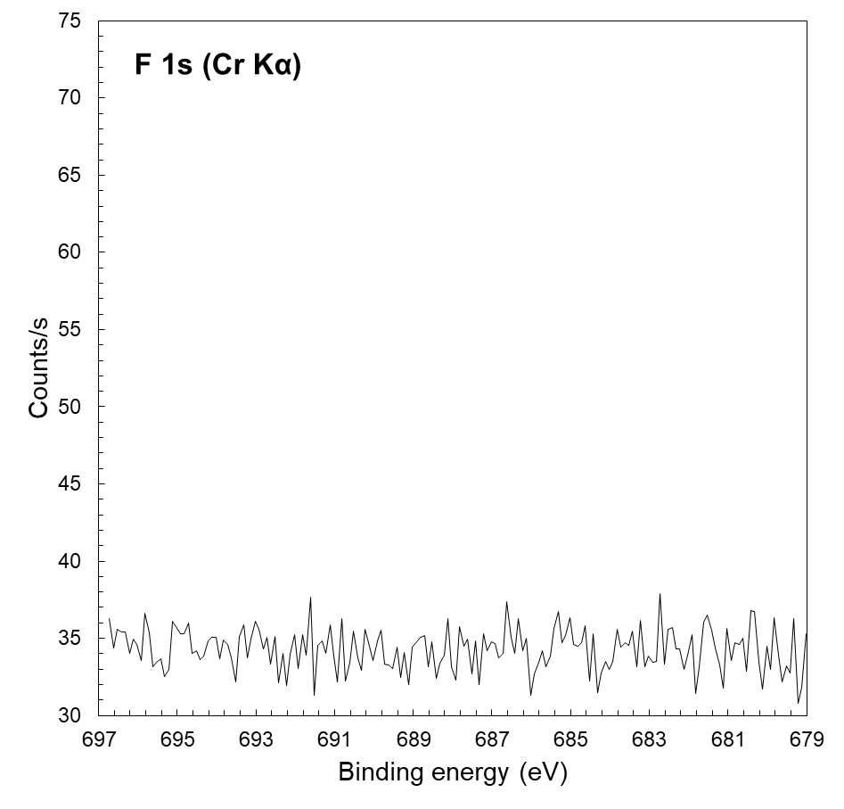 | Publish in SSS: Yes ☒ No ☐
 | ■ Accession #: F 1s (Cr Kα)
 | ■ Specimen: Li
 | ■ Technique: XPS
 | ■ Spectral Region: F 1s
 | Instrument: ULVAC-PHI Quantes
 | Excitation Source: Cr Ka monochromatic
 | Source Energy: 5414.8 eV
 | Source Strength: 50 W
 | Source Size: 0.1 mm x 0.1 mm
 | Analyzer Type: spherical sector
 | Incident Angle: 84 ˚
 | Emission Angle: 38 ˚
 | Analyzer Pass Energy 112 eV
 | Analyzer Resolution: 1.42 eV
 | Total Signal Accumulation Time: 3894 s
 | Total Elapsed Time: 4284 s
 | Number of Scans: 16
 | Effective Detector Width: 12.8 eV
 | Comments: The spectrum was acquired after the O1s measurement.

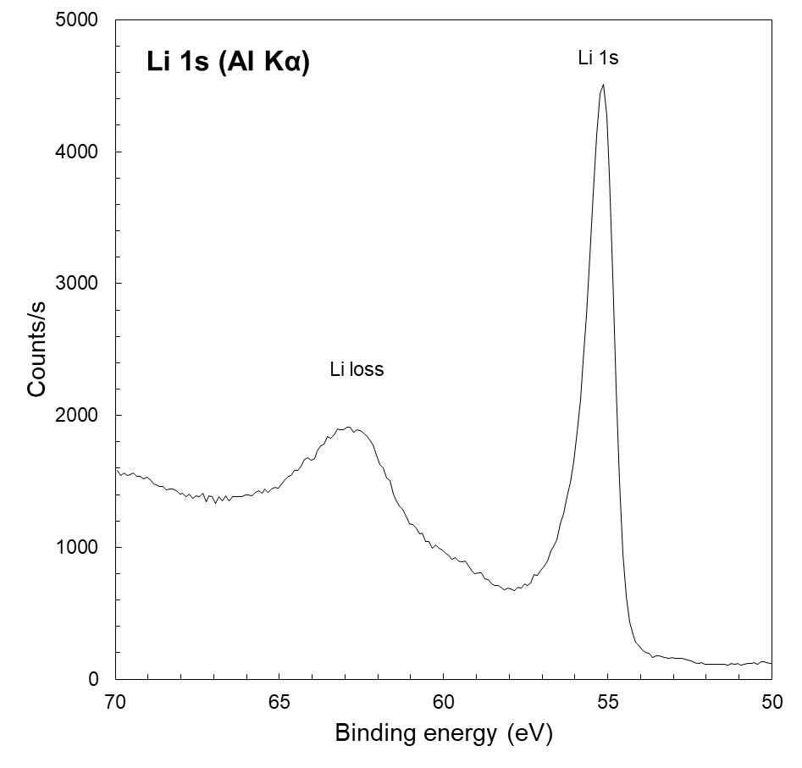 | Publish in SSS: Yes ☒ No ☐
 | ■ Accession #: Li 1s (Al Kα)
 | ■ Specimen: Li
 | ■ Technique: XPS
 | ■ Spectral Region: Li 1s
 | Instrument: ULVAC-PHI Quantes
 | Excitation Source: Al Ka monochromatic
 | Source Energy: 1486.6 eV
 | Source Strength: 25 W
 | Source Size: 0.1 mm x 0.1 mm
 | Analyzer Type: spherical sector
 | Incident Angle: 84 ˚
 | Emission Angle: 39 ˚
 | Analyzer Pass Energy 55 eV
 | Analyzer Resolution: 0.8 eV
 | Total Signal Accumulation Time: 1512 s
 | Total Elapsed Time: 1674 s
 | Number of Scans: 48
 | Effective Detector Width: 6.4 eV
 | Comments: The spectrum was obtained by repeating a 5 minutes Ar ion sputtering followed by O 1s (0.5 minutes), Li 1s (2 minutes) and F 1s (0.5 minutes) measurements.

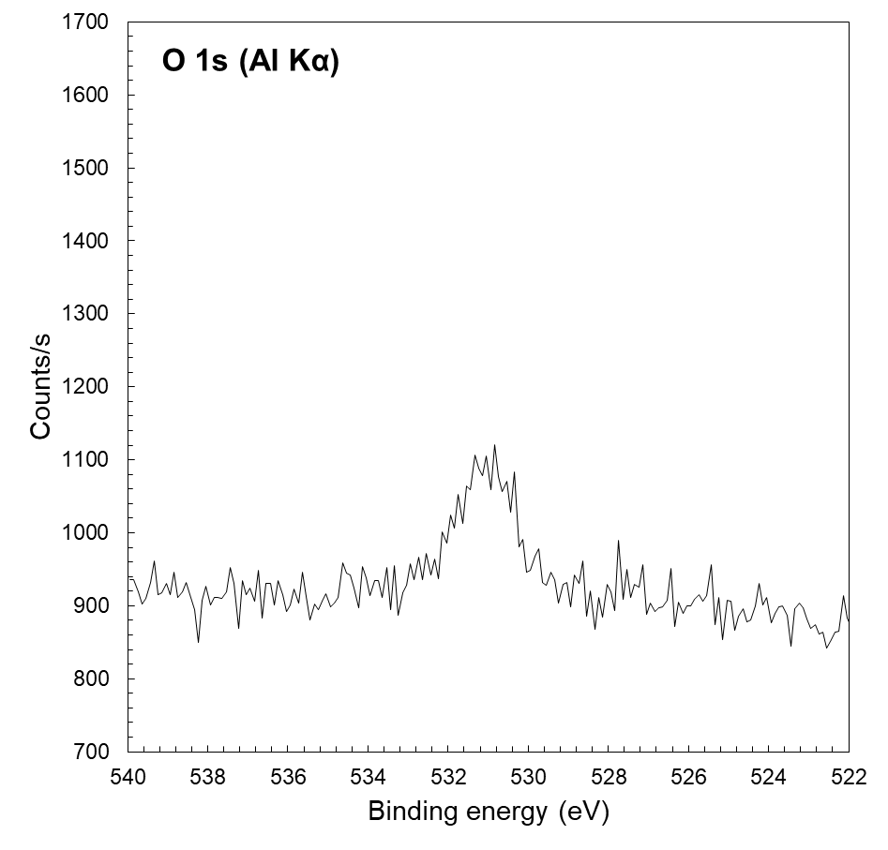 | Publish in SSS: Yes ☒ No ☐
 | ■ Accession #: O 1s (Al Kα)
 | ■ Specimen: Li
 | ■ Technique: XPS
 | ■ Spectral Region: O 1s
 | Instrument: ULVAC-PHI Quantes
 | Excitation Source: Al Ka monochromatic
 | Source Energy: 1486.6 eV
 | Source Strength: 25 W
 | Source Size: 0.1 mm x 0.1 mm
 | Analyzer Type: spherical sector
 | Incident Angle: 84 ˚
 | Emission Angle: 39 ˚
 | Analyzer Pass Energy 55 eV
 | Analyzer Resolution: 0.8 eV
 | Total Signal Accumulation Time: 462 s
 | Total Elapsed Time: 516 s
 | Number of Scans: 16
 | Effective Detector Width: 6.4 eV
 | Comments: Comments: The spectrum was obtained by repeating a 5 minutes Ar ion sputtering followed by O 1s (0.5 minutes), Li 1s (2 minutes) and F 1s (0.5 minutes) measurements.

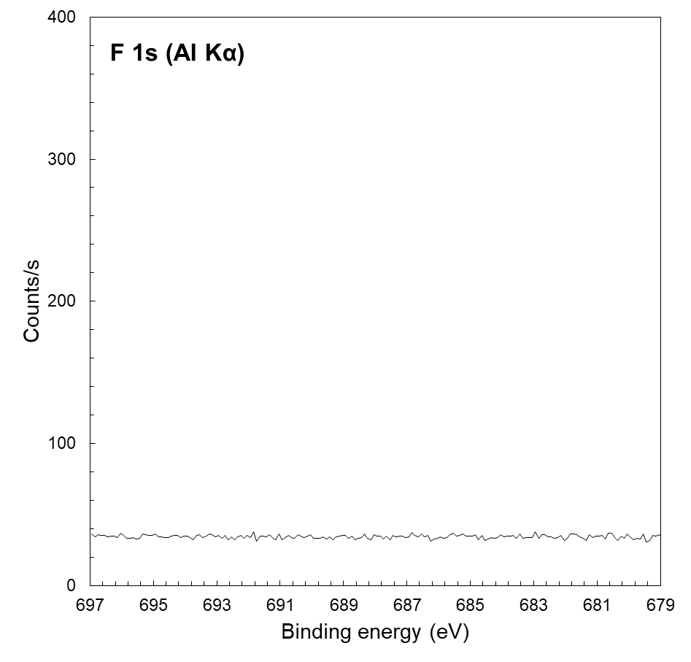 | Publish in SSS: Yes ☒ No ☐
 | ■ Accession #: F 1s (Al Kα)
 | ■ Specimen: Li
 | ■ Technique: XPS
 | ■ Spectral Region: F 1s
 | Instrument: ULVAC-PHI Quantes
 | Excitation Source: Al Ka monochromatic
 | Source Energy: 1486.6 eV
 | Source Strength: 25 W
 | Source Size: 0.1 mm x 0.1 mm
 | Analyzer Type: spherical sector
 | Incident Angle: 84 ˚
 | Emission Angle: 39 ˚
 | Analyzer Pass Energy 55 eV
 | Analyzer Resolution: 0.8 eV
 | Total Signal Accumulation Time: 462 s
 | Total Elapsed Time: 516 s
 | Number of Scans: 16
 | Effective Detector Width: 6.4 eV
 | Comments: The spectrum was obtained by repeating a 5 minutes Ar ion sputtering followed by O 1s (0.5 minutes), Li 1s (2 minutes) and F 1s (0.5 minutes) measurements.

