On-Surface Synthesis of Multiple Cu Atom-Bridged Organometallic Oligomers
Kewei Sun^{1,2}, Kazuma Sugawara³, Andrey Lyalin^{4,5}*, Yusuke Ishigaki³, Kohei Uosaki⁵, Oscar Custance¹, Tetsuya Taketsugu^{3,4}, Takanori Suzuki³*, Shigeki Kawai^{1,6}*

¹Center for Basic Research on Materials, National Institute for Materials Science, 1-2-1 Sengen, Tsukuba, Ibaraki 305-0047, Japan.
²International Center for Young Scientists, National Institute for Materials Science, 1-2-1 Sengen, Tsukuba, Ibaraki 305-0044, Japan.
³Department of Chemistry, Faculty of Science, Hokkaido University, Sapporo, Hokkaido 060-0810, Japan.
⁴Institute for Chemical Reaction Design and Discovery (WPI-ICReDD) Hokkaido University, Sapporo 001-0021, Japan.
⁵Global Research Center for Environment and Energy based on Nanomaterials Science, National Institute for Materials Science, 1-1 Namiki, Tsukuba, Ibaraki 305-0044, Japan.
⁶Graduate School of Pure and Applied Sciences, University of Tsukuba, Tsukuba 305-8571, Japan.
*lyalin@icredd.hokudai.ac.jp, *tak@sci.hokudai.ac.jp, *KAWAI.Shigeki@nims.go.jp

Abstract
A metal-metal bond between coordination complexes is in the nature of the covalent bond in hydrocarbons. While bimetallic and trimetallic compounds usually have three-dimensional structures in solution, the high directionality and robustness of the bond can be applied for on-surface syntheses. Here, we present a systematic formation of complex organometallic oligomers on Cu(111) through sequential ring-opening of 11,11,12,12-tetraphenyl-1,4,5,8-tetraazaanthraquinodimethane and bonding of phenanthroline derivatives by multiple Cu atoms. A detailed characterization with a combination of scanning tunneling microscopy and density functional theory calculations revealed the role of the Cu adatoms in both enantiomers of chiral oligomers. Furthermore, we found sufficient strength of the bonds against sliding friction by manipulating the oligomers up to a hexamer. This finding may help to increase the variety of organometallic nanostructures on surfaces.

KEYWORDS: Organometallic oligomer, on-surface synthesis, tup-induced manipulation, scanning tunneling microscopy, density functional theory calculations
Low-dimensional carbon-based nanomaterials formed on surfaces have attracted tremendous interest of researchers due to the high controllability of their structures down to the atomic level.^{1,2} Such designer nano-carbon structures are expected to become key elements in the next-generation of nano-electronics. Since the nano-architecture relies on various molecular self-assemblies with small precursors, the intermolecular interactions, such as van der Waals force,^{3,4} dipole-dipole,^{5,6} hydrogen bonds,^{7,8} coordination bonds (like C-Cu, N-Cu, N-Ni bonds),^{9,10} and covalent bonds between nonmetallic elements (like C-C, C-N, B-O bonds),^{11,12} which play a decisive role in the formation. Particularly, the bond strength affects the size of products because bond formation and rupture take place until reaching an equilibrium. For this reason, the synthesis of extended covalent organic frameworks (COFs) is usually challenging due to the irreversible formation of carbon-carbon bonds.^{13,14} In contrast, since the moderate strength of the coordination bonds between metal atoms and organic compounds offers a stochastic dynamic of formation and rupture at a reaction temperature, extended metal-organic frameworks (MOFs) can be synthesized.^{9,10} So far, various MOFs have been successfully formed on surfaces by coordination bonding between small organic molecules and metal atoms.^{15,16} Among them, nitrogen-metal-nitrogen (N-M-N) coordination bonds are most commonly studied due to the rich variety of N-containing precursors and the universality of the coordination bond.¹⁶⁻²⁰
The metal-metal bond between complexes, arising from a strong directional interaction between two metal atoms or ions, has been well-studied in the field of coordination chemistry.^{21,22} Since the identification of polynuclear metal carbonyls by Dahl et al in 1957²³ and the subsequent synthesis of multiple Re-Re bonds in [Re₂Cl₈]²⁻ and [Re₂Br₈]²⁻ complexes by Cotton et al. in 1964,²⁴ various bimetallic and trimetallic complexes containing metal-metal bond such as Ni-Ni,²⁵ Ru-Pt,²⁶ Cr-Hg-Cr,²⁷ Zn-Zr-Zn bonds,²⁸ have been successfully synthesized in solution. The nature of the metal-metal bonds differs from those of the coordination bond and the covalent bond between nonmetallic elements as well as the metallic bond in bulk,²¹ and so that compounds linked by the metal-metal bonds may have unique properties. However, it is rather challenging to synthesize large carbon-based nanostructures composed of metal-metal bonds as basic linkers due to their insolubility,^{29,30} which could be viewed as an important technique for coupling the functional units with an atomic metal electrode towards single-molecule devices.^{31,32} Alternatively, since on-surface synthesis is free from the solubility issue, it can be expected to form designer nanostructures with the bonds.^{1,2} However, the synthesis of metal coordination complexes with multiple metal-metal bonds on surfaces is still scarce.³³⁻³⁶
Here, we utilized 11,11,12,12-tetraphenyl-1,4,5,8-tetraazaanthraquinodimethane 1 to form chiral organometallic oligomers with multiple Cu-Cu bond linkers on Cu(111) by thermal treatment. Their chemical structures were investigated with a combination of high-resolution scanning tunneling microscopy (STM) and density functional theory (DFT) calculations. Each unit in the oligomers is slightly rotated in both clockwise and counterclockwise directions, resulting in the formation of chiral structures. Furthermore, we found that the Cu-Cu, π-coordination-type Cu-C, and Cu-(NN) bonds in the organometallic compounds are strong enough to maintain the structure during the tip-induced lateral manipulation of the oligomers up to the hexamer.

Results and discussion
In our previous work, we found that diquinolino[2,3,4-hi:2’,3’,4’-st]-5,12-diazapentacene 2 was synthesized from 11,11,12,12-tetraphenyl-1,4,5,8-tetraazaanthraquinodimethane 1³⁷ through ring-opening and ring-forming of C-N heterocycles by annealing on Au(111) at 550 K.³⁸ Since 1,10-phenanthroline is known as an acceptor for the metal-ligand coupling,³⁹ we expected to obtain organometallic compounds by linking the units with metal atoms on surfaces. We selected Cu(111) as a substrate since a large number of Cu adatoms, diffusing on the surface even at room temperature, can increase the reaction yield. Scheme 1 summarizes the reaction processes of dimers and oligomers with the multiple Cu-Cu bond linkers.
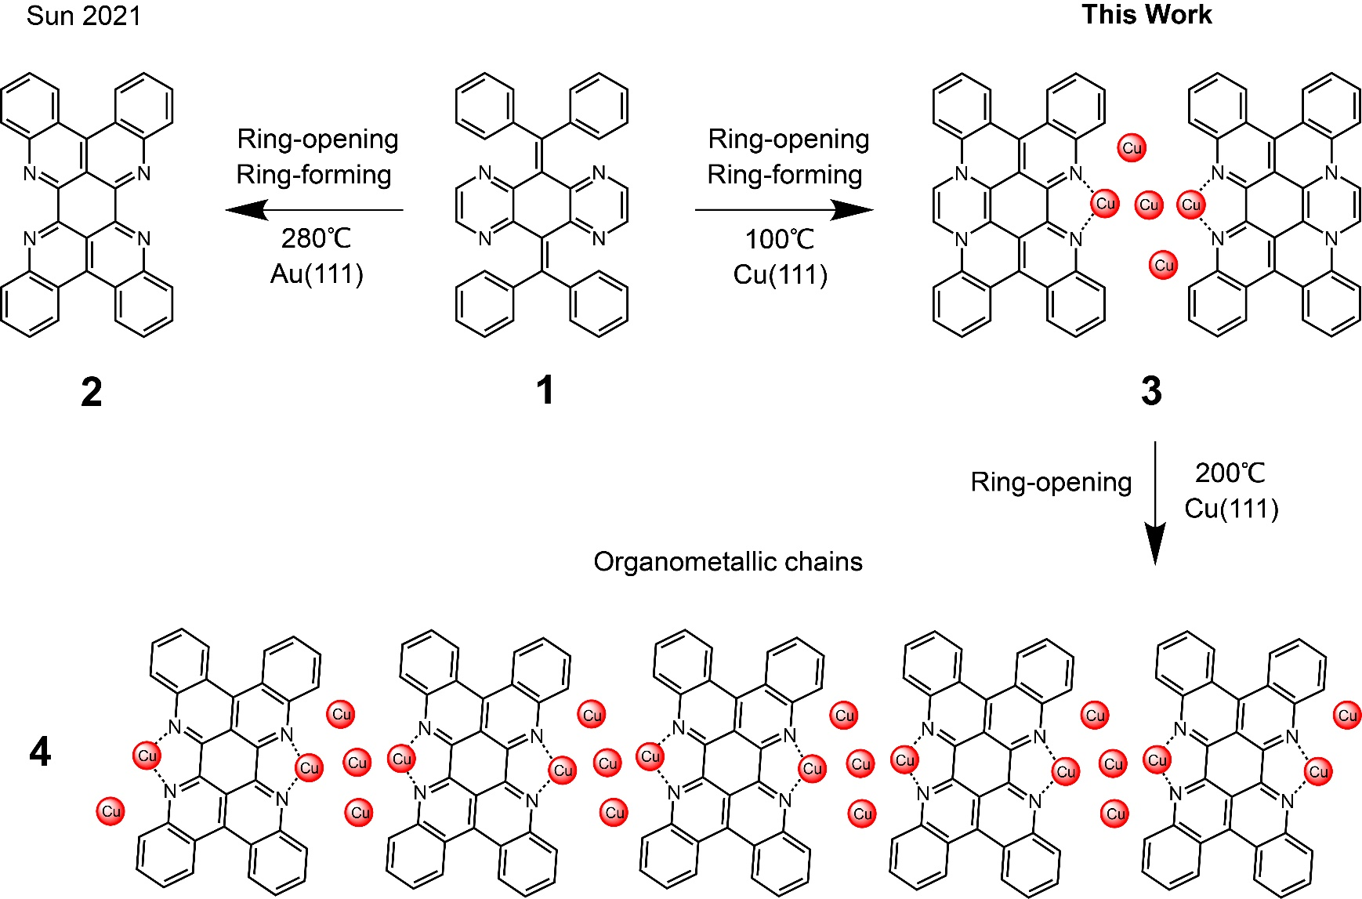
Scheme 1. On-surface reaction of an organometallic compound with multiple Cu-Cu bond linkers.

After depositing 1 on Cu(111) kept at room temperature (Figure S1) and subsequently annealing at 100 °C for 10 min, the dimers were observed in the STM topography as indicated by ellipses in Figure 1a. The growth directions followed the three-fold crystal orientation of the substrate. The inset shows a close-up view of the individual compound, in which a mirror symmetric structure is seen. At the center of the dimer, we found a faint bridge with a length of 370 ± 40 pm (inset of Figure 1a), which is longer than any covalent bond. Since the formation of N-Cu coordination on Cu(111) has been demonstrated,^{40,41} we expected that Cu adatoms bridged the two units. It is known that the 1,10-phenanthroline complex is in a twisted configuration in crystal because such the tetrahedral coordination geometry arises from the steric hindrance between the adjacent units.⁴² Apparently, the Cu adatoms in the bridge played a role in the planarization of the dimer 3 on the surface. Moreover, since the adsorption height of the adatom was lower than that of the molecular unit,⁴³ the coordinated part of the unit was pulled down to the surface. Consequently, the termini of 3 were lifted up as observed in the STM topography. Such tilted geometry was also clearly seen in the high-resolution dI/dV map taken with a CO-terminated tip at a constant height mode (Figure 1b).^{44,45} The distance between two N atoms (indicated by the overlaid molecular models in Figure 1b) was 650 ± 30 pm, much longer than the typical length of N-Cu-N (390 pm),⁴⁶ hence we assigned the bridge in 3 composed of multi-Cu adatoms. Although the corrugated structure induced strong distorted contrasts by the excessive tilting effect of the CO tip, the inner structure can still be identified in the corresponding Laplace-filtered image (Figure S2). The structure of the organic ligands in 3 indicates two key points: the appearance of the bridge in the center of 3 (inset of Figure 1a) and the long distance of 650 pm between N atoms of the adjacent units (Figure 1b). Thus, we deduced that the bridge was composed of at least three Cu adatoms (Figure S2).^{33,35} Since the termini of 3 were lifted up from the surface, the annealing temperature at 100 °C was not high enough to induce the ring opening at the termini.³⁸ Consequently, no extended structure was formed. Note that several disordered nanoclusters may relate to randomly fused fragments of 1, which were dissociated from precursors in the process of C-C cleavage (Figure S1).
In order to induce the ring-opening at the dihydropyrazine termini of 3, the sample was annealed at a higher temperature of 200 °C for 10 min. We found the formation of extended oligomers 4 on the surface (Figure 1c). The growth direction was the same as that of the dimer. The inset of Figure 1c shows the close-up view of each unit, which appears as a dumbbell-like shape. Since the contrast of the STM topography was the same as the one observed on Au(111) in our previous work,³⁸ we assumed that the unit corresponds to 2. Note that 1 on Ag(111) was also transformed into 2 by annealing at 250 °C (Figure S3). However, unlike the reaction on Cu(111), 2 did not form a one-dimensional organometallic compound by incorporating silver adatoms, which may relate to the weak N-Ag-N coordination bonds.⁴⁷ The planar configuration of the unit allowed us the observation of the coordination centers. We found that the adatoms located at the sites slightly shifted from the longitudinal axis of the oligomer. Since the gap between the two adjacent bright protrusions ascribed to Cu adatoms (400 pm) (inset of Figure 1c) was much longer than that of the Cu-Cu bonds (256 pm),⁴⁸ several Cu adatoms should be present in the intermolecular space, in accord with the structure of 3. Thus, we assumed that the Cu-complexes of 2 were connected with multiple Cu atoms. Note that only two Cu adatoms can be observed while the others were not visible presumably due to the lower adsorption height. Figure 1d shows the corresponding constant height dI/dV map of the single unit, in which the central ring is brighter than the other parts. The corresponding Laplace-filtered image shows the occurrence of the ring-opening at both sides of 1 (Figure S4). However, the number of the Cu atom in the linker is unclear from the experiment. We found that the structure of 4 is commensurate to the substrate lattice, having a period of 1.27 ± 0.01 nm along [110] direction (Figure 1e).
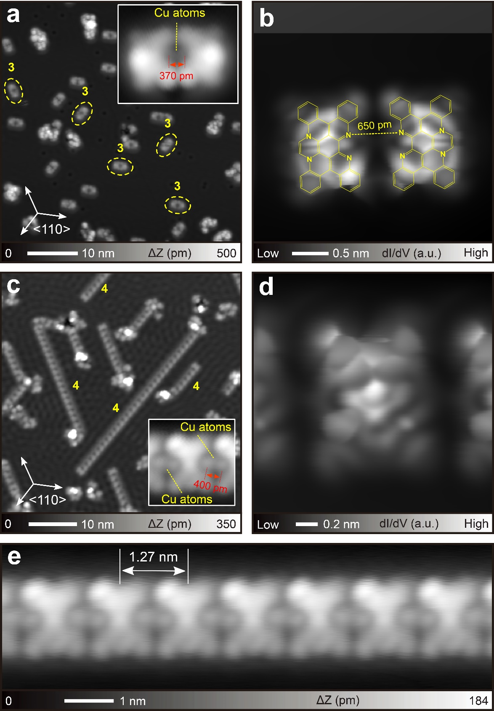
Figure 1. (a) Large-scale STM topography of the Cu(111) surface after depositing 1 and subsequently annealing at 100 °C. Inset shows the closeup view of the dimer. (b) Constant height dI/dV map taken with a CO terminated tip. (c) Large-scale STM topography of Cu(111) after annealing at 200 °C. Inset shows the closeup view of the unit. (d) Constant height dI/dV map. High-resolution STM topography of a long 4. Measurement parameters: Sample bias voltage V = 200 mV and tunneling current I = 10 pA in (a), V = 100 mV and I = 20 pA in the inset of (a), V = 10 mV and I = 10 pA in (c), V = 200 mV and I = 5 pA in the inset of (c), and V = 200 mV and I = 10 pA (e).
To understand the detailed structures of the extended oligomers 4 on the Cu(111) surface we have performed DFT calculations revealing the role of the intermolecular Cu adatoms in the stabilization of 4 chains. The metal surface is modeled by the 5-layer 5x5$\sqrt{3}$ Cu(111) rectangular slab of the size of 12.715 Å × 22.023 Å which perfectly fits the periodicity of the 4 chain along the [110] direction. As the structure of the intermolecular Cu linkers is not clear in the experiment, we have performed structural optimization of molecule 2 on the surface linked by up to 5 Cu adatoms. Calculations demonstrate that pristine 2 and Cu-terminated 2 (i.e. having N-Cu-N termination on both sides) adsorb on the Cu(111) surface with the adsorption energy, E_{ad}, of -3.60 eV and -7.01 eV, respectively. The corresponding optimized structures are shown in Figures S5 and S6. The distance between the molecular plane, defined by the central carbon hexagonal ring and Cu surface increases from 2.38 Å to 3.31 Å as a result of N-Cu-N termination. Thus, trapping two Cu adatoms into intermolecular space results in the elevation of molecule 2 by 0.93 Å with respect to the pristine case. The Cu adatoms adsorb at a distance of 1.97 Å above the topmost surface layer and 1.34 Å below the molecular plane defined by the central carbon hexagonal ring. Therefore, it should be difficult to observe these adatoms in the constant-height imaging. This result is in full accord with the previous studies.³³ As molecules 2 form the extended oligomer 4 on the Cu(111) surface, it is important to elucidate the origin of the intermolecular forces binding molecules 2 together. To this end, we have performed structural optimization of the Cu-terminated 2 on the extended 8x5$\sqrt{3}$ surface slab, which is large enough to eliminate the possible interaction between the periodically replicated molecules. However, the calculated adsorption energy of the Cu-terminated 2 on the 8×5$\sqrt{3}$ Cu(111) surface remains unchanged and equal to -7.01 eV. This indicates that there is no noticeable interaction between Cu-terminated 2 in the 5×5$\sqrt{3}$ structure. Indeed, the distance between two Cu adatoms in this structure is 5.78 Å, which is too large to bind these molecules in chain 4. Therefore, it should be more than two adatoms per unit cell to stabilize the chain 4. To elucidate the possible structure of Cu-linkers we have systematically investigated the most stable structures of 2 on the 5×5$\sqrt{3}$ Cu(111) linked with up to 5 Cu atoms. Our DFT calculations demonstrate that three Cu adatoms form a linear chain with a Cu-Cu distance of 2.63 Å linking molecules together as shown in Figure S7. The adsorption energy of the central Cu atom in the middle of the chain is -3.50 eV which is 0.57 eV larger than the adsorption energy of a Cu atom on the pure Cu(111) surface (-2.93 eV). Therefore, it is energetically favorable for the surface Cu adatoms to be trapped in the intermolecular space, binding Cu-terminated 2. Our calculations demonstrate that an excess of Cu adatoms on the Cu(111) surface can be further trapped in the intermolecular space, forming structures bridged by four (Figure S8) and five (Figure 2a, 2b) Cu adatoms. The simulated STM image based on the model of five Cu adatoms has a very similar surface morphology to the actual experimental images (Figure 2c). Hence, taking structural symmetry into consideration, both the three-adatom and the five-adatom models are candidates for the actual structure.
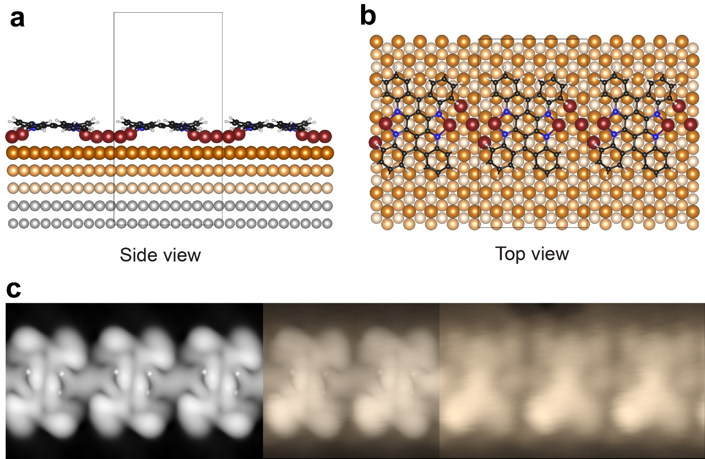
Figure 2. (a) Side and (b) top view of the optimized structure of oligomer 4 bridged with five Cu adatoms on the 5×5$\sqrt{3}$ Cu(111) surface. Cu adatoms are shown in dark brown color. Cu atoms in the top, second, and third surface layers are shown in brown, light brown, and peach colors, respectively. Cu atoms in the fourth and fifth layers are shown in grey. C, N, and H atoms are shown in black, blue, and light grey colors, respectively. The unit cell is shown with black lines. (c) To the left: DFT-simulated STM image in the constant current mode, integration energy range [-0.2, 0] eV. To the right: A cut from the raw experimental data, as in Figure S10a. In the center: overlaid theoretical and experimental STM images.

Our calculations demonstrate that in the case of bridging the units 2 with five Cu adatoms as it is shown in Figure 2b, the units 2 are slightly tilted from the longitudinal axis of the oligomer by approximately 3 degrees. This important feature is in favor of the model with five Cu adatom linkers. Indeed, two kinds of oligomers with the same rotational symmetry were observed experimentally (Figure 3a). While both oligomers grew in the [110] direction, each unit appeared slightly differently. The corresponding close-up views (Figure 3b,3c) show the asymmetric contrasts in each unit as the upper longitudinal side has two different contrasts. Here, we labeled the units with the bright contrasts on the right and left sides as “R” and “L”, respectively. The orientations of the units were shifted by approximately 5 degrees from the longitudinal axis of the oligomer. The different contrasts between left and right Cu adatoms in “R” chiral oligomers may be attributed to their different adsorption sites. On the other hand, the upper and lower parts of the oligomer have different apparent corrugation heights, that is because they locate at different atomic sites of the Cu(111), leading to the C₃ rotational symmetry (Figure S9). In the calculated structure with five Cu atoms in the bridge (Figure 2), two Cu atoms are involved in chelating with phenanthroline units. Another Cu atom is located between these two. Each of the additional two Cu atoms is located beneath the edge of the fused benzene ring with π-type coordination to induce the deviation of the ring from the molecular plane of 2, which is related to the origin of the chiral arrangement (brighter contrasts between left and right parts) of the oligomer. The corresponding simulated STM image of the oligomer 4 structure (Figure 2c) is in good agreement with our experimental observations.
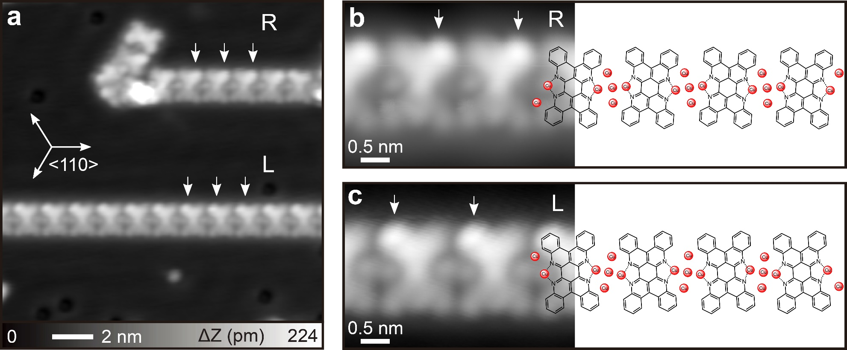
Figure 3. Chirality of 4. (a) Two different chirality of the units labeled as R and L, and (b)(c) the corresponding high-resolution STM topographies, overlapping structural models. Measurement parameters: V = 200 mV and I = 5 pA in (a). V = 5 mV and I = 110 pA in (b). V = 200 mV and I = 3 pA in (c).

In order to investigate the strength of the bonding, we manipulated a dimer 3 on Cu(111).^{49,50} After the STM tip was placed above the terminus of 3 with given setpoints, the feedback was turned off. Subsequently, the tip was laterally moved along the arrow (Figure 4a). The tip was gradually set closer to the surface with a step of 10 pm until the successful movement. We found that 3 was manipulated without any breakage (Figure 4a). This result indicates a sufficient strength of the Cu-Cu bonds in organometallic hybrids against friction. We also attempted to manipulate the long oligomer yet immediately found that the tip was contacting the substrate before any successful lateral manipulation. The lack of success on manipulating the long oligomer may be related to the commensurate adsorption geometry on Cu(111) as suggested in Figure 3 so that the friction between the oligomer and the substrate proportionally increases with length.⁵¹ Therefore, we first cut the oligomer by scanning the tip across the longitudinal axis (Figure S10) and obtained the pentamer as a result, which was successfully dragged by the tip along the arrow direction on the surface (Figure 4b). During one of these cutting experiments, we found Cu adatoms between disconnected oligomers; two Cu adatoms stayed at the coordination center of the terminal unit and three Cu adatoms were pulled out and placed nearby (Figure S11). This result supports the presence of five Cu adatoms as a possible linker in the structure and demonstrates that the Cu-Cu bonds are weaker than the Cu-(NN) bonds. Indeed, DFT calculations confirm that the binding energy of Cu atoms to a free molecule 2 leading to the formation of Cu-(NN) bonds is 2.4 eV per Cu adatom. On the other hand, the strength of the Cu-Cu bonds in the Cu bridge (excluding the interaction of Cu adatoms with the Cu surface) is about 0.55-0.57 eV per Cu adatom. Moreover, the magnitude of the Cu-Cu bond is also at least ten times greater than that of the diffusion barrier of a single Cu adatom on Cu(111).⁵² In fact, up to a hexamer could be manipulated (Figure S12). After the manipulation, the C₃ rotational symmetry disappeared, suggesting that the adsorption sites of the coordination center were changed during the process.
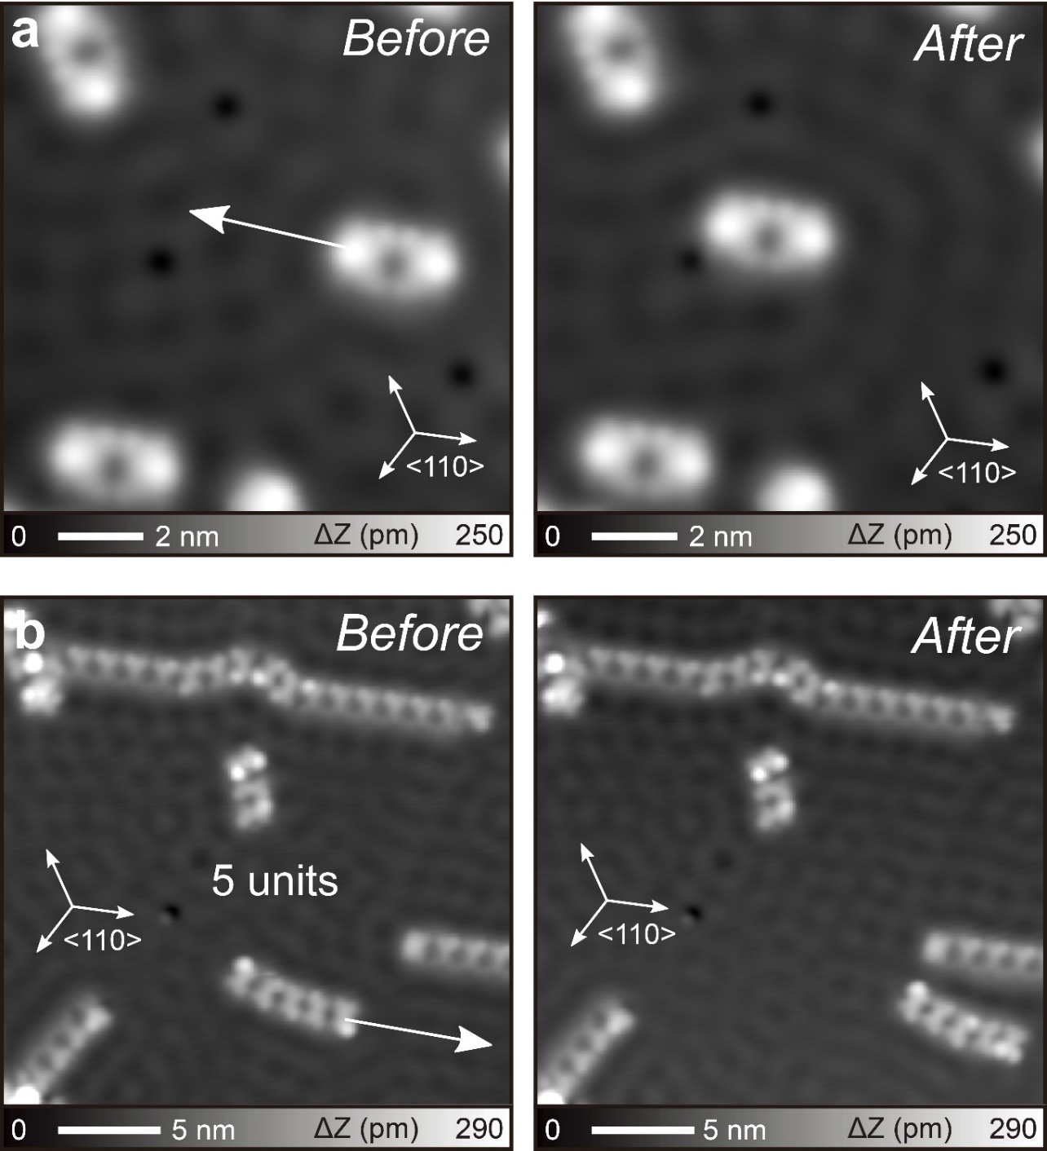
Figure 4. (a) Tip-induced manipulations of the organometallic dimer and (b) pentamer. Measurement parameters: V = 10 mV and I = 20 pA in (a). V = 10 mV and I = 10 pA in (b).

Conclusions
Directional organometallic hybrids with multiple Cu-Cu bonds were successfully formed on the Cu(111) surface after the heterocyclic ring-closing and opening of 11,11,12,12-tetraphenyl-1,4,5,8-tetraazaanthraquinodimethane and the subsequent formation of coordination and covalent bonds between phenanthroline derivatives and Cu adatoms. We found that the linker is most likely composed of five Cu atoms. Furthermore, judicious investigation with our DFT calculations shows that the chirality of each unit in the one-dimensional organometallic compounds arose from the C₃ rotational symmetry of the π-coordination-type Cu-C bond formation sites in the linker. Through the tip-induced lateral manipulation of the dimer and up to the hexamer, we also verified relatively high strength of the Cu-Cu bonds, which can even overcome the sliding friction between the oligomer and the Cu(111) substrate.⁵³ This study for metal-metal bonded hybrids may promote the fabrication of various types of advanced nanostructures.

Methods
STM Measurements. All the experiments were conducted in an ultra-high vacuum low-temperature scanning tunneling microscopy (STM) system (homemade) at 4.3 K under a vacuum environment (< 1 × 10⁻¹⁰ mbar). Cu(111) substrates were cleaned through cyclic Ar⁺ sputtering for 10 min and annealing at 700 K for 15 min. 11,11,12,12-tetraphenyl-1,4,5,8-tetraazaanthraquinodimethane 1 were deposited onto clean Cu(111) surfaces kept at room temperature. A STM tip was made from the chemically etched tungsten. The tip apex was terminated by a CO molecule picked up from the surface for bond-resolved imaging. For constant height dI/dV imaging, the sample bias voltage was set close to zero voltage. The modulation amplitude was 7 mV_{rms} and the frequency was 510 Hz.

Theoretical Calculations.
DFT calculations were performed using the nonlocal Van der Waals density functional OptB86b-vdW of Klimeš, Bowler, and Michaelides⁵⁴ and the projector-augmented wave (PAW) method as implemented in the Vienna ab Initio Simulation Package (VASP).^{55,56} A plane wave basis set with an energy cutoff of 450 eV was used. The Cu fcc lattice was optimized using the Monkhorst−Pack 24 × 24 × 24 k-point mesh for Brillouin zone sampling. The calculated Cu lattice parameter, a = 3.597 Å, is in good agreement with its experimental value of 3.61496 Å.⁵⁷ The optimized lattice of bulk Cu was used to construct a five-layer 5x5$\sqrt{3}$ slab of Cu(111) surface with the lattice parameters of a = 12.715 Å and b = 22.023 Å. The periodically replicated slabs were separated by a vacuum region of 16 Å. The Brillouin zone of the slab was sampled by a 4 × 2 × 1 Γ-centered Monkhorst−Pack grid. The adsorbed molecules have been optimized on the Cu(111) surface, where Cu atoms in the bottom two layers of the slab were fixed, while all other atoms were fully relaxed until forces were <0.01 eV Å⁻¹. The simulated STM image was obtained in the constant current mode based on calculated electron densities using the Tersoff−Hamann model^{58,59} in conjunction with Bardeen’s approximation for tunneling matrix elements.⁶⁰

Supporting Information
The following files are available free of charge at https://pubs.acs.org/doi/......
As-deposited 1 on Cu(111); STM characterization on dimer of 3; On-surface reaction of molecule 1 on Ag(111); Laplace filtered image of 4; Optimized structures of pristine 2 on Cu(111); Optimized structures of 2 linked with two Cu Adatoms on Cu(111); Optimized structures of 2 linked with three Cu Adatoms on Cu(111); Optimized structures of 2 linked with four Cu Adatoms on Cu(111); STM characterization on rotational symmetry of 4 on Cu(111); Cutting the organometallic compound by the STM tip; Number of Cu adatoms between the units; Tip-induced lateral manipulation (PDF). Optimized coordinates of 3Cu and 5Cu structures (CIF).

AUTHOR INFORMATION
Corresponding Author
* lyalin@icredd.hokudai.ac.jp
* tak@sci.hokudai.ac.jp
* KAWAI.Shigeki@nims.go.jp

Notes
The authors declare no competing financial interest.

ACKNOWLEDGEMENTS
This work was supported in part by Japan Society for the Promotion of Science (JSPS) KAKENHI Grant Number 21K18885, 21F21058, 22H00285, 20H02719, 20K21184, 21H01912 and 21H05468, as well as by MEXT Program: Data Creation and Utilization-Type Material Research and Development Project Grant Number JPMXP1122712807. K.Sun acknowledges the supporting of ICYS project. Calculations were performed using computational resources of the Numerical Materials Simulator, NIMS, Tsukuba, Japan; the Institute for Solid State Physics, the University of Tokyo, Japan; and the Research Center for Computational Science, Okazaki, Japan (Projects: 22-IMS-C019 and 23-IMS-C016).

References
- Grill, L.; Hecht , S. Covalent On-Surface Polymerization. Nat. Chem. 2020, 12, 115−130.
- Talirz, L.; Ruffieux, P.; Fasel, R. On-Surface Synthesis of Atomically Precise Graphene Nanoribbons. Adv. Mater. 2016, 28, 6222–6231.
- Tahara, K.; Lei, S.; Mössinger, D.; Kozuma, H.; Inukai, K.; Van der Auweraer, M.; De Schryver, F. C.; Höger, S.; Tobe, Y.; De Feyter, S. Giant Molecular Spoked Wheels in Giant Voids: Two-Dimensional Molecular Self-Assembly Goes Big. Chem. Commun. 2008, 44, 3897–3899.
- Zhang, H.; Xie, Z.; Mao, B.; Xu, X. Self-Assembly of Normal Alkanes on the Au (111) Surfaces. Chem. Eur. J. 2004, 10, 1415–1422.
- Yokoyama, T.; Yokoyama, S.; Kamikado, T.; Okuno, Y.; Mashiko, S. Selective Assembly on a Surface of Supramolecular Aggregates with Controlled Size and Shape. Nature 2001, 413, 619–621.
- Wang, Y.; Wu, K.; Kröger, J.; Berndt, R. Review Article: Structures of Phthalocyanine Molecules on Surfaces Studied by STM. AIP Adv. 2012, 2, 041402.
- Pawin, G.; Wong, K. L.; Kwon, K. Y.; Bartels, L. A Homomolecular Porous Network at a Cu(111) Surface. Science 2006, 313, 961−962.
- Bernstein, J.; Davis, R. E.; Shimoni, L.; Chang, N. L. Patterns in Hydrogen Bonding: Functionality and Graph Set Analysis in Crystals. Angew. Chem. Int. Ed. Engl. 1995, 34, 1555−1573.
- Kitagawa, S.; Kitaura, R.; Noro, S. Functional Porous Coordination Polymers. Angew. Chem. Int. Ed. 2004, 43, 2334–2375.
- Furukawa, H.; Cordova, K. E.; O’Keeffe, M.; Yaghi, O. M. The Chemistry and Applications of Metal-Organic Frameworks. Science 2013, 341, 1230444.
- Côté, A. P.; Benin, A. I.; Ockwig, N. W.; O’Keeffe, M.; Matzger, A. J.; Yaghi, O. M. Porous, Crystalline, Covalent Organic Frameworks. Science 2005, 310, 1166−1170.
- Geng, K.; He, T.; Liu, R.; Dalapati, S.; Tan, K. T.; Li, Z.; Tao, S.; Gong, Y.; Jiang, Q.; Jiang, D. Covalent Organic Frameworks: Design, Synthesis, and Functions. Chem. Rev. 2020, 120, 8814−8933.
- Bieri, M.; Treier, M.; Cai, J.; Aït-Mansour, K.; Ruffieux, P.; Gröning, O.; Gröning, P.; Kastler, M.; Rieger, R.; Feng, X.; Müllen, K.; Fasel, R. Porous Graphenes: Two-Dimensional Polymer Synthesis with Atomic Precision. Chem. Commun. 2009, 0, 6919−6921.
- Galeotti , G.; De Marchi, F.; Hamzehpoor, E.; MacLean, O.; Rajeswara Rao, M.; Chen, Y.; Besteiro, L. V.; Dettmann, D.; Ferrari, L.; Frezza, F.; Sheverdyaeva, P. M.; Liu, R.; Kundu, A. K.; Moras, P.; Ebrahimi, M.; Gallagher, M. C.; Rosei, F.; Perepichka, D. F.; Contini, G. Synthesis of Mesoscale Ordered Two-Dimensional π-Conjugated Polymers with Semiconducting Properties. Nat. Mater. 2020, 19, 874−880.
- Dmitriev, A.; Spillmann, H.; Lin, N.; Barth, J. V.; Kern, K. Modular Assembly of Two-Dimensional Metal–Organic Coordination Networks at a Metal Surface. Angew. Chem. Int. Ed. 2003, 42, 2670−2673.
- Schlickum, U.; Decker, R.; Klappenberger, F.; Zoppellaro, G.; Klyatskaya, S.; Ruben, M.; Silanes, I.; Arnau, A.; Kern, K.; Brune, H.; Barth, J. V. Metal−Organic Honeycomb Nanomeshes With Tunable Cavity Size. Nano Lett. 2007, 7, 3813−3817.
- Stepanow, S.; Lin, N.; Payer, D.; Schlickum, U.; Klappenberger, F.; Zoppellaro, G.; Ruben, M.; Brune, H.; Barth, J. V.; Kern, K. Surface-Assisted Assembly of 2D Metal–Organic Networks That Exhibit Unusual Threefold Coordination Symmetry. Angew. Chem. Int. Ed. 2007, 46, 710–713.
- Urgel, J. I.; Écija, D.; Lyu, G.; Zhang, R.; Palma, C. -A.; Auwärter, W.; Lin, N.; Barth, J. V. Quasicrystallinity Expressed in Two-Dimensional Coordination Networks. Nat. Chem. 2016, 8, 657–662.
- Matena, M.; Björk, J.; Wahl, M.; Lee, T. -L.; Zegenhagen, J.; Gade, L. H.; Jung, T. A.; Persson, M.; Stöhr, M. On-Surface Synthesis of a Two-Dimensional Porous Coordination Network: Unraveling Adsorbate Interactions. Phys. Rev. B 2014, 90, 125408.
- Pawlak, R.; Meier, T.; Renaud, N.; Kisiel, M.; Hinaut, A.; Glatzel, T.; Sordes, D.; Durand, C.; Soe, W.-H.; Baratoff, A.; Joachim, C.; Housecroft, C. E.; Constable, E. C.; Meyer, E. Design and Characterization of an Electrically Powered Single Molecule on Gold. ACS Nano 2017, 11, 9930–9940.
- Lyngdoh, R. H. D.; Schaefer, H. F.; King, R. B. Metal−Metal (MM) Bond Distances and Bond Orders in Binuclear Metal Complexes of the First Row Transition Metals Titanium Through Zinc. Chem. Rev. 2018, 118, 11626−11706.
- Berry, J. F.; Lu, C. C. Metal−Metal Bonds: From Fundamentals to Applications. Inorg. Chem. 2017, 56, 7577−7581.
- Dahl, L. F.; Ishishi, E.; Rundle, R. E. Polynuclear Metal Carbonyls. I. Structures of Mn₂(CO)₁₀ and Re₂(CO)₁₀. J. Chem. Phys. 1957, 26, 1750−1751.
- Cotton, F. A.; Curtis, N. F.; Harris, C. B.; Johnson, B. F. G.; Lippard, S. J.; Mague, J. T.; Robinson, W. R.; Wood, J. S. Mononuclear and Polynuclear Chemistry of Rhenium (III): Its Pronounced Homophilicity. Science 1964, 145, 1305−1307.
- Steiman, T. J.; Uyeda, C. Reversible Substrate Activation and Catalysis at an Intact Metal−Metal Bond Using a Redox-Active Supporting Ligand. J. Am. Chem. Soc. 2015, 137, 6104−6110.
- Uemura, K.; Uesugi, N.; Matsuyama, A.; Ebihara, M.; Yoshikawa, H.; Awaga, K. Integration of Paramagnetic Diruthenium Complexes into an Extended Chain by Heterometallic Metal−Metal Bonds with Diplatinum Complexes. Inorg. Chem. 2016, 55, 7003−7011.
- Song, L.; Tao, Z.; Hu, Q.; Wang, R.; Wang, H. Synthesis and characterization of trimetallic complexes [η⁵-RC₅H₄(CO)₃E]₂Hg (E = Cr, Mo, W ; R = Me, Et, n-Bu). Crystal structure of [η⁵-EtC₅H₄(CO)₃Cr]₂Hg. Polyhedron 1994, 13, 2179−2184.
- Wang, Y.; Quillian, B.; Wannere, C. S.; Wei, P.; Schleyer, P. v. R.; Robinson, G. H. A Trimetallic Compound Containing Zn-Zr Bonds: Cp₂Zr(ZnR)₂ (Cp = C₅H₅; R = C₆H₃-2,6-(2,4,6-i-Pr₃C₆H₂)₂). Organometallics 2007, 26, 3054−3056.
- Watson, M. D.; Fechtenkötter, A.; Müllen, K. Big Is Beautiful−“Aromaticity” Revisited from the Viewpoint of Macromolecular and Supramolecular Benzene Chemistry. Chem. Rev. 2001, 101, 1267−1300.
- Chen, L.; Hernandez, Y.; Feng, X.; Müllen, K. From Nanographene and Graphene Nanoribbons to Graphene Sheets: Chemical Synthesis. Angew. Chem. Int. Ed. 2012, 51, 7640–7654.
- Su, T. A.; Neupane, M.; Steigerwald, M. L.; Venkataraman, L.; Nuckolls, C. Chemical Principles of Single-Molecule Electronics. Nat. Rev. Mater. 2016, 1, 16002.
- Xin, N.; Guan, J.; Zhou, C.; Chen, X.; Gu, C.; Li, Y.; Ratner, M. A.; Nitzan, A.; Stoddart, J. F.; Guo, X. Concepts in the Design and Engineering of Single-Molecule Electronic Devices. Nat. Rev. Phys. 2019, 1, 211–230.
- Wang, W.; Hong, Y.; Shi, X.; Minot, C.; Van Hove, M. A.; Tang, B. Z.; Lin, N. Inspecting Metal-Coordination-Induced Perturbation of Molecular Ligand Orbitals at a Submolecular Resolution. J. Phys. Chem. Lett. 2010, 1, 2295–2298.
- Kawai, S.; Foster, A. S.; Björkman, T.; Nowakowska, S.; Björk, J.; Canova, F. F.; Gade, L. H.; Jung, T. A.; Meyer, E. Van der Waals Interactions and the Limits of Isolated Atom Models at Interfaces. Nat. Commun. 2016, 7, 11559.
- Krull, C.; Castelli, M.; Hapala, P.; Kumar, D.; Tadich, A.; Capsoni, M.; Edmonds, M. T.; Hellerstedt, J.; Burke, S. A.; Jelinek, P.; Schiffrin, A. Iron-Based Trinuclear Metal-Organic Nanostructures on a Surface with Local Charge Accumulation. Nat. Commun. 2018, 9, 3211.
- Galeotti, G.; Di Giovannantonio, M.; Cupo, A.; Xing, S.; Lipton-Duffin, J.; Ebrahimi, M.; Vasseur, G.; Kierren, B.; Fagot-Revurat, Y.; Tristant, D.; Meunier, V.; Perepichka, D. F.; f Rosei, F.; Contini, G. An Unexpected Organometallic Intermediate in Surface-Confined Ullmann Coupling. Nanoscale 2019, 11, 7682–7689.
- Suzuki, T.; Ishigaki, Y.; Sugawara, K.; Umezawa, Y.; Katoono, R.; Shimoyama, A.; Manabe, Y.; Fukase, K.; Fukushima, T. Narrower HOMO-LUMO Gap Attained by Conformational Switching through Peripheral Polyarylation in 1,4,5,8-Tetraaza-9,10-Anthraquinodimethanes. Tetrahedron 2018, 74, 2239−2244.
- Sun, K.; Sugawara, K.; Lyalin, A.; Ishigaki, Y.; Uosaki, K.; Taketsugu, T.; Suzuki, T.; Kawai, S. Heterocyclic Ring-Opening of Nanographene on Au(111). Angew. Chem. Int. Ed. 2021, 60, 9427–9432.
- Sammes, P. G.; Yahioglu, G. 1,10-Phenanthroline:A Versatile Ligand. Chem. Soc. Rev. 1994, 23, 327–334.
- Zhang, X.; Xue, N.; Li, C.; Li, N.; Wang, H.; Kocić, N.; Beniwal, S.; Palotás, K.; Li, R.; Xue, Q.; Maier, S.; Hou, S.; Wang, Y. Coordination-Controlled C−C Coupling Products via ortho-Site C−H Activation. ACS Nano 2019, 13, 1385−1393.
- Ecija, D.; Vijayaraghavan, S.; Auwärter, W.; Joshi, S.; Seufert, K.; Aurisicchio, C.; Bonifazi, D.; Barth, J. V. Two-Dimensional Short-Range Disordered Crystalline Networks from Flexible Molecular Modules. ACS Nano 2012, 6, 4258–4265.
- Armaroli, N. Photoactive mono- and polynuclear Cu(I)–phenanthrolines. A viable alternative to Ru(II)–polypyridines? Chem. Soc. Rev. 2001, 30, 113–124.
- Kawai, S.; Sadeghi, A.; Okamoto, T.; Mitsui, C.; Pawlak, R.; Meier, T.; Takeya, J.; Goedecker; S.; Meyer, E. Organometallic Bonding in an Ullmann-Type On-Surface Chemical Reaction Studied by High-Resolution Atomic Force Microscopy. Small, 2016, 12, 5303−5311.
- Gross, L.; Mohn, F.; Moll, N.; Liljeroth, P.; Meyer, G. The Chemical Structure of a Molecule Resolved by Atomic Force Microscopy. Science 2009, 325, 1110−1114.
- Temirov, R.; Soubatch, S.; Neucheva, O.; Lassise, A. C.; Tautz, F. S. A Novel Method Achieving Ultra-High Geometrical Resolution in Scanning Tunnelling Microscopy. New J Phys. 2008, 10, 053012.
- Li, Q.; Yang, B.; Björk, B.; Zhong, Q.; Ju, H.; Zhang, J.; Cao, N.; Shi, Z.; Zhang, H.; Ebeling, D.; Schirmeisen, A.; Zhu, J.; Chi, L. Hierarchical Dehydrogenation Reactions on a Copper Surface. J. Am. Chem. Soc. 2018, 140, 6076−6082.
- Zhang, W.; Wang, T.; Han, D.; Huang, J.; Feng, L.; Ding, H.; Hu, J.; Zeng, Z.; Xu, Q.; Zhu, J. Stepwise Synthesis of N−Ag−N and C−Ag−C Organometallic Structures on a Ag(111) Surface. J. Phys. Chem. C 2020, 124, 16415−16422.
- Inukai, J.; Osawa, Y.; Itaya, K. Adlayer Structures of Chlorine, Bromine, and Iodine on Cu(111) Electrode in Solution: In-situ STM and ex-situ LEED Studies. J. Phys. Chem. B 1998, 102, 10034–10040.
- Eigler, D. M.; Schweizer, E. K. Positioning Single Atoms with a Scanning Tunnelling Microscope. Nature 1990, 344, 524–526.
- Crommie, M. F.; Lutz, C. P.; Eigler, D. M. Confinement of Electrons to Quantum Corrals on a Metal Surface. Science 1993, 262, 218–220.
- Kawai, S.; Benassi, A.; Gnecco, E.; Söde, H.; Pawlak, R.; Feng, X.; Müllen, K.; Passerone, D.; Pignedoli, C. A.; Ruffieux, P.; Fasel, R.; Meyer, E. Superlubricity of Graphene Nanoribbons on Gold Surfaces. Science, 2016, 351, 957–961.
- Repp, J.; Meyer, G.; Rieder, K. H.; Hyldgaard, P. Site Determination and Thermally Assisted Tunneling in Homogenous Nucleation. Phys. Rev. Lett. 2003, 91, 206102.
- Ternes, M.; Lutz, C. P.;Hirjibehedin, C. F.; Giessibl, F. J.; Heinrich, A. J. The Force Needed to Move an Atom on a Surface. Science, 2008, 1066–1069.
- Klimeš, J.; Bowler, D. R.; Michaelides, A. Van der Waals Density Functionals Applied to Solids. Phys. Rev. B 2011, 83, 195131.
- Kresse, G.; Furthmüller, J. Efficient Iterative Schemes for AB Initio Total-Energy Calculations Using a Plane-Wave Basis Set. Phys. Rev. B 1996, 54, 11169–11186.
- Kresse, G.; Joubert, D. From Ultrasoft Pseudopotentials to the Projector Augmented-Wave Method. Phys. Rev. B 1999, 59, 1758–1775.
- Wyckoff, R. W. G. Crystal Structures, Wiley, 1963, Vol. 1, p 7-83.
- Tersoff, J.; Hamann, D. R. Theory and Application for the Scanning Tunneling Microscope. Phys. Rev. Lett. 1983, 50, 1998–2001.
- Tersoff, J.; Hamann, D. R. Theory of the Scanning Tunneling Microscope. Phys. Rev. B 1985, 31, 805–813.
- Bardeen, J. Tunnelling from a Many-Particle Point of View. Phys. Rev. Lett. 1961, 6, 57–59.

TOC
