Lattice Softening and Band Convergence in GeTe-based Alloys for High Thermoelectric Performance
Song Yi Back^{1,2}, Hyunyong Cho^{1,2}, Wenhao Zhang², Takao Mori^{2,3,*}, Jong-Soo Rhye^{1,*}

¹Dept. of Applied Physics and Institute of Natural Sciences, Kyung Hee University, Yong-in 17104, South Korea
²International Center for Materials Nanoarchitectonics (WPI-MANA), National Institute for Materials Science (NIMS), 1-1 Namiki, Tsukuba, Ibaraki 305-0044, Japan
³Graduate School of Pure and Applied Science, University of Tsukuba, 1-1-1 Tennodai, Tsukuba, Ibaraki 305–8671, Japan

KEYWORDS. GeTe, Thermoelectric, Lattice softening, Band convergence
ABSTRACT: GeTe-based alloys have been studied as promising TE materials in the mid-temperature range, as a lead-free alternate to PbTe due to their non-toxicity. Our previous study on GeTe_{1-x}I_{x} revealed that I-doping increases lattice anharmonicity and decreases the structural phase transition temperature, consequently enhancing thermoelectric performance. Our current work elucidates the synergistic interplay between band convergence and lattice softening, resulting in an enhanced thermoelectric performance for Ge_{1-y}Sb_{y}Te_{0.9}I_{0.1} (y=0.10, 0.12, 0.14, and 0.16). Sb doping in GeTe_{0.9}I_{0.1} serves a double role: firstly, it leads to lattice softening, thereby reducing lattice thermal conductivity; secondly, it promotes a band convergence, thus a higher valley degeneracy. The presence of lattice softening is corroborated by an increase in the internal strain ratio observed in XRD patterns. Doping also introduces phonon scattering centers, further diminishing lattice thermal conductivity. Additionally, variations in the electronic band structure are indicated by an increase in density of state effective mass and a decrease in carrier mobility with Sb concentration. Besides, Sb doping optimizes the carrier concentration efficiently. Through a two-band modeling and electronic band structure calculations, the valence band convergence due to Sb doping can be confirmed. Specifically, the energy difference between valence bands progressively narrows upon Sb doping in Ge_{1-y}Sb_{y}Te_{0.9}I_{0.1} (y=0, 0.02, 0.05, 0.10, 0.12, 0.14, and 0.16). As a culmination of these effects, we have achieved a significant enhancement in $zT$ for Ge_{1-y}Sb_{y}Te_{0.9}I_{0.1} (y=0.10, 0.12, 0.14, and 0.16) across the entire range of measured temperatures. Notably, the sample with y=0.12 exhibits the highest $zT$ value of 1.70 at 723K.

1. INTRODUCTION
Thermoelectricity can provide direct conversion between heat and electricity. The conversion efficiency of thermoelectric (TE) materials is usually evaluated in terms of the figure-of-merit, $zT=S^{2}T/{(κ}_{e}+κ_{l})ρ$, where $S$, $T$, $ρ$, $κ_{e}$, and $κ_{l}$ are the Seebeck coefficient, absolute temperature, electrical resistivity, electronic thermal conductivity, and lattice thermal conductivity, respectively. According to the expression of $zT$, there are two main strategies to achieve high TE performance. One is to minimize the lattice thermal conductivity by increasing the phonon scattering rates,^{1–6} and the other is to enhance the power factor, PF$=S^{2}/ρ$, by manipulating the electronic band structure^{7–11}.
The GeTe-based alloys have been studied as promising TE materials in the mid-temperature range due to their non-toxicity. According to theoretical calculations using Boltzmann transport theory, the $zT$ value for GeTe is maximized when the carrier concentration is optimized around $2.0×{10}^{19} {cm}^{-3}$¹². However, the formation energy of Ge vacancy in GeTe is so low that GeTe has a non-stoichiometric composition^{13–15}. The TE performance of pristine GeTe is poor due to intrinsic Ge vacancy defect, which leads to a high carrier concentration of up to $10×{10}^{21} {cm}^{-3}$^{16,17}. Fermi level of the electronic band structure of Ge defective Ge_{1-δ}Te compounds is located in the valence band, causing metallic transport behavior, whereas pristine GeTe has a typical semiconductor-like transport properties^{18–20}. Therefore, the intrinsic Ge vacancies in GeTe result in poor TE performance, and the optimization of carrier concentration of GeTe-based alloys is necessary to achieve high TE performance. Various doping elements such as Bi²¹, Sb^{16,22}, In¹⁸, Sc¹⁵, Cr²³, and I²⁰ have been reported to improve the $zT$ value by tuning the carrier concentration. It was also reported that the Fermi level offset in GeTe-CuInTe composite can adjust the carrier concentration²⁴.
Manipulating valence band of GeTe is another route to enhance its TE performance. GeTe undergoes a structural phase transition from rhombohedral to cubic structure at around 670K^{25–27}. Since cubic GeTe has higher valence band degeneracy compared to rhombohedral GeTe^{28,29}, lowering the transition temperature by using dopants such as Sb^{16,22}, Ga³⁰, Mn³¹, Pb³², In-Sb³³, and Bi³⁴ can enhance the Seebeck coefficient. The crystal field effect of Ti substitution at the Ge site increases the band degeneracy, which improves the carrier effective mass and Seebeck coefficient³⁵. The engineering of atomic bonding angle boosts the band convergence by designing the phase structure temperatures^{36,37}.
In addition to controlling the electronic band structure, novel methods to reduce the lattice thermal conductivity of GeTe have recently been reported. Sb and Cu co-doping in GeTe generate multi-dimensional defect structures, which intensify phonon scattering³⁸. FeGe₂ and GeTe composites also demonstrate that the phonon dispersion of the secondary phase FeGe₂ can result in the multiscale phonon scattering³⁹. The local structural distortion induced by the discordant nature of Cd in GeTe results in reduced thermal conductivity⁴⁰. Finally, the lone-pair electrons of Al in GeTe enhance acoustic and optical phonon interaction and reduce phonon velocity and can lead to the strengthened phonon scattering⁴¹.
Our previous work on GeTe_{0.9}I_{0.1} demonstrates I-doping in GeTe enhances lattice anharmonicity and decreases the structural phase transition temperature. In this work, we demonstrate the synergistic interplay between band convergence and lattice softening, which leads to the enhancement of thermoelectric performance of GeTe_{0.9}I_{0.1}. Sb doping in GeTe_{0.9}I_{0.1} not only introduces phonon scattering centers, thereby reducing lattice thermal conductivity, but also induces lattice softening, resulting in a notable reduction in lattice thermal conductivity. The increase in the internal strain ratio derived from the XRD analysis indicates lattice softening with Sb concentration. Two-band modeling and electronic band structure calculations are used to reveal the valence band convergence of Sb-doped GeTe_{0.9}I_{0.1}. Specifically, upon Sb doping in GeTe_{0.9}I_{0.1}, the energy difference between different valence bands becomes smaller compared to that of GeTe_{0.9}I_{0.1}. As a result, we have attained a significant enhancement in $zT$ for Ge_{1-y}Sb_{y}Te_{0.9}I_{0.1} (with y=0.10, 0.12, 0.13, and 0.16) across the entire range of measured temperatures. Notably, the highest $zT$ value of 1.70 is observed in the sample with y=0.12 at 723K.

2. EXPERIMENTAL METHODS
Synthesis
Polycrystalline compounds of Ge_{1-y}Sb_{y}Te_{0.9}I_{0.1} (y=0, 0.02, 0.05, 0.10, 0.12, 0.14, and 0.16) were prepared by melting and sintering. Stoichiometric mixture of high purity elements of Ge (99.999%), Sb (99.999%), Te (99.999%), and I (99.999%) were sealed in evacuated quartz ampoules under low pressure (~10-5 torr). The vacuum sealed quartz ampoules were heated at 1223 K for 6 hours with following slow cooling to room temperature for 10 hours. The ingots were pulverized into fine powders by hands and the obtained powders were loaded into a carbon mold with a diameter of 12.7 mm for vacuum hot-press (HP). The carbon molds with samples are heated up to 540 °C for 75 min and maintain the temperature for 40 min under a uniaxial pressure of 50 MPa. The sintered samples have high densities, greater than 98 % of a theoretical density. We cut and polished the samples to measure physical properties along the parallel direction to the uniaxial pressure direction.

Sample Characterization
Powder X-ray diffraction was performed using Cu K$α$ radiation (D8 Advance, Bruker, Germany) with a 2$θ$ scan range of 20-70$°$ with a scan time of 2$°$/min. The temperature-dependent electrical resistivity $ρ$ and Seebeck coefficient $S$ measurement was carried by a thermoelectric measurement system (ZEM-3, ULVAC-RICO, Japan) in a high purity (99.999 %) He atmosphere. The Hall resistivity $ρ_{xy}$ and heat capacity $C_{p}$ were measured by the physical property measurement system (PPMS Dynacool 14 T, Quantum Design, U.S.A.) under sweeping magnetic field $-5$ T ≤ H ≤ $5$ T. The Hall carrier concentration $n_{H}$ and Hall mobility $μ_{H}$ were obtained by the relationship, $n_{H}=-1/(eR_{H})$ and $μ_{H}=1/(ρ{en}_{H})$ where $R_{H}=ρ_{xy}/H$ is the Hall coefficient. The total thermal conductivity $κ$ was evaluated by κ=κlL+κe, where κlL and $κ_{e}$ are lattice and electronic thermal conductivity. The electronic thermal conductivity is $κ_{e}=LσT$ by Wiedemann-Franz law where $L$ and $σ$ are Lorenz number and electrical conductivity. The lattice thermal conductivity κlL=dCpλ, where $d$ is a density of sample, C_{p} is a heat capacity at high temperature limit, and λ is a thermal diffusivity. The thermal diffusivity measurement was carried out by laser flash diffusivity method (LFA-447, Netzsch, Germany).

First Principles Calculation
First principles calculation of cubic and rhombohedral GeTe and doped composition are performed using Quantum Espresso (version 7.2) within PBEsol pseudopotential from pslibrary.^{42,43} The lattice parameter and internal coordinates of undoped GeTe are fully relaxed until forces on ions are smaller than $1×{10}^{-4}$ Ry/Bohr using the 2 atoms primitive cell. The relaxed cell parameter is 2% larger than the experimental value for GeTe in cubic lattice but agrees with experimental value very well for the rhombohedral structure (within 0.1%)⁴⁴. The rhombohedral angle of the relaxed structure is 58.867$°$. Spin orbital coupling is not considered in the structural relaxation but is considered for the band structure calculation. The choice of the k points path in the Brillouin zone (BZ) of the primitive cell is W–L–$Γ$–K–L–W and B–L–$Γ$–P–Z–B following Hong et al.⁴⁵ The electronic band gap is 0.04 eV and 0.3 eV for the cubic and rhombohedral GeTe, respectively. The electronic structure of I and Sb, I co-doped GeTe in both the cubic lattice and the rhombohedral lattice is calculated using the supercell approach. Supercells containing 64 atoms with shape close to a cube is constructed from the cubic and rhombohedral primitive cell with the transformation matrix $P$:
$$P=\left(\begin{matrix}-2 & 2 & 2 \\ 2 & -2 & 2 \\ 2 & 2 & -2\end{matrix}\right)$$
The supercell composition of Ge₃₂Te₂₉I₃ and Ge₂₉Sb₃Te₂₉I₃ is used to simulate the experimental chemical composition of GeTe_{0.9}I_{0.1} and Ge_{0.9}Sb_{0.1}Te_{0.9}I_{0.1}, respectively. The positions of the Sb and I dopants in the supercell are determined by optimizing the cluster function considering atom pairs and triplets within a 8 $Å$ radius, as in the special quasi-random structure (SQS) method, using Alloy Theoretic Automated Toolkit (ATAT)^{46,47}. Internal coordinates for the doped supercell are fully relaxed while the lattice vector is fixed to the stochiometric GeTe to perverse the symmetry of the lattice for unfolding the electronic structure from supercell BZ to the primitive BZ. Although the lattice vector is not optimized, the stress components are small suggesting that the volume change due to doping should be minor and not affect the electronic structure. BandUp code is used to unfold the band structure of the doped supercell.^{48,49} For the supercell calculation, Ge 3d electrons are not considered as valence electrons to reduce computation time. It is checked that there is no distinguishable difference between the band structure calculated with/without Ge 3d electrons.

3. RESULTS AND DISCUSSION
The X-ray diffraction (XRD) patterns of Ge_{1-y}Sb_{y}Te_{0.9}I_{0.1} (y=0, 0.02, 0.05, 0.10, 0.12, 0.14, and 0.16) compounds at room temperature are shown in Fig. 1(a). In the literatures, the Ge vacancy is identified as the most favorable native defect in pristine GeTe, which leads to the formation of Ge precipitates and the Ge-deficient composition. Ge_{1-y}Sb_{y}Te_{0.9}I_{0.1} compounds with low Sb doping concentration exhibit Ge secondary peaks, whereas the Ge peaks disappear with increasing Sb concentration. Thus, Sb doping is found to suppress the formation of Ge vacancies in GeTe and results in the decrease of carrier concentration, as listed in Table 1. It is known that Sb doping into Ge sites in GeTe decreases the structural phase transition temperature from rhombohedral to cubic phase^{[5,10]}. This can be confirmed from the peak shift near 43 degrees in the XRD patterns. It has been reported that co-doping and alloying in GeTe enable the crystal structure to exist as a cubic structure even at room temperature^{31,32,50}. Indeed, the XRD pattern in Fig. 1(a) shows that the two peaks near 43 degrees become closer with increasing Sb concentration, and the compounds with high Sb doping concentration ($y>0.14$) eventually crystallize in the cubic structure. In our previous work, it was also observed that I-doping in GeTe enhances the cubic structure nature from the peak shift in XRD patterns²⁰. Therefore, it can be confirmed that Sb and I co-doping in GeTe induce the stabilization of the cubic β-phase at room temperature.
The position and intensity of peaks in XRD patterns are determined by sample properties such as the grain size, strain of crystallites and stacking faults⁵¹, and conversely, sample’s microstructure can be analyzed through XRD measurements. Here, the average crystallite size (D) and internal strain (ε) are determined by the Williamson-Hall method from powder XRD patterns. Fig. 1(b) depicts the results of the Williamson–Hall analysis of Ge_{1-y}Sb_{y}Te_{0.9}I_{0.1} (y=0, 0.02, 0.05, 0.10, and 0.12) compounds. The internal strain and average crystallite size can be estimated as a function of $sin⁡(θ)$ using the following relationship:
$$βcos⁡(θ)=4ε∙sin⁡(θ)+\frac{λ}{D}$$
where $β$ is the full width half maximum, $θ$ is the angle of the diffraction peak (in radians), $ε$ is the micro-strain rate, $λ$ is the wavelength of the radiation, $D$ is the average crystallite size. We have plotted the above function for Ge_{1-y}Sb_{y}Te_{0.9}I_{0.1} (y=0, 0.02, 0.05, 0.10, and 0.12) and they are shown in Fig. 1(b). The slope of $βcos⁡(θ)$ versus $sin⁡(θ)$ is a measure of the micro-strain rate and their values ($ε)$ are listed in Table 1. It can be found that the internal strain of Ge_{1-y}Sb_{y}Te_{0.9}I_{0.1} become more significant when increasing Sb content.
Normally, when impurities and internal strain coexist in a material, both the electrical conductivity and the thermal conductivity could decrease since the mean free path of the charge/energy carriers would be shorter. The total resistivity can be written as $ρ_{tot}=ρ_{imp}+ρ_{strain}+ρ(T)$ by Matthiessen’s rule. If the sample contain more impurity, the resistivity $ρ_{imp}$ increases⁵². Not only more impurity but also straining in the sample increases the resistivity $ρ_{tot}$. In addition, the evaluation of internal strain values with Sb doping concentration can be correlated to the heat-carrying phonon propagation in a material, which is confirmed by the change of lattice thermal conductivity. Therefore, the increases in the micro-strain rate, $ε$, with increasing Sb concentration explains well the lower carrier mobility (Table 2) and the lower lattice thermal conductivity (Fig. 4(a)) with increasing Sb concentration.
Fig. 2 illustrates the temperature-dependent electrical resistivity, Seebeck coefficient and power factor of Ge_{1-y}Sb_{y}Te_{0.9}I_{0.1} compounds (y=0, 0.02, 0.05, 0.10, 0.12, 0.14, and 0.16). The electrical resistivity and Seebeck coefficient increase with increasing temperature, which indicates the degeneratre semiconductor behavior. With increasing Sb doping concentration, both $ρ(T)$ and $S(T)$ is systematically increased, which suggests a reduction of carrier concentration and successful suppression of Ge vacancies in the sample. The high charge carrier concentration of pristine GeTe leads to poor thermoelectric performance due to intrinsic Ge vacancy defects. Suppressing the formation of Ge vacancy prohibit GeTe-based materials to have excess carriers, leading to the poor thermoelectric performance. The increase in $ρ(T)$ and $S(T)$ is more pronounced when $y≥0.10$. This trend based on the doping level is also observed in the Hall resistivity measurement results listed in Table 2. The Hall carrier concentration decreases with increasing Sb concentration, giving direct evidence of the reduction of Ge vacancy in Ge_{1-y}Sb_{y}Te_{0.9}I_{0.1} (y=0.02, 0.05, 0.10, 0.12, 0.14, and 0.16). On the other hand, effective mass increases with increasing Sb concentration. Significant changes in Hall resistivity and effective mass begin from the sample with $y≥0.10$. This is consistent with the sudden change in both $ρ(T)$ and $S(T)$. The deviation of Pisarenko plot (Seebeck coefficient versus carrier concentration) also starts from the sample with $y=0.10$, as shown in Fig. 2(d).
Although there is a decrease in carrier mobility that can be attributed to the larger impurity scattering and strain caused by Sb and I doping, significantly enhanced Seebeck coefficient is achieved due to the reduced carrier concentration and the increased carrier effective mass. As shown in Fig. 2(d), the increase of density of state effective mass is important for the enhancement of Seebeck coefficient. Furthermore, the effective mass values of highly Sb-doped samples with $y≥0.10$ deviate from the Pisarenko plot, which is within the assumption of a single parabolic band model. Therefore, to precisely interpret the enhancement of the Seebeck coefficient and the deviation in the Pisarenko plot, we investigated the relationship between the Seebeck coefficient and charge carrier concentration by two-band model fitting (see SI, section I for detail), as illustrated in Fig. 3. Among the fitting parameters, note that the m* of L band was fixed to be 1.5 m_{e} (m_{e} = free electron mass) and the deformation potential values of each Σ and L band for all samples were fixed to be the same for simplicity. That is, quantitative values were investigated using the two-band model to track changes in the Σ band according to bandgap changes. (see details in Supplementary Information).
It is well known that the modulation of the electronic band structure can improve thermoelectric performance. Increasing the number of band valley that participate into thermoelectric transport increases the density of state effective mass m*, consequently enhancing thermoelectric performance. It is known that the band convergence in GeTe can be promoted by doping Sb^{16,22}, Ga³⁰, Mn³¹, Pb³² and Cd⁴⁰. Fig. 3(d) is a schematic of electronic band structure of r-GeTe and c-GeTe. The band offset energy between Σ band and $L$ band of r-GeTe is larger than that of c-GeTe as shown in Fig. 3(d). Fig. 3(a) and (b) indicates the band offset $∆E_{Σ-L}$ and show that this value reduces significantly with Sb doping in Ge_{1-y}Sb_{y}Te_{0.9}I_{0.1} (y=0, 0.02, 0.05, 0.10, 0.12, 0.14, and 0.16) samples. When the values of $∆E_{Σ-L}$ decreases, the corresponding Seebeck coefficient increases. The sample with y≥1.0 shows a visible decrease in $∆E_{Σ-L}$. This is consistent that the crystal structure that is increasingly cubic upon Sb doping, observed from the XRD patterns. The calculated density of state effective mass from the two-band model is shown in Fig. 3(c). The significant enhancement of effective mass of $Σ$ band is observed with increasing Sb concentration. Therefore, it can be concluded that Sb doping in Ge_{1-y}Sb_{y}Te_{0.9}I_{0.1} indeed promotes valence band convergence and thereby enhancing the Seebeck coefficient.
Since two-band modeling strongly suggests the band convergence, we calculated the electronic band structure of GeTe_{0.9}I_{0.1} and Sb-doped GeTe_{0.9}I_{0.1} to further verify the role of Sb in Ge_{1-y}Sb_{y}Te_{0.9}I_{0.1}. Fig. 4(a)-(f) illustrates the electronic band structure of GeTe, I-doped GeTe, and GeTe co-doped with I and Sb in both rhombohedral and cubic structures. As discussed in Fig. 3(d), the $Γ$ band and $Σ$ band in GeTe converges and the energy difference $ε_{Σ}-ε_{Γ}$ becomes smaller when the crystal structure change from rhombohedral to cubic. This is theoretically confirmed by our calculated electronic band structures, as shown in Fig. 4(a) and (b). The $L$ points and $Z$ points are shifted up in energy when I dopants and I-/Sb-dopants are considered in the GeTe structure, compared to those of pristine GeTe even when the crystal structure is rhombohedral, as shown in Fig. 4(a)-(c), which provides the evidence for the enhanced Seebeck coefficient due to I-doping and I-/Sb-co-doping. When we look at the electronic band structures for I-doped and I-/Sb- co-doped GeTe in cubic structure, as depicted in Fig. (e) and (f), well converged bands can be found at the $L$ point. Moreover, Sb-doping induces slight flattening of bands near the band edge at $L$. These findings align with the valence band convergence suggested from the two-band modeling very well.
Finally, the reduction of thermal conductivity in our samples are analyzed from the Debye model. The total thermal conductivity is composed of the electronic thermal conductivity ($κ_{e}$) and the lattice thermal conductivity ($κ_{l})$. The electronic thermal conductivity can be calculated using the Wiedemann-Franz’s law, $κ_{e}=L_{0}Tσ$, where $L_{0}$ is the Lorenz number. The $L_{0}$ value for the simple Drude model in metals is given by $L_{0}=\frac{π^{2}}{3}{\left(\frac{k_{B}}{e}\right)}^{2}=2.45×{10}^{-8} WΩ K^{-2}$. To estimate the Lorenz number in semiconductors accurately within a single parabolic band model. Using the Fermi integral, defined as⁵³
$$F_{n}\left(η\right)=\int_{0}^{∞}{\frac{x^{n}}{1+e^{x-η}}dx}$$
where $F_{n}\left(η\right)$ is the $n$th order Fermi integral, and $η=μ/k_{B}T$ is the reduced chemical potential. The following Eq. gives the temperature-dependent Lorenz number $L(T)$:
$$L={\left(\frac{k_{B}}{e}\right)}^{2}\left\{\frac{(r+\frac{7}{2})F_{r+\frac{5}{2}}(η)}{(r+\frac{3}{2})F_{r+\frac{1}{2}}(η)}-{\left[\frac{(r+\frac{5}{2})F_{r+\frac{3}{2}}(η)}{(r+\frac{3}{2})F_{r+\frac{1}{2}}(η)}\right]}^{2}\right\}$$
where the scattering parameter is $r=-1/2$ when the dominant scattering sauce is acoustic phonon. The resulting lattice contribution to the thermal conductivity $κ_{l}$ is shown in Fig. 5(a).
The lattice thermal conductivity in the Debye approximation can be written as
$$κ_{l}=\frac{k_{B}}{2π^{2}v}{\left(\frac{k_{B}}{ħ}\right)}^{3}T^{3}\int_{0}^{θ_{D}/T}{τ\left(x\right)\frac{x^{4}e^{x}}{{\left(e^{x}-1\right)}^{2}}}dx=\frac{1}{3}\int_{0}^{θ_{D}/T}{v^{2}τ\left(x\right)C\left(x\right)dx}$$
Where $θ_{D}$ is the Debye temperature, $v$ is an average phonon velocity (approximately equal to the velocity of sound in solids), the dimensionless variable $x$ expressed as reduced phonon frequency is defined as $x= ℏω/k_{B}T$, and $τ_{q}\left(x\right)$ is the relaxation time. The Debye approximation of the differential lattice specific heat is $C\left(x\right)dx$=$\frac{3k_{B}}{2π^{2}v^{3}}{\left(\frac{k_{B}}{ħ}\right)}^{3}T^{3}\frac{x^{4}e^{x}}{{(e^{x}-1)}^{2}}dx$.⁵² At high temperatures $\left(T>θ_{D}\right)$, when phonon-phonon scattering dominates ($τ=τ_{pp}$), the lattice thermal conductivity becomes
$$κ_{L}=\frac{{(6π^{2})}^{2/3}\overline{M}}{V^{2/3}4π^{2}γ^{2}}\frac{\left\langle v_{g}^{3}\right\rangle }{T}=A\frac{v_{s}^{3}}{T}$$where $τ_{pp}={\left(\frac{6π^{2}}{V}\right)}^{1/3}\frac{\overline{M}v_{g}v_{p}^{2}}{2k_{B}γ^{2}ω^{2}T}$. The above model suggests that reduction in lattice thermal conductivity can be achieved either by larger anharmonicity ($γ$) or through the decrease in phonon velocity from the relationship $κ_{L}∝v_{s}^{3}$.
The decrease in speed of sound was found to be linearly with the increase in the internal strain in PbTe⁵⁴ and the lattice thermal conductivity was significantly decreased due to the lattice softening. The velocity of sound can vary due to the internal strain^{54,55} and charge carrier concentration⁵⁶, and defects⁵⁷ in materials, all of which induce lattice softening. Lattice softening, alongside the introduction of phonon scatterings, is effective way to reduce the lattice thermal conductivity. Lattice softening affects both the phonon lifetime and the phonon propagation direction, while the center of phonon scattering alters the direction of phonon propagation.
As shown in Fig. 5(a), it is evident that the lattice thermal conductivity decreases with increasing Sb concentration. This decrease in lattice thermal conductivity correlates with the observed increase in internal lattice strain of Ge_{1-y}Sb_{y}Te_{0.9}I_{0.1} (y=0, 0.02, 0.05, 0.10, and 0.12) as depicted in the XRD patterns. As depicted in Fig. 5(b), when the lattice thermal conductivity is plotted as a function of micro-strain rate ε (%), the lattice thermal conductivity progressively decreases as micro-strain rate increases. This suggests that Sb doping in Ge_{1-y}Sb_{y}Te_{0.9}I_{0.1} induces fluctuations in mass and strain fields, consequently reducing the lattice thermal conductivity.
To further comprehend the phonon transport properties, the lattice thermal conductivity was fitted using Debye$-$Callaway model. Our fitted sound velocity of GeTe and Ge_{0.9}Sb_{0.1}Te_{0.9}I_{0.1} are 1767 and 1385 m s⁻¹, as listed in Table S2. This indicates the reduction of sound velocity leads to the decrease in lattice thermal conductivity, as shown in Fig. 5(a). From the increased interal strain ratio from Williamson-Hall plot, we expected that the lattice softening can be occurred as increasing Sb concentration. As illustrated in Fig. 5(c), the significant reduction in lattice thermal conductivity originates from lattice softening rather than phonon scattering, as initially expected from XRD pattern analysis.
As a result of increased effective mass due to band convergence and a significantly reduction in lattice thermal conductivity. The samples with $y≥0.10$ show a large increase in $zT$ values from room temperature to 723 K compared comparison to the sample without Sb doping (GeTe_{0.9}I_{0.1}), as shown in Fig. 5(d). Due to the enhanced performance across board temperature range, the engineering $ZT$ of the Sb doped sample almost doubled across the whole measured temperature range, as illustrated in Fig. S2. Since engineering $ZT$ serves as a practical indicator for thermoelectric conversion efficiency. These findings are promising for achieving high conversion efficiency in GeTe thermoelectric modules⁵⁸.

4. CONCLUSIONS
In summary, Sb doping in Ge_{1-y}Sb_{y}Te_{0.9}I_{0.1} not only leads to stronger phonon scattering but also significant lattice softening, both of which reduces lattice thermal conductivity. The observation of lattice softening is evidenced by the increase in the internal strain ratio from XRD patterns together with thermal conductivity analysis using the Debye–Callaway model. Moreover, the increase of density of state effective mass and a reduced carrier mobility suggests variations in the electronic band structure with Sb concentration. By employing a two-band modeling and first-principles electronic band structures calculation, the valence band convergence due to co-doping from I and Sb is evident, i.e., when Sb is doped into GeTe_{0.9}I_{0.1}, the energy difference between different valence bands becomes progressively smaller compared to that of GeTe_{0.9}I_{0.1}. In the end, we have attained a significant enhancement in $zT$ for Ge_{1-y}Sb_{y}Te_{0.9}I_{0.1} (with y=0.10, 0.12, 0.13, and 0.16) across the entire range of measured temperatures with the highest $zT$ value of 1.70 is observed in the sample with y=0.12 at 723K.

ASSOCIATED CONTENT
Supporting Information

AUTHOR INFORMATION
Corresponding Author
* Email: MORI.takao@nims.go.jp, jsrhyee@khu.ac.kr.

Author Contributions
S.Y.B. conducted the whole work from experiment, data analysis, methodology, and to writing and revising a manuscript. H.C. contributed on the data analysis and reviewing a manuscript. W.Z contribute to the data analysis and reviewing a manuscript. T.M. supervised the work, reviewing and editing a manuscript, and funding acquisition. J.S.R. supervised the work, data analysis, reviewing and editing a manuscript, and funding acquisition.

Funding Sources
This research was supported by JST Mirai Program, Japan (grant number JPMJMI19A1) and the National Research Foundation of Korea(NRF) funded by the Ministry of Education, Science and Technology (NRF-2022M3C1A3091988).

Acknowledgements

REFERENCES
1. Poudel, B. et al. High-Thermoelectric Performance of Nanostructured Bismuth Antimony Telluride Bulk Alloys. Science 320, 634–638 (2008).
2. Delaire, O. et al. Giant anharmonic phonon scattering in PbTe. Nature Mater 10, 614–619 (2011).
3. Hu, L., Zhu, T., Liu, X. & Zhao, X. Point Defect Engineering of High-Performance Bismuth-Telluride-Based Thermoelectric Materials. Adv. Funct. Mater. 24, 5211–5218 (2014).
4. Zhao, L.-D. et al. Ultralow thermal conductivity and high thermoelectric figure of merit in SnSe crystals. Nature 508, 373–377 (2014).
5. Meng, X. et al. Grain Boundary Engineering for Achieving High Thermoelectric Performance in n‐Type Skutterudites. Adv. Energy Mater. 7, 1602582 (2017).
6. Li, X. et al. Ultralow thermal conductivity from transverse acoustic phonon suppression in distorted crystalline α-MgAgSb. Nat Commun 11, 942 (2020).
7. Kishimoto, K. & Koyanagi, T. Preparation of sintered degenerate n -type PbTe with a small grain size and its thermoelectric properties. Journal of Applied Physics 92, 2544–2549 (2002).
8. Heremans, J. P. et al. high lattice anharmonicity_resonant bonding. Science 321, 554–557 (2008).
9. Pei, Y. et al. Convergence of electronic bands for high performance bulk thermoelectrics. Nature 473, 66–69 (2011).
10. Liu, W. et al. Convergence of Conduction Bands as a Means of Enhancing Thermoelectric Performance of n -Type Mg 2 Si 1 − x Sn x Solid Solutions. Phys. Rev. Lett. 108, 166601 (2012).
11. Mao, J. et al. High thermoelectric power factor in Cu–Ni alloy originate from potential barrier scattering of twin boundaries. Nano Energy 17, 279–289 (2015).
12. Xu, L., Wang, H.-Q. & Zheng, J.-C. Thermoelectric Properties of PbTe, SnTe, and GeTe at High Pressure: an Ab Initio Study. Journal of Elec Materi 40, 641–647 (2011).
13. Lewis, J. E. The Defect Structure of Non‐Stoichiometric Germanium Telluride from Magnetic Susceptibility Measurements. Physica Status Solidi (b) 38, 131–140 (1970).
14. Edwards, A. H. et al. Theory of persistent, p-type, metallic conduction in c-GeTe. J. Phys.: Condens. Matter 17, L329–L335 (2005).
15. Liu, Z. et al. High Power Factor and Enhanced Thermoelectric Performance in Sc and Bi Codoped GeTe: Insights into the Hidden Role of Rhombohedral Distortion Degree. Advanced Energy Materials 10, 2002588 (2020).
16. Li, J., Zhang, X., Lin, S., Chen, Z. & Pei, Y. Realizing the High Thermoelectric Performance of GeTe by Sb-Doping and Se-Alloying. Chem. Mater. 29, 605–611 (2017).
17. Li, J. et al. High-Performance GeTe Thermoelectrics in Both Rhombohedral and Cubic Phases. J. Am. Chem. Soc. 140, 16190–16197 (2018).
18. Wu, L. et al. Resonant level-induced high thermoelectric response in indium-doped GeTe. NPG Asia Mater 9, e343–e343 (2017).
19. Bayikadi, K. S. et al. Enhanced thermoelectric performance of GeTe through in situ microdomain and Ge-vacancy control. J. Mater. Chem. A 7, 15181–15189 (2019).
20. Back, S. Y. et al. High thermoelectric performance by chemical potential tuning and lattice anharmonicity in GeTe _{1−x} I _{x} compounds. Inorg. Chem. Front. 8, 1205–1214 (2021).
21. Perumal, S., Roychowdhury, S. & Biswas, K. Reduction of thermal conductivity through nanostructuring enhances the thermoelectric figure of merit in Ge _{1−x} Bi _{x} Te. Inorg. Chem. Front. 3, 125–132 (2016).
22. Perumal, S., Roychowdhury, S., Negi, D. S., Datta, R. & Biswas, K. High Thermoelectric Performance and Enhanced Mechanical Stability of p -type Ge _{1– x} Sb _{x} Te. Chem. Mater. 27, 7171–7178 (2015).
23. Shuai, J., Sun, Y., Tan, X. & Mori, T. Manipulating the Ge Vacancies and Ge Precipitates through Cr Doping for Realizing the High‐Performance GeTe Thermoelectric Material. Small 16, 1906921 (2020).
24. Hui, S. et al. Engineering Temperature‐Dependent Carrier Concentration in Bulk Composite Materials via Temperature‐Dependent Fermi Level Offset. Advanced Energy Materials 8, 1701623 (2018).
25. Pawley, G. S., Cochran, W., Cowley, R. A. & Dolling, G. Diatomic Ferroelectrics. Phys. Rev. Lett. 17, 753–755 (1966).
26. Chattopadhyay, T., Boucherle, J. X. & vonSchnering, H. G. Neutron diffraction study on the structural phase transition in GeTe. J. Phys. C: Solid State Phys. 20, 1431–1440 (1987).
27. Bauer Pereira, P. et al. Lattice dynamics and structure of GeTe, SnTe and PbTe. Physica Status Solidi (b) 250, 1300–1307 (2013).
28. Chen, Y. et al. Transport properties and valence band feature of high-performance (GeTe) ₈₅ (AgSbTe ₂ ) ₁₅ thermoelectric materials. New J. Phys. 16, 013057 (2014).
29. Hong, M., Zou, J. & Chen, Z. Thermoelectric GeTe with Diverse Degrees of Freedom Having Secured Superhigh Performance. Advanced Materials 31, 1807071 (2019).
30. Zhang, Q. et al. Lifshitz Transitions Induced by Temperature and Surface Doping in Type‐II Weyl Semimetal Candidate T _{d} ‐WTe ₂. Physica Rapid Research Ltrs 11, 1700209 (2017).
31. Liu, Z. et al. Phase-transition temperature suppression to achieve cubic GeTe and high thermoelectric performance by Bi and Mn codoping. Proc. Natl. Acad. Sci. U.S.A. 115, 5332–5337 (2018).
32. Feng, Y. et al. Band convergence and carrier-density fine-tuning as the electronic origin of high-average thermoelectric performance in Pb-doped GeTe-based alloys. J. Mater. Chem. A 8, 11370–11380 (2020).
33. Hong, M. et al. Realizing zT of 2.3 in Ge ₁₋ _{x} ₋ _{y} Sb _{x} In _{y} Te via Reducing the Phase‐Transition Temperature and Introducing Resonant Energy Doping. Advanced Materials 30, 1705942 (2018).
34. Dong, J. et al. Medium-temperature thermoelectric GeTe: vacancy suppression and band structure engineering leading to high performance. Energy Environ. Sci. 12, 1396–1403 (2019).
35. Shuai, J. et al. Enhanced thermoelectric performance through crystal field engineering in transition metal–doped GeTe. Materials Today Physics 9, 100094 (2019).
36. Wang, L. et al. Anomalous enhancement of thermoelectric performance in GeTe with specific interaxial angle and atomic displacement synergy. Cell Reports Physical Science 3, 101009 (2022).
37. Liu, C. et al. Charge transfer engineering to achieve extraordinary power generation in GeTe-based thermoelectric materials. Sci. Adv. 9, eadh0713 (2023).
38. Kim, H. et al. Generation of multi-dimensional defect structures for synergetic engineering of hole and phonon transport: enhanced thermoelectric performance in Sb and Cu co-doped GeTe. Inorg. Chem. Front. 8, 2782–2787 (2021).
39. Xie, L. et al. Enhanced Thermoelectric Performance in Ge _{0.955−} _{x} Sb _{x} Te/FeGe ₂ Composites Enabled by Hierarchical Defects. Small 17, 2100915 (2021).
40. Nshimyimana, E. et al. Discordant nature of Cd in GeTe enhances phonon scattering and improves band convergence for high thermoelectric performance. J. Mater. Chem. A 8, 1193–1204 (2020).
41. Dou, Y. et al. Lone-pair engineering: Achieving ultralow lattice thermal conductivity and enhanced thermoelectric performance in Al-doped GeTe-based alloys. Materials Today Physics 20, 100497 (2021).
42. Dal Corso, A. Pseudopotentials periodic table: From H to Pu. Computational Materials Science 95, 337–350 (2014).
43. Giannozzi, P. et al. Advanced capabilities for materials modelling with Quantum ESPRESSO. J. Phys.: Condens. Matter 29, 465901 (2017).
44. Samanta, M., Ghosh, T., Arora, R., Waghmare, U. V. & Biswas, K. Realization of Both n- and p-Type GeTe Thermoelectrics: Electronic Structure Modulation by AgBiSe ₂ Alloying. J. Am. Chem. Soc. 141, 19505–19512 (2019).
45. Hong, M. et al. Rashba Effect Maximizes Thermoelectric Performance of GeTe Derivatives. Joule 4, 2030–2043 (2020).
46. Fontaine, D. D. Cluster Approach to Order-Disorder Transformations in Alloys. in Solid State Physics vol. 47 33–176 (Elsevier, 1994).
47. van de Walle, A. et al. Efficient stochastic generation of special quasirandom structures. Calphad 42, 13–18 (2013).
48. Medeiros, P. V. C., Tsirkin, S. S., Stafström, S. & Björk, J. Unfolding spinor wave functions and expectation values of general operators: Introducing the unfolding-density operator. Phys. Rev. B 91, 041116 (2015).
49. Medeiros, P. V. C., Stafström, S. & Björk, J. Effects of extrinsic and intrinsic perturbations on the electronic structure of graphene: Retaining an effective primitive cell band structure by band unfolding. Phys. Rev. B 89, 041407 (2014).
50. Li, P. et al. Positive Effect of Ge Vacancies on Facilitating Band Convergence and Suppressing Bipolar Transport in GeTe‐Based Alloys for High Thermoelectric Performance. Adv Funct Materials 30, 1910059 (2020).
51. Ladd, M. & Palmer, R. Structure Determination by X-Ray Crystallography: Analysis by X-Rays and Neutrons. (Springer US, Boston, MA, 2013). doi:10.1007/978-1-4614-3954-7.
52. Thermal Conductivity: Theory, Properties, and Applications. (Kluwer Academic/Plenum Publishers, New York, 2004).
53. Kim, H.-S., Gibbs, Z. M., Tang, Y., Wang, H. & Snyder, G. J. Characterization of Lorenz Number with Seebeck Coefficient Measurement. APL Materials 3, 041506 (2015).
54. Hanus, R. et al. Lattice Softening Significantly Reduces Thermal Conductivity and Leads to High Thermoelectric Efficiency. Advanced Materials 31, 1900108 (2019).
55. Muchtar, A. R. et al. Physical Insights on the Lattice Softening Driven Mid‐Temperature Range Thermoelectrics of Ti/Zr‐Inserted SnTe—An Outlook Beyond the Horizons of Conventional Phonon Scattering and Excavation of Heikes’ Equation for Estimating Carrier Properties. Advanced Energy Materials 11, 2101122 (2021).
56. Slade, T. J. et al. Charge-carrier-mediated lattice softening contributes to high zT in thermoelectric semiconductors. Joule 5, 1168–1182 (2021).
57. Back, S. Y. et al. Enhancement of thermoelectric properties by lattice softening and energy band gap control in Te-deficient InTe1− δ. AIP Advances 8, 115227 (2018).
58. Kim, H. S., Liu, W., Chen, G., Chu, C.-W. & Ren, Z. Relationship between thermoelectric figure of merit and energy conversion efficiency. Proc. Natl. Acad. Sci. U.S.A. 112, 8205–8210 (2015).

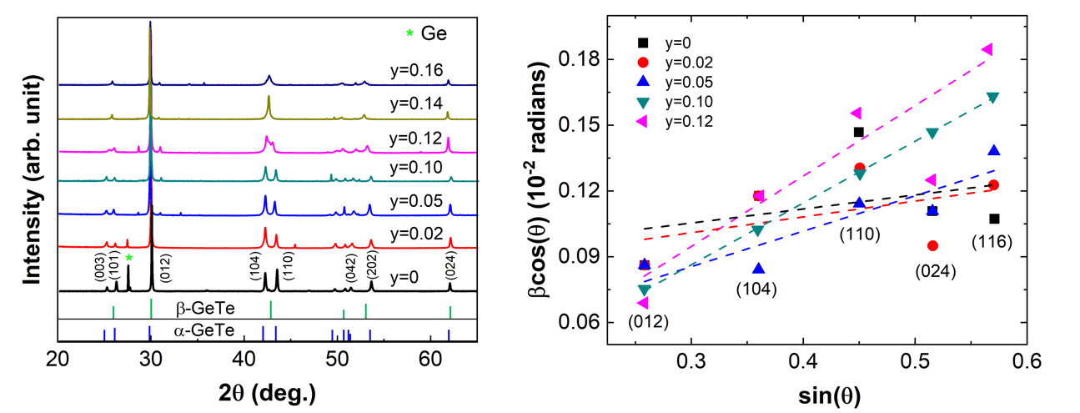
Fig. 1. (a) Room temperature XRD patterns of Ge_{1-y}Sb_{y}Te_{0.9}I_{0.1} (y=0, 0.02, 0.05, 0.10, 0.12, 0.14 and 0.16) and (b) Williamson-Hall strain analysis of Ge_{1-y}Sb_{y}Te_{0.9}I_{0.1} (y=0, 0.02, 0.05, 0.10 and 0.12).

y | 0 | 0.02 | 0.05 | 0.10 | 0.12
$ε$ (%) | 0.01 | 0.02 | 0.04 | 0.07 | 0.08
$D$ (μm) | 4.64 | 4.83 | 5.03 | 4.31 | 4.72
Table 1. Micro-strain rate ($ε$) and average crystallite size ($D$) of Ge_{1-y}Sb_{y}Te_{0.9}I_{0.1} (y=0, 0.02, 0.05, 0.10 and 0.12) determined by Williamson-Hall analysis.
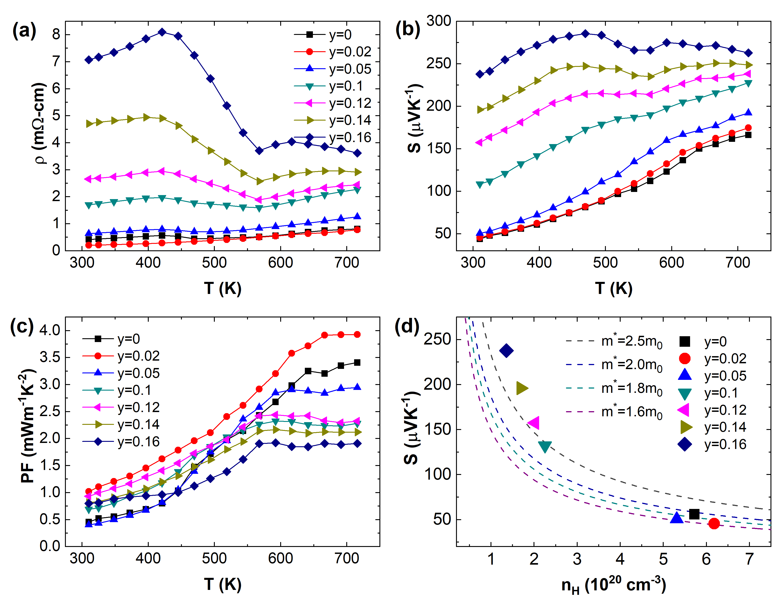
Fig. 2. Temperature-dependent (a) electrical resistivity, (b) Seebeck coefficient, (c) Power factor and (d) Seebeck coefficient as a function of carrier concentration at 300 K under a single parabolic band model of Ge_{1-y}Sb_{y}Te_{0.9}I_{0.1} (y=0, 0.02, 0.05, 0.10, 0.12, 0.14 and 0.16)

y | 0 | 0.02 | 0.05 | 0.10 | 0.12 | 0.14 | 0.16
$n_{H}$  (10²⁰ ${cm}^{-3}$) | 5.72 | 6.18 | 5.31 | 2.25 | 2.02 | 1.69 | 1.36
$$μ_{H}$$  (${cm}^{2} V^{-1} s^{-1}$) | 27 | 49 | 23 | 16 | 12 | 8 | 6
$m^{*}$ ($m_{0}$) | 1.92 | 1.65 | 1.65 | 2.43 | 2.70 | 2.98 | 3.13
$S$ ($μV{ K}^{-1}$) | 44 | 46 | 51 | 109 | 157 | 196 | 238
$ρ$ ($mΩ∙cm$) | 0.4226 | 0.2035 | 0.6333 | 1.7052 | 2.6553 | 4.7060 | 7.0711
Table 2. Hall carrier concentration $n_{H}$, Hall carrier mobility $μ_{H}$, effective mass $m^{*}$, Seebeck coefficient $S$ and electrical resistivity $ρ$ at room temperature for Ge_{1-y}Sb_{y}Te_{0.9}I_{0.1} (y=0, 0.02, 0.05, 0.10, 0.12, 0.14 and 0.16).

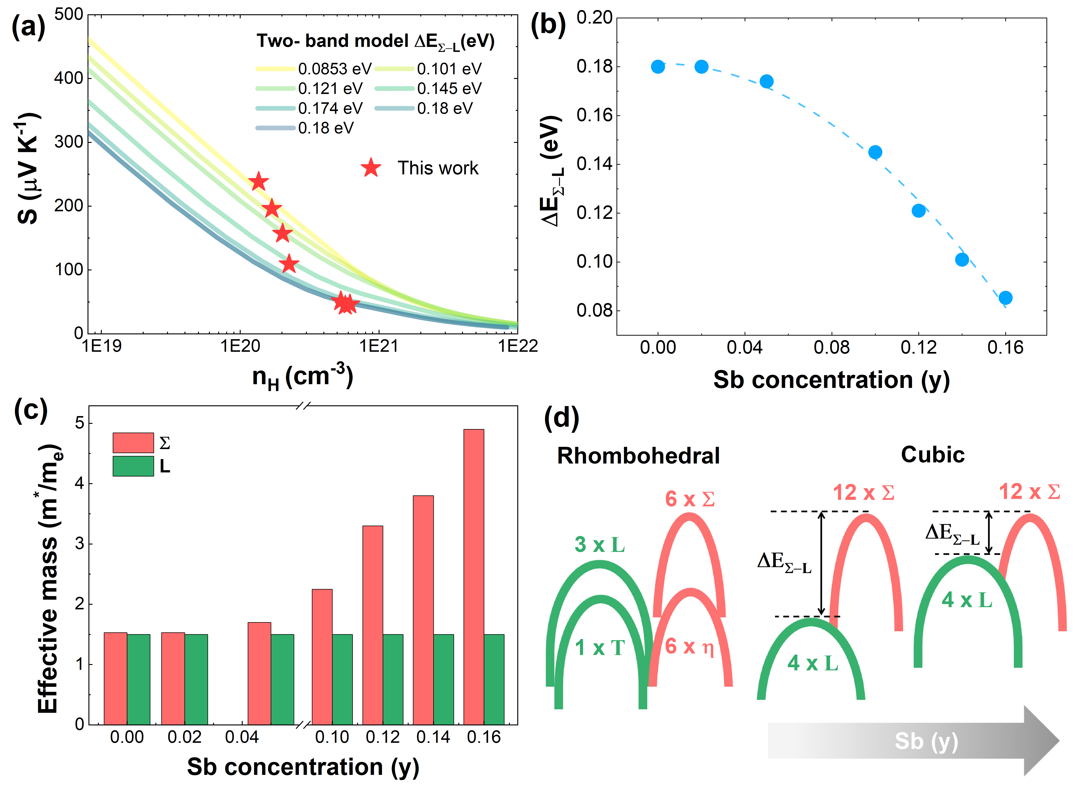
Fig. 3. (a) Seebeck coefficient plotted against Hall carrier concentration for Ge_{1-y}Sb_{y}Te_{0.9}I_{0.1} (y=0, 0.02, 0.05, 0.10, 0.12, 0.14 and 0.16), (b) band offset between $Σ$ and $Γ$ and (c) effective mass plotted against Sb concentration for Ge_{1-y}Sb_{y}Te_{0.9}I_{0.1} (y=0, 0.02, 0.05, 0.10, 0.12, 0.14 and 0.16). (d) Schematic showing the band structure of Rhombohedral and Cubic GeTe.

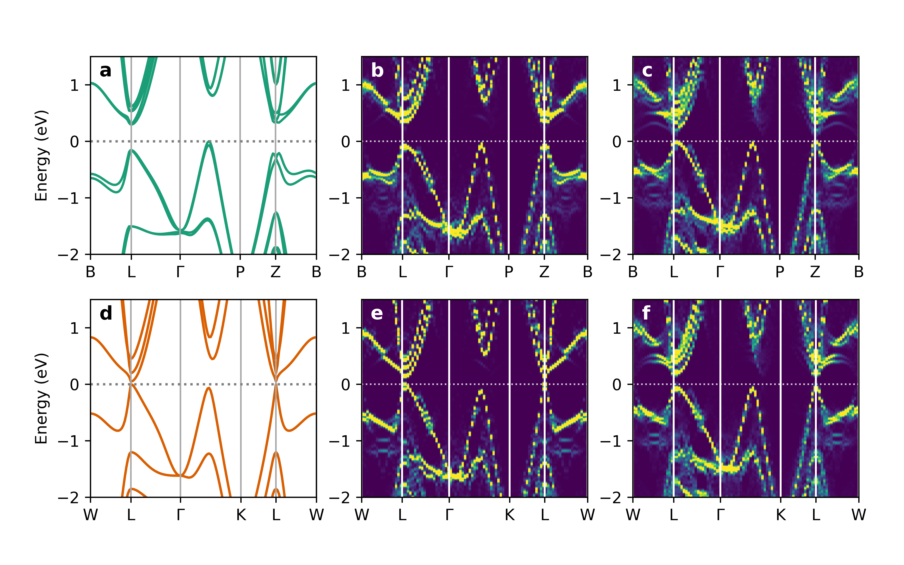
Fig. 4. Calculated electronic band structures of the primitive cell for (a) rhombohedral GeTe and (d) cubic GeTe. Band structure for doped GeTe is shown in (b) for rhombohedral Ge₃₂Te₂₉I₃ (GeTe_{0.91}I_{0.09}), (e) cubic Ge₃₂Te₂₉I₃, (c) rhombohedral Ge₂₉Sb₃Te₂₉I₃ (Ge_{0.91}Sb_{0.09}Te_{0.91}I_{0.09}), and (f) cubic Ge₂₉Sb₃Te₂₉I₃. The unfolded band structure from supercell calculation is presented in the form of spectrum function $A(k,ε$) where $k$ denotes reciprocal vector and $ε$ is the energy relative to the valence band maximam. SOC is considered in the band structure calculation.
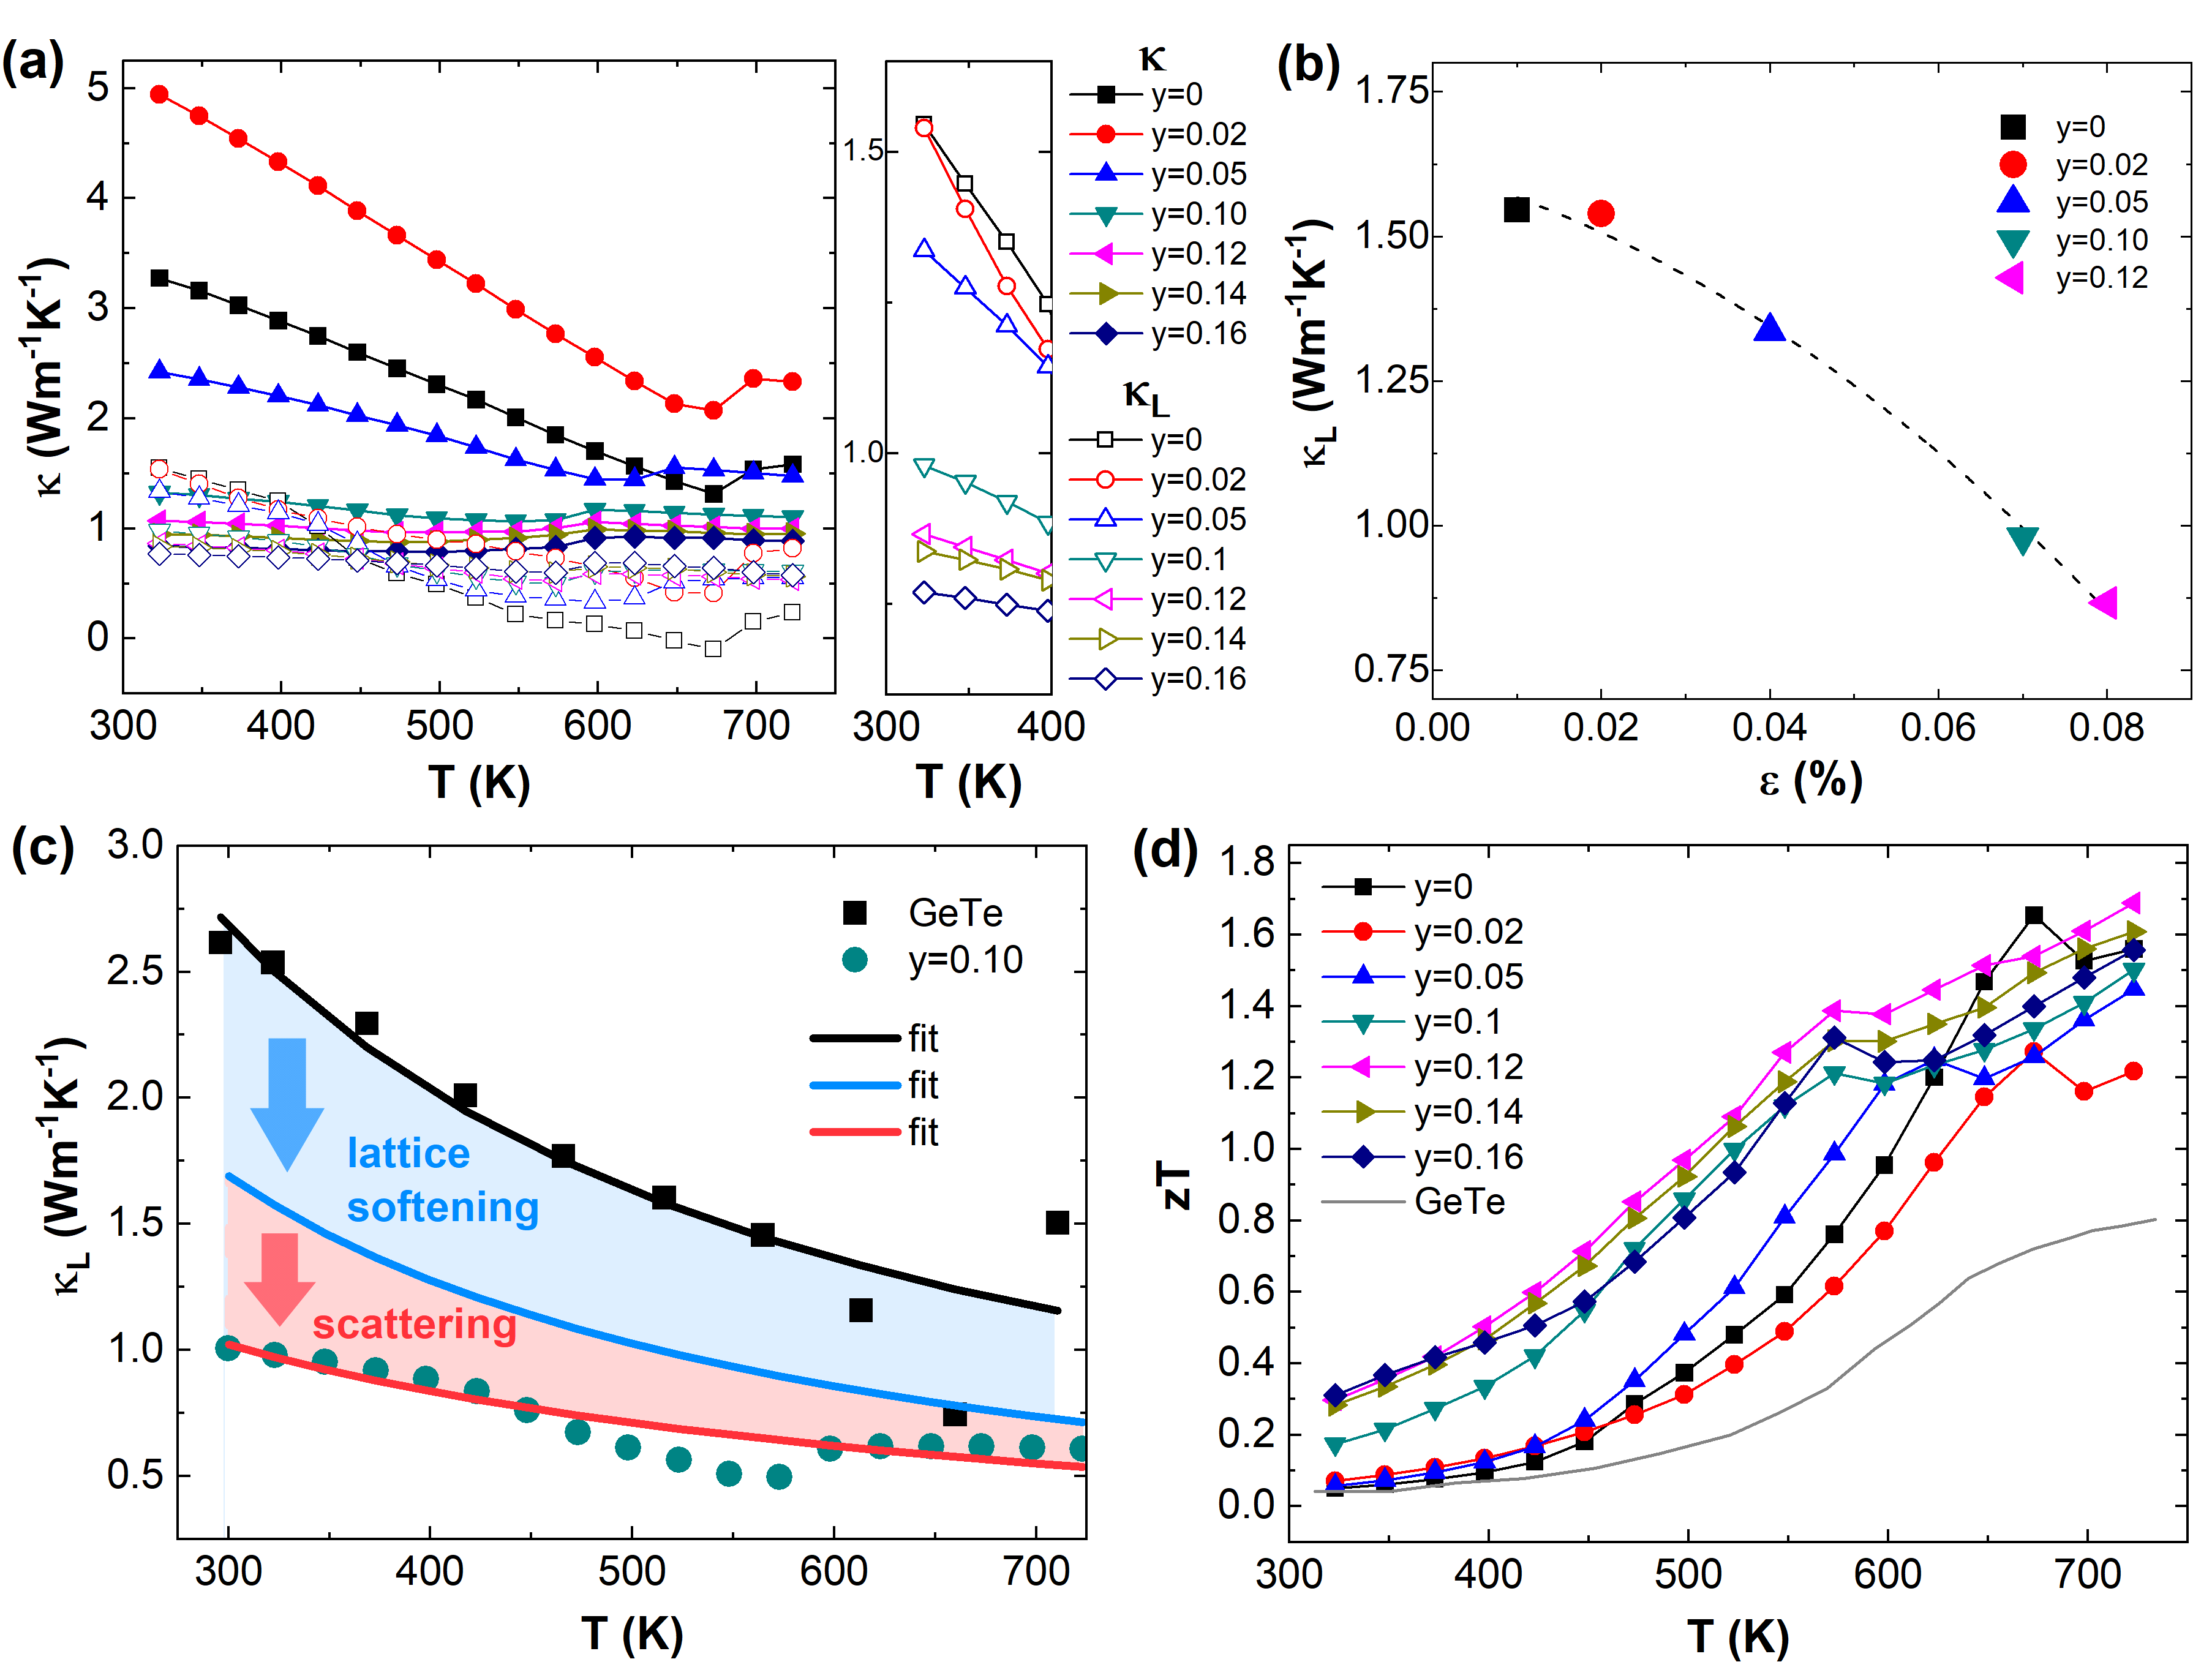
Fig. 5. (a) Temperature-dependent thermal conductivity, (b) lattice thermal conductivity as a function of internal strain at room temperature, (c) theoretical modeling of temperature-dependent lattice thermal conductivity, (d) temperature-dependent ZT for Ge_{1-y}Sb_{y}Te_{0.9}I_{0.1} (y=0, 0.02, 0.05, 0.10, 0.12, 0.14 and 0.16).

