Insulating 6,6-Phenyl-C61-butyric Acid Methyl Ester on Transition-Metal Dichalcogenides: Impact of the Hybrid Materials on the Optical and Electrical Properties

Ruben Canton-Vitoria^{a,b*} and Ryo Kitaura^{a,c}

[a] Prof. Dr. R. Canton-Vitoria, Prof. Dr. R. Kitaura
Department of Chemistry
Nagoya University
Nagoya, Aichi 464-8602, Japan
[b] Prof. Dr. R. Canton-Vitoria
Theoretical and Physical Chemistry Institute Department of Chemistry
National Hellenic Research Foundation
48 Vassileos Constantinou Avenue, 11635 Athens, Greece.
E-mail: rcanton@eie.gr
[c] Prof. Dr. R. Kitaura
International Center for Materials Nanoarchitectonics
National Institute for Materials Science
1-1 Namiki, Tsukuba 305-0044, Japan
Supporting information for this article is given via a link at the end of the document.

Abstract: In this study we develop a strategy to insulate 6,6 -Phenyl C₆₁ butyric acid methyl ester (PCBM) on the basal plane of transition metal dichalcogenides (TMDs). Concretely single layers of MoS₂, MoSe₂, MoTe₂, WS₂, WSe₂ and WTe₂ and ultrathin MoO₂ and WO₂ were grown via chemical vapor deposition (CVD). Then, the thiol group of a PCBM modified with cysteine reacts with the chalcogen vacancies on the basal plane of TMDs, yielding PCBM-MoS_{2,} PCBM-MoSe₂, PCBM-WS₂, PCBM-WSe₂, PCBM-WTe₂, PCBM-MoO₂ and PCBM-WO₂. Afterwards, all the hybrid materials were characterized using several techniques, including XPS, Raman spectroscopy, TEM, AFM, and cyclic voltammetry. Furthermore, PCBM causes a unique optical and electrical impact in every TMDs. For MoS₂ devices, the conductivity and photoluminescence (PL) emission achieve a remarkable enhancement of 1700% and 200% in PCBM-MoS₂ hybrids. Similarly, PCBM-MoTe₂ hybrids exhibit a 2-fold enhancement in PL emission at 1.1 eV. On the other hand, PCBM-MoSe₂, PCBM-WSe₂ and PCBM-WS₂ hybrids exhibited a new interlayer exciton at 1.29-1.44, 1.7 and 1.37-154 eV along with an enhancement of the photo-response by 2400, 3200 and 600%, respectively. Additionally, PCBM-WTe₂ and PCBM-WO₂ showed a modest photo-response, in sharp contrast with pristine WTe₂ or WO₂ which archive pure metallic character.

Introduction
The combination, insulation and characterization of low-dimensional materials pose significant challenges and require cutting-edge technologies due to their nanoscopic dimensions. Specifically, low-dimensional materials are described as any material in which at least one of the 3 dimensions is smaller than 100 nm.^{[1]} Commonly referred to as nanomaterials, they often exhibit quantum states, and possess properties that significantly differ from their three-dimensional (3D) counterparts. Graphene, as a prime illustration, epitomizes a two-dimensional (2D) material with one dimension being incredibly thin, with just a single carbon atom thickness (0.3 Å), while the other two dimensions extend infinitely.^{[2]} A notable instance of a one-dimensional (1D) material concerns carbon nanotubes or lineal polymers, where two of the three dimensions are smaller than 1 nm. ^{[3]} On the other hand, insulated molecules such as fullerenes with dimensions of 1nm³ are the quintessential example of zero-dimensional (0D) materials. With the exception of a few 2D materials, manipulating insulated low-dimensional materials is exceedingly challenging, primarily because they are not optically visible. In recent years, substantial efforts have been undertaken to overcome these obstacles.^{[4,5]}
One of the most representative 2D materials are the so-called Transition Metal Dichalcogenide (TMDs). TMDs are generally represented by the formula MX₂, where M refers to transition metal such as Mo and W and X denotes dichalcogenides (S, Se, and Te). Single layers of TMDs have a height of 3 atoms (between 0.62 A for MoS₂ and 0.82 for MoTe₂)^{[6,7]} while the other two dimensions can also be macroscopic. In fact, large monocrystals of TMDs are easily visible with the naked eye.^{[8]} 2D-TMDs have different structural phases, with the 2H being the most extensively studied in nanotechnology due to its semiconducting character^{[9]} whereas the 1T, which is metallic, has interesting applications in catalysis. Semiconducting TMDs are stables at room temperature and relatively resistant to chemical degradation.^{[9]} The bandgap (BG) of TMDs is situated in the visible to near-infrared (NIR) region (2.2-1.0 eV) and exhibit a large quantum yield, leading in a bright photoluminescence. On the other hand, the mechanical properties of TMDs allow to transfer single layers from one substrate to another and further manipulation without inducing significant cracks.^{[10-12]} Devices of TMDs such as transistors can easily reach carrier mobilities superior to 50 cm²/Vs and archive current on-off ratio superior to 8 orders.^{[13]}Therefore, TMDs are attractive in nanotechnology for the fabrication of new nanodevices.
In certain areas of nanoscience, it is crucial to devise simple strategies that facilitate targeted interactions between nanomaterials. For example, MoS₂ (a 2D-material) can interact towards van deer Waals forces with WS₂ (another 2D-Material)^{[14]} or carbon nanotubes^{[15]} (a 1D-Material) by employing pick-up methods. However, transfer processes^{[16]} needs very experimented professionals and requires an excessive amount of time. Furthermore, 0D-materials have sizes that are several orders of magnitude lower than the resolution of visible light, rendering this approach inapplicable. The main objective of transfer procedures is to obtain ultraclean samples to thoroughly investigate any property such as interlayer excitons,^{[14]} the photovoltaic effect^{[17,18]} or develop new nanodevices.^{[19,20]} Nanomaterials mixed in liquid or solid state have the risk to produce random aggregated species, poisoning or directly killing their low dimensional properties; nevertheless, based in its simplicity and high-yield, this approach can easily reach real applications.^{[21]} Essentially, combination of the best advantages of both methodologies is extremely demanded. Close to this ideal situation, covalent functionalization could mix homogeneously both materials, swiftly and at low prices. The main challenge about this methodology is to forecast the chemical reactivity of both nanomaterials to archive the desired hybrid material.
The reactivity of TMDs is mainly located at the edges, which contain a high concentration of defects such as chalcogen vacancies. Concretely, thiols^{[22-26]} or disulfanes^{[27]} react with chalcogen vacancies of TMDs and, in addition, are able to carry molecules or quantum dots.^{[28]} Disulfanes has been extensively employed to functionalize the edges of layered MoS₂ and WS₂ with chromophores such as porphyrins,^{[29]} phthalocyanines,^{[30]} or perylenes.^{[31]} On the other hand, the basal plane of large TMDs nanosheets remains inert due to the lack of vacancies, decreasing the functionalization ratio and challenging the proper characterization. However, the presence of chalcogen vacancies enables the basal functionalization of TMDs with thiols or disulfanes.^{[9]} Concretely, the basal plane of MoS₂ and WS₂ were functionalized with Zn-porphyrin (ZnP) bearing a dithiolane by simple mixing the materials during several days. Aggregates or non-covalent species were removed by simple washings.^{[32]} ZnP was completely insulated in regions of 1 nm² and a new interlayer exciton with a lifetime of 3.5 ns was detected. In addition, thiols owned in antibodies can covalently react with the basal plane of MoS₂ or WS₂, enabling the development of reusable biosensors for COVID-19 detection.^{[33]} However, this new covalent functionalization strategy has only been employed with MoS₂ or WS₂ and its effects with other chalcogens such as Se or Te remains totally unexplored.
The aim of this contribution is to develop a universal and simple technique that allows the insulation of 0D-materials at the basal plane of 2D-TMDs and pay close attention to the optical and electronic properties of the new hybrid materials. To achieve this goal, we chemically functionalize the basal plane of semiconducting MoS₂, MoSe₂, MoTe₂, WS₂, WSe₂ and metallic WTe₂, MoO₂ (40 nm) and WO₂ (100 nm) with N-([6,6] Phenyl C₆₁ butanoyl)cysteine (PCBM-Cys). The functionalization reaction was successful in all the materials, archiving 1 functional group of PCBM-Cys per every 18-40 units of MX₂ in PCBM-TMDs. As a result, each individual PCBM molecule (0.72 nm in diameter) is successfully insulated on the surface of TMDs, covering areas with an average range between 2.1 and 4.4 nm², representing 9-20% of the surface and thereby preventing PCBM self-interactions.. The absence of aggregations facilitates precise investigation of the optoelectronic properties exhibited by the newly developed PCBM-MoS₂, PCBM-MoSe₂, PCBM-MoTe₂, PCBM-WS₂, PCBM-WSe₂ and PCBM-WTe₂ 0D-2D hybrid materials. Briefly, the results obtained by absorption spectra, PL emission spectra, fluorescence lifetime, cyclic voltammetry and the photocurrent suggest that PCBM-MoS₂ and PCBM-MoTe₂ has an alignment type I and PCBM-MoSe₂, PCBM-WS₂, PCBM-WSe₂, type II. On the other hand, the effect of PCBM in PCBM-WTe₂, PCBM-MoO₂ and PCBM-WO₂ was depreciable. Finally, we want to point out that all TMDs were synthesized, functionalized, and manipulated by employing the same techniques, obtaining a clear and precise comparison among all the PCBM-TMDs material.
Results and Discussion
To start with, figure 1a shows the synthetic route of N-([6,6] Phenyl C₆₁ butanoyl) cysteine (PCBM-Cys). Briefly, [6,6]-Phenyl C₆₁ butyric acid methyl ester (PCBM) was hydrolyzed according with the bibliography and further coupled with cysteine.^{[34,35]} On the other hand, TMDs (MoS₂, MoSe₂, MoTe₂, WS₂, WSe₂, WTe₂, MoO₂ and WO₂) were synthesized by chemical vapor deposition (CVD), employing NaCl as a promotor.^{[9,32,33,36]} All the conditions are shown at supporting information and table S1. Among all the nanomaterials mentioned, MoS₂, WS₂, MoSe₂, and WSe₂ exclusively exhibit semiconducting characteristics.^{[35]} MoTe₂ displays a combination of metallic and semiconducting phases,^{[11]} while WTe₂, MoO₂, and WO₂ are exclusively metallic. Then, the covalent functionalization reaction was carried out by the simple mixture of PCBM-Cys with the target TMDs (see experimental section and figure S1). Figure 1b shows all these PCBM-TMDs (PCBM-MoS₂, PCBM-MoSe₂, PCBM-MoTe₂, PCBM-WS₂, PCBM-WSe₂, PCBM-WTe₂, PCBM-MoO₂ and PCBM-WO₂) described in this study, along with their respective emissive regions. In addition, when conducting blank experiments, such as the functionalization of MoS₂ with cysteine (Figure S2), minimal changes were observed in the optoelectronic properties of the nanomaterial.^{[34]} Hence, PCBM plays a pivotal role in inducing the observed optical and electronic changes in TMDs.

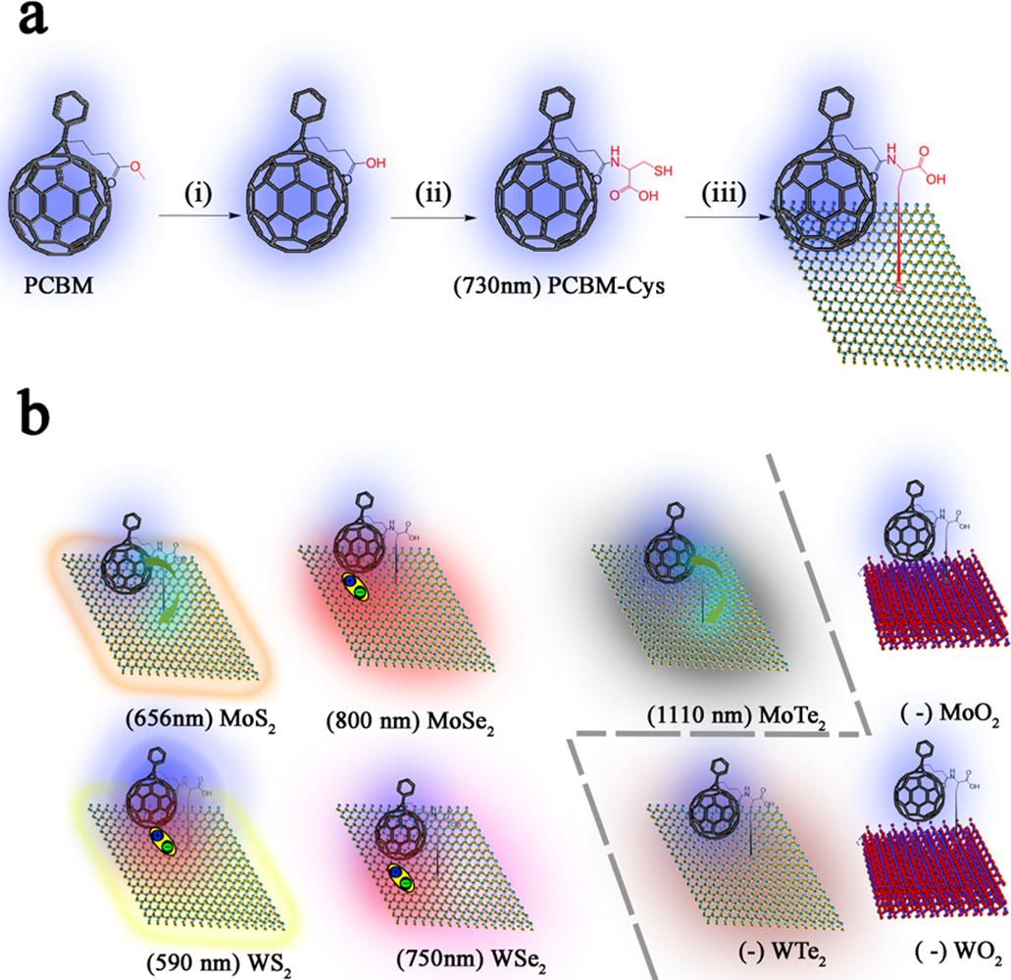
Figure 1. (a) Synthesis of PCBM-TMDs. (i) Acetic acid/HCl (ii) EDCI, DMAP, Cysteine, THF (iii) Exf. TMDs, DMAc (b) Representation of all the PCBM-TMDs, the dash line shows the semiconducting and metallic TMDs hybrids at the left and right, respectively.
To ensure the absence of non-covalent impurities or aggregations in all PCBM-TMDs materials, a meticulous washing process was employed using dimethylacetamide (DMAc) in a Soxhlet extractor. This method was chosen to meticulously purify the PCBM-TMDs, ensuring the absence of non-covalent species or additional impurities in the final product.^{[32]} Subsequently, we conducted standard characterization techniques to verify the successful covalent functionalization.^{[27,28,32,33]} Raman mappings revealed signatures of PCBM-Cys, including the D band at 1300 cm⁻¹, D’ band at 1374 cm⁻¹, and G band at 1566 cm⁻¹, exclusively on the surface of the TMDs flakes (see inset of figure 2a). Additionally, the relative intensity of some defective nodes of TMDs such as 2LA(M) decreases. For instance, 2LA(M) band at 460 cm⁻¹ of MoS₂ decreases an average of 7% in PCBM-MoS₂ (see a representative example in figure 2a). The reduction in the intensity of the 2LA(M) band, which is a defective band, serves as evidence of the covalent interaction between chalcogen vacancies in TMDs and the thiol group of PCBM-Cys.^{[32,33]} Furthermore, the Atomic Force Microscopy (AFM) technique demonstrates the presence of ultra-small regions, which are attributed to the presence of PCBM-Cys on the surface of the TMDs (refer to figure 2b-c for a representative of AFM to low and high magnifications, respectively). Due to the constrained resolution of the 15 nm diameter AFM tip, the atomic-level intricacies along the x and y axes manifest dimensions in the order of several nanometers for ultra-small molecules such as PCBM, rather than 1 nm² dimensions.^{[32,37]} These ultra-small regions were conspicuously absent in the pristine CVD materials, characterized by a wholly homogeneous surface, as illustrated in Figure S11a. This observation underscores the conclusion that these regions were introduced during the reaction process.
In contrast, transmission electron microscopy (TEM) exhibits ample resolution to differentiate individual circular features of approximately 1 nm² on the surface of PCBM-MoS₂. This stands in stark contrast to the pristine CVD sample, which displayed a remarkably uniform appearance, (figure 2d vs S11). These features could be attributed to the presence of individual PCBM molecules, further revealing a large range of functionalization. The diffraction pattern confirms the semiconducting nature of MoS₂ and its complete stability after undergoing the functionalization process (see a representative example in figure 2d, inset). Furthermore, atomic-scale resolution energy-dispersive X-ray spectroscopy (EDX) conducted via TEM confirmed the presence of sulfur at 2.31 keV on the basal plane of all the materials, providing evidence for the incorporation of PCBM-Cys in PCBM-TMDs hybrids (a representative example of WSe₂-PCBM is shown in figure 2e).^{[30]} X-ray photoelectron spectroscopy (XPS) not only corroborates the findings of EDX but also provides valuable insights into the nature of the bonding. For instance, the detection of amide groups identified through XPS at 399.45 eV confirms the presence of PCBM-Cys on the surface of TMDs. Additionally, changes in the morphology of the sulfur binding energies suggest a transformation in the nature of the thiol group of PCBM-Cys upon interaction with Mo or W metals within chalcogen vacancies. Specifically, this transformation leads to the formation of new metal-sulfur bonds and the cleavage of the S-H bond. Notably, the sulfur bands at 164.62 and 168.68 eV in PCBM-Cys are eliminated, giving way to new bands at 160.54 and 166.27 eV in PCBM-MoSe₂, and justifying the covalent functrionalization.^{[27,32,33,38,39]} In addition, prior to functionalization, the metal and chalcogen bands of TMDs exhibit peaks associated with vacancies, which are superimposed with conventional bands.^{[27]} Following functionalization with PCBM-Cys, the vacancies are covered, leading to a reduction or elimination of the previously observed defective peaks and ending in a subtle shift. Such phenomena have been observed in varying ratios across all the materials. Furthermore, based on the Scofield sensitivity factors and the XPS emission area of the elements of TMDs and PCBM, we can estimate that there is approximately one functional group of PCBM-Cys for every 18-40 units of MX₂, indicating a similar ratio of functionalization across all TMDs. This suggests that the described covalent functionalization technique provides a consistent and standard functionalization for all the TMDs. Specifically, it was observed that one functional group of PCBM is attached per every 43, 18, 27, 30, 21, 18, 30, and 30 units of MoS₂, MoSe₂, MoTe₂, WS₂, WSe₂, WTe₂, MoO₂, and WO₂, respectively. Considering the unit cell of each material, this implies the isolation of one PCBM molecule in average areas of 4.4, 2.1, 3.5, 3.5, 2.4, 2.7, 3.1 and 3.0 nm², respectively. Therefore, a PCBM coverage ranging between 9-20% of the total TMDs surface was observed, corresponding to an average spacing of PCBM-PCBM molecules ranging from 0.72 to 1.3 nm. Considering the typical distances between π-π interactions (0.35 nm), interactions among PCBM molecules on the TMDs surface are almost negligible. This leads to an approach towards the maximum functionalization of TMDs, where the final hybrid can be considered as a 0D material insulated within a 2D material. The covalent functionalization character between PCBM-Cys and each TMDs was further analyzed via AFM, EDX-TEM, Raman, and XPS. The data and a comprehensive explanation can be found in the supporting information (Figure S2-S10). However, in this manuscript, we have selectively showcased a subset of the most representative examples for brevity and clarity (Figure 2).
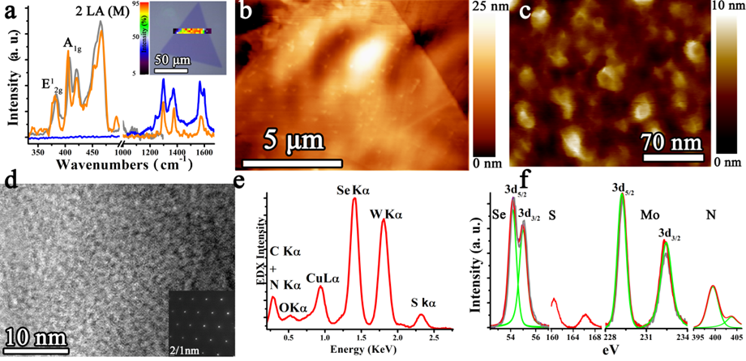
Figure 2. (a) Raman of pristine MoS₂ (gray), PCBM-Cys (blue) and PCBM-MoS₂ hybrid material (orange); Inset corresponds to the intensity mapping of PCBM in PCBM-MoS₂. (b-c) AFM for representative PCBM- MoS₂;(d) TEM of PCBM-MoS₂; inset corresponds to the diffraction pattern. (e) EDX for representative PCBM-TMDs, concretely PCBM-WSe₂; Inset, selected area for perform EDX under TEM magnifications. (f) XPS for pristine MoSe₂ (gray), PCBM-MoSe₂ (red) and deconvolution of PCBM-MoSe₂, (green) as a representative PCBM-TMDs.
In short, we asserted that all the TMDs were functionalized with a similar yield, insulating molecules of PCBM on the surface of each TMDs. Our next goal is to compare the optical and electronic properties of the new hybrids, comprehending the distinctions and similarities observed in each TMDs, standardizing all the techniques to ensure that any minor differences do not compromise the integrity of our results.
Absorption spectroscopy provides valuable information about the electronic transitions in semiconducting nanomaterials. PCBM-Cys exhibits significant absorption in the solid state between 300-600 nm, with peak maxima at 367 and 488 nm (3.38 and 2.54 eV). TMDs, on the other hand, display A to D- excitons across a broader range of 300-1200 nm. Figure 3a illustrates the electronic transitions of pristine MoS₂, MoSe₂, WS₂, WSe₂, and MoTe₂, and their band morphology aligns with the existing literature.^{[11,40]} Further, the PCBM-TMDs archive the same bands that pristine materials but with an increment in the absorption associated with PCBM region at 300-600 nm (4.1-2.0 eV). In addition, PCBM-MoS₂ exhibits absorption bands at 516 and 676 nm (1.24 and 1.83 eV). The band at 516 nm can be directly attributed to PCBM-Cys whereas the band at 676 nm corresponds to the transition between the valence band (VB) of MoS₂ to the lowest unoccupied molecular orbital (LUMO) of PCBM-Cys, creating a new electron-hole pair (anticipating figure 3g). The slight nanometer shift of the band transitions in PCBM-MoS₂, PCBM-MoSe₂, PCBM-WS₂, PCBM-WSe₂ and PCBM-MoTe₂ suggests electronic interactions between the PCBM and TMDs. Similar electronic interactions were described previously in theoretical studies of PCBM-TMDs composites.^{[41,42]} On the other hand, metallic PCBM-WTe₂, PCBM-MoO₂ and PCBM-WO₂ only exhibit slight absorption bands attributed to PCBM-Cys (see figure S8-10).
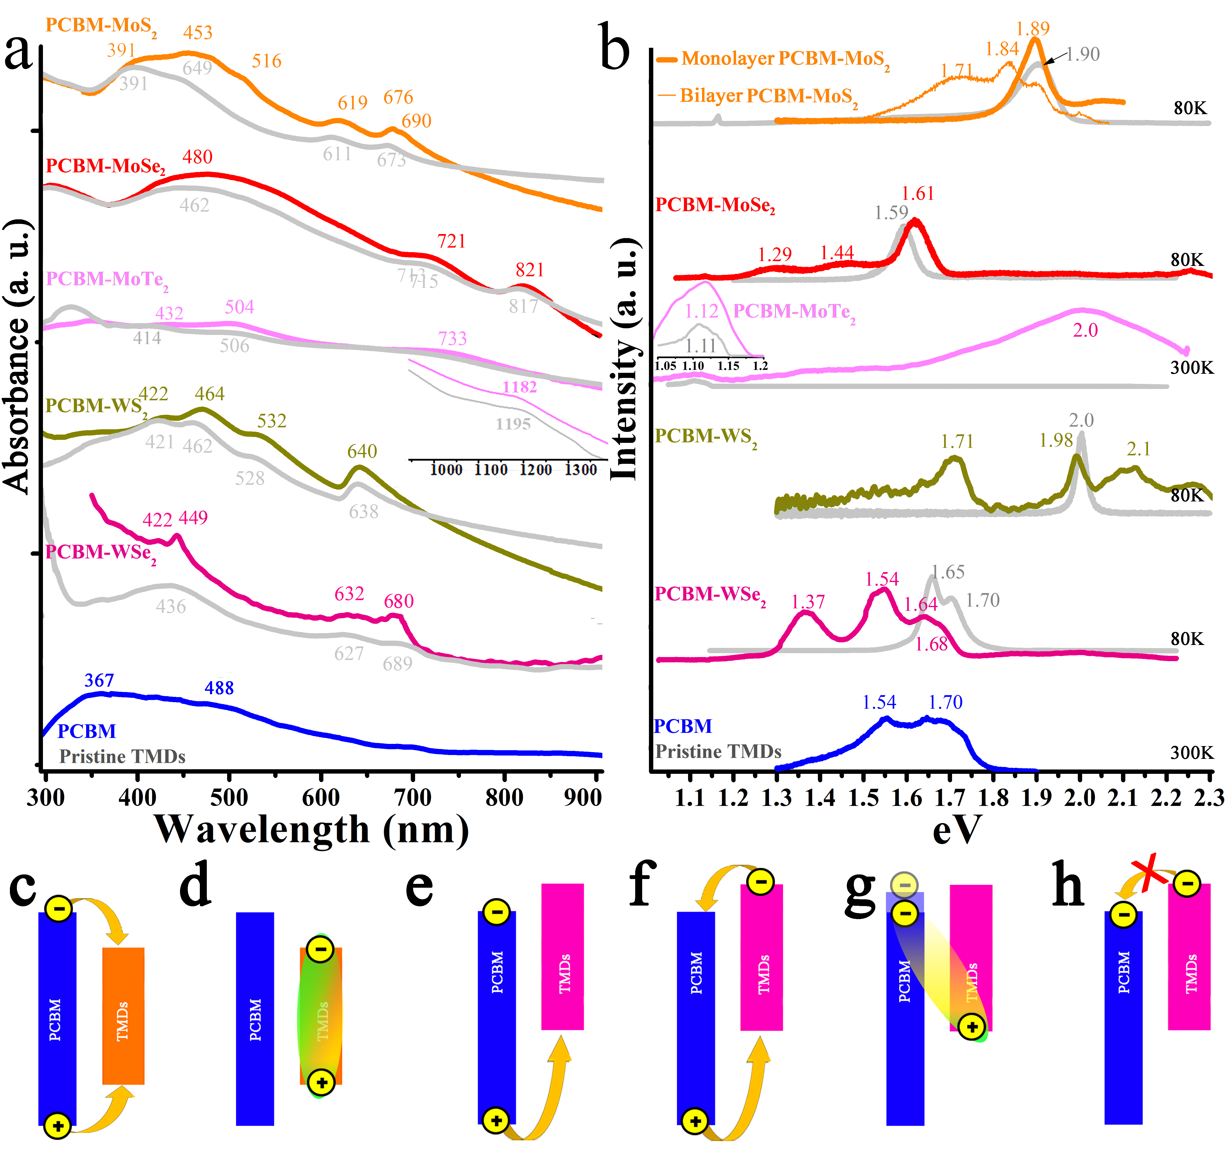
Figure 3. (a) Absorption and (b) PL emission spectra, at low temperature, at 488 or 532 nm laser excitation, of PCBM-Cys (blue), pristine TMDs (gray) and functionalized PCBM-MoS₂ (orange), PCBM-MoSe₂ (red), PCBM-MoTe₂ (magenta), PCBM-WS₂ (olive), PCBM-WSe₂ (pink). Representative examples of electronic mobility in alignment (c-d) - Type I and (e-h) - Type II.
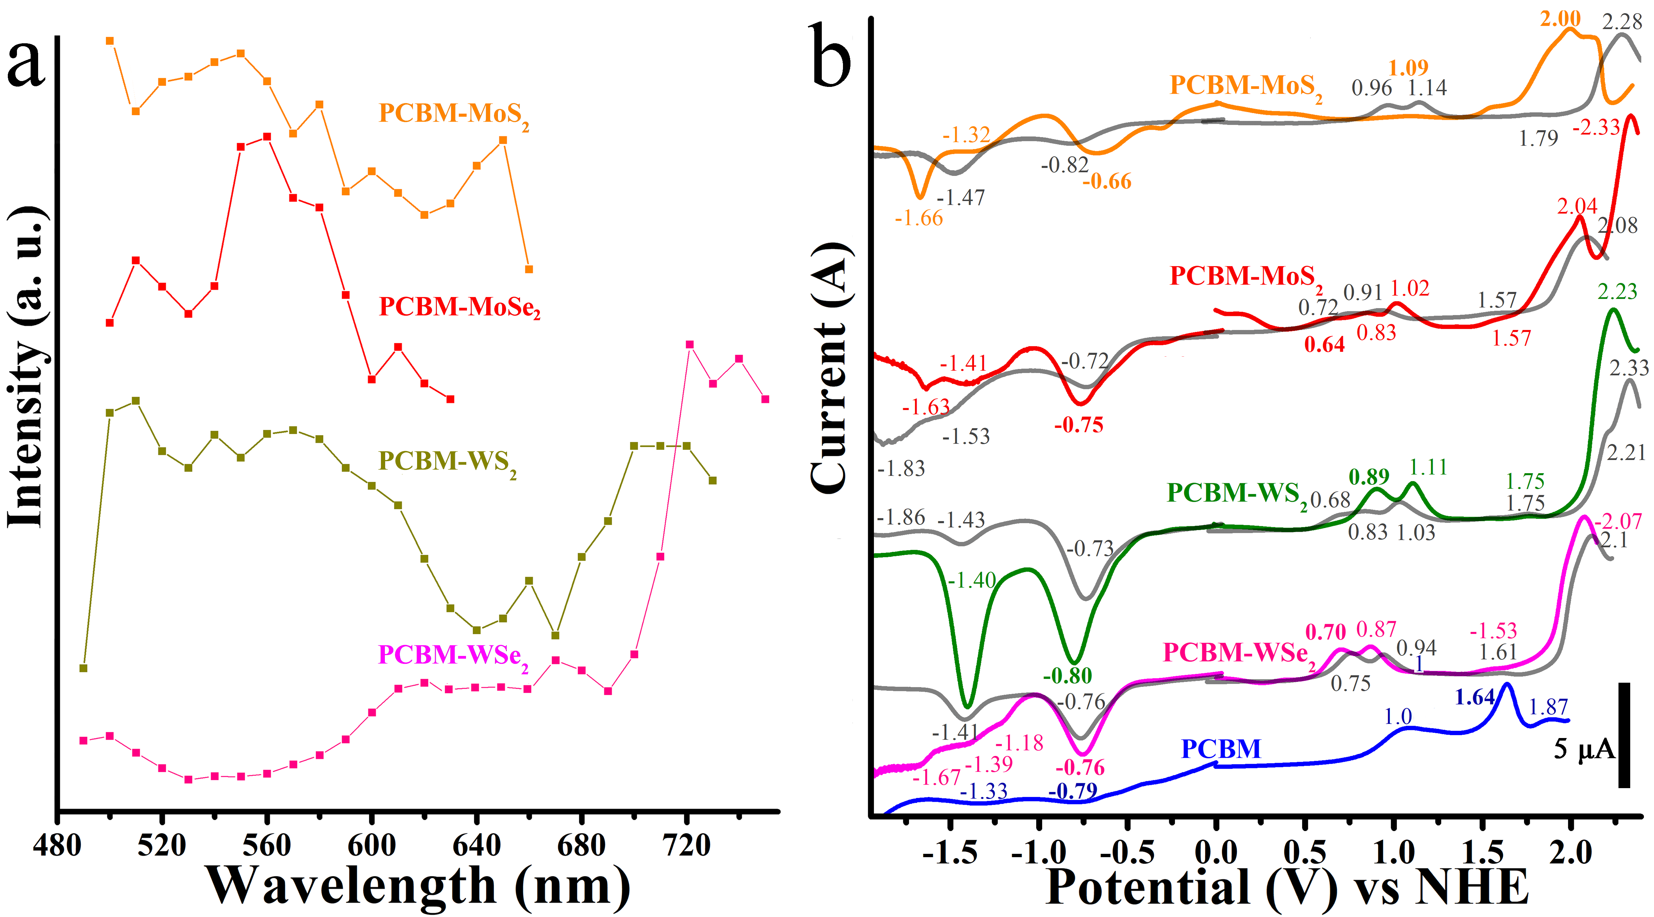
Figure 4. (a) PLE and (b) SWV of PCBM-Cys (blue), pristine TMDs (gray) and functionalized PCBM-MoS₂ (orange), PCBM-MoSe₂ (red), PCBM-MoTe₂ (magenta), PCBM-WS₂ (olive), PCBM-WSe₂ (pink), PCBM-WTe₂ (black), PCBM-MoO₂ (violet) and PCBM-WO₂ (purple).
Photoluminescence (PL) emission provides additional information on the electronic transitions of TMDs and PCBM-Cys. Initially, PCBM-Cys exhibits a broad emissive band at 1.5-1.7 eV, associated with the self-aggregation of PCBM. However, the emission of insulated PCBM at 2.00 eV was not observed in the solid state. The PL emission from PCBM-PCBM self-aggregation is absent in all semiconducting PCBM-TMDs materials, while new bands at 2.00-2.10 eV confirm the insulation of PCBM on the surface of TMDs. Next, the intensity of single layer MoS₂ enhances 3-folds in PCBM-MoS₂, suggesting an alignment type I with PCBM-Cys (see figure 3b). In this alignment, under light irradiation, the PCBM-Cys transfer electrons from the LUMO to the conduction band (CB) of MoS₂ and holes from the highest occupied molecular orbital (HOMO) to the VB (Figure 3c), thereby enhancing the PL emission of MoS₂ (Figure 3d). When measuring bilayers of PCBM-MoS₂, where the bandgap of MoS₂ is reduced,^{[43]} the intensity decreases and a new band (NB) transition appears at 1.84 eV, suggesting alignment type II. Under alignment type II, electrons from the CV are transferred to the LUMO, while holes predominantly accumulate at the valence band (Figure 3f). This electronic redistribution fosters the creation of stable electron-hole pairs, and the NB emerges through their emissive recombination, resulting in significant fluorescence emission (Figure 3g). It should be noted that the blank experiment with cysteine-MoS₂ (figure S2) does not exhibit appreciable changes in the material's intensity. Therefore, we consider the passivation effect conducted by PCBM-Cys to be negligible in our system. Next, for MoSe₂, the PL emission remains constant in PCBM-MoSe₂, archiving a new couple of bands, NB, at low energies, 1.44 and 1.29 eV, that can be explained by electron transfer of LUMO and LUMO⁺¹ of PCBM-Cys to valence band of MoSe₂ (figure 3g). Moreover, the PL of PCBM-MoSe₂ suggests alignment type II; Similar information was observed in PCBM-WS₂ and PCBM-WSe₂ (see figure 3b). In PCBM-MoTe₂, the PL emission of MoTe₂ is enhanced 2-fold, indicating an alignment type I, and a band at 2.0 eV ensures that PCBM is completely insulated and free of aggregations. Next, PCBM-WTe₂ is the only material that shows the presence of PCBM aggregations at 1.71 eV. However, the intensity is very weak, and the morphology is completely different from that of PCBM-PCBM, suggesting a low number of these aggregations. Finally, PCBM-MoO₂ or PCBM-WO₂ exhibit very weak PL emission of insulated PCBM at 2.13 and 2.08 eV, respectively (see figure S12).
Furthermore, Trion (A⁻ ) and neutral exciton (A⁰) have been found in all semiconducting TMDs and PCBM-TMDs materials at low temperatures. Concretely, MoS₂, MoSe₂, MoTe₂, WS₂ and WSe₂ shows a A⁻ , 1.850, 1.582, 1.092, 1.992 and 1.6501 eV and A⁰ at 1.890, 1.597, 1.104, 2.010, 1.701 eV whereas the values are shifted after functionalization, appearing the A⁻ of PCBM-MoS₂, PCBM-MoSe₂, PCBM-MoTe₂, PCBM-WS₂ and PCBM-WSe₂ at 1.840, 1.608, 1.092, 2.009 and 1.632 and A⁰ at 1.883, 1.622, 1.1043, 2.034 and 1.679 eV, respectively. Moreover, PCBM strongly tailored the optical properties of TMDs. The binding (dissociation) energy shows ultra-low values for all the materials, ranging from 40 meV for MoS₂ to 12 meV for MoTe₂ in exfoliated materials and 43 meV for PCBM-MoS₂ to 12 meV for PCBM-MoTe₂ in functionalized materials. Such values imply that electrons and holes can be easily dispersed throughout the material, which is consistent with the elevated photo-responses (R) observed in the TMDs transistor devices (see below).
Photoluminescence excitation (PLE) spectra (see figure 4a) reveal new electronic transitions in PCBM-WS₂, PCBM-WSe₂ and in bilayers of PCBM-MoS₂. Concretely, the bilayer of PCBM-MoS₂ shows the new transition at 650 nm (1.9 eV) in bilayers of MoS₂. On the other hand, the transitions of PCBM-WS₂ were found at 610 nm (2.03 eV) and 720 nm (1.72 eV), while the transition of PCBM-WSe₂ hybrid material is located at 740 nm (1.67 eV). Strong emission at these excitations for PCBM-WS₂ and PCBM-WSe₂ and bilayers of PCBM-MoS₂ can be correlated with absorption of energy from valence band of TMDs to LUMO or LUMO⁺¹ of PCBM-Cys, creating a new electron hole pair (see figure 3g). Therefore, these new PLE transitions must be intimately related to the NB described in the photoluminescence emission.
Fluorescence lifetimes were recorded using time-correlated single-photon counting (TCSPC) for each PL emission band of TMDs, PCBM-Cys and NB separately. After functionalization, the lifetimes of TMDs or PCBM-Cys are shortened in PCBM-MoSe₂, PCBM-WS₂ and PCBM-WSe₂ (see table 1), which indicates a new pathway of relaxation between PCBM-Cys and TMDs (figure 3f). On the other hand, those bands associated to new transitions NB shows long lifetimes up to 3 ns in PCBM-MoSe₂ (figure 3g). In the supporting information, figure S13 illustrates the lifetime decay of the new bands for PCBM-MoS₂, PCBM-MoSe₂, PCBM-WS₂, and PCBM-WSe₂. Subsequently, the reduction in lifetimes associated with the MoS₂ and MoTe₂ bands in PCBM-MoS₂ and PCBM-MoTe₂ suggest that the holes at HOMO of PCBM-Cys can be transferred to VB of TMDs increasing the possibilities of electron hole recombination between CB and VB of MoS₂ or MoTe₂ (see figure 3c).
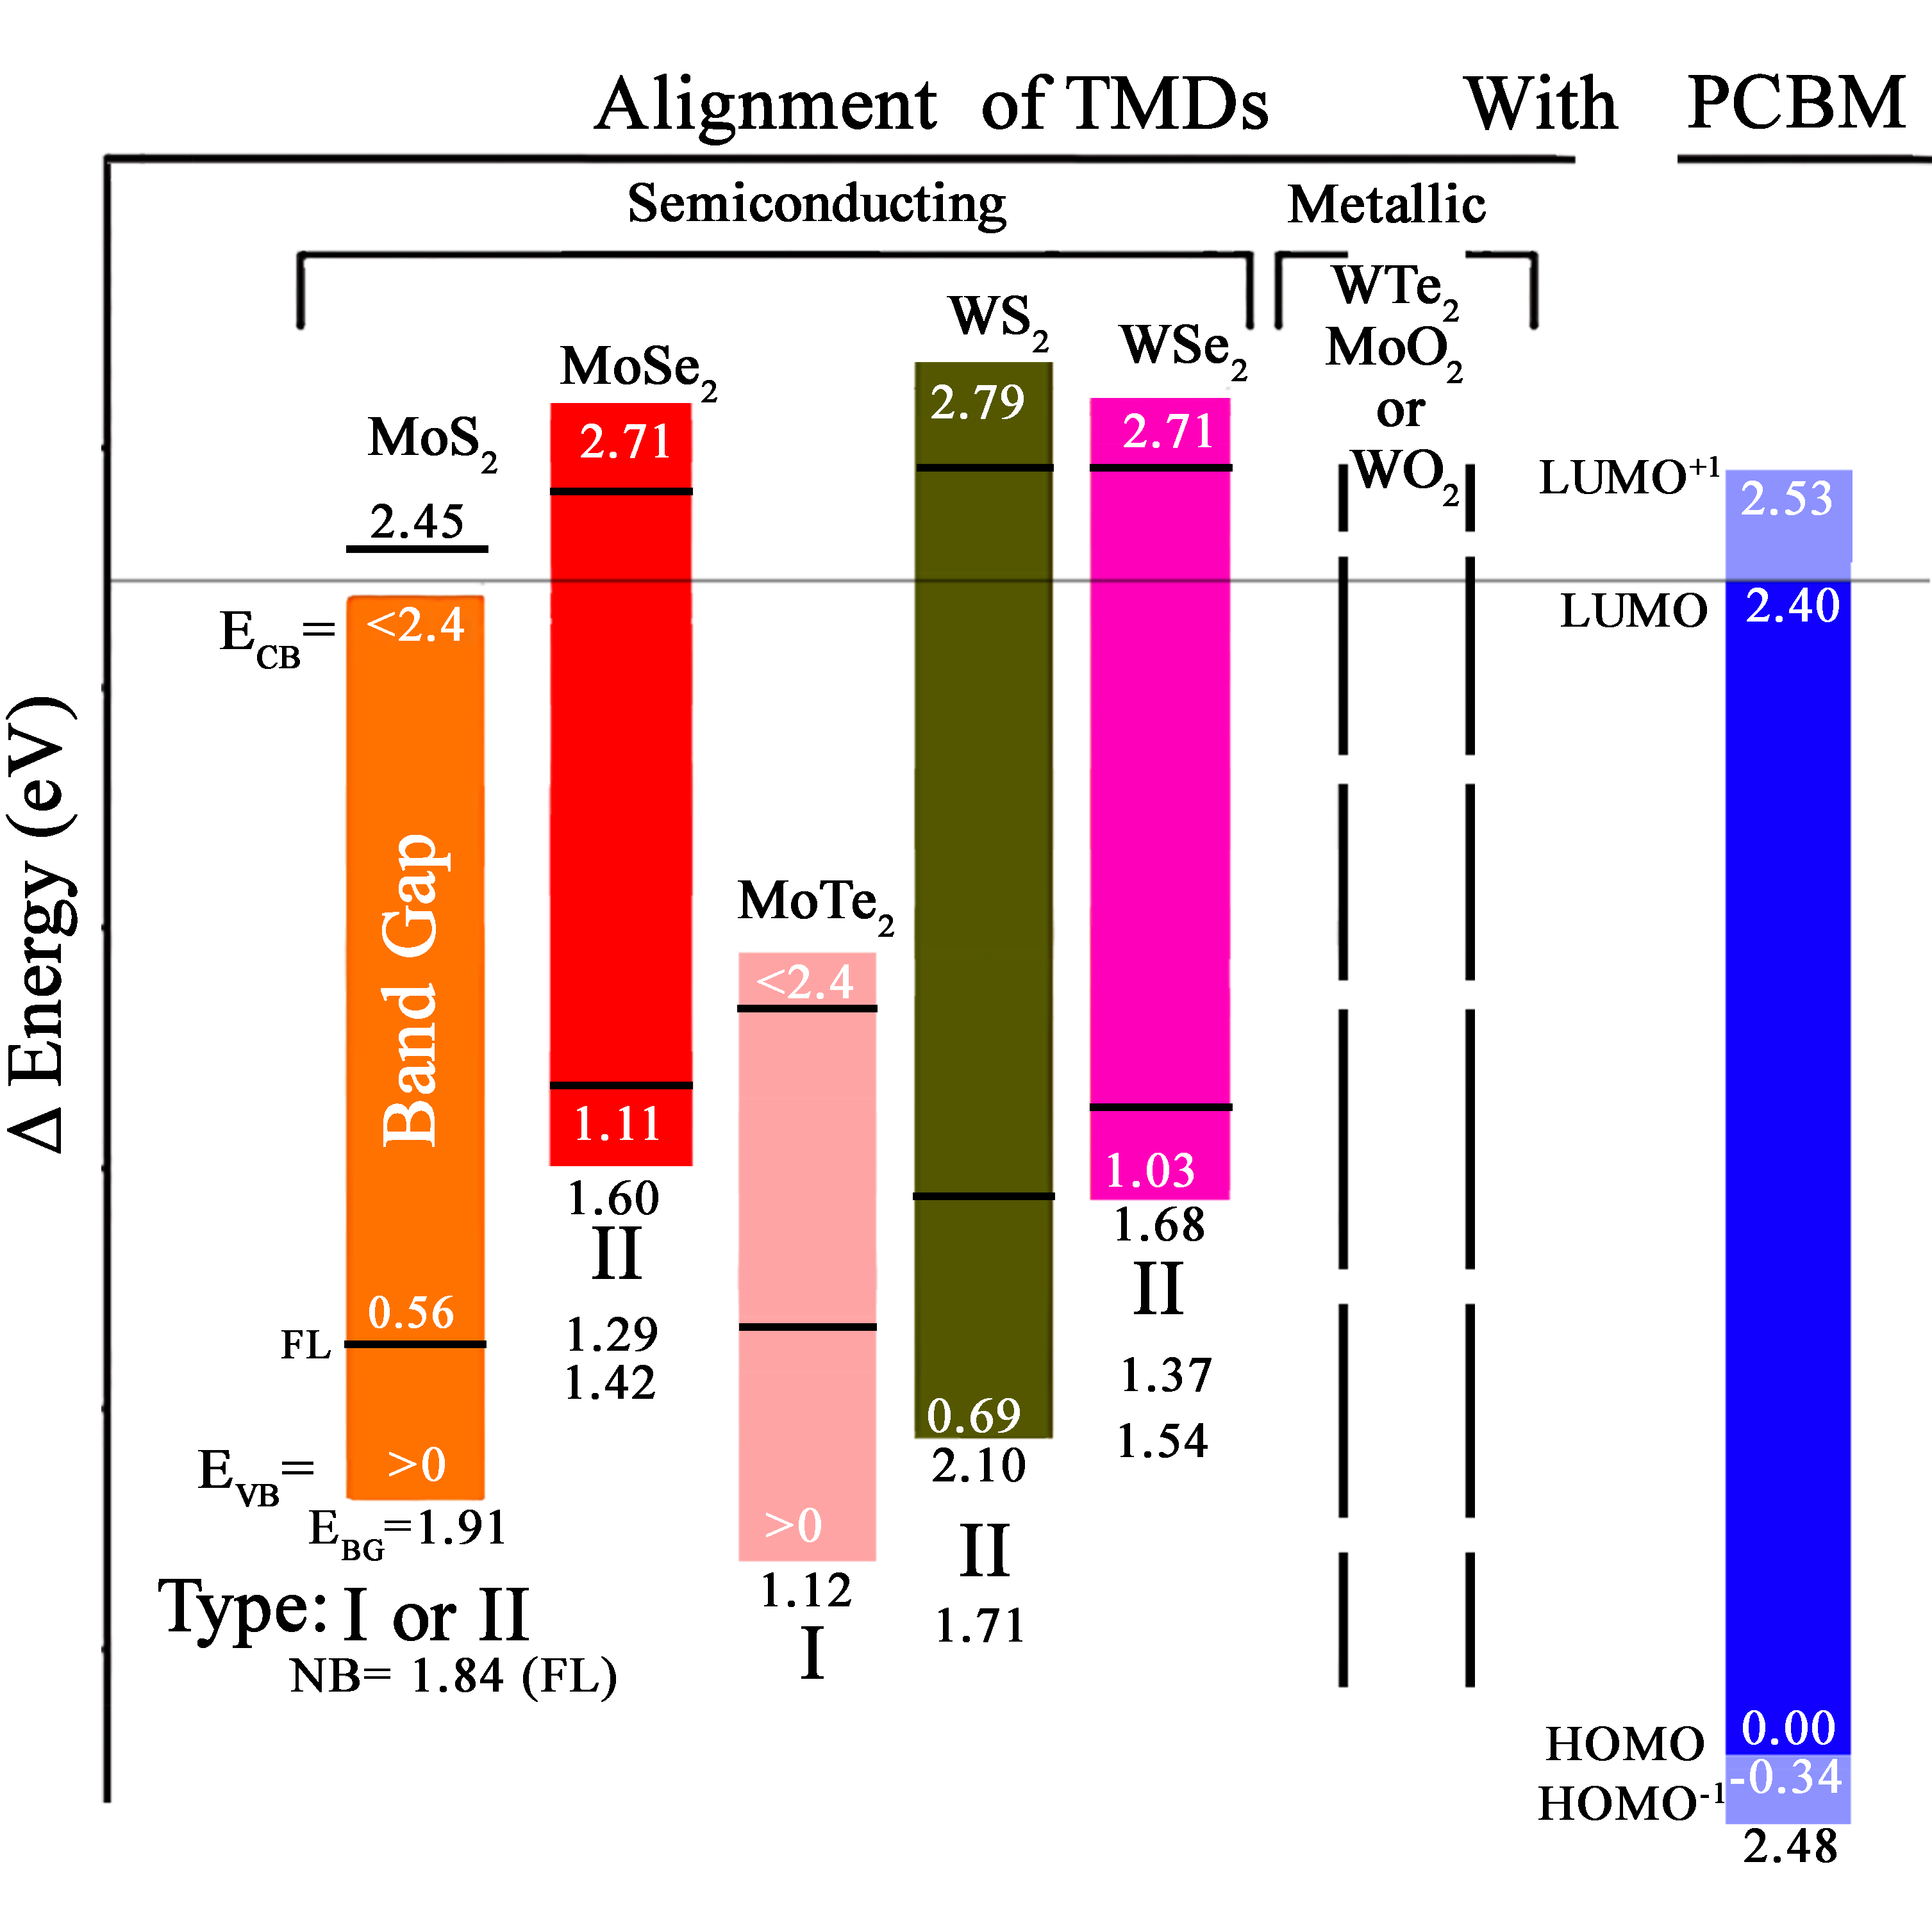Figure 5. Energy diagram for PCBM-MoS₂ (orange), PCBM-MoSe₂ (red), PCBM-MoTe₂ (magenta), PCBM-WS₂ (olive) and PCBM-WSe₂ (pink) hybrids. The energy diagram was shifted +6.10 eV from the traditional vacuum energy diagram to start the HOMO of PCBM at 0.0 eV.
Varshini equation was employed to carefully obtain the bandgap (BG) in each sample based on the PL shift with respect to temperature (table 1). In addition, excitation power versus integral of PL emission (Intensityµ (power)^{µ}) was studied to assign the nature of the materials. All information is presented in (table 1). It is worthy to remark that single layer of PCBM-MoS₂ displays an enhancement of the slope (α) of MoS₂ emission caused by the effect of PCBM, probably by the injection of electrons-holes. In addition, new bands in PCBM-MoSe₂, PCBM-WS₂ and PCBM-WSe₂ show slopes << 1, in agreement with previous 0D-2D mixed materials.^{[23,32]} This small α value of NB is expected due to the relatively low loading of PCBM-Cys and the limited diffusion of excitons. The blank experiment of Cys-MoS₂ shows no evidence of any spectroscopic change in absorption spectra, PL emission or fluorescence lifetime (see figure S2). Moreover, we discard the possibility that these new bands in PCBM-TMDs are related with defects since they are not very broad, and they are not observed before functionalization. Furthermore, the width of the band at low energy and high energy are very symmetric in any temperature.^{[44,45]}
Next, electrochemical voltammetry will provide information about the potentials at which each material (TMDs, PCBM-Cys or PCBM-TMDs) can undergo oxidation or reduction. This information can be utilized to gain initial insights into the electronic distribution of the material. The square wave voltammetry (SWV) of PCBM, MoS₂, MoSe₂, WS₂, WSe₂ and the hybrid materials PCBM-MoS₂, PCBM-MoSe_{2,} PCBM-WS₂ and PCBM-WSe₂ are shown in figure 4b. First, PCBM has an oxidation peak at -0.79 V (-3.43 eV) and two reductions peaks at 1.64V (-5.86 eV) and 1.87 V ( -6.09 eV) which correspond to the electrochemical HOMO, LUMO and LUMO⁺¹, respectively. Moreover, the electrochemical bandgap of PCBM corresponds to 2.43 eV in agreement with the bibliography.^{[46]} In addition, PCBM has a second oxidation peak at 1.01 V (-5.23 eV) associated with the PCBM aggregations. The electrochemical analysis of single layers of TMDs or PCBM-TMDs hybrids proved challenging due to the low sensitivity of the instrument. Consequently, we were compelled to analyze liquid-exfoliated materials. Layered PCBM-MoS₂, PCBM-MoSe_{2,} PCBM-WS₂ and PCBM-WSe₂ exhibit an oxidation peaks at 1.09 V (-5.31 eV), 0.64 V (-4.87 eV), 0.89 V (-5.11 eV) and 0.7 V (-4.92 eV), respectively, while the reduction peaks are shown at -0.67 V (-3.55 eV), -0.75 V (-3.47 eV), -0.80 V (-3.42 eV) and -0.76 V (-3.46 eV), respectively. Therefore, layered PCBM-MoS₂, PCBM-MoSe_{2,} PCBM-WS₂ and PCBM-WSe₂ have electrochemical bandgaps of 1.76, 1.39, 1.69 and 1.45 eV, in agreement with the values obtained by PL emission (see figure 3b). The shifts in the TMDs signatures after functionalization (see figure 4b) further indicate a significant electronic coupling with PCBM.
Utilizing the optical bandgaps calculated with the Varshini equation and the electrochemical energy levels obtained through Square Wave Voltammetry (SWV), a simplified energy diagram was constructed (see Figure 5). Initially, the values of a HOMO (-6.10 eV) and LUMO (-3.70 eV) of insulated PCBM were compared with the bibliography,^{[45,47]} and the sourced bandgap of 2.40 eV agrees with the electrochemical values derived from SWV (2.43 eV). Subsequently, single layers of MoS₂ and MoTe₂ exhibit optical bandgaps within the range of PCBM-Cys, consistent with the alignment type I. Conversely, the energy (E) of NBs of bilayer of PCBM-MoS₂, PCBM-MoSe₂, PCBM-WS₂ and PCBM-WSe₂ corresponds to the energy difference between the LUMO (or LUMO⁺¹) of PCBM-Cys and valence band of TMDs (equation 1). Having calculated the position of the valence band, the conduction band of PCBM-MoS₂, PCBM-MoSe₂, PCBM-WS₂ and PCBM-WSe₂ was determined by adding the corresponding optical bandgaps to the valence band. It is noteworthy that this vacuum energy level diagram is similar but not identical to those described by the classical band alignment in 3D-3D systems, (see supporting information figure S14)^{[45,46]} despite the fact that PCBM-Cys is a 0D material and the fermi level of thin films should not be applied.^{[46]}
Table 1. Optical and electronic parameters of PCBM-TMDs hybrid materials.
Material | TMDs  BG [eV] | TMDs  t [ns] | TMDs  α | PCBM  BG [eV] | PCBM  t [ns] | PCBM  α | NB  BG [eV] | NB  t [ns] | NB  α | T_{PER}  [s] | σ  [nA/V]
PCBM-Cys | - | - | - | 1.54, 1.74 | 1.06 | 1 | - | - | - | - | -
MoS₂ | 1.91 | 0.5 | 0.8 | - | - | - | - | - | - | 0.33 | 0.04
PCBM-MoS₂ | 1.91 300%ª | 0.2 | 1.05 | 1.71 | 0.3 | 0.6 | 1.84^{b} | 1.6^{b} | - | 0.61 | 0.71
Cys-MoS₂ | 1.91 | - | 0.8 | - | - | - | - | - | - | 0.16^{c} | 0.04
MoSe₂ | 1.60 | 0.24 | 0.86 | - | - | - | - | - | - | 0.13 | 136
PCBM-MoSe₂ | 1.60 100%ª | 0.24 | 0.86 | 2.00 | 0.1 | - | 1.29, 1.44 | 3 ns | 0.53 | 0.10 | 61
MoTe₂ | 1.1 | - | - | - | - | - | - | - | - | 19 | 0.030
PCBM-MoTe₂ | 1.1 300%ª | - | - | 2.00 | 0. 58 | 0.15 | - | - | - | 4.5 | 0.002
WS₂ | 2.05 | 0.172 | 0.95 | - | - | - | - | - | - | 1.44 | 0.009
PCBM-WS₂ | 2.10 5%ª | 0.012 | 0.8 | 2.10 | 0.6 | 0.76 | 1.71 | 1.8 | 0.82 | 0.43 | 3x10⁻⁵
WSe₂ | 1.71 | 0.60 | 1.08 | - | - | - | - | - | - | 0.03 | 3x10⁻⁵
PCBM-WSe₂ | 1.68 20%ª | 0.24 | 0.76 | 2.00 | 0.1 | 0.6 | 1.37, 1.54 | 0.1 | 0.88 | <0.001 | 2x10⁻⁶
WTe₂ | - | - | - | - | - | - | - | - | - | - | -
PCBM-WTe₂ | - | - | - | 1.71 | 0.67 | 1 | - | - | - | 1.50 | 8x10⁻⁶
MoO₂ | - | - | - | - | - | - | - | - | - | - | 4x10⁶
PCBM-MoO₂ | - | - | - | 2.13 | - | - | - | - | - | - | 1x10⁶
WO₂ | - | - | - | - | - | - | - | - | - | 0.31 | 0.015
PCBM-WO₂ | - | - | - | 2.08 | - | - | - | - | - | 0.20 | 0.003
^{a)} The overmentioned percentage corresponds to the ratio of Intensity Area of PCBM-TMDs versus pristine TMDs (equation 4); ^{b)} BL corresponds to bilayer of MoS₂; ^{c)} This value was normalized.
Next, phototransistors aid in understanding how light affects conductivity in PCBM-TMDs materials. PCBM should transfer electrons and/or holes under light illumination, with different behavior in alignment type I or II, and due to the low binding energies extracted by photoluminescence, ranging between 12-43 eV in pristine TMDs and PCBM-TMDs, the charges should be easily delocalized, contributing to tailoring the electronic behavior of the devices. Furthermore, the absence of PCBM aggregations aids understanding of the system by suppressing PCBM-PCBM interactions while reducing trap states.
Concretely, field-effect transistor (FET) devices with single layers (<1nm) of MoS₂, MoSe₂, WS₂, WSe₂, MoTe₂ and ultrathin MoO_{2,} MoO₂ (40 nm) and WO₂ (90 nm) were crafted in SiO₂ substrate. The electrodes of bismuth/gold were fabricated using an electron beam lithography (EBL) and metal deposition approach, with a channel length of 5 μm for all the TMDs. It should be noted that the same devices were studied previously and after being functionalized with PCBM-Cys. The devices of TMDs with semiconducting character were depicted in figure 6 whereas the metallic hybrid materials can be found at supporting information (figure S8-S10). Following their absorption spectra, all pristine materials show a maximum photo-response between 407 and 532 nm (figure 3a VS figure 6). Then, after functionalization, PCBM-MoS₂ shows an increasing of 1700% of the conductivity (I) under dark condition in comparison with pristine MoS₂ material because PCBM-Cys provides holes at valence band and electrons in conduction band by electron/hole-transfer spontaneously generated (figure 3c). On the other hand, the light response (equation 2) does not enhance proportionally, indicating that PCBM-Cys transfer more holes at valence band (dark current) than electrons at conduction band (under light illumination). Ultimately, the variation of the response of PCBM-MoS₂ in contrast to pristine MoS₂ (${ΔR}_{f/P}$; equation 3) shows values of -81% at 254 nm, 43% at 365 nm, -60% at 407 nm, -48% at 532 nm and -74% at 650 nm. Therefore, the response of PCBM-MoS₂ rises only under 365 nm light illumination, region in which the absorption is mainly dominated by the PCBM-Cys (all responses are shown in figure 6). Enhancement of dark current was not observed in PCBM-MoTe₂, probably because the bounding of thiols at Tellurium vacancies produces a negative effect at the basal plane of MoTe₂. Nevertheless, the light response of PCBM-MoTe₂ increases out from the MoTe₂ absorption region, obtaining higher ${ΔR}_{f/P}$values at 365 nm > 254 nm > 650nm > 532nm and decreasing at 407 nm. PCBM-MoSe₂ has alignment type II and thermal or spontaneous electrons generated on TMDs are trapped by the LUMO of PCBM-Cys. In consequence, the conductivity in dark conditions decreases in PCBM-MoSe₂ (figure 3e). However, under light illumination, photo-holes generated on PCBM-Cys are transferred not only to the valence band of MoSe₂, but in addition, electrons at LUMO in PCBM-Cys block the electron transfer from CB of MoSe₂ to LUMO of PCBM-Cys, reducing the electron confinement (figure 3h). Hence, photo-response of PCBM-MoSe₂ improves in ${ΔR}_{f/P}$ 25-folds at 254 nm, 7-folds at 354 nm, 6.5-folds at 407 nm, 8.8-folds at 532 nm and 3-folds at 650 nm. PCBM-WS₂ and PCBM-WSe₂ also show alignment type II, and the ${ΔR}_{f/P}$ enhance at 532 nm 33 and 7-folds after functionalization with PCBM-Cys. Typically, the value of ${ΔR}_{f/P}$ increases when laser excitation is close to PCBM-Cys maxima absorption and out from the TMDs excitons (figure 3a VS figure 6). PCBM-WTe₂ and ultrathin materials of PCBM-MoO₂ and PCBM-WO₂ show metallic character exclusively with a substantial flow of current. For example, MoO₂ has a conductivity^{[48]} of 4×10⁻³ A/V, being 3×10⁵-fold more conductive than any other material presented in this work, but no photo-response was archived even after functionalization with PCBM-Cys.

((Equation)) (1)

$${VB}_{TMDs}=E_{LUMO-PCBM}-E_{NB}$$

Where, VB_{TMDs} is the valance band of TMDs, $E_{LUMO-PCBM}$ is the position of the energy vacuum diagram of the LUMO or LUMO⁺¹ of PCBM and $E_{NB}$ is the energy subtracted by the PL emission of the new bands, in alignment type II.

((Equation)) (2)

$$R=\left(\frac{I_{light}}{I_{dark}}-1\right)x100\%$$

Where R is response, $I_{light}$ and $I_{dark}$ are the conductivity of the material under light illumination and dark).

((Equation)) (3)

$${ΔR}_{f/P}=\frac{R_{PCBM‐TMDs}-R_{TMDs}}{R_{TMDs}}x100\%$$
Where ${ΔR}_{f/P}$ is the variation of the response between the PCBM-TMDs and pristine TMDs, $R_{PCBM‐TMDs}$ and${ R}_{TMDs}$ are the response of PCBM-TMDs and pristine TMDs, respectively.

((Equation)) (4)

$$A_{Ratio}=\frac{A_{PCBM-TMDs}}{A_{TMDs}}x100\%$$
Where $A_{Ratio}$ is the variation of the PL intensity between the PCBM-TMDs and pristine TMDs, $A_{PCBM‐TMDs}$ and${ A}_{TMDs}$ are the PL emission of PCBM-TMDs and pristine TMDs, respectively.

Time of photoelectric responses (T_{PER}) and response recoveries of pristine TMDs or PCBM-TMDs are minimally affected by the power of the laser and wavelength. Moreover, we show a representative laser excitation power (407 nm at 10.5 mW/cm²) before and after functionalization (see table 1). Notably, the addition of PCBM-Cys has a negative effect on the response of MoS₂, doubling the time in PCBM-MoS₂. In contrast, the addition of PCBM-Cys improves the time responses in PCBM-WSe_{2,} PCBM-WS_{2,} PCBM-MoTe₂, and PCBM-MoSe₂, being 3, 23, 30 and 77% of the original lifetime in pristine WSe_{2,} WS_{2,} MoTe_{2,} and MoSe₂ FET-devices, respectively (see table 1).
The values of Responsivity (R_{λ}), External Quantum Efficiency (EQE) at 254, 365, 407, 532 and 650 nm were recorded at table S2 and S3 for all TMDs and PCBM-TMDs materials while table 2 displays the best performance for any of the PCBM-TMDs hybrid materials. Specific detectivity (D*) was additionally recorded in table S3. Remarkably, PCBM-MoS₂ and PCBM-MoSe₂ and PCBM-WO₂ show maxima responsivity of 1.4, 2.1×10⁻² and 9.3×10⁻³ A/W and an EQE of 320, 5.0 and 1000%, respectively. On the other hand, all the semiconducting PCBM-TMDs exhibited excellent detectivities, ranging from 3.8×10¹⁴ for PCBM-WSe₂ to 2.8×10¹² for PCBM-WS₂ at 650 nm. Overall, the responses, responsivities, external quantum efficiencies and detectivities of the investigated materials are excellent, surpassing some of the previous findings described in the literature for 0D-2D heterostructures (as shown in table 2).
Valuable information such as transfer curve or characteristics were recorded at the supporting information (figure S3-S10). In summary, ohmic contact was negligible in all semiconducting materials and the photo-current is affected by the gate voltage. For example, the photo-response of PCBM-MoS₂ enhances 2 orders of magnitude when -30 V was applied to the gate (see figure S3o), implying a light response of 150.000%. On the other hand, the dark current and photocurrent of PCBM-WSe₂ exhibited a proportional increase with the drain-source voltage (V_{DS}). In addition, the photo-response is proportional to the laser power densities within the range of 1-15 mW/cm² the (see figure S7j). For instance, PCBM-MoS₂ (see figure S3o) and PDBM-WSe₂ (see figure S7k-l) show a photo-response of 5.4×10⁻⁶ A×cm²/W and 3.31×10⁻⁹ A×cm²/W, respectively. Regarding carrier mobilities, it is noteworthy that PCBM-MoSe₂ improves 12-fold in dark, while PCBM-WSe₂ exhibited an 11-fold improvement, under light illumination, as compared to the pristine materials. Further details about carrier mobilities in dark and light are described at supporting information (see description and figures S2-S10), while the conductance (σ) in dark is shown in table 1.
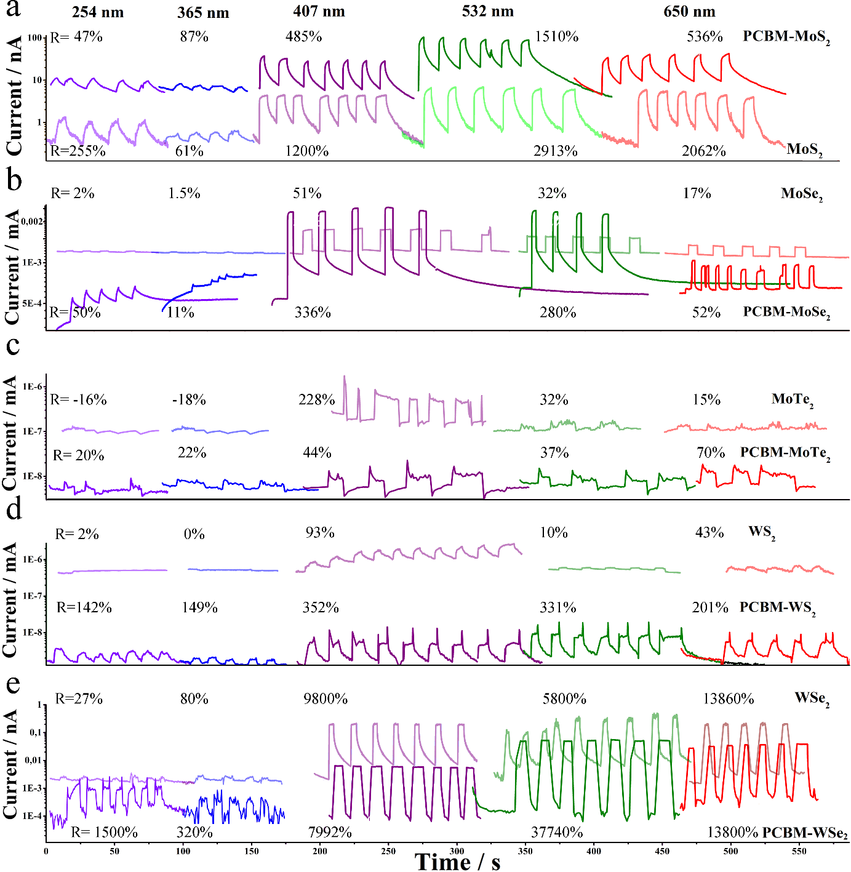
Figure 6. Photo-response of semiconducting (a) PCBM-MoS₂ (opaque line) and pristine MoS₂ (semitransparent line), (b) PCBM-MoSe₂ (opaque line) and pristine MoSe₂ (semitransparent line), (c) MoTe₂ (opaque line) and pristine MoTe₂ (semitransparent line), (d) PCBM-WS₂ (opaque line) and pristine WS₂ (semitransparent line) and (e) PCBM-WSe₂ (opaque line) and pristine WSe₂ (semitransparent line) at 254 (violet), 365 (blue), 407(purple), 532 (green), and 650 nm (red) light excitation. Response and laser excitation are labeled in the picture.
Finally, the best outcomes from this work are compared to other PCBM hybrids listed in the bibliography. No evidence of covalent functionalization is found. Instead, non-covalent functionalization between PCBM and TMDs is reported in a few publications that focus on composites. Thus, The photoresponse between 400-500 nm of composites based on WS₂ and PCBM became comparable to our hybrid PCBM-WS₂ upon the addition of a third component (Poly-(N, N'-bis-4-butylphenyl-N, N'-bisphenyl) benzidine which modifies the ground state of the hybrid material.^{[71,72]} PCBM-WSe₂ exhibits significant improvements of the electronic properties in comparison with the PCBM and WSe₂ composites described in the bibliography.^{[73]} For example, the photo-response enhance 7 folds in our PCMB-WS_{2,} whereas nanocomposites show only a 16% improvement.^{[47]} Composites of PCBM with layered MoS₂ shows alignment type II and were employed in catalytic purposes^{[74]} and for create memory devices,^{[36]} handicapping any reliable comparison. However, at low PCBM concentration (0.2%) the conductivity of the system is double at 1 V_{DS} whereas in our PCBM-MoS₂ the value increases 17-folds. Unfortunately, no comparable data were found in the bibliography for PCBM-MoTe₂ or PCBM-MoSe₂. Overall, our results highlight the potential of PCBM-Cys as an effective approach for enhancing the electronic properties of PCBM-TMDs FET devices and pave the way for the application of PCBM-TMDs in advanced electronic technologies, where improved device performance and enhanced charge transport are desired.
Table 2. Response, Responsivity and External Quantum Efficiency of 2D TMDs functionalized with 0D materials.
Material | R (%)ª | R_{λ} [A/W] | ΕQΕ [%] | Reference
COVALENT
Pyrene-WS₂ | -20 | - | - | [38]
ZnP-MoS₂ | 1200 | 4.9×10⁻⁵ | 1.4×10⁻² | [32]
ZnP-WS₂ | 600 | 2.3×10⁻⁵ | 7.3×10⁻³ | [32]
NiP-WS₂ | 300 | - | - | [49]
PCBM-MoS₂ | 1510; (150000 at -30 V_{G}) | 1.4 | 3.2×10² | This Work
PCBM-MoSe₂ | 336 | 2.1×10⁻² | 5 | This Work
PCBM-MoTe₂ | 44 | 2.2×10⁻³ | 5×10⁻¹ | This Work
PCBM-WS₂ | 352 | 5×10⁻⁵ | 9.6×10⁻³ | This Work
PCBM-WSe₂ | 37740 | 3.6×10⁻⁴ | 7×10⁻² | This Work
PCBM-Te₂ | 17 | 9×10⁻⁹ | 2.5×10⁻⁶ | This Work
PCBM-MoO₂ | 0 | 0 | 0 | This Work
PCBM-WO₂ | 47 | 3.1 | 1.0×10³ | This Work
NON-COVALENT
PbS/MoS₂ | 200 | - | - | [50]
Ge/WS₂ | 100000 | 0.6 |  | [51]
PbSe/MoS₂ | 1 | - | - | [52]
Perylene/MoS₂ | 15000 | 1×10³ |  | [53]
Au/MoTe₂ | - | 4×10⁻⁵ | - | [54]
Perylene/WS₂ | - | - | 2 | [55]
Methylene blue/MoS₂ | 1900 | - | - | [56]
ZnP/MoS₂ | 1500 | - | - | [57]
ZnP/WS₂ | 500 | - | - | [57]
ZnP/MoSe₂ | 5 | - | - | [57]
ZnP/WSe₂ | 5 | - | - | [57]
ZnP/MoS₂ | 800 | - | - | [58]
FeP/MoS₂ | 500 | - | - | [58]
H₂P/MoS₂ | 200 | - | - | [58]
GaP/MoS₂ | 200 | - | - | [58]
ZnPc/MoS₂ | 300000 | 4.3×10² | - | [37]
NiPc/WSe₂ | 230 | - | - | [59]
CuPc/MoS₂ | 800 | 2 | 13 | [60]
Rodamine/MoS₂ | - | 1.1 | 2.8×10² | [61]
BTP-4F/MoS₂ | 100000 | 3.2 | 7.6×10² | [62]
BTBT/MoS₂ | 300 | 4.7×10² | 1.5×10⁵ | [63]
MoO₂/MoSe₂ | 100000 | 0.1 | 2.3×10 | [64]
Carbon dots/MoS₂ | 80000 | 3.8×10² | - | [65]
IEICO-4F/WSe₂ | 350 | 8.32 | - | [66]
Polymer/Au/WS₂ | 8000 | 1.02 | 8 | [45]
MoS₂/C₆₀ | 1000 | - | 3.5×10 | [67,68]
WS₂/C₆₀ | - | - | 2.3×10 | [68]
WO₃/WS₂ |  | 2.5×10² | 8.5×10⁴ | [69]
Si/WS₂ |  | 4.3 | 1.1×10³ | [70]
^{a)} The best values of the photo response were shown at optimal excitation wavelength. Regarding bibliography, the values of V_{DS} and 0V_{G,} light power densities, temperatures and wavelengths remain unspecified .
Experimental Section
Synthesis:
6,6 -Phenyl C₆₁ butyric acid (PCBM-COOH): The ester owned in 6,6-Phenyl C₆₁ butyric acid methyl ester (PCBM) was hydrolyzed, resulting in the formation of PCBM-COOH compound, as described in the bibliography.^{[34]} Essentially, 300 mg of PCBM was sonicated in a solution of 3/7 acetic acid, 1/7 HCl, and 3/7 toluene with a volume of 100 ml. The mixture was then stirred at reflux overnight. Then, the material was purified. ¹H NMR (400 MHz, 1/1: (CD₃)₂SO/CD₃OD) δ 8.02 (d, J = 7.1 Hz, 2H), 7.58 (t, J = 7.4 Hz, 2H), 7.49 (t, J = 7.4 Hz, 1H), 2.92 (m, 2H), 2.42 (t, 2H), 2.05 (m, 2H). Maldi (C₇₁H₁₂O₂): Predicted= 896.08, 897.09, 898.09, 899.09, 900.10, experimental= 896.148, 897.163, 898.165, 899.188, 900.197. See spectroscopic characterization in figure S1.

N-([6,6] Phenyl C₆₁ butanoyl)cysteine (PCBM-Cys): First, 10 mg of PCBM-COOH, 134 mg of 1-Ethyl-3-(3-dimethylaminopropyl) carbodiimide (EDCI) (5 equiv.), and 100 mg of 4-Dimethylaminopyridine (DMAP) (5 equiv.) were dispersed in dry Tetrahydrofuran (THF) and sonicated for a few minutes. The mixture was then added dropwise to an ice-cooled solution of dry THF containing 132 mg of cysteine (20 equiv.) under stirring for 30 minutes. Subsequently, it was sonicated for 30 seconds and stirred on ice for 30-60 minutes. This stirring and sonication process was repeated multiple times. Finally, the solution was stirred overnight at temperatures below 50 ºC. The resulting product is brown and tends to adhere to the walls. It was purified by passing it through a 0.1 μm PTFE membrane filter. The material was then washed sequentially with hot water (20 ml), DMF (10 ml), acetone (10 ml), and DCM (1 ml). Finally, the PCBM-Cys was completely dried under vacuum overnight, yielding 50%. The material should be stored in a dark and cool environment.¹H NMR (400 MHz, CDCL₃) δ 7.92 (s, 1H), 7.53 (s, 4H), 5.65 – 4.76 (m, 1H), 2.90 (s, 2H), 2.57 – 2.41 (m, 1H), 2.28 (s, 4H), 2.03 (s, 2H). Maldi (C₇₄H₁₇NO₃S) predicted= 999.09,1000.10, 1001.10, 1002.10,1003.10, experimental= 999.222, 1000.229, 1001.236, 1003.244, 1003.253, 1004.255. IR, -NH and -CH₂-=3050-2800, -COOR- =1695, -CONR- =1653cm⁻¹, Aromatic=1550-1400 cm⁻¹. UV-Vis (NMP): 329 nm, 490 nm. PL (solid) 650-750 nm, Raman: D=1300, D´=1374, G=1566 cm⁻¹. XPS: 168.62 eV (thiol), 289.46 and 287.12 eV (carbonyl), 285.8 (C-H), 285.04 (aromatic carbon). See information in figure S1.

Chemical Vapor deposition of TMDs: The CVD growth of all the TMDs was performed using a separator temperature controller AFM-9P-III ASH.^{[9,32,36]} The temperature controller allowed precise control of the growth conditions during the chemical vapor deposition process. Additionally, the Argon flow was monitored using a Horiba STEC controlled unit PE-D2O. This unit ensured accurate monitoring and control of the Argon gas flow rate, which is crucial for controlling the growth parameters and optimizing the growth process. For a more detailed explanation of the growth process and specific growth conditions for each TMD, please refer to the supporting information, experimental section, and table S1.

PCBM-TMDs covalent functionalization: The following procedure is valid for CVD-TMDs, on a substrate of HBN or SiO₂ with or without electrodes. MoS₂ (or WS₂) [or other TMDs] was immersed in 5ml of Dimethylacetamide, abbreviated as DMAc, with 2 mg PCBM-Cys. The reaction mixture was stirred at 1 revolution per minute (r.p.m) for 4 days under vacuum at a temperature of 50 ºC (or 40ºC) [or at room temperature] while being kept in the dark. Subsequently, the sample was cleaned by immersion in pure DMAc, repeating the cleaning process four times. To ensure the complete removal of non-covalently bound species, a Solhex extractor using carbon sulfide was employed. The sample was treated with carbon sulfide for a period of 12 to 24 hours to remove any residual non-covalent additives.
For information on substrate pre-treatment, TEM, AFM, PL, XPS methodologies, and device fabrication, please refer to the experimental section of the supporting documentation.

Conclusion
In this work we have developed a new methodology to conveniently insulate molecules on the basal plane of TMDs. Concretely, chemically modified PCBM interacts with chalcogen vacancies randomly dispersed around the surface of TMDs. The optical and electronic analysis shows that PCBM-MoS₂ and PCBM-MoTe₂ forms alignment type I whereas PCBM-MoSe₂, PCBM-WS₂ and PCBM-WSe₂ and bilayers of PCBM-MoS₂ have type II. Furthermore, PCBM produces no relevant changes at PCBM-WTe₂ and ultrathin PCBM-MoO₂ and PCBM-WO₂ hybrids. By synthesizing and functionalizing all the TMDs using the same methodology, a comprehensive and accurate comparison of the materials is possible. First, we found an enhancement of the TMDs emission in alignment type I, increasing 2-folds in PCBM-MoS₂ and PCBM-MoTe₂, with only PCBM-MoS₂ exhibiting an exceptional photo-response—a remarkable 150,000% enhancement under optimal conditions. In addition, new sharp bands associated with interlayer excitons were found in PCBM-MoSe₂, PCBM-WS₂ and PCBM-WSe₂ within the energy range of 1.29-1.71 eV. Further, PCBM-MoS₂, PCBM-MoSe₂, PCBM-WS₂ and PCBM-WSe₂ exhibit improvements in the photo-responses, rendering values of 150.000, 336, 352 and 37740%, respectively. Some of the best accomplishments include the time response of PCBM-WSe₂ and PCBM-MoSe₂, which were 0.001 and 0.1s, respectively. To the best of our knowledge, this is the first time that one covalent functionalization technique has been proved with multiple TMDs. This technique allows to perform excellent transistors and straightforward comparison between different properties of the materials, fact that makes this work pioneering and paves the way to develop more efficient nanodevices^{[75]} based on transition metal dichalcogenides and zero-dimensional materials.
Supporting Information
The authors have cited additional references within the Supporting Information.^{[76-99]}
Acknowledgements
This project has received funding from Japan Society for the Promotion of Science (JSPS) postdoctoral fellowship grant agreement No P19368. We thank Kaori Asai for her proofreading.
Keywords: PCBM • nanomaterials • covalent functionalization • TMDs • energy conversion
[] E. A. J. Bleeker, W. H. de Jong, R. E. Geertsma, M. Groenewold, E. H. W. Heugens, M. Koers-Jacquemijns, D. van de Meent, J. R. Popma, A. G. Rietveld, S. W. P. Wijnhoven, F. R. Cassee, A. G. Oomen. Regul. Toxicol. Pharmacol. 2013, 65 (1), 119–125. DOI:10.1016/j.yrtph.2012.11.007.
[2] A. K. Geim, K. S. Novoselov. Nanosci. Technol. 2009, 11–19. DOI:10.1142/9789814287005_0002.
[3] R. Verdejo, M. M. Bernal, L. J. Romasanta, F. J. Tapiador, M. A. Lopez-Manchado. Cell. Polym. 2011, 30 (2), 45–62. DOI:10.1177/026248931103000201.
[4] T. Hotta, A. Ueda, S. Higuchi, M. Okada, T. Shimizu, T. Kubo, K. Ueno, T. Taniguchi, K. Watanabe, R. Kitaura. ACS Nano 2020, 15 (1), 1370–1377. DOI:10.1021/acsnano.0c08642.
[5] T. Iwasaki, K. Endo, E. Watanabe, D. Tsuya, Y. Morita, S. Nakaharai, Y. Noguchi, Y. Wakayama, K. Watanabe, T. Taniguchi, S. Moriyama. ACS Appl. Mater. Interfaces 2020, 12 (7), 8533–8538. DOI:10.1021/acsami.9b19191.
[6] Y. Li, A. Chernikov, X. Zhang, A. Rigosi, H. M. Hill, A. M. van der Zande, D. A. Chenet, E.-M. Shih, J. Hone, T. F. Heinz. Phys. Rev. B 2014, 90 (20). DOI:10.1103/physrevb.90.205422.
[7] S. Pace, L. Martini, D. Convertino, D. H. Keum, S. Forti, S. Pezzini, F. Fabbri, V. Mišeikis, C. Coletti. ACS Nano 2021, 15 (3), 4213–4225. DOI:10.1021/acsnano.0c05936.
[8] H. Li, G. Lu, Z. Yin, Q. He, H. Li, Q. Zhang, H. Zhang. Small 2012, 8 (5), 682–686. DOI:10.1002/smll.201101958.
[9] R. Canton-Vitoria, T. Hotta, Z. Liu, T. Inoue, R. Kitaura. J. Chem. Phys. 2020, 153 (8), 084702. DOI:10.1063/5.0012782.
[10] P. Tonndorf, R. Schmidt, P. Böttger, X. Zhang, J. Börner, A. Liebig, M. Albrecht, C. Kloc, O. Gordan, D. R. Zahn, S. M. de Vasconcellos, R. Bratschitsch. CLEO: 2013, 2013. DOI:10.1364/cleo_qels.2013.qtu1d.1.
[11] C. Ruppert, B. Aslan, T. F. Heinz. Nano Lett. 2014, 14 (11), 6231–6236. DOI:10.1021/nl502557g.
[12] J. Zhou, J. Lin, X. Huang, Y. Zhou, Y. Chen, J. Xia, H. Wang, Y. Xie, H. Yu, J. Lei, D. Wu, F. Liu, Q. Fu, Q. Zeng, C.-H. Hsu, C. Yang, L. Lu, T. Yu, Z. Shen, H. Lin, B. I. Yakobson, Q. Liu, K. Suenaga, G. Liu, Z. Liu. Nature 2018, 556 (7701), 355–359. DOI:10.1038/s41586-018-0008-3.
[13] P.-C. Shen, C. Su, Y. Lin, A.-S. Chou, C.-C. Cheng, J.-H. Park, M.-H. Chiu, A.-Y. Lu, H.-L. Tang, M. M. Tavakoli, G. Pitner, X. Ji, Z. Cai, N. Mao, J. Wang, V. Tung, J. Li, J. Bokor, A. Zettl, C.-I. Wu, T. Palacios, L.-J. Li, J. Kong. Nature 2021, 593 (7858), 211–217. DOI:10.1038/s41586-021-03472-9.
[14] M. Okada, A. Kutana, Y. Kureishi, Y. Kobayashi, Y. Saito, T. Saito, K. Watanabe, T. Taniguchi, S. Gupta, Y. Miyata, B. I. Yakobson, H. Shinohara, R. Kitaura. ACS Nano 2018, 12 (3), 2498–2505. DOI:10.1021/acsnano.7b08253.
[15] K. Otsuka, N. Fang, D. Yamashita, T. Taniguchi, K. Watanabe, Y. K. Kato. Nat. Commun. 2021, 12 (1). DOI:10.1038/s41467-021-23413-4.
[16] A. J. Watson, W. Lu, M. H. Guimarães, M. Stöhr. 2D Mater. 2021, 8 (3), 032001. DOI:10.1088/2053-1583/abf234.
[17] T. Akamatsu, T. Ideue, L. Zhou, Y. Dong, S. Kitamura, M. Yoshii, D. Yang, M. Onga, Y. Nakagawa, K. Watanabe, T. Taniguchi, J. Laurienzo, J. Huang, Z. Ye, T. Morimoto, H. Yuan, Y. Iwasa. Science 2021, 372 (6537), 68–72. DOI:10.1126/science.aaz9146.
[18] S. Zhang, M. Maruyama, S. Okuda, M. Xue, K. W., T. Taniguchi, K. Hashimoto, Y. Miyata, R. Canton-Vitoria, R. Kitaura. Observation of the Photovoltaic Effect in a van der Waals Heterostructure. Nanoscale, 2023, 15, (12), 5948–5953. DOI: 10.1039/D2NR06616E
[19] J. Cenker, S. Sivakumar, K. Xie, A. Miller, P. Thijssen, Z. Liu, A. Dismukes, J. Fonseca, E. Anderson, X. Zhu, X. Roy, D. Xiao, J.-H. Chu, T. Cao, X. Xu. Nat. Nanotechnol." 2022, 17 (3), 256–261. DOI:10.1038/s41565-021-01052-6.
[20] K. Ulman, S. Y. Quek. Nano Lett. 2021, 21 (20), 8888–8894. DOI:10.1021/acs.nanolett.1c03435.
[21] S. P. Ogilvie, M. J. Large, G. Fratta, M. Meloni, R. Canton-Vitoria, N. Tagmatarchis, F. Massuyeau, C. P. Ewels, A. A. King, A. B. Dalton. Sci. Rep. 2017, 7 (1). DOI:10.1038/s41598-017-17123-5.
[22] Q. Ding, K. J. Czech, Y. Zhao, J. Zhai, R. J. Hamers, J. C. Wright, S. Jin. ACS Appl. Mater. Interfaces 2017, 9 (14), 12734–12742. DOI:10.1021/acsami.7b01262.
[23] S. S. Chou, M. De, J. Kim, S. Byun, C. Dykstra, J. Yu, J. Huang, V. P. J. Am. Chem. Soc. 2013, 135 (12), 4584–4587. DOI:10.1021/ja310929s.
[24] D. M. Sim, M. Kim, S. Yim, M.-J. Choi, J. Choi, S. Yoo, Y. S. Jung. ACS Nano 2015, 9 (12), 12115–12123. DOI:10.1021/acsnano.5b05173.
[25] M. Makarova, Y. Okawa, M. Aono. J. Phys. Chem. C 2012, 116 (42), 22411–22416. DOI:10.1021/jp307267h.
[26] Z. Wei, Z. Guan, N. Shan, H. Li, Y. Fang, Y. Zhao, L. Fu, Z. Huang, M. G. Humphrey, C. Zhang. J. Alloy. Compd. 2023, 934, 167902. DOI:10.1016/j.jallcom.2022.167902.
[27] R. Canton-Vitoria, Y. Sayed-Ahmad-Baraza, M. Pelaez-Fernandez, R. Arenal, C. Bittencourt, C. P. Ewels, N. Tagmatarchis. npj 2D Mater. Appl. 2017, 1 (1). DOI:10.1038/s41699-017-0012-8.
[28] L. Vallan, R. Canton-Vitoria, H. B. Gobeze, Y. Jang, R. Arenal, A. M. Benito, W. K. Maser, F. D’Souza, N. Tagmatarchis. J. Am. Chem. Soc. 2018, 140 (41), 13488–13496. DOI:10.1021/jacs.8b09204.
[29] R. Canton-Vitoria, T. Scharl, A. Stergiou, A. Cadranel, R. Arenal, D. M. Guldi, N. Tagmatarchis. Angew. Chem. Int. Ed. 2020, 59 (10), 3976–3981. DOI:10.1002/anie.201914494.
[30] R. Canton-Vitoria, H. B. Gobeze, V. M. Blas-Ferrando, J. Ortiz, Y. Jang, F. Fernández-Lázaro, Á. Sastre-Santos, Y. Nakanishi, H. Shinohara, F. D’Souza, N. Tagmatarchis. Angew. Chem. Int. Ed. 2019, 131 (17), 5768–5773. DOI:10.1002/ange.201900101.
[31] I. K. Sideri, Y. Jang, J. Garcés-Garcés, Á. Sastre-Santos, R. Canton-Vitoria, R. Kitaura, F. Fernández-Lázaro, F. D’Souza, N. Tagmatarchis. Angew. Chem. Int. Ed. 2021, 60 (16), 9120–9126. DOI:10.1002/anie.202016249.
[32] R. Canton-Vitoria, T. Hotta, Y. Tanuma, I. K. Sideri, N. Tagmatarchis, C. Ewels, R. Kitaura. J. Phys. Chem. C 2023. DOI:10.1021/acs.jpcc.2c08009.
[33] R. Canton-Vitoria, K. Sato, Y. Motooka, S. Toyokuni, Z. Liu, R. Kitaura. Nanoscale 2023, 15 (9), 4570–4580. DOI:10.1039/d2nr06630k.
[34] Q. Wei, T. Nishizawa, K. Tajima, K. Hashimoto. Adv. Mater. 2008, 20 (11), 2211–2216. DOI:10.1002/adma.200792876.
[35] J. A. Mikroyannidis, A. N. Kabanakis, S. S. Sharma, G. D. Sharma. Adv. Funct. Mater. 2010, 21 (4), 746–755. DOI:10.1002/adfm.201001807.
[36] R. Canton-Vitoria, T. Hotta, M. Xue, S. Zhang, R. Kitaura. JACS AU 2023, 775–784. DOI:10.1021/jacsau.2c00536.
[37] A. Stergiou, C. Stangel, R. Canton-Vitoria, R. Kitaura, N. Tagmatarchis. Nanoscale 2021. DOI:10.1039/d1nr00404b.
[38] R. Canton-Vitoria, S. Nufer, X. Che, Y. Sayed-Ahmad-Baraza, R. Arenal, C. Bittencourt, A. Brunton, A. B. Dalton, C. P. Ewels, N. Tagmatarchis. Pyrene-functionalized tungsten disulfide as stable resistive photosensor. Mat. Adv. 2020, 1 (7), 2459–2466. DOI:10.1039/d0ma00429d.
[39] M. Blanco, M. Lunardon, M. Bortoli, D. Mosconi, L. Girardi, L. Orian, S. Agnoli, G. Granozzi. J. Mater. Chem. A 2020, 8 (21), 11019–11030. DOI:10.1039/d0ta03302b.
[40] N. Dong, Y. Li, Y. Feng, S. Zhang, X. Zhang, C. Chang, J. Fan, L. Zhang, J. Wang. Sci. Rep. 2015, 5 (1). DOI:10.1038/srep14646.
[41] W. Lv, H. Wang, L. Jia, X. Tang, C. Lin, L. Yuwen, L. Wang, W. Huang, R. Chen. ACS Appl. Mater. Interfaces 2018, 10 (7), 6552–6559. DOI:10.1021/acsami.7b16878.
[42] Y. Huang, F. Zhuge, J. Hou, L. Lv, P. Luo, N. Zhou, L. Gan, T. Zhai. Van Der Waals Coupled organic molecules with monolayer MoS₂ for fast response photodetectors with gate-tunable responsivity. ACS Nano 2018, 12 (4), 4062–4073. DOI:10.1021/acsnano.8b02380.
[43] J. Kang, S. Tongay, J. Zhou, J. Li, J. Wu. Appl. Phys. Lett. 2013, 102 (1), 012111. DOI:10.1063/1.4774090.
[44] H. Liu, C. Wang, D. Liu, J. Luo. Nanoscale 2019, 11 (16), 7913–7920. DOI:10.1039/c9nr00967a.
[45] R. Kaupmees, M. Grossberg, M. Ney, A. Asaithambi, A. Lorke, J. Krustok. Phys. Status Solidi RRL 2019, 14 (2), 1900355. DOI:10.1002/pssr.201900355.
[46] J. Maibach, E. Mankel, T. Mayer, W. Jaegermann. J. Mater. Chem. C 2013, 1 (45), 7635. DOI:10.1039/c3tc31745e.
[47] Y. Zhong, S. Izawa, K. Hashimoto, K. Tajima, T. Koganezawa, H. Yoshida. J. Phys. Chem. C 2014, 119 (1), 23–28. DOI:10.1021/jp506296j.
[48] E. Pu, D. Liu, P. Ren, W. Zhou, D. Tang, B. Xiang, Y. Wang, J. Miao. AIP Adv. 2017, 7 (2), 025015. DOI:10.1063/1.4977543.
[49] M. P. Minadakis, R. Canton-Vitoria, C. Stangel, E. Klontzas, R. Arenal, J. Hernández-Ferrer, A. M. Benito, W. K. Maser, N. Tagmatarchis. ChemSusChem 2023, 16 (8). DOI:10.1002/cssc.202202322.
[50] D. Kufer, I. Nikitskiy, T. Lasanta, G. Navickaite, F. H. Koppens, G. Konstantatos. Adv. Mater. 2014, 27 (1), 176–180. DOI:10.1002/adma.201402471.
[51] D. Wu, J. Guo, C. Wang, X. Ren, Y. Chen, P. Lin, L. Zeng, Z. Shi, X. J. Li, C.-X. Shan, J. Jie. ACS Nano 2021, 15 (6), 10119–10129. DOI:10.1021/acsnano.1c02007.
[52] J. Schornbaum, B. Winter, S. P. Schießl, F. Gannott, G. Katsukis, D. M. Guldi, E. Spiecker, J. Zaumseil. Epitaxial growth of pbse quantum dots on MoS₂ nanosheets and their near-infrared photoresponse. Adv. Funct. Mater. 2014, 24 (37), 5798–5806. DOI:10.1002/adfm.201400330.
[53] X. Xu, Z. Chen, B. Sun, Y. Zhao, L. Tao, J.-B. Xu. Sci. Bull. 2019, 64 (22), 1700–1706. DOI:10.1016/j.scib.2019.09.009.
[54] J. Lai, D. Sun, J.-H. Chen, S. Zhou, J. Feng, Y. Li, Y. Wu, X. Zhuo, Q. Gu, Y. Liu, X. Ren, K. Zhang, Q. Wang, J. Ma, X. Liu. Adv. Mater. 2018, 30 (30), 1870220. DOI:10.1002/adma.201870220.
[55] X. Liu, J. Gu, K. Ding, D. Fan, X. Hu, Y.-W. Tseng, Y.-H. Lee, V. Menon, S. R. Forrest. Nano Lett. 2017, 17 (5), 3176–3181. DOI:10.1021/acs.nanolett.7b00695.
[56] Y. Huang, W. Zheng, Y. Qiu, P. Hu. ACS Appl. Mater. Interfaces 2016, 8 (35), 23362–23370. DOI:10.1021/acsami.6b06968.
[57] H. Zhang, J. Ji, A. A. Gonzalez, J. H. Choi. J. Mater. Chem. C 2017, 5 (43), 11233–11238. DOI:10.1039/c7tc02861j.
[58] H. Zhang, J. Choi, A. Ramani, D. Voiry, S. N. Natoli, M. Chhowalla, D. R. McMillin, J. H. Choi. ChemPhysChem 2016, 17 (18), 2854–2862. DOI:10.1002/cphc.201600511.
[59] J. Choi, H. Zhang, J. H. Choi. ACS Nano 2016, 10 (1), 1671–1680. DOI:10.1021/acsnano.5b07457.
[60] J. Pak, J. Jang, K. Cho, T.-Y. Kim, J.-K. Kim, Y. Song, W.-K. Hong, M. Min, H. Lee, T. Lee. Nanoscale 2015, 7 (44), 18780–18788. DOI:10.1039/c5nr04836b.
[61] S. H. Yu, Y. Lee, S. K. Jang, J. Kang, J. Jeon, C. Lee, J. Y. Lee, H. Kim, E. Hwang, S. Lee, J. H. Cho, ACS Nano 2014, 8 (8), 8285–8291. DOI:10.1021/nn502715h.
[62] Z. Xu, M. He, Q. Wu, C. Wu, X. Li, B. Liu, M. Tang, J. Yao, G. Wei. Adv. Sci. 2023, 10 (12). DOI:10.1002/advs.202207743.
[63] B. Zhao, Z. Gan, M. Johnson, E. Najafidehaghani, T. Rejek, A. George, R. H. Fink, A. Turchanin, M. Halik. Adv. Funct. Mater. 2021, 31 (42), 2105444. DOI:10.1002/adfm.202105444.
[64] N. Wazir, R. Liu, C. Ding, X. Wang, X. Ye, X. Ling, T. Lu, L. Wei, B. Zou. ACS Appl. Nano Mater. 2020, 3 (8), 7543–7553. DOI:10.1021/acsanm.0c01195.
[65] H. Liu, F. Gao, Y. Hu, J. Zhang, L. Wang, W. Feng, J. Hou, P. Hu. 2D Mater. 2019, 6 (3), 035025. DOI:10.1088/2053-1583/ab1c20.
[66] Q. Zhu, Y. Chen, T. Chen, L. Zuo, Y. Sun, R. Wang, M. Xu. Nano Res. 2022, 15 (9), 8595–8602. DOI:10.1007/s12274-022-4488-y.
[67] Y. Xing, Y. Wang, L. Liu, Z. Wu. Micromachines 2023, 14 (3), 660. DOI:10.3390/mi14030660.
[68] J. Baek, T. Umeyama, W. Choi, Y. Tsutsui, H. Yamada, S. Seki, H. Imahori. Eur. J. Chem. 2017, 24 (7), 1561–1572. DOI:10.1002/chem.201703699.
[69] S. Maity, K. Sarkar, P. Kumar. Nanoscale, 2023, 15, 16068-16079. DOI: 10.1039/D3NR03754A
[70] S. Pal, S. Mukherjee, R. Jangir, D. Jana, S. K. Mandal, S. Bhunia, C. Mukherjee, S. N. Jha, S. K. Ray. ACS Appl. Nano Mater. 2021, 4, 3241–3251. DOI: 10.1021/acsanm.1c00421
[71] F. Huang, J. Z. Li, Z. H. Xu, Y. Liu, R. P. Luo, S. W. Zhang, P. B. Nie, Lv, S. X. Zhao, W. T. Su, Li, S. X. Zhao, G. D. Wei, H. C. Kuo, F. Y. Kang. Nanomaterials 2019, 9 (9), 1312. DOI:10.3390/nano9091312.
[72] L. Najafi, V. Romano, R. Oropesa‐Nuñez, M. Prato, S. Lauciello, G. D’Angelo, S. Bellani, F. Bonaccorso. Small Structur. 2020, 2 (3), 2000098. DOI:10.1002/sstr.202000098.
[73] H. Liu, S. Hussain, J. Lee, D. Vikraman, J. Kang. Materials 2021, 14 (12), 3206. DOI:10.3390/ma14123206.
[74] S. Bellani, L. Najafi, A. Capasso, A. E. Del Rio Castillo, M. R. Antognazza, F. Bonaccorso. J. Mater. Chem. A 2017, 5 (9), 4384–4396. DOI:10.1039/c6ta10572f.
[75] J. Jiang, Y. Wen, H. Wang, L. Yin, R. Cheng, C. Liu, L. Feng, J. He. Adv. Electron. Mater. 2021, 7 (7), 2001125. DOI:10.1002/aelm.202001125.
[76] S. Golovynskyi, O. I. Datsenko, D. Dong, Y. Lin, I. Irfan, B. Li, D. Lin, J. Qu. J. Phys. Chem. C 2021, 125 (32), 17806–17819. DOI:10.1021/acs.jpcc.1c04334.
[77] P. Soubelet, A. E. Bruchhausen, A. Fainstein, K. Nogajewski, C. Faugeras. Physical Review B 2016, 93 (15). DOI:10.1103/physrevb.93.155407.
[78] P. Vishnoi, A. Sampath, U. V. Waghmare, C. N. Rao. Eur. J. Chem. 2016, 23 (4), 886–895. DOI:10.1002/chem.201604176.
[79] B. Salhi, F. Vaurette, B. Grandidier, D. Stiévenard, O. Melnyk, Y. Coffinier, R. Boukherroub. Nanotechnol. 2009, 20 (23), 235601. DOI:10.1088/0957-4484/20/23/235601.
[80] L. Zhou, K. Xu, A. Zubair, X. Zhang, F. Ouyang, T. Palacios, M. S. Dresselhaus, Y. Li, J. Kong. Adv. Func. Mater. 2016, 27 (3), 1603491. DOI:10.1002/adfm.201603491.
[81] S. Cho, S. Kim, J. H. Kim, J. Zhao, J. Seok, D. H. Keum, J. Baik, D. H. Choe, K. J. Chang, K. Suenaga, S. W. Kim, Y. H. Lee, H. Yang. Science 2015, 349 (6248), 625–628. DOI:10.1126/science.aab3175.
[82] B. Sirota, N. Glavin, S. Krylyuk, A. V. Davydov, A. A. Voevodin. Sci. Rep.2018, 8 (1). DOI:10.1038/s41598-018-26751-4.
[83] F. Perrozzi, S. M. Emamjomeh, V. Paolucci, G. Taglieri, L. Ottaviano, C. Cantalini. Sens. Actuators B Chem. 2017, 243, 812–822. DOI:10.1016/j.snb.2016.12.069.
[84] A. Han, X. Zhou, X. Wang, S. Liu, Q. Xiong, Q. Zhang, L. Gu, Z. Zhuang, W. Zhang, F. Li, D. Wang, L. J. Li, Y. Li. Nat. Comm. 2021, 12 (1). DOI:10.1038/s41467-021-20951-9.
[85] Z. Liu, N. Li, C. Su, H. Zhao, L. Xu, Z. Yin, J. Li, Y. Du. Nano Energy 2018, 50, 176–181. DOI:10.1016/j.nanoen.2018.05.019.
[86] R. Zhang, D. Drysdale, V. Koutsos, R. Cheung. Adv. Funct. Mater. 2017, 27 (41), 1702455. DOI:10.1002/adfm.201702455
[87] X. Ma, P. Guo, C. Yi, Q. Yu, A. Zhang, J. Ji, Y. Tian, F. Jin, Y. Wang, K. Liu, T. Xia, Y. Shi, Q. Zhang. Physical Review B 2016, 94 (21). DOI:10.1103/physrevb.94.214105.
[88] Y. C. Jiang, J. Gao, L. Wang. Sci.Rep. 2016, 6 (1). DOI:10.1038/srep19624.
[89] A. Apte, K. Mozaffari, F. S. Samghabadi, J. A. Hachtel, L. Chang, S. Susarla, J. C. Idrobo, D. C. Moore, N. R. Glavin, D. Litvinov, P. Sharma, A. B. Puthirath, P. M. Ajayan. Adv. Mater. 2020, 32 (24), 2000006. DOI:10.1002/adma.202000006.
[90] J. Moosburger-Will, J. Kündel, M. Klemm, S. Horn, P. Hofmann, U. Schwingenschlögl, V. Eyert. Phys. Rev. B 2009, 79 (11). DOI:10.1103/physrevb.79.115113.
[91] R. Narro-García. Int. J. Electrochem 2017, 3907–3915. DOI:10.20964/2017.05.51.
[92] Ramakant Srivastava, L. L. Chase.Sol. St. Comm., Vol. 11, PP. 349—353, 1972. DOI: 10.1016/0038-1098(72)90247-5.
[93] P. A. Spevack, N. S. McIntyre. J. Phys. Chem. 1992, 96, 22, 9029–9035. DOI: 10.1021/j100201a062
[94] C. Lyu, L. Zhang, X. Zhang, H. Zhang, H. Xie, J. Zhang, Y. Liu, Y. Liu, R. Wu, J. Zhang, C. Zha, W. Wang, Z. Wan, B. Li, C. Ma, H. Duan, X. Wang. Adv. Mater. 2023, 35 (12), 2207895. DOI:10.1002/adma.202207895.
[95] R. Wu, J. Zhang, Y. Shi, D. Liu, B. Zhang. J. Am. Chem. Soc. 2015, 137 (22), 6983–6986. DOI:10.1021/jacs.5b01330.
[96] R. Canton-Vitoria, Y. Sayed-Ahmad-Baraza, B. Humbert, R. Arenal, C. Ewels, N. Tagmatarchis. Nanomaterials 2020, 10 (2), 363. DOI:10.3390/nano10020363.
[97] M. F. Daniel, B. Desbat, J. C. Lassegues, B. Gerand, M. Figlarz. J. Solid State Chem. 1987, 67 (2), 235–247. DOI:10.1016/0022-4596(87)90359-8.
[98] M. Köppen. Condens. Matter. 2019, 4 (3), 82. DOI:10.3390/condmat4030082.
[99] J. Ghosh, P. Giri. J. Phys Materials, 2021, 4, 032008. DOI: 10.1088/2515-7639/abf544

Entry for the Table of Contents
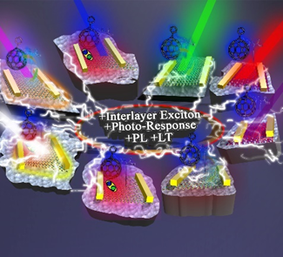

The PCBM was insulated onto the surfaces of ten transition metal dichalcogenides (TMDs) through covalent functionalization. Comprehensive studies were conducted on their optical and electronic properties, including photoluminescence, conductivity, and photo-response. PCBM customized the properties of each TMDs, classifying them into three groups based on alignment: type I, type II, and metallic.

Institute and/or researcher Twitter usernames: @EIEgr; @chemiproject

