Supplementary information

Crystal Structure and Physical Properties of Au₄Al-Type Suboxides in the Ti-Rh-Si-O and Ti-Ir-Si-O Systems

Zhijun Li,^{1,2,*} Xun Kang,^{1,2} Xuan Liang,^{1,2} Alexei A. Belik,¹ Masao Arai,³
Kazunari Yamaura^{1,2,*} Rintaro Oshikiri,⁴ Asuka Ishikawa,⁴ Takafumi D. Yamamoto,⁴
Shintaro Suzuki,^{4,#} Ryuji Tamura ⁴

- Research Center for Materials Nanoarchitectonics (MANA), National Institute for Materials Science (NIMS), 1-1 Namiki, Tsukuba, Ibaraki 305-0044, Japan
- Graduate School of Chemical Sciences and Engineering, Hokkaido University, North 10 West 8, Kita-ku, Sapporo, Hokkaido 060-0810, Japan
- Center for Basic Research on Materials, National Institute for Materials Science (NIMS), 1-1 Namiki, Tsukuba, Ibaraki 305-0044, Japan
- Department of Materials Science and Technology, Tokyo University of Science, 6-3-1 Niijuku, Katsushika-ku, Tokyo 125-8585, Japan

Corresponding Author
* Zhijun Li and Kazunari Yamaura
Quantum Solid State Materials Group
Research Center for Functional Materials
National Institute for Materials Science
1-1-Namiki, Tsukuba, Ibaraki 305-0044, Japan
TEL: +81-29-860-4658
E-mail: Li.Zhijun@nims.go.jp and YAMAURA.Kazunari@nims.go.jp

Present Address
# Shintaro Suzuki
Department of Physical Sciences, College of Science and Engineering, Aoyama Gakuin University, 5-10-1 Fuchinobe, Chuo-ku, Sagamihara, Kanagawa 252-5258, Japan

Figure S1: Lattice parameter a of the cubic phase for samples with nominal compositions Ti₈₈Rh₃₄Si_{24-x}(SiO₂)_{x}, plotted as a function of x. The data show that the lattice parameter remains relatively constant across varying oxygen contents, indicating that oxygen introduction has minimal impact on the cubic lattice parameter. The dashed red line serves as a visual guide to the trend.

Figure S2: X-ray diffraction patterns of Ti₃MSiO (M = Rh, Rh_{0.5}Ir_{0.5}, Ir) measured using Cu-K_{α} radiation. The experimental data (colored lines) for all three samples show strong agreement with the calculated patterns (not displayed), confirming the formation of the cubic phase.

Figure S3: Temperature dependence of the lattice parameter and unit cell volume for cubic Ti₃RhSiO. (a) The lattice parameter a shows gradual thermal expansion with increasing temperature. (b) The unit cell volume V (red circles) and the thermal expansion coefficient (blue diamonds) both increase with temperature up to 800 K.
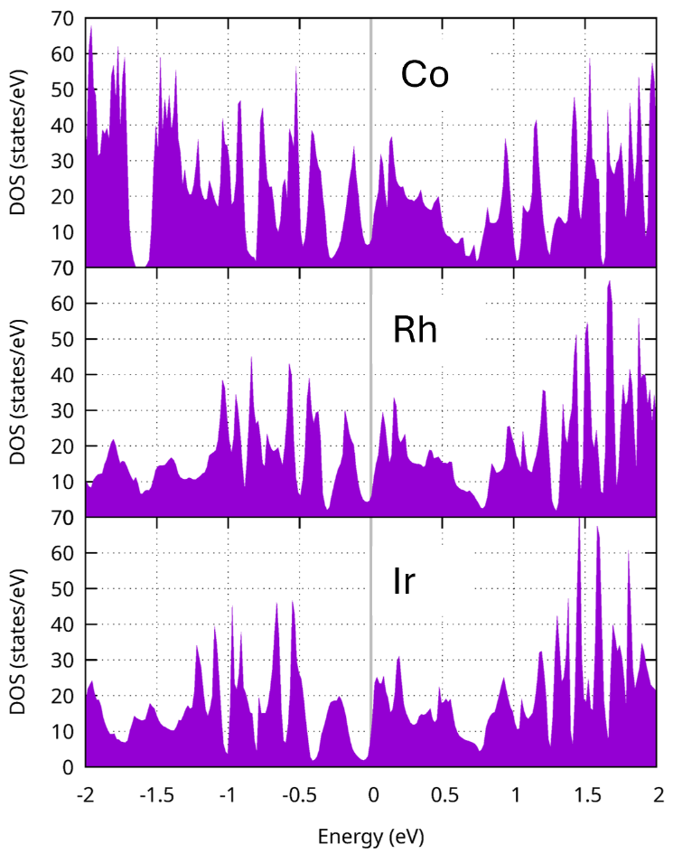
Figure S4: Density of States (DOS) for Ti₃MSiO compounds (M = Co, Rh, Ir) as a function of energy. The plots show the distribution of electronic states near the Fermi level (set at 0 eV) for Co, Rh, and Ir substitutions. Systematic variations in the DOS near the Fermi level are observed across the compounds, including notable drops resembling a quasi-gap. Note that the compound with M = Co has not been experimentally confirmed or synthesized in this study. The calculations were performed using the projector augmented wave method implemented in the Vienna Ab initio Simulation Package (VASP).^{1,2} The generalized gradient approximation (GGA) of density functional theory, with the Perdew-Burke-Ernzerhof exchange-correlation functional, was employed.³ Structural optimization was conducted by fully relaxing the cell shape and internal atomic coordinates based on the calculated stress and atomic forces. DOS were subsequently computed for the optimized structure.
References:
(1) Kresse, G.; Furthmüller, J. Efficiency of Ab-Initio Total Energy Calculations for Metals and Semiconductors Using a Plane-Wave Basis Set. Comput Mater Sci 1996, 6 (1), 15–50. https://doi.org/10.1016/0927-0256(96)00008-0.
(2) Kresse, G.; Joubert, D. From Ultrasoft Pseudopotentials to the Projector Augmented-Wave Method. Phys Rev B 1999, 59 (3), 1758–1775. https://doi.org/10.1103/PhysRevB.59.1758.
(3) Perdew, J. P.; Burke, K.; Ernzerhof, M. Generalized Gradient Approximation Made Simple. Phys Rev Lett 1996, 77 (18), 3865–3868. https://doi.org/10.1103/PhysRevLett.77.3865.

