High-performance Graphite||Li₄Ti₅O₁₂ Dual-ion Full Batteries Enabled by In-situ Formation of LiF-rich Solid Electrolyte Interphase on Li₄Ti₅O₁₂ Anode

Hekang Zhuª, Shuyu Dongª, Yu Zhaoª, Pui-Kit Leeª, Denis Y. W. Yu^{a,b *}

ªSchool of Energy and Environment, City University of Hong Kong, Tat Chee Avenue, Kowloon, Hong Kong, P.R. China
^{b}Research Center for Energy and Environmental Materials (GREEN), National Institute for Materials Science, Tsukuba, Ibaraki 305-0044, Japan.

- mail: yu.denis@nims.go.jp (Denis Y. W. Yu)

Figure S1. Selected cycling voltage profiles of graphite||LTO DIBs with (a) FEMC, (b) EMC, (c) EMC + LiDFOB electrolytes at 20 C. 5th, 50th,100th, 150th and 200th cycle for FEMC and EMC electrolytes, and the 50th, 500th, 1000th, 2000th, 3000th, 4000th, 4500th and 4950th cycle for EMC + LiDFOB electrolytes.

Figure S2. Coulombic efficiency of graphite||LTO DIBs cycling at 20 C with FEMC, EMC, EMC + LiDFOB or FEMC + LiDFOB electrolytes: (a) long cycling up to 8000 cycles, (b) the initial 200 cycles.

Figure S3. Cycling performance of graphite||Li half cells at 500 mA (g_{graphite})⁻¹ with cut-off voltage region: 3.0 - 5.2 V.

Figure S4. Cycling performance of LTO||Li batteries at 500 mA (g_{LTO})⁻¹ with cut-off voltage region: 1.0 - 3.0 V.

Figure S5. Self-discharge performance of graphite||Li DIBs with electrolytes (a) EMC or EMC + LiDFOB, (b) FEMC or FEMC + LiDFOB.

Figure S6. The first charge-discharge curves of (a) graphite||Li and (b) LTO||Li half cells. Cycling performance of the graphite||LTO DIBs in (c) EMC electrolyte or (d) FEMC electrolyte (2 cycles at 5 C followed by subsequent cycles in 20 C). Cycled graphite and cycled LTO refer to graphite and LTO electrodes cycled with (c) EMC + LiDFOB electrolyte or (d) FEMC + LiDFOB electrolyte when paired with a Li metal anode for two cycles. Capacity for (c) and (d) is calculated with respect to the mass of the graphite cathode.

Figure S7. XRD patterns of LTO electrodes after cycling in graphite||LTO dual-ion cells with (a) EMC or EMC+LiDFOB electrolytes, (b) FEMC or FEMC+LiDFOB electrolytes.

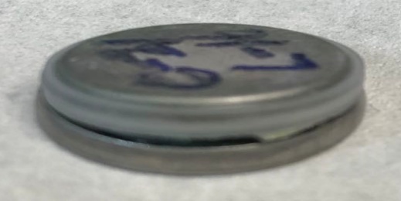
Figure S8. Opened coin cell of a graphite||LTO DIB with EMC electrolyte after cycling.

Figure S9. Electrochemical performance of DIBs with different amounts of LiDFOB additive in EMC electrolyte. (a) Voltage profiles of graphite||LTO cells during the initial cycle; (b) cycling performance with different amount of LiDFOB additive in the EMC electrolytes; (c) voltage profiles of the initial cycle of LTO||Li half batteries with different amount LiDFOB additive in EMC electrolyte.

Figure S10. Electrochemical performance of graphite||LTO DIBs with different amounts of LiDFOB additive in FEMC electrolyte. (a) Voltage profiles of the initial cycle; (b) cycling performance with different amounts of LiDFOB additive in the FEMC electrolytes.

Figure S11. (a) Rate performance of DIBs with different amounts of LiDFOB additive in EMC electrolyte. Voltage profiles of graphite||LTO cells (b) without LiDFOB additive and (c) with 2.5 wt. % LiDFOB additive at different charge/discharge current rates.

