On-Surface Synthesis of Polyene Linked Porphyrin Cooligomer
Kewei Sun^{1,2}, Atsushi Ishikawa³, Ryota Itaya⁴, Yuichiro Toichi⁴, Takuya Yamakado⁵, Atsuhiro Osuka⁵, Takayuki Tanaka⁵, Kazuyuki Sakamoto^{4,6}, Shigeki Kawai^{2,7}*

¹International Center for Young Scientists, National Institute for Materials Science, 1-2-1 Sengen, Tsukuba, Ibaraki 305-0047, Japan.
²Center for Basic Research on Materials, National Institute for Materials Science, 1-2-1 Sengen, Tsukuba, Ibaraki 305-0047, Japan.
³Department of Transdisciplinary Science and Engineering, School of Environment and Society, Tokyo Institute of Technology, 2-12-1 Ookayama, Meguro-ku, Tokyo, 152-8552, Japan.
⁴Department of Applied Physics, Osaka University, Osaka 565-0871, Japan.
⁵Graduate School of Science, Kyoto University, Kitashirakawa Oiwake-cho, Sakyo-ku, Kyoto 606-8502, Japan.
⁶Spintronics Research Network Division, Institute for Open and Transdisciplinary Research Initiatives, Osaka University, Osaka 565-0871, Japan.
⁷Graduate School of Pure and Applied Sciences, University of Tsukuba, Tsukuba 305-8571, Japan.

*KAWAI.Shigeki@nims.go.jp

Abstract
π-conjugated molecules are viewed as fundamental components in forthcoming molecular nanoelectronics, in which semiconducting functional units are linked to each other via metallic molecular wires. However, it is still challenging to construct such block cooligomers on surface. Here, we present a synthesis of [18]-polyene linked Zn-porphyrin cooligomers via two-step reaction of the alkyl groups on Cu(111) and Cu(110). Nonyl groups (-C₉H₁₉) substituted at the 5,15-meso positions of Zn-porphyrin were first transformed to alkenyl groups (-C₉H₁₀) by dehydrogenation. Subsequently, homocoupling of the terminal -CH₂ groups resulted in the formation of extended [18]-polyene linked porphyrin cooligomers. The structures of products at each reaction step were investigated by bond-resolved scanning tunneling microscopy at low temperature. A combination of angle-resolved photoemission spectroscopy and density functional theory calculations revealed the metallic property of the all trans [18]-polyene linker on Cu(110). This finding may provide an approach to fabricate complex nano-carbon structures on surface.

Keywords: On-surface synthesis, [18]-polyene linked Zn-porphyrin cooligomers, scanning tunneling microscopy, angle-resolved photoemission spectroscopy, density functional theory calculations.

π-conjugated molecules have attracted tremendous attention in the past decades due to the remarkable potential for application in molecular electronic devices^{1,2}. The delocalized valence electrons in molecules lead to tunable semiconducting properties³⁻⁵. To this end, a number of complex and large π-conjugated systems have been synthesized by coupling small molecules in solution^{6,7}. Since the solubility of products decreases with increasing the molecular mass, the alkyl groups are often introduced to each monomer⁶⁻⁸. However, to obtain sufficient solubility, the insulating alkyl groups usually take a major part of the products, which may deteriorate the electronic property and reduce thermal stability.
On-surface synthesis became an alternative approach for bottom-up fabrication of large π-conjugated systems with atomically defined structures. In this reaction, small precursor molecules are sublimed on surfaces in vacuum, and subsequently linked with each other by annealing^{9,10}. So far, various nanomaterials, such as nanographenes^{11,12}, graphene nanoribbons¹³⁻¹⁹, their hetero-structures²⁰⁻²⁴, and covalent organic frameworks²⁵⁻²⁷, have been successfully synthesized mainly by Ullmann-type coupling^{10,28,29} and/or cyclization¹¹⁻¹³. In order to increase the variety of products, several on-surface reactions have also been developed, such as Glaser-type coupling³⁰⁻³², Sonogashira-type coupling³³⁻³⁵, Bergman-type reaction^{36,37}and dehydrogenative coupling³⁸⁻⁴⁰. To facilitate the use of such products in the forthcoming electronic devices, it is of importance to conjugate conductive molecular wires (e.g. polyynic carbyne chain and polyacetylene) and functional units (e.g. fullerene and porphyrin) in a controlled way. However, such synthesis has remained challenging^{41,42}.
Here, we present on-surface synthesis of [18]-polyene linked Zn-porphyrin cooligomers as large π-conjugated molecular system. The nonyl groups (n-C₉H₁₉) substituted at the 5,15-meso positions of Zn-porphyrin were first transformed to alkenyl groups (n-C₉H₁₀) by dehydrogenation on Cu(111) and Cu(110). Subsequent homocoupling between the terminal -CH₂ groups resulted in formation of [18]-polyene linked Zn-porphyrin oligomers. The structures of the products after each reaction step were identified by bond-resolved scanning tunneling microscopy (STM) at 4.3 K. Density functional theory (DFT) calculations indicate that aromatic characters of Zn-porphyrin core were changed by dehydrogenation of the nonyl groups. Furthermore, a combination of angle-resolved photoemission spectroscopy (ARPES) and the DFT calculations revealed the metallic property of all trans [18]-polyene in the porphyrin cooligomer caused by strong interactions with Cu substrates.

Results and discussions
5,15-Dinonylporphyrinatozinc(II) (1), in which Zn-porphyrin core has two nonyl (C₉H₁₉) groups at the 5,15-meso positions, was employed as a precursor (Scheme 1). Zn-porphyrin and its derivatives are one of the important compounds for catalysis⁴³, solar cells⁴⁴, and optoelectronic devices⁴⁵. In addition, in contrast to the free-base porphyrin, the Zn center pulls pyrrole subunits inward, increasing the rigidity of the porphyrin core. The relatively flat adsorption geometry on surface would reduce the diffusion barrier⁴⁶, which may help for increase of the reaction yield. The nonyl groups (n-C₉H₁₉) transform into polyene groups (-C₉H₁₀) via dehydrogenation^{40,47} by annealing on Cu(111) and Cu(110) at 100 °C and 150 °C, respectively, yielding Zn-porphyrin with alkenyl (n-C₉H₁₀) groups 2. The intermolecular C-C coupling at the termini of the alkenyl groups is further caused at higher temperature, leading to the formation of [18]-polyene linked Zn-porphyrin oligomers 3. Unlike a sequential reaction of unit by unit to synthesis cooligomers⁴⁸, this method produces the cooligomers with well-defined alternating unit structures.

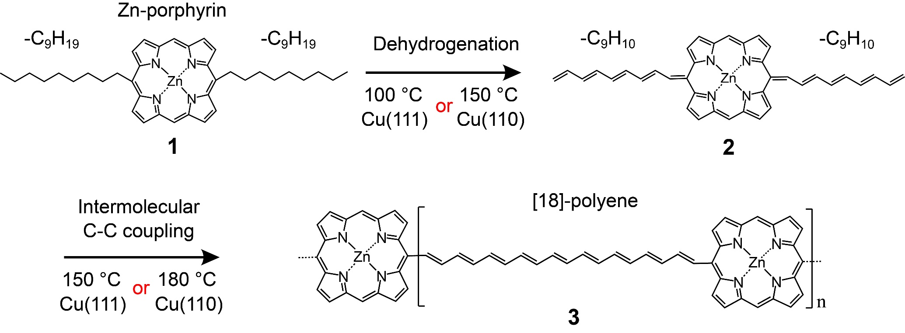
Scheme 1. Reaction process towards the formation of long cooligomers composed of Zn-porphyrin core and [18]-polyene linker on Cu(111) and Cu(110) surfaces.

We first deposited molecule 1 on Cu(111) held at room temperature under ultra-high vacuum condition and found formation of one-dimensional self-assemblies (Figure 1a). On close inspection, two types of structures were identified in the STM topographies. Type I was composed of alternating corrugated and dark square units with a periodic distance of 2.20 nm as indicated by yellow and blue arrows in Figure 1b, respectively. In order to resolve the inner structures, the tip apex was terminated by a CO molecule^{49,50} and scanned over the molecule at a constant height while recording the differential conductance dI/dV signal (Figure 1c). We found that the corrugated parts in the topography correspond to the alkyl groups, which are condensed to each other. Between the alkyl groups, four-fold symmetric Zn-porphyrin cores and even the pyrrole subunits were seen (Figure 1c). We found that the periodic distance of Type II (1.93 nm) is smaller than that of Type I (Figure 1d). Because the alkyl groups in Type II were extended to out of the longitudinal axis of one-dimensional structure, the porphyrin cores located closer to each other. The corresponding constant height dI/dV map shows that the length of the alkyl-alkyl contact of Type II was shorter than that of Type I (Figure 1e), indicating presence of a weaker van der Waals interaction. Since the statistical analysis over 144 linkers shows the ratio of Type I to Type II to be approximately 4:1, Type I is more stable than Type II. These self-assembled structures can be separated through tip manipulation (Figure S1). To gain a deeper insight to the structure, we conducted DFT calculation to obtain optimized geometries of the molecules on Cu(111). The initial configurations of the alkyl chains were derived from experimental STM images. Subsequent molecular dynamics (MD) simulations and DFT geometry optimizations of Type I and Type II yielded relaxed structures as shown in Figures 1f and 1g, respectively. The top views show that the terminus of the alkyl chains in Type II contact the porphyrin core, leading to a shorter periodic lattice spacing (1.99 nm) compared to Type I (2.22 nm). Additionally, the side views show that alkyl chains in both Type I and Type II protrude noticeably from the Cu(111) surface compared to the porphyrin core, resulting in distinct bright features in the constant height dI/dV maps (Figure 1c and 1e). Furthermore, we occasionally found individual 1 on Cu(111) (Figure S2). The alkyl chain exhibits a higher apparent height than the Zn-porphyrin core, which is further supported by the DFT calculations. (Figure S2). Note that the CO molecules tend to adsorb at the center of Zn-porphyrin core as indicated by arrows in Figure 1a (Figure S3).
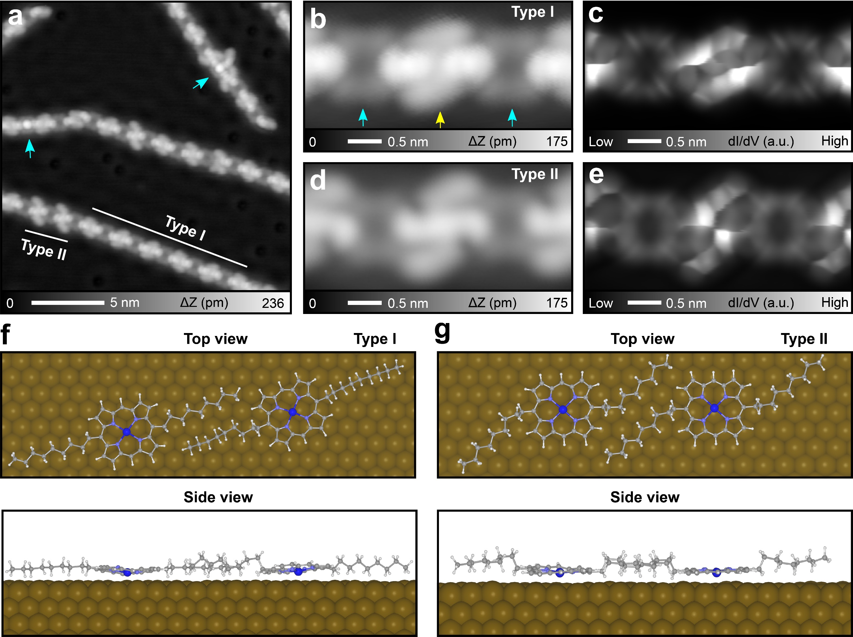
Figure 1. Self-assembly of Zn-porphyrin molecules on Cu(111). (a) STM topography of as-deposited 1 kept at room temperature. (b) Close-up view of Type I and (c) the corresponding constant height dI/dV map with a CO-tip. (d) Close-up view of Type II and (e) the corresponding dI/dV map. (f)(g) DFT-optimized self-assembled structures: (f)Type I and (g) Type II. Measurement parameters: Sample bias voltage V = 200 mV and tunneling current I = 2 pA in (a), V = 100 mV and I = 20 pA in (b), (d). STM characterization at 4.3 K.

Annealing at 100 °C for 5 min induced drastic changes of the molecular structures on surface. While the one-dimensional self-assembled structure disappeared, individual molecules with both straight and bent chains appeared as indicated by blue and red arrows, respectively (Figure 2a). We took a close-up view of the individual molecule indicated by a rectangle at the bottom of Figure 2a. Instead of the flexible alkyl groups, the straight chains were connected to the 5,15-meso positions of the porphyrin core (Figure 2b). Moreover, their longitudinal axes were offset against each other. Such observation suggests that the nonyl (n-C₉H₁₉) groups were transformed during the annealing process. The bond-resolved dI/dV map taken in a constant height mode (Figure 2c) and the corresponding Laplace filtered image (Figure 2d) provide detailed structural information. We found that the contrast of the straight chain is in good agreement with that in the previous report of on-surface [n]-polyene formation via dehydrogenation⁴⁰. Thus, the nonyl groups connected to the porphyrin core were transformed into the alkenyl (n-C₉H₁₀) groups (Figure 2e), that is product 2. The alkenyl group exhibits a lower apparent height than alkyl group, which was also confirmed by the DFT-optimized structures (Figure S2). The straight chain corresponds to all trans alkenyl group while the kink site arises from the cis isomer segment (Figure 2a and Figure S4). We also found bright dots at the termini of the chain as indicated by white arrows in Figure 2a. The corresponding constant height dI/dV map shows that the terminal methyl group still existed (Figure S5). This observation suggests that cascade dehydrogenation of the nonyl groups started at the α-methylene side (presumably with the aid of radical stabilizing nature of porphyrins)⁵¹. Besides the monomer as the main product, we found syntheses of dimers and short oligomers (Figure S6). Apparently, such oligomerization was caused by intermolecular C(sp²)-C(sp²) homocoupling between the termini of the alkenyl groups.
We attempted to promote the homocoupling by annealing at a higher temperature of 150 °C. The product indeed became longer, yet many kinks also appeared instead of desired straight oligomers (Figure 2f). The constant height dI/dV map taken with a CO terminated tip (Figure 2g) revealed the inner structure of the bent oligomer segment (inset of Figure 2f). The corresponding Laplace filtered image at the bottom-right in Figure 2h shows that the linker has four cis segments as indicated by arrows in the top-left of Figure 2h. Among them, cis-1, -2, and -3 result from a double bond formation via thermal trans-cis isomerism (Figure 2h). In contrast, cis-4 arises from a single bond with the cis configurations.
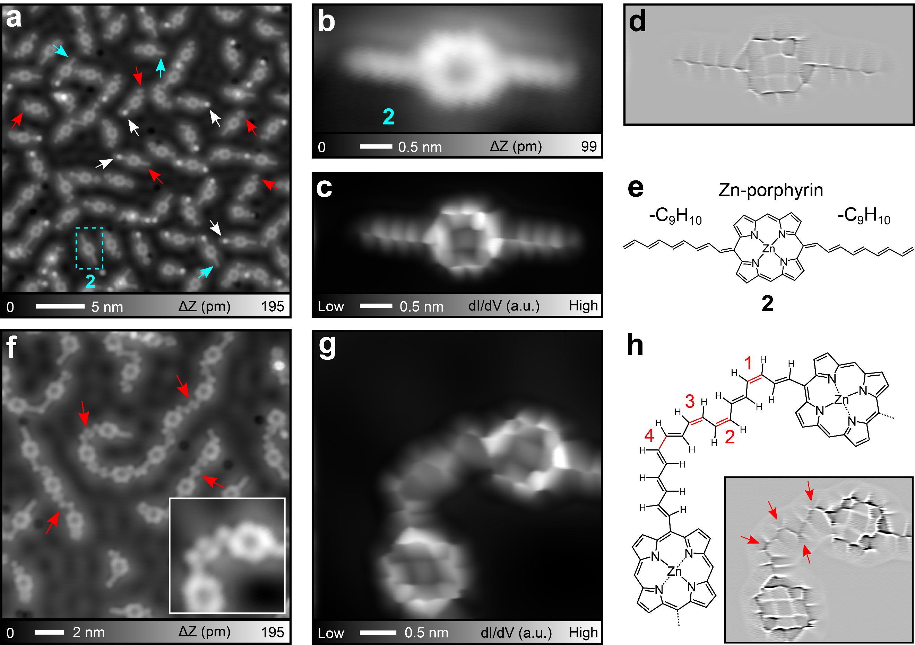
Figure 2. Dehydrogenative polyene synthesis. (a) Large-scale STM topography of Cu(111) with molecules after heating at 100 °C for 5 min. (b) Close-up view of a single molecule, (c) the corresponding constant-height dI/dV map, and (d) Laplace filtered image as well as (e) the chemical structure. (f) STM topography of Cu(111) after annealing at 150 °C for 5 min. Inset shows the close-up view of the oligomer segment and (g) the corresponding constant-height dI/dV map. (h) Top left: the corresponding chemical structure. Bottom right: Laplace filtered image of (g). Measurement parameters: Sample bias voltage V = 200 mV and tunneling current I = 5 pA in (a), V = 100 mV and I = 10 pA in (b), V = 50 mV and I = 10 pA in (f). STM characterization at 4.3 K.

Interestingly, we found that the contrast of Zn-porphyrin core in the dI/dV map was significantly changed by the formation of the nonyl group. Such a variation can be seen in the bond-resolved images of 1 and 2 (Figures 3a and 3b, Figure S7). The Zn-porphyrin 1 core was composed of bright pyrrole rings at the corners and a cross with the rectangle core at the center (Figure 3a). In contrast, the Zn-porphyrin core of 2 was composed of nine small blocks, in which the pyrrole ring is smaller than that in 1 while the zinc core remarkably broadened as a square (Figure 3b). We assume that bond orders in the Zn-porphyrin core were rearranged by the reaction, resulting in modification of the planarity in the core. In addition, porphyrin has a macrocyclic ring with 18 π-electrons, which is aromatic according to the Hückel theory⁵² and can affect the on-surface reactions^{53,54}. In contrast, the substitution of the alkenyl group results in the transformation of the C1-C2 and C3-C4 bonds in the Zn-porphyrin core into single bonds (Figure 3c). This transformation may lead to the formation of the so-called quinoidal porphyrin, which is known as a non-aromatic unit due to lack of the π-conjugated cycle ring, as reported in previous literature⁵⁵⁻⁵⁷. The direct measurement of the bond length was challenging due to the limited resolution on the dI/dV maps, which may result from the slightly corrugated porphyrin cores. To gain a deeper insight, we obtained the nucleus independent chemical shift (NICS) values of 1 and 2 with the DFT method. Since the NICS values were evaluated at 1 Å above the porphyrin plane, these are denoted as NICS(1). The calculated NICS(1) values at the Zn-porphyrin core for 1 were more negative, indicating high aromaticity of this part (Figure 3d). In contrast, the NICS(1) values of 2 were closer to zero, especially in small rings 5,6,7 and 8 containing zinc ion (Figure 3e). These calculations reveal the significant reduction of the aromaticity by the dehydrogenation from 1 to 2. We further conducted DFT calculations and analyzed the bond lengths of 2 adsorbed on Cu(111) (Figure S8). We observed that the C-C bond length of the alkenyl group closest to the porphyrin core is shorter than a typical single bond (~1.5 Å) but longer than a double bond (~1.3 Å), suggesting a bond order of approximately 1.5. This bond order may result from a resonating structure between quinoidal and diradical porphyrin cores.
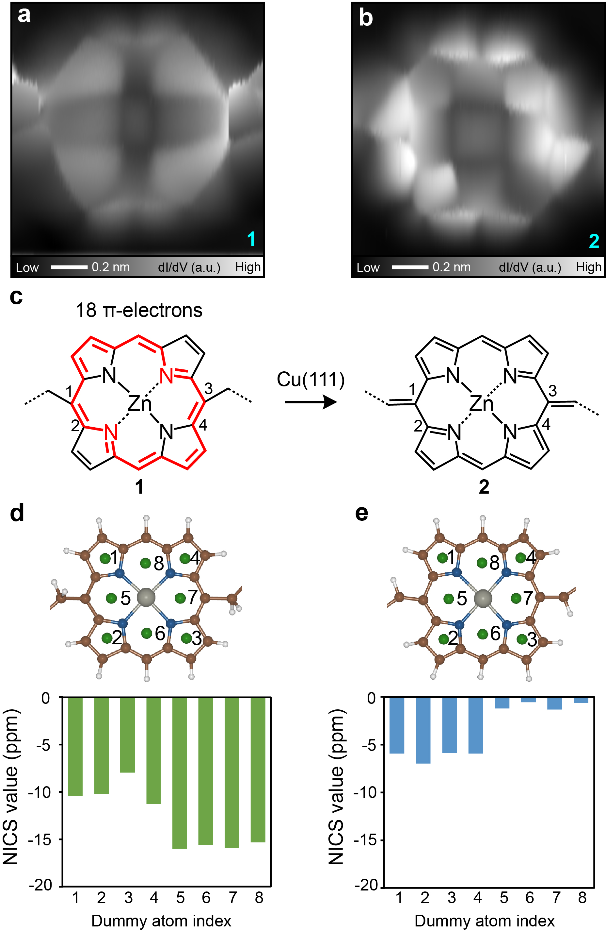
Figure 3. (a) Constant height dI/dV maps of Zn-porphyrin cores of 1 and (b) 2 taken with a CO-tip. (c) Chemical structures of 1 and 2. (d)(e) DFT calculated NICS(1) values of Zn-porphyrin core of (d) 1 and (e) 2.

It is known that the trans polyacetylene has a higher electric conductivity than the cis one^{58,59}. Thus, extended all trans [18]-polyene linked Zn-porphyrin cooligomer can be regarded as an alternative metallic and semiconductive one-dimensional chain. In order to obtain the long oligomer, we first increased the coverage of molecules 1 on Cu(111), but found the synthesis of disordered structures after annealing (Figure S9). We deduced that the three-fold symmetric substrate was not suitable for the synthesis of one-dimensional structure. Therefore, we switched the substrate to Cu(110) since the rows of the surface lattice running along the [1 −1 0] direction can align adsorbed molecules (Inset of Figure 4a)⁶⁰. Indeed, 1 deposited on the clean substrate kept at room temperature adsorbed on the surface along [1 −1 0] and [0 0 1] directions (Figure 4a). The porphyrin core is adsorbed at a given atomic site of the corrugated Cu(110) surface while keeping a certain freedom of the geometry of alkyl chains. Since the alkyl-alkyl chain interaction was not strong enough to reposition the porphyrin core, no ordered self-assembled structure was seen. Since the flexibility of the chain remained unchanged as forming the cis- and trans co-existing structures (“R” and “S” types), the molecule should be intact. We found that the alkyl groups of molecules transformed into straight structures after annealing at 150 °C for 5 min (Figure 4b). A close-up view shows a single straight molecule (Figure 4c), whose shape is the same as that of porphyrin with two alkenyl groups on Cu(111) (Figure 2b). The bond-resolved dI/dV map and the corresponding Laplace filtered image confirmed the synthesis of product 2 (Figure 4d-f). Since no other structure was observed, the reaction yield of dehydrogenation of the nonyl group on Cu(110) was close to 100 %, much higher than that on Cu(111). After annealing at 200 °C for 10 min, longer oligomers formed, yet accompanying with undesired cis isomers in the polyene groups (Figure 4g). We deduced that the low coverage of precursor molecules allowed the porphyrin cores to diffuse in any direction during annealing, which is responsible for the formation of the cis isomers. We then formed one monolayer of 1 on Cu(110) kept at room temperature, subsequently annealed the substrate at 180 °C for 30 min. The large-scale STM topography shows the synthesis of extended oligomers, which were almost perfectly aligned along the [1 −1 0] direction (Figure 4h). Therefore, high coverage of molecules effectively prevents trans-cis isomerism, which can be seen in the statistical analysis of the product length (Figure S10). Note that a small number of defects and kinks correspond to the trans structures in polyene chains. We found a hexamer whose length was approximately 19.3 nm (Figure 4i). The corresponding bond-resolved STM image was shown in Figure 4j and chemical structure was exhibited in Figure 4k. These results demonstrate the synthesis of target product 3. We further performed DFT geometry optimization of 3 on Cu(110), utilizing a periodic Zn-porphyrin trimer as the model. Subsequently, we analyzed the C-C bond lengths of the polyene chain segment (Figure S11). At the middle of the chain, alternating single and double bonds exist. Such repeat modulation of the bond length disappears once with increasing the distance from the middle of polyene and appears again at the termini connected to the porphyrin core. Since the C2-C3 and C18-C19 bonds are significantly shorter, the double-bond character in these bonds can be reasonably assigned, in consistent with the periodicity of the single-double bonds in the middle of the polyene. These observations indicate the synthesis of [18]-polyene unit instead of [20]-polyene unit.

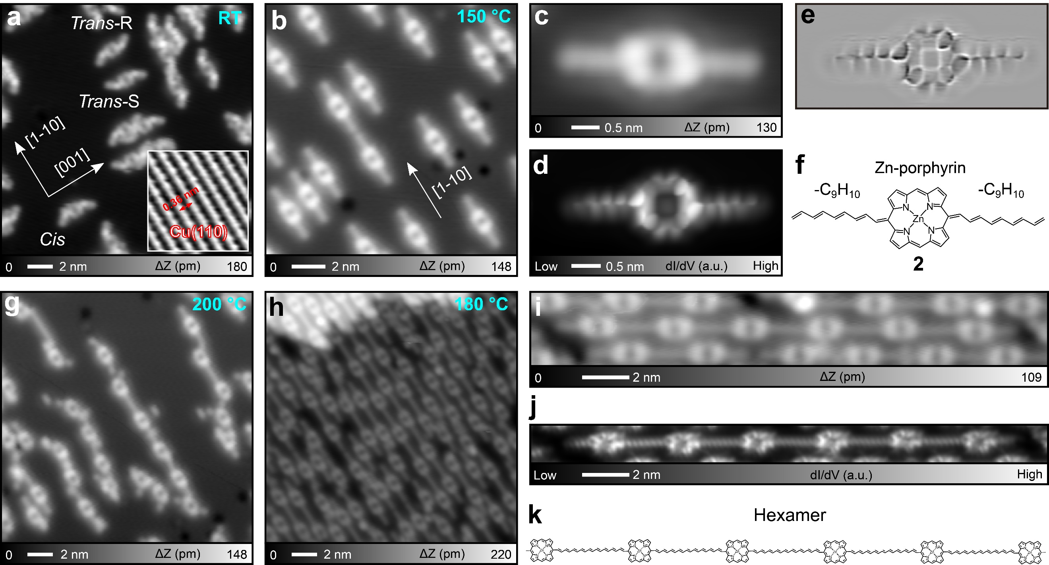
Figure 4. On-surface synthesis of 3 on Cu(110). (a) STM topography of as-deposited 1 on Cu(110) kept at room temperature. Inset shows the Cu(110) surface with atomic resolution, scale: 3 nm × 3 nm. (b) STM topography of the surface with a low coverage of molecules after annealing at 150 °C for 5 min. (c) Close-up view of a single molecule, (d) the corresponding constant-height dI/dV map, and (e) Laplace filtered image as well as (f) the chemical structure. (g) STM topography of the surface after annealing at 200 °C for 10 min. (h) Large STM topography of the surface with a high coverage (~1 ML) of molecules after annealing at 180 °C for 30 min. (i) STM topography of a long hexamer on surface. (j) Constant height dI/dV map of the hexamer, and (k) the corresponding chemical structure. Measurement parameters: V = 100 mV and I = 50 pA in (a), V = 100 mV and I = 20 pA in (b), V = 200 mV and I = 10 pA in (c), V = 50 mV and I = 50 pA in (g), V = 10 mV and I = 100 pA in (h), V = 6 mV and I = 50 pA in (i). STM characterization at 4.3 K.

In order to investigate the electronic properties of 3 on Cu(110), we performed scanning tunneling spectroscopy (STS) measurements (Figure S12), and found no significant feature, which may relate to the strong interaction between the molecules and the copper substrate. Thus, the angle-resolved photoelectron spectroscopy (ARPES) measurements were conducted at 80 K. Figures 5a and 5d show the Fermi surfaces of a clean Cu(110) surface as a reference and the Cu(110) surface that is almost fully covered with 3, respectively. The surface covered with 3 was prepared by the same method as that used for Figure 4h, meaning that only a small number of defects, which will not affect the ARPES results, were present on the sample. Figures 5b and 5e show the ARPES images of the two surfaces along $k_{[1\overline{1}0]}$ at $k_{[001]}=0.6 Å^{-1}$ and Figures 5c and 5f are those along $k_{[1\overline{1}0]}$ at $k_{[001]}=0.4 Å^{-1}$. Note that the yellow dotted lines in Figure 5 indicate artifactual signals, resulting from the He Iβ line of the light source (The energy of the He Iβ line is 1.87 eV higher than the most intense He Iα line, and the relative intensity of the He Iα line and He Iβ line is 100:1.5). Despite the unchanged Fermi surface and band dispersion of the metallic band of Cu(110) upon molecule adsorption, the two metallic bands observed in Figures 5d-f would correspond to the [18]-polyene moieties in 3. The dispersions of these two electronic bands are similar to those of longer trans-polyene^{40,61}, in which a strong interaction between polyene and Cu surfaces induces charge transfer, leading to semiconductor-to-metal transformation. Therefore, [18]-polyene unit can be regarded as a conductive wire with electrons doping by underlying substrates.

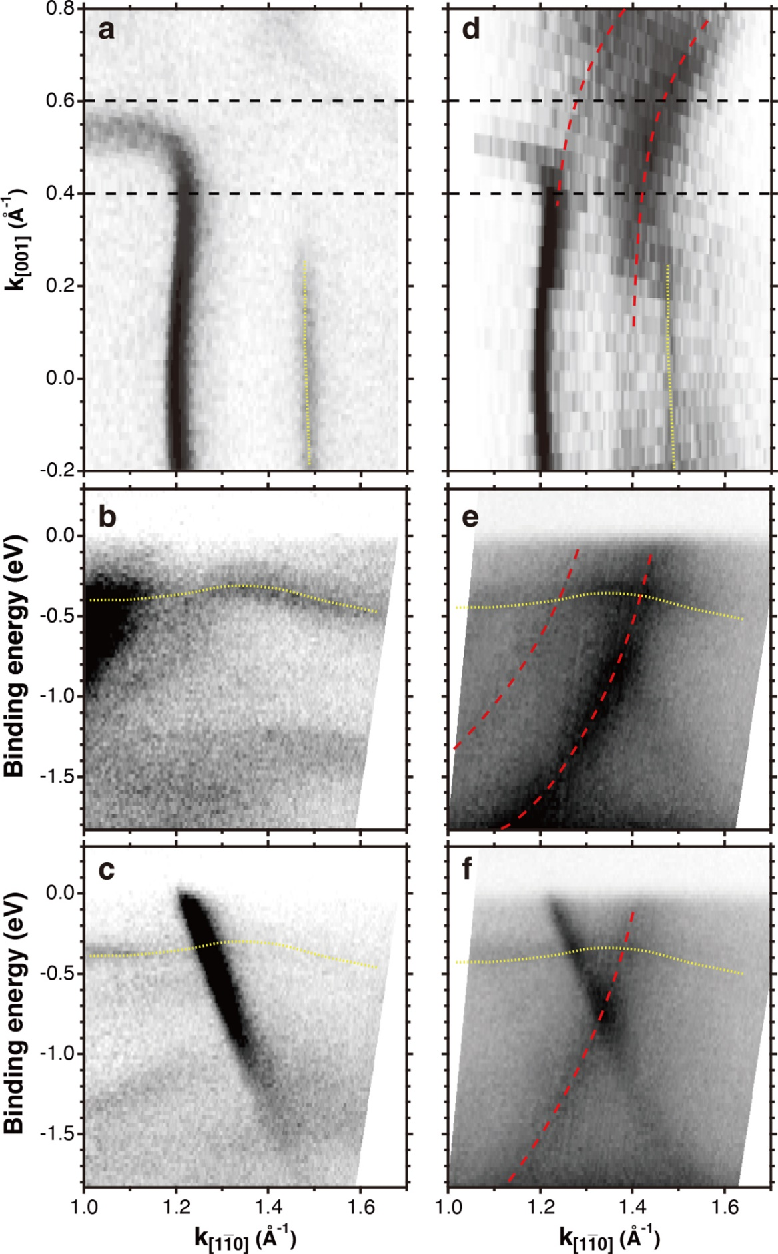
Figure 5. (a) Fermi surface and (b) band dispersion measured along $k_{[1\overline{1}0]}$ at $k_{[001]}=0.6 Å^{-1}$ and (c) at $k_{[001]}=0.4 Å^{-1}$ of a clean Cu(110) surface. (d) Fermi surface and (e) band dispersions at $k_{[001]}=0.6 Å^{-1}$ and (f) $0.4 Å^{-1}$ of 3 adsorbed on Cu(110). The red dashed lines indicate the metallic bands of the molecular arrays.

To get a deeper insight into the electronic structure, especially the metallic property of 3 on Cu substrate, the DFT calculations were carried out. The periodically repeated structure of 1 and 2 monomers adsorbed on Cu(110) were optimized. Figures 6a and 6b show the calculated charge density near the Fermi level (−1 to 1 eV) of 1 and 2, respectively. Note that the [18]-polyene linked Zn porphyrin core 3 corresponds to 2, while Zn porphyrin core is linked by the nonyl group in 1. The higher charge density in the linkage part of 2 indicates the higher electron density in the polyene part of 2, while there is minimal electron density in 1. Figures 6c and 6d show the localized density of states (LDOS) of C atoms in 1 and 2, respectively. The higher DOS value near the Fermi level (indicated by the dashed rectangles) is observed when the Zn porphyrin core is linked by polyene, while the DOS values are close to zero for the nonyl group linkage. These DOSs are consistent both with the charge density plot and with the ARPES experimental results, which indicate the metallic character of 3 caused by strong interaction with Cu substrates. Furthermore, the DOSs of the dimers and trimers of 1 and 2 are examined (Figure S13). The calculated DOSs are similar to those of monomer (i.e. Figure 6c and 6d), thus the above discussions should be held even when larger models are used. Thus, the DFT-calculated electronic states support the fact that the [18]-polyene linkage adsorbed on Cu(110) can lead to metallic character.

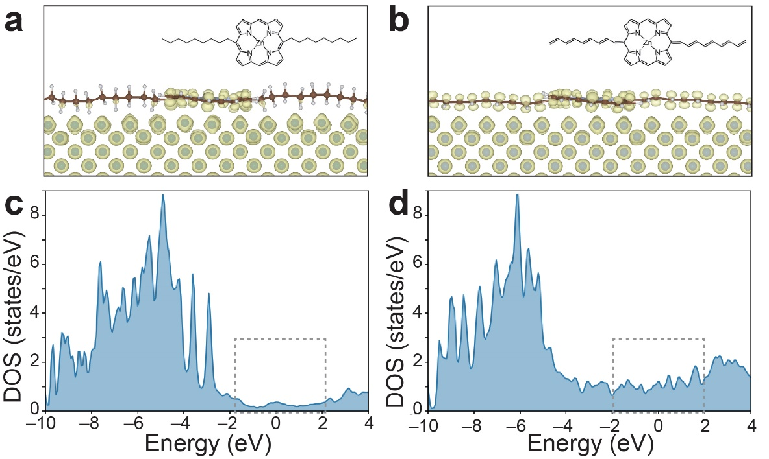
Figure 6. (a) Charge density plots of Zn-porphyrin core linked by -C₉H₁₉ and (b) -C₉H₁₀. The charge densities were limited in energy range of −1 to 1 eV, relative to the Fermi level. The yellow part shows the positive charge density component. The LDOSs corresponding to (a) and (b) were shown in (c) and (d), respectively (relative to the Fermi level). The DOSs of alkyl and alkenyl chain carbon atoms are shown. The boxes with broken lines show the region near the Fermi level.

Conclusions
We demonstrated a synthesis of block cooligomers composed of alternating Zn-porphyrin core and [18]-polyene linker on Cu(111) and Cu(110). Alkyl (-C₉H₁₉) groups substituted to the 5,15-meso positions of Zn-porphyrin first transformed into conjugated polyene (-C₉H₁₀) groups and subsequent terminal homocoupling led to the extended [18]-polyene bridged Zn-porphyrin oligomers. Bond-resolved STM revealed the inner structures of the molecule, which was all-conjugated. DFT calculations indicate the reduction of aromatic properties of Zn-porphyrin core after dehydrogenation. All trans [18]-polyene groups are metallic molecular wires between Zn-porphyrin cores due to electrons doping by Cu substrates. This method may provide a well guidance for designing more complex large molecules and novel nanostructures.

Methods
STM experiments: All experiments were performed with home-made low temperature scanning tunneling microscopy (STM) operating at 4.3 K under ultrahigh vacuum condition (< 2 × 10⁻¹⁰ mbar). Clean single crystal Cu(111) and Cu(110) substrates were prepared through cyclic sputtering (Ar⁺, 10 min) and annealing (720 K, 15 min). The temperature of the sample was measured by a thermocouple and a pyrometer. 5,15-Dinonylporphyrinatozinc molecules were deposited from a Knudsen cell (Kentax GmbH). A STM tip was made from the chemically etched tungsten. For constant height dI/dV imaging, the tip apex was terminated by a CO molecule by picking up from the surface⁶². The sample bias voltage was set close to zero voltage. The modulation amplitude was 7 mV_{rms} and the frequency was 510 Hz.

ARPES experiments: The high-resolution ARPES measurements were performed in an ultra-high vacuum chamber under a base pressure of $<1×{10}^{-10}$ mbar. Photoelectrons excited by a p-polarized light (He Iα line; $hν=21.22$ eV) were collected by a hemispherical photoelectron analyzer (R4000, Scienta Omicron). The energy and momentum resolutions were set to 6.25 meV and less than 1% of the Brillouin zone. The sample was kept at 80 K during the measurement.

Theoretical canulations: The slab model was used to represent the Zn-porphyrin derivatives adsorbed on Cu(111) or Cu(110) surfaces. The Cu surfaces were constructed by repeating the unit cell by 12×6×3 for x, y, and z directions, respectively. This results in the Cu surface with 270 and 288 Cu atoms for (111) and (110) surfaces. The lattice constant was set to 3.61 Å. The vacuum region of ~15 Å was placed between slabs, to remove the artificial interaction between slabs. The dipole correction was also added for this purpose. In the DFT calculations, projector augmented-wave (PAW) method was used to represent the core electrons while the plane wave basis set was used to expand the valence electrons up to energy cutoff of 400 eV⁶³. Perdew-Burke-Ernzefhof (PBE) functional plus van der Waals interaction (DFT-D3 with Becke-Johnson damping function) was used for the exchange-correlation functional^{64,65}. Gaussian broadening with 𝜎 = 0.1 was used for smearing the electron occupancy near the Fermi level. The convergence thresholds of 1.0×10⁻⁵ eV and 0.05 eV/Å for the self-consistent-field calculation and geometry optimization, respectively. The reciprocal lattice space integration was done numerical with the k-points; two levels of k-points were used, 1×1×1 for molecular dynamics (MD) and geometry optimization calculation, and 4×2×1 was used when calculating the charge density and the DOS. Before optimizing geometry, the MD simulation with NVT ensemble was performed to alleviate the dependence of the initially set geometry. The MD calculations were performed at least 2.0 ps with 1 fs time step. The temperature was set to 200 K, and Berendsen thermostat was used to control the temperature. After the MD calculation, the geometry optimization was carried out. The NICS values were calculated to analyze the aromaticity of the Zn-porphyrin derivatives. These calculations were performed with Gaussian16 software⁶⁶. The geometries were taken from the optimized geometry of the Zn-porphyrin derivatives adsorbed on Cu(111), while the Cu(111) parts were omitted in the NICS calculations. The PBE0 functional and aug-cc-pVDZ basis set were used. The NICS probes were placed 1 Å above the porphyrin ring, often denoted as NICS(1). All the calculations except for the NICS were performed by Vienna ab initio simulation package (VASP) version 5.4⁶⁷.

Synthesis of molecule: 5,15-Dinonylporphyrinatozinc (1)
5,15-Dinonylporphyrinatozinc (1) was synthesized by acid-catalyzed condensation reaction of bis(2-pyrrolyl)methane with decanal followed by addition of DDQ, and subsequent Zn insertion according to the previously reported method⁶⁸.

Supporting Information
Tip manipulation, Experimental line profiles and DFT optimized structures, Adsorption of CO molecules on Zn-porphyrin core, Cis isomer segment, Incompletely reacted molecule, Dimer on Cu(111), Contrasts of Zn-porphyrin cores before and after reactions, Calculated C-C bond lengths of the alkenyl groups of 2, Disordered structures on Cu(111), Statistical analysis of the product formed on Cu(110), Calculated C-C bond lengths of the polyene chain between the Zn-porphyrin cores, STS measurements, DFT-calculated localized density of states (LDOS) of dimer and trimers (PDF).

AUTHOR INFORMATION
Corresponding Author
*KAWAI.Shigeki@nims.go.jp

Notes
The authors declare no competing financial interest.

ACKNOWLEDGEMENTS
This work was supported in part by Japan Society for the Promotion of Science (JSPS) KAKENHI Grant Number JP22H00285, JP22H01957 and JP20H05621. K. Sun acknowledges the support of ICYS project.

Competing interests: The authors declare that they have no competing interests.

References
- Single-Molecule Electronics. Edited by Manabu Kiguchi. ISBN 978-981-10-0723-1, 2016.
- Xiang, D.; Wang, X.; Jia, C.; Lee, T.; Guo, X. Molecular-Scale Electronics: From Concept to Function. Chem. Rev. 2016, 116, 4318−4440.
- Cornil, J.; Beljonne, D.; Calbert, J.; Brédas, J. Interchain Interactions in Organic π-Conjugated Materials: Impact on Electronic Structure, Optical Response, and Charge Transport Adv. Mater. 2001, 13, 1053−1067.
- Watson, M. D.; Fechtenkötter, A.; Müllen, K. Big Is Beautiful−“Aromaticity” Revisited from the Viewpoint of Macromolecular and Supramolecular Benzene Chemistry. Chem. Rev. 2001, 101, 1267−1300.
- Narita, A.; Wang, X.; Feng, X.; Müllen, K. New Advances in Nanographene Chemistry. Chem. Soc. Rev. 2015, 44, 6616−6643.
- Sukegawa, J.; Schubert, C.; Zhu, X.; Tsuji, H.; Guldi, D. M.; Nakamura, E. Electron Transfer through Rigid Organic Molecular Wires Enhanced by Electronic and Electron–Vibration Coupling. Nat. Chem. 2014, 6, 899−905.
- Tanaka, T.; Osuka, A. Conjugated Porphyrin Arrays: Synthesis, Properties and Applications for Functional Materials. Chem. Soc. Rev. 2015, 44, 943−969.
- Berresheim, A. J.; Müller, M.; Müllen, K. Polyphenylene Nanostructures. Chem. Rev. 1999, 99, 1747−1785.
- Grill, L.; Hecht, S. Covalent On-Surface Polymerization. Nat. Chem. 2020, 12, 115−130.
- Grill, L.; Dyer, M.; Lafferentz, L.; Persson, M.; Peters, M. V.; Hecht, S. Nano-Architectures by Covalent Assembly of Molecular Building Blocks. Nat. Nanotechnol. 2007, 2, 687−691.
- Treier, M.; Pignedoli, C. A.; Laino, T.; Rieger, R.; Müllen, K.; Passerone, D.; Fasel, R. Surface-Assisted Cyclodehydrogenation Provides a Synthetic Route Towards Easily Processable and Chemically Tailored Nanographenes. Nat. Chem. 2011, 3, 61−67.
- Rogers, C.; Chen, C.; Pedramrazi, Z.; Omrani, A. A.; Tsai, H.; Jung, H. S.; Lin, S.; Crommie, M. F.; Fischer, F. R. Closing the Nanographene Gap: Surface-Assisted Synthesis of Peripentacene from 6,6’-Bipentacene Precursors. Angew. Chem. Int. Ed. 2015, 54, 15143−15146.
- Cai, J.; Ruffieux, P.; Jaafar, R.; Bieri, M.; Braun, T.; Blankenburg, S.; Muoth, M.; Seitsonen, A. P.; Saleh, M.; Feng, X.; Müllen, K.; Fasel, R. Atomically Precise Bottom-Up Fabrication of Graphene Nanoribbons. Nature 2010, 466, 470−473.
- Ruffieux, P.; Wang, S.; Yang, B.; Sánchez-Sánchez, C.; Liu, J.; Dienel, T.; Talirz, L.; Shinde, P.; Pignedoli, C. A.; Passerone, D.; Dumslaff, T.; Feng, X.; Müllen, K.; Fasel, R. On-Surface Synthesis of Graphene Nanoribbons with Zigzag Edge Topology. Nature 2016, 531, 489−492.
- Chen, Y.-C.; de Oteyza, D. G.; Pedramrazi, Z.; Chen, C.; Fischer, F. R.; Crommie, M. F. Tuning the Band Gap of Graphene Nanoribbons Synthesized from Molecular Precursors. ACS Nano 2013, 7, 6123−6128.
- Zhang, H.; Lin, H.; Sun, K.; Chen, L.; Zagranyarski, Y.; Aghdassi, N.; Duhm, S.; Li, Q.; Zhong, D.; Li, Y.; Müllen, K.; Fuchs, H.; Chi, L. On-Surface Synthesis of Rylene-Type Graphene Nanoribbons. J. Am. Chem. Soc. 2015, 137, 4022–4025.
- Kawai, S.; Saito, S.; Osumi, S.; Yamaguchi, S.; Foster, A. S.; Spijker, P.; Meyer, E. Atomically Controlled Substitutional Boron-Doping of Graphene Nanoribbons. Nat. Commun. 2015, 6, 8098.
- Kawai, S.; Nakatsuka, S.; Hatakeyama, T.; Pawlak, R.; Meier, T.; Tracey, J.; Meyer, E.; Foster, A. S. Multiple Heteroatom Substitution to Graphene Nanoribbon. Sci. Adv. 2018, 4, eaar7181.
- Sun, K.; Ji, P.; Zhang, J.; Wang, J.; Li, X.; Xu, X.; Zhang, H.; Chi, L. On-Surface Synthesis of 8- and 10-Armchair Graphene Nanoribbons. Small 2019, 1804526.
- Cai, J.; Pignedoli, C. A.; Talirz, L.; Ruffieux, P.; Söde, H.; Liang, L.; Meunier, V.; Berger, R.; Li, R.; Feng, X.; Müllen, K.; Fasel, R. Graphene Nanoribbon Heterojunctions. Nat. Nanotechnol. 2014, 9, 896−900.
- Chen, Y. C.; Cao, T.; Chen, C.; Pedramrazi, Z.; Haberer, D.; de Oteyza, D. G.; Fischer, F. R.; Louie, S. G.; Crommie, M. F. Molecular Bandgap Engineering of Bottom-Up Synthesized Graphene Nanoribbon Heterojunctions. Nat. Nanotechnol. 2015, 10, 156−160.
- Nguyen, G. D.; Tsai, H.-Z.; Omrani, A. A.; Marangoni, T.; Wu, M.; Rizzo, D. J.; Rodgers, G. F.; Cloke, R. R.; Durr, R. A.; Sakai, Y.; Liou, F.; Aikawa, A. S.; Chelikowsky, J. R.; Louie, S. G.; Fischer, F. R.; Crommie, M. F. Atomically Precise Graphene Nanoribbon Heterojunctions from A Single Molecular Precursor. Nat. Nanotechnol. 2017, 12, 1077−1082.
- Li, J.; Merino-Díez, N.; Carbonell-Sanromà, E.; Vilas-Varela, M.; de Oteyza, D. G.; Peña, D.; Corso, M.; Pascual, J. I. Survival of Spin State in Magnetic Porphyrins Contacted by Graphene Nanoribbons Sci. Adv. 2018, 4, eaaq0582.
- Sun, K.; Krejči, O.; Foster, A. S.; Okuda, Y.; Orita, A.; Kawai, S. Synthesis of Regioisomeric Graphene Nanoribbon Junctions via Heteroprecursors. J. Phys. Chem. C 2019, 123, 17632−17638.
- Zwaneveld, N. A. A.; Pawlak, R.; Abel, M.; Catalin, D.; Gigmes, D.; Bertin, D.; Porte, L. Organized Formation of 2D Extended Covalent Organic Frameworks at Surfaces. J. Am. Chem. Soc. 2008, 130, 6678–6679.
- Bieri, M.; Treier, M.; Cai, J.; Aït-Mansour, K.; Ruffieux, P.; Gröning, O.; Gröning, P.; Kastler, M.; Rieger, R.; Feng, X.; Müllen, K.; Fasel, R. Porous Graphenes: Two-Dimensional Polymer Synthesis with Atomic Precision. Chem. Commun. 2009, 0, 6919−6921.
- Sun, K.; Silveira, O. J.; Ma, Y.; Hasegawa, Y.; Matsumoto, M.; Kera, S.; Krejčí, O.; Foster, A. S.; Kawai, S. On-Surface Synthesis of Disilabenzene-Bridged Covalent Organic Frameworks. Nat. Chem. 2023, 15, 136–142.
- Hla, S.-W.; Bartels, L.; Meyer, G.; Rieder, K.-H. Inducing All Steps of a Chemical Reaction with the Scanning Tunneling Microscope Tip: Towards Single Molecule Engineering. Phys. Rev. Lett. 2000, 85, 2777−2780.
- Wang, W.; Shi, X.; Wang, S.; Van Hove, M. A.; Lin, N. Single-Molecule Resolution of an Organometallic Intermediate in a Surface-Supported Ullmann Coupling Reaction. J. Am. Chem. Soc. 2011, 133, 13264−13267.
- Zhang, Y.-Q.; Kepčija, N.; Kleinschrodt, M.; Diller, K.; Fischer, S.; Papageorgiou, A. C.; Allegretti, F.; Björk, J.; Klyatskaya, S.; Klappenberger, F.; Ruben, M.; Barth, J. V. Homo-Coupling of Terminal Alkynes on a Noble Metal Surface. Nat. Commun. 2012, 3, 1286.
- Gao, H.-Y.; Wagner, H.; Zhong, D.; Franke, J.-H.; Studer, A.; Fuchs, H. Glaser Coupling at Metal Surfaces. Angew. Chem. Int. Ed. 2013, 52, 4024–4028.
- Kawai, S.; Krejčí, O.; Foster, A. S.; Pawlak, R.; Xu, F.; Peng, L.; Orita, A.; Meyer, E. Diacetylene Linked Anthracene Oligomers Synthesized by One-Shot Homocoupling of Trimethylsilyl on Cu(111). ACS Nano 2018, 12, 8791−8797.
- Kanuru, V. K.; Kyriakou, G.; Beaumont, S. K.; Papageorgiou, A. C.; Watson, D. J.; Lambert, R. M. Sonogashira Coupling on an Extended Gold Surface in Vacuo: Reaction of Phenylacetylene with Iodobenzene on Au(111). J. Am. Chem. Soc. 2010, 132, 8081–8086.
- Wang, T.; Huang, J.; Lv, H.; Fan, Q.; Feng, L.; Tao, Z.; Ju, H.; Wu, X.; Tait, S. L.; Zhu, J. Kinetic Strategies for the Formation of Graphyne Nanowires via Sonogashira Coupling on Ag(111). J. Am. Chem. Soc. 2018, 140, 13421−13428.
- Sun, K.; Sagisaka, K.; Peng, L.; Watanabe, H.; Xu, F.; Pawlak, R.; Meyer, E.; Okuda, Y.; Orita, A.; Kawai, S. Head-to-Tail Oligomerization by Silylene-Tethered Sonogashira Coupling on Ag(111). Angew. Chem. Int. Ed. 2021, 60, 19598−19603.
- Schuler, B.; Fatayer, S.; Mohn, F.; Moll, N.; Pavliček, N.; Meyer, G.; Peña, D. P.; Gross, L. Reversible Bergman Cyclization by Atomic Manipulation. Nat. Chem. 2016, 8, 220−224.
- Sun, Q.; Zhang, C.; Li, Z.; Kong, H.; Tan, Q.; Hu, A.; Xu, W. On-Surface Formation of One-Dimensional Polyphenylene through Bergman Cyclization. J. Am. Chem. Soc. 2013, 135, 8448−8451.
- Zhong, D.; Franke, J.; Podiyanachari, S. K.; Blömker, T.; Zhang, H.; Kehr, G.; Erker, G.; Fuchs, H.; Chi, L. Linear Alkane Polymerization on a Gold Surface. Science 2011, 334, 213−216.
- Sun, K.; Chen, A.; Liu, M.; Zhang, H.; Duan, R.; Ji, P.; Li, L.; Li, Q.; Li, Q.; Zhong, D.; Müllen, K.; Chi, L. Surface-Assisted Alkane Polymerization: Investigation on Structure− Reactivity Relationship. J. Am. Chem. Soc. 2018, 140, 4820−4825.
- Li, X.; Niu, K.; Zhang, J.; Yu, X.; Zhang, H.; Wang, Y.; Guo, Q.; Wang, P.; Li, F.; Hao, Z.; Xu, C.; Tang, Y.; Xu, Z.; Lu, S.; Liu, P.; Xue, G.; Wei, Y.; Chi, L. Direct Transformation of N-Alkane into All-Trans Conjugated Polyene via Cascade Dehydrogenation. Natl. Sci. Rev. 2021, 8, nwab093.
- Kuang, G.; Chen, S.; Wang, W.; Lin, T.; Chen, K.; Shang, X.; Liu, P.; Lin, N. Resonant Charge Transport in Conjugated Molecular Wires beyond 10 nm Range. J. Am. Chem. Soc. 2016, 138, 11140−11143.
- Saywell, A.; Browning, A. S.; Rahe, P.; Anderson, H. L.; Beton, P. H. Organisation and Ordering of 1D Porphyrin Polymers Synthesised by On-Surface Glaser Coupling. Chem. Commun. 2016, 52, 10342−10345.
- Maeda, C.; Taniguchi, T.; Ogawa, K.; Ema, T. Bifunctional Catalysts Based on m-Phenylene-Bridged Porphyrin Dimer and Trimer Platforms: Synthesis of Cyclic Carbonates from Carbon Dioxide and Epoxides. Angew. Chem. Int. Ed. 2015, 54, 134 –138.
- Yella,A.; Lee, H.; Tsao, H. N.; Yi, C.; Chandiran, A. K.; Nazeeruddin, K.; Diau, E.; Yeh, C.; Zakeeruddin, S. M.; Grätzel, M. Science 2011, 334, 629-634.
- Mousawi, A. A.; Poriel, C.; Dumur, F.; Toufaily, J.; Hamieh, T.; Fouassier, J. P.; Laleveé, J. Zinc Tetraphenylporphyrin as High Performance Visible Light Photoinitiator of Cationic Photosensitive Resins for LED Projector 3D Printing Applications. Macromolecules 2017, 50, 746–753.
- Marbach, H. Surface-Mediated in Situ Metalation of Porphyrins at the Solid−Vacuum Interface. Acc. Chem. Res. 2015, 48, 2649−2658.
- Hao, Z.; Zhang, J.; Xie, M.; Li, X.; Wang, L.; Liu, Y.; Niu, K.; Wang, J.; Song, L.; Cheng, T.; Zhang, H.; Chi, L. From N-Alkane to Polyacetylene on Cu(110): Linkage Modulation in Chain Growth. Sci. China Chem. 2022, 65, 733−739.
- Kawai, S.; Ishikawa, A.; Ishida, S.; Yamakado, T.; Ma, Y.; Sun, K.; Tateyama, Y.; Pawlak, R.; Meyer, E.; Saito, S.; Osuka, A. On-Surface Synthesis of Porphyrin-Complex Multi-Block Co-Oligomers by Defluorinative Coupling. Angew. Chem. Int. Ed. 2022, 61, e202114697.
- Gross, L.; Mohn, F.; Moll, N.; Liljeroth, P.; Meyer, G. The Chemical Structure of a Molecule Resolved by Atomic Force Microscopy. Science 2009, 325, 1110−1114.
- Temirov, R.; Soubatch, S.; Neucheva, O.; Lassise, A. C.; Tautz, F. S. A Novel Method Achieving Ultra-High Geometrical Resolution in Scanning Tunneling Microscopy. New J Phys. 2008, 10, 053012.
- Shimizu, D.; Osuka, A. Porphyrinoids as a platform of stable radicals. Chem. Sci. 2018, 9, 1408–1423.
- Hückel, E. Z. Physik Quantentheoretische Beiträge zum Benzolproblem. 1931, 70, 204–286.
- Cao, N.; Björk, J.; Corral-Rascon, E.; Chen, Z.; Ruben, M.; Senge, O. M.; Barth, J. V.; Riss, A. The Role of Aromaticity in the Cyclization and Polymerization of Alkyne-Substituted Porphyrins on Au(111). Nat. Chem. 2023, 15, 1765–1772.
- Rascon, E. C.; Riss, A.; Matĕj, A.; Wiengarten, A.; Mutombo, P.; Soler, D.; Jelinek, P.; Auwärter, W. On-Surface Synthesis of Square-Type Porphyrin Tetramers with Central Antiaromatic Cyclooctatetraene Moiety. J. Am. Chem. Soc. 2023, 145, 967−977.
- Zhang, H.; Phan, H.; Herng, T. S.; Gopalakrishna, T. Y.; Zeng, W.; Ding, J.; Wu, J. Conformationally Flexible Bis(9-fluorenylidene)porphyrin Diradicaloids. Angew. Chem. Int. Ed. 2017, 56, 13484 –13488.
- Shimizu, D.; Osuka, A. Porphyrinoids as a Platform of Stable Radicals. Chem. Sci. 2018, 9, 1408–1423.
- Umetani, M.; Naoda, K.; Tanaka, T.; Lee, S.-K.; Oh, J.; Kim, D.; Osuka. A. Synthesis of Di-peri-dinaphthoporphyrins by PtCl₂-Mediated Cyclization of Quinodimethane-type Porphyrins. Angew. Chem. Int. Ed. 2016, 55, 6305–6309.
- Chiang, C. K.; Park, Y. W.; Heeger, A. J.; Shirakawa, H.; Louis, E. J.; Gau, S. C.; MacDiarmid, A. G. Electrical Conductivity in Doped Polyacetylene. Phys. Rev. Lett. 1977, 39, 1098−1101.
- Shirakawa, H.; Louis, E. J.; MacDiarmid, A. G.; Chiang, C. K.; Heeger, A. J. Synthesis of Electrically Conducting Organic Polymers: Halogen Derivatives of Polyacetylene, (CH)_{X}. J.C.S. Chem. Comm. 1977, 578−580.
- Vasseur, G.; Fagot-Revurat, Y.; Sicot, M.; Kierren, B.; Moreau, L.; Malterre, D.; Cardenas, L.; Galeotti, G.; Lipton-Duffin, J.; Rosei, F.; Di Giovannantonio, M.; Contini, G.; Le Fèvre, P.; Bertran, F.; Liang, L.; Meunier, V.; Perepichka, D. F. Quasi One-Dimensional Band Dispersion and Surface Metallization in Long-Range Ordered Polymeric Wires. Nat. Commun. 2016, 7, 10235.
- Wang, S.; Sun, Q.; Gröning, O.; Widmer, R.; Pignedoli, C. A.; Cai, L.; Yu, X.; Yuan, B.; Li, C.; Ju, H.; Zhu, J.; Ruffieux, P.; Fasel, R.; Xu, W. On-Surface Synthesis and Characterization of Individual Polyacetylene Chains. Nat. Chem. 2019, 11, 924−930.
- Bartels, L.; Meyer, G.; Rieder, K.-H. Controlled Vertical Manipulation of Single CO Molecules with the Scanning Tunneling Microscope: A Route to Chemical Contrast. Appl. Phys. Lett. 1997, 71, 213−215.
- Blöchl, P. E., Projector augmented-wave method, Phys. Rev. B 2014, 50, 17953–17978.
- Perdew, J. P.; Burke, K.; Ernzerhof, M, Generalized Gradient Approximation Made Simple, Phys. Rev. Lett. 1997, 77, 3865−3868.
- Grimme, S; Antony, J.; Ehrlich. S; Krieg, H. A Consistent and Accurate Ab Initio Parametrization of Density Functional Dispersion Correction (DFT-D) for the 94 Elements H-Pu, J. Chem. Phys. 2010, 132, 154104.
- Kresse, G.; Hafner, J. Ab Initio Molecular Dynamics for Liquid Metals, Phys. Rev. B 1993, 47, 558–561.
- Kresse, G.; Joubert, D. From ultrasoft pseudopotentials to the projector augmented-wave method, Phys. Rev. B 1999, 59, 1758–1775.
- Nakamura, Y.; Jang, S. Y.; Tanaka, T.; Aratani, N.; Lim, J. M.; Kim, K. S.; Kim, D.; Osuka, A., Two-Dimensionally Extended Porphyrin Tapes: Synthesis and Shape-Dependent Two-Photon Absorption Properties. Chem. Eur. J. 2018, 14, 8279−8289.

TOC
