Crystalline Phase Dependence of the Inverse Spin Hall Effect
in Sb₂Te₃/CoFeB Bilayers

Misako Morota¹*, Wipakorn Jevasuwan², Hiroyasu Nakayama³,
Naoki Fukata², and Yuta Saito^{4,5}

¹ National Institute of Advanced Industrial Science and Technology, Semiconductor Frontier Research Center, Tsukuba Central 2, 1-1-1 Umezono, Tsukuba, Ibaraki 305-8568, Japan
² Research Center for Materials Nanoarchitectonics, National Institute for Materials Science, 1-1 Namiki, Tsukuba, Ibaraki 305-0044, Japan
³ National Institute of Advanced Industrial Science and Technology, Research Center for Emerging Computing Technologies, 1-1-1 Umezono, Tsukuba, Ibaraki 305-8568, Japan
⁴ Research Center for Green X-Tech, Tohoku University, 6-6-11, Aoba-yama, Aoba-ku, Sendai 980-8579, Japan
⁵ Department of Materials Science, Graduate School of Engineering, Tohoku University, 6-6-11, Aoba-yama, Aoba-ku, Sendai 980-8579, Japan

*E-mail: misako.morota@aist.go.jp

Abstract
Sb₂Te₃ is a layered material with properties of both a topological insulator and a phase-change material. In this study, to investigate the relationship between the spin current-to-charge current conversion efficiency of Sb₂Te₃ and its phase, we fabricated Sb₂Te₃/CoFeB bilayers with varying Sb₂Te₃ thicknesses. The electromotive force induced at both ends of the bilayer was measured as a result of scattering of the spin current injected into Sb₂Te₃ by spin pumping due to ferromagnetic resonance, so-called inverse Spin Hall effect (ISHE). Two different Sb₂Te₃ phases—crystalline and amorphous—were prepared, and the phase dependence of the ISHE was investigated. The ISHE of crystalline Sb₂Te₃ film exhibited a strong dependence with the thickness, whereas the amorphous phase showed only a minor variation with thickness. These findings contribute to the development of novel devices that exploit both charge and spin degrees of freedom in topological insulator-based spintronics applications.

Keywords: Spintronics, inverse spin Hall effect, phase-change material, topological insulator, ferromagnetic resonance, layered material, Sb₂Te₃

Introduction
Sb₂Te₃ is known to exhibit a reversible phase transition between the crystalline and amorphous phases by external stimuli such as electric or optical laser pulse. This transition leads to significant changes in physical properties such as optical reflectivity and electrical resistivity, making these materials suitable for use in optical disc recording layers and non-volatile phase-change memory (PCM) devices.^{[1,2]} Meanwhile, the crystalline phase of these layered chalcogenides is also known as a topological insulator^{[3]} and is expected to serve as a highly efficient charge-to-spin current converter due to their strong spin-orbit coupling (SOC).^{[4–6]} In other words, layered chalcogenide materials possess both phase-change and spin-functional properties simultaneously. However, limited research has explored the relationship between spin properties and the crystalline phase. ^{[7,8]}
Our previous study on Sb₂Te₃ demonstrated a clear correlation between the crystalline phase and the spin pumping effect by analyzing the linewidth of ferromagnetic resonance (FMR), which indicates the magnitude of the spin current flowing into Sb₂Te₃.^{[9]} However, it still remains unknown that the change in linewidth, which represents spin relaxation, is whether due to spin injection from the ferromagnet into Sb₂Te₃ or by exchange coupling ^{[10,11]} at the Sb₂Te₃/ferromagnet interface. To accurately assess Sb₂Te₃ as a spin source, direct electrical measurements are required.
In this study, we measured the inverse spin Hall voltage of Sb₂Te₃ to investigate the relationship between the crystalline phase and its spin-to-charge current conversion efficiency. The inverse spin Hall voltage ^{[6,12]} is an electromotive force generated by the conversion of spin current into charge current via the spin-orbit interaction. In a bilayer structure comprising a spin Hall material and a ferromagnetic material, spin current is injected from the ferromagnetic layer into the spin Hall material through spin pumping induced by FMR ^{[13-15]}. This allows for the evaluation of spin current generation efficiency by measuring the resulting electromotive force.
In recent decades, spin torque ferromagnetic resonance (ST-FMR) ^{[16,17]} has been widely used with bilayer films of ferromagnetic and target materials to assess spin generation efficiency. ^{[5,18,19]} However, our recent study revealed that the Sb₂Te₃/CoFeB heterostructure undergoes an interfacial reaction upon annealing at approximately 200 °C. Currently, it is well recognized that Te-based chalcogenide materials readily react with ferromagnetic transition metals, which may influence their spintronic properties. ^{[20–22]}
The ST-FMR method requires a micro-fabrication process that includes thermal treatment, making it challenging to maintain a pristine interface. Additionally, the high-frequency current flowing through the sample during ST-FMR measurements induces Joule heating, potentially promote further interfacial reactions particularly for chalcogenides with high-electrical resistance.
To overcome these challenges, we employed inverse spin Hall effect (ISHE) measurements using spin pumping with a cavity method, which allows for evaluation without requiring device fabrication of the bilayer film.^{[6,12]} In this study, we investigated the dependence of ISHE on the crystalline phase and thickness of Sb₂Te₃/CoFeB bilayers by systematically varying the Sb₂Te₃ film thicknesses in both crystalline and amorphous phases. This approach enabled us to explore the relationship between spin-to-charge current conversion efficiency and the crystalline phase.

Materials and Methods
Fig. 1(a) illustrates the schematic structure of the fabricated crystalline Sb₂Te₃/CoFeB stacked sample. The samples were prepared via radio frequency (RF) magnetron sputtering on thermally oxidized silicon substrates. Initially, a 3-nm-thick amorphous Sb₂Te₃ seed layer was deposited at 300 K. The sample was then heated to 503 K in the deposition chamber to induce crystallization of the amorphous layer, after which the remaining Sb₂Te₃ film was deposited at the same elevated temperature.^{[23]} In contrast, amorphous Sb₂Te₃ samples were deposited entirely at room temperature without any post-deposition annealing. After cooling, a 5-nm-thick ferromagnetic Co₄₀Fe₄₀B₂₀ film was deposited at room temperature, followed by the growth of a 3-nm-thick SiO₂ protective layer. All deposition processes were conducted without breaking vacuum. The thicknesses of the crystalline Sb₂Te₃ films were 4, 5, 7, 10, 15, 20, 30, 40, and 50 nm, while the amorphous films had thicknesses of 4, 5, 7, 10, 20, and 50 nm.
As depicted in Fig. 1(b), the crystalline Sb₂Te₃ structure consists of a layered arrangement of Te-Sb-Te-Sb-Te atomic layers, held together by van der Waals forces. Fig. 1(c) presents the X-ray diffraction (XRD) patterns of crystalline Sb₂Te₃ samples. The identical peak positions regardless of the thickness, assigned to the 00l planes, confirm that all samples were successfully fabricated with high orientation. Fig. 1(d) shows the dependence of the full width at half maximum (FWHM) of the 0015 peak on Sb₂Te₃ film thickness. The FWHM increases as the film becomes thinner (inset of Fig. 1(d)), indicating successful crystallization into a layered structure, as FWHM is inversely proportional to crystal grain size according to the Scherrer equation ^{[24]}.
In contrast, the amorphous samples, fabricated with the same stacking structure as the crystalline samples (inset of Fig. 1(e)), exhibited no diffraction peaks except for the Si substrate peak, as shown in Fig. 1(e). This confirms that Sb₂Te₃ films grown at room temperature exist in a disordered amorphous phase. XRD analysis thus validates that two distinct Sb₂Te₃ phases could be prepared: layered crystalline and amorphous.
Fig. 2(a) presents a schematic diagram of the inverse spin Hall measurement system. The inverse spin Hall voltage was measured using a lock-in technique with an alternating magnetic field modulated at 100 kHz. The sample was placed inside a TE₀₁₁ cavity and excited with microwaves at approximately 9.6 GHz. An external static magnetic field was swept in the in-plane direction of the sample to induce ferromagnetic resonance (FMR) in the CoFeB layer.
At FMR, spin angular momentum is transferred from the CoFeB layer into the Sb₂Te₃ layer as a spin current through the spin pumping mechanism. This spin current is subsequently converted into a charge current via spin-orbit interaction within the Sb₂Te₃ layer, generating an electromotive force at both ends of the sample. This voltage was measured using a nanovoltmeter by connecting electrodes attached to both ends of the sample outside the cavity. Both FMR and ISHE measurements were conducted simultaneously on the same sample. All measurements were performed at room temperature, with a typical microwave power of 100 mW, except in cases where microwave power dependence was examined.

Results and Discussion
Figs. 2(b) and 2(c) present the FMR spectra of crystalline and amorphous Sb₂Te₃ samples, respectively, with a film thickness of 5 nm. For this thickness, the linewidth of the crystalline sample is notably broader than that of the amorphous sample. The FMR linewidth (ΔH) and resonance field (H_{res}) were extracted by fitting the resonance spectra using a Lorentz derivative function, as indicated by the yellow-green dashed lines in Figs. 2(b) and (c).
Figs. 2(d) and 2(e) illustrate the dependence of ΔH and H_{res}, respectively, on Sb₂Te₃ film thickness for crystalline and amorphous samples. As shown in Fig. 2(d), the linewidth of crystalline samples increases significantly for Sb₂Te₃ thickness below 5 nm, exceeding that of the control CoFeB layer. In contrast, for Sb₂Te₃ thicknesses above 7 nm, the linewidths of both crystalline and amorphous samples stabilize at approximately 8 mT, becoming independent of thickness and remaining lower than that of the control CoFeB layer. This pronounced enhancement of linewidth with decreasing Sb₂Te₃ is characteristic of crystalline samples.
Regarding H_{res}, it increases for both crystalline and amorphous samples when the Sb₂Te₃ thickness is below 7 nm but remain constant for thicknesses above this threshold. Additionally, the H_{res} values of the bilayer samples are lower than those of the control CoFeB layer. Notably, the dependence of H_{res} on Sb₂Te₃ thickness exhibits a similar trend regardless of the phase.
The linewidth ΔH of the ferromagnetic resonance spectrum is a key parameter that reflects the degree of magnetic relaxation in the CoFeB layer. An increase in linewidth indicates enhanced magnetic relaxation. Generally, in a bilayer system containing a ferromagnetic material, the primary mechanisms contributing to increased magnetic relaxation include spin pumping from the ferromagnetic layer into the adjacent material, interfacial reactions,^{[25]} and Interaction with the neighboring layer, i.e., magnetic proximity effect. ^{[10,26]}
In bilayer systems composed of a ferromagnet and a transition metal with strong spin-pumping effects,^{[15]} such as Pt, no significant thickness dependence is typically observed. Unlike the case of crystalline Sb₂Te₃, where ΔH increases as the layer becomes thinner, ΔH in transition metal systems generally decreases with reduced thickness,^{[18]} due to spin current dissipation and reflection at the interface with the substrate.
If the observed increase in ΔH were caused by interfacial reactions, a consistent enhancement would be expected across all film thicknesses. However, the ΔH increase in crystalline Sb₂Te₃ samples is only observed for film thickness below 5 nm, making interfacial reaction an unlikely origin. This is because if it is an interfacial reaction, the increment of ΔH must be observed at all film thicknesses. If we assume that crystalline Sb₂Te₃ exhibits topological insulator properties, similar to Bi₂Se₃ as reported in Ref. [27], the existence of Topological Surface State (TSS) in its band structure could be responsible for the observed effect.
In crystalline Sb₂Te₃ films with thicknesses between 4 and 5 nm, the TSS is expected to be enhanced, potentially influencing the CoFeB layer and leading to an increase in spin pumping. The presence of TSS provides an additional channel for spin current transfer, resulting in an increased flow of spin currents from CoFeB to Sb₂Te₃. This enhancement of spin pumping due to TSS is the proposed mechanism underlying the observed increase in ΔH.
On the other hand, for the amorphous sample, ΔH is independent of film thickness. The surface roughness in the amorphous Sb₂Te₃ film is expected to be more significant than in the crystalline Sb₂Te₃ film, since CoFeB films on Sb₂Te₃ films are sensitive to the surface roughness of the Sb₂Te₃ films. As a result, the magnetic anisotropy of the CoFeB film is determined. Since the ΔH values also dependent on the magnetic anisotropy of the ferromagnetic material ^{[28]}, the surface roughness has a significant contribution in the amorphous sample. For the reason, the ΔH values of amorphous samples show little change with film thickness. In the case of crystalline Sb₂Te₃ samples with Sb₂Te₃ film thickness of more than 7 nm, the ΔH values are comparable to those of amorphous samples. Thus, crystalline Sb₂Te₃ films could also have the equivalent surface roughness as amorphous Sb₂Te₃ at the thicknesses thicker than 7 nm.
Conversely, the resonance field H_{res} exhibits a similar trend in both crystalline and amorphous samples as a function of Sb₂Te₃ thickness. The deviation from the reference CoFeB layer increases with Sb₂Te₃ film thickness, suggesting that the strong spin-orbit interaction at the Sb₂Te₃/CoFeB interface may influence the magnetic ordering of CoFeB. However, both ΔH and Hₐₑₛ are affected by multiple factors, including crystal structure, chemical reactivity, and interfacial stress. Therefore, it is not able to accurately determine the spin current injected from CoFeB into Sb₂Te₃ solely based on ΔH variations by this method. A more precise evaluation of spin current requires a detailed analysis of the frequency dependence of FMR using samples with varying CoFeB thicknesses.^{[29]}
Figs. 3(a) and 3(b) present the electromotive force (EMF) measured for crystalline and amorphous Sb₂Te₃ samples, respectively, with a film thickness of 5 nm at a microwave power of 100 mW. Notably, for this Sb₂Te₃ thickness, the EMF is lower in the crystalline sample compared to the amorphous one—an inverse trend relative to ΔH. This behavior contrasts with the typical increase in EMF observed with increasing ΔH in bilayer systems of ferromagnetic materials and transition metals Pt. ^{[30]} As discussed earlier, this discrepancy is attributed to magnetic coupling and chemical interactions at the Sb₂Te₃/CoFeB interface. As shown by the black and gray solid curves in Figs. 3(a) and 3(b), the measured EMF data can be decomposed into two components—the symmetric component V_{Sym} and the asymmetric component V_{Asym}—using the following fitting equation ^{[12,30]}:
$V=V_{Sym}\frac{Γ^{2}}{{\left(H-H_{res}\right)}^{2}+Γ^{2}}+V_{Asym}\frac{-2Γ\left(H-H_{res}\right)}{{\left(H-H_{res}\right)}^{2}+Γ^{2}}$, (1)
where Γ represents the linewidth and H_{res} denotes the resonance field. The symmetric component V_{Sym} corresponds to the ISHE, while the asymmetric component V_{Asym} is attributed to the anomalous Hall voltage of the CoFeB layer.
Figs. 3(c) and 3(d) illustrate the EMF measured for crystalline and amorphous Sb₂Te₃ samples with a thickness of 5 nm as a microwave power, ranging from 1 to 200 mW. The data clearly indicate that the electromotive force increases with RF power in both sample types. The EMF at each RF power level was decomposed into V_{Sym} and V_{Asym} components using Eq. (1), and their respective values are plotted against RF power in Figs. 3(e) and 3(f). As shown in these figures, V_{Sym} and V_{Asym} are positively and negatively proportional, respectively, to RF power for both crystalline and amorphous samples, confirming that the induced EMF originates from spin pumping accompanying FMR.
Figs. 4(a) and 4(b) present the EMF measured for all Sb₂Te₃ film thicknesses for crystalline and amorphous samples, respectively. As observed in Fig. 4(a), for crystalline Sb₂Te₃, the EMF remains small for film thicknesses of 4 and 5 nm but increases significantly between 7 and 15 nm. Beyond 20 nm, the EMF starts to gradually decrease for thicknesses exceeding 30 nm. The broadening of the EMF to the external magnetic field corresponds to the linewidth of the FMR. Conversely, in amorphous Sb₂Te₃ samples, as depicted in Fig. 4(b), the EMF remains nearly independent of film thickness.
Using these EMF signals, the V_{Sym} components associated with ISHE were extracted via Eq. (1). Moreover, V_{Sym} was normalized by the sample resistance to obtain the charge current I_{c}, which represents the spin current injected from CoFeB and converted into a charge current via spin-orbit interaction in the Sb₂Te₃ layer. Fig. 4(c) shows the thickness dependence of V_{Sym}, namely the inverse spin Hall voltage, derived from Figs. 4(a) and (b) using Eq. (1) for each crystalline phase. The V_{Sym} of amorphous sample is larger than that of crystal sample with all thickness. The amorphous sample has a higher electrical resistivity than the crystalline sample because amorphous Sb₂Te₃, which is a phase-change material, has a higher electrical resistivity than crystalline Sb₂Te₃. As a result, the potential difference between the two ends of the sample generated by the charge current is larger in the amorphous samples.
Figs. 5(a) and 5(b) show I_{c} plots as a function of Sb₂Te₃ film thickness for crystalline and amorphous samples, respectively. For crystalline Sb₂Te₃, as shown in Fig. 5(a), I_{c} increases with film thickness up to 20 nm and then decreases again followed by saturation for thicknesses beyond 30 nm. In contrast, for amorphous sample, I_{c} increases for film thicknesses below 7 nm, but as the thickness extends to 50 nm, a slight decline is observed. However, this decrease is minimal and is likely due to increased surface roughness in thicker amorphous Sb₂Te₃ films.
The experimentally obtained charge current I_{c} as a function of Sb₂Te₃ film thickness $t_{{Sb}_{2}{Te}_{3}}$ can be described by the following equation:^{[30]}
$I_{c}=θ_{ISHE}w\left(\frac{2e}{ℏ}\right)λ\tanh\left(\frac{t_{{Sb}_{2}{Te}_{3}}}{2λ}\right)j_{S}^{0}$ , (2)
where θ_{ISHE}, w, e, $ℏ$ and λ represent the spin Hall angle, the width of a sample, the elementary charge, Dirac constant, and the spin diffusion length, respectively. Additionally, $j_{S}^{0}$ denotes the spin current injected into the Sb₂Te₃ layer. In Eq. (2), I_{c} is expressed as increasing with the thickness of the Sb₂Te₃ film and eventually reaching saturation. For the amorphous sample, the I_{c} curve saturates at a Sb₂Te₃ thickness greater than 7 nm, the I_{c} are reproduced using Eq. (2), as shown in Fig. 5(b). In this case, the spin diffusion length of amorphous Sb₂Te₃ is evaluated as 1.6 nm.
On the other hand, I_{c} exhibits a remarkable decrease for crystalline samples when the thickness over 20 nm. This decrease is attributed to a volume effect, as proposed in Ref. [31]. The volume effect causes the spin current to scatter in the opposite direction from the surface in the bulk of the material beyond a certain thickness. Initially, for Sb₂Te₃ films with thicknesses below 20 nm (yellow region in Fig. 5(a)), it is assumed that only the surface contributes to spin current scattering, which is fitted using Eq. (2). For Sb₂Te₃ films thicker than 20 nm (green region), the fitting is performed using Eq. (3), which incorporates an additional volume component with the surface component i.e. Eq. (2).
$I_{c}=θ_{ISHE}^{surf}w\left(\frac{2e}{ℏ}\right)λ_{surf}\tanh\left(\frac{t_{surf}}{{2λ}_{surf}}\right)j_{S}^{0}+θ_{ISHE}^{vol}w\left(\frac{2e}{ℏ}\right)λ_{vol}\tanh\left(\frac{t_{{Sb}_{2}{Te}_{3}}}{2λ_{vol}}\right)j_{S}^{vol}$, (3)
where ${\text{θ}}_{\text{ISHE}}^{ \text{surf}}$, λ_{surf} and t_{surf} represent the spin Hall angle, the spin diffusion length, and the thickness of the surface zone, respectively. Moreover, ${\text{θ}}_{\text{ISHE}}^{\text{vol}}$, and λ_{vol} refer to the spin Hall angle and the spin diffusion length in the volume zone, while ${\text{j}}_{\text{S}}^{\text{vol}}$ denotes the spin current injected into the volume zone of the Sb₂Te₃ layer. In this model, the condition of t_{surf} = 20 nm, and $0<{\text{θ}}_{\text{ISHE}}^{\text{surf}}$and ${\text{θ}}_{\text{ISHE}}^{\text{vol}}<0$ are used.
As a result of the fitting for Fig. 5(a) using Eq. (3), the spin diffusion lengths λ_{surf} = 4.6 nm and λ_{vol}=5.5 nm are estimated. When the Sb₂Te₃ thickness over 30 nm, the I_{c} values become independent of the crystalline phase and remain constant. Within the thickness range of 10–20 nm, the I_{c} for the crystalline sample is larger than that for the amorphous sample. As shown in Fig. 2(c), the linewidth ΔH, which reflects the magnitude of spin injection from the CoFeB layer into the Sb₂Te₃ layer, shows negligible changes with respect to both film thickness and crystallinity in this range. This suggests that the conversion efficiency is higher in the crystalline sample because the same spin injection occurs in both amorphous and crystalline samples, yet the charge current I_{c} converted from the spin current is larger in the crystalline sample.
Conversely, when the thickness of the Sb₂Te₃ films is below 7 nm, the I_{c} of the amorphous sample becomes larger than that of the crystalline sample. This is because the charge current converted from the injected spin current decreases due to the reflection and absorption of the spin current at the interface with the substrate when the film thickness is equal to spin diffusion length. This behavior is confirmed by the fact that the spin diffusion length of the surface component of crystalline Sb₂Te₃ is 4.6 nm, which significantly decreases below the 5 nm film thickness. In contrast, the spin current injected from the CoFeB layer seems unable to reach the substrate-side interface in amorphous Sb₂Te₃, as its spin diffusion length λ=1.6 nm is much shorter than the film thickness. Therefore, the behavior of the spin-charge current conversion in the crystalline and amorphous samples can be schematically drawn as shown in Figs. 5(c) and (d), respectively. Fig. 5(c) shows that the spin current is scattered by the Sb₂Te₃/CoFeB interface layer and the bulk layer remote from the interface in the crystalline sample, while it is scattered only by the interface layer in the amorphous sample shown in Fig. 5(d). This is attributed to maintain the long-range order in the layered structure of crystalline Sb₂Te₃, even greater than 20 nm thick films.
Our experiments demonstrated that Sb₂Te₃ can effectively control the spin-to-charge current conversion efficiency, depending on its film thickness and crystalline phase. Since Sb₂Te₃ is also a phase-change material, these findings highlight its potential for developing novel phase-change spin devices that leverage both charge and spin as information carriers, exploiting the unique properties of the material.

Summary
To investigate the relationship between the spin current-to-charge current conversion efficiency of Sb₂Te₃ and its crystalline properties, we fabricated Sb₂Te₃/CoFeB bilayers with varying Sb₂Te₃ thickness and measured the electromotive force induced at both ends of the bilayer by ferromagnetic resonance. The inverse spin Hall voltage was then derived from the electromotive force, allowing us to estimate the charge current converted from the spin current in Sb₂Te₃. The results revealed that the conversion from spin current to charge current occurs solely on the surface of crystalline Sb₂Te₃ films with a thickness less than 20 nm, while both the surface and bulk of Sb₂Te₃ films with thicknesses greater than 20 nm contribute to this conversion. In contrast, for amorphous Sb₂Te₃, the conversion occurs exclusively at the surface, regardless of thickness. Moreover, the generated charge current is larger for amorphous Sb₂Te₃ than for crystalline Sb₂Te₃ when the thickness is less than 7 nm, while it is reversed for thicknesses above 7 nm. For films thicker than 30 nm, the charge currents for crystalline and amorphous Sb₂Te₃ are nearly identical. These findings offer a new perspective on controlling spin conduction in spintronics by incorporating the “phase-change phenomenon” into conventional spintronics research, paving the way for the development of phase-change spintronic devices that exploit both charge and spin degrees of freedom.

Acknowledgements
This work is supported by JSPS KAKENHI (Grant Nos. 22H01151 and 23K04576) and the Japan Science and Technology Agency (JST), PRESTO Grant No. JPMJPR23H6, Japan.

References
[1] Wuttig, M. & Yamada, N. Phase-change materials for rewriteable data storage. Nat. Mater. 6, 824–832 (2007).
[2] Noé, P. et al. Phase-change materials for non-volatile memory devices: from technological challenges to materials science issues. Semicond. Sci. Technol., 33, 013002 (2018).
[3] Hasan, M. Z. & Kane, C. L. Colloquium: Topological insulators. Rev. Mod. Phys. 82, 3045–3067 (2010).
[4] Han, J. & Liu, L. Topological insulators for efficient spin–orbit torques. APL Mater. 9, 060901 (2021).
[5] Kondou, K. et al. Fermi-level-dependent charge-to-spin current conversion by Dirac surface states of topological insulators. Nat. Phys. 12, 1027–1031 (2016).
[6] Shiomi, Y. et al. Spin-electricity conversion induced by spin injection into topological insulators. Phys. Rev. Lett. 113, 196601 (2014).
[7] Ryu, J. et al. Observation of the D’yakonov-Perel’ Spin Relaxation in Single-Crystalline Pt Thin Films. Phys. Rev. Lett. 116, 256802 (2016).
[8] Fukumoto, N. et al. Observation of large spin conversion anisotropy in bismuth. PNAS. 120 (13) e2215030120 (2023). https://doi.org/10.1073/pnas.2215030120
[9] Morota, M. et al. Enhancement of Spin Pumping from CoFeB to Sb2Te3 Layers by Crystal Orientation Control. Phys. Status. Solidi. RRL. 15, 2100247 (2021).
[10] Liu, T. et al. Changes of Magnetism in a Magnetic Insulator due to Proximity to a Topological Insulator. Phys. Rev. Lett. 125, 017204 (2020).
[11] Tang, C. et al. Dirac surface state-modulated spin dynamics in a ferrimagnetic insulator at room temperature. Sci. Adv. 4, eaas8660 (2018).
[12] Saitoh, E., Ueda, M., Miyajima, H. & Tatara, G. Conversion of spin current into charge current at room temperature: Inverse spin-Hall effect. Appl. Phys. Lett. 88, 182509 (2006).
[13] Mizukami, S. et al. J. Magn. Magn. Mater. 226-230, 1640 (2001).
[14] Tserkovnyak, Y. et al. Phys. Rev. Lett. 88, 117601 (2002).
[15] Tserkovnyak, Y., Brataas, A., Bauer, G. E. W. & Halperin, B. I. Nonlocal magnetization dynamics in ferromagnetic heterostructures. Rev. Mod. Phys. 77, 1375–1421 (2005).
[16] Liu, L. et al. Phys. Rev. Lett. 106, 036601 (2011).
[17] Liu. L. et al. Science 336, 555 (2012)
[18] Bonell, F. et al. Control of Spin-Orbit Torques by Interface Engineering in Topological Insulator Heterostructures. Nano Lett. 20, 5893−5899 (2020).
[19] Wang, Y. et al. Nat. Commn 8, 1364 (2017).
[20] Longo, E. et al. Chemical, structural and magnetic properties of the Fe/Sb2Te3 interface. J. Magn. Magn. Mater. 474, 632–636 (2019).
[21] Will-Cole, A. R. et al. Antiferromagnetic Fe Te 2 1 T − phase formation at the Sb 2 Te 3 / Ni 80 Fe 20 interface. Phys. Rev. Mater. 7, 024406 (2023).
[22] Longo, E. et al. Fe/Sb 2 Te 3 Interface Reconstruction through Mild Thermal Annealing. Adv. Mater. Interfaces 7, 2000905 (2020).
[23] Saito, Y. et al. Mater. Sci. Semicond. Process. 135.
[24] Scherrer, P. & Ein Lehrbuch, K. (Springer, Berlin, 1912).
[25] Morota, M. et al. Surface and Interface, (2024).
[26] Bansal, R. et al. Appl. Phys. Lett. 112, 262403 (2018).
[27] Fanchiang, Y. T. et al. Strongly exchange-coupled and surface-state-modulated magnetization dynamics in Bi2Se3/yttrium iron garnet heterostructures. Nat. Commun. 9, 223 (2018).
[28] Mizukami, S. et al. Jpn. J. Appl. Phys. 40, 580 (2001).
[29] Yoshii, S. et al. Significant modulation of Gilbert damping in ultrathin ferromagnetic films by altering the surface magnetic anisotropy. Phys. Rev. B 109, L020406 (2024).
[30] Nakayama, H. et al. Geometry dependence on inverse spin Hall effect induced by spin pumping in Ni 81 Fe 19 /Pt films. Phys. Rev. B 85, 144408 (2012).
[31] Hou, D. et al. Interface induced inverse spin Hall effect in bismuth/permalloy bilayer. Appl. Phys. Lett. 101, 042403 (2012).

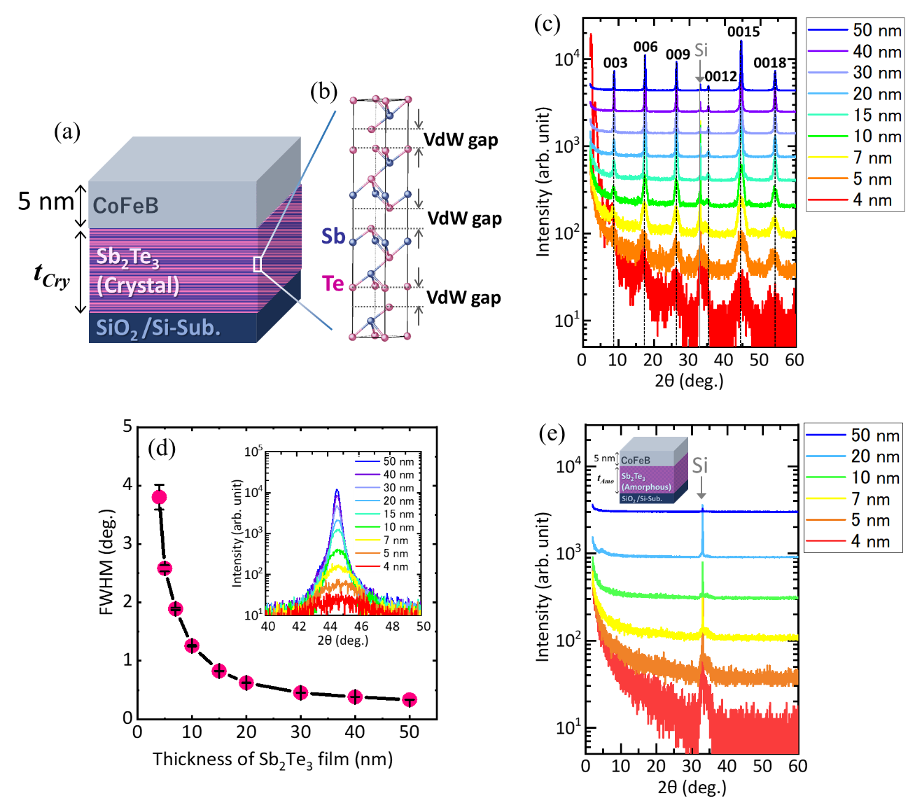
Figure 1. (a) Schematic of the crystalline sample stack. (b) Crystal structure of crystalline Sb₂Te₃. (c) XRD patterns of Sb₂Te₃ films in crystalline samples. (d) FWHM of the (0015) peak as a function of Sb₂Te₃ film thickness. The inset shows the thickness dependence of XRD patterns focused on the (0015) peak. (e) XRD patterns of Sb₂Te₃ films in amorphous samples. The inset shows the stack of the amorphous sample.

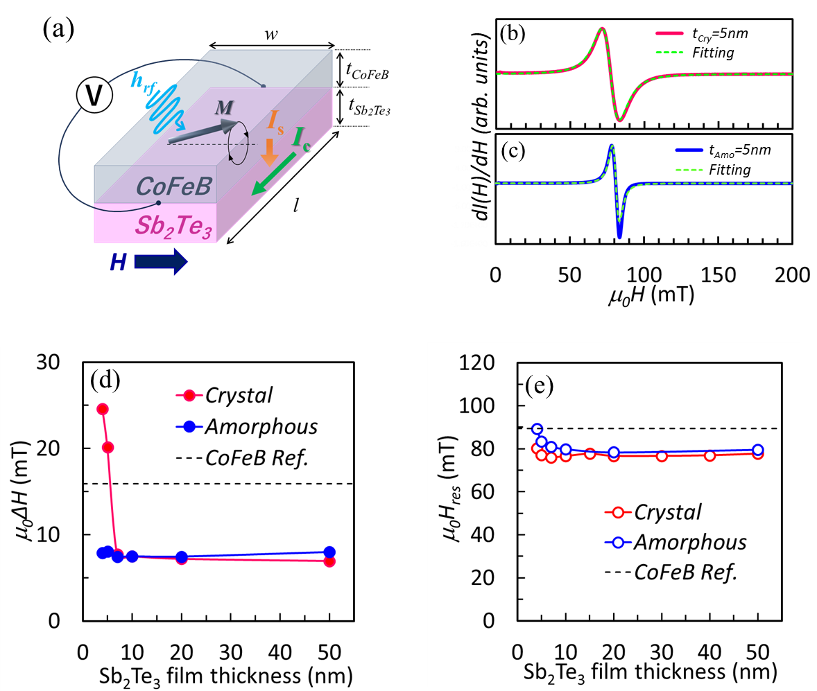
Figure 2. (a) Schematic illustration of the measurement system. FMR spectra of the (b) amorphous and (c) crystalline Sb₂Te₃ samples with a thickness of 5 nm. Thickness dependence of the (d) linewidth ΔH and (e) resonance field for the crystalline and amorphous samples, with the plain CoFeB layer used as a reference.

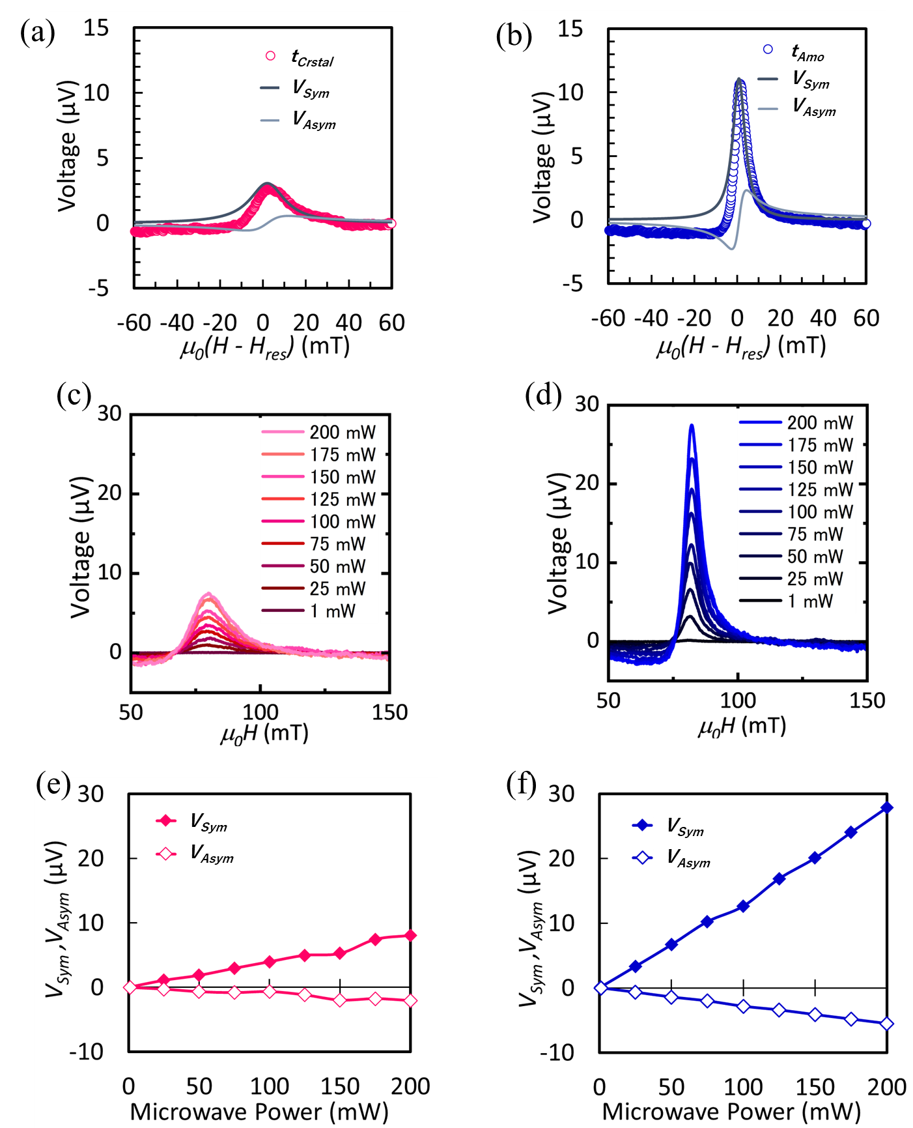

Figure 3. The electromotive force (EMF) signals for (a) crystalline and (b) amorphous samples with a thickness of 5 nm. The symmetric components, V_{Sym}, and asymmetric components, V_{Asym}, obtained from the fitting, are shown by the black and gray solid curves, respectively. The EMF signals as a function of RF power for the (c) crystalline and (d) amorphous samples. RF power dependence of V_{Sym} and V_{Asym} for the (e) crystalline and (f) amorphous samples, as derived from Figs. 3(c) and 4(d), respectively.
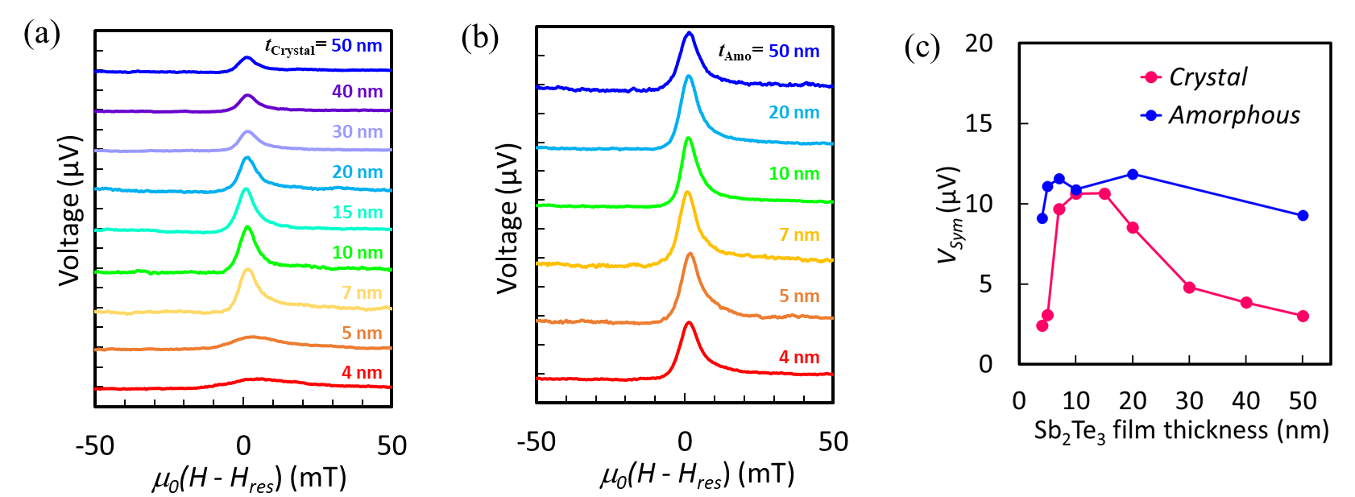
Figure 4. The EMF signals for (a) crystalline and (b) amorphous samples with varying thicknesses of the Sb₂Te₃ films. (c) shows the thickness dependence of V_{Sym} for crystalline and amorphous samples.

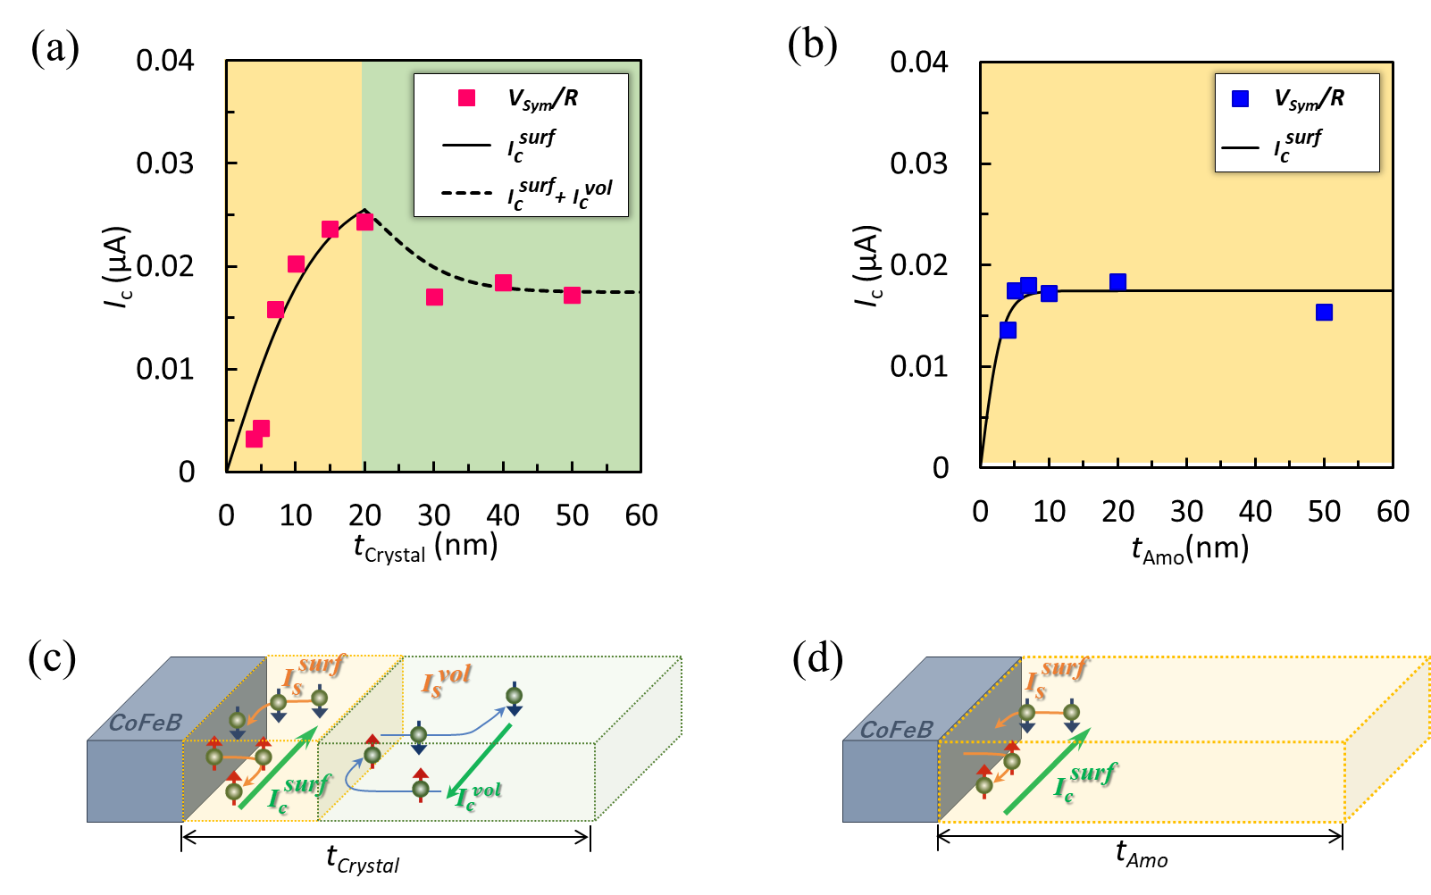

Figure 5. The thickness dependence of the charge current (I_{c}) for (a) crystalline and (b) amorphous Sb₂Te₃ films. The solid and dashed curves represent the fitting curves using Eq. (2) and Eq. (3), respectively. (c) and (d) are schematic diagrams of the spin current-charge current conversion in crystalline and amorphous Sb₂Te₃ layers, respectively.

