Aluminum Nanostructures:
A New Approach for 355 nm
Surface-Enhanced Raman Spectroscopy

P.A. Atanasov1, N.N. Nedyalkov1∗, A.O. Dikovska1, N. Fukata2,

W. Jevasuwan2
¹Institute of Electronics, Bulgarian Academy of Sciences, Sofia, Bulgaria ²International Center for Materials for NanoArchitectonics (MANA), National Institute for Materials Science (NIMS), Tsukuba, Japan
∗Corresponding author Email: nned@ie.bas.bg

Abstract. The ability for surface-enhanced Raman spectroscopy (SERS) study of fluorescent - rhodamine 6G (R6G) and methylene blue (MB) – as well as nonfluorescent (coconut milk) probing chemicals with 355 nm excitation wave-length was demonstrated according to our knowledge for the first time. Alu-minum nanostructures (NSs) arrays used were produced by direct pulsed depo-sition either with ps laser on fused silica substrate or with ns laser decomposition of AlN ceramic surface – all active substrates were produced for the first time. The efficiency of the Al active nanostructures produced on AlN for 355 nm SERS was simulated using the finite difference time domain (FDTD) method. 355 nm SERS was used as an alternative instead of excitation with more high-energetic ultraviolet (UV) or deep ultraviolet (DUV) wavelengths. The increase of the sensitivity of the active alumina substrates was discussed.

KEY WORDS: 55 nm SERS, Al active nanostructures, AlN decomposition, FDTD simulations, R6G, MB and coconut milk.

Introduction

Raman spectroscopy has been widely applied to detect and analyze variety of chemicals. It is expressed by an enormous enhancement of the Raman signal, when the material is in close vicinity of the metal nanostructure. However, the application of Raman spectroscopy has some drawbacks, when studying some samples, for instance which have fluorescence. This can be overcome when excitation wavelength is in the high energetic ultraviolet (UV) or better in the deep ultraviolet (DUV) wavelengths [1–4]. Other advantages, when using UV excitation, are stronger and more defined Raman peaks, since the Raman signal is proportional to the fourth power of the light frequency [5].
The plasmonic studies of variety of chemicals, as well as our former studies (see for example Atanasov et al. [6]) were concentrated on noble metals - gold and

silver, which plasmon resonance is situated in the visible region of the electro-magnetic (EM) spectrum. However, in less than two decades, aluminum plas-monics have emerged and become of great interest [3, 7–11]. On the contrary, the plasmon resonance of Al is situated in the UV and thus, it can be used for studying organic, biological systems and those, which have strong fluorescence, absorptions, and photocatalysis in this region. Aluminium is a relatively cheap metal, stable and easy to work with. However, it is self-limiting oxidizing and consequently, the preparing and storing of the nanostructures must be done in vacuum environment.
Several techniques were theoretically or experimentally studied, developed and applied for producing active Al substrates for SERS. Ordered Al nanohole ar-rays were theoretically proposed and simulated by using the finite-difference
time-domain (FDTD) method for tunable UV SERS [12]. The enhancement factor (EF) as high as 10^{5÷6} was attained at optimal geometry by DUV laser excitation. Extremely sensitive detection of the molecule adenine (∼ 3 × 10⁴ molecules) using DUV surface-enhanced resonance Raman scattering (SERRS)
on Al nanostructures (NSs) was reported by Jha et al. [13]. The authors fabri-cated well-defined Al nanoparticle (NP) arrays using DUV interference lithog-raphy, which exhibited sharp and tunable plasmon resonances in the UV and DUV wavelength ranges. Moreover, the FDTD method was used to understand the near-field and far-field optical properties of the NP arrays, when the Raman measurements at a laser excitation wavelength of 257.2 nm were performed.
Sigle et al. [14] presented a novel scalable route for the fabrication of Al nano-voids for SERS in the DUV. EF about ≈10⁶ was observed, with excitation at 244 nm on structures which were optimized for this wavelength. Sharma et
al. [15] reported the first-time fabrication of Al film-over nanosphere substrates for 229 nm SERRS. The structures were characterized by localized surface plas-mon resonance (LSPR) spectroscopy, electron microscopy, SERRS of different molecules, and dielectric function analysis. EF >10⁶ was achieved. Ponzellini et al. [16] prepared active nano-porous Al-Mg alloy films. The authors tunned the stoichiometry, the porosity, and the oxide contents by changing the ratio between Al and Mg and experimentally demonstrated its efficacy in enhancing fluorescence and surface Raman scattering for excitation wavelengths of 360 and 257 nm, respectively. They numerically showed the superior performance of the nano-porous Al-Mg alloy in the UV range compared with the equivalent porous Au structures and claimed that this material is promising for a wide range of applications in UV/DUV plasmonics. Furthermore, Garoli et al. [17] from the same scientific group have fabricated substrates of nano-porous Al from an alloy of Al₂Mg₃.
Recently, Al NP were fabricated directly on different Al film layers, and the nanoscale-thick alunum interlayer obtained between neighboring Al films acts as natural dielectric gaps [18]. The plasmonic couplings between the Al NP and Al film increase with the number of Al film layers. The FDTD method was also

applied by the authors to verify the experimental results. Finally, Al NSs arrays were produced by decomposition and nanostructuring of AlN ceramics by ps or ns laser pulses in air and vacuum [19, 20].
As it was mentioned above, one of the advantages of the UV-excited Raman study is to detect fluorescent chemicals. Two probe molecules were used in this study: rhodamine 6G (R6G) and methylene blue (MB). The first one was widely used in agriculture, textile, paper, and printing industries, but as it is highly toxic to the human body and other organisms was strictly banned for use in the food industry [20, 21]. The second one is aromatic chemical compound widely used as a dye and in medicine. Additionally, coconut milk was chosen as a non fluorescent probing analyte due to its importance in nutrition and medicine.
The goal of this communication is to describe preparation of the active Al NSs arrays on AlN ceramic substrates using nanosecond (ns) laser pulse decompo-sition, or also produced on fused silica directly using picosecond (ps) laser de-position. According to our knowledge, the preparation of such structures by these methods was proposed for the first time. The morphology of the active substrates has also been studied. The efficiency of the Al active NSs produced on AlN for 355 nm SERS was simulated using the finite difference time domain (FDTD) method. Their ability for SERS study at 355 nm excitation was proven by the use of fluorescent chemicals R6G, MB and nonfluorescent coconut milk. It is important to note that the first two chemicals were explored very much by many researchers, but coconut milk was studied for the first time. However, the purpose of this study is not to detect the lowest quantity of the analytes (or min-imum detection limit) but to prove the ability of the SERS study if excitation at 355 nm is suitable.

Experimental

  - Materials and instrumentation.
Preparation of aluminum nanostructured arrays
Rhodamine 6G - R6G (Sigma Aldrich Co., LLC), methylene blue - MB (Tokyo Chem. Industry Co., Ltd.) and canned coconut milk (Chaokoh, Thailand) with concentration of 99.98 % and 0.02 % antioxidant (sodium metabisulfite) were used in the study. They were diluted in distilled water in order to produce liquid solutions with relatively lower concentrations.
Samples of aluminum nanostructures (NSs) were fabricated by decomposition the surface of aluminum nitride (AlN) ceramic substrates using ns laser pulses or direct pulsed laser deposition on fused silica using picosecond (ps) pulses [20–22]. In the first case, up to 600 pulses, with an energy density of 10 J/cm² delivered by Nd:YAG laser (Lotis TII), operating at λ = 1064 nm with a pulse duration of 12 ns were applied. The nano-structuring was accomplished in an

ambient pressure of 7.9 × 10⁻⁴ Torr. The second set of samples of Al NSs were fabricated by direct PLD on fused silica substrates using a 1 KHz repetition rate ps Nd:YAG laser (Model: CNI Laser, PS-A1-1064). It generates 10-ps pulses at
1064 nm. The aluminum target was situated at about ≈3 cm from the substrate
and was ablated by laser pulses with a fluence of 2 J/cm² in an ambient pressure of 9.5 × 10⁻⁴ Torr at room temperature. The deposition time was 5 min.
Prior to processing, the basic substrates were cleaned with alcohol, washed with deionized water, and dried. Liquid drops of the analytes at concentration of 0.1 M were deposited and dried on glass plate in order to get their µ-Raman spectra for reference and – 0.1, 0.01 M on the active Al substrates.
The surface morphology analysis was carried out by scanning electron micro-scopy (SEM) (FEI Quanta FEG 250 and Zeiss EVO 15, equipped with Energy Dispersive X-ray (EDX) spectrometer (Oxford Instruments, Abingdon, UK)). The phase and chemical characterization of the processed areas was done based on EDX and X-ray photoelectron spectroscopy (XPS) (AXIS Supra electron spectrometer, Kratos Analytical Ltd., Stretford, UK) with the standard decon-volution software (ESCApeTM 1.2.0.1325 of Kratos Analytical Ltd., Manch-ester, UK) analyses. The transmission electron microscopy (TEM) study was accomplished by JEOL JEM 2100 at an accelerating voltage of 200 kV and Al NPs were visualized in order to evaluate their shape and size distribution. The analysis of the obtained results was based on the calculations of the near-field en-hancement at different conditions based on Finite Difference Time Domain sim-ulation (Omnisim, Photon Design, Edmonton, AL, Canada) and the extinction spectra calculations was based on Generalized Mie scattering theory [23, 24]. The structures considered in these simulations were taken from the SEM images of the real samples.
The Raman spectra were achieved using a µ-Raman spectrometer (Photon De-sign, Tokyo, Japan) supplied with an optically pumped semiconductor laser (Genesis CX) generating at λ = 355 nm. The beam was focused using a con-
focal microscope with a 90× objective lens and various laser excitation powers
up to 2.0 mW have been applied. In order to avoid irregularities, each Raman
spectrum was obtained on the basis of averaging of at least two scans taken from different points of the samples and an acquisition time of 10 min.

Results and Discussions

  - The morphological properties of the Al nanostructures
Several changings are expected to happen when laser light interacts with AlN ceramics: decomposition of the surface, which significantly altered of its chem-ical composition, mechanical and insulating properties; formation of cracks and periodic ripples as a result of the high mechanical stresses caused by temper-

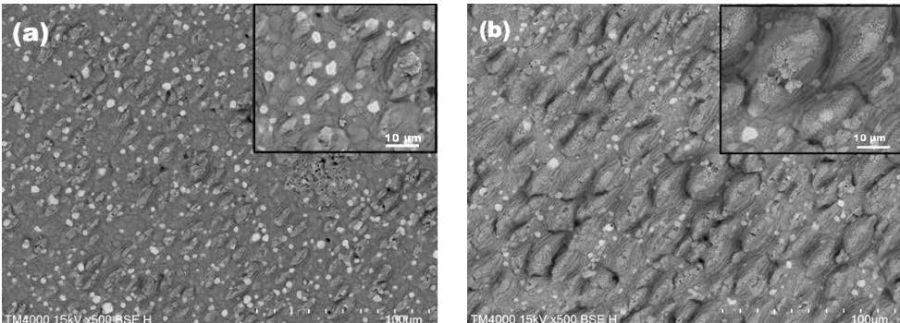
Figure 1. SEM pictures of Al nanostructures produced by nanosecond (ns) laser pulses with fluence of 10 J/cm² for the decomposition on the aluminum nitride (AlN) ceramic surface: (a) 100 laser pulses; and (b) 300 laser pulses. The insets depict SEM at higher magnification [21].

ature gradients. In this respect, the ns laser processing induces change in the
surface composition. According to Dryburgh [25], the reaction which dominate at the lowest decomposition temperature is: AlN → Al(s, l) + 1/2N₂(g), where s, l and g represent solid, liquid and gas state, respectively. This reaction is the
main one that defines the surface composition after ns laser processing. Some SEM pictures of Al nanostructures produced by ns laser on the aluminum nitride (AlN) surface are depicted in Figure 1(a) and (b).
In some cases, formation of periodic ripples was observed (Figure 1). Such structures are typical when ultrashort laser pulses (pulse duration of pico- and femtoseconds) were used [26]. They are orientated perpendicular to the laser
polarization and the characteristic period is in the order of the used wave-length (about ≈900 nm). The surface of the fabricated material has also a sub-micrometer structure. It is composed of nanoparticles with sizes in the range of 10 ÷ 100 nm.
The processing was also accomplished in air. In all cases, ripple structures with the same characteristics as presented in the case of irradiation in vacuum were formed.
The material formed after the laser ablation in all cases presented was electri-cally conductive. By using two probe measurements, it was found that the resis-tance value is in the order of tens of Omhs. A higher value of about 10% was obtained for the structures fabricated in air. In order to clarify the chemical com-position of the material in the irradiated zone, XPS analyses were performed. It is worth noting that all described features were observed and studied thoroughly in case of ps pulses interaction with AlN by Nedyalkov et al. [19].
The ps laser was used for direct deposition of Al NSs on fused silica substrates. The samples were vied by TEM analysis. The procedure was following. Alu-minum nanoparticles were deposited at the same conditions on TEM copper grid

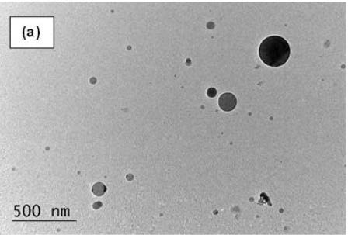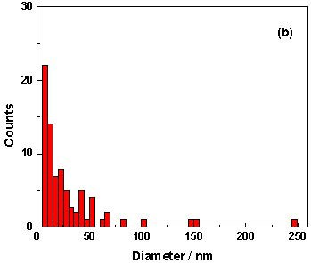
Figure 2. (a) TEM image of the deposited material at picosecond (ps) laser deposition of Al in vacuum. The deposition time was 2 min at laser fluence 2 J/cm²; (b) Size distribution of the deposited Al nanoparticles. Five images (in total 90 particles) were used to construct the dependence.

for 2 min in order to avoid accumulation of material that would hamper evalua-tion of the nanoparticles’characteristics (Figure 2(a)). As is seen, it is composed of spherical nanoparticles. The size distribution of the Al NPs is also presented in Figure 2(b). Here, data from five TEM images were used in order to present
better statistics. The most probable particles diameter is about ≈7.5 nm, as sin-
gle particles with size of several hundreds of nanometers are also present.

  - Material composition in case of ns laser processing of AlN ceramics
As concluding from XPS analyses, the ns ablation of AlN ceramics results in the formation of oxide that dominates the surface composition in both vacuum and air conditions. Additionally, analysis of the surface composition was performed by EDX. Figure 3 shows the obtained compositions of the material in a specific area, which is indicated by a cross in the presented SEM images. The estimation
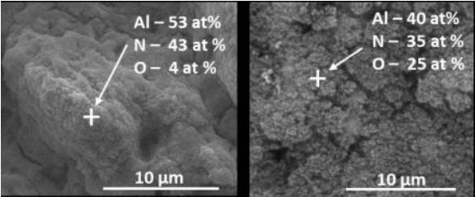
Figure 3. SEM images with marked areas, where EDX analyses was performed. The laser fluence used was 18 J/cm² and 300 pulses. The ablation was performed in vacuum
- (a) or (b) in air at atmospheric pressure [20].

of the chemical composition given by EDX analysis clarifies that the clusters observed on the surface of the material processed in air contains nanoparticles with a high composition of aluminium oxide.

  - Efficiency of the SERS signals as result of morphology of the fabricated Al structures on AlN - FDTD simulation
Figure 4 presents an FDTD simulation of the EM field intensity distribution in the vicinity of structures formed by ns laser processing of AlN ceramics. The considered structures have similar morphology in some areas seen in the SEM images of the real samples. In this case, the maximum excitation reaches about
≈ 1.2 × 10². It is related to the presence of closely located NPs, where efficient
charge coupling is realized.
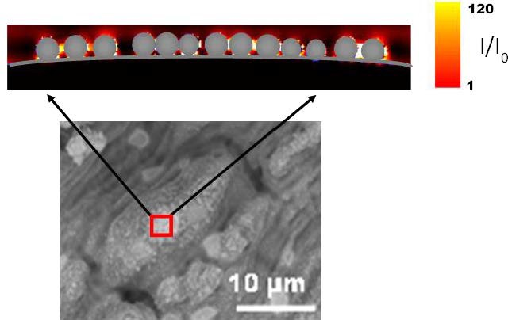
Figure 4. FDTD simulation of the EM field intensify distribution in the vicinity of Al nanoparticle array on the top of micro-sized Al particle. The red line in the SEM image shows the observation plane presented in the simulation. Nanoparticles sizes are 80, 90 and 100 nm. The SEM image corresponds to Figure 1(b) [21].

  - 355 nm µ-Raman and SERS of the R6G, MB and coconut samples
Figure 5 depicts 355 nm SERS spectrum of R6G deposited on aluminum struc-tures, which were produced on quartz substrates via pulsed laser deposition or on the surface of AlN substrates. The characteristic bands presented are around
612, 776, 1650, 1310 and 1077 cm⁻¹, which were also reported by other au-
thors [27–29]. Here, very strong peaks at 612, 656, 667, and 909 are character-istic to the AlN ceramics [30, 31]. The peak at 612 cm⁻¹ of AlN is much larger, when R6G was presented. This is because the peaks of AlN and R6G at 612 cm⁻¹ strictly coincide and could not be separated. The lowest detection limit

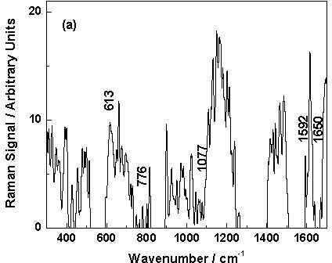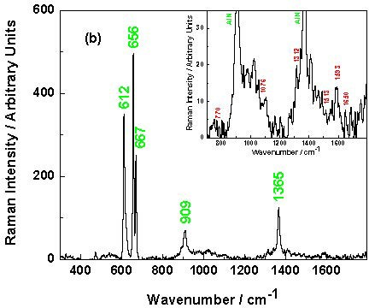
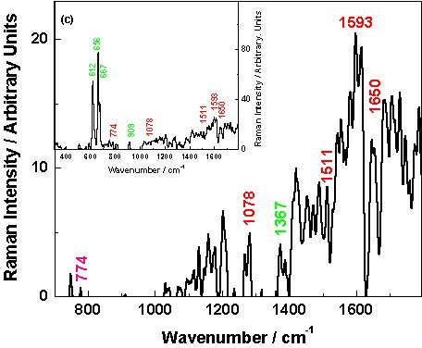
Figure 5. Surface-enhanced Raman spec-troscopy (SERS) spectra of 0.01 M rho-damine 6G (R6G) deposited on: (a) Al nanostructure array produced on quartz; (b) nanostructured AlN with 300 pulses, as the Inset depicts the enlarged part of the spec-
trum from 750 to 1600 cm⁻¹; (c) nanos-
tructured AlN with 600 pulses, as the Inset
depicts entire spectrum. The AlN peaks are indicated in green and the R6G – in red, re-spectively.

was estimated based on the values of the strongest SERS peaks, i.e. 1310 and 1650 cm⁻¹, to be about ≈10⁻⁷ M.
The SERS spectrum of MB, deposited on the Al NS array on a quartz substrate is exposed in Figure 6. Here, the peaks around 450, 1180, 1402, and 1431 cm⁻¹ and the most intensive one at 1620 cm⁻¹ are presented. All bands coincide with the reported before from other authors [32–34].
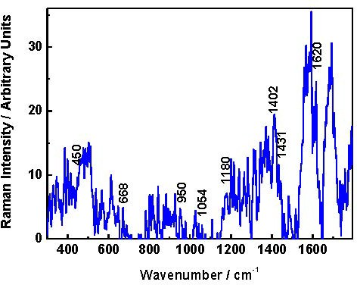
The µ-Raman and SERS spectra as well as cover package of the coconut milk

Figure 6. Surface-enhanced Raman spec-troscopy (SERS) spectrum of 0.01 M methylene blue (MB) deposited on Al nanostructure produced on quartz.

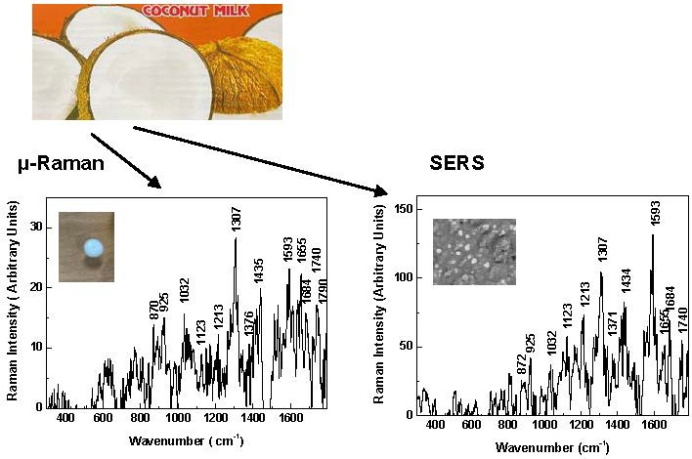
Figure 7. µ-Raman spectrum of coconut milk as purchased in liquid form (the drop) on quartz substrate. SERS of 0.1 M coconut milk deposited on Al nanostructures area produced by nanosecond (ns) laser on the aluminum nitride (AlN) ceramic surface.

used were depicted in Figure 7. As is seen, the intensities of the SERS peaks are at least ≈ 5 ÷ 6 times higher than corresponding in the µ-Raman spectrum, regardless the lower concentration (one order of magnitude) in the SERSs case.
The SERS spectrum of 0.1 M coconut milk, deposited on Al NPs arrays pro-duced on quartz substrate is shown in Figure 8. As it is seen, the peaks having
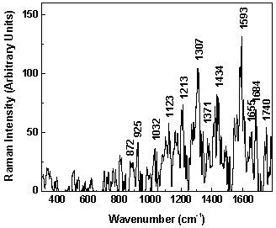
most prominent intensity are situated at 1593 and 1684 cm⁻¹ and those at 925, 1032, 1213, 1655, and 1790 cm⁻¹ belong to the vibration of some additives in the coconut milk, and the rest peaks belong to the coconut oil. The peaks at 1300

Figure 8. Surface-enhanced Raman spec-troscopy spectrum of 0.1 M coconut milk, deposited on aluminium nanoparticles ar-rays produced by pulsed laser deposition on quartz substrate.

and 1440 cm⁻¹ belong to the coconut oil and are close to the first two most in-tensive SERS peaks [35, 36]. It is worth noting that the intensity of the peaks in the SERS spectrum are more than six times higher than those of the coconut
milk deposited on glass, regardless of an order of magnitude lower concentration and thus, EF was estimated to be about > 5 × 10².
The comparison between the SERS spectra obtained indicated that the enhance-ment of the signal is much larger in the case of the aluminum NSs generated on the AlN ceramics than those on the quartz substrates. This may relate to the sizes of the NPs, larger in the case of decomposed ceramics, which deter-mines the position of the plasmon resonance with respect to the Raman excita-tion wavelength. The obtained results indicated that the fabricated structures ex-press enhancement of the Raman signal when they are used as active substrates in SERS.
Finaly, the experimental results obtained are very promising. In order to increase the sensitivity of the samples and to improve the methods a shift of the plasmon resonance to match with 355 nm excitation is possible by tailoring the size of the Al NPs and structures in general. Figure 9 depicts optical transmission spectrum of aluminium nanostructure array used in this study. The point of the ultraviolet Raman excitation at 355 nm is indicated. As is seen that it is shifted and about
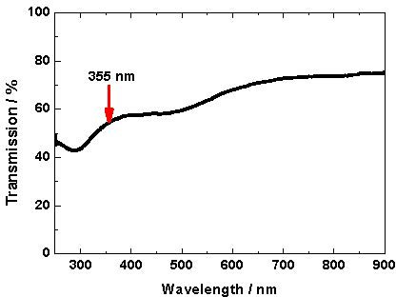
≈12% lower than this at the plasmon resonance at 287 nm.

Figure 9. Optical transmission spectrum of aluminium nanostructure array produced by ps PLD on fused quartz. The point of the ultraviolet Raman excitation at 355 nm is indicated (red arrow).

Conclusions

In summary, the ability for µ-Raman and SERS studies for detecting fluorescent chemicals - rhodamine 6G (R6G) and methylene blue (MB) – as well as coconut milk at 355 nm excitation was demonstrated for the first time. Moreover, the active aluminum nanostructures used for the SERS investigations were prepared on quartz substrates directly using picosecond laser pulses or by ns laser decom-position of AlN ceramics. The experimental results obtained are very promising. With a view to increase the sensitivity of the samples and to improve the method some more work is needed in order to shift the position of the plasmon resonance

to match with 355 nm excitation wavelength of the Raman equipment used by tailoring the size of the Al nanoparticles, which is the subject of the next study.

Acknowledgements
Authors gratefully acknowledged the collaboration with Prof. Alexandrov, Prof.
D. Karashanova, Dr. R. Nikov and Dr. G. Atanasova - Bulgaria, Dr. K. Gro-chowska and Dr. J. Karczewski – Poland and the support of the National Institute for Materials Science (NIMS), Japan (2021–2022) by using its facilities.

References

- S.A. Asher, C.R. Johnson (1984) Raman spectroscopy of a coal liquid shows that fluorescence interference is minimized with ultraviolet excitation. Science 225 311-313.
- C. Langhammer, M. Schwind, B.K.I. Zoric´ (2008) Localized surface plasmon res-onances in aluminum nanodisks. Nano Lett. 8 1461-1471.
- D. Gerard, S.K. Gray (2015) Aluminium plasmonics. J. Phys. D: Appl. Phys. 48
184001.
- C. Liu (2011) Implementation of deep ultraviolet Raman spectroscopy. PhD Thesis, DTU, Chemistry.
- P.R. Griffiths (2001) in: Handbook of Vibrational Spectroscopy, Vol. 1, eds: J.M. Chalmers, P.R. Griffiths, Wiley, USA, pp, 33-43.
- P.A. Atanasov, N.N. Nedyalkov, N. Fukata, W. Jevasuwan (2021) Advanced silver and gold substrates for surface-enhanced Raman spectroscopy of pesticides. Spec-troscopy Lett. 54(7) 528-538.
- S.A. Asher (1988) UV resonance Raman studies of molecular structure and dynam-ics. Ann. Rev. Phys. Chem. 39 537-588.
- K. Ray, M.H. Chowdhury, J.R. Lakowicz (2007) Aluminum nanostructured films as substrates for enhanced fluorescence in the ultraviolet-blue spectral region. Anal. Chem. 79(17) 6480-6487.
- A. Taguchi, Y. Saito, K. Watanabe, S. Yijian, S. Kawata (2012) Tailoring plasmon resonances in the deep-ultraviolet by size-tunable fabrication of aluminum nanos-tructures. Appl. Phys. Lett. 101 081110.
- M.W. Knight, N.S. King, L. Liu, H.O. Everitt, P. Nortlander, N. Hallas (2014) Alu-minum for plasmonics. ACS Nano 8(1) 834-840.
- J. Martin, M. Kociak, Z. Mahfoud, J. Proust, D. Gérard, J. Plain (2014) High-resolution imaging and spectroscopy of multipolar plasmonic resonances in alu-minum nanoantennas. Nano Lett. 14(10) 5517-5523.
- Z.-L. Yang, Q.-H. Li, B. Ren, Z.-Q. Tian (2011) Tunable SERS from aluminium nanohole arrays in the ultraviolet region. Chem. Commun. 47 3909-3911.
- S.K. Jha, Z. Ahmed, M. Agio, Y. Ekinci, J.F. Löffler (2012) Deep-UV surface-enhanced resonance Raman scattering of adenine on aluminum nanoparticle arrays.
J. Am. Chem. Soc. 134 1966-1969.
- D.O. Sigle, E. Perkins, J.J. Baumberg, S. Mahajan (2013) Reproducible deep-UV SERRS on aluminum nanovoids. J. Phys. Chem. Lett. 4 1449-1452.

- B. Sharma, M.F. Cardinal, M.B. Ross, A. Zrimsek, S.V. Bykov, D. Punihaole, S.A. Asher, G.C. Schatz, R.P. Van Duyne (2016) Aluminum film-over-nanosphere sub-strates for deep-UV surface-enhanced resonance Raman spectroscopy. Nano Lett. 16 7968-7973.
- P. Ponzellini, G. Giovannini, S. Cattarin, R.P. Zaccaria, S. Marras, M. Prato, A. Schirato, F. D’Amico, E. Calandrini, F. De Angelis, W. Yang, H.-J. Jin, A. Alabas-tri, D. Garoli (2019) Metallic Nanoporous Aluminum-Magnesium Alloy for UV Enhanced Spectroscopy. J. Phys. Chem. C 123(33) 20287-20296.
- D. Garoli, A. Schirato, G. Giovannini, S. Cattarin, P. Ponzellini, E. Calandrini, R.P. Zaccaria, F. D’Amico, M. Pachetti, W. Yang, H.-J. Jin, R. Krahne, A. Alabastri (2020) Galvanic replacement reaction as a route to prepare nanoporous aluminum for UV plasmonics. Nanomaterials 10 102.
- Z. Li, C. Li, J. Yu, Z. Li, X. Zhao, A. Liu, S. Jiang, C. Yang, C. Zhang, B. Man (2020) Aluminum nanoparticle films with an enhanced hot-spot intensity for high-efficiency SERS. Opt. Express 28(7) 9174-9185.
- N. Nedyalkov, A. Dikovska, P. Atanasov, G. Atanasova, L. Aleksandrov (2023) Ablation and surface structuring of nitride ceramics induced by picosecond laser pulses. Nucl. Instrum. Methods Phys. Res. B 543 165092.
- P. Atanasov, A. Dikovska, R. Nikov, G. Atanasova, K. Grochowska, J. Karczewski,
N. Fukata, W. Jevasuwan, N. Nedyalkov (2024) Surface-Enhanced Raman Spec-troscopy of Ammonium Nitrate Using Al Structures, Fabricated by Laser Process-ing of AlN Ceramic. Materials 17 2254.
- P.A. Atanasov, N.N. Nedyalkov, A.O. Dikovska, N. Fukata, W. Jevasuwan (2023) Aluminum nanostructures for 355 nm surface-enhanced Raman spectroscopy of flu-orescing chemicals. J. Raman Spectrosc. 54 1383-1391.
- P.A. Atanasov, N.N. Nedyalkov, A.O. Dikovska, D. Karashanova, N. Fukata, W. Jevasuwan (2024) Application of Aluminium Nanostructures for 355 nm Surface-enhanced Raman Spectroscopy of Coconut Milk. C.R. Acad. Bulg. Sci. 77(2) 179-187.
- Y.-L. Xu (2003) Scattering Mueller matrix of an ensemble of variously shaped small particles. J. Opt. Soc. Am. A 20 2093-2105.
- Y.-L. Xu, B.A.S. Gustafson (2001) A generalized multiparticle Mie-solution: fur-ther experimental verification. J. Quant. Spectr. Rad. Transf. 70 395-419.
- P.M. Dryburgh (1992) The estimation of maximum growth rate for aluminium ni-tride crystals grown by direct sublimation. J. Cryst. Growth 125(1-2) 65-68.
- J. Bonse, S. Graf (2020) Maxwell meets Marangoni—a review of theories on laser-induced periodic surface structures. Las. Photon. Rev. 14(10) 2000215.
- P. Hildebrandt, M. Stockburger (1984) Surface-enhanced resonance Raman spec-troscopy of Rhodamine 6G adsorbed on colloidal silver. J. Phys. Chem. 88 5935-5944.
- D. Pristinski, S. Tan, M. Erol, H. Du, S. Sukhishvili (2006) In situ SERS study of Rhodamine 6G adsorbed on individually immobilized Ag nanoparticles. J. Raman Spectrosc. 37 762-770.
- C. Wu, E. Chen, J. Wie (2016) Surface enhanced Raman spectroscopy of Rho-damine 6G on agglomerates of different-sized silver truncated nanotriangles. Col-loids Surf. A Physicochem. Eng. Asp. 506 450-456.

- Y.G. Cao, X.L. Chen, Y.C. Lan, J.Y. Li, Y.P. Xu, T. Xu, Q.L. Liu, J.K. Liang (2000)
Blue emission and Raman scattering spectrum from AlN nanocrystalline powders.
J. Crys. Growth 213 198-202.
- M. Bernard, A. Deneuville, O. Thomas, P. Gergaud, P. Sandstrom, J. Birch (2000) Raman spectra of TiN/AlN superlattices. Thin Solid Films 380 252-255.
- M.P. Rodríguez-Torres, L.A. Díaz-Torres, S. Romero-Servin (2014) Heparin as-sisted photochemical synthesis of gold nanoparticles and their performance as SERS substrates. Int. J. Mol. Sci. 15 19239-19252.
- S.N.A. De Nicolai, P.R.P. Rodrigues, S.M.L. Agostinho, J.C. Rubim (2002) Electro-chemical and spectroelectrochemical (SERS) studies of the reduction of methylene blue on a silver electrode. J. Electroanal. Chem. 527 103-111.
- N.X. Dinh, T.Q. Huy, L.V. Vu, L.T. Tam, A.-T. Le (2016) Multiwalled carbon nan-otubes/silver nanocomposite as effective SERS platform for detection of methylene blue dye in water. J. Sci.: Adv. Mater. Dev. 1 84-89.
- G.N. Xiao, S.Q. Man (2007) Surface-enhanced Raman scattering of methylene blue adsorbed on cap-shaped silver nanoparticles. Chem. Phys. Lett. 447(4-6) 305-309.
- M.De Géa Neves, R.J. Poppi (2018) Monitoring of adulteration and purity in co-conut oil using Raman spectroscopy and multivariate curve resolution. Food Anal. Methods 11(7) 1897-1905.

