Surface-modified BaTiO₃ as a functional filler in poly(ethylene oxide)-based solid polymer electrolytes for lithium-metal batteries

Shuyu Dongª, Yiyi Zhengª, Qiaohui Duanª, Yu Zhaoª, Tian Tanª, Yu Zhouª, Tian Raoª, Hanbing Yan^{b}, Weiqian Guo^{b}, Denis Y. W. Yu^{c}*

ªSchool of Energy and Environment, City University of Hong Kong, 83 Tat Chee Avenue, Kowloon, Hong Kong, China
^{b}Tsinghua Shenzhen International Graduate School, Tsinghua University, Shenzhen 518055, China
^{c}Research Center for Energy and Environmental Materials (GREEN), National Institute for Materials Science, Namiki 1-1, Tsukuba, Ibaraki 305-0044, Japan

* Corresponding author
Email: yu.denis@nims.go.jp
Address: Namiki 1-1, Tsukuba, Ibaraki-ken, Japan 305-0044

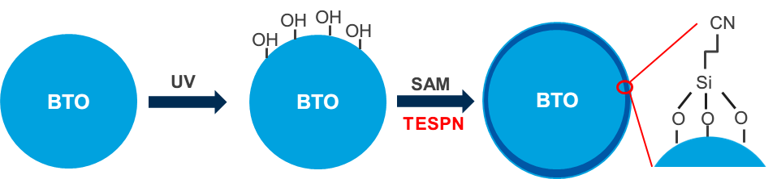

Figure S1. Schematic diagram of the coating process of BTO@TESPN.

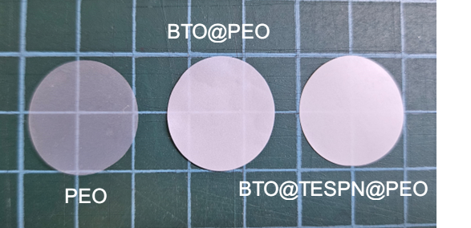

Figure S2. Optical photographs of PEO, BTO@PEO and BTO@TESPN@PEO electrolytes.

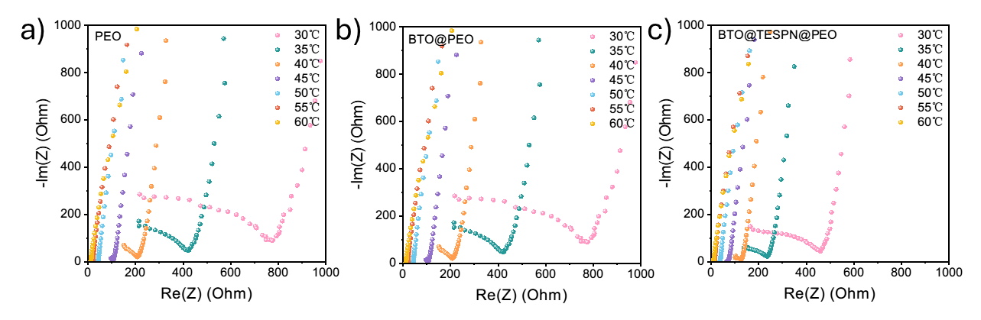
Figure S3. Electrochemical impedance plots of a) PEO, b) BTO@PEO, c) BTO@TESPN@PEO electrolytes in stainless steel-stainless steel symmetric cells at 30-60 ℃.

Figure S4. Li-transfer number of PEO and BTO@PEO SPE.

Figure S5. Linear sweep voltammetry plots of PEO, BTO@PEO and BTO@TESPN@PEO electrolytes at a scan rate of 0.1 mV s⁻¹ at 60 °C with stainless steel working electrode and Li counter electrode.
Figure S6. Linear sweep voltammograms of Li-Li symmetric cell with PEO, BTO@PEO and BTO@TESPN@PEO electrolytes from -0.25 V to 0.25 V with a scan rate of 1 mV s⁻¹.

Figure S7. Tafel plots and exchange current density of BTO@PEO obtained from the linear sweep voltammetry tests in the range of -0.25 V to 0.25 V
Figure S8. Critical current density of symmetric cells with BTO@PEO electrolytes from a rate-performance test with a capacity of 0.1 mAh cm⁻² per half cycle.

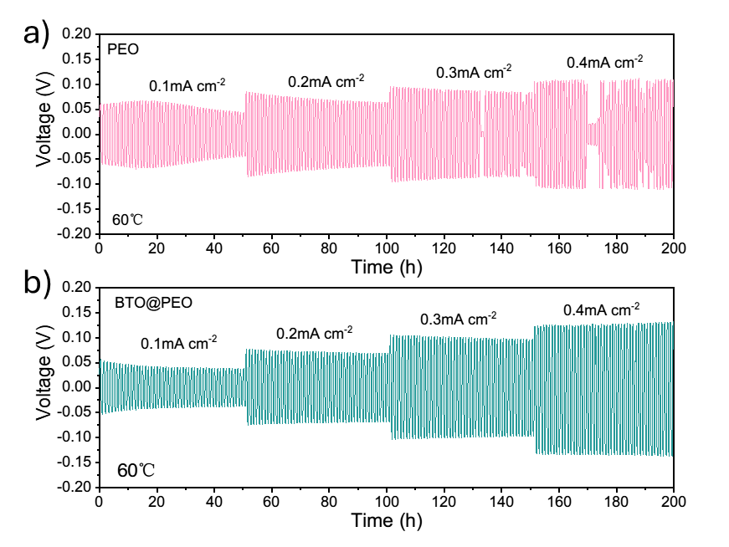
Figure S9. Galvanostatic cycling of Li-Li symmetric cell with a) PEO, b) BTO@PEO from 0.1 to 0.4 mA cm⁻² with a capacity limit of 0.05 to 0.2 mAh cm⁻² (half hour charge/half hour discharge).

Figure S10. Galvanostatic cycling of Li-Li symmetric cell with BTO@PEO electrolytes with 0.1 mA cm⁻².

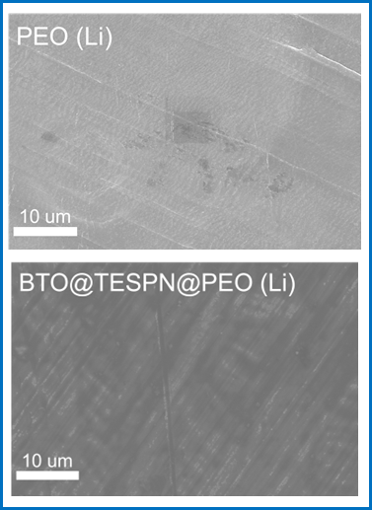
Figure S11. SEM images of Li anode after 10 cycles at 0.1 mA cm⁻² /0.1 mAh cm⁻² with PEO and BTO@TESPN@PEO electrolytes.

Table S1. Comparison of capacity of PEO-based electrolyte

Electrolyte compositions | Li⁺:EO | Specific  capacity  (mAh g⁻¹) | Cycle  number | Capacity  retention | Working temperature  (℃) | Current  density
PEO+LLZO+SCN^{[1]} | 1:18 | 130.2 | 500 | 80% | 60 | 1.0 C
PEO+SN+LiAlO₂^{[2]} | 1:10 | 141.3 | 25 | 84.9% | 60 | 1.0 C
PEO+LLZTO+SN^{[3]} | 1:18 | 151.1 | 200 | 98% | 60 | 0.5 C
PEO+LLZTO@PDA^{[4]} | 1:8 | 142.6 | 50 | 99% | 50 | 0.2 C
PEO+PI^{[5]} | 1:15 | 138 | 300 | 96% | 60 | 0.5 C
PEO+MOF^{[6]} | 1:18 | 151 | 100 | 95% | 60 | 0.5 C
PEO+aligned LAGP^{[7]} | 1:8 | 148.7 | 300 | 93.3% | 60 | 0.3 C
PEO+LLZO^{[8]} | 1:16 | 162.7 | 120 | 91.7% | 60 | 0.1 C
PEO+KPF₆^{[9]} | 1:16 | 142.1 | 200 | 91.3% | 60 | 0.5 C
PEO+H₂TPP(PEG)₄^{[10]} | - | 158.2 | 120 | 97.1% | 60 | 0.2 C
PEO+LS-AFE^{[11]} | 1:16 | 112.4 | 150 | 96.7% | 60 | 2.0 C
PEO+SBA-LiIL^{[12]} | 1:16 | 150.3 | 90 | 88.4% | 60 | 0.07 C
PEO+HPEA^{[13]} | 1:26 | 155.4 | 110 | 90.8% | 50 | 0.1 C
PEO+BTO@TESPN  (our work) | 1:20 | 155.4 | 700 | 93.0% | 60 | 0.5 C

References
[1] F. Chen, W. Zha, D. Yang, S. Cao, Q. Shen, L. Zhang, D. R. Sadoway, J. Electrochem. Soc. 2018, 165, A3558.
[2] N. Zhang, J. He, W. Han, Y. Wang, J. Mater. Sci. 2019, 54, 9603.
[3] W. Zha, F. Chen, D. Yang, Q. Shen, L. Zhang, J. Power Sources 2018, 397, 87.
[4] Z. Huang, W. Pang, P. Liang, Z. Jin, N. Grundish, Y. Li, C.-A. Wang, J. Mater. Chem. A 2019, 7, 16425.
[5] J. Wan, J. Xie, X. Kong, Z. Liu, K. Liu, F. Shi, A. Pei, H. Chen, W. Chen, J. Chen, X. Zhang, L. Zong, J. Wang, L.-Q. Chen, J. Qin, Y. Cui, Nat. Nanotechnol. 2019, 14, 705.
[6] J.-F. Wu, X. Guo, J. Mater. Chem. A 2019, 7, 2653.
[7] X. Wang, H. Zhai, B. Qie, Q. Cheng, A. Li, J. Borovilas, B. Xu, C. Shi, T. Jin, X. Liao, Y. Li, X. He, S. Du, Y. Fu, M. Dontigny, K. Zaghib, Y. Yang, Nano Energy 2019, 60, 205.
[8] Z. Wan, D. Lei, W. Yang, C. Liu, K. Shi, X. Hao, L. Shen, W. Lv, B. Li, Q.-H. Yang, F. Kang, Y.-B. He, Adv. Funct. Mater. 2019, 29, 1805301.
[9] J. Li, J. Liang, Z. Ren, C. Shi, Y. Li, L. Zhang, Q. Zhang, C. He, X. Ren, Electrochimica Acta 2022, 429, 141061.
[10] Q. Zeng, P. Chen, Z. Li, X. Wen, W. Wen, Y. Liu, H. Zhao, S. Zhang, H. Zhou, L. Zhang, ACS Appl. Mater. Interfaces 2021, 13, 48569.
[11] Z. Shi, W. Guo, L. Zhou, Q. Xu, Y. Min, J. Mater. Chem. A 2021, 9, 21057.
[12] X. Shen, R. Li, H. Ma, L. Peng, B. Huang, P. Zhang, J. Zhao, Solid State Ion. 2020, 354, 115412.
[13] P. Chen, X. Liu, S. Wang, Q. Zeng, Z. Wang, Z. Li, L. Zhang, ACS Appl. Mater. Interfaces 2019, 11, 43146.

