Recent Progress in Advanced Conjugated Coordination Polymers for Rechargeable Batteries

Hao Gong, Min Yue, Fei Xue, Songtao Zhang, Mengtao Ma, Xiaowei Mu, Hairong Xue,* and Renzhi Ma,*

((Optional Dedication))

H. Gong, M. Yue, F. Xue, M. T. Ma
Department of Chemistry and Materials Science, College of Science, Nanjing Forestry University, Nanjing 210037, P. R. China.
H. R. Xue,
Zhongyuan Critical Metals Laboratory, School of Materials Science and Engineering, Zhengzhou University, Zhengzhou, 450001, P. R. China.
E-mail: xuehairong@zzu.edu.cn

R. Z. Ma,
Research Center for Materials Nanoarchitectonics, National Institute for Materials Science (NIMS), 1-1 Namiki, Tsukuba, Ibaraki 305-0044, Japan.
E-mail: MA.Renzhi@nims.go.jp

H. Gong, X.W. Mu
National Laboratory of Solid State Microstructures & Department of Energy Science and Engineering, Nanjing University, Nanjing 210093, PR China.

- T. Zhang
Testing Center, Yangzhou University, Yangzhou 225009, P. R. China.

Keywords: Conjugated coordination polymers; Energy conversion and storage; Metal-ion battery; Supercapacitors; Li-S battery; Metal-air battery

Abstract:
Metal-organic frameworks (MOFs) have been extensively studied and applied as promising active materials in the field of energy storage and conversion. Recently, conductive π-d conjugated coordination polymers (CCPs) have garnered significant attention due to their high conductivity, high porosity, tunable components, and adjustable pore sizes. These CCPs typically consist of transition metal ions and organic ligands, forming an in-plane π-d conjugated system. In this review, we provide a concise summary of the design principles, synthesis methods, and reaction mechanisms of CCPs as electrodes for energy storage systems, including metal-ion batteries and supercapacitors. In addition, we highlight several novel energy storage applications, such as metal-air batteries and photo-enhanced batteries. Finally, we discuss the challenges that need to be addressed urgently and offer perspectives on the further application of CCPs in more advanced energy storage and conversion systems.

1. Introduction
Over the past century, the consumption of fossil fuels has led to global warming and significant climate-related issues.^{[1]} Although some clean energy sources, such as solar, wind, and tidal energy, have been adopted as power sources, their intermittency and regional variability remain substantial obstacles.^{[1b, 1c, 2]} To facilitate the storage of clean energy, the development of novel energy storage materials and devices has become a major research hot topic in the past decade.^{[3]} The commercial lithium-ion battery (LIB) has achieved significant success with the rapid advancement of electric drive technologies. However, the limited energy density and global scarcity of cobalt necessitate the exploration of alternative energy storage systems, including supercapacitors (SCs)^{[4]}, sodium-ion batteries (SIBs)^{[5]}, potassium-ion batteries (PIBs)^{[6]}, zinc-ion batteries (ZIBs)^{[7]} and lithium-oxygen batteries (LOBs)^{[8]}, among others^{[9]}. Electrode materials, as a critical component of these energy storage systems, exert a decisive influence on their electrochemical performance.^{[10]} Currently, the development of advanced electrode materials represents a prominent area of research, with substantial progress being made incrementally.
Metal-organic frameworks (MOFs), composed of metal centres (metal ions or metal cluster), have been utilized and applied in a multitude of fields, including gas storage and separation, photocatalysis, sensor and energy storage.^{[1c, 11]} As electrode materials, MOFs process a large surface area and wide aperture distribution which can facilitate electrolyte infiltration and stand volume change during the cycling process.^{[12]} It is noteworthy that the regular open pore structures can also provide transmission channel for metal ions and hinder the migration of others, making them suitable as the battery diaphragm in LIBs.^{[13]} In lithium-sulfur batteries (LSBs), the MOFs can work as both battery diaphragms and sulfur hosts.^{[14]} However, the majority of reported MOFs are insulative and unable to transfer electrons during the charge/discharge process in batteries.^{[15]} Consequently, the MOFs are traditionally transformed into carbon-based materials or metallic compound (oxides, nitrides and carbides) to obtain high-performance electrocatalysts.^{[16]} However, the thermal treatment process often results in the structure collapsing, buried active sites and clogged internal channels. Consequently, extensive efforts have been dedicated to developing efficient methods for fabrication of conductive MOFs with high electrical conductivity.
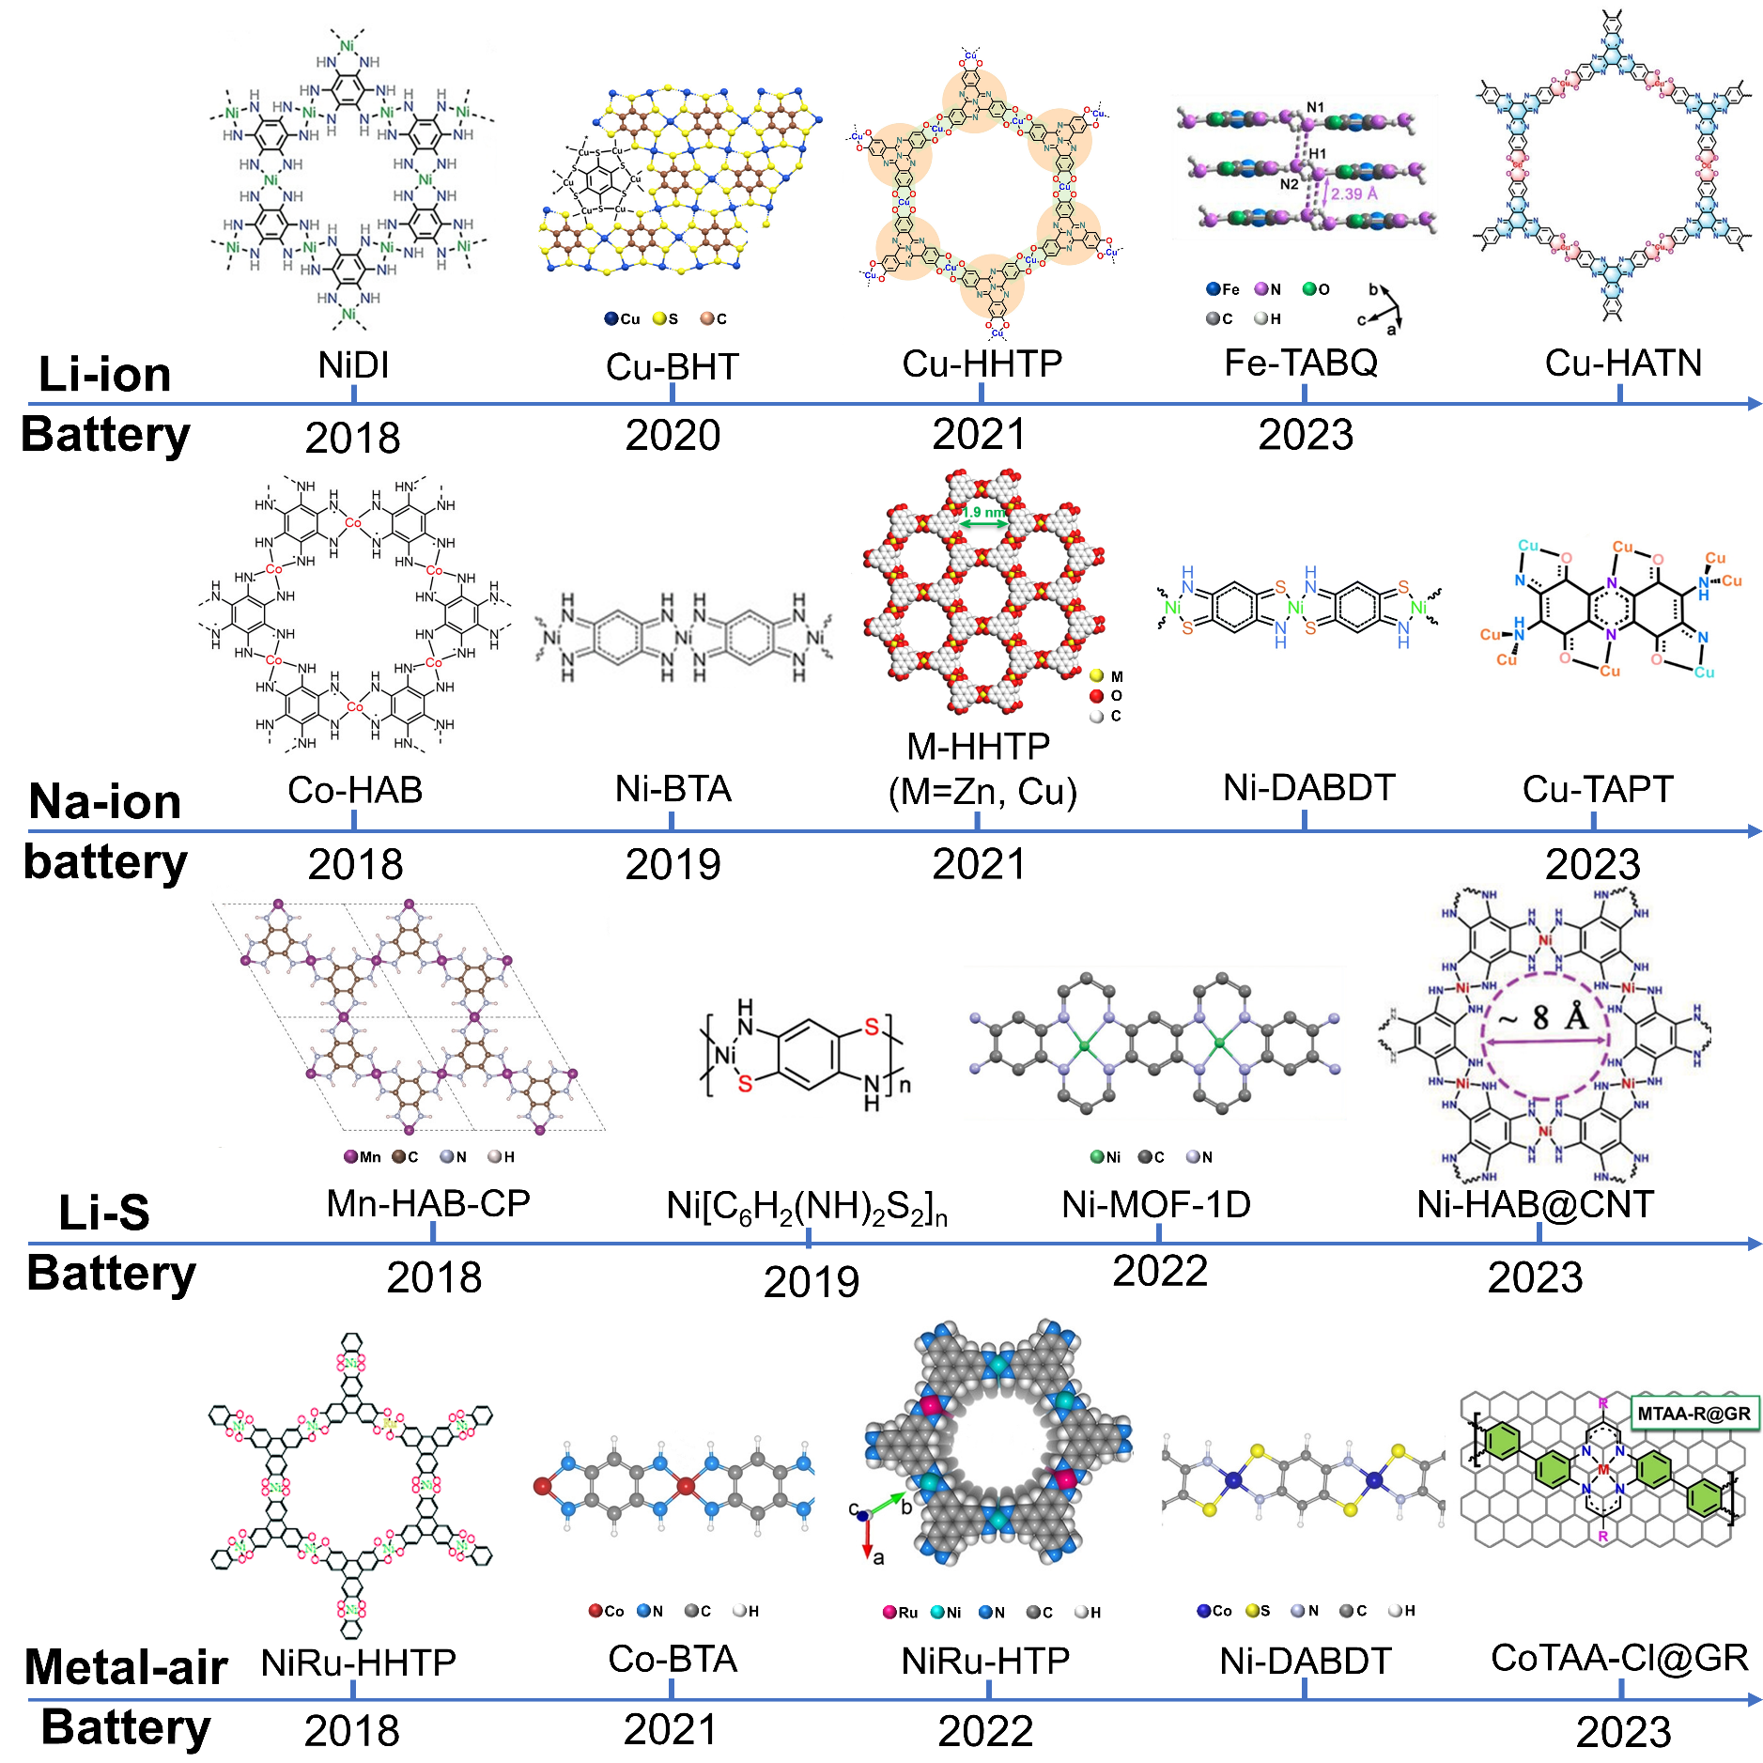
Figure 1. Schematic structure of representative π-d conjugated coordination polymers for Li-ion battery, Na-ion battery, Li-S battery and metal-air battery. These reported π-d conjugated coordination polymers are uniformly named as M-Ligand.
As a novel category of conductive metal-organic frameworks (MOFs), π-d conjugated coordination polymers (CCPs) have recently been developed, characterized by an extended conjugated framework formed through the linkages between planar organic ligand linkers and transition-metal nodes. The in-plane π-conjugation electrons ensure the high electrical conductivity (up to 10³ S cm⁻¹ as reported in Cu-benzenehexathiol) and facilitate the rapid electron transfer kinetics during energy conversion processes.^{[17]} Similar with other MOFs, CCPs exhibit high porosity, tunable components and adjustable pore size.^{[18]} Moreover, the high delocalization of electrons and lamellar extended conjugation ensure the structural stability as electrode materials. Since their initial description by Yaghi’s group in 2012,^{[19]} various conjugated polymers have been designed and implemented across numerous domains of energy storage and conversion, as summarized in Figure 1.
Generally, the metal centres in the CCPs are usually transition metal ions (including Cr, Mn, Fe, Co, Ni, Cu and so on), which contain empty d-orbitals to form in-plane π-d conjugated system.^{[20]} All the organic ligands typically possess functional groups like -NH₂, -OH, -SH, -SeH or combinations thereof to substitute the π-conjugated planar structure.^{[21]} These π-conjugated systems have been extensively explored, from substituted benzene derivatives to a series of ligands including hexa-substituted triphenylene, octa-substituted porphyrin and octa-substituted phthalocyanine. Nevertheless, there remains significant potential for discovery of new organic ligands. Except for the tetrasubstituted benzene, the majority of reported π-d CCPs exhibit a two-dimensional (2D) structure. In comparison to the bulk conductive MOFs, these 2D CCPs further boost the electron/mass transfer kinetics and provide an open surface with abundant active sites for electrochemical reactions.^{[8c, 22]}
To date, the fundamental building block of π-d conjugated unit is widely recognized as M-X₄ structure, including metal-O₄, metal-N₄ and metal-S₄ configurations. These square-planar units are also adopted as the active sites during the catalytic process. Nevertheless, the field remains subject to considerable debate. For most reported polymers, the theoretical research on reaction mechanism is based on the ideal crystal structure, but high-quality crystals of π-d conjugated polymers are rarely obtained. The low purities make the intrinsic relationship between the structural properties and electrochemical performance hard to predict. Thus, seeking an effective methodology to obtain the high-quality crystals is crucial to better understand their electrochemical performance.
As illustrated in Figure 2 and Table 1, this review surveys recent research progress on conductive π-d CCPs obtained through various synthesis methods and their application in electrochemical energy storage and conversion fields, including supercapacitor, Li-S batteries, LIBs, and SIBs. Different from previous review articles, recent novel metal-air batteries and metal ion batteries including K-ion batteries, Zn-ion batteries, Zn-air batteries, Li-O₂ batteries and photo-enhanced Li-O₂ batteries with conductive π-d CCPs as air cathodes have also been covered. We expect that this review can offer a comprehensive understanding of π-d conjugated materials and promote their application in advanced energy storage devices.
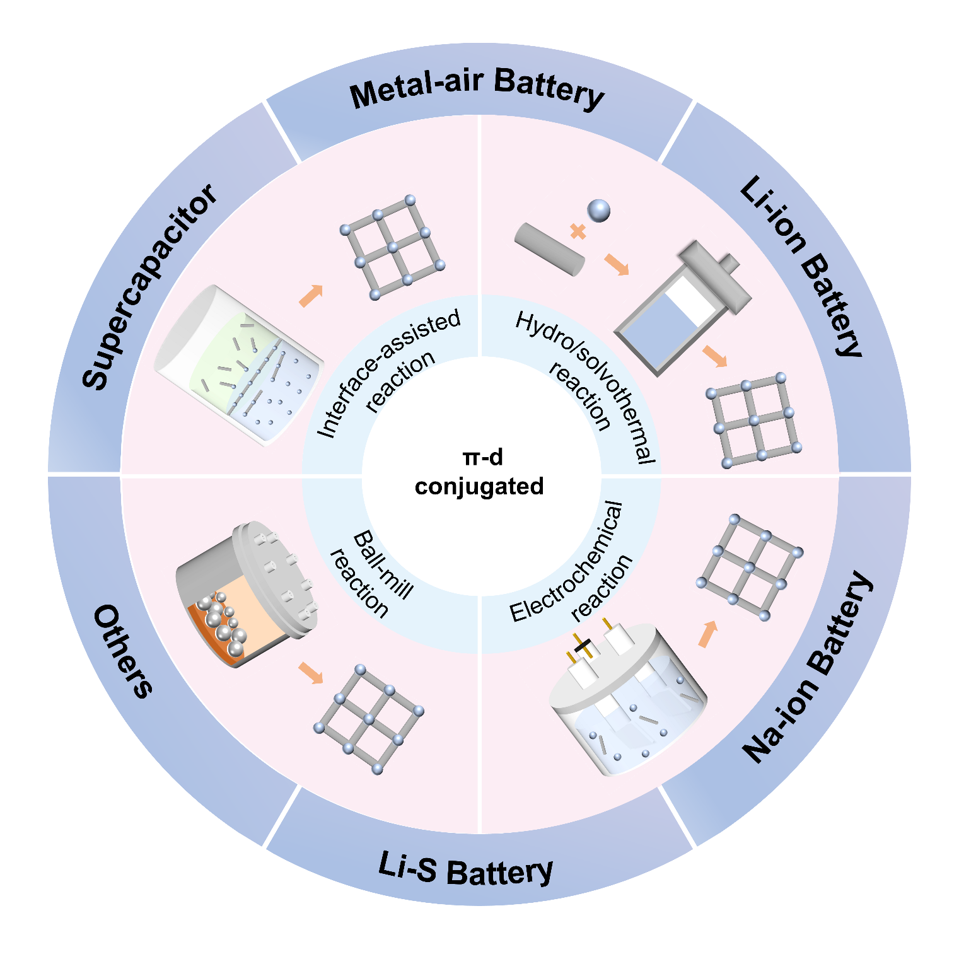
Figure 2. Illustration of the synthesis strategies, and applications of π-d CCPs.

2. Conductive mechanism
When serving as electrode materials, the fast charge transfer is of great importance. Fundamentally, the charge transport in solid materials can be attributed to hopping transport and band-like transport. The charge transfer by hopping transport is achieved by localized charge carriers in discrete and nonbonded sites, while strong interactions in solids create delocalized charge carriers and form continuous energy bands, demonstrating band-like transport.^{[23]} The hopping-type conductivity can be improved with increased temperatures whereas the band-like transport can be both thermally activated and deactivated.^{[23-24]} For now, most reported CCPs are featured with strong covalent bonding and are not single crystalline, leaving plenty of disorder or defects. As a result, the decisive determination of conduction mechanism in CCPs still needs in-depth investigation. In general, the electroconductivity property has been considered from the metal ions, organic ligands and dopants. For most π-d CCPs, the ligands have benzene ring with chelating functional groups. When conjugated with metal ions, the obtained CCPs have been treated as graphene analogs with the delocalization of electrons. This indicates that a larger conjugated benzene ring may result in higher delocalization. Furthermore, improving the bonding between metal ions and ligands can also result in stronger charge delocaliztion. On the other hand, the noncovalent interactions between organic fragments in the vertical direction lead to the π-π stacking with continuous charge transport pathways, also contributing to higher electroconductivity. Apart from the structure design, several other aspects such as crystallinity and morphology also influence the final electroconductivity.

3. Construction and synthesis strategies
In general, the design and synthesis of π-d CCPs involve a bottom-up approach, whereby the chemical component can be highly tunable by selecting initial reactants.^{[25]} The synthetic conditions, including pH values, temperature, solvent and other additives, significantly influence the morphology and crystalline structure of resulting materials.^{[26]} These factors will affect the solubility, coordination velocity, and deprotonation of the organic ligands. For instance, the lower pH values facilate the rapid coordination velocity, and the higher temperatures enhance reaction velocity. However, these conditions can result in poor crystallinity and low structural stability. Consequently, variations in synthesis conditions will affect the coordination of metal ions, reaction rate and the crystalline quality of final products. To date, a series of synthetic methods have been developed to assemble or self-assemble π-d CCPs, including hydro/solvothermal reactions, interface-assisted synthesis, electrochemical synthesis and mechanical milling method.

3.1. Hydro/solvothermal reaction
Most reported π-d CCPs are synthesized by hydro/solvothermal reactions in solvents with sealed or open conditions under specific temperatures. The precise control of reaction conditions, including the choice of solvent, temperature, precursor and atmosphere, has been considered as an efficient method to adjust and regulate morphology and crystalline structure, thereby achieving the desired electrochemical property. In a liquid-phase reaction, the polarity of solvent, reaction time and temperature can be used to modify pore structure and specific surface area without altering the chemical ligands and metal-ions. Early in 2012, Hmadeh and colleagues^{[19]} reported the extended metal-catecholate frameworks (M-CATs), which consist of bivalent metal ions interconnected by the linker molecule 2,3,6,7,10,11-hexahydroxytriphenylene (HHTP), as shown in Figure 3a-c. Typically, the HHTP and two equivalents of metal ions are dissolved in an aqueous solution and reacted at 85 ℃ for 24 hours. The resultant M-CATs exhibit high electric conductivity and thermal stability, as well as high insolubility in both aqueous and non-aqueous solutions. It is noted that larger crystals can be obtained by adjusting the solvent composition with 10% 1-methyl-2-pyrrolidone (NMP). The solvent has a significant impact on the size of the crystals. Li’s group^{[27]} synthesized larger-sized Ni-HHTP nanorod arrays with addition of 50% NMP. Later, Chen^{[28]} reported a series of π-d CCPs consisted with 2,3,6,7,10,11-Hexaiminotriphenylene (HITP) and metal ion (Co²⁺, Ni²⁺and Cu²⁺) as shown in Figure 3d-e. The deprotonation of amidogen is slowed down to reduce the crystal nucleation rate by changing the solvents. To achieve high crystallinity for Co₃(HITP)₂, Ni₃(HITP)₂ and Cu₃(HITP)₂, a series of solvents including N, N-dimethylacetamide, N, N-dimethylformamide and Dimethyl sulfoxide are well-selected. Furthermore, the alkalinity of the solution also plays a crucial role. Substitution of ammonium hydroxide with CH₃CO₂Na has been found to result in higher crystallinity. Through the refined synthesis adjustment, electric conductivity significantly improved from 0.0058 to 55.4 S cm⁻¹.
Apart from the solvent and alkalinity, the atmosphere during the preparation process is also important. It is impossible to obtain Co₃(HITP)₂ products without atmospheric oxidation. It is believed that the synthesis of M₃(HITP)₂ involves the coordination of -NH₂ to M²⁺, followed by the deprotonation of amino groups, and culminating in oxidation in an aerial environment. In comparison to oxidation in air, easy-to-handle solid oxidants like quinones seems more controllable. As depicted in Figure 3h, Xiao^{[29]} used different kinds of quinones as chemical oxidant, including 2,5-dichloro-1,4-benzoquinon, 1,4-benzoquinone, 1,4-benzoquinone, and 2,6-dimethyl-1,4-benzoquinone. It is noteworthy that those quinones are volatilized/evaporated into the precursor solution, resulting in a transformation of Cu₃(HHTP)₂ from nanorods to nanosheets (Figure 3i-l). The precise mechanism remains unclear, and further investigation is necessary.

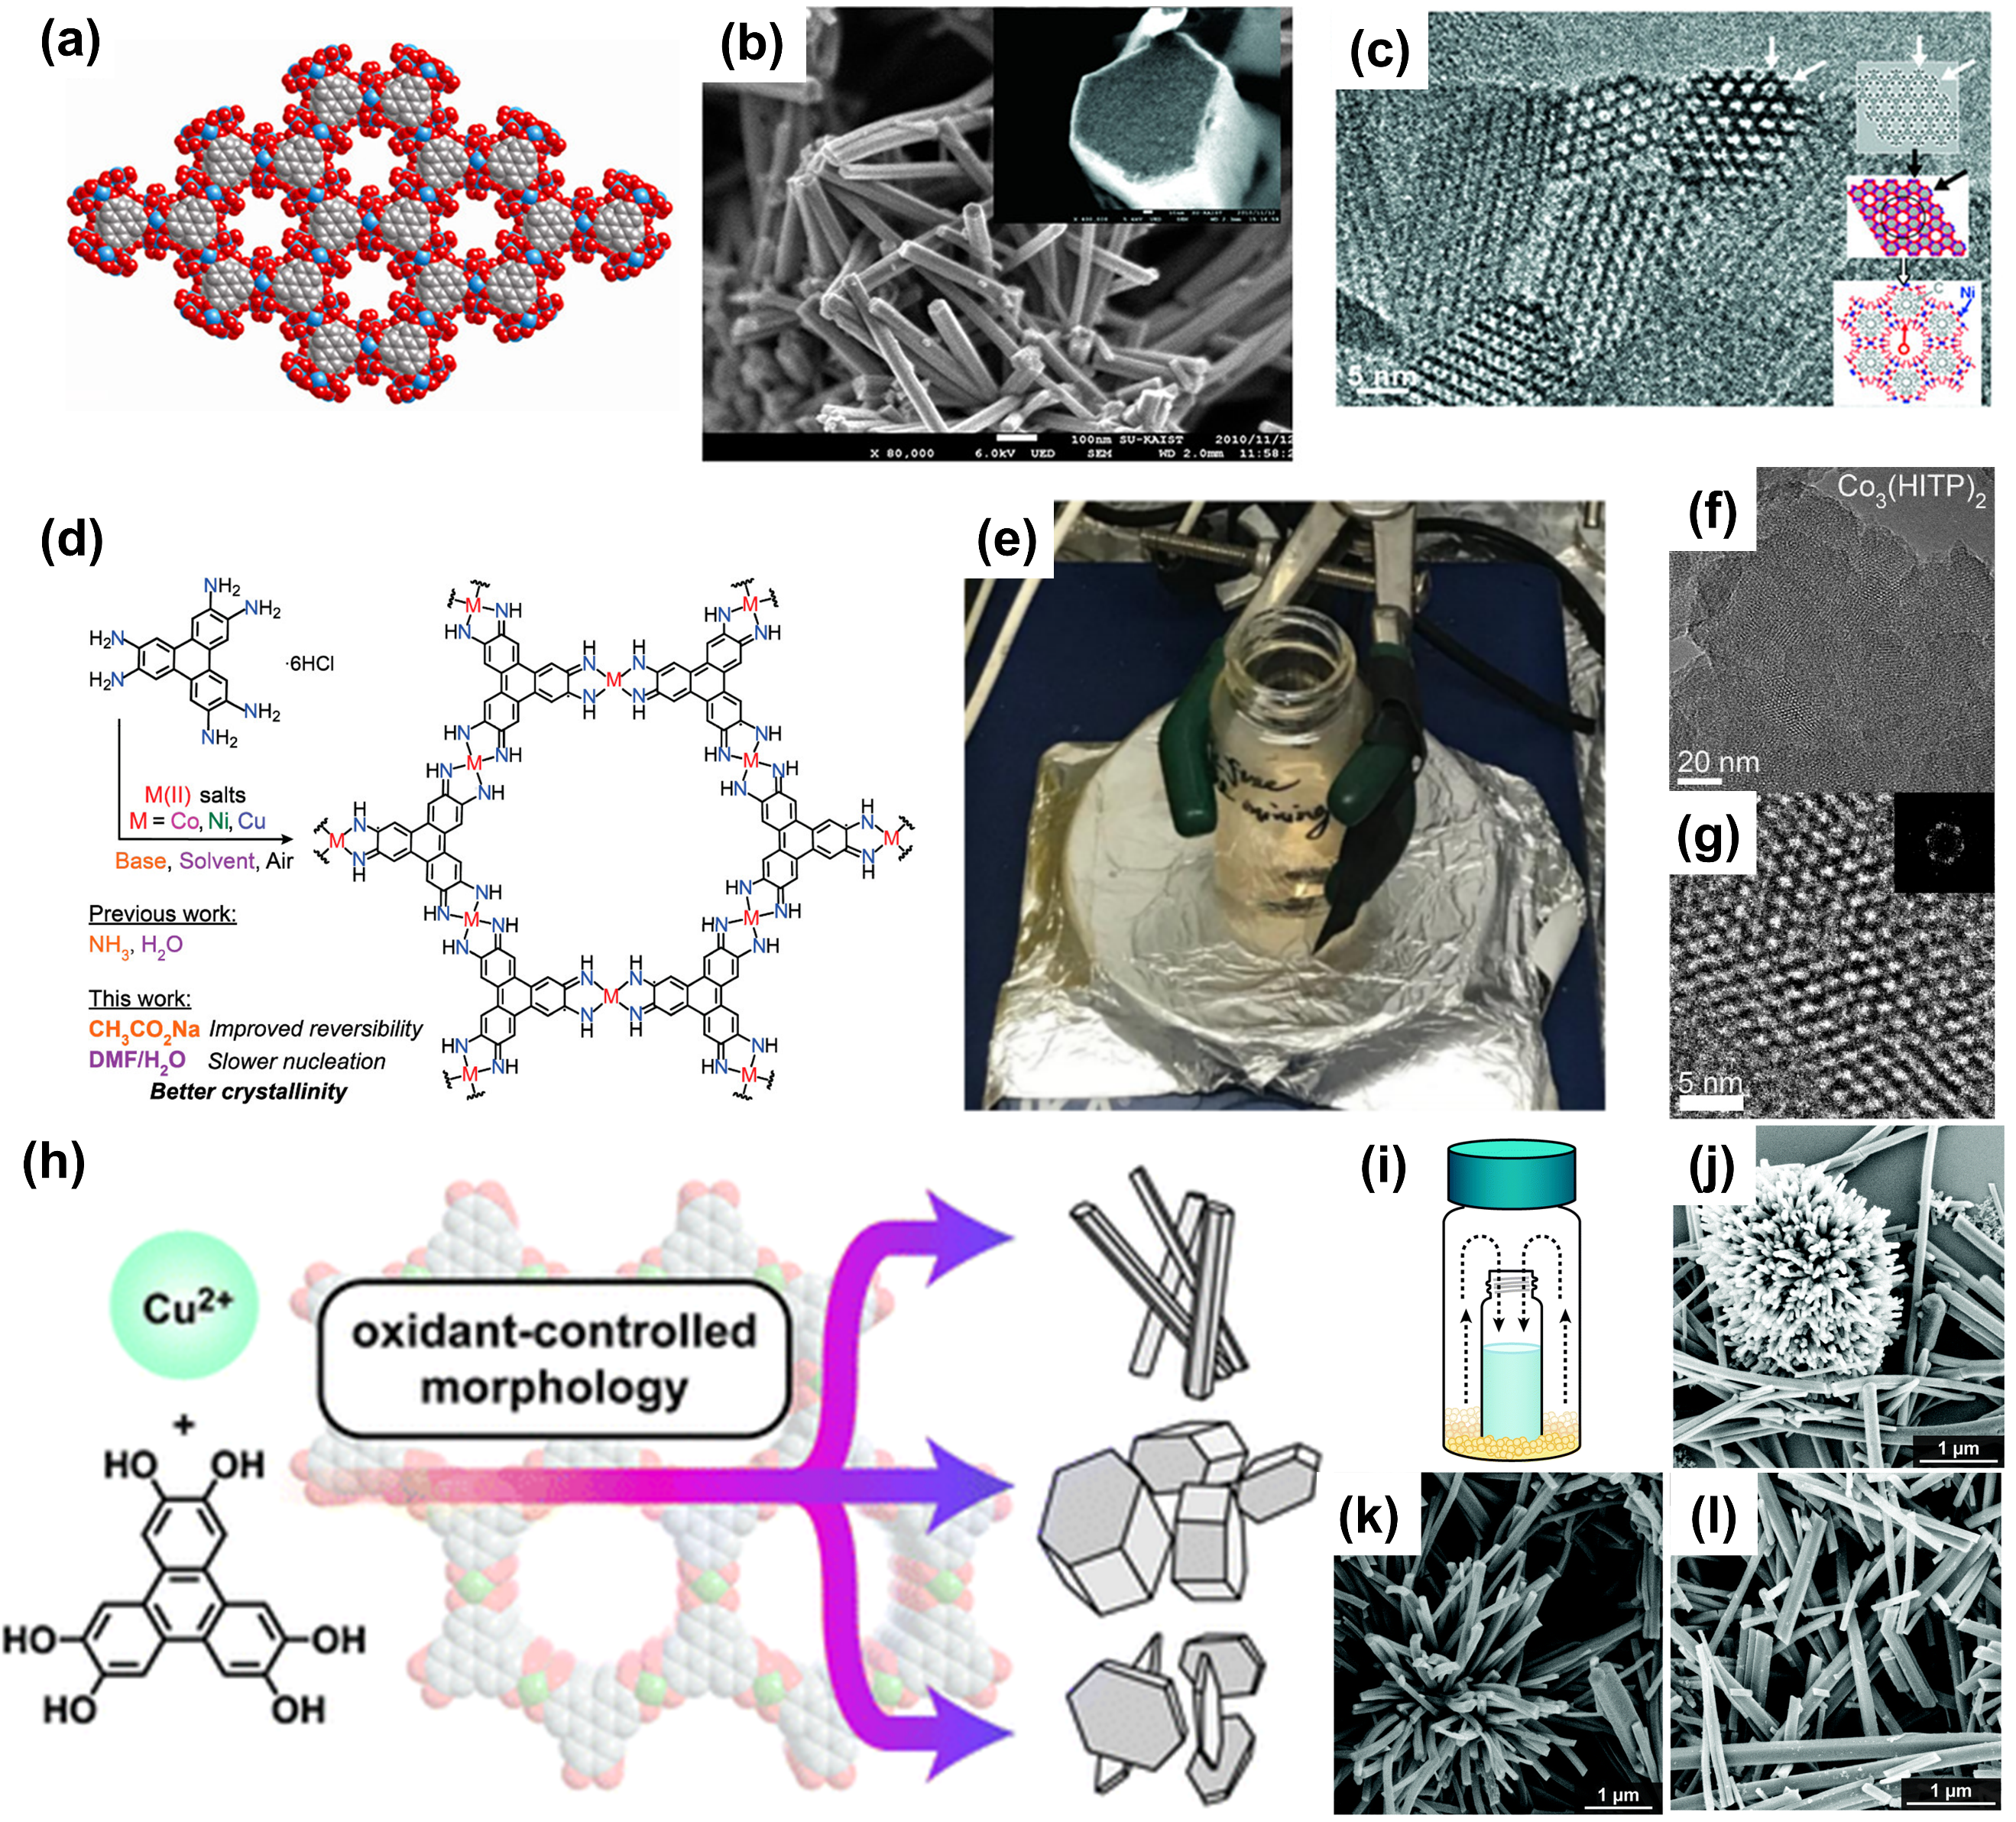
Figure 3. (a) Space-filling model of the single-crystal structure of CoCAT-1; (b-c) Scanning electron microscopy (SEM) images and high-resolution transmission electron microscopy (HR-TEM) analysis of NiCAT-1.^{[19]} Reproduced from ref. 19 with permission from American Chemical Society, Copyright 2012. (d-e) Synthesis diagram of M₃(HITP)₂ (M = Co, Ni, Cu) with different reaction conditions and digital image of the reaction vessel; (f-g) HRTEM images of Co₃(HITP)₂.^{[28]} Reproduced from ref. 28 with permission from American Chemical Society, Copyright 2020. (h) Synthesis diagram of Cu₃(HHTP)₂ and (i) standard sublimation reaction with quinone oxidant outside the smaller vial; (j-l) SEM images of Cu₃(HHTP)₂ with different equivalents of 2,5-dichloro-1,4-benzoquinone as a pre-oxidant.^{[30]} Reproduced from ref. 30 with permission from Royal Society of Chemistry, Copyright 2022.
Over-all, the π-d CCPs synthesized by hydro/solvothermal reaction are predominantly powdery where the aggregated powders lead to poor electric conductivity. To improve conductivity and structural integrity, several post-processing procedures, such as chemical plating and thermal treatment, are often necessary.

3.2. Interface-assisted reaction
The interface-assisted synthesis is a common method used to prepare 2D materials, including gas-liquid, liquid-liquid and solid-liquid interface. Taking liquid-liquid interface reaction as example, a monolayer of the surfactant at the interface will restrict the precursor to the 2D boundary or induce the arrangement of monomers to coordinate into desired morphology. Compared with hydro/solvothermal reactions, the electric conductivity of CCPs synthesized via interface-assisted methods is typically improved due to the 2D morphology. Additionally, the interface-assisted reactions have been considered as the most efficient way for massive production of CCPs with controlled layer thickness and morphology.
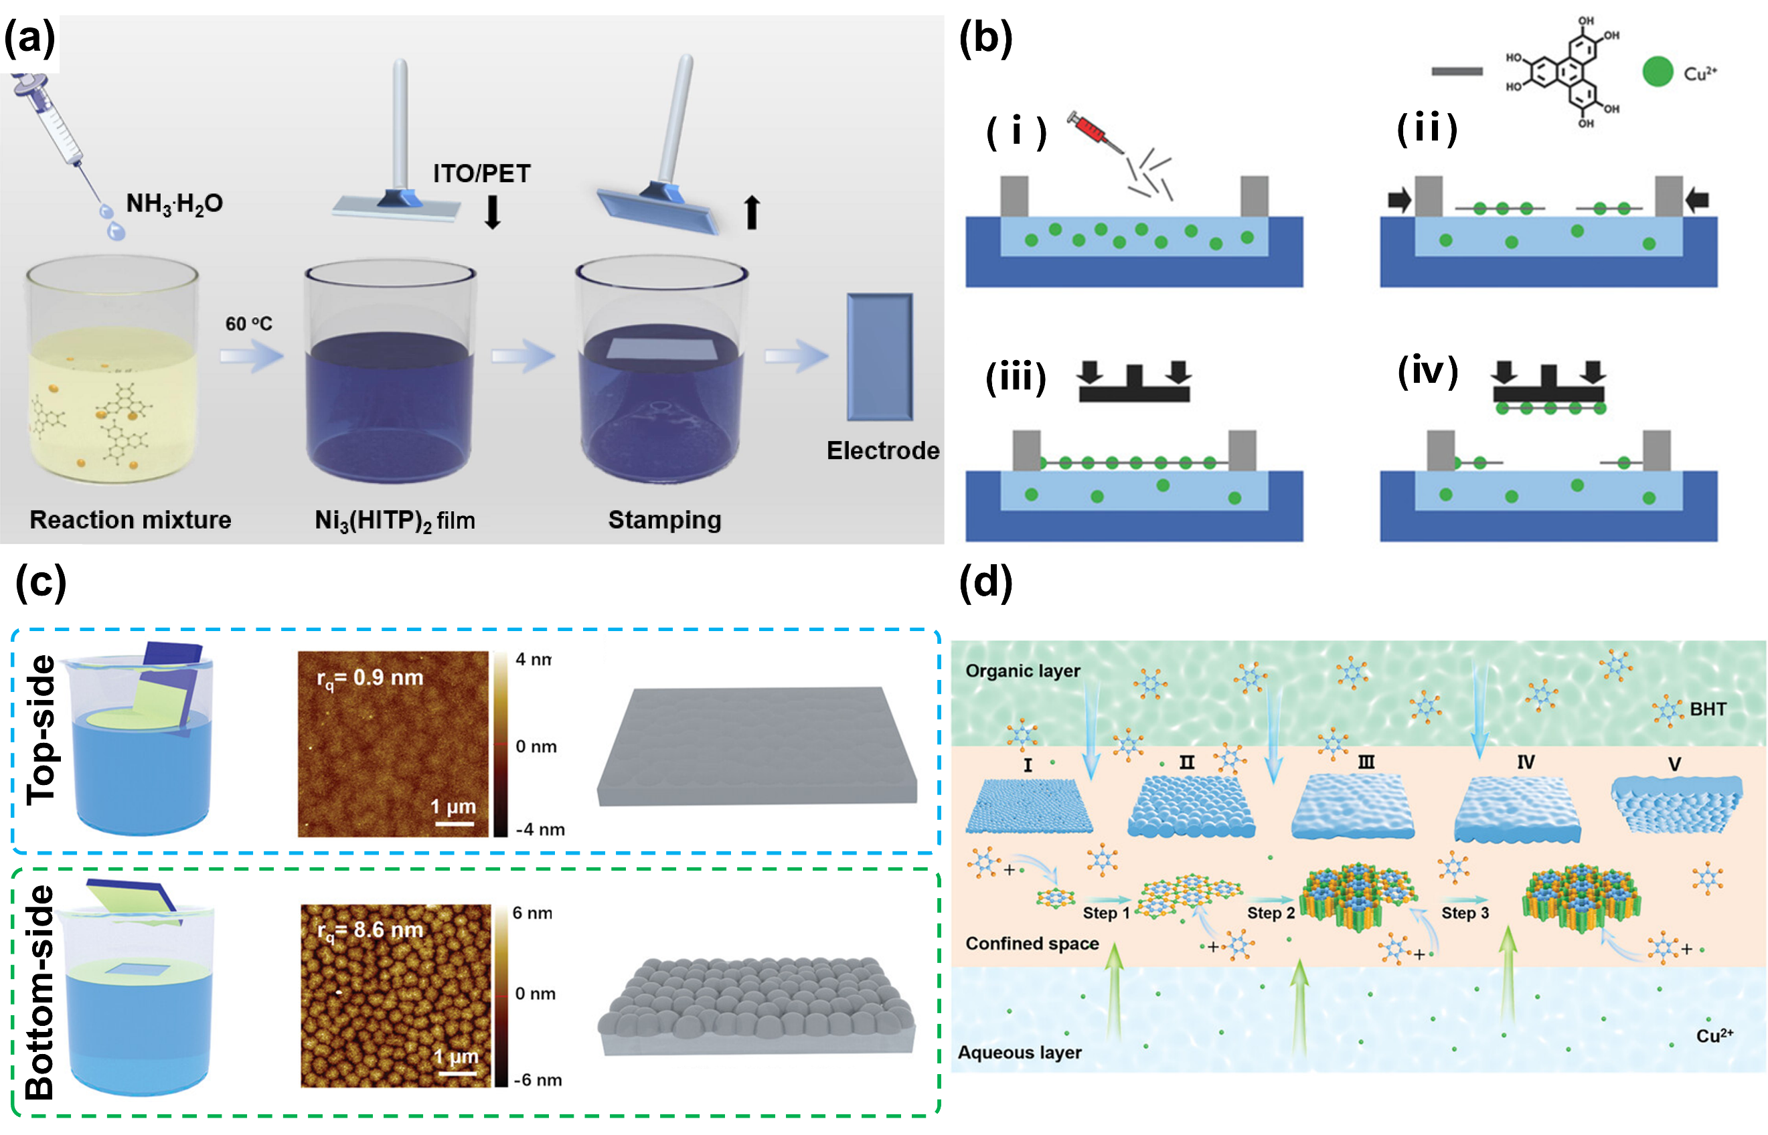
Figure 4. (a) Schematic illustration of the Ni₃(HITP)₂/ITO/PET electrode, which is fabricated utilizing the Langmuir-Schafer technique.^{[31]} Reproduced from ref. 31 with permission from Science China Press, Copyright 2020. (b) Fabrication of uniform Cu-CAT-1 films with tunable thickness by sequential transfer of nanosheets: (i) formation, (ii) compression, (iii) application of optimal pressure to achieve continuous layer, and (iv) film transfer process onto substrate.^{[32]} Reproduced from ref. 32 with permission from Wiley-VCH Verlag GmbH & Co. KGaA, Weinheim, Copyright 2018. (c) The transfer of Cu-BHT films and the corresponding atomic force microscope (AFM) images; (d) Diagrammatic illustration of the formation process for Cu-BHT films at the interface between aqueous and organic phases.^{[33]} Reproduced from ref. 33 with permission from Wiley-VCH GmbH, Copyright 2021.
Huang’s group synthesized a Ni₃(HITP)₂ film on an ITO/PET substrate through Langmuir-Schaefer process^{[31]}. As illustrated in Figure 4a, the Ni²⁺ and HITP were prepared in a cylindrical vial, followed by addition of NH₃∙H₂O. The uniform Ni₃(HITP)₂ film formed at the air/liquid interface and was subsequently transferred on the front side of ITO/PET stamps. The formation of these films is attributed to a combination of van der Waals forces, hydrogen bonding, and coulombic interactions. The films exhibit remarkable optoelectronic properties, including a transmittance (T) of 78.4%, a sheet resistance (Rs) of 51.3 Ω sq⁻¹, exceptional areal capacitance performance (CA = 1.63 mF cm⁻²), and a rate capability reaching up to 5000 mV s⁻¹. Giménez^{[32]} reported an ultra-thin conductive Cu₃(HHTP)₂ (Cu-CAT-1) film (approximately 10-50 nm) through Langmuir-Blodgett (LB) transfer and layer-by-layer (LbL) sequential deposition. As given in Figure 4b, Cu-CAT-1 forms at the air-liquid interphase and is grouped together with the surface pressure changes from 0.2 mN m⁻¹ to 10 mM m⁻¹. Compared to free-floating liquid-liquid (LL) method, the films obtained by LB transfer exhibit lower resistance values, attributed to the superior uniformity and electronic transfer capabilities. Xu’s group^{[34]} also prepared the Cu₃(HHTP)₂ thin film in a LbL fashion by a spray method, where the growth thickness can be controlled by removing unreacted reactants with ethanol. Figure 4c illustrates the preparation of Cu-benzenehexathiol (Cu-BHT) thin films by the gas-liquid interface reaction method, as described by Liu’s group.^{[33]} The resulting films exhibited a flat top-side surface (the surface contacting the organic phase) and a synaptic-like structured bottom-side surface. As depicted in Figure 4d, upon contact with the aqueous phase, the copper ions in aqueous solution will coordinate with upper organic ligands (BHT) at the aqueous/organic interface. The crystalline structure of Cu-BHT further grows and spread out, filling grain boundaries into a smooth-surfaced film. These methods highlight the advantages of interface-assisted synthesis in producing high-quality, conductive 2D materials with improved electronic properties and structural integrity. Most reported substrate are directly used as the current collectors and the adhesion between substrate and CCPs should also be concerned. Further research effort can be directed to the functionalization of the substrates with stronger electrostatic adsorption or even forming chemical bonds.

3.3. Other synthesis
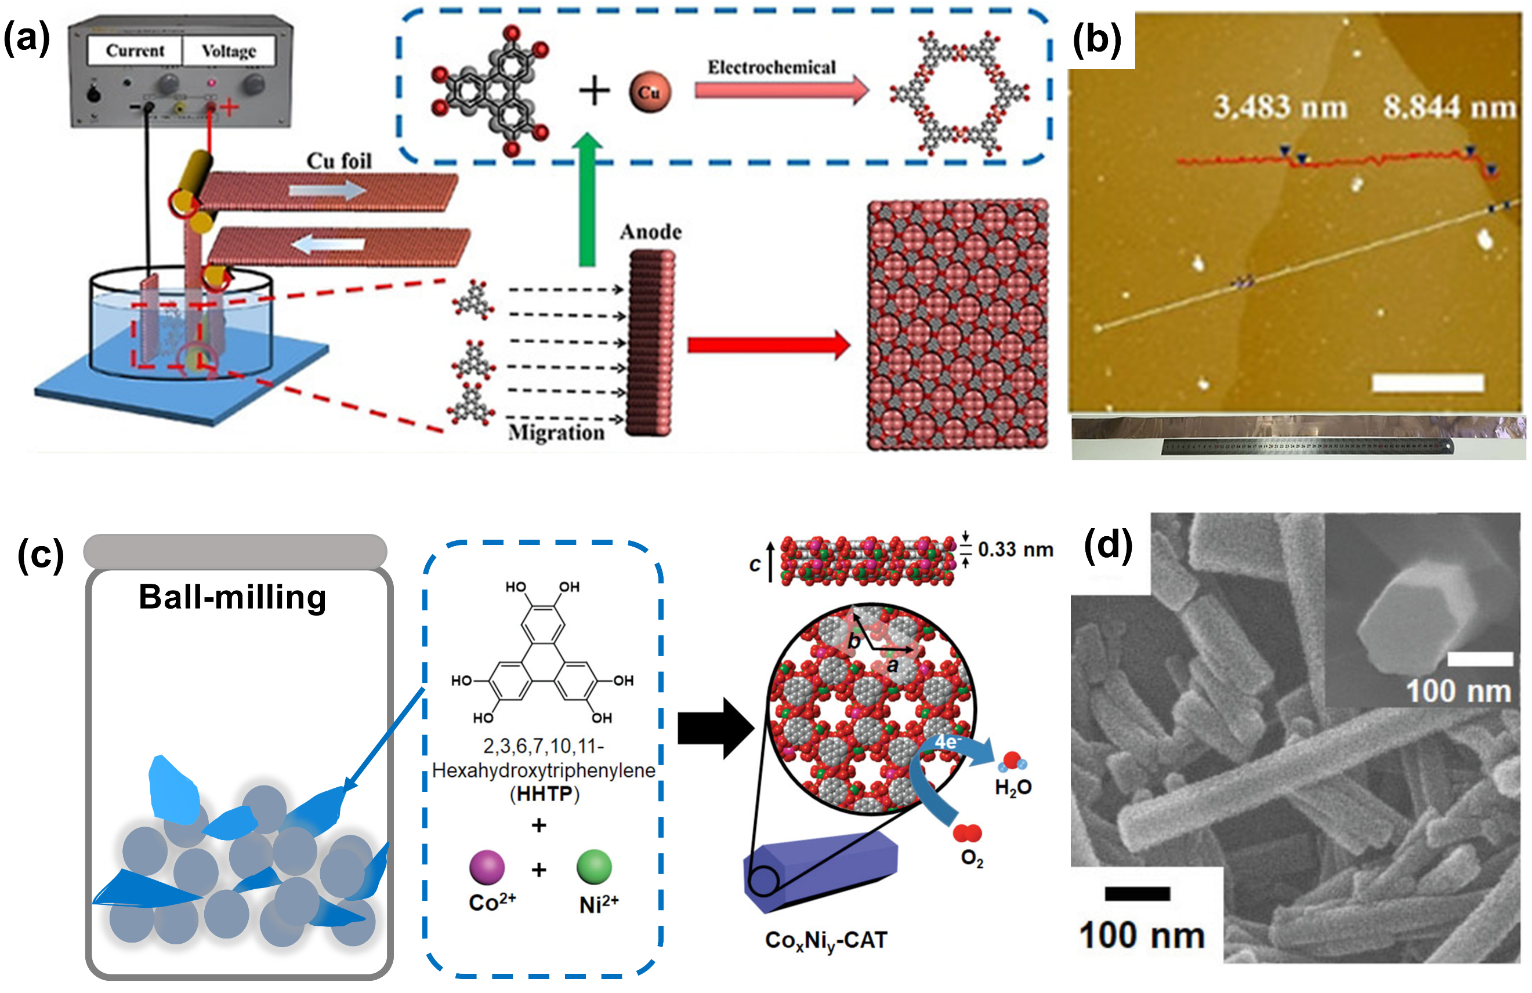
Figure 5. (a) Diagram of preparing Cu₃(HHTP)₂/Cu films by electrochemical reaction; (b) AFM image of Cu₃(HHTP)₂ film. Scale bar 5 μm.^{[35]} Reproduced from ref. 35 with permission from Wiley-VCH GmbH, Copyright 2020. (c) the ball-milling process for construction of bimetallic 2D Co_{x}Ni_{y}-CATs; (d) SEM image of Co_{0.27}Ni_{0.73}-CAT. ^{[36]} Reproduced from ref. 36 with permission from Wiley-VCH Verlag GmbH & Co. KGaA, Weinheim, Copyright 2019.
Electrochemical reactions involve oxidation (anodic) process and reduction reactions cathodic) process without the involvement of external oxidants or reducing agents. The process is operated under standard pressure and temperature, with the reaction rate controlled by the applied potential and current density. Recently, electrochemical synthesis has emerged as an efficient approach for preparing large-area films. For example, as depicted in Figure 5a, Liu and coworkers utilized the Cu foils as the substrate, whereby the in-situ electrochemical oxidation of Cu occured and reacted with HHTP anions to form Cu₃(HHTP)₂.^{[35]} In more detail, this system contains a HHTP solution and two Cu foils serving as cathode and anode. The cathodic oxidation reaction releases Cu²⁺ from the surface which then conjugates with HHTP. By a continuous movement of Cu foils in the solution, a steady production of Cu₃(HHTP)₂ is achieved. The obtained Cu₃(HHTP)₂ demonstrated a high crystalline quality with an electrical conductivity of 0.087 S cm⁻¹. Notably, several other Cu-based MOFs can also be obtained by this electrochemical synthesis process, providing an efficient and universal method for large-scale production of 2D MOF films. Although great efforts have been made in electrochemical synthesis process, there are still many challenges to be addressed, including the solvent selection, electrode material limitations and the separation with substrate.
The crystal growth of π-d CCPs can also be prepared by ball-mill synthesis process, where the raw materials are directly mixed and milled together. As shown in Figure 5c-d, Yoon and colleagues^{[36]} prepared the Co_{x}Ni_{y}-CAT through a ball-mill reactor, resulting in a high crystal structure and an excellent oxygen reduction reaction (ORR) activity. The advantages of short rection time, high productivity and lower usage of solvents make it possible for industrial application.

4. Application in the energy storage and conversion area
4.1. Li-ion battery
The Li-ion batteries, known as “rocking-chair” batteries, operate based on the shuttling of Li⁺ between cathode and carbon-based anode. Specifically, during discharge, the anode, known as the negatively charged electrode, releases Li⁺ into the electrolyte. Those ions are then intercalated into the cathode, such as LiCoO₂, LiMn₂O₄, and LiFePO₄, thereby generating an external working voltage. Conversely, upon charged, an external voltage drives the deintercalation of Li⁺ from cathode and subsequently inserted into the anode^{[37]}. On the one hand, since commercialized in 1991, the graphite keeps as the dominant anode material in production, proving challenging to supplant.^{[38]} It stores the Li⁺ in the form of LiC₆ with the theoretical capacity of 372 mAh g⁻¹.^{[39]} Despite its ubiquity, graphite is hampered by issues, associated with lithium dendrites and the solid electrolyte interphase (SEI) formation. To meet the increasing demand of high-capacity LIBs, several alternative anode materials have been proposed, including silicon, intercalation oxides, nanostructured materials, as well as alloying- and conversion-type compounds.^{[40]} On the other hand, cathode materials such as Li(NiCoMn)O₂ and LiFePO₄ play a crucial role in determining energy density. Currently, their specific capacities are close to theoretical limits, and no commercial positive cathode has surpassed these values. Recently, the CCPs with abundant lithium storage sites, excellent electroconductivity, and stable skeleton structure have become attractive for potential application as both cathode and anode materials.
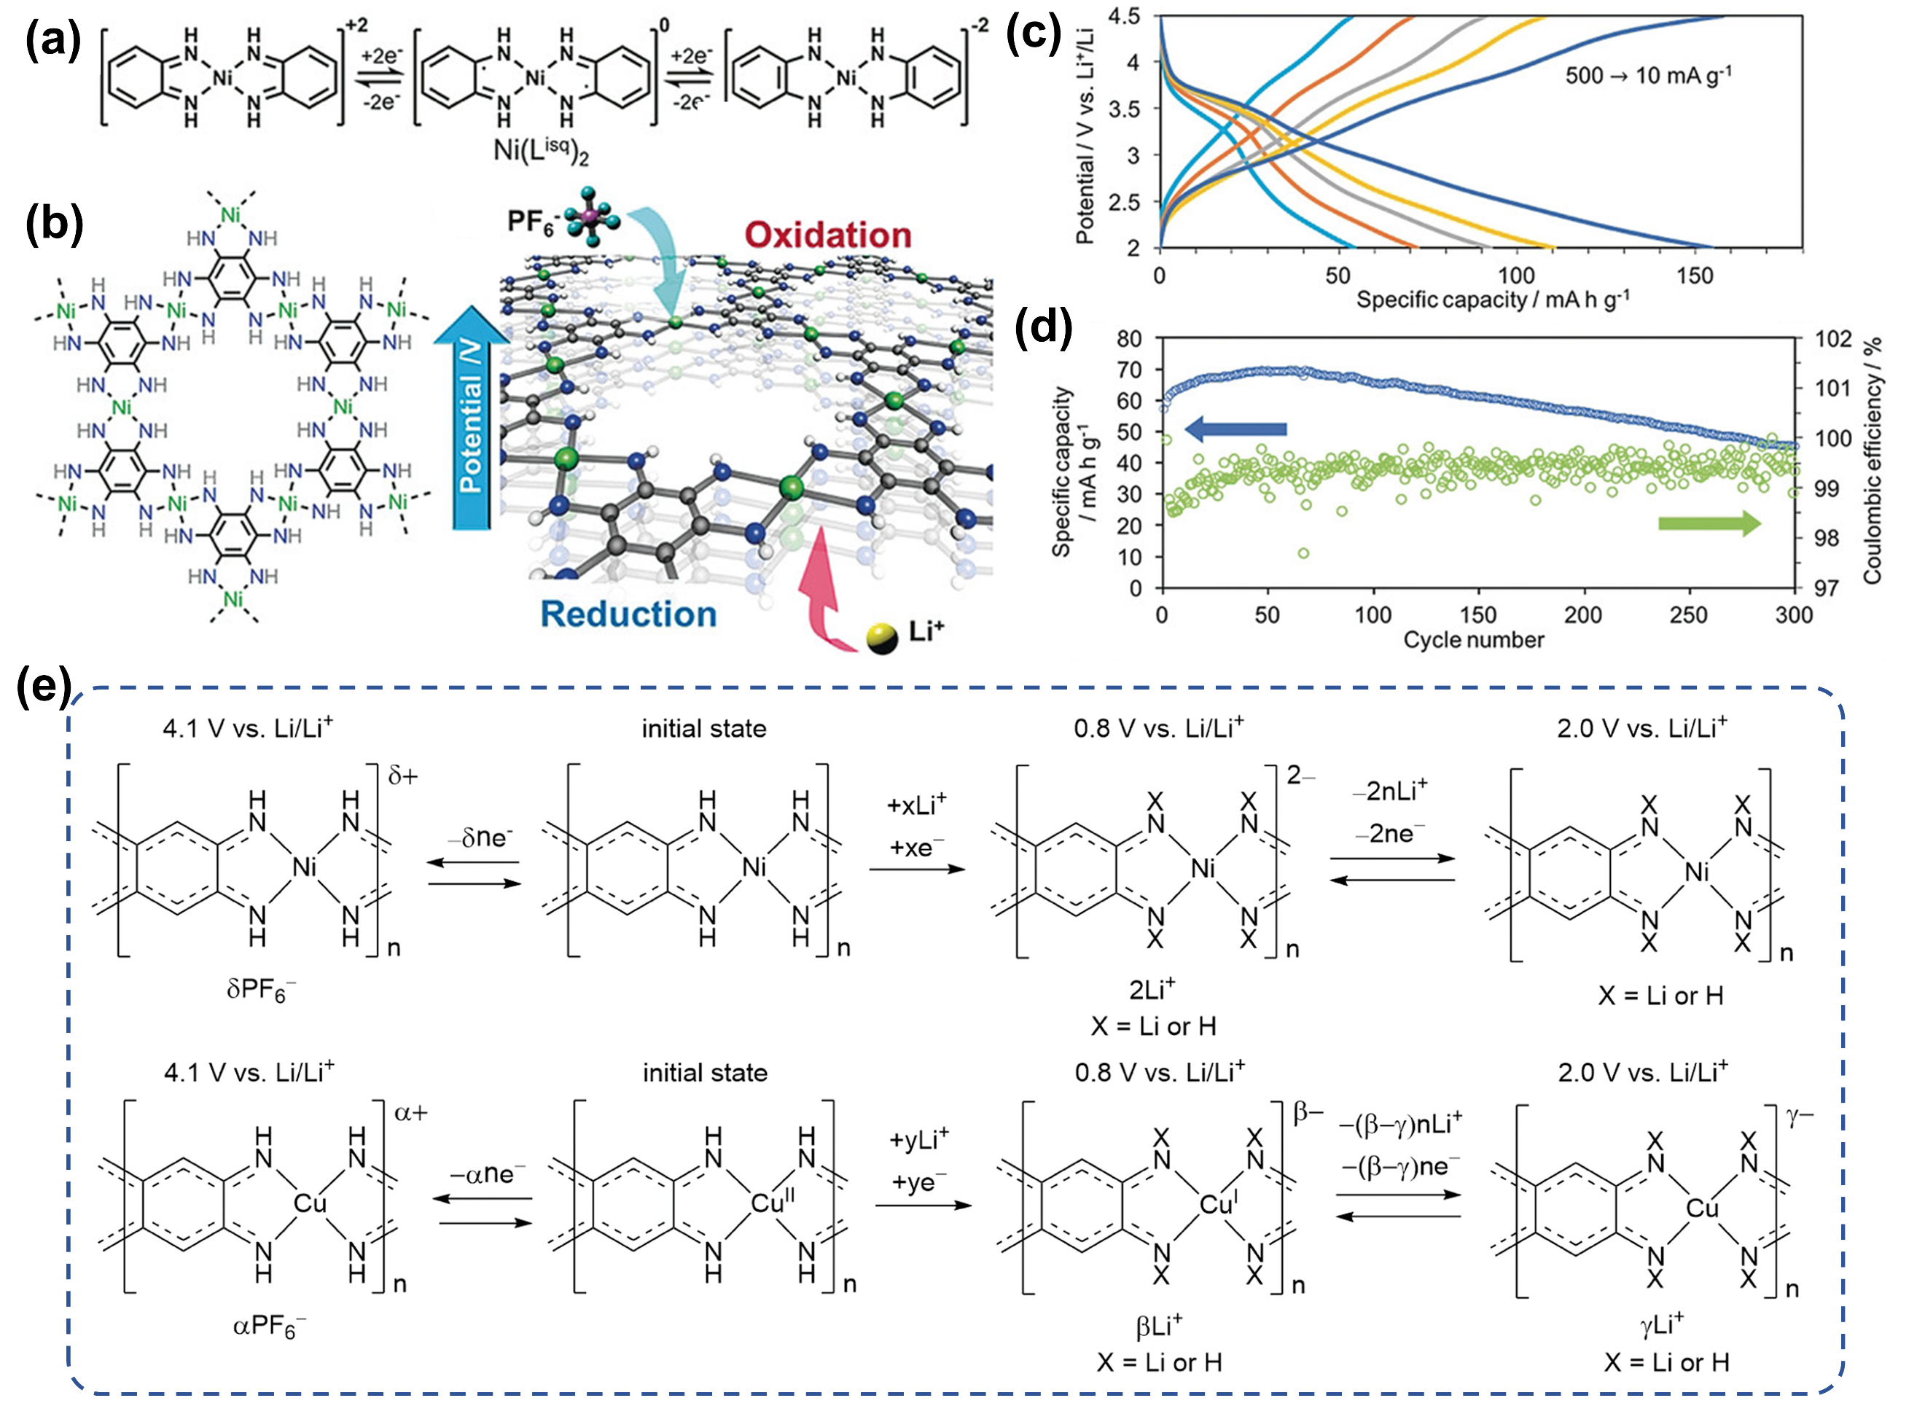
Figure 6. (a) Chemical structure and the redox reactions of Ni₃(HAB)₂ for LIBs; (b) chemical structure and the redox reactions of Ni₃(HAB)₂ with respective counter ions; (c) the discharge/charge curves obtained at 10 to 500 mA g⁻¹; (d) cycling performance for 300 cycles at 250 mA g⁻¹.^{[41]} Reproduced from ref. 41 with permission from Wiley-VCH Verlag GmbH & Co. KGaA, Weinheim, Copyright 2018. (e) Proposed Li⁺ storage mechanism for NiTIB and CuTIB.^{[42]} Reproduced from ref. 42 with permission from American Chemical Society, Copyright 2019.
Nishihara and colleagues ^{[41]} recently reported the Ni₃(HAB)₂ (Hexaiminobenzene, HAB) framework as cathode materials in Figure 6a-b, featuring two-dimensional (2D) coordination networks with several redox states. It provides a high specific capacity of 155 mAh g⁻¹ at 10 mA g⁻¹ and maintaining stability over 300 cycles at 250 mA g⁻¹ (Figure 6c-d). Subsequent investigations into a variety of π-d CCPs have demonstrated excellent electrochemical property as anode materials for LIBs through conversion type and insertion-type mechanism. In comparison with HAB, 1,2,4,5-tetraaminobenzene (TAB) has been proposed as a potential alternative due to its commercial availability. Kapaev and colleagues investigated corresponding nickel (II) and copper (II) coordination polymers as anode and cathode materials for LIBs. The designed coordination polymers, denoted as NiTIB and CuTIB, exhibit remarkable stability and impressive specific capacities as anode materials. They also proposed a reasonable and widely accepted charge-discharge mechanism as depicted in Figure 6e. This mechanism highlights the substitutability of NH-protons in both NiTIB and CuTIB, facilitating Li⁺ storage at low potentials during the initial cycles. The metal-N₄ sites are identified as the active sites, yet the distinct chemical states in the NiTIB and CuTIB brings about a divergent mechanism. The NiTIB can reversibly accept two Li⁺ at approximately 1.1-1.5 V, whereas CuTIB undergoes a reduction of Cu^{II} to Cu^{I} at 1.5 V, subsequently offering reversible capacity in the anode mode (0.8-2.0 V vs Li/Li⁺). In the cathode modes (1.5~4.1 or 2.0~3.8 V), NiTIB and CuTIB undergo oxidation at high potentials to form stable cation species and balance in that case by PF₆⁻ anions. CuTIB delivers a high energy density of 616 Wh kg⁻¹, while is unable to sustain long-term cycling due to the instability in high working potential. The organic ligands are highly adjustable and the quinone substituent group will provide additional active sites for Li⁺ storage. Based on this, Li’s group^{[43]} synthesized the tetraamino-benzoquinone (TABQ) monomer from tetrachloro-p-benzoquinone and potassium phthalimide via two-step coupling reactions. As depicted in Figure 7a-d, the Fe-TABQ, characterized by square-planar Fe-N₂O₂ linkages and phenylenediamine building blocks, exhibit two redox centres and confirmed by ex-situ FTIR and XPS analysis: Fe cations and benzoquinone groups. The 2D Fe-TABQ cathode delivers a high specific capacity of 251.1 mAh g⁻¹ (50 mA g⁻¹) and an energy density of 577.5 Wh kg⁻¹. Except from the metal-N conjugated polymers, Awaga’s group^{[22a]} synthesized the Cu-THQ MOF (THQ=tetrahydroxy-1,4-benzoquinone) with Cu-O₄ as unit, which demonstrates a high discharge capacity of 390 mAh g⁻¹. The underlying charge/discharge mechanism, investigated through magnetic susceptivity and density functional theory (DFT)calculation, attributes the high capacity to three components: reduction of residual Cu(II), unsaturated quinoid ligand and delocalized π band. To comprehensively understand the reaction during Li⁺ storage, in-situ analysis become increasingly crucial. As seen in Figure 7e-g, Liu’s group^{[44]} selected 2,5-dihydroxybenzoquinone (DHBQ) as organic ligand and Ni²⁺ as metal source. The in-situ XRD demonstrated that the π-d CCP (Ni-DHBQ) cathode delivers an ultrahigh capacity via 9-electron transfers. Furthermore, Zhang’s group^{[45]} synthesized Cu-S linked polymers with Cu(II) salt and benzenehexathiolate (BHT). The highly conjugated structure ensures the potential appication as cathode materials with a high electronic conductivity of 231 S cm⁻¹, and a reversible four-electron reaction guarantee an excellent reversible capacity of 175 mAh g⁻¹ at a high current density of 300 mA g⁻¹.
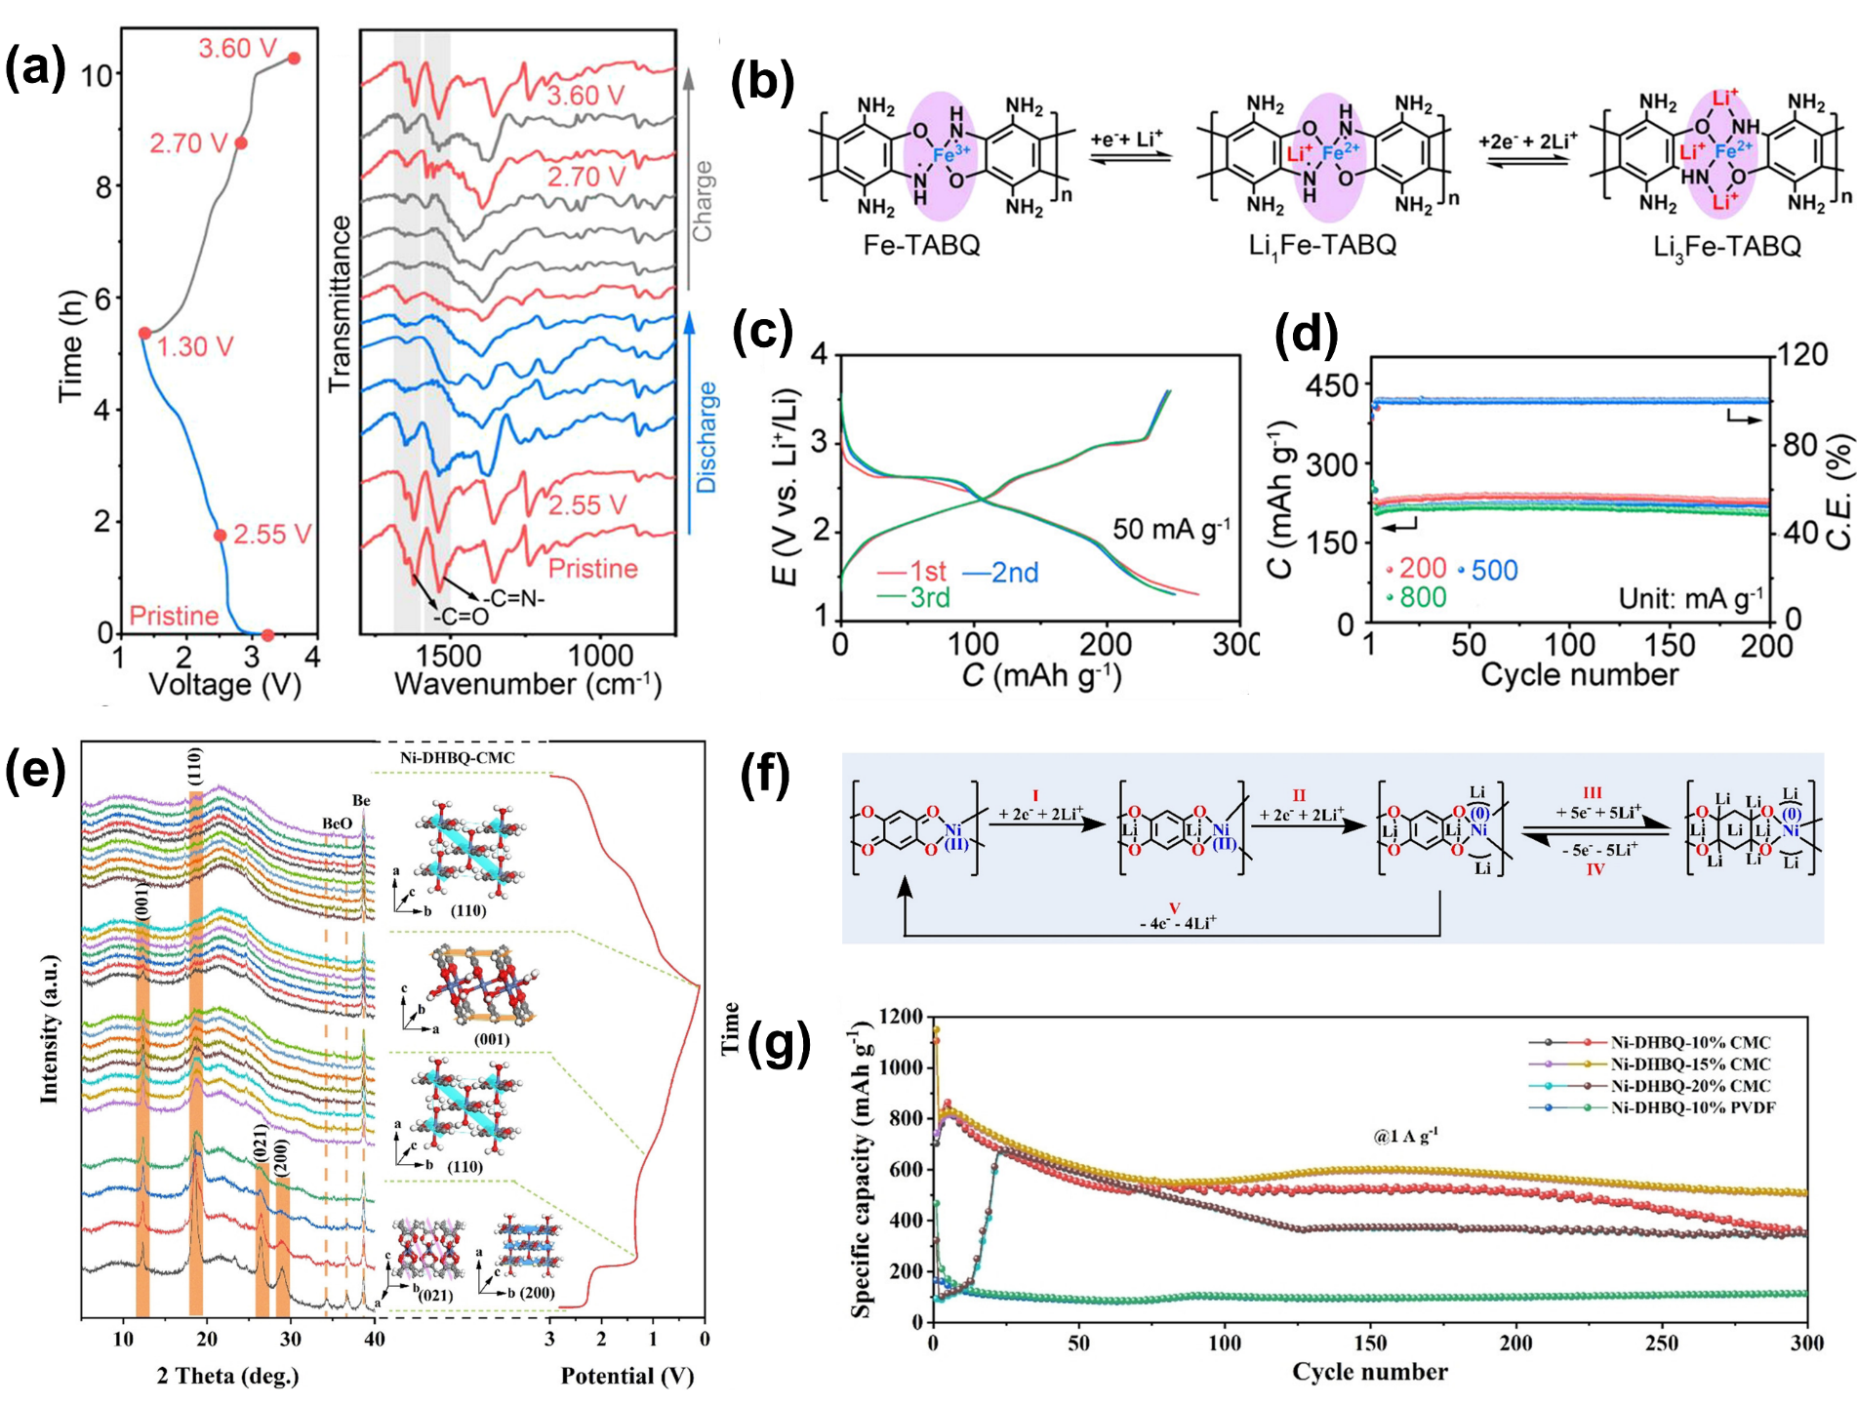
Figure 7. (a) The charge-discharge curves and ex-situ FTIR spectra of Fe-TABQ at 50 mA g⁻¹ for the first cycle; (b) Proposed redox mechanism of Fe-TABQ; (c) Cycling performance of Fe-TABQ at 50 mA g⁻¹; (d) Durability testing at 200, 500, and 800 mA g⁻¹.^{[43]} Reproduced from ref. 43 with permission from American Chemical Society, Copyright 2023. (e) In-situ XRD patterns of Ni-DHBQ electrode for the first cycle; (f) Proposed redox mechanism of Ni-DHBQ; (g) Cycling performances at 100 mA g⁻¹.^{[44]} Reproduced from ref. 44 with permission from Wiley-VCH GmbH, Copyright 2022.
Apart from the cathode materials, some of CCPs cannot stay stable in the higher working potential, while can serve as the anode materials. Li’s group integrated a nitrogen-rich aromatic molecule tricycloquinazoline (TQ) and a Cu-O₄ unit into a two-dimensional (2D) conductive MOF with further improvement of conductivity and insolubility in electrolytes.^{[46]} The resultant Cu-HHTQ can works as anode materials with an excellent capacity (657.6 mAhg⁻¹ at 600 mAg⁻¹) and impressive cyclability (82% capacity retention after 200 cycling). Bu and co-workers^{[47]} adopted a similar strategy with hexaazatriphenylene (HATN) as ligand to synthesize Cu-HATN anode and further attributed that the high Li⁺ storage performance derives from the maximal number of active sites (C=N sites in the HATN unit and C=O sites in the Cu-O₄ unit), favorable electrical conductivity, and efficient mass transfer channels. Recently, their team reported Cu₃(HHTP)(THQ)^{[48]} and Cu-TAC^{[49]} (TAC, Triazacoronene) anode with CuO₄ as active sites in Li-ion battery. The brand-new Cu-TAC CCPs with a large, conjugated plane and abundant active sites deliver a reversible capacity of 772.4 mAh g⁻¹ and outstanding long-term cyclability at 300 mA g⁻¹ (83% capacity retention for 600 cycles), superior to most 2D c-MOF-based electrodes.

4.2. Na-ion battery
With rapid development of electric vehicles, battery costs have become the most substantial expenditure, predominantly due to the constrained global reserves of lithium and cobalt sources. Recently, SIBs have attracted extensive attention due to their analogous mechanism to that of LIBs. Sodium, compared with lithium, is a more abundant element in nature. Furthermore, the electrochemical redox potential of Na⁺/Na reaches -2.71 V, which is 330 mV lower than Li⁺/Li. The low working potential of SIBs results in an inferior volumetric and gravimetric energy density, and make SIB at the inferiority position for electric vehicles. Nevertheless, given the low price and high security, there is a broad market potential in low-speed electric vehicles and energy storage power stations.^{[50]} The SIBs and LIBs share the similar working principles, and the graphite has been employed as a cost-effective and high-capacity anode in LIB. Yet, this success has not been replicated in SIBs, primarily due to the larger ionic radius of Na⁺ (1.02 Å) compared to Li⁺ (0.76 Å). Therefore, an efficient SIB anode should have a larger pore size and abundant reactive sits to accommodate a vast quantity of sodium ions per formula. Additionally, owing to the lower redox potential of Na⁺/Na, the anode must possess a low potential close to that of pure sodium metal to ensure the working potential when assembled with a cathode. In recent decades, the organic anode including Schiff-base polymers (reaction occurs at C=N site), polyamides (reaction occurs at C=O), poly-quinones and conjugated polymers have attracted considerable attention.^{[51]} Moreover, it is also urgent to develop the cathode materials, where traditional transition metal oxides and ferrocyanides are blamed for the low energy density. In this way, the high tunability of π-d CCPs also makes it possible to achieve high-performance cathode materials.
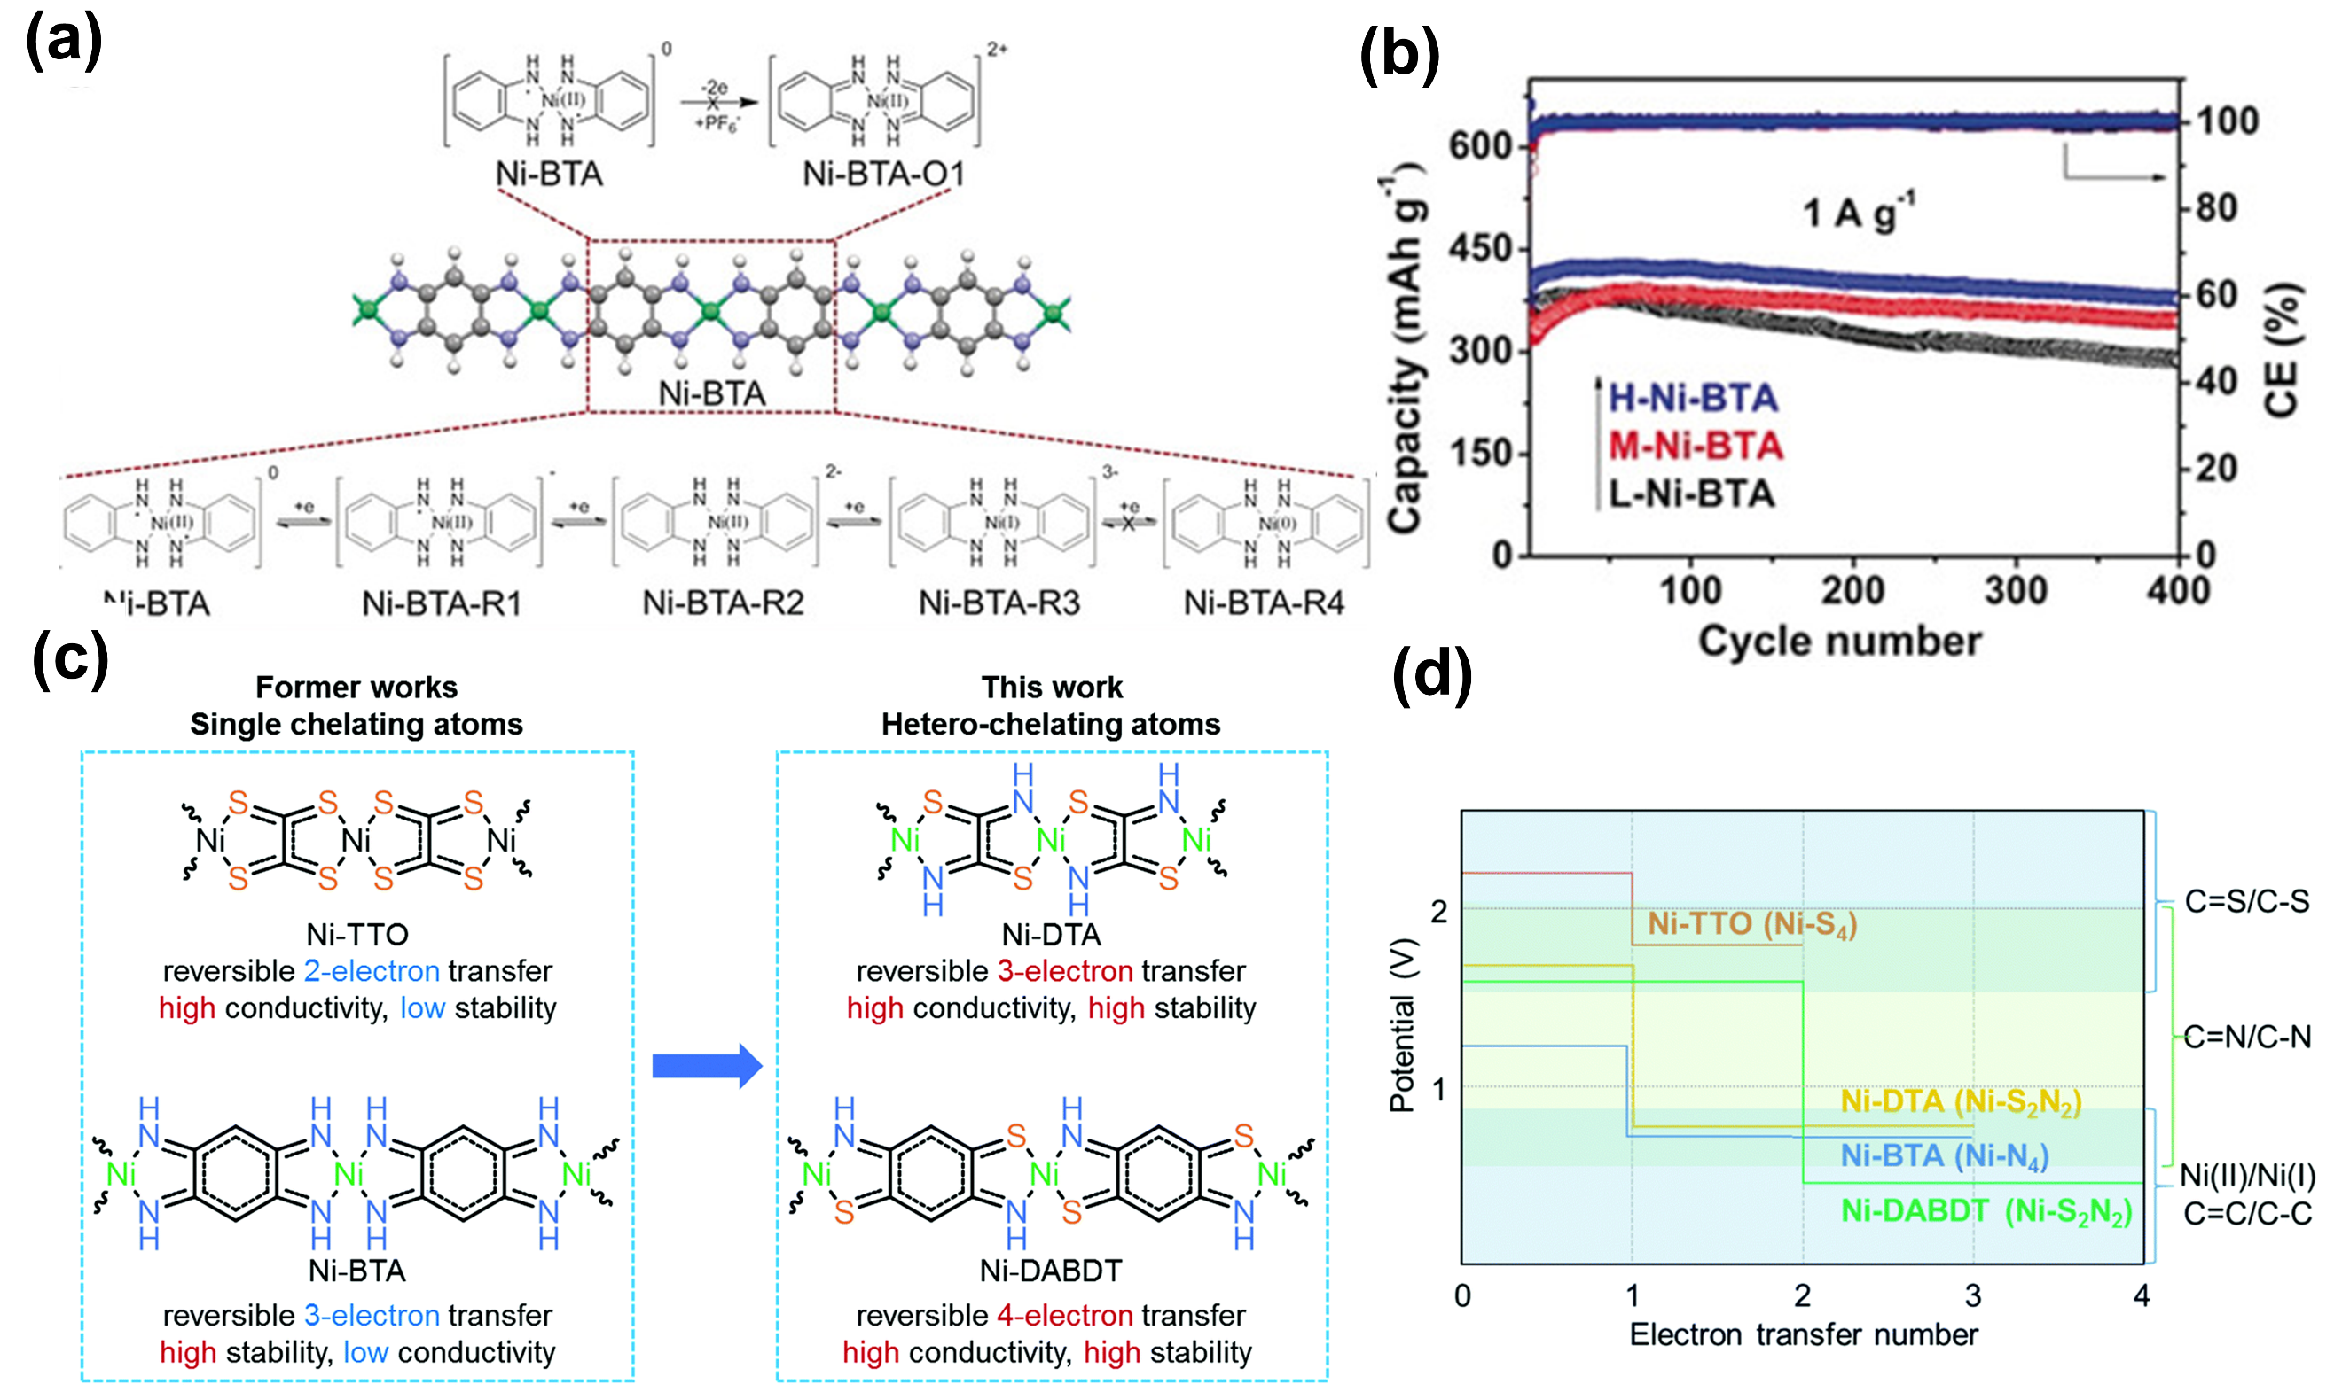
Figure 8. (a) Diagram of the possible storage mechanism of Ni-BTA anode; (b) Cycling performance of Ni-BTA electrodes at 1 A g⁻¹.^{[52]} Reproduced from ref. 52 with permission from Wiley-VCH Verlag GmbH & Co. KGaA, Weinheim, Copyright 2019. (c) Four CCPs with Ni-S₄, Ni-N₄ and Ni-S₂N₂ as repeating units and the transferred electron numbers for each; (d) the calculated results of discharge plateaus, electron transfer number and possible charge storage mechanisms.^{[53]} Reproduced from ref. 53 with permission from Royal Society of Chemistry, Copyright 2021.
Recently, Bao’s group reported on the cobalt-based CCPs (Co-HAB) as anode materials, demonstrating the sodium storage mechanism for the first time.^{[54]} The crystalline structure of Co-HAB can storge three Na⁺ per HAB molecule, achieving a theoretical capacity of 312 mAh g⁻¹ in organic electrolytes. Electrochemical analyses revealed a high specific capacity of 291 mAh g⁻¹ at 50 mA g⁻¹. Subsequently, Wang and colleagues ^{[52]} utilized 1,2,4,5-benzenetetramine (BTA) as organic ligand to prepare one-dimensional (1D) CCPs. As demonstrated in Figure 8a, sufficient evidences have proved that each unit can storge three electrons, facilitated by the conversion of C=N double bonds (two electrons) and Ni^{II} (one electron) to C-N single bonds and Ni^{I}, respectively. The highly crystalline Ni-BTA delivered a significant specific capacity of approximately 500 mAh g⁻¹ at 0.1 Ag⁻¹ and superior cycling stability (400 cycles at 1 A g⁻¹). Leveraging on the success of Ni-BTA, Wang’s group^{[53]} further reported two additional Ni-based CCPs: Ni-DTA (DTA=dithiooxamidato) and Ni-DABDT (DABDT=2,5-diamino-1,4-benzenedithiol) as anode materials. As depicted in Figure 8c-d, the chelation of N and S atoms significantly enhanced the electrical conductivity, stability and rate capability, compared with previous CCPs with only N or S as the chelating atom. Consequently, the Ni-DTA exhibited a capacity of 492 mA h g⁻¹at 0.2 A g⁻¹ through a three-electron transfer process, while Ni-DABDT achieved a capacity of 517 mA h g⁻¹ at 0.2 A g⁻¹ through a four-electron transfer process. In addition to the modification of organic ligands, the crystalline structure and morphology also have a significant effect on the electrochemical properties of these materials in SIBs. Li’s group^{[5a]} reported the 2D Ni-TABQ, where each Ni²⁺ is coordinated to four N atoms via d-p hybridization in the dimethyl sulfoxide and ammonium hydroxide atmosphere. This structure delivered an impressive capacity of 469.5 mAh g⁻¹ at 0.1 A g⁻¹ and 345.4 mAh g⁻¹ at 8 A g⁻¹, maintaining the large capacities for 100 cycles with almost 100% coulombic efficiencies.
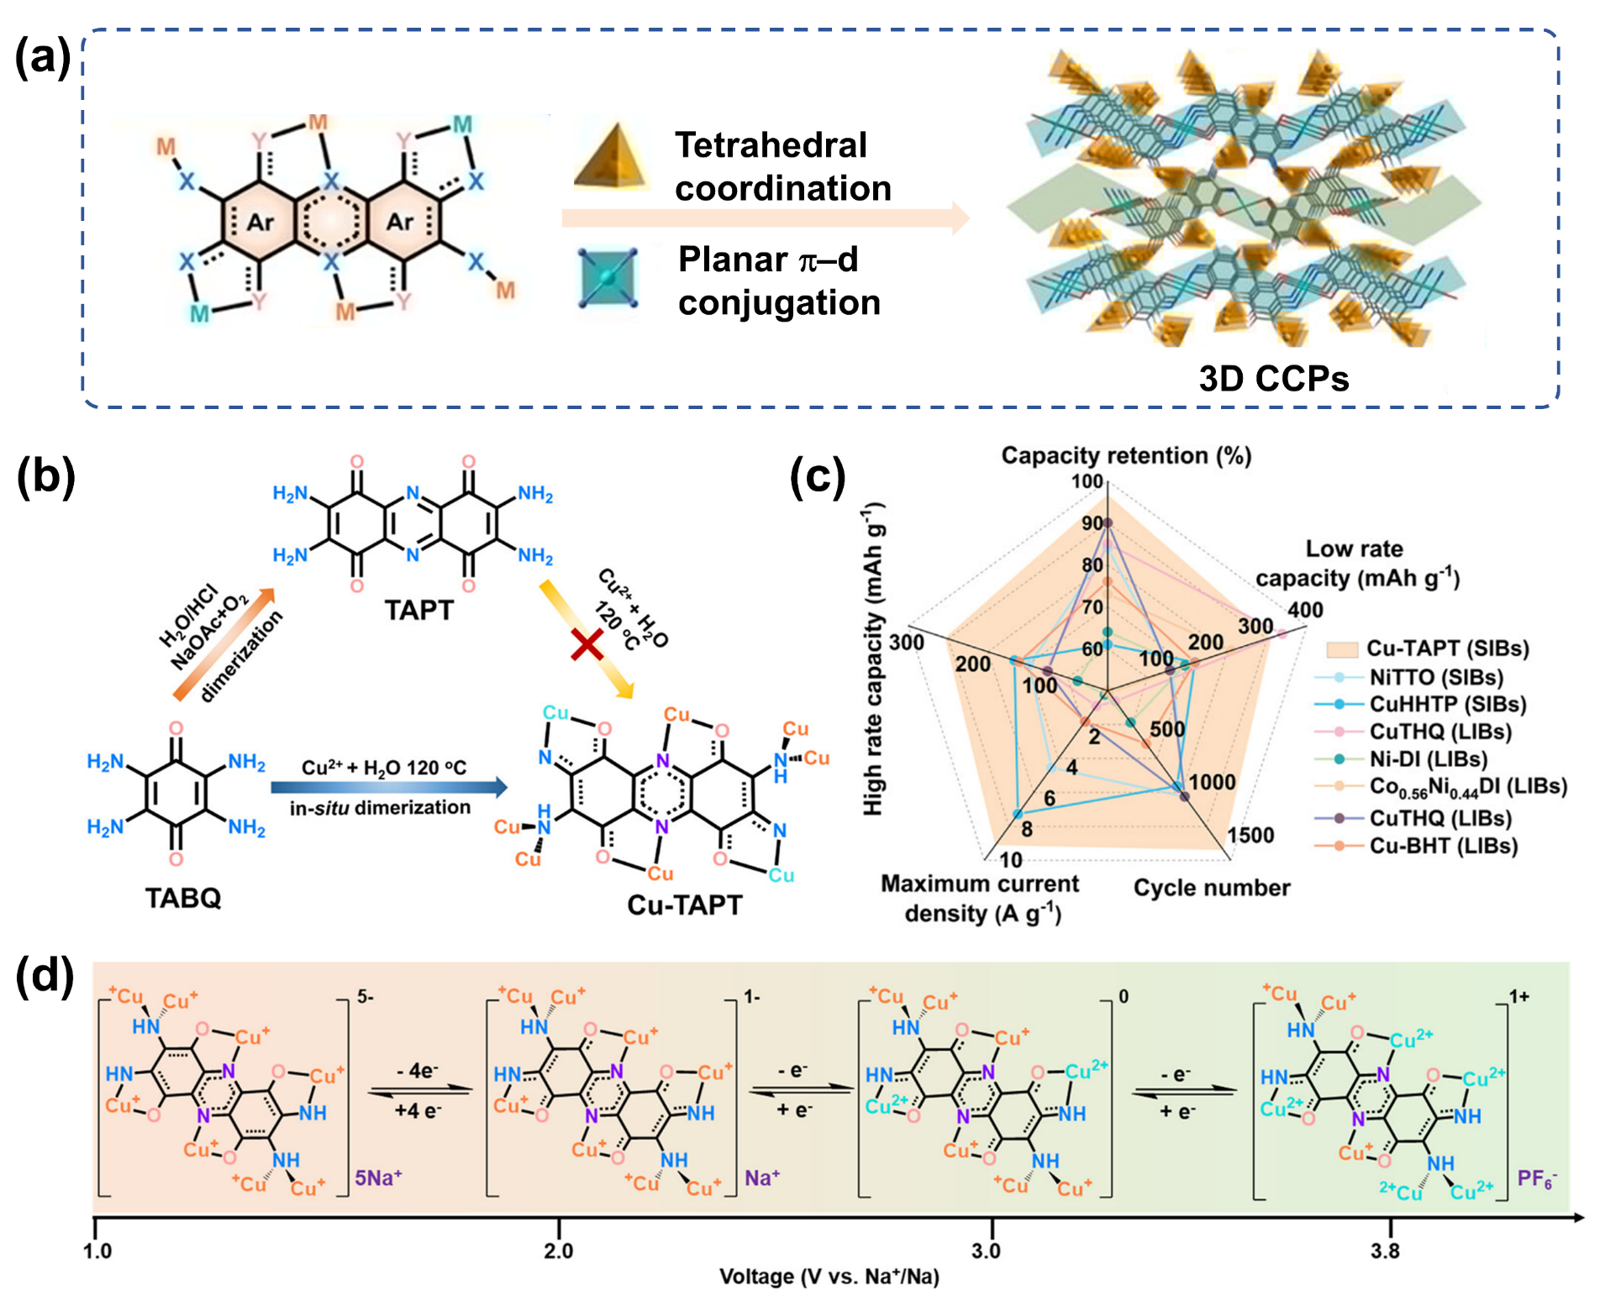
Figure 9. (a-b) Synthesis route of 3D Cu-TAPT; (c) Comparison of electrochemical performance of typical CCPs as cathode in Na-ion batteries; (d) Proposed Na⁺ storage mechanism of Cu-TAPT cathode.^{[55]} Reproduced from ref. 55 with permission from American Chemical Society, Copyright 2023.
Apart from working as anode materials, several CCPs have been reported with higher redox potential and adopted as cathode materials. Wang’s group developed sulphur-based CCPs with tetrathiooxalate (TTO) as a precursor, named as Ni-TTO. The electrochemical results showed two cathodic peaks at 2.4/1.5 V and anodic peaks at 2.8/1.6 V, indicating potential application as cathode materials in SIBs. Further tests demonstrated a high initial capacity of 155 mAh g⁻¹ and excellent capacity retention of 84% at 5 A g⁻¹ over 30 cycles.^{[56]} More recently, Wang’s group^{[55]} firstly reported 3D CCP consists of 1D conductive π-d CCPs chains and bridged linkers between the 1D chains, leading to an improved charge delocalization and higher electrical conductivity. Specifically, the Cu²⁺ and TABQ were suspended in aqueous solution and hydrothermally reacted for 72 hours. Unlike previously reported Cu-TABQ obtained in alkaline, the 2,3,7,8-tetraaminophenazine-1,4,6,9-tetraone (TAPT) was generated through in situ dimerization of TABQ and subsequently self-assembled with Cu²⁺. The electrochemical performance reveals a high reversible capacity (313.4 mA h g⁻¹), fabulous rate capability (∼253 mA h g⁻¹ at 3 C), and superior cyclability (>1500 cycles). As proposed in Figure 9, the high capacity is contributed to the TAPT ligand with four electrons, while the pristine Cu²⁺ pristine Cu⁺ contributes another electron, respectively.

4.3. Other Metal-ion batteries
Apart from LIBs and SIBs, ZIBs have been recognized as promising next-generation energy storage systems for their high theoretical capacity (820 mAh g⁻¹), low cost and environmental friendliness. Most ZIBs are assembled in aqueous electrolyte, bringing additional advantages in terms of safety and low toxicity. The development of novel cathode materials is crucial for the advancement of ZIBs. Traditional cathodes for ZIBs are the manganese and vanadium-based layered materials, which suffer from the unstable phase transition in aqueous electrolyte or the high cost for massive application. Recently, small-molecule organic materials, including quinone-, carbonyl- and imine-compounds, have been proposed as cathode materials, while the dissolution and poor electronic/ionic conductivity issues remain to be solved. Cu₃(HHTP)₂ (HHTP = 2,3,6,7,10,11-hexahydroxytriphenylene) was introduced as an idea cathode material for rechargeable aqueous ZIBs in Figure 10a.^{[57]} The Cu₃(HHTP)₂ boasts a high electrical conductivity of 0.2 S cm⁻¹ and large pore size of 2 nm (Figure 10b). The electrochemical analysis and DFT calculations in Figure 10c indicate a pseudo-capacitive mechanism involving copper and quinoid structures as redox-active sites. Further XRD and HRTEM data confirmed that Zn²⁺ are stored in those pores. The Cu₃(HHTP)₂ demonstrates a high capacity of 228 mAh g⁻¹ at 50 mA g⁻¹ and maintains a capacity retention of 75% at 4000 mA g⁻¹ after 500 cycles. Soon afterwards, Liang and colleagues^{[7a]} compared electrochemical property of the different crystallinity and center metal ions in π-d CCPs. The Ni²⁺ and Cu²⁺ was chosen to coordinate with BTA. The Cu-BTA-H materials with high crystallinity were obtained through the water bath treatment for 12 h at 60 °C, delivering a much superior property than Ni-BTA in ZIBs. Specifically, Cu-BTA-H as organic cathode delivers a high reversible capacity (330 mAh g⁻¹, 200 mA g⁻¹), excellent rate performance (106.1 mAh g⁻¹, 2 A g⁻¹ after 500 cycles) and a high coulombic efficiency (~100%).
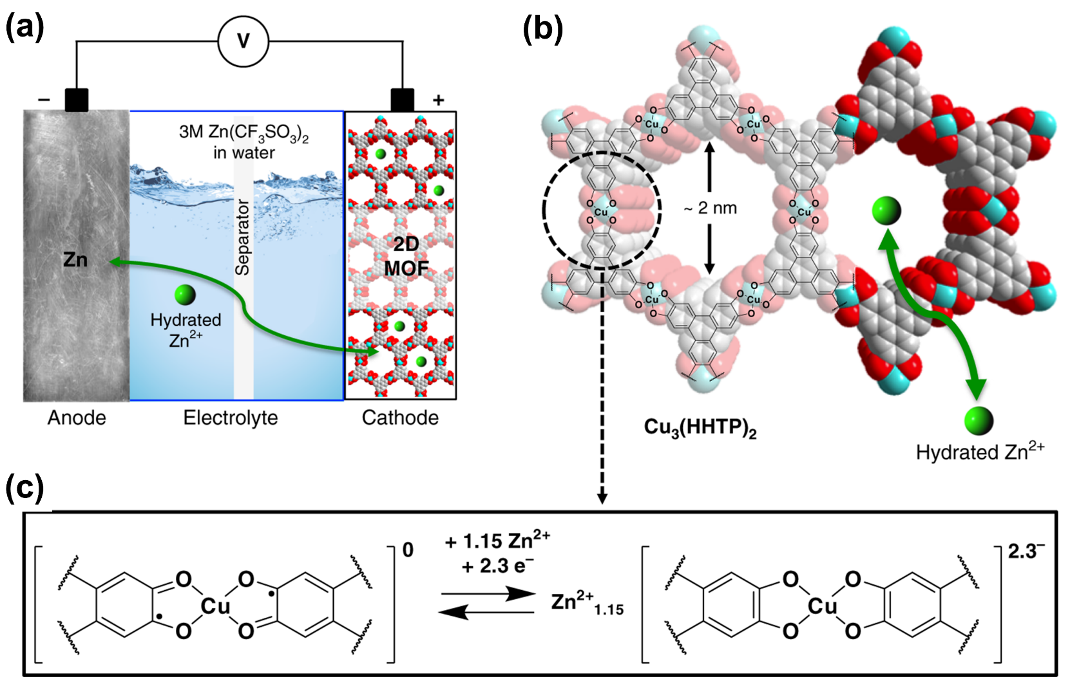
Figure 10. (a) Schematic illustration of ZIBs with Cu₃(HHTP)₂ as cathode; (b) Structure of Cu₃(HHTP)₂ 2D sheets; (c) Proposed Zn²⁺ storage mechanism of Cu₃(HHTP)₂.^{[57]} Reproduced from ref. 57 with permission from Springer Nature, Copyright 2019.
PIBs as a novel alkali metal-based battery, have garnered significant attention due to the abundant potassium reserves, inexpensive usage of aluminum anode collectors, and appropriate reduction potential (-2.93 V) close to that of Li (-3.04 V). However, PIBs have been suffering from the large radius of K⁺, which necessitates the development of advanced host materials capable of accommodating K⁺ ions effectively. CCPs are well-suited to meet the requirements for the topological diversity, high porosity, and adjustable pore size. Zhu’s group^{[58]} made significant advancements in this area by synthesizing hexaazanonaphthalene-based (HANTNH) metal-organic framework on the carbon nanotubes, which was then applied as a cathode material for PIBs. Based on the DFT and electrochemical analysis, it is found that the C=N and [CuO₄] units function as dual-active centres. Additionally, the carbon nanotubes (CNTs) enhance the utilization of active sites and accelerate electron transfer. The Cu-HATNH@CNT exhibits a high capacity of 317.5 mAh g⁻¹ (0.1 A g⁻¹), excellent long-term cycling stability of 2200 cycles (5 A g⁻¹) and excellent rate performance. These findings highlight the potential of CCP-based materials in developing efficient and durable potassium-ion batteries, addressing one of the key challenges in the field.

4.4. Li-S battery
LSBs have been attractive for their impressive theoretical capacity (1672 mAh g⁻¹) and high energy density (2600 Wh kg⁻¹), along with the cost-effectiveness and abundance of sulfur compared to the cobalt used in LIBs.^{[9e, 59]} Theoretically, the operation of LSB is based on the electrochemically reversable formation of chemical bonds between Li and S. Despite these advantages, there are several intractable problems before practical application. First of all, active cathodic sulfur (5x10⁻³⁰ S cm⁻¹) and the resulting discharge product Li₂S (10⁻¹³ S cm⁻¹) are both electrically insulating, which leads to slow oxidation-reduction reactions and high polarization. This leads to a trade-off between sulfur loading and performance. The lower sulfur loading will decrease capacity, while the higher loading will cause the high electrochemical impedance due to poor electrical conductivity. Additionally, the severe volume changes (> 80%) during the charge/discharge process will lead to the structural collapse. Vitally, the reduction of S will go through several reaction intermediate and the solubility of lithium polysulfides Li₂S_{x} (3 ≤ x ≤ 8) in the liquid electrolytes. These polysulfides will migrate from the S cathode to the Li anode, leading to the corrosion of metal lithium and causing self-discharge. To address those obstacles, the cathode requires to have a high density of adsorption sites, high electronic conductivity, high porosity, and high structure stability. Previous researches have successfully adopted the MOFs as ideal host materials, which has large internal channels or cages to trap and immobilize sulfur by the Lewis acid-base interactions between MOFs and Li₂S_{x}. However, the insulating nature has been the main drawbacks. Recently, CCPs have been adopted as a promising solution, combining the advantages of MOFs with high conductivity necessary for efficient battery operation.
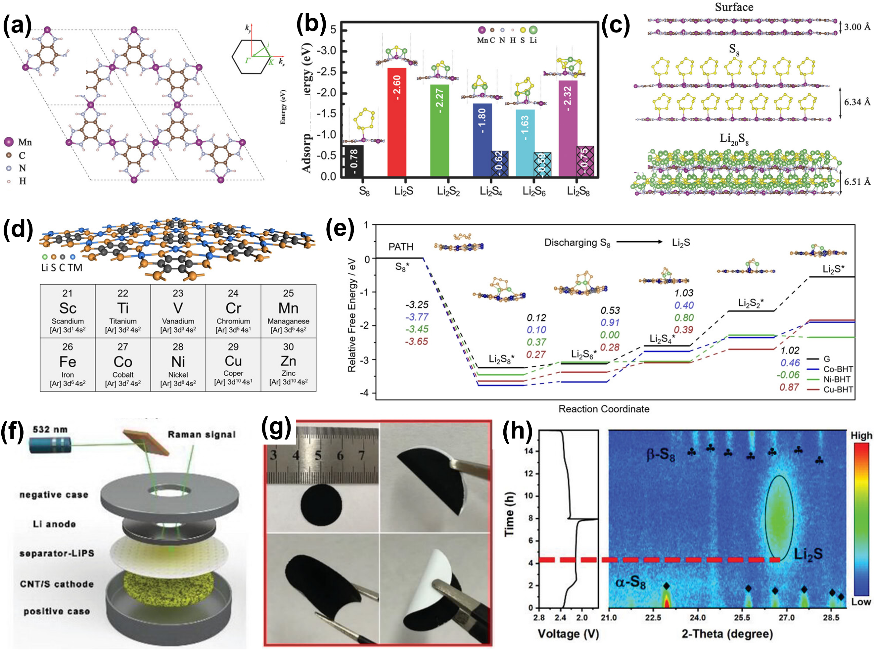
Figure 11. (a) Structure of Mn-HAB-CP; (b)Calculated adsorption energy of S₈, and Li₂S_{y} on surface (c) The interlayer distance of two layers with absorbing S₈ and L₂₀S₈.^{[60]} Reproduced from ref. 60 with permission from Wiley-VCH Verlag GmbH & Co. KGaA, Weinheim, Copyright 2018. (d) The structure of TM-BHT with the potential transition metal; (e) Calculated free energy of polysulfides on graphene and Co/Ni/Cu-BHT.^{[61]} Reproduced from ref. 61 with permission from Wiley-VCH Verlag GmbH & Co. KGaA, Weinheim, Copyright 2020. (f) Structural drawings of in situ Raman tests in Li-S batteries; (g) digital images of Ni-HAB@CNT modified separator; (h) in situ Raman analysis obtained during the charge/discharge processes.^{[62]} Reproduced from ref. 62 with permission from Wiley-VCH GmbH, Copyright 2023.
As proposed, the high porosity of obtained nanostructured d-π CCPs allows large sulfur-loading and relieve the volume change of the sulfur cathode during cycling. The inherent porosity also physically limits the dissolution of polysulfides. Additionally, abundant exposed active sites strongly adsorb polysulfides, thereby mitigating their dissolution and accelerating reaction kinetics. A typical 2D hexaaminobenzene-based coordination polymers (2D-HAB-CPs) have been predicted as cathode candidate materials for LSBs.^{[60]} Based on DFT analysis in Figure 11a-b, it was demonstrated that Mn-HAB-CP could adsorb Li₂S_{x} (x = 4, 6, 8) species, with nitrogen edges atoms binding Li⁺ and S₈ molecule captured by Mn atoms. This interaction facilitates the breakdown S₈ into smaller size that further compound with Li⁺ to form a layer structure, similar to bulk Li₂S. The calculated band structures of Mn-HAB-CP with different polysulfides (Li₅S₈, Li₁₀S₈, Li₁₅S₈, Li₂₀S₈ and Li₃₆S₁₆) show that the Li₂₀S₈ and Mn-HAB-CP can thermodynamically bond against the dissolution/separation of Li₂S_{x} molecules. They also provide a model with sandwich structure constructed with 2D-HAB-CP/S/2D-HAB-CP in Figure 11c. The results indicates that the vertical expansion after full lithiation is only 3%, much lower than that observed in the LIB systems. Moreover, Song^{[61]} systematically investigated coordination of different metal ions (Sc, Ti, V, Cr, Mn, Fe, Co, Ni, Cu, Zn) with benzenehexathiol (BHT) in Figure 11d. Among the studied metal-BHT complexes, the Co/Ni/Cu-BHT have relatively moderate adsorption energy and calculated energy barrier of decomposition of Li₂S_{n} also decreased when compared to traditional graphene. Further free energy in Figure 11e illustrates that the rate-limiting steps of Co/Ni/Cu-BHTs are the reaction of L₂S₆ to Li₂S₄ (Co-BHT), Li₂S₄ to Li₂S₂ (Ni-BHT) and Li₂S₂ to Li₂S (Cu-BHT). The above results clearly confirmed the Co/Ni/Cu-BHT can not only catalyze the decomposition reactions of S₈/Li₂S_{x}, but also synergistically discharge with sulfur materials. By providing a clearer understanding of the reaction mechanisms and identifying the rate-limiting steps in the conversion of polysulfides, these researchs have clearly provided a theoretical guidance towards the application of d-π conjugated electrodes in LSBs.
Experimental studies, such as those conducted by Lu’s group ^{[63]}, have reported two nanostructured d-π CCPs including Ni[C₆H₂(NH)₄]_{n} and Ni[C₆H₂(NH)₂S₂]_{n}. substitution of two NH bonds with S atoms in the Ni[C₆H₂(NH)₂S₂]_{n} have led to improved electrochemical stability and energy storage ability with a high reversible capacity (1164 mAh g⁻¹) and an ultralong stability (1500 cycles). To understand the redox mechanisms, the quantitative analyses were conducted and the result shows capacitive contribution in Ni-S is 63.8% and the diffusion contribution is 36.2%. From this point, the tailor-ability of organic substituent groups indeed can improve the electrochemical property. Chou^{[64]} utilized the Schiff-based reaction to Ni-MOF-1D complexes from Ni²⁺, BTA and 1,1,3,3-tetramethoxypropane. Compared with Ni-BTA, each Ni²⁺ is coordinated to four N, the ring structure around Ni provides a higher electrical conductivity than activated carbon. This increased conductivity enables the S@Ni-MOF-1D to sustain a high capacity of 575 mAh g⁻¹ at 8 C and maintain a long-term stability at 3C with a minor capacity decay of 0.018% per cycle.
Apart from working as the electrode materials, these CCPs can also be utilized to construct separator modification layer, which can physically inhibit the shuttle effect. As shown in Figure 11f, Zhu et al.^{[62]} prepared the 2D conductive CCPs (Ni-HAB) on carbon nanotubes and then directly filtrated on the commercial separator. The pore size of Ni-HAB, quantified at 8 Å, is smaller than that of lithium polysulfides, albeit permitting the passage of Li⁺ ions. In-situ XRD analysis (Figure 11g) and DFT computations convincingly proved that the well-dispersed Ni-N₄ units can kinetically accelerate both the formation and decomposition of Li₂S. The LSBs assembled with Ni-HAB@CNT as separator achieved a high capacity of 6.29 mAh cm⁻² and endured 500 cycles with an extremely low capacity-fade rate of 0.041% per cycle at a high sulfur loading of 6.5 mg cm⁻². Apart from the filtration approach, the Ni₃(HITP)₂ prepared by Fang’s group^{[65]} can also be directly transferred onto the separator by liquid-solid interface method without cracks or phase impurity. In this way, the thickness of separator is customizable in a range of 90-970 nm and electron conductivity reaches as high as 3720 S m⁻¹.

4.5. Supercapacitor
The electrochemical supercapacitor is emerging as a promising candidate for energy storage system due to its high-power density, rapid charge/discharge capabilities and enduring cycle life. However, the relatively low energy density remains a significant challenge, impeding its broader applications. To address this, extensive research efforts have been dedicated to improve specific capacitance of advanced electrode materials.
The π-d CCPs have been known to have conjugated skeleton, ordered porous structure and abundant redox-active sites. The porous structure enhances capacity by electrochemical double layer (EDL), where electrolyte ions will adsorb/desorb at the interface between electrodes and electrolytes without any electrons transfer. The redox-active sites, including metal ions and organic ligands, will facilitate the storage of charges in a faradaic process, which is a crucial aspect to achieve high energy density. Unlike the traditional MOFs, which are hindered by slow charge transport, the conjugated skeleton ensures high electronic conductivity and efficient charge transport during charge/discharge process. Dinca’s group^{[66]} were the first to utilize Ni₃(HITP)₂ as active material for supercapacitors, as illustrated in Figure 12a-c. The assembled device reaches a notable capacitance of about 18 μF cm⁻² and a capacity retention of over 90% across 10,000 cycles, capable to the commercial devices. These values are proved to be an excellent candidate for double-layer capacitive energy storage, but do not outperform the optimal materials. Subsequently, as depicted in Figure 12d-e, Bao’s group^{[67]} selected hexaaminobenzene (HAB) linker with Ni²⁺/Cu²⁺ to construct conductive CCPs with an augmented number of redox-active centres. The compact HAB ligand ensures a densely structured framework, and the obtained Ni-HAB delivers a superior capacitive volumetric performance of 760 F cm⁻³. The stable redox behavior gravimetric capacitance guarantees a capacitance retention of 90% even after 12,000 cycles. Lee^{[68]} also prepared a 1D π-d conjugated coordination polymer (Ni-BTA) via a scalable chemical bath deposition method. As illustrated in Figure 12f, the resultant film demonstrated high coloration efficiency (223.6 cm² C⁻¹), high gravimetric capacity (168.1 mAh g⁻¹) and sustained electrochemical stability (>10,000 cycles). Further assembled solid-state electrochemical double layer (EDL) capacitor with Ni-BTA as electrochromic layer, sprayed TiO₂ as ion storage layer, and KOH/polyvinyl alcohol as solid electrolyte, exhibited high gravimetric and areal capacities of 125.2 mAh g⁻¹ and 98 mAh m⁻². These advancements in π-d CCPs highlight their potential in enhancing the performance of electrochemical supercapacitors, making a significant advancement towards more efficient and practical energy storage solutions.
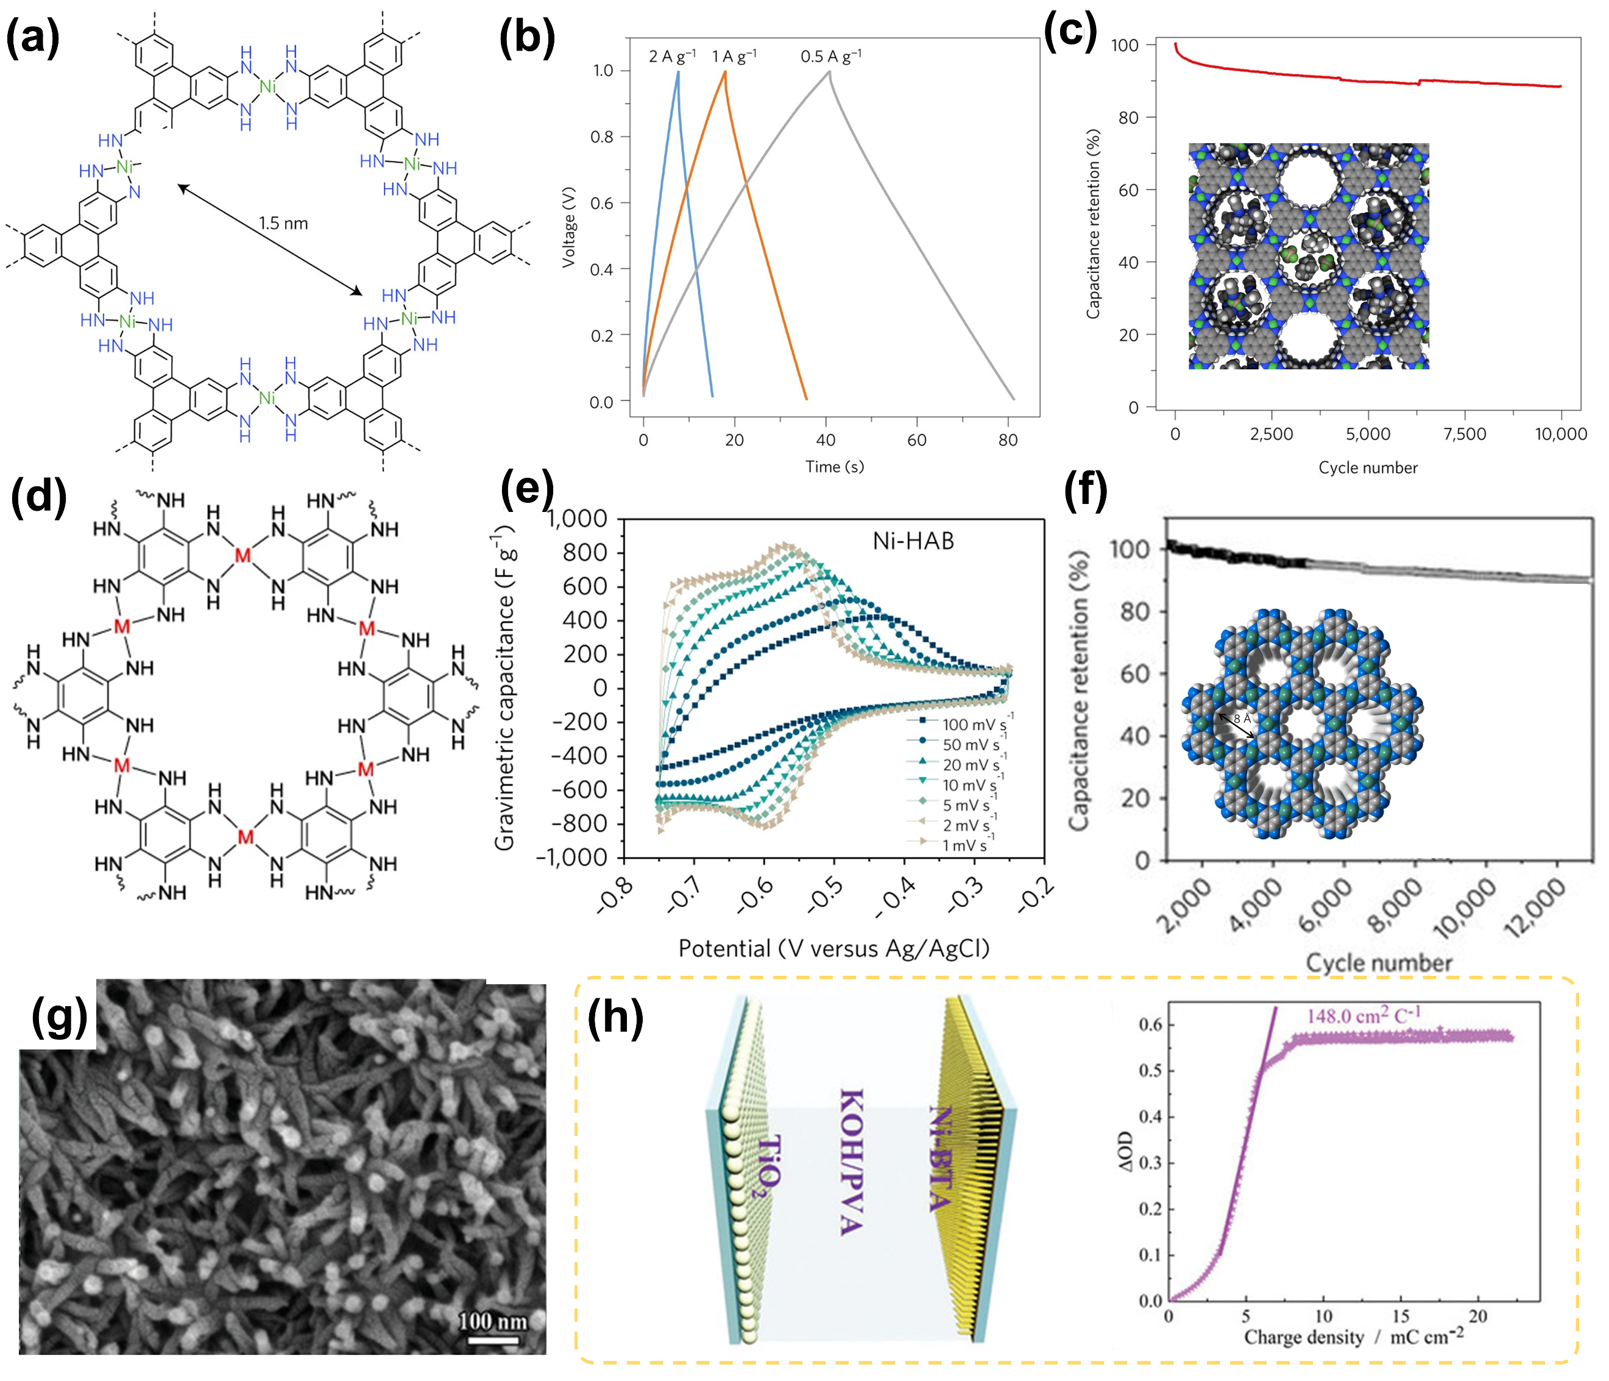
Figure 12. (a) Structure of Ni₃(HITP)₂; (b) Charge/discharge curves obtained at 0.5, 1.0, 2.0 A g⁻¹. (c) Capacitance retention obtained by cycling at 2 A g⁻¹ for 10,000 cycles.^{[66]} Reproduced from ref. 66 with permission from Springer Nature, Copyright 2016. (d) Structure of Cu-/Ni-HAB MOFs; (e) Cyclic voltammetry profiles collected at different scan rates for Ni-HAB; (f) Capacitance retention obtained by cycling at 10 A g⁻¹ for 10,000 cycles.^{[67]} Reproduced from ref. 67 with permission from Springer Nature, Copyright 2018. (g) SEM images of Ni-BTA film on FTO glass; (h) Construction of the solid-state device assembled with Ni-BTA as the electrochromic layer, sprayed TiO₂ as the ion storage layer, and KOH/PVA as electrolyte and the optical density as a function of the charge density during coloring process at 500 nm.^{[68]} Reproduced from ref. 68 with permission from Wiley-VCH GmbH, Copyright 2020.

4.6. Metal-air battery
The metal-air batteries have attracted vast attention for their high theoretical energy density and high working potential. Among all, the Li-O₂ batteries and Zn-air batteries are treated as the most dazzling energy storage system. Li-O₂ batteries operate based on a two-electron electrochemical reaction 2Li + O₂ ↔ Li₂O₂ (E = 2.96 V) and boast an extremely high theoretical energy density of 3600 Wh kg⁻¹,^{[69]} while the Zn-air batteries are based on four-electron oxygen reduction reaction (ORR) and oxygen evolution reaction (OER), delivering slightly lower theoretical energy densities of 1370 Wh kg⁻¹.^{[70]} However, both of them are suffering from the sluggish kinetics of ORR and OER performance, leading to the low energy efficiency, poor durability and low practical capacity. Traditionally, noble metals such as Pt, Ru, Ir and their oxides have been commonly doped as the most efficient ORR/OER electrocatalysts.^{[70c, 71]} Nevertheless, the high cost and scarce availability limit their massive commercial application. Extensive efforts have been applied and several alternatives have been proposed, including transition metal oxides, nitrides, carbides, sulfide, hydroxide and carbon-based hybrids.^{[70b, 72]} Those inorganic transition metal -based catalysts are mostly composed of nanoparticles, resulting in inadequate electronic conductivity and low specific surface area, while the carbon-based hybrids are blamed for the severe inherent corrosion. Therefore, seeking an economic and efficient bifunctional electrocatalyst is still the main task for metal air battery.
The π-d CCPs offer promising solutions to the above problems faced by metal-air batteries due to the excellent electrical conductivity, tunable structures and abundant catalytic active sites. Chen’s group^{[73]} has developed a serious of TM-based (TM=Mn/Fe/Co/Ni/Cu) coordination polymers. Assistant with first-principle calculations in Figure 13a, they found that Co-BTA materials strengthen the adsorption of rate-determining *OOH intermediates on TM centres, making them ideal candidates for the oxygen reduction reaction (ORR). Further by modifying organic ligands from BTA to TABQ, the substituent oxygen atoms near the active sites (Co-N₄) further enhanced catalytic performance. Co-TABQ manifest the highest activity with a 0.19 V lower overpotential compared to Co-BTA (Figure 13c). When Co-TABQ was anchored on the CNT by a facial liquid-phase reaction, it delivers an onset potential (E_{onset}) of 0.99 V, a half-wave potential (E_{1/2}) of 0.85 V and a considerable stability of 96.6% after 10 hours. Recently, Yuan and Chen^{[74]} investigated the chemical environment around Co-N₄ active sites. They constructed 1,4,8,11-tetraaza[14]annulene (TAA)-based polymers using 3,3-diaminobenzidine and β-substituted malondialdehyde through the Schiff-based reaction. The changes of β-substituted radical group can make the difference in electron-donors/acceptors interaction around Co-N₄ sites. Based on the Sabatier principle, the DFT calculations suggest that Cl substituent group modulates the electronic distribution on Co centres and thereby optimizes the binding strength with key *OH intermediates. As a result, the CoTAA-Cl@GR delivers an excellent ORR performance with a high turnover frequency (TOF) value of 0.49 es⁻¹ site⁻¹ (0.8 V). The assembled ZAB with CoTAA-Cl@GR can work for more than 350 hours without significant decay, achieving a peak power density of 195.3 mW cm⁻².
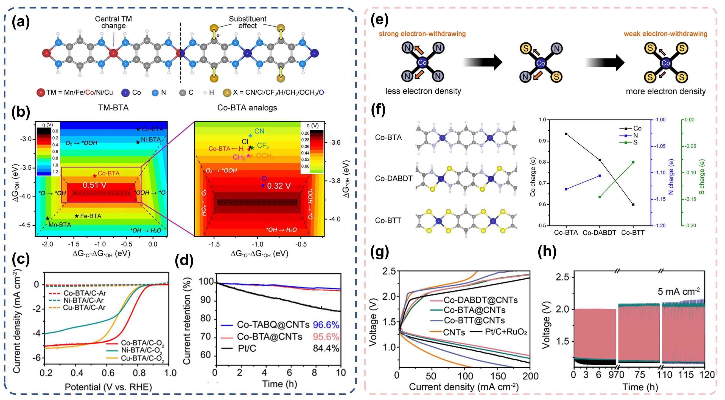
Figure 13. (a) Structure of TM-BTA with optimized TM and substituent modification strategy; (b) The color-filled map of ORR activity volcano of TM-BTA and the Co-BTA analogs; (c) Linear sweeping voltammetry of TM-BTA/C in 0.1 M KOH solution; (d) Stability test at -0.47 V. ^{[73]} Reproduced from ref. 73 with permission from Wiley-VCH GmbH, Copyright 2021. (e) Schematic diagrams of the charge regulation strategy; (f) Structure of Co-BTA, Co-DABDT, and Co-BTT. (g) Charge and discharge curves of as-assembled Zn-air battery with different catalysts as air cathode at 10 mA cm⁻²; (h) long-term cycling performance at 5 mA cm⁻².^{[75]} Reproduced from ref. 75 with permission from American Chemical Society, Copyright 2022.
In many carbon-based ORR catalysts, the metal-N₄ units like Fe-N₄, Co-N₄, are considered active sites obtained from the high-temperature thermal treatment. However, fine-tuning N atoms in metal-N₄ to S or other heteroatoms through thermal treatment is challenging. By adjusting the organic ligands from BTA to DABDT (DABDT=2,5-diaminobenzene-1,4-dithiol) and Co-BTT (BTT=1,2,4,5-tetramercaptobenzene), the charge density around Co can be customized from Co-N₄ to Co-N₂S₂ and Co-S₄. Thus, the ORR performance will be affected by atomic arrangement and electron redistribution.^{[75]} As shown in Figure 13d, the electronegativity of S is higher than that of N atoms, increasing the charge density of Co from Co-N₄ to Co-S₄. The Co-N₂S₂ would effectively optimize and stabilize the key intermediate (OOH*) with the assistance of hydrogen bonding interactions between intermediates and active S atoms (*OO-H···S). Experimental results showed that Co-DABDT@CNTs achieved an outstanding half-wave potential of 0.85 V. The assembled ZAB with Co-DABDT@CNTs delivers a high peak power density of 244.8 mW cm⁻² superior than that of Pt/C + RuO₂ (139.2 mW cm⁻²). The specific capacity can reach 791.7 mAh g_{Zn}⁻¹ at the current of 10 mAcm⁻² and operate over 380 h.
In comparison to ZABs, non-aqueous LOBs involve the reduction of oxygen to solid-state Li₂O₂. The electrically insulated Li₂O₂ will accumulate on the catalytic sites during discharge process, thereby impeding the ORR and lead to premature termination. During the charge process, the insulator needs a high overpotential for decomposition, and the intermediates may react with the cathode materials leading to ever side reactions. Consequently, when adopted as cathode, several strict requirements have been proposed, including large open area for growing discharge products, good structure stability against superoxide radical and self-standing morphology to reduce the binder-associated by-products. As illustrated in Figure 14, Li’s group have prepared the Ni-HHTP nanofiber arrays on the carbon paper through liquid phase reaction.^{[76]} By adjusting the synthesis condition, the spin state of partial Ni²⁺ metal centres nickel catecholate framework (Ni^{II}-NCF) was regulated to be high-valence Ni³⁺ (Ni^{III}-NCF), which creates more nickel-oxygen covalency and improves the affinity of intermediate LiO₂. The discharge products also turned to be nanosheet-like Li₂O₂ on the Ni^{III}-NCF nanowires. The LOBs with Ni^{III}-NCF as cathode presents a narrow charge/discharge gap of 0.92 V (500 mA g⁻¹), a large discharge capacity of 16800 mAh g⁻¹ and long-time stability of 200 cycles. Soon, their group reported another hexagonal conductive nickel-hexaiminotriphenylene (Ni-HTP) nanowire arrays and the electrochemical performance is improved by incorporating Ru atoms into its skeleton.^{[77]} Confirmed by DFT analysis, the tunable d-band center ensures the strong adsorption for the LiO₂ intermediate, resulting in the formation of Li₂O₂ on the surface in a film-like morphology.
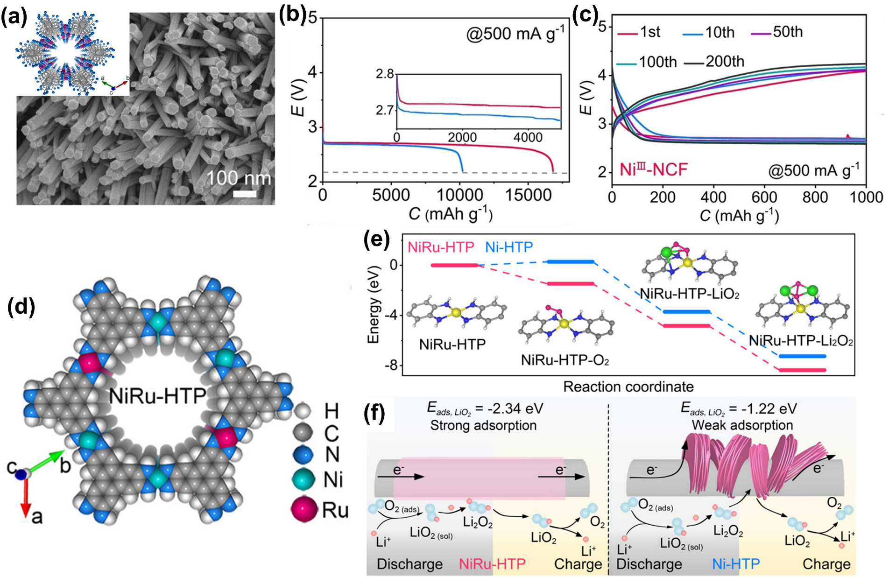
Figure 14. (a) SEM images of Ni^{III}-NCF electrode and an inset of Crystal structure of Ni-NCF; (b) the discharge capacity of Ni^{III}-NCF and Ni^{II}-NCF at 500 mA g⁻¹; (c) Discharge/charge curves of the selected runs over 200 cycles at 500 mA g⁻¹ with Ni^{III}-NCF as cathode.^{[76]} Reproduced from ref. 76 with permission from Wiley-VCH GmbH, Copyright 2021. (d) Simulated structure of NiRu-HTP cathode; (e) Free energy diagrams of oxygen reduction with NiRu-HTP and Ni-HTP cathodes; (f) Proposed reaction mechanisms and the adsorption energy of LiO₂.^{[77]} Reproduced from ref. 77 with permission from American Chemical Society, Copyright 2022.
While most reported π-d CCPs are highly conductive and works as the electrochemical active materials, we noticed that the cobalt-tetramino-benzoquinone (Co-TABQ) delivers a suitable visible light absorption capacity as a semiconductor and can be utilized as bifunctional catalysts in photo-involved Li-O₂ battery in Figure 15.^{[78]} Typically, upon light illumination, the photo-induced electrons and holes are generated on the surface. During the discharge process, the band bending enables electrons to reduce the oxygen and get a high discharge potential, while the remained holes will capture the electrons from the external circuit.^{[69a, 79]} During the charge process, the photo-generated electrons will pass through the external circuit with the charge overpotential and reduce the Li⁺, while the remained holes will decompose the discharge products. The band structure of Co-TABQ nanosheet arrays is illustrated in Figure 15b, where the VB value is 4.23 V and the CB value is 2.03 V. The assembled novel photo-enhanced LOBs achieved a high energy efficiency of 94% with a discharge voltage of 3.12 V, breaking the thermodynamic equilibrium potential (2.96 V), and charge potential drop from 4.31 V to 3.32 V compared to that of dark condition.
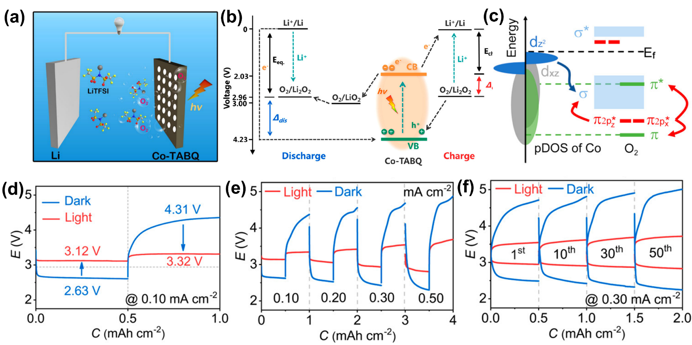
Figure 15. (a-b) Structure diagram and the recation mechanism of the proposed photo-involved Li-O₂ battery; (c) pDOS of Co in Co-TABQ and its schematic formation of σ and π bonds with O₂; (d)the charge/discharge curves under/without light illumination; (e-f) rate and longtime cycling performance under different light condition.^{[78]} Reproduced from ref. 78 with permission from American Chemical Society, Copyright 2021.

5. Challenge and perspective
Consequently, this perspective mainly focusses on π-d CCPs as electrode materials for energy storage equipment, including metal-ion batteries, LSBs, supercapacitors, and metal-air batteries. Indeed, the CCPs have provided and opened a brand-new option for developing efficient electrodes, considering the high porosity, extensive redox active sites and adjustable active sites in atomic level. Although, these polymers have also been widely researched and applied in many other electrocatalytic reaction (hydrogen evolution reaction, nitrogen reduction reaction, carbon dioxide reduction reaction), it's still in its infancy and leaves a lot to be desired. Here, we proposed several potential perspectives for further development and highlighted as below.
(i) Unsatisfying electron conductivity. The π-d CCPs have been claimed to be electronic conductivity for the poor crystallinity and crystal defect, while it still far lower than the carbon-based or metallic electrocatalytic. The high crystallinity will fasten the charge transfer during electrochemical catalytic process and can improve the power performance of energy storage devices. To date, most conjugated polymers are synthesized through the simple liquid phase reaction and the growth mechanism has not been systematically studied. It is hard to precisely control the structure, composition and morphology.
Thus, the additional conductive substrates have been considered as an effective way to improve the electronic conductivity. The CCPs can anchor on the 2D substrate through nonbond interactions or covalent bonds, where the latter can provide higher stability and tailored electronic properties. The reduced graphene and Mxene have abundant functional groups which can establish covalent connections with organic ligands (such as -NH₂ and -SH). What’s more, these 2D substrates provide large open area and exposed active sites for catalytic reaction. The well-dispersed conjugated polymers function as the reactive sites and the substrate facilitates rapid electron transfer.
(ii) Limited kind of organic ligands and metal centres. On the one hand, the most reported π-d conjugated materials are commonly based on the substituent groups of -NH₂, -OH and -SH. To prepare the organic ligands, the hydrogen atom of benzene and triphenylene or others should be substituted through complex organic synthesis process with bulk organic solvents, which leads to the high price. The economical method for preparing the organic ligands should been explored and some other substituent groups can also be introduced. On the others, the metal centre of most reported π-d conjugated materials are Cu, Fe, Ni and Co, while some other transition metals (like Bi, Mn, Ti, Pd and so on) are rarely synthesized or just predicted without successful preparation. Therefore, it is necessary to forecast the potential combination of transition metals and organic ligands, and further verify the electrochemical performance through a relevant machine-learning process.
(iii) Low stability. For most polymer electrode, the structure stability and solubility in electrolyte have been wildly concerned. As electrocatalysts, the conjugated materials should tolerate the large oxidation potential or reduction potential and maintain catalytic activity under strong acidic or alkaline electrolytes. Serving as anode or cathode in metal-ion battery, the structure stability during the ion insertion-deinsertion reaction along with the redox of transition metal may cause the structural collapse and further dissolve in the electrolyte. To this end, future exploration should focus on monitoring the stability and degradation of the conjugated materials during the catalytic process and charge/discharge process.
(iv) Unclear catalytic and energy storage mechanism. To date, extensive efforts have been conducted to analyze and elaborate the energy storage mechanisms such as Li⁺ insertion/deinsertion reaction, oxygen reduction reaction, through theoretical calculations. The crystal structure of most reported CCPs is typically studied using powder X-ray diffraction (PXRD) along with theoretical simulations. Theoretical research on reaction mechanisms often relies on single-crystal data. Therefore, developing an effective methodology to obtain high-quality crystals is crucial for a better understanding of their electrochemical performance. Moreover, a poor crystallinity will lead to uncontrollable pore size, morphology and defective sites, which impart a significant influence on the electrochemical property and mechanism. As a consequence, some ex/in-situ instrumental techniques (in-site Raman, FTIR, XRD and others) will be necessary to detect the reaction intermediate and explore the relationship between structure and activity.
This review primarily delved into the research of π-d CCPs in rechargeable batteries. These polymers with high porosity, large surface area, good conductively and extensive customizable active sites provide an alternative choice as electrode materials different from traditional carbon materials. Beyond their role as battery electrodes, the application of conjugated polymers is widely expanded. For example, they can also function as electrochemical catalysts for nitrogen reduction reaction (NRR), carbon dioxide reduction reaction (CO₂RR), hydrogen evolution reaction (HER), and various other areas. It is believed that advancing controllable synthesis schemes for CCPs will pave the way for their broader utilization in energy storage and conversion applications.

Acknowledgements
The authors express their appreciations for the financial support from the National Science Foundations of China (22309084 and 22171137), Natural Science Foundation of Jiangsu Province (BK20210616), the China Postdoctoral Science Foundation (2023M731589), Jiangsu Key Laboratory of Electrochemical Energy Storage Technologies (EEST2021-2), the project of Zhongyuan Critical Metals Laboratory (GJJSGFYQ202422), and a project funded by the Priority Academic Program Development of Jiangsu Higher Education Institutions (PAPD).

Conflict of Interest

The authors declare no conflict of interest.

Received: ((will be filled in by the editorial staff))
Revised: ((will be filled in by the editorial staff))
Published online: ((will be filled in by the editorial staff))

Table 1. Summary of the reported CCPs electrocatalysts for energy storage application
 | Material | Ligand | Active sites | Capacity (mAh g⁻¹)/  Current density (mA g⁻¹) | Stability | σ^{c}  (S cm⁻¹) | Ref
Li-ion battery | NiDI | L^{isq} (o-diiminobenzosemiquinonate) | Ni-N₄ | 155/10 | 300 cycles (>99%)ª  at 250 mA g⁻¹ | - | ^{[41]}
Li-ion battery | Ni-TIB/  Cu-TIB | TAB  (1,2,4,5-tetraaminobenzene) | Ni-N₄ | 83/20000 | 20000 cycles (79%)^{b}  at 20 A g⁻¹ | <10⁻⁸ | ^{[42]}
Li-ion battery | Ni-TIB/  Cu-TIB | TAB  (1,2,4,5-tetraaminobenzene) | Cu-N₄ | 98/50 | 20000 cycles (55 mAh g⁻¹) at 5 A g⁻¹ | <10⁻⁸ | ^{[42]}
Li-ion battery | Fe-TABQ | TABQ  (tetraminobenzoquinone) | Fe-N₂O₂ | 251.1/50 | 200 cycles (95%)^{b}  at 200 mA g⁻¹ | 3×10⁻⁵ | ^{[43]}
Li-ion battery | Cu-THQ | THQ  (tetrahydroxy-1,4-benzoquinone) | Cu-O₄ | 390/50 | - | - | ^{[22a]}
Li-ion battery | Ni-DHBQ | DHBQ  (2,5-dihydroxybenzoquinone) | Ni-O₄ | 650.7/100 | 100 cycles (67.4%)^{b}  at 100 mA g⁻¹ |  | ^{[44]}
Li-ion battery | Cu-HHTQ | HHTQ  (2,3,7,8,12,13-hexahydroxytricycloquinazoline) | Cu-O₄ | 657.6/600 | 200 cycles (82%)^{b}  at 600 mA g⁻¹ | 5×10⁻³ | ^{[46]}
Li-ion battery | Cu-HATN | HATN  (hexaazatriphenylene) | Cu-O₄ | 763/300 | 600 cycles (90%)^{b}  at 300 mA g⁻¹ | 2.15×10⁻⁸ | ^{[47]}
Li-ion battery | Cu-BHT | BHT  (benzenehexathiolate) | Cu-S₄ | 232/50 | 500 cycles (78%)^{b}  at 300 mA g⁻¹ | 231 | ^{[45]}
Na-ion battery | Co-HAB | HAB  (hexaaminobenzene) | Co-N₄ | 228/1000 | 50 cycles (≈100%)ª  at 500 mA g⁻¹ | 1.57 | ^{[54]}
Na-ion battery | Ni-BTA | BTA  (1,2,4,5-benzenetetramine) | Ni-N₄ | 500/100 | 400 cycles (≈100%)^{b}  at 1 A g⁻¹ | - | ^{[52]}
Na-ion battery | Ni-TTO | BHT  (benzenehexathiol) | Ni-S₄ | 155/100 | 1000 cycles (76%) ^{b}  at 1 A g⁻¹ | 30 | ^{[56]}
Na-ion battery | Ni-TTO/ Ni-DABDT | DTA  (dithiooxamidato))/  DABDT  (2,5-diamino-1,4-benzenedithiol) | Ni-N₂S₂ | 492/200  517/200 | 800 cycles (993.2%)^{b}  at 2 A g⁻¹  2000 cycles (82.9%)^{b}  at 2 A g⁻¹ | 4.64×10⁻⁹  2.54×10⁻⁷ | ^{[53]}
Na-ion battery | Ni-TABQ | TABQ  (tetraminobenzoquinone) | Ni-N₄ | 469.5/100 | 100 cycles (≈100%)ª at 1 A g⁻¹ | 6.8×10⁻³ | ^{[5a]}
Na-ion battery | Cu-TAPT | TABQ  (tetraminobenzoquinone) | Cu-N₂O₂ | 313.4/100 | 1500 cycles (77%)^{b} at 5 A g⁻¹ | 4 | ^{[55]}
Na-ion battery | Zn-HHTP | HHTP  (2,3,6,7,10,11-hexahydroxytriphenylenehydrate) | Zn-O₄ | 150/100 | 1000 cycles (90%)^{b} at 100 mA g⁻¹ | 8000 | ^{[80]}
Na-ion battery | HATN-OCu | HATN-6OH  (hexaazatrinaphthylene hexahydroxyl) | Cu-O₄ | 500/100 | 500 cycles (80%)^{b} at 2 A g⁻¹ | - | ^{[81]}
Li-S battery | Ni[C₆H₂(NH)₄]_{n}  Ni[C₆H₂(NH)₂S₂]_{n} | diamino-and dithiolene- | Ni-N₄  Ni-N₂S₂ | 1655/100  1374/100 | 1000 cycles (>99.84%)ª at 3 A g⁻¹  1500 cycles (>99.87%)ª at 3 A g⁻¹ | - | ^{[63]}
Li-S battery | Ni-MOF-1D | BTA  (1,2,4,5-benzenetetramine) | Ni-N₄ | 1491/0.1 C  (6.63/6.7)^{d} | 1000 cycles (>99.6%)ª at 3 C | - | ^{[64]}
Li-S battery | Ni-HAB@CNT | HAB  (hexaaminobenzene) | Ni-N₄ | 1310/0.2 C  (6.29/6.5)^{d} | 200 cycles (85.2%)^{b} at 0.2 C | 0.9±0.15 | ^{[62]}
Li-O₂ battery | Co-TABQ | TABQ  (tetraminobenzoquinone) | Co-N₄ | - | 50 cycles at 0.30 mA cm⁻² | - | ^{[78]}
Li-O₂ battery | Ni^{Ⅲ}-NCF | HHTP  (2,3,6,7,10,11-hexahydroxytriphenylenehydrate) | Ni-O₄ | 16800/500(mA cm⁻²) | 200 cycles at 500 mA g⁻¹ | - | ^{[76]}
Li-O₂ battery | NiRu-HTP | HTP  (hexaiminotriphenylene) | Ni-N₄ | 18280/500 | 200 cycles (75.7%) at 500 mA g⁻¹ | - | ^{[77]}
Zn-Air battery | CoTAA-Cl@GR | TAA  (1,4,8,11-tetraaza[14]annulene) | Co-N₄ | 805.7/50 | 350h at 10 mA cm⁻² | - | ^{[74]}
Zn-Air battery | Co-DABDT@  CNTs | DABDT  (2,5-diaminobenzene-1,4-dithiol) | Co-N₂S₂ | 791.7/100 (mA cm⁻²) | 380h at 100 mA cm⁻² | - | ^{[75]}
- Data is obtained from the coulombic efficiency; ^{b)} Data is obtained from the capacity retention; ^{c)} Electrical conductivity at room temperature; ^{d)} Areal capacity (mAh cm⁻²)/sulfur loading (mg cm⁻²)
References
[1] a) E. Pomerantseva, F. Bonaccorso, X. L. Feng, Y. Cui, Y. Gogotsi, Science 2019, 366, 969; b) Q. Fu, J. Han, X. Wang, P. Xu, T. Yao, J. Zhong, W. Zhong, S. Liu, T. Gao, Z. Zhang, L. Xu, B. Song, Adv. Mater. 2020, 33, e1907818; c) M. C. Wang, R. H. Dong, X. L. Feng, Chem. Soc. Rev. 2021, 50, 2764.
[2] M. H. Yu, R. H. Dong, X. L. Feng, J. Am. Chem. Soc. 2020, 142, 12903.
[3] X. Liu, W. Li, X. Zhao, Y. Liu, C. W. Nan, L. Z. Fan, Adv. Funct. Mater. 2019, 29, 1901510.
[4] a) Y. A. Zhang, J. L. Chen, C. Y. Su, K. Y. Chen, H. B. Zhang, Y. H. Yang, W. H. Huang, Nano Res. 2022, 15, 8983; b) M. Shaheen, M. Z. Iqbal, S. Siddique, S. Aftab, S. M. Wabaidur, Mater. Today Sustain. 2023, 23, 100415; c) A. Q. He, J. F. He, L. Y. Cao, J. X. Chen, B. Cheng, R. Ma, Y. Ding, G. W. Yang, F. Yi, Adv. Mater. Technol. 2024, DOI: 10.1002/admt.2023019312301931; d) Q. C. Zhu, D. Y. Zhao, M. Y. Cheng, J. Q. Zhou, K. A. Owusu, L. Q. Mai, Y. Yu, Adv. Energy Mater. 2019, 9, 1901081; e) T. Deng, Y. Lu, W. Zhang, M. L. Sui, X. Y. Shi, D. Wang, W. T. Zheng, Adv. Energy Mater. 2018, 8, 1702294.
[5] a) L. B. Wang, Y. X. Ni, X. S. Hou, L. Chen, F. J. Li, J. Chen, Angew. Chem. Int. Edit. 2020, 59, 22126; b) F. X. Wang, Z. C. Liu, C. Q. Yang, H. X. Zhong, G. Nam, P. P. Zhang, R. H. Dong, Y. P. Wu, J. Cho, J. Zhang, X. L. Feng, Adv. Mater. 2020, 32, e1905361; c) P. Ma, D. Fang, Y. Liu, Y. Shang, Y. Shi, H. Y. Yang, Adv. Sci. 2021, 8, 2003185; d) Y. Gao, H. Zhang, J. Peng, L. Li, Y. Xiao, L. Li, Y. Liu, Y. Qiao, S. L. Chou, Carbon Energy 2024, 6, e464; e) A. Kumar Prajapati, A. Bhatnagar, J. Energy Chem. 2023, 83, 509.
[6] a) T. Hosaka, T. Shimamura, K. Kubota, S. Komaba, Chem. Rec. 2018, 19, 735; b) Y. Dong, J. Huo, C. Xu, D. Ji, H. Zhao, L. Li, Y. Lei, Adv. Mater. Technol. 2024, 9, 2301840; c) F. Li, X. Gu, A. Cui, Y. Li, S. Dong, S. Wu, Z. Cheng, Q. Yao, J. Yang, M. Wu, Adv. Funct. Mater. 2024, 34, 2313146; d) J. Yu, M. Jiang, W. Zhang, G. Li, R. A. Soomro, N. Sun, B. Xu, Small Methods 2023, 7, 2300708; e) K. Sada, J. Darga, A. Manthiram, Adv. Energy Mater. 2023, 13, 2302321.
[7] a) Z. Sang, J. Liu, X. Zhang, L. Yin, F. Hou, J. Liang, ACS Nano 2023, 17, 3077; b) L. Li, S. Yue, S. Jia, C. Wang, D. Zhang, Chem. Rec. 2024, 24, e202300341 ; c) F. Lionetto, N. Arianpouya, B. Bozzini, A. Maffezzoli, M. Nematollahi, C. Mele, J. Energy Storage 2024, 84, 110849; d) R. Deng, J. Chen, F. Chu, M. Qian, Z. He, A. W. Robertson, J. Maier, F. Wu, Adv. Mater. 2023, 36, e2311153; e) H. Y. Lu, J. S. Hu, X. J. Wei, K. Q. Zhang, X. Xiao, J. X. Zhao, Q. Hu, J. Yu, G. M. Zhou, B. A. Xu, Nat. Commun. 2023, 14, 4435.
[8] a) P. Wang, Y. Y. Ren, R. T. Wang, P. Zhang, M. J. Ding, C. X. Li, D. Y. Zhao, Z. Qian, Z. W. Zhang, L. Y. Zhang, L. W. Yin, Nat. Commun. 2020, 11, 1576; b) W.-J. Kwak, Rosy, D. Sharon, C. Xia, H. Kim, L. R. Johnson, P. G. Bruce, L. F. Nazar, Y.-K. Sun, A. A. Frimer, M. Noked, S. A. Freunberger, D. Aurbach, Chem. Rev. 2020, 120, 6626; c) C. Li, L. Shi, L. Zhang, P. Chen, J. Zhu, X. Wang, Y. Fu, J. Mater. Chem. A 2020, 8, 369; d) X. Y. Wen, X. B. Zhu, X. Tang, Y. G. Wu, Y. Wang, Z. N. Man, W. T. Qi, J. Q. Wang, Z. Lv, Nano Energy 2024, 123, 109405; e) L.-N. Song, L.-J. Zheng, X.-X. Wang, D.-C. Kong, Y.-F. Wang, Y. Wang, J.-Y. Wu, Y. Sun, J.-J. Xu, J. Am. Chem. Soc. 2024, 146, 1305.
[9] a) L. J. Kong, M. Zhong, W. Shuang, Y. H. Xu, X. H. Bu, Chem. Soc. Rev. 2020, 49, 2378; b) Y. Wang, L. T. Yan, K. Dastafkan, C. Zhao, X. B. Zhao, Y. Y. Xue, J. M. Huo, S. N. Li, Q. G. Zhai, Adv. Mater. 2021, 33, e2006351; c) M. T. Li, Y. Sun, K. S. Zhao, Z. Wang, X. L. Wang, Z. M. Su, H. M. Xie, ACS Appl. Mater. Interfaces 2016, 8, 33183; d) J. Zhou, M. L. Holekevi Chandrappa, S. Tan, S. Wang, C. Wu, H. Nguyen, C. Wang, H. Liu, S. Yu, Q. R. S. Miller, G. Hyun, J. Holoubek, J. Hong, Y. Xiao, C. Soulen, Z. Fan, E. E. Fullerton, C. J. Brooks, C. Wang, R. J. Clément, Y. Yao, E. Hu, S. P. Ong, P. Liu, Nature 2024, 627, 301; e) W. H. Jin, X. Y. Zhang, M. Liu, Y. Zhao, P. Zhang, Energy Storage Mater. 2024, 67, 103223.
[10] a) Y. L. Liang, Y. Yao, Joule 2018, 2, 1690; b) H. L. Zhang, H. B. Zhao, M. A. Khan, W. W. Zou, J. Q. Xu, L. Zhang, J. J. Zhang, J. Mater. Chem. A 2018, 6, 20564; c) J. Ran, Y. Liu, H. Feng, H. Shi, Q. Ma, J. Ind. Eng. Chem. 2024, DOI: 10.1016/j.jiec.2024.03.043.
[11] a) H. B. Zhang, J. W. Nai, L. Yu, X. W. Lou, Joule 2017, 1, 77; b) Q. Wang, D. Astruc, Chem. Rev. 2020, 120, 1438; c) X. F. Lu, Y. J. Fang, D. Y. Luan, X. W. D. Lou, Nano Lett. 2021, 21, 1555; d) A. Felix Sahayaraj, H. Joy Prabu, J. Maniraj, M. Kannan, M. Bharathi, P. Diwahar, J. Salamon, J. Inorg. Organomet. Polym. Mater. 2023, 33, 1757; e) Y. Zhang, H. Liu, F. Gao, X. Tan, Y. Cai, B. Hu, Q. Huang, M. Fang, X. Wang, EnergyChem 2022, 4, 100078; f) Y. Peng, J. Xu, J. M. Xu, J. Ma, Y. Bai, S. Cao, S. T. Zhang, H. Pang, Adv. Colloid Interface Sci. 2022, 307, 102732.
[12] H. F. Wang, L. Y. Chen, H. Pang, S. Kaskel, Q. Xu, Chem. Soc. Rev. 2020, 49, 1414.
[13] H. B. Son, S. Cho, K. Baek, J. Jung, S. Nam, D. Y. Han, S. J. Kang, H. R. Moon, S. Park, Adv. Funct. Mater. 2023, 33, 2302563.
[14] J. Han, S. Gao, R. X. Wang, K. L. Wang, M. Jiang, J. Yan, K. Jiang, ACS Appl. Mater. Interfaces 2019, 11, 46792.
[15] P. Sindhu, K. S. Ananthram, A. Jain, K. Tarafder, N. Ballav, Nat. Commun. 2022, 13, 187.
[16] A. Mahmood, W. Guo, H. Tabassum, R. Zou, Adv. Energy Mater. 2016, 6.
[17] X. Huang, H. Y. Yao, Y. T. Cui, W. Hao, J. Zhu, W. Xu, D. B. Zhu, ACS Appl. Mater. Interfaces 2017, 9, 40752.
[18] a) Y. Shan, G. X. Zhang, Y. X. Shi, H. Pang, ACS Energy Lett. 2023, 4, 101301; b) Z. Zhang, J. Cui, Y. Wu, D. Yu, J. Liu, P. Zhang, Y. Zhang, J. Wang, S. Ma, Y. Wu, ACS Appl. Electron. Mater. 2023, 5, 6408; c) S. Jiang, T. Lv, Y. Peng, H. Pang, Adv. Sci. 2023, 10, e2206887; d) Q. Z. Xiong, Y. Chen, D. X. Yang, K. H. Wang, Y. Wang, J. F. Yang, L. B. Li, J. P. Li, Mater. Chem. Front. 2022, 6, 2944; e) J. Song, L. Chai, A. Kumar, M. Zhao, Y. Sun, X. Liu, J. Pan, Small 2023, 20, 2306272.
[19] M. Hmadeh, Z. Lu, Z. Liu, F. Gándara, H. Furukawa, S. Wan, V. Augustyn, R. Chang, L. Liao, F. Zhou, E. Perre, V. Ozolins, K. Suenaga, X. F. Duan, B. Dunn, Y. Yamamto, O. Terasaki, O. M. Yaghi, Chem. Mater. 2012, 24, 3511.
[20] a) G. Xing, S. Liu, J.-y. Liu, Int. J. Hydrogen Energy 2023, 48, 3486; b) X. Yong, W. Shi, G. Wu, S. S. Goh, S. Bai, J.-W. Xu, J.-S. Wang, S.-W. Yang, J. Mater. Chem. A 2018, 6, 19757; c) L. Lin, C. Zhang, C. Liang, H. Zhang, Z. Wang, P. Wang, Z. Zheng, H. Cheng, D. Xing, Y. Dai, B. Huang, Y. Liu, Adv. Mater. 2024, DOI: 10.1002/adma.2024023882402388.
[21] a) Z. Liang, T. Zhang, P. Cao, T. Yoshida, W. Tang, X. Wang, Y. Zuo, P. Tang, M. Heggen, R. E. Dunin-Borkowski, J. R. Morante, A. Cabot, M. Yamashita, J. Arbiol, Chem. Eng. J. 2022, 442, 136129; b) D. Xing, H. Wang, Z. Cui, L. Lin, Y. Liu, Y. Dai, B. Huang, J. Colloid Interface Sci. 2024, 656, 309; c) S. Feng, M. Zhang, Y. Ma, X. Ding, T. Yan, Y. Wu, W. Huang, L. Zhang, H. Ye, Y. Ji, Y. Li, Y. Li, Adv. Mater. 2023, 35, e2307736; d) V. M. Santhini, C. Wäckerlin, A. Cahlík, M. Ondráček, S. Pascal, A. Matěj, O. Stetsovych, P. Mutombo, P. Lazar, O. Siri, P. Jelínek, Angew. Chem. Int. Ed. 2020, 60, 439; e) J. Liu, Y. Zhou, Z. Xie, Y. Li, Y. Liu, J. Sun, Y. Ma, O. Terasaki, L. Chen, Angew. Chem. Int. Ed. 2019, 59, 1081.
[22] a) Q. I. Chen, O. Adeniran, Z. F. Liu, Z. Y. Zhang, K. Awaga, J. Am. Chem. Soc. 2023, 145, 1062; b) D. Xing, Y. Wang, P. Zhou, Y. Liu, Z. Wang, P. Wang, Z. Zheng, H. Cheng, Y. Dai, B. Huang, Appl. Catal., B-Environ. 2020, 278, 119295; c) Y. T. Cui, J. Yan, Z. J. Chen, W. L. Xing, C. H. Ye, X. Li, Y. Zou, Y. M. Sun, C. M. Liu, W. Xu, D. B. Zhu, Iscience 2020, 23.
[23] L. S. Xie, G. Skorupskii, M. Dincă, Chem. Rev. 2020, 120, 8536.
[24] L. Lin, Q. Zhang, Y. Ni, L. Shang, X. Zhang, Z. Yan, Q. Zhao, J. Chen, Chem 2022, 8, 1822.
[25] a) B. Zhang, Y. Luo, K. Kanyuck, N. Saenz, K. Reed, P. Zavalij, J. Mowery, G. Bauchan, RSC Advances 2018, 8, 33059; b) Y. R. Miao, D. T. Lee, M. D. de Mello, M. Ahmad, M. K. Abdel-Rahman, P. M. Eckhert, J. A. Boscoboinik, D. H. Fairbrother, M. Tsapatsis, Nat. Commun. 2022, 13, 420; c) K. Zhao, W. Zhu, S. Liu, X. Wei, G. Ye, Y. Su, Z. He, Nanoscale Adv. 2020, 2, 536.
[26] a) J. W. Ren, N. M. Musyoka, H. W. Langmi, B. C. North, M. Mathe, W. Pang, M. J. Wang, J. Walker, Appl. Surf. Sci. 2017, 404, 263; b) C. C. Ma, Y. Guo, H. O. Liu, X. F. Zhang, Microporous Mesoporous Mater. 2021, 322, 111153; c) T. De Villenoisy, N. Ho, S. Chen, X. Zheng, C. C. Sorrell, Y. Zhang, P. Koshy, Mater. Chem. Phys. 2023, 309, 128448; d) N. Liu, C. W. Jing, Z. M. Li, W. Y. Huang, B. Gao, F. You, X. D. Zhang, Mater. Lett. 2019, 237, 92.
[27] Q. Lv, Z. Zhu, Y. Ni, J. Geng, F. Li, Angew. Chem. Int. Ed. 2022, 61, e202114293.
[28] T. Chen, J. H. Dou, L. Yang, C. Sun, N. J. Libretto, G. Skorupskii, J. T. Miller, M. Dinca, J. Am. Chem. Soc. 2020, 142, 12367.
[29] K. M. Snook, L. B. Zasada, D. Chehada, D. J. Xiao, Chem. Sci. 2022, 13, 10472.
[30] K. M. Snook, L. B. Zasada, D. Chehada, D. J. Xiao, Chem. Sci. 2022, 13, 10472.
[31] W. Zhao, T. Chen, W. Wang, B. Jin, J. Peng, S. Bi, M. Jiang, S. Liu, Q. Zhao, W. Huang, Sci. Bull. 2020, 65, 1803.
[32] V. Rubio-Giménez, M. Galbiati, J. Castells-Gil, N. Almora-Barrios, J. Navarro-Sánchez, G. Escorcia-Ariza, M. Mattera, T. Arnold, J. Rawle, S. Tatay, E. Coronado, C. Martí-Gastaldo, Adv. Mater. 2018, 30, 1704291.
[33] X. Chen, J. Dong, K. Chi, L. Wang, F. Xiao, S. Wang, Y. Zhao, Y. Liu, Adv. Funct. Mater. 2021, 31, 2102855.
[34] M. S. Yao, X. J. Lv, Z. H. Fu, W. H. Li, W. H. Deng, G. D. Wu, G. Xu, Angew. Chem. Int. Ed. 2017, 56, 16510.
[35] Y. Liu, Y. Wei, M. Liu, Y. Bai, X. Wang, S. Shang, J. Chen, Y. Liu, Angew. Chem. Int. Ed. 2020, 60, 2887.
[36] H. Yoon, S. Lee, S. Oh, H. Park, S. Choi, M. Oh, Small 2019, 15, e1805232.
[37] a) D. E. Demirocak, S. S. Srinivasan, E. K. Stefanakos, Appl. Sci.-Basel 2017, 7; b) S. Patnaik, Ionics 2024, DOI: 10.1007/s11581-024-05579-1.
[38] V. Gopalakrishnan, A. Sundararajan, P. Omprakash, D. Bhat Panemangalore, J. Electrochem. Soc. 2021, 168, 040541.
[39] L. Xie, C. Tang, Z. Bi, M. Song, Y. Fan, C. Yan, X. Li, F. Su, Q. Zhang, C. Chen, Adv. Energy Mater. 2021, 11, 2101650.
[40] a) N. Jiang, B. Li, F. H. Ning, D. G. Xia, J. Energy Chem. 2018, 27, 1651; b) L. S. Roselin, R. S. Juang, C. T. Hsieh, S. Sagadevan, A. Umar, R. Selvin, H. H. Hegazy, Materials 2019, 12, 1229; c) K. Roy, A. Banerjee, S. Ogale, ACS Appl. Mater. Interfaces 2022, 14, 20326; d) Z. Y. Zhao, F. Q. Chen, J. W. Han, D. B. Kong, S. Y. Pan, J. Xiao, S. C. Wu, Q. H. Yang, Adv. Energy Mater. 2023, 13, 2300367.
[41] K. Wada, K. Sakaushi, S. Sasaki, H. Nishihara, Angew. Chem. Int. Ed. 2018, 57, 8886.
[42] R. R. Kapaev, S. Olthof, I. S. Zhidkov, E. Z. Kurmaev, K. J. Stevenson, K. Meerholz, P. A. Troshin, Chem. Mater. 2019, 31, 5197.
[43] J. R. Geng, Y. X. Ni, Z. Zhu, Q. Wu, S. N. Gao, W. B. Hua, S. Indris, J. Chen, F. J. Li, J. Am. Chem. Soc. 2023, 145, 1564.
[44] Y. Wu, J. Shen, Z. Sun, Y. Yang, F. Li, S. Ji, M. Zhu, J. Liu, Angew. Chem. Int. Ed. 2022, 62, e202215864.
[45] Z. Z. Wu, D. Adekoya, X. Huang, M. J. Kiefel, J. Xie, W. Xu, Q. C. Zhang, D. B. Zhu, S. Q. Zhang, ACS Nano 2020, 14, 12016.
[46] J. Yan, Y. T. Cui, M. Xie, G. Z. Yang, D. S. Bin, D. Li, Angew. Chem. Int. Edit. 2021, 60, 24467.
[47] J. Yin, N. Li, M. Liu, Z. Li, X. Wang, M. Cheng, M. Zhong, W. Li, Y. Xu, X. H. Bu, Adv. Funct. Mater. 2023, 33, 2211950.
[48] J. C. Yin, Y. Q. Zhang, Z. G. Li, M. R. Cheng, M. Liu, W. Li, N. Li, X. H. Bu, Sci China Mater 2023, 66, 4814.
[49] J. C. Yin, X. Lian, Z. G. Li, M. Cheng, M. Liu, J. Xu, W. Li, Y. Xu, N. Li, X. H. Bu, Adv. Funct. Mater. 2024, DOI: 10.1002/adfm.202403656.
[50] a) A. Massaro, F. Fasulo, A. Pecoraro, A. Langella, A. B. Muñoz-García, M. Pavone, Phys. Chem. Chem. Phys. 2023, 25, 18623; b) M. Armand, J. M. Tarascon, Nature 2008, 451, 652; c) Y. Jayamkondan, T. R. Penki, P. K. Nayak, Mater. Today Energy 2023, 36, 101360; d) M. Bartoli, A. Piovano, G. A. Elia, G. Meligrana, R. Pedraza, N. Pianta, C. Tealdi, G. Pagot, E. Negro, C. Triolo, L. V. Gomez, N. Comisso, A. Tagliaferro, S. Santangelo, E. Quartarone, V. Di Noto, P. Mustarelli, R. Ruffo, C. Gerbaldi, Renew. & Sust. Energ. Rew. 2024, 194, 114304.
[51] a) M. Mohammadiroudbari, S. Li, J. Huang, Z. Yang, F. Chen, L. Cheng, C. Luo, Batteries & Supercaps 2023, DOI: 10.1002/batt.202300472e202300472; b) X. H. Huang, W. Y. Ma, L. T. Tang, L. W. Hu, Y. Chen, C. Zhang, X. L. Ji, J. X. Jiang, Chem. Eng. J. 2023, 477, 147305.
[52] Y. Chen, M. Tang, Y. C. Wu, X. Z. Su, X. Li, S. F. Xu, S. M. Zhuo, J. Ma, D. Q. Yuan, C. L. Wang, W. P. Hu, Angew. Chem. Int. Ed. 2019, 58, 14731.
[53] Y. Wu, Y. Zhang, Y. Chen, H. Tang, M. Tang, S. Xu, K. Fan, C. Zhang, J. Ma, C. Wang, W. Hu, Energ. Environ. Sci. 2021, 14, 6514.
[54] J. Park, M. Lee, D. W. Feng, Z. H. Huang, A. C. Hinckley, A. Yakoyenko, X. D. Zou, Y. Cui, Z. A. Bao, J. Am. Chem. Soc. 2018, 140, 10315.
[55] K. Fan, J. Li, Y. S. Xu, C. Fu, Y. Chen, C. Y. Zhang, G. Q. Zhang, J. Ma, T. Y. Zhai, C. L. Wang, J. Am. Chem. Soc. 2023, 145, 12682.
[56] Y. Wu, Y. Chen, M. Tang, S. Zhu, C. Jiang, S. Zhuo, C. Wang, Chem. Commun. 2019, 55, 10856.
[57] K. W. Nam, S. S. Park, R. dos Reis, V. P. Dravid, H. Kim, C. A. Mirkin, J. F. Stoddart, Nat. Commun. 2019, 10, 4948.
[58] J. Wang, H. Jia, Z. Liu, J. Yu, L. Cheng, H. G. Wang, F. Cui, G. Zhu, Adv. Mater. 2023, 36, e2305605.
[59] Y. J. Liu, P. He, H. S. Zhou, Adv. Energy Mater. 2018, 8, 1701602.
[60] G. Gao, F. Zheng, F. Pan, L. W. Wang, Adv. Energy Mater. 2018, 8, 1801823.
[61] M. Cui, X. Zhao, T. Wang, W. Qiu, E. Song, ChemistrySelect 2020, 5, 7783.
[62] T. Guo, Y. C. Ding, C. Xu, W. X. Bai, S. C. Pan, M. L. Liu, M. Bi, J. W. Sun, X. P. Ouyang, X. Wang, Y. S. Fu, J. W. Zhu, Adv. Sci. 2023, 10, e2302518.
[63] J. Xie, X. F. Cheng, X. Cao, J. H. He, W. Guo, D. S. Li, Z. C. J. Xu, Y. Z. Huang, J. M. Lu, Q. C. Zhang, Small 2019, 15, e1903188.
[64] D. Yang, Z. Liang, P. Tang, C. Zhang, M. Tang, Q. Li, J. J. Biendicho, J. Li, M. Heggen, R. E. Dunin-Borkowski, M. Xu, J. Llorca, J. Arbiol, J. R. Morante, S. L. Chou, A. Cabot, Adv. Mater. 2022, 34, e2108835.
[65] Y. Zang, F. Pei, J. Huang, Z. Fu, G. Xu, X. Fang, Adv. Energy Mater. 2018, 8, 1802052.
[66] D. Sheberla, J. C. Bachman, J. S. Elias, C. J. Sun, Y. Shao-Horn, M. Dinca, Nat. Mater. 2017, 16, 220.
[67] D. Feng, T. Lei, M. R. Lukatskaya, J. Park, Z. Huang, M. Lee, L. Shaw, S. Chen, A. A. Yakovenko, A. Kulkarni, J. Xiao, K. Fredrickson, J. B. Tok, X. Zou, Y. Cui, Z. Bao, Nat. Energy 2018, 3, 30.
[68] G. Cai, P. Cui, W. Shi, S. Morris, S. N. Lou, J. Chen, J. H. Ciou, V. K. Paidi, K. S. Lee, S. Li, P. S. Lee, Adv. Sci. 2020, 7, 1903109.
[69] a) H. Gong, T. Wang, K. Chang, P. Li, L. Liu, X. Yu, B. Gao, H. Xue, R. Ma, J. He, J. Ye, Carbon Energy 2022, 4, 1169; b) W. Wang, Y. C. Lu, SusMat 2023, 3, 146; c) Z. Z. Wu, Y. H. Tian, H. Chen, L. G. Wang, S. S. Qian, T. P. Wu, S. Q. Zhang, J. Lu, Chem. Soc. Rev. 2022, 51, 8045.
[70] a) X. L. Tian, X. F. Lu, B. Y. Xia, X. W. Lou, Joule 2020, 4, 45; b) D. D. Gao, W. X. Zhu, J. X. Chen, K. Y. Qin, M. J. Ma, J. Shi, Q. Wang, Z. L. Fan, Q. Shao, F. Liao, M. W. Shao, Z. H. Kang, ACS Catal. 2024, 14, 3700; c) J. Kwon, S. Sun, S. Choi, K. Lee, S. Jo, K. Park, Y. K. Kim, H. B. Park, H. Y. Park, J. H. Jang, H. Han, U. Paik, T. S. Song, Adv. Mater. 2023, 35, e2300091.
[71] a) J. Wang, Y. Wang, X. Lu, J. Qian, C. Yang, I. Manke, H. Song, J. Liao, S. Wang, R. Chen, Adv. Mater. 2023, DOI: 10.1002/adma.202308257e2308257; b) B. Liu, C. He, Y. Li, Z. Li, W. Wang, Z. Lu, Z. Wang, S. Zhao, G. Liu, X. Gao, Matter 2023, DOI: 10.1016/j.matt.2023.10.020.
[72] a) S. Li, P. Miao, Y. Zhang, J. Wu, B. Zhang, Y. Du, X. Han, J. Sun, P. Xu, Adv. Mater. 2021, 33, e2000086; b) H. Gong, H. Xue, M. Yue, X. Yu, S. Zhang, T. Wang, J. He, Chem. Eng. J. 2024, 480.
[73] Y. Ni, L. Lin, Y. Shang, L. Luo, L. Wang, Y. Lu, Y. Li, Z. Yan, K. Zhang, F. Cheng, J. Chen, Angew. Chem. Int. Ed. 2021, 60, 16937.
[74] B. Y. Huang, X. N. Tang, Y. S. Hong, L. B. Li, T. Hu, K. Yuan, Y. W. Chen, Angew. Chem. Int. Edit. 2023, 62, e202306667.
[75] L. Lin, Y. X. Ni, L. Shang, H. X. Sun, Q. Zhang, W. Zhang, Z. H. Yan, Q. Zhao, J. Chen, ACS Catal. 2022, 12, 7531.
[76] Q. L. Lv, Z. Zhu, Y. X. Ni, J. R. Geng, F. J. Li, Angew. Chem. Int. Edit. 2022, 61, e202114293.
[77] Q. L. Lv, Z. Zhu, Y. X. Ni, B. Wen, Z. L. Jiang, H. Y. Fang, F. J. Li, J. Am. Chem. Soc. 2022, 144, 23239.
[78] Q. Lv, Z. Zhu, S. Zhao, L. Wang, Q. Zhao, F. Li, L. A. Archer, J. Chen, J. Am. Chem. Soc. 2021, 143, 1941.
[79] H. Gong, H. Xue, B. Gao, Y. Li, X. Fan, S. Zhang, T. Wang, J. He, Energy Storage Mater. 2020, 31, 11.
[80] Y. Chen, Q. Zhu, K. Fan, Y. Gu, M. Sun, Z. Li, C. Zhang, Y. Wu, Q. Wang, S. Xu, J. Ma, C. Wang, W. Hu, Angew. Chem. Int. Ed. 2021, 60, 18769.
[81] B. Wang, J. Li, M. Ye, Y. Zhang, Y. Tang, X. Hu, J. He, C. C. Li, Adv. Funct. Mater. 2022, 32, 2112072.


Hao Gong received his B.S. (2014) and PhD (2020) degree at the College of Material Science and Technology, Nanjing University of Aeronautics and Astronautics (NUAA, China). In 2018, he joined in the group of Prof. Renzhi Ma as a one-year visiting student. Since 2021, Dr. Gong starts to work in the College of Science, Nanjing Forestry University and also worked as a Postdoctoral Fellow in Nanjing University. His current research focuses on advanced materials for energy storage and conversion, particularly on the metal-air battery and photo-involved energy storage system.


Hairong Xue received his B.S. (2009), M.S. (2012) and PhD degree (2016) at the College of Material Science and Technology, Nanjing University of Aeronautics and Astronautics (NUAA, China). He worked as a lecturer at College of Chemical Engineering, Zhejiang University of Technology (ZJUT, China) after graduation. During 2018-2022, he has worked in the group of Prof. Renzhi Ma at National Institute for Materials Science (NIMS, Japan) as a Postdoctoral Fellow. Now he is a Professor at Zhongyuan Critical Metals Laboratory, Zhengzhou University. His research interest centers on developing functional materials for energy storage and conversion.


Renzhi Ma is a group leader at the Research Center for Materials Nanoarchitectonics (MANA), National Institute for Materials Science (NIMS) and a guest professor at Department of Nanoscience and Nanoengineering, Faculty of Advanced Science and Engineering, Waseda University, Japan. He is also a fellow of Royal Society of Chemistry (FRSC) and serves as an Associate Editor Nanoscale & Nanoscale Advances. He received his BE and PhD both from Tsinghua University (Beijing, China). Since 2000, he has been working at NIMS. His recent research interests include developing advanced functional 1D/2D nanomaterials and hybrids for energy-related applications.

Application of conductive π-d conjugated coordination polymers as electrode materials for advanced energy storage and conversion systems, including supercapacitors, sodium-ion batteries, potassium-ion batteries, zinc-ion batteries and lithium-oxygen batteries.

Hao Gong, Min Yue, Fei Xue, Songtao Zhang, Mengtao Ma, Hairong Xue,* and Renzhi Ma,*

Recent Progress in Advanced Conjugated Coordination Polymers for Rechargeable Batteries

