Correlated electrons
The single-atom Kondo effect falsified

Jörg Kröger
Institut für Physik, Technische Universität Ilmenau, D-98693 Ilmenau, Germany
joerg.kroeger@tu-ilmenau.de

Takashi Uchihashi
Surface Quantum Phase Materials Group, Research Center for Materials Nanoarchitectonics, National Institute for Materials Science, 1-1, Namiki, Tsukuba, Ibaraki, 305-0044, Japan
uchihashi.takashi@nims.go.jp

Scanning tunnelling spectroscopy experiments combined with ab-initio simulations cause a longstanding model system for the single-atom Kondo effect to totter.
Understanding the interaction between an atomic spin and the substrate conduction electrons is a fundamental issue in condensed-matter physics. In the Kondo picture, the electrons screen the impurity spin by an effortless spin-flip process and give rise to a correlated many-electron state. For more than two decades, the Kondo picture has been the consensus to explain spectroscopic data for single magnetic atoms at coinage metal surfaces. Now, writing in Nature Physics, Felix Friedrich and colleagues used a scanning tunnelling microscope (STM) and first-principles calculations to question the validity of a longstanding model system for the Kondo effect¹.
The hallmark of the Kondo effect is an electronic resonance at the Fermi energy, which is referred to as the Kondo resonance and which reflects a many-electron state. It can be imagined as a cloud of conduction electrons whose spins are correlated due to the magnetic interaction with the impurity. Kondo² and others showed that this electron cloud is responsible for the afore experimentally observed resistivity increase below a specific temperature, the Kondo temperature, of normal metals containing minute amounts of magnetic atoms³.
At surfaces, the Kondo effect can be studied at the single-atom level with an STM (Fig. 1a). In scanning tunnelling spectroscopy (STS) of the differential conductance of the underlying tunnelling junction, the Kondo resonance appears close to zero bias voltage with a characteristic line shape^{4,5}. However, a zero-bias resonance in STS experiments does not necessarily entail the presence of the Kondo effect. Additional properties of the resonance, most notably its broadening with increasing temperature and its splitting in an external magnetic field, must hold for the unequivocal assignment of the resonance to the Kondo effect.
Recently, an alternative rationale for the zero-bias resonance has been proposed⁶. Unlike in the Kondo picture (Fig. 1b), the magnetic anisotropy of the impurity plays an important role. It defines an energy scale that reflects the tendency of the moment to orient in space and, thus, introduces an energy cost to flip the spin. A Co atom on Cu(111) exhibits a substantial out-of-plane anisotropy leading to spin excitations that couple to the conduction electrons. The resulting many-electron state (Fig. 1c) was termed spinaron. Its STS signature is nearly identical to the Kondo resonance.
The experiments by Felix Friedrich and colleagues followed suggestions of the theoretical work to verify the spinaron scenario and focused on the zero-bias resonance evolution in an external magnetic field for a Co atom on Cu(111). Intriguingly, the resonance line shape did not vary in the way expected for the Kondo effect. Rather than a gradually increased splitting of the resonance, the authors observed starting from fields of 6 Tesla a complex spectroscopic fine structure with individual contributions shifting differently with the field. These experimental findings alone excluded the Kondo effect as the origin of the resonance.
The actual origin was elucidated by spin-polarized STS, which owing to an iron-coated and thus magnetically active tip identified the spin texture of the fine structure. Surprisingly, while a spectroscopic component with majority-spin character shifts to higher energy in the increasing field, a component with minority-spin character takes the opposite way. This behaviour contradicts the Kondo picture but is in accordance with the spinaron scenario. Indeed, the zero-bias resonance was shown to be compatible with two spinarons, one resulting from a Co $d_{z^{2}}$-orbital in the majority spin channel and the other from $d_{xz,yz}$-orbitals in the minority spin channel.
The findings reported by Felix Friedrich and colleagues are staggering and exciting at the same time. Having ourselves contributed to the Kondo effect at surfaces and thereby assuming the validity of longstanding model systems, the experimental evidence for a distinct scenario is somewhat shocking. But, saying it in the words of Karl Popper, our scientific convictions remain valid as long as they are verified by experiments; they must be abandoned, however, upon falsification.
The excitement lies in the challenges the emerging spinaron picture must meet. For instance, it is unclear at present whether the spinaron spectroscopic signature can reproduce the line shape variations of the zero-bias resonance upon hybridization of the magnetic impurity with other atoms [7,8] or in the presence of magnetic exchange interaction [9,10]. Joint efforts of the surface science community are anticipated in which besides spin-polarized STM also X-ray magnetic circular dichroism studies as well as electron spin resonance experiments with an STM may take an active part in revisiting Kondo physics, spin-orbit interactions and spin excitations of model systems.

References
- Friedrich, F. et al. Nat. Phys., X, y (2023).
- Kondo, J. Prog. Theor. Phys. 32, 37 (1964).
- Meissner, W. & Voigt, B. Ann. Phys. 7, 892 (1930).
- Li, J. et al. Phys. Rev. Lett. 80, 2893 (1998).
- Madhavan, V. et al. Science 280, 567 (1998).
- Bouaziz, J. et al. Nat. Commun. 11, 6112 (2020).
- Néel, N. et al. Phys. Rev. Lett. 98, 016801 (2007).
- Néel, N. et al. Phys. Rev. Lett. 101, 266803 (2008).
- Uchihashi, T. et al. Phys. Rev. B 78, 033402 (2008).
- Néel, N. et al. Phys. Rev. Lett. 107, 106804 (2011).

Competing interests
The authors declare no competing interests.

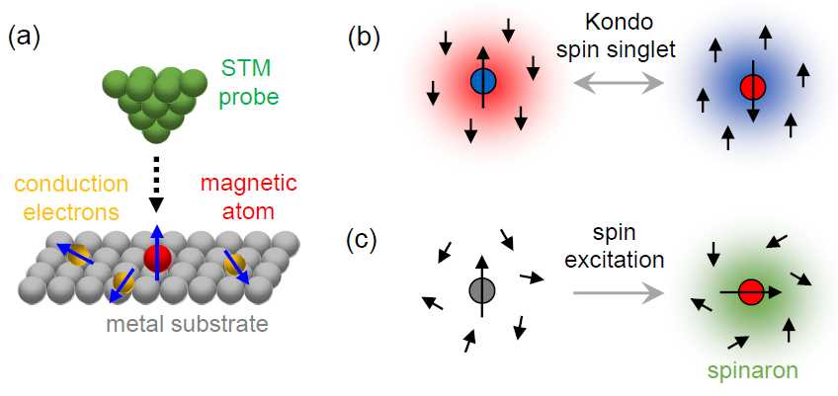

Fig. 1: Kondo versus spinaron picture in single-atom scanning tunnelling microscopy (STM) experiments. (a) An STM tip probes the conductance of the atomic junction close to zero bias voltage. Spins of the magnetic atom and electrons of the metal substrate are indicated as arrows. (b) In the Kondo picture, the spin of the magnetic atom is screened by the substrate conduction electrons giving rise to a spin singlet ground state. Spins are perpetually flipped without energy. (c) In the spinaron scenario, the spin of the magnetic atom is excited with finite energy provided by the tunnelling electron. The spin excitation couples to the conduction electrons and causes a many-electron state – the spinaron. The pale red, blue and green coloured areas surrounding the magnetic atom in (b) and (c) mark the electron and spin correlations.

