Electrically Confined Electroluminescence of Neutral Excitons in WSe₂ Light-emitting Transistors

June-Chul Shin, Jae Hwan Jeong, Junyoung Kwon, Yeon Ho Kim, Bumho Kim, Seung-Je Woo, Kie Young Woo, Minhyun Cho, Kenji Watanabe, Takashi Taniguchi, Young Duck Kim, Yong-Hoon Cho, Tae-Woo Lee, James Hone, Chul-Ho Lee, Gwan-Hyoung Lee*

Dr. J.-C. Shin, Dr. J.H. Jeong, Dr. S.-J. Woo, Prof. T.-W. Lee, Prof. G.H. Lee
Department of Materials Science and Engineering, Seoul National University, Seoul 08826, Republic of Korea
E-mail: (E
Dr. J. Kwon
Department of Material Science and Engineering, Yonsei University, Seoul 03722, Republic of Korea
Y.H. Kim
KU-KIST Graduate School of Converging Science and Technology, Korea University, Seoul 02841, Republic of Korea
Dr. B. Kim
Department of Physics and Astronomy, University of Pennsylvania, Philadelphia, Pennsylvania 19104, United States
Dr. K.Y. Woo, Prof. Y.-H. Cho
Department of Physics, Korea Advanced Institute of Science and Technology, Daejeon 34141, Republic of Korea
M. Cho, Prof. Y.D. Kim
Department of Physics and Department of Information Display, Kyung Hee University, Seoul 02447, Republic of Korea
Dr. K. Watanabe
Research Center for Electronic and Optical Materials, National Institute for Materials Science, 1-1 Namiki, Tsukuba 305-0044, Japan
Dr. T. Taniguchi
Research Center for Materials Nanoarchitectonics, National Institute for Materials Science, 1-1 Namiki, Tsukuba 305-0044, Japan
Prof. J. Hone
Department of Mechanical Engineering, Columbia University, New York, NY 10027, United States
Prof. C.-H. Lee
Department of Electrical and Computer Engineering, Seoul National University, Seoul 08826, Republic of Korea
Keywords: Electrical confinement, neutral exciton, electroluminescence, van der Waals heterostructure, light-emitting transistor

Abstract: Monolayer transition metal dichalcogenides (TMDs) have drawn significant attention for their potential in optoelectronic applications due to their direct band gap and exceptional quantum yield. However, TMD-based light-emitting devices have shown low external quantum efficiencies as imbalanced free carrier injection often leads to the formation of non-radiative charged excitons, limiting practical applications. Here, we demonstrate electrically confined electroluminescence (EL) of neutral excitons in WSe₂ light-emitting transistors (LETs) based on the van der Waals (vdW) heterostructure. The WSe₂ channel is locally doped to simultaneously inject electrons and holes to the one-dimensional (1D) region by a local graphene gate. At balanced concentrations of injected electrons and holes, the WSe₂ LETs exhibited strong EL with a high external quantum efficiency (EQE) of ~8.2% at room temperature. Our experimental and theoretical results consistently show that the enhanced EQE could be attributed to dominant exciton emission confined at the 1D region while expelling charged excitons from the active area by precise control of external electric fields. Our work shows a promising approach to enhancing the EQE of 2D light-emitting transistors and modulating the recombination of exciton complexes for excitonic devices.

1. Introduction
TMDs and their vdW heterostructures have been considered promising platforms for next-generation optoelectronics because the TMDs have shown large binding energies of excitons and strong light-matter interactions with near-unity photoluminescence (PL) quantum yield (QY) in a monolayer limit due to broken-inversion symmetry.^{[1-7]} The exceptional properties of the TMDs have facilitated the development of exotic optoelectronic quantum devices that exhibit unique capabilities, such as chiral light emission, excitonic complexes, and high-temperature exciton condensation, that have not been observed in conventional bulk materials.^{[8-12]} Despite the great potential of the monolayer TMDs, the low EQE of TMD-based light-emitting devices and control of exciton complexes are major challenges to be addressed for practical applications.^{[13-18]}
Enhancing the EQE of TMD-based light-emitting devices necessitates the fulfillment of two main prerequisites: First, it is essential to elevate the efficacy of radiative electron-hole (e-h) recombination within the TMDs. Second, achieving efficient and balanced injection of charge carriers into the TMDs is of paramount importance for facilitating effective light emission.^{[19]} However, it is challenging to achieve both conditions simultaneously. Facilitating effective carrier injection into the emission layer requires elevated doping concentrations using methods, such as electrostatic or chemical doping, aiming to decrease the Schottky barrier height.^{[20]} However, these increased doping levels in TMDs lead to the creation of exciton complexes, like charged excitons, predominantly contributing to non-radiative recombination.^{[6]} This compromise limits the feasible doping range as a viable approach for carrier injection, necessitating the exploration of alternative injection mechanisms that enable effective carrier injection without generating excessive charge populations.
Here, we demonstrate electrically confined electroluminescence of neutral excitons in WSe₂ LETs based on the vdW heterostructure consisting of tungsten diselenide (WSe₂, channel), graphene (electrodes and gate), and hexagonal boron nitride (hBN, dielectric). To achieve highly efficient light emission in the gate-tunable LETs, we used WSe₂ as an emitting layer due to its ambipolar transport properties, direct bandgap, and high QY at room temperature.^{[7,21-25]} Through the utilization of monolayer graphene as the gate-tunable source and drain electrodes with van der Waals contacts, we effectively mitigated Fermi level pinning and successfully attained appropriate band alignment for ambipolar transport within the WSe₂.^{[26-28]} By electrically modulating gate and drain bias, our WSe₂ LETs selectively injected charge carriers of electrons and holes into WSe₂ from the respective graphene electrodes and effectively regulated the movement of these injected charges by modulating the barrier height at the WSe₂ homojunction, resulting in reconfigurable electrical transport properties. By balancing the densities of injected electrons and holes, we achieved strong EL with a high EQE of ~8.2% at room temperature. The EL measurements revealed that neutral excitons dominantly contribute to the strong EL due to the confinement of neutral excitons within the 1D region facilitated by the in-plane electric field created by the local graphene gate and the expulsion of charged excitons from the 1D region by the charge interaction.

2. Results and Discussion
Figure 1a illustrates the WSe₂ LETs consisting entirely of 2D materials. We used double gates of graphene and Si to electrically confine the neutral excitons in the 1D region of WSe₂. To fabricate the devices, exfoliated flakes were stacked layer-by-layer using a dry pick-up transfer method.^{[29]} The hBN-encapsulated monolayer WSe₂ FETs with the graphene contacts showed ambipolar transport characteristics (Figure S1), which is in contrast to the monolayer WSe₂ FETs on a SiO₂/Si substrate with metal electrodes that exhibit only p-type conductance.^{[30,31]} For local gating, the graphene flake was aligned precisely to overlap half of monolayer WSe₂. After transferring two monolayer graphene flakes for source and drain electrodes, the whole stack was encapsulated with the hBN because the hBN encapsulation can neutralize the doping level of TMDs and improve their optical and electrical properties.^{[32-34]} Note that the WSe₂ used in this work was grown by the flux method, which is known as a method to synthesize high-quality 2D crystals with low defect density (Figure S2).^{[35]} After the transfer, the stack was annealed at 300$℃$ in a forming gas of hydrogen and argon for 3 h to enhance interfacial adhesion between the stacked layers.^{[36]} Raman and PL maps of the stacked sample show that the WSe₂ is in conformal contact with graphene electrodes (Figure S3). Since the stacked sample of WSe₂ and graphene are embedded in the hBN, we used the graphene etch stop technique to form the via contacts to the embedded graphene electrodes, as described in our previous report.^{[37,38]} The stacked sample was patterned by e-beam lithography and exposed to XeF₂ gas to etch the top hBN (hBN1), followed by metal deposition. There were no contamination and cracks in the devices, indicating the clean interfaces in the vdW heterostructure (see Figure S4 for the fabrication process). As shown in the energy band diagram of Figure 1c, the Fermi energy levels of two graphene electrodes and the band offset of WSe₂ can be separately modulated by double gates of graphene and Si. By controlling the contact barrier heights at graphene-WSe₂ interfaces, two graphene electrodes can selectively inject electrons and holes into the WSe₂, respectively. Then, injected electrons and holes emit light through e-h recombination in the 1D region of WSe₂.
The double gate structure in the WSe₂ LET is crucial for the simultaneous modulation of injection and transport of both electrons and holes, unlike conventional ambipolar FETs with a single gate configuration that can transport only one type of charged carrier at a specific gate voltage. To validate gate-tunable carrier injection and transport in the WSe₂ LETs, we manipulated gate voltages of graphene (V_{GG}) and Si (V_{BG}) gates, as shown in Figure 2. Depending on the applied gate voltages of V_{GG} and V_{BG}, the WSe₂ LET can reconfigure the polarity of transfer characteristics between n-type and p-type modes within a single WSe₂ channel, as shown in Figure 2a, b. When the Si back gate is biased at 60 V for n-type mode, the Fermi energy level of graphene source contact (Gr (S)) shifts close to the conduction band of WSe₂. Simultaneously, the conduction band of WSe₂ is bent down, resulting in efficient electron injection from Gr (S) to WSe₂, as illustrated in Figure 2c. At V_{DS} = 0.5 V, WSe₂ LET exhibits n-type switching behavior with no noticeable hysteresis, consistent with previous reports.^{[39]} This behavior can be attributed to the modulated transport of injected electrons by the energy barrier of WSe₂ homojunction through sweeping V_{GG} (see Figure 2c (i) – (ii)). Meanwhile, at a larger drain bias of V_{DS} = 2 V, the transfer curve exhibited ambipolar transport behavior with a higher on-current compared to V_{DS} = 0.5 V. Under positive voltage conditions of V_{GG,} injected electrons from Gr (S) transport across the energy barrier at the WSe₂ homojunction (Figure 2c (ii)). At V_{GG} = -6 V, the current increases owing to the recombination of electrons and holes that are simultaneously injected from corresponding graphene contacts (Figure 2c (iii)). Conversely, when a negative gate voltage of V_{GG} = -6 V is applied for p-type operation, holes can be injected from the Gr (D) into the WSe₂ layer, leading to p-type transport (Figure S5). These results indicate that our device can efficiently control both the selective injection of charge carriers and the transport of injected carriers through WSe₂.
Because of modulation of charge injection and local doping, the pn homojunction in the WSe₂ shows rectifying behaviors in the output curves of Figure 3a (green dots at V_{BG} = 60 V and V_{GG} = -6 V and blue dots at V_{BG} = -60 V and V_{GG} = 6 V). The increase in forward bias current is attributed to the elevated recombination probability of injected electrons and holes from corresponding graphene electrodes at the 1D region of WSe₂. Therefore, when V_{DS} was applied at 3 V at V_{BG} = 60 V and V_{GG} = -6 V, a strong EL peak was observed through the e-h recombination at the 1D region, which is similar to the PL spectrum of WSe_{2,} as shown in Figure 3b. This correspondence indicates that the EL at 1.65 eV originates from the e-h recombination across the direct bandgap of WSe₂. As estimated, the EL was clearly observed at the 1D region of WSe₂, as shown in the optical microscopic image of Figure 3c. Our photocurrent measurements also show that the photocurrent predominantly generates at the 1D region (Figure S6). This indicates that the excitons generated by a laser can be dissociated into free carriers at the pn junction owing to a built-in electric field.^{[20,40]} In addition, we observed long EL retention over ~10⁴ s, indicating high stability of the WSe₂ LETs (Figure S7).
To investigate the electrical tunability of the WSe₂ LETs, we measured the EL and EQE by varying drain bias and gate voltages in Figure 4. As the V_{DS} increased (current density increases in the output curve in Figure 3a) at fixed gate voltages of V_{BG} = 60 V and V_{GG} = -8 V, the EL intensity increased with no EL peak shift as shown in Figure 4a. The EL intensity monotonically increased with the V_{DS} owing to effective injection of electrons and holes over reduced contact barrier, reaching a high EQE of ~5.3% at V_{DS} = 2.5 V at room temperature (Figure 4b and S8). The EQEs of the WSe₂ LETs were extracted using the method described in other reports.^{[17,20]} (see Supplementary Note 1 and Figure S9). At V_{DS} > 2.5 V, the EQE decreased due to non-radiative recombination paths, such as exciton-exciton annihilation at high exciton concentration.^{[20]} To modulate the density of injected electrons, we measured the EL and EQE by varying the V_{BG} at fixed V_{GG} = -8 V and V_{DS} = 2.5 V (Figure 4c and d). In this condition, the density of injected holes is fixed and more electrons are injected into the WSe₂ owing to reduced contact barrier by increasing the V_{BG}. As a result, the EL increased with V_{BG}, maintaining the EL peak position at 1.65 eV, as shown in Figure 4c. Similarly, we also observed an increase in the EL by varying V_{GG} at fixed V_{BG} and V_{DS} due to the lowered contact barrier for hole injection (Figure S10). It is worth noting that the monochromic EL peaks in the contour plots of Figure 4a and c were consistently maintained at 1.65 eV, regardless of applied bias and gate voltages. It is because the EL of the WSe₂ LETs occurs by e-h recombination through the intrinsic direct bandgap of WSe₂. At fixed V_{GG} = -8 V which observed the highest EQE in Figure S10, the EQE of the WSe₂ LET extracted by varying the V_{BG} increased as a function of the V_{BG}, reaching a maximum EQE of ~8.2% at room temperature, as shown in Figure 4d. At the larger V_{BG}, the EQE slightly decreased along with the saturation of EL intensity, which indicates that balanced concentrations of electrons and holes are required for high light emission efficiency. We measured the EQEs of several WSe₂ LETs, where flux-grown and purchased samples of WSe₂ were used. The flux-grown WSe₂ showed higher EQEs than the purchased one, which is in agreement with the higher PL efficiency of the flux-grown samples (Figure S11).^{[35]}
Figure 5a and b show the PL and EL spectra of the WSe₂ LET. All spectra can be deconvoluted into two peaks of neutral exciton (X⁰) and charged exciton (X*). When the WSe₂ LET was partially p- and n-doped by applying V_{GG} = -6 V and V_{BG} = 60 V as shown in the inset of Figure 5a, the PL spectra of these regions exhibited two dominant PL peaks corresponding to X* and X⁰. Notably, the X* peak is stronger than the X⁰ peak for both p- and n-doped regions. In contrast, X⁰ is more dominant than X* in the EL spectrum of Figure 5b. As shown in Figure 5c, the EL intensity ratio of the neutral excitons to charged excitons (X⁰/X*) is fourteen times higher than PL intensity ratios of X⁰/X* in p- and n-doped regions. As shown in the schematic device geometry and energy band diagram of Figure 5d, the injected electrons and holes from n- and p-doped regions form exciton complexes at the 1D region. Notably, the in-plane electric field within the 1D region leads to the confinement of neutral excitons^{[41]}. To investigate the effect of in-plane field and doping on the exciton behaviors, we calculated charge densities of electrons and holes and potentials of neutral excitons and charged excitons (X⁺ and X⁻) using the electrostatic simulation of the device as shown in Figure 5e. (See Experimental Section/Methods and Supplementary Note 2). The local doping by graphene and Si gates dopes the WSe₂ separately into adjacent p- and n-doped regions with large charge densities and in-plane electric field along the edge of graphene gate.^{[40]} The in-plane electric field confines neutral excitons at the 1D nanoscale region of WSe₂ with minimum exciton potential. In addition, neutral excitons are pushed toward the 1D region by repulsive interaction that is caused by the charge density gradient.^{[41]} This unique phenomenon is mainly observed in the ultrathin TMDs with large exciton binding energies, enabling excitons to withstand the in-plane electric fields.^{[42]} Furthermore, the charged excitons drift away from the 1D region by potential gradients of charged excitons (bottom of Figure 5e).^{[43,44]} As a result, the EL from neutral excitons is predominant owing to their electrical confinement in the 1D region of WSe₂ LETs.

3. Conclusion
In conclusion, we demonstrate the efficient light-emitting devices based on monolayer WSe₂ that satisfy the prerequisites for high EQE: efficient injection of charge carriers and predominant emission of neutral excitons. Through precise band alignment of WSe₂ and graphene and double gate geometry, the WSe₂ LETs can achieve efficient charge injection and e-h recombination for strong EL with a high EQE of ~8.2%. Our results show that the strong EL peak of WSe₂ LET is attributed to the electrical confinement of neutral excitons due to the in-plane electric field and strong charge interactions. Our work not only highlights the potential of 2D light-emitting devices but also provides a new avenue for modulating the recombination of neutral and charged excitons for excitonic devices.

4. Experimental Section/Methods
Device fabrication: All the flakes were mechanically exfoliated from a bulk crystal onto a SiO₂/Si substrate with a thickness of 285 nm of SiO₂. We used two types of WSe₂ crystals, one grown by the self-flux method and the other purchased from SPI Supplies. A stack of flakes consisting of top hBN, graphene electrodes, WSe₂, and bottom hBN was fabricated using the pick-up transfer technique with a polydimethylsiloxane (PDMS) stamp coated with a polycarbonate (PC) film.^{[29]}.\ The stacked heterostructure was transferred onto graphene as a gate on a SiO₂ (285 nm)/Si substrate by releasing the PC film from the PDMS at 180 $℃$. The PC film was dissolved in chloroform overnight. The stacked heterostructure was annealed at 300$℃$ for 3 h in a 10⁻⁴ Torr vacuum to enhance adhesion between layers.^{[36]} To form connections between the metal and embedded graphene, we patterned the sample using e-beam lithography (Raith pioneer 2) and then exposed it to XeF₂ gas of 2 Torr for 200 s at room temperature using XeF₂ etcher (VPE-4F, SAMCO).^{[37]} The metals Cr (1 nm)/Pd (40 nm)/Au (50 nm) were deposited by an e-beam evaporator (Korea Vacuum Tech.) under ultrahigh vacuum conditions of ~10⁻⁷ Torr, followed by a lift-off process.
Raman and PL measurements: Raman and PL spectra were measured using Raman spectroscopy (LabRAM HR Evolution) with 532 nm laser excitation under ambient conditions. To obtain Raman and photoluminescence mapping images, samples were scanned on an x-y stage with laser illumination.
Electrical and optoelectrical measurements: For electrical measurement, a semiconductor parameter analyzer (Keithley 4200A-SCS) was used at room temperature under 10⁻³ Torr. EL spectra were measured using a customized optical measurement system with a photodetector (Si avalanche), and electrical bias and gate voltage were applied by source meters (Keithley 2400). All EL measurements were performed in a 10⁻² Torr vacuum chamber, with light signals collected through ×100 objective lens. The use of vacuums enabled stable measurement of the devices.
Electrostatic simulation for electrical confinement of exciton complexes: To obtain quantitative information on the in-plane electric field, charge density distributions, voltage, and excitonic confining potential of exciton and charged excitons in the device, we used commercial finite element analysis software (COMSOL Multiphysics). The simulated device geometry is depicted in Figure 5, including double gates of graphene gate and silicon back gate, 1L graphene electrodes, and hBN with 30nm thickness. The semiconductor behavior of WSe₂ was calculated using the drift-diffusion model with the density-gradient theory.^{[45]} The carrier density was determined based on the Fermi-Dirac distribution, considering the band structure, Fermi level, and density of states (DOS) of WSe₂. The following material parameters were used in the calculation: bandgap of WSe₂ = 1.65 eV, dielectric constant = 21, carrier mobility = 31 cm²/Vs, election affinity = 3.7 eV, effective density of states (DOS) = 6×10²⁴ m⁻³. The dielectric constants for hBN were 3.76 and 6.93 along the out-of-plane and in-plane directions, respectively.^{[45-51]} The excitonic confining potential was calculated using an equation derived from the previous studies, based on electric field and charge density obtained from calculation and measurement constants.^{[41]} The constants used in this calculation were exciton polarizability (10.027×10⁻⁵ meVcm²/kV²), trion polarizability (411.367×10⁻⁵ meVcm²/kV²), trion hyperpolarizability (8.48×10⁻⁷ meVcm⁴/kV⁴), effective exciton-electron coupling strength (~0.7 μeVμm²), and trion-electron coupling strength (1.32 μeVμm²).^{[52-54]}.

Supporting Information
Supporting Information is available from the Wiley Online Library or from the author.

Acknowledgments
J.-C.S. and J.H.J. contributed equally to this work. This work was supported by LG Display and the National Research Foundation (NRF) of Korea Grant funded by the Korean Government (2021R1A2C3014316, 2017R1A5A1014862 (SRC program: vdWMRC center). G.H.L. acknowledges the support from the Research Institute of Advanced Materials (RIAM), Institute of Engineering Research (IER), Institute of Applied Physics (IAP), and Inter-University Semiconductor Research Center (ISRC) at the Seoul National University. M.C and Y.D.K were supported by NRF of Korea, (2022R1A4A3030766, 2021R1A2C2093155, 2021R1A6C101A437). K.W. and T.T. acknowledge support from the JSPS KAKENHI (Grant Numbers 21H05233 and 23H02052) and World Premier International Research Center Initiative (WPI), MEXT, Japan.

Received: ((will be filled in by the editorial staff))
Revised: ((will be filled in by the editorial staff))
Published online: ((will be filled in by the editorial staff))

References
[1] K. F. Mak, J. Shan, Nat. Photon. 2016, 10, 216.
[2] T. Mueller, E. Malic, npj 2D Mater. Appl. 2018, 2, 29.
[3] Q. H. Wang, K. Kalantar-Zadeh, A. Kis, J. N. Coleman, M. S. Strano, Nat. Nanotechnol. 2012, 7, 699.
[4] A. Chernikov, T. C. Berkelbach, H. M. Hill, A. Rigosi, Y. Li, B. Aslan, D. R. Reichman, M. S. Hybertsen, T. F. Heinz, Phys. Rev. Lett. 2014, 113, 076802.
[5] L. Britnell, R. M. Ribeiro, A. Eckmann, R. Jalil, B. D. Belle, A. Mishchenko, Y. J. Kim, R. V. Gorbachev, T. Georgiou, S. V. Morozov, A. N. Grigorenko, A. K. Geim, C. Casiraghi, A. H. C. Neto, K. S. Novoselov, Science 2013, 340, 1311.
[6] D.-H. Lien, S. Z. Uddin, M. Yeh, M. Amani, H. Kim, J. W. Ager, E. Yablonovitch, A. Javey, Science 2019, 364, 468.
[7] H. Kim, S. Z. Uddin, N. Higashitarumizu, E. Rabani, A. Javey, Science 2021, 373, 448.
[8] Y. J. Zhang, T. Oka, R. Suzuki, J. T. Ye, Y. Iwasa, Science 2014, 344, 725.
[9] K. F. Mak, K. He, C. Lee, G. H. Lee, J. Hone, T. F. Heinz, J. Shan, Nat. Mater. 2013, 12, 207.
[10] H. Ryu, J. Kwon, S. Yang, K. Watanabe, T. Taniguchi, Y. D. Kim, J. Hone, C.-H. Lee, G.-H. Lee, ACS Photonics 2021, 8, 3455.
[11] Z. Wang, D. A. Rhodes, K. Watanabe, T. Taniguchi, J. C. Hone, J. Shan, K. F. Mak, Nature 2019, 574, 76.
[12] X.-X. Zhang, Y. You, S. Y. F. Zhao, T. F. Heinz, Phys. Rev. Lett. 2015, 115, 257403.
[13] J. Wang, I. Verzhbitskiy, G. Eda, Adv. Mater. 2018, 30, 1802687.
[14] A. Pospischil, M. M. Furchi, T. Mueller, Nat. Nanotechnol. 2014, 9, 257.
[15] J. S. Ross, P. Klement, A. M. Jones, N. J. Ghimire, J. Yan, D. G. Mandrus, T. Taniguchi, K. Watanabe, K. Kitamura, W. Yao, D. H. Cobden, X. Xu, Nat. Nanotechnol. 2014, 9, 268.
[16] B. W. H. Baugher, H. O. H. Churchill, Y. Yang, P. Jarillo-Herrero, Nat. Nanotechnol. 2014, 9, 262.
[17] F. Withers, O. Del Pozo-Zamudio, A. Mishchenko, A. P. Rooney, A. Gholinia, K. Watanabe, T. Taniguchi, S. J. Haigh, A. K. Geim, A. I. Tartakovskii, K. S. Novoselov, Nat. Mater. 2015, 14, 301.
[18] D.-H. Lien, M. Amani, S. B. Desai, G. H. Ahn, K. Han, J.-H. He, J. W. Ager, M. C. Wu, A. Javey, Nat. Commun. 2018, 9, 1229.
[19] T. Ahmed, J. Zha, K. K. H. Lin, H.-C. Kuo, C. Tan, D.-H. Lien, Adv. Mater. 2023, n/a, 2208054.
[20] J. Kwon, J.-C. Shin, H. Ryu, J. Y. Lee, D. Seo, K. Watanabe, T. Taniguchi, Y. D. Kim, J. Hone, C.-H. Lee, G.-H. Lee, Adv. Mater. 2020, 32, 2003567.
[21] J. Zaumseil, R. H. Friend, H. Sirringhaus, Nat. Mater. 2006, 5, 69.
[22] S. Z. Bisri, T. Takenobu, K. Sawabe, S. Tsuda, Y. Yomogida, T. Yamao, S. Hotta, C. Adachi, Y. Iwasa, Adv. Mater. 2011, 23, 2753.
[23] J. S. Ross, S. Wu, H. Yu, N. J. Ghimire, A. M. Jones, G. Aivazian, J. Yan, D. G. Mandrus, D. Xiao, W. Yao, X. Xu, Nat. Commun. 2013, 4, 1474.
[24] A. Allain, A. Kis, ACS Nano 2014, 8, 7180.
[25] F. Withers, O. Del Pozo-Zamudio, S. Schwarz, S. Dufferwiel, P. M. Walker, T. Godde, A. P. Rooney, A. Gholinia, C. R. Woods, P. Blake, S. J. Haigh, K. Watanabe, T. Taniguchi, I. L. Aleiner, A. K. Geim, V. I. Fal’ko, A. I. Tartakovskii, K. S. Novoselov, Nano Lett. 2015, 15, 8223.
[26] K. Wu, H. Ma, Y. Gao, W. Hu, J. Yang, J. Mater. Chem. A 2019, 7, 7430.
[27] G.-H. Lee, X. Cui, Y. D. Kim, G. Arefe, X. Zhang, C.-H. Lee, F. Ye, K. Watanabe, T. Taniguchi, P. Kim, J. Hone, ACS Nano 2015, 9, 7019.
[28] Y.-J. Yu, Y. Zhao, S. Ryu, L. E. Brus, K. S. Kim, P. Kim, Nano Lett. 2009, 9, 3430.
[29] P. J. Zomer, M. H. D. Guimarães, J. C. Brant, N. Tombros, B. J. van Wees, Appl. Phys. Lett. 2014, 105, 013101.
[30] J.-C. Shin, Y. H. Kim, K. Watanabe, T. Taniguchi, C.-H. Lee, G.-H. Lee, Adv. Mater. Interfaces 2022, 9, 2101763.
[31] H. Fang, S. Chuang, T. C. Chang, K. Takei, T. Takahashi, A. Javey, Nano Lett. 2012, 12, 3788.
[32] R. Decker, Y. Wang, V. W. Brar, W. Regan, H.-Z. Tsai, Q. Wu, W. Gannett, A. Zettl, M. F. Crommie, Nano Lett. 2011, 11, 2291.
[33] C. R. Dean, A. F. Young, I. Meric, C. Lee, L. Wang, S. Sorgenfrei, K. Watanabe, T. Taniguchi, P. Kim, K. L. Shepard, J. Hone, Nat. Nanotechnol. 2010, 5, 722.
[34] J. Wierzbowski, J. Klein, F. Sigger, C. Straubinger, M. Kremser, T. Taniguchi, K. Watanabe, U. Wurstbauer, A. W. Holleitner, M. Kaniber, K. Müller, J. J. Finley, Sci. Rep. 2017, 7, 12383.
[35] D. Edelberg, D. Rhodes, A. Kerelsky, B. Kim, J. Wang, A. Zangiabadi, C. Kim, A. Abhinandan, J. Ardelean, M. Scully, D. Scullion, L. Embon, R. Zu, E. J. G. Santos, L. Balicas, C. Marianetti, K. Barmak, X. Zhu, J. Hone, A. N. Pasupathy, Nano Lett. 2019, 19, 4371.
[36] H. Rokni, W. Lu, Nat. Commun. 2020, 11, 5607.
[37] J. Son, J. Kwon, S. Kim, Y. Lv, J. Yu, J.-Y. Lee, H. Ryu, K. Watanabe, T. Taniguchi, R. Garrido-Menacho, N. Mason, E. Ertekin, P. Y. Huang, G.-H. Lee, A. M. van der Zande, Nat. Commun. 2018, 9, 3988.
[38] Y. Shin, J. Kwon, Y. Jeong, K. Watanabe, T. Taniguchi, S. Im, G.-H. Lee, Small 2022, 18, 2200882.
[39] X. Cui, G.-H. Lee, Y. D. Kim, G. Arefe, P. Y. Huang, C.-H. Lee, D. A. Chenet, X. Zhang, L. Wang, F. Ye, F. Pizzocchero, B. S. Jessen, K. Watanabe, T. Taniguchi, D. A. Muller, T. Low, P. Kim, J. Hone, Nat. Nanotechnol. 2015, 10, 534.
[40] M. Massicotte, F. Vialla, P. Schmidt, M. B. Lundeberg, S. Latini, S. Haastrup, M. Danovich, D. Davydovskaya, K. Watanabe, T. Taniguchi, V. I. Fal’ko, K. S. Thygesen, T. G. Pedersen, F. H. L. Koppens, Nat. Commun. 2018, 9, 1633.
[41] D. Thureja, A. Imamoglu, T. Smoleński, I. Amelio, A. Popert, T. Chervy, X. Lu, S. Liu, K. Barmak, K. Watanabe, T. Taniguchi, D. J. Norris, M. Kroner, P. A. Murthy, Nature 2022, 606, 298.
[42] M. Goryca, J. Li, A. V. Stier, T. Taniguchi, K. Watanabe, E. Courtade, S. Shree, C. Robert, B. Urbaszek, X. Marie, S. A. Crooker, Nat. Commun. 2019, 10, 4172.
[43] L. A. Jauregui, A. Y. Joe, K. Pistunova, D. S. Wild, A. A. High, Y. Zhou, G. Scuri, K. De Greve, A. Sushko, C.-H. Yu, T. Taniguchi, K. Watanabe, D. J. Needleman, M. D. Lukin, H. Park, P. Kim, Science 2019, 366, 870.
[44] D. Sanvitto, F. Pulizzi, A. J. Shields, P. C. M. Christianen, S. N. Holmes, M. Y. Simmons, D. A. Ritchie, J. C. Maan, M. Pepper, Science 2001, 294, 837.
[45] M. G. Ancona, J. Comput. Electron. 2011, 10, 65.
[46] S.-Y. Lee, T.-Y. Jeong, J.-H. Kim, S. Yun, K.-J. Yee, Opt. Express 2018, 26, 23061.
[47] W. Zhao, Z. Ghorannevis, L. Chu, M. Toh, C. Kloc, P.-H. Tan, G. Eda, ACS Nano 2013, 7, 791.
[48] B. Liu, Y. Ma, A. Zhang, L. Chen, A. N. Abbas, Y. Liu, C. Shen, H. Wan, C. Zhou, ACS Nano 2016, 10, 5153.
[49] Y. Liang, S. Huang, R. Soklaski, L. Yang, Appl. Phys. Lett. 2013, 103, 042106.
[50] P. R. Patel, J. R. Rathod, H. S. Patel, K. D. Patel, V. M. Pathak, Adv Mat Res 2013, 665, 53.
[51] A. Laturia, M. L. Van de Put, W. G. Vandenberghe, npj 2D Mater. Appl. 2018, 2, 6.
[52] L. S. R. Cavalcante, D. R. da Costa, G. A. Farias, D. R. Reichman, A. Chaves, Phys. Rev. B. 2018, 98, 245309.
[53] Y. Xu, C. Horn, J. Zhu, Y. Tang, L. Ma, L. Li, S. Liu, K. Watanabe, T. Taniguchi, J. C. Hone, J. Shan, K. F. Mak, Nat. Mater. 2021, 20, 645.
[54] E. Liu, J. van Baren, Z. Lu, M. M. Altaiary, T. Taniguchi, K. Watanabe, D. Smirnov, C. H. Lui, Phys. Rev. Lett. 2019, 123, 027401.

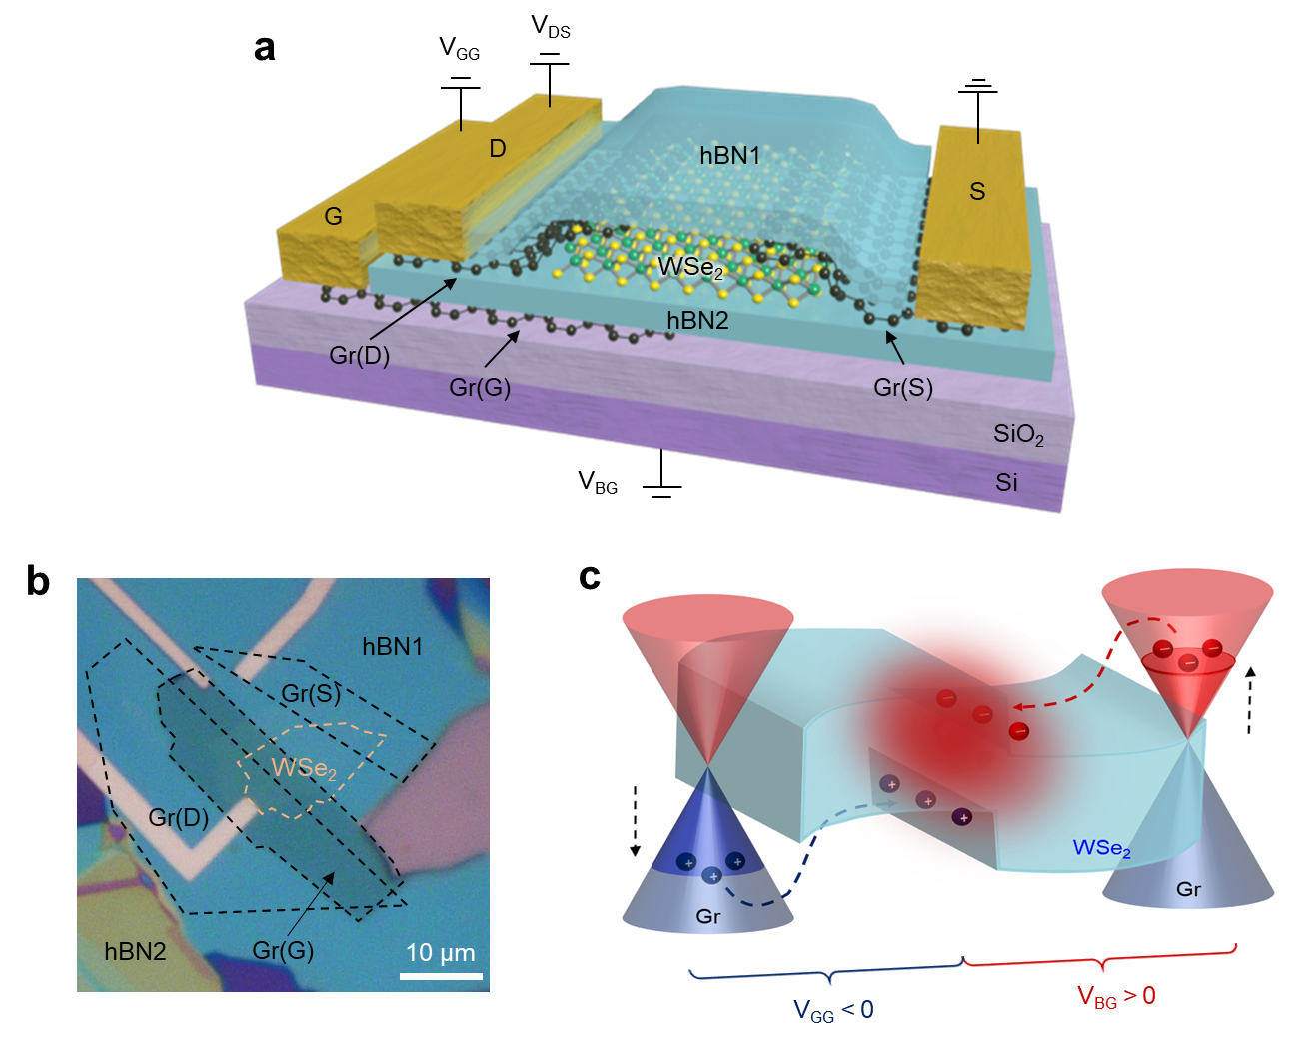
Figure 1. Device geometry and working principle of WSe₂ LET. (a) Schematic illustration of 1L WSe₂ LET with 1L graphene contact encapsulated by hBN. WSe₂ LET has double gates of graphene and silicon gates. (b) Optical image of the fabricated device. A portion of 1L WSe₂ is overlapped by the graphene gate. (c) Band diagrams of the device at electroluminescence operation. The double gates can modulate individual regions of the divided WSe₂ layer, leading to injecting electrons or holes from graphene into the WSe₂ layer and transporting charge carriers in the WSe₂ layer. Light emission occurs in the 1D region between the p-n junction in a WSe₂ layer due to the e-h recombination of transported carriers.

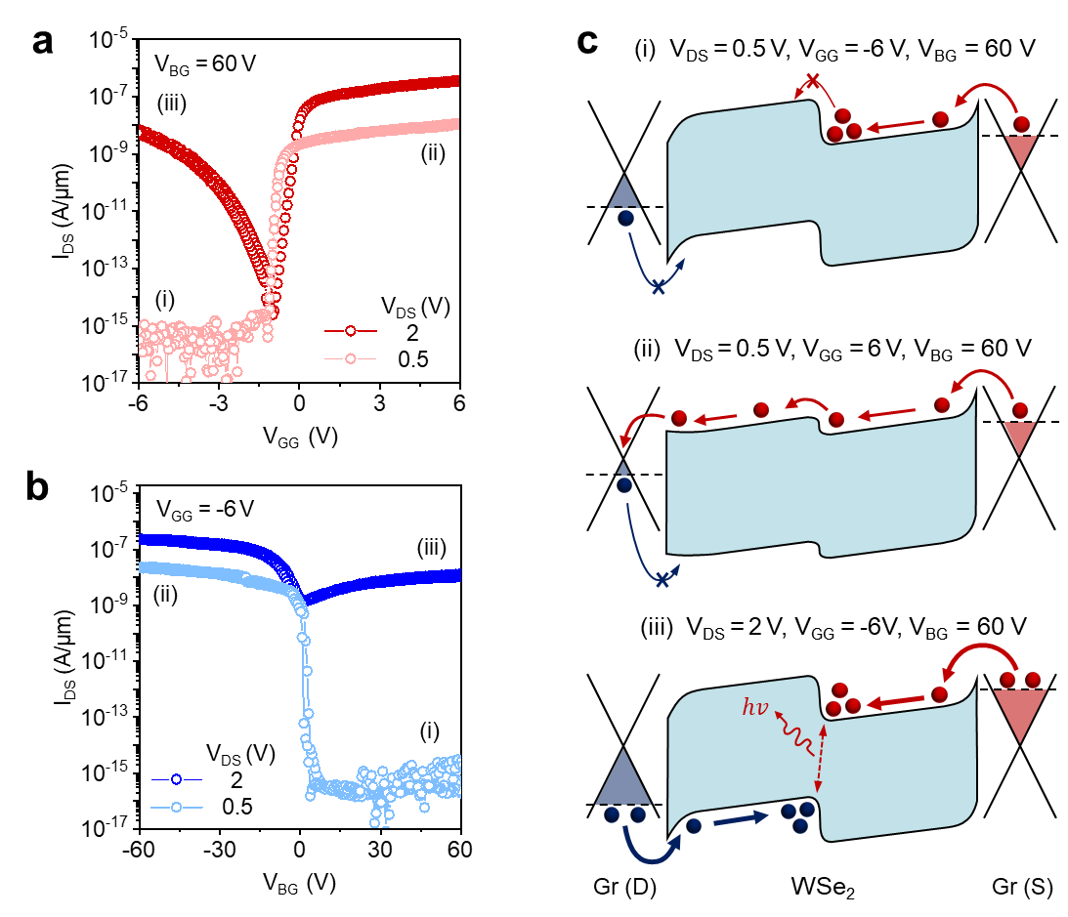
Figure 2. Reconfigurable transport properties using electrical modulation of WSe₂ LET. (a) Transfer curve (I_{DS}-V_{GG}) of the device at a fixed voltage of V_{BG} = 60 V for n-type transport operation. (b) Transfer curve (I_{DS}-V_{BG}) of the device at a fixed voltage of V_{GG} = -6 V for p-type transport operation. (c) Schematics of band diagrams of three conditions at the n-type operation of the device using electrical modulation. By adjusting the double gate and drain voltages, the carrier type injected into WSe₂ can be selected, and the carrier transport can be switched by modulating the potential barrier at the WSe₂ homojunction.

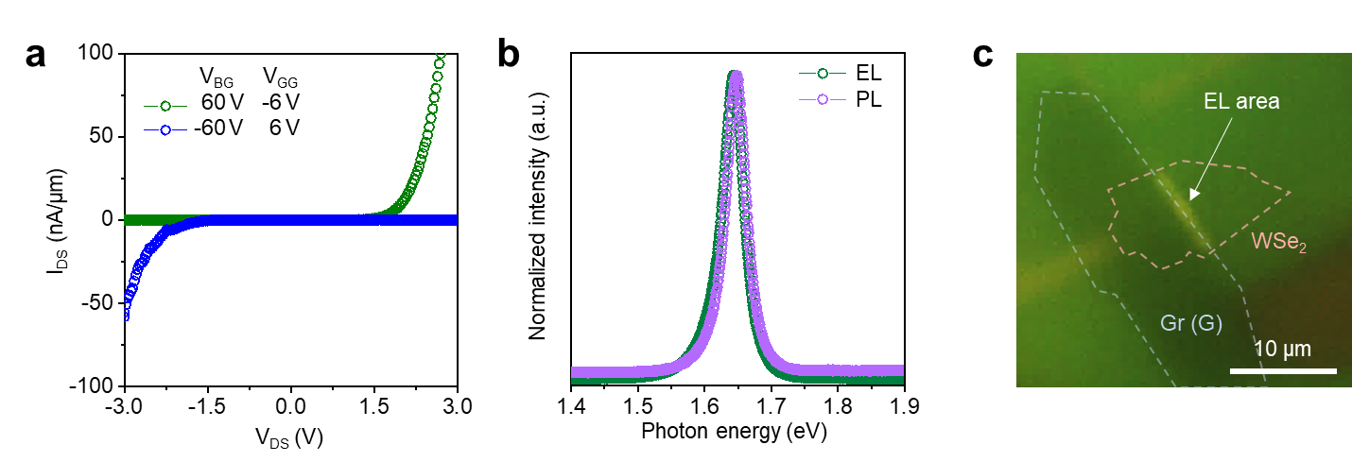
Figure 3. Light emission of WSe₂ LET. (a) Output curves (I_{DS}-V_{DS}) at opposite voltage using double gates. The output curves show a rectifying behavior due to the p-n junction formation at WSe₂. (b) Normalized PL and EL spectra of the device. The EL spectrum is consistent with the PL spectrum, which indicates that EL originated from e-h recombination across the direct bandgap of WSe₂. (c) Optical image of light emission of the device. Strong EL is observed at the p-n junction of WSe_{2.}

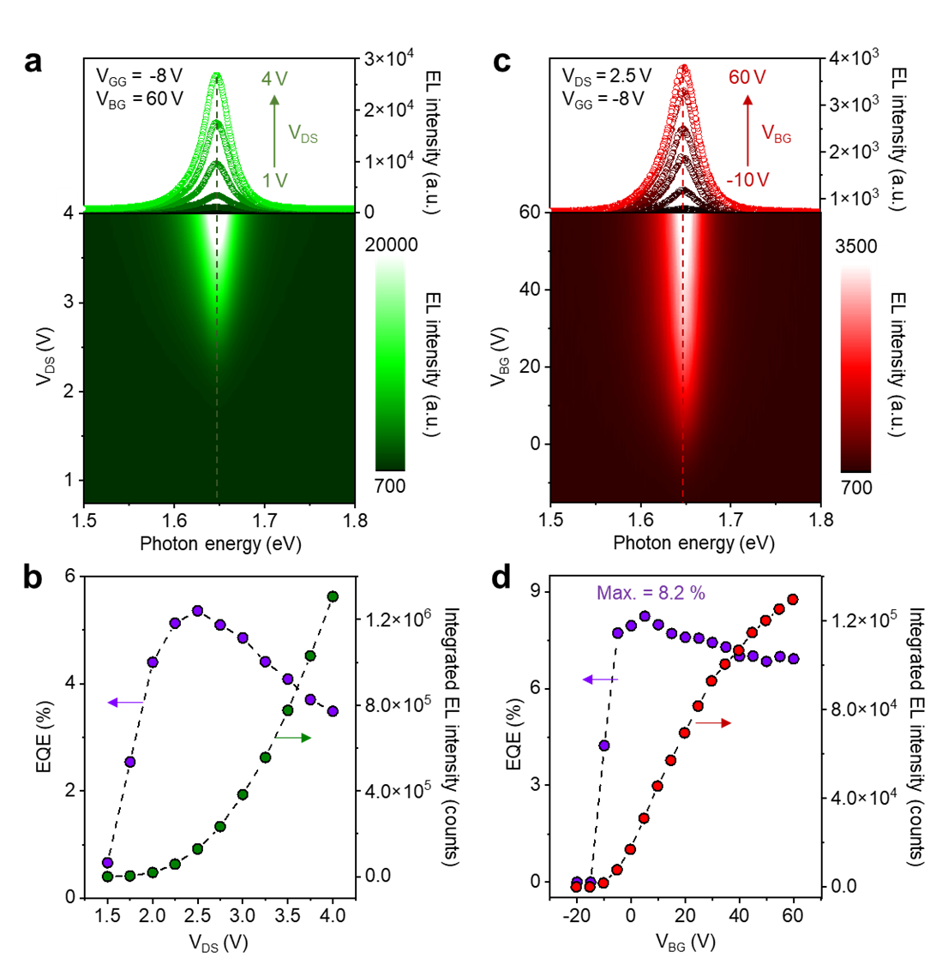
Figure 4. Electrical tunability of electroluminescence of WSe₂ LET. (a) EL spectrum and contour plot of the device at varying V_{DS} and fixed V_{GG} = -8 V and V_{BG} = 60 V. (b) EQE (purple) and integrated EL intensity (green) as a function of V_{DS}. V_{GG} and V_{BG} were fixed at -8 V, and 60 V, respectively. (c) EL spectrum and contour plot of the device at varying V_{BG} and fixed V_{DS} = 2.5 V and V_{GG} = -8 V. (d) EQE (purple) and integrated EL intensity (red) as a function of V_{BG}. V_{DS} and V_{GG} were fixed at 2.5 V, and -8 V, respectively. By optimizing with V_{DS}, V_{BG}, and V_{GG}, a maximum EQE of 8.2% was obtained with WSe₂ LET and EL intensity exhibits no peak shift.
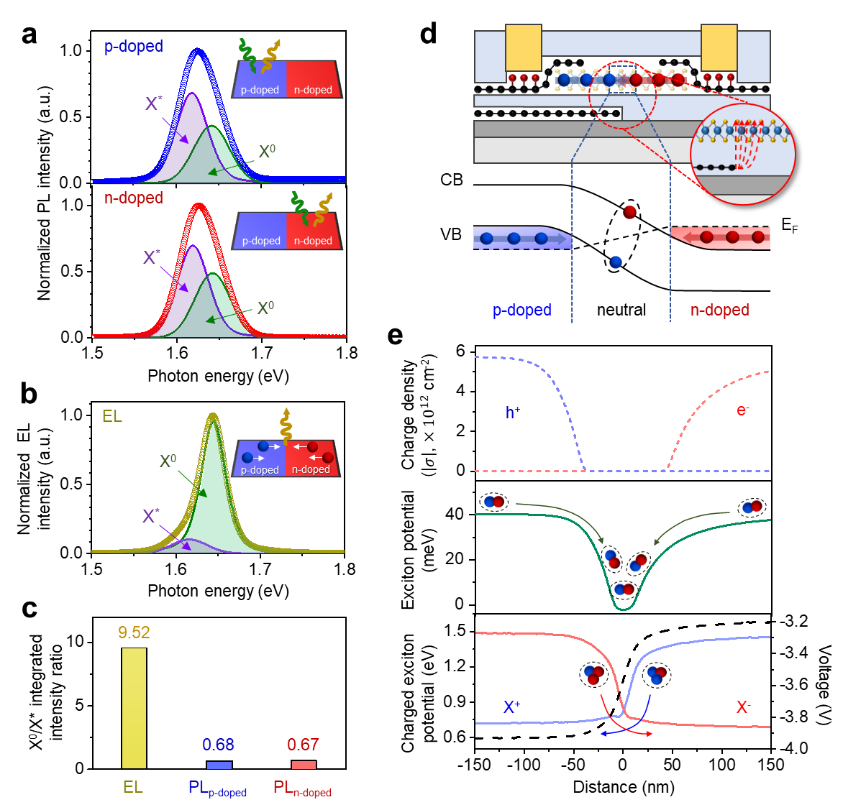
Figure 5. Electroluminescence of electrically confined neutral exciton at the 1D region in the p-n junction of WSe₂. (a) Normalized PL spectrum of hole-doped (blue) and electron-doped (red) WSe₂ in the WSe₂ LET measured at V_{GG} = -6 V and V_{BG} = 60 V, respectively. (b) Normalized EL spectrum of the device. All spectrums were deconvoluted into the two distinct peaks of the neutral exciton (X⁰, green) and charged exciton (X*, purple). (c) Comparison of X⁰/X* intensity ratio in PL and EL. Compared to PL, the EL intensity of the device primarily arises from the neutral exciton. (d) Schematic of the device structure and energy band diagram in WSe₂ LET. (e) Electrostatic simulation of the spatial dependence of charge density of holes (blue dashed line) and electrons (red dashed line), exciton potential (green line), and potential of the positively charged exciton (blue line) and negatively charged exciton (red line), and voltage (black dashed line) in WSe₂. Since neutral excitons are electrically confined to the 1D region in WSe₂ and charged excitons are pushed away from the 1D region by the potential difference, WSe₂ LET can emit predominantly neutral excitons.

