Supporting Information
Dual-atom Co/Ni Electrocatalyst Anchored at the Surface-Modified Ti₃C₂T_{x} MXene Enables Efficient Hydrogen and Oxygen Evolution Reactions
Xin Zhao,ª Wanpeng Li, ª Yanhui Cao, ^{b} Arsenii S Portniagin, ª Bing Tang, ª Shixun Wang, ª Qi Liu, ª Denis Y. W. Yu,^{c} Xiaoyan Zhong, ª Xuerong Zheng, ^{a,b,d *} Andrey L. Rogach^{a *}

Xin Zhao,ª Wanpeng Li, ª Yanhui Cao, ^{b} Arsenii S Portniagin, ª Bing Tang, ª Shixun Wang, ª Qi Liu, ª Denis Y. W. Yu,^{c} Xiaoyan Zhong, ª Xuerong Zheng, ^{a,b,d *} Andrey L. Rogach^{a *}

ª Department of Materials Science and Engineering, City University of Hong Kong, 83 Tat Chee Avenue, Kowloon, Hong Kong S.A.R. 999077, P.R. China
^{b} School of Materials Science and Engineering, Tianjin University, Tianjin, 300072 P. R. China
^{c} Research Center for Energy and Environmental Materials (GREEN), National Institute for Materials Science, Namiki 1-1, Tsukuba, Ibaraki, Japan 305-0044
^{d} Key Laboratory of Pico Electron Microscopy of Hainan Province, School of Materials Science and Engineering, Hainan University, Haikou 570228, P.R. China

*E-mail: andrey.rogach@cityu.edu.hk; E-mail: xrzh@tju.edu.cn

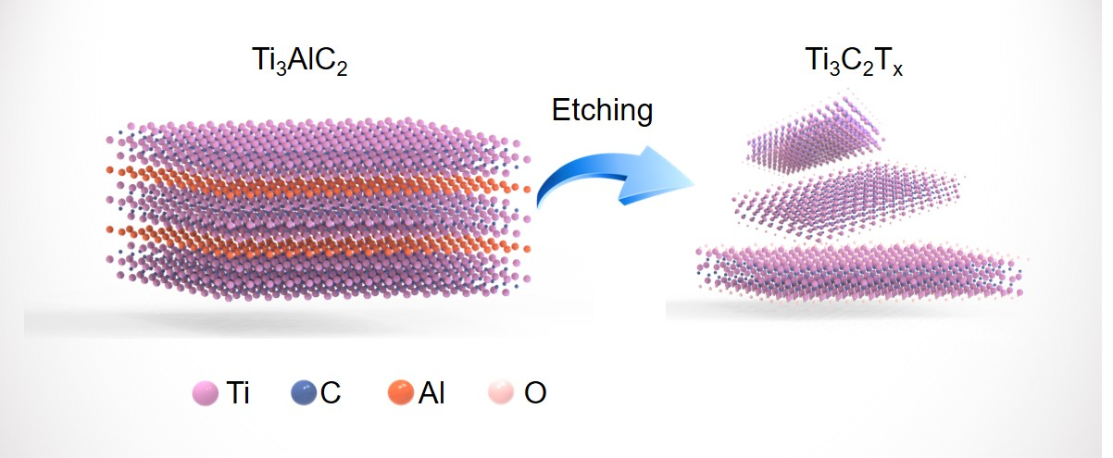
Figure S1. Schematic illustration of the synthesis procedure of Ti₃C₂T_{x} MXene.

Figure S2. SEM image of Ti₃C₂T_{x} MXene.
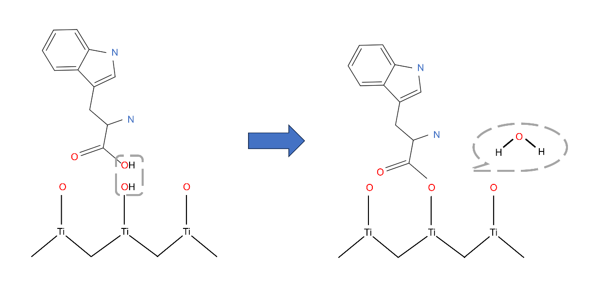
Figure S3. Illustration of the covalent bonding of L-tryptophan at the surface of Try-Ti₃C₂T_{x} MXene.
Figure S4. FTIR spectrum of tryptophan.
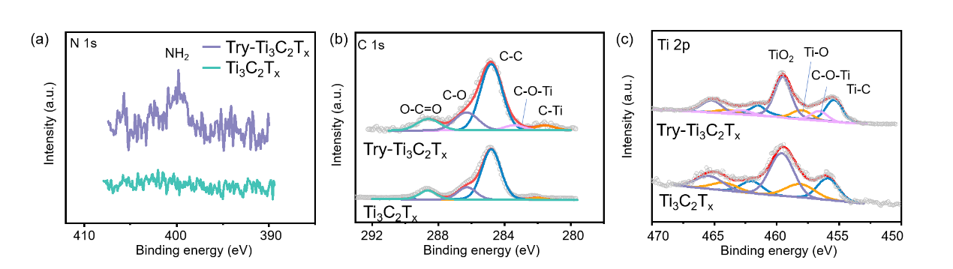
Figure S5. High-resolution XPS spectra of a) N 1s, b) C 1s and c) Ti 2p in Try-Ti₃C₂T_{x} and Ti₃C₂T_{x}.

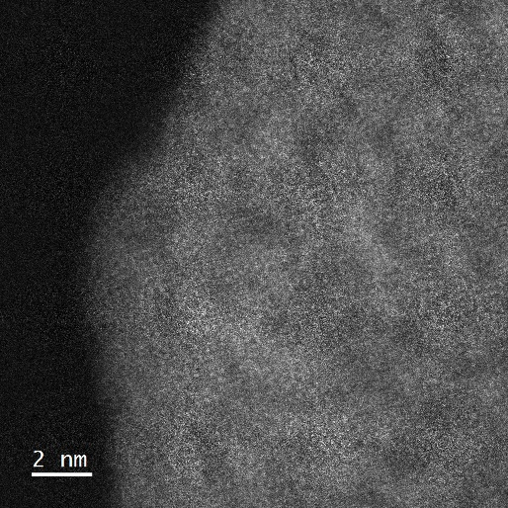

Figure S6. HAADF-STEM image of Try-Ti₃C₂T_{x}.
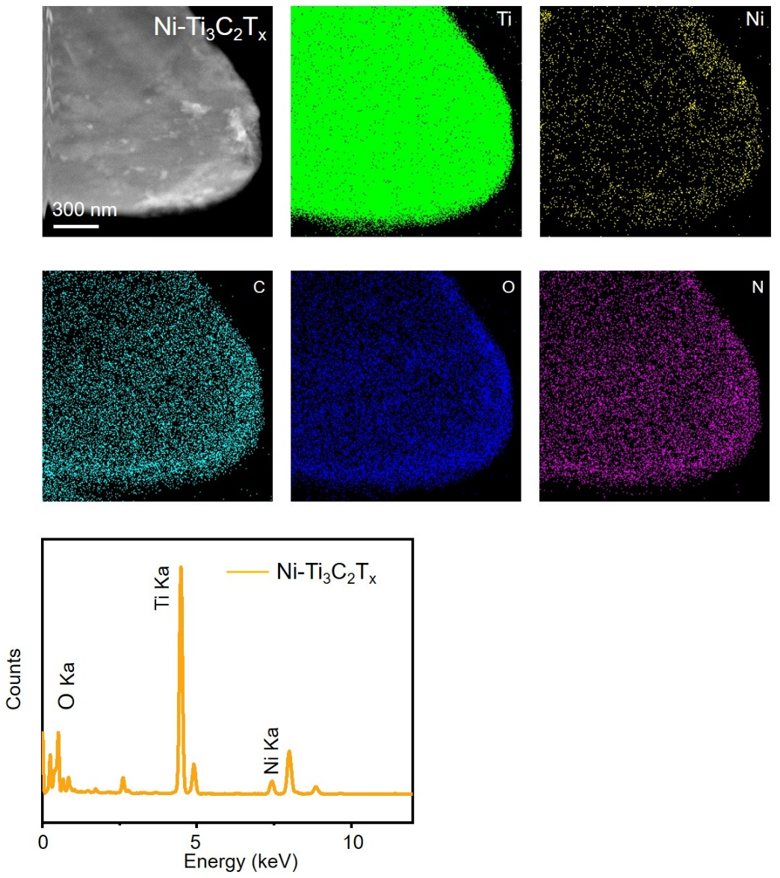
Figure S7. Elemental mapping of Ti, Ni, C, O and N in a piece of Ni-Ti₃C₂T_{x} composite (TEM image provided at the top left), and its EDS spectrum.

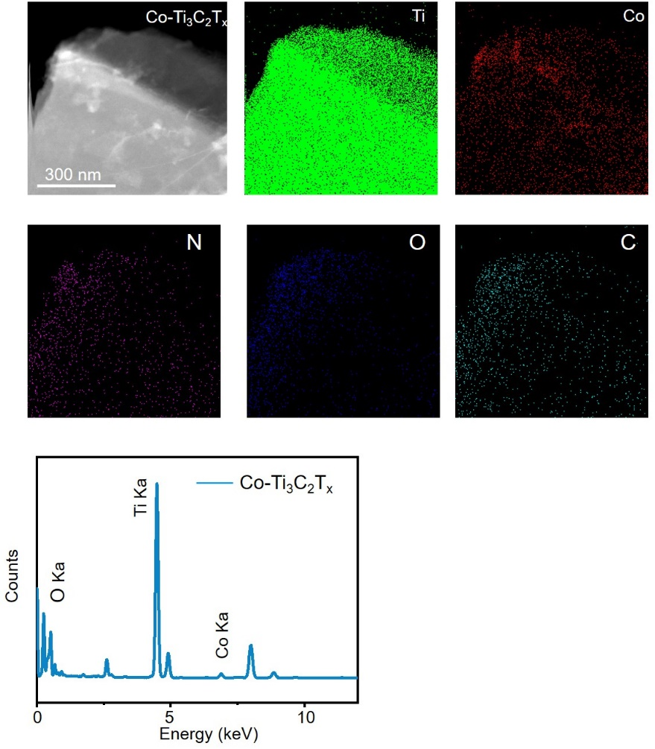
Figure S8. Elemental mapping of Ti, Co, N, O and C in a piece of Co-Ti₃C₂T_{x} composite (TEM image provided at the top left), and its EDS spectrum.
Figure S9. Intensity profiles obtained on adjacent metal atomic pairs, taken from three different sites marked by red rectangles in Figure 2a.

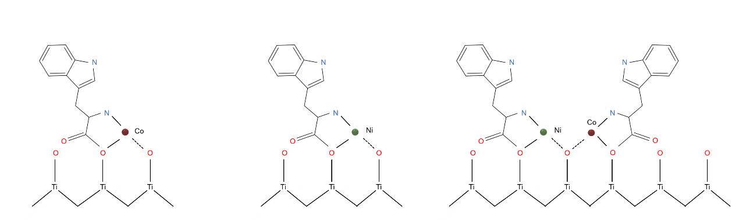

Figure S10. Schematics of chelating Co and Ni single atoms through N-bonds at the Try-Ti₃C₂T_{x} surface.

Figure S11. Schematics of bonding of Co and Ni single atoms to oxygen terminating atoms at the Ti₃C₂T_{x} surface.

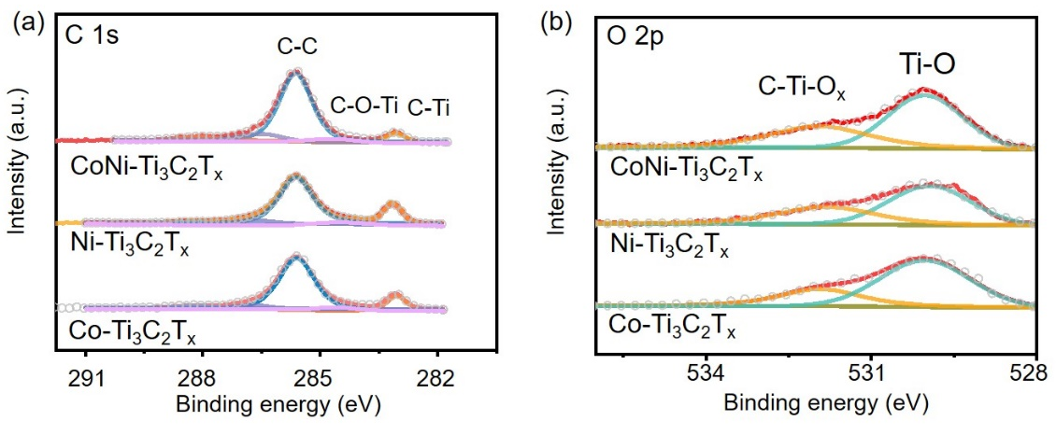
Figure S12. High-resolution XPS spectra of a) C 1s and b) O 2p in CoNi-Ti₃C₂T_{x}, Ni-Ti₃C₂T_{x} and Co-Ti₃C₂T_{x} composites.

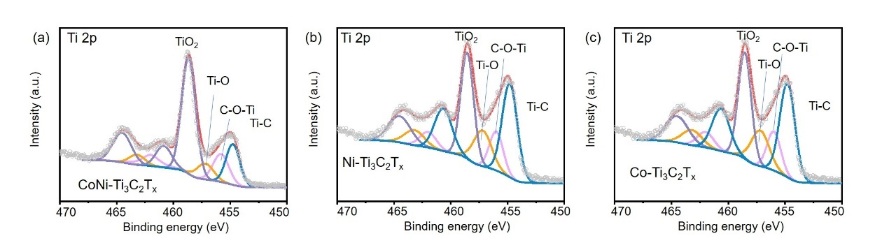
Figure S13. High-resolution XPS spectra of Ti 2p in a) CoNi-Ti₃C₂T_{x}, b) Ni-Ti₃C₂T_{x} and c) Co-Ti₃C₂T_{x} composites.

Figure S14. FTIR spectra of CoNi-Ti₃C₂T_{x}, Ni-Ti₃C₂T_{x} and Co-Ti₃C₂T_{x} composites.

Figure S15. Raman spectra of CoNi-Ti₃C₂T_{x}, Ni-Ti₃C₂T_{x} and Co-Ti₃C₂T_{x} composites, all excited at 532 nm.

Figure S16. a) k³-weighted Fourier transform (FT) of the Co K-edge EXAFS of CoNi-Ti₃C₂T_{x}, Co₃O₄ and Co foil. b) k³-weighted Fourier transform (FT) of the Ni K-edge EXAFS of CoNi-Ti₃C₂T_{x}, NiO and Ni foil.

Figure S17. MWT images of Co K-edge EXAFS for Co foil, CoO and Co₃O₄.

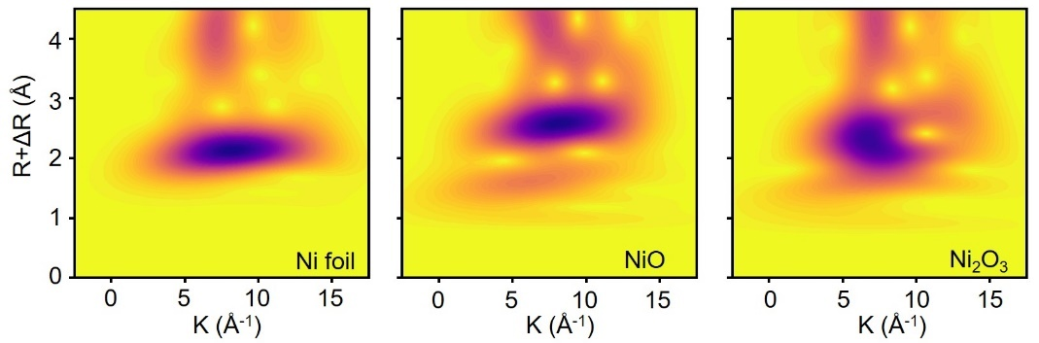
Figure S18. MWT images of Ni K-edge EXAFS for Ni foil, NiO and Ni₂O₃.

Figure S19. OER LSV curves of CoNi-Ti₃C₂T_{x} electrodes with the Co/Ni ratio of 1:1, 2:1 and 1:2, at 5 mV s⁻¹.

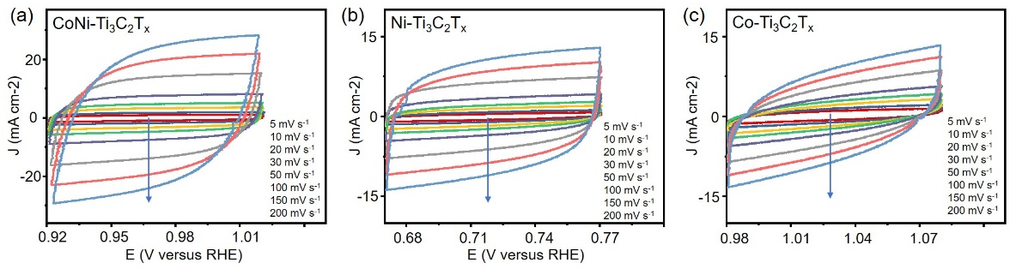
Figure S20. CVs of a) CoNi-Ti₃C₂T_{x}, b) Ni-Ti₃C₂T_{x}, and c) Co-Ti₃C₂T_{x} electrodes, recorded in 1.0 M KOH at different scan rates.

Figure S21. a) OER and b) HER chronopotentiometry response of Ni-Ti₃C₂T_{x} and Co-Ti₃C₂T_{x} electrodes at a current density of 10 mA cm⁻².

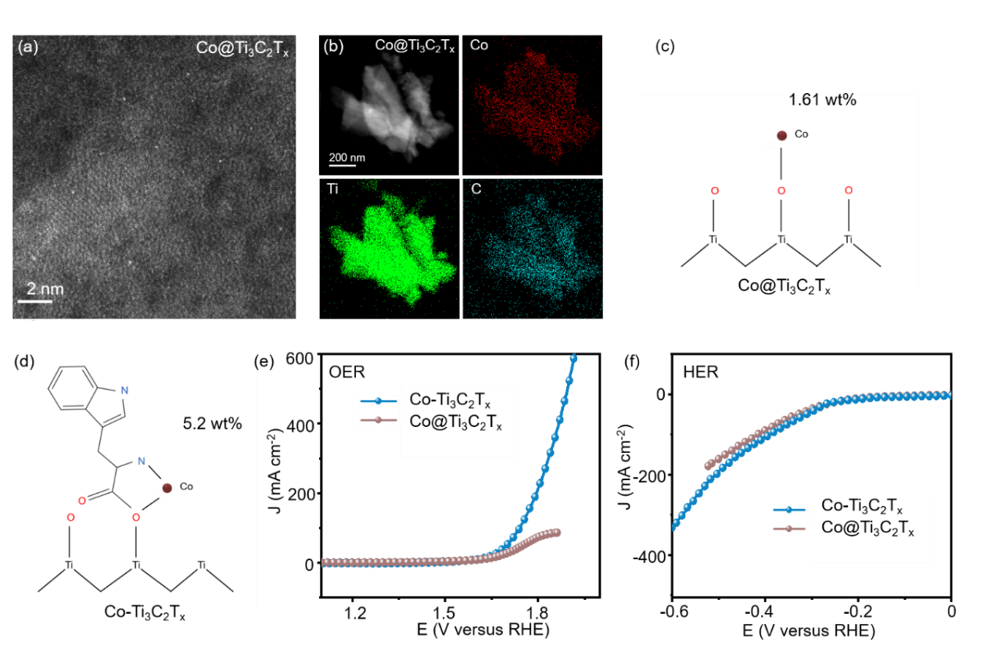
Figure S22. a) HAADF-STEM image of Co@Ti₃C₂T_{x} composite where single Co atoms were anchored directly on the MXene substrate. b) Elemental mapping images of Co, Ti, and C in this Co@Ti₃C₂T_{x} composite. Schematics of bonding of Co single atoms to oxygen terminating atoms at c) Ti₃C₂T_{x} and d) Try-Ti₃C₂T_{x} surface and corresponding mass loading (wt%) determined by ICP-OES analyses. e) OER and f) HER LSV curves of Co@Ti₃C₂T_{x} and Co-Ti₃C₂T_{x} electrodes at 5 mV s⁻¹.

Figure S23. The optimized configurations of CoNi-Ti₃C₂T_{x}(Ni), CoNi-Ti₃C₂T_{x}(Co), Ni-Ti₃C₂T_{x,} Co-Ti₃C₂T_{x} showing chemisorption of three intermediates in the OER process in an alkaline solution.
Table S1. Metal loading in the studied electrocatalysts (wt%) determined by ICP-OES analysis.
 | Ni loading | Co loading | Total metal loading
CoNi-Ti₃C₂T_{x} | 2.5 | 3.1 | 5.6
Ni-Ti₃C₂T_{x} | 5.4 | 0 | 5.4
Co-Ti₃C₂T_{x} | 0 | 5.2 | 5.2

Table S2. Comparison of metal loading achieved in this work with other reported MXene-based electrocatalysts.
Metal | Substrate | Metal loading (wt%) | Reference
CoNi | Ti₃C₂T_{x} | 5.6 | This work
Ni | Ti₃C₂T_{x} | 5.4 | This work
Co | Ti₃C₂T_{x} | 5.2 | This work
Pt | Ti₃C₂T_{x} | 0.2 | ¹
Pt | Mo₂TiC₂T_{x} | 1.2 | ²
Ru | Ti₃C₂T_{x} | 1.2 | ³
Pt | N, P co-doped Ti₃C₂T_{X} | 2.32 | ⁴
Ni | Ti₃C₂T_{x} | 2.9 | ⁵
Ir | NS-Ti₃C₂T_{x} | 2.5 | ⁶
Fe | Mo₂TiC₂T_{x} | 1.8 | ⁷
Cu | Ti₃C₂T_{x} | 1.19 | ⁸
Ru | N- Ti₃C₂T_{x} | 1.1 | ⁹
Co | Ti₃C₂T_{x} | 1.61 | ¹⁰
Co | Ni₂CT_{x} | 1.63 | ¹⁰
Co | V₂CT_{x} | 1.58 | ¹⁰

Table S3. Co K-edge EXAFS analysis for CoNi-Ti₃C₂T_{x} and Co-Ti₃C₂T_{x} composites
 | Path | CN | R (Å) | σ² (Å²) | ∆E₀ (eV) | R-factor
CoNi-Ti₃C₂T_{x} | Co-O | 2.8 | 1.91 | 0.0092 | 8.902 | 0.0038
CoNi-Ti₃C₂T_{x} | Co-O-Co | 11.4 | 3.38 | 0.0022 | 8.902 | 0.0038
Co-Ti₃C₂T_{x}  . | Co-O | 2.9 | 1.91 | 0.0089 | 6.410 | 0.0090
Co-Ti₃C₂T_{x}  . | Co-O-Co | 11.2 | 3.50 | 0.0054 | 6.410 | 0.0090
N, coordination number; R, distance between absorber and backscatter atoms; σ², Debye–Waller factor to account for both thermal and structural disorders; ΔE₀(eV), inner potential correction to account for the difference in the inner potential between the sample and the reference compound; R-factor (%) indicates the goodness of the fit.

Table S4. Ni K-edge EXAFS analysis results of the CoNi-Ti₃C₂T_{x} and Ni-Ti₃C₂T_{x}.
Sample | Path | CN | R (Å) | σ² (Å²) | ∆E₀ (eV) | R-factor
CoNi-Ti₃C₂T_{x} | Ni-O | 2.7 | 2.06 | 0.0000 | 0.5 | 0.0074
CoNi-Ti₃C₂T_{x} | Ni-O-Ni | 11.5 | 3.07 | 0.0091 | 0.5 | 0.0074
Ni-Ti₃C₂T_{x}  . | Co-O | 3.0 | 2.06 | 0.0049 | 0.005 | 0.0016
Ni-Ti₃C₂T_{x}  . | Ni-O-Ni | 11.8 | 3.38 | 0.0042 | 0.005 | 0.0016
N, coordination number; R, distance between absorber and backscatter atoms; σ², Debye–Waller factor to account for both thermal and structural disorders; ΔE₀(eV), inner potential correction to account for the difference in the inner potential between the sample and the reference compound; R-factor (%) indicates the goodness of the fit.

Table S5. Z-fit equivalent circuit data of CoNi-Ti₃C₂T_{x}, Ni-Ti₃C₂T_{x}, and Co-Ti₃C₂T_{x} composites.
 | R_{s} | CPE | R_{ct}
CoNi-Ti₃C₂T_{x} | 3.12 | 0.81 | 14.61
Ni-Ti₃C₂T_{x} | 3.23 | 0.92 | 40.54
Co-Ti₃C₂T_{x} | 3.86 | 0.87 | 49.66

Table S6. Comparison of overpotentials (at 10 mA cm⁻²) of the CoNi-Ti₃C₂T_{x} electrocatalyst introduced in this work with other reported MXene-based electrocatalysts for OER.

Electrocatalyst | Electrolyte | Overpotential  (mV) | Ref.
Ru-SA/Ti₃C₂T_{x} | 0.1M HClO₄ | 290 | ¹¹
LDH/MQD/NG | 0.1 M KOH | 270 | ¹²
Ti₃C₂T_{x}-N₆ | 1.0 M KOH | 360 | ¹³
Ti₃C_{1.6}N_{0.4} | 1.0 M KOH | 450 | ¹⁴
Co-CoO/Ti₃C₂-MXene/NF | 1.0 M KOH | 271 | ¹⁵
NiFeCoP/MXene | 1.0 M KOH | 240 | ¹⁶
FeS₂@MXene | 1.0 M KOH | 240 | ¹⁷
CoNi-ZIF-67@Ti₃C₂T_{x} | 1.0 M KOH | 275 | ¹⁸
FeNi-LDH/Ti₃C₂T_{x} | 1.0 M KOH | 298 | ¹⁹
MWCNT@V₂CT_{x} | 1.0 M KOH | 560 | ²⁰
Co@V₂CT_{x} | 1.0 M KOH | 242 | ¹⁰
10-Ag/M | 0.5 M H₂SO₄ | 250 | ²¹
MXene/ZIF-67 | 1.0 M KOH | 366 | ²²
MXene@RuCo NPs | 1.0 M KOH | 253 | ²³
ZnCoCH@Ti₃C₂T_{x} | 1.0 M KOH | 280 | ²⁴
NiSe–NiO/Ta₄C₃T_{x} | 1.0 M KOH | 255 | ²⁵
MXene@Ce-MOF | 1.0 M KOH | 270 | ²⁶
CoNi-Ti₃C₂T_{x} | 1.0 M KOH | 241 | This work

Table S7. Comparison of overpotentials (at 10 mA cm⁻²) of the CoNi-Ti₃C₂T_{x} electrocatalyst introduced in this work with other reported MXene-based electrocatalysts for HER.
Electrocatalyst | Electrolyte | Overpotential  (mV) | Ref.
Co-CoO/Ti₃C₂-MXene/NF | 1.0 M KOH | 45 |  | ¹⁵
Ru-SA/Ti₃C₂T_{x} | 0.1 M HClO₄ | 70 |  | ¹¹
Mo₂CT_{x}-Co | 1.0 M H₂SO₄ | 180 |  | ²⁷
Mo₂TiC₂T_{x}−Pt_{SA} | 0.5 M H₂SO₄ | 30 |  | ²
Ru_{SA}−N−Ti₃C₂T_{x} | 0.5 M H₂SO₄ | 23 |  | ⁹
Ru_{SA}−N−Ti₃C₂T_{x} | 1.0 M KOH | 27 |  | ⁹
Ru_{SA}−N−S−Ti₃C₂T_{x} | 0.5 M H₂SO₄ | 76 |  | ²⁸
Co³⁺@3D-Nb₂CT_{x} NW | 1.0 M KOH | 236 |  | ²⁹
Fe³⁺@3D-Nb₂CT_{x} NW | 1.0 M KOH | 302 |  | ²⁹
V-Ti₄N₃T_{x} | 0.5 M H₂SO₄ | 330 |  | ³⁰
P3-V₂CT_{x} | 0.5 M H₂SO₄ | 74 |  | ³¹
P-Mo₂CT_{x} | 0.5 M H₂SO₄ | 114 |  | ³²
Mo₂CT_{x}/2H-MoS₂ | 0.5 M H₂SO₄ | 119 |  | ³³
MXene@Pt/SWCNTs | 0.5 M H₂SO₄ | 78 |  | ³⁴
Pt SA-PNPM | 1.0 M KOH | 33 |  | ⁴
Co@V₂CT_{x} | 1.0 M KOH | 35 |  | ¹⁰
MX@RG | 1.0 M KOH | 121 |  | ³⁵
Ru/Mo₂CT_{x} | 1.0 M phosphate | 73 |  | ³⁶
Nb₂CT_{x}@Pt3.8 | 0.5 M HClO₄ | 141 |  | ³⁷
Re@Ti₃C₂T_{x} | 0.5 M H₂SO₄ | 298 |  | ³⁸
10-Ag/M | 0.5 M H₂SO₄ | 117 |  | ²¹
LDH(60%)/H-Ti₃C₂T_{x} | 1.0 M KOH | 187 |  | ³⁹
CoNi-Ti₃C₂T_{x} | 1.0 M KOH | 31 |  | This work

Table S8. Comparison of the two-electrode CoNi-Ti₃C₂T_{x} (+,−) electrolyzer with previous reports.

Electrocatalyst | Electrolyte | Cell voltage at  10 mA cm⁻²(V) | Ref.
Ni_{0.7}Fe_{0.3}PS₃/Ti₃C₂T_{x} | 1.0 M KOH | 1.65 | ⁴⁰
BP QDs/Ti₃C₂T_{x} | 1.0 M KOH | 1.78 | ⁴¹
Ti₃C₂@mNiCoP | 1.0 M KOH | 1.61 | ⁴²
Co-NC@Mo₂C | 1.0 M KOH | 1.68 | ⁴³
1T/2H MoSe₂/ Ti₃C₂T_{x} | 1.0 M KOH | 1.64 | ⁴⁴
Ti₃C₂T_{x}-N₆ | 1.0 M KOH | 1.72 | ¹³
CoS₂@Ti₃C₂T_{x} | 1.0 M KOH | 1.63 | ⁴⁵
Fe_{MC}-MXene/GrH | 1.0 M KOH | 1.60 | ⁴⁶
Co@V₂CT_{x} | 1.0 M KOH | 1.60 | ¹⁰
Co@Nb₂CT_{x} | 1.0 M KOH | 1.73 | ¹⁰
Co@Ti₃C₂T_{x} | 1.0 M KOH | 1.80 | ¹⁰
CoNi-Ti₃C₂T_{x} | 1.0 M KOH | 1.58 | This work

References
- Zhao, D.; Chen, Z.; Yang, W.; Liu, S.; Zhang, X.; Yu, Y.; Cheong, W.-C.; Zheng, L.; Ren, F.; Ying, G.; Cao, X.; Wang, D.; Peng, Q.; Wang, G.; Chen, C. MXene (Ti₃C₂) Vacancy-Confined Single-Atom Catalyst for Efficient Functionalization of CO₂. J. Am. Chem. Soc. 2019, 141 (9), 4086-4093.
2. Zhang, J.; Zhao, Y.; Guo, X.; Chen, C.; Dong, C.-L.; Liu, R.-S.; Han, C.-P.; Li, Y.; Gogotsi, Y.; Wang, G. Single platinum atoms immobilized on an MXene as an efficient catalyst for the hydrogen evolution reaction. Nat. Catal. 2018, 1 (12), 985-992.
3. Ramalingam, V.; Varadhan, P.; Fu, H.-C.; Kim, H.; Zhang, D.; Chen, S.; Song, L.; Ma, D.; Wang, Y.; Alshareef, H. N.; He, J.-H. Heteroatom-Mediated Interactions between Ruthenium Single Atoms and an MXene Support for Efficient Hydrogen Evolution. Adv. Mater. 2019, 31 (48), 1903841.
4. Peng, W.; Han, J.; Lu, Y.-R.; Luo, M.; Chan, T.-S.; Peng, M.; Tan, Y. A General Strategy for Engineering Single-Metal Sites on 3D Porous N, P Co-Doped Ti₃C₂T_{x} MXene. ACS Nano. 2022, 16 (3), 4116-4125.
5. Zhou, S.; Zhao, Y.; Shi, R.; Wang, Y.; Ashok, A.; Héraly, F.; Zhang, T.; Yuan, J. Vacancy-Rich MXene-Immobilized Ni Single Atoms as a High-Performance Electrocatalyst for the Hydrazine Oxidation Reaction. Adv. Mater. 2022, 34 (36), 2204388.
6. Lin, W.; Lu, Y.-R.; Peng, W.; Luo, M.; Chan, T.-S.; Tan, Y. Atomic bridging modulation of Ir–N, S co-doped MXene for accelerating hydrogen evolution. J. Mater. Chem.A. 2022, 10 (18), 9878-9885.
7. Jin, L.; You, S.; Ren, N.; Ding, B.; Liu, Y. Mo Vacancy-Mediated Activation of Peroxymonosulfate for Ultrafast Micropollutant Removal Using an Electrified MXene Filter Functionalized with Fe Single Atoms. Environ sci & tech. 2022, 56 (16), 11750-11759.
8. Yang, P.; Long, Y.; Huang, W.; Liu, D. Single-atom copper embedded in two-dimensional MXene toward peroxymonosulfate activation to generate singlet oxygen with nearly 100% selectivity for enhanced Fenton-like reactions. Appl. Catal. B. Environ. 2023, 324, 122245.
9. Liu, H.; Hu, Z.; Liu, Q.; Sun, P.; Wang, Y.; Chou, S.; Hu, Z.; Zhang, Z. Single-atom Ru anchored in nitrogen-doped MXene (Ti₃C₂T_{x}) as an efficient catalyst for the hydrogen evolution reaction at all pH values. J. Mater. Chem.A. 2020, 8 (46), 24710-24717.
10. Zhao, X.; Zheng, X.; Lu, Q.; Li, Y.; Xiao, F.; Tang, B.; Wang, S.; Yu, D. Y. W.; Rogach, A. L. Electrocatalytic enhancement mechanism of cobalt single atoms anchored on different MXene substrates in oxygen and hydrogen evolution reactions. EcoMat. 2023, 5 (2), e12293.
11. Peng, X.; Zhao, S.; Mi, Y.; Han, L.; Liu, X.; Qi, D.; Sun, J.; Liu, Y.; Bao, H.; Zhuo, L. Trifunctional single‐atomic Ru sites enable efficient overall water splitting and oxygen reduction in acidic media. Small. 2020, 16 (33), 2002888.
12. Han, X.; Li, N.; Xiong, P.; Jung, M. G.; Kang, Y.; Dou, Q.; Liu, Q.; Lee, J. Y.; Park, H. S. Electronically coupled layered double hydroxide/MXene quantum dot metallic hybrids for high-performance flexible zinc–air batteries. InfoMat. 2021, 3 (10), 1134-1144.
13. Chen, X.; Zhai, X.; Hou, J.; Cao, H.; Yue, X.; Li, M.; Chen, L.; Liu, Z.; Ge, G.; Guo, X. Tunable nitrogen-doped delaminated 2D MXene obtained by NH₃/Ar plasma treatment as highly efficient hydrogen and oxygen evolution reaction electrocatalyst. Chem. Eng. J. 2021, 420, 129832.
14 Tang, Y.; Yang, C.; Tian, Y.; Luo, Y.; Yin, X.; Que, W. The effect of in situ nitrogen doping on the oxygen evolution reaction of MXenes. Nanoscale. Adv. 2020, 2 (3), 1187-1194.
15. Guo, D.; Li, X.; Jiao, Y.; Yan, H.; Wu, A.; Yang, G.; Wang, Y.; Tian, C.; Fu, H. A dual-active Co-CoO heterojunction coupled with Ti₃C₂-MXene for highly-performance overall water splitting. Nano. Res. 2022, 15 (1), 238-247.
16. Li, N.; Han, J.; Yao, K.; Han, M.; Wang, Z.; Liu, Y.; Liu, L.; Liang, H. Synergistic phosphorized NiFeCo and MXene interaction inspired the formation of high-valence metal sites for efficient oxygen evolution. J. Mater. Sci. Technol. 2022, 106, 90-97.
17. Xie, Y.; Yu, H.; Deng, L.; Amin, R. S.; Yu, D.; Fetohi, A. E.; Maximov, M. Y.; Li, L.; El-Khatib, K. M.; Peng, S. Anchoring stable FeS₂ nanoparticles on MXene nanosheets via interface engineering for efficient water splitting. lnorg. Chem. Front. 2022, 9 (4), 662-669.
18. Wen, Y.; Wei, Z.; Ma, C.; Xing, X.; Li, Z.; Luo, D. MXene Boosted CoNi-ZIF-67 as Highly Efficient Electrocatalysts for Oxygen Evolution. Nanomaterials. 2019, 9 (5), 775.
19. Yu, M.; Zhou, S.; Wang, Z.; Zhao, J.; Qiu, J. Boosting electrocatalytic oxygen evolution by synergistically coupling layered double hydroxide with MXene. Nano Energy. 2018, 44, 181-190.
20. Zahra, S. A.; Rizwan, S. MWCNT-modified MXene as cost-effective efficient bifunctional catalyst for overall water splitting. RSC. Adv. 2022, 12 (14), 8405-8413.
21. Sharma, V.; Dhiman, R.; Mahajan, A. Ti²⁺ and Ti⁴⁺ species enriched MXene electrocatalyst for highly efficient hydrogen evolution and oxygen evolution reaction kinetics. Appl. Surf. Sci. 2023, 612, 155883.
22. Środa, B.; Dymerska, A. G.; Zielińska, B.; Mijowska, E. Promotion of MXene (Ti₃C₂T_{x}) as a robust electrocatalyst for oxygen evolution reaction via active sites of ZIF-67 - In situ mechanism investigations. Int. J. Hydrogen Energy. 2023, 48 (49), 18696-18707.
23. Li, J.; Hou, C.; Chen, C.; Ma, W.; Li, Q.; Hu, L.; Lv, X.; Dang, J. Collaborative Interface Optimization Strategy Guided Ultrafine RuCo and MXene Heterostructure Electrocatalysts for Efficient Overall Water Splitting. ACS Nano. 2023, 17 (11), 10947-10957.
24. Li, M.; Zeng, Z.; Liu, W.; Zong, H.; Li, B.; Gong, S.; Yu, K.; Zhu, Z. Dual enhancement of water oxidation catalysis by MXene in the grass-like ZnCoCH@Ti₃C₂T_{x} heterostructure. Chem. Eng. J. 2023, 456, 141041.
25. Yan, L.; Liang, J.; Li, H. In situ construction of heterostructure NiSe–NiO nanoarrays with rich oxygen vacancy on MXene for efficient oxygen evolution. Int. J. Hydrogen Energy. 2023, 48 (35), 13159-13169.
26. Li, S.; Chai, H.; Zhang, L.; Xu, Y.; Jiao, Y.; Chen, J. Constructing oxygen vacancy-rich MXene @Ce-MOF composites for enhanced energy storage and conversion. J. Colloid Interface Sci. 2023, 642, 235-245.
27. Kuznetsov, D. A.; Chen, Z.; Kumar, P. V.; Tsoukalou, A.; Kierzkowska, A.; Abdala, P. M.; Safonova, O. V.; Fedorov, A.; Müller, C. R. Single Site Cobalt Substitution in 2D Molybdenum Carbide (MXene) Enhances Catalytic Activity in the Hydrogen Evolution Reaction. J. Am. Chem. Soc. 2019, 141 (44), 17809-17816.
28. Ramalingam, V.; Varadhan, P.; Fu, H. C.; Kim, H.; Zhang, D.; Chen, S.; Song, L.; Ma, D.; Wang, Y.; Alshareef, H. N.; He, J. H. Heteroatom-Mediated Interactions between Ruthenium Single Atoms and an MXene Support for Efficient Hydrogen Evolution. Adv. Mater. 2019, 31 (48), 1903841.
29. Pang, S. Y.; Io, W. F.; Wong, L. W.; Zhao, J.; Hao, J. Efficient Energy Conversion and Storage Based on Robust Fluoride-Free Self-Assembled 1D Niobium Carbide in 3D Nanowire Network. Adv.Sci. 2020, 7 (10), 1903680.
30. Djire, A.; Wang, X.; Xiao, C.; Nwamba, O. C.; Mirkin, M. V.; Neale, N. R. Basal Plane Hydrogen Evolution Activity from Mixed Metal Nitride MXenes Measured by Scanning Electrochemical Microscopy. Adv. Funct. Mater. 2020, 30 (47), 2001136.
31. Yoon, Y.; Tiwari, A. P.; Choi, M.; Novak, T. G.; Song, W.; Chang, H.; Zyung, T.; Lee, S. S.; Jeon, S.; An, K.-S. Precious-Metal-Free Electrocatalysts for Activation of Hydrogen Evolution with Nonmetallic Electron Donor: Chemical Composition Controllable Phosphorous Doped Vanadium Carbide MXene. Adv. Funct. Mater. 2019, 29 (30), 1903443.
32. Qu, G.; Zhou, Y.; Wu, T.; Zhao, G.; Li, F.; Kang, Y.; Xu, C. Phosphorized MXene-phase molybdenum carbide as an earth-abundant hydrogen evolution electrocatalyst. ACS Appl. Energy. Mater. 2018, 1 (12), 7206-7212.
33. Lim, K. R. G.; Handoko, A. D.; Johnson, L. R.; Meng, X.; Lin, M.; Subramanian, G. S.; Anasori, B.; Gogotsi, Y.; Vojvodic, A.; Seh, Z. W. 2H-MoS₂ on Mo₂CT_{x} MXene Nanohybrid for Efficient and Durable Electrocatalytic Hydrogen Evolution. ACS nano. 2020, 14 (11), 16140-16155.
34. Cui, C.; Cheng, R.; Zhang, H.; Zhang, C.; Ma, Y.; Shi, C.; Fan, B.; Wang, H.; Wang, X. Ultrastable MXene@Pt/SWCNTs' Nanocatalysts for Hydrogen Evolution Reaction. Adv. Funct. Mater. 2020, 30 (47), 2000693.
35. Thirumal, V.; Yuvakkumar, R.; Kumar, P. S.; Ravi, G.; Arun, A.; Guduru, R. K.; Velauthapillai, D. Heterostructured two dimensional materials of MXene and graphene by hydrothermal method for efficient hydrogen production and HER activities. Int. J. Hydrogen Energy. 2023, 48 (17), 6478-6487.
36. Wu, Y.; Wang, L.; Bo, T.; Chai, Z.; Gibson, J. K.; Shi, W. Boosting Hydrogen Evolution in Neutral Medium by Accelerating Water Dissociation with Ru Clusters Loaded on Mo₂CT_{x} MXene. Adv. Funct. Mater. 2023, 33 (16), 2214375.
37. Shabana, N.; Arjun, A. M.; Nubla, K.; Ankitha, M.; Rasheed, P. A. Platinum nanoparticles decorated Nb₂CT_{x} MXene as an efficient dual functional catalyst for hydrogen evolution and oxygen reduction reaction. Int. J. Hydrogen Energy. 2023, 48 (21), 7698-7707.
38. Suragtkhuu, S.; Sunderiya, S.; Purevdorj, S.; Bat-Erdene, M.; Sainbileg, B.; Hayashi, M.; Bati, A. S.; Shapter, J. G.; Davaasambuu, S.; Batmunkh, M. Rhenium anchored Ti₃C₂T_{x} (MXene) nanosheets for electrocatalytic hydrogen production. Nanoscale Adv. 2023, 5, 359-355.
39. Shen, B.; Feng, Y.; Wang, Y.; Sun, P.; Yang, L.; Jiang, Q.; He, H.; Huang, H. Holey MXene nanosheets intimately coupled with ultrathin Ni–Fe layered double hydroxides for boosted hydrogen and oxygen evolution reactions. Carbon. 2023, 212, 118141.
40. Du, C.-F.; Dinh, K. N.; Liang, Q.; Zheng, Y.; Luo, Y.; Zhang, J.; Yan, Q. Self-Assemble and In Situ Formation of Ni_{1−x}Fe_{x}PS₃ Nanomosaic-Decorated MXene Hybrids for Overall Water Splitting. Adv. Energy Mater. 2018, 8 (26), 1801127.
41. Zhu, X.-D.; Xie, Y.; Liu, Y.-T. Exploring the synergy of 2D MXene-supported black phosphorus quantum dots in hydrogen and oxygen evolution reactions. J. Mater. Chem.A. 2018, 6 (43), 21255-21260.
42. Yue, Q.; Sun, J.; Chen, S.; Zhou, Y.; Li, H.; Chen, Y.; Zhang, R.; Wei, G.; Kang, Y. Hierarchical Mesoporous MXene–NiCoP Electrocatalyst for Water-Splitting. ACS Appl. Mater & Interfaces. 2020, 12 (16), 18570-18577.
43. Liang, Q.; Jin, H.; Wang, Z.; Xiong, Y.; Yuan, S.; Zeng, X.; He, D.; Mu, S. Metal-organic frameworks derived reverse-encapsulation Co-NC@Mo₂C complex for efficient overall water splitting. Nano Energy. 2019, 57, 746-752.
44. Li, N.; Zhang, Y.; Jia, M.; Lv, X.; Li, X.; Li, R.; Ding, X.; Zheng, Y.-Z.; Tao, X. 1T/2H MoSe2-on-MXene heterostructure as bifunctional electrocatalyst for efficient overall water splitting. Electrochim. Acta. 2019, 326, 134976.
45. Han, S.; Chen, Y.; Hao, Y.; Xie, Y.; Xie, D.; Chen, Y.; Xiong, Y.; He, Z.; Hu, F.; Li, L.; Zhu, J.; Peng, S. Multi-dimensional hierarchical CoS₂@MXene as trifunctional electrocatalysts for zinc-air batteries and overall water splitting. Sci. China. Mater. 2021, 64 (5), 1127-1138.
46. Nguyen, T. H.; Tran, P. K. L.; Dinh, V. A.; Tran, D. T.; Kim, N. H.; Lee, J. H. Metal Single-Site Molecular Complex–MXene Heteroelectrocatalysts Interspersed Graphene Nanonetwork for Efficient Dual-Task of Water Splitting and Metal–Air Batteries. Adv. Funct. Mater. 2023, 33 (7), 2210101.

