Article
Towards Establishment of Harmonized Physicochemical Profiling Platform for Therapeutic Oligonucleotides: A Case Study for Aptamers Where the Higher-Order Structure Influences Physical Properties
Shoko Takeuchi ^{1,}*, Tomohiko Yamazaki ², Katsutoshi Yamaguchi ³, Fusae Komura ⁴, Takahiro Tabata ⁵, Hirotaka Nishi ⁶, Satomi Azumai ⁶, Kanako Miura ⁶ , Mai Hirokawa ⁷ , Keisuke Ikemoto⁷ and Kohsaku Kawakami ^{2,} ⁸*
¹ Analytical Development, Pharmaceutical Sciences, Takeda Pharmaceutical Co., Ltd., 26-1 Muraoka Higashi 2-Chome, Fujisawa, Kanagawa 2518555, Japan
² Medical Soft Matter Group, Research Center for Macromolecules and Biomaterials, National Institute for Materials Science, 1-1 Namiki, Tsukuba, Ibaraki 3050044, Japan
³ Pharmaceutical Developability, CMC Research, Astellas Pharma Inc., 21 Miyukigaoka, Tsukuba, Ibaraki 3058585, Japan
⁴ Analytical Research, Pharmaceutical Science & Technology Unit, Pharmaceutical Profiling & Development Function, Deep Human Biology Learning, Eisai Co., Ltd., 5-1-3 Tokodai, Tsukuba-shi, Ibaraki 3002635, Japan
⁵ Pharmacokinetics Group, Biological Research Development, Sawai Pharmaceutical Co., Ltd., 5-2-30 Miyahara, Yodogawa-ku, Osaka 5320003, Japan
⁶ Formulation Technology Research Laboratories, Pharmaceutical Technology Division, Daiichi Sankyo Co., Ltd., 1-2-58 Hiromachi, Shinagawa-ku, Tokyo 1408710, Japan
⁷ Modality Pharmaceutical Research Group, CMC Modality Technology Laboratories, Production Technology & Supply Chain Management Division, Mitsubishi Tanabe Pharma Corporation, 7473-2, Onoda, Sanyo-Onoda, Yamaguchi 7560054, Japan
⁸ Graduate School of Pure and Applied Sciences, University of Tsukuba, 1-1-1 Tennodai, Tsukuba, Ibaraki 3058577, Japan

* Correspondence: shoko.takeuchi@takeda.com; Tel.: +81-466-32-2856; Fax: +81-466-29-4432, kohsaku.kawakami@nims.go.jp; Tel. +81-29-860-4424

Abstract:
Oligonucleotides are short nucleic acids that serve as one of the most promising classes of drug modality. However, attempt to establish physicochemical evaluation platform of oligonucleotides for acquiring comprehensive view on their properties have been limited. As the chemical stability and the efficacy as well as the solution properties at high concentration should be related to their higher-order structure and intra/intermolecular interactions, their detailed understanding enables effective formulation development. Here, the higher-order structure and the thermodynamic stability of thrombin-binding aptamer (TBA) and four modified TBAs, which have similar sequences but were expected to have different higher-order structures, were evaluated using ultraviolet spectroscopy (UV), circular dichroism (CD), differential scanning calorimetry (DSC), and nuclear magnetic resonance (NMR). Then, the relationship between the higher-order structure and the solution properties including solubility, viscosity, and stability were investigated. The impact of the higher-order structure on antithrombin activity was also confirmed. The higher-order structure and intra/intermolecular interactions of the oligonucleotides were affected by types of buffers because of different potassium concentrations, which are crucial for formation of G-quadruplex structure. Consequently, solution properties, such as solubility and viscosity, chemical stability, and antithrombin activity were also influenced. Each instrumental analysis had a complemental role for investigating the higher-order structure of TBA and modified TBAs. The utility of each physicochemical characterization method during preclinical developmental stages is also discussed.
Keywords: oligonucleotide; higher-order structure; thrombin aptamer; G-quadruplex; physicochemical profiling

1. Introduction
Extensive physicochemical profiling is essential for new chemical entities during developmental study in pharmaceutical industry, which enables seamless development of compounds even if unexpected behaviors are found during development^{1,2}. The profiling protocol has already been well-established for low-molecular-weight compounds, where properties such as crystallinity, crystalline polymorphism, solubility, and stability are investigated using standardized methods^{3,4}. However, such protocols are still under development for novel drug modalities.
Oligonucleotides are widely used as effective therapeutics for cancer, cardiovascular diseases, and neurological diseases through modulation of gene and protein expression^{5,6}. Oligonucleotide therapeutics include antisense oligonucleotide, small interfering RNA, microRNA, aptamers, and decoys, which can be chemically modified or conjugated^{7,8}. The chemical modification and the conjugation can enhance the cellular uptake, the stability, and the target property to the organs. Moreover, the parenteral administration, either intravenous (IV) infusion or subcutaneous (SC) injection, may be enabled by the modification or conjugation⁸. Oligonucleotide therapeutics are generally formulated as aqueous solutions owing to their cost-effective production and convenience during administration to the patients⁹. SC administration is more favored than IV administration due to its convenience and patient compliance¹². Oligonucleotide therapeutics are required to be formulated at the high concentration to achieve the high plasma exposure and the desired efficacy after the SC administration, because the dosing volume of the SC formulations should be restricted to be small, which is typically smaller than 2 mL^{10,11}. Consequently, the dosing concentrations for many oligonucleotides are larger than 100 mg/mL.
Oligonucleotides possess hydrogen bond donors/acceptors and aromatic rings in their structure to form supramolecular assemblies in the aqueous solution through hydrogen bond, π-π stacking, base-pair size, and shape complementarity¹³. Highly concentrated formulations are susceptible to the aggregation/precipitation of molecules, liquid-liquid phase separation, and high viscosity^{10,11,14} due to the presence of many types of intra/intermolecular interactions. Even at a low concentration, physicochemical properties of the oligonucleotide solutions are influenced by their sequence, chemical modifications, and conjugations because of changes in the intra/intermolecular interactions¹⁶. For example, lipid conjugation to oligonucleotides, which is an emerging technology to improve the cellular uptake and stability of oligonucleotides in biological media, can help in the formation of micellar structures with the sizes larger than 100 nm^{17,18}. The morpholino-modified oligonucleotide, which is utilized for Eteplirsen for treating Duchenne muscular dystrophy, showed decrease in the activity owing to the aggregation in solution¹⁹. The number of guanosine-rich oligonucleotides in the sequence was assumed to affect the aggregation tendency as well²⁰. Solution conditions including pH, ionic strength, and excipients can improve issues related to aggregation, viscosity, and stability^{15,16}. The types and concentrations of buffers were reported to influence chemical stability of N-acetylgalactosamine (GalNAc) conjugated single stranded oligonucleotides¹⁶, where the self-interaction and the higher-order structure appeared to be influenced. The formation of higher-order structures should be clarified at an early stage in the development of therapeutic oligonucleotides to avoid unexpected drawbacks.
The thrombin-binding aptamer (TBA, 5’-GGT TGG TGT GGT TGG-3’) is a single-stranded DNA oligonucleotide, which forms an intramolecular G-quadruplex (G4) structure with two G-tetrads stabilized by cations^{21,22,23}. The cations including potassium was reported to be coordinated through the interactions with carbonyl (O6) atoms within two G-quartet formed by Hoogsteen base parings of four guanosines in G4 structures. Chemical modifications and sequence changes of TBA yield the diverse higher-order molecular structures, including parallel and antiparallel topologies^{24,25,26}. Anticoagulant properties by interacting with thrombin through thymine loops may be influenced by the higher-order structures.
In this study, we evaluated the physicochemical properties of TBA and four modified TBAs with similar sequences but offer different intra/intermolecular interactions in aqueous environments to understand how differences influence solution properties including solubility, viscosity, and chemical stability. The physicochemical properties were investigated by ultraviolet spectroscopy (UV), circular dichroism (CD), differential scanning calorimetry (DSC), and nuclear magnetic resonance (NMR). Then, solution properties, including solubility, viscosity and solution stability, and antithrombin activity were evaluated, and their relevance to higher-order structures was examined to establish a physicochemical evaluation platform for therapeutic oligonucleotides. The observation suggested that understanding higher-order structures of oligonucleotides provide deeper insights for the development of therapeutic formulations with high efficacy.

2. Materials and Methods

2.1. Materials
TBA and modified TBAs were designed to control the intra/intermolecular interactions based on the G4 structure (Table 1) which was synthesized by Hokkaido System Science (Sapporo, Japan) as a sodium salt through the purification by reversed phase high-performance liquid chromatography (HPLC). Their purities and identities were confirmed by HPLC and liquid chromatograph-mass spectrometry (LC-MS), respectively. The purity of each oligonucleotide was higher than 96%. The solid materials were dissolved with deionized distilled water at a concentration of 10 or 20 mg/mL, followed by dilution to the appropriate concentrations for each analysis. Phosphate-buffered saline (PBS) was purchased from Nacalai Tesque (Kyoto, Japan) and salts were added to mimic environment inside and outside of cells, abbreviated as PBS_{in} and PBS_{out}, respectively. Their detailed compositions are presented in Table 2. Deuterium oxide (≥ 99.96 atom % D) and bovine serum albumin were obtained from Sigma-Aldrich (St. Louis, MO, USA). Triton X-100 and human α-thrombin were supplied from MP Biomedicals (Santa Ana, CA, USA) and Haematologic Technologies (Essex Junction, VT, USA), respectively. Fibrinogen from bovine plasma was purchased from FUJIFILM Wako Chemicals (Osaka, Japan). AlphaScreen conjugation kit containing streptavidin-coated donor beads and unconjugated acceptor beads was obtained from PerkinElmer (Waltham, MA, USA). All other chemicals were of the reagent grade, and all other solutions were prepared using deionized water. All buffers were degassed by sonication and vacuum before use.

Table 1. Sequences of TBA and modified TBAs used in this study.
Names | Sequences | Expected structure | Number of bases | CG content [%]
TBA | GGTTGGTGTGGTTGG | G4 (2 G-quartets) | 15 | 60.0
T1 | GGGTTGGGTGTGGGTTGGG | G4 (3 G-quartets) | 19 | 68.4
T2 | GGGTTGGTGTGGTTGGG | G4 (Mismatched G number) | 17 | 64.7
T3 | GGGTTGGTGTGGTTGGTGGG | G4 (Intra/intermolecular interaction) | 20 | 65.0
T4 | GTGTGGTGTGGTGTG | Single strand | 15 | 60.0

Table 2. Compositions of PBS used in this study.
Names | pH | Composition
PBS_{in} | 7.4 | 8.1 mM Na₂HPO₄, 57.32 mM KCl, 1.47 mM KH₂PO₄, 11.9 mM NaCl
PBS_{out} | 7.4 | 8.1 mM Na₂HPO₄, 2.68 mM KCl, 1.47 mM KH₂PO₄, 137 mM NaCl

2.2. UV Melting Curve
Melting temperature (T_{m}) was determined with a UV-vis spectrometer UV-2700 (Shimadzu, Kyoto, Japan) using a 1-cm path length cuvette at a wavelength of 295 nm. The samples were diluted to 0.08 mg/mL using PBS_{in} and PBS_{out}. Each solution was heated from 20 °C to 90 °C at a heating rate of 1 °C/min and maintained at 90 °C for 10 min. Then, it was cooled to 5 °C at a rate of 1 °C/min and held at that temperature for 10 min, followed by heating to 90 °C at a rate of 1 °C/min. T_{m} was determined using the first derivative of the 2nd heating curve.

2.3. Diffential Scanning Calorimetry (DSC)
DSC measurements were performed on a MicroCal Automated PEAQ-DSC instrument (Malvern Panalytical, Worcestershire, UK). All samples were diluted to 0.5 mg/mL using PBS_{in} and PBS_{out}. The solutions were heated from 5 °C to 90 °C at a rate of 1 °C/min under a medium feedback condition and maintained at 90 °C for 10 min. Then, the samples were cooled to 5 °C at a rate of 1 °C/min under a high feedback condition and maintained at that temperature for 10 min. Subsequently, the samples were heated again to 90 °C at a rate of 1 °C/min under a medium feedback condition. The 2nd heating curve was analyzed using MicroCal PEAQ-DSC software after subtracting the baseline to obtain T_{m} and the melting enthalpy (ΔH_{m}) values.

2.4. Circular Dichroism (CD) Spectroscopy
CD measurements were performed on a J-815 spectropolarimeter (JASCO, Tokyo, Japan) at a concentration of 0.2 mg/mL. The samples were heated from 20 °C to 90 °C at a rate of 1 °C/min, followed by maintenance at 90 °C for 10 min, and then cooled to 5 °C at a rate of 1 °C/min. After the maintenance at 5 °C for 10 min, the samples were heated again to 90 °C at a rate of 1 °C/min. The spectrum was acquired at 20 and 50 °C during the heating processes in the wavelength range from 205 nm to 340 nm using a cuvette with a pathlength of 1 mm. The temperature of the cell holder was regulated by a JASCO PTC-423S/15 temperature controller (JASCO, Tokyo, Japan), to which dry nitrogen was supplied during the measurements for avoiding moisture condensation on the cuvette surface.

2.5. Nuclear Magnetic Resonance (NMR) Spectroscopy
NMR experiments were performed on the AVANCE III 600 MHz (Bruker, Billerica, MA, USA) equipped with PA BBO 600S3 BBF-H-D-05 Z SP probe, and AVANCE NEO 500 MHz (Bruker, Billerica, MA, USA) equipped with CP DCH 500S2 C/H-D-05 Z probe capable of generating gradient field strength of 53 G/cm, for ¹H NMR and ¹H diffusion ordered spectroscopy (DOSY) measurements, respectively. Samples were diluted to 8 mg/mL using PBS_{out} (10% D₂O) and held at 90 °C for 5 min, followed by slow cooling to room temperature. The samples were then loaded into a 5 mm NMR tube (SHIGEMI, Tokyo, Japan). All experiments were performed at 25 °C and calibrated at 0 ppm using CH₃ peak of sodium trimethylsilylpropanesulfonate.
¹H NMR measurement was performed using an excitation sculpting based Bruker zgesgp pulse sequence²⁷. The NMR spectra were recorded with 4096 scans and spectral width of 18 kHz. The relaxation delay (D1) was set to 1 s.
The DOSY experiment was performed using the Bruker ledbpgp2s pulse sequence²⁸. The number of scans, relaxation delay (D1), diffusion time (D20) and gradient pulse (P30) were set to 1024 times, 4 s, 100 ms and 1.5 ms, respectively. The diffusion gradient was ramped linearly from 20% to 98% with 64 steps. DOSY NMR data processing and analysis were performed using TopSpin 4.0.7 software (Bruker, Billerica, MA, USA). The minimum and maximum diffusion coefficient limits were set at 1×10^{-10.2} and 1×10^{-9.4} m²/s, respectively. The experimental values of the diffusion coefficient were calculated from the exponential decay fitting of peak intensities for approximately 10 representative peaks. The theoretical diffusion coefficient values were estimated from the molecular weight using Stokes-Einstein Gierer-Wirtz Estimation (SEGWE) method ²⁹.

2.6. Solubility
The solubility of TBA and modified TBAs was evaluated by visual inspection at 25 °C. The buffer was added to each solution to obtain a one-phase transparent solution. The solutions at each concentration were left for 5 min to determine their dissolution states.

2.7. Viscosity
The viscosity of sample solutions was measured at 25 °C on m-VROC Viscometer (RheoSense, San Ramon, CA, USA) calibrated by isopropyl alcohol (IPA) with a value of 2.21 mPa・s. The measurement principle is based on microfluidic and micro-electro-mechanical system technologies, where the dynamic viscosity is determined from decrease in pressure during flow of the sample in the microfluidic channel.

2.8. Solution Stability
The chemical stability of solutions was assessed by storing the solutions at a concentration of 0.1 mg/mL in temperature-controlled ovens at 5, 25, 40, 50, and 60 °C. The storage periods for the samples at 5 and 25 °C were 28 days, and those at 40, 50, and 60 °C were 7, 14, and 28 days. After the storage, the remaining concentrations and formation of degradation products were assessed by HPLC following the procedure described below. Three independent samples were assessed for all conditions to obtain mean values.

2.9. HPLC
The concentrations of the samples and possible formation of degradation products were evaluated using a HPLC system of ACQUITY Arc Premier (Waters, Milford, MA, USA) equipped with a photodiode array detector. The measurements were performed at a detection wavelength of 260 nm. A Waters ACQUITY UPLC BEH C18 packaged column (Waters, Milford, MA, USA) was used at 60 °C under a flow rate of 0.3 mL/min. The column had dimensions of 2.1 × 150 mm and was filled with 1.7 μm particles. Mobile phase A included 15 mM triethylamine (TEA) and 400 mM 1,1,1,3,3,3-hexafluoro-2-propanol (HFIP) as aqueous solutions. Mobile phase B was 100% methanol (MeOH). The starting mobile phase consisted of 95% A and 5% B, which was gradually changed to 70% A and 30% B in 10 min, followed by a change to 10% A and 90% B in 1 min. Then, the mobile phase composition returned to the initial one after 1 min and the column was re-equilibrated for 2.9 min for the next measurement. The relative standard deviation (RSD) for each analysis was smaller than 0.6%. The linearity from 25 to 200 µg/mL was confirmed with a correlation coefficient of 1.00.

2.10. Antithrombin Activity
Antithrombin activity of TBA and modified TBAs was evaluated based on the formation of insoluble fibrin. The samples were dissolved in PBS_{in} or PBS_{out} at a concentration of 2 µM and heated at 95 °C for 5 min, followed by cooling to 25 °C at a rate of 1 °C /min to help formation of the G4 structure. Then, 40 µL of the sample solutions adjusted to different concentrations were mixed with 460 µL of thrombin solution prepared using the same buffer to incubate at 25 °C for 5 min. Subsequently, 500 µL of fibrinogen solution (2 mg/mL) was added. Time-lapse turbidity measurements were performed at 380 nm on a UV-spectrophotometer, U-2000 (Hitachi High-Tech, Ibaraki, Japan), every second for 600 s. The coagulation time was defined as the time with the highest coagulation rate, which was determined by differentiating the time-absorption curve.

2.11. Binding Efficacy
Interactions between thrombin and TBA including modified TBAs were evaluated using an amplified luminescent proximity homogeneous assay (alpha assay). Human α-thrombin was immobilized on unconjugated-acceptor beads by Borch reaction via aldehyde group on the beads surface and amino group of thrombin using the following procedure. Fifty µL of unconjugated-acceptor beads (20 mg/mL) were centrifuged at 20,000 x g for 15 min and the supernatant was discarded. The acceptor beads were then washed by adding 50 µL of PBS. Hundred µL of 1 mg/mL human α-thrombin, 1.25 µL of 10 w/v% Tween 20, 10 µL of 400mM sodium cyanoborohydride, 88.75 µL of PBS were added to the tube containing 1 mg of washed unconjugated-acceptor beads. The reaction mixture was incubated for 24 h at room temperature under agitation (10 rpm) using a rotary shaker. After the crosslinking reaction, 10 µL of 65 mg/mL carboxymethylamine hemihydrochloride dissolved in 800 mM NaOH was added to the mixture and incubated for 1 h at room temperature using a rotary shaker (10 rpm) to block the unreacted aldehyde group on beads. The thrombin-immobilized acceptor beads were collected by centrifugation at 20,000 x g for 15 min, and then washed twice with 200 µL of 100 mM Tris-HCl (pH8.0). Thrombin-immobilized acceptor beads were resuspended in PBS containing 0.05 w/v% proclin-300 at 5 mg/mL and stored at 4 °C until use.
The same concentration of 5’-terminal biotinylated probe A (5’-AGAATGCTGAGATGTAGA-3’) and TBA including modified TBAs with probe A complementation sequence at the 3' end were mixed and hybridized at 25 °C for 10 min. Ten µL of hybridized samples adjusted to different concentrations (final concentrations in alpha assay from 0.05 to 5 nM) were mixed with 10 µL of 60 µg/mL streptavidin-coated donor beads in assay buffer (PBS_{in} or PBS_{out}) containing 0.5% v/v Triton X-100, 0.1 w/v% bovine serum albumin and then pipetted into the 96 half-wells plate, followed by incubation at 25 °C for 1 hr. Afterward, 10 µL of 60 µg/mL thrombin immobilized acceptor beads was added, and the plates were covered with seals and incubated at 25 °C in the dark for 1 h. The luminescent output signals were measured with an EnSight plate reader (PerkinElmer, Waltham, MA, USA). The final concentrations of acceptor and donor beads were 20 µg/mL.

3. Results

3.1. UV Melting Curve
Figure 1 shows UV melting curves of each sample during the 2nd heating process, and T_{m} values are listed in Table 3. The 1st and the 2nd heating curves agreed well for both PBS_{in} and PBS_{out} (Figure S1 and S2). T_{m} of TBA determined by UV melting curve was reported to be 50 °C in 100 mM KCl and 10 mM Na cacodylate (pH 7.4) at a concentration of 5 µM³⁰. The same T_{m} was observed in PBS_{in}; however, T_{m} in PBS_{out} was significantly lower. T_{m} value of T1 was the highest among the modified TBAs, and higher than that for TBA in both media, indicating an increase in thermal stability presumably due to the larger number of the G4 quartets. Higher T_{m} was observed for T2 and T3 than that for TBA, whereas no obvious T_{m} was found for T4 in both media. T_{m} in PBS_{in} was higher than those in PBS_{out} for all samples except for T4, indicating potassium ion played an important role for stabilizing the higher-order structure. Impact of concentration on the T_{m} values were confirmed for TBA and T3 in the concentration range from 15 to 800 μg/mL to find that T_{m} was not influenced by the concentration (Figure S3 and Table S1).

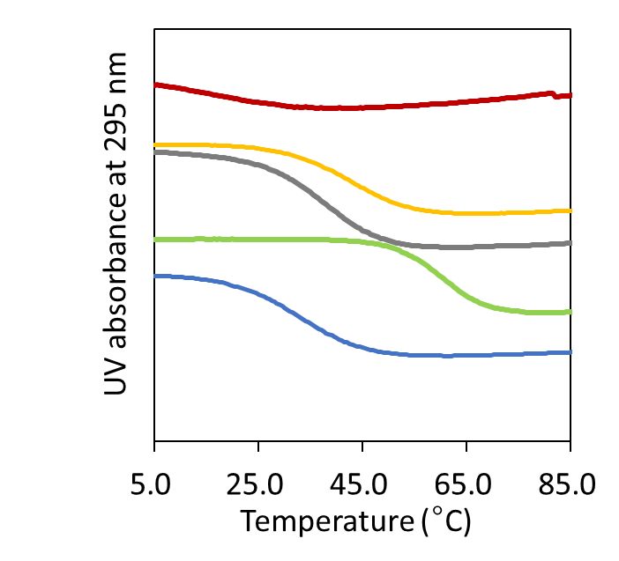
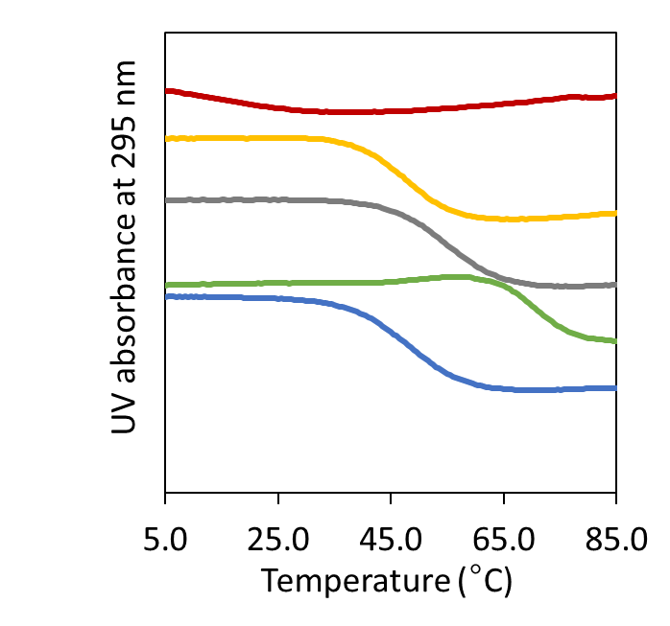
PBS_{out}

Figure 1. UV melting curves of TBA (blue), T1 (green), T2 (gray), T3 (yellow), and T4 (red) in PBS_{in} (left) and PBS_{out} (right) during the 2nd heating process.
PBS_{in}

3.2. DSC Curve
DSC measurement was conducted to acquire thermodynamic parameters accompanied with the thermal transition³¹. Figure 2 shows the DSC curves of each sample, where the 2nd heating curves are provided. The curves of the 1st and the 2nd runs were totally the same in PBS_{in} for all the samples, whereas those for T2 and T3 changed after the 1st heating in PBS_{out} (Figure S4 and S5). The curves for these modified TBAs showed multiple peaks in the 1st run, suggesting the need for heat treatment to obtain homogeneous higher-order structures for these samples. The thermodynamic parameters obtained during the 2nd run are presented in Table 3. The parameters obtained for TBA agreed well with literature information³². T_{m} values of all the samples agreed well with those obtained from the UV melting curves, except that T_{m} for T4 was detected only by DSC. The melting enthalpy, ΔH_{m}, was always larger in PBS_{in} except for T1. ΔH_{m} for T4 were much smaller than those of other samples, suggesting that the molecular interactions to form the higher-order structure was weak for T4. Although a negative ΔG was found for TBA in PBS_{in}, that was positive in PBS_{out} at 37 °C, suggesting that the equilibrium higher-order structures for TBA were different under these conditions. T1, T2, and T3 were likely to form the higher-order structures in both environments, whereas T4 was not. The ΔH_{m} value for T1 was approximately 1.5 times of that for TBA in PBS_{in}, and that for T2 was between them, suggesting that the structuring and melting largely depended on the G4 structure, whereas intermolecular interactions was partially responsible in PBS_{out}³³.

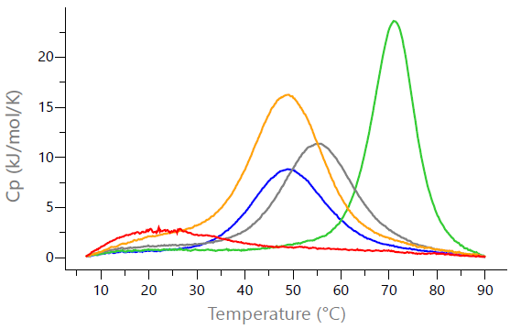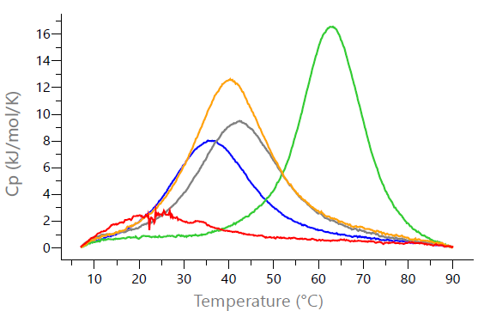
PBS_{out}
PBS_{in}
Figure 2. DSC heating curves of TBA (blue), T1 (green), T2 (gray), T3 (yellow), and T4 (red) in PBS_{in} (left) and PBS_{out} (right). Cp: Specific heat capacity.

Table 3. Thermodynamic parameters for melting of TBA, T1, T2, T3, and T4 in PBS_{in} and PBS_{out} determined from UV melting curves and DSC measurements.
Medium | Names | T_{m} (°C)  (UV) | T_{m} (°C)  (DSC) | ΔH_{m}  (kJ/mol) | ΔS_{m}  (kJ/mol/K) | ΔG (37 °C)  (kJ/mol) | ΔG (25 °C)  (kJ/mol)
PBS_{in} | TBA | 48.1 | 49.2 | 193 | 0.599 | -7.30 | -14.5
PBS_{in} | T1 | 70.8 | 70.7 | 290 | 0.843 | -28.4 | -38.5
PBS_{in} | T2 | 55.0 | 55.1 | 247 | 0.752 | -13.6 | -22.6
PBS_{in} | T3 | 47.5 | 48.5 | 363 | 1.13 | -13.0 | -26.5
PBS_{in} | T4 | ND | 27.2 | 107 | 0.356 | 3.49 | -0.784
PBS_{out} | TBA | 33.0 | 36.6 | 202 | 0.652 | 0.261 | -7.56
PBS_{out} | T1 | 60.5 | 62.7 | 313 | 0.932 | -24.0 | -35.1
PBS_{out} | T2 | 42.0 | 42.6 | 251 | 0.795 | -4.45 | -14.0
PBS_{out} | T3 | 41.6 | 40.7 | 310 | 0.988 | -3.65 | -15.5
PBS_{out} | T4 | ND | 23.5 | 79.6 | 0.268 | 3.62 | 0.403
ND: Not detected

3.3. CD Spectroscopy
TBA is known to form an antiparallel G4 structure, which is characterized by a positive peak around 295 nm and a negative peak near 270 nm in CD spectrum^{34, 35}. Figure 3 shows the CD spectra for each sample during the 2nd heating. Comparison of the 1st and the 2nd heating is provided in Figure S6. The assigned structures are presented in Table 4. The positive bands at 295 nm and the negative band at 270 nm were observed at 20 °C for T2 and T3 as well as for TBA both before and after heat treatment, indicating the formation of antiparallel G4 structure by the modified TBAs as well. These band intensities increased with heat treatment, indicating convergence to a stable higher-order structure. However, the band intensity for T2 and T3 was weaker compared to that of TBA, suggesting formation of multiple topologies. The spectra during the 1st and 2nd heating were slightly different for T2 and T3, although the wavelengths that exhibited the positive and negative peaks were observed at essentially the same positions. This observation agrees with the DSC curves, on which a small difference was observed between the 1st and 2nd curves. The spectrum of T1 in PBS_{in} changed during the 1st heating and yielded a negative band near 240 nm and a positive band near 260 nm. These results suggested the formation of a parallel G4 structure. In addition, the CD spectrum of T1 in PBS_{out} displayed a negative band near 240 nm and a positive band near 295 nm, suggesting the formation of a hybrid structure. No clear peaks were observed in the CD spectra of T4 in PBS_{in/out}. Except for T4, all modified of the TBAs showed stronger intensities of positive and negative bands in PBS_{in}, indicating the importance of potassium in forming the higher-order structures. At 50 °C, which is above T_{m} except for T1, the signal intensity of CD spectra was attenuated for TBA, T2, and T3. This can be explained by the deformation of the higher-order structure above T_{m}. Impact of concentration on the shape of the spectra was confirmed for TBA and T3 in the concentration range from 20 to 500 μg/mL to find that the spectra was not influenced by the concentration (Figure S8).

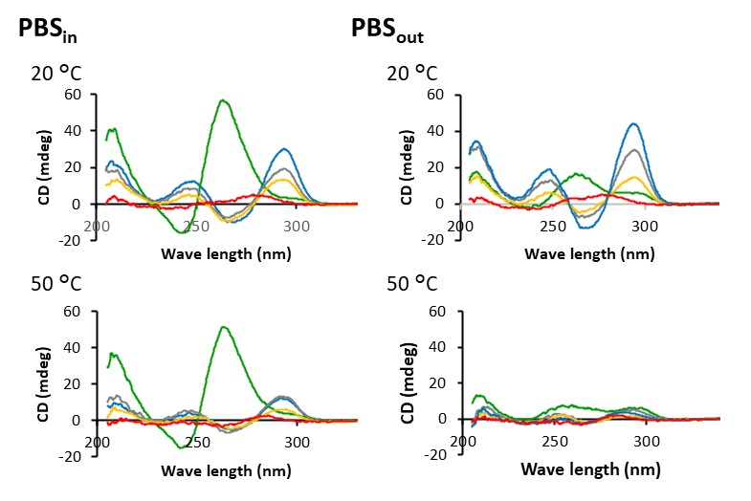
Figure 3. CD spectra of TBA (blue), T1 (green), T2 (gray), T3 (yellow), and T4 (red) in PBS_{in} (left) and PBS_{out} (right) during the 2nd heating process.

Table 4. G4 structure at 20 °C determined by the CD measurement.
Names | PBS_{in} | PBS_{out}
TBA | Antiparallel | Antiparallel*
T1 | Parallel | Hybrid
T2 | Antiparallel | Antiparallel
T3 | Antiparallel | Antiparallel
T4 | None | None
* may be metastable (see Discussion)

3.4. NMR Spectroscopy
¹H NMR can detect hydrogen bonding interactions of bases in the imino proton region at 9-15 ppm. The guanine residues are strongly shielded by the layered G4 structure, leading to signals appearing in the high-field area of the imino proton region (11-13 ppm)^{36,37}. For ¹H NMR analysis, samples were diluted in PBS_{out} containing 90% H₂O and 10% D₂O in order to observe the exchangeable proton signals. Therefore, excitation sculpting based water suppression pulse sequence “zgesgp” was used for the experiment. Figure 4 illustrates, TBA including other modified TBAs exhibited the imino proton signals indicative of the G4 structure except for T4. In addition, the number of imino proton peaks of guanines were larger than the number of guanine residues in the TBA, T2, and T3 sequences, indicating the existence of multiple higher-order structures. In particular, the appearance of numerous peaks for T3 indicates that the complexity of its higher-order structure.
¹H DOSY was performed to evaluate the diffusion coefficients of the molecules, which are expected to be affected by formation of the higher-order structure³⁸. The 2D DOSY spectra and exponential decay fitting of the representative peaks are shown in Figure 5 and Figure S9-S13, respectively. The average values of the experimental diffusion coefficients as determined from the representative peaks and the theoretical diffusion coefficient were summarized in Table 5. Peaks with clearly different diffusion coefficients were not observed in the DOSY experiment for samples that formed multiple higher-order structures. The diffusion coefficients of TBA, T2, and T4 agreed with the expected values. However, those for T1 and T3 were larger and smaller than expected, respectively. A larger value of experimental diffusion coefficient indicates the formation of a more compact structure than expected based on the molecular weight, and vice versa. The diffusion coefficient estimated from the doubled molecular weight of T3 was 1.04 × 10⁻¹⁰ m²/s, which is in good agreement with the experimental value (1.07 × 10⁻¹⁰ m²/s), indicating that T3 formed dimers.
The NMR samples of TBA and T3 were collected and subjected to the DSC measurements after adjustment of the concentration to 4 mg/mL (Figure S6 and Table S2). Similar curves with those at 0.5 mg/mL (Figure 2) were obtained to find that the higher order structure remained the same in this concentration range and absence of the effect of 10% D₂O.

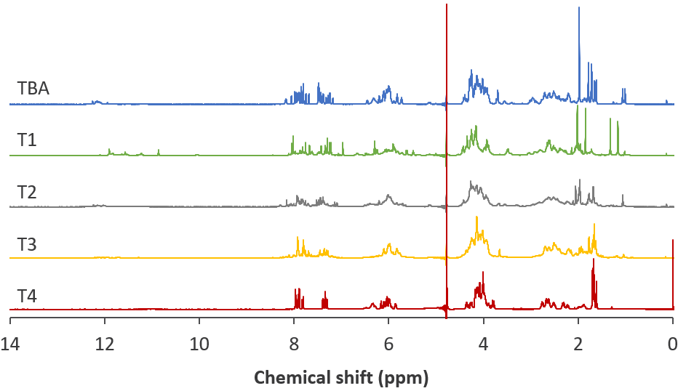
Full scale
(a)

(b)
Imino proton region
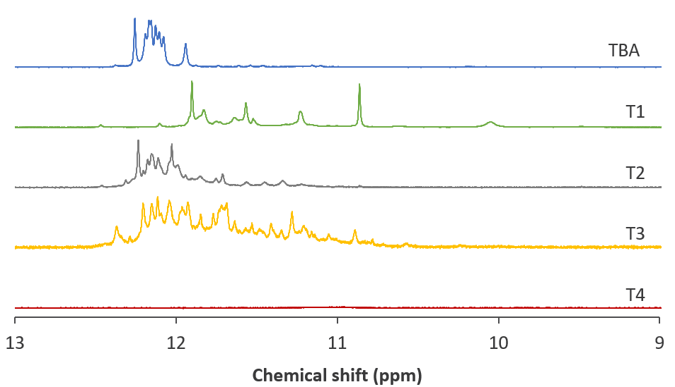

Figure 4. ¹H NMR spectra of TBA (blue), T1 (green), T2 (gray), T3 (yellow), and T4 (red) in (a) full scale and (b) imino proton region. The scale of each spectrum in (b) was changed for comparison as follows: TBA ×1, T1 ×0.5, T2 ×1.5, T3 ×5, and T4 ×1.
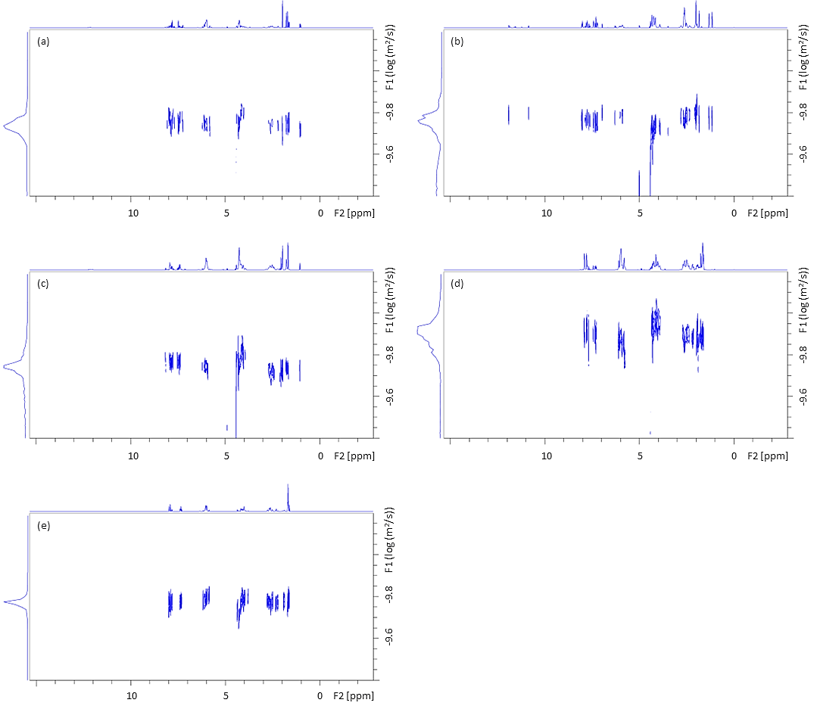

Figure 5. DOSY spectra of (a) TBA, (b) T1, (c) T2, (d) T3, and (e) T4.

Table 5. The experimental and theoretical diffusion coefficient.
Names | Experimental ª  (10⁻¹⁰ m²/s) | Theoretical (SEGWE)  (10⁻¹⁰ m²/s)
TBA | 1.48 ± 0.26 | 1.50
T1 | 1.49 ± 0.19 | 1.37
T2 | 1.46 ± 0.17 | 1.43
T3 | 1.07 ± 0.13 | 1.34
T4 | 1.55 ± 0.04 | 1.50
ª Data are Mean ± standard deviation.

3.5. Solution Properties
T1 immediately dissolved in distilled water at a concentration of 100 mg/mL, whereas T4 yielded an opaque appearance when suspended at the same concentration (Figure 6 and Table 6). The T4 solution exhibited phase separation into a transparent upper phase and a gel phase after 5 min. A single-phase T4 solution was obtained when the suspension was diluted with distilled water to 80 mg/mL. The viscosity of the T4 solution at a concentration of 80 mg/mL exhibited much higher value than that of the T1 solution at 100 mg/mL (Table 7). The shear rate dependence of the viscosity of the T4 solution indicated non-Newtonian behavior, which is a common property of heterogeneous complexes such as highly concentrated polymer solutions and antibody aggregates³⁹. This observation indicated that the formation of the higher-order structure contributed to reduction in viscosity.
Figure 7 shows chemical stability of TBA and modified TBAs. The chromatogram obtained in each storage condition is shown in Figure S14-S18. The degradation rates obtained under assumption of the first-order reaction are summarized in Table 8. The degradation at 4 °C and 25 °C was almost negligible for all samples in both PBS_{in} and PBS_{out}, and thus the results at these temperatures are not reported. All samples exhibited higher stability in PBS_{in}, indicating an influence of the higher-order structures on the chemical stability. This is also supported by the finding that T1 and T4 were the most stable and unstable, respectively, among all the samples tested. Arrhenius plot was applied for the data from 40 °C to 60 °C, which revealed that the temperature dependency of the degradation rate could not be described with linear lines (Figure 8). In PBS_{in}, the degradation was faster than expectation from the Arrhenius fit for T2, T3, and T4 at 60 °C. As T_{m} for T2 and T3 was found near 50 °C, the higher-order structure was likely to be responsible for chemical stabilization. A similar tendency was observed for PBS_{out}.

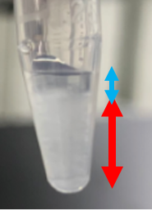
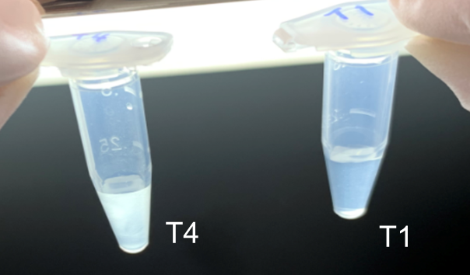
Figure 6. Appearance of T1 and T4 in water at a concentration of 100 mg/mL. Left: Immediately after dissolution. Right: Five minutes after dissolution (T4). The transparent upper phase and the gel phase (without precipitation) are indicated by the blue and red arrows, respectively.

Table 6. Appearance and solubility of T1 and T4 in water.
Medium | Names | Concentration (mg/mL)
Medium | Names | 80 | 90 | 100
water | T1 | - | - | Transparent
water | T4 | Transparent | Opaque | Phase separation

Table 7. Viscosity of T1 and T4 in water at 25 °C.
Medium | Names | Concentration (mg/mL) | Shear rate (s⁻¹) | Viscosity (mPa・s)
water | T1 | 100 | 1500 | 1.9
water | T1 | 100 | 3000 | 1.6
water | T4 | 80 | 250 | 41.3
water | T4 | 80 | 500 | 30.8

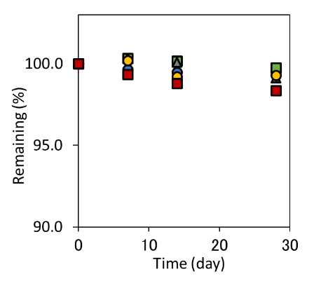
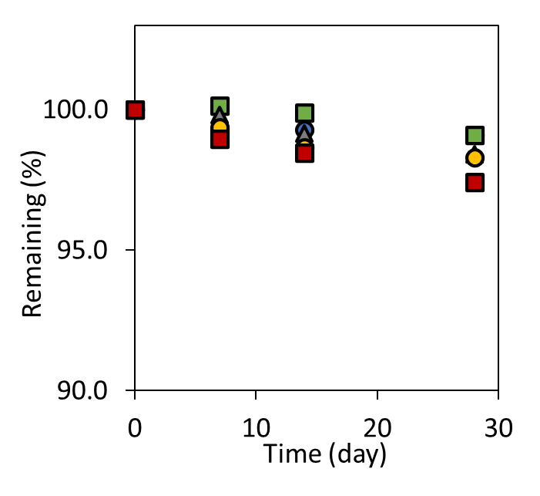
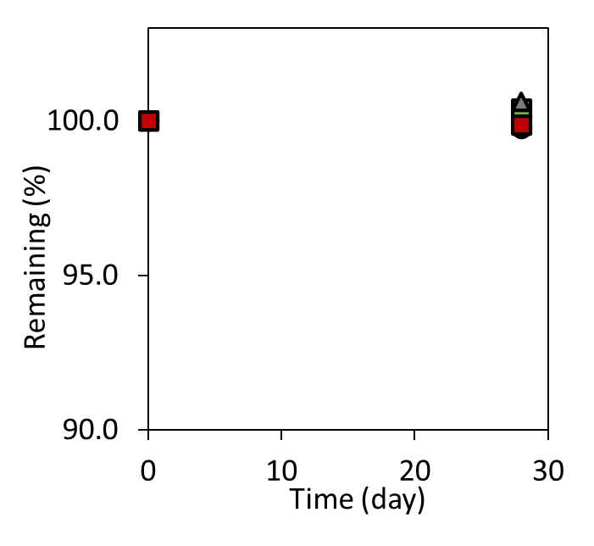
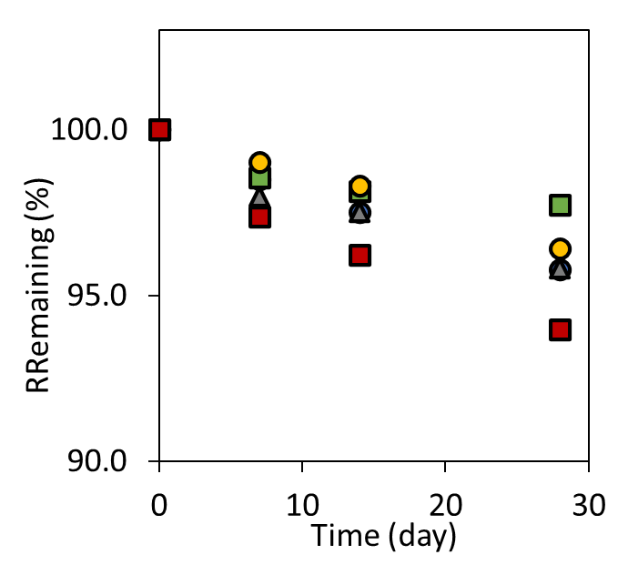
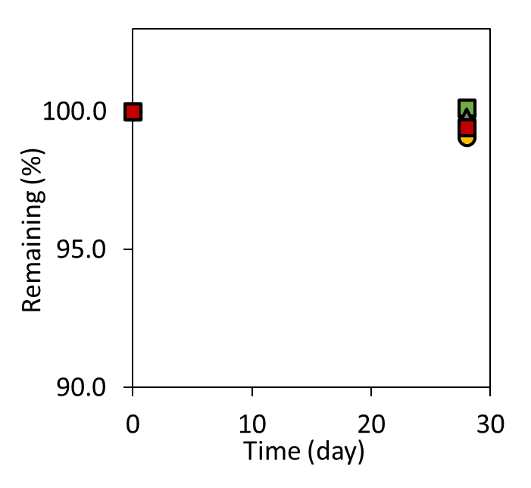
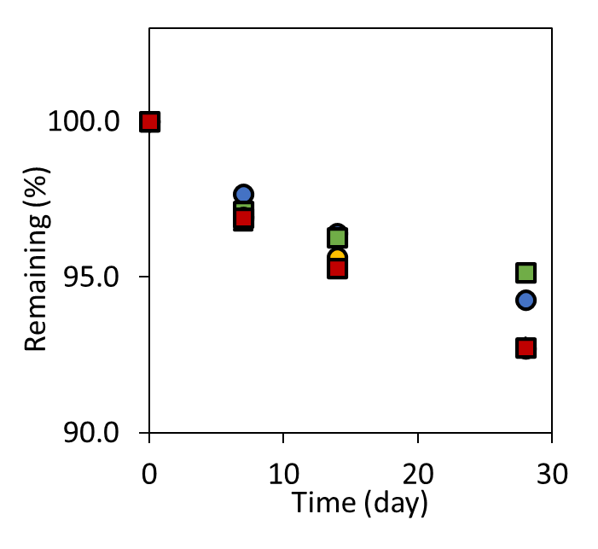
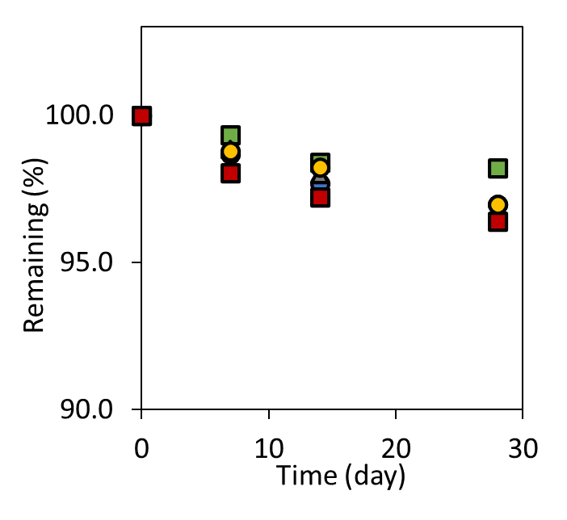
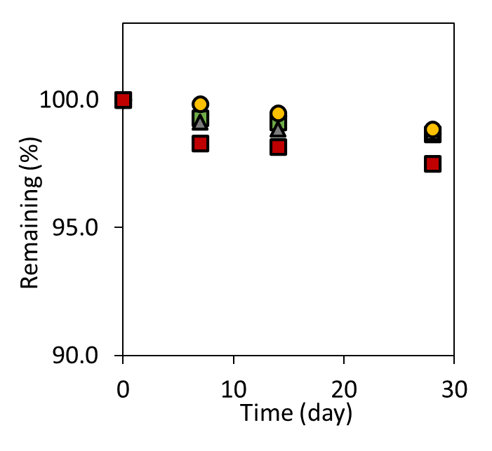
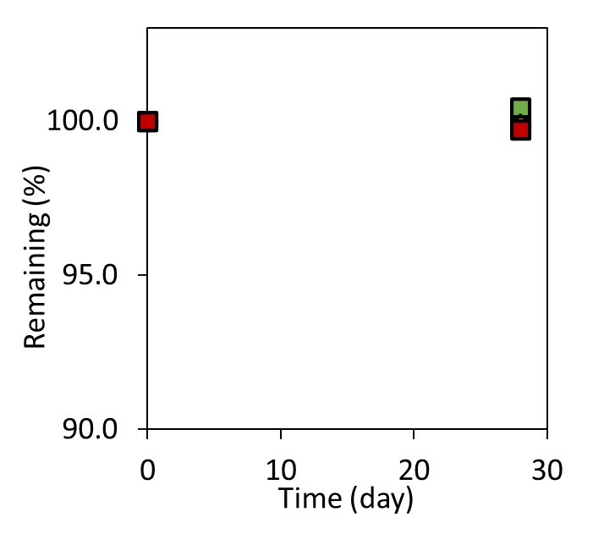
(j)
(i)
(h)
(g)
(f)
(e)
(d)
(c)
(b)
(a)
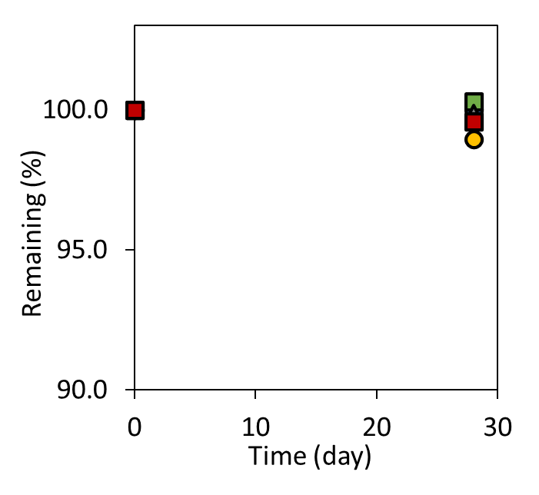
Figure 7. Chemical stability of TBA (blue), T1 (green), T2 (gray), T3 (yellow), and T4 (red) at (a) 4 °C, (b) 25 °C, (c) 40 °C, (d) 50 °C, (e) 60 °C in PBS_{in} and (f) 4 °C, (g) 25 °C, (h) 40 °C, (i) 50 °C, (j) 60 °C in PBS_{out} (n=2). Deviation of the values was smaller than 0.3% in most cases.

Table 8. Degradation rate (K) for TBA, T1, T2, T3, and T4 in PBS_{in} and PBS_{out}.
Medium | Names | T_{m} (°C) (by UV) | Degradation rate, K (d⁻¹)
Medium | Names | T_{m} (°C) (by UV) | 40 °C | 50 °C | 60 °C
PBS_{in} | TBA | 48.1 | －0.015 | －0.044 | －0.147
PBS_{in} | T1 | 70.8 | －0.012 | －0.044 | －0.073
PBS_{in} | T2 | 55.0 | －0.036 | －0.041 | －0.140
PBS_{in} | T3 | 47.5 | －0.032 | －0.042 | －0.127
PBS_{in} | T4 | not detected | －0.057 | －0.078 | －0.204
PBS_{out} | TBA | 33.0 | －0.027 | －0.104 | －0.196
PBS_{out} | T1 | 60.5 | －0.035 | －0.064 | －0.158
PBS_{out} | T2 | 42.0 | －0.059 | －0.111 | －0.246
PBS_{out} | T3 | 41.6 | －0.060 | －0.103 | －0.249
PBS_{out} | T4 | not detected | －0.088 | －0.120 | －0.248
PBS_{out}
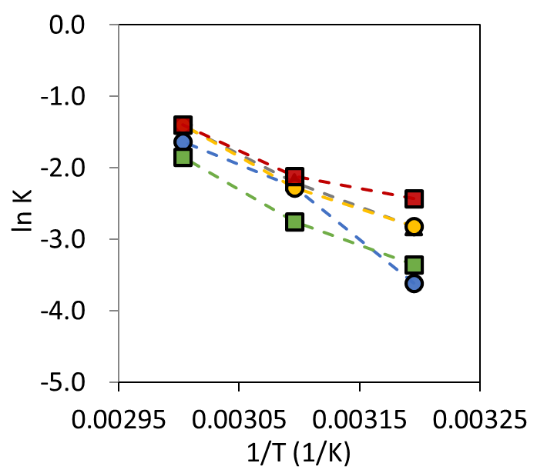
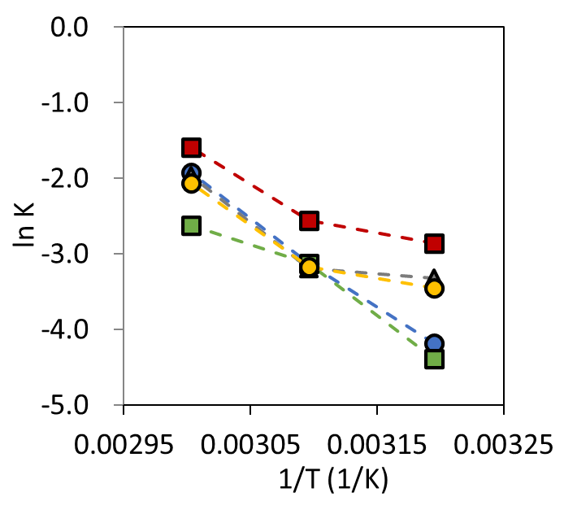
PBS_{in}
Figure 8. Arrhenius plot for the thermal degradation of TBA (blue), T1 (green), T2 (gray), T3 (yellow), and T4 (red) in PBS_{in} (left) and PBS_{out} (right).

3.6. Anticoagulant Activity and Binding Efficacy
TBA interacts with positively charged exosites I and II, which are the fibrinogen recognition sites of thrombin, and thereby inhibits the anticoagulant activity of thrombin^{40,41}. The anticoagulant activity and interaction with thrombin of all modified TBAs as well as TBA were tested using fibrin formation and alpha binding assays, respectively. TBA inhibited thrombin much more effectively than other modified TBAs⁴¹. Figure 9 shows the anticoagulant activities of the TBA and modified TBAs. Longer coagulation times result from the higher anticoagulant activity of TBAs. The anticoagulant activity of TBA in PBS_{out} was higher than that in PBS_{in}. T2 and T3 showed anticoagulant activity in both buffer； however, no anticoagulant activity has been obtained for T1 and T4 up to 20 nM. T1 showed anticoagulant effects only in the PBS_{in} and not in PBS_{out} at concentrations of sub-μM.
Alpha assay, in which human α-thrombin was immobilized on acceptor beads, was performed to understand the structural changes affect the binding to thrombin. It is a promising analysis to detect molecular interactions and has already been applied to test binding of TBA to thrombin⁴³. As shown in Figure 10, TBA, T2, and T3 bound to thrombin with an equilibrium dissociation constant for sub-nM TBA in both PBS_{out} and PBS_{in}. This indicates that TBA, T2, and T3 have high affinity for thrombin. This is consistent with the anticoagulant activity test results. No binding of T4 was observed. T1 bound to human α-thrombin in PBS_{in} but not in PBS_{out}.
These results concluded that antiparallel structures of TBA, T2, and T3 play an important role in anticoagulant activity by interacting with thrombin. T4 did not form any high-order structures contributing to anticoagulant activity. T1 could not bind to thrombin to form hybrid structures in PBS_{out}； however, T1 with a parallel topology bound slightly to thrombin. Thus, T1 formed different topologies in the different buffers, which may explain the difference in the anticoagulant activity in PBS_{in} and PBS_{out}.

PBS_{out}
PBS_{in}

Figure 9. Concentration dependency of anticoagulant activity of TBA (blue), T1 (green), T2 (gray), T3 (yellow), and T4 (red). Assay was carried out in PBS_{in} (left) and PBS_{out} (right) condition. Concentrations of fibrinogen and thrombin were 1 mg/mL and 5.5 nM, respectively. Data shown are the means ± SE of triple experiments.
PBS_{out}
PBS_{in}

Figure 10. Saturation isotherms of TBA (blue), T1 (green), T2 (gray), T3 (yellow), and T4 (red) to human thrombin in PBS_{in} (left) and PBS_{out} (right) conditions.

4. Discussion

4.1. Complementary Roles of Each Characterization Method for Determining Higher-Order Structure
The melting behavior and the higher-order structures of TBA and modified TBAs were evaluated using a series of instrumental methods including UV, DSC, CD, and NMR. The distinct strength and limitation of each method should be understood well to obtain a reasonable and comprehensive view of the higher-order structure of oligonucleotides.
T_{m} of TBA and all modified TBAs except for T4 were consistent when measured using UV and DSC methods. Since the higher-order structure was not likely to be influenced by the difference in the concentration, small differences in the T_{m} values determined by these two methods should be due to different measurement principles. The melting peaks detected by DSC were broad for all samples. In such cases, the peak-top temperature is sensitive to the sample concentration and the instrumental properties. UV observation did not provide T_{m} value for T4; however, it was detected by DSC. This should be simply because of different detection sensitivities.
The required amount of sample for DSC is larger than that for UV measurements. Nevertheless, DSC could provide thermodynamic parameters for the melting behavior, which help understand the structuring/melting mechanism. Formation of the higher-order structure was found to be energetically favored at 37 °C for TBA in the PBS_{in}; but not in PBS_{out}. Modified TBAs did not exhibit such environment-responsiveness. TBA was found to form an antiparallel G4 structure in CD analysis in PBS_{out}, and the NMR measurement also suggested the formation of the higher-order structure. This represents a metastable state, i.e., stable structure at lower temperatures that is maintained only for a limited period of time. Notably, TBA likely to form the G4 structure in the presence of thrombin even without cations⁴⁴. Since our thermodynamic evaluations were performed only for pure oligonucleotides, their behaviors may differ in the presence of the substrate. If the formation of the G4 structure dominates the structuring/melting behavior, ΔG in PBS_{in} is expected to be smaller than that in PBS_{out}, which was indeed the case for TBA and the three modified TBAs, except for T4. ΔH_{m} was approximately proportional to the number of the G4 quartets. Thus, the higher-order structures of T2 and T3 seemed to be more complicated compared to TBA and T1.
Detailed information on the structure was obtained from the CD and NMR analyses. CD could clearly distinguish types of the secondary structures (i.e., parallel or antiparallel) of TBA and all modified TBAs and also detected their changes during increasing and decreasing temperatures. NMR is effective in determining the number of topologies^{35,36}. Several discrepancies and complementary information were detected upon comparison of results of different evaluations. Based on the T_{m} melting data, all samples appeared to form G4 structures spontaneously, since no significant differences were found between the 1st and the 2nd heating data. However, this was proved not to be true by the DSC and CD observations for T1, T2, and T3. Although heat treatment to regenerate the higher-order structures of oligonucleotide is a common procedure, it may be overlooked if attention is paid only to the UV melting data. T3 was designed to yield a complex higher-order structure, which is likely the reason for the differences in structures between the 1st and the 2nd heating in the UV and CD analyses. This complexity was clearly demonstrated by the NMR finding. DOSY results provided information on the compactness of the molecule, which helped understanding of the higher-order structure. Although none of the methods alone can provide perfect picture of the higher-order structure, this is possible by combining multiple techniques. As the higher-order structure was found to play an influential role on the solution properties including viscosity and stability, its detailed understanding is crucial during pharmaceutical development.

4.2. Relationship between Higher-Order Structure and Solution Properties / Activity
Higher-order structures were proved to have significant effect on solution properties such as solubility, viscosity, and stability. T1 was found to yield the most stable structure as this had the largest number of G4 quartets per molecule. TBA, T2, and T3 likely possessed multiple topologies, which was partially because of unmatching number of the G sequence (T2 and T3) and more than four G sequences (T3). Ability of T4 to form higher-order structures was not strong. In all the cases, the structure was more stable in PBS_{in} than in PBS_{out} because of higher concentration of potassium ions. LLPS and an increase in viscosity were observed for T4, but not for T1, suggesting the influential role of the higher-order structure in determining the solution properties. The increase in the viscosity of T4 may be due to its elongated structure and the absence of a higher-order structure, which enables entanglement of the oligonucleotide chains. As these events are considered to be risky as dosage forms of injection, a detailed assessment of the higher-order structure is important during the physicochemical profiling of oligonucleotide therapeutics.
Regarding the chemical stability, TBA, T1, T2, and T3 exhibited increased stability under potassium-rich conditions and T4 was extremely unstable under all conditions. At 60 °C, stability of unfolded TBA, T2 and T3 was lower than folded T1. These data suggested that a higher-order structure is relevant for the chemical stability.
The anticoagulant activity of all the modified TBAs was lower than that of TBA, and no significant activity was detected for T1 and T4 due to their inability to bind to thrombin in PBS_{out}. A moderate binding of T2 and T3 to thrombin was observed because of the presence of mainly antiparallel structures and three T-rich loops in T2 and T3. The anticoagulant activity is highly sensitive to higher-order structure of thrombin.
For the low-molecular-weight drugs, polymorphism is one of the most important properties to be clarified during pharmaceutical development. Thus, extensive screening study is usually performed prior to clinical studies. Although polymorphism has been recognized for a century, it was not regarded as an important property for a long time. One of the molecule that increased attention to polymorphisms in this regard was ritonavir, which was withdrawn from the market following its approval due to the appearance of a new crystal form during production⁴⁵. It is now widely recognized that much care regarding polymorphisms is required for poorly soluble drugs, as the crystal form may have a great impact on the dissolution properties of the drug. Optimistic investigations are possible for highly soluble compounds, and almost no attention is required when the dosage form is in liquid state. Researchers understand well how to deal with polymorphisms in low-molecular-weight drugs depending on their solubility and dosage forms. To this end, similar knowledge may be required for nucleic acids as well, as the higher-order structure can be considered in the same context as the “polymorphism” for low-molecular-weight drugs. Our findings suggest that the efficacy and/or stability of misfolded oligonucleotides may be lower than expected. Thus, the higher-order structure should be evaluated during physicochemical profiling study for oligonucleotide drugs.

4.3. Implications for Establishing Physicochemical Profiling Platform for Therapeutic Oligonucleotides
UV, DSC, and CD measurements generated different results for the 1st and the 2nd heating in many cases, indicating that heating pretreatment is required to obtain a stable higher-order structure. In the presence of a strong driving force to form a higher-order structure, the structure likely forms without pretreatment, as observed for T1 in the presence of potassium ions. Thus, pretreatment has a significant impact when the strength of formation of the higher-order structure is moderate or weak. This issue can be overcome by repeating the heat-cool cycles in the case of UV, CD, and DSC measurements; however, much care is required for studies that include observations of chemical stability, viscosity, and activity.
From a practical point of view, all of the evaluation methods used in this study can be applied to only a few candidates which survived for the developability assessment and chemistry manufacturing control (CMC) development. Although all of methods are meaningful for candidate selection and development, the timing of each evaluation method is also dependent on the availability of the sample amount. Table 9 summarizes the required amount of oligonucleotides and periods for each study. Figure 11 shows the suggested timing to apply each method during the developmental study. T_{m} must be evaluated using UV and/or DSC at an early stage of drug discovery. A UV study can be performed with a relatively small amount of the sample, whereas the required amount for DSC depends on the higher-order structure. In this study, DSC study was performed at a concentration of 0.5 mg/mL, at which the G4 structure could be easily detected. However, a higher concentration is generally required for oligonucleotides that form weak higher-order structures. Information on T_{m} is necessary to determine the temperature conditions for storage, hybridization, and various evaluations. Information on T_{m} obtained by the UV method may involve kinetic factors, whereas thermodynamic information is available from DSC. Structural characterization using CD is also required at an early stage, if the formation of a higher-order structures is anticipated. CD provides high sensitivity for observing the secondary structures of oligonucleotides. Although NMR requires a large amount of sample, it allowed confirmation of the presence of multiple topologies, molecular interactions, and the compactness of the molecules. Thus, NMR should be considered as an option for evaluation, when higher-order structures are suspected to play an influential role. Different concentrations must be employed for each instrumental analysis. Although the higher-order structure of nucleic acids may be influenced by the concentration, it was proved to be negligible for TBA and modified TBAs in the concentration range from 0.015 mg/mL to 8 mg/mL in this study. Determination of solution properties such as solubility, viscosity, and stability is essential for the developability assessment of injectable products; however, they may be difficult to measure at a very early discovery stage because of the requirements of a large amount of sample. They may be employed only when one candidate for further development is selected. The information obtained by UV, CD, and DSC analyses indicates the possibility of an impact of higher-order structures on the properties of highly concentrated solutions. Thus, the strategic evaluation of physicochemical properties at an early stage is important for the successful and seamless development of the subsequent stages in the developmental study.

Table 9 Amount of samples and assay time required for physicochemical characterization study (per one test medium)
Items |  | Methods | Concentration (mg/mL) | Required amount (mg) | Required time (day) | Note
Thermal stability | Melting point | UV | 0.08 | 0.008 | 1
Thermal stability | Melting point, ΔH_{m}, ΔG and ΔS_{m} | DSC | 0.5 | 0.15 | 1 | Larger amount required for general nucleic acids
Structural analysis | Secondary structure | CD | 0.2 | 0.25 | 1
Structural analysis | ¹H NMR | NMR | 8 | 5 | 1-7 | Partially reusable
Solution properties | Solubility | Appearance | 100 | 50 | 1 | 100 mg/mL,  Reusable
Solution properties | Viscosity | Viscometer | 100 | 10 | 1 | 100 mg/mL,  Partially reusable
Solution properties | Chemical stability | HPLC | 0.1 | 0.1 | 30

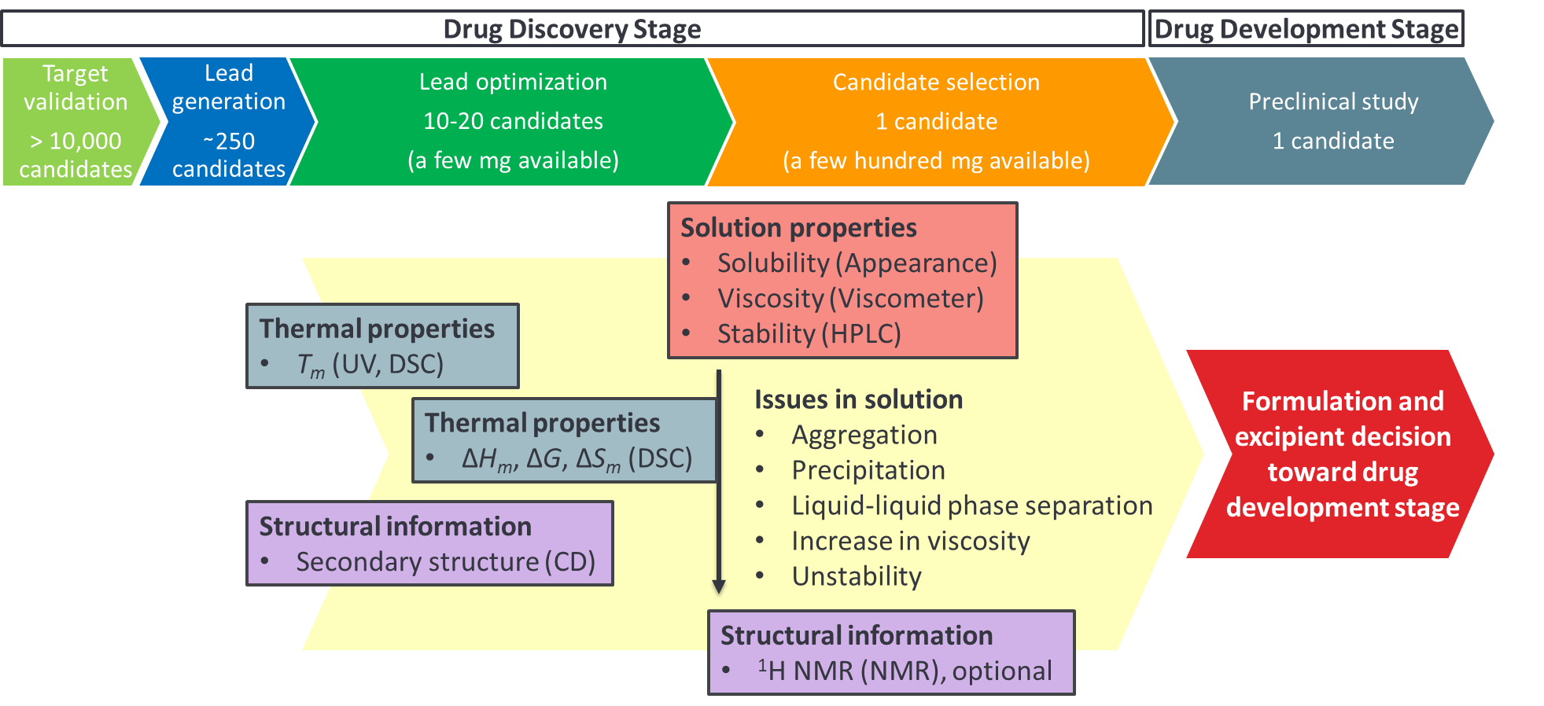
Figure 11. Physicochemical evaluation and developability assessment workflow.

5. Conclusion
Recognition of the relevance between high-order structure and physicochemical properties, including activity may enable the fast and cost-efficient development of oligonucleotides. We proposed the comprehensive analytical platform based on studies of TBA and four modified TBAs, which exhibited varied higher-order structures due to the distinct intra- or intermolecular interactions. UV and DSC analyses revealed improved thermal stability of T1 compared to TBA, whereas T4 did not have a clear melting point as expected based on its sequence. In the CD spectrum, only T1 showed a parallel G4 structure, suggesting a more rigid structure as supported by NOSY observations. This was presumably due to the larger number of G4 quartets compared to TBA. TBA, T2, and T3 formed antiparallel G4 structures. NMR spectroscopy confirmed the existence of multiple topologies for these oligonucleotides. Dimer formation was suggested for T3 based on NOSY measurements. These analytical techniques provided consistent conclusions and served complementary roles.
We analyzed the physicochemical properties such as solubility, viscosity, and stability of T1 and T4 because of the large difference in higher-order structures between these modified TBAs. T4 exhibited significantly lower solubility and higher viscosity compared to T1. These results revealed the importance of forming a higher-order structure on the aggregation, LLPS, and viscosity in the solution. We also identified a correlation between chemical and thermal stability indicating that degradation can be accelerated without the formation of a higher-order structure. Anticoagulant activity and binding efficacy studies further confirmed the requirement of antiparallel structures for thrombin binding and anticoagulant activity.
We elucidated the intra- and intermolecular interactions and high-order structures of modified TBAs, including TBA, using complementary analytical techniques, and shedding light on their impact on physicochemical properties. Considering the required amount, time, and value of the obtained data for each evaluation, performing each analysis in the preclinical developmental stages was also suggested. This knowledge should be useful for seamless development of oligonucleotides as pharmaceutics.

Contents of supporting information:
UV melting curves during 1st heating run; concentration dependence of UV melting curves and melting temperatures; comparison of 1st and 2nd heating DSC curves; concentration dependence of DSC curves and thermodynamic parameters determined from the DSC curves; comparison of the 1st and the 2nd heating CD spectra; concentration dependence of CD spectra; the exponential decay fitting of intensity of representative peaks in DOSY experiment; HPLC chromatogram of chemical stability testing.

Funding: This work was funded by Materials Open Platform for Pharmaceutical Science and each author’s affiliation.

Acknowledgments:
The authors are grateful for discussion and technical support by Dr. Yukihiro Ikeda, Mr. Masaru Ushiro, Mr. Yuya Kinoshita, Ms. Riho Ishioka (Takeda Pharmaceutical Co. Ltd.), Ms. Tomoyo Umezawa (National Institute for Materials Science), Dr. Takashi Hasebe, Dr. Junichi Mizoguchi, and Ms. Shiho Tsutsumi (Eisai Co., Ltd). This study was conducted as part of Materials Open Platform for Pharmaceutical Science (Center of Excellence for Pharmaceutical Materials Science) led by National Institute for Materials Science. Part of this work was conducted at the NIMS Molecule and Material Synthesis Platform, supported by the Nanotechnology Platform Program of the Ministry of Education, Culture, Sports, Science, and Technology (MEXT), Japan.

Conflicts of Interest: The authors declare no conflict of interest.

References
- Brittain, H. G. Characterization of Pharmaceutical Compounds in the Solid State. In Handbook of Modern Pharmaceutical Analysis; Ahuja, S., Scypinski, S., Eds.; Academic Press: San Diego, 2011; pp 11－58.
- Haleblian, J.; McCrone, W. Pharmaceutical Applications of Polymorphism. J. Pharm. Sci. 1969, 58 (8), 911－929.
- Brittain, H. G. Methods for the characterization of polymorphs and solvates. In Polymorphism in Pharmaceutical Solids; Brittain, H. G., Eds.; Marcel Dekker: New York, 1999; pp 227－278.
- Yu, L.; Reutzel, S. M.; Stephenson, G. A. Physical characterization of polymorphic drugs: an integrated characterization strategy. Pharm. Sci. Technol. Today 1998, 1 (3), 118－127.
- Kulkarni, J. A.; Witzigmann, D.; Thomson, S. B.; et al. The current landscape of nucleic acid therapeutics. Nature Nanotechnology 2021, 16, 630－643.
- Amanat, M.; Nemeth, C. L.; Fine, A. S.; et al. Antisense Oligonucleotide Therapy for the Nervous System: From Bench to Bedside with Emphasis on Pediatric Neurology. Pharmaceutics 2022, 14 (11), 2389.
- Roberts, T. C.; Langer, R.; Wood, M. J. A. Advances in oligonucleotide drug delivery. Nature Reviews Drug Discovery 2020, 19 (10), 673－694.
- Egli, M.; Manoharan, M. Chemistry, structure and function of approved oligonucleotide therapeutics. Nucleic Acids Res. 2023, 51 (6), 2529－2573.
- Thakur, S.; Sinhari, A.; Jain, P.; et al. A perspective on oligonucleotide therapy: Approaches to patient customization. Front. Pharmacol. 2022, 13, 1006304.
- Watt, R. P.; Khatri, H.; Dibble, A. R. G. Injectability as a function of viscosity and dosing materials for subcutaneous administration. Int. J. Pharm. 2019, 554, 376－386.
- Lim, M.; Dibble, A. Osmolality of antisense oligonucleotide parenteral formulations: Implications on counterion dissociation and recommended osmometry techniques. Int. J. Pharm. 2016, 515 (1-2), 788－799.
- Zhang, M. M.; Bahal, R.; Rasmussen, T. P.; et al. The growth of siRNA-based therapeutics: updated clinical studies. Biochem. Pharmacol. 2021, 189, 114432.
- Kamya, P. R. N.; Muchall, H. M. Revisiting the Effects of Sequence and Structure on the Hydrogen Bonding and π-Stacking Interactions in Nucleic Acids. J. Phys. Chem. A 2011, 115 (45), 12800－12808.
- Farzan, M.; Ross, A.; Müller, C.; et al. Liquid crystal phase formation and non-Newtonian behavior of oligonucleotide formulations. Eur. J. Pharm. Biopharm. 2022, 181, 270－281.
- Dibble, A.; Tillman, L.; Coldren, B.; et al. Antisense oligonucleotide compositions. WO2013173789A2, 2013.
- Poecheim, J.; Graeser, K. A.; Hoernschemeyer, J.; et al. Development of stable liquid formulations for oligonucleotides. Eur. J. Pharm. Biopharm. 2018, 129, 80－87.
- Karaki, S.; Benizri, S.; Mejías, R.; et al. Lipid-oligonucleotide conjugates improve cellular uptake and efficiency of TCTP-antisense in castration-resistant prostate cancer. Journal of Controlled Release 2017, 258, 1－9.
- Barakat, F.; Gaudin, K.; Vialet, B.; et al. An analytical study of lipid-oligonucleotide aggregation properties. J. Pharm. Biomed. Anal. 2021, 205, 114327.
- Chow, G.; Morcos, P. A.; Moulton, H. M. Aggregation and Disaggregation of Morpholino Oligomers in Solution. Methods Mol. Biol. 2017, 1565, 31－38.
- Wu, Z. S.; Guo, M. M.; Shen, G. L.; et al. G-rich oligonucleotide-functionalized gold nanoparticle aggregation. Anal. Bioanal. Chem. 2007, 387 (8), 2623－2626.
- Fialová, M.; Kypr, J.; Vorlícková, M. The thrombin binding aptamer GGTTGGTGTGGTTGG forms a bimolecular guanine tetraplex. Biochem. Biophys. Res. Commun. 2006, 344 (1), 50－54.
- Kankia, B. I.; Marky, L. A. Folding of the Thrombin Aptamer into a G-Quadruplex with Sr2+: Stability, Heat, and Hydration. J. Am. Chem. Soc. 2001, 123 (44), 10799－10804.
- Rache, A. D.; Kejnovská, I.; Vorlíčková, M.; et al. Elongated Thrombin Binding Aptamer: A G-Quadruplex Cation-Sensitive Conformational Switch. Chemistry 2012, 18 (14), 4392－4400.
- Martino, L.; Virno, A.; Randazzo, A.; et al. A new modified thrombin binding aptamer containing a 50–50 inversion of polarity site. Nucleic Acids Research 2006, 34 (22), 6653－6662.
- Riccardi, C.; Napolitano, E.; Platella, C.; et al. G-quadruplex-based aptamers targeting human thrombin: Discovery, chemical modifications and antithrombotic effects. Pharmacology & Therapeutics 2021, 217, 107649.
- Benigno, D.; Virgilio, A.; Bello, I.; et al. Properties and Potential Antiproliferative Activity of Thrombin-Binding Aptamer (TBA) Derivatives with One or Two Additional G-Tetrads. Int. J. Mol. Sci. 2022, 23 (23), 14921.
- Hwang, T. L.; Shaka, A. J. Water Suppression That Works. Excitation Sculpting Using Arbitrary Wave-Forms and Pulsed-Field Gradients. Journal of Magnetic Resonance, Series A 1995, 112 (2), 275－279.
- Wu, D. H.; Chen, A. D.; Johnson, C. S. An Improved Diffusion-Ordered Spectroscopy Experiment Incorporating Bipolar-Gradient Pulses. Journal of Magnetic Resonance, Series A 1995, 115 (2), 260－264.
- Evans, R.; Poggetto, G. D.; Nilsson M.; et al. Improving the Interpretation of Small Molecule Diffusion Coefficients. Anal. Chem. 2018, 90 (6), 3987－3994.
- Kosman, J.; Juskowiak, B. Thrombin-Binding Aptamer with Inversion of Polarity Sites (IPS): Effect on DNAzyme Activity and Anticoagulant Properties. Int. J. Mol. Sci. 2021, 22 (15), 7902.
- Gill, P.; Moghadam, T. T.; Ranjbar, B. Differential Scanning Calorimetry Techniques: Applications in Biology and Nanoscience. J. Biomol. Tech. 2010, 21 (4), 167－193.
- Nagatoishi, S.; Isono, N.; Tsumoto, K.; et al. Loop Residues of Thrombin-Binding DNA Aptamer Impact G-Quadruplex Stability and Thrombin Binding. Biochimie 2011, 93 (8), 1231－1238.
- Pagano B.; Martino L.; Randazzo A.; et al. Stability and Binding Properties of a Modified Thrombin Binding Aptamer. Biophys J. 2008, 94 (2), 562－569.
- Viglasky, V.; Hianik, T. Potential uses of G-quadruplex-forming aptamers. Gen. Physiol. Biophys. 2013, 32 (2), 149－172.
- Kypr, J.; Kejnovská, I.; Renčiuk, D.; et al. Circular dichroism and conformational polymorphism of DNA. Nucleic Acids Res. 2009, 37 (6), 1713－1725.
- Stubbs, M. T.; Bode, W. A player of many parts: the spotlight falls on thrombin’s structure. Thromb. Res. 1993, 69 (1), 1－58.
- Macaya, R. F.; Schultze, P.; Smith, F. W.; et al. Thrombin-binding DNA aptamer forms a unimolecular quadruplex structure in solution. Proc. Natl. Acad. Sci. USA 1993, 90 (8), 3745－3749.
- Morris, G. A. Diffusion-Ordered Spectroscopy. In Encycl. Magn. Reason.; Harris R. K., Wasylishen, R. E., Becker, W. D., et al. Eds.; John Wiley & Sons Ltd.: Chichester, 2009; pp 515－532.
- Castellanos, M. M.; Pathak, J. A.; Leach, W.; et al. Explaining the Non-Newtonian Character of Aggregating Monoclonal Antibody Solutions Using Small-Angle Neutron Scattering. Biophys. J. 2014, 107 (2), 469－476.
- Padmanabhan, K.; Padmanabhan, K. P.; Ferrara, J. D.; et al. The structure of alpha-thrombin inhibited by a 15-mer single-stranded DNA aptamer. J. Biol. Chem. 1993, 268 (24), 17651－17654.
- Padmanabhan, K.; Tulinsky, A. An ambiguous structure of a DNA 15-mer thrombin complex. Acta Crystallogr. D Biol. Crystallogr. 1996, 52 (Pt2), 272－282.
- Pagano, B.; Martino, L.; Randazzo, A.; et al. Stability and Binding Properties of a Modified Thrombin Binding Aptamer. Biophys. J. 2008, 94 (2), 562－569.
- Lautner, G.; Balogh, Z.; Gyurkovics, A.; et al. Homogeneous assay for evaluation of aptamer-protein interaction. Analyst 2012, 137 (17), 3929－3931.
- Nagatoishi, S.; Tanaka, Y.; Tsumoto, K. Circular dichroism Spectra Demonstrate Formation of the Thrombin-Binding DNA Aptamer G-Quadruplex under Stabilizing-Cation-Deficient Conditions. Biochem. Biophys. Res. Commun. 2007, 352 (3), 812－817.
- Bauer, J.; Spanton, S.; Henry, R.; et al. Ritonavir: An Extraordinary Example of Conformational Polymorphism. Pharm. Res. 2001, 18 (6), 859－866.

