Modifications of silicate bioglass synthesis and composition for in vitro dissolution control: static and dynamic assessment
Stefania Wolff^{1,2*}, Sharafat Ali³, Jakub Karczewski¹, Małgorzata Rutkowska⁴, Hiroyo Segawa⁵, Natalia Anna Wójcik^{1,3**}
¹ Institute of Nanotechnology and Materials Engineering, Gdańsk University of Technology, 11/12 G. Narutowicza Street, 80-233 Gdańsk, Poland
²Centre for Plasma and Laser Engineering, Institute of Fluid-Flow Machinery, Polish Academy of Sciences, 14 Fiszera Street, 80-231 Gdańsk, Poland
³Department of Built Environment and Energy Technology, Linnaeus University, 35195 Växjö, Sweden
⁴Department of Analytical Chemistry, Faculty of Chemistry, Gdańsk University of Technology, 11/12G. Narutowicza Street, Gdańsk 80-233, Poland
⁵National Institute for Materials Science, 1-1 Namiki, Tsukuba 305-0044, Japan

*corresponding author: stefania.wolff@pg.edu.pl ** natalia.wojcik@pg.edu.pl

Abstract
A set of fifteen calcium-phosphate-silicate glass samples, varying in alkali, magnesium, silicon, and nitrogen content, was prepared, and their structural, thermal, and in vitro dissolution properties were analyzed. Infrared spectroscopy showed a high degree of depolymerization of the silicate network consisting mainly of Q² and Q³ units. Thermal analysis showed that the silicon content primarily affects both the glass transition temperature and the thermal stability of the glasses. In vitro dissolution studies were conducted both in static and dynamic modes in phosphate-buffered saline. Greater weight loss can be observed for materials tested in the dynamic mode than in the static mode. Ion concentration profiles determined for PBS after immersing the glasses showed the release of sodium and calcium into solutions. Subsequent studies, conducted using scanning electron microscopy, X-ray diffraction, and infrared spectroscopy showed the formation of an amorphous or crystalline layer of calcium phosphates, most likely hydroxyapatite.

Keywords: Phosphate-silicate bioglasses; static in vitro dissolution; dynamic in vitro dissolution; thermal properties.

- Introduction
Currently, bioactive glasses and ceramics are used primarily to repair and rebuild damaged hard tissues of the body, i.e. bones. That is why they are used in orthopedics, including: in hip and knee replacement surgery, in dentistry - as dental implants, fillings after extractions, as well as in various types of periodontal diseases that result in damage to bone tissue [1]. Various forms of bioglass are used - most often solid implants (replacing bones), powders, and granulates (accelerating bone reconstruction) [2,3]. In contact with living tissue, a layer of mineral - hydroxyapatite is formed on the glass surface, which is a compound naturally occurring in living organisms (including as a component of bones and teeth), thanks to which the material is not rejected. In addition, collagen fibers attach to the mineral layer and the connection with the body is strengthened. Also of great importance for medicine is the fact that bioactive glasses have regenerative and bactericidal properties, and also inhibit the development of pathogens - this applies to both aerobic and anaerobic bacteria [4,5]. Covering the surfaces of implants, dentures, etc. introduced into the body with bioactive glass can prevent infections and thus accelerate healing. Taking into account the fact that bioglasses release ions from the structure when dissolving in the body, it is important to select the appropriate composition of active ingredients to positively influence their regenerative, angiogenic, immunogenic, and healing properties [2–4,6]. By far, the most popular glass composition, 45S5 (46SiO₂–26.91CaO–24.35Na₂O–2.60P₂O₅ in mol%), still has the most favorable biological properties and is therefore widely used [3,5,7]. However, it also has some disadvantages. Its slow biodegradation causes problems with matching its speed to the growth rate of new tissue. This glass also does not fully transform into hydroxyapatite [8,9] and the long-term presence of high concentrations of SiO₂ in the body may cause side effects [10,11]. Additionally, the bioglass above the glass transition temperature (T_{g}) has a high tendency to crystallize due to the narrow glass thermal stability, which reduces the strength of the manufactured scaffolding. The required high temperature for sintering scaffolds often leads to partial crystallization of the glass, which in consequence may cause a decrease in bioactivity [2,3,7]. Taking into account the above problems, it is important to search for new, improved bioglasses by modifying their composition.
Magnesium is a key element for the body, performing important functions such as maintaining osmotic pressure and cell structure. The addition of MgO to bioactive glass affects its thermal and bioactive properties. Various information can be found in the literature on the effect of MgO addition on the structure, thermal, and bioactive properties of silicate glasses [12–14]. Magnesium ions, depending on their content, can form or modify the glass network [14,15]. Their role determines the target properties of the glass, including the glass dissolution rate and the possible deposition of an apatite layer on it [16,17]. S. J. Watts et al. observed that the gradual replacement of CaO by MgO (in contents from 0.4 to 1.2 wt%), weakens the bonding of the glass network by introducing Mg–O bonds with a much lower bonding strength compared to Si–O [14]. As a consequence, the glass transition temperature decreases and its coefficient thermal expansion increases [14]. In other studies, the authors assessed the impact of the presence of magnesium as a trace element in the composition of silicate bioglass on bioactive properties [18]. It was observed that the presence of Mg accelerates the dissolution of glass, increases the thickness of the silica gel layer that forms before the apatite, and slows down the crystallization of the apatite layer. The slowdown of the crystallization process is observed until the amorphous phase stabilizes for glass with Mg content above 1.2 wt% [18]. As the magnesium oxide content in glass increases (up to 4 mol%), the thickness of the hydroxyapatite layers on the surface was found to decrease [19]. J. Massera et al. showed that for a longer immersion time, glasses with 4 mol% of MgO showed a slower tendency to react with the simulated body fluid than glass without Mg [19]. A similar effect was found for higher MgO concentrations above 7 mol% [13]. However, some studies suggest that magnesium does not have a significant effect on the formation of the hydroxyapatite layer [20–24], which highlights the complexity of its role in the bioactivity of glass.
One of the mentioned disadvantages of commonly used bioactive glasses is their strong tendency to crystallize due to the relatively low silica content. Potassium, an essential element in the body, positively affects the thermal stability of glass materials, reducing the tendency of silicate glass to crystallize [25–28]. Potassium cations in the glass network contribute to the breaking of silicon-oxygen bonds and modify the network, leading to the formation of non-bridging oxygen groups. As a result, the obtained glass dissolves faster in an aqueous environment [29]. However, a significant addition of K₂O weakens the silicate network too much and, as a result, worsens the growth of hydroxyapatite layers on the glass surface [30,31]. Nevertheless, the formation of apatite layers on the surface of glasses doped with potassium is considered sufficient, although it may occur slightly slower compared to glass without potassium [32].
Niobium is an element increasingly studied for applications in tissue engineering. It shows promise as a dopant for silicate glass, especially when its concentration is less than 1%mol [33–37]. Studies suggest that Nb plays an important role in bone regeneration due to its lower cytotoxicity than other metal ions, stimulating the mineralization of bone-forming cells [13,33,34]. Bioactive Nb-doped glasses (containing less than 1 mol% Nb₂O₅) exhibit osteoconductive and osteostimulating properties [35–37]. Moreover, recent studies on Nb-containing silicate bioglass confirm their angiogenic potential [38]. All the mentioned properties make Nb-doped silicate bioglasses suitable for biomedical applications [33–40].
Depending on the content, aluminum has different effects on the structure and bioactive properties of silicate glasses. Research suggests that a small addition of Al₂O₃ creates strong bonds with the silicate network, increasing its cross-linking and, as a result, increasing the hardness and glass transition temperature of the bioglass [41–43]. However, higher amounts of Al₂O₃ may increase the brittleness of the glass [44]. Even a small addition of Al₂O₃ improves the long-term chemical stability of silicate glasses with a small impact on the bioactive properties [45]. It was previously assumed that the presence of ≥ 1.5 wt.% Al₂O₃ inhibits the formation of HA [32], however, recent studies have shown that even a larger amount of Al₂O₃ (1.1 mol%) does not negatively affect the bioactivity and, moreover, increases resistance to glass crystallization [15]. On the other hand, the addition of nitrogen to bioactive silicate glasses increases their structural polymerization and consequently increases their glass transition temperature, fracture resistance, hardness, and elastic modulus [46,47]. However, higher amounts of nitrogen (above 1 at%) can reduce the bioactivity of the glass and slow down the formation of the hydroxyapatite layer [46–51].
Al₂O₃ and Nb₂O₅ can also be incorporated into glass melts through crucible corrosion, as can direct addition of reagents to glass batches. Therefore these impurities also alter the structure of the glass. However, there is a correlation between the amount of Al³⁺ and Nb⁵⁺ ions that diffuse into the lattice and the temperature and time of melting process. Niobium and alumina crucibles present a cost-effective to platinum crucibles. However, concerns about the negative impact of Al₂O₃ on glass bioactivity often lead to the choice of more expensive option. Innovative bioglass should aim for lower production costs while maintaining unchanged or improved bioactive properties. Therefore, it is worth exploring the use of cheaper crucibles and investigating the effect of their impurities. In the presented work, bioactive silicate glasses were designed containing various amounts of the above-described dopants: Mg, K, Nb, Al, and N to analyze their effect on in vitro dissolution. The glasses were synthesized using an unusual two-step melting technique in a controlled nitrogen atmosphere.
- Materials and methods
  - Synthesis
In this study, two series of glass samples were prepared in the calcium-phosphate-silicate system, containing alkalis and doped with magnesium and/or silicon/magnesium nitride. The initial compositions were denoted as follows: (28Na₂O - 21.5CaO - 46SiO₂ - 4.5P₂O₅) for series 0M0SN and (28Na₂O - 3.5K₂O - 18CaO - 46SiO₂ - 4.5P₂O₅) for series 0M0MN, expressed in mol %. In the second series, 3.5 mol% of CaO was substituted with K₂O compared to the first series. The base glasses were prepared by mixtures of high-purity silicon dioxide (SiO₂, 99.9%, ABCR GmbH & Co.), calcium carbonate (CaCO₃, Sigma-Aldrich >99.95%), sodium hydrogen phosphate (Na₂HPO₄, Acros 99%), potassium oxide (K₂CO₃, Sigma-Aldrich >99.95%), and sodium carbonate (Na₂CO₃, Sigma-Aldrich >99.95%). A total of 30g of precursor mixture was placed in alumina crucibles and heated to a temperature of 1350 °C. The melt was held for 30 minutes, and then poured into cold water.
The base material, consisting of one-gram batches, was ground in appropriate proportions with additives and then placed in a niobium crucible and heated up to 1500-1650 °C, depending on the composition, in a nitrogen gas atmosphere using the radio frequency furnace. The melts were cooled by turning off the furnace at the end of the synthesis. The cooling time from 1500-1650 °C to a temperature < T_{g} is just a few minutes. After that, further cooling of the sample to room temperature is already extended and takes even more than 30 minutes, which constituted sample annealing. In the first series, eight glasses were prepared with composition (100 - x - y)(28Na₂O - 21.5CaO - 46SiO₂ - 4.5P₂O₅) - xMg - ySi₃N₄ (in mol%), where x ranged from 0 to 3, and y ranged from 1 to 4. In the second series, five glasses with composition (100 - x - y)(28Na₂O - 3.5K₂O - 18CaO - 46SiO₂ - 4.5P₂O₅) - xMg - yMg₃N₂ (in mol%), doped with metallic Mg (x = 1 or 3) and Mg₃N₂ (1 ≤ y ≤ 4) were prepared. Si₃N₄ and Mg₃N₂ were used as the sources of N, Si, and Mg. During the melting process, some mixtures experienced bubbling and foaming formation, which eventually melted down.
  - Characterization
The homogeneity of glass samples was examined by scanning electron microscope (SEM), using FEI, Quanta FEG250 model. Imaging was conducted with a SE-ETD detector (secondary electron—Everhart-Thornley detector) at 30 kV beam accelerating voltage under low vacuum. The glass compositions were obtained by using an energy-dispersive X-ray spectrometer (EDX GENESIS Apex Apollo X60 Spectrometer). EDX analysis was carried out on a minimum of 3 distinct areas for each sample. Nitrogen and oxygen contents were assessed using inert gas fusion and gas melting techniques, respectively with employing a nitrogen and oxygen elemental analyzer (LECO Corp., TC-436Ar). Nitrogen levels were deduced from the thermal conductivity of N₂ gas, while oxygen levels were determined via the infrared absorption of CO₂ gas post-combustion with He gas. In all samples, the nitrogen content was found to be below 1 wt.%, which was the detection limit of the equipment. The average values of all cations and anions are presented in Table 1. The nitrogen content was estimated based on the EDX results, while the oxygen content was calculated considering the charge requirements of the analyzed cations and data obtained from tests with LECO equipment. The compositional accuracy is approximately within a standard deviation of ± 5%.
The amorphous nature of each sample was determined using the Powder X-ray diffraction (XRD) technique. XRD data were obtained using a Bruker D2 PHASER diffractometer with CuKα radiation (l = 1.541 Å) and LynxEye-XE detector. The measurements were performed over a 2θ range of 10 – 70°, with a step size of 0.02° and during a time of 15 minutes.
Infrared spectroscopy measurements were performed using a PerkinElmer Frontier FTIR spectrometer. Plane-parallel pellets were prepared by grinding and pressing a mixture of glass and KBr powders in a mass ratio of 1:100. The spectra were acquired within the range of 400 - 4000 cm⁻¹, with a resolution of 4 cm⁻¹. A total of 64 scans were collected, and the average spectrum was used for evaluation. To facilitate qualitative comparison, the displayed spectra were scaled to their maximum distance (from minimum to maximum) in the mid-infrared region and were background-corrected. The positions of the bands were determined using Origin software with a precision of ± 4 cm⁻¹.
The glass transition and crystallization temperatures for each sample were determined using differential thermal analysis (DTA). DTA measurements were performed on powdered samples placed in Al₂O₃ crucibles. The measurements were conducted up to 1000 °C with a heating rate of 20 °Cmin⁻¹ in flowing nitrogen, using a NETZSCH STA 409PC instrument. The temperature at the onset of an endothermic shift in the DTA curve was taken as the glass transition temperature (T_{g}). The observed exothermic processes in all samples were associated with crystallization processes. The thermal properties parameters were calculated using commercial software NETZSCH - Proteus Analysis with precision within ±2% of the determined values.
  - In vitro dissolution tests
The in vitro dissolution process was investigated in a phosphate-buffered saline (PBS) solution. The PBS solution (FisherBioReagents) used for the study consisted of 0.01 M phosphate buffer, 0.0027 M potassium chloride, and 0.137 M sodium chloride. The solution was prepared in a similar manner as we reported in our previous work⁴⁴. The prepared solution was measured using a pH meter at a temperature of 36.6 ℃, with a pH value of 7.45. Subsequently, the solution was distributed into 30 sterile containers, each containing 20 ml. A powdered sample with an initial mass close to 50 mg was placed in each container. The samples were subjected to parallel dynamic and static studies for 10 days. During the dynamic study, the PBS solution was exchanged on alternative days. Each time, the solution was prepared using the same method mentioned above. The sealed containers were placed in an orbital shaker incubator (Labnet 311DS) at a temperature of 36.6 °C and shaken at 120 rpm in an air atmosphere. The pH of the PBS solutions was monitored daily for a period of 10 days using a pH meter (Elmetron CPC-411). Each sample was measured three times, and the average was recorded. Prior to the study, the pH meter was calibrated using three pH standards (pH 4, 7, and 9). After the specified time, the samples were rinsed with deionized water, dried in a desiccator for 24 hours, weighed, and reanalyzed using XRD and SEM-EDS.
After 10 days of immersion, the PBS solutions were analyzed using microwave plasma-atomic emission spectroscopy (MP-AES, Agilent model 4210) to determine the elemental concentrations of Na, Ca, P, K, Mg, and Nb. To analyze, we used the standards listed in our previous work⁴⁴. The elements in the analyzed samples were determined using MP-AES at specific wavelengths for each element. Multiple wavelength measurements were performed for each element, and the selection of the final wavelength was based on the coefficient of determination R² from the calibration curve. The numerical values of the regression parameters for the calibration curves were used to estimate the limit of detection (LOD) and the quantification limit of the analytical method.
- Results and discussion
  - Structure and thermal behavior
The Na₂O - CaO/(K₂O) - SiO₂ - P₂O₅ glasses considered herein are compiled in Table 1 and conform to either of two series, I and II, whose respective members are labeled by the types and contents of dopants: Mg and Si₃N₄/Mg₃N₂. In all samples, trace amounts of aluminum were detected, likely introduced into the glass during the synthesis of bass glasses from alumina crucibles. Notably, sample 1M3MN exhibits a high content of aluminum of 2.4 at%. Although the introduction of such a high amount of aluminum was unintentional, and its origin is most likely related to contamination, it was decided to conduct further research on this sample In series I, most of the samples showed the presence of small amounts of niobium, which formed as a result of the melting process during the second stage of synthesis. This phenomenon is caused by the high solubility of phosphorus in the niobium crucible and, as a consequence, the ease of their reaction with each other. Additionally, nitrogen was also detected, which was intentionally included in the composition of the samples. Conversely, series II did not show any traces of niobium and nitrogen according to EDX analysis. The lack of trace amounts of Nb and N can be attributed to the high reactivity of magnesium nitride. Magnesium nitride reacts with water or even moisture in the air and produces ammonia gas with magnesium hydroxide. This reaction is rapid and can occur both during ingredient mixing and the melting process. The reaction of magnesium nitride with water must dominate over the reaction of niobium with phosphorus, which explains the higher content of phosphorus in series II than the series I. Moreover, both parent glasses 0M0SN and 0M0MN were transparent while re-melted glasses in both series were grayish and translucent. Dark coloration is typical for oxynitride glasses [47]. However, in the current scenario, the slight nitrogen incorporation into the glass network suggests that the dark color is likely a result of the dopant addition and the reducing atmosphere used during synthesis [12,52].

Table 1. Glass IDs and analyzed compositions along with the content of the dopants added during synthesis.
Series I (100 - x - y)(28Na₂O - 21.5CaO - 46SiO₂ - 4.5P₂O₅) - xMg - ySi₃N₄ in mol%
Doping (mol%) Analyzed composition (at%)
ID | xMg | ySi₃N₄ | Si | P | Na | Ca | Mg | O | N | Nb | Al
0M0SN | 0 | 0 | 16.2 | 3.3 | 19.1 | 7.5 | 0 | 53.5 |  |  | 0.4
0M2SN | 0 | 2 | 20 | 1.2 | 18 | 8.3 | 0 | 52.2 | 0 | 0 | 0.4
0M3SN | 0 | 3 | 19.8 | 0.5 | 17.4 | 9.4 | 0 | 52.1 | 0.3 | 0.2 | 0.3
1M1SN | 1 | 1 | 19.1 | 0.9 | 19.4 | 6.8 | 0.6 | 51.3 | 1 | 0.5 | 0.5
1M2SN | 1 | 2 | 19 | 1.1 | 18.5 | 8.8 | 0.3 | 51.5 | 0.5 | 0.1 | 0.3
1M3SN | 1 | 3 | 19.3 | 0.6 | 18.9 | 7.9 | 0.4 | 51.7 | 0.8 | 0.1 | 0.3
1M4SN | 1 | 4 | 20.7 | 0.1 | 18.7 | 6.3 | 0.7 | 51.9 | 1 | 0.1 | 0.5
2M1SN | 2 | 1 | 17.7 | 1.8 | 20.3 | 6.6 | 1 | 51.2 | 0.9 | 0.1 | 0.4
3M1SN | 3 | 1 | 19.2 | 0.7 | 18.6 | 8 | 1.3 | 50.7 | 0.7 | 0.4 | 0.4
Series II (100 - x - y)(28Na₂O - 3.5K₂O - 18CaO - 46SiO₂ - 4.5P₂O₅) - xMg - yMg₃N₂ in mol%
ID | xMg | yMg₃N₂ | Si | P | Na | Ca | Mg | O | Al |  | K
0M0MN | 0 | 0 | 15.4 | 2.9 | 17.7 | 6.1 | 0 | 54.8 | 0.6 |  | 2.5
1M1MN | 1 | 1 | 16.8 | 2.5 | 15.7 | 8.6 | 1.4 | 51.5 | 0.5 |  | 3.1
1M2MN | 1 | 2 | 15.5 | 2.1 | 17.2 | 5.7 | 3.5 | 53.7 | 0.3 |  | 2.1
1M3MN | 1 | 3 | 14.4 | 1.8 | 13.7 | 6.6 | 3.3 | 55.5 | 2.4 |  | 2.4
1M4MN | 1 | 4 | 15.1 | 1.7 | 17.4 | 4.7 | 5.8 | 53.3 | 0.2 |  | 1.7
3M1MN | 3 | 1 | 16.1 | 2.1 | 17 | 6.7 | 2.5 | 53 | 0.2 |  | 2.5

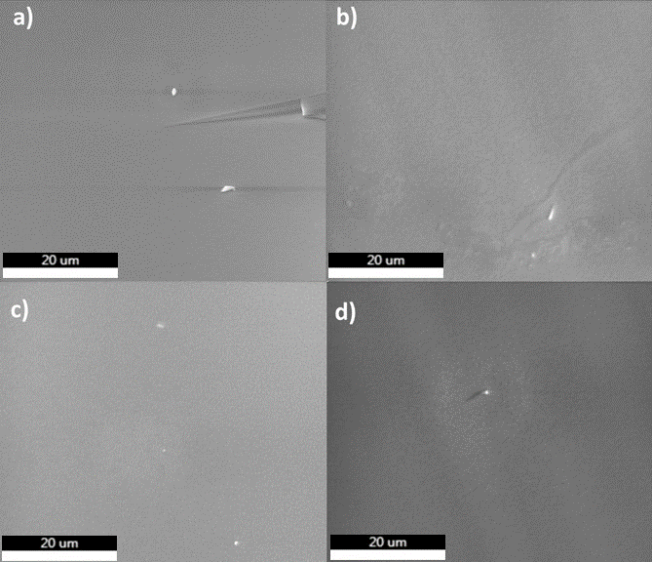
Figure 1. SEM micrographs of fresh fractured samples from series I: a) 1M2SN, b) 2M1SN c) 0M3SN. and series II: d) 3M1MN.

Figure 1. shows example micrographs for samples from series I: a) 1M2SN, b) 2M1SN c) 0M3SN, and series II: d) 3M1MN. The micrographs display a homogeneous structure typical for glasses without visible inhomogeneities. The topography for the other glasses appears similar. Figure 2 presents the XRD curves for example samples from series I (a) and series II (b). All samples exhibit an amorphous bump confirming their glassy structure. However, most samples from series I also show single small and broad reflections which can be correlated with the crystalline phase of nanometer size. Samples 1M1SN and 1M3SN exhibit one reflection correlated with the NbP crystalline phase, while in samples 1M4SN and 0M2SN, visible reflection can be assigned to the Na₂SiO₃ phase. In samples 0M3SN and 2M1SN, few observed reflections may be correlated with Na₄Ca₄(Si₆O₁₈) phase. The higher tendency of series I samples to crystallize may suggest that the added Si₃N₄ act as a nucleation agent. In such a case, the gradual cooling method applied may be too slow to avoid the nucleation in the samples. However, visible reflections might also be due to instrument error, hence, all samples are referred to as glasses.

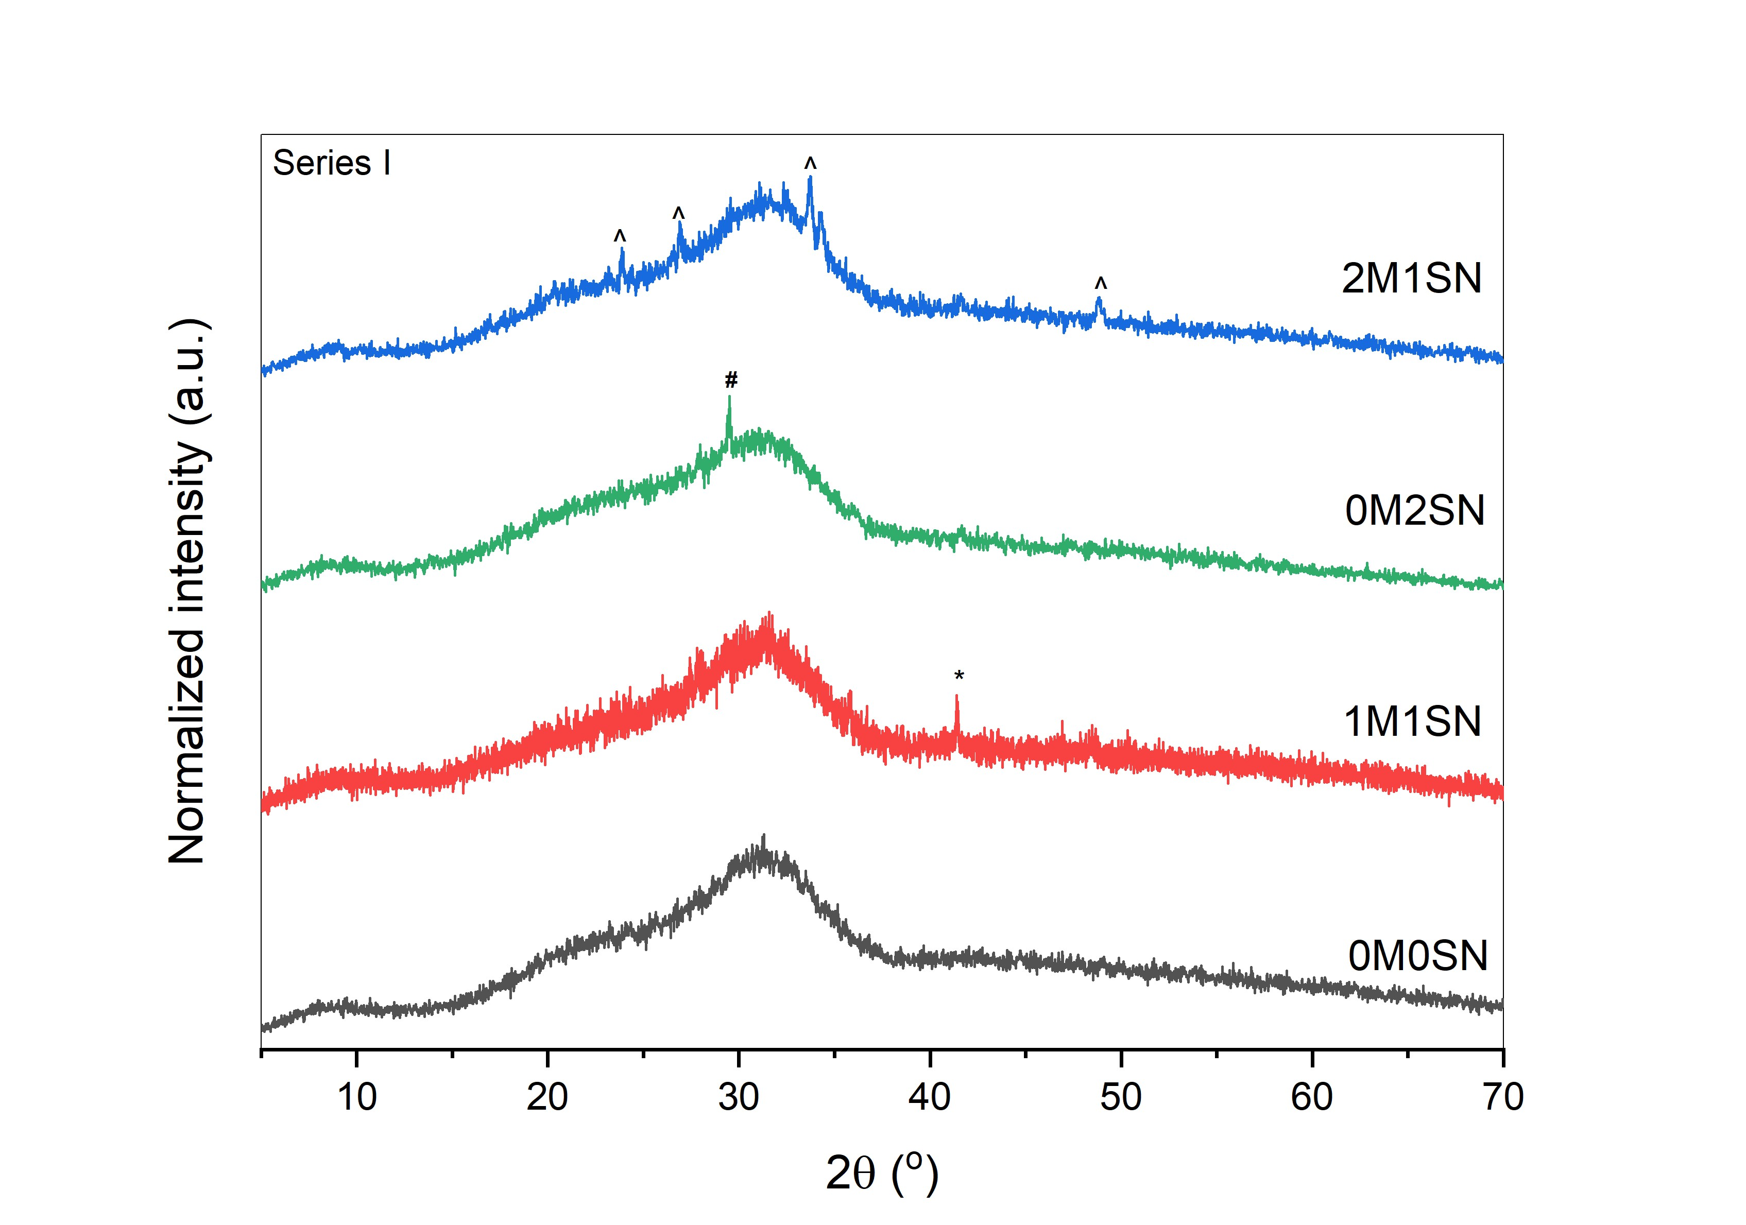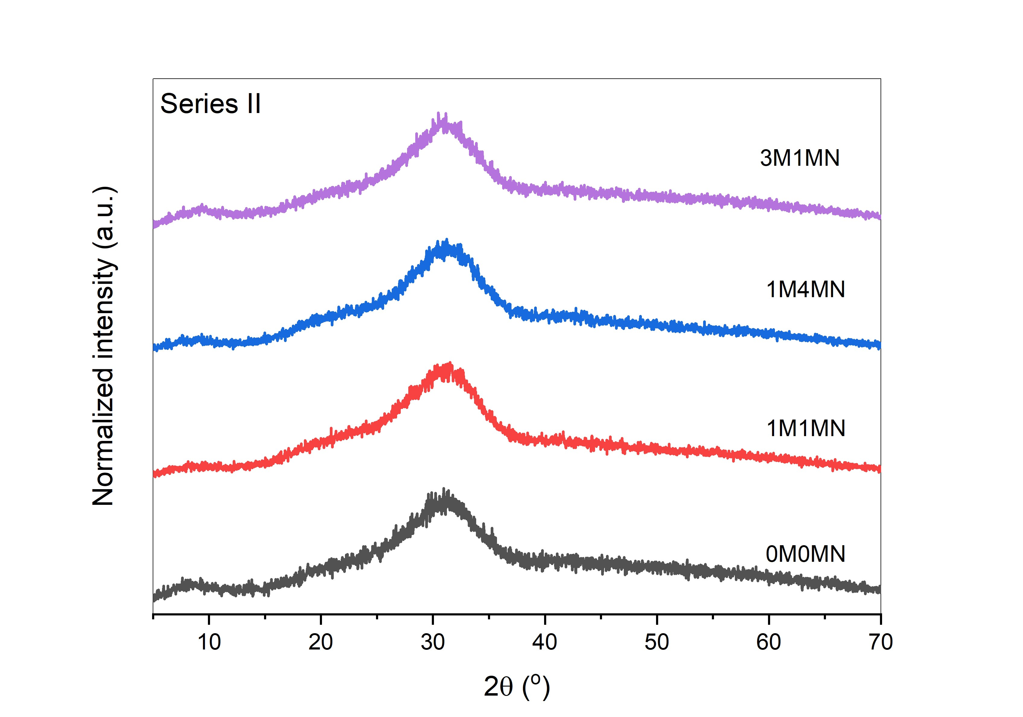
Figure 2. XRD curves for example samples of a) series I and b) series II. Signature * is assigned to crystalline phase of NbP, reference code: 01-086-0790, ICSD collection code: 081493 [53], # Na₂SiO₃ reference code: 01-082-0604, ICSD collection code: 074640 [54], and ^ Na₄Ca₄(Si₆O₁₈) reference code: 01-075-1687, ICSD collection code: 031246 [55].

The compositions of glasses serve as a basis for calculating network connectivity (NC), representing the average number of bonds linking each repeat unit in the network. Phosphorus dissolved in small amounts in silicate glasses exists generally as an orthophosphate complex, rather than entering the silicate glass network. This implies that P₂O₅ initially creates tetrahedral [PO₄]³⁻ units, with the remaining oxygen atoms subsequently modifying the silicate matrix [56,57]. Considering phosphorus as an orthophosphate complex ([PO₄]³⁻ tetrahedra) in the silicate network the NC can be described as [57]:

${NC}_{Si(P)}=\frac{4\left[{SiO}_{2}\right]+6\left[P_{2}O_{5}\right]-2(\left[M_{2}O\right]+\left[M^{´}O\right])}{\left[{SiO}_{2}\right]}$ (1)

The NC values are listed in Table 2. In series I the NC reaches a maximum value of 2.46 observed for parent glass, but after doping with Mg and Si₃N₄ it decreased.
A similar behavior of reducing the NC values in the glass after melting compared to the parent material is observed for samples in the second series. However, in this case, the NC values are generally lower than those in the first series. Through evaluating the NC of various glass compositions that exhibit distinct bioactivities, measured in terms of either the rate of hydroxyapatite (HA) layer formation or bone bonding capability, an empirical threshold of approximately NC=2.7 has been suggested. This value distinguishes bioactive glasses (NC<2.7) from their bio-inactive counterparts (NC>2.7). A low NC signifies glass structures that are open and fragmented [57,58]. These structures exhibit swift partial dissolution in a physiological aqueous environment, resulting in the accelerated formation of HA and quicker bone bonding compared to glasses with a more interconnected network. For comparison, the NC value for the widely recognized 45S5 bioglass is 2.11, while for S53P4, it is 2.54. The lower values found for current glasses suggest their possible bioactive properties.

Table 2 The O:Si ratio is based on the premise that P₂O₅ initially forms [PO₄]³⁻ tetrahedra, and only the remaining oxygen atoms modify the silicate network. The NC also considers the presence of phosphorus in an orthophosphate environment (Eq.1). Refer to Table 1 for details on all glasses. Thermal properties of glasses are represented by: glass transition temperature T_{g}, temperature of crystallization process T_{cr}, and thermal stability S.
ID | O:Si | NC | T_{g}  (ºC) | T_{cr}  (ºC) | S  (ºC)
I series
0M0SN | 2.51 | 2.46 | 532 | 767 | 235
0M2SN | 2.37 | 2.43 | 561 | 800 | 239
0M3SN | 2.53 | 2.22 | 558 | 790 | 232
1M1SN | 2.49 | 2.31 | 573 | 780 | 207
1M2SN | 2.49 | 2.22 | 550 | 772 | 222
1M3SN | 2.55 | 2.24 | 548 | 772 | 224
1M4SN | 2.49 | 2.41 | 573 | 802 | 229
2M1SN | 2.49 | 2.27 | 540 | 786 | 246
3M1SN | 2.50 | 2.13 | 560 | 744 | 184
II series
0M0MN | 2.81 | 2.43 | 517 | 758 | 241
1M1MN | 2.49 | 2.10 | 523 | 768 | 245
1M2MN | 2.92 | 1.96 | 525 | 797 | 272
1M3MN | 3.36 | 1.72 | 509 | 800 | 291
1M4MN | 3.09 | 1.65 | 513 | 796 | 283
3M1MN | 2.77 | 2.04 | 519 | 790 | 271

Silicate glasses containing less than 50 mol% of SiO₂ exhibit highly disrupted structure. Alkali ions in high concentrations and less mobile calcium ions penetrate the silicate network, breaking the silicon-oxygen bonds (Si-O-Si). As a consequence, they lead to the formation of non-bridged oxygen groups, which then stabilize in the SiO₄ network. Depending on the composition of the glass they may prefer to balance the charge of different tetrahedra, for example, alkali ions prefer to balance with AlO₄ if present, while calcium ions prefer to balance with SiO₄ [59–61]. MgO is recognized as an intermediate oxide in glass formation. It can play the role of modifier or as a glass-forming agent, contingent on the alkali content present [15,16]. MgO forms the MgO₄ tetrahedra in the highly disrupted phosphate-silicate glass network [14]. Nb⁵⁺ cations also break Si-O-Si bonds and form different polyhedral [Nb(OM)_{6_y}(OSi)_{y}], where 1 ≤ y ≤ 5 and M = Na, Ca, or P [62]. The considerations about the role of cations in silicate networks are taken also into account in calculations of the O:Si ratio, listed in Table 2. Series I, glasses which have lower P content, the O/Si ratio varies between 2.37 and 2.55, suggesting the domination of Q³ silicate units with 3 bridging oxygens [63,64]. In series II glasses, where the P content is higher and Si content is lower compared to series I, the ratio increases even beyond 3.0, indicating the domination of Q² units and the possible presence of Q¹ units in the structure. Figure 3. displays IR spectra for example samples from series I and series II. In all the tested glasses, the visible bands exhibit a rounded shape, indicating their amorphous nature. There are no visible sharpened bands correlated with the crystalline phase. The IR spectrum of the parent glass in series I (Fig. 3a) shows dominant bands at 1035 and 938 cm⁻¹, corresponding to the Si–O vibration of silicate tetrahedral containing non-bridging oxygens Q³ and Q², respectively [12,48]. The band observed at 1035 cm⁻¹ is asymmetric with a small shoulder distinguished around 1160 cm⁻¹ correlated with the presence of Q⁴ units [65–67]. Another, high intense band at 494 cm⁻¹ along with a lower intensity band at 755 cm⁻¹ results from the bending modes of the symmetric Si–O–Si or O–Si–O and Si–O–Si stretching vibrations of oxygen bridging between two adjacent SiO₄ tetrahedra, respectively [64]. The last noticeable band at 591 cm⁻¹ can be interpreted as a characteristic of the P-O bending mode, indicating the presence of non-apatite or amorphous calcium phosphate (ACP) [49]. Typically, ACP indicates the presence of apatite precursors in the material [49,68,69]. This parent glass with NC value of 2.46 and an O:Si ratio of 2.51 (Table 2), pointing to a depolymerized silicate network, formed mostly by Q³ silicate units. However, in modified glass, the generalized equilibrium takes place 2 Q^{n} ↔ Q^{n-1} + Q^{n+1} (0 < n < 4) [67]. Therefore the analysis of the FTIR spectrum suggests the presence of all Q⁴, Q³, and Q² units with domination of Q³ unit. Additionally, the IR spectrum shows a weak band in the area of 1633 cm⁻¹, which can be correlated with the presence of small amounts of water absorbed from humidity during the preparation of pellets for infrared measurements [70].
The IR spectra of re-melted samples do not show significant changes. However, in series I glasses, the band at 591 cm⁻¹ visibly decreases in intensity when compared to the parent glass. In samples 1M3SN, 1M4SN, and 0M3SN this band completely disappears. Moreover, for the other samples, there is a partial overlap of the bands at 491 and 591 cm⁻¹ visible in the form of asymmetry of the band (491 cm⁻¹) and a characteristic shoulder. This is related to the decrease in the amount of phosphates in the glass structure. The relative intensity of this band decreases with decreasing P content in all glasses. Such changes indicate the lower content of ACP in the doped glasses compared to the parent one. In samples doped with 3 and 4 %mol of Si₃N₄ content: 1M3SN, 1M4SN, and 0M3SN, the relative intensity of band around 938 cm⁻¹ slightly increases due to an increase in the content of Q² units and consequently higher depolymerization of the network. Additionally, the asymmetry of the main band slightly softened after re-melting, indicating a decrease in the content of Q⁴ units. Both subtle changes are a consequence of doping. A new small band around 1435 cm⁻¹ is present in most of the doped glasses which can be interpreted as asymmetric stretching of the C-O groups originating from air [70].
The IR spectrum of the parent glass 0M0MN in series II (Fig. 3b) also shows bands at the same positions as glass 0M0SN in series I, despite the partial substitution of Ca by K. Only one additional band was observed at 1435 cm⁻¹ similar to the doped series I samples. Subtle changes can also be observed in the slightly lower intensity of the Q² band and more pronounced shoulder from the Q⁴ band, both typical for increased polymerization of the glass network. However, these observations are in contradiction to theoretical predictions. It is possible that alkali ions, which are in higher content in this sample, prefer to charge balance AlO₄ while the lower content of calcium ions influences the residual silicate network [59–61]. After doping, samples of series II exhibit analogous changes to series I. The band correlated with Q⁴ is not distinct in their IR spectra, while the phosphate band overlaps with the band of bending modes of the symmetric Si–O–Si or O–Si–O. In these samples, the phosphorous content is still high enough for its presence to be visible.

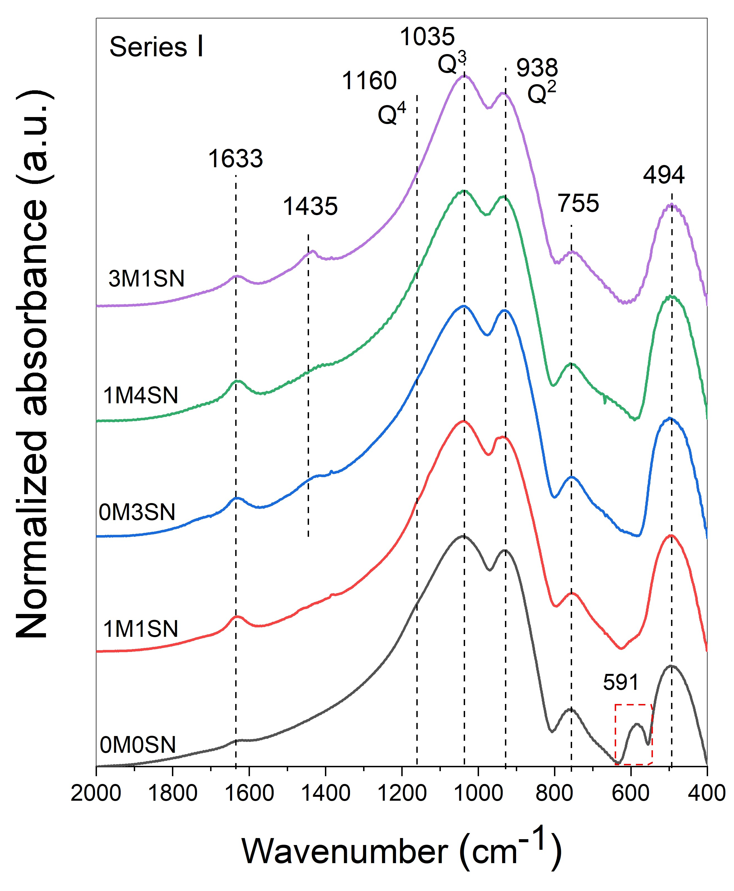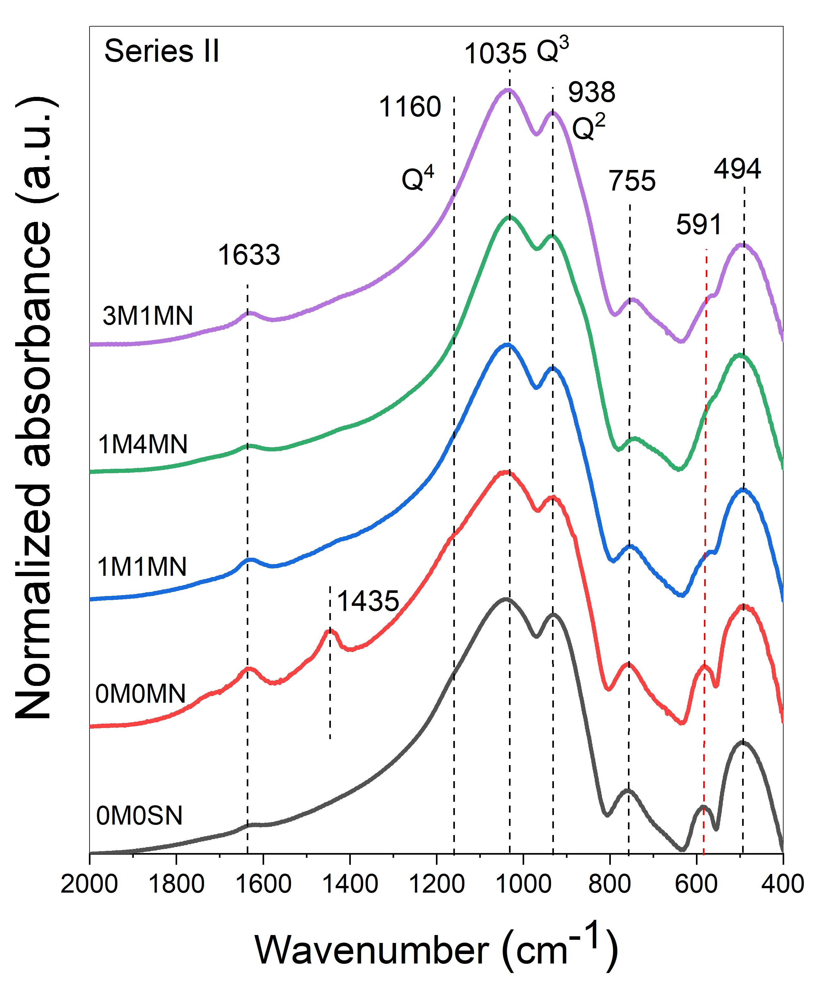
Figure 3. FTIR spectra for example left) series I glasses and right) series II glasses with parent glass from series I.
Figure 4a shows the DSC curves for representative samples: 0M0SN, 1M3SN, 0M0MN, 1M1MN. The first endothermic drift corresponds to the glass transition temperature T_{g}, while the exothermic process is attributed to the crystallization T_{cr}. Both characteristic temperatures are marked in the figure. DSC curves for the remaining samples were similar. The obtained thermal properties results are summarized in Table 2. The parent glass in series I exhibits a T_{g} of 532 ºC, while doped glasses show higher values, reaching up to 573 ºC. This increase can be explained by a higher content of Si incorporated into the glass network with Si₃N₄. This element plays a crucial role in the forming glass network, and therefore, its amount can significantly influence the thermal behavior of glass. The increase in the glass transition temperature can also be correlated with the incorporation of nitrogen, which caused the increase in the degree of crosslinking while Si-N bonds replaced Si-O bonds [46,47]. Two samples: 1M4SN and 1M4SN with detected 1 at% of N, showed significantly higher T_{g} (573 ºC) values than the others. However, Mg, Nb, and Al ions can also influence the glass transition temperature. Their effect usually, depends on their content as a consequence of related changes in the glass structure. Alkali ions usually, decrease the glass transition temperature of silicate glass due to breaking of Si-O bonds and thus loosening the glass network as typical modifiers [29]. When selecting the decisive parameter dominating thermal behavior trends, all compositional changes were taken into account, and ultimately, the silicon content proved to be the most important as shown in Figure 4b and 4c. The observed dependence follows a close to linear trend and deviations from it are the result of the influence of other dopants. Glasses in series II also fit into silicon dependence despite being doped with Mg₃N₂ instead of Si₃N₄. These glasses exhibit lower values of T_{g} (around 30 - 40 ºC) compared to series I. The important influence is the substitution of quite a significant amount of monovalent potassium ions in exchange for divalent calcium ions. By replacing stronger Ca-O bonds with weaker K-O bonds, the glass network weakens, leading to a decrease in its glass transition temperature [71]. Another important factor is the lower silicon content and the complete lack of nitrogen observed in the series II samples. These factors significantly impact the degree of polymerization, which may translate into a higher T_{g} in glasses from series I. Furthermore, P and Mg amounts may also affect the T_{g}. Mg usually increases the T_{g} depending on its concentration and the overall composition of the glass.

a)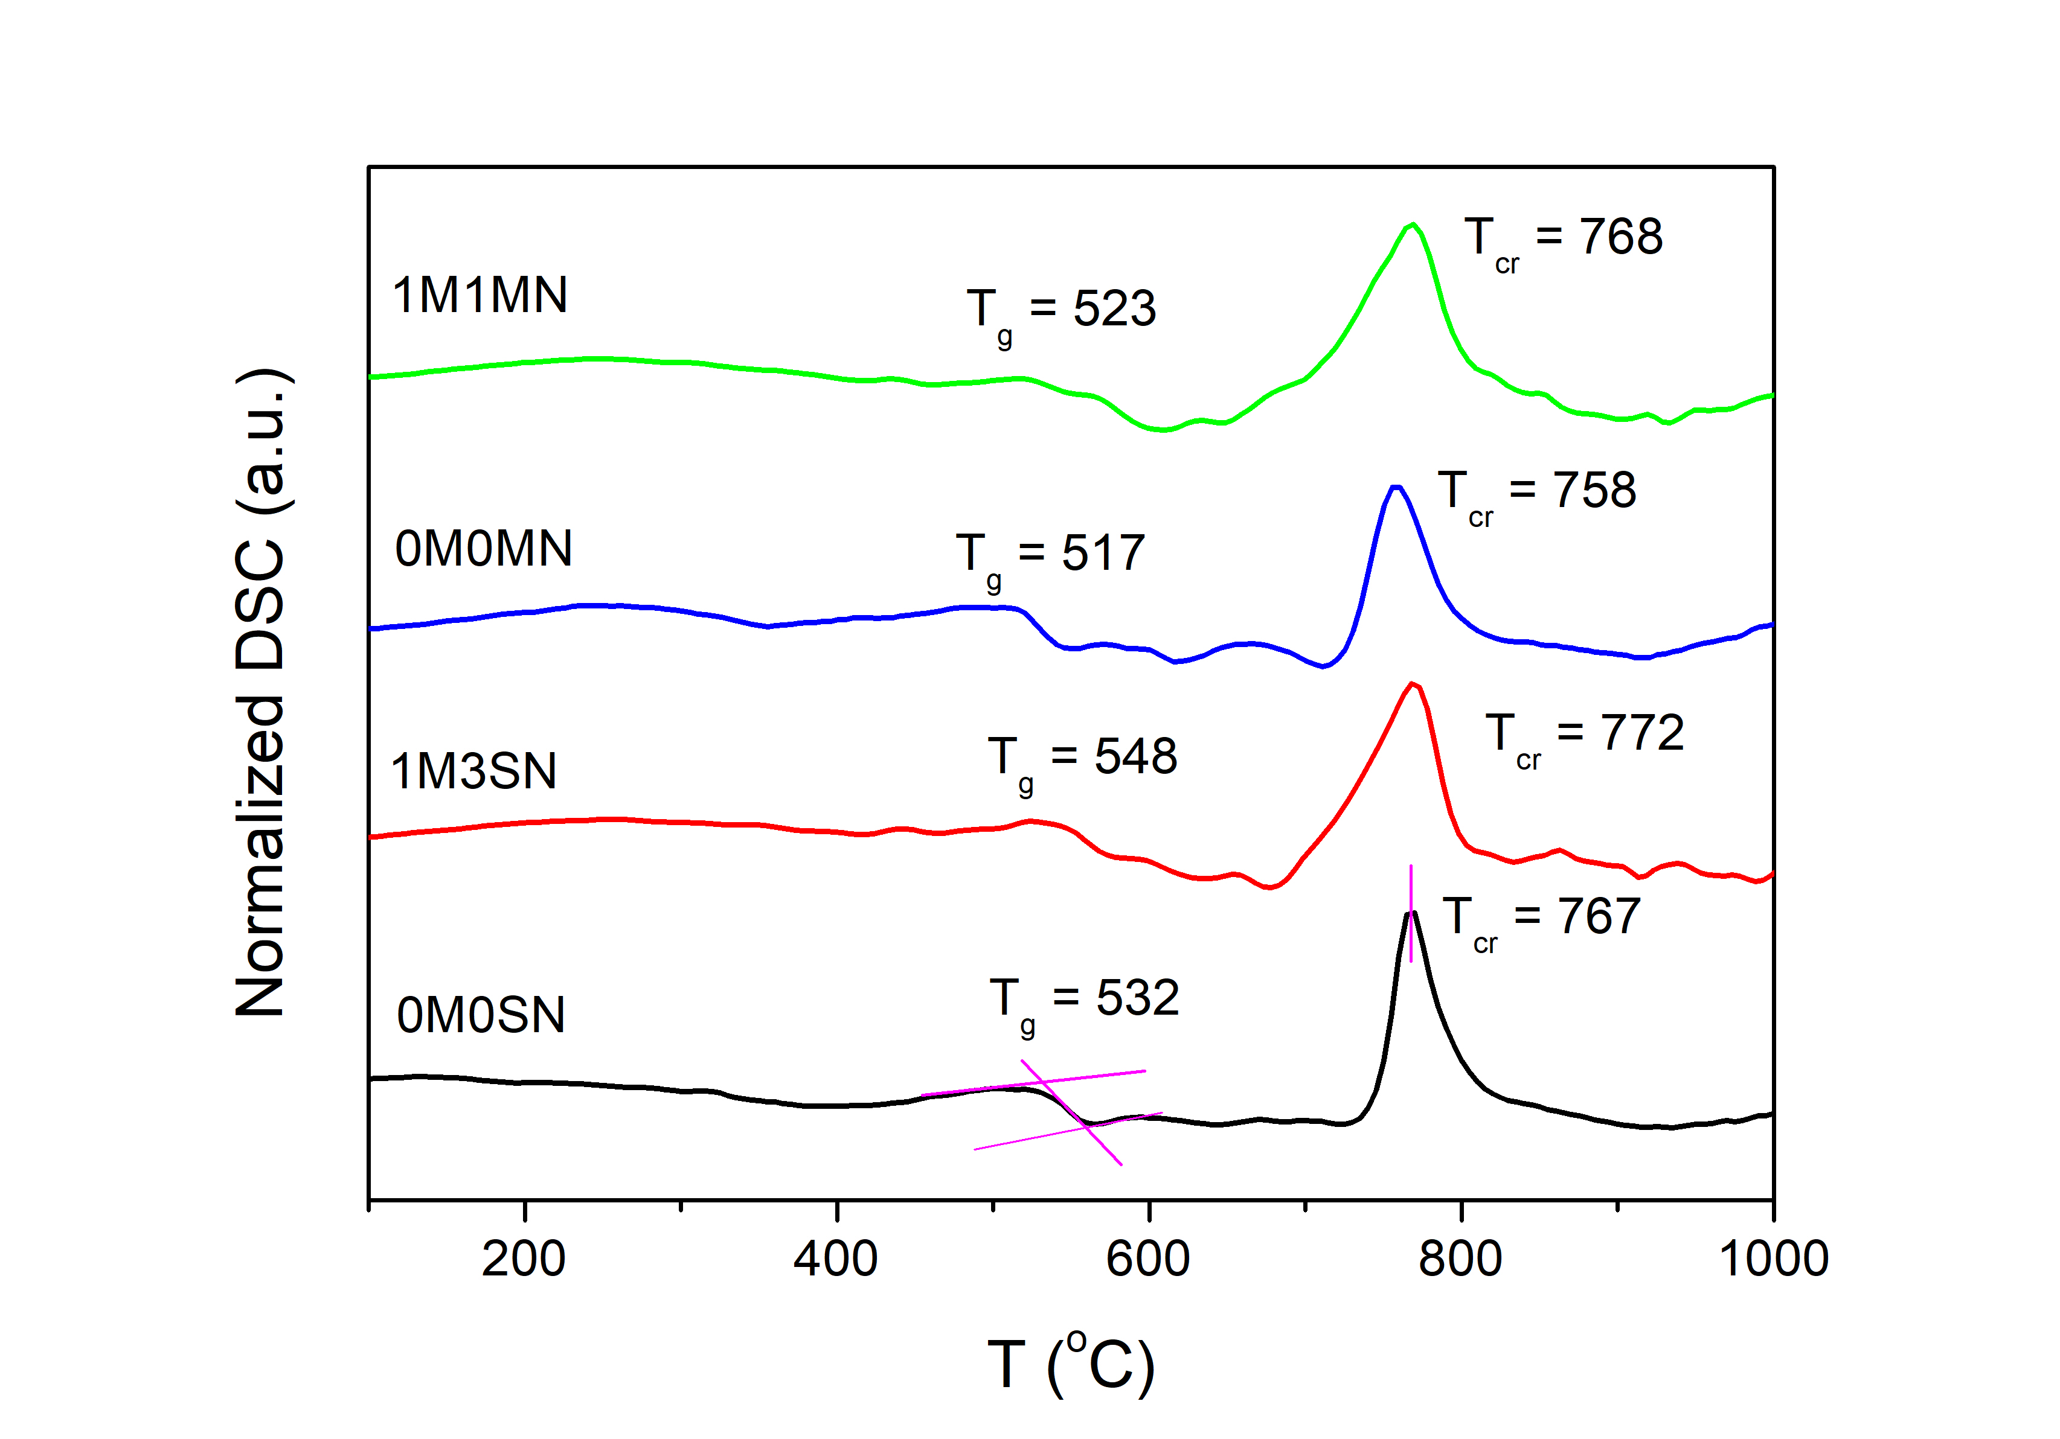
b)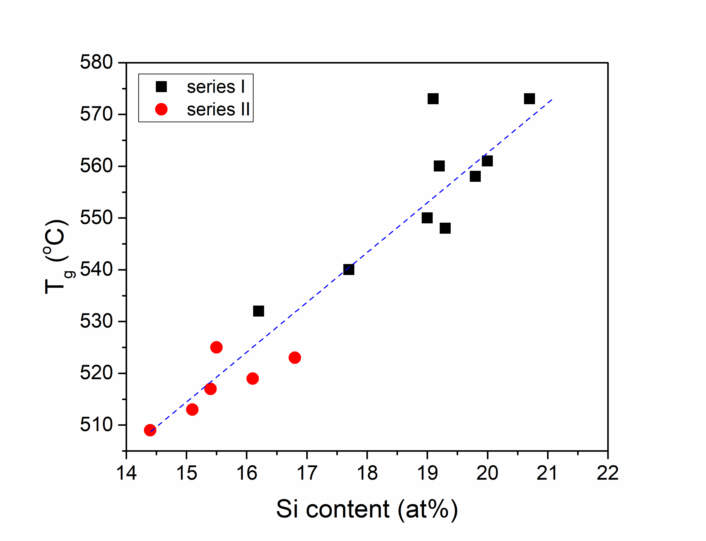c)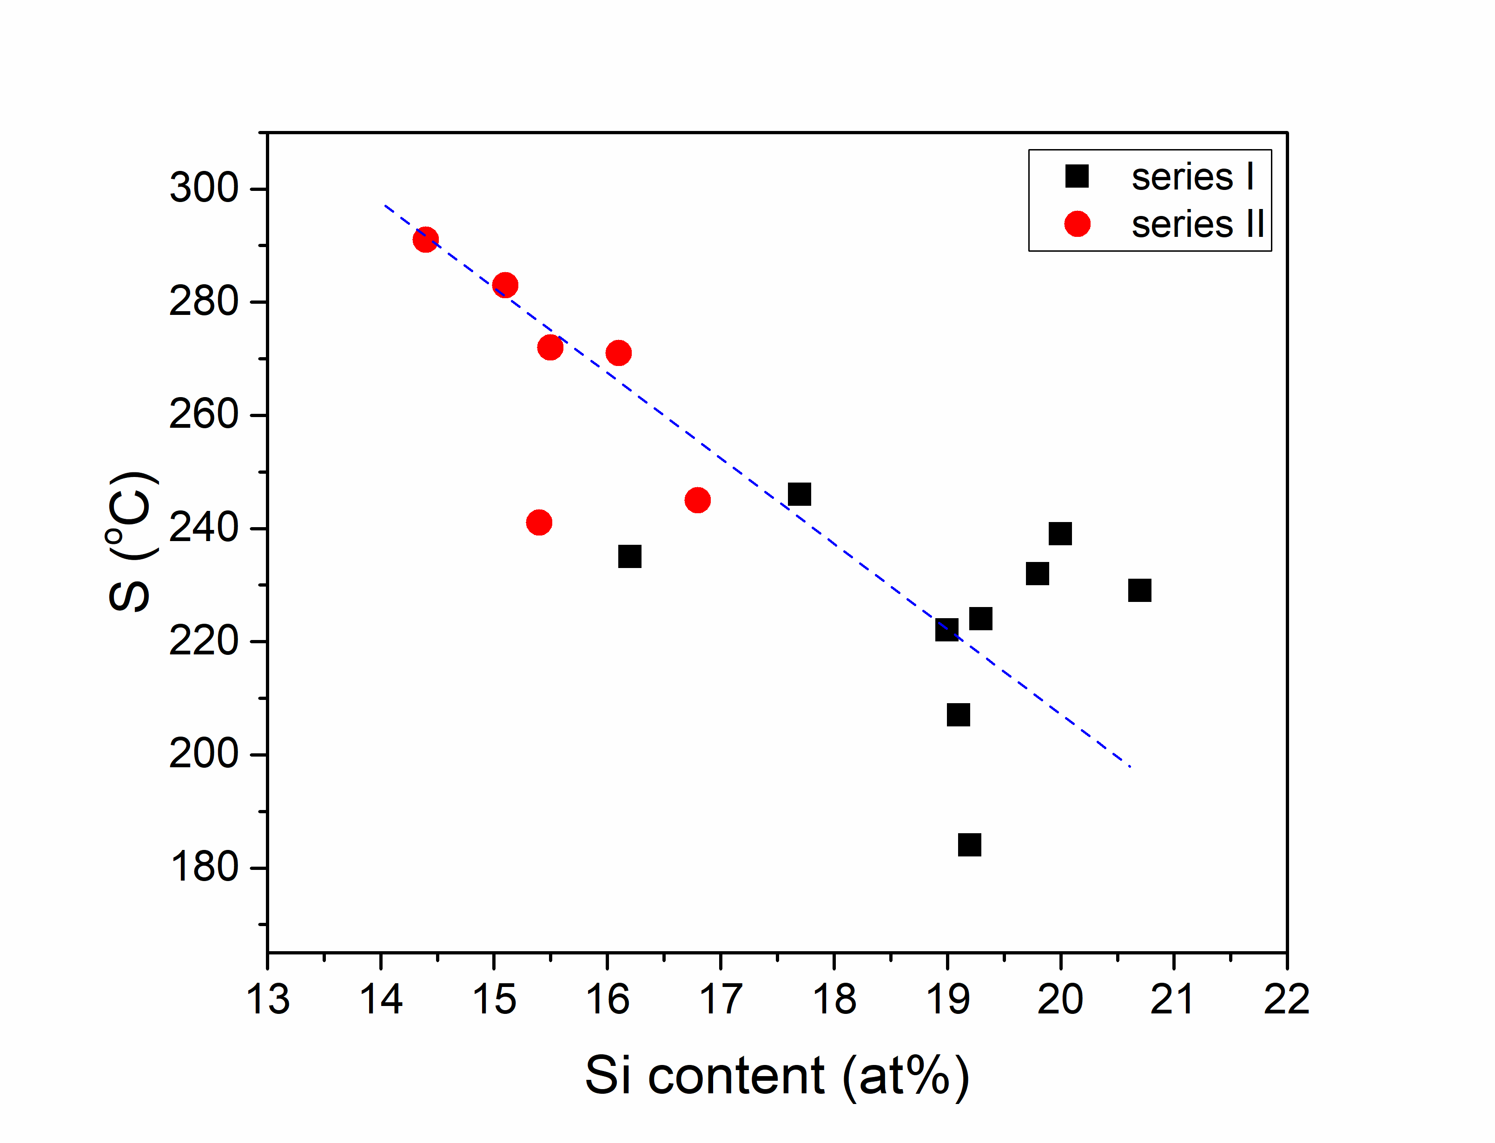
Figure 4. a) DSC curves for representative samples: 0M0SN, 1M3SN, 0M0MN, 1M1MN. Thermal properties: b) glass transition temperature and c) thermal stability as a function of Si content for all glasses (solid lines are for eyes guide).
Thermal stability (S) value allows to determine the temperature range in which bioactive glasses can be sintered in the form of bone scaffolds without affecting their amorphous nature. Glass stability is the difference between the value of the first crystallization process and the glass transition temperature, presented as S = T_{cr} – T_{g}. The parent glasses have S values of 235 °C for series I and 241 °C for series II, respectively. In series I, almost all glasses exhibit lower or similar S values to the parent glass. In series II, the situation is the opposite, all doped glasses show an increase in S values due to the incorporation of high Mg content. Magnesium has been shown to support the sintering window or "working range" in silicate glass and inhibit crystallization [14]. However, thermal stability also presents the highest dependence on silicon content in both series as shown in Figure 4c. Increasing the silicon content decreases the S of the glasses. The most significant differences were found for increasing the silicon content between two samples of the same series, 2M1SN (17.7 at% Si) and 3M1SN (19.2 at% Si), resulting in a decrease in the glass stability of up to 68°C. Similarly in series II, between samples 1M1MN (16.8% at. Si) and 1M3MN (14.4% at. Si), the decrease of S was found to be 46°C. However, glass thermal stability is also dependent on other network modifiers.

  - In vitro dissolution assessment in dynamic and static modes
    - PBS changes
The in vitro dissolution process in PBS is a complex process and therefore changes in the pH of the solutions were regularly measured. The samples were tested in parallel using two modes, static and dynamic, and the results are shown in Figure 5. During static dissolution, the pH of the solutions for the series I samples increased during the first two days of immersion, reaching values between 10.5 and 9.5, and then stabilized or exhibited a slight decrease. Solutions with series II samples showed an increase in pH within the first two days after immersion, followed by stabilization and a minor decrease, with pH values ranging between 10.0 and 9.0. Samples tested in the dynamic immersion mode showed an increase in pH each day after the PBS change. The observed increase in pH is lower with each subsequent replacement of the solution. The large increase in the pH of the solutions after immersing the samples is mainly caused by the exchange of alkaline ions on the glass surface, i.e. Na⁺, K⁺, Ca^{2+,} and Mg²⁺ with H⁺ or H₃O⁺ ions from the solution. Additionally, due to the increase in the concentration of OH⁻ ions on the glass surface, the Si-O-Si bridge bonds break, leading to the transfer of orthosilicic acid Si(OH)₄ into the liquid [19]. Consequently, there is a further increase in pH. Both of these phenomena related to the glasses dissolution occur at a linear rate until the equilibrium pH is reached. The alkaline environment favors the nucleation of hydroxyapatite, which significantly depletes the solution of calcium ions and, to a lesser extent, phosphorus and OH⁻ ions. The deposition of hydroxyapatite on the surface of the glasses, results in a slight drop in pH in the remaining solution. This slight pH decrease might be attributed to the breaking of P-O-P bonds due to the continuous exposure to water, causing the release of [PO₄] units from the glass lattice into the solution. Phosphorus cations tend to combine with protons and form phosphoric acid, which decreases the pH of the solution [72–74]. However, considering that the phosphorus content in the tested samples was very low compared to the amount of phosphorus ions in the PBS solution, this process may have little effect on the pH of the solution. The significantly lower pH values observed for solutions with immersed glasses of the II series, compared to the I series, may be due to the lower silicon and higher phosphorus content. A similar situation occurs when comparing samples from series I during static dissolution. Glasses 0M0SN and 2M1SN are characterized by the lowest silicon content and consequently, the increase in pH was also the lowest in their cases. However, the effect of incorporating magnesium and nitrogen into the 2M1SN sample is only visible within the first 24 hours of immersion, where the pH of the solution is markedly lower. This lower value of pH can be assigned to the partly delayed release of silicon due to strong silicon-nitrogen binding. However, no similar behavior was found for other samples containing nitrogen and magnesium. On the other hand, the most significant increase in pH was observed in the solution after immersing sample 0M3SN, which contains the highest amount of calcium along with the high quantity of silicon. In the dynamic mode, the behavior of samples 2M1SN and 3M1SN noticeably differed from others, especially during the first stages of immersion. Over the long-term dissolution, the pH of most solutions is getting closer and reaches values between 8 and 8.8. Only sample 2M1SN causes a further high increase in the pH of the solution up to 9.5 possibly due to the further release of sodium ions. In the static mode, the difference in pH of solutions with immersed samples of series II is lower than for series I. The lowest pH values were observed for immersion of sample 1M3MN with the lowest content of silicon while the highest was observed for sample 0M0MN with the highest sodium quantity and quite high silicon content. In the first stage of immersion during dynamic mode, there were no visible differences between pH which became visible during long-term incubation. Most probably, the silicon content is also crucial in this case.
Figure 5. pH changes of PBS during 10 days of immersion of series I (left) and II samples (right) in static (up) and dynamic (down) modes.

The investigation of ions concentrations in PBS solutions was exclusively conducted under static testing conditions, following a 10-day immersion of the samples. The tests were performed primarily to confirm the release of calcium ions into the PBS, necessary for hydroxyapatite formation and the subsequent decrease in phosphorus ions concentration in the PBS. Table 3 presents the release values of Na, Ca, P, K, Mg, and Nb ions in the solutions. The release of the Si element was not studied, as the existing literature data already confirmed its rapid dissolution. Notably, the total Na ion content in PBS remained high across all samples, confirming the release of Na ions from the sample surface into the solution. Additionally, the concentration of Ca ions increased in all solutions, with a more pronounced elevation observed in series II. It is important to note that PBS does not inherently contain Ca, all Ca content originates from the glass surface. Furthermore, the content of P ions decreased in comparison to PBS before samples immersion. Changes observed for Ca and P ions are expected and suggest possible precipitation of hydroxyapatite from the solution and its deposition on the surface of the samples. The PBS displayed a discernible reduction in the concentration of K ions after immersion of all samples from series I and most of the samples from series II. Furthermore, Mg was detected in PBS only after immersion sample 2Mg1SN from the series I and in trace amounts in the series II samples. This observation may be linked to the limited quantity of Mg introduced into the glass network, particularly in series I, and its robust bonding with the structure. Interestingly, Al ions were not identified in any of the samples, further suggesting their strong association with the silicate network. Despite the relatively low content of Nb in the examined series I samples and its absence in series II, its presence is discernible in each tested solution. The highest content of Nb was found for sample 1M1SN. The results suggest that even in series II a trace amount of niobium occurred which was not detected by EDX.

Table 3. The ions concentrations in PBS after 10 days of immersion in static mode by MP-AES analysis.
Elements in PBS
 | Na  (568.3 nm) |  |  | Ca  (430.3 nm) |  | P  (213.6 nm) |  | K  (404.4 nm) |  | Mg  (279.6 nm) |  | Nb  (313.1 nm)
ID | c (mgl⁻¹) | U |  | c (mgl⁻¹) | U | c (mgl⁻¹) | U | c (mgl⁻¹) | U | c (mgl⁻¹) | U | c (mgl⁻¹) | U
PBS | 3019 |  |  | 0 |  | 331.8 |  | 470 |  | 0 |  | 0
Series I samples
0M0SiN | 3954 |  | 14 | 0.74 | 0.01 | 192.0 | 0.6 | 439 | 20 | <LOQ | - | 0.33 | 0.02
0M2SN | 4016 |  | 21 | 1.49 | 0.16 | 155.9 | 0.3 | 338 | 38 | <LOQ | - | 13.00 | 0.14
0M3SN | 3822 |  | 10 | 0.65 | 0.02 | 142.2 | 0.3 | 384 | 27 | <LOQ | - | 0.27 | 0.01
1M1SN | 3626 |  | 14 | 0.82 | 0.02 | 156.0 | 0.7 | 395 | 10 | <LOQ | - | 51.94 | 0.57
1M2SN | 4251 |  | 31 | 1.58 | 0.16 | 154.8 | 0.2 | 461 | 28 | <LOQ | - | 3.11 | 0.10
1M3SN | 4082 |  | 13 | 4.82 | 0.22 | 164.2 | 0.5 | 407 | 20 | <LOQ | - | 1.74 | 0.27
1M4SN | 3781 |  | 18 | 1.76 | 0.12 | 150.4 | 0.4 | 407 | 16 | <LOQ | - | 0.40 | 0.02
2M1SN | 3712 |  | 19 | 1.43 | 0.17 | 189.8 | 0.6 | 319 | 31 | 0.13 | 0.01 | 0.46 | 0.02
3M1SN | 3697 |  | 14 | 1.42 | 0.11 | 168.9 | 0.6 | 371 | 28 | <LOQ | - | 25.11 | 0.16
Series II samples
0M0MN | 4000 |  | 25 | 1.21 | 0.11 | 204.6 | 0.6 | 559 | 12 | <LOQ | - | 0.94 | 0.01
1M1MN | 3992 |  | 13 | 5.43 | 0.27 | 183.0 | 0.4 | 596 | 23 | 0.12 | 0.01 | 3.72 | 0.16
1M2MN | 3635 |  | 15 | 2.32 | 0.14 | 192.5 | 0.4 | 389 | 36 | 0.45 | 0.02 | 0.30 | 0.02
1M3MN | 3613 |  | 20 | 2.89 | 0.10 | 196.0 | 0.5 | 438 | 24 | 0.78 | 0.01 | 0.47 | 0.01
1M4MN | 3492 |  | 17 | 2.63 | 0.15 | 193.4 | 0.4 | 411 | 18 | 0.99 | 0.03 | 0.31 | 0.01
3M1MN | 3751 |  | 17 | 2.37 | 0.13 | 190.0 | 0.6 | 474 | 29 | 0.42 | 0.02 | 0.62 | 0.01

    - Characterization of glasses after immersion
After the in vitro dissolution test, the samples were measured again. The resulting changes in mass are outlined in Table 4, revealing measurable mass losses ranging from 16% to 50% in static mode and from 28% to 66% in dynamic mode. This variation in mass loss depends on the composition of the tested material. The static dissolution tests of series I, revealed the highest mass loss in glasses 0M2SN, 0M3SN, 1M2SN, and 1M3SN, around 50%. These materials lacked magnesium in their structure or contained a minimal amount, approximately 0.3 - 0.4 at.%, and were also richer in calcium. Conversely, samples with around 1 at% of magnesium and lower calcium content demonstrated up to half the mass loss compared to those without magnesium. In series II static testing, similar trends in mass changes were observed, with sample 1M1MN exhibiting the most significant loss. Notably, this sample possessed the lowest magnesium content at 1.4 at% and the highest calcium content. However, the other series II samples generally exhibit lower mass loss compared to series I. This could also be linked to the lower silicon concentrations in series II, as silicon is known to release quickly from silicate glasses.
As anticipated, the dynamic test exhibited a more pronounced mass loss compared to the static test. This phenomenon is attributed to the continuous exchange of ions between the solution and the glass surface. In the body, body fluids are in constant motion, and the bones are constantly flushed with fresh fluid characterized by the constant presence of K, Ca, Mg and P ions and a constant pH level. When glass undergoes dissolution, there is an escalation in the concentration of specific ions in close proximity to the material, originating from the glass surface. This, in turn, leads to alterations in pH levels around the material, which subsequently decelerates the dissolution process. Consequently, it is observable that in a dynamic test, where new fluid is intermittently introduced, more substantial pH fluctuations and increased ion exchange take place.
Subsequently, the samples were subjected to scrutiny for the formation of a hydroxyapatite (HAp) layer, undergoing analysis via SEM-EDS and XRD.

Table 4. The mass loss and Ca/P ratios examined by EDX after 10 days of immersion in static and dynamic mode.
ID | Mass loss  (%) | Mass loss  (%) | Ca/P_{b} | Ca/P_{as} | Ca/P_{ad}
 | after immersion  in static mode | after immersion  in dynamic mode | before immersion | after immersion  in static mode | after immersion  in dynamic mode
0M0SN | 24 | 41 | 2.31 | 1.83 | 1.73
0M2SN | 47 | 57 | 6.87 | 1.97 | 1.66
0M3SN | 50 | 56 | 19.67 | 2.02 | 1.64
1M1SN | 38 | 46 | 7.59 | 1.79 | 1.60
1M2SN | 49 | 65 | 8.07 | 1.82 | 1.87
1M3SN | 48 | 57 | 12.24 | 1.66 | 1.59
1M4SN | 26 | 47 | 70.33 | 1.59 | 1.89
2M1SN | 25 | 41 | 3.60 | 1.84 | 1.55
3M1SN | 26 | 66 | 11.38 | 1.81 | 1.44
0M0MN | 28 | 39 | 2.10 | 1.63 | 1.44
1M1MN | 27 | 51 | 3.49 | 1.67 | 1.68
1M2MN | 21 | 28 | 2.73 | 1.93 | 1.62
1M3MN | 16 | 32 | 3.73 | 1.96 | 1.79
1M4MN | 21 | 42 | 2.87 | 2.39 | 2.38
3M1MN | 19 | 40 | 3.21 | 1.61 | 1.64

SEM was employed to visualize the surface of the examined samples after immersion in PBS under both static and dynamic testing conditions. Figure 6 displays micrographs of example samples surfaces: a) 0M0SN (static mode), b) 0M3SN (static mode), c) 1M1MN (dynamic mode), and d) 1M2MN (dynamic mode). The topography of the other samples was similar. A discernible layer was identified on each sample, and to ascertain their composition, measurements were conducted using EDX.
The EDX findings reveal that, for all glasses, the content of Ca and P on the surface exhibited an increase post-immersion in PBS, in comparison to the analyzed compositions of glasses obtained after the melting process as outlined in Table 1. Conversely, the concentration of Na and Si on the surface notably decreased in all samples. This is in accord with the previous results, indicating the release of Na and Si from the glass surface into the solution, followed by the deposition of calcium phosphate layers. Moreover, the Ca/P ratio before and after immersion in static and dynamic mode was calculated for all samples, as shown in Table 4. The results show that, following the melting process, the ratio exceeded 2 in all samples, due to the low phosphorus content. However, after immersion, a significant decrease in ratio values was observed, aligning them more closely with the Ca/P ratio characteristic of Hydroxyapatite (Ca₁₀(PO₄)₆(OH)₂), which is approximately 1.67. Notably, only one sample, 1M4MN, with the lowest calcium content (4.7 at%) showed Ca/P ratio after immersions still noticeably higher than that of HAp. In this case, the calcium content might be too low for HAp to precipitate within 10 days of immersion, and the layer is composed of other calcium phosphates.

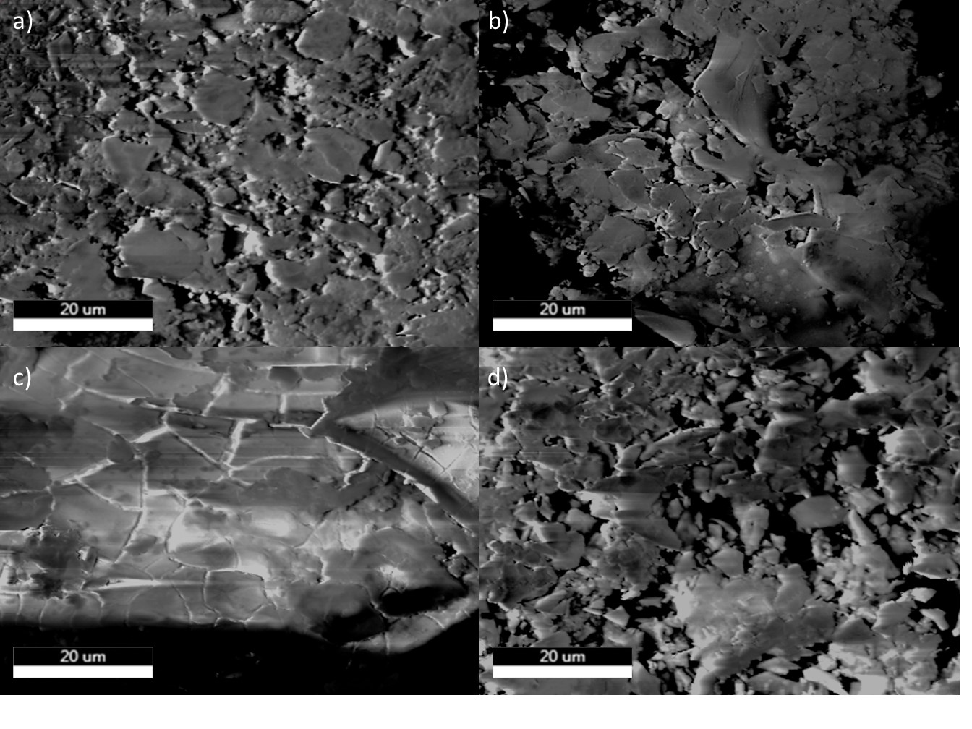Figure 6. SEM images of example samples surfaces after static and dynamic in vitro dissolution tests conducted in PBS: a) 0M0SN (static mode), b) 0M3SN (static mode), c) 1M1MN (dynamic mode), and d) 1M2MN (dynamic mode).

The XRD results from dissolution tests confirm the presence of crystalline phases in the most of samples. Figure 7 displays X-ray diffractograms for representative samples of post-static and dynamic in vitro dissolution. After the static mode test in series I, samples exhibit an amorphous halo alongside small, relatively broad reflections attributed to the HAp phase. Samples 2M1SN and 1M4SN predominantly display an amorphous spectrum, indicating their initial richness in N and low Ca content. It can be assumed that the observed layer is still amorphous and composed of calcium phosphates, which will likely transform into crystalline HAp with prolonged immersion. After static dissolution, most tested glasses in series II also exhibit amorphous halos and minor reflections associated with the HAp crystalline phase. Only the parent sample 0M0MN shows a higher degree of crystalline phase. The other two samples: 1M3MN and 1M1MN exhibit single reflection correlated with HAp. This difference is likely due to the lower content of calcium and higher magnesium content in series II compared to series I.
Similar X-ray diffraction patterns were observed for series II samples after dynamic mode dissolution. These samples predominantly exhibit an amorphous phase, except for sample 0M0MN, which displays a distinct outcome. In contrast, samples from series I demonstrate a varied response. Most samples exhibit a crystalline phase with small, yet defined reflections attributed to HAp.

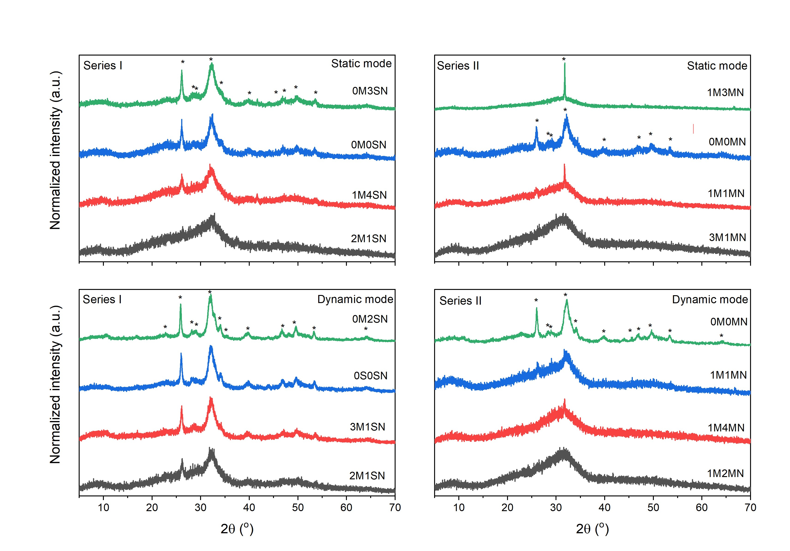Figure 7. X-ray diffraction patterns of samples: a) I series and b) II series, after immersion in dynamic mode. Signature * is assigned to crystalline phase of hydroxyapatite Ca₅(PO₄)₃(OH), reference code: 01-084-1998, ICSD collection code: 203027 [75].
Additionally, the samples after the in vitro dissolution test were examined using the FTIR technique. The obtained IR spectra for the example samples from series I: 0M3SN, 1M4SN, 3M1SN (left) and from series II: 1M1MN, 1M4MN, 3M1MN (right) are presented in Figure 8. The spectra of samples after the static test are shown in black, while those after the dynamic test are shown in red. For comparison, spectra of the starting samples (0M0SN and 0M0MN) before immersion are shown in blue. For series I samples, significant changes in the spectra can be observed after immersion. The dominant band at ~1035 cm⁻¹ corresponding to Q³ units narrowed, while the band at ~940 cm⁻¹ associated with Q² units together with ~755 cm⁻¹, completely disappeared. The band ~494 cm⁻¹ for most samples reduced the intensity significantly. These changes correlate with silicate unit dissolution into PBS. Along with the disappearance of most of the silicate bands, new sharpened bands at 605 cm⁻¹ and 565 cm⁻¹ associated with P-O bonds (HPO₄²⁻ and PO₄³⁻, respectively) formed from one rounded band [76,77] This change suggests the appearance of a phosphate phase in a crystalline form. Additionally, small sharpened bands at ~874 cm⁻¹ and ~1424 cm⁻¹ associated with O-H and C-O (CO₃²⁻) bonds, respectively, appeared [76–78]. All described bands are characteristic for HAp. Additionally, the dominant band ~1040 cm⁻¹ with a slight asymmetry around ~1100 cm⁻¹ can also be attributed to P-O bonds characteristic for HAp (PO₄³⁻) [76–78]. These results are consistent with XRD data and confirm the formation of a amorphous or crystalline HAp layer. For series II samples, analogous spectra were observed for samples 0M0MN, 1M1MN and 3M1MN as in series I, though the intensity and sharpening of P-O bands were lower, likely due to the presence of K, which may inhibit crystalline hydroxyapatite formation. IR spectra of the remaining samples, to which 2, 3 and 4 mol% Mg₃N₂ was added, respectively (1M2MN, 1M3MN, 1M4MN) differ. A broad band around 940 cm⁻¹ (Q² units) can still be seen, the band at ~ 495 cm⁻¹ is still intense, suggesting a lower loss of silicate units than in the other glasses. Additionally, the band at ~ 600 cm⁻¹ is single and rounded, suggesting that the phosphate units present in the material are in amorphous form. This shows the effect of adding higher amounts of Mg (more than 3 at%) on slowing down the formation of the hydroxyapatite layer and its crystallization. When comparing the results obtained for both the dynamic dissolution test modes and the static dissolution test, no significant differences in the IR spectra were observed.

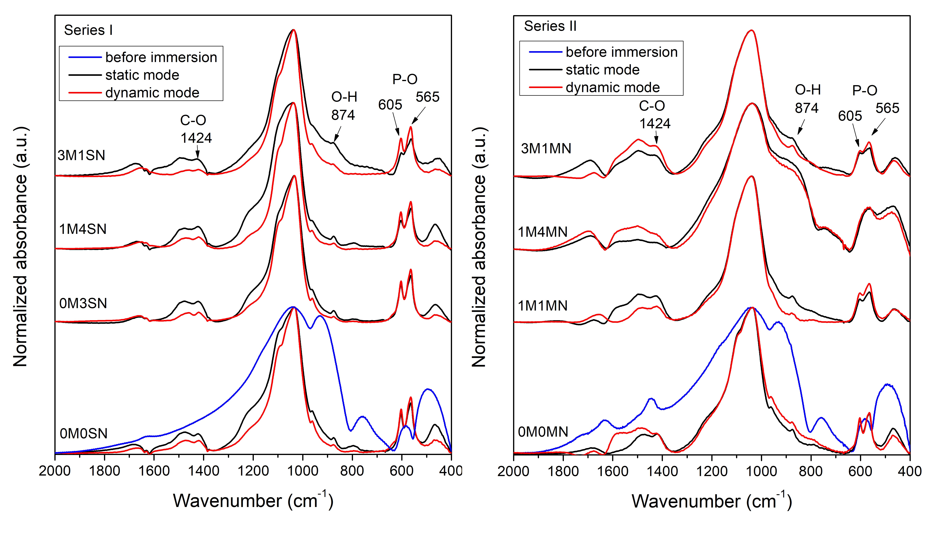
Figure 8. FTIR spectra after immersion in PBS for example left) series I glasses and right) series II glasses. Black line indicates the results obtain in static mode test and red in dynamic mode test.

- Conclusions
A total of 15 samples of calcium-phosphate-silicate glasses, containing alkali and doped with Mg and Si₃N₄ or Mg₃N₂, were melt-prepared for in vitro bioactivity-composition study. These materials display amorphous and partially transparent characteristics with a dark color. Network connectivity calculations, with the highest value at 2.43, verified that the tested glasses met the criteria for bioactive materials. Structural assessments affirmed a highly depolymerized silicate network primarily comprising of Q² and Q³ units. However, no significant shifts in band positions were observed between glasses from series I and II, suggesting a minor impact of substituting potassium for calcium on the polymerization of the glass network. Thermal property analysis revealed that silicon content plays a crucial role in the glass transition temperature trend. Furthermore, thermal stability decreased with an increase in silicon content.
In vitro dissolution testing in PBS in static and dynamic modes demonstrated the potential bioactive properties of all glasses. The pH of PBS with immersed glass samples showed a noticeable increase during the first two days, followed by a stabilization and a slight decrease to a pH range between 10.0 and 9.0. This suggests the gradual dissolution of the glass network in the solution, in particular sodium and silicon, followed by precipitation and subsequent deposition of calcium phosphates on the surface of the material. Ion dissolution profiles confirmed the release of Na and Ca ions into the solutions and a reduction in the concentration of P ions. After immersion, amorphous and crystalline layers of calcium phosphate, most likely hydroxyapatite, were formed on their surface, which was confirmed by SEM-EDX, X-ray diffraction and FTIR tests. The addition of K addition and higher amounts of Mg (> 3 at%) were observed to slow the formation and crystallization of the HAp layer. Based on the presented results, the tested glass compositions show potential as materials for promoting bone regeneration.

- Acknowledgements
NAW acknowledges the financial support by the National Science Centre of Poland under Miniatura 7 [grant number: 2023/07/X/ST3/00443]. SA acknowledges the financial support by Crafoord (20220692) and LNU advanced materials (87202002)

- Author contributions
SW: Conceptualization, Data curation, Formal analysis, Investigation, Methodology, Writing – original draft. SA: Conceptualization, Funding acquisition, Methodology, Writing – review & editing, JK: Methodology, MR: Investigation, HS: Investigation, NAW: Conceptualization, Data curation, Formal analysis, Funding acquisition, Investigation, Methodology, Project administration, Writing – original draft, Supervision.
- Data availability
The data that support the findings of this study are available from the corresponding author upon reasonable request.
- Conflict of Interest
The authors declare that they have no known competing financial interests or personal relationships that could have appeared to influence the work reported in this paper.

- Reference
[1] Hench, L. L. Chronology of Bioactive Glass Development and Clinical Applications. NJGC 2013, 03 (02), 67–73. https://doi.org/10.4236/njgc.2013.32011.
[2] Cannio, M.; Bellucci, D.; Roether, J. A.; Boccaccini, Dino. N.; Cannillo, V. Bioactive Glass Applications: A Literature Review of Human Clinical Trials. Materials 2021, 14 (18), 5440. https://doi.org/10.3390/ma14185440.
[3] Jafari, N.; Habashi, M. S.; Hashemi, A.; Shirazi, R.; Tanideh, N.; Tamadon, A. Application of Bioactive Glasses in Various Dental Fields. Biomater Res 2022, 26 (1), 31. https://doi.org/10.1186/s40824-022-00274-6.
[4] Dash, P. A.; Mohanty, S.; Nayak, S. K. A Review on Bioactive Glass, Its Modifications and Applications in Healthcare Sectors. Journal of Non-Crystalline Solids 2023, 614, 122404. https://doi.org/10.1016/j.jnoncrysol.2023.122404.
[5] Filip, D. G.; Surdu, V.-A.; Paduraru, A. V.; Andronescu, E. Current Development in Biomaterials—Hydroxyapatite and Bioglass for Applications in Biomedical Field: A Review. JFB 2022, 13 (4), 248. https://doi.org/10.3390/jfb13040248.
[6] Krishnan, V. Future Applications of Bioglass. In Biocompatible Glasses; Marchi, J., Ed.; Advanced Structured Materials; Springer International Publishing: Cham, 2016; Vol. 53, pp 317–336. https://doi.org/10.1007/978-3-319-44249-5_13.
[7] Jones, J. R. Review of Bioactive Glass: From Hench to Hybrids. Acta Biomaterialia 2013, 9 (1), 4457–4486. https://doi.org/10.1016/j.actbio.2012.08.023.
[8] Huang, W.; Day, D. E.; Kittiratanapiboon, K.; Rahaman, M. N. Kinetics and Mechanisms of the Conversion of Silicate (45S5), Borate, and Borosilicate Glasses to Hydroxyapatite in Dilute Phosphate Solutions. J Mater Sci: Mater Med 2006, 17 (7), 583–596. https://doi.org/10.1007/s10856-006-9220-z.
[9] Rahaman, M. N.; Day, D. E.; Sonny Bal, B.; Fu, Q.; Jung, S. B.; Bonewald, L. F.; Tomsia, A. P. Bioactive Glass in Tissue Engineering. Acta Biomaterialia 2011, 7 (6), 2355–2373. https://doi.org/10.1016/j.actbio.2011.03.016.
[10] Salih, V.; Franks, K.; James, M.; Hastings, G. W.; Knowles, J. C.; Olsen, I. Development of Soluble Glasses for Biomedical Use Part II: The Biological Response of Human Osteoblast Cell Lines to Phosphate-Based Soluble Glasses. Journal of Materials Science: Materials in Medicine 2000, 11 (10), 615–620. https://doi.org/10.1023/A:1008901612674.
[11] Abou Neel, E. A.; Pickup, D. M.; Valappil, S. P.; Newport, R. J.; Knowles, J. C. Bioactive Functional Materials: A Perspective on Phosphate-Based Glasses. J. Mater. Chem. 2009, 19 (6), 690–701. https://doi.org/10.1039/B810675D.
[12] Wójcik, N. A.; Ali, S.; Mielewczyk-Gryń, A.; Jonson, B. Two-Step Synthesis of Niobium Doped Na–Ca–(Mg)–P–Si–O Glasses. J Mater Sci 2021, 56 (12), 7613–7625. https://doi.org/10.1007/s10853-021-05781-w.
[13] Vallet-Regí, M.; Salinas, A. J.; Román, J.; Gil, M. Effect of Magnesium Content on the in Vitro Bioactivity of CaO-MgO-SiO₂-P₂O₅ Sol-Gel Glasses. J. Mater. Chem. 1999, 9 (2), 515–518. https://doi.org/10.1039/a808679f.
[14] Watts, S. J.; Hill, R. G.; O’Donnell, M. D.; Law, R. V. Influence of Magnesia on the Structure and Properties of Bioactive Glasses. Journal of Non-Crystalline Solids 2010, 356 (9–10), 517–524. https://doi.org/10.1016/j.jnoncrysol.2009.04.074.
[15] Başak, O.; Hruška, B.; Buňová, L.; Muñoz, F.; Michálek, M.; Chromčíková, M. The Influence of Time Dependent Al₂O₃ Dissolution during Melting on the Structure-Bioactivity Correlation of Mg Containing Silica-Based Bioactive Glasses. Journal of Non-Crystalline Solids 2024, 629, 122873. https://doi.org/10.1016/j.jnoncrysol.2024.122873.
[16] Sarkar, D.; Kumar, B. V. M.; Basu, B. Understanding the Fretting Wear of Ti₃SiC₂. Journal of the European Ceramic Society 2006, 26 (13), 2441–2452. https://doi.org/10.1016/j.jeurceramsoc.2005.05.006.
[17] Al-Noaman, A.; Rawlinson, S. C. F.; Hill, R. G. The Role of MgO on Thermal Properties, Structure and Bioactivity of Bioactive Glass Coating for Dental Implants. Journal of Non-Crystalline Solids 2012, 358 (22), 3019–3027. https://doi.org/10.1016/j.jnoncrysol.2012.07.039.
[18] Dietrich, E.; Oudadesse, H.; Lucas‐Girot, A.; Mami, M. In Vitro Bioactivity of Melt‐derived Glass 46S6 Doped with Magnesium. J Biomedical Materials Res 2009, 88A (4), 1087–1096. https://doi.org/10.1002/jbm.a.31901.
[19] Massera, J.; Hupa, L.; Hupa, M. Influence of the Partial Substitution of CaO with MgO on the Thermal Properties and in Vitro Reactivity of the Bioactive Glass S53P4. Journal of Non-Crystalline Solids 2012, 358 (18–19), 2701–2707. https://doi.org/10.1016/j.jnoncrysol.2012.06.032.
[20] Pérez-Pariente, J.; Balas, F.; Vallet-Regí, M. Surface and Chemical Study of SiO₂·P₂O₅·CaO·(MgO) Bioactive Glasses. Chem. Mater. 2000, 12 (3), 750–755. https://doi.org/10.1021/cm9911114.
[21] Wójcik, N. A.; Ali, S.; Karczewski, J. L.; Jonson, B.; Bartmański, M.; Barczyński, R. J. DC and AC Conductivity, Biosolubility and Thermal Properties of Mg-Doped Na₂O–CaO-P₂O₅ Glasses. Materials 2021, 14 (10), 2626. https://doi.org/10.3390/ma14102626.
[22] Wójcik, N. A.; Jonson, B.; Möncke, D.; Palles, D.; Kamitsos, E. I.; Ghassemali, E.; Seifeddine, S.; Eriksson, M.; Ali, S. Influence of Synthesis Conditions on Glass Formation, Structure and Thermal Properties in the Na₂O-CaO-P₂O₅ System Doped with Si₃N₄ and Mg. Journal of Non-Crystalline Solids 2018, 494, 66–77. https://doi.org/10.1016/j.jnoncrysol.2018.04.055.
[23] Sharafat, A.; Grins, J.; Esmaeilzadeh, S. Properties of High Nitrogen Content Mixed Alkali Earth Oxynitride Glasses (AExCa1−x)_{1.2(1)}SiO_{1.9(1)}N_{0.86(6)}, AE=Mg, Sr, Ba. Journal of Non-Crystalline Solids 2009, 355 (22–23), 1259–1263. https://doi.org/10.1016/j.jnoncrysol.2009.04.036.
[24] Ali, S.; Jonson, B. Compositional Effects on the Properties of High Nitrogen Content Alkaline-Earth Silicon Oxynitride Glasses, AE=Mg, Ca, Sr, Ba. Journal of the European Ceramic Society 2011, 31 (4), 611–618. https://doi.org/10.1016/j.jeurceramsoc.2010.11.005.
[25] Shirtliff, V. J.; Hench, L. L. Bioactive Materials for Tissue Engineering, Regeneration and Repair. Journal of Materials Science 2003, 38 (23), 4697–4707. https://doi.org/10.1023/A:1027414700111.
[26] Arstila, H.; Hupa, L.; Karlsson, K. H.; Hupa, M. Influence of Heat Treatment on Crystallization of Bioactive Glasses. Journal of Non-Crystalline Solids 2008, 354 (2–9), 722–728. https://doi.org/10.1016/j.jnoncrysol.2007.06.092.
[27] Li, P.; Yang, Q.; Zhang, F.; Kokubo, T. The Effect of Residual Glassy Phase in a Bioactive Glass-Ceramic on the Formation of Its Surface Apatite Layerin Vitro. J Mater Sci: Mater Med 1992, 3 (6), 452–456. https://doi.org/10.1007/BF00701242.
[28] Cannillo, V.; Sola, A. Potassium-Based Composition for a Bioactive Glass. Ceramics International 2009, 35 (8), 3389–3393. https://doi.org/10.1016/j.ceramint.2009.06.011.
[29] Serra, J.; González, P.; Liste, S.; Chiussi, S.; León, B.; Pérez-Amor, M.; Ylänen, H. O.; Hupa, M. Influence of the Non-Bridging Oxygen Groups on the Bioactivity of Silicate Glasses. Journal of Materials Science: Materials in Medicine 2002, 13 (12), 1221–1225. https://doi.org/10.1023/A:1021174912802.
[30] Marikani, A.; Maheswaran, A.; Premanathan, M.; Amalraj, L. Synthesis and Characterization of Calcium Phosphate Based Bioactive Quaternary P₂O₅–CaO–Na₂O–K₂O Glasses. Journal of Non-Crystalline Solids 2008, 354 (33), 3929–3934. https://doi.org/10.1016/j.jnoncrysol.2008.05.005.
[31] Salman, S. M.; Salama, S. N.; Abo-Mosallam, H. A. The Role of Strontium and Potassium on Crystallization and Bioactivity of Na₂O–CaO–P₂O₅–SiO₂ Glasses. Ceramics International 2012, 38 (1), 55–63. https://doi.org/10.1016/j.ceramint.2011.06.037.
[32] Rabiee, S. M.; Nazparvar, N.; Azizian, M.; Vashaee, D.; Tayebi, L. Effect of Ion Substitution on Properties of Bioactive Glasses: A Review. Ceramics International 2015, 41 (6), 7241–7251. https://doi.org/10.1016/j.ceramint.2015.02.140.
[33] Obata, A.; Takahashi, Y.; Miyajima, T.; Ueda, K.; Narushima, T.; Kasuga, T. Effects of Niobium Ions Released from Calcium Phosphate Invert Glasses Containing Nb ₂ O ₅ on Osteoblast-Like Cell Functions. ACS Appl. Mater. Interfaces 2012, 4 (10), 5684–5690. https://doi.org/10.1021/am301614a.
[34] De Souza, L. P. L.; Lopes, J. H.; Ferreira, F. V.; Martin, R. A.; Bertran, C. A.; Camilli, J. A. Evaluation of Effectiveness of 45S5 Bioglass Doped with Niobium for Repairing Critical‐sized Bone Defect in in Vitro and in Vivo Models. J Biomedical Materials Res 2020, 108 (3), 446–457. https://doi.org/10.1002/jbm.a.36826.
[35] Lopes, J. H.; Souza, L. P.; Domingues, J. A.; Ferreira, F. V.; De Alencar Hausen, M.; Camilli, J. A.; Martin, R. A.; De Rezende Duek, E. A.; Mazali, I. O.; Bertran, C. A. In Vitro and in Vivo Osteogenic Potential of Niobium‐doped 45S5 Bioactive Glass: A Comparative Study. J Biomed Mater Res 2020, 108 (4), 1372–1387. https://doi.org/10.1002/jbm.b.34486.
[36] Obata, A.; Lee, S.; Kasuga, T. Bioactive Glass Materials for Tissue Regeneration. J. Ceram. Soc. Japan 2022, 130 (8), 595–604. https://doi.org/10.2109/jcersj2.22054.
[37] Kushwaha, M.; Pan, X.; Holloway, J. A.; Denry, I. L. Differentiation of Human Mesenchymal Stem Cells on Niobium-Doped Fluorapatite Glass-Ceramics. Dental Materials 2012, 28 (3), 252–260. https://doi.org/10.1016/j.dental.2011.10.010.
[38] Miguez-Pacheco, V.; De Ligny, D.; Schmidt, J.; Detsch, R.; Boccaccini, A. R. Development and Characterization of Niobium-Releasing Silicate Bioactive Glasses for Tissue Engineering Applications. Journal of the European Ceramic Society 2018, 38 (3), 871–876. https://doi.org/10.1016/j.jeurceramsoc.2017.07.028.
[39] Wójcik, N. A.; Sinitsyna, P.; Ali, S.; Hupa, L.; Jonson, B. In Vitro Dissolution of Na-Ca-P-Oxynitrides. Materials 2021, 14 (23), 7425. https://doi.org/10.3390/ma14237425.
[40] Wójcik, N. A.; Ali, S.; Kamitsos, E. I.; Möncke, D. Niobate in Silicate and Phosphate Glasses: Effect of Glass Basicity on Crucible Dissolution. Int J of Appl Glass Sci 2022, 13 (1), 121–134. https://doi.org/10.1111/ijag.16505.
[41] Karakuzu-Ikizler, B.; Terzioğlu, P.; Basaran-Elalmis, Y.; Tekerek, B. S.; Yücel, S. Role of Magnesium and Aluminum Substitution on the Structural Properties and Bioactivity of Bioglasses Synthesized from Biogenic Silica. Bioactive Materials 2020, 5 (1), 66–73. https://doi.org/10.1016/j.bioactmat.2019.12.007.
[42] Konidakis, I.; Varsamis, C. P. E.; Kamitsos, E. I. Effect of Synthesis Method on the Structure and Properties of AgPO₃-Based Glasses. Journal of Non-Crystalline Solids 2011, 357 (14), 2684–2689. https://doi.org/10.1016/j.jnoncrysol.2011.03.013.
[43] Malavasi, G.; Pedone, A.; Menziani, M. C. Study of the Structural Role of Gallium and Aluminum in 45S5 Bioactive Glasses by Molecular Dynamics Simulations. J. Phys. Chem. B 2013, 117 (15), 4142–4150. https://doi.org/10.1021/jp400721g.
[44] Wójcik, N. A.; Wolff, S.; Karczewski, J. L.; Rutkowska, M.; Ali, S. Effect of Nb and Al on in Vitro Dissolution Behavior and Structure of Na₂O-MgO CaO-P₂O₅ Glasses. Journal of Non-Crystalline Solids 2022, 585, 121544. https://doi.org/10.1016/j.jnoncrysol.2022.121544.
[45] Ohtsuki, C.; Kokubo, T.; Yamauro, T. Compositional Dependence of Bioactivity of Glasses in the System CaO-SiO₂-Al₂O₃: Its in Vitro Evaluation. J Mater Sci: Mater Med 1992, 3 (2), 119–125. https://doi.org/10.1007/BF00705279.
[46] Hanifi, A. R.; Pomeroy, M. J.; Hampshire, S. Novel Glass Formation in the Ca–Si–Al–O–N–F System. Journal of the American Ceramic Society 2011, 94 (2), 455–461. https://doi.org/10.1111/j.1551-2916.2010.04147.x.
[47] Bachar, A.; Mercier, C.; Tricoteaux, A.; Leriche, A.; Follet, C.; Saadi, M.; Hampshire, S. Effects of Addition of Nitrogen on Bioglass Properties and Structure. Journal of Non-Crystalline Solids 2012, 358 (3), 693–701. https://doi.org/10.1016/j.jnoncrysol.2011.11.036.
[48] Mneimne, M.; Hill, R. G.; Bushby, A. J.; Brauer, D. S. High Phosphate Content Significantly Increases Apatite Formation of Fluoride-Containing Bioactive Glasses. Acta Biomaterialia 2011, 7 (4), 1827–1834. https://doi.org/10.1016/j.actbio.2010.11.037.
[49] O’Donnell, M. D.; Watts, S. J.; Hill, R. G.; Law, R. V. The Effect of Phosphate Content on the Bioactivity of Soda-Lime-Phosphosilicate Glasses. J Mater Sci: Mater Med 2009, 20 (8), 1611–1618. https://doi.org/10.1007/s10856-009-3732-2.
[50] Bachar, A.; Mercier, C.; Tricoteaux, A.; Hampshire, S.; Leriche, A.; Follet, C. Effect of Nitrogen and Fluorine on Mechanical Properties and Bioactivity in Two Series of Bioactive Glasses. Journal of the Mechanical Behavior of Biomedical Materials 2013, 23, 133–148. https://doi.org/10.1016/j.jmbbm.2013.03.010.
[51] Bachar, A.; Mercier, C.; Tricoteaux, A.; Leriche, A.; Follet, C.; Hampshire, S. Bioactive Oxynitride Glasses: Synthesis, Structure and Properties. Journal of the European Ceramic Society 2016, 36 (12), 2869–2881. https://doi.org/10.1016/j.jeurceramsoc.2015.12.017.
[52] Wójcik, N. A.; Wolff, S.; Karczewski, J.; Ryl, J.; Ali, S. Effect of Crystallinity on Structural, Thermal, and in Vitro Dissolution Properties of Na₂O-CaO-Nb₂O₅/MgO-P₂O₅ Glass-Ceramics. Journal of the European Ceramic Society 2023, 43 (5), 2234–2244. https://doi.org/10.1016/j.jeurceramsoc.2022.12.053.
[53] Xu, J.; Greenblatt, M.; Emge, T.; Höhn, P.; Hughbanks, T.; Tian, Y. Crystal Structure, Electrical Transport, and Magnetic Properties of Niobium Monophosphide. Inorg. Chem. 1996, 35 (4), 845–849. https://doi.org/10.1021/ic950826f.
[54] Liu, F.; Garofalini, S. H.; King-Smith, R. D.; Vanderbilt, D. Structural and Electronic Properties of Sodium Metasilicate. Chemical Physics Letters 1993, 215 (4), 401–404. https://doi.org/10.1016/0009-2614(93)85736-8.
[55] Fischer, R. X.; Tillmanns, E. The Equivalent Isotropic Displacement Factor. Acta Crystallogr C Cryst Struct Commun 1988, 44 (4), 775–776. https://doi.org/10.1107/S0108270187012745.
[56] O’Donnell, M. D.; Watts, S. J.; Law, R. V.; Hill, R. G. Effect of P₂O₅ Content in Two Series of Soda Lime Phosphosilicate Glasses on Structure and Properties – Part I: NMR. Journal of Non-Crystalline Solids 2008, 354 (30), 3554–3560. https://doi.org/10.1016/j.jnoncrysol.2008.03.034.
[57] Brauer, D. S.; Möncke, D. Chapter 3. Introduction to the Structure of Silicate, Phosphate and Borate Glasses. In Smart Materials Series; Boccaccini, A. R., Brauer, D. S., Hupa, L., Eds.; Royal Society of Chemistry: Cambridge, 2016; pp 61–88. https://doi.org/10.1039/9781782622017-00061.
[58] Edén, M. The Split Network Analysis for Exploring Composition–Structure Correlations in Multi-Component Glasses: I. Rationalizing Bioactivity-Composition Trends of Bioglasses. Journal of Non-Crystalline Solids 2011, 357 (6), 1595–1602. https://doi.org/10.1016/j.jnoncrysol.2010.11.098.
[59] Greaves, G. N. EXAFS and the Structure of Glass. Journal of Non-Crystalline Solids 1985, 71 (1–3), 203–217. https://doi.org/10.1016/0022-3093(85)90289-3.
[60] Thomsen, R. M.; Skibsted, J.; Yue, Y. The Charge-Balancing Role of Calcium and Alkali Ions in Per-Alkaline Aluminosilicate Glasses. J. Phys. Chem. B 2018, 122 (12), 3184–3195. https://doi.org/10.1021/acs.jpcb.7b12437.
[61] Le Losq, C.; Neuville, D. R.; Florian, P.; Henderson, G. S.; Massiot, D. The Role of Al³⁺ on Rheology and Structural Changes in Sodium Silicate and Aluminosilicate Glasses and Melts. Geochimica et Cosmochimica Acta 2014, 126, 495–517. https://doi.org/10.1016/j.gca.2013.11.010.
[62] Lopes, J. H.; Magalhães, A.; Mazali, I. O.; Bertran, C. A. Effect of Niobium Oxide on the Structure and Properties of Melt‐Derived Bioactive Glasses. J. Am. Ceram. Soc. 2014, 97 (12), 3843–3852. https://doi.org/10.1111/jace.13222.
[63] Hannon, A. C.; Vaishnav, S.; Alderman, O. L. G.; Bingham, P. A. The Structure of Sodium Silicate Glass from Neutron Diffraction and Modeling of Oxygen‐oxygen Correlations. J Am Ceram Soc. 2021, 104 (12), 6155–6171. https://doi.org/10.1111/jace.17993.
[64] Mysen, B. O.; Virgo, D. Structure and Properties of Silicate Glasses and Melts; Theories and Experiment. In Advanced Mineralogy; Marfunin, A. S., Ed.; Springer Berlin Heidelberg: Berlin, Heidelberg, 1994; pp 238–254. https://doi.org/10.1007/978-3-642-78523-8_14.
[65] Ali, S.; Hakeem, A. S.; Eriksson, M.; Wójcik, N. A. A Novel Approach for Processing CaAlSiON Glass-Ceramics by Spark Plasma Sintering: Mechanical and Electrical Properties. Journal of the European Ceramic Society 2022, 42 (1), 96–104. https://doi.org/10.1016/j.jeurceramsoc.2021.09.055.
[66] Furukawa, T.; Fox, K. E.; White, W. B. Raman Spectroscopic Investigation of the Structure of Silicate Glasses. III. Raman Intensities and Structural Units in Sodium Silicate Glasses. The Journal of Chemical Physics 1981, 75 (7), 3226–3237. https://doi.org/10.1063/1.442472.
[67] Kamitsos, E. I.; Kapoutsis, J. A.; Jain, H.; Hsieh, C. H. Vibrational Study of the Role of Trivalent Ions in Sodium Trisilicate Glass. Journal of Non-Crystalline Solids 1994, 171 (1), 31–45. https://doi.org/10.1016/0022-3093(94)90030-2.
[68] Rey, C.; Combes, C.; Drouet, C.; Lebugle, A.; Sfihi, H.; Barroug, A. Nanocrystalline Apatites in Biological Systems: Characterisation, Structure and Properties. Materialwissenschaft Werkst 2007, 38 (12), 996–1002. https://doi.org/10.1002/mawe.200700229.
[69] Jones, J. R.; Sepulveda, P.; Hench, L. L. Dose‐dependent Behavior of Bioactive Glass Dissolution. J. Biomed. Mater. Res. 2001, 58 (6), 720–726. https://doi.org/10.1002/jbm.10053.
[70] Hospodarova, V.; Singovszka, E.; Stevulova, N. Characterization of Cellulosic Fibers by FTIR Spectroscopy for Their Further Implementation to Building Materials. AJAC 2018, 09 (06), 303–310. https://doi.org/10.4236/ajac.2018.96023.
[71] Ali, S.; Wójcik, N. A.; Jonson, B.; Kamitsos, E. I.; Li, X.; Luo, J.; Möncke, D. Synthesis, Structural Characterization, and Thermal Properties of Ca‐ and La‐doped Soda‐lime Glasses by Laser Melting. Int J of Appl Glass Sci 2020, 11 (4), 699–706. https://doi.org/10.1111/ijag.15477.
[72] Hench, L. L.; Splinter, R. J.; Allen, W. C.; Greenlee, T. K. Bonding Mechanisms at the Interface of Ceramic Prosthetic Materials. J. Biomed. Mater. Res. 1971, 5 (6), 117–141. https://doi.org/10.1002/jbm.820050611.
[73] Lopes, J. H.; Mazali, I. O.; Landers, R.; Bertran, C. A. Structural Investigation of the Surface of Bioglass 45S5 Enriched with Calcium Ions. J. Am. Ceram. Soc. 2013, 96 (5), 1464–1469. https://doi.org/10.1111/jace.12305.
[74] Souza, L.; Lopes, J. H.; Encarnação, D.; Mazali, I. O.; Martin, R. A.; Camilli, J. A.; Bertran, C. A. Comprehensive in Vitro and in Vivo Studies of Novel Melt-Derived Nb-Substituted 45S5 Bioglass Reveal Its Enhanced Bioactive Properties for Bone Healing. Sci Rep 2018, 8 (1), 12808. https://doi.org/10.1038/s41598-018-31114-0.
[75] Frey, U.; Senn, H. J. [Demonstration of osseous tumor micrometastases: comparison of the value of bone marrow cytology and histology]. Schweiz Med Wochenschr 1978, 108 (3), 82–91.
[76] Sahana, H.; Khajuria, D. K.; Razdan, R.; Mahapatra, D. R.; Bhat, M. R.; Suresh, S.; Rao, R. R.; Mariappan, L. Improvement in Bone Properties by Using Risedronate Adsorbed Hydroxyapatite Novel Nanoparticle Based Formulation in a Rat Model of Osteoporosis. j biomed nanotechnol 2013, 9 (2), 193–201. https://doi.org/10.1166/jbn.2013.1482.
[77] Kumar, P. T. S.; Srinivasan, S.; Lakshmanan, V.-K.; Tamura, H.; Nair, S. V.; Jayakumar, R. Synthesis, Characterization and Cytocompatibility Studies of α-Chitin Hydrogel/Nano Hydroxyapatite Composite Scaffolds. International Journal of Biological Macromolecules 2011, 49 (1), 20–31. https://doi.org/10.1016/j.ijbiomac.2011.03.006.
[78] Gheisari, H.; Karamian, E.; Abdellahi, M. A Novel Hydroxyapatite –Hardystonite Nanocomposite Ceramic. Ceramics International 2015, 41 (4), 5967–5975. https://doi.org/10.1016/j.ceramint.2015.01.033.

