Supplementary Material
TEM foil thickness measurement and particle number density and size distribution
The FEI Themis-Z was used to collect Electron Energy Loss Spectrum (EELS) to measure the thickness of the TEM foil. The thickness, $t$, was calculated using the relation [1]: $\frac{t}{\overline{λ}}=\ln\left(\frac{I_{t}}{I_{0}}\right)$, where $\overline{λ}$ is the mean free path,$I_{t}$is the intensity of all the plasmon peaks, and $I_{0}$is the intensity of the incident beam. The mean free path $\overline{λ}$ depends on the exciting voltage, average atomic number, and the collection semiangle according to [1]: $\overline{λ}=\frac{106F}{ln⁡(2βE_{0}/E_{m})}\frac{E_{0}}{E_{m}}$,where $E_{0}$is the incident beam energy of 200 keV, F is a relativistic factor with a value of 0.618 for $E_{0}$ = 200 keV, $β$ is the collection semiangle with a value of 68.8 mrad, and $E_{m}$ is the mean energy loss of the electrons passing through the sample. A single EELS line profile relating the foil thickness to the distance from the hole was obtained, which was then used to obtain the thickness for each of the different regions examined. This was done by fitting the thickness vs distance data to obtain $t=f(d)$. Then for each HAADF-STEM micrograph, the intensity vs distance data was fitted to obtain $I=f(d)$ ( Fig. S2). Using these two linear equations, the foil thickness was obtained as a function of the intensity. A camera length of 115 mm and field of view (FOV) of 3.3 μm were used for both EELS measurement and HAADF-STEM micrographs. The screen current when viewing the hole was 0.1 nA. The minimum and maximum thickness values were 20 and 100 nm, respectively, from which an average thickness of 60 nm was obtained.
The HAADF STEM micrographs were post-processed using ImageJ software to estimate the particle number density and the size distribution. Eleven micrographs from which a total of 4500 particles were analyzed in order to obtain the size and number density data. The background of the micrographs was subtracted using a rolling ball radius value of 20 pixels. The image was converted to binary, and speckling was reduced by the “despeckle” and “remove outliers” function. Areas were drawn out on the images to analyze the particles. Contaminants and scales were avoided to ensure accurate estimation. In order to verify whether the automatic detection of particles was resulting in over/under counting, sections from each images were chosen and the particles were manually counted by using Clickermaster2000. It was found that the automatic particle detection using ImageJ over-counted the particles by 15% on average. This was corrected by subtracting 15% from the final count. It is to be noted that the thickness near the hole is ~ 20 nm, and the average particle size is also ~20 nm, thus most of the particles in this thin region were obliterated by the jet-thinning process. This explains why so few particles are observed to be present near the hole.
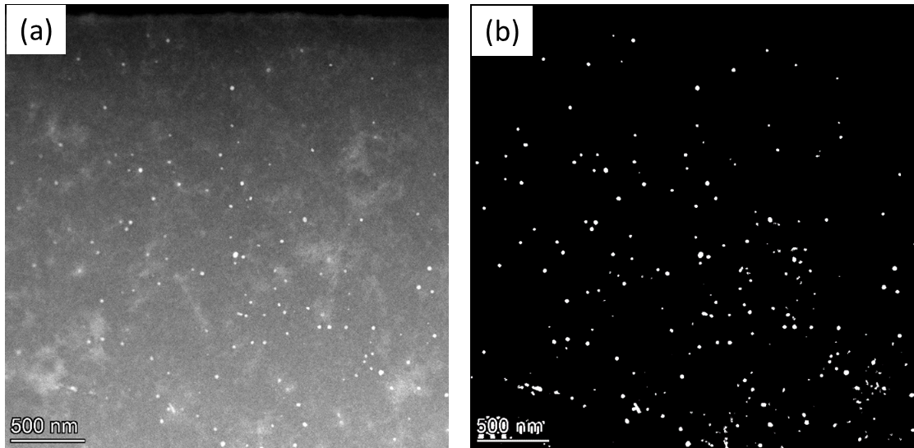
Figure S1: A representative HAADF STEM micrograph from which the particle number density and the size distribution were estimated: (a) as-captured and (b) post-processed using ImageJ to highlight particles.

Figure S2: Correlation between the EELS thickness measurement (blue) and the intensity measurement (orange). A field of view and camera length of 3.03 µm and 115 mm, respectively, were used to capture the micrographs.
Figure S3: The size (i.e. equivalent spherical diameter) distribution of Zn-Zr particles. The mean size is 20 nm with a standard deviation of 8 nm.

Zn-Zr particles - formation energy, lattice parameter, and elastic constants.
All density functional theory (DFT) [2,3] calculations on Zn₂Zr₃ (space group P4₂/mnm) and Zn₂Zr (space group Fd$\overline{3}$m) were performed using Vienna Ab initio Simulation Package (VASP) version 5.4.4 [4,5], applying the generalized gradient approximation (GGA) [6] of Perdew-Burke-Ernzerhof (PBE) [7]. For Zn and Zr, the valence states were considered as 3d¹⁰4s², 4s²4p⁶5s²4d², respectively. The Methfessel-Paxton scheme was used with a smearing parameter of 0.2 eV, and the ion-electron interactions were described by the projector augmented wave method (PAW) [8], with an energy cutoff of 400 eV for all structures. The Brillouin zone was sampled using a Gamma-centered Monkhorst-Pack scheme [9] with over 10,000 k points per reciprocal atom. All degrees of freedom of the structures were allowed to change for structure optimization. To improve computational energy, the static calculation using the tetrahedron method with Blöchl corrections was performed after structure optimization [10]. The calculated formation energy, and lattice parameters of the equilibrium structures are provided in Table S1. The formation energy was calculated as: $ΔE_{f}\left(Zn_{x}Zr_{y}\right)=E\left(Zn_{x}Zr_{y}\right)-x_{Zn}E\left(Zn\right)-x_{Zr}E\left(Zr\right)$ where E(Zn_{x}Zr_{y}), E(Zn), and E(Zr) are the total bulk energies per atom for Zn_{x}Zr_{y}, HCP Zn, and HCP Zr, respectively, calculated by DFT at 0K.

Table S1 Lattice parameters and formation energy of Zn₂Zr₃ and Zn₂Zr
Structure | Reference | Lattice parameter |  | ΔE_{f} (Zn_{x}Zr_{y}) kJ/mol atom
Structure | Reference | a / Å | c / Å | ΔE_{f} (Zn_{x}Zr_{y}) kJ/mol atom
Zn₂Zr₃ | Literature | 7.633 [11] | 6.695 [11] | -17.74 [12]
Zn₂Zr₃ | This work | 7.598 | 6.802 | -18.43
Zn₂Zr | Literature | 7.393 [13] | - | -27.91 [12]
Zn₂Zr | This work | 7.392 | - | -27.37

For the calculation of elastic stiffness constants (C_{ij}), the relaxation of the atomic positions in the distorted unit cell was allowed. For tetragonal Zn₂Zr₃, there are six independent elastic stiffness constants: C₁₁, C₁₂, C₁₃, C₃₃, C₄₄, C₆₆; for cubic Zn₂Zr, there are three independent C_{ij}s: C₁₁, C₁₂, C₄₄.The strain-energy method was used to determine the C_{ij}s by applying small strain to the equilibrium unit cell [14], $E_{s}=E\left(V\right)-E\left(V_{0}\right)=\frac{V_{0}}{2}\sum_{i,j=1}^{6}{C_{ij}}s_{i}s_{j}$ where E_{s}, E(V₀), and E(V) are the strain energy, the energy of equilibrium unit cell, and the energy of the distorted unit cell, respectively. The C_{ij}’s could be derived from the secondary derivatives of the strain energy with respect to the strains [15,16]:$C_{ij}=2\frac{∂^{2}E_{s}}{∂s_{i}∂s_{j}}{\left.​\right|}_{V=V_{0}}$
In the current work, six values for each set of strains were applied, namely, s = ±0.015, ±0.01, ±0.005. The distortions of the unit cell for DFT calculation, and the post-processing of the VASP calculated data to obtain the C_{ij}’s were performed by VASPKIT code [17,18], and the calculated C_{ij}’s are listed in Table S2.

Table S2 The calculated C_{ij}’s (GPa) of Zn₂Zr₃ and Zn₂Zr compared with the reported data
Structure | Reference | C₁₁ | C₁₂ | C₁₃ | C₃₃ | C₄₄ | C₆₆
Zn₂Zr₃ | Literature [19] | 145.94 | 90.00 | 73.72 | 155.22 | 31.76 | 47.00
Zn₂Zr₃ | This work | 154.51 | 83.35 | 74.01 | 159.16 | 34.17 | 52.01
Zn₂Zr | Literature [19] | 183.72 | 68.59 | - | - | 62.36 | -
Zn₂Zr | This work | 178.30 | 69.51 | - | - | 54.84 | -

Anti-phase domain boundary energy (APBE) calculations
Fig. 4 (a) and (b) illustrate the APB which is built by shifting a segment of monolayer GP zone (h-MgCaZn) by $\frac{1}{3}\left[1\overline{2}10\right]$ Burgers vector on (0001) plane. The APB energy ($γ_{APB}$) is calculated according to [20]: $γ_{APB}=\frac{E_{APB}-E_{perfect}}{2×A_{APB}},$ where $A_{APB}=l_{b}×\frac{l_{c}}{6}$., where, E_{APB} and E_{perfect} are the total energies of GP zone unit cell with and without APB, respectively; A_{APB} is the area of APB, with l_{b} and l_{c} being the width and height of the unit cell. E_{APB}, and E_{perfect} were obtained from DFT by VASP, employing the same computational settings as for Zn-Zr, with the exception of the relaxation scheme. To simulate the constrain from the Mg matrix, only the atomic positions were allowed to relax while keeping the cell shape and volume fixed [21]. For the APBE calculations for Mg-Ca-Al GP zones (h-MgCaAl), the settings remain the same as those used for h-MgCaZn. The only difference is in the structure file where the Zn atom is replaced with Al.

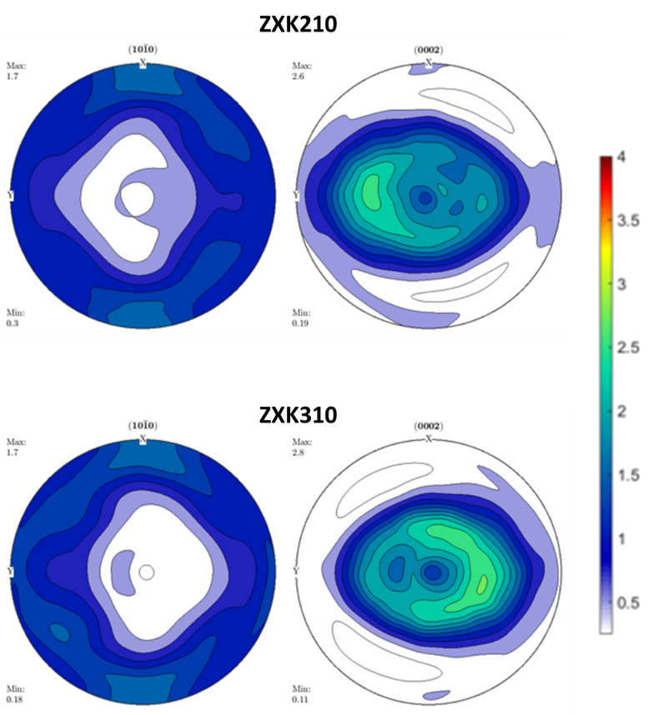
Figure S4: The texture of solutionized ZXK210 and ZXK310 alloys showing a weak weak basal texture (~3 mrd) where the basal poles are tilted ~30°-50° towards TD and the (101 ̅0) prismatic poles are weakly aligned with RD.
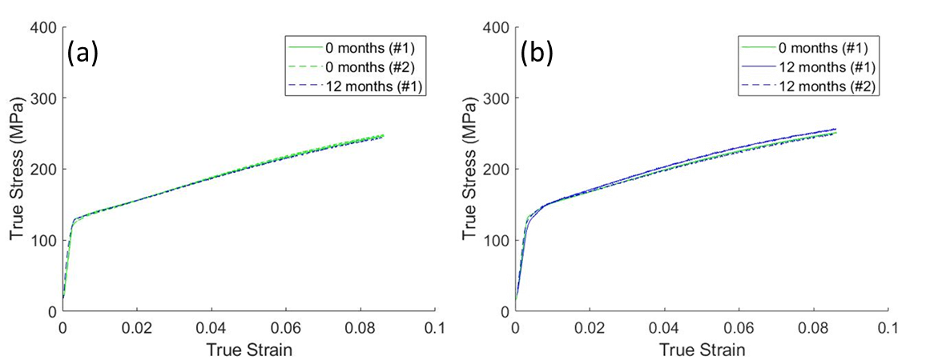
Figure S5: Stress-strain curves of solutionized ZXK210 (a) deformed in TD tension and (b) deformed in tension along 45° from RD. The tests were performed within one week of the heat treatment (0 months) and after one year of natural aging, (denoted as 12 months. No evidence of strengthening due to natural aging was found.
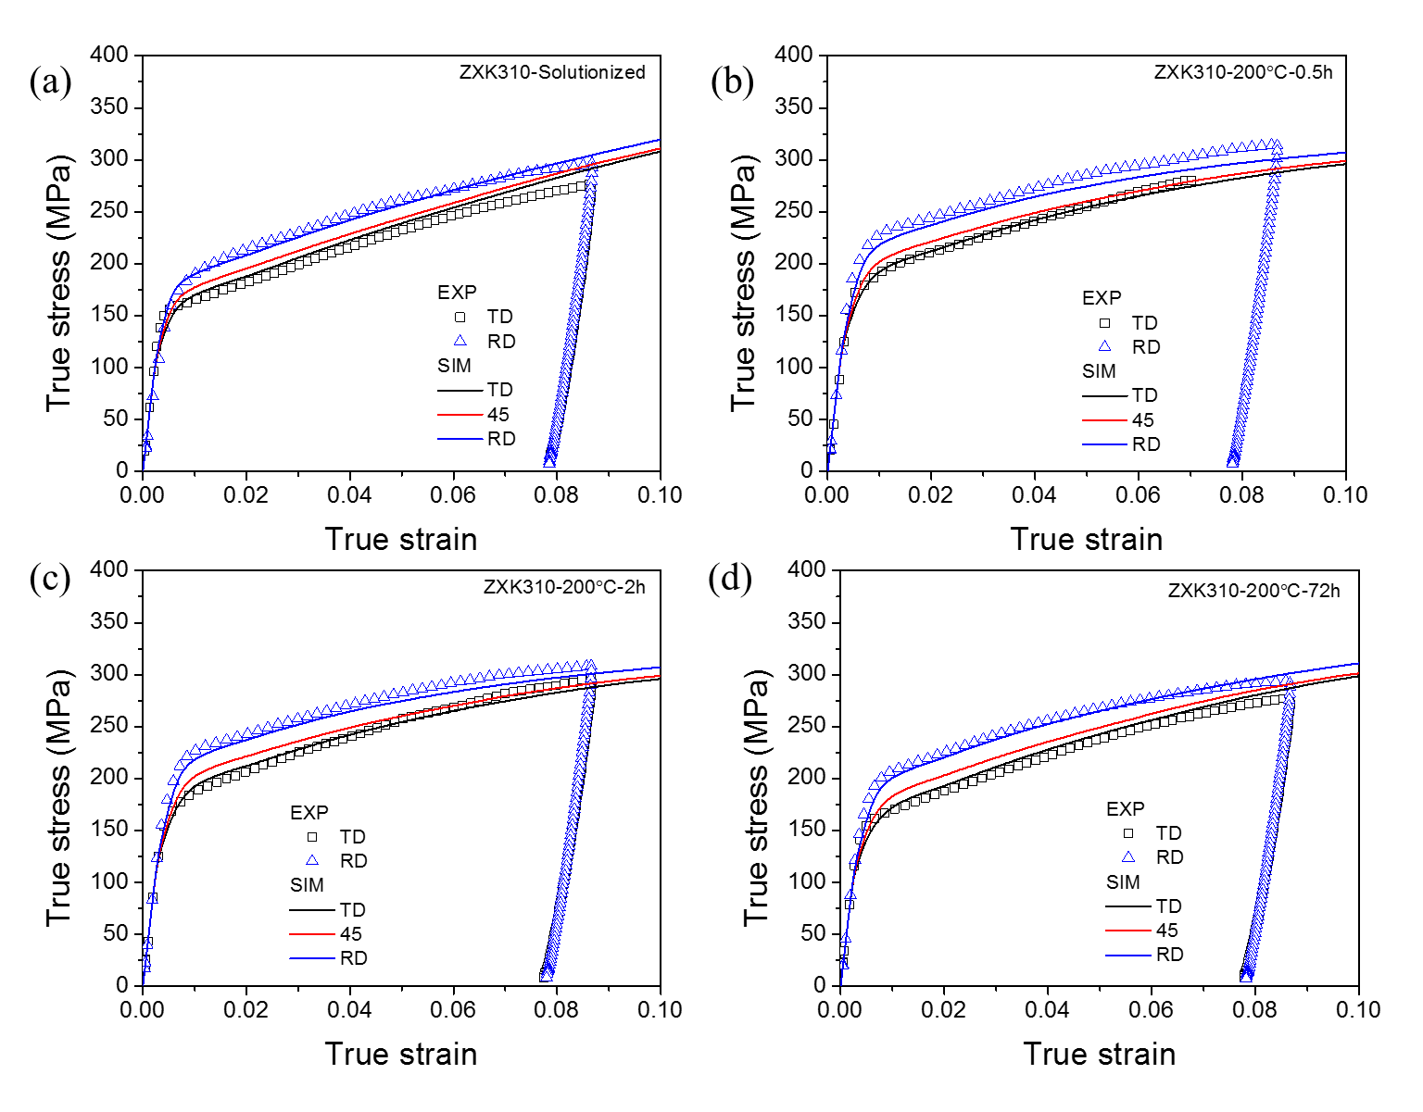Figure S6: The experimental and simulated flow curves of ZXK310 alloy for various aging conditions.

Reference:
[1] B. Fultz, J.M. Howe Transmission electron microscopy and diffractometry of materials. (2012) 178-179.
[2] P. Hohenberg, W. Kohn, Physical Review 136 (1964) B864.
[3] W. Kohn, L.J. Sham, Physical Review 140 (1965) A1133.
[4] G. Kresse, J. Furthmüller, Comput Mater Sci 6 (1996) 15–50.
[5] G. Kresse, J. Furthmüller, Phys Rev B 54 (1996) 11169.
[6] J.P. Perdew, J.A. Chevary, S.H. Vosko, K.A. Jackson, M.R. Pederson, D.J. Singh, C. Fiolhais, Phys Rev B 46 (1992) 6671.
[7] J.P. Perdew, K. Burke, M. Ernzerhof, Phys Rev Lett 77 (1996) 3865.
[8] G. Kresse, D. Joubert, Phys Rev B 59 (1999) 1758.
[9] H.J. Monkhorst, J.D. Pack, Phys Rev B 13 (1976) 5188.
[10] P.E. Blöchl, O. Jepsen, O.K. Andersen, Phys Rev B 49 (1994) 16223.
[11] D.R. Petersen, H.W. Rinn, Acta Crystallogr 14 (1961) 328–329.
[12] R. Arroyave, Z.K. Liu, Calphad 30 (2006) 1–13.
[13] P. Pietrokowsky, JOM 6 (1954) 219–226.
[14] X.S. Zhao, S.L. Shang, Z.K. Liu, J.Y. Shen, Journal of Nuclear Materials 415 (2011) 13–17.
[15] S. Wu, S. Shahab Naghavi, G.H. Fecher, C. Felser, S.C. Wu, Journal of Modern Physics 9 (2018) 775–805.
[16] X. Meng, X. Wen, G. Qin, Comput Mater Sci 49 (2010) S372–S377.
[17] V. Wang, N. Xu, J.C. Liu, G. Tang, W.T. Geng, Comput Phys Commun 267 (2021) 108033.
[18] S. Li, S. Zhao, H. Chu, Y. Gao, P. Lv, V. Wang, G. Tang, J. Hong, Journal of Physical Chemistry C 126 (2022) 4715–4725.
[19] S. Wang, Y. Zhao, H. Guo, F. Lan, H. Hou, Materials 11 (2018) 2010.
[20] J.E. Saal, C. Wolverton, Acta Mater 103 (2016) 57–62.
[21] D. Cheng, E.R. Hoglund, K. Wang, J.M. Howe, S.R. Agnew, B.C. Zhou, Scr Mater 216 (2022) 114744.

