Flash joining of TZP bodies under an AC electric field

Kohta Nambu^{1,2}, Taisuke Kitaoka³, Koji Morita^{1,2}, Kohei Soga³, Takahisa Yamamoto⁴, Hiroshi Masuda⁵, Hidehiro Yoshida^{5,6}

¹Department of Materials Science and Engineering, Kyushu University, 744 Motooka, Nishi-ku, Fukuoka, 891-0395, Japan

²National Institute for Material Science, 1-2-1 Sengen, Tsukuba, Ibaraki 305-0047, Japan

³Department of Materials Science and Technology, Tokyo University of Science, 6-3-1 Niijuku, Katsushika-key, Tokyo 125-8585, Japan

⁴Materials Design Innovation Engineering, Graduate School of Engineering, Nagoya University, Furo-cho, Chikusa-ku, Nagoya, Aichi 464-8601, Japan

⁵Department of Materials Science and Engineering, School of Engineering, The University of Tokyo, 7-3-1 Hongo, Bunkyo-ku, Tokyo 113-8656, Japan

⁶Next generation Zirconia Social Cooperation Program, Institute of Engineering Innovation, The University of Tokyo, 7-3-1 Hongo, Bunkyo-ku, Tokyo 113-8656, Japan

*Author to whom correspondence should be addressed.
e-mail: nambu.kohta.188@s.kyushu-u.ac.jp

Keywords: Flash joining; 3Y-TZP; alternating current; Joint strength

Abstract
In this study, we conducted flash joining experiments using an AC field on 3 mol% Y₂O₃-stabilized tetragonal ZrO₂ polycrystals (3Y-TZP) bodies. Moreover, the necessary conditions to obtain a high-strength joining of 3Y-TZP bodies were clarified. The specimens were successfully joined by applying the AC field at 60 mA·mm⁻² for 80 seconds at a furnace temperature of 1000 °C, thus resulting in a successfully joined specimen with 92% of the flexural strength of the monolithic TZP body. The perfect joining of 3Y-TZP was achieved at current densities beyond 30 mA·mm⁻², and input energy beyond 4 kJ. Both input energy and electric current were important factors for producing the reliable joining of ceramics.

- Introduction
Y₂O₃-stabilized tetragonal ZrO₂ polycrystal (Y-TZP) has been practically used for structural application owing to its excellent mechanical properties such as high strength and fracture toughness [1-4]. Similar to most other ceramics, Y-TZP materials are mostly fabricated through the sintering process, which limits the outer size and shape of the products. Joining of the TZP ceramics can overcome the difficulty of manufacturing large- and complex-shaped components [5,6]. The joining of ceramics components has been performed by brazing [6-12] or diffusion/superplastic joining [13-19]. The joining of TZP components by brazing has been industrially attained, e.g., the joining of TZP bodies could be accomplished at 850 °C using Ag-Cu-Ti alloy [6]. However, the bending strength of the brazed TZP components was only 180MPa, significantly lower than those of typical TZP ceramics (approximately 1 GPa) [20-23]. Diffusion/superplastic joining, in contrast, is applicable for fine-grained ceramics, and is expected to suppress the deterioration in the strength of the joined portion because of the direct joining without interphases. However, high temperature and long time durations are required for the diffusion/superplastic joining to produce sufficient diffusion flux necessary for the high temperature plastic flow by diffusional creep or grain boundary sliding. For instance, 3Y-TZP with an average grain size of 0.3 μm was joined through a superplastic flow at a furnace temperature of 1400 °C for 2 hours under a compressive stress of 15 MPa [13].
A new technique has been recently reported by Xia et al., called flash joining, in which ceramic components are joined by accelerated high temperature plastic flow under an occurrence of a flash event [24,25]. Flash event is a phenomenon in which the electric conductivity and diffusion mass transport in oxide ceramics are highly accelerated under threshold conditions of the applied electric field and ambient temperature [26-33]. Using the flash event to the green compact of raw ceramic powder, rapid densification, i.e., so-called flash sintering, can occur at a relatively low furnace temperature for a short sintering time. In addition, our recent studies demonstrated that applying the electric field greatly enhanced high temperature plastic flow by grain boundary sliding in TZP [34-36]. According to the investigation by Xia et al., dense TZP bodies can be successfully joined by employing the flash event under a DC field at the furnace temperature of 800 °C and current density of 100 mA·mm⁻² for 18 seconds. Nevertheless, the flexural strength of the joined TZP specimen was only 600 MPa. The joining condition should be optimized to improve the strength of the joint. In addition, the use of an AC field for the flash joining has not been previously examined, though flash sintering using an AC field can produce a uniform densified body without asymmetric grain size distributions between the electrodes [37-40]. In this study, we conducted the flash joining experiments using an AC field on Y-TZP bodies and determined necessary conditions to obtain a high-strength joining of Y-TZP bodies. Microstructure observation by transmission electron microscopy (TEM) and three-point flexural tests were performed for the AC-flash joined specimens to examine the characteristics of the AC-flash joined interfaces.

- Experimental Procedure
2.1 Preparation of dense TZP specimens
The material used in the present study was a fully-densified Y-TZP body produced by conventional sintering of commercially available 3 mol% Y₂O₃-stabilized tetragonal ZrO₂ powder (TZ-3Y; Tosoh Co., Japan). The green compacts of the raw powder were prepared by cold isostatic pressing (CIP) at 392 MPa. The green compacts were sintered by conventional sintering in ambient air without additional pressure at 1400 °C for 2 hours. The relative density of the sintered TZP body was 98% of the theoretical density. The densified bodies were ground in cylindrical specimens having a cross-sectional diameter of 6 mm and height of 6 mm. For the flexural test of the AC-flash joined specimens, rectangular TZP bodies with dimensions of 4 mm $×$ 5 mm in cross-section and 20 mm in length were prepared from the densified TZP bodies. The top and bottom surfaces of cylindrical specimens were polished to a mirror state as contact faces. The edge of contact faces was slightly chamfered to avoid stress concentration during the joining experiment. The surface roughness of the contact faces was measured to be 0.7 μm by a laser microscope (VK-X3000; Keyence, Japan).

2.2 Joining experiment
The AC-flash joining experiments were performed using a mechanical testing machine (AG-X 50 kN; Shimazu, Japan) attached to an electric furnace, as schematically shown in Fig. 1. Two cylindrical TZP specimens were stacked such that the mirror surfaces were in contact with each other, and two platinum wires were wound around the side surfaces of the stacked specimens. The furnace temperature was elevated up to 1000 °C at a constant heating rate of 10 °C·min⁻¹ in air. The stacked specimens were compressed by upper and lower silicon carbide jigs under a compressive stress of 20 MPa. An AC square wave with a maximum strength of 50 V·cm⁻¹ and a frequency of 1 Hz was applied to the specimens using a high voltage power supply (POP200-1.75; Matsusada Precision, Japan) through the two platinum wires. The maximum current limit was set to a constant value ranging from 15 mA·mm⁻² to 60 mA·mm⁻². At the onset of the flash event, the current through the specimen reached the limit value within one second of the applying the electric field, and the power supply was automatically switched from voltage control to current control. Therefore, the current was maintained at the limit value. The waveforms of both voltage and current were kept rectangular during the flash event. The surface temperature of the specimens during the flash joining experiments was measured at the center of the joining interfaces using a pyrometer (IR-CAS; Chino, Japan) through the observation hole in the furnace. The specimen temperature was measured in a 1.5 mm diameter area in the center of the surface of the specimen. The power supply and furnace were turned off after the holding time in the range of 10 to 7200 seconds from the application of the electric field. The power density $P_{w}$ [mW·mm⁻³] was defined as the electric power dissipated per unit volume of the specimens between the platinum wires during the joining experiments, and was given by $P_{w}={E J}/{10}$, where $E$ [V·cm⁻¹] was an electric field and $J$ [mA·mm⁻²] was at an electric current density. The input energy during the flash event $P$ [kJ] was defined by the total amount of power integrated with respect to the holding time,
$P= \int{P_{w}dt.}$ (1)
To examine the effect of specimen temperature on the joining, the joining test without applying an electric field was conducted at the furnace temperature of 1160 °C, the duration time of 7200 sec, and the compressive stress of 20 MPa. As will be shown later, the temperature of 1160 °C was the maximum specimen temperature in the AC-flash joining experiment at 60 mA·mm⁻².

2.3 Flexural test on the joined specimens
The flexural strength of the AC-flash joined specimens was measured by a three-point flexural test at room temperature using silicon carbide jigs with a span length of 16 mm at a crosshead speed of 0.5 mm·min⁻¹. For the flexural test, the AC-flash joining was performed on the rectangular TZP bodies with the dimensions of 4 mm × 5 mm and 20 mm under the two conditions: the current density of 30 mA·mm⁻² for 380 seconds, and the density of 60 mA·mm⁻² for 80 seconds. The flash joined specimens were then ground and mirror-polished in a rectangular shape with the dimensions of 3 × 4 × 40 mm³ for the three-point flexural tests. The flexural strength of the dense 3Y-TZP specimen with the same dimensions was measured for comparison. Flexural tests were conducted on nine specimens of each of the above three types of samples.

2.4 Microstructure
The microstructure of the joined bodies was characterized by scanning electron microscopy (SEM; SU-8000, Hitachi, Japan). The flash joined specimens were cut in the central cross-sections that were parallel to the applied field. For the SEM observations, the cross-sections of the joined specimen were polished to a mirror state, and then thermally etched at 1300 °C for 30 min. The average grain size of the present materials was determined by π/2 times the average linear intercept length [41] of more than 300 grains in the SEM images. The microstructure in the vicinity of the joined interface of the AC-flash joined specimen at 60 mA·mm⁻² for 80 seconds was observed using a transmission electron microscope (TEM, ?, ?, Japan). For the TEM observation, a thin plate in the center of the specimen perpendicular to the joined interface was carved using a focused ion beam (FIB) system. The specimens were then thinned by an Ar ion beam (PIPS, Gatan) for electron transparency.

- Results
The applied electric field, current through the specimen, power density and specimen temperature during the AC-flash joining experiments at different current densities are plotted as functions of the time in Fig. 2. In Figs. 2(a), (b) and (c), the maximum field strength, current and power density for each period of alternating values were plotted, respectively. The flash events occurred under all examined conditions at the furnace temperature of 1000 °C; just after the application of the AC field, the current density steeply increased to each limit value, and the field strength automatically dropped to maintain the limit value of the current density. The power density values showed surges at the occurrence of the flash events, as shown in Fig.2 (c). For example, the maximum power density of 1080 mW·mm⁻³ was achieved at the onset of the flash event at 60 mA·mm⁻², but rapidly went down to the stable value of 310 mW·mm⁻³ within 20 seconds. As shown in Fig. 2(d), the maximum specimen temperature reached 1160 °C, and then decreased to 1140 °C at 60 mA·mm⁻². It should be noted that the specimen temperature during the flash joining was significantly lower than the sintering temperature of TZP specimens.
Under the condition of 60 mA·mm⁻², the specimens were successfully joined by holding for 80 seconds after the onset of the flash event. At lower current densities of the 30 mA·mm⁻² and 40 mA·mm⁻², a longer holding time of 380 seconds and 240 seconds, respectively, were required for successful joining. In contrast, the specimens were not joined under the current density of 15 mA·mm⁻² ; the joining could not be achieved even when the holding time was extended to 1hour (3600 seconds). The condition of the 20 mA·mm⁻² achieved only imperfectly joining even after a long time duration of the AC-flash joining; the imperfectly joined refers to the condition that the TZP specimens were once apparently joined, but were detached as a result of cutting the joined specimens in the longitudinal direction for microstructure observations. To examine the effects of the specimen temperature on the joining, the joining experiment was performed without the electric field at 1160 °C for 7200 seconds under the compressive stress of 20 MPa. Despite the same specimen temperature with the AC-flash joining experiment at 60 mA·mm⁻², and despite a much longer holding time, the TZP specimens were not joined by the conventional joining method. Therefore, the AC-flash joining in the present study was not explained only by conventional diffusion/superplastic joining.
A photograph of the central cross-section parallel to the electric field in the specimens joined at 30 mA·mm⁻² for 380 seconds is presented in Fig. 3(a). The joined interface of the specimen joined at 30 mA·mm⁻² was unrecognized inside the specimen, but the location of the joined interface could be distinguished by the chamfered edges of the contact faces, although the chamfered edges can be hardly seen in the image. Fig. 3(b) shows the SEM image of the central cross-section across the joined interface at 30 mA·mm⁻² for 380 seconds. The AC-flash joining at the current density of 30 mA·mm⁻² resulted in almost complete joining without any voids, although the joined interface was slightly seen. The SEM microstructure of the specimen joined at 60 mA·mm⁻² for 80 seconds is shown in Fig. 3(c). The joined interface was hardly recognized even in the SEM image. The average grain sizes in the specimens joined at 30 mA·mm⁻² for 380 seconds and 60 mA·mm⁻² for 80 seconds were almost the same, about 0.42 μm, even near the joining interfaces. The SEM image of the as-sintered TZP body is provided in Fig. 3(d) for comparison. The average grain size of the as-sintered TZP body was 0.38 μm. The AC-flash joined specimens exhibited slight grain growth compared to the as-sintered body. The mass transport must occur in the AC-flash joining to fill the 1.4 μm of clearance gap existing at the contact interfaces before joining. In addition, the aspect ratio of the grains, i.e., the average grain size in the direction parallel to the field direction divided by the grain size in the direction perpendicular to the field, in the vicinity of the joined interface at 60 mA·mm⁻² was 1.02. The present results in Fig. 3(b) and (c) indicated that grain boundary switching and rotation, rather than plastic deformation of the grains, were responsible for the joining.
Fig. 4 shows a bright field TEM image at the center of the longitudinal section across the joined interface of the AC-flash joined specimen at 60 mA·mm⁻² for 80 seconds. The joined interface was indicated by arrows. The microstructure in the vicinity of the joined interface consisted of equiaxed grains, and neither grain growth nor dislocation activity was observed in the conventional TEM observation. The joined interface was almost indistinguishable, except for residual voids with a longitudinal length of less than 100 nm on the joined interface. The TEM observation also confirmed the hypothesis that the joining took place by the plastic flow caused by the grain boundary sliding process.
The flexural strength of the conventionally sintered 3Y-TZP body and the AC-flash joined specimens at 30 mA·mm⁻² for 380 seconds and 60 mA·mm⁻² for 80 seconds were presented in Fig. 5(a). The three-point flexural strength of the TZP body was 958 MPa, close to the typical value reported in conventional TZP materials [20-23]. The flexural strength values of the AC-flash joined specimens at 30 mA·mm⁻² and 60 mA·mm⁻² were 766 MPa and 881 MPa, respectively. The latter specimen, in which the perfect joining was accomplished with only limited residual voids, exhibited 92% of the flexural strength of the as-sintered TZP body. A photograph of the fractured specimen joined at 30 mA·mm⁻² is shown in Fig. 5(b). The fracture initiated at the joined interface, i.e., at the center of the flexural specimen, but the crack propagated apart from the joined interface. This result indicated that the joined interface exhibited high strength comparable to the matrix. The AC-flash joining method can produce the joined TZP components with mechanical strength close to that of the monolithic TZP material.
The flash event occurred under all examined conditions at the furnace temperature of 1000 °C and similar field strength. However, the joining experiments were not always successful, as referred to above results. Both current density and input energy were important factors for joining of the TZP specimens. The outcomes of the joining experiments mapped against the current density and the input energy (defined by Eq. (1)) are described in Fig. 6. In the map, the crosses indicate unjoined, the triangles indicate imperfectly joined, and the open circles indicate successfully joined conditions. The conditions of the 30 mA·mm⁻² for 380 seconds and 60 mA·mm⁻² for 80 seconds shown in Fig. 3(b) and (c), respectively, are indicated by filled circles. At the high current densities over 30 mA·mm⁻², the specimen was successfully joined at the input energy beyond 4 kJ. At the current density of 15 mA·mm⁻² or 20 mA·mm⁻², even when the accumulated input power was much larger than 4 kJ, the joining failed. This result indicated that both input energy and current density above the threshold values must be applied to achieve the successful joining.

- Discussion
4.1 Athermal effect of the AC-flash joining of TZP
As shown in Figs. 3(b) and (c), the AC-flash joined specimens consisted of equiaxed grains, and neither grain coarsening nor refinement was observed at the interfaces. In addition, the original contact surfaces were almost unrecognized in the successfully joined specimens, despite the roughness of up to 0.7 μm on each contact surface. Such joined interface can be achieved only by grain boundary sliding, i.e., grain rotation and switching.
The grain boundary sliding can occur in fine-grained TZP at high temperature and low strain rates [13-19, 42-46]. According to the literature, tensile stress of 20 MPa at the furnace temperature of 1150 °C results in a strain rate of 4 × 10⁻⁸ s⁻¹ in 3Y-TZP with the average grain size of 0.3 μm [42]. Under the deformation condition, the main mechanism of the plastic deformation was grain boundary sliding rate-controlled by diffusion of Zr cations [14-15, 18-19, 43-46]. In the AC-flash joining at 60 mA·mm⁻² for 80 seconds, the specimen temperature was 1160 °C and the applied stress was 20 MPa. The combination of the stress, specimen temperature and time should yield a strain of 3.2 × 10⁻⁶ by the grain boundary sliding. The strain corresponds to a deformation of about 19 nm in the present specimen. The deformation was extremely small to fill the clearance gap between the original interfaces of the Y-TZP bodies. In fact, the specimens were not joined in the joining experiment without applying an electric field at 1160 °C for 7200 seconds. According to these results, the AC-flash event must highly enhance the grain boundary sliding, and the enhancement cannot be explained only by joule heating. The previous reports have suggested that the flash event can promote grain boundary sliding in TZP [24,25,34-36,47-49]. The enhanced grain boundary sliding due to the flash event must be the origin of the successful joining in the present study.

4.2 Flash joining conditions necessary to obtain perfect joining interfaces
Grain boundary diffusion is supposed to be an accommodation process of stress concentrations built up at grain boundaries and grain boundary multiple junctions [13-19, 42-46, 50]. As shown in Fig. 6, the TZP specimens were perfectly joined when the current density and input energy beyond the threshold values were applied. The threshold conditions of current and energy must be critical factors to produce enough amount of the diffusion flux required to cause grain boundary sliding. It has been reported in flash sintering experiments that rapid atomic diffusion under the flash event is closely related to the current density [33,51,52]. In the flash sintering of YSZ (yttria-stabilized zirconia), the sintering densification and grain growth were promoted as the current density increased [51]; by flash sintering at a furnace temperature of 900 °C, the final densities of the YSZ polycrystals reached 76% and 93% at 20 mA·mm⁻² and 40 mA·mm⁻², respectively, by holding for 60 seconds. The flash sintering with the current density of 20 mA·mm⁻² cannot produce fully-densified YSZ even for a long duration time of 600 seconds. The previous results indicated that a threshold value of current density required for sufficient atomic diffusion exists in the flash sintering. In the present investigation, the TZP specimen was not joined by applying the current lower than 20 mA·mm⁻², probably due to insufficient atomic diffusion. In contrast, the current of the specimen beyond 30 mA·mm⁻² provided sufficient enhancement of atomic diffusion, resulting in the successful joining of the TZP specimens. The physical meaning of the threshold current value of 20-30 mA·mm⁻² has not been clarified yet, but the existence of the threshold value in the present joining technique is consistent with the previous investigation on flash sintering of YSZ.
Furthermore, it has been suggested that the amount of input energy is another factor that determines densification in the flash event [53]. The literature reported that the relative density tended to increase with increasing the input energy. As shown in Fig. 6, the perfect joining of TZP was achieved at constant input energy of 4 kJ during the AC-flash event. Sufficient amounts of the input energy and current density above the threshold values should be applied to yield enough amount of the diffusion flux to activate the grain boundary sliding. This result is consistent with the importance of the input energy previously reported for the flash sintering.

- Conclusion
In the present study, we conducted the flash joining experiments using an AC field on TZP bodies and determined the necessary conditions to obtain a high-strength joining of TZP bodies. The present results are summarized as follows:
- Under the condition of 60 mA·mm⁻², the TZP specimens were successfully joined by holding for 80 seconds after the onset of the flash event at the furnace temperature of 1000 ºC. The flexural strength value in the AC-flash joined specimen at 60 mA·mm⁻² was 881 MPa. The perfect joining was accomplished with only limited residual voids, resulting in 92% of the flexural strength of the as-sintered, monolithic TZP body.
- The microstructure of the AC-flash joined specimens consisted of equiaxed grains, and neither significant grain growth nor dislocation activity was observed even in the vicinity of the joined interfaces.
- The obtained results indicated that grain boundary sliding was responsible for the success of joining. The TZP specimens were not joined by the conventional joining method. According to these results, the AC-flash event must highly enhance the grain boundary sliding, and the enhancement cannot be explained only by joule heating.
- The successful joining can be accomplished under both the conditions of the current densities over 30 mA·mm⁻² and the input energy beyond 4 kJ. The threshold conditions during the AC-flash event must be required to produce enough amount of the diffusion flux for the occurrence of the grain boundary sliding.

Acknowledgements
A part of this work was financially supported by CREST (JPMJCR1996) from Japan Science and Technology Agency (JST) and JSPS KAKENHI (Grant Numbers 17H03394 and 19H05792). The authors would like to thank Enago (www.enago.jp) for the English language review.

References
[1] I. Birkby, R. Stevens, Applications of zirconia ceramics, KeyEng. Mater. 122–124 (1996) 527–552.
[2] C. Piconi, G. Maccauro, Zirconia as a ceramic biomaterial, Biomaterials 20 (1999) 1-25.
[3] J.R. Kelly, I. Denry, Stabilized zirconia as a structural ceramic: An overview, Dent. Mater. 24 (2008) 289-298.
[4] K. Matsui, K. Nakamura, M. Saito, A. Kuwabara, H. Yoshida, Y. Ikuhara, Low-temperature degradation in yttria-stabilized tetragonal zirconia polycrystal: Effect of Y³⁺ distribution in grain interiors, Acta Mater. 227 (2022) 117659.
[5] W.B. Hanson, K.I. Ironside, J.A. Fernie, Active metal brazing of zirconia, Acta Mater. 48 (2000) 4673-4676.
[6] D. Sciti, A. Bellosi, L. Esposito, Bonding of zirconia to super alloy with the active brazing technique, J. Eur. Ceram. Soc. 21 (2001) 45-52.
[7] Y.N. Liang, M.I. Osendi, P. Miranzo, Joining mechanism in S_{i3}N₄ bonded with a Ni-Cr-B interlayer, J. Eur. Ceram. Soc. 23 (2003) 547-553.
[8] Y. Liu, Z.R. Huang, X.J. Liu, Joining of sitered silicon carbide using ternary A-Cu-Ti active brazing alloy, Ceram. Int. 35 (2009) 3479-3484.
[9] Y.M. He, J. Zhang, C.F. Liu, Y. Sun, Microstructure and mechanical properties of Si₃N₄/Si₃N₄ joint brazed with Ag-Cu-Ti+SiCp composite filler, Mater. Sci. Eng. 527 (2010) 2819-2825.
[10] M. Ali, K.M. knowles, P.M. Mallison, J.A. Fernie, Microstructural evolution and characterization of interfacial phases in Al₂O₃/Ag-Cu-Ti/Al₂O₃ braze joints, Acta Mater. 96 (2015) 143-158.
[11] M. Patel, V. Singh, S. Singh, V.V. Bhanu Prasad, Microstructural evolution during diffusion bonding of C-SiC/C-SiC composite using Ti interlayer, Mater. Charact. 135 (2018) 71-75.
[12] R.J. Hellming, H. Ferkel, Using Alumina Nanopowder as Cement in Bonding of Alumina Ceramics, Phys. Stat. Soi. (a) 175 (1999) 549-553.
[13] J. Ye, A. Dominguez-Rodriguez, Joining of Y-TZP parts, Scr. Metall. Mater. 33 (1995) 441-445.
[14] A. Dominguez-Rodriguez, A. Bravo-Leon, J.D. Ye, M. Jimenez-Melendo, Grain size and temperature dependence of the threshold stress for superplastic deformation in yttria-stabilized zirconia polycrystal, Mater. Sci. Eng. A 247 (1998) 97-101.
[15] A. Dominguez-Rodriguez, Heterogeneous junction of yttria partially stabilizes zirconia by superplastic flow, J. Mater. Res. 13 (1998) 1631-1636.
[16] A. Dominguez-Rodriguez, M. Jimenez-Melendo, Superplasticity of YTZP: New approach and application, Mater. Trans. 40 (1999) 830-835.
[17] F. Gutierrez-Mora, A. Dominguez-Rodriguez, J.L. Routbort, Joining of yttria-tetragonal stabilized zirconia polycrystals using nanocrystals, Scr. Mater. 41 (1999) 455-460.
[18] A. Dominguez-Rodriguez, F. Gutierrez-Mora, M. Jimenez-Melendo, J.L. Routbort, R. Chaim, Current understanding of superplastic deformation of Y-TZP and its application to joining, Mater. Sci. Eng. A 302 (2001) 154-161.
[19] H. Muto, A. Matsuda, M. Sakai, Superplastic joining of 3Y-TZP, J. Eur. Ceram. Soc. 26 (2006) 379-384.
[20] T.K. Gupta, F.F. Lange, J.H. Bechtold, Effect of stress-induced phase transformation on the properties of polycrystalline zirconia containing metastable tetragonal phase, J. Mater. Sci. 13 (1978) 1464-1470.
[21] D.Y. Lee, D-J. Kim, K-S. Cho, Mechanical properties of hot-pressed TZP ceramics doped with Y₂O₃ and Nb₂O₅, Mater. Trans. 39 (1998) 262-267.
[22] Y-H. Sun, Y-F. Zhang, J-K. Guo, Microstructure and bending strength of 3Y-TZP ceramics by liquid-phase sintering with CAS addition, Ceram. Int. 29 (2003) 229-232.
[23] T. Kosmac, A. Kocjan, Ageing of dental zirconia ceramics, J. Eur. Ceramic. Soc. 32 (2012) 2613-2622.
[24] J. Xia, K. Ren, Y. Wang, One-second flash joining of zirconia ceramic by an electric field at low temperatures, Scr. Mater. 165 (2019) 34-38.
[25] J. Xia, K. Ren, W. Liu, Y. Wang, Ultrafast joining of zirconia ceramics using electric field at low temperature, J. Eur. Ceramic. Soc. 39 (2019) 3137-3179.
[26] M. Cologna, B. Rashkova, R. Raj, Flash sintering of nanograin zirconia in <5 s at 850 °C, J. Am. Ceram. Soc. 93 (2010) 3556-3559.
[27] M. Cologna, A.L.G. Prette, R. Raj, Flash-sintering of cubic yttria-stabilized zirconia at 750°C for possible use in SOFC manufacturing, J. Am. Ceram. Soc. 94 (2011) 316-319.
[28] A.L.G. Prette, M. Cologna, V. Sglavo, R. Raj, Flash-sintering of Co₂MnO₄ spinel for solid oxide fuel cell applications, J. Power Sources 196 (2011) 2061-2065.
[29] M. Cologna, J.S.C. Francis, R. Raj, Field assisted and flash sintering of alumina and its relationship to conductivity and MgO-doping, J. Eur. Ceram. Soc. 31 (2017) 2827-2837.
[30] J.C. M’Peko, J.S.C. Francis, R. Raj, Field-assisted sintering of undoped BaTiO₃: Microstructure evolution and dielectric permittivity, J. Eur. Ceram. Soc. 34 (2014) 3655-3660.
[31] A. Karakuscu, M. Cologna, D. Yarotski, J. Won, J.S.C. Francis, R. Raj, B.P. Uberuaga, Defect structure of flash-sintered strontium titanate, J. Am. Ceram. Soc. 95 (2012) 2531-2536.
[32] E. Zapata-Solvas, S. Bonilla, P.R. Wilshaw, R.I. Todd, Preliminary investigation of flash sintering of SiC, J. Eur. Ceram. Soc. 33 (2013) 2811-2816.
[33] H. Yoshida, Y. Sakka, T. Yamamoto, J.M. Lebrun, R. Raj, Densification behavior and microstructural development in undoped yttria prepared by flash-sintering, J. Eur. Ceramic. Soc. 34 (2014) 991-1000.
[34] H. Yoshida, Y. Sasaki, Low temperature and high strain rate superplastic flow in structural ceramics induced by strong electric-fields, Scr. Mater. 146 (2018) 173-177.
[35] Y. Sasaki, K. Morita, T. Yamamoto, K. Soga, H. Masuda, H. Yoshida, Electric current dependence of plastic flow behavior with large tensile elongation in tetragonal zirconia polycrystal under a DC field, Scr. Mater. 194 (2021) 113659.
[36] H. Motomura, D. Tamao, K. Nambu, H. Masuda, H. Yoshida, Athermal effect of flash event on high-temperature plastic deformation in Y₂O₃-stabilized tetragonal ZrO₂ polycrystal, J. Eur. Ceram. Soc. 42 (2022) 5045-5052.
[37] W. Qin, H. Majidi, J. Yun, K. van Benthem, Electrode Effects on Microstructure Formation During FLASH Sintering of Yttrium-Stabilized Zirconia, J. Am. Ceram. Soc. 99 (2016) 2253-2259.
[38] W. Qin, J. Yun, A. M. Thron, K. van Benthem, Temperature gradient and microstructure evolution in AC flash sintering of 3 mol% yttria-stabilized zirconia, Mater. Manuf. Processes 32 (2017) 549-556.
[39] M. Biesuz, L. Pinter, T. Saunders, M. Reece, J. Binner, V.M. Sglavo, S. Grasso, Investigation of Electrochemical, Optical and Thermal Effects during Flash Sintering of 8YSZ, Materials 11 (2018) 1214-1229.
[40] K. Nambu, K. Morita, K. Soga, T. Yamamoto, H. Masuda, H. Yoshida, Densification of Y₂O₃ by flash sintering under an AC electric field, J. Eur. Ceramic. Soc. 42 (2022) 567-575.
[41] R. L. Fullman, Measurement of particle sizes in opaque bodies, Trans. AIME 197 (1953) 447-452.
[42] F. Wakai, S. Sakaguchi, Y. Matsuno, Superplasticity of yttria-stabilized tetragonal ZrO₂ polycrystal, J. Adv. Ceram. 1 (1986) 259-263.
[43] A.H. Chokshi, Superplasticity in fine grained ceramics and ceramic composites: current understanding and future prospects, Mater. Sci. Eng. A., 166 (1993) 119–133.
[44] A.H. Chokshi, A.K. Mukherjee, T.G. Langdon, Superplasticity in advanced materials, Mater. Sci. Eng. R., 10 (1993) 237–274.
[45] M. Jiménez-Melendo, A. Domínguez-Rodríguez, A. Bravo-León, Superplastic flow of fine-grained yttria-stabilized zirconia polycrystals: constitutive equation and deformation mechanisms, J. Am. Ceram. Soc., 81 (1998) 2761–2776.
[46] K. Hiraga, B.-N. Kim, K. Morita, H. Yoshida, T.S. Suzuki, Y. Sakka, High-strain-rate superplasticity in oxide ceramics, Sci. Technol. Adv. Mater., 8 (2007) 578–587.
[47] K. Wang, G. Chen, Q. Wang, X. Fu, W. Zhou, Unusual electrode-dependent deformation of 3Y-TZP induced by weak electric current in oxygen-lean atmosphere, Scr. Mater. 205 (2021) 114220.
[48] K. Morita, B.-N. Kim, Effect of electric current on high temperature flow behavior of 8Y-CSZ ceramics, J. Eur. Ceram. Soc. 42 (2022) 2341-2348.
[49] D. Liu, K. Wang, K. Zhao, J. Liu, L. An, Creep behavior of zirconia ceramics under a strong DC field, Scr. Mater. 214 (2022) 114654.
[50] A.H. Chokshi, An evaluation of the grain-boundary sliding contribution to creep deformation in polycrystalline alumina, J. Mater. Sci. 25 (1990) 3221-3228.
[51] John S.C. Francis, R. Raj, Influence of the field and the current limit on flash sintering at isothermal furnace temperature, J. Am. Ceram. Soc. 99 (2013) 2754-2758.
[52] M. Yoshida, S. Falco, R. I. Todd, Measurement and modelling of electrical resistivity by four-terminal method during flash sintering of 3YSZ, J. Ceram. Soc. Jpn. 126 (2018) 579-590.
[53] H. Yoshida, H. Hayasaka, K. Soga, K. Morita, B-N. Kim, T. Yamamoto, Doping effect on the flash sintering of Y₂O₃: Promotion of densification and optical translucency, J. Eur. Ceram. Soc. 40 (2020) 6053-6060.

Figure captions
Figure 1 A schematic illustration of the apparatus for the flash joining experiments.

Figure 2 (a) Electric field, (b) current density, (c) power density and (d) specimen temperature curves as functions of the time at different current conditions.

Figure 3 (a) The image of the central cross-section parallel to the electric field in the AC-flash joining specimen at the current density of 30 mA·mm⁻² after 380 seconds. SEM images in the center of the longitudinal sections of the specimens AC-joined at (b) 30 mA·mm⁻² after 380 seconds, (c) 60 mA·mm⁻² after 80 seconds and (d) the as-sintered 3Y-TZP specimen. The joined interfaces in the images are indicated by the triangles.

Figure 4 A bright field TEM image in the center of the longitudinal section across the joined interface of the AC-flash joined specimen at the current density of 60 mA·mm⁻² and the holding time of 80 seconds. The joined interfaces in the images are indicated by the triangles.

Figure 5 (a) The flexural strength of the 3Y-TZP densified body and the AC-flash joined specimens at 30 mA·mm⁻² for 380 seconds and 60 mA·mm⁻² for 80 seconds. (b) The photograph of the AC-flash joining specimen at the current density of 30 mA·mm⁻² for 380 seconds after fracture by the three-point bending test.

Figure 6 The mapping of the outcomes of the joining experiments against the current density and input energy of the joining experiments. In the map, the crosses indicate unjoined, the triangles indicate imperfectly joined, the open circles indicate successfully joined specimens. The filled circles indicate the conditions of the 30 mA·mm⁻² for 380 seconds and 60 mA·mm⁻² for 80 seconds.

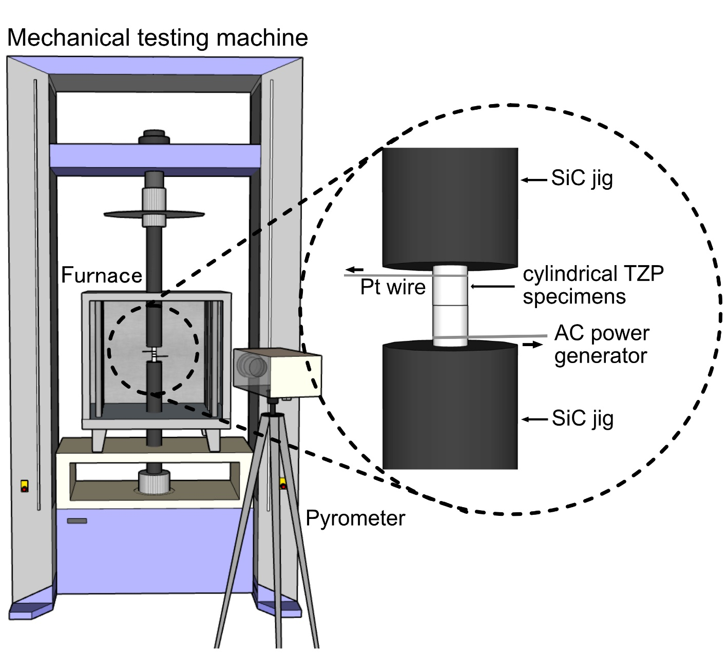

Figure 1

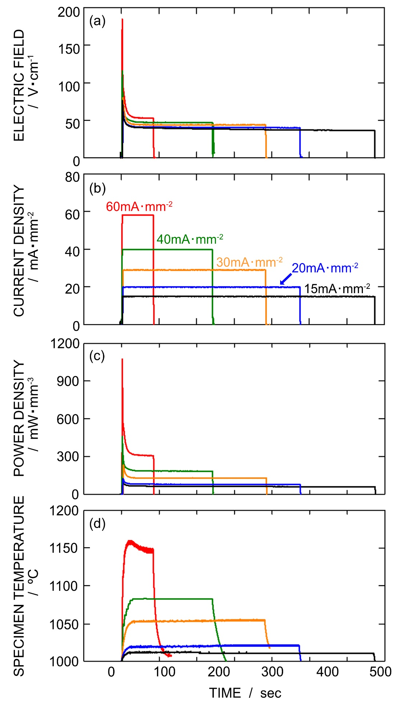

Figure 2

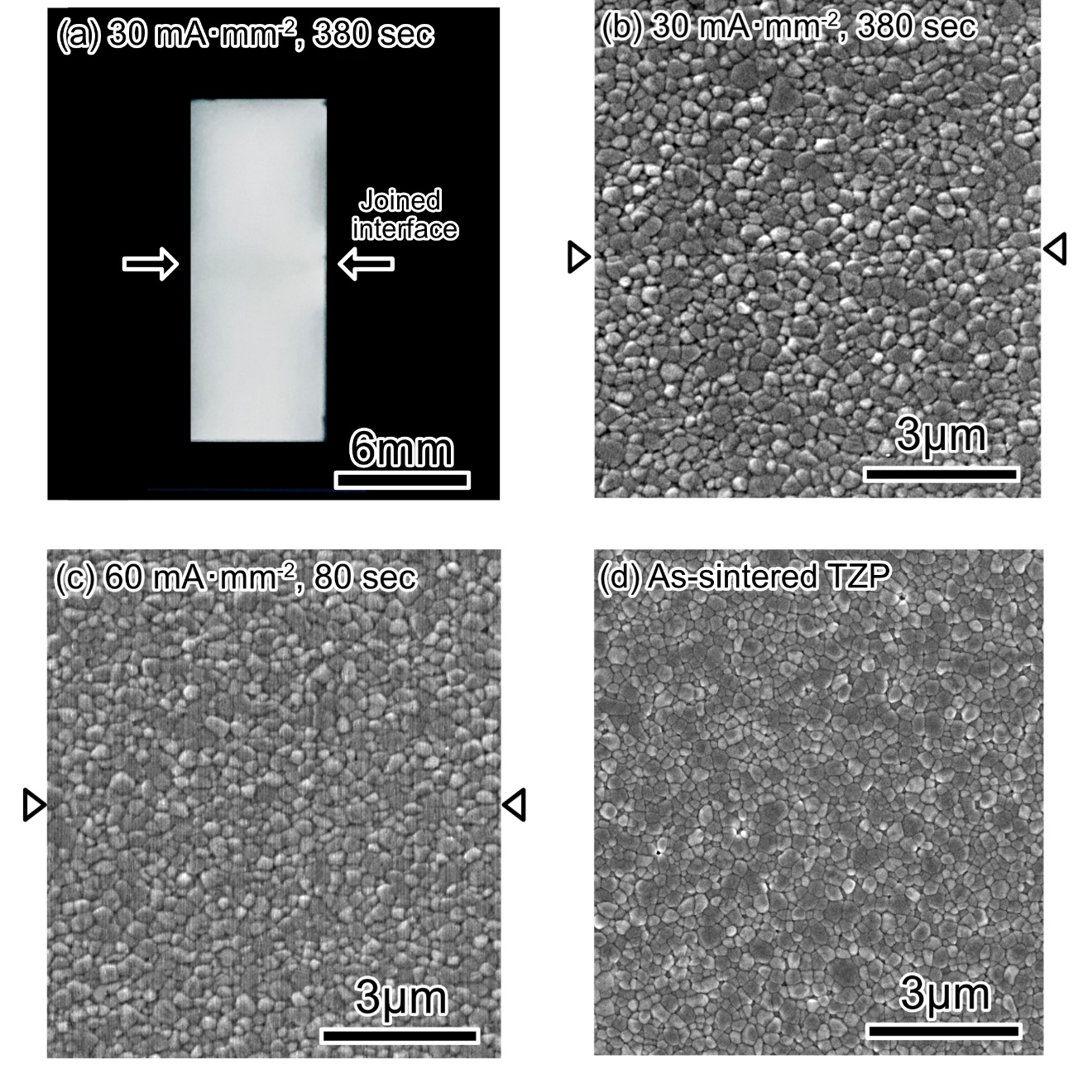

Figure 3

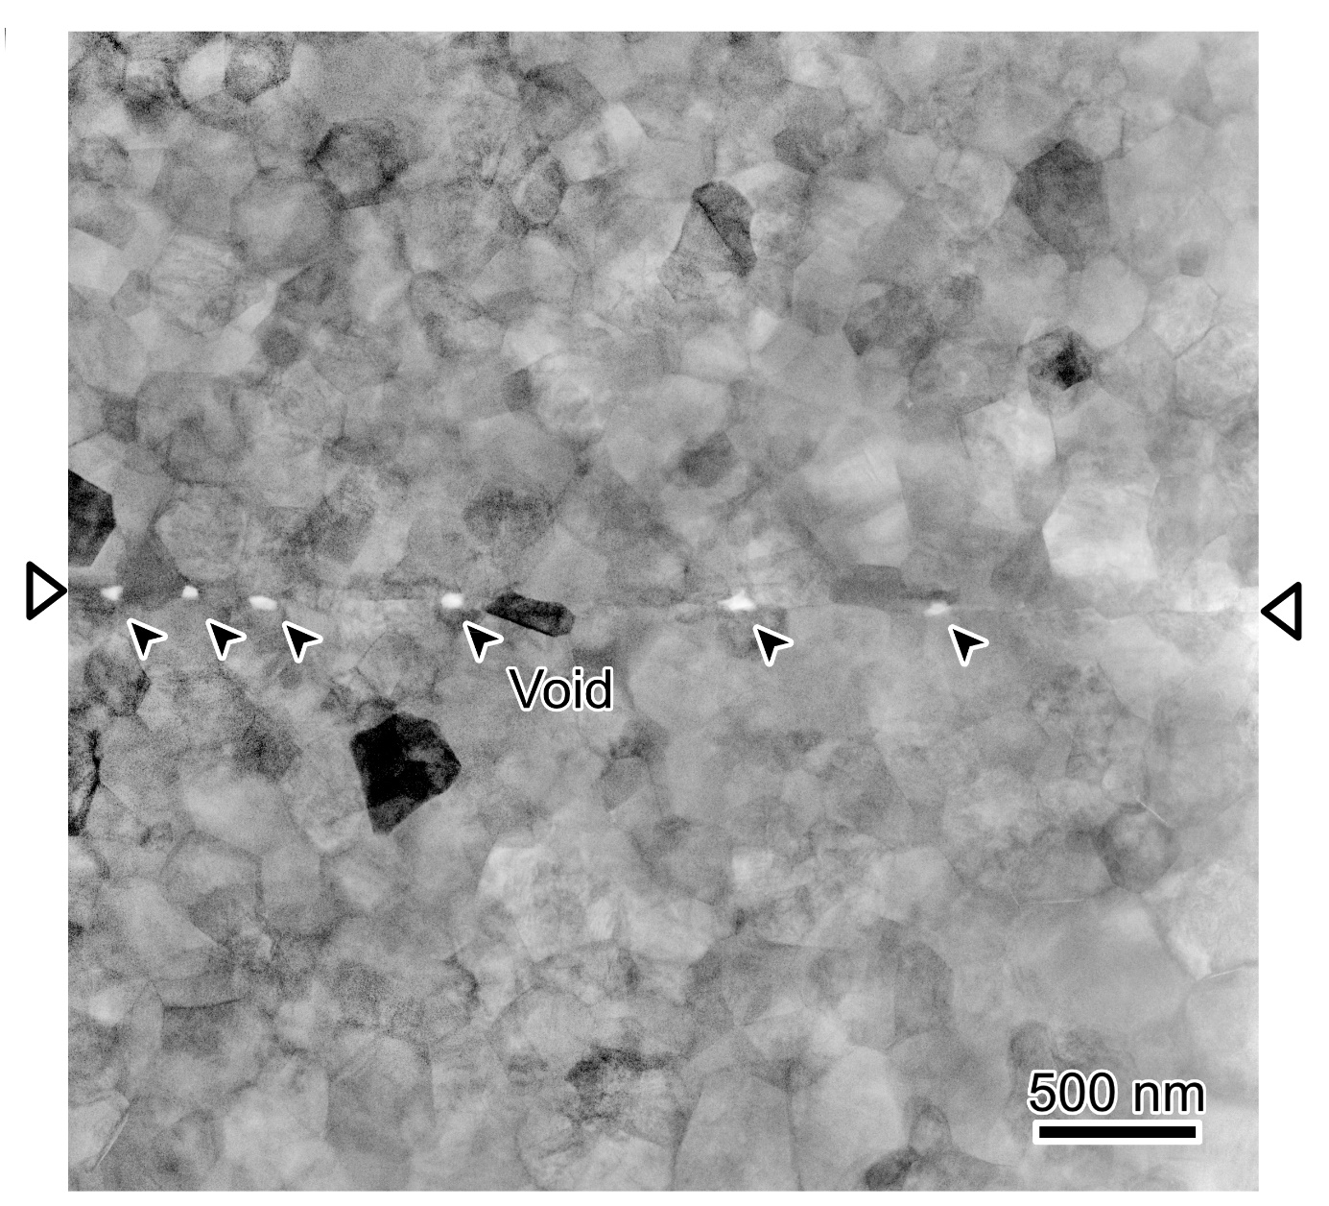

Figure 4

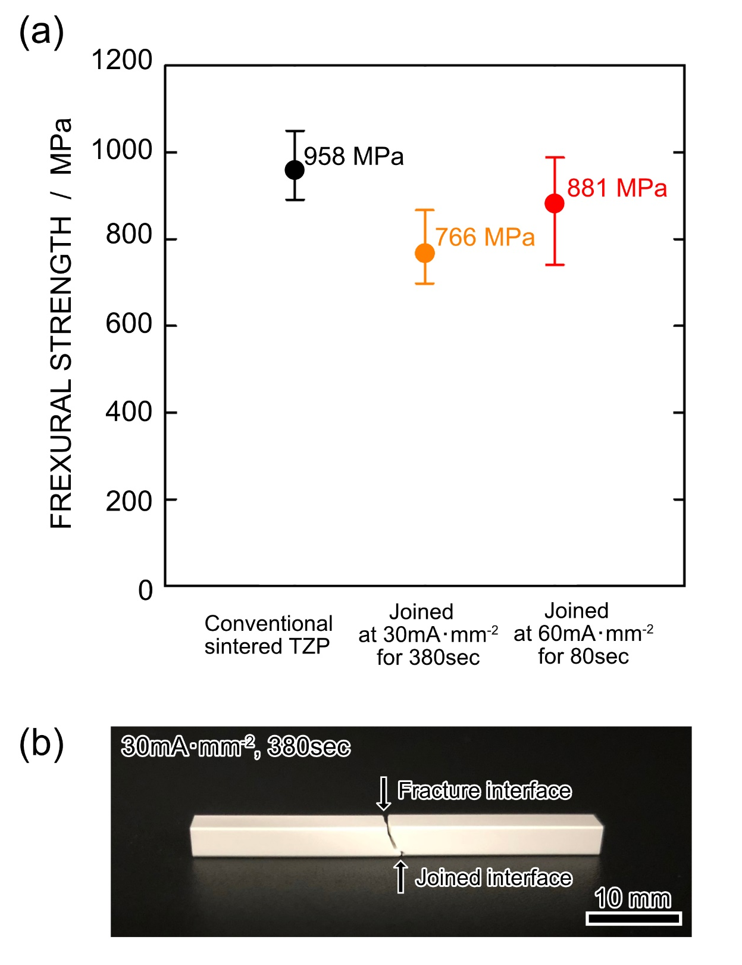

Figure 5

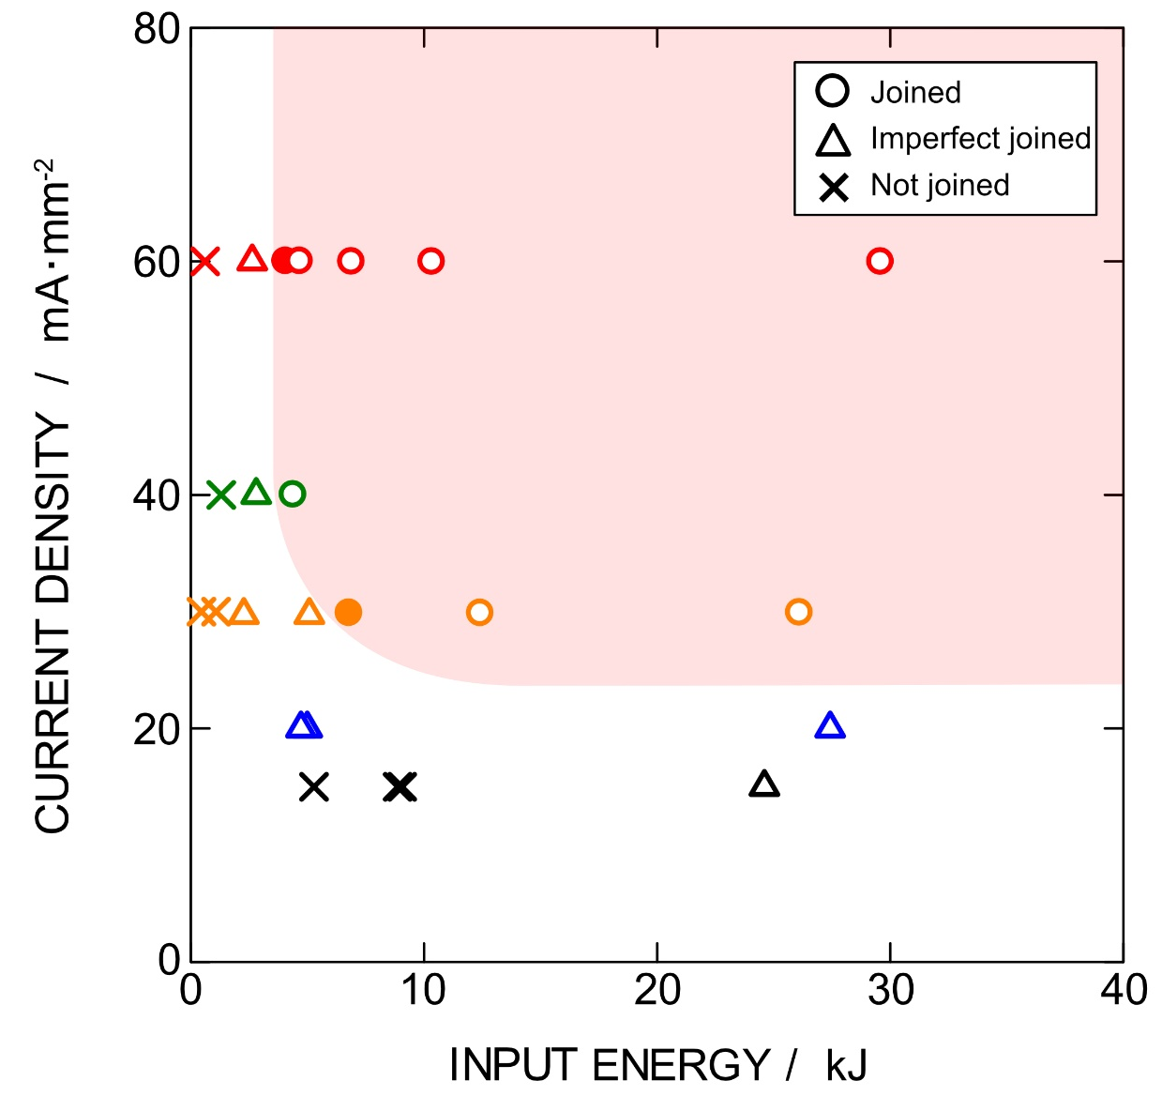

Figure 6

