Coercivity engineering in Sm(Fe_{0.8}Co_{0.2})₁₂B_{0.5} thin films by
Si grain boundary diffusion
A. Bolyachkin¹, H. Sepehri-Amin¹, M. Kambayashi², Y. Mori²,
T. Ohkubo¹, Y.K. Takahashi¹, T. Shima², K. Hono¹
¹National Institute for Materials Science, 1-2-1 Sengen, Tsukuba 305-0047, Japan
²Tohoku Gakuin University, 1-13-1 Tagajo, Miyagi 985-8537, Japan
Achieving a large coercivity in the SmFe₁₂-based compounds with excellent intrinsic magnetic properties is the main challenge toward the development of new high-performance permanent magnets. In this study, we investigated the effect of microstructural factors on coercivity using Sm(Fe_{0.8}Co_{0.2})₁₂B_{0.5} thin films as a model system. The films were composed of columnar Sm(Fe_{0.8}Co_{0.2})₁₂ grains with [001] out-of-plane texture separated by ~5 nm-thick (Fe,B)-rich amorphous intergranular phase. To decrease the Fe content in the intergranular phase and improve the magnetic isolation of Sm(Fe_{0.8}Co_{0.2})₁₂ grains, grain boundary diffusion of Si was performed, which led to an increase in coercivity from 1.11 T to a record high value of 1.32 T for the Sm(Fe_{0.8}Co_{0.2})₁₂ compound. Detailed microstructure characterization using scanning transmission electron microscopy (STEM) and atom probe tomography (APT) confirmed that Si diffused in-part into the intergranular phase which became depleted of Fe and Co. Micromagnetic simulations on a model constructed based on STEM images have shown that triple junctions of the intergranular phase can act as nucleation centers during demagnetization process. This detrimental effect can be suppressed by full-depth diffusion of Si weakening the ferromagnetism of the intergranular phase. However, the presence of α-(Fe,Co) grains at the interface with a V underlayer substantially reduces the benefits of grain boundary diffusion. Thus, high coercivity in the SmFe₁₂-type magnets cannot be obtained unless the soft magnetic α-(Fe,Co) phases are eliminated.
Keywords: coercivity, ThMn₁₂-type structure, thin magnetic films, micromagnetic simulations
1. Introduction
After several decades of research, Sm-Fe intermetallic compounds with the ThMn₁₂-type structure (1:12) have received revived interest as potential hard magnetic materials [1-8]. The SmFe₁₂ phase has the highest molar ratio of Fe to Sm among Sm-Fe compounds that results in the highest saturation magnetization of µ₀M_{s} = 1.64 T at room temperature [9]. The high magnetization in combination with strong uniaxial magnetic anisotropy (µ₀H_{a} = 12 T [9]) can yield a superior performance of SmFe₁₂-based magnets comparing with those of Nd-Fe-B at the elevated temperatures of 150-200 ºC. Hence, the development of SmFe₁₂-based magnets may compliment to Nd₂Fe₁₄B-based ones in the view of balanced use of rare earth elements.
However, it is hard to convert such prospective intrinsic magnetic properties into desired hysteretic properties of bulk magnets, i.e., high coercivity, remanence and maximum energy product. As an example, the following properties were recently achieved for Sm₈Fe_{73.5}Ti₈V₈Ga_{0.5}Al₂ sintered magnet: µ₀H_{c} = 1 T, µ₀M_{s} = 0.74 T, M_{r}/M_{s} = 0.84 and (BH)_{max} = 74 kJ/m³ [10]. This progress is still far from the potential coercivity of µ₀H_{a}/3 = 3.4 T for this composition; the remanence is low as well. There are several reasons for challenges with the SmFe₁₂ phase. First, the phase is unstable in the bulk state. It is usually overcome by the substitution of Fe sites with nonmagnetic stabilizing element M like Ti, V, Mo or others [6-8]. Their concentration should be minimized to prevent magnetization deterioration. Also, the phase stability can be improved with the substitution of Sm sites by Zr atoms [11-15]. Second, the microstructure of SmFe₁₂-based alloys requires optimization: soft magnetic secondary phases should be avoided as well as defects like twins [16], good [001] crystallographic texture should be preserved, and the intergranular phase isolating Sm(Fe,M)₁₂ grains should be formed [17-19].
Thin films of SmFe₁₂-based compounds can serve as a model system to design optimum microstructure and composition toward high coercivity in the 1:12 alloys. Ogawa et al. demonstrated the grain boundary diffusion process of nonmagnetic alloys from a capping layer into the polycrystalline Sm(Fe,Co)₁₂ thin film [20]. The increase in coercivity from 0.4 T to 0.78 T, 0.84 T, and 0.87 T was obtained using Cu, CuGa, and low eutectic Mg-Zn capping layers, respectively. The co-sputtering of light elements B, C, N or their combination with Sm(Fe,Co)₁₂-based thin films resulted in further coercivity enhancement up to 1.1 T [21]. Recently, Sepehri-Amin et al. reported a large coercivity of 1.2 T by co-sputtering the Sm(Fe_{0.8}Co_{0.2})₁₂ with B [22]. Detailed microstructural investigation revealed the formation of columnar microstructure with Sm(Fe_{0.8}Co_{0.2})₁₂ nanograins isolated by B-rich amorphous intergranular phase. The intergranular phase is expected to be ferromagnetic considering its composition of Fe_{73.3}Co_{10.6}B_{10.3}Sm_{5.8} at.% with large amount of Fe and Co measured by atom probe tomography [22]. Although the origin of the large coercivity was discussed to be pinning of magnetic domain walls at the intergranular phase, there is no direct evidence for the magnetization reversal mechanism. Further reduction of Fe and Co in the intergranular phase should result in the weakening of its ferromagnetism that is beneficial for the coercivity enhancement. It has been reported that Si has a rather large diffusion constant into amorphous Fe₈₂B₁₈ alloy even at low temperatures of 300–400 ºC which cannot be realized in the other crystalline metals such as Fe in a comparable temperature range [23,24]. Since the intergranular phase of Sm(Fe_{0.8}Co_{0.2})₁₂B_{0.5} film was an amorphous (Fe,B)-rich phase, we considered it may be possible to dilute its magnetization by the low temperature diffusion of Si.
In this work, we investigated how Si diffusion into the amorphous FeCoBSm intergranular phase affects the coercivity of the Sm(Fe_{0.8}Co_{0.2})₁₂B_{0.5} thin films. This approach resulted in the record high coercivity of 1.32 T for the Sm(Fe_{0.8}Co_{0.2})₁₂ compound. To shed a light on the effect of grain boundary magnetism on coercivity, we developed a detailed micromagnetic model based on STEM images of the Sm(Fe_{0.8}Co_{0.2})₁₂B_{0.5} thin films. Micromagnetic simulations enabled us to clarify the magnetization reversal process in the films and its weak links that determine coercivity. This study will pave a way to realize an optimum microstructure required for Sm(Fe_{0.8}Co_{0.2})₁₂-based magnets with a large coercivity.
2. Experimental
SmFe₁₂-based thin films were prepared to investigate the effect of Si grain boundary diffusion process on coercivity. Their synthesis started with the deposition of 20-nm-thick V underlayer onto a MgO(100) single crystal substrate at 350 °C using an ultra-high vacuum magnetron sputtering system with a base pressure below 10⁻⁸ Pa. For the first film, a Sm(Fe_{0.8}Co_{0.2})₁₂B_{0.5} layer of 100 nm nominal thickness was deposited on the V underlayer by co-sputtering of Sm, Fe, Fe₅₀Co₅₀, and Fe₈₀B₂₀ (at.%) targets. This film was used as a Si-free reference. The same Sm(Fe_{0.8}Co_{0.2})₁₂B_{0.5} layer was deposited for the second film and covered by a 8-nm-thick Si capping layer. Hereafter, this sample is referred as Si-diffused sample. All films were protected against oxidation by a 10-nm thin V capping layer.
Hysteresis loops of the films were measured in a magnetic field up to 7 T at room temperature using a superconducting quantum interference device (SQUID) equipped with vibrating sample magnetometer (VSM). Microstructure was studied with TEM using a FEI Titan G2 80200 STEM equipped with a probe aberration corrector. A laser assisted local electrode atom probe (LEAP5000XS) was used to perform APT analysis evaluating local chemical compositions. The specimens for the TEM and 3D atom probe (3DAP) analyses were prepared using a focused ion beam (FEI Helios G4-UX) dual-beam system via the lift out method. Micromagnetic simulations were performed in order to link magnetic properties with the observed microstructure of the films. For that, a finite element model reproducing real microstructure was created using Trelis (Cubit). GPU-accelerated simulations were carried out by ‘b4vex’ code [25] in the energy minimization mode.
3. Results and Discussions
3.1 Magnetic properties and microstructure
Hysteresis loops of (a) Sm(Fe_{0.8}Co_{0.2})₁₂B_{0.5} and (b) Si-diffused Sm(Fe_{0.8}Co_{0.2})₁₂B_{0.5} films are shown in Figure 1 for both out-of-plane (OOP) and in-plane (IP) directions of applied magnetic field $H_{ex}$. OOP magnetization curves were replotted into internal magnetic field $H_{in}=H_{ex}-NM$ using demagnetization factor N = 1.0. Si-free Sm(Fe_{0.8}Co_{0.2})₁₂B_{0.5} film has a high saturation magnetization $µ_{0}M_{s}$ of 1.58 T and a coercivity of 1.11 T (Fig.1(a)). Prominent remanent magnetization $M_{r}$ of OOP hysteresis loop (${M_{r}}/{M_{s}}=0.97$) indicates excellent out-of-plane texture of easy magnetization axes associated with [001] axis of 1:12 phase. The S-shape of IP hysteresis loop with low coercivity and high remanence of 0.39 T can be due to the presence of soft magnetic phases. Since OOP loop does not exhibit any clear kink, soft phases should be strongly exchange coupled with the main anisotropic 1:12 phase. In the case of Si-diffused Sm(Fe_{0.8}Co_{0.2})₁₂B_{0.5} sample, OOP coercivity is enhanced up to 1.32 T (Fig. 1(b)) that is the highest reported coercivity for SmFe₁₂-based anisotropic thin films to the best of our knowledge. Saturation magnetization is slightly reduced to 1.5 T, as well as IP remanence of 0.33 T. Superior texture of the film is maintained, ${M_{r}}/{M_{s}}=0.97$.
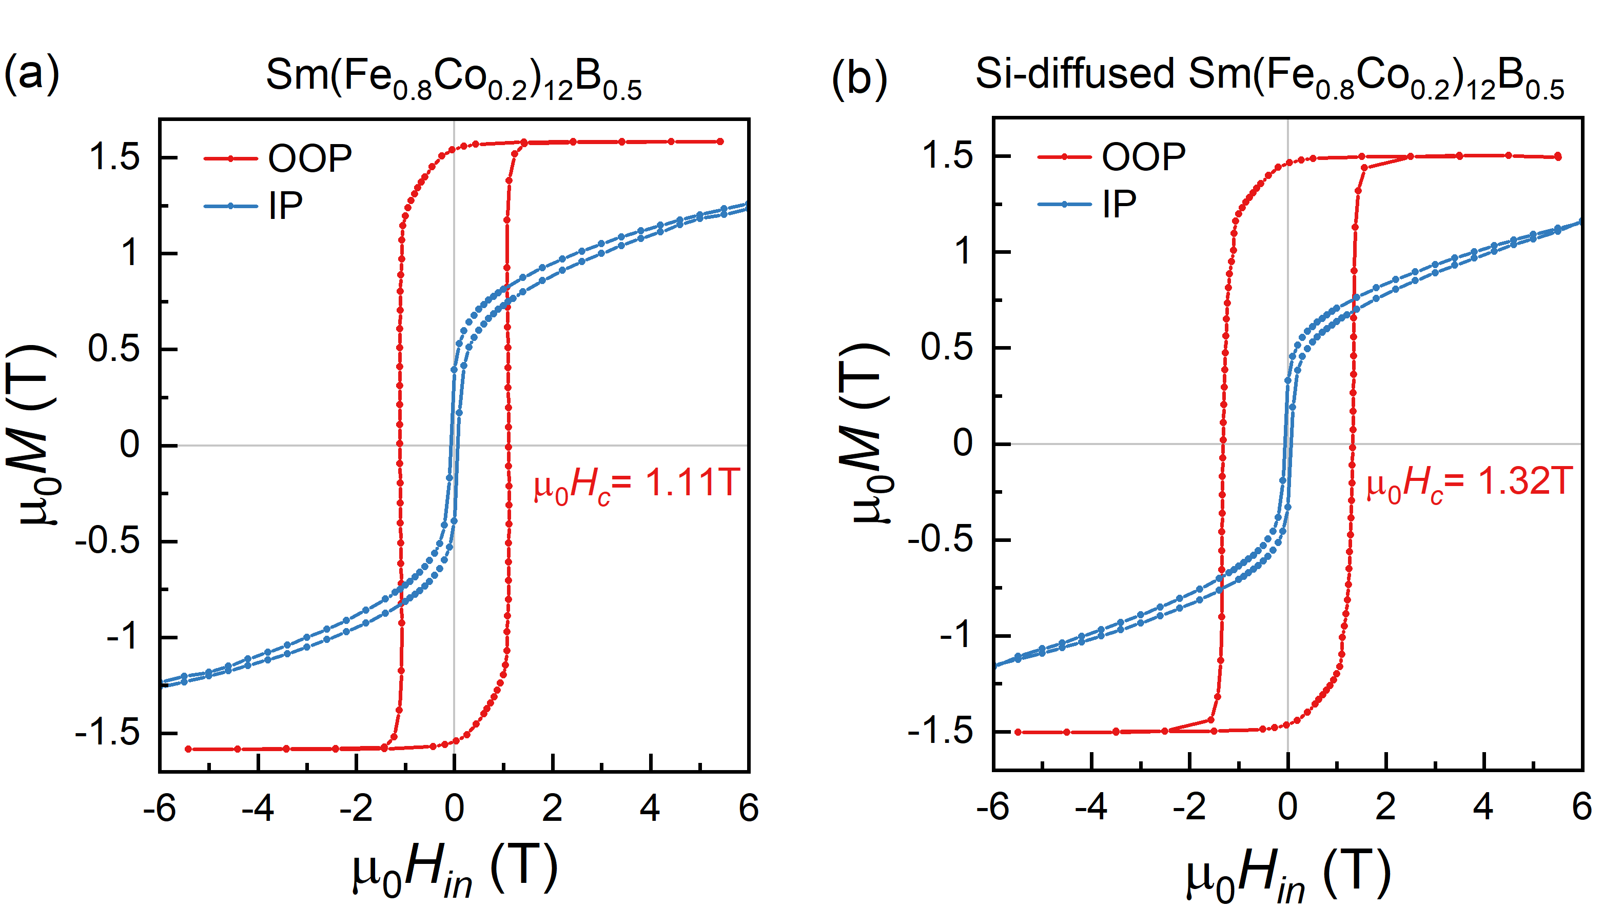
Figure 1. Out-of-plane (OOP) and in-plane (IP) hysteresis loops measured at room temperature for (a) Sm(Fe_{0.8}Co_{0.2})₁₂B_{0.5} and (b) Si-diffused Sm(Fe_{0.8}Co_{0.2})₁₂B_{0.5} films.

A detailed microstructural investigation of the films was performed to elucidate the origins of the high coercivity. Plane-view and cross-sectional bright field (BF)-TEM images obtained for Sm(Fe_{0.8}Co_{0.2})₁₂B_{0.5} and Si-diffused Sm(Fe_{0.8}Co_{0.2})₁₂B_{0.5} films are shown in Figure 2. Columnar microstructure with a broad grain size distribution within a range of about 10-40 nm and 20 (7) nm mean (standard deviation) value can be seen in both films. Grain sizes are estimated as $\sqrt{{4A}/π}$, where $A$ is the plane-view area of a grain. All grains are well isolated by rather thick intergranular phase of 5.8 (0.6) nm and 4.9 (0.8) nm in thickness respectively. The height of grains is of about 90 nm.
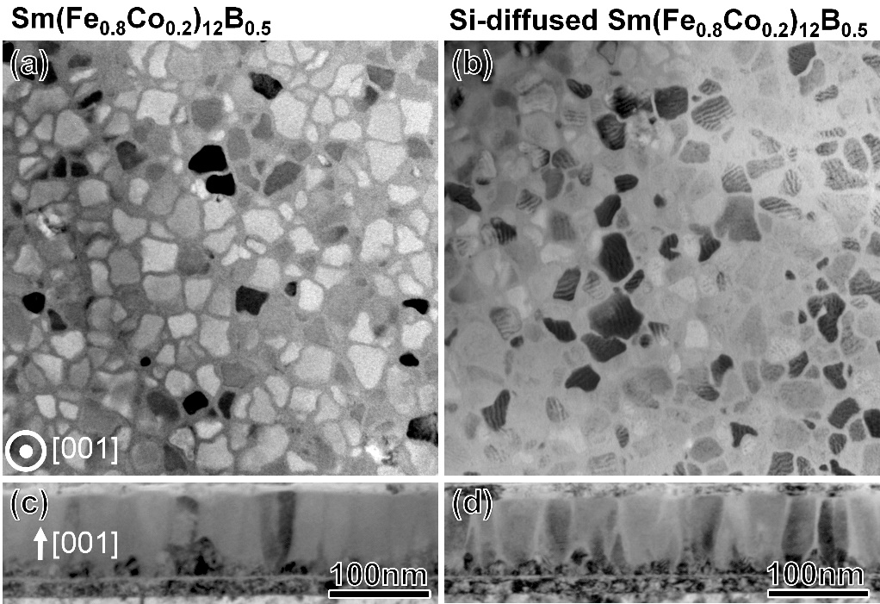
Figure 2. Plane-view (top) and cross-sectional (bottom) bright field (BF)-TEM images of (a) Sm(Fe_{0.8}Co_{0.2})₁₂B_{0.5} and (b) Si-diffused Sm(Fe_{0.8}Co_{0.2})₁₂B_{0.5} films.
Figure 3 shows plane-view and cross-sectional STEM-energy-dispersive X-ray spectroscopy (EDS) maps of Fe, Co, Sm, and Si obtained for (a-c) Sm(Fe_{0.8}Co_{0.2})₁₂B_{0.5} and (d-e) Si-diffused Sm(Fe_{0.8}Co_{0.2})₁₂B_{0.5} films. Depletion of Co from the intergranular phase is clearly seen in both films. In the Si-diffused Sm(Fe_{0.8}Co_{0.2})₁₂B_{0.5} film, Si is detected mainly in the intergranular phase. Also, cross-sectional STEM-EDS maps revealed the presence of Sm-depleted Fe-rich phase at the interface with the V underlayer that is typical for all samples. In the case of Sm(Fe_{0.8}Co_{0.2})₁₂B_{0.5} film covered by Si layer, the diffusion of Si into the intergranular phase on the depth of about 25 nm is observed. Note that the detection of boron is not possible using STEM-EDS.
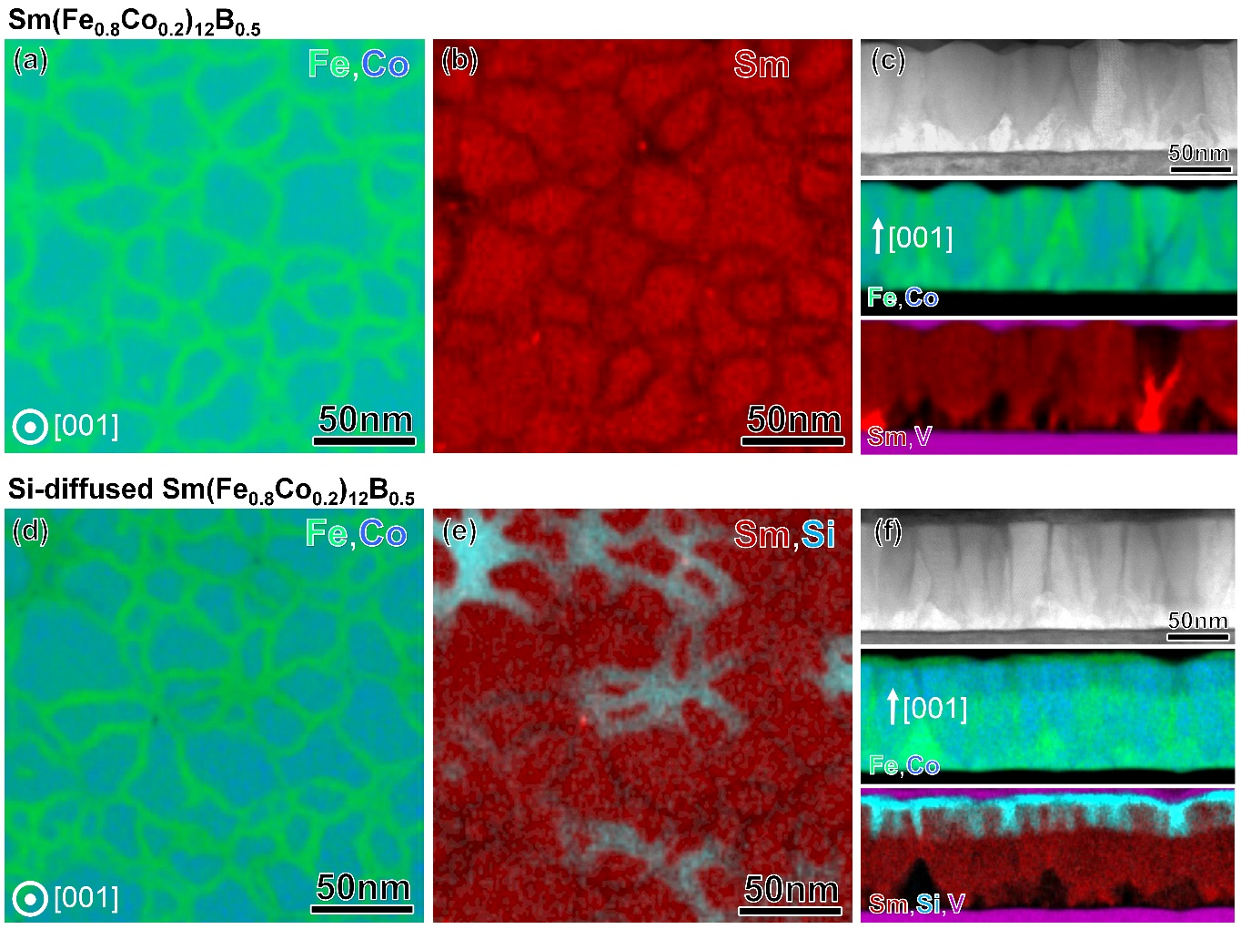
Figure 3. Plane-view and cross-sectional STEM-EDS maps of (a-c) Sm(Fe_{0.8}Co_{0.2})₁₂B_{0.5} and (d-e) Si-diffused Sm(Fe_{0.8}Co_{0.2})₁₂B_{0.5} films.
Figure 4 shows cross-sectional high angle annular dark field (HAADF)-STEM images obtained along the [100] zone-axis of the Sm(Fe,Co)₁₂ grains of (a) Sm(Fe_{0.8}Co_{0.2})₁₂B_{0.5} and (b) Si-diffused Sm(Fe_{0.8}Co_{0.2})₁₂B_{0.5} films. An amorphous intergranular phase (IG) separates 1:12 grains in both films. Grain boundaries of the Si-diffused Sm(Fe_{0.8}Co_{0.2})₁₂B_{0.5} film were analyzed in more details using 3DAP technique as shown in Figure 5. Atom maps of Sm, Fe, Co, Si and isoconcentration surfaces of B with a concentration of above 7 at.% are shown in two different viewing directions: out-of-plane observation (Fig. 5(a), top and middle) and cross-sectional one (Fig. 5(a), bottom). A rotating animation of Figure 5(a) is available in Supplementary materials (S1). B-rich intergranular phases can be clearly seen in the atom maps. Figure 5(b) shows the concentration profiles taken from the selected volumes (i) and (ii) marked in Figure 5(a). 1:12 grains have a chemical composition of Sm_{8.2}Fe_{71.3}Co_{20.3}B_{0.2} at.%. Si is not dissolved in the 1:12 phase, suggesting that the diffusion of Si takes place in the intergranular phase predominantly. Thus, two types of the intergranular phase exist: Si-enriched intergranular phase with a composition of Sm_{4.7}Fe_{61.7}Co_{10.2}B_{8.0}Si_{15.4} at.% and Si-free one with a composition of Sm_{5.3}Fe_{66.7}Co_{11.4}B_{16.6} at.%. The diffusion of Si into the intergranular phase results in a dilution of ferromagnetic elements, e.g. Fe + Co reduces from 78.1 to 71.9 at.%. Hence, it can be expected that the Si-enriched intergranular phase has a smaller saturation magnetization than that of the Si-free one. Note that the α-(Fe,Co) phase located at the interface of 1:12 film with the V underlayer was also observed in the 3DAP of Si-diffused Sm(Fe_{0.8}Co_{0.2})₁₂B_{0.5} film.
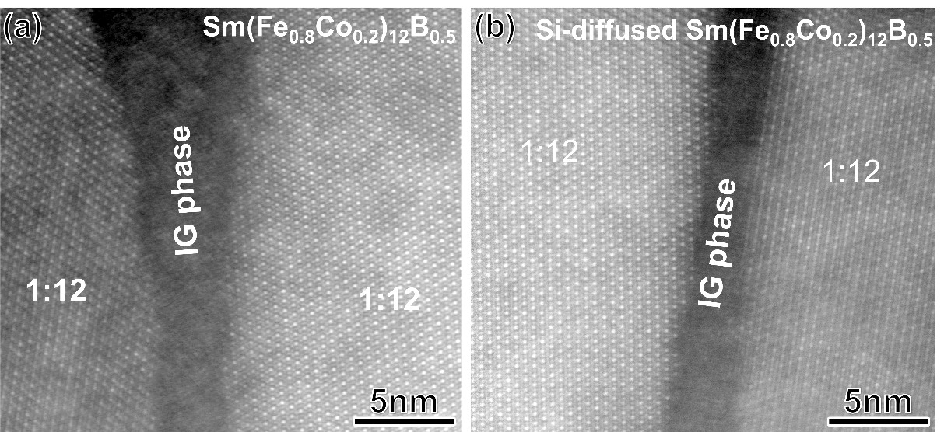
Figure 4. High magnification cross-sectional HAADF-STEM images obtained from (a) Sm(Fe_{0.8}Co_{0.2})₁₂B_{0.5} and (b) Si-diffused Sm(Fe_{0.8}Co_{0.2})₁₂B_{0.5} films.
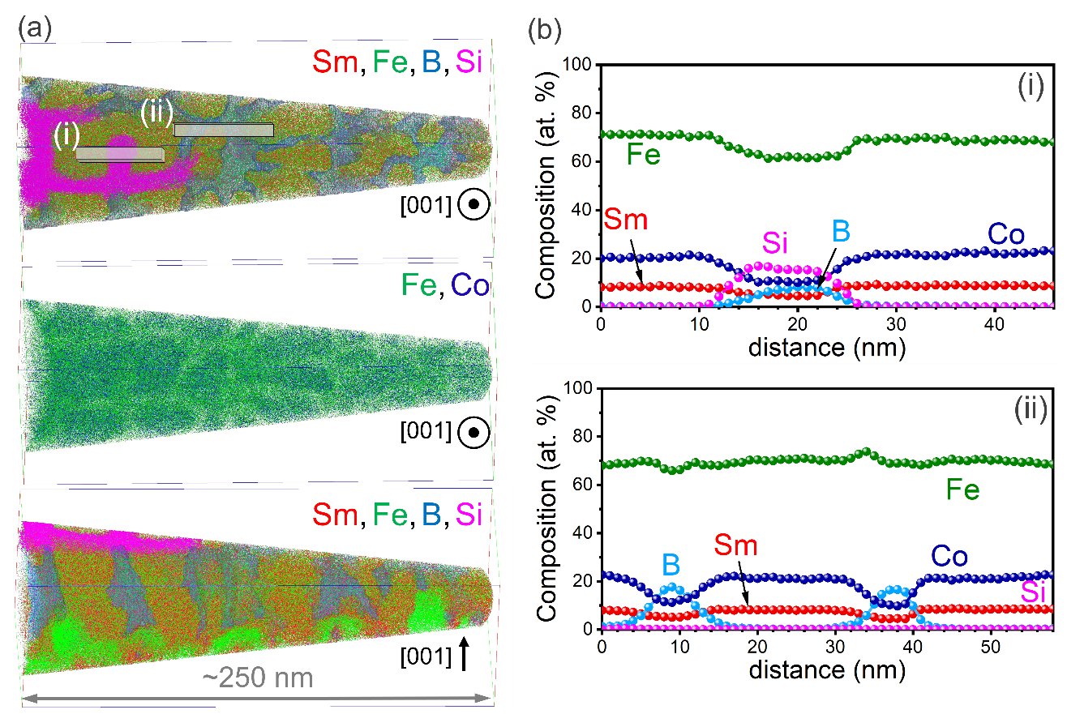
Figure 5. (a) Atom maps of Sm, Fe, Co, Si and isoconcentration surfaces of B-rich region obtained from Si-diffused Sm(Fe_{0.8}Co_{0.2})₁₂B_{0.5} thin film. 3D atom maps of Sm+Fe+Si+B are shown in two view directions: out-of-plane one and cross-section of the film. (b) Composition profiles of the constituent elements calculated from selected volumes (i) and (ii) marked in (a).

3.2. Micromagnetic Models
The above-described detailed microstructural investigation of SmFe₁₂-based thin films allowed us to design accurate finite element model for micromagnetic simulations aiming to explain how the Si diffusion process affects hysteretic properties of the films. The HAADF-STEM image of the Si-diffused Sm(Fe_{0.8}Co_{0.2})₁₂B_{0.5} film in Figure 6(a) was segmented and recognized contours of individual grains were approximated by polygons as shown in Figure 6(b). The approximation was performed with the accuracy of 0.5 nm giving an average interpoint distance of about 5.0 nm that was large enough to avoid small curves causing problems for meshing. For the same reason, small parts of grains and narrow regions appeared along the image edges were deleted or slightly corrected. In Figure 6(b) the polygon-based top view after described processing is shown demonstrating excellent correspondence with the initial STEM image. Columnar microstructure with some inclined and interrupted grains (Fig. 6(c)) was simplified up to the system of straight columns, so the top-view geometry was extruded by a height of 90 nm making a 3D model (Fig. 6(d)). For such 1:12 grains perfect out-of-plane texture of [001] axes was assumed. Intergranular (IG) phase was split into two parts: Si-rich IG phase with thickness passing the values of [25, 60, 90] nm and Si-free one (Fig. 6(d)).
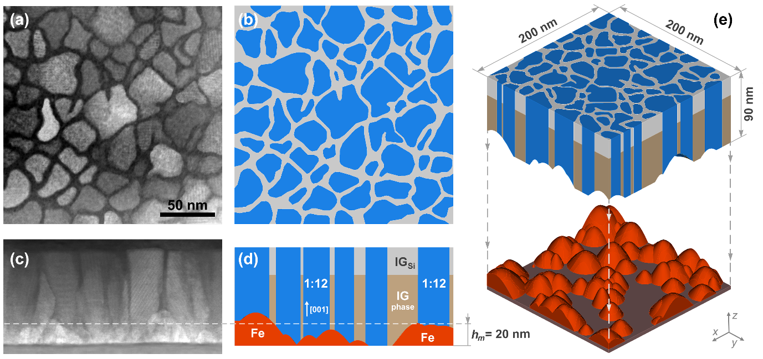
Figure 6. (a) Selected plane-view HAADF-STEM image of Si-diffused Sm(Fe_{0.8}Co_{0.2})₁₂B_{0.5} film and (b) its polygon-based segmentation with corrections preventing small geometrical entities. (c) Cross-sectional HAADF-STEM image of the film and (d) its imitation with straight columnar 1:12 grains separated by Si-free intergranular phase (IG) and Si-diffused one (IG_{Si}). α-(Fe,Co) grains were introduced as random spline-based cones. (e) 3D micromagnetic model of Si-diffused Sm(Fe_{0.8}Co_{0.2})₁₂B_{0.5} film with shifted α-(Fe,Co) grains for better visibility.
Shape of α-(Fe,Co) grains located at the bottom of the film was imitated with spline-based cones. Their height h and aspect ratio ($h/R$, where R is a radius) were governed by normal distributions with means (standard deviations) of 20 (5) nm and 1.0 (0.2), respectively. These grains were introduced in the model iteratively. First, a candidate grain was put on the substrate at random coordinates and subtracted from the previous geometry to create a new one. Then, it was checked that subtraction did not cause any of small curves, surfaces, and narrow regions which can be detrimental for final mesh quality. If none of small entities were detected, the grain was accepted, otherwise it was rejected as well as related transformations, and a new random grain was generated. During this process, the volume fraction of α-(Fe,Co) grains ${V_{Fe}}/V$ and their covering of the bottom area of the film ${A_{Fe}}/A$ were controlled stopping the algorithm when a desired value was achieved. Visual similarity of such synthetically created α-(Fe,Co) grains with their real counterparts can be seen in Figure 6(c,d) where dash line is the mean height of grains.
The final 3D model for the case of $V_{Fe}=9 vol.\%$ is shown in Figure 6(e) with artificially shifted α-(Fe,Co) grains for better visibility. Simulation area was of $200×200$ nm² and the height was of 90 nm. All models were meshed by geometry adaptive algorithm with mesh size of 1.5 nm allowed to be reduced up to 0.5 nm to resolve narrow regions of the intergranular phase. Created meshes consisted of 10-13×10⁶ tetrahedral elements.

3.3. Micromagnetic simulation results and discussion
Micromagnetic constants chosen for simulations are listed in Table 1. The chemical composition of the 1:12 grains in the Si-diffused film was determined to be Sm_{8.2}Fe_{71.3}Co_{20.3}B_{0.2} (Sm_{1.08}(Fe_{0.78}Co_{0.22})₁₂B_{0.03}) by APT, that was close to Sm(Fe_{0.8}Co_{0.2})₁₂ with some excess of Sm and small addition of B. Therefore, saturation magnetization $μ_{0}M_{s}=1.78$ T, exchange stiffness A ≈ 20 pJ/m ($T_{c}=859 K$) [26] and magnetic anisotropy constant K₁ = 8.5 MJ/m³ were taken for Sm(Fe_{0.8}Co_{0.2})₁₂ [9,27]. Accordingly, the exchange length $l_{ex}=\sqrt{A/{\left(μ_{0}M_{s}^{2}\right)}}$ and Bloch wall parameter $δ_{0}=\sqrt{A/{K_{1}}}$ of 2.8 nm and 1.5 nm, respectively, define the limitation for mesh size. Micromagnetic constants of Si-free intergranular phase with the chemical composition of Sm_{5.3}Fe_{66.7}Co_{11.4}B_{16.6} were chosen considering the values for Fe₂B ($μ_{0}M_{s}=1.53 T$, 𝐴 ≈ 10 pJ/m [28]) and amorphous melt-spun Sm_{3.5}Fe₆₂Co_{9.5}B₂₅ ($μ_{0}M_{s}=1.35 T$ [29]) ribbon as references. For Si-rich intergranular phase $μ_{0}M_{s}$ and A were varied keeping the scaling $A \sim { M}_{s}^{2}$. Magnetic anisotropy of both intergranular phases was ignored due to their amorphous state. For simplicity micromagnetic constants of α-(Fe,Co) grains were prescribed to those of α-Fe [28]. Being a part of exchange-coupled system with dominant high-anisotropy 1:12 phase, magnetic anisotropy of α-(Fe,Co) grains was neglected.
Table 1. Saturation magnetization $μ_{0}M_{s}$, exchange stiffness A, magnetic anisotropy constant K₁, and exchange length l_{ex} of different phases composing the micromagnetic model of Si-diffused Sm(Fe_{0.8}Co_{0.2})₁₂B_{0.5} thin film.
 | $μ_{0}M_{s}$ (T) | A (pJ/m) | K₁ (MJ/m³) | l_{ex} (nm)
Sm(Fe,Co)₁₂ grains | 1.78 [9] | $\sim$20 [26] | 8.5 [9] | 2.8
Intergranular  phase (IG) | 1.5 | $\sim$12 | 0 | 2.6
Si-rich IG phase | 0-1.5 | 0-12 | 0 | 2.6
α-(Fe,Co) grains | 2.15 [28] | 21 [28] | 0 | 2.4

Figure 7 shows OOP and IP hysteresis loops calculated for the Si-free Sm(Fe_{0.8}Co_{0.2})₁₂B_{0.5} thin film with different volume fractions of α-(Fe,Co) grains located at the bottom of the film. The simulated loops are very similar to the experimental one (Fig. 1(a)). The following features are well reproduced: deterioration of the squareness in the second quadrant of OOP loops, drastic difference between OOP coercivity and the anisotropy field of 12 T, and S-shape of the IP loops. With the increase in volume fraction of α-(Fe,Co) grains, OOP hysteresis loops degrade: all coercivity, remanence, and squareness decrease. S-shape of the IP hysteresis loop becomes more prominent while IP coercivity remains the same. Obtained OOP coercivity was of 1.6 T that was higher than the experimental value of 1.11 T. A better quantitative correspondence between them can be achieved if the uncertainty with choosing micromagnetic parameters of the IG phase is reduced.
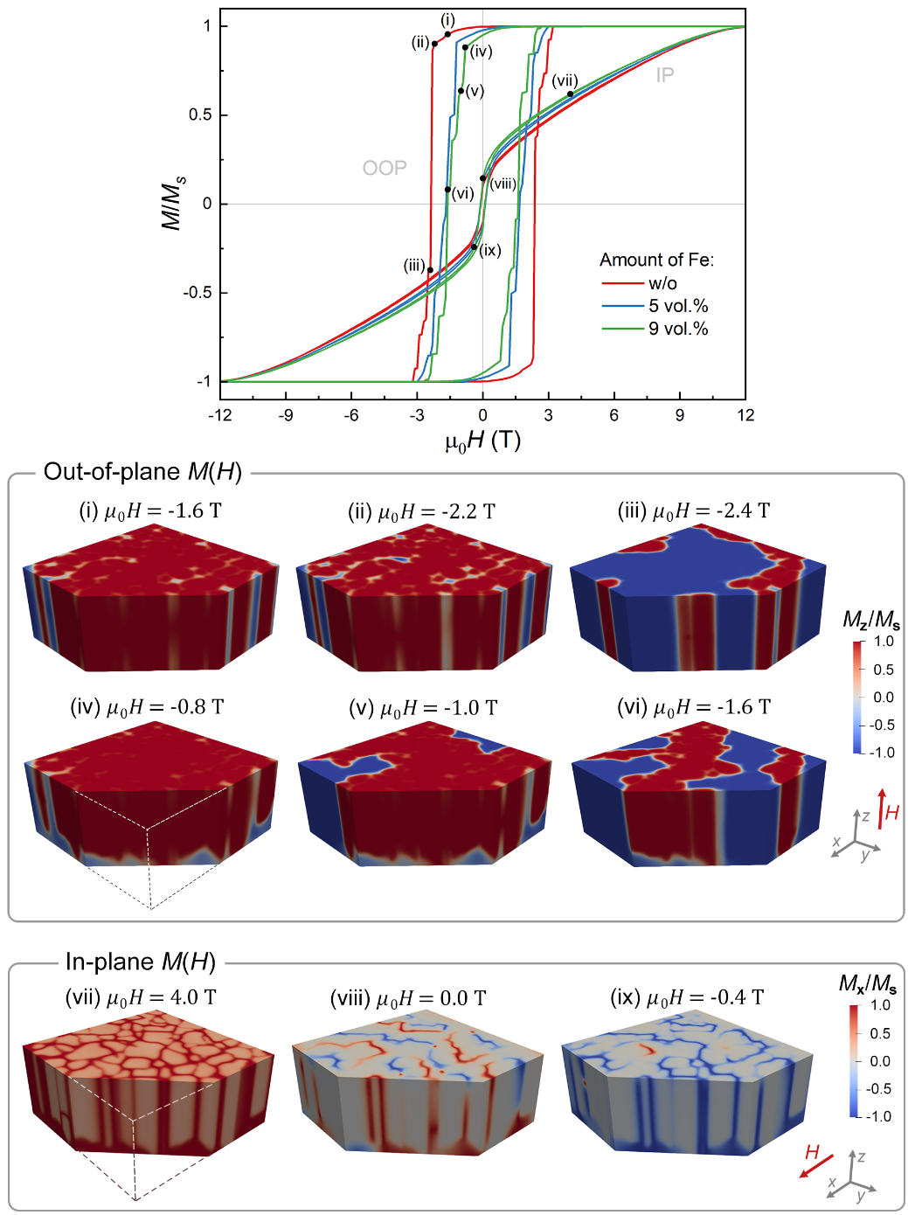
Figure 7. Simulated out-of-plane (OOP) and in-plane (IP) hysteresis loops of the Si-free Sm(Fe_{0.8}Co_{0.2})₁₂B_{0.5} thin film with variation of the volume fraction of α-(Fe,Co) grains located at the bottom of the film. Snapshots of micromagnetic structures with a slice are taken at (i-ix) points of the loops. Colormaps correspond to the normalized magnetization projected on Z and X axes for OOP and IP respectively.
The snapshots of magnetization reversal process in the models are shown in Figure 7(i-ix) for two cases: the absence of α-(Fe,Co) grains (i-iii) and 9 vol.% of them (iv-ix). The colormap corresponds to magnetization normalized by M_{s} and projected on Z (X) axis which is collinear with H for the OOP (IP) configuration. Animated OOP and IP reversals are available in the Supplementary materials (S2-S5). It can be seen that the OOP magnetization reversal in the film without α-(Fe,Co) starts with the reversal in thick junctions of the soft-magnetic intergranular phase (Fig. 7(i,ii)). This feature can be observed better in Figure 8 which shows top-view cross-section of the film in Figure 7(ii) taken at the half of its thickness. It demonstrates a full-depth reversal in some thick junctions as well as the reversal of a small grain (dashed circle) provoked by surrounding IG phase (animation in S6). The rest IG phase remains in good exchange coupling with 1:12 grains since its thickness of 5-6 nm is comparable with 2l_{ex} (Table 1). Cascade propagations of domain walls through 1:12 grains occur at 2.2 T. These domain walls are pinned by grain boundaries as shown in Fig. 7(iii). There is a different scenario of magnetization reversal in the film with α-(Fe,Co) grains at the bottom. Reversed domains start to nucleate from the α-(Fe,Co) grains in a much lower magnetic field that can be seen at the slice in Fig. 7(iv). First events of domain wall propagation into 1:12 grains start at 0.8 T. This process involves a smaller number of 1:12 grains since pinning by IG phase is more efficient in reduced H. Thus, we can see that thick junctions of ferromagnetic intergranular phase are the weak links in magnetization reversal meaning that they have the lowest nucleation fields. This role is transferred to α-(Fe,Co) grains if they exist in the film. IP reversal takes place as a combination of the magnetization rotation of 1:12 grains and the propagation of domain walls through ferromagnetic intergranular phase (Fig. 7(vi-ix)). The latter gives S-shape of the IP hysteresis loop.
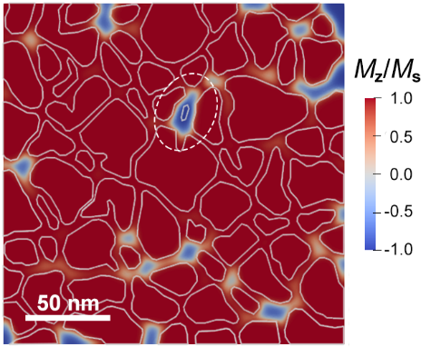
Figure 8. Micromagnetic top-view cross section of the Sm(Fe_{0.8}Co_{0.2})₁₂B_{0.5} thin film taken at the half of its thickness in µ₀H = -2.2 T. The micromagnetic state corresponds to Figure 7(ii). Dashed circle emphasizes a small 1:12 grain reversed due to strong exchange coupling with surrounding ferromagnetic intergranular phase. Solid lines depict contours of grains.
Figure 9 shows results of micromagnetic simulations for the Sm(Fe_{0.8}Co_{0.2})₁₂B_{0.5} thin films with Si grain boundary diffusion. Let us consider first the films with α-(Fe,Co) grains at the bottom as it was observed in actual samples. The amount of α-(Fe,Co) grains was fixed to be 9 vol.%. The effect of diffusion depth x is demonstrated in Figure 9(a) with two cases for the Si-rich intergranular phase (IG_{Si}): (top) the ferromagnetic phase with $μ_{0}M_{s}=0.75 T$ that is a twice reduced magnetization of the remaining Si-free intergranular phase, and (bottom) nonmagnetic one. In the former case exchange stiffness was of 3 pJ/m according to the scaling $A\sim M_{s}^{2}$. In both cases, domain wall pinning by grain boundaries becomes stronger with the increase in diffusion depth. This conclusion comes from the comparison of pinning and depinning fields for magnetization steps (e.g. x = 0 nm vs. x = 60 nm). However, it does not improve the coercivity of the film remarkably since it is mainly governed by the nucleation field in the α-(Fe,Co) grains. Thus, even for full-depth expansion (x = 90 nm) of either Si-rich ferromagnetic or nonmagnetic intergranular phase, coercivity is enhanced only to 1.9 T or 2.2 T, respectively. For x of 25 nm and 60 nm the change of coercivity is not well resolved due to the limited number of grains in the simulation volume. The full-depth diffusion is considered separately in Figure 9(b) with more detailed magnetization variation of IG_{Si} phase. Let us note that for 9 vol.% of α-(Fe,Co) grains, their areal coverage of the bottom interface is 70%. It means that only a few grains are well isolated by nonmagnetic IG_{Si} phase, and the rest of them are interconnected at the bottom by α-(Fe,Co) as shown in the inset of Figure 9(b). Hence, the only way to recover the benefits of the grain boundary diffusion process with Si is to eliminate α-(Fe,Co) grains. In combination with full-depth penetration it turns into ideal tuning of the magnetism of grain boundaries which results are shown in Figure 9(c). A significant growth of coercivity becomes possible. For example, magnetization reduction of Si-rich intergranular phase down to 0.75 T provides coercivity of 6 T. Cascade propagation of domain walls is fully suppressed, instead of it 1:12 grains start to switch independently as can be seen in the animation S7.
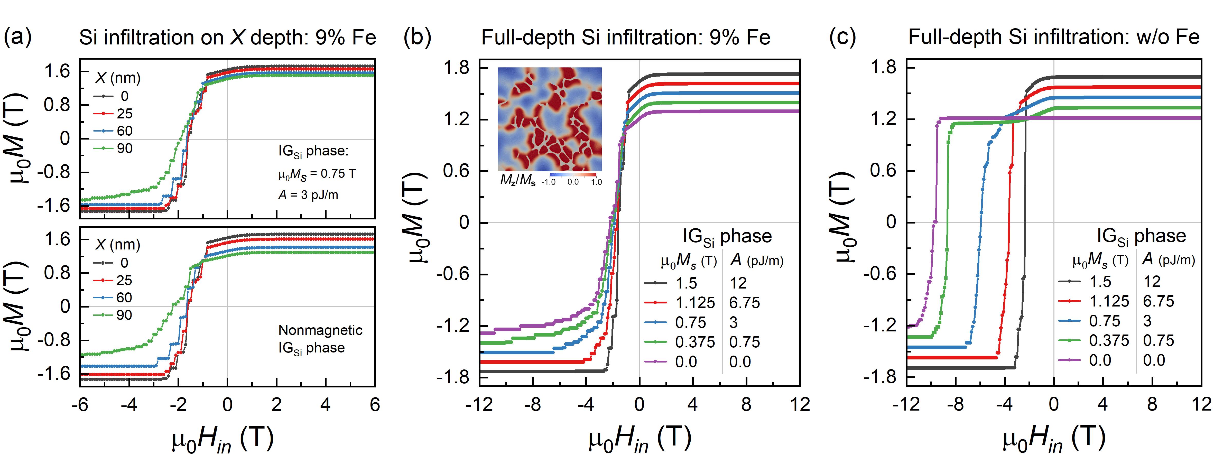
Figure 9. Simulated magnetization curves of the Si-diffused Sm(Fe_{0.8}Co_{0.2})₁₂B_{0.5} thin films (a,b) with 9 vol.% of α-(Fe,Co) grains at the bottom and (c) without them. In (a) the effect of penetration depth of (top) ferromagnetic Si-rich intergranular phase (IG_{Si}) and (bottom) nonmagnetic IG_{Si} is presented. For full-depth Si diffusion the effect of magnetization reduction of IG_{Si} is shown for the cases of (b) presence and (c) absence of α-(Fe,Co) grains. In the inset there is a micromagnetic structure at µ₀H = -3.2 T for the film with α-(Fe,Co) grains and nonmagnetic IG_{Si} shown from the bottom view point.
4. Conclusion
In this work, we have demonstrated a large coercivity in anisotropic Sm(Fe_{0.8}Co_{0.2})₁₂B_{0.5} thin films via low temperature diffusion of Si into the grain boundaries. The films had a distinct columnar microstructure with Sm(Fe,Co)₁₂ grains of 10-40 nm diameter enveloped by an Sm_{5.3}Fe_{66.7}Co_{11.4}B_{16.6} amorphous phase of 5-6 nm thickness. The low temperature (~350 ºC) diffusion of Si from 8-nm-thick Si capping layer into grain boundaries resulted in the increase of OOP coercivity from 1.11 T to a record value of 1.32 T. Si diffused into 25 nm depth forming the Si-enriched amorphous intergranular phase Sm_{4.7}Fe_{61.7}Co_{10.2}B_{8.0}Si_{15.4} with reduced magnetization. A finite element model was created from a digitized STEM image of the real sample. Micromagnetic simulations using the model have shown that magnetization reversals start at the thick triple junctions of the soft-ferromagnetic intergranular phase. Then cascade domain wall propagation occurs through Sm(Fe,Co)₁₂ grains with weak pinning at the intergranular phase. The micromagnetic simulations predicted that full-depth diffusion of Si into the grain boundaries can substantially increase their pinning strength and coercivity if α-(Fe,Co) grains can be eliminated from the interface with the underlayer.
Acknowledgements
This work was in-part supported by Elements Strategy Initiative Center for Magnetic Materials (ESICMM), Grant Number JPMXP0112101004, through the Ministry of Education, Culture, Sports, Science and Technology (MEXT).
References
[1] K. Ohashi, Y. Tawara, R. Osugi, and M. Shimao, Magnetic properties of Fe-rich rare-earth intermetallic compounds with a ThMn₁₂ structure, J. Appl. Phys. 64 (1988) 5714–5716.
[2] H. Sun, Y. Otani, J.M.D. Coey, C.D. Meekison, and J.P. Jakubovics, Coercivity and microstructure of melt-spun Sm(Fe₁₁Ti), J. Appl. Phys. 67 (1990) 4659–4661.
[3] Y.Z. Wang, and G.C. Hadjipanayis, Magnetic properties of Sm-Fe-Ti-V alloys, J. Magn. Magn. Mater. 87 (1990) 375–378.
[4] J. Wecker, M. Katter, K. Schnitzke, and L. Schultz, Magnetic hardening of Sm-Fe-Ti alloys, J. Appl. Phys. 67 (1990) 4951–4953.
[5] J. Ding, and M. Rosenberg, Crystallized melt spun Sm(Fe_{10-x}Co_{x})₁₁Ti alloys with (BH)_{max} products larger than 90 kJm⁻³ (11.3 MGOe), J. Less-Common Metals 161 (1990) 263–268.
[6] Y.K. Takahashi, H. Sepehri-Amin, and T. Ohkubo, Recent advances in SmFe₁₂-based permanent magnets, Sci. Technol. Adv. Mater. 22(1) (2021) 449–460.
[7] P. Tozman, H. Sepehri-Amin, K. Hono, Prospects for the development of SmFe₁₂-based permanent magnets with a ThMn₁₂-type phase, Scr. Mater. 194 (2021) 113686.
[8] G.C. Hadjipanayis, A.M. Gabay, A.M. Schönhöbel, A. Martín-Cid, J.M. Barandiaran, and D. Niarchos, ThMn₁₂-type alloys for permanent magnets, Engineering 6 (2020) 141–147.
[9] Y. Hirayama, Y.K. Takahashi, S. Hirosawa, and K. Hono, Intrinsic hard magnetic properties of Sm(Fe_{1-x}Co_{x})₁₂ compound with the ThMn₁₂ structure, Scr. Mater. 138 (2017) 62–65.
[10] J.S. Zhang, X. Tang, H. Sepehri-Amin, A.K. Srinithi, T. Ohkubo, and K. Hono, Origin of coercivity in an anisotropic Sm(Fe,Ti,V)₁₂-based sintered magnet, Acta Mater. 217 (2021) 117161.
[11] T. Kuno, S. Suzuki, K. Urushibata, K. Kobayashi, N. Sakuma, M. Yano, A. Kato, and A. Manabe, (Sm,Zr)(Fe,Co)_{11.0-11.5}Ti_{1.0-0.5} compounds as new permanent magnet materials, AIP Adv. 6 (2016) 025221.
[12] P. Tozman, H. Sepehri-Amin, Y.K. Takahashi, S. Hirosawa, and K. Hono, Intrinsic magnetic properties of Sm(Fe_{1-x}Co_{x})₁₁Ti and Zr-substituted Sm_{1-y}Zr_{y}(Fe_{0.8}Co_{0.2})_{11.5}Ti_{0.5} compounds with ThMn₁₂ structure toward the development of permanent magnets, Acta Mater. 153 (2018) 354.
[13] P. Tozman, Y.K. Takahashi, H. Sepehri-Amin, D. Ogawa, S. Hirosawa, and K. Hono, The effect of Zr substitution on saturation magnetization in (Sm_{1-x}Zr_{x})(Fe_{0.8}Co_{0.2})₁₂ compound with the ThMn₁₂ structure, Acta Mater. 178 (2019) 114.
[14] D.S. Neznakhin, S.V. Andreev, M.A. Semkin, N.V. Selezneva, M.N. Volochaev, A.S. Bolyachkin, N.V. Kudrevatykh, and A.S. Volegov, Structure and magnetic properties of (Sm_{0.9}Zr_{0.1})Fe₁₁Ti alloys with ThMn₁₂-type structure, J. Magn. Magn. Mater. 484 (2019) 212–217.
[15] A.G. Popov, A.V. Protasov, V.S. Gaviko, D.A. Kolodkin, P.B. Terentev, E. G. Gerasimov, T. Zhang, and C. Jiang, Magnetic properties of melt-spun ribbons (Sm_{1-x}Zr_{x})(Fe_{0.92}Ti_{0.08})₁₀ with ThMn₁₂ structure and their hydrides, J. Rare Earths 37 (2019) 1066–1071.
[16] S. Ener, K.P. Skokov, D. Palanisamy, T. Devillers, J. Fischbacher, G.G. Eslava, F. Maccari, L. Schäfer, L.V.B. Diop, I. Radulov, B. Gault, G. Hrkac, N.M. Dempsey, T. Schrefl, D. Raabe, and O. Gutfleisch, Twins – A weak link in the magnetic hardening of ThMn₁₂ -type permanent magnets, Acta Materialia 214 (2021) 116968.
[17] D. Palanisamy, S. Ener, F. Maccari, L. Schäfer, K.P. Skokov, O. Gutfleisch, D. Raabe, and B. Gault, Grain boundary segregation, phase formation, and their influence on the coercivity of rapidly solidified SmFe₁₁Ti hard magnetic alloys, Phys. Rev. Mater. 4 (2020) 054404.
[18] X. Tang, J. Li, A.K. Srinithi, H. Sepehri-Amin, T. Ohkubo, and K. Hono, Role of V on the coercivity of SmFe₁₂-based melt-spun ribbons revealed by machine learning and microstructure characterizations, Scr. Mater. 200 (2021) 113925.
[19] A.K. Srinithi, H. Sepehri-Amin, X. Tang, P. Tozman, J. Li, J. Zhang, S. Kobayashi, T. Ohkubo, T. Nakamura, and K. Hono, Phase relations and extrinsic magnetic properties of Sm-(Fe,Co)-Ti-(Ga)-based alloys for ThMn₁₂-type permanent magnets, J. Mag. Mag. Mat. 529 (2021) 167866.
[20] D. Ogawa, X.D. Xu, Y.K. Takahashi, T. Ohkubo, S. Hirosawa, K. Hono, Emergence of coercivity in Sm(Fe_{0.8}Co_{0.2})₁₂ thin films via eutectic alloy grain boundary infiltration, Scr. Mater. 164 (2019) 140–144.
[21] M. Kambayashi, H. Kato, Y. Mori, and T. Shima, Structure and magnetic properties of Sm(Fe_{0.8}Co_{0.2})₁₂ thin films by adding light elements, J. Magn. Soc. Jpn. 45 (2021) 66–69.
[22] H. Sepehri-Amina, Y. Tamazawa, M. Kambayashi, G. Saito, Y.K. Takahashi, D. Ogawa, T. Ohkubo, S. Hirosawa, M. Doi, T. Shima, and K. Hono, Achievement of high coercivity in Sm(Fe_{0.8}Co_{0.2})₁₂ anisotropic magnetic thin film by boron doping, Acta Mater. 194 (2020) 337–342.
[23] F. E. Luborsky, Diffusion of silicon into amorphous Fe_{x}B_{100-x}, J. Appl. Phys. 54 (1983) 5732-5738.
[24] B. Batz, H. W. Maed, and C. Birchenall, Diffusion of Silicon in Iron, J. Met., (1952) 1070.
[25] J. Fischbacher, A. Kovacs, H. Oezelt, T. Schrefl, L. Exl, J. Fidler, D. Suess, N. Sakuma, M. Yano, A. Kato, T. Shoji, and A. Manabe, Nonlinear conjugate gradient methods in micromagnetics, AIP Adv. 7 (2017) 045310.
[26] T. Fukazawa, H. Akai, Y. Harashima, and T. Miyake, First-principles study of spin-wave dispersion in Sm(Fe_{1−x}Co_{x})₁₂, J. Mag. Mag. Mat. 469 (2019) 296–301.
[27] D. Ogawa, T. Yoshioka, X.D. Xu, Y.K. Takahashi, H. Tsuchiura, T. Ohkubo, S. Hirosawa, and K. Hono, Magnetic anisotropy constants of ThMn₁₂-type Sm(Fe_{1–x}Co_{x})₁₂ compounds and their temperature dependence, J. Mag. Mag. Mat. 497 (2020) 165965.
[28] M.D. Kuz’min, K.P. Skokov, L.V.B. Diop, I.A. Radulov, and O. Gutfleisch, Exchange stiffness of ferromagnets, Eur. Phys. J. Plus 135:301 (2020) 1–8.
[29] W. Zhang and A. Inoue, Soft magnetic properties of (Fe,Co)-RE-B amorphous alloys with large supercooled liquid region, Mat. Trans. 42 (2001) 1142–1145.

