Crystallographic and electronic structures of Nb:YTaO₄ and Tb:YTaO₄ single-crystal scintillators
Yueshen Zhou ^{a, c,} *, Encarnación G. Víllora ª, Ryoji Sahara ^{b}, Arkapol Saengdeejing ^{b} and Kiyoshi Shimamura ^{a, c,} *
ª National Institute for Materials Science, 1-1 Namiki, Tsukuba, Ibaraki, 305-0044, Japan
^{b} National Institute for Materials Science, 1-2-1 Sengen, Tsukuba, Ibaraki, 305-0047, Japan
^{c} Waseda University, 3-4-1 Ookubo, Shinjuku, Tokyo, 169-8555, Japan

Abstract: Single-crystals of YTaO₄, partially substituted with Nb on the Ta site or Tb on the Y one, are potential alternatives to toxic CdWO₄ single-crystal scintillators. Compared with UV-emitting YTO, these isovalently substituted Nb:YTO and Tb:YTO compounds emit in the visible, matching to Si-photodiode detectors. Upon Nb or Tb incorporation, a bandgap narrowing takes place. The present study elucidates its origin in detail based on single-crystal diffraction measurements and subsequent density-functional-theory calculations and high-resolution X-ray photoelectron spectroscopy. Nb 4d band overlaps with the conduction band bottom of YTO, causing a red-shifted emission. On the contrary, the Tb ground levels overlap with the top of the valence band, favoring the intraatomic Tb green emission.
Keywords: Nb:YTaO₄ ; Tb:YTaO₄ ; Single-crystal structure analysis; DFT; XPS

1. Introduction
Homeland security based on high-energy radiography relies on CdWO₄ (CWO) scintillators. Despite containing toxic Cd and an average light yield (LY) of ~ 14000 ph/MeV, CWO is still the material of choice due to its excellent stopping power (density×effective atomic number⁴, ρ∙Z_{eff}⁴ = 134×10⁶), low afterglow, and broad visible emission matching well to Si-photodiodes (Si-PDs) detectors.¹⁻⁴ The urge to find environmentally friendly materials is driving a renewed search for alternative compounds.⁵⁻⁸ Heavy tantalates with a high stopping power (ρ∙Z_{eff}⁴ > 150×10⁶) such as Lu₃TaO₇, LuTaO₄ (LTO), GdTaO₄ (GTO), and AlTaO₄ (ATO) have been considered.⁹ Lu₃TaO₇ and GTO can be grown by the Czochralski technique, however, their scintillation characteristics are by far insufficient.⁹⁻¹¹ LTO melts incongruently, making its growth difficult.¹² LTO and ATO possess low LYs.⁹ Another tantalate that has caught attention due to its relatively high LY (15200 ph/MeV) is YTaO₄ (YTO, ρ∙Z_{eff}⁴ = 121×10⁶).⁹ However, YTO could be synthesized only in ceramic form, and its UV emission does not match well with the most sensitive region of Si-PDs.⁹ To overcome this issue, isovalently substituted YTO singles-crystals grown by the floating zone (FZ) technique were recently investigated, showing notable scintillation characteristics.¹³⁻¹⁵ On the one hand, after Nb concentration optimization, 1%Nb:YTO improved the scintillation performance relative to YTO (~ 5% better considering Si-PD detectors), thanks to the red-shifted emission.¹⁶ On the other hand, Tb incorporation up to ~ 20% in YTO led to a high scintillation LY of ~ 24000 ph/MeV due to intraatomic Tb green-emission.^{17,18} Both promising scintillators, Nb:YTO and Tb:YTO, exhibit a bandgap narrowing whose origin and influence in scintillation performance is not well understood yet.
The present study aims to gain insight into the electronic structure of isovalently substituted Nb:YTO and Tb:YTO to elucidate the bandgap narrowing. As previous studies on YTO are based on ceramics, precise single-crystal structure analysis on FZ single-crystals is carried out. Subsequently, density-functional-theory (DFT) calculations are undertaken to evaluate the density-of-states (DOS) of each atom (s, p, d, f orbitals) in the conduction band (CB) and the valence band (VB) using two different approaches. Due to the discrepancies between theoretical and experimental results in the case of Tb, additional X-ray photoelectron spectroscopy (XPS) measurements are conducted with a particular focus on the VB region.

2. Experimental
Pure YTO, YNO (YNbO₄), and TTO (TbTaO₄), as well as mixed 15%Tb:YTO single crystals were grown by the FZ technique under reducing atmosphere as detailed in previous publications.^{16,18} Single crystal XRD analysis was performed at room temperature using a Rigaku VariMax Saturn diffractometer with Mo Kα radiation (λ = 0.71073 Å) and a CCD detector. Submillimeter-size single crystals were fixed on the tip of a thin glass fibers. Diffraction data were processed with the Rigaku Crystal-Clear suite (d*trek) and the structures were solved using the dual-space algorithm method (SHELXT). Refinements were carried out with full-matrix least squares on F² using SHELXL-2018/3 in the WinGX package.¹⁹
The XPS analysis was conducted using a PHI-5000 VersaProbe II (ULVAC-PHI) instrument with a monochromatic Al Kα source. Both survey and high-resolution spectra were recorded and calibrated with the C 1s peak, setting it at 284.8 eV.
DFT calculations were carried out first with the generalized gradient approximation (GGA) functionals and second with the additional Hubbard U parameter. In the study, we introduced a 2 × 2 × 2 supercell constructed with a total of 192 atoms for YTO, YNO, and Nb:YTO, and 1 × 1 × 1 cell constructed with 24 atoms for TTO and Tb:YTO. Special quasirandom structure (SQS) models were introduced to reproduce random atomic distributions in Y, Ta, and Nb for 2 × 2 × 2 supercell.^{20,21} To perform DFT calculations, we used the projector augmented wave method as implemented in the Vienna Ab Initio Simulation Package.²²⁻²⁴ The exchange-correlation energy was calculated within GGA proposed by Perdew, Burke, and Ernzerhof.²⁵ The total energy was minimized over the degrees of freedom of both the electron density and the ionic positions and structural parameters. Electronic convergence was set as 10⁻⁵ eV for 2 × 2 × 2 supercell and 10⁻⁴ eV for 1 × 1 × 1 cell, and force convergence was set as 10⁻⁴ eV/Å for 2 × 2 × 2 supercell and 10⁻³ eV/Å for 1 × 1 × 1 cell. The cut-off energy for the plane wave expansion was taken as 500 eV for 2 × 2 × 2 supercell and 400 eV for 1 × 1 × 1 cell. Brillouin zone integrations were performed using a set of 4 × 4 × 4 k-points for 2 × 2 × 2 supercell and 8 × 8 × 8 k-points for 1 × 1 × 1 cell. In the test calculations, the Hubbard U model was introduced to improve the problem of band gap narrowing in DFT for Ta_{1-x}Nb_{x}YO₄ system as a test case.²⁶ Even though the band gap value was somewhat improved, the composition dependence of the lattice constant showed a different trend from the experimental results. Therefore, in this study, the U parameter was not introduced.

3. Results and discussion
The results of single-crystal structure analysis for YTO, YNO, and TTO single crystals are summarized in Tables 1 and 2. All three compounds, synthesized from melt by the FZ technique, possess the same monoclinic structure upon cooling to room temperature. The space group I2/a agrees with that of ceramics reacted over the monoclinic-to-tetragonal transition at ~ 1450℃ ^{27,28} in contrast to the P2/c space group (also monoclinic) of ceramics synthesized at lower temperatures.^{29,30} The R-factors are all pretty small, indicating the high quality of grown YTO, YNO, and TTO single crystals after overcoming various growth difficulties.^{16,18,31-34} The corresponding CIF files are available in the supporting information. Figure 1 shows the crystal structure of the unit cell projected along the <001> direction. There are two distinct cationic sites: Ta/Nb occupy an octahedral site coordinated by six oxygen atoms, and Y/Tb a dodecahedral one coordinated by eight oxygen atoms. The two distinct oxygen sites lead to three Ta/Nb-O and four Y/Tb-O bond lengths (Å), as presented in Table 3.

Table 1. Calculated crystal structure and refinement parameters of YTO, YNO, and TTO single crystals.
Chemical formula | YTaO₄ | YNbO₄ | TbTaO₄
Formula weight (g mol⁻¹) | 333.86 | 245.82 | 403.87
Temperature (K) | 296 | 302 | 300
Crystal system | Monoclinic | Monoclinic | Monoclinic
Space group | I2/a (no. 15) | I2/a (no. 15) | I2/a (no. 15)
Lattice constants (Å) | a=5.0556(3), b=10.9304(6), c=5.3283(3), β=95.477(6)° | a=5.0786(2), b=10.9550(4), c=5.3029(2), β=94.544° | a=5.0697(10), b=11.0187(3), c=5.3830(10), β=95.709(2)°
Volume (Å³) | 293.1 (3) | 294.105 (19) | 299.211 (3)
Density (g cm⁻³) | 7.566 | 5.552 | 8.965
Z | 4 | 4 | 4
F₀₀₀ | 576 | 448 | 680
Absorption coefficient (mm⁻¹) | 56.814 | 23.339 | 59.797
Theta range (deg.) | 3.723-29.153 | 3.677-37.647 | 3.698-30.507
Limiting indices | -6 ≤ h ≤ 6, -14 ≤ k ≤ 9, -6 ≤ l ≤ 6 | -8 ≤ h ≤8, -18 ≤ k ≤ 18, -8 ≤ l ≤ 8 | -7 ≤ h ≤ 7, -15 ≤ k ≤ 15, -7 ≤ l ≤ 7
Reflection number | 1470 | 3634 | 3222
Unique/collected reflection number | 355/344 | 751/732 | 453/450
R_{int} | 0.0463 | 0.0412 | 0.0449
R/wR factors (I > 2σ(I)) | 0.0306/0.0735 | 0.0221/0.0528 | 0.0141/0.0333
R/wR factors (all data) | 0.0318/0.0748 | 0.0230/0.0532 | 0.0143/0.0333
Goodness of fit | 1.126 | 1.086 | 1.105
Largest difference peak/hole (e/Å³) | 3.463/-3.730 | 1.239/-2.467 | 2.183/-1.402

Table 2. Fractional coordinates, Wyckoff symmetry, and equivalent displacement parameters of atomic sites in YTO, YNO and TTO single crystals.
Compound | Atom | Wyckoff position | Occupancy | x | y | z | U (Å²)
YTO | Y | 4e | 1 | 0.0000 | 0.6313 | 0.2500 | 0.0033
YTO | Ta | 4e | 1 | 0.0000 | 0.1018 | 0.2500 | 0.0026
YTO | O1 | 8f | 1 | 0.2559 | 0.4685 | 0.2847 | 0.0054
YTO | O2 | 8f | 1 | 0.1552 | 0.2039 | 0.1613 | 0.0041
YNO | Y | 4e | 1 | 0.0000 | 0.6287 | 0.2500 | 0.0037
YNO | Nb | 4e | 1 | 0.0000 | 0.1062 | 0.2500 | 0.0033
YNO | O1 | 8f | 1 | 0.2536 | 0.4681 | 0.2942 | 0.0065
YNO | O2 | 8f | 1 | 0.1582 | 0.2102 | 0.1604 | 0.0062
TTO | Tb | 4e | 1 | 0.0000 | 0.6315 | 0.2500 | 0.0048
TTO | Ta | 4e | 1 | 0.0000 | 0.1006 | 0.2500 | 0.0043
TTO | O1 | 8f | 1 | 0.2603 | 0.4686 | 0.2888 | 0.0067
TTO | O2 | 8f | 1 | 0.1555 | 0.2096 | 0.1614 | 0.0073

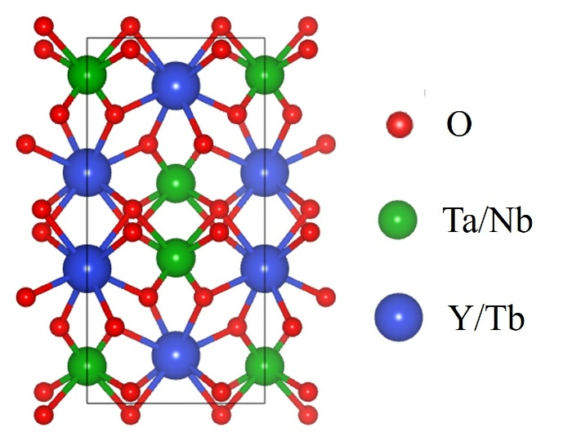
Figure 1. Unit cell of YTO/YNO/TTO projected along the <001> direction.

Table 3. Bond lengths of YTO, YNO, and TTO single crystals.
Compound |  | Bonds length (Å)
YTO | Y-O1^{i} |  | Y-O1^{ii} | Y-O2^{i} | Y-O2^{ii} | Ta-O1^{iii} | Ta-O1^{iiii} | Ta-O2^{ii}
YTO | 2.324 |  | 2.447 | 2.307 | 2.366 | 2.334 | 1.952 | 1.842
YNO | Y-O1^{i} |  | Y-O1^{ii} | Y-O2^{i} | Y-O2^{ii} | Nb-O1^{iii} | Nb-O1^{iiii} | Nb-O2^{ii}
YNO | 2.329 |  | 2.410 | 2.314 | 2.373 | 2.423 | 1.929 | 1.849
TTO | Tb-O1^{i} |  | Tb-O1^{ii} | Tb-O2^{i} | Tb-O2^{ii} | Ta-O1^{iii} | Ta-O1^{iiii} | Ta-O2^{ii}
TTO | 2.360 |  | 2.477 | 2.320 | 2.380 | 2.326 | 1.948 | 1.863

DFT calculations were performed based on the detailed crystal structures obtained from single-crystal diffraction. The Brillouin zone of the monoclinic I2/a space group of YTO is shown in Figure 2, together with the symmetry paths used to calculate the band structures.^{35,36}
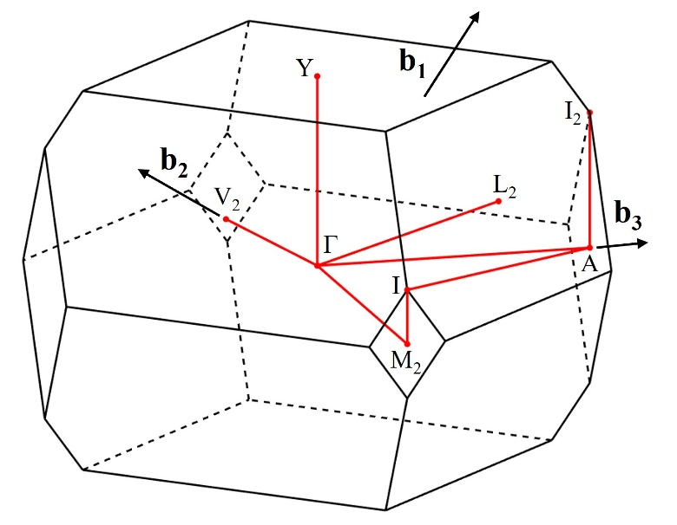
Figure 2. First Brillouin zone of the monoclinic lattice with space group I2/a. Symmetry points and the paths along which the band structures are calculated are marked^{28,29}: Γ—A—I₂|I—M₂—Γ—Y|L₂—Γ—V₂.

The calculated band structures of YTO and YNO exhibit the indirect bandgaps of 4.0 eV and 3.5 eV, respectively, as shown in Figures 3(a) and (b). These values are ~ 1 eV lower than the experimental bandgaps of YTO and YNO (5.0 eV and 4.4 eV, respectively) determined from transmittance Tauc plots.¹⁶ This commonly found underestimation, inherent to the GGA, arises from the over-delocalization of occupied states.³⁷ Nevertheless, this physically well-established approach can estimate the change of properties upon cationic substitution, particularly in the present case, where the crystal structure remains the same. Total DOS of Figures 3(a) and (b) are deconvoluted in Figures 3(c) and (d), respectively. Y contribution (mainly through Y 4d orbitals) to CB and VB is relatively small. The VB in both compounds is dominated by the O 2p orbitals, while the CBs are dominated by the Ta 5d and Nb 4d orbitals, respectively. The YNO bandgap is smaller than that of YTO because the Nb 4d electrons have a lower energy than the Ta 5d ones. To elucidate how the bandgap changes with the Nb concentration, DFT calculations of Nb:YTO (YTNO) were carried out with various partial substitutions.
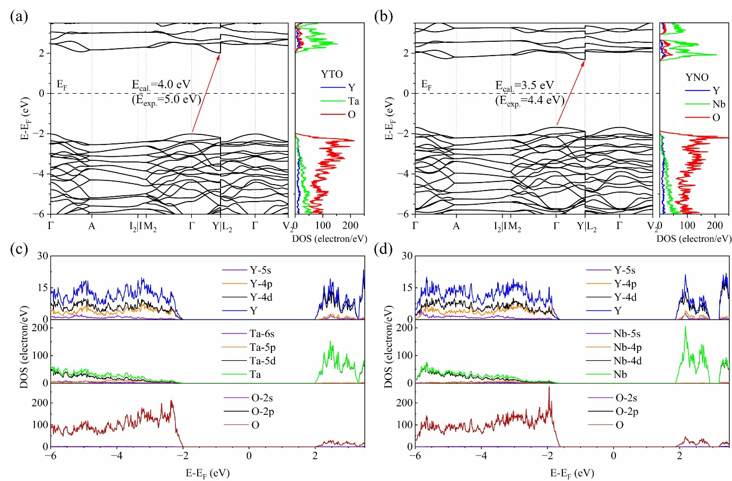
Figure 3. Band structure and total DOS of (a) YTO and (b) YNO. Partial DOS of (c) YTO and (d) YNO.

The bandgap change from YTO to YTNO by the partial Ta substitution with Nb is due to the appearance of the Nb band below the CB minimum in YTO. With the increase in Nb concentration, the Nb 4d band broadens a bit, leading to a slight decrease in the bandgap as illustrated in Figure 4(a). Therefore, apart from the difference in absolute values, the experimental bandgap narrowing is pretty well reproduced by DFT calculations with the simple GGA approximation.¹⁶ Analogously, the estimated change in lattice parameters with the Nb content is compared in Figure 4(b) with the experimental one.¹⁶ From the structural point of view, a pretty good agreement is also found, as the lattice parameters’ dependence of a, b, and c is relatively close to the linear Vegard’s law in both theoretical and experimental cases.
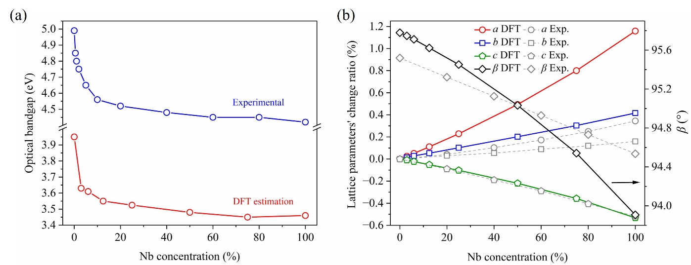
Figure 4. Comparison of DFT-calculated and measured (a) bandgap and (b) lattice parameters’ change in YTNO crystals.

After the successful DFT simulations of the YTNO solid-solution, the same DFT calculations were carried out for the Tb-substituted YTO (YTTO). In contrast to the YTNO case, the structural optimization is challenging due to the presence of the Tb 4f valence electrons. Strongly correlated systems arise from the d- and f-electrons, which exhibit both localized atomic-like and delocalized band-like behavior. This complexity, combined with the strong coupling between charge, spin, orbital, and lattice interactions, makes accurate calculations challenging for the current GGA and GGA+U approximation.³⁸ Higher level of exchange and correlation approximations, such as metaGGA, hybrid functional, and the GW method, might be able to solve the optimization problem of the Tb case. However, the computational resources required for the higher-level approximations are significantly higher. ³⁹⁻⁴⁶ Figure 5 shows the estimated total DOS for 25%Tb:YTO and TTO considering the electrons’ spin. The appearance of Tb 4f orbitals, occupied majority spin ones within the VB and unoccupied minority spin ones within the bandgap of YTO, is clearly stated. The correlation between calculated and experimental results of bandgap and lattice parameters fails, as can be seen in Figures 6(a) and (b), respectively. The proper explanation for the observed bandgap narrowing with Tb content was found through XPS measurements.

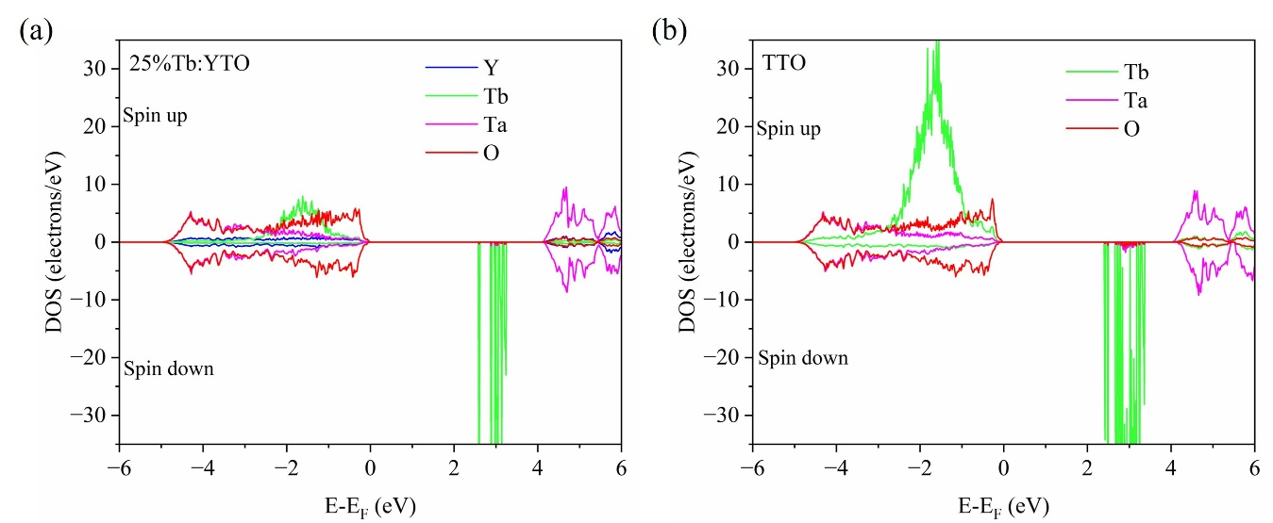
Figure 5. Total DOS of (a) 25%Tb:YTO and (b) TTO.

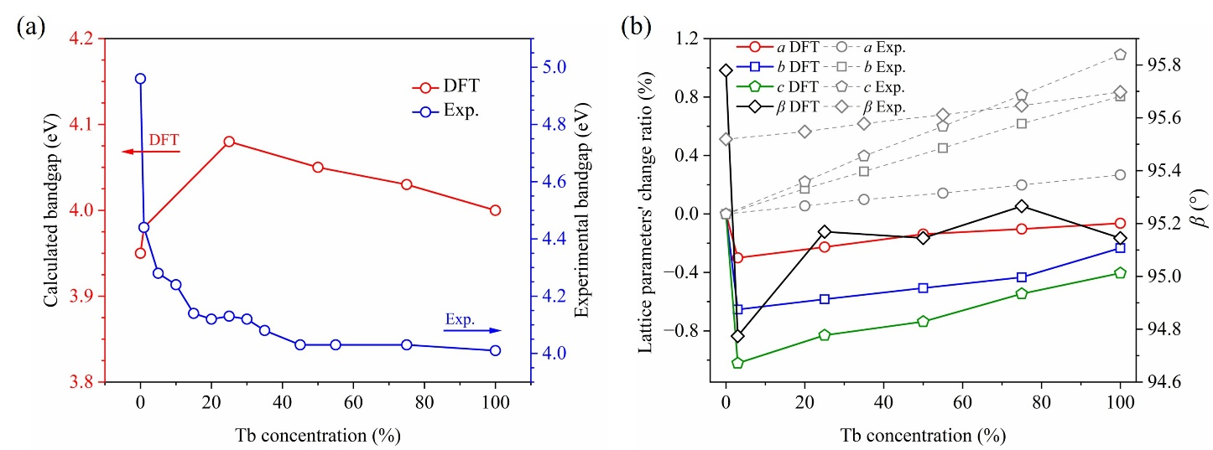
Figure 6. DFT calculated (a) bandgap and (b) lattice parameters’ change of YTTO in comparison with experimental values.

XPS was carried out on three representative crystals: YTO, YNO, 15%Tb:YTO, and TTO. The results of the general surveys are given in Figure 7. The presence of all matrix cations is confirmed for the four crystals. Carbon, the only impurity found at the surface, was used for calibration of the energy axis. High-resolution XPS spectra of characteristic peaks are summarized in Figure 8.

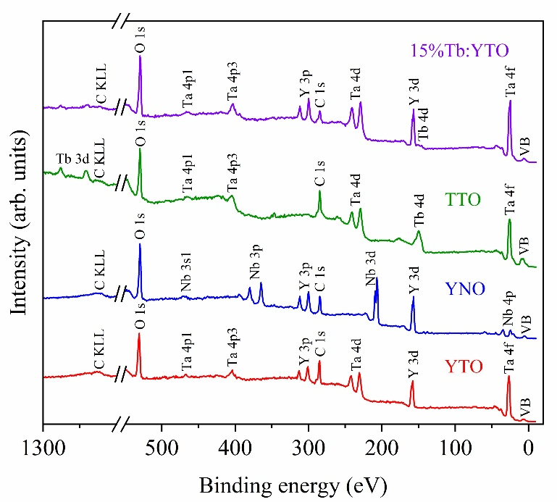
Figure 7. XPS survey spectra of YTO, YNO, 15%Tb:YTO, and TTO single crystals.

In the case of YTO, the Y 3d peaks centered at 155.75 and 157.77 eV (Figure 8(a)) correspond to 3d5/2 and 3d3/2 states of Y³⁺, since these are consistent with reported values for Y₂O₃⁴⁷ and polycrystalline YTO.⁴⁸ The Ta 4f7/2 and Ta 4f5/2 peaks at 25.86 and 27.76 eV of Figure 8(b) are in correspondence with those of Ta₂O₅⁴⁹ and a similar tantalate,⁵⁰ thus confirming the presence of Ta⁵⁺. In YNO, the peaks of Y 3d centered at 157.14 and 159.18 eV (Figure 8(d)), are also assigned to 3d5/2 and 3d3/2 states of Y³⁺, respectively, and are identical to the reported for polycrystalline YNO.⁵¹ The peaks of Nb 3d centered at 206.79 and 209.52 eV are the 3d5/2 and 3d3/2 states of Nb⁵⁺, respectively, since they are equal to those of pure Nb₂O₅.⁵²⁻⁵⁴ In the case of TTO, Ta 4f of Figure 8(h) resembles the case of Ta in YTO (Figure 8(b)). The broad peak centered at 148.74 eV with shoulders on both sides at 145.08 and 154.24 eV, see Figure 8(g), agrees with the 4d signature of Tb³⁺ and confirms the absence of Tb in the tetravalent state.⁵⁵⁻⁵⁷ This conclusion is further supported by the double peaks in the range 1200-1300 eV of the survey spectrum, corresponding to 3d3/2 and 3d5/2 Tb³⁺ electrons.^{56,57} Furthermore, the high-resolution O 1s XPS spectra of all three compounds in Figures 8(c), (f), and (i) exhibit a main peak at ~ 530 eV, which corresponds with the O²⁻ in the crystals, and a broad peak at ~ 531 eV, which can be attributed to oxygen adsorbed at the surface.^{58,59}
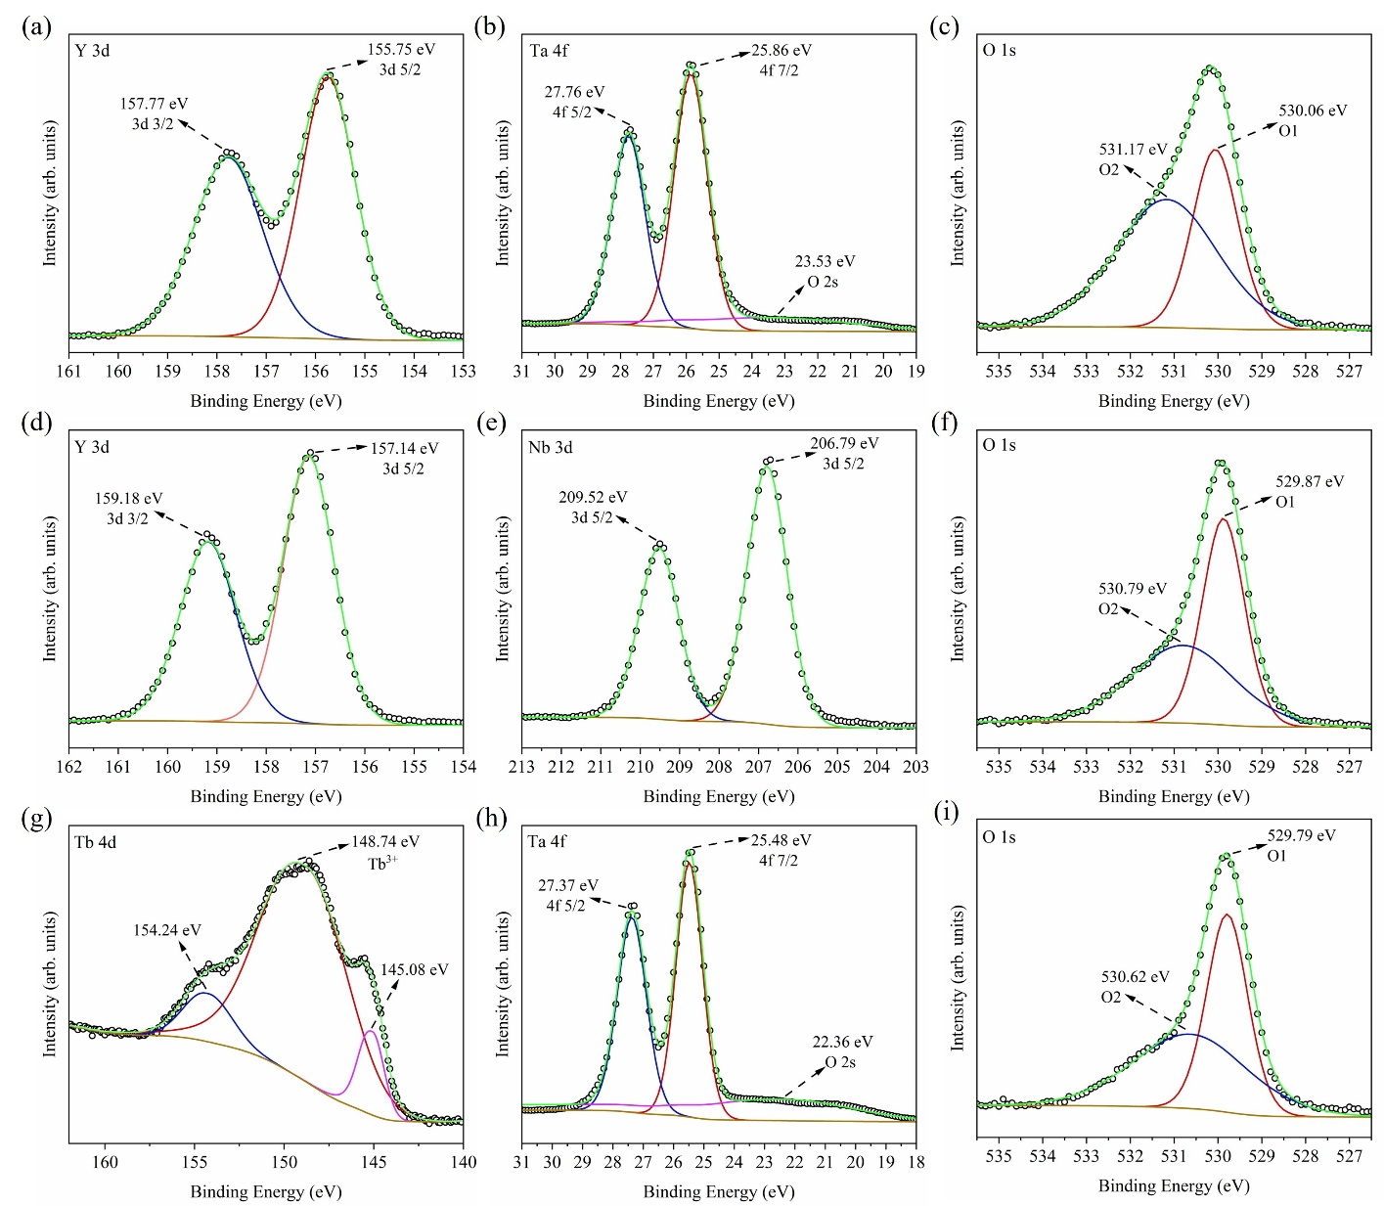
Figure 8. High-resolution XPS spectra of YTO ((a)-(c)), YNO ((d)-(f)) and TTO ((g)-(i)).

The most relevant information obtained by XPS measurement lies in the VB region. Figure 9 depicts the VB spectra of YTO, YNO, 15%Tb:YTO, and TTO. According to the DFT results of Figure 3, the YTO and YNO VBs are mainly contributed by O&Ta and O&Nb, respectively, and stretch along roughly 5 eV. These VBs are found experimentally in Figures 9(a) and (b), and exhibiting similar features. The VBs are a bit broader than calculated ones, and the VB maxima close, at -2.8 and -2.6 eV from the Fermi level, respectively. These similarities are reasonable since these VBs are dominated by the same O 2p orbitals, and the smaller contributions of Ta 5d and Nb 4d are relatively equivalent. The situation is entirely different when Tb substitutes Y partially or entirely. The approximate deconvolution of 15%Tb:YTO and TTO VBs is shown in Figure 9(c) and (d). Since the Ta and O concentration in these crystals is equal to that of YTO, the contribution of these ions is simulated from the results of Figure 9(a) as a red line, and the remaining, due to the Tb incorporation, is approximated by three broad peaks. These deconvolutions are justified by the fact that the O&Ta contribution (red line) is about the same in both 15%Tb:YTO and TTO, and that the Tb peaks rise equally and correspondingly with the Tb concentration. Comparing these results with that of DFT calculation of Figure 5, it is seen that the Tb contribution is not a broad peak within the range of O&Ta VB constituents. Tb 4f levels exhibit a complex distribution and go beyond the O&Ta band on both sides, extending over ~ 12 eV and resembling that of oxidized Tb metal VB.⁶⁰ The maximum of the VBs is not determined anymore by the O 2p orbitals, but by the ⁷F₆ ground level of Tb, and it lies at -1.4 eV below the Fermi level for TTO.
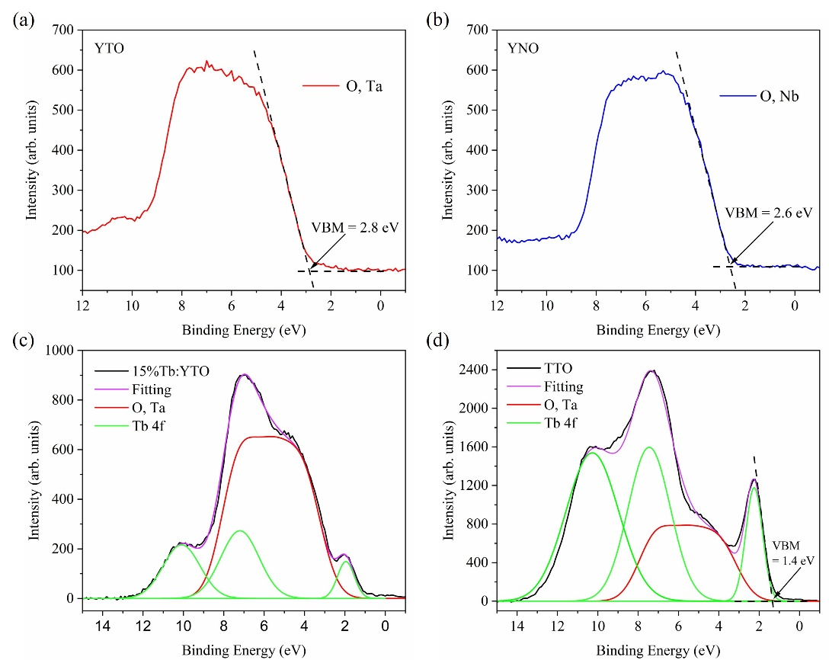
Figure 9. High-resolution VB XPS spectra of (a) YTO, (b)YNO, (c) 15%Tb:YTO, and (d) TTO.

Considering the XPS and transmittance measurements together, Figure 10 illustrates schematically the YTO, YNO, and TTO energy levels around the bandgap. The initial YTO has a bandgap of 5.0 eV, given by the energy difference between O 2p (VB maximum) and Ta 5d (CB minimum) orbitals. Bandgap narrowing occurs immediately after the partial substitution of Ta by Nb or Y by Tb. In the first case, the Nb 4d band overlaps with the YTO CB bottom, while in the second case, the Tb ground state overlaps with the YTO VB top. These superposing bands broaden a bit with the Nb and Tb content, and consequently, pure YNO and TTO bandgaps are as small as 4.6 and 4.0 eV, respectively. The position of the Fermi level is not in the middle of the bandgap. For YTO and YNO, it is a bit above, while for TTO, it is below. The Nb:YTO bandgap narrowing leads to the observed red-shifted emission from self-trapped excitons,¹⁶ while the intragap levels in Tb:YTO favor the Tb green emission.^{17,18}
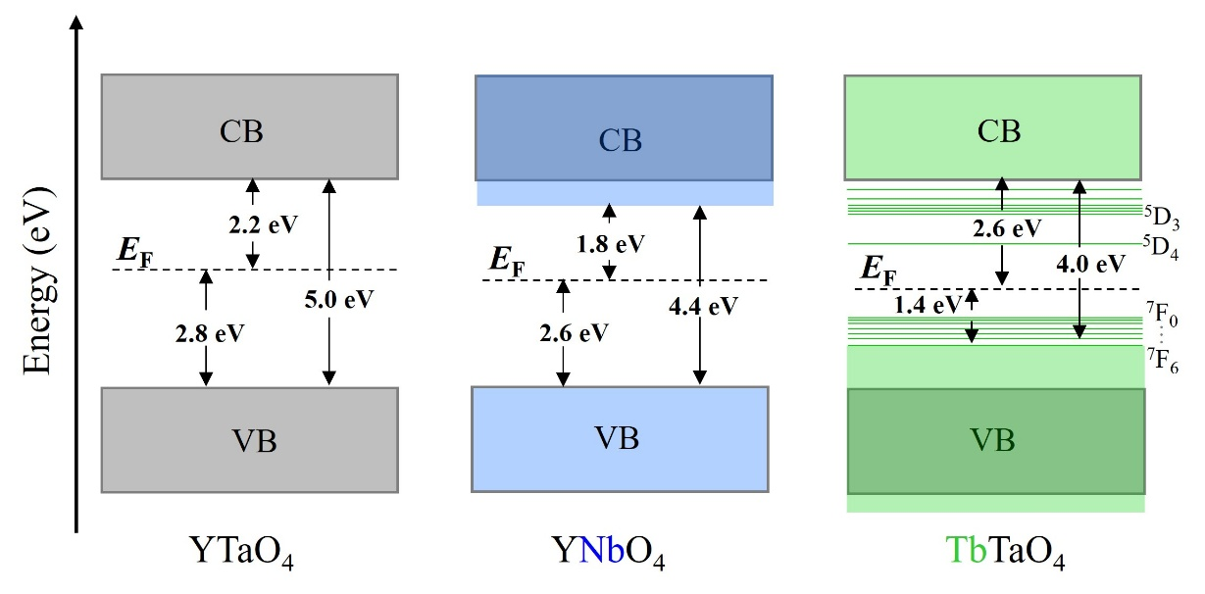
Figure 10. Schematic energy levels of YTO, YNO, and TTO.

4. Conclusion
YTO single crystals, partially substituted with isovalent Nb or Tb, are promising compounds for replacing the CWO scintillator in high-energy radiography applications. Previous studies on FZ-grown Nb:YTO and Tb:YTO single crystals proved the existence of bandgap narrowing upon cation substitution. In this study, the crystal structures of pure YTO, YNO, and TTO are analyzed by single-crystal diffraction. The subsequent DFT and XPS analyses elucidate the different origins of bandgap narrowing. By Nb incorporation, the 4d level partially overlaps with the CB bottom of YTO, leading to a red shift in the emission of self-trapped excitons. On the contrary, the Tb ground states partially overlap with the VB top of YTO, thus favoring the intra-atomic Tb green emission.

ASSOCIATED CONTENT
Supporting information
The supporting information includes the corresponding CIF files of the single-crystal samples.

AUTHOR INFORMATION
Corresponding Author
*Email: ZHOU.Yueshen@nims.go.jp; SHIMAMURA.Kiyoshi@nims.go.jp

Author Contributions
The manuscript was written through contributions of all authors. All authors have given approval to the final version of the manuscript.

Notes
The authors declare no competing financial interest.

ACKNOWLEDGMENTS
The authors would like to sincerely thank Mr. Satoshi Yamamoto for his help with crystal polishing and Dr. Yoshitaka Matsushita for his help crystal structure analysis. This work was partially supported by the "Advanced Research Infrastructure for Materials and Nanotechnology in Japan (ARIM)" of the Ministry of Education, Culture, Sports, Science and Technology (JPMXP12 23NM5337).

REFERENCES
(1) Huaping Xiao, Hongbing Chen, Fang Xu, Chengyong Jiang, and Peizhi Yang, Bridgman growth of CdWO₄ single crystals, J. Cryst. Growth 2008, 310, 521-524. https://doi.org/10.1016/j.jcrysgro.2007.10.058

(2) NK&K Crystals, Cadmium Tungstate, Available online: https://nkk.co.jp/en/products/ scintilla-tor/scintillator/ (accessed March 20, 2025).

(3) LUXIUM SOLUTIONS Crystals, Cadmium Tungstate, Available online: https://www.luxiumsolutions.com/radiation-detection-scintillators/crystal-scintillators/cdwo4-cadmium-tungstate (accessed March 20, 2025).

(4) Lu Lu, Mingzi Sun, Qiuyang Lu, Tong Wu, and Bolong Huang, High energy X-ray radiation sensitive scintillating materials for medical imaging, cancer diagnosis and therapy, Nano Energy 2021, 79, 105437. https://doi.org/10.1016/j.nanoen.2020.105437

(5) Jarek Glodo, Yimin Wang, Ryan Shawgo, Charles Brecher, Rastgo H. Hawrami, Joshua Tower, and Kanai S. Shah, New Developments in Scintillators for Security Applications, Phys. Procedia 2017, 90, 285-290. https://doi.org/10.1016/j.phpro.2017.09.012

(6) N. J. Cherepy, Z. M. Seeley, S. A. Payne, E. L. Swanberg, P. R. Beck, D. J. Schneberk, G. Stone, R. Perry, B. Wihl, and S. E. Fisher et al. Transparent ceramic scintillators for gamma spectroscopy and MeV imaging, Proc. SPIE 9593, Hard X-Ray, Gamma-Ray, and Neutron Detector Physics XVII, 95930P. https://doi.org/10.1117/12.2189156

(7) Ia Gerasymov, T. Nepokupnaya, A. Boyarintsev, O. Sidletskiy, D. Kurtsev, O. Voloshyna,
O. Trubaieva, Y. Boyarintseva, T. Sibilieva, and A. Shaposhnyk et al. GAGG:Ce composite scintillator for X-ray imaging, Opt. Mater 2020, 109, 110305. https://doi.org/10.1016/j.optmat.2020.110305

(8) Kei Kamada, Takanori Endo, Kousuke Tsutumi, Takayuki Yanagida, Yutaka Fujimoto, Akihiro Fukabori, Akira Yoshikawa, Jan Pejchal, and Martin Nik, Composition Engineering in Cerium-Doped (Lu,Gd)₃(Ga,Al)₅O₁₂ Single-Crystal Scintillators, Cryst. Growth Des. 2011, 11, 4484-4490. https://doi.org/10.1021/cg200694a

(9) Edith D. Bourret, David M. Smiadak, Ramesh B. Borade, Yunfeng Ma, Gregory Bizarri,
Marv J. Weber, and Stephen E. Derenzo, Scintillation of tantalate compounds, J. Lumin. 2018, 202, 332-338. https://doi.org/10.1016/j.jlumin.2018.05.044

(10) Huajun Yang, Fang Peng, Qingli Zhang, Changxin Guo, Chaoshu Shi, Wenpeng Liu, Guihua Sun, Yiping Zhao, Deming Zhang, and Dunlu Sun et al. A promising high-density scintillator of GdTaO₄ single crystal, CrystEngComm 2014, 16, 2480-2485. https://doi.org/10.1039/C3CE42350F
(11) Dou Renqin, Qingli Zhang, Jinyun Gao, Yuanzhi Chen, Shoujun Ding, Fang Peng, Wenpeng Liu, and Dunlu Su, Rare-Earth Tantalates and Niobates Single Crystals: Promising Scintillators and Laser Materials, Crystals 2018, 8, 55. https://doi.org/10.3390/cryst8020055

(12) Xue Xing, Xiaofei Wang, Qingli Zhang, Guihua Sun, Chaoshu Shi, Wenpeng Liu, Dunlu Sun, and Shaotang Yin, High-Temperature Phase Relations in the Lu₂O₃-Ta₂O₅ System, J. Am. Ceram. Soc. 2016, 99, 1042–1046. https://doi.org/10.1111/jace.13977

(13) Maren Lepple, SergeyV. Ushakov, Kristina Lilova , ChandraA. Macauley,
Abel N. Fernandez, Carlos G. Levi , and Alexandra Navrotsky, Thermochemistry and phase stability of the polymorphs of yttrium tantalate, YTaO₄, J. Eur. Ceram. Soc. 2021, 41, 1629-1638. https://doi.org/10.1016/j.jeurceramsoc.2020.10.039

(14) L. I. Kazakova, A. B. Dubovsky, G. V. Semenkovich, and O. A. Ivanova, Luminescence of YTaO₄ single crystals Radiat. Meas. 1995, 24, 359-360. https://doi.org/10.1016/1350-4487(95)00012-4

(15) O. Voloshyna, S. V. Neicheva, N. G. Starzhinskiy, I.M. Zenya, S. S. Gridin, V. N. Baumer, and O.Ts. Sidletskiy, Luminescent and scintillation properties of orthotantalates with common formulae RETaO₄ (RE = Y, Sc, La, Lu and Gd), Mater. Sci. Eng. B. 2013, 178, 1491-1496. http://dx.doi.org/10.1016/j.mseb.2013.08.003

(16) Yueshen Zhou, Dongsheng Yuan, Encarnación G. Víllora, Daisuke Nakauchi, Takumi Kato, Noriaki Kawaguchi, Takayuki Yanagida, and Kiyoshi Shimamura, High-density Nb:YTaO₄ single crystals or X-ray scintillation, CrystEngComm. 2025, 27, 81-89. https://doi.org/10.1039/D4CE00848K

(17) Encarnación G. Víllora, Yueshen Zhou, Kenichi Watanabe, and Kiyoshi Shimamura, Scintillation efficiency of Tb:YTaO₄ single crystals, Appl. Phys. Express 2025, 18, 032002. https://doi.org/10.35848/1882-0786/adb89f

(18) Yueshen Zhou, Dongsheng Yuan, Encarnación G. Víllora, Daisuke Nakauchi, Noriaki Kawaguchi, Takayuki Yanagida, and Kiyoshi Shimamura, High Performance Y_{1–x}Tb_{x}TaO₄ Single-Crystal Scintillators for X-ray Detection, Cryst. Growth Des. 2025, 25, 359–366. https://doi.org/10.1021/acs.cgd.4c01391

(19) Xiuwei Fu, Encarnación G. Víllora, Yoshitaka Matsushita, Yuuki Kitanaka, Yuji Noguchi, Masaru Miyayama, Kiyoshi Shimamura, and Naoki Ohashi, Resistivity and piezoelectric properties of Ca₃TaGa_{1.5}Al_{1.5}Si₂O₁₄ single crystals for high temperature sensors, RSC Adv. 2017, 7, 56697-56703. https://doi.org/10.1039/c7ra11926g

(20) Alex Zunger, S. -H. Wei, L. G. Ferreira, and James E. Bernard, “Special quasirandom structures”, Phys. Rev. Lett. 1990, 65, 353–356. https://doi.org/10.1103/PhysRevLett.65.353

(21) A. van de Walle, M. Asta, and G. Ceder, The alloy theoretic automated toolkit: a user guide, Calphad 2002, 26, 539–553. https://doi.org/10.1016/S0364-5916(02)80006-2

(22) P. E. Blóchl, Projector augmented-wave method, Phys Rev B 1994, 50, 17953–17979.
https://doi.org/10.1103/PhysRevB.50.17953

(23) G. Kresse and D. Joubert, From ultrasoft pseudopotentials to the projector augmented-wave method, Phys Rev B 1999, 59, 1758–1775. https://doi.org/10.1103/PhysRevB.59.1758

(24) G. Kresse and J. Furthmüller, Efficient iterative schemes for ab initio total-energy calculations using a plane-wave basis set, Phys. Rev. B 1996, 54, 11169–11186. https://doi.org/10.1103/PhysRevB.54.11169

(25) J. P. Perdew, K. Burke, and M. Ernzerhof, Generalized Gradient Approximation Made Simple, Phys. Rev. Lett. 1996, 77, 3865-3868. https://doi.org/10.1103/PhysRevLett.77.3865

(26) V. I. Anisimov, J. Zaanen, and O. K. Andersen, Band theory and Mott insulators: Hubbard U instead of Stoner I, Phys. Rev. B 1991, 44, 943-954.
https://doi.org/10.1103/PhysRevB.44.943

(27) L. H. Brixner and H. Y. Chen, On the Structural and Luminescent Properties of the Mʹ LnTaO₄ Rare Earth Tantalates, J. Electrochem. Soc. 1983, 130, 2435-2443. https://doi.org/10.1149/1.2119609

(28) Scott A. Mather and Peter K. Davies, Nonequilibrium Phase Formation in Oxides Prepared at Low Temperature: Fergusonite-Related Phases, J. Am. Ceram. Soc. 1995, 78, 2737-2745. https://doi.org/10.1111/j.1151-2916.1995.tb08049.x

(29) G. M. Wolten, The structure of the M'-phase of YTaO₄, a third Fergusonite polymorph, Acta Cryst. 1967, 23, 939-944. https://doi.org/10.1107/S0365110X67004098

(30) V. S. Stubičan, High-Temperature Transitions in Rare-Earth Niobates and TantaIates, J. Am. Ceram. Soc, 1964, 47, 55-58. https://doi.org/10.1111/j.1151-2916.1964.tb15654.x

(31) C. Keller, Über ternäre Oxide des Niobs und Tantals vom Typ ABO₄, ZAAC 1962，318， 89-106. https://doi.org/10.1002/zaac.19623180108

(32) Daisuke Nishio-Hamane, Tetsuo Minakawa, and Yukikazu Ohgoshi, Takanawaite-(Y), a new mineral of the M-type polymorph with Y(Ta,Nb)O₄ from takanawa mountain, Ehime prefecture, Japan, J. Mineral. Petrol. Sci. 2013, 108, 335-344. https://doi.org/10.2465/jmps.120513a

(33) Pankaj Sarin, Robert W. Hughes, Daniel R. Lowry, Zlatomir D. Apostolov, and Waltraud M. Kriven, High-Temperature Properties and Ferroelastic Phase Transitions in Rare-Earth Niobates (LnNbO₄), J. Am. Ceram. Soc. 2014, 97, 3307-3319. https://doi.org/10.1111/jace.13095

(34) Bryce G. Mullens, Matilde Saura-Múzquiz, Frederick P. Marlton, Maxim Avdeev, Helen E.A. Brand, S. Mondal, G. Vaitheeswaran, and Brendan J. Kennedy, Beyond the ionic radii: A multifaceted approach to understand differences between the structures of LnNbO₄ and LnTaO₄ fergusonites, J. Alloys Compd. 2023, 930, 167399. https://doi.org/10.1016/j.jallcom.2022.167399

(35) Yoyo Hinuma, Giovanni Pizzi, Yu Kumagai, Fumiyasu Oba, and Isao Tanaka, Band structure diagram paths based on crystallography, Comp. Mat. Sci. 2017, 128, 140-184. https://doi.org/10.1016/j.commatsci.2016.10.015

(36) Atsushi Togo, Kohei Shinohara, and Isao Tanaka, Spglib: a software library for crystal symmetry search, STAM Methods, 2024, 4, 1-11. https://doi.org/10.1080/27660400.2024.2384822

(37) Tuan V. Vu, A. A. Lavrentyev, B. V. Gabrelian, Dat D. Vo, Khang D. Pham, N. M. Denysyuk, L. I. Isaenko, A. Y. Tarasova, and O. Y. Khyzhun, DFT study and XPS measurements elucidating the electronic and optical properties of KPb₂Cl₅, Opt. Mater. 2020, 102, 109793. https://doi.org/10.1016/j.optmat.2020.109793

(38) Hong Jiang, First-principles approaches for strongly correlated materials: A theoretical chemistry perspective, Int. J. Quantum Chem. 2015, 115, 722-730. https://doi.org/10.1002/qua.24905

(39) Jianmin Tao and John P. Perdew, Climbing the Density Functional Ladder: Nonempirical Meta-Generalized Gradient Approximation Designed for Molecules and Solids, Phys. Rev. Lett. 2003, 91, 146401. https://doi.org/10.1103/PhysRevLett.91.146401

(40) John P. Perdew, Adrienn Ruzsinszky, Ga´bor I. Csonka, Lucian A. Constantin, and Jianwei Sun, Workhorse Semilocal Density Functional for Condensed Matter Physics and Quantum Chemistry, Phys. Rev. Lett. 2009, 103, 026403. https://doi.org/10.1103/PhysRevLett.103.026403

(41) Jianwei Sun, Bing Xiao, and Adrienn Ruzsinszky, Communication: Effect of the orbital-overlap dependence in the meta generalized gradient approximation, J. Chem. Phys. 2012, 137, 051101. https://doi.org/10.1063/1.4742312

(42) John P. Perdew and Matthias Ernzerhof, Rationale for mixing exact exchange with density functional approximations, J. Chem. Phys. 1996, 105, 9982-9985.
https://doi.org/10.1063/1.472933

(43) Jochen Heyd and Gustavo E. Scuseria, Hybrid functionals based on a screened Coulomb potential, J. Chem. Phys. 2003, 118, 8207-8215. https://doi.org/10.1063/1.1564060

(44) Jochen Heyda and Gustavo E. Scuseria, Efficient hybrid density functional calculations in solids: Assessment of the Heyd-Scuseria-Ernzerhof screened Coulomb hybrid functional, J. Chem. Phys. 2004, 121, 1187-1192. https://doi.org/10.1063/1.1760074

(45) F Aryasetiawany and O Gunnarssonz, The GW method, Rep. Prog. Phys. 1998, 61 (1998) 237-312. https://doi.org/10.1088/0034-4885/61/3/002

(46) Wilfried G. Aulbur, Lars Jönsson, and John W. Wilkins, Quasiparticle Calculations in Solids, Sol. State Phys. 2000, 54, 1-218. https://doi.org/10.1016/S0081-1947(08)60248-9

(47) L. Mariscal-Becerra, R. Vázquez-Arreguín, U. Balderas, S. Carmona-Téllez, H. Murrieta Sánchez, and C. Falcony, Luminescent characteristics of layered yttrium oxide nanophosphors
doped with europium, J. Appl. Phys. 2017, 121, 125111. https://doi.org/10.1063/1.4979209

(48) Changzheng Wang, Lulu Wang, Zeyu Lang, and Quan Yuan, Synthesis, Microstructure, and Fluorescence Properties of (YSZ)_{x}-(YTaO₄)_{1-x} Ceramic Powder Prepared by Chemical Coprecipitation Method, J. Mater. Eng. Perform 2025, 34, 2107-2116. https://doi.org/10.1007/s11665-024-09184-1

(49) Yong Le, Xiaochen Ma, Di Wang, Hongdi Xiao, Caina Luan, Biao Zhang, and Jin Ma,
Heteroepitaxial growth of the orthorhombic Ta₂O₅ single-crystalline films on epi-GaN/α-Al₂O₃ (0001) substrates by MOCVD, Ceram. Int. 2022, 48, 26800-26805. https://doi.org/10.1016/j.ceramint.2022.05.379

(50) Helena Brunckova, Maria Kanuchova, Hristo Kolev, Erika Mudra, and Lubomir Medvecky, XPS characterization of SmNbO₄ and SmTaO₄ precursors prepared by sol-gel method, Appl. Surf. Sci. 2019, 473, 1-5. https://doi.org/10.1016/j.apsusc.2018.12.143

(51) H. Pei, L. M. Su, G. M. Cai, and Z. P. Jin, Modification of YNbO₄ and YNbTiO₆ photoluminescence by nitrogen doping, AIP Advances 2018, 8, 045107. https://doi.org/10.1063/1.5012071

(52) V. I. Chukwuike, K. Rajalakshmi, and R. C. Barik, Surface and electrochemical corrosion analysis of niobium oxide film formed in various wet media, Appl. Surf. Sci. Adv. 2021, 4, 100079. https://doi.org/10.1016/j.apsadv.2021.100079

(53) D. Morris, Y. Dou, J. Rebane, C. E. J. Mitchell, and R. G. Egdell, Photoemission and STM study of the electronic structure of Nb-doped TiO₂, Phys. Rev. B 2000, 61, 13445-13457. https://doi.org/10.1103/PhysRevB.61.13445

(54) Silvia Leticia Fernandes, Luiz Gustavo Simão Albano, Lucas Jorge Affonço, José Humberto Dias da Silva, Elson Longo, and Carlos Frederico de Oliveira Graeff, Exploring the Properties of Niobium Oxide Films for Electron Transport Layers in Perovskite Solar Cells, Front. Chem. 2019, 7, 1-9. https://doi.org/10.3389/fchem.2019.00050

(55) Keiko Masumoto, Chiharu Kimura, Hidemitsu Aoki, and Takashi Sugino, Annealing effect on photoluminescence of Tb-doped AlBON films, Solid State Commun. 2010, 150, 1396-1399. https://doi.org/10.1016/j.ssc.2010.04.030

(56) G. Blanco, J. M. Pintado, S. Bernal, M. A. Cauqui, M. P. Corchado, A. Galtayries, J. Ghijsen, R. Sporken, T. Eickhoff and W. Drube, Influence of the nature of the noble metal (Rh,Pt) on the low-temperature reducibility of a Ce/Tb mixed oxide with application as TWC component, Surf. Interface Anal. 2002, 34, 120–124. https://doi.org/10.1002/sia.1266

(57) Lina Zhang, Zhanwei Wang, Jingbo Zhang, Changliang Shi, Xiaoli Sun, Dan Zhao and Baozhong Liu, Terbium Functionalized Schizochytrium-Derived Carbon Dots for Ratiometric Fluorescence Determination of the Anthrax Biomarker, Nanomaterials 2019, 9, 1234. https://doi.org/10.3390/nano9091234

(58) Terry J. Frankcombe and Yun Liu, Interpretation of Oxygen 1s X‑ray Photoelectron Spectroscopy of ZnO, Chem. Mater. 2023, 35, 5468−5474. https://doi.org/10.1021/acs.chemmater.3c00801

(59) David J. Morgan, Photoelectron spectroscopy of ceria: Reduction, quantification and the myth of the vacancy peak in XPS analysis, Surf Interface Anal. 2023, 55, 845–850. https://doi.org/10.1002/sia.7254

(60) B. D. Padalia, W. C. Lang, P. R. Norris, L. M. Watson, and D. J. Fabian, X-Ray Photoelectron Core-Level Studies of the Heavy Rare-Earth Metals and Their Oxides, Proc. R. Soc. Lond. A 1977, 354, 269-290. https://doi.org/10.1098/rspa.1977.0067

