Role of deformation on the hydrogen trapping in the pearlitic steel
Z.H. Li, T.T. Sasaki, R. Ueji, Y. Kimura, A. Shibata, T. Ohkubo, K. Hono
National Institute for Materials Science, Tsukuba 305-0047, Japan
Corresponding author: SASAKI.Taisuke@nims.go.jp

Abstract
Improving hydrogen embrittlement resistance is a prerequisite for expanding the application of high-strength steels. A high-strength deformed pearlitic steel exhibits excellent hydrogen embrittlement resistance presumably because strong hydrogen trapping sites induced by deformation prevent hydrogen accumulation at potential crack initiation sites. This work reports the conclusive identification of the strong hydrogen trapping site in the deformed pearlitic steels. Thermal desorption spectroscopy showed a distinct hydrogen desorption peak at high temperature of ~ 600 K solely in the deformed pearlite. Scanning transmission electron microscopy and atom probe tomography analyses revealed that the deformation resulted in strain localization at the ferrite/cementite interfaces, together with the formation of a large number of dislocations, leading to the strong segregation of deuterium, a natural isotope of hydrogen, at the interface. Therefore, hydrogen trapping in the deformed pearlitic steels is attributed to the strained ferrite/cementite interface.

Keywords: pearlitic steel; deformation; hydrogen; trapping site; atom probe tomography

Advanced high-strength steels have been sought in the automotive industry to meet weight reduction requirements for fuel economy and vehicle safety [1,2]. However, the high susceptibility to hydrogen embrittlement (HE), i.e., the sudden loss of ductility and consequent premature failure upon hydrogen absorption, has limited the manufacturing and industrial applications of high-strength steels [3,4]. Among the high-strength steels, the pearlitic steels subjected to deformation processes, such as cold drawing and rolling, have attracted considerable attention due to their excellent combination of high strength and exceptionally high resistance to HE [5-7]. The high HE resistance of deformed pearlitic steels could be attributed to their unique microstructural features, such as the anisotropic ferrite/cementite lamellar structure, the crystallographic texture, and the absence of prior austenite grain boundaries, which delay the propagation of hydrogen-induced cracking [7]. However, the interaction between hydrogen and microstructure is even more critical for the HE, because dislocations, ferrite/cementite interfaces, and carbon vacancies within the cementite can act as hydrogen trapping sites, so may suppress the initiation of H cracking [8-10]. Recent studies have reported the presence of strong hydrogen trapping sites in deformed pearlitic steels by demonstrating pronounced hydrogen desorption at high temperatures using thermal desorption spectroscopy (TDS) [9]. Since strong hydrogen trapping sites can prevent hydrogen from accumulating at potential crack initiation sites, the introduction of strong traps is one of the key factors in retarding HE [10,11]. While previous studies have suggested that strong hydrogen trapping sites in the deformed pearlite may be present around the ferrite/cementite interface by hydrogen microprinting [12,13], the conclusive identification of the trapping sites and the visualization of hydrogen trapping at the nano-/atomic-scale will provide insight into the microstructural origin of the excellent HE resistance in deformed pearlitic steels.
Atom probe tomography (APT) has been recognized as a powerful tool to map hydrogen distribution with a high spatial resolution [14,15]. Pioneering work by Takahashi et al. succeeded in 3D visualization of hydrogen trapping in 3D on various carbides such as TiC and VC in high-strength ferritic steels using deuterium (D), an isotope of H, as a proxy for H to distinguish it from residual H in the analysis chamber [16,17]. APT has since proven its usefulness as a technique for mapping trace hydrogen, and recent studies have successfully mapped hydrogen (deuterium) trapped on various nanoscale features such as precipitates, dislocations, and grain boundaries (GBs) in martensitic steels [18,19]. Recent reports on pearlitic steels have shown that hydrogen is predominantly segregated in the decomposed or near stoichiometric cementite regardless of the degree of deformation [20,21], in contrast to the study of hydrogen micro-printing, which illustrated that the strained ferrite/cementite interface primarily provides hydrogen trapping sites [13]. Therefore, a definitive study of hydrogen trapping in pearlitic steels is needed. In this work, we have succeeded in identifying the hydrogen trapping site in a caliber-rolled pearlitic steel, which has similar strength but higher HE resistance compared to the martensitic steels reported in previous studies [7,22]. Hydrogen distributions and traps in undeformed and deformed pearlitic steels were studied using TDS and APT. The microstructural origin of hydrogen trapping in the deformed pearlite was discussed based on scanning transmission electron microscopy (STEM) analysis.
A medium-carbon steel (Fe-0.53C-1.48Si-0.70Mn-0.76Cr, wt.%) (SAE9254) was used in this study. The round bar with a dimension of ~ 40 mm in diameter and ~ 100 mm in length was austenitized at 850 °C for 30 min followed by air cooling to obtain a pearlitic structure. The heat-treated bar was subsequently caliber rolled to a square bar with cross-sectional dimensions of ~ 14 mm × 14 mm at room temperature by multi passes with a total area reduction of ~ 88%. Lubricant was used to reduce the rolling load. Rolling conditions were set to be the same as those applied in the previous study [7]. Hereafter, the heat-treated and caliber-rolled bars are denoted as undeformed and deformed samples, respectively. Plate-shaped samples with dimensions of 15 × 5 × 1 mm³ were cut from undeformed and deformed samples, and charged in a 0.1 mol/L NaOH aqueous solution at current density of 25 A/m² for 48 h. The charged samples were then stored in liquid nitrogen until the TDS analysis with heating rates of 100, 200 and 300 K/h. Scanning electron microscope (SEM) observations were performed using a field emission SEM, Carl Zeiss Cross Beam 550. The observation surface was mechanically polished by SiC paper, and then electropolished in a solution mixture of 10% perchloric acid and 90% acetic acid. TEM observations were carried out using a FEI Titan G² 80-200 TEM operating at 200 kV. Thin foil samples were prepared using focused ion beam (FIB, FEI Helios 5 UX) with a standard lift-out technique. The needle-shaped specimens for APT were prepared by a two-stage electropolishing method [23]. Deuterium charging into the needle-shaped specimen was performed using 0.1 mol/L NaOH in pure D₂O solution at -3 V for 60 min. Note that different charging conditions were selected to bring the APT needles to deuterium saturation without significant surface contamination during the charging process. After charging, the sample holder was immediately placed on the cold stage at ~ 150 K under high purity N₂ atmosphere to avoid the specimens to be frozen, and then transferred to a cryo-suitcase (CAMECA, vacuum-cryo-transfer module (VCTM)) with high vacuum state at < 5 × 10⁻⁷ mbar at ~ 190 K. The specimen was subsequently transferred to the FIB-SEM with a cryo-stage and slightly sharpened to remove the contamination formed during the charging process. After that, the cryo-prepared specimen was introduced into a local electrode atom probe (CAMECA LEAP 5000XS) using the VCTM and analyzed in voltage pulse mode at a temperature of 50 K.
Figures 1a-d show secondary electron (SE) and electron channeling contrast (ECC) SEM images for undeformed and deformed samples. The undeformed sample consists mainly of equiaxed pearlite colonies with lamellar structure and a few proeutectoid ferrite grains, Fig. 1a. Close inspection of the pearlite colony from the ECC image shows an alternating arrangement of ferrite and cementite lamellae with an average interlamellar spacing of ~ 176 nm, Fig. 1b, as indicated by white and black arrowheads, respectively. The ECC image also shows a contrast variation within the ferrite (indicated by arrows), indicating a slight change in grain orientations. In contrast, the deformed sample exhibits elongated pearlitic colonies with the lamellar structure inclined to the rolling direction (RD), Fig. 1c. The magnified ECC image shows the locally deformed ferrite/cementite lamellae with a narrower interlamellar spacing of ~ 95 nm than that of the undeformed sample, Fig. 1d. Spike-like contrasts, indicated by arrows, are visible at the ferrite/cementite interfaces, suggesting that the localized strain was induced around the interface by the deformation [24].
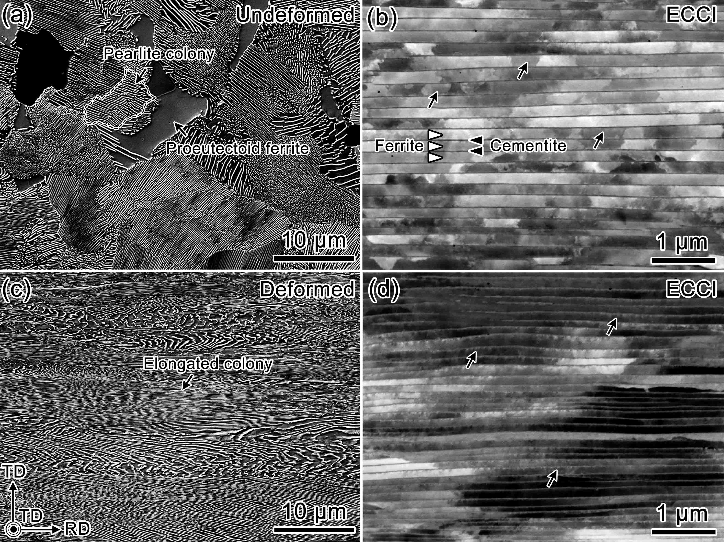
Fig. 1. SE and magnified ECC images of (a,b) undeformed and (c,d) deformed samples, respectively. Note that the images of the deformed sample were taken along the transverse direction of the rolled bar.
Figure 2a shows the representative TDS profiles at different heating rates obtained from the undeformed samples (open circles) and the deformed samples (solid circles) after H charging. The undeformed sample exhibits very small desorption peaks at ~ 400 K (Peak 1),
indicating the desorption of a small amount of hydrogen. However, the deformed sample shows a much higher Peak 1 than the undeformed sample, and a distinct peak at ~ 600 K (Peak 2), as reported in previous studies [7,9]. The positions of the desorption peaks shift to the higher temperature with increasing heating rates due to the thermal activation effect, and the activation energy, E_{a}, for hydrogen traps, can be evaluated by Kissinger's equation [25,26];
$$\frac{∂ln\left(ϕ/T_{c}^{2}\right)}{∂\left(1/T_{c}\right)}=-\frac{E_{a}}{R} (1)$$
where ϕ, T_{c}, and R are the heating rate, peak desorption temperature, and gas constant, respectively. Fig. 2b shows the plot of ln(ϕ/T_{c}²) as a function of 1/T_{c} obtained from the deformed sample. The values of E_{a} estimated from the slopes of linear regression lines are ~ 27.8 and ~ 51.6 kJ/mol for Peak 1 and Peak 2, respectively. Comparing the obtained E_{a} values with reported ones, the Peak 1 is attributed to the desorption of hydrogen at weak trapping sites such as vacancies, dislocations, and coherent ferrite/cementite interfaces [5,27,28]. In contrast, the desorbed hydrogen in the Peak 2 observed only in the deformed sample could be attributed to strong hydrogen traps such as strained ferrite/cementite interfaces and/or defects within the cementite [9,29-31].
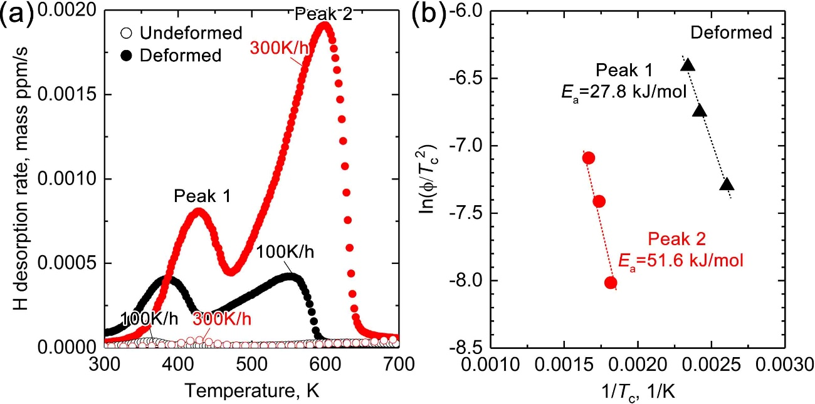
Fig. 2. (a) TDS profiles of undeformed and deformed samples at various heating rates after H charging. (b) Plot of ln(ϕ/T_{c}²) as a function of 1/T_{c}.
Figures 3a and b show normalized APT mass-to-charge spectra for the undeformed and deformed samples, respectively. Note that the mass spectra were acquired from both the uncharged and D-charged samples. The ${{}_{\text{1}}^{\text{1}}H}^{\text{+}}$ (H⁺) peak observed at 1 Da, regardless of deformation and D-charging, is due to the detection of residual hydrogen gas in the analysis chamber. However, since a peak at 2 Da is detected only in the D-charged samples, this peak is assigned as ${{}_{1}^{2}H}^{+}$ (D⁺), which proves the successful deuterium charging into the needle-like specimen [16,18]. The deformed sample shows a higher D⁺ peak with a D/H peak ratio of ~ 0.4, which is four times larger than that of the undeformed sample, ~ 0.1, indicating a larger amount of D trapped in the deformed sample.
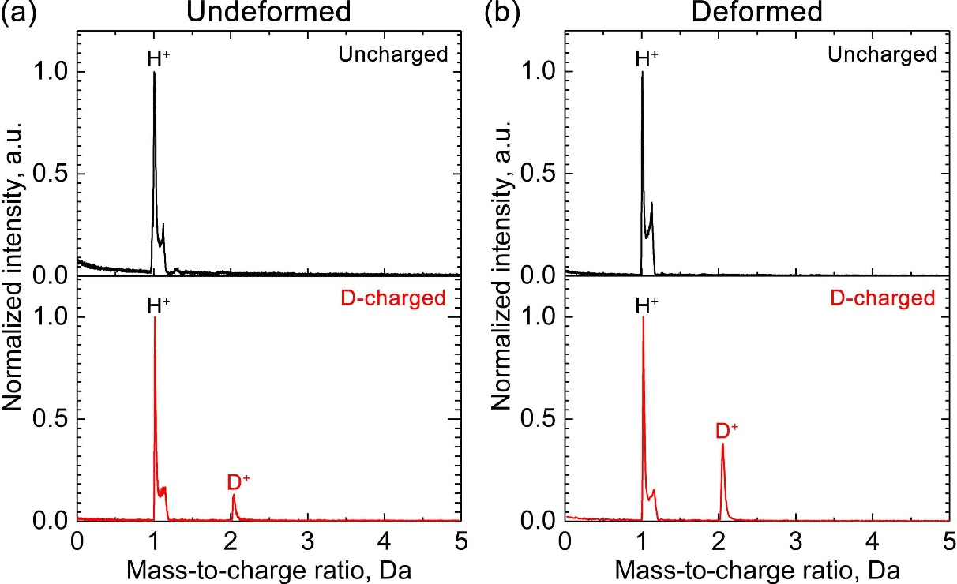
Fig. 3. Normalized APT mass-to-charge spectra of (a) undeformed and (b) deformed samples in the uncharged and D-charged conditions, respectively.
Figure 4a shows 3D atom maps of C, Si, Cr, Mn, and D obtained from the D-charged undeformed sample. The cementite plate is enriched in C, Cr, and Mn, while depleted in Si. There is no D enrichment around or within the cementite, and such a feature is also evident in an enlarged 3D atom map obtained from the selected volume indicated by the dashed line, which shows a random distribution of D atoms in both cementite and ferrite. The 1D compositional profiles across the cementite shows that the C concentration within the cementite is consistent with the stoichiometric value for Fe₃C, ~ 25 at.%. The average concentration of D in the analyzed volume is only ~ 0.06 at.%, suggesting no obvious hydrogen trapping site in the undeformed sample. Nevertheless, the 1D composition profile still shows a slight depletion of D from the cementite, which may be related to the high migration barrier in undeformed cementite [31].
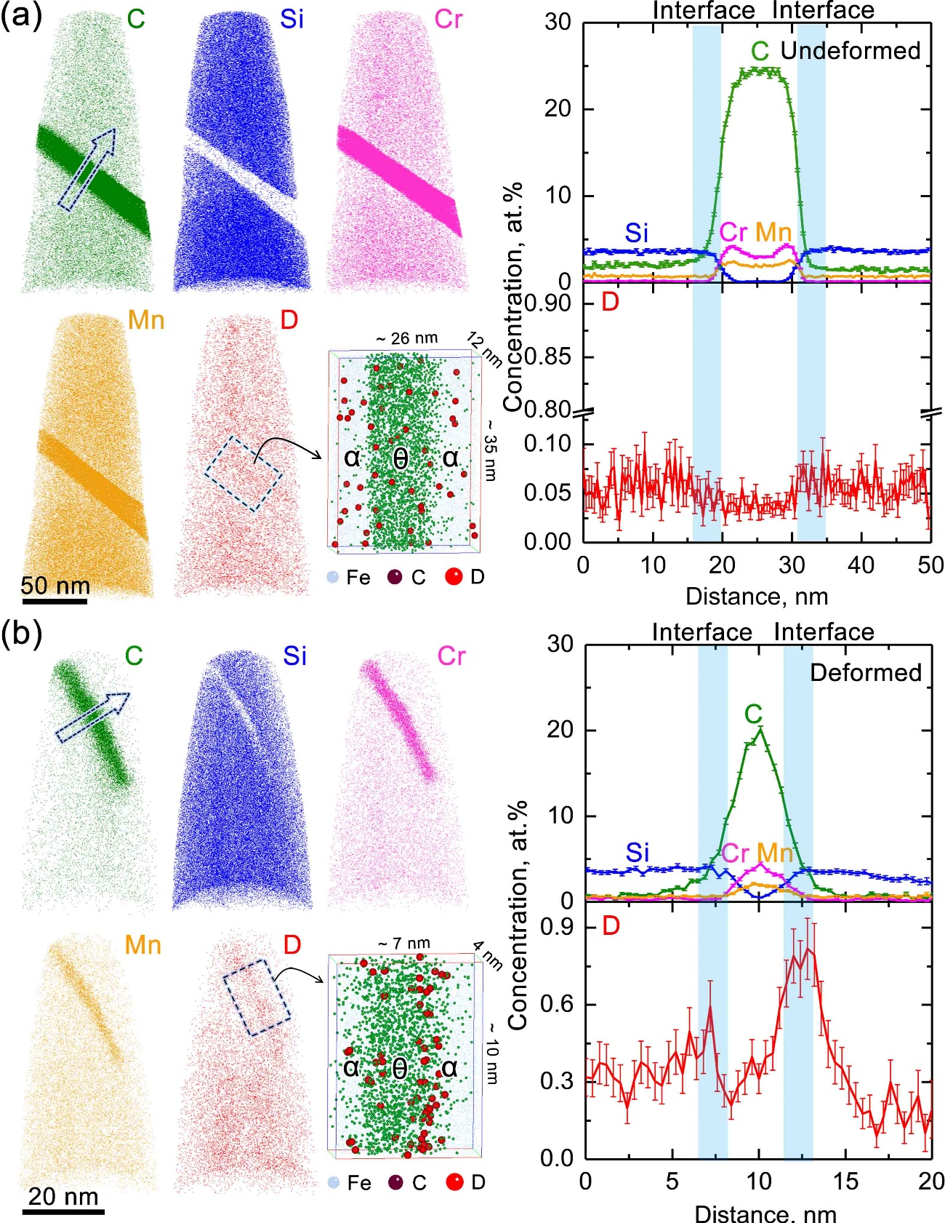
Fig. 4. 3D atom maps of C, Si, Cr, Mn, and D, and corresponding 1D compositional profiles across the cementite in (a) undeformed and (b) deformed samples after D-charging. Note that α and θ refer to the ferrite and cementite, respectively.
Contrary to the undeformed sample, the deformed sample shows an obvious D enrichment around the cementite, while the distribution of other constituent elements is similar to that of the undeformed sample, Fig. 4b, and the video of the 3D atom map provided as Fig. S.1. A closer look at the enlarged 3D atom map reveals the D segregation at the ferrite/cementite interfaces. The D concentration on one side of the cementite, ~ 0.8 at.% is slightly higher than that on the other side, ~ 0.6 at.%, which may result from the different defect densities or strain fields on the two sides of strained interface, as indicated by the imaging contrast in Fig. 1. The carbon content across the cementite is ~ 20 at.%, indicating a slight decomposition of the cementite by the deformation [32]. The slight variations in D concentration in the bottom half of the 3D atom map are attributed to the pole decoration because the other elements such as Si, Cr, and Mn contents are also varied, unlike the cementite/ferrite interface.
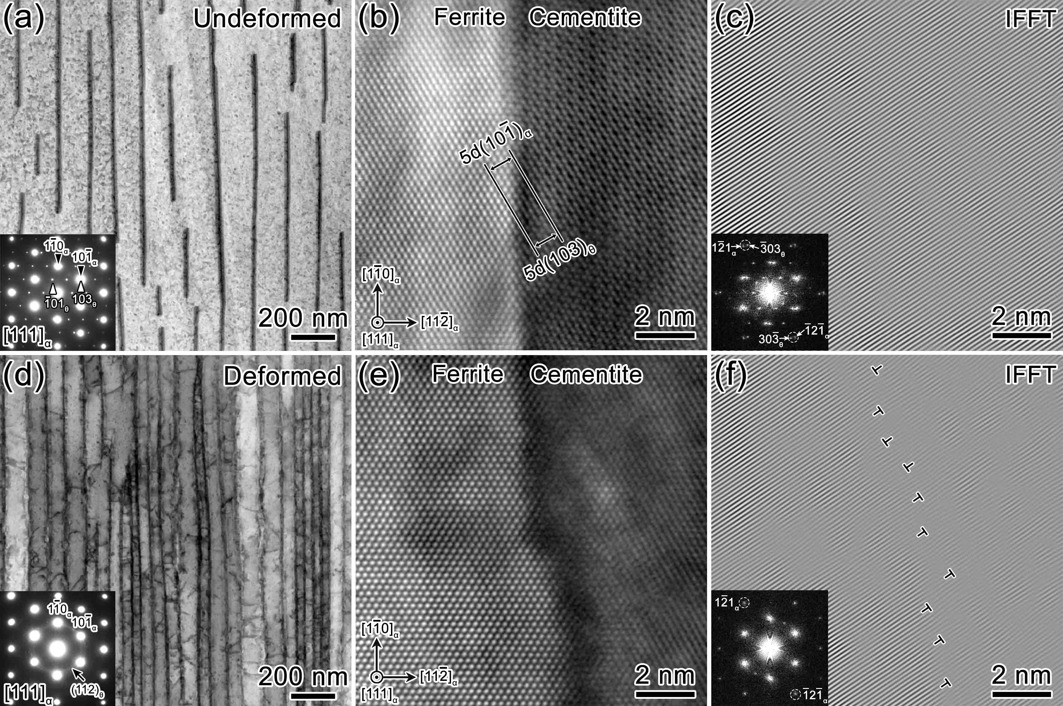
Fig. 5. Low-magnification BF-STEM images and SAED patterns, atomic resolution HAADF-STEM and corresponding IFFT images of (a-c) undeformed and (d-f) deformed samples, respectively. Note that electron beam is parallel to [111]_{α}.
Figure 5a shows a bright-field STEM image and corresponding selected area electron diffraction (SEAD) pattern obtained from the undeformed sample along the [111]_{α} zone axis. The darkly imaged parallel cementite has an average thickness of ~ 10 nm and an Isaichev orientation relationship (OR) with ferrite described as ${\left(\text{103}\right)}_{\text{θ}}\text{//}{\left(\text{10}\overline{\text{1}}\right)}_{\text{α}}$, ${\left[\text{010}\right]}_{\text{θ}}\text{//}{\left[\text{111}\right]}_{\text{α}}$ [33,34]. An atomic-resolution HAADF-STEM image shows brightly imaged ferrite compared to the cementite due to low C content, Fig. 5b, and atomically sharp ferrite/cementite interface along the atomic planes of ${\left(\text{010}\right)}_{\text{θ}}\text{//}{\left(\text{112}\right)}_{\text{α}}$. The corresponding inverse fast Fourier transform (IFFT) image shows well-arranged atomic columns across the interface, Fig. 5c, providing a coherent interface, while this may not be the case where there is a slight grain orientation within the ferrite. The deformation caused the thinning of the cementite to an average thickness of ~ 5 nm and induced a large number of dislocations in the ferrite as shown in Fig. 5d. In contrast to the spotty reflections from the cementite in the undeformed sample, Fig. 5a, a ring-like reflection, indexed as the ${\left\{\text{112}\right\}}_{\text{θ}}$, appears in the SAED pattern of the deformed sample, indicating that the OR no longer holds between the cementite and ferrite in the deformed sample due to the fragmentation of cementite lamellae. The atomic-resolution HAADF-STEM image shows an undulated interface structure with darker contrast compared to the cementite interior, which may be attributed to the suppression of electron channeling by the introduced defects around the ferrite/cementite interface [35,36], Fig. 5e, and such a feature is typically observed in the undeformed sample, Fig. S.2. A large number of interface dislocations are identified by the corresponding IFFT image, Fig. 5f.
This study clearly showed that the ferrite/cementite interface is the strong hydrogen trapping site in deformed pearlitic steel. Cold deformation induced a high density of dislocations within the ferrite and dislocation accumulation at the ferrite/cementite interfaces, Figs. 1 and 5. Since they are accepted as weak hydrogen trapping sites [5,27,28,31], corresponding to Peak 1 in the TDS spectrum, Fig. 2a, the accumulated dislocations at the ferrite/cementite interface would not provide strong hydrogen trapping sites. Lattice strain is another feature induced by deformation due to the strength difference between ferrite and cementite [37]. Although it remains unclear whether the interfacial dislocations contribute to the formation of lattice strain, it would still be reasonable to conclude that the origin of the strong hydrogen trapping sites is brought by lattice strain rather than the dislocation core. APT analysis has shown that cold deformation also reduces the carbon content in cementite to ~20 at.%, Fig. 4, suggesting the formation of vacancies at carbon sites which could act as strong hydrogen trapping sites [8,16-18,30,31,38]. If the vacancies provide strong hydrogen trapping sites, Peak 2 should also appear in the TDS spectrum of the undeformed sample due to the presence of thermally equilibrium vacancies. Considering the absence of Peak 2 in the TDS spectrum of the undeformed sample, Fig. 2b, it is unlikely that the vacancies on the cementite surface provide strong hydrogen trapping sites.
A common feature in mechanisms explaining hydrogen embrittlement is hydrogen accumulation in stress concentrated regions, which are the potential crack nucleation sites, to accelerate the fracture via interface-bond decohesion [39] or promoted plastic deformation locally [40]. The strong hydrogen trapping at the strained ferrite/cementite interface, which was clearly presented in this study, suggests that one reason for the excellent hydrogen embrittlement resistance of deformed pearlitic steels is the significant shortage of diffusive hydrogen, preventing the possible mechanisms of hydrogen embrittlement.
In summary, this work has shown that there is a strong hydrogen trapping site in the deformed pearlitic steel. APT analysis of the D-charged specimens revealed that the strong deuterium segregation at the ferrite/cementite interface in the deformed pearlitic steel, whereas there was no prominent deuterium segregation in the undeformed sample. The ECC imaging and STEM analysis showed that the deformation resulted in the straining at the ferrite/cementite interfaces. Therefore, we conclude that the significant hydrogen trapping at the strained ferrite/cementite interface, suppressed hydrogen accumulation in the stress field, contributing to the excellent HE resistance.

Acknowledgements
This work was in part supported in part by the Japan Institute of Metals and Materials, and the technical research aid, JFE 21st Century Foundation, and MEXT Program: Data Creation and Utilization-Type Material Research and Development Project Grant Number JPMXP1122684766.

References
- R. Kuziak, S. Waengler, Advanced high strength steels for automotive industry: a review, VIII (2008).
- O. Kwon, K. Lee, G. Kim, K.G. Chin, New trends in advanced high strength steel developments for automotive application, Mater. Sci. Forum, 638 (2010) 136-141.
- B. Sun, D. Wang, X. Lu, D. Wan, D. Ponge, X. Zhang, Current challenges and opportunities toward understanding hydrogen embrittlement mechanisms in advanced high-strength steels: a review, Acta Metall. Sin. 34 (2021) 741-754.
- P. Gong, A. Turk, J. Nutter, F. Yu, B. Wynne, P. Rivera-Diaz-del-Castillo, W.M. Rainforth, Hydrogen embrittlement mechanisms in advanced high strength steel, Acta Mater. 223 (2022) 117488.
- J.S. Kim, Y.H. Lee, D.L. Lee, K.-.T. Park, C.S. Lee, Microstructural influences on hydrogen delayed fracture of high strength steels, Mater. Sci. Eng. A 505 (2009) 105-110.
- W. Hui, Z. Xu, Y. Zhang, X. Zhao, C. Shao, Y. Weng, Hydrogen embrittlement behavior of high strength rail steels: a comparison between pearlitic and bainitic microstructures, Mater. Sci. Eng. A 704 (2017) 199-206.
- R. Ueji, Y. Kimura, T. Inoue, Preferable resistance against hydrogen embrittlement of pearlitic steel deformed by caliber rolling, ISIJ Int. 62 (2022) 368-376.
- K. Takai, G. Yamauchi, M. Nakamura, M. Nagumo, Hydrogen trapping characteristics of cold-drawn pure iron and eutectoid steel evaluated by thermal description spectrometry, J. Japan Inst. Metals 62 (1998) 267–275.
- T. Doshida, K. Takai, Dependence of hydrogen-induced lattice defects and hydrogen embrittlement of cold-drawn pearlitic steels on hydrogen trap state, temperature, strain rate and hydrogen content, Acta Mater. 79 (2014) 93-107.
- S.M. Myers, M.I. Baskes, H.K. Birnbaum, J.W. Corbett, G.G. DeLeo, S.K. Estreicher, E.E. Haller, P. Jena, N.M. Johnson, R. Kirchheim, S.J. Pearton, M.J. Stavola, Hydrogen interactions with defects in crystalline solids, Rev. Mod. Phys. 64 (1992) 559-617.
- M.L. Martin, M. Dadfarnia, A. Nagao, S. Wang, P. Sofronis, Enumeration of the hydrogen-enhanced localized plasticity mechanism for hydrogen embrittlement in structural materials, Acta Mater. 165 (2019) 734-750.
- W.C. Luu, J.K. Wu, The influence of microstructure on hydrogen transport in carbon steels, Corros. Sci. 239 (1996) 239-245.
- S.H. Yu, S.M. Lee, S. Lee, J.H. Nam, J.S. Lee, C.M. Bae, Y.K. Lee, Effects of lamellar structure on tensile properties and resistance to hydrogen embrittlement of pearlitic steel, Acta Mater. 172 (2019) 92-101.
- B. Gault, A. Chiaramonti, O. Cojocaru-Mirédin, P. Stender, R. Dubosq, C. Freysoldt, S.K. Makineni, T. Li, M. Moody, J.M. Cairney, Atom probe tomography, Nat. Rev. Methods Primer., 1 (2021) 1-30.
- Y.S. Chen, M.J. Griffith, J.M. Cairney, Cryo Atom Probe: freezing atoms in place for 3D mapping, Nano Today, 37 (2021) 101107.
- J. Takahashi, K. Kawakami, Y. Kobayashi, T. Tarui, The first direct observation of hydrogen trapping sites in TiC precipitation-hardening steel through atom probe tomography, Scr. Mater. 63 (2010) 261-264.
- J. Takahashi, K. Kawakami, T. Tarui, Direct observation of hydrogen-trapping sites in vanadium carbide precipitation steel by atom probe tomography, Scr. Mater. 67 (2012) 213-216.
- Y.S. Chen, H. Lu, J. Liang, A. Rosenthal, H. Liu, G. Sneddon, I. McCarroll, Z. Zhao, W. Li, A. Guo, J.M. Cairney, Observation of hydrogen trapping at dislocations, grain boundaries, and precipitates, Science, 367 (2020)171-175.
- I.E. McCarroll, Y.-C. Lin, A. Rosenthal, H.-W. Yen, J.M. Cairney, Hydrogen trapping at dislocations, carbides, copper precipitates and grain boundaries in a dual precipitating low-carbon martensitic steel, Scr. Mater. 221 (2022) 114934.
- A.J. Breen, L.T. Stephenson, B. Sun, Y. Li, O. Kasian, D. Raabe, M. Herbig, B. Gault, Solute hydrogen and deuterium observed at the near atomic scale in high-strength steel, Acta Mater 188 (2020) 108–120.
- Y.S. Chen, R. Niu, P.Y. Liu, P. Burr, J. Cairney, Direct Observation of Hydrogen Distribution in Pearlite, Microsc. Microanal, 28 (2022) 1618-1620.
- Y. Nie, Y. Kimura, T. Inoue, F. Yin, E. Akiyama, K. Tsuzaki, Hydrogen Embrittlement of a 1500-MPa Tensile Strength Level Steel with an Ultrafine Elongated Grain Structure, Metall. Mater. Trans. A 43 (2012) 1670-1687.
- M.K. Miller, Atom Probe Tomography, Springer, US, Boston, MA (2000).
- Y. Ogawa, H. Nishida, M. Nakamura, V. Olden, A. Vinogradov, H. Matsunaga, Dual roles of pearlite microstructure to interfere/facilitate gaseous hydrogen-assisted fatigue crack growth in plain carbon steels, Int. J. Fatigue 154 (2022) 106561.
- H.E. Kissinger, Reaction kinetics in differential thermal analysis, Ana. Chem. 29 (1957) 1702-1706.
- W. Y. Choo, J. Y. Lee, Thermal analysis of trapped hydrogen in pure iron, Metall. Mater. Trans. A 13 (1982) 135-140.
- G.-W. Hong, J.-Y. Lee, The interaction of hydrogen and the cementite-ferrite interface in carbon steel, J. Mater. Sci. 18 (1983) 271-277.
- M. Nagumo, K. Takai, N. Okuda, Nature of hydrogen trapping sites in steels induced by plastic deformation, J. Alloys Compd. 293 (1999) 310-316.
- D.G. Enos, J.R. Scully, A critical-strain criterion for hydrogen embrittlement of cold-drawn, Metal. Mater. Tran. A 33 (2002) 1151-1166.
- K. Takai, R. Watanuki, Hydrogen in trapping states innocuous to environmental degradation of high-strength steels, ISIJ Int. 43 (2003) 520-526.
- K. Kawakami, T. Matsumiya, Ab-initio investigation of hydrogen trap state by cementite in bcc-Fe, ISIJ Int. 53 (2013) 709-713.
- K. Hono, M. Ohnuma, M. Murayama, S. Nishida, A. Yoshie, T. Takahashi, Cementite decomposition in heavily drawn pearlite steel wire, Scr. Mater. 6 (2001) 977-983.
- D.S. Zhou, G.J. Shiﬂet, Ferrite: Cementite crystallography in pearlite, Metall. Trans. A 23 (1992) 1259–1269.
- Y.T. Zhou, S.J. Zheng, Y.X. Jiang, T.Z. Zhao, Y.J. Wang, X.L. Ma, Atomic structure of the Fe/Fe₃C interface with the Isaichev orientation in pearlite, Philos. Mag. 97 (2017) 1-12.
- Y.T. Zhou, X.H. Shao, S.J. Zheng, X.L. Ma, Structure evolution of the Fe₃C/Fe interface mediated by cementite decomposition in cold-deformed pearlitic steel wires, J. Mater. Sci. Technol. 101 (2022) 28-36.
- P.Y. Tung, X. Zhou, D. Mayweg, L. Morsdorf, M. Herbig, Under-stoichiometric cementite in decomposing binary Fe-C pearlite exposed to rolling contact fatigue, Acta Mater. 216 (2021) 117144.
- T. Shimokawa, T. Niiyama, M. Okabe, J. Sawakoshi, Interfacial-dislocation-controlled deformation and fracture in nanolayered composites: Toward higher ductility of drawn pearlite, Acta Mater. 164 (2019) 602–617.
- J. Takahashi, K. Kawakami, Y. Kobayashi, Origin of hydrogen trapping site in vanadium carbide precipitation strengthening steel, Acta Mater., 153 (2018) 193-204.
- R.A. Oriani, Whitney award lecture–1987: hydrogen–the versatile embrittler, Corrosion, 43 (1987) 390-397.
- I.M. Robertson, P. Sofronis, A. Nagao, M.L. Martin, S. Wang, D.W. Gross, K.E. Nygren, Hydrogen embrittlement understood, Metall. Mater. Trans. A, 46 (2015) 2323-2341.

