Metasurface Platform Incorporating Aggregation Induced Emission Based Biosensor for Enhanced Human Serum Albumin Detection

Qi Hu ^{1, 2}, Masanobu Iwanaga ^{1, *}, Youhong Tang ^{2, *}

¹. Research Centre for Electronic and Optical Materials, National Institute for Materials Science (NIMS), 1-1 Namiki, Tsukuba 305-0044, Japan
². Institute for NanoScale Science and Technology, Medical Device Research Institute, College of Science and Engineering, Flinders university, South Australia 5042, Australia

* Corresponding authors. iwanaga.masanobu@nims.go.jp (M Iwanaga) and youhong.tang@flinders.edu.au (Y Tang)

Supporting information
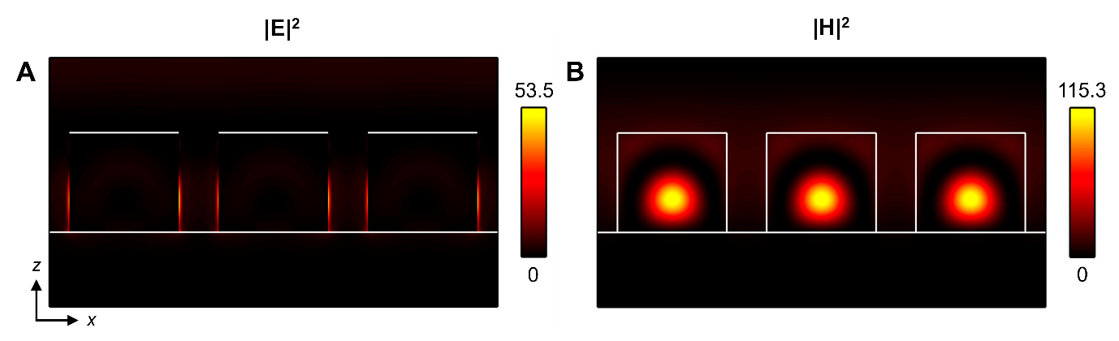

Figure S1. (A) and (B) Electric and magnetic field intensities (|E|² and |H|²), respectively, induced at 750 nm, which is indicated by an arrow in Figure 2B. This xz-section was set to cut through the centre of the Si nanocolumns. Incident field was set to be unity, that is, |E_{in}|² = 1 and |H_{in}|² = 1. Colour bars indicate the field intensities. White lines show the interfaces of the Si nanocolumns with air and the underlying SiO₂ layer.

A
B
Figure S2. (A) and (B) Simulated and measured reflectance spectra, respectively.

Figure S3. The effect of reaction sequence between different combinations among biotin-HSA antibody (HSA Ab), HSA, and TPE-4TA (4TA); Brackets represent a well-mixed solution that have been fully reacted and incubated in advance with these components. [HSA] = 5 μg mL⁻¹, [Biotin-HSA antibody] = 5 μg mL⁻¹, [TPE-4TA] = 20 μg mL⁻¹, Exposure time: 6000 ms, Gain: 10.

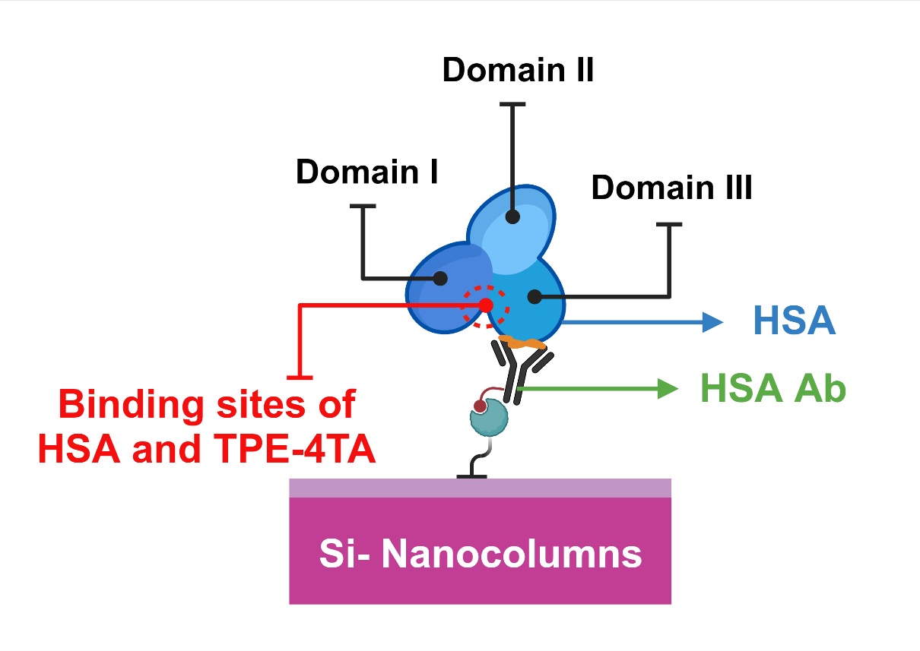
Figure S4. Explanation for FL quenching effect.

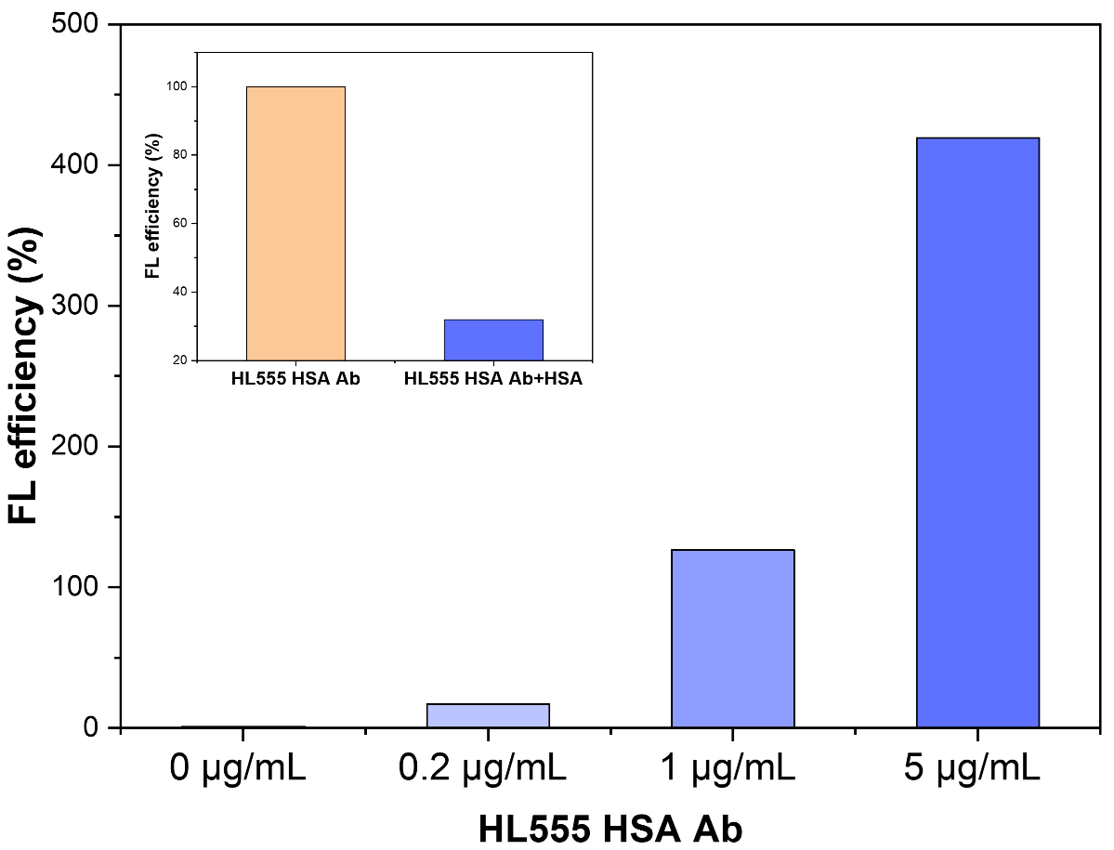
Figure S5. The change of FL efficiency with different concentrations of HL555-HSA Ab; [Biotin-HSA Ab] = 2 μg mL⁻¹, Exposure time: 3000 ms, Gain: 10. Inset figure represents FL quenching before and after adding HSA. [Biotin-HSA Ab] = 2 μg mL⁻¹, [HL555-HSA Ab] = 5 μg mL⁻¹, Exposure time: 3000 ms, Gain: 10.

Figure S6. The FL spectra of TPE-4TA+HSA (black), TPE-4TA (red), HSA (blue) and PBS (green). λ_{ex} = 350 nm, [HSA] = 100 μg mL⁻¹ and [TPE-4TA] = 10 μg mL⁻¹.

Figure S7. TPE-4TA concentration effect with or without HSA; [TPE-4TA] = 0-20 μg mL⁻¹, [HSA] = 0, 100, 1000 μg mL⁻¹, Exposure time: 3000 ms, Gain: 10.

Figure S8. The standard curve of TPE-4TA for HSA detection using the microplate platform. λ_{ex} = 360 nm, [HSA] = 0-200 μg mL⁻¹ and [TPE-4TA] = 20 μg mL⁻¹, Exposure time: 3000ms, Gain: 10.

Figure S9. The standard curve of TPE-4TA for HSA detection using the microfluidic platform. λ_{ex} = 360 nm, [HSA] = 0-200 μg mL⁻¹ and [TPE-4TA] = 20 μg mL⁻¹, Exposure time: 3000ms, Gain: 10.

Figure S10. Spectrum of untreated urine.

Figure S11. The effect of urine dilution where dilution ratios refer to total volume/treated urine volume with PBS buffer as diluent. λ_{ex} = 360 nm, Exposure time: 3000ms, Gain: 10.

Content | Commercial  kits | Microplate wells system | Microfluidic system | Metasurface platform
Measured concentration | 45.828 μg mL⁻¹ | 40.720 μg mL⁻¹ | 41.917 μg mL⁻¹ | 43.832 μg mL⁻¹
Recovery rate | ─── | 88.85% | 91.47% | 95.64%
Table S1.The measurement of HSA concentrations and corresponding recovery rates in urine among microplate, microfluidic and metasurface platforms.

