Beryllium-Vacancy Color Center in Diamond

Abstract: Diamond color centers represent distinctive quantum spin systems with unique electronic and optical properties, positioning them as promising candidates for applications in single-photon sources, nanoscale quantum sensors, and quantum information. In this study, density functional theory is used to investigate the potential of the beryllium-vacancy (BeV) color center in diamonds and its electronic and optical properties. The formation energy of BeV in different charge states are calculated to show that BeV²⁻ can possess spin-triplet ground state. The optical index Zero-Phonon Line (ZPL) of the predicted BeV²⁻ color center is at 578 nm within the visible light range, and the influences of various electron donors on the ZPL have also been explored, which can be an instructive guidance for the preparation method of the BeV color center. These characteristics can demonstrated that BeV²⁻ can be a potential candidate of color center. We believe that these results can eventually pave the way for the further experimental explorations for the identification and comprehension of the BeV center in diamond and also its possible applications in nanoscale quantum sensors.
Keywords: Beryllium-vacancy center; Quantum sensor; Density function theory; Diamond semiconductor.

Introduction
Single color center in diamonds has attracted much attention for their unique electronic and optical transition properties, which are crucial in acting as single-photon sources [1–3], high-precision nanoscale quantum sensors [4–8], and quantum computing bits [9–12]. The negatively charged nitrogen-vacancy (NV⁻) center in diamond is the leading system in high-precision quantum sensors with high temporal and spatial resolution [13]. Their unique electronic and optical properties enable high-fidelity manipulations at room temperature [18,19], showing their potential in nanoscale quantum sensing fields [14–16].
Except for NV⁻ color center, many solid state systems with similar electronic and optical properties have been studied. Some practical criteria for identifying new color centers are proposed such as: (a) A spin-triplet bound state suitable for a qubit. (b) Negligible interference from the electronic states of the host (defects should lie deep inside the bandgap). (c) No thermal excitations between bound states at room temperature (the energy levels of the color center have significant separations) [17].
The theoretical and experimental studies to identify new color centers as promising nanoscale quantum sensors are in full progress. The quantum color centers in diamond commonly exhibit${ D}_{3d }$or${ C}_{3v}$symmetry. However, under natural conditions the pure$D_{3d}$symmetry color centers (SiV⁻, GeV⁻, SnV⁻, and PbV⁻) have no permanent electric dipole moment, making their optical transitions less sensitive to electromagnetic field [18–21], so a nanoscale quantum sensor color center is anticipated to have $C_{3v}$ symmetry, which is sensitive to external electric and magnetic fields. The $C_{3v}$ symmetry color centers commonly include NV⁻, neutral oxygen-vacancy center (OV⁽⁰⁾), boron-vacancy center with one negative charge (BV⁻). Nevertheless, even if OV⁽⁰⁾ and BV⁻ centers have spin-triplet ground states [22–27], they do not show detectable luminescence mainly because of Jahn-Teller instability and distortion of the triplet-excited states, which are thus excluded from the NV-like color centers [23]. Therefore, NV⁻ like $C_{3v}$ symmetry vacancy centers in diamond are relatively rare.
In this study, it is demonstrated that the beryllium vacancy center in diamond with two negative charges (BeV²⁻) could be a powerful $C_{3v}$ symmetry color center. The beryllium vacancy refers to a structure in a diamond where a beryllium atom replaces a carbon atom with an adjacent vacancy. Up to now, there are very few experimental and theoretical researches on beryllium in diamonds. To explore the feasibility of the predicted BeV center, the density-function theory (DFT) calculations have been conducted for the accurate evaluation of the properties. These can provide ideas for the future preparation of BeV color centers.

Computational methods
The computational analyses presented in this study were conducted using the PWmat package, a robust plane-wave pseudopotential code designed for (DFT) calculations. In our calculation, we first utilize the Perdew-Burke-Ernzerhof (PBE) functional for a rough and fast calculation, and then the Heyd-Scuseria-Ernzerhof (HSE06) hybrid functional is used for the further accurate validation of the DFT calculations [28]. We use Gamma sampling Monkhorst-Pack k-point [34] to perform geometric optimizations to determine electronic properties, including formation energies and wave functions. With a cutoff energy of 50 Ry (680 eV), we first use PBE functional for a fast optimization of primitive cells with the lattice parameter of 3.545 Å, close to the experimental lattice parameter of diamonds 3.567 Å [29]. The rest of the calculations are carried out in a $4×4×4$ supercell with 512 atoms, ensuring that the supercell size is adequately extensive to minimize the interactions between periodic defect and electronic donor images so that the dispersion of in-gap defect states is negligible.
The charge states of the system are critical in determining the stability and charge density polarization. Formation energies have been calculated to identify the most stable charge states for given Fermi levels using the following expression [17,27,30]:
$$E^{f}[C:BeV^{q}]=E_{tot}[C:BeV^{q}]-E_{tot}[C:bulk]-μ_{Be}+μ_{C}+q(ε_{F}+ε_{VBM}^{bulk}+ΔV)$$
here, $μ_{x}$represents the chemical potential,${ ε}_{F}$ is the referenced Fermi level, $ε_{VBM}^{bulk}$ is the valence band maximum (VBM) in the bulk material, and $\text{q}ΔV$ accounts for the energy needed to align the VBM of the defect supercell with that of the bulk [31].
The excited-state spin occupations have been introduced for the Zero-Phonon Line (ZPL) calculations to accurately simulate the optical transition properties of beryllium-related defects by promoting an electron to a higher energy level. The ground and excited states with constrained occupations are fully relaxed until the atomic forces are reduced to less than 0.01 eV/ Å.

Results and discussion
We first identify the stable BeV^{q} (q represents the quantity and sign of the electric charge) systems in diamonds by calculating the structures and formation energy. To be an quantum color center, criteria mentioned above like wide bandgap and spin-triplet ground states should be satisfied. So we calculate the energy level diagrams of those identified BeV^{q} systems to determine which charge state can be color center. Next, the electronic and optical properties of the newly-predicted BeV color center in diamond have been calculated, such as the formation energy and structure, for the confirmation of BeV to be a qualified color center in diamonds. Then, the optical properties such as Zero-Phonon Line (ZPL) have been studied by manually introducing electrons or various electronic donors. Finally, the potential preparation method for the fabrication of the beryllium vacancy center has been briefly discussed with the above properties.
3.1 Formation energy and structures
First, the different ground charge states are calculated without preliminary symmetry constraints. Figure 1(a) shows the formation energy of the -2, -1, 0, 1, 2 charge states of the BeV center as a function of the Fermi level. The charge states can be obtained through the slope of lines, and the stable state for a given Fermi level is the one with the lowest formation energy. For example, BeV²⁻center can be stable when the Fermi level is 2.72 eV above.
For a suitable host, color center criteria (b) requires that impurity energy levels should not exist in wide bandgap, preventing interference from the electronic states of the host during the optical transition process [17]. To identify suitable charge states of BeV systems, we calculate the ground states energy levels with different charges, which shows that only BeV²⁻ has a deeply located spin-triplet ground state$(a_{1}^{2}e^{2}){ [}^{3}A_{2}]$ in accordance with criteria (a) and (b) (Fig. 1(b)). The calculated bandgap is 5.49 eV, which is close to the experiment value of diamonds (5.5 eV) [29], manifesting that the bulk diamonds are electronically stable after introducing a beryllium atom and a vacancy. Meanwhile, we also find a minor vacancy state close to Valence Band Maximum (VBM). Later calculations imply that this minor state has a negligible effect on the existence of the spin-triplet ground state and the energy and optical properties of the system. In other charge state systems, the ground triplet states are destroyed probably due to Jahn-Teller instability which may break the${ C}_{3v}$symmetry (see Section S1) [32,33]. Therefore, they do not possess spin states suitable for color centers.
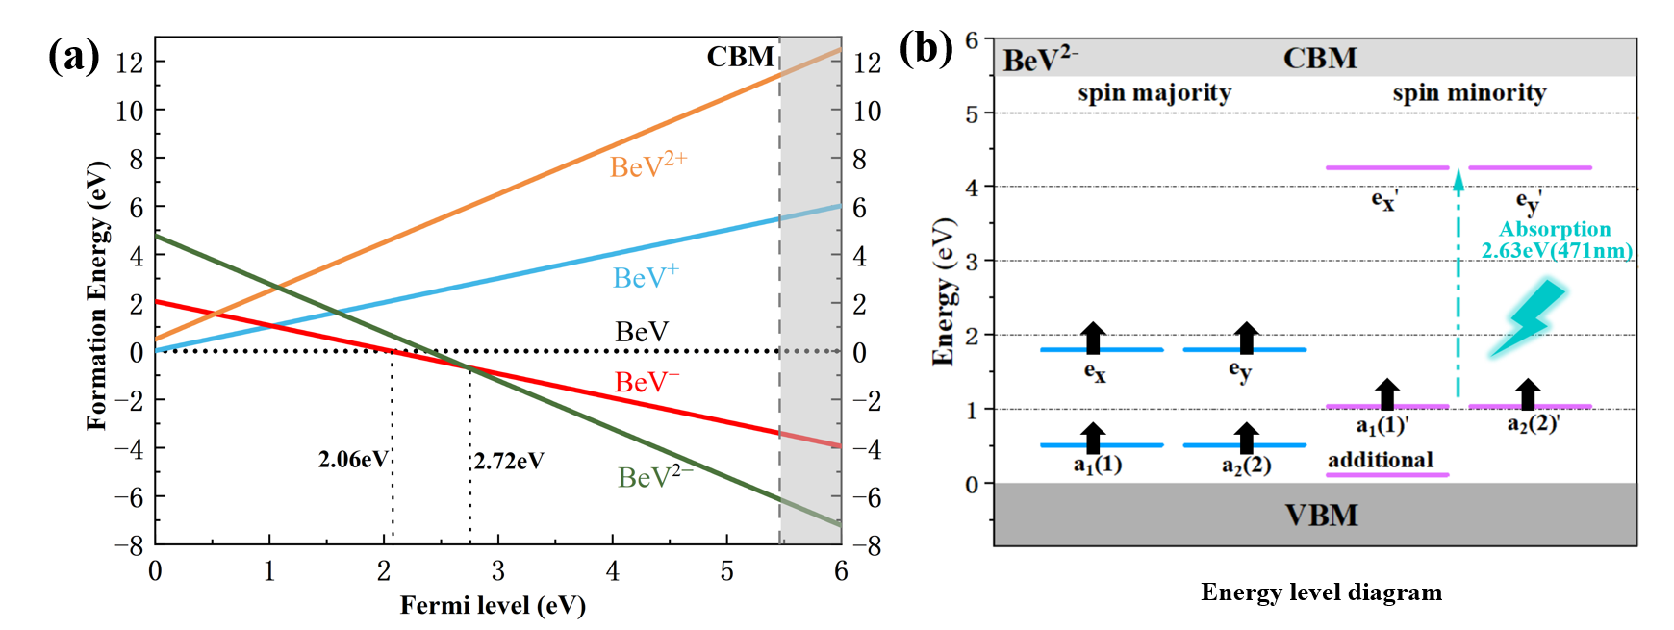
Fig. 1. (a) The calculated formation energy as a function of Fermi level for -2, -1, 0, 1, and 2 charge states denoted by BeV²⁻, BeV–, BeV, BeV⁺, and BeV²⁺, respectively. (b) The ground state energy level diagram of BeV²⁻. The spin majority levels are characterized in blue, and the spin minority levels are purple. Only spin minority states are involved in spin-conserving optical excitations, which are located deeply within the bandgap. The dashed line shows the transition direction of electrons, and the corresponding absorption energy is marked in cyan.
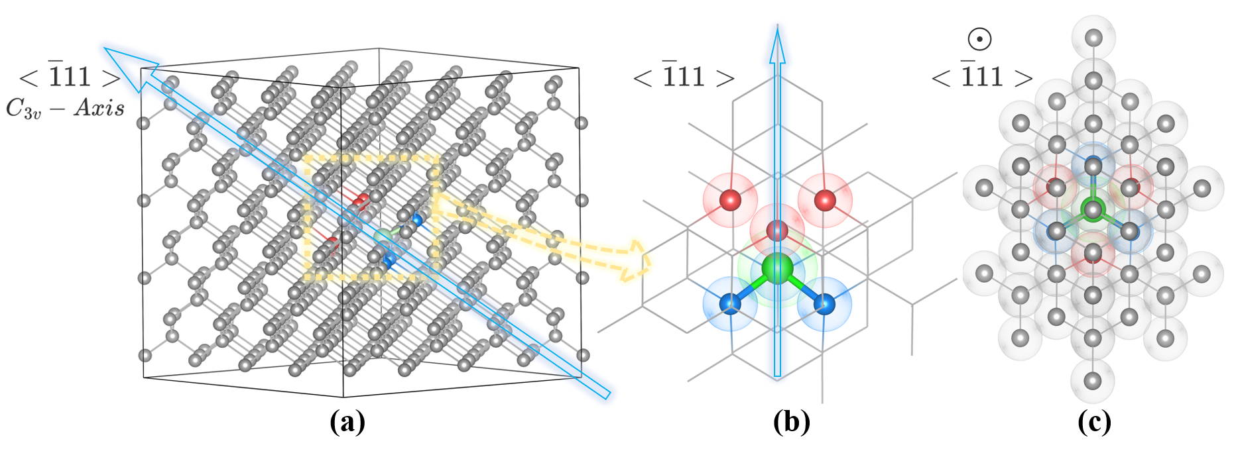
Fig. 2. Structure of a BeV²⁻ quantum center consisting of six carbons and one beryllium in diamonds. (a) A 512 supercell with${ C}_{3v }$symmetry axis parallel to $<\overline{1}11>$ axis. (b) BeV²⁻ in top view. (c) BeV²⁻ in front view. Beryllium atoms are shown in green. Three carbon atoms close to vacancy are shown in red, and three adjacent to beryllium atom are in blue.
The ground state structure of BeV²⁻ is illustrated in Figure. 2. The geometric structure has been calculated without any preliminary symmetry constraints, and the optimized structure exhibit ${ C}_{3v}$symmetry akin to the NV⁻. At the ground state, the interatomic distance between the carbon atoms and the adjacent vacancy is 2.65 Å, and between these carbon atoms and the Beryllium atom the distance is 2.31 Å. This extended spacing suggests no long chemical bonds are formed. Furthermore, the C-Be bonds are 11.0% (0.26 Å) longer, and the C-C bonds of the adjacent atoms are 2.7% (0.06 Å) shorter compared to those in the pristine diamond lattice. Consequently, the beryllium atom moves towards the vacancy while the three adjacent carbon atoms shift outward. In contrast, in the NV⁻ center, the N-C and C-C bonds in the vicinity of the vacancy contract by approximately 4% and 3%, respectively [34]. Therefore, the relative vacancy sites in NV⁻ and BeV²⁻ are similar.
3.2 Electronic properties
Then we study the electronic properties of BeV²⁻ by calculating electronic density clouds. The localization of defect state electrons is depicted in Figures. 3 and 4. In Figure 3, the vacancy electrons differ from global electrons in that their electronic density clouds are localized near the color center. Figure 4 shows electronic density clouds of different energy levels in the spin-triplet ground state, manifesting that overall density clouds exhibit $C_{3v}$symmetry. Moreover, the additional minor state (Fig. 3 b-d) will break neither the vacancy states in higher energy nor the${ C}_{3v}$symmetry, only impacting the exact values of specific electronic and optical properties. Therefore, the dangling bonds exhibit $C_{3v}$symmetry.
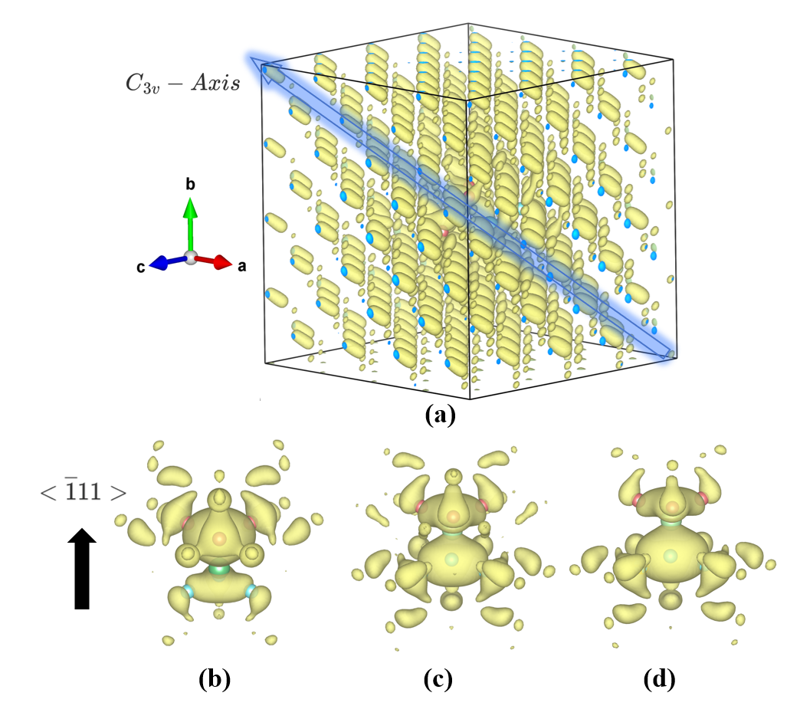
Fig. 3. (a) The electronic density cloud for a global electron. (b) (c) (d) The electronic density cloud of symmetric additional states occurring when introducing external electronic donors. The isovalue is set to be 0.001 e·bohr⁻³.

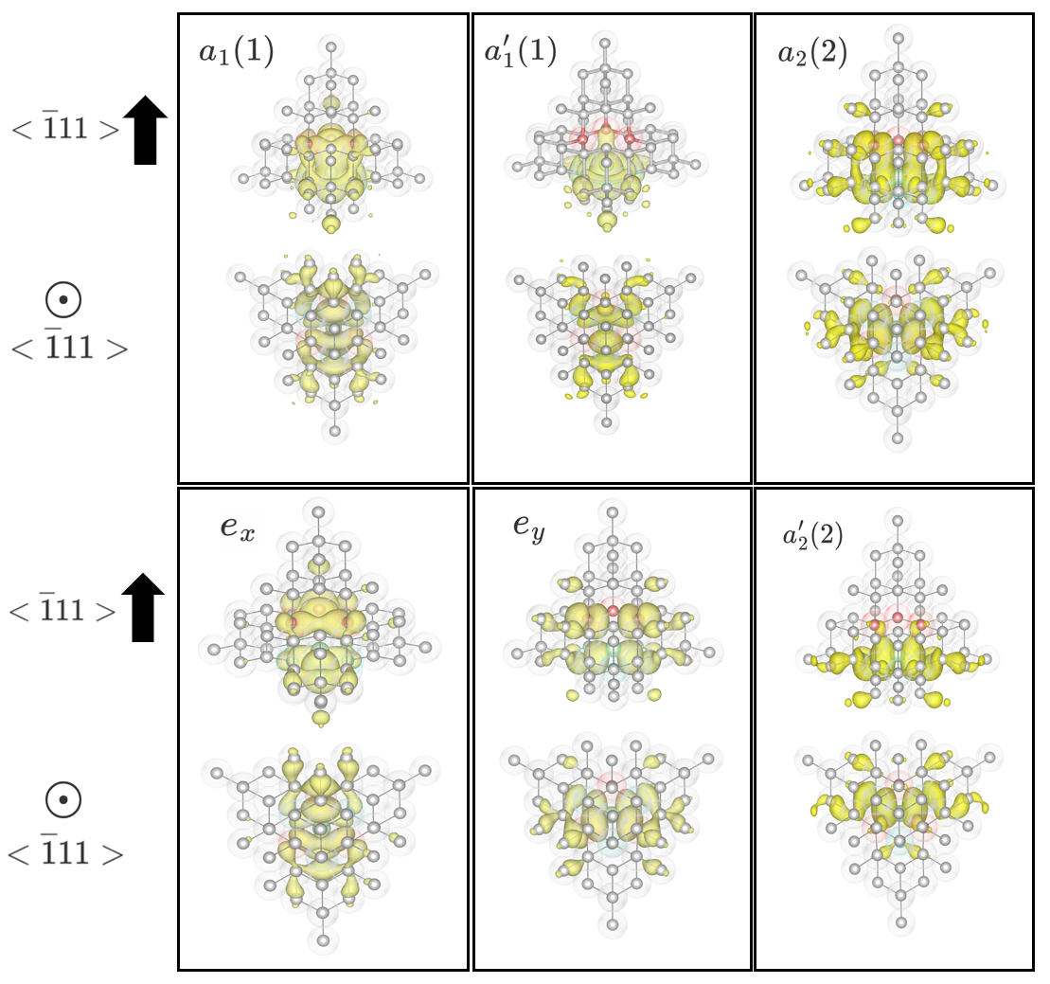
Fig. 4. Defect ground states wavefunctions of BeV^{2–} in diamonds. Beryllium atoms are shown in green. Three carbon atoms close to vacancy are shown in red, the three adjacent to beryllium atom are in blue, and the electron cloud is in yellow. The isovalue is set to be 0.001 e·bohr⁻³.
Furthermore, the electronic density rapidly decays with proximity to nearby atoms, indicating that the defect level is deeply embedded within the bandgap and originates from the vacancy center (see Section S2). It is anticipated that the spin-orbit coupling in the defect-bound states is negligible to prevent unwanted spin flips, which is likely met as the DFT calculations suggest. Moreover, if the energy difference between two defect spin states is not large enough compared to thermal energy at room temperature, the thermal excitations may couple and compromise spin information, which limits its applications only at a range far lower than room temperature [17]. We confirm the existence of substantial spin polarization at the defect center, ensuring that the deep defect-bound states are sufficiently separated in energy to avoid thermal excitations [35]. Therefore, BeV²⁻ may be a stable spin system in relatively high temperature.
  - Optical properties
Then, we turn to study the Zero-Phonon Line (ZPL) of BeV²⁻. Spin-conserving optical excitation and pumping cycle are crucial for characterizing promising qubit candidates, as they potentially enable precise optical control of these states.
The optically active spin minority levels are situated deep within the bandgap in Fig. 1(b), without significant resonance with the host valence electron states. The spin-conserving optical excitation process can be conceptualized by promoting the electron in level a' to the higher energy level e'. This facilitates the creation of an optical pumping cycle, involving transitions from the ground to excited states, followed by spin-selective nonradiative decay pathways, and finally, spin-conserving fluorescent transitions, known as Zero-Phonon Line (ZPL) transitions.
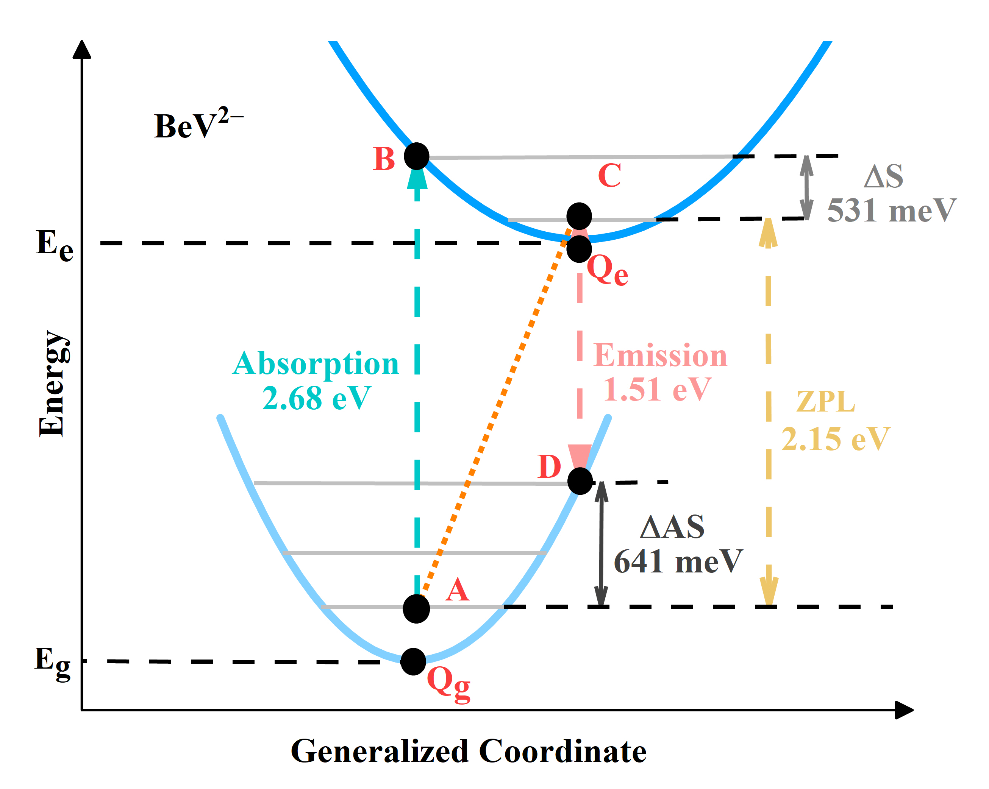
Fig. 5. Schematic for the energy versus configuration coordinate Q for two negative electron-charged states involved in the optical transition.
The ZPL is calculated as the difference in total energy between the excited and ground states, $ZPL=E_{e}(Q_{e})-E_{g}(Q_{g})$, as shown in Figure. 5. Using the Heyd-Scuseria-Ernzerhof hybrid functional (HSE06), the calculated ZPL is 2.15 eV (578nm), which falls within the visible light range, facilitating easy detection. The Stokes shift $ΔS$ and anti-Stokes shift $ΔAS$ values are 531 meV and 641 meV, respectively. Visible light range ZPL can be measured and collected easily, even using an affordable Silicon Avalanche Diode. Thus, it can be a promising fluorescent marker and single-photon source in biology and medicine.
In order to maintain the BeV²⁻ charge state, the Fermi level must be raised above 2.72 eV (Fig. 1). Common methods of engineering Fermi level include introducing external electronic donors [36–38] and introducing nin diamond conjection [39]. Taking NV centers and SiV centers as examples, P and N donors are generally used to provide electron donors to maintain the negative charge state of the color centers [38,40–42]. Inspired by this, it can be expected that proper doping can increase Fermi energy, enhancing the stability of BeV²⁻. As Be itself serves as a p-type acceptor (see Section S4) , adding extra n-type donors is necessary to ensure relatively high Fermi level.
In above calculations, the optical property discussion is conducted by manually adding 2 charges to the supercell for the formation of BeV²⁻. This aims to simulate a situation where donors are positioned far from the center of BeV²⁻, so the interactions between donors and BeV²⁻ are negligible. Now, we conduct calculations involving additional donors in BeV²⁻, using oxygen, selenium as two-electron donors and nitrogen, phosphorus as one-electron donors. To introduce two negative charges, we need to place one two-electron donor or two one-electron donors. As confirmed in the NV⁻ system, if the distance between defect centers and donors is far enough, empirically larger than 10.0 Å [43], the donor energy levels would not influence the defect. However, if we place electron donors in high symmetry sites, the donor’s volume and inner electrons may impose less influence on the whole system, so the request for far distance will primarily weaken [43]. To minimize the impact, for the one-electron donor, we add it to the ${ C}_{3v }$axis, more than 10.0 Å far away from the center of defects, and as for two-electron donors, we add one in the$C_{3v}$axis and another in the midpoint of the edge of supercell cube.
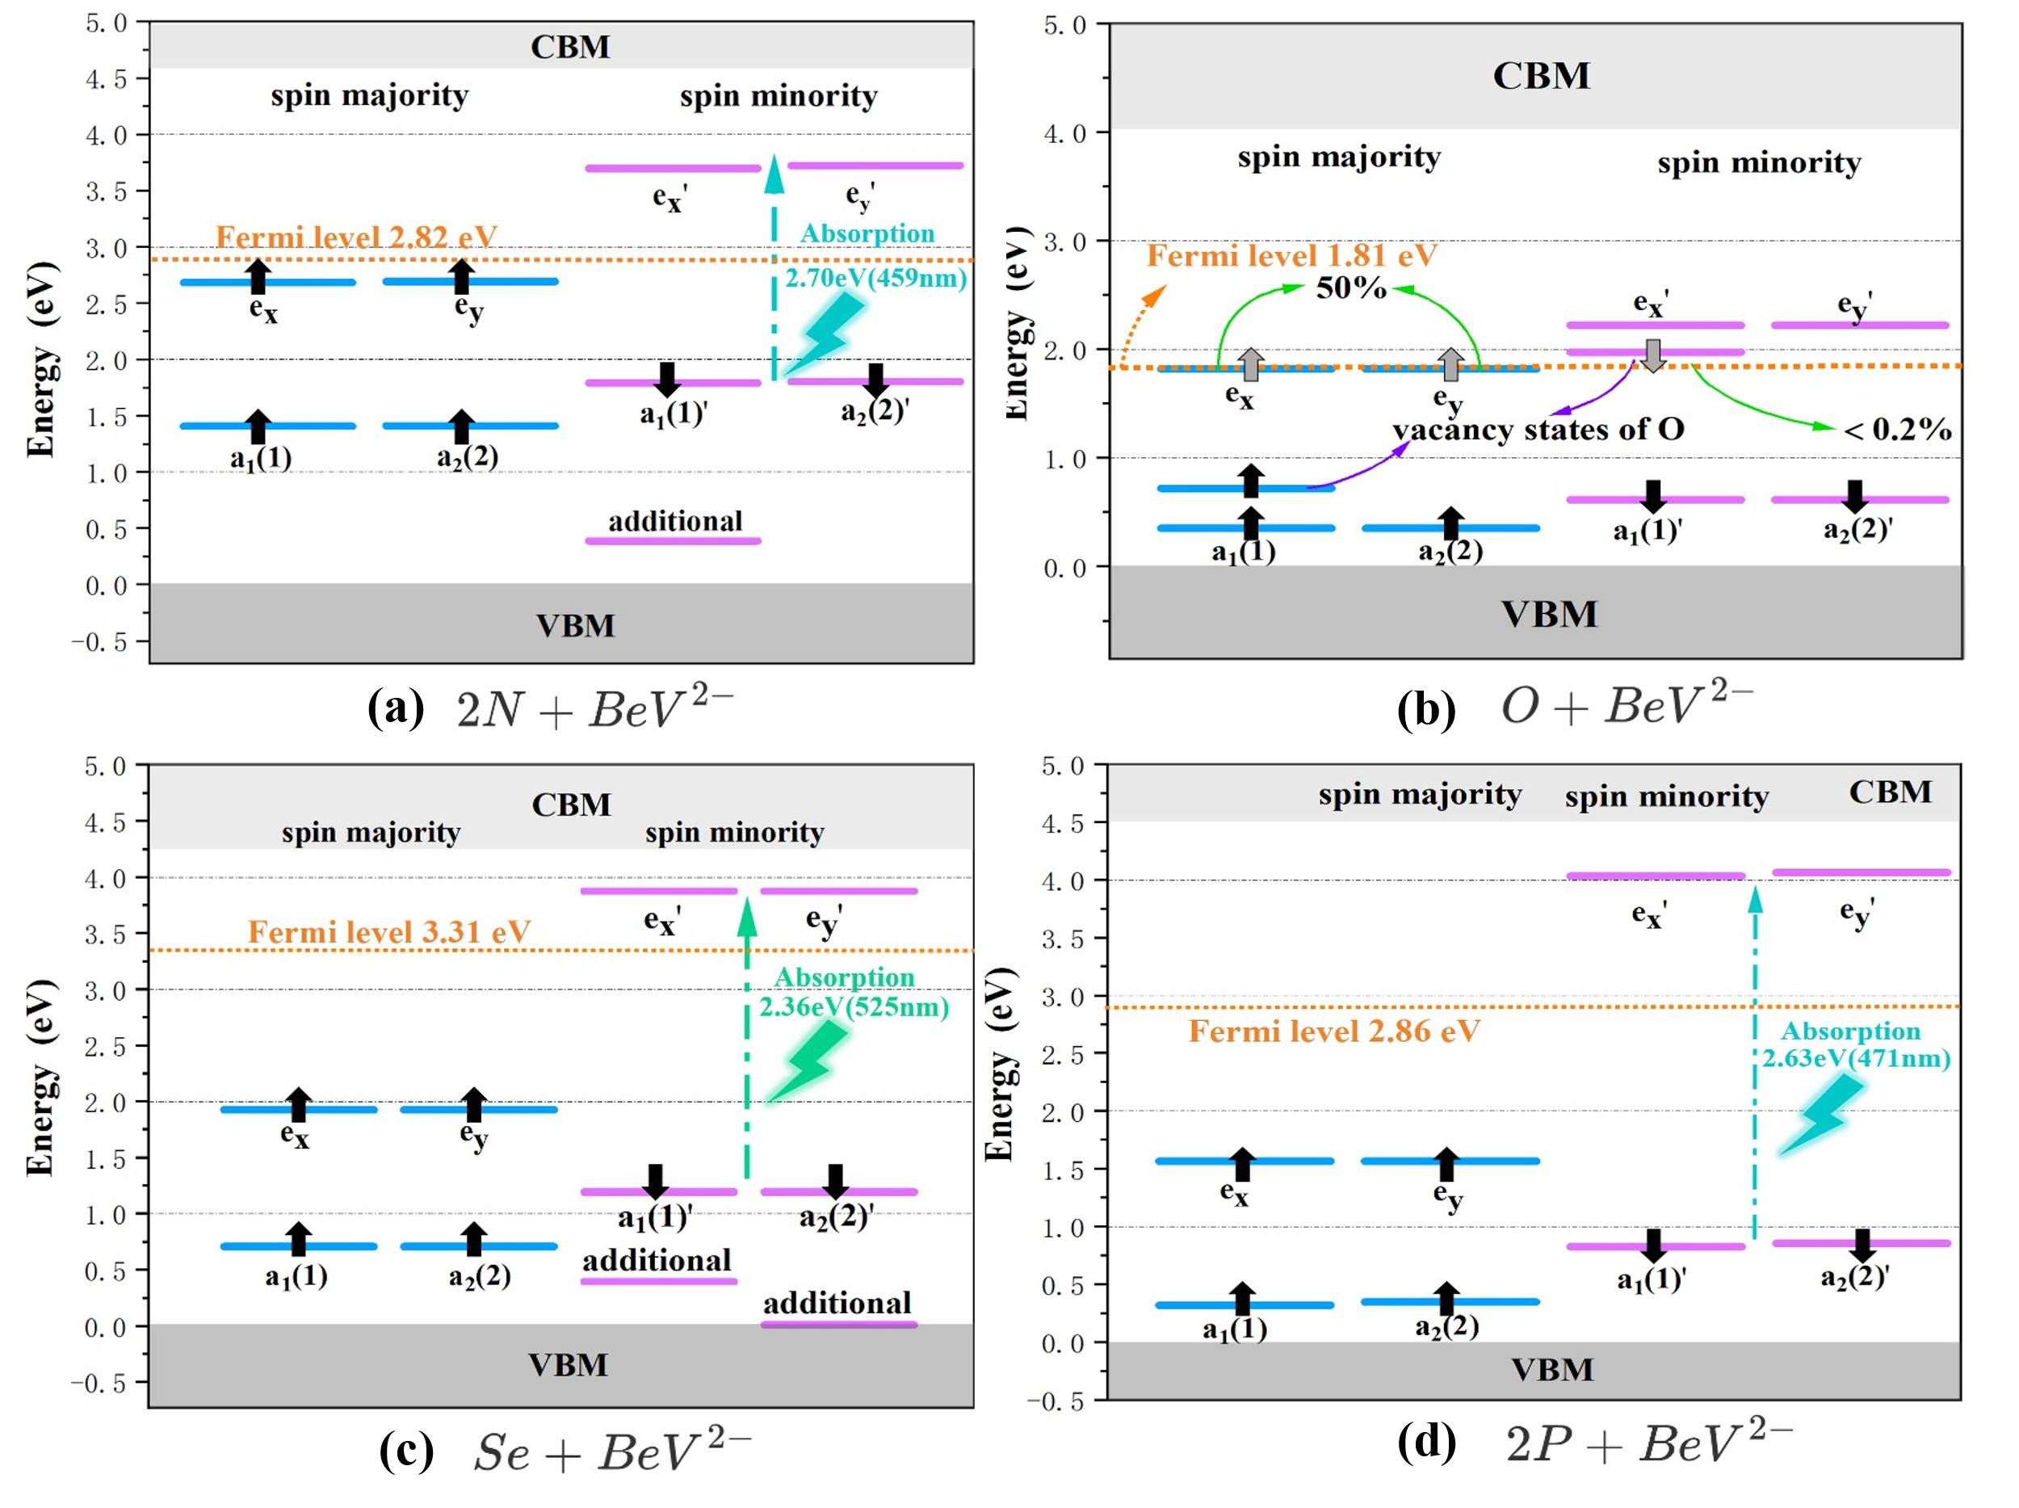
Fig. 6. Ground states energy level diagrams of beryllium vacancy centers with various electronic donors. (a) Two nitrogen donors. One additional state and ZPL drops 0.4 eV. (b) One oxygen donor. Fractional occupation of electron states occur in this situation. (c) One selenium donor. Two additional states exist and ZPL drops 0.33 eV. (d) Two phosphorus donors. No additional states and ZPL drops 0.35 eV.
It can be found that the ground triplet spin states exist in Se, P, and N doping systems. However, fractional electron state occupation occurs when oxygen and selenium atoms act as electron donors (Figure. 6(b)). This phenomenon may be attributed to the vacancy states of oxygen atoms, which interfer with the defect states positioned deep inside the host's bandgap. Moreover, we find a similar drop in the energy, about 0.35 eV, of the excited states of systems with Se, P, and N donors, as shown in the decline of ZPL in Table Ⅰ. This phenomenon may attribute to the centers not-far-enough distance between donors and vacancy, or the relatively low electronegativity of the beryllium atom, which can not attract the adjacent electron clouds firmly. Therefore, the donor’s volume and inner electrons may distort the electronic properties of BeV²⁻ even though it is introduced 10 Å away from the center. Meanwhile, the quantity of additional states is different with various electronic donors, because of the different electric disturbance caused by various electronic donors (see Section S3). This may result in slight differences among the values in BeV²⁻+Se, BeV²⁻+P, and BeV²⁻+N systems. Above all, introducing electron donors is not an easy method to add two electrons or lift Fermi levels. It requires more accurate ion implantation. Therefore, other methods like nin diamond conjection might be more appropriate to increase the Fermi energy.
Table Ⅰ. Optical transition energies for beryllium-vacancy center with different donors in diamonds calculated using the HSE06 and PBE functionals. All energies are given in electron volts (eV).
System | Method |  | ZPL |  | A to B | C to D | Strokes shift | Anti-Strokes shift
BeV²⁻ |  | PBE | 1.73 | 2.05 |  | 1.63 | 0.325 | 0.092
 |  | HSE06 | 2.15 | 2.68 |  | 1.51 | 0.531 | 0.641
BeV²⁻+Se |  | HSE06 | 1.82 | 2.36 |  | 1.41 | 0.539 | 0.401
BeV²⁻+P |  | HSE06 | 1.80 | 2.63 |  | 1.18 | 0.834 | 0.618
BeV²⁻+N |  | HSE06 | 1.75 | 2.70 |  | 1.10 | 0.947 | 0.651
NV⁻ |  | HSE06 | 1.96 | 2.21 |  | 1.74 | 0.258 | 0.217
 |  | Expt. | 1.95 | 2.18 |  | 1.76 | 0.235 | 0.185
  - Preparation methods and future experiments
This study does not prepare BeV²⁻, but the possible preparation methods for future experiments are discussed as follows. Chemical Vapor Deposition (CVD) and ion implantation are predominant techniques for preparing NV⁻ center [44–46]. For CVD method, the toxicity of beryllium and its compounds presents a challenge, as toxic residues can accumulate within the growth chamber, ultimately affecting the diamond film fabrication process. Ion implantation using beryllium ion implantation source [47] emerges as a more suitable approach for creating BeV²⁻ with greater control over the positioning of color centers. After ion implantation, vacancies can be increased through electron irradiation to form the BeV structure [48]. It is recommended to further increase the Fermi level by ion implantation of donors (N, P, or Se) or introducing nin diamond conjection, thereby promoting the formation of BeV²⁻. Then, this structure can be created through annealing, where vacancies may combine with beryllium atoms to form beryllium vacancy centers.

Conclusions
Our research reports BeV²⁻ $C_{3v}$ symmetry spin system in diamonds which satisfies color center criteria and can be a promising color center. Its formation energy and configuration-coordinate diagram suggest that BeV²⁻ center is stable with spin-triplet ground states when the Fermi level is above 2.72 eV. The Zero-Phonon Line (ZPL) of the beryllium vacancy center is at 2.15 eV, corresponding to 575 nm light in the visible spectrum. Furthermore, adding suitable electron donors can raise the Fermi level to stabilize the negative charge state and achieve the desired optical properties. Additional energy states will form variously when introducing different electronic donors. These states will not break the $C_{3v}$ symmetry but will slightly influence the exact electronic and optical properties.
High-quality BeV²⁻ centers can probably be prepared by ion implantation and applied in quantum information fields. As a promising candidate in nanoscale quantum sensors, it shows potential in a wide range of applications, such as the microscopic detection of irregularities in materials and high-precision measurements of biomarkers in biological physics. It is believed that these results can eventually pave the way for the further experimental explorations for the identification and comprehension of the BeV center in diamond and also its possible applications in high-resolution quantum sensing.

Acknowledgements

Appendix A. Supplementary data
Supplementary data to this article can be found online.

References
[1] S. Gao, Z.-N. Tian, P. Yu, H.-Y. Sun, H. Fan, Q.-D. Chen, H.-B. Sun, Deep diamond single-photon sources prepared by a femtosecond laser, Optics Letters 46 (2021) 4386–4389.
[2] D.Y. Fedyanin, Optoelectronics of Color Centers in Diamond and Silicon Carbide: From Single-Photon Luminescence to Electrically Controlled Spin Qubits, Advanced Quantum Technologies 4 (2021) 2100048.
[3] I. Khramtsov, M. Agio, D.Y. Fedyanin, Electrical excitation of color centers in diamond: Toward practical single-photon sources, in: AIP Conference Proceedings, AIP Publishing, 2021.
[4] C. Li, R. Soleyman, M. Kohandel, P. Cappellaro, SARS-CoV-2 quantum sensor based on nitrogen-vacancy centers in diamond, Nano Letters 22 (2021) 43–49.
[5] P. Rembold, N. Oshnik, M.M. Müller, S. Montangero, T. Calarco, E. Neu, Introduction to quantum optimal control for quantum sensing with nitrogen-vacancy centers in diamond, AVS Quantum Science 2 (2020).
[6] T. Zhang, G. Pramanik, K. Zhang, M. Gulka, L. Wang, J. Jing, F. Xu, Z. Li, Q. Wei, P. Cigler, others, Toward quantitative bio-sensing with nitrogen–vacancy center in diamond, ACS Sensors 6 (2021) 2077–2107.
[7] N. Savage, Quantum diamond sensors, Nature 591 (2021) S37.
[8] E. Moreva, E. Bernardi, P. Traina, A. Sosso, S.D. Tchernij, J. Forneris, F. Picollo, G. Brida, Ž. Pastuović, I. Degiovanni, others, Practical applications of quantum sensing: A simple method to enhance the sensitivity of nitrogen-vacancy-based temperature sensors, Physical Review Applied 13 (2020) 054057.
[9] J. Zhang, S.S. Hegde, D. Suter, Efficient implementation of a quantum algorithm in a single nitrogen-vacancy center of diamond, Physical Review Letters 125 (2020) 030501.
[10] Y.-C. Liu, Y.-C. Dzeng, C.-C. Ting, Nitrogen vacancy-centered diamond qubit: The fabrication, design, and application in quantum computing, IEEE Nanotechnology Magazine 16 (2022) 37–43.
[11] S. Pezzagna, J. Meijer, Quantum computer based on color centers in diamond, Applied Physics Reviews 8 (2021).
[12] K. Khazen, H.J. von Bardeleben, NV-centers in SiC: A solution for quantum computing technology?, Frontiers in Quantum Science and Technology 2 (2023) 1115039.
[13] G. Balasubramanian, P. Neumann, D. Twitchen, M. Markham, R. Kolesov, N. Mizuochi, J. Isoya, J. Achard, J. Beck, J. Tissler, others, Ultralong spin coherence time in isotopically engineered diamond, Nature Materials 8 (2009) 383–387.
[14] F. Jelezko, T. Gaebel, I. Popa, M. Domhan, A. Gruber, J. Wrachtrup, Observation of Coherent Oscillation of a Single Nuclear Spin and Realization<? format?> of a Two-Qubit Conditional Quantum Gate, Physical Review Letters 93 (2004) 130501.
[15] F. Jelezko, I. Popa, A. Gruber, C. Tietz, J. Wrachtrup, A. Nizovtsev, S. Kilin, Single spin states in a defect center resolved by optical spectroscopy, Applied Physics Letters 81 (2002) 2160–2162.
[16] F. Jelezko, J. Wrachtrup, Read-out of single spins by optical spectroscopy, Journal of Physics: Condensed Matter 16 (2004) R1089.
[17] J. Weber, W. Koehl, J. Varley, A. Janotti, B. Buckley, C. Van de Walle, D.D. Awschalom, Quantum computing with defects, Proceedings of the National Academy of Sciences 107 (2010) 8513–8518.
[18] A. Sipahigil, K.D. Jahnke, L.J. Rogers, T. Teraji, J. Isoya, A.S. Zibrov, F. Jelezko, M.D. Lukin, Indistinguishable photons from separated silicon-vacancy centers in diamond, Physical Review Letters 113 (2014) 113602.
[19] T. Iwasaki, Y. Miyamoto, T. Taniguchi, P. Siyushev, M.H. Metsch, F. Jelezko, M. Hatano, Tin-vacancy quantum emitters in diamond, Physical Review Letters 119 (2017) 253601.
[20] E.A. Ekimov, S.G. Lyapin, M.V. Kondrin, Tin-vacancy color centers in micro- and polycrystalline diamonds synthesized at high pressures, Diamond and Related Materials 87 (2018) 223–227. https://doi.org/10.1016/j.diamond.2018.06.014.
[21] S. Lagomarsino, A.M. Flatae, S. Sciortino, F. Gorelli, M. Santoro, F. Tantussi, F.D. Angelis, N. Gelli, F. Taccetti, L. Giuntini, M. Agio, Optical properties of silicon-vacancy color centers in diamond created by ion implantation and post-annealing, Diamond and Related Materials 84 (2018) 196–203. https://doi.org/10.1016/j.diamond.2018.03.010.
[22] J. Goss, P. Briddon, M. Rayson, S. Sque, R. Jones, Vacancy-impurity complexes and limitations for implantation doping of diamond, Physical Review B—Condensed Matter and Materials Physics 72 (2005) 035214.
[23] G. Thiering, A. Gali, Characterization of oxygen defects in diamond by means of density functional theory calculations, Physical Review B 94 (2016) 125202.
[24] Y. Zhang, Z. Tang, X. Zhao, G. Cheng, Y. Tu, W. Cong, W. Peng, Z. Zhu, J. Chu, A neutral oxygen-vacancy center in diamond: A plausible qubit candidate and its spintronic and electronic properties, Applied Physics Letters 105 (2014).
[25] T. Umeda, K. Watanabe, H. Hara, H. Sumiya, S. Onoda, A. Uedono, I. Chuprina, P. Siyushev, F. Jelezko, J. Wrachtrup, others, Negatively charged boron vacancy center in diamond, Physical Review B 105 (2022) 165201.
[26] M. Muruganathan, H. Mizuta, Boron vacancy color center in diamond: Ab initio study, Diamond and Related Materials 114 (2021) 108341.
[27] A. Kunisaki, M. Muruganathan, H. Mizuta, T. Kodera, First-principles calculation of a negatively charged boron-vacancy center in diamond, Japanese Journal of Applied Physics 56 (2017) 04CK02.
[28] J.P. Perdew, K. Burke, M. Ernzerhof, Generalized gradient approximation made simple, Physical Review Letters 77 (1996) 3865.
[29] L.S. Pan, D.R. Kania, Diamond: electronic properties and applications, Springer Science & Business Media, 2013.
[30] C. Freysoldt, J. Neugebauer, C.G. Van de Walle, Fully ab initio finite-size corrections for charged-defect supercell calculations, Physical Review Letters 102 (2009) 016402.
[31] T. Mattila, A. Zunger, Deep electronic gap levels induced by isovalent P and As impurities in GaN, Physical Review B 58 (1998) 1367.
[32] I. Harris, C.J. Ciccarino, J. Flick, D.R. Englund, P. Narang, Group-III quantum defects in diamond are stable spin-1 color centers, Physical Review B 102 (2020) 195206.
[33] I.B. Bersuker, V.Z. Polinger, Vibronic interactions in molecules and crystals, Springer Science & Business Media, 2012.
[34] T.A. Abtew, W. Gao, X. Gao, Y. Sun, S. Zhang, P. Zhang, Theory of oxygen-boron vacancy defect in cubic boron nitride: a Diamond NV-Isoelectronic Center, Physical Review Letters 113 (2014) 136401.
[35] J. Wrachtrup, S.Y. Kilin, A. Nizovtsev, Quantum computation using the 13 C nuclear spins near the single NV defect center in diamond, Optics and Spectroscopy 91 (2001) 429–437.
[36] A. Watanabe, T. Nishikawa, H. Kato, M. Fujie, M. Fujiwara, T. Makino, S. Yamasaki, E.D. Herbschleb, N. Mizuochi, Shallow NV centers augmented by exploiting n-type diamond, Carbon 178 (2021) 294–300. https://doi.org/10.1016/j.carbon.2021.03.010.
[37] T. Kageura, Y. Sasama, C. Shinei, T. Teraji, K. Yamada, S. Onoda, Y. Takahide, Charge stability of shallow single nitrogen-vacancy centers in lightly boron-doped diamond, Carbon 192 (2022) 473–481. https://doi.org/10.1016/j.carbon.2022.01.027.
[38] A.M. Flatae, S. Lagomarsino, F. Sledz, N. Soltani, S.S. Nicley, K. Haenen, R. Rechenberg, M.F. Becker, S. Sciortino, N. Gelli, L. Giuntini, F. Taccetti, M. Agio, Silicon-vacancy color centers in phosphorus-doped diamond, Diamond and Related Materials 105 (2020) 107797. https://doi.org/10.1016/j.diamond.2020.107797.
[39] T. Murai, T. Makino, H. Kato, M. Shimizu, T. Murooka, E. Herbschleb, H. Morishita, M. Fujiwara, M. Hatano, S. Yamasaki, others, Engineering of Fermi level by nin diamond junction for control of charge states of NV centers, Applied Physics Letters 112 (2018).
[40] K. Ohno, F. Joseph Heremans, L.C. Bassett, B.A. Myers, D.M. Toyli, A.C. Bleszynski Jayich, C.J. Palmstrøm, D.D. Awschalom, Engineering shallow spins in diamond with nitrogen delta-doping, Applied Physics Letters 101 (2012).
[41] J. Geng, T. Shalomayeva, M. Gryzlova, A. Mukherjee, S. Santonocito, D. Dzhavadzade, D.B.R. Dasari, H. Kato, R. Stöhr, A. Denisenko, others, Dopant-assisted stabilization of negatively charged single nitrogen-vacancy centers in phosphorus-doped diamond at low temperatures, Npj Quantum Information 9 (2023) 110.
[42] D. Zou, S. Shen, L. Li, Q. Wang, K. Liang, L. Chen, G. Wu, W. Shen, Influence of phosphorus donor on the NV center in diamond: A first-principles study, Physica B: Condensed Matter 676 (2024) 415614. https://doi.org/10.1016/j.physb.2023.415614.
[43] R. Löfgren, R. Pawar, S. Öberg, J.A. Larsson, Charged dopants in neutral supercells through substitutional donor (acceptor): nitrogen donor charging of the nitrogen-vacancy center in diamond, New Journal of Physics 20 (2018) 023002.
[44] E. Janitz, K. Herb, L.A. Völker, W.S. Huxter, C.L. Degen, J.M. Abendroth, Diamond surface engineering for molecular sensing with nitrogen—vacancy centers, Journal of Materials Chemistry C 10 (2022) 13533–13569.
[45] T. Luo, L. Lindner, J. Langer, V. Cimalla, X. Vidal, F. Hahl, C. Schreyvogel, S. Onoda, S. Ishii, T. Ohshima, others, Creation of nitrogen-vacancy centers in chemical vapor deposition diamond for sensing applications, New Journal of Physics 24 (2022) 033030.
[46] G. Wu, Q. Wang, Y. Wu, X. Sun, J. Liao, J. Pan, M. Chen, M. Kasu, S. Liu, Evolution of defects, morphologies and fundamental growth characteristics of CVD diamond films induced by nitrogen addition, Materials Today Communications 25 (2020) 101504.
[47] J. Chen, Y. Peng, X. Zhang, W. Wei, S. Zhong, K. He, L. Wang, J. Zhang, Z. Chen, W. Sun, Long time aging effect on Be-implanted GaN epitaxial layer, AIP Advances 9 (2019).
[48] M. Capelli, A.H. Heffernan, T. Ohshima, H. Abe, J. Jeske, A. Hope, A.D. Greentree, P. Reineck, B.C. Gibson, Increased nitrogen-vacancy centre creation yield in diamond through electron beam irradiation at high temperature, Carbon 143 (2019) 714–719. https://doi.org/10.1016/j.carbon.2018.11.051.

