Elucidating the improved properties of Defect Engineered Lanthanum-Doped Nickel Oxide as Hole-Transport Layer in Triple-Cation Perovskite Solar Cells
Vishnuvardhan Reddy Chappidi^{1,2}, Sudhanshu Kumar Nayak², Md. Emrul Kayesh¹, Md. Abdul Karim¹, Yulu He¹, Ashraful Islam^{1*}, Sai Santosh Kumar Raavi^{2,3 *}
¹Photovoltaic Materials Group, Center for Green Research on Energy and Environmental Materials, National Institute for Materials Science (NIMS), 1-2-1 Sengen, Tsukuba, Ibaraki 305-0047, Japan
²Ultrafast Photophysics and Photonics Laboratory, Department of Physics, Indian Institute of Technology Hyderabad, Kandi 502285, Telangana, India
³Department of Climate Change, Indian Institute of Technology Hyderabad, Kandi 502285, Telangana, India
* Corresponding author: ISLAM.Ashraful@nims.go.jp, sskraavi@phy.iith.ac.in
Abstract
Charge recombination at the interface between the hole transport layer (HTL) and perovskite (PVK) has been a performance bottleneck for perovskite solar cells (PSCs). We present a detailed examination for the solar cell efficiency of the device using lanthanum (La)-doped nickel oxide (NiO_{x}) as an HTL. The NiO_{x} and La-doped NiO_{x} films were prepared using the spray pyrolysis process. We employed low-temperature photoluminescence (LT-PL) to estimate the defect activation energy and utilized SCAPS 1D software to simulate the interface defect density. According to the data obtained, the interface between La: NiO_{x} and PVK shows a lower activation energy for defects, indicating that it is more advantageous for charge transfer compared to the interface between NiO_{x} and PVK. Utilizing SCAPS simulations the experimental $JV$ curves closely match the simulated $JV$ curves obtained from SCAPS simulations. These simulations were performed using optimal parameters, which involved increasing the R_{sh} values and reducing the interface density in La:NiO_{x} based PSCs. The interface defect densities are estimated to be La:NiO_{x}/PVK and NiO_{x}/PVK interfaces are 1×10¹² cm⁻² and 1.7×10¹² cm⁻², respectively. This indicates ≈ 70 % reduction in defect density at the La:NiO_{x}/PVK interface compared to the NiO_{x}/PVK interface. The conductivity values obtained from linear sweep voltammetry (LSV) are 1.01×10⁻³ S cm⁻¹ for NiO_{x} films and 1.21×10⁻³ S cm⁻¹ for La: NiO_{x} films. This indicates a significant enhancement of ≈ 20 % in the conductivity of La: NiO_{x} films compared to undoped films. This leads to improvements in V_{OC} and ultimately enhances the PCE. The calculating defect density at the HTL/PVK interface can contribute to the fabrication of futuristic highly efficient PSCs.

Keywords: Halide Perovskite Solar Cells, NiO_{x}, SCAPS, Hole-transport material, Recombination, Photoluminescence.

1. Introduction
In recent years, PSCs have gained popularity due to their rapidly increasing power conversion efficiency (PCE), ranging from 3.8% to 25.7% [1, 2]. The perovskite absorber layer enables the PSCs to have broadband absorption, high carrier mobility, long carrier diffusion length, ambipolar transport characteristics, low electron-hole recombination rate, as well as a cost-effective and simple solution processing method [3-5]. Many of the most efficient perovskites are based on the standard n-i-p structure, but they are prone to instability and hysteresis. As an alternative to conventional devices, the p-i-n structure inverted planar solar cells (IPSCs) gained popularity due to their ease of manufacture, low hysteresis, and excellent environmental stability [6, 7]. In IPSCs, the HTLs are considered to be an important component for achieving high-performance PCE. Organic hole transport materials like, PEDOT:PSS, PTAA has been used widely in IPSCs [8, 9]. However, they faced instability and high costs, despite having the highest PCE. For alternative low expensive, Inorganic materials have been used as an HTL in IPSCs, such as CuSCN [10], CuI [11], Cu₂O [12], NiO_{x} [13], and V₂O₅ [14]. Among them, NiO_{x} has a wide bandgap greater transmission, natural stability, and good energy level alignment. However, the inherent low electrical conductivity of NiO_{x} contributes to increased recombination rates and hinders extraction of holes, ultimately leading to a decline in the V_{OC} [15]. It is well known that large ionization energy of Ni vacancies limits hole density in NiO_{x} [16]. To improve further electrical conductivity, researchers explore the methods of surface modification, plasma treatment, and doping [17-19]. Among these methods, doping is extensively employed to enhance the electrical and optical characteristics of NiO_{x}. Among various dopants, rare earth (RE) ions have rich energy level structure with empty 5d orbitals and partially filled 4f orbitals that help to improve the free charge carrier in the host atom [13, 20, 21].
The triple cation (TC) perovskites offer several advantages over single cation perovskites in solar cell applications, including better charge transport, tunable bandgap, improved stability, and higher PCE [22, 23]. In this study, we focused on the optimized triple cation perovskite (TC-PVK) composition as reported in the literature [24]. Here, we discuss several reports on TC-PVK based devices utilizing NiO as the HTL. According to Yang et al., a 3% potassium (K) doped NiO_{x}, synthesized using the sol-gel process, achieved a device configuration of FTO/K: NiO_{x}/TC-PVK/TBABF4+PCBM/TIPD/Ag with a notable 17.05% PCE [25]. Boyd et al. reported on a device architecture consisting of glass/ITO/NiO_{x}/TC-PVK/LiF/C60/bathocuproine (BCP)/Ag, utilizing various molar excesses of A-site in the perovskite. The leading device, incorporating 3 mol% excess FAI, demonstrated a superior PCE of 19.66% compared to other compositions [26]. Li et al. introduced a bilayer of NiO_{x}/2BrPXZPA. The device configuration ITO/HTL/TC-PVK/spiro-OMeTAD/Au achieved a notable PCE of 23.66%, surpassing the efficiency of NiO-based devices [27]. In this paper, our primary focus is not on enhancing device efficiency but rather on exploring the recombination mechanism occurring at the interface between the HTL and PVK. The novelty of this study lies in its methodology for investigating recombination at the interface between the HTL and PVK by determining defect activation energy through LT-PL, while also estimating interface defect density through SCAPS 1D simulation.
Recombination is the main concern due to a mismatch of energy level at the interface of electron transport layer (ETL): HTL/PVK, the presence of defects at the interface, and intrinsic defect present in PVK, collectively leading to recombination events that diminish device performance [28, 29]. Notably, radiative recombination involves the interaction between free electrons and free holes, although this form of recombination remains relatively feeble in PSCs [30]. Conversely, non-radiative recombination critically hampers the open-circuit voltage (V_{OC}) occurring as electrons recombine with a holes defect or impurity sites [31]. Improving V_{OC} can be achieved through techniques such as regulating the crystallinity of PVK, optimizing interface engineering and passivation of defect layers [32-34]. Stolterfoh et al. explored recombination losses loss in triple cation ((CsPbI₃)_{0.05}((FAPbI₃)_{0.83}(MAPbBr₃)_{0.17})_{0.95}) and CH₃NH₃PbI₃ (MAPbI₃) utilized photoluminescence measurements to reveal MAPbI₃ exhibited a smaller quasi-fermi level splitting and greater non-radiative losses compared to the triple cation perovskite, resulting reduction in V_{OC} of the device [35]. Employing a combination of time resolved photoluminescence (TrPL), transient absorption spectroscopy, Laquai et al. provided insights into recombination analysis in NiO_{x}:PTAA/MAPbI₃ film and found that PTAA/MAPbI₃ film exhibited a shorter lifetime and reduced non-radiative recombination in comparison to the NiO_{x}/MAPbI₃ film, leading to an enhanced PCE in PTAA based devices [36]. Gloeckler etc.al, explained defect analysis in Cadmium Telluride (CdTe) photovoltaic solar cells (SCs) using defect activation calculated from LT-PL [37]. This paper extensively explore the recombination analysis at the NiO_{x}/PVK and La:NiO_{x}/PVK interface, employing the concepts discussed above.
In the present work, we employed the spray pyrolysis technique to fabricate NiO_{x} and La:NiO_{x} HTLs for the efficient IPSCs. We systematically examined both the structural and optical properties of these HTLs. Incorporating La: NiO_{x} as HTL led to improved charge conductivity and diminished recombination at the interface of HTL/PVK, resulting to notable improvement in PCE as compared to NiO_{x} based IPSC. Additionally, we have performed recombination analysis at the HTL/PVK interface using LT-PL and SCAPS 1D simulation. This remarkable improvement underscores the potential of the La:NiO_{x} film as a highly promising candidate for effective IPSC development.
2. Experimental and Simulation details:
2.1. Materials:
All the reagents used for synthesizing the (La)-doped nickel oxide (NiO_{x}) and triple cation perovskite Cs_{0.08}(MA_{0.17}FA_{0.83})_{0.92}Pb(I_{0.83}Br_{0.17})₃ were purchased from Sigma-Aldrich, Wako Co., Japan, and Tokyo Chemical Industry Co., Japan. All details of chemicals are provided in supporting information (SI).
2.2. Device fabrication:
Initially, the ITO/glass substrates were cleaned in an ultrasonic bath for 20 minutes using soap solution, deionized H₂O, ethanol, and isopropanol. After drying the cleaned substrate with N₂, UV ozone irradiation was performed for 30 minutes to eliminate the organic residue left on it. The NiO_{x}/La:NiO_{x} films were prepared by spray pyrolysis method. The solution contains 0.1mM Ni(NO₃)₂·6H₂O, La(NO₃)₂·6H₂O molar ratios (1%, 3%, 5%) [13] in 1ml of ethanol was sprayed on clean FTO substrates at 570⁰C. The precursor solution was formulated by dissolving PbI₂, (1.1 M), PbBr₂ (0.2 M), FAI (1 M), and MABr (0.2 M) in a solvent mixture of DMF and DMSO in a 1:4 (v: v). In a subsequent step, a separate solution containing CsI (1.5 M) in DMSO was prepared and subsequently mixed with the first solution to achieve the desired Cs content of 8%. The solution was stirred for 1 h at 40 ⁰C and filtered by a 0.45-μm PTFE syringe filter. The precursor solution was applied onto the ITO/ NiO_{x} or La: NiO_{x} substrates using spin-coating at 1000 rpm for 10 s, followed by 5000 rpm for 20 s. At 27 seconds, 300 μL of CB was deposited onto the spinning substrate. The substrates were subsequently subjected to annealing at 150°C for a duration of 10 minutes. After that, PCBM (20 mg mL−1 in CB) and BCP (0.5 mg mL−1 in methanol) were spin-coated with speeds of 1000 rpm for 30 s and 6000 rpm for 30, respectively. These substrates were annealed at 60 °C for 10 min in each step. Finally, the 80 nm thickness of the Ag electrode was thermally evaporated in a vacuum chamber (base pressure < 9×10⁻⁴ Pa) through a shadow mask.
2.3. Characterization:
The optical absorption spectra were measured by a Shimadzu UV/Vis 3600 spectrophotometer. The conductivity of the films was measured using linear sweep voltammetry (LSV) with a three-electrode setup. The working electrode was the NiO_{x} and La:NiO_{x} films, the reference electrode was Ag/AgCl, and the counter electrode was a platinum electrode. The electrolyte solution used was 0.1M KCl. The measurements were conducted using an Autolab PGSTAT 302N equipped with a frequency analyzer and NOVA 1.11 software. Photoelectron emission spectroscopy (PES) was measured with a Rikaken Keiki AC-3 spectrometer. The current-voltage (J-V) curves were obtained using a solar simulator (WXS-155S-10, Wacom Denso Co., Japan) with standard air mass 1.5 sunlight conditions (100 mWcm⁻²). PL and TrPL were measured by FLS 1000 photoluminescence spectrometer, Edinburgh instrument. XPS was recorded by AXIS SUPRA.
2.4. Simulation details:
The solar cell is composed of FTO, active material, HTL, and electrode in the manner of glass/FTO/NiO_{x}::La:NiO_{x}/Cs_{0.08}(MA_{0.17}FA_{0.83})_{0.92}Pb(I_{0.83}Br_{0.17})₃/PCBM/BCP/Ag. In this study SCAPS-1D software was employed to evaluate the efficiency of the perovskite solar cell [38]. In order to simulate the structure, the following equations are required
Poisson equation:
$$-\frac{∂}{∂x}\left(-ε\left(x\right)\frac{∂V}{∂x}\right)=q\left[ p\left(x\right)-n\left(x\right)+N_{D}^{+}\left(x\right)-N_{A}^{-}\left(x\right)+p_{t}\left(x\right)-n_{t}\left(x\right)\right]$$
Continuity equation for the hole:
$$\frac{∂p}{∂t}=\frac{1}{q}\frac{∂J_{P}}{∂x}+G_{P}-R_{P}$$
Continuity equation for the electron:
$$\frac{∂n}{∂t}=\frac{1}{q}\frac{∂J_{n}}{∂x}+G_{n}-R_{n}$$
Where $q$ is the charge, $ε$ is the dielectric permittivity, $V$ is the potential, $p\left(x\right)$ is the concentration of free holes, $n\left(x\right)$ is the concentration of free electrons, $N_{D}^{+}\left(x\right)$ is the ionized donor concentration, $N_{A}^{-}\left(x\right)$ is the ionized acceptor concentration, $n_{t}\left(x\right),$ and$p_{t}\left(x\right)$ are the trap density of electron and hole, respectively, $J_{n}$ and $J_{P}$ are the electron and hole current densities $G_{n}$ is the rate of electron generation, $G_{P}$ is the rate of hole generation, and $R_{n}$ and $R_{P}$ are the rates of electron and hole recombination, respectively.
The parameters for NiO_{x}, PVK, and PCBM are sourced from literature [39] [40-42]. The work function values for FTO and the back contact (Ag) were set at 4.9 eV and 4.71 eV, respectively. The bandgap energies (E_{g}) of NiO_{x} and La:NiO_{x} are determined using Tauc plots, as illustrated in Fig. S1(d), yielding values of 3.49 eV and 3.53 eV, respectively. The valance band minmum (VBM) for NiO_{x} and La:NiO_{x} are calculated from photoelectron emission spectroscopy (PES), resulting in VBM values of 5.37 eV and 5.41 eV, respectively, as shown in Fig. S2(a-b). The electron affinity values for NiO_{x} and La:NiO_{x} are estimated from calculations based on the VBM and band gap values, yielding values of 1.88 eV and 1.89 eV, respectively. We assumed electron and hole mobilities in La: NiO_{x} to be 13 cm²/vs and 2.9 cm²/vs, respectively. Additionally, we assumed the acceptor density in La:NiO_{x} to be 3×10¹⁸ cm⁻³, considering the general trend of increased doping density after doping. The valence band of effective density states in the La:NiO_{x} film were assumed to be 8.1×10²⁰ cm³. Absorption coefficients in both films were calculated using the relationship $α(E)=A_{α}\sqrt{(h_{ν}-E_{g})}$, with $A_{α}$ set to 10⁵ cm⁻¹ eV^{-0.5}. For defect densities, we assumed a value of 1×10¹⁴ eV for NiO_{x} and La: NiO_{x}. Series resistance (R_{s}) values for NiO_{x} and La:NiO_{x} were assumed to be 3.2 Ω.cm². and 3.2 Ω.cm², respectively, while shunt resistance (R_{sh}) values for NiO_{x} and La:NiO_{x} were also assumed to be 1700 Ω.cm² eV and 2800 Ω.cm², respectively. We assumed the remaining parameter values for La:NiO_{x} to be consistent with those of NiO_{x}. Simulations were conducted using parameters provided in Tables 1 and 2. The outcome of J-V curves showed better agreement with experimental J-V curves, as depicted in Fig. 5(b), providing valid evidence of the accuracy of our simulations.

3. Results and discussion
Intially, we optimized doping percentange of La (3%) by JV curves as shown in Fig. S1. In order to explore the effect of La (3%) doping on structural and optical properties of NiO_{x}, we have performed the XRD measurement to observe the effect of La doping on the phase and the crystal structure of the material. The XRD patterns of NiO_{x} and La:NiO_{x} films deposited on FTO are shown in Fig. 1(a). The Diffracted peaks associated with NiO_{x} were identified at positions 2θ of 37.27°, 62.9°, and 79.3°, attributed to the (111), (220), and (222) crystallographic planes, respectively. These peaks align with the cubic phase of NiO_{x} (indexed as JCPDS 47-1049) [43]. The peaks corresponding to FTO were recognized at 2θ values of 33.9°, 51.7°, 54.84°, and 65.7°, assigned to the (101), (211), (220), and (301) planes, respectively. These peaks concord with the tetragonal structure of SnO₂ indexed as JCPDS 41-1445) [44]. The XRD pattern of the La-doped NiO_{x} film demonstrated similarity to the NiO_{x} film pattern, with no additional peaks related to impurities or phases of RE₂O₃ being observed.
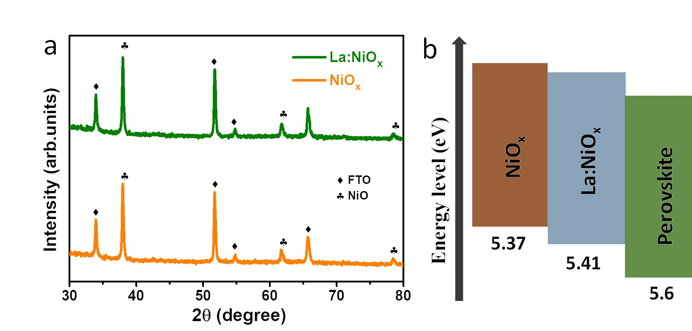
Fig. 1. (a) XRD pattern of NiO_{x} and La doped NiO_{x.}, (b) energy diagram of perovskite, NiO_{x} and La: NiO_{x}.

X-ray photoelectron spectroscopy (XPS) was employed to examine the chemical compositions and oxidation states of La:NiO_{x} and NiO_{x} films. Fig. 2 illustrates the core-level of XPS spectra of Ni 2p and O 1s of NiO_{x}, and La:NiO_{x} films. The XPS spectra of Ni 2p for both films exhibited a split into 2p_{1/2} and 2p_{3/2} components due to spin orbit coupling [45]. The peaks (2p_{3/2}) peaks were identified at energy levels of 851.13/853.07 eV and 850.94/852.80 eV corresponding to Ni²⁺ and Ni³⁺states, respectively, along with shakeup-satellite peaks at 858.19 and 858.12 eV respectively, as shown in Fig. 2(a-b). The peak corresponding to Ni²⁺ is attributed to the Ni-O octahedral bonding present in cubic NiO, while the Ni³⁺ peak induced by Ni vacancy in Ni₂O₃ and presence of NiOOH [46, 47].
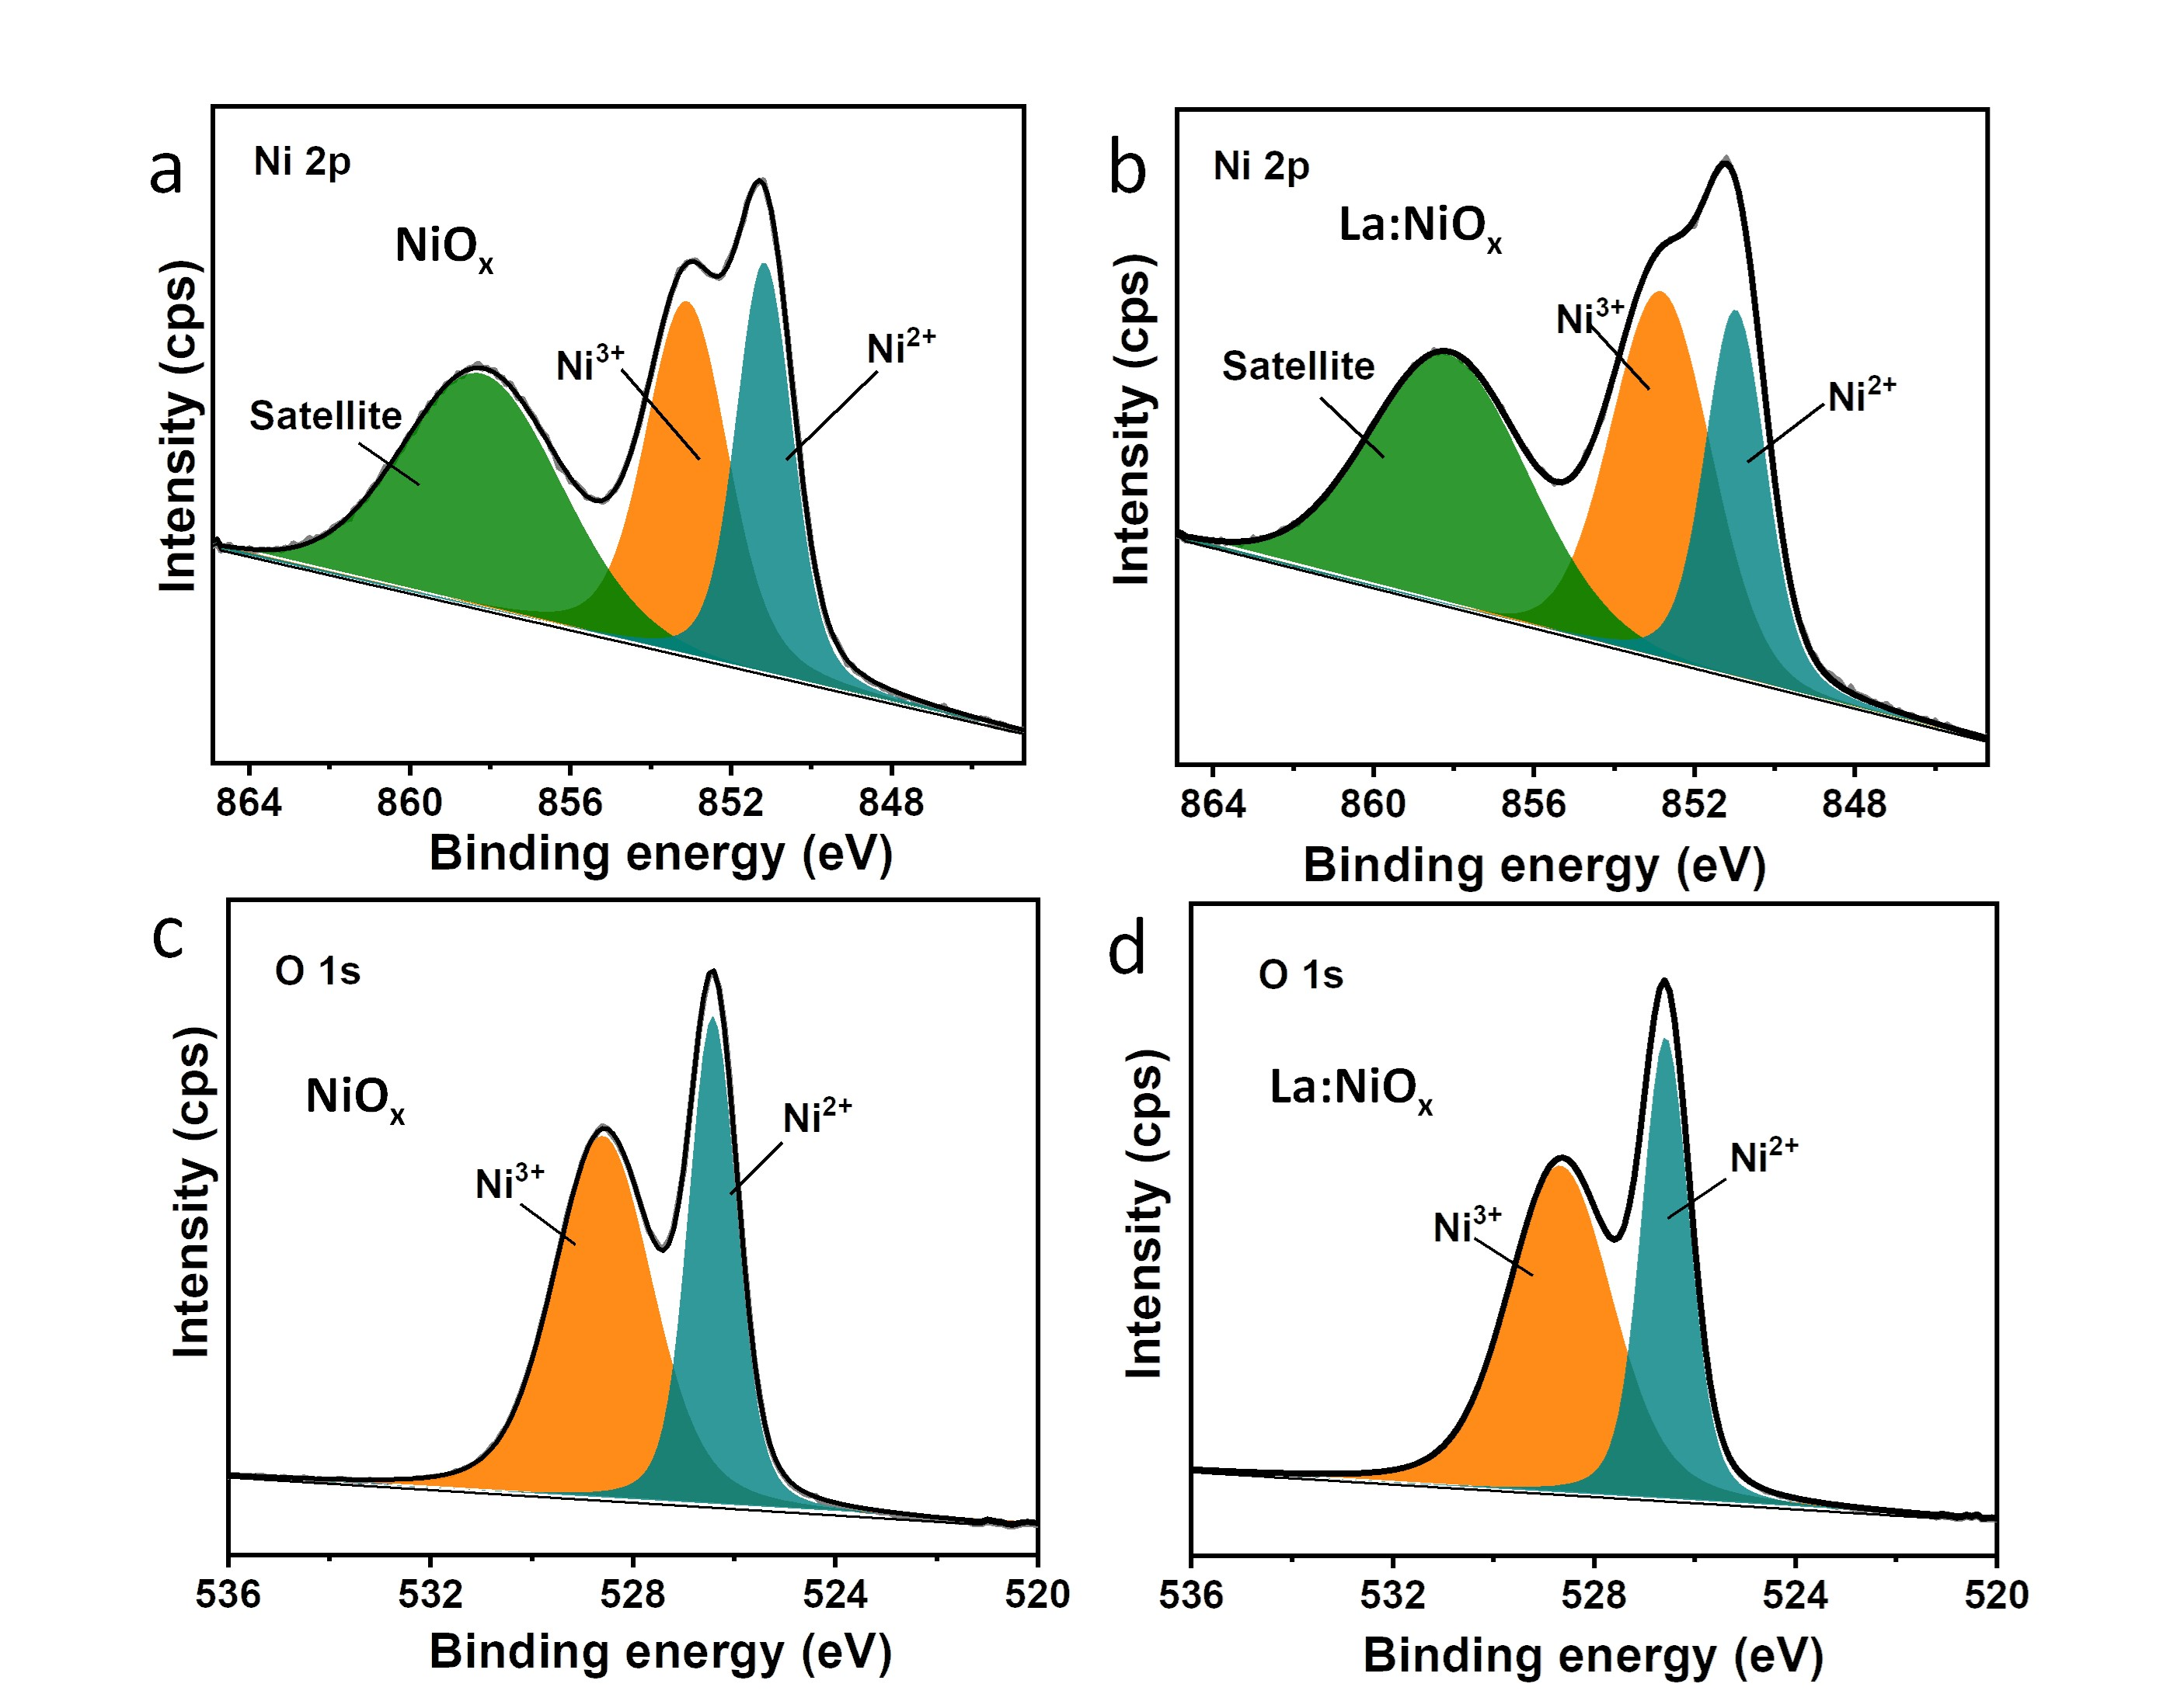
Fig. 2. The core-level of XPS spectra of Ni 2p (a) NiO_{x}, (b) La: NiO_{x} films and O 1s of (c) NiO_{x}, (d) La: NiO_{x} films.
Moreover, the calculated ratio of Ni³⁺/Ni²⁺ were estimated as 1.5 and 1.2 for La:NiO_{x} and NiO_{x} films, respectively, as mentioned in Table S1. In general, the conductivity in NiO_{x} is due Ni vacancies and oxygen interstitials. Notably, the introduction of RE ions with a (+3) charge induces Ni vacancies [48]. In La:NiO_{x} film, the observed increase in the ratio of Ni³⁺/Ni²⁺ suggests enhanced conductivity. This finding is consistent with the conductivity values obtained from LSV, as shown in Fig. 3(b), where conductivity values are 1.01×10⁻³ S cm⁻¹ for NiO_{x} films and 1.21×10⁻³ S cm⁻¹ for La: NiO_{x} films, respectively. Regarding the O 1s peak, both films (Fig. 2c, 2d) displayed peaks at 526.5 eV and 526.3 eV, corresponding to the Ni²⁺ state and indicating Ni-O octahedral bonding within NiO and La:NiO_{x} films, respectively. Additionally, peaks at 528.6 eV and 528.5 eV in NiO and La:NiO_{x} films corresponding to Ni³⁺ state, suggesting the presence of metal deficiency Ni³⁺ ion or excess of oxygen from NiOOH [49, 50]. The calculated Ni³⁺/Ni²⁺ ratios were 1.27 and 1.29 for NiO_{x}, and La:NiO_{x} films, respectively (Table S1). Furthermore, the XPS spectrum of La 3d in the La: NiO_{x} film revealed peaks at 824 eV, corresponding to La 3d_{3/2}, as shown in Fig. 3(a). These peaks signify the incorporation of La into the NiO_{x} structure.
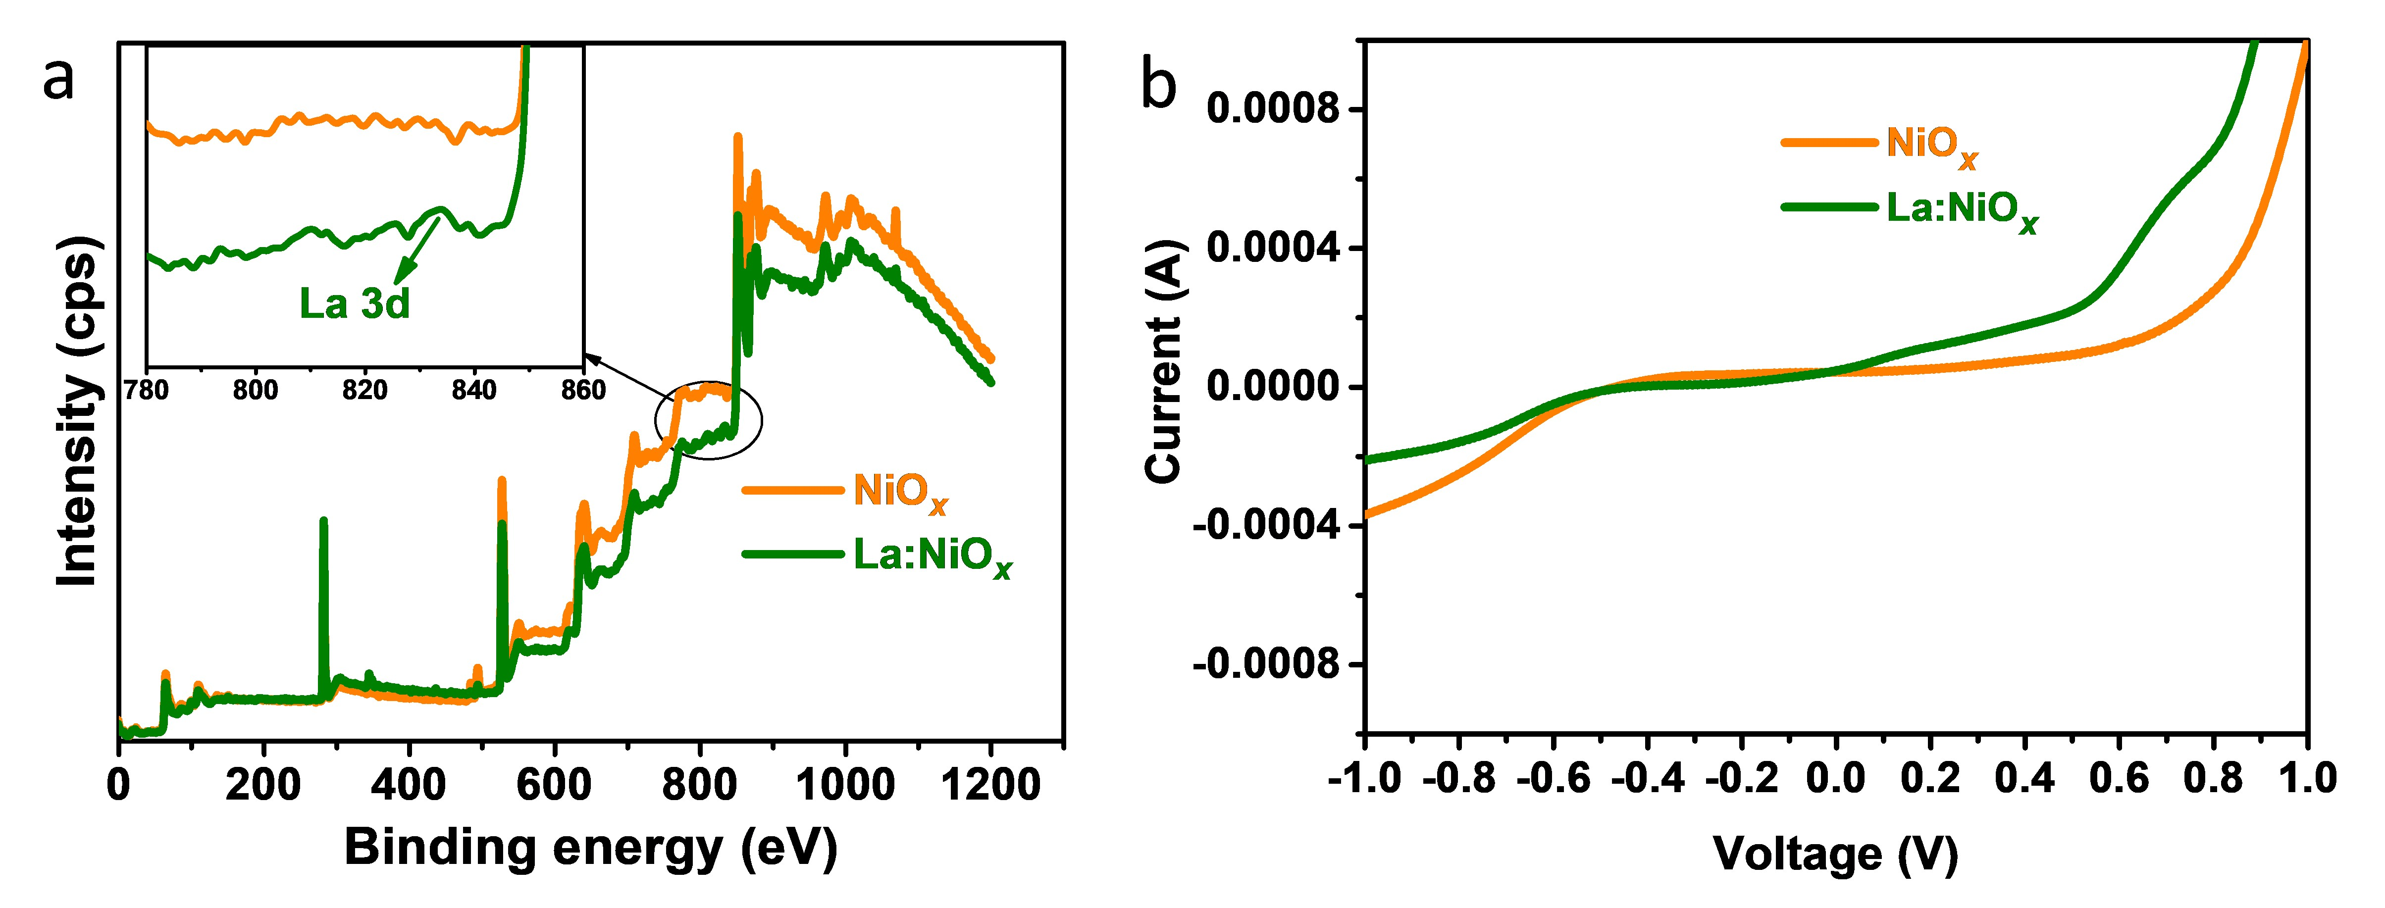
Fig. 3. (a) The XPS spectrum of NiO_{x} and La:NiO_{x} films, with an inserted La 3d spectrum, (b) the current vs voltage curves of NiO_{x} and La:NiO_{x} films.
Scanning electron microscopy (SEM) and Atomic force microscopy (AFM) analysis were used to understand the surface morphology NiO_{x} and La:NiO_{x} films. As shown in Figure 4 (a-d), the quality of La:NiO_{x} film is superior to NiO_{x} film. According to AFM analysis, the La:NiO_{x} film is smoother, with a lower root mean square roughness of 15.6 nm compared to 16.8 nm for NiO_{x}. Higher smoothness means that the La helps to generate more uniform gain sizes and passivates grain boundaries, resulting in fewer surface defects and a smoother, higher quality film. The smooth and quality film surface helps to create better contact with the PVK layer, enhancing carrier transport and reducing recombination loss, resulting in an increase in device PCE.

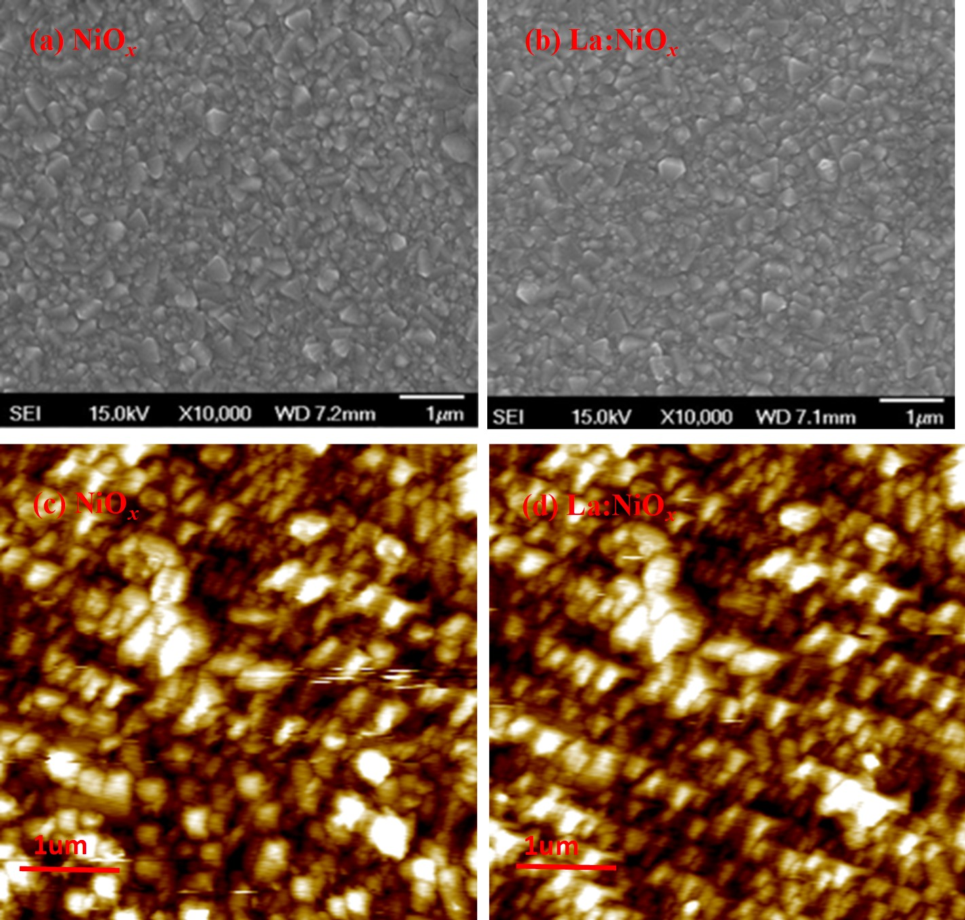
Fig. 4. The SEM and AFM images of (a,c) NiO_{x} and (b,d) La:NiO_{x} films.
We fabricated an inverted structure consisting of FTO/La:NiO_{x} (or) NiO_{x}/PVK/PCBM/BCP/Ag to examine photovoltaic characteristics, as depicted in Fig. 5(a). The J-V measurements of IPSC were examined under 1 sun (1000 mWcm⁻¹) illumination conditions. Additionally, we conducted simulations to generate J-V curves for the IPSCs under the same illumination conditions. Remarkably, the experimental J-V curves for devices closely matched the simulated values, as depicted in Fig. 5(b). Notably, the La:NiO_{x} based IPSC exhibited with better J-V curves in comparison to the pristine device. The detailed results, presented in Table 3, highlight that the La:NiO_{x} based IPSC achieved the average PCE of 11.36 % with V_{OC} with a value of 0.87 V, J_{SC} of 18.88 mAcm⁻² and FF of 68.5%. In contrast, the NiO_{x} based IPSC achieved the average PCE of 9.7% with V_{OC} of 0.83 V, J_{SC} of 18.84 mAcm⁻² and FF of 61.4%. In comparison, the La:NiO_{x} based IPSC exhibited higher PCE than NiO_{x} based IPSC. The increase in V_{OC} can be attributed to several factors, one of which is a reduction in recombination at the interface between La:NiO_{x} and the PVK layer. Interface recombination is affected by surface recombination velocity (S), which is defined as $S=σV_{th}N_{it}$ where, $σ , V_{th}$are capture cross section area, thermal velocity of charge carriers, and $N_{it}$ interface defect density [51]. The S values for NiO_{x} and La:NiO_{x} based IPSC are 1.7 cm/s and 1 cm/s, respectively. The decrease of S is due to decrease of interface defect density at La:NiO_{x} and PVK interface, resultant enhanced V_{OC}. Another contributing factor to the V_{OC} enhancement could be the reduction in the energy gap between the valence band of La: NiO_{x} and the highest occupied molecular orbital (HOMO) level of PVK. This reduction in gap, as observed in the PES data (Fig S2(a-c)) leads to a stronger potential at the interface, which facilitates the transfer of a greater number of charge carriers and consequently enhances V_{OC}. Furthermore, it was observed that the V_{OC} decreases with higher interface defect density, exhibits a slight increase with N_{A}, and remains nearly unchanged with increasing values of R_{sh}, μ_{e}, and μ_{h}, as depicted in Fig. S3. The enhancement of FF is due to increase R_{sh}. The R_{sh} arises primarily from imperfections or defects in the cell's material or manufacturing process [51]. The R_{sh} values are estimated from simulations are 1700 Ω.cm² and 2800 Ω.cm² of NiO_{x} and La:NiO_{x} based IPSC, respectively. The increase in R_{sh} results in an improved FF, which in turn leads to an enhanced PCE. Furthermore, it was observed that the FF decreases with higher interface defect density, exhibits an increase with N_{A,} and remains nearly unchanged with increasing values of μ_{e}, and μ_{h}, as shown in Fig. S3. The J_{SC} is almost unchanged the increases of parameters interface defect density, N_{A,} R_{sh,} μ_{e}, and μ_{h}, as shown in Fig. S3. This finding is consistent with the IPCE results. The J_{SC} primarily depends on the thickness of the PVK layer. We observed that the overall improvement of PCE in La:NiO_{x} based IPSCs is attributed to a decrease in interface defect density and increases in N_{A} and R_{sh}.
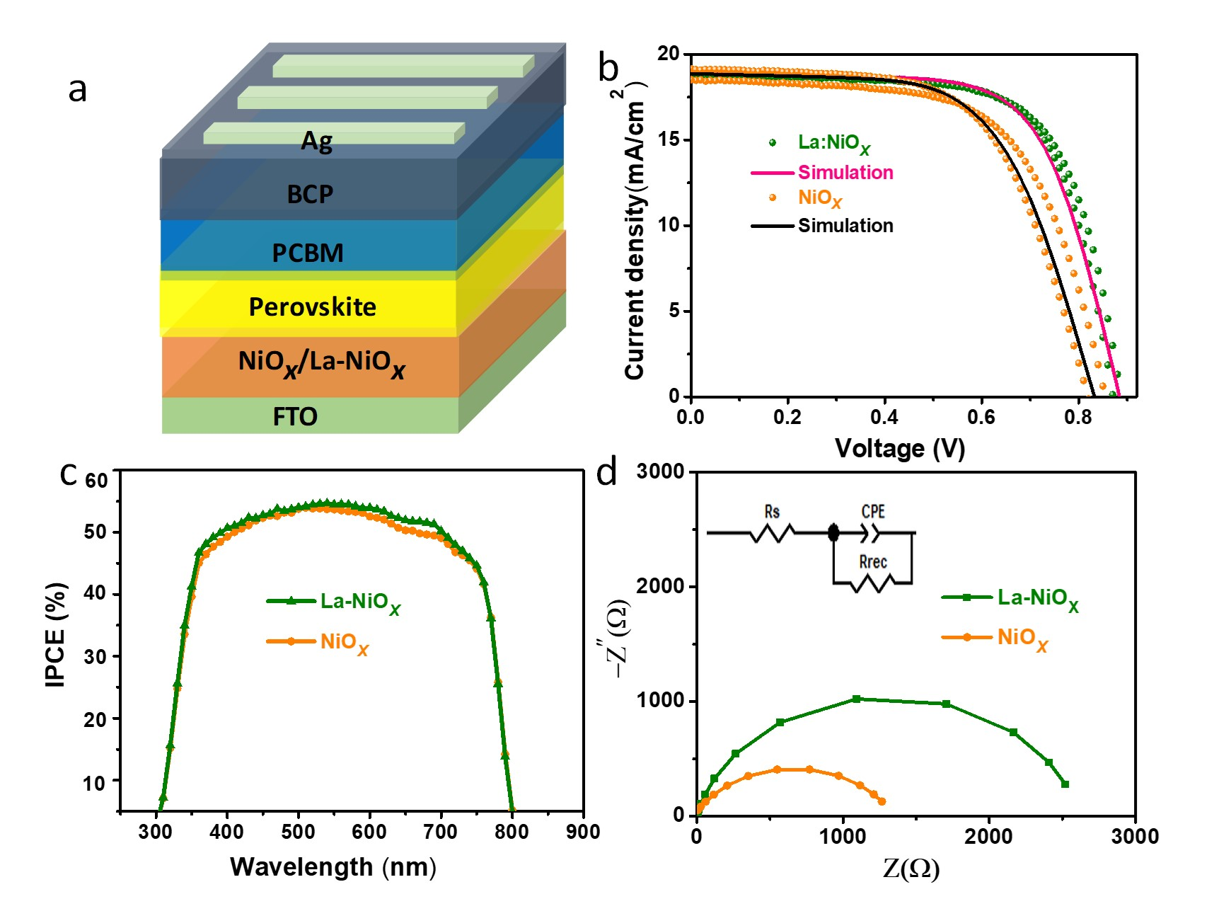
Fig. 5. (a) Schematic diagram of IPSC, (b) Simulated and experimental J-V curves of NiO_{x} and La:NiO_{x} based IPSC. (c). IPCE as a function of wavelength for, and (d) EIS spectra of NiO_{x} and La:NiO_{x} based IPSC.
Further, we conducted the incident photon to current conversion efficiency (IPCE) measurements for both NiO_{x} and La:NiO_{x} based IPSCs. The IPCE values at 530 nm for the NiO_{x} and La: NiO_{x} based IPSCs are 53.1% and 54.4%, respectively, as illustrated in Fig. 5(c). The almost unchanged in IPCE of La:NiO_{x} and NiO_{x} based IPSC. Additionally, we conducted EIS tests to analyse the charge transfer resistance, as shown in Fig. 5(d), which are fitted using a model (as shown in the inset). The charge transfer resistance (R_{rec}) value of La:NiO_{x} device is higher than NiO_{x} based device. The large R_{rec} signifies the suppression of charge recombination and acceleration of charge transport, ultimately contributing to improvement in the fill factor (FF).
Table 1
the physical parameters of NiO_{x}, La doped NiO_{x}, PVK, and PCBM
Parameters | NiO_{x} | La doped NiO_{x} * | PVK | PCBM
Thickness (nm) | 30 | 30 | 375 | 50
Band gap (eV) | 3.49# | 3.53# | 1.67# | 2
Electron affinity χ (eV) | 1.88# | 1.89# | 3.93# | 3.92
Dielectric permittivity (ε) | 10.75 | 10.75 | 6.5 | 4
CB effective density of states N_{c} (cm⁻³) | 2.8×10²⁰ | 2.8×10²⁰ | 1×10¹⁸ | 2.5×10²¹
VB effective density of states N_{V} (cm⁻³) | 8.1×10²⁰ | 8.1×10²⁰ | 1×10¹⁸ | 2.5×10²¹
Mobility μ_{e} (cm²/v.s) | 1.2×10¹ | 1.3×10¹ | 2 | 1×10⁻²
Mobility μ_{h} (cm²/v.s) | 2.8×10⁰ | 2.9×10⁰ | 2 | 1×10⁻²
Electron thermal velocity V_{e} (cm/s) | 1×10⁷ | 1×10⁷ | 1×10⁷ | 1×10⁷
Hole thermal velocity V_{h} (cm/s) | 1×10⁷ | 1×10⁷ | 1×10⁷ | 1×10⁷
Total defect density N_{t} (cm⁻³) | 1×10¹⁴ | 1×10¹⁴ | 1×10¹³ | 1×10¹⁵
Shallow uniform donor density N_{D} (cm⁻³) | 0 | 0 | 0 | 1×10¹⁵
Shallow uniform donor density N_{A} (cm⁻³) | 1×10¹⁸ | 3×10¹⁸ | 1×10¹⁵ | 0

Table 2
Obtained defect density of PVK and at interfaces between CTL and PVK.
 | NiO_{x}/PVK | La:NiO_{x}/PVK* | PVK/ETL
Type of Defect | Neutral | Neutral | Neutral
Electrons Capture cross section (cm²) | 1×10⁻¹⁹ | 1×10⁻¹⁹ | 1×10⁻¹⁹
Holes Capture cross section (cm²) | 1×10⁻¹⁹ | 1×10⁻¹⁹ | 1×10⁻¹⁹
Energetic distribution | Single | Single | Single
Defect energy level Reference E_{t} | Above the highest E_{V} | Above the highest E_{V} | Above the highest E_{V}
Energy level related to reference (eV) | 0.6 | 0.6 | 0.6
Total density -integrated over all energies (cm⁻²) | 1.7×10¹² | 1×10¹² | 1×10¹²
# Experimental * assumed.
Table 3
Photovoltaic parameters of NiO_{x} and La-doped NiO_{x} IPSCs under AM1.5G illumination at 100mWcm⁻².
 |  | V_{OC}(V) | J_{SC}  (mAcm⁻²) | Fill Factor  (F.F)(%) | PCE(%)
Pristine NiO_{x} | Experimental  simulation | 0.83  0.81  0.85  0.82 | 18.84  19.16  18.52  18.86 | 61.4  61.1  62.6  62.2 | 9.7 (average)  9.5 (forward)  9.9 (backward)  9.7
La-doped NiO_{x} | Experimental  simulation | 0.87  0.87  0.88  0.89 | 18.88  18.94  18.83  18.88 | 68.5  68.5  68.4  67.4 | 11.3(average)  11.3(forward)  11.4(backward)  11.4

In addition, we conducted UV-vis measurements to study of optical properties of both NiO_{x} and La:NiO_{x} films. Analysis of the Tauc plots (Fig. S2(d)) revealed that the band gaps of NiO_{x} and La:NiO_{x} films are 3.45 eV and 3.53 eV, respectively. Moreover, we employed PES to examine the impact of La³⁺ doping on the energy bands. The calculated VBM values for NiO_{x} and La:NiO_{x}, as shown in Fig. S2(a-b), were calculated to be 5.33 eV and 5.41 eV, respectively. Based on these findings, we estimated energy diagram, showcasing the close proximity of the VBM of the La:NiO_{x} film to that of the perovskite layer as compared to the pristine film, as shown in Fig. 1(b). As the energy levels are closely aligned, the inherent potential difference strengthens, which could impart an additional driving force for hole transport. This enhancement may accelerate carrier transport and impede recombination at HTL/PVK interface, leading to an increase in device performance.
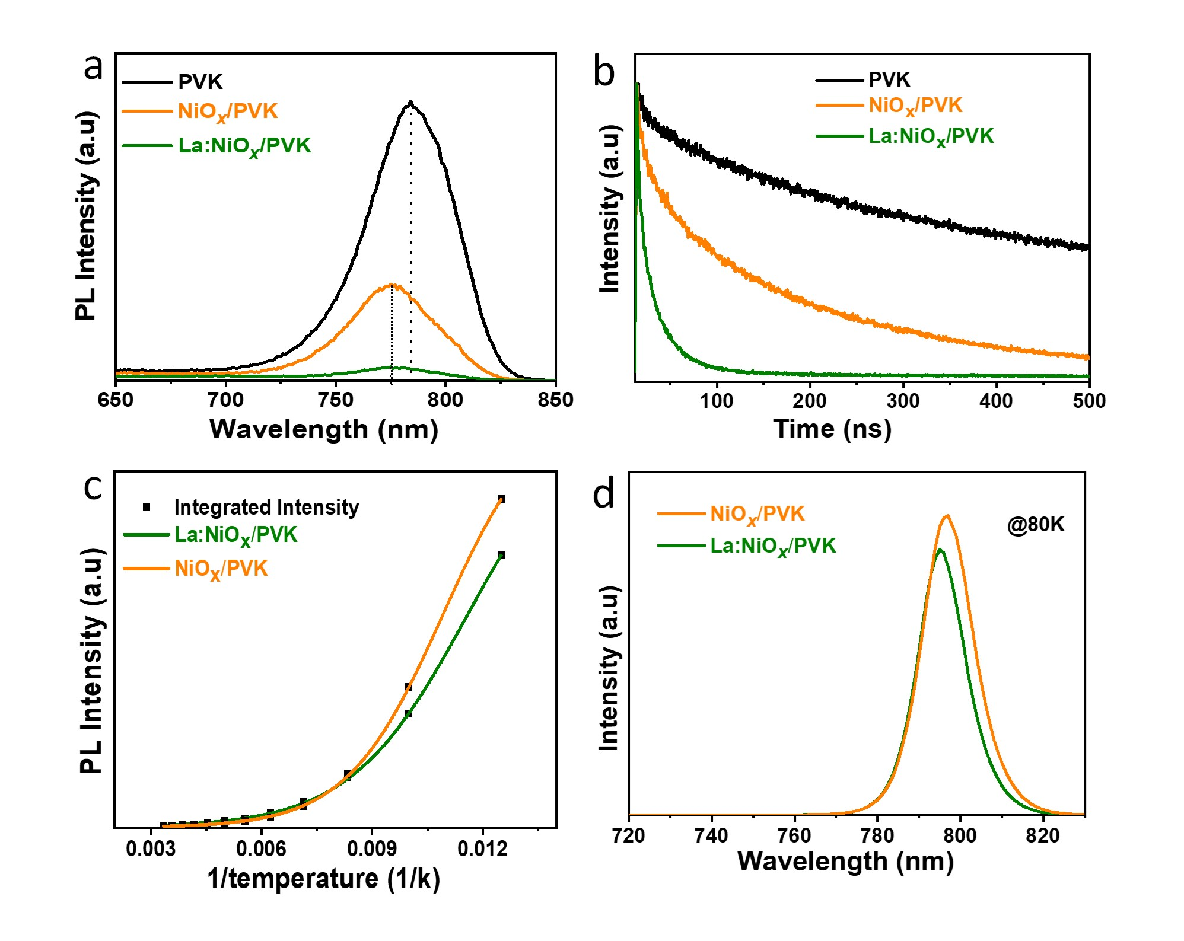
Fig. 6. Room temperature (a) PL and (b) TrPL of perovskite with free HTL, NiO_{X}. (c) Activation energy, (d) PL intensity at 80K of NiO_{x} /PVK and La:NiO_{x} /PVK.
To examine the transfer of charges from perovskite to HTLs, extensive photoluminescence (PL) measurements at room and low temperature (77K) were performed using FLS-1000 Edinburgh Instrument. We prepared samples with the configuration of FTO/HTL/PVK using the same preparation method employed for SCs and were photoexcited under of 510 nm wavelength. The emission peak wavelengths were recorded at 784 nm, 776 nm, and 774 nm for PVK, NiO_{x}/PVK, and La:NiO_{x}/PVK configuration, respectively, as illustrated in the Fig. 6(a). Significantly, the La:NiO_{x}/PVK film exhibited a distinct blue shift. This phenomenon of blue shift has also been observed by Tingli Ma et al., [52]. This shift could be attributed to a reduction in defects at the interface between La:NiO_{x} and PVK layers. Furthermore, the La:NiO_{x}/PVK film exhibited a greater quenching effect compared to the NiO_{x}/PVK film. This quenching effect suggests that the La:NiO_{x} film is more favourable to charge extraction from PVK.
In order to understand the dependence of hole injection at HTL/PVK interface, TrPL were measured under the emission wavelength of 784 nm with the 475 nm EPL picosecond diode laser using time correlated single photon counting (TCSPC), as shown in Fig. 6(b). The Curves were fitted by the exponential equation, $I\left(t\right)=B_{1}\exp\left(-\frac{t}{{}_{1}}\right)+B_{2}\exp\left(-\frac{t}{{}_{2}}\right),$ and the average decay time was calculated by ${}_{avg}=\frac{\sum{B_{i}{}_{i}^{2}}}{\sum{B_{i}{}_{i}}} .$Where ${}_{1}$ and ${}_{2}$ are fast and slow decay components, respectively. The fast decay attribute to charge transfer at HTL/PVK, whereas slow decay associated to bimolecular radiative recombination. It deals with the recombination between unbound electrons and holes will begin to take over [53]. The summarised lifetime parameters as shown in Table 4. The ${}_{1}$ decay times for PVK with HTL-free, NiO_{x} and La:NiO_{x} are 189.3 ns, 68.4 ns and 23.1 ns respectively. The short decay time indicates photo generated charge carriers are effectively transported at La: NiO_{x}/PVK interface [54] due to energy level of La:NiO_{x} close to PVK, as confirmed by PES measurements. The less Long decay time ${}_{2}$ of La:NiO_{x}/PVK interface compare to pristine suggests, implies a reduction in LTdefect density. These results consistent with EIS results.
Table 4
Lifetime parameters from exponential fitting of TrPL measurements.
 | B₁(%) | τ₁(ns) | B₂(%) | τ₂ (ns) | τ_{avg} (ns)
FTO/PVK | 26.1 | 18.5 | 60.4 | 189.3 | 182.4
FTO/NiO_{x}/PVK | 50.2 | 18.4 | 6.95 | 68.4 | 35.3
FTO/La:NiO_{x}/PVK | 43.9 | 4.07 | 31.3 | 23.1 | 19.4
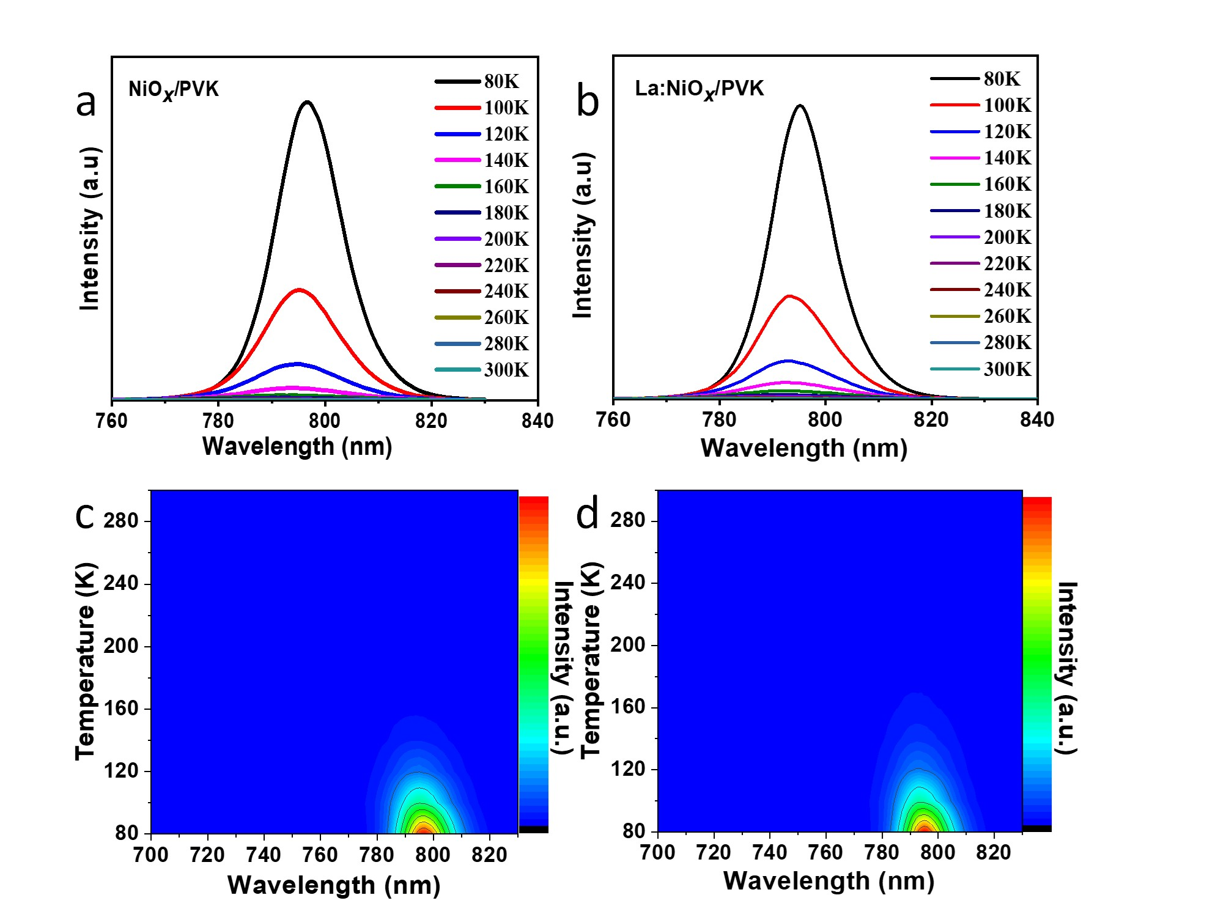
Fig. 7. Low temperature PL and contour plots intensity dependence upon temperature and wavelength for (a, c) NiO_{x}/PVK, and (b, d) La:NiO_{x}/PVK films.
To deep understand about the recombination at HTL/PVK interface, we have measured LT-PL ranging from 80 K to 300 K for La:NiO_{x}/PVK and NiO_{x}/PVK under excitation wavelength of 510 nm, as shown in Fig. 7(a) and (b), respectively. The emission peaks were observed at 795 nm and 793 nm at 80K for NiO_{x}/PVK and La:NiO_{x}/PVK films, respectively. These blue shifts in emissions were observed both at low temperature and room temperature. This phenomenon could be due to decrease in defects at interface between La: NiO_{x}/PVK. The PL quenching of La:NiO_{x}/PVK observed even at low temperature as shown in Fig. 6(d). In addition, as temperature increase blue shift is observed in both films, this is due to decrease in bandgap with decrease in temperature, this in normal effect in lead perovskites [55]. Both films exhibit strong PL intensity at low temperature and become weaker at higher temperature, which is attributed to non-radiative recombination, as shown in Fig. 7(c) and (d). Further, we calculated defect activation energy (E_{a}) by integrated PL intensity (Fig. 6(c)) using following equation [56, 57].
$$I\left(T\right)=\frac{I_{0}}{\left(1+C_{1}\exp\left(-\frac{E_{a}}{k_{B}T}\right)\right)}$$
Where, I_{o} is PL intensity at lowest temperature, K_{B} is Boltzmann’s constant and C₁ is a temperature-independent coefficient. The values of E_{a} for NiO_{x}/PVK and La:NiO_{x}/PVK are extracted from fitting with 66.19±0.83 meV and 54.14±0.78 meV, respectively. The decrease in E_{a} depicts the reduction of defect density at La:NiO_{x}/PVK interface. The reduction in defect density results in improved charge transport and decreased recombination losses, ultimately leading to enhanced PCE.
4. Conclusion
In summary, we studied recombination analysis on the effect of La doping NiO_{x}/PVK interface through LT-PL. We calculated the values of E_{a} for NiO_{x}/PVK and La:NiO_{x}/PVK with 66.19±0.83 meV and 54.14±0.78 meV respectively, a decrease in E_{a} suggested the defect density reduced at La:NiO_{x}/PVK interface. XPS observations revealed that the Ni³⁺/Ni²⁺ ratio increased with La doping leading to enhanced conductivity in the La- NiO_{x} film. The results obtained from LSV indicate a significant increase of ≈20 % in the conductivity of La:NiO_{x} films compared to NiO_{x} films. The better energy alignments improve the hole extraction and reduce the recombination at La:NiO_{x}/PVK interface. Consequently, the PSCs with La- NiO_{x} as HTL improved PCE with V_{OC} of 0.91 V and J_{SC} of 18.9 mAcm⁻². Additionally, we estimated the interface defect density to be 1.7×10¹⁴ cm⁻², 1×10¹⁴ cm⁻² for the NiO_{x}/PVK interface and La:NiO_{x}/PVK interface, respectively. The successful incorporation of La resulted in an enhanced PCE of the PSCs and a reduction in interface defects. This advancement paves the way for potential future commercialization endeavours.
Acknowledgements:
RSSK acknowledges the financial support of DST, India, for the following projects no's BRICS/PilotCall2/IEEEOSC/2018 (G) and CRG/2019/003197 and JICA. VVR acknowledges the financial support from UGC-JRF.
Data Availability:
Data will be available upon request.
References:
1. Kojima, A., et al., Organometal halide perovskites as visible-light sensitizers for photovoltaic cells. Journal of the american chemical society, 2009. 131(17): p. 6050-6051.
2. Chart, B.R.C.E.; Available from: https://www.nrel.gov/pv/cell-efficiency.html.
3. Xing, G., et al., Long-range balanced electron-and hole-transport lengths in organic-inorganic CH3NH3PbI3. Science, 2013. 342(6156): p. 344-347.
4. Stranks, S.D., et al., Electron-hole diffusion lengths exceeding 1 micrometer in an organometal trihalide perovskite absorber. Science, 2013. 342(6156): p. 341-344.
5. Liang, Y., F. Li, and R. Zheng, Low‐dimensional hybrid perovskites for field‐effect transistors with improved stability: progress and challenges. Advanced Electronic Materials, 2020. 6(9): p. 2000137.
6. Xue, Q., et al., Dual interfacial modifications enable high performance semitransparent perovskite solar cells with large open circuit voltage and fill factor. Advanced Energy Materials, 2017. 7(9): p. 1602333.
7. Hu, L., et al., Inverted planar perovskite solar cells with a high fill factor and negligible hysteresis by the dual effect of NaCl-doped PEDOT: PSS. ACS applied materials & interfaces, 2017. 9(50): p. 43902-43909.
8. Li, F., et al., Regulating surface termination for efficient inverted perovskite solar cells with greater than 23% efficiency. Journal of the American Chemical Society, 2020. 142(47): p. 20134-20142.
9. Hu, L., et al., PEDOT: PSS monolayers to enhance the hole extraction and stability of perovskite solar cells. Journal of Materials Chemistry A, 2018. 6(34): p. 16583-16589.
10. Ye, S., et al., CuSCN-based inverted planar perovskite solar cell with an average PCE of 15.6%. Nano letters, 2015. 15(6): p. 3723-3728.
11. Chen, W.-Y., et al., Low-cost solution-processed copper iodide as an alternative to PEDOT: PSS hole transport layer for efficient and stable inverted planar heterojunction perovskite solar cells. Journal of Materials Chemistry A, 2015. 3(38): p. 19353-19359.
12. Zuo, C. and L. Ding, Solution‐processed Cu2O and CuO as hole transport materials for efficient perovskite solar cells. Small, 2015. 11(41): p. 5528-5532.
13. Chen, X., et al., Rare earth ions doped NiOx hole transport layer for efficient and stable inverted perovskite solar cells. Journal of Power Sources, 2019. 444: p. 227267.
14. Cheng, M., et al., Efficient perovskite solar cells based on a solution processable nickel (II) phthalocyanine and vanadium oxide integrated hole transport layer. Advanced Energy Materials, 2017. 7(14): p. 1602556.
15. Corani, A., et al., Ultrafast dynamics of hole injection and recombination in organometal halide perovskite using nickel oxide as p-type contact electrode. The journal of physical chemistry letters, 2016. 7(7): p. 1096-1101.
16. Zhang, K.H., et al., P-type transparent conducting oxides. Journal of Physics: Condensed Matter, 2016. 28(38): p. 383002.
17. Liu, Z., et al., Nickel oxide nanoparticles for efficient hole transport in pin and nip perovskite solar cells. Journal of Materials Chemistry A, 2017. 5(14): p. 6597-6605.
18. Bai, Y., et al., Effects of a molecular monolayer modification of NiO nanocrystal layer surfaces on perovskite crystallization and interface contact toward faster hole extraction and higher photovoltaic performance. Advanced Functional Materials, 2016. 26(17): p. 2950-2958.
19. Chen, W., et al., Understanding the doping effect on NiO: toward high‐performance inverted perovskite solar cells. Advanced Energy Materials, 2018. 8(19): p. 1703519.
20. Yan, C., et al., Lanthanide ion doped upconverting nanoparticles: synthesis, structure and properties. Small, 2016. 12(29): p. 3888-3907.
21. Katta, V.S., et al., Deciphering the role of (Er3+/Nd3+) co-doping effect on TiO2 as an improved electron transport layer in perovskite solar cells. Solar Energy, 2023. 262: p. 111801.
22. Tyagi, B., et al., Double-halide composition-engineered SnO2-triple cation perovskite solar cells demonstrating outstanding performance and stability. ACS Applied Energy Materials, 2020. 3(9): p. 8595-8605.
23. Ašmontas, S., et al., Cesium-containing triple cation perovskite solar cells. Coatings, 2021. 11(3): p. 279.
24. Weber, S., et al., Investigation of NiO x-hole transport layers in triple cation perovskite solar cells. Journal of Materials Science: Materials in Electronics, 2018. 29: p. 1847-1855.
25. Chen, P.-C. and S.-H. Yang, Potassium-doped nickel oxide as the hole transport layer for efficient and stable inverted perovskite solar cells. ACS Applied Energy Materials, 2019. 2(9): p. 6705-6713.
26. Boyd, C.C., et al., Overcoming redox reactions at perovskite-nickel oxide interfaces to boost voltages in perovskite solar cells. Joule, 2020. 4(8): p. 1759-1775.
27. Li, Z., et al., Simple and robust phenoxazine phosphonic acid molecules as self-assembled hole selective contacts for high-performance inverted perovskite solar cells. Nanoscale, 2023. 15(4): p. 1676-1686.
28. Braly, I.L., et al., Hybrid perovskite films approaching the radiative limit with over 90% photoluminescence quantum efficiency. Nature Photonics, 2018. 12(6): p. 355-361.
29. Wolff, C.M., et al., Reduced interface‐mediated recombination for high open‐circuit voltages in CH3NH3PbI3 solar cells. Advanced materials, 2017. 29(28): p. 1700159.
30. Wehrenfennig, C., et al., High charge carrier mobilities and lifetimes in organolead trihalide perovskites. Advanced materials, 2014. 26(10): p. 1584-1589.
31. Chen, J. and N.G. Park, Causes and solutions of recombination in perovskite solar cells. Advanced Materials, 2019. 31(47): p. 1803019.
32. Abdi-Jalebi, M., et al., Maximizing and stabilizing luminescence from halide perovskites with potassium passivation. Nature, 2018. 555(7697): p. 497-501.
33. Shao, Y., et al., Origin and elimination of photocurrent hysteresis by fullerene passivation in CH3NH3PbI3 planar heterojunction solar cells. Nature communications, 2014. 5(1): p. 5784.
34. Wang, Q., et al., Thin insulating tunneling contacts for efficient and water‐resistant perovskite solar cells. Advanced Materials, 2016. 28(31): p. 6734-6739.
35. Zhang, S., et al., Defect/interface recombination limited quasi-fermi level splitting and open-circuit voltage in mono-and triple-cation perovskite solar cells. ACS applied materials & interfaces, 2020. 12(33): p. 37647-37656.
36. Khan, J.I., et al., Charge carrier recombination at perovskite/hole transport layer interfaces monitored by time-resolved spectroscopy. ACS Energy Letters, 2021. 6(12): p. 4155-4164.
37. Kuciauskas, D., et al., Recombination analysis in cadmium telluride photovoltaic solar cells with photoluminescence spectroscopy. IEEE Journal of Photovoltaics, 2015. 6(1): p. 313-318.
38. Burgelman, M., P. Nollet, and S. Degrave, Modelling polycrystalline semiconductor solar cells. Thin solid films, 2000. 361: p. 527-532.
39. Samiul Islam, M., et al., Defect study and modelling of SnX3-based perovskite solar cells with SCAPS-1D. Nanomaterials, 2021. 11(5): p. 1218.
40. Ahmmed, S., et al., A numerical simulation of high efficiency CdS/CdTe based solar cell using NiO HTL and ZnO TCO. Optik, 2020. 223: p. 165625.
41. Raza, E., et al., Numerical simulation analysis towards the effect of charge transport layers electrical properties on cesium based ternary cation perovskite solar cells performance. Solar Energy, 2021. 225: p. 842-850.
42. Chowdhury, M., et al., Effect of deep-level defect density of the absorber layer and n/i interface in perovskite solar cells by SCAPS-1D. Results in Physics, 2020. 16: p. 102839.
43. Chandrasekhar, P., et al., Room temperature solution-processed Fe doped NiOx as a novel hole transport layer for high efficient perovskite solar cells. Applied Surface Science, 2019. 481: p. 588-596.
44. Kong, Y., et al., Enhanced photoelectrochemical performance of tungsten oxide film by bifunctional Au nanoparticles. RSC advances, 2017. 7(25): p. 15201-15210.
45. Haunsbhavi, K., et al., The effect of rare-earth element (Gd, Nd, La) doping of NiO films on UV photodetector. Physica Scripta, 2022. 97(5): p. 055815.
46. Cui, J., et al., CH3NH3PbI3-based planar solar cells with magnetron-sputtered nickel oxide. ACS applied materials & interfaces, 2014. 6(24): p. 22862-22870.
47. Kwon, U., et al., Solution-processible crystalline NiO nanoparticles for high-performance planar perovskite photovoltaic cells. Scientific reports, 2016. 6(1): p. 30759.
48. Al Boukhari, J., A. Khalaf, and R. Awad, Structural and electrical investigations of pure and rare earth (Er and Pr)-doped NiO nanoparticles. Applied Physics A, 2020. 126(1): p. 74.
49. Kim, K. and N. Winograd, X-ray photoelectron spectroscopic studies of nickel-oxygen surfaces using oxygen and argon ion-bombardment. Surface Science, 1974. 43(2): p. 625-643.
50. Langell, M. and M. Nassir, Stabilization of NiO (111) thin films by surface hydroxyls. The Journal of Physical Chemistry, 1995. 99(12): p. 4162-4169.
51. Patel, A.K., R. Mishra, and S.K. Soni, Electrical and optical parameters optimization and interface engineering for efficiency improvement of double CIGS absorber based solar cell. Solar Energy, 2023. 257: p. 125-136.
52. Teo, S., et al., The Role of Lanthanum in a Nickel Oxide‐Based Inverted Perovskite Solar Cell for Efficiency and Stability Improvement. ChemSusChem, 2019. 12(2): p. 518-526.
53. Davies, C.L., et al., Bimolecular recombination in methylammonium lead triiodide perovskite is an inverse absorption process. Nature communications, 2018. 9(1): p. 293.
54. Cui, Q., et al., Charge transfer modification of inverted planar perovskite solar cells by NiO x/Sr: NiO x bilayer hole transport layer. Chinese Physics B, 2022. 31(3): p. 038801.
55. Wu, K., et al., Temperature-dependent excitonic photoluminescence of hybrid organometal halide perovskite films. Physical Chemistry Chemical Physics, 2014. 16(41): p. 22476-22481.
56. Vatavu, S., et al., Photoluminescence studies of CdTe films and junctions. Thin Solid Films, 2007. 515(15): p. 6107-6111.
57. Halliday, D., et al., Photoluminescence study of a bulk vapour grown CdTe crystal. Journal of crystal growth, 2000. 220(1-2): p. 30-38.

