Numerical investigation of structural optimization and defect suppression for high-performance perovskite solar cells via SCAPS-1D
Siliang Cao¹, Yulu He¹, Muhammad Monirul Islam¹, Shaoqiang Chen², Ashraful Islam^{1,3} and Takeaki Sakurai¹*
¹Graduate School of Pure and Applied Sciences, University of Tsukuba, 1-1-1 Tennodai, Tsukuba 305-8577, Ibaraki, Japan
²State Key Laboratory of Precision Spectroscopy, Department of Electronic Engineering, East China Normal University, Shanghai, 200241, China
³Photovoltaic Materials Group, Center for Green Research on Energy and Environmental Materials, National Institute for Materials Science (NIMS), 1-2-1 Sengen, Tsukuba, Ibaraki, 305-0047, Japan
E-mail: sakurai.takeaki.ft@u.tsukuba.ac.jp

This work proposes a simple simulation method for optimization of n-i-p perovskite solar cell (PSCs) via SCAPS-1D and aims to achieve high-performance devices. Nowadays, the carrier recombination induced by heavy defects in bulk and interfaces is one of the main obstacles which restricts the PSCs efficiency and meanwhile is harmful to device stability. Here we modify the MAPbI₃ device through a series of structural and basic optimization, including thickness of each layer, carrier diffusion length, interface recombination, doping concentration and overall series resistance. Through the modified simulation, high-performance MAPbI₃ device with suppressed recombination and optimized structure is realized, resulting in an encouraging power conversion efficiency (PCE) of 20.09%, enhanced V_{oc} of 1.087 V, J_{sc} of 22.56 mA/cm² and FF of 78.5%. These findings unveil the critical effect of defect suppression on PSCs and offer a simple method to achieve high-performance device.

1. Introduction
As a renewable and eco-friendly energy, solar energy is a prospective substitution for traditional energy in the future. Therefore, the 3rd generation solar cells, especially perovskite solar cells have become a prevalent trend for worldwide researchers in recent years owing to their superior opto-electronic properties, including high absorption coefficient, tunable band gap and high charge carrier mobility, etc.^{1),2)} In 2012, Park et al. introduced an all-solid-state structure PSC with encouragingly improved stability, which utilized mesoporous TiO₂ as electron transport layer and Spiro-OMeTAD as hole transport layer to substitute the electrolyte in dye-sensitized cell.³⁾ The new mesoporous heterojunction structure achieved long-term stability over 500h without encapsulation. Simultaneously, the solution processable perovskite solar cell with an excellent mesoporous Al₂O₃ scaffold beneficial for perovskite growth resulted in a power conversion efficiency (PCE) over 10%, which emerged rapidly and afterwards grew very fast in photovoltaic field within a decade.⁴⁾
As the most typical organic-inorganic hybrid perovskite material, MAPbI₃ performs desirable energy bandgap and exhibits great potential in obtaining high-performance devices. To date, the commonly used one-step solution method achieved a record PCE over 18% for pure MAPbI₃ PSCs.⁵⁾ Up to now, plenty of approaches have been developed for device modification, including additive engineering, interface passivation such as various Lewis bases, for example, IDIC, PVP and PCDTBT, energy level engineering and fabrication methodology.^{6)–8)} For example, Zhang and his co-workers reported an effective additive engineering strategy by doping of FAI in MAPbI₃ film to regulate the crystallization and suppress the defect density of perovskite film.⁹⁾ In 2020, Li et al. introduced a facile method to modify the PEDOT:PSS layer with sodium benzenesulfonate (C₆H₅SO₃Na) as well-matched energy level alignment structure in commonly inverted PSCs.¹⁰⁾ Recently, a tetragonal (200) oriented MAPbI₃ film has been obtained by screening hot-casting technique, which achieved less trap density and accelerated charge transfer in absorber layer.¹¹⁾ In summary, the MAPbI₃-based PSCs have been successfully developed in PCE due to the efforts by masses of researchers and promote the future commercialization for PSCs.
Despite the most rapid developments for PSCs in photovoltaic community, there is a certain discrepancy between the experiment and theoretical PCE which is ~30.5% in prediction according to Shockley-Queisser Limit.¹²⁾ The heavy defect density in the configuration of PSCs is one of the main reasons to undermine their performance, finally leading to the huge efficiency discrepancy.¹³⁾ In this work, we analyze the J-V characteristics of MAPbI₃ device via the Solar Cell Capacitance Simulator (SCAPS) simulation and come up with a simple optimization strategy using interface engineering method to improve the device performance.¹⁴⁾ The SCAPS is a one-dimensional solar cell simulator developed with LabWindows/CVI from University of Gent and utilized in different organic and inorganic thin film devices, such as silicon, CIGS, CdTe and perovskite solar cells.¹⁵⁾ Herein, the investigation is focused on analysis of planar n-i-p structure PSCs by changing configuration parameters of the simulation, including thicknesses of each layer, defect density, interface recombination, doping concentration, the series and shunt resistances. Moreover, two interface defect layers (IDLs) of 10 nm are inserted between ETL/perovskite and perovskite/HTL to compute the interface recombination.

2. Experimental methods
2.1 Material Preparation
All the reagents were used as received without further purification. Methylamine iodide (MAI, > 99.99%), lead iodide (PbI₂, > 99.99%), 2,2’,7,7’-tetrakis (N, N-di-p-methoxyphenylamine)-9,9’-spirobifluorene (Spiro-OMeTAD, >99.5%), tris (2-(1H-pyrazol-1-yl)-4-tert-butylpyridine)-cobalt (Ⅲ) tris (bis-(trifluoromethylsulphonyl) imide) (FK209, > 99%), bis(trifluoromethance) sulfonimide lithium salt (LiTFSI, > 99%) and 4-tert-butylpyridine (4-TBP, > 96%) were purchased from Tokyo Chemical Industry (TCI) Co., Japan. The SnO₂ colloid solution (tin (Ⅳ) oxide) was obtained from Alfa Aesar. Other chemicals were provided by Wako Co., Japan.

2.2 Preparation of SnO₂ ETL on FTO Substrate
Fluorine-doped tin oxide (FTO) conducting glass substrates (sheet resistance of 10 Ω sq⁻¹) were sequentially washed by ultrasonication in detergent solution, deionized water, ethyl alcohol, acetone and isopropanol (IPA) for 20 min, respectively. The SnO₂ colloid solution (15%) was diluted with deionized water to the concentration of 5 wt%. Before ETLs deposition, the cleaned FTO substrates were dried with nitrogen and treated by UV-ozone for 30 min. The colloid precursor of SnO₂ was spin-coated onto FTO substrate at 3000 rpm for 20 s. The substrate was then annealed at 150 ℃ for 30 min to obtain the SnO₂ film.

2.3 Solar Cell Fabrication and Characterization
After the preparation for ETLs, the substrates were moved into a glove box filled with N₂ for perovskite, HTL deposition and electrode evaporation. The MAPbI₃ perovskite layers were fabricated by one-step method as reported. 553 mg PbI₂ and 190 mg MAI were dissolved in 1 ml mixed DMF/DMSO (4:1) solvent and stirred for one night at 50 ℃. After that, 100 μl of the precursor was spin-coated onto the FTO/SnO₂ substrate at 1000 rpm for 12 s and 5000 rpm for 30s, respectively. During the high-speed spin-coating process, 200 μl antisolvent was dripped on the perovskite film after 7s to promote the perovskite crystallization. Subsequently, the substrates were annealed at 100 ℃ for 10 min to form uniform and compact films. For HTL, the mixture of 72 mg Spiro-OMeTAD, 14 μl FK209 (376 mg ml⁻¹ in acetonitrile), 17 μl Li-TFSI (520 mg ml⁻¹ in acetonitrile) and 29 μl 4-TBP dissolved in 1 ml CB was spin-coated onto perovskite film at 4000 rpm for 20s. Finally, 100 nm gold (Au) was thermally evaporated on the top of films under vacuum (<5 × 10⁻⁴ Pa). The active area of all the solar cells was 0.09 cm². The J-V characteristic of all the devices were recorded using a solar simulator (WXS-155S-10: Wacom Denso Co., Japan) under AM 1.5G illumination at 100 mW cm⁻² in air condition.

3. Simulation section
Figure 1(a) shows the simulation structure of planar n-i-p MAPbI₃ PSC, which is comprised of FTO substrate/SnO₂/MAPbI₃/Spiro-OMeTAD/Au. As the transparent electrode and metal back electrode, the FTO substrate and gold layer take on the work function of 4.4 eV and 5.1 eV, respectively.¹⁶⁾ This structure presents the suitable energy alignment, which is beneficial to accelerate the carrier separation and transfer to both transport layers, as shown in Fig. 1(b). In this study, the numerical modeling is based on solving the semiconductor equations including Poisson equation and continuity equations for electrons and holes. The physical and electronic parameters of each function layer such as band gap, film thickness, carrier mobility etc. are set in the working panel and compute for opto-electronic measurements such as J-V and IPCE characterizations.¹⁷⁾ In addition, the recombination for bulk and interface layer is analyzed by Shockley-Read-Hall (SRH) model, through which the electron and hole are capable to exchange between the interface and two adjacent layers. Therefore, here we insert two interface defect layers with 10 nm thickness at ETL/absorber layer and absorber layer/HTL to simulate the interface recombination, respectively. To obtain the preliminary simulation value, we set the initial thickness according to the literature.¹⁸⁾ Table Ⅰ summarizes the basic simulation parameters of each layer, in which the thickness, donor density, interface and bulk defect density are variable in further optimization.^{19)–23)} Figure 2(a) depicts the optical absorbance of MAPbI₃ layer based on simulation. The absorption coefficient is calculated by the equation: $ahv=A\sqrt{hv-E_{g}}$, where a is absorption coefficient, hv is incident photo energy, A is a constant pre-factor normally set to be 1×10⁵ and E_{g} is optical bandgap energy.²⁴⁾ Consistently, the electron/hole thermal velocity of each layer is regarded as a constant to be 10⁷ cm/s.²⁵⁾ The initial series resistance is assumed to be 1 Ω cm² with a shunt resistance as 3000 Ω cm².²⁶⁾ The simulation working condition is under AM 1.5G illumination at 100 mW/cm², 300 K for room temperature. In addition, the capture cross sections of electron and hole for the absorber layer and interface layers are set to be 2×10⁻¹⁴ cm² and 1×10⁻¹⁵ cm², respectively.²⁷⁾ The defect state distribution in absorber layer is regarded as neutral in Gaussian distribution, whereas in single distribution for ETL and HTL. The defect energy level is assumed in the middle of the band gap for each layer with the characteristic energy of 0.1 eV. To verify our simulation model, we also fabricated the pure-MAPbI₃ device to compare with simulation result, as illustrated in Fig. 2(b). The preliminary simulation, hereafter referred to as control device, generates a PCE of 15.68% with V_{oc} = 1.022 V, J_{sc} = 19.45 mA cm⁻² and FF = 75.5%, whereas the experimental J-V curve shows similar result with PCE = 14.64% with V_{oc} = 1.019 V, J_{sc} = 19.27 mA cm⁻² and FF = 74.6%, respectively. Compared with the control device, the experiment result shows slightly lower J_{sc}, owing to the optical reflection from substrate and each layer, which has not been calculated in SCAPS.²⁸⁾ Therefore, the comparative results of both experiment and simulation demonstrate the proper estimation for pure-MAPbI₃ devices. The further simulation optimization in structure and defects will contribute to high performance devices in future PSCs design and manufacture.

4. Results and discussion
4.1 Effect of changing defect density (N_{t})
To investigate both the bulk recombination and interface recombination, the Shockley Read Hall (SRH) model is utilized in this simulation. The trap-assisted SRH recombination is mainly acknowledged to be the dominated recombination mechanism in PSCs.²⁹⁾ Owing to the undesired film quality such as poor crystallization and high surface defect in absorber layer, the generated free electron and hole is of higher possibility to be captured and thus recombine in trap centers. This so-called trap-assisted SRH recombination has been widely used to assess the photoconversion loss in single absorber device, which can be described by Eq. (1).³⁰⁾
$R_{SRH}=\frac{np-n_{i}^{2}}{τ\left(p+n+2n_{i}cosh\left(\frac{E_{i}-E_{t}}{KT}\right)\right)}$ (1)
where the R_{SRH} is the Shockley Read Hall recombination rate, n and p is the concentration of electron and hole, n_{i} represents the intrinsic carrier density, τ represents the carrier lifetime, E_{i} and E_{t} refer to conduction/valence band and trapping energy level, respectively. It is evident that the SRH recombination rate is determined by the carrier lifetime of the perovskite layer. On behalf of interpreting the critical dependency of defect density for recombination, the Eq. (2) is utilized to show the relation between carrier lifetime and defect density.³¹⁾
$τ=\frac{1}{σ×N_{t}×v_{th}}$ (2)
where τ represents the carrier lifetime, σ is the carrier capture cross section, N_{t} is the defect density and v_{th} refers to electron thermal velocity. According to the Eqs. (1) and (2), the defect density is inversely proportional to carrier lifetime owing to the constant parameters for σ and v_{th} at room temperature. Therefore, the SRH recombination rate is exclusively dependent on the defect density. Figure 3(a) demonstrates the SRH recombination rate as a function of film depth with varied defect density for absorber layer. Within the defect density of 10¹⁴ cm⁻³, the recombination rates are at lower level in the range of absorber from 0.25 to 0.5 μm. As the defect density increases from 10¹⁴ to 10¹⁶ cm⁻³, the recombination rate rises significantly in perovskite layer. Notably, in high defect density of 10¹⁶ cm⁻³, a much steeper curve is observed for higher depth region indicative to near ETL side for absorber layer. Since the sunlight illuminates the front of the device by FTO side, there are masses of generated carriers accumulated in the first interface of ETL/absorber rather than the second of absorber/HTL due to the excellent absorption of MAPbI₃ perovskite.³²⁾ The quantitative discrepancy for non-equilibrium carriers brings more trap states and recombination centers in interface of ETL/absorber, and thus results in rapidly increased recombination rate. As a result, Figure 3(b) exhibits the J-V curves for varied defect density from 10¹³ to 10¹⁷ cm⁻³. While the defect density increases from 10¹³ to 10¹⁵ cm⁻³, the device performance drops mainly attributed by the reduced V_{oc} from 1.116 V to 0.993 V. Simultaneously, the J_{sc} nearly remains the same level. However, when the defect density increases up to 10¹⁶ cm⁻³ or even higher, the observably severe recombination leads to the degradation both in V_{oc}, J_{sc} and FF. Therefore, it is vital for PSCs to suppress the defect density within 10¹⁵ cm⁻³ in absorber layer to obtain good PCE.
As an excellent absorber material, MAPbI₃ perovskite possesses high diffusion length, which is beneficial for carrier extraction and even the absorption property in near-spectral region.³³⁾ Some researchers also reported a long diffusion length over 1 μm in the nanostructured MAPbI₃ perovskite.³⁴⁾ Here we investigate the relation between diffusion length and bulk recombination to improve the device performance. Equation (3) describes the relation between carrier lifetime and diffusion length.
$L_{D}=\sqrt{Dτ}$ (3)
where D is diffusion coefficient and related to the carrier mobility. Therefore, the suppressed defect density leads to increased carrier lifetime and prolonged diffusion length, as summarized in Table Ⅱ. Figure 4 demonstrates the variation in J-V characteristics as a function of the diffusion length. An impressive impact is observed mainly in V_{oc} and FF owing to the higher diffusion length, attributed to suppressed defect density. Meanwhile the effect on J_{sc} is very tiny while L_{D}＞0.2 μm. Thus, the V_{oc} improvement is dominant to affect PCE in this case. With the increasing diffusion length over 1.0 μm, the improvement of PCE is getting slower as well as V_{oc}. According to the literature, the optimization for absorber quality such as additive doping and crystallization control is effective to improve the diffusion length of perovskite and obtain high performance.³⁵⁾ Considering the actual experimental process in absorber deposition, the thickness of one-step MAPbI₃ film is commonly within 500 nm. Under suppressed defect density of 5×10¹³ cm⁻³, the suitable carrier diffusion length for the subsequent simulation is assumed to be 720 nm with carrier lifetime of 100 ns. Therefore, the better PCE of 17.86% is achieved with improved V_{oc} of 1.097 V and FF of 79.8%, compared with the control device PCE of 15.68%. In addition, to avoid blocking the carrier extraction and transfer, the film thickness is preferable within 720 nm.

4.2 Effect of absorber thickness
In Sect. 4.2, the effect of absorber thickness is compared and analyzed from 150 nm to 500 nm. Generally, with regards to the PSCs, the sufficient absorber thickness contributes to better device performance due to the preferable J_{sc}.³⁶⁾ However, the excessively grown thickness may introduce the problems of film morphology control and increase of defect centers, which lead to the severe recombination and V_{oc} loss.³⁷⁾ Fig.5 shows the J-V characteristics with varied MAPbI₃ thickness from 150 nm to 500 nm to demonstrate the effect of absorber thickness, as summarized in Table Ⅲ. It is clear the thicker absorber layer from 150 nm to 400 nm is beneficial for optical absorption and results in dramatically improved J_{sc} from 15.63 to 22.27 mA/cm². Meanwhile, the V_{oc} and FF have slight declines. Therefore, the PCE rises to 16.60% instead of 13.09%. On the contrary, since the thickness grows, the V_{oc} reduces from 1.037 V to 0.992 V and FF reduces from 77.3% to 66.6% continuously because of the severe recombination. Additionally, the series resistance also has a potential impact on the declining performance, which we will discuss in details hereinafter. Even though the absorption ability is getting better, the J_{sc} has gradually become saturated with sufficient thickness, inducing the PCE loss over the thickness of 400 nm. In summary, the desirable absorber thickness is around 400 nm to achieve optimized J_{sc}, proper V_{oc} and FF, leading to superior device performance.

4.3 Effect of ETL/HTL thickness
To investigate the effect of ETL/HTL thickness, the device performance is simulated with the varied thickness of transport layer, as shown in Fig. 6. As for ETL, we used colloid SnO₂ precursor for deposition, which is interpreted in experimental Sect. 2. According to the literature, the thickness of SnO₂ film is around 35 nm.³⁸⁾ Thus, the varied thickness of ETL is set to be 20 to 100 nm in the simulation. Figure 6(a) shows that the overall J-V characteristics, including FF, J_{sc} and V_{oc}. The photovoltaic parameters almost remain constant since the thickness of ETL increases, which indicates the excellent carrier extraction capacity and defect-state tolerance. As a result, there is negligible effect on device PCE by varying the ETL thickness. Oppositely, the HTL exhibits a declined PCE from 15.75% to 15.55%, attributed to the decrease in FF from 75.9% to 74.9%. Meanwhile, other parameters like V_{oc} and J_{sc} have no significant change, as shown in Fig. 6(b). The reason for the varied FF is that the Spiro-OMeTAD film with high resistivity leads to higher series resistance and poor conductivity which is harmful for charge transport and transfer, comparing to the tiny impact from relevantly thin film of ETL with lower resistivity.^{39),40)} As an organic small molecule material, thin Spiro-OMeTAD film is also likely to suppress defects and achieves higher efficiency, as reported in several studies.^{41),42)} Therefore, the proper thickness of ETL and HTL is set to be 20 nm and 150 nm for the subsequent optimization.

4.4 Effect of interface recombination
After the assumption for absorber layer and both transport layer, the interfaces between these layers are also investigated in Sect. 4.4. To analyze the effect of interface recombination, the IDLs with thickness of 10 nm are simulated as ETL/perovskite and perovskite/HTL, respectively. Figure 7(a) presents the overall recombination from HTL-interface to ETL-interface based on the varied interface defect density from 10¹⁶, 10¹⁸ and 10²⁰ cm⁻³, respectively. At the low interface defect density of 10¹⁶ cm⁻³, the dominant recombination is in the range within 0.15 μm to 0.57 μm, which refers to the majority of bulk region and the interface ETL/absorber, respectively. In particular, the recombination rate of bulk region rises rapidly near the ETL side, indicative of the masses of carrier collection in interface ETL/absorber. Simultaneously, it shows a relatively minor peak for interface absorber/HTL. Fig. 7(b) demonstrates the effect of interface defect density for device performance. With the interface defect density increased to 10¹⁸ cm⁻³ and even higher, the recombination rate of interface ETL/absorber emerges and becomes stronger remarkably. Therefore, the severely increased recombination restrains the electron extraction and collection efficiency in FTO electrode, finally leading to heavy energy loss. The V_{oc} shift from 1.093 V to 1.036 V whereas the J_{sc} and FF almost keep the same. Thus, it leads to an efficiency discrepancy around only 1% since the defect density increases for several orders of magnitude. Similarly, the peak of interface absorber/HTL exhibits a relatively lower intensity and has a minor impact on device performance when the interface defect density is gradually increased, as shown in Fig. 7(c). The summary of J-V variation in Table Ⅳ shows that the interface ETL/absorber plays a critical role in interface recombination, which is harmful to the overall device parameters under high defect density (>10¹⁸ cm⁻³). One of the explanations could derive from the more generated carriers collected and accumulated at the front side during light illumination than the backside. This high carrier density causes an increase in traps at the recombination centers. Generally, the surface for perovskite growth, which indicates SnO₂ in this n-i-p structure, is of great significance for the formation of film morphology and interface defects.⁴³⁾ Therefore, according to the J-V simulation, to get good carrier extraction and transfer, the defect density in interface ETL/absorber need to be suppressed within 10¹⁷ cm⁻³.

4.5 Effect of doping concentration
In Sect. 4.5, we investigate the effect of doping concentration, which is also of great relevance for the bulk and interface recombination, as shown in Fig. 8. It has been reported that the doping concentration of MAPbI₃ perovskite is a practical method such as cation doping to improve opto-electronic property.⁴⁴⁾ Here we set a series of varied doping concentration from 10¹³ to 10¹⁷ cm⁻³ to demonstrate the suitable value for device performance. In the low concentration region within 10¹⁵ cm⁻³, the increased doping concentration obtains negligible change in recombination, as illustrated in Fig. 8(a). However, when it rises over 10¹⁵ cm⁻³, the recombination rate grows up by several orders of magnitude, especially approaching the side of interface ETL/absorber. Thus, it induces the larger amount of electron accumulated in the interface ETL/absorber, especially for the concentration of 10¹⁷ cm⁻³, as shown in Fig. 8(b). While the doping concentration increases from 10¹⁵ cm⁻³ to 10¹⁶ cm⁻³, the electric filed is reinforced and accelerates the separation of the photo-generated carriers, which contributes to a slightly enhanced V_{oc}, as shown in Fig. 8(c). Nevertheless, the increasing bulk and interface recombination ascribed to changed doping concentration aggravate the device PCE with gradually decreased J_{sc}. Therefore, the reasonable doping concentration of perovskite should be assumed to be 10¹⁵ cm⁻³.

4.6 Effect of series and shunt resistance
The effect of series resistance (R_{s}) is generally ascribed to the ohmic loss from bulk resistance and the electrode contact, especially at the interface contact of metal/semiconductor.⁴⁵⁾ Basically, the origin of the shunt resistance (R_{shunt}) is from the leakage current, owing to the heavy defect states in the interface.²⁸⁾ In PSCs, the introduced R_{s} commonly induces a severe energy loss, compared with R_{shunt}. Therefore, here we evaluate the device performance with the varied R_{s} and R_{shunt}.⁴⁶⁾ Figure 9(a) and 9(b) depict the relations between device performance and R_{s}, in which the increased R_{s} aggravates the efficiency from 20.55% to 18.26%, mainly attributed to the accordingly declined FF from 80.3% to 71.4%. The photovoltaic parameters are summarized in Table Ⅴ. The impact of the increased R_{s} can be approximately interpreted by Eq. (4), which is dependent synergistically by the internal absorber resistance and the contribution from electrodes.⁴⁷⁾
$R_{s}≅ρb+\frac{ρ_{s}L^{2}}{2}$ (4)
where b is absorber thickness, L is substrate length, ρ and ρ_{s} refer to the resistivity of the absorber layer and FTO sheet resistance, respectively. On account of the constant effect from the electrode material, we ought to control the perovskite thickness because of the contribution for increased R_{s} , even thicker film will lead to higher J_{sc}. Meanwhile, the effect on device performance is slightly enhanced with highly increased R_{shunt}, as shown in Fig. 9(c). As a result, the PCE gradually improved as well as FF with reduced R_{s} and increased R_{shunt} for our simulation structure. Therefore, the optimized device owns the R_{s} within 1 Ω and R_{shunt} over 3000 Ω to get better FF.

4.7 Optimized device performance
According to the modification and improvement above, including suitable increased absorber layer thickness of 400 nm, thinner carrier transport layer thickness of 20 nm for ETL and 150 nm for HTL, suppressed defect density of 5×10¹³ cm⁻³ for absorber and 10¹⁷ cm⁻³ for interfaces, well-controlled doping concentration of 10¹⁵ cm⁻³, R_{s} within 1Ω and R_{shunt} over 3000Ω, we reconstruct the device structure and obtain improved device performance. Importantly, the thicker absorber thickness provides sufficient optical absorption, leading to higher J_{sc}. Meanwhile, the suppressed bulk and interface recombination by suppressed defect density are the key point to achieve high V_{oc} and PCE. As a result, Figure 10 shows the optimized device achieves the improved J-V characteristics with V_{oc} of 1.087 V, J_{sc} of 22.56 mA/cm², FF of 78.5% and an encouraging PCE of 20.09%, comparing with control device with V_{oc} of 1.022 V, J_{sc} of 19.45 mA/cm², FF of 75.52% and PCE of 15.68%.

5. Conclusions
In conclusion, our work has presented a dramatic improvement for device optimization on n-i-p structure PSCs via SCAPS-1D. Compared with our experimental result, the initial simulation for the control device is well-matched and exhibits distinct V_{oc} loss and J_{sc} deficiency. It was found these poor performances could be attributed to the improper device structure and severe defects in bulk and interfaces. With the modification and improvement of various basic properties, the best simulation result is achieved with superb V_{oc}, J_{sc} and FF, leading to encouraging PCE over 20% for pure-MAPbI₃ PSCs. These optimizations unveil the critical role for defect suppression and provide a simple method to improve device performance on n-i-p MAPbI₃ PSCs. For purpose of realizing the S-Q limit of over 30%, further effort and design are required in optically corrected radiative loss and high-quality film which will avoid ohmic loss and defect-induced recombination.

Acknowledgments
This work is financially supported by National Nature Science Foundation of China No.62274065.

References

1) A. Kojima, K. Teshima, Y. Shirai and T. Miyasaka, J. Am. Chem. Soc. 131, 17, 6050 (2009).
2) W. Zhang, G. E. Eperon and H. J. Snaith, Nat. Energy, 2016.
3) H.-S. Kim, C.-R. Lee, J.-H. Im, K.-B. Lee, T. Moehl, A. Marchioro, S.-J. Moon, R. Humphry-Baker, J.-H. Yum, J. E. Moser, M. Grätzel and N.-G. Park, Sci. Rep. 2 [1], 591 (2012).
4) M. M. Lee, J. Teuscher, T. Miyasaka, T. N. Murakami and H. J. Snaith, Science (80-. ). 338 [6107], 643 (2012).
5) Y. Chen, X. Zuo, Y. He, F. Qian, S. Zuo, Y. Zhang, L. Liang, Z. Chen, K. Zhao and Z. Liu, Adv. Sci. 8 [5], 2001466 (2021).
6) Y. Lin, L. Shen, J. Dai, Y. Deng, Y. Wu, Y. Bai, X. Zheng, J. Wang, Y. Fang and H. Wei, Adv. Mater. 29 [7], 1604545 (2017).
7) Y. Zhang, X. Zhuang, K. Zhou, C. Cai, Z. Hu, J. Zhang and Y. Zhu, J. Mater. Chem. C 5 [35], 9037 (2017).
8) A. Kaewprajak, P. Kumnorkaew, K. Lohawet, B. Duong, T. Chonsut, N. Kayunkid, N. Saranrom and V. Promarak, Surfaces and Interfaces 23, 100969 (2021).
9) Y. Zou, H. Wang, Y. Qin, C. Mu, Q. Li, D. Xu and J. Zhang, Adv. Funct. Mater. 29 [7], 1805810 (2019).
10) W. Li, H. Wang, X. Hu, W. Cai, C. Zhang, M. Wang and Z. Zang, Sol. RRL 5 [1], 2000573 (2021).
11) R. Lu, Y. Liu, J. Zhang, D. Zhao, X. Guo and C. Li, Chem. Eng. J. 433, 133845 (2022).
12) W. E. I. Sha, X. Ren, L. Chen and W. C. H. Choy, Appl. Phys. Lett. 106 [22], 221104 (2015).
13) M. Samiee, S. Konduri, B. Ganapathy, R. Kottokkaran, H. A. Abbas, A. Kitahara, P. Joshi, L. Zhang, M. Noack and V. Dalal, Appl. Phys. Lett. 105 [15], 153502 (2014).
14) M. Burgelman, P. Nollet and S. Degrave, Thin Solid Films 361, 527 (2000).
15) T. Minemoto and M. Murata, J. Appl. Phys. 116 [5], 54505 (2014).
16) A. Andersson, N. Johansson, P. Bröms, N. Yu, D. Lupo and W. R. Salaneck, Adv. Mater. 10 [11], 859 (1998).
17) M. Burgelman, J. Verschraegen, S. Degrave and P. Nollet, Prog. Photovoltaics Res. Appl. 12 [2‐3], 143 (2004).
18) A. Z. Chen, B. J. Foley, J. H. Ma, M. R. Alpert, J. S. Niezgoda and J. J. Choi, J. Mater. Chem. A 5 [17], 7796 (2017).
19) J. H. Noh, S. H. Im, J. H. Heo, T. N. Mandal and S. Il Seok, Nano Lett. 13 [4], 1764 (2013).
20) H. J. Snaith and M. Grätzel, Adv. Mater. 19 [21], 3643 (2007).
21) D. Poplavskyy and J. Nelson, J. Appl. Phys. 93 [1], 341 (2003).
22) D. Liu and T. L. Kelly, Nat. Photonics 8 [2], 133 (2014).
23) H. Zhou, Q. Chen, G. Li, S. Luo, T. B. Song, H. S. Duan, Z. Hong, J. You, Y. Liu and Y. Yang, Science, 345, 6196 (2014).
24) M. Ju, J. Dai, L. Ma and X. C. Zeng, Adv. Energy Mater. 7 [18], 1700216 (2017).
25) B. Turedi, V. Yeddu, X. Zheng, D. Y. Kim, O. M. Bakr and M. I. Saidaminov, ACS Energy Lett. 6 [2], 631 (2021).
26) J. Huang, M. Wang, L. Ding, Z. Yang and K. Zhang, RSC Adv. 6 [61], 55720 (2016).
27) L. Huang, X. Sun, C. Li, R. Xu, J. Xu, Y. Du, Y. Wu, J. Ni, H. Cai, J. Li, Z. Hu and J. Zhang, Sol. Energy Mater. Sol. Cells 157, 1038 (2016).
28) S. Karthick, S. Velumani and J. Bouclé, Sol. Energy 205, 349 (2020).
29) T. S. Sherkar, C. Momblona, L. Gil-Escrig, J. Avila, M. Sessolo, H. J. Bolink and L. J. A. Koster, ACS energy Lett. 2 [5], 1214 (2017).
30) V. Sarritzu, N. Sestu, D. Marongiu, X. Chang, S. Masi, A. Rizzo, S. Colella, F. Quochi, M. Saba and A. Mura, Sci. Rep. 7 [1], 1 (2017).
31) K. C. Kao, Dielectric phenomena in solids (2004).
32) M.-H. Jung, RSC Adv. 11 [52], 32590 (2021).
33) C. C. Stoumpos, C. D. Malliakas and M. G. Kanatzidis, Inorg. Chem. 52 [15], 9019 (2013).
34) V. Gonzalez-Pedro, E. J. Juarez-Perez, W.-S. Arsyad, E. M. Barea, F. Fabregat-Santiago, I. Mora-Sero and J. Bisquert, Nano Lett. 14 [2], 888 (2014).
35) Z. Yang, Z. Yu, H. Wei, X. Xiao, Z. Ni, B. Chen, Y. Deng, S. N. Habisreutinger, X. Chen, K. Wang, J. Zhao, P. N. Rudd, J. J. Berry, M. C. Beard and J. Huang, Nat. Commun. 10 [1], 4498 (2019).
36) K. Wang, C. Liu, P. Du, L. Chen, J. Zhu, A. Karim and X. Gong, Org. Electron. 21, 19 (2015).
37) Z. Liu, J. Hu, H. Jiao, L. Li, G. Zheng, Y. Chen, Y. Huang, Q. Zhang, C. Shen and Q. Chen, Adv. Mater. 29 [23], 1606774 (2017).
38) Z. Liu, K. Deng, J. Hu and L. Li, Angew. Chemie - Int. Ed., 131, 33, 11621 (2019).
39) J.-L. Brousseau, H. Bourque, A. Tessier and R. M. Leblanc, Appl. Surf. Sci. 108 [3], 351 (1997).
40) J. Burschka, A. Dualeh, F. Kessler, E. Baranoff, N.-L. Cevey-Ha, C. Yi, M. K. Nazeeruddin and M. Grätzel, J. Am. Chem. Soc. 133 [45], 18042 (2011).
41) N. A. N. Ouedraogo, G. O. Odunmbaku, B. Guo, S. Chen, X. Lin, T. Shumilova and K. Sun, ACS Appl. Mater. Interfaces 14 [30], 34303 (2022).
42) Z. Hawash, L. K. Ono and Y. Qi, Adv. Mater. Interfaces 5 [1], 1700623 (2018).
43) D. Yang, X. Zhou, R. Yang, Z. Yang, W. Yu, X. Wang, C. Li, S. F. Liu and R. P. H. Chang, Energy Environ. Sci. 9 [10], 3071 (2016).
44) Z.-K. Tang, Z.-F. Xu, D.-Y. Zhang, S.-X. Hu, W.-M. Lau and L.-M. Liu, Sci. Rep. 7 [1], 1 (2017).
45) R. F. Reyna, A. Martı́ and J. C. Maroto, Solid. State. Electron. 42 [4], 567 (1998).
46) D. Walter, Y. Wu, T. Duong, J. Peng, L. Jiang, K. C. Fong and K. Weber, Adv. Energy Mater. 8 [2], 1701522 (2018).
47) G. T. Koishiyev and J. R. Sites, Sol. Energy Mater. Sol. Cells 93 [3], 350 (2009).

Figure Captions
Fig. 1. (a) Device architecture of n-i-p MAPbI₃ PSC for SCAPS simulation and (b) the corresponding energy level diagram.

Fig. 2. (a) Optical absorbance of MAPbI₃ layer based on SCAPs simulation (b) J-V curve based on simulation and experimental result, respectively.

Fig. 3. (a) Recombination rate and (b) J-V curves based on different defect density in absorber layer.

Fig. 4. J-V characteristics with varied carrier diffusion length: (a) PCE, (b) V_{oc}, (c) J_{sc} and (d) FF.

Fig. 5. The variations of J-V characteristics as a function of absorber thickness.

Fig. 6. The variations of J-V characteristics as a function of (a) ETL thickness and (b) HTL thickness.

Fig. 7. (a) Recombination rate from HTL-side to ETL-side and J-V curves based on varied defect density in interfaces of (b) ETL/absorber and (c) absorber/HTL.

Fig. 8. (a) Recombination rate, (b) Electron density from HTL-side to ETL-side and (c) J-V curves based on varied doping concentration for perovskite layer.

Fig. 9. (a) The variation of FF and PCE as a function of R_{s}. (b) J-V curves based on the varied R_{s} and (c) R_{shunt}.

Fig. 10. The optimization result for J-V curves

Table Ⅰ. Basic parameters for each layer of the device
 | FTO | SnO₂ | Absorber | Spiro
Thickness (nm) | 600 | 50 | 250 | 250
Bandgap (eV) | 3.50 | 3.50 | 1.55 | 2.91
Electron affinity (eV) | 4 | 4 | 3.9 | 2.45
Dielectric permittivity | 9 | 9 | 6.5 | 3
CB effective density of states (cm⁻³) | 2.2×10¹⁸ | 2.2×10¹⁷ | 2.2×10¹⁸ | 2.2×10¹⁸
VB effective density of states (cm⁻³) | 2.2×10¹⁸ | 2.2×10¹⁷ | 1.8×10¹⁹ | 2.2×10¹⁸
Electron mobility (cm²/V s) | 20 | 20 | 2 | 2×10⁻⁴
Hole mobility (cm²/V s) | 10 | 10 | 2 | 2×10⁻⁴
Donor density (cm⁻³) | 2×10¹⁹ | 1×10¹⁸ | 1×10¹⁶ | 0
Acceptor density (cm⁻³) | 0 | 0 | 0 | 2×10¹⁸
Defect density (cm⁻³) | 1×10¹⁵ | 1×10¹⁵ | 1×10¹⁵ | 1×10¹⁵

Table Ⅱ. Summary of the photovoltaic parameters for varied diffusion length
N_{t} (cm) | 10¹⁶ | 10¹⁵ | 10¹⁴ | 5×10¹³ | 10¹³
τ (ns) | 0.5 | 5 | 50 | 100 | 500
L_{D} (μm) | 0.051 | 0.16 | 0.51 | 0.72 | 1.6

Table Ⅲ. Summary of the photovoltaic parameters for varied diffusion length
Thickness (nm) | PCE (%) | V_{oc} (V) | J_{sc}(mA/cm²) | FF (%)
150 | 13.09 | 1.037 | 15.63 | 77.3
200 | 14.66 | 1.029 | 17.82 | 76.5
250 | 15.68 | 1.022 | 19.45 | 75.5
300 | 16.30 | 1.015 | 20.67 | 74.4
350 | 16.58 | 1.009 | 21.59 | 72.9
400 | 16.60 | 1.003 | 22.27 | 71.2

Table Ⅳ. Summary of the photovoltaic parameters for varied defect density in ETL/absorber
Defect density (cm⁻³) | PCE (%) | V_{oc} (V) | J_{sc}(mA/cm²) | FF (%)
10¹⁶ | 20.17 | 1.088 | 22.58 | 78.6
10¹⁷ | 20.09 | 1.087 | 22.56 | 78.5
10¹⁸ | 19.43 | 1.077 | 22.33 | 77.3
10¹⁹ | 17.31 | 1.058 | 21.23 | 73.8
10²⁰ | 16.00 | 1.049 | 20.17 | 72.4

Table Ⅴ. Summary of the photovoltaic parameters for varied R_{s}
R_{shunt} (Ω) | PCE (%) | V_{oc} (V) | J_{sc}(mA/cm²) | FF (%)
0 | 20.55 | 1.087 | 22.57 | 80.3
1 | 20.09 | 1.087 | 22.56 | 78.5
2 | 19.63 | 1.087 | 22.55 | 76.7
3 | 19.17 | 1.087 | 22.54 | 74.9
4 | 18.71 | 1.087 | 22.53 | 73.2
5 | 18.26 | 1.087 | 22.52 | 71.4

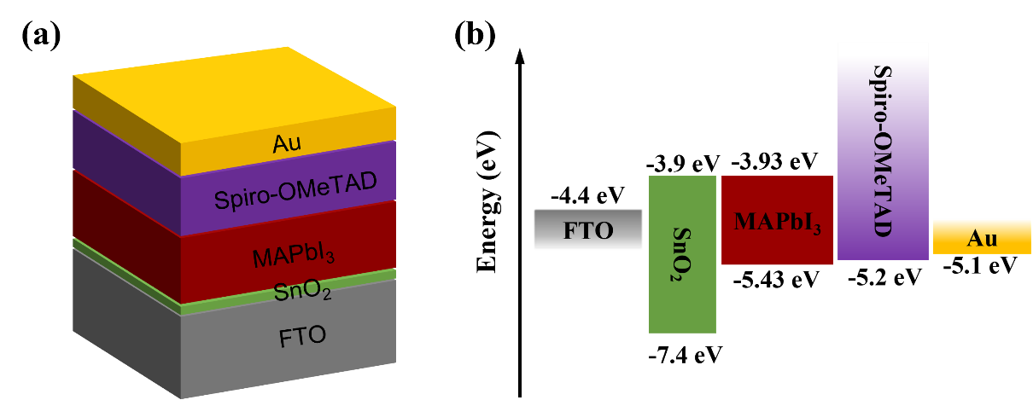
Fig.1.

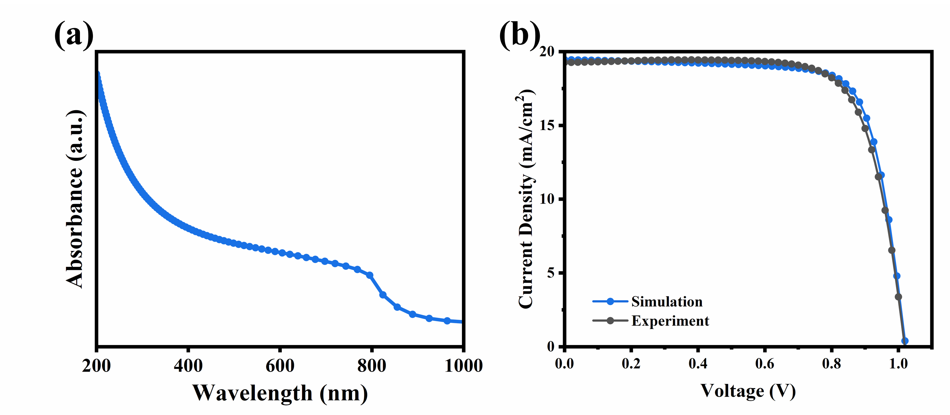
Fig. 2.

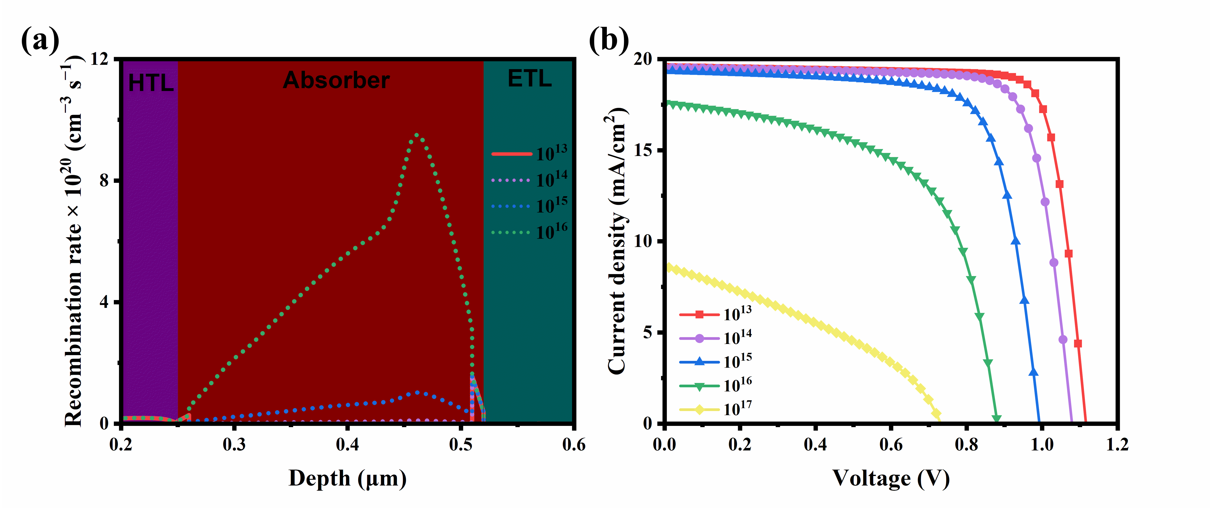
Fig. 3.

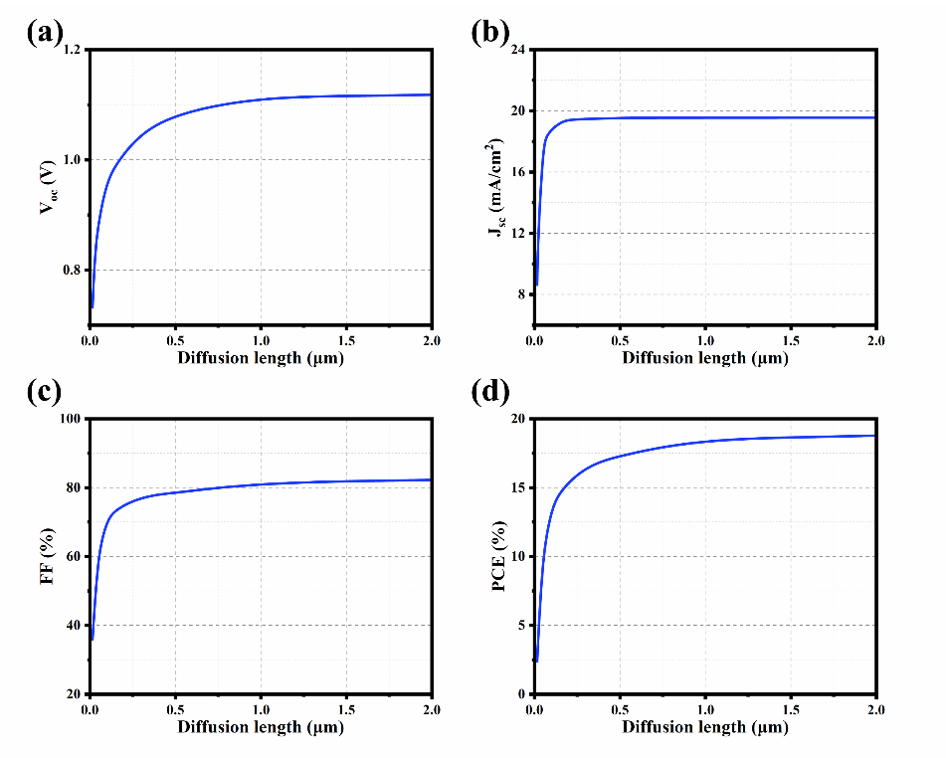
Fig. 4.

Fig. 5.

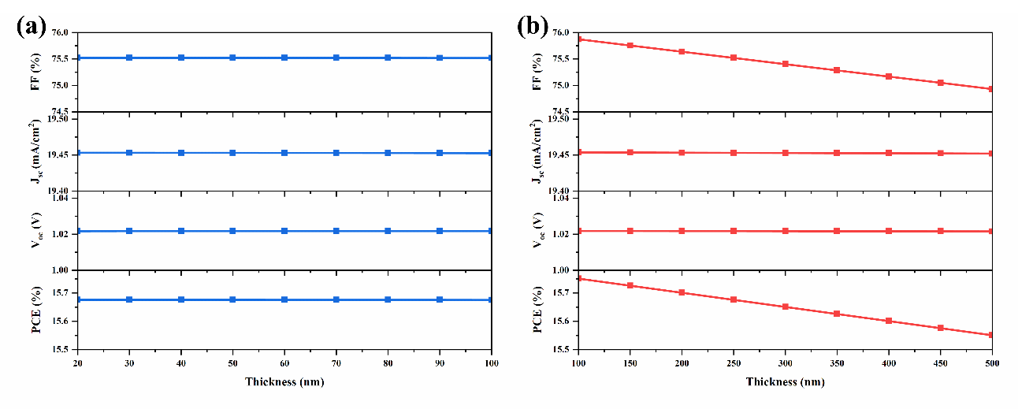
Fig. 6.

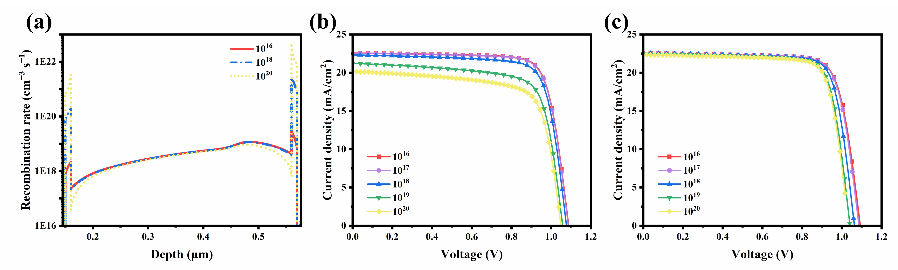
Fig. 7.

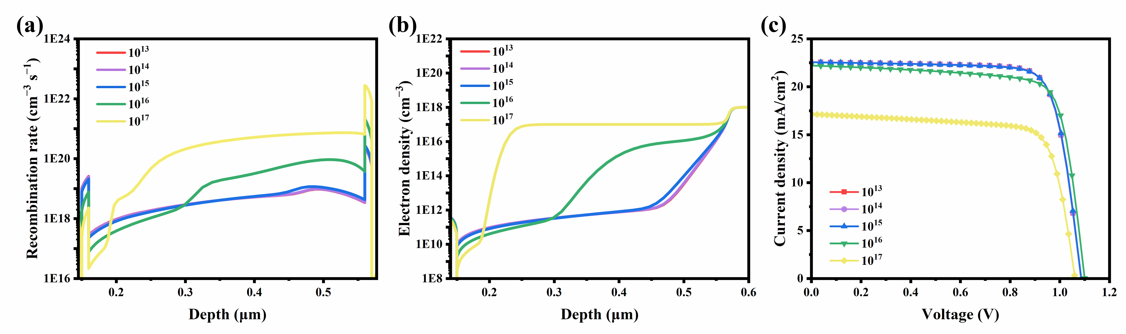
Fig. 8.

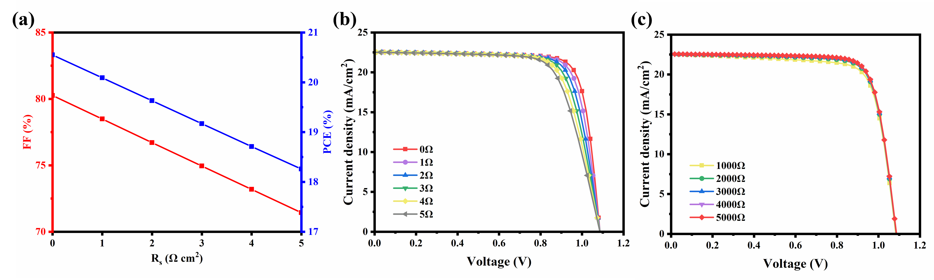
Fig. 9.

Fig. 10.

